Introduction to Internet Technology

Dr R Poornima, Dr K Kavithamani, Dr S Girija

Associate Professor, Department of Mathematics, Hindusthan College of Engineering and Technology, Coimbatore-32

- Introduction

The Internet is a group of computers that are located all over the world and are linked to one another by a high-speed network. The primary means of transmitting knowledge and exchanging cultures are now the Internet.
All networks and computers that are connected exchange information and make use of different services. Consequently, the World Wide Web (WWW or W3) is not the Internet. Although it is the most frequently utilised service, the World Wide Web (or Web) is simply one of the services that the Internet provides to its customers.

The global network of connected computer networks is known as the Internet. The Web's interconnected hypertext pages and applications, email, phone calls, and file sharing are just a few of the numerous information resources and services available on the Internet.

The Web Concepts

As a repository for human culture and knowledge, the Web was created to enable remote team members to communicate and exchange ideas on all facets of a single project. The Web is made up of a huge variety of files and documents that are kept on these computers and written in one or more forms of Hyper Text Markup Language (HTML), which instructs browsers how to display the data. Because they can handle requests from numerous users concurrently, the computers that house the data are referred to as servers. Users use programmes called browsers to access these HTML files and documents.
The key ideas on the web are:
Web Page
A Web page is an online informational area where details on a certain person, company, organisation, or cause are presented.
• Web pages (docs) are files that make up the Web.
• It contains links to online resources, including text, photos, audio files, videos,
and other types of data.

Web Site
A website is a grouping of online pages that are typically connected to one another through different methods. commonly referred to as a "web site" or just a "site." The website typically provides details about a specific person, company, organisation, or cause.
Static and dynamic websites are the two main categories of website styles:
• A static website is one that stores its web pages on the server exactly as the user will see them.
• A dynamic website is one that doesn't keep its web pages on the server in the exact same format
that users will see them. Instead, a set of criteria is used to determine how frequently and/or
automatically the web page content updates. A dynamic website might have two different
meanings. The first is that the web page code is created piecemeal and dynamically. The second
is that different web page content is shown depending on specific parameters. The standards may
be pre-established guidelines or they may be dependent on alterable user input.

The Web Terms
Uniform Resource Locator (URL)

It contains three parts that tell where the web page is stored on the Internet and is the full address of a World Wide Web page. These components are the protocol, site name, and absolute path to the file or resource, as demonstrated in the sample below.

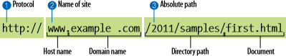

- The protocol name, such as HTTP;
http:// The protocol that will be utilised for that specific transaction is the first thing the URL does. The letters HTTP instruct the server to enter "web mode," or use the Hypertext Transfer Protocol.
- the domain name or hostname (the server's address that a user wants to connect to), such as www.google.com. www.example.com The website's domain name is revealed in the following part of the URL. The website address in this illustration is example.com. The specific host name at that domain is indicated by the "www." component at the start. Examples are clients.example.com, development.example.com, and so forth.
- The file name, which is optional, denotes access to a file or directory on the main webpage./2012/samples/first.html This is the server's absolute directory path to the requested HTML file, first.html. The directory names, beginning with the host's root directory, are words divided by slashes.

Example: http://www.icci.org/studies/ips.html.

- Protocol: http.

- Host computer name: www.

- Second-level domain name: icci.

- Top-level domain name: org.

- Directory name: studies.

- File name: ips.html.

Several Top-level domain are common:

Web hosting

A website must be kept in a location where users can access it constantly once it has been created. For this, we make use of web hosting services and businesses. They are the owners of content-storage web servers.

Search engine
Search engines enable us to look up data, photos, and other sorts of items on the Internet that are spread across a number of different locations. Search engines operate in accordance with specific algorithms that present the user with pertinent search results. In order to organise and save the data in the database for later use, the data from the many websites is initially collected, stored, and then analysed. When a user submits a query into the search engine, the database is indexed and the user is shown the results that most closely match the search terms they submitted. It is crucial to realise that utilising a search engine only searches the search engine's database and not the entire Internet. As a result, every time we utilise a different web engine, we can get a different set of results.4. Internet protocols

- TCP/IP protocol: The primary protocol for Internet communication is TCP/IP. It outlines the guidelines that computers must adhere to in order to communicate with one another via a network.
- The Hypertext Transfer Protocol (HTTP) is a network protocol that permits the exchange of nearly any kind of resource on the internet. Resources include documents, web pages, photos, search results, etc. In essence, it is the language used by web browsers to communicate with servers. For HTTP communications, there is also the HTTPS version, which is safe and encrypted.
- FTP (File Transfer Protocol): This protocol is used to transfer files between computers connected to the Internet or between clients and servers. In other words, this protocol is in charge of Internet file transfers.
- A company known as an Internet Service Provider (ISP) gives people and other businesses access to the Internet and other associated services like e-mail.

Web Design: Client-Server Architecture

- Client-Server Architecture

Client/server architecture is used by computers on the Internet. This indicates that the user's local client system receives files and services from the faraway server computer.
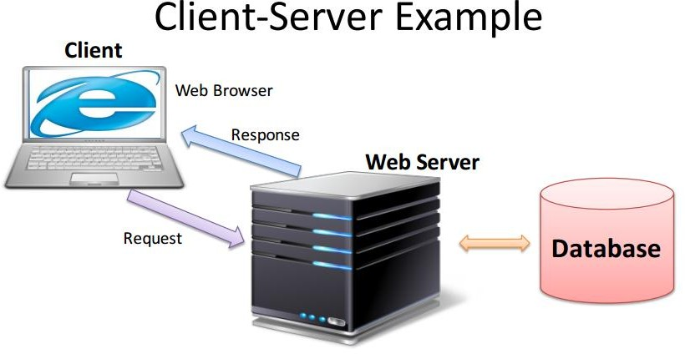

Web Server

A machine designed to run specialised serving software is called a web server. When a client, typically a Web browser, requests them, that software "serves" the HTML pages the client requests along with any files that go with them. If a person is on the same network as the Web Server, he or she may be able to save the data straight onto the Web Server computer (if authorised). However, the computer is secured so that only authorised persons can access it to make changes to the data.

Server-side:

    - JSP (Java Server Pages)
    - ASP (Active Server Pages)
    - ASP.NET (next generation of ASP)
    - PHP
    - Phython

Client

The Web browser on a user's computer is often referred to as the client (front end) or user side of the Web. Additionally, it might apply to add-ons and assistance programmes that improve browser functionality to enable particular website services. The phrase can either refer to a handheld device that offers Web access or the whole user machine.

Client-side:

    - HTML / XHTML (Extensible Hyper Text Markup Language)
    - CSS (Cascading Style Sheets )
    - JavaScript / VBScript (client-side scripting).

Web Browsers

A web browser is an application or programme for finding, displaying, and accessing information sources on the World Wide Web. A URI, or Uniform Resource Identifier, can be used to identify any type of information resource, including web pages, images, videos, and other media.

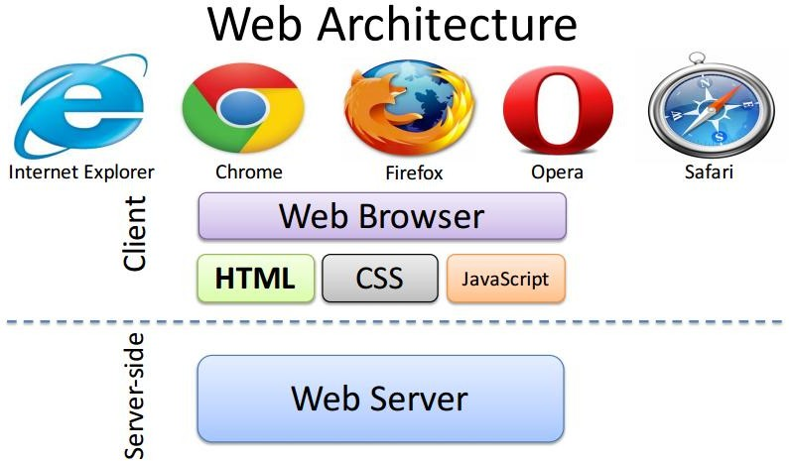

Web Operations

The Web is run using client-server technologies. Following are the steps for using the internet:
1. The user types the web page's URL (for example, http://www.tutorialspoint.com)
into the address bar of the browser.
2.Following that, the browser asks the Domain Name Server for the IP address
associated with www.tutorialspoint.com.
3.Using the HTTP protocol, which outlines how the browser and web server
communicate, the browser sends the request for a web page to the web server after getting the IP address.
4.The web server then checks its search for the requested web page after receiving
the HTTP protocol request. If it is, it sends the information back to the browser and ends the HTTP connection.
5. The web browser now receives the website, interprets it, and displays the website's contents in the browser window.
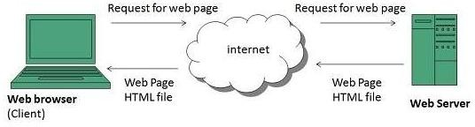
3. Site Structure

Every Web site was created with a pre-existing structure that it should maintain, and this organisation is known as the site structure. A site is a grouping of HTML files, documents, and images that are kept in a single root folder. You can save your documents in this root folder, organised into subfolders that make sense to you and other members of your department who might need to alter the data.Therefore, it is recommended that the structure of Web site include:

1. A root directory that houses the website.

2. A Web page called index.htm (or index.html) that is located inside the root folder and serves as
the website's default home page.

3.The images folder, which houses the photographs, illustrations, graphics, and other media used
in the Web pages.

4. Additional folders for further content organisation.

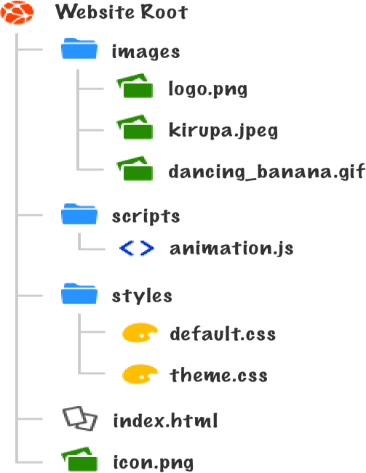

Hyperlinks
The main way to move between pages and websites is through hyperlinks. Links can direct users to other web pages, websites, images, documents, audio files, email addresses, and other areas of the same web page. Typically, text that serves as a hyperlink is underlined and has a different colour. Links come in four different varieties.
- Text hyperlinks use specific words or phrases to direct users to different files, webpages, or documents.
- Image hyperlink - This type of link use an image to direct users to another page, file, or document.
- Bookmark hyperlink - Takes users to another section of a website using text or an image.
- Email hyperlink: This feature enables users to send emails to the displayed email address.

How Browsers Display Web pages

A browser reads and analyses the HTML file when a Web page is opened, then prepares the Web page for display. When a reference to an external file, such as an image or multimedia file, is found, the server downloads the specified file, and the browser window loads it for display. You do not "embed" these files within the Web page; rather, HTML files are text files that simply contain references to the external resources.

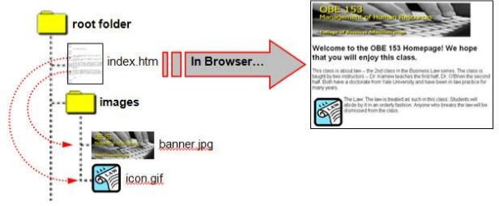

Types of Web Sites
There are many different kinds of websites, each of which caters to a specific kind of usage or content. Therefore, a few representative but not all-inclusive situations are provided below:
- Blog (Web Log): Website used mostly for posting online diaries that may also include forums.
- Social networking site: a place where users could interact and share media with one another, including images, videos, music, and blogs. Web apps and games may be among them.
- Wiki sites, like Wikipedia and Wikihow, allow users to edit content together.
4)Web portal: a place to start or a doorway to other Internet resources.

5)Sites like Google, Yahoo, and Bing search engines are intended to be accessed through search
engine sites, which offer generic information.

6)Information on recent occurrences at or involving their school may be posted on an education
site by teachers, students, or administrators.

- Website Design Issues

The design of a website involves several considerations that one should bear in mind. Following are some factors that make a website user-friendly and simple to access for visitors:
1) Information Availability - The website ought to have all the data necessary for a visitor to decide on their course of action. 80–90% of what a user or visitor is seeking for should generally be available on a good website, according to the common standard.
2) Page layout: How the content is presented on the page -- People should be able to access pertinent information easily if the page is laid up well.
Else they lose interest and leave the site. Page should be simple to enhance the usability of the page.
3)Standard colours should be utilised because they can affect how usable a site is. For instance, it is best to stick with the traditional link colours of blue for links, violet for visited links, and red for active links to avoid confusing the visitors.
4)Web accessibility - Web accessibility refers to the ability of all users, including those with impairments (such as those affecting their ability to see, hear, move, or speak), to engage with or contribute to the Web. People with disabilities should be better able to utilise and contribute to the Web as more and more accessible Web sites and applications become available.
5)A user-friendly website should be developed based on the needs of the target audience.
6)Download Speed: A web designer cannot predict the download speed. Making smaller pages, avoiding nested tables, and optimising the graphics (pictures no more than 10 kb) are a few things to think about.

