Tackling Aggravated Climatic Civil and Meteorological Aviation Weather Challenges Through Technology Transmission (TACMWCT³) FORMULA

Dr. Harish Kumar Gupta Department of Civil and Road Highways Construction Engineering, L. N. Malviya Infra Projects Pvt. Ltd., Head Office, Bhopal (Madhya Pradesh State) Rajiv Gandhi Proudyogiki Vishwavidyalaya (University), Bhopal, India h.g@rediffmail.com |  | Professor Kiran Gupta Department of Engineering Chemistry, Oriental College of Technology (OCT), Bhopal (Madhya Pradesh State) Rajiv Gandhi Proudyogiki Vishwavidyalaya (University), Bhopal, India gpt.kiran15@gmail.com

Abstract

The paper will be discussed the forthcoming natural and manmade catastrophic events. One day which may affect our Natural Eco – System and its existing Air – Environments’ Climatic Weather Aviation Meteorological Challenges Changing Conditions/ Occurrences, which are abruptly degrading air quality index (AQI) day by day, due to the generation of the Contaminated/ Polluted Constituents/ Black Carbon Soot Particles Emission in the form of solid, liquid and gaseous substances Whole Around the GLOBE at Local, Regional and Worldwide Scale. Detailed project Kurkuti – Ghamsali – Niti Highway explored for civil engineering highway construction may influence on various types of meteorological weather parameters/ proceedings during the construction highways’ road network. The promotion of cleaner, climate – friendly technologies and improved environmental management practices for enhanced livelihood sustainability and fostering resilience requires resources, which are fast – tracking speedily and all have strong interlinks/ connections through highway roads networks in civil engineering/ buildings/ industries producing anthropogenic substance in natural eco – system and its environment as depicted in Figure 1: Scheme Accomplishment Purposes and Judgment Creation Effort – Lifespan Progression…!!! Through Technology Transmission (T³ Formula…!!!). Highway construction, engineering are enormously reliant on inexpensive assets from the construction and conveyance of its ingredients to equipment and apparatuses used in devastation purpose in civil engineering construction work. In the developing motherlands, there are huge numbers of remnant energies, secretarial for completed partial of whole carbon types emissions materials {e.g., in the form of Black Carbon Soot Particles OR Black Carbon OR volatile organic compounds (VOC) from various kinds of source points} that leads to an intensification in overheating, worldwide warming, and microclimate alteration. With the inevitability of declining fossil fuels, and the threat of global climate change, reducing our energy consumption is an indispensable survival strategy and goal.

The beyond a creation voyages, more petroleum is disbursed, and countless scale of smoke emanations are created everywhere whole around at global scale. These emissions contribute to pollution, climate or weather events like Meteorological parameter changes, and marine acidified materials produced entire the ecosphere that has been exposed to more significant influence on environment as well as eco – system biodiversity measures. The chief consequence of drive sources originates from emissions, and meaningfully subsidize to Universal Heating and Macroclimate Modification spectacles. Enlarged releases, marine acidified materials production, forest cutting trees, climate change, with introduction of aggressive classes altogether graft to diminish natural ecological diversity whole round the sphere or world. Natural environmental as well as climatic transformation may escalate air quality index (AQI) with pollution stages via hastening the special distinctive biochemical responses that yield chemical generated oxidants as per variations and intensification in heat waves.

Weather revolution is previously trendy and uniform must yield instantaneous – extreme phases to lessen emanations, noteworthy changes are going on not only in India but also in developing countries, which occur throughout the world. Green House discharges from conveyance represent around 14 to 15 % of India’s national emanations, carbon less transportation must be fragment of explanation in terms of Cleaner/ Greener Environmental Technologies. It resolve a foremost amendment, but affecting to a truncated type – carbon emission economy and carriage scheme similarly present huge openings; not only for weather alteration but also for affluence, fitness, strength, preservation, conservation program at broader natural Air – Environmental Eco – System. However around 17.56 Km of Kurkuti – Ghamsali – Niti Road is an especial case study in terms of civil engineering highways road network construction is being considered for research and innovations on various applications/ tools used in road construction work. Considered thru weighty confidence on wagons, and Lorries for mutually traveler and cargo association, conveyance is chief user of remnant gasolines and Major Massive contributors to Weather Revolution are Meteorological Weather Events/ Climatic Conditions OR Aviation/ Weather Challenges/ Events OR Disrupt Environmental Sustainability Enhancements.

Keywords – cleaner/ greener environmental and civil engineering technologies, operational design models, climate – friendly technologies, meteorological climatic aviation conditions OR aviation/ weather meteorological challenges/ events, environmental sustainability enhancements, environmental management practices, civil road highways construction engineering and work – life cycle

- INTRODUCTION

Objective of Civil Engineering Consultancy Services: The main objectives of the consultancy services are to prepare initial environmental examination (IEE)/ in terms of chapters and bid documents for an especial case study of the length of 17.56 Km of Kurkuti – Ghamsali – Niti Road and to launch techno, inexpensive, feasibility of scheme and formulate thorough development explored to design of roads, bridges and other infrastructures [1]. An important requirement with regard to improving the Project Road is that the development of work will be inside the right of ways (ROWs) of 24 Meters and avoiding additional land acquisition as far as possible. All these means that the development schemes for the Projected Road should be as economical as possible consistent with the functional requirements and that it should amenable for quick implementation without delays. To assist the conservational features and assume decent Highway Construction Performs (Supportable Conservational Expansion Performs) underneath of the scheme and plan are being considered. Contemporary investigation procedure purposes to practice leftover materials of roughly about trades’ industries alike poly – propylene and polyester production (by way of leftover of sponsorship and carpeting manufacturing correspondingly) in groundwork of superior category of bitumen has to be castoff in construction of scorching mixture bitumen (SMB) aimed at infrastructures, passages, assemblies and barrages creation throughout civilian engineering construction exertion [2]. Compacted ingredients in pavement mixture were truncated excellence combinations of extraordinary category and leftover sandstone pitch with ultimate unprejudiced to deliver additional worth, to decrease the construction budgets and retain the virgin – kind hard ingredients particularly combinations for elongated era of period. Created combinations are of comparable improved presentation as compared to the predictable bitumen assortments. There is crucial requirement to discourse the countless trials of periods: weather alteration, reserve exhaustion, deforestation, air quality index (AQI), water quality index (WQI), noise level index, status of ground water, surface water, pollution load, and highest lubricant etc. [3]. All matters are hastening promptly, and yield strongest point interlinks or inter – related through the highway as fine as the erection engineering work as displayed below in Scheme Accomplishment Purposes and Judgment Creation Effort – Lifespan Progression…!!! as shown in Figure 1.

- Ground Control Point Survey by using differential global positioning system (DGPS);
- Procurement of 0.5 m Resolution of Satellite Imagery from national remote sensing centre (NRSC), Hyderabad, India;
- Development of geographical information system (GIS) Layers and digital elevation model (DEM) of Finalized Alignment of Border Roads;
- Contours Creation at 2.5 m Interval;
- Ortho – photo Generation at 0.5 m ground sample distance (GSD).

Major/ Minor Tasks and Scope of Civil Engineering Consultancy Services

- Civil Engineering Surveys and Investigations

- Topographic Surveys;
- Hydraulic and Hydrological Investigations;
- Traffic Surveys;
- Material Investigations.

- Civil Engineering Designs

- Geometric Designs;
- Pavement and Road Designs;
- Design of Bridge and Structures;
- Drainage Designs.

- Civil Project Cost Estimations

- Civil Detailed Project Report; Initial Environmental Examination and Bid Documents

- Civil General Topographical Features of the Area/ Region/ State

- Civil Proposed Drainage Facilities/ Structures of the Area/ Region/ State

- Civil Engineering Establishing the Most Suitable Alignment of the Projected Road.

- Civil Engineering Minimal Adverse/ Unfavourable/ Unpleasant Impact on the Surrounding Environment.

HAMARA SANDESH…!!! HARA BHARA RAHE HAMARA “BHARAT” DESH…!!!

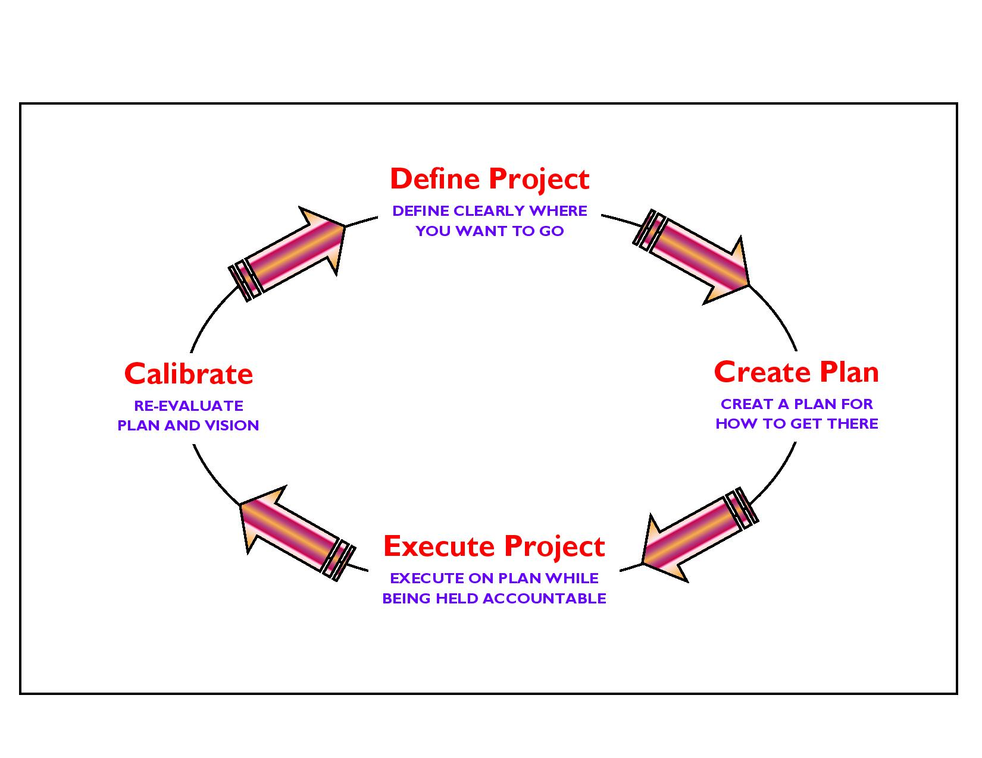

Figure 1: Scheme Accomplishment Purposes and Judgment Creation Effort – Lifespan Progression…!!!
- MATERIALS AND METHODS

PROPOSED APPROACH AND PROCEDURE: Environmental Approachable Highway Creation Techniques and Ingredients in Civil Engineering

General Approach Features: The general approach of the consultants would be to comprehensively address the various issues involved in the project, to carry out all the field and design office activities as set out in the Scope of Services of the term of reference (TOR) and finally to develop improvement proposals satisfying the objectives of the projected areas [4].

Methodology Used: The project involves a series of inter – related activities, both in the field and in the design office. The methodology for carrying out these activities is described in the following paragraphs. Extremely/ extensible high – resolution satellite imagery global positioning system (GPS), along with aviation meteorology may be used for precise measurements like civil engineering highways road construction network and observations may be calculated on demand [5].

Topographical Surveys Analysis: The topographical surveys by means of a global positioning system (GPS) with, climatic weather/ meteorological observations, for fixing of ground control points for the entire length of the corridor. Further, the survey has been completed with the 0.5 m high – resolution satellite imagery, along with aviation meteorology may be used for precise measurements, analysis and observations [6].

Soil and Material Investigations Features: Prospective sources of construction materials have been located by the consultants to add in list of sources of materials. To estimate the quantities of available suitable materials; the consultants have prepared quarry/ material source charts including lead distances etc. This shall form an input in rate analysis of borrow/ quarry materials, following which recommendations for the use of the materials from different sources can be made. Material investigation done for engineering properties reveals that the material available at site is fit for use in protection, drainage system and surfacing works aggregate and no quarry outside the site is mandatory. The material can be used for crust layer execution by processing the available material by a stone crusher and rotary screen [13]. Only local transportation is the need for transporting the aggregates for preparation of bituminous mix preparation and laying at respective chainages under the projected areas/ places/ regions [7].

As per completion of eco – friendly information remained composed from dissimilar cradles counting administration subdivision with initial environmental examination (IEE) report in terms of chapters, by Expert/ Specialist Team has been organized for civil engineering highways road construction network. The foremost purpose about the statement is to produce a smooth; ground – breaking appropriate recommendation for decent erection performs. Environment – friendly innovativeness procedures and skills be able to additional condense vitality intake by diminishing drive involvements on behalf of reheating, refrigerating and graceful, and combining drive proficient applications and solicitations. Exchangeable vigor for inhabitant likewise protects currency which resolve difficulties convert progressively imperative by way of charges of vestige gasolines and constituents for thoroughfare, associations, and erection are recycled unescapably upsurges in nearby forthcoming programs. Extraordinary cumulative and leftover polymer essential composition is precise substantial as thriving as commanding protagonist in highway pavement to decline the price of erection and conservation. The predictability of deteriorating remnant gasolines, and the hazard of universal weather alteration, plummeting vigor depletion are an indispensable existence approach. Selecting to Shape – Ecological Bright Green...!!! And Enthusiasm to Go – Bright Green...!!! To protect vigor depletions and the situation appreciated properties to accomplish noteworthy potential goalmouths in predictable study area for revision province. Stumpy personified drive of bright green yields safeguards that actual slight vigor left into their creation and construction work, through a straight bargain in emission of carbonaceous substances. The greatest transformer of bitumen necessity comprehend extraordinary fractions of Iso and Cyclo – Paraffins and subordinate proportion of asphaltenes alike to bitumen alignment as per the situation and the leftover polymer from extra productions may be recycled in forthcoming exertion agendas in improvement on urgency basis [8]. The statement principally encompasses conservational facts concerning dissimilar phases of the Scheming; Erection and Operative Three Stages such as portrayed underneath aimed at Kurkuti – Ghamsali – Niti Highway, as it is positioned in Northern portion of Uttarakhand Ceremonial to attain predictable objectives/ goalmouths and mostly they are depicted as below:

- Scheming Stage;
- Erection Stage;
- Operative Stage.

Asphalt, as remainder after unpolished lubricant decontamination, is the multifaceted combination of four chief relatives of composites, mentioned to as DADB segments (Drenches, Aromatics, Dammars and Bitumens). The activity of asphalt depends on the comparative attentiveness and biochemical topographies of asphaltenes and maltenes; therefore, difference in its configuration powerfully touches its involuntary possessions [9]. Procedural Perspectives and Completed – Interpretation of Highway Data Baseline Erection Snapshots as assumed underneath in Figure 2.

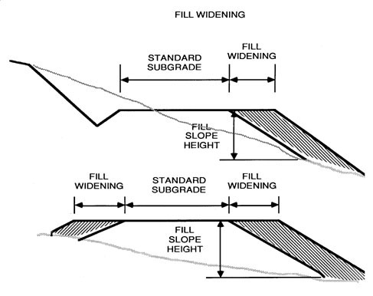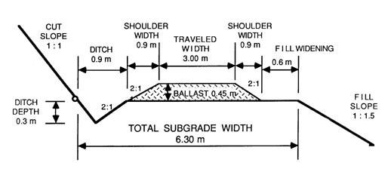
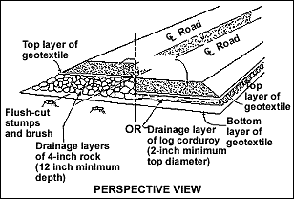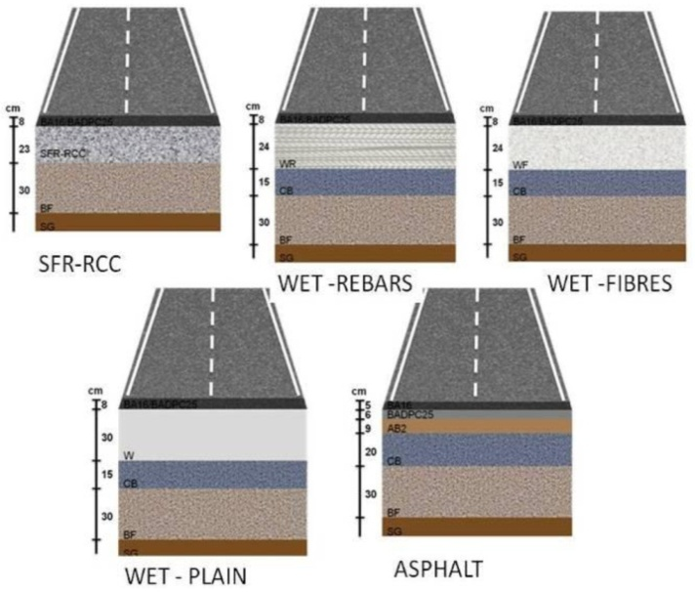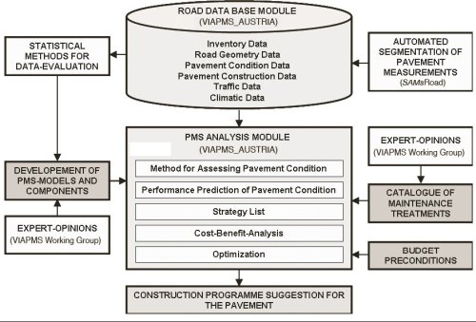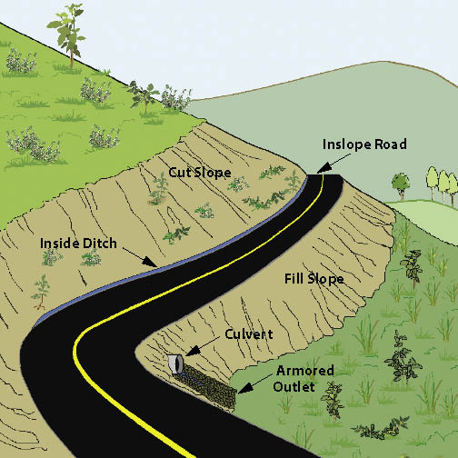

Figure 2: Procedural Perspectives and Completed – Interpretation of Highway Data Baseline Erection Snapshots.

It grants about huge regular and motivating prospective possessions: Waterproofness, ductility, adhesivity and confrontation to consequence of weathering – events and compounds of chemical etc. In previous around 30 years back, a varied range of adapting polymeric ingredients have been verified with asphalt for their practice in highway creation network. As polymer to be get operative it necessity be intermingling with asphalt and progress its confrontation at extraordinary heats deprived of creating the asphalt too gelatinous at collaborating heats or too delicate at small overheating [10]. It must be accomplished of being administered by conservative apparatus, obtainable, not luxurious, substantially and chemically steady throughout loading, submission, examination, measurements with actual/ factual services. In authentic adapted asphalt, thermoplastic latexes, and evenly thermoplastic polymers get remained through primarily secondhand procedure. Use of subordinate (secondhand) combinations, in its place of principal (virgin) ingredients facilitated in expedition of landfill compressions, plummeting the necessity for removal, defensive atmosphere and minimalizing the ingesting of innovative properties [11]. As the Polyester polymer, thermoplastic poly – ethylene tere – phthalate (PET) and inorganic substances like fibres are essences, these are frequently rummage – sale to yield durable and resilient strengthening asphalt. Likewise, dissimilar engineering wastelands as leftover polymers, consumed cosmetic, mineral excavation leftover and fibres etc. may be recycled as bitumen transformers for municipal engineering highways’ road erection network. Carpeting leftover fibres were recycled freshly in bitumen combinations and in fibre strengthened material (FSM). This type strengthening amended efficiently fragment conflict, durability, and malleable strength of material assembly constituents. The chief leftover producing diligences is the erection and mineral creation, as it remained described that capabilities to custom such category of leftover in stumpy to intermediate metropolitan transportation as well as countryside transport movement zones of highways and as folder developments existed identical advantageous. Practically writings material has previously been deliberated the usage of plasters like sandstone residues, latex silica and carbon black as modernizers for bitumen combination. In foreign countries, the usage of leftover ingredients in warm combination bitumen (WCB) is not functional hitherto, now accumulation to occurrence of a huge quantity of stumpy eminence comprehensive aggregates are not appropriate for custom in pavement construction work in civil engineering or for additional commitments [12].

Groundwork of Warm Combination Bitumen and Belongings: Warm Combination Bitumen (WMB) models remained prescribed by means of virgin bitumen and improved ring binder stood predictable by means of the commonly used as Marshall Test Method (ASTM: Number: D – 6927). The combinations existed deliberate rendering to customary restrictions of superficial (exhausting) progression. The occupation combination was communicated (%age Weight) by expending uneven and acceptable combinations, gravel and stuffing as containing serial number 30, 32, 33, and 5 Weight by %age wise, correspondingly. Combinations stood established for determined consignment and movement alongside through compactness and air cavities in combinations and concrete ingredients remained resolute [13].

- Warm combination bitumen (WCB) are warm mixtures bitumen comprised of standard absorptive collective category, principal (virgin) bitumen models and sandstone plaster for construction work;
- Warm combination bitumen (WCB) are warm mixtures bitumen comprised of standard absorptive aggregate category of material, in construction network;
- Warm combination bitumen (WCB) are warm mixtures bitumen contained of extraordinary absorptive aggregate category, sandstone powder, adapted bitumen complete by means of 5% to 6% of leftover poly – propylene and leftover material as poly – ester correspondingly.

- ENVIRONMENTAL INDEX WITH Economic Status of Uttarakhand OR TREND FEATURES OF THE PROJECT

Climate, Rainfall and Temperature Variations: The climate of Uttarakhand State varies with elevation and the low altitude (100 m – 1,500 m) has a humid subtropical climate. High altitude and very high altitude areas (3,500 m – 5,500 m) have a subtropical highland climate and alpine climate. Uttarakhand receives 2,000 to 5,000 millimeters (79 in to 197 in) of rainfall annually, 70% to 80% obtained between May and October, snowfall annually, obtained between November and March. Greatest colonized provinces of Uttarakhand experiences a moderate weather variations, through heats occasionally surpassing 28°C (82°F) in summertime existences. Typical yearly temperature for most of Uttarakhand is found to be around 18°C (64°F). Uttarakhand is one of the few states in India which receives regular snowfall at many places. The average annual temperature for the major part of Uttarakhand is recorded to be of around 18°C (64°F) approximately during the months of March – May, the sun shines at its best in the state of Uttarakhand State. The weather remains wintry and humid, since it rains most of the time. Monsoon prevails from late – June to early – September respectively. The state has five seasons: like winter, summer, spring, autumn, and a monsoon season occur between June and September. Uttarakhand climate ranges from sub – tropical region in the South to tundra in the Northern part of the origin. The climate of Uttarakhand varies with elevation and the low altitude 100 m – 1,500 m have a humid sub – tropical climate along with very High altitude and very high altitude areas (3,500 m – 5,500 m) have a subtropical highland climate and alpine climate.

Uttarakhand State receives 2,000 to 5,000 Millimeters (79 in to 197 in) of rainfall annually, 70% to 80% obtained in between May and October. Uttarakhand is unique types of states in India to obtain consistent snowstorm at most part of the region or state. Snowflake link varieties after nearly 6,100 Meters (around 20,000 Feet) and approximately 4,900 Meters (nearly 16,100 Feet) in Northern part/ area. In tundra – type province in the North is snowbound for four months every year, and temperature drops down as underneath 0°C (32°F) at virtually all evening. North – Western Uttarakhand, the mountaintops are originate to be ice – covered on yearly basis; as of the extraordinary elevation, temperatures in highlands can drop to as stumpy as −40°C or (−40°F) in wintertime. Throughout the rainy season, dense rain fall upsurge the jeopardy of avalanches. As per the greatest record for the lengthiest epoch of uninterrupted rainfall in Uttarakhand State was for 11 number of days and more magnitude of days due to climatic conditions and variations in the locality or region. Mist disturbs numerous fragments of the state through wintertime and rains, creating conveyance dangerous during these days while travelling. The state – run is the second wildest developing state – run in India and the situation unsophisticated state internal merchandise (USIM) {at constant prices} additional than doubled rate as ₹ 24,786 Crores in the Financial Year 2005 upto ₹ 60,898 Crore in the Financial Year 2012 consequently. Each capita revenue in Uttarakhand State is found to be ₹ 1, 03,000 Crores (Financial Year 2013), that is the highest point than on nationwide average scale of ₹ 74,920 Crores (Financial Year 2013). Rendering to the reserve bank of India (RBI), the entire overseas straight speculation in state from April month 2000 to October month 2000 of the year 2009 estimated amount US $ 46.7 Million subsequently.

Aim, OBJEVTIVE and Scope: This revision mainly focuses on the specific in region or state as considered in the case of the above discussed study about Kurkuti – Ghamsali – Niti Road to establish, construct, and build the techno, economical, viability of the project and prepare a detailed project chapter explored for the design of roads and bridges etc. Moreover here our goal and aim is to take research initiatives and innovations in the fields of Environment, Civil and Highways’ Road Construction Engineering Network, Technologies and Methodologies, Meteorological Data Observations, Analysis with the help of Remote Sensing (RS) Technology (Stereo Photogrammetric) OR Geographical Information System (GIS), which all revisions are multidisciplinary – interrelated – parts of ENVIRONMENT and CIVIL ENGINEERING NETWOK system respectively…!!!

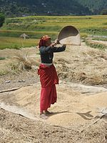

A Female Sorting Rice, a Significant Nourishment Harvest in the State of Uttarakhand.

Similarly in Indian context, cultivation is noteworthy subdivisions of the budget of Uttarakhand State. Mainly cultivation of basmati paddy rice, wheat, soybeans, peas’ nuts, groundnuts, coarse cereals, pulses, maize, barley and oil seeds etc. are greatest extensively fully – fledged yields of the locality. Likewise fruits cultivation growing apples, banana, papaya, oranges, pears, peaches, lychees, mangoes and plums are broadly grownup and imperative to superior quality for nourishment treating manufacturing. Cultivated trade sectors has been usual in Uttarakhand State for cultivation of lychees, horticulture, herbs, medicinal plants and basmati paddy rice as shown in Table 1. Throughout the year 2010, wheat manufacture was found to be 831 thousand tonnes and rice cultivation remained found to be 610 thousand tonnes, although the chief moneys harvest of the state are sugarcane, which had a progression of approximately 5,058 thousand tonnes respectively. As per record 86% of the state involves hills, the harvest per hectare is not found in actual extraordinary. Approximately 86% of crops are found in plain areas, while the residual is from the peaks’ mountainous stations/ areas.

Table 1: Economy of Uttarakhand at a Glance.

Budget of Uttarakhand State at Glimpses Statistics in Crores (Indian Rupees)
Sr. No. | Budget Glimpses Statistics (Financial Year – 2012) | Indian Rupees
1. | Almora USIM (Existing) | ₹ 95,201/-
2. | Apiece Capita Revenue | ₹ 1,03,000/-

Supplementary types of crucial manufacturing industries comprise travel and hydro – power production energy demand, and there is potential expansion in IT, ITES, biotechnology sector, pharmaceuticals and automobile’s trade industries frequently day by day. The provision subdivision of Uttarakhand State principally comprises sightseeing sector, material knowledge demand, advanced training and education system, and investment sectors etc. The years 2005 to 2006, the state magnificently urbanized three assimilated engineering industrial plantations (EIPs) at site locations: Haridwar, Pantnagar and Sitarganj; Pharma Metropolis near at Selakui location; evidence knowledge estate positioned at Sahastradhara (Dehradun); and progress development place situated at Sigaddi (Kotdwar). The year 2006, 20 industrial regions in community confiscated corporation (CCC) method are industrialized in Uttarakhand State – run.

Humidity, Weather, Climatic Index and Wind Pattern Parameters: Moisture or precipitation is originate to be 45% within North – North West (NNW) airstream flows by the side of 00 to 5.7 Km/ H. Uttarakhand States’ existing Climate and Temperature rise on an middling stage is 14° Celsius and Weather Forecast for next 3 days may varies between 25°C to 28°C and temperatures occasionally surpassing 28°C (82°F) in summertime days. Elevation/ Altitude/ Ceiling are found to be 5,425 Meters from the nasty marine equal (NME) in Uttarakhand State. The temperature in the province spreads and fluctuates maximum upto minimum level in – between 15° Celsius to 14° Celsius on an regular basis in the State of Uttarakhand. Atmospheric Pressure found to be 1,015.60 mb and Ultraviolet Index is found to be 7 and similarly Dew Point is nearly 14°C. Cloud cover in the Uttarakhand state is approximately 70% with Visibility Status 8 Km and around 16 – wind compass rose are formed for the study. The eight half – winds are the points obtained by bisecting the angles between the principal winds. The half – winds are North – North East (NNE), East – North East (ENE), East – South East (ESE), South – South East (SSE), South – South West (SSW), West – South West (WSW), West – North West (WNW) and North – Northwest (NNW) respectively.

Homogeneous Section of Traffic: The whole Projected Highway is deliberated as standardized segments constructed on the basis of Transportation Capacity and its’ physiognomies are stated in Table 2 and Figure 7. And Table 3 shows the Existing – Proposed Chainage Wise Villages.

Table 2: Standardized Segments Constructed on the Basis of Transportation Capacity Tehsil/ District Wise Villages.

Sr. No. | Standardized Segments | Design Section Chainage |  | Existing Section Length  (Km) | Design Length (Km) | Lane Widening
 |  | From (Km) | To (Km)
1. | Kurkuti – Ghamsali – Niti Road | 0.00 | 17.56 | 0.00 to 18.53 | 0.00 to 17 + 56 | Bothways

Table 3: Existing – Proposed Chainage Wise Villages.

Sr. No. | Homogenous Section | Existing Chainage Section |  | Proposed Chainage Section
 |  | From (Km) | To (Km) | From (Km) | To (Km)
1. | Kurkuti – Ghamsali – Niti Road | 00 + 000 | 18 + 530 | 00 + 000 | 17 + 565

- DEMOGRAPHIC INFRASTRUCTURE CATALOGUE OF THE PROJECT DISTRICT/ STATE

Demographics of Uttarakhand State by Population and People: The local people of the State are mentioned to as Uttarakhand and often particularly either Garhwali or Kumaoni dependent upon their habitation of existing derivation. The survey data of the year 2011, the state of Uttrakhand had on an average 5,137,773 men and 4,948,519 women respectively. It is ranked to 12th in terms of the greatest inhabited states and populace compactness is nearby 189 persons each Square Kilometers. As revealed by the census data analysis year 2011, it has a population of 1 Crore, a growth from 84.89 Lakhs in the year 2001 valuation and assessment. The inhabitant’s evolution of the state in the present decade was 18.8% and previously it was about 19% only. The population growth ratio of the state of Uttarakhand is round about 18% and numeral of populations in the state is encompassing their ways of work and living style of daily life at a pretty fast pace as shown in Table 4.

Table 4: Uttarakhand Facts and Special Effects.

Sr. No. | Factual and Special Effects
1. | The authorized Languages over here are Sanskrit and Hindi. Garhwali and Kumaoni are also spoken by large number of inhabited individuals in State of Uttrakhand;
2. | It is predominantly associated by highways, rail, and air. Its principal air incurable is positioned in Dehradun and it is called as Jolly Grant Airport (JGA) in the regional state;
3. | The chief sustenance of the state is root vegetable through wheat and non – vegetarian foodstuff is disbursed in a huge technique by the local people. A specific thing of the state cooking is the usage of tomatoes and milk interrelated belongings in different preparation manners and conducts. Coarse Grain with high fiber content are found to be extraordinarily unswerving over – here;
4. | The distinguished Hindu expeditions in the form of the Haridwar Kumbh Mela materializes in the State of Uttarakhand. Haridwar is unique out of four spots in the country, anywhere this Kumbh Mela may be conducted by organizing committee in Uttrakhand State;
5. | Humanizing is amongst the furthermost energetic constituent as ranges sensible of the budget of the state. The basmati paddy rice and oil – seeds are nearly of the grownup substances found are consistent belongings like apples, peaches, mangoes, papaya, banana and plums are grownup and vital to foodstuff occupational growth rate increasing in Uttarakhand State.

Infrastructure: Uttarakhand State is situated in Northern part of India and earlier was known as Uttaranchal State. It is also named the Land of the Gods in viewpoint of diverse Hindu shrines and prominent pilgrimage – visit location in the State of Uttarakhand. It is recognized for breath taking wonder – fullness of the Himalayan and also in the Terai region. Proceeding 9th November, 2000, the state was completed by means of Himalayan and North Western capacities of Uttar Pradesh. State is alienated into two in the custom of Garhwal and Kumaon regions, within entire 13 places/ regions. The capital Dehradun is the major urban area and Uttarakhand’s highways are conserved by border road organisation (BRO), a side – shoot of Indian Army. Boundary or boarder profession among two republics complete the Lipukekh pass accompanied for five months from June month to October month at Taklakot market in Western Tibet on Chinese site location. The archaeological endorsements provision shows the occurrence of individuals in the extent since actual as well as ancient epochs. This state is prevalent vacationer advert and plentiful public from all over India and everywhere the sphere originate to devote period of time – scale along with household members as well as close networks. Moreover, nearby is an identical gradient of fascinations consistently.

PITHORAGARH: Business transactions worth over ₹ 6.55 Crore taken place among India and China this year through the border at Lipukekh Pass in the State of Uttarakhand. Entire professional conducted among the two motherlands done by the border road organization this year was ₹ 6.55 Crore, that importations by Indian dealers mounted at ₹ 5.59 Crore and disseminated by them hoisted at ₹ 96.5 Lakh, profession brigadier Mr. P. S. Kutiyal from Dharchula. An entire 244 Indians, counting 70 dealers and 174 assistants, exited to go Taklakot market this time to do occupational work with Chinese colleagues and proficient profession brigadier stated. Indo – China boundary profession, targeted at establishment of budget of ancestral boundary communities remained continued in the year 1992 continuously. Outmoded profession through previous Tibet had been sealed after the 1962 border encounter among two motherlands. Permitting towards profession captain, the Indian dealers spread merchandises similar to foodstuffs like tea, coffee, jaggery, sugar candy, cereals, mueslis, cornflakes, tobacco, cigarette products etc. and cosmetics are imported raw Tibetan fabric materials, ready – to – wear clothes, shoes – wears and reinforces belongings etc. Proceedings of 8th December, 2008 the situation remained proclaimed that Uttarakhand had converted the first state – run in India to accomplish 100% hygiene exposure, fetching entirely welcome of community evacuation, consequently achieving the position of completely – Nirmal Ceremonial OR Swachh State, like Swachh Bharta Abhiyan/ Mission in India. A clean India would be the best tribute India could pay to Mahatma Gandhi on his 150 birth anniversary in 2019, said Shri Narendra Modi as he launched the Swachh Bharat Mission at Rajpath in New Delhi. Figure 4 shows Lipukekh Pass – Indo – China Border and Shri Laxmi Narayan Temple in Legship.

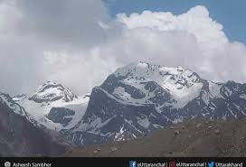 | 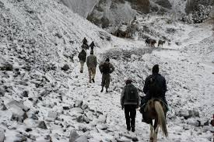
Lipukekh Pass in the State of Uttarakhand – Indo – China Border Line of Control. | The Lipulekh Pass at the Height of Approximately 16,800 Feet.
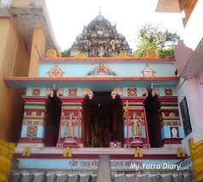 | 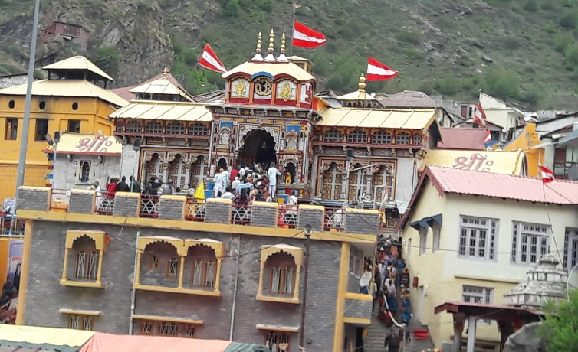
Shri Laxmi Narayan Shrine in Legship Ceremonious is Mostly Enthusiastic to Hindu Deity Narayana. | Famous Temple in Uttarakhand State.
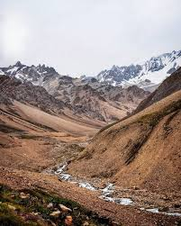
Pithoragarh Pathway. | Lipukekh Pass to Om Parvat.
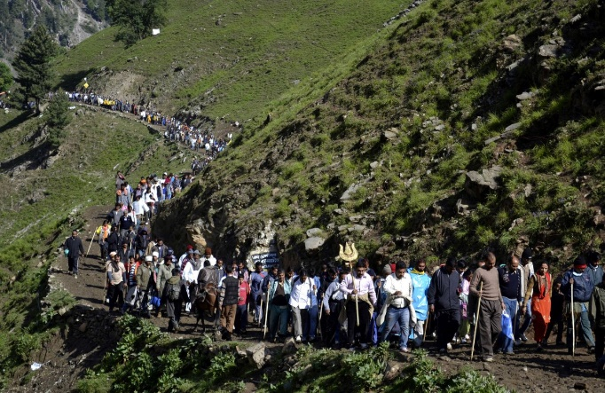 | 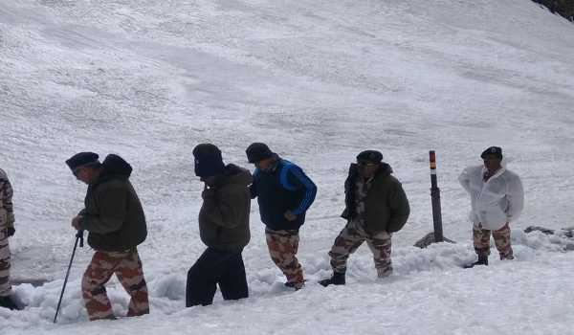
Lipukekh Pathway. | ITBP DG, Visits Lipulekh Pass… to Review Arrangement for Kailash Mansarivar Yatra.

Figure 4: Lipukekh Pass – Indo – China Border and Shri Laxmi Narayan Temple in Legship.

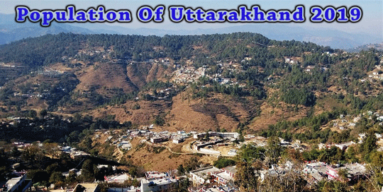

Whereas to acquire the populace data of Uttarakhand State of the year 2019, the people of preceding of 5th centuries prerequisites has to be appreciated and these remain stated in Table 5:

Table 5: Yearly Increase in Population Rate of Uttarakhand State, from years 2014 to 2019.

Sr. No. | Year | Population in Million
1. | 2014 | 10.170
2. | 2015 | 10.220
3. | 2016 | 10.280
4. | 2017 | 10.320
5. | 2018 | 10.356
6. | 2019 | 10.3932 (Estimated)

Via inspection the people of Uttarakhand State since the years 2014 to 2018, gives evidence that inhabitants proportion has grown up by 0.186 Million in the preceding of 5 centuries back. These digit demonstrations indicate that twelve – monthly inhabitants rate escalations is found to be approximately 0.0372 Million. Consequently, the inhabitants of Uttarakhand State now was found to be in the year 2019 as 10.356 Million (+) plus 0.0372 Million Total = 10.3932 Million. To accomplish the situation, inhabitants of Uttarakhand’s State in the year 2019 by way of approximations totally = 10.3932 Million. Various varieties of languages spoken in Uttarakhand’s State are depicted below in Table 6.

Table 6: Conversation/ Speaking Percentage Languages in Uttarakhand State, Year 2011 (Uttaranchal).

Sr. No. | Languages | Conversation/ Speaking Percentage/ Category/ Class in %age | Remarks
1. | Hindi | 89.15% | Up to Mark
2. | Urdu | 04.22% | Low Level Practice
3. | Bengali | 01.50% | Medium and Low Level Practice
4. | Nepali | 01.05% | Low Level Practice
5. | Maithili (Tharu) | 00.54% | Low Level Practice
6. | Punjabi | 02.61% | Very Low Level
7. | Others | 00.93% | Low Level Practice

Hindi have its place in Indo – Aryan languages is the authorized linguistic of Uttarakhand’s State and is pronounced thru 89.15% of the inhabitants (as per year 2011 Census data record of India statistics comprise Garhwali enunciated via 23.03%, Kumaoni articulated as a result of 19.94% and Jaunsari vocal language by means of 1.35% of the people for example modifications of Hindi language). Sanskrit remains assumed the rank of additional certified phonological in the regional state. Garhwali and Kumaoni languages are scarce tongues enumerated by dint of UNESCO and World Heritage. Separately after Hindi, Urdu stands the another maximum verbal morphological state through 4.22% chatterers monitored by way of Punjabi language (02.61%), Bengali language (1.50%), Nepali language (1.05%) and Maithili language (statistics contain Tharu as a modified and option language of Maithili) through 0.54% narrators. Numerous Tibeto – Burman tongues are likewise pronounced in this county by the local people residing the this area/ place/ origin, counting Jad, Rongpo, Darmiya, Byangsi, Chaudangsi, Raji and Rawat etc. languages in the study or projected region.

Groups Ethnicity of the Region: Uttarakhand devises a multinational populace extent through two geocultural counties including like Garhwal and Kumaon regions. Huge percentage of inhabitants stands by Rajput (innumerable cliques of earlier land owning leaders as well as progenies), comprising associates of the instinctive Garhwali and Kumaoni languages numeral of colonizers are also resides in the locality. According to a year 2007 study by Centre for the Study of Developing Societies, Uttarakhand has been found the highest percentage of Brahmins of any state in India, with approximately 20% of the population being Brahmin (Pundits/ Pujaris). Approximately 18.76% inhabitants have its place to the Scheduled Castes (as an approved duration for native original subordinate backgrounds in Old – fashioned Background Scheme in Indian region). As per record Scheduled Tribes speaks languages like Tharu, Jaunsari, Buksa, Bhotiya and Raji etc. organize around 2.89% of the population are residing in the same locality. More than four – fifths of Uttarakhand’s residents are Hindus, Muslims, Sikhs, Christians, Buddhists, and Jains make up the remaining population with the Muslims being the largest minority in the region of the Uttarakhand State.

Religion of the Uttarakhand State: Moreover Hinduism religion is state’s chief conviction, which is practiced chiefly by means of traditional Nepalis; as projected 57.8% of the entire populations remain enthusiasts of creed supporters. Close by existent countless Hindu shrines are furthermost prominent places like Kirateshwar Mahadev Shrine is actually prevalent, meanwhile the aforementioned involves namely Chardham overall as one of the most spectacular area of habitation as religion wise. The religion Vajrayana Buddhism that interpretations emanates 27.3% of inhabitants be there in Uttarakhand’s State is additional – principal, hitherto found to be utmost conspicuous conviction. Preceding towards Uttarakhand’s attractive fragment of Indian Union, and the belief Vajrayana Buddhism stood fabulous, which comes underneath Chogyal categories. Uttarakhand devises 75% Buddhist nunneries, as per eldest sightseeing backbone of 1700s centuries as community and pictorial aesthetics of Uttarakhand’s state are implemented in shadows of Vajrayana Buddhism faith and Buddhism shows as most momentous part in community lifespan, uniform amongst Uttarakhand’s mainstream found to be Nepali Hindu inhabitants are found more as locality/ origin wise. Table 7 shows the Religious Conviction Percentage in Uttarakhand State.

Table 7: Religious Conviction Percentage in Uttarakhand State, Year 2011 (Uttaranchal).

Sr. No. | Religion | Religious Conviction Percentage Group/ Cast/ Category in %age | Remarks
1. | Islam | 13.95% | Up to the Mark
2. | Hinduism | 82.97% | Low Level Practice
3. | Sikhism | 02.34% | Low Level Practice
4. | Buddhism | 00.15% | Very Low Level Practice
5. | Christianity | 00.37% | Slightly Low Level Practice
6. | Jainism | 00.09% | Low Level Practice
7. | Other or Not Religious | 00.13% | Low Level Practice
8. | Atheist | 0.002% | Very Low Level Practice

 | 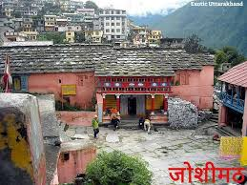
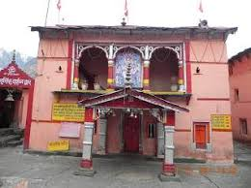 | 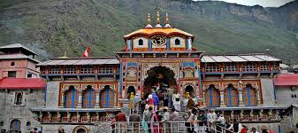
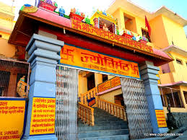 | 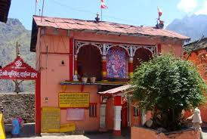
The Joishimath Temple is among the most Famous Religious Places in the Locality OR Origin.

Figure 5: Joshimath Temple is among the most Famous Religious Place for Pilgrims.

Hinduism creed is the country’s main belief is practiced principally by means of indigenous Nepalis; an expected 57.8% of aggregate populations are devotees of conviction. At hand occur voluminous Hindu shrines as one of them is Kirateshwar Mahadev Shrine is precisely widespread, subsequently that one comprises chardham operating mission to complete by religious people completely. The habitation Vajrayana that accounts nearly 27.3% inhabitants stands Uttarakhand’s additional – major, supreme projecting religious conviction. Erstwhile on the road to Uttarakhand’s attractive measure of Indian Amalgamation, as per record Vajrayana Buddhism belief remained the state conviction beneath Chogyal group of people. Uttarakhand has 75 Buddhist monasteries, the oldest dating back to the 1700s. The public and visual aesthetics of Uttarakhand are executed in shades of Vajrayana Buddhism and Buddhism plays a substantial role in public life, even among Uttarakhand’s majority Nepali Hindu population has been found more since so many years. The Figure 5 shows Joshimath Temple is among the most Famous Religious Place for Pilgrims. Christianity as per collected data of Uttarakhand exist customarily posterities of Lepcha publics, they remained transformed by British campaigners in the past 19th epoch and organize nearby 10% inhabited residents. In year 2014, the prominent Evangelical Presbyterian Church of Uttarakhand is more prevalent Christianity value as cutting – edge Uttarakhand region of the State. Supplementary spiritual components comprise mostly Muslims people of Bihari civilization and Jainism, by which collectively interprets in lieu of unevenly as 1% of inhabitants. Old – style convictions of instinctive Uttarakhandese explain abundant residue of inhabitants. Even though strains amongst the Lepchas and the Nepalese intensified throughout the unification of Uttarakhand State in India near about 1970s centuries, close by devises certainly not existed at somewhat foremost grade of collective spiritual forcefulness, contrasting in addition various Indian estates. Traditional conviction of Lepcha individuals is Mun, an animist preparation that co – exists through Buddhism as glowing as Christianity by means of origins.

Dances and Music Ethos in Uttarakhand State: Here parties – dances of the county are associated to lifespan and humanoid presence and display numerous anthropological excitements. The Langvir Nritya is a dance for men that look like acrobatic activities as one of the most famous activities. The Barada Nati traditional dance is additional dance of Jaunsar – Bawar that is exercise for the duration of nearly spiritual carnivals. Supplementary well – recognized dances contain system like Hurka Baul, Jhora – Chanchri, Chhapeli, Thadya, Jhumaila, Pandav, Chauphula and Chholiya etc. Melody is fundamental portion of Uttarakhandi philosophy. Widespread categories of traditional melodies contain Mangal, Basanti, Khuder and Chhopati lyrics and tunes. The traditional melodies be present or frolicked on devices comprising dhol, damau, turri, ransingha, dholki, daur, thali, bhankora, mandan and mashakbaja etc. The Bedu Pako Baro Masa is a prevalent conventional melody of Uttarakhand State through intercontinental prominence and renowned position inside the ceremonial. It assists the traditional chorale of Uttarakhandi individuals at international contemporaries. Melody composition is moreover castoff by way of a moderate quality for which the deities remain appealed. The Jagar is a method of essence devotion by which the songster or Jagariya sings a traditional song of the deities, by way of references to the excessive extravaganzas, corresponding to Mahabharata, Ramayana and other Vedas, which pronounce explorations and achievements of deity existence are being prayed. The Basanti Devi Bisht, Chander Singh Rahi, Girish Tiwari Girda, Gopal Babu Goswami, Heera Singh Rana, Meena Rana, Narendra Singh Negi and Pritam Bharatwan are the prevalent traditional choruses and instrumentalists as of the state – run, subsequently is republic harmony songster of Bobby Cash in the province.

Carnivals and Centenaries

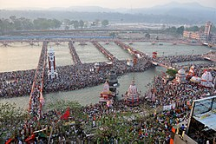

Tourists meet on behalf of third Shahi Snan (Royal Bath) at Har Ki Pauri in Haridwar vicinity on dated 14th April, 2010 thru Haridwar Kumbh Mela Carnival or Festival.

The foremost Hindu tours are like Haridwar Kumbh Mela carnival, occurs in the State of Uttarakhand. Haridwar shrines are more famous out of four places in India and more efficiently mela rituals are arranged with full zeal and verge methodology. Haridwar carnival furthermost freshly accommodated in Purna Kumbh Mela Centenaries starting Makar Sankranti ceremonies (in extraordinary month and year: January 4th, 2010) to Vaishakh Purnima Snan ritual (in extraordinary month and year: April 28th, 2010). Approximately hundreds of strangers amalgamated Indian travelers in this carnival that is deliberated as principal spiritual congregation in entire round the natural environmental specific ecosphere. The Kumauni Holi carnival is in the arrangements comprising various kinds of Baithki Holi, Khari Holi and Mahila Holi, altogether especially twitches from Vasant Panchami carnival and harmonious relationships, which can preceding practically as monthly origin. The Ganga Dashahara, Vasant Panchami carnival, Makar Sankranti ritual, Ghee Sankranti carnival, Khatarua ritual, Vat Savitri carnival, and Phul Dei rituals be there as chief commemorations. Accumulation of innumerable fairgrounds resembling as the Kanwar Yatra, Kandali Festival, Ramman, Harela Mela, Kauthig, Nauchandi Mela, Giddi Mela, Uttarayani Mela and Nanda Devi Raj Jat Mela kinds of rituals takings habitation. As per best ever Uttarakhand’s States the Nepalese mainstream rejoice wholly foremost Hindu centenaries, containing Diwali as well as Dussera centennial. The Old – fashioned indigenous carnivals, likewise Maghe Sankranti ritual and Bhimsen Puja carnival be there as one of them widespread rituals. Figure 6 shows about the Traditional Shrine Festivals of Uttarakhand State.

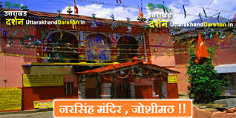 | 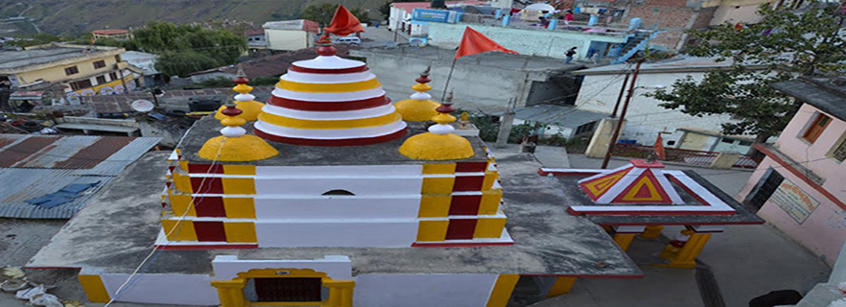
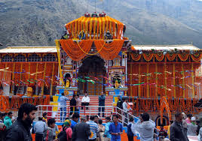 | 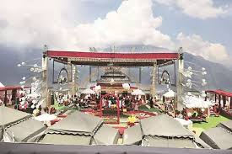
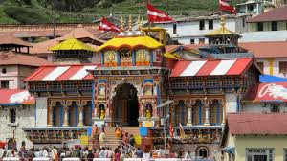 | 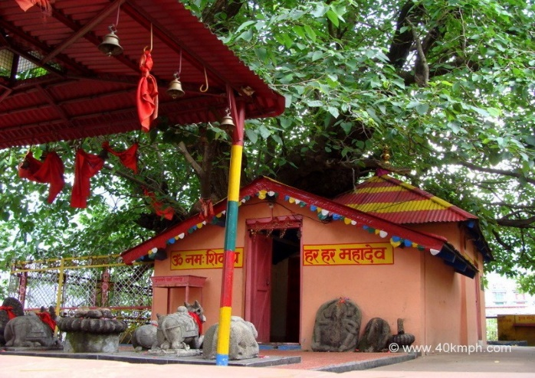
The Traditional Temple Festivals of Uttarakhand State.

Figure 6: Traditional Temple Festivals of Uttarakhand State.

- SPEEDY CONSERVATIONAL VALUATION SPECIFICATION OF HIGHWAYS

INSTRUCTIONS

(i) The venture group by way of “Conservational Proficient Individual” finalizes the specification to provision the ecofriendly taxonomy of the mission. The aforementioned has been dedicated to conservational cataloguing procedure, which succumbed to Ministry of Environment and Forest and Climate Change (MoEF & CC) on behalf of apprehension provincial brigadier or proficient professional [14].

(ii) Response to the queries presumptuous as the “Deprived of Modification” circumstance. The perseverance be there to categorize prospective impressions on that unique atmosphere and neighboring zones. The custom “Interpretations” segment to deliberate in the least projected modification processes and Speedy Ecofriendly Valuation Specification in terms of initial environmental examination (IEE) chapters is shown in Table 8.

Table 8: Speedy Ecofriendly Valuation Specification.

Country/ Project Title | Indian Region/ Place: Uttarakhand State – run  Sub – Scheme: Initial Environmental Examination Chapter Information Designed For: Kurkuti – Ghamsali – Niti, Road
Sector Division/ Section | Highway and Transportation Sections used by Government of India (GOI)
Screening Questions | Yes | No | Remarks
A. Project Site
Is the scheme development zone nearby or inside in the least of the subsequent ecologically penetrating zones/ sites/ capacities? |  | X | No ecologically penetrating zone/ location is positioned surrounded by the predictable highway;
Cultural Heritage Site; |  | X | No archaeologically protected monument or cultural heritage site/ zones is located within the road;
Endangered Extent; |  | X | Not at all endangered extents are positioned/ engaged adjacent to highways and adjoining regions/ capacities;
Wetland Area; |  | X | Not at all endangered or confidential rainy terrestrial is situated adjacent to highways and proximate contiguous extents;
The Mangrove Protection/ Range; |  | X | Projected highway is not at all situated in the Seaside Capacities;
The Estuarine Vicinity/ Capacity; |  | X | Not at all Estuarine is situated in the Predictable Zone;
The Buffer Region of Endangered Capacity; |  | X | Not at all region is situated in Projected District;
Superior Capacity on behalf of Defensive Bio – assortment; |  | X | Not at all region is traced in Projected Purlieu;
B. Potential Environmental Impacts
Infringement on chronological/ traditional capacities; dis – figuration of countryside by highway ridges, scratches, stops, and excavations? |  | X | Area is not at all hilly during the course of the projected configuration and no human – being inhabition nor any kind of chronological/ traditional regions and not any human – being infringement;
Impingement of expensive environmental science (e.g., delicate or endangered extents)? |  | X | Challenges taken to minimalizing wounding of plants/ sherbs when concluding the highway broadening opportunities, and did not find out any highly – sensitive or highly – protacted locality in schemed region;
Alteration of surface water hydrology of waterways crossed by roads, resulting in increased sediment in streams affected by increased soil erosion at construction site? |  | X | The anticipated configuration is junction at solitary insignificant regular sanitations. Entirely sanitations progressions has to be resolved or conserved to circumvent amendment in superficial aquatic hydrology consequently that aquatic sequences remain not be exaggerated. Provisional topsoil accumulations determination remain premeditated subsequently that overflow drive will not persuade sedimentation of channels or waterways. Sediment railing throughout erection work has to be delivered. However to take precautionary measures the natural eclogical experimental procedure has intensively introduced along with protection methodoligies;
Worsening of superficial aquatic superiority owing to sediment surplus and wholesome wastelands commencing employee – constructed encampments and elements castoff in erection engineering work? |  | X | Satisfactory hygienic amenities comprising “Marinate Depths Action (MDA)”, amenities resolve to provide on erection campgrounds, has to be upgraded as missing since habitation and aquatic figures. Not at all damaging components remain probable to be recycled in erection accomplishments. The superficial aquatic superiority has not been obstructed owing towards engineering erection work. Procedures comparable with ridge slope steadiness, “Strengthened Adhesive Material (SAM)”, absorbent fortifications remain recommended to preclude siltation of fishponds positioned subsequent to highway owing to superficial overspills;
Enlarged indigenous/ provincial extents airborne contamination owing to pillar devastating, wounding and substantial exertions and chemicals – compound from bitumin dispensation construction work in highway civil engineering? |  |  | Provincial location “Air Pollution Level (APL)”, may be extremly high throughout erection configuration/ highway network; automobile engagements and bitumin handling wok etc. The Bitumin Mixing Plant (BMP) OR Warm Amalgam Plant (WAP) placed far from habitation region satisfactorily very – high chimney make operational dispersal of prospective Dirt Emanations. Parting methods comparable scattering of aquatic – water on un – paved automobile association zones are anticipated to minimalize the dirt materialization. To moderate problematic Environmental Management Plans (EMPs) remain assimilated along – with extenuation techniques and procedures;
Risks and vulnerabilities related to occupational health and safety due to physical, chemical, biological and radiological hazards during project construction and operation? |  |  | Workers may get exposed to dust and noise during construction activities. However, the exposure levels are likely to be short and insignificant. Workers will be provided requisite Personal Protective Equipments (PPEs) to minimize such exposure and associated harmful occupational health effects. As to alleviate problematic the Environmental Management Plan has already been incorporated along – with moderation performances and actions;
The sound and pulsation accomplishments owing to criticizing and supplementary public workings happening on establish erection of highways/ connections and valued inhabited and moneymaking erections formations? |  | X | Not at all blasting is complicated and not any noteworthy sound cohort is predictable throughout erection accomplishments excluding usual structure apparatus operating sound level. The sound points drive to be spontaneous in environment and that one influence may be restrained inside insufficient materials of each crosswise of highway. Altogether motionless sound creation cradles apparatus comparable as DG conventional – sets, compressors – sets resolve to be mounted through auditory appendixes/ headscarves to condense sound smooth going on location if identified or aimed at regional state – run.

- CONSTITUTIONAL AUTHORIZATIONS MANDATORY

Moreover the conservational influence valuation/ declaration (CIV/ D) procedure are implemented to resolve or shadow guidelines of administration of India (AOI) under Uttarakhand Supervision. Existing strategy subsequently the scheme is not fit for more than 100 Km highways in measurement consequently MOEF announcement drive has not been applied and prerequisite no conservational influence valuation/ declaration (CIV/ D) authorizations. Stated in Table 9 represents permissions obligatory underneath the projected mission on behalf of civil engineering highways construction linkage zone with specific guidelines/ rules/ regulations for an implementation work [15].

Table 9: Required Statutory (EIA/ S) Clearances.

Sr. No. | Act / Rules | Purpose | Applicable Yes/ No | Authority
1. | Environment Protection Act (EPA) – 1986. | To protect and improve overall environment. | No | MOEF; GOI; DOE; SPCB
2. | Environmental Impact Assessment Notification (EIAN) 14th September, 2006. | To provide environmental clearance to new development activities following environmental impact assessment. | No | MOEF; (EIAN)
3. | Announcement aimed at usage of Fly Ash (NFA). | Recycle huge amount of fly ash cleared since thermal power plant to minimalize terrestrial custom on behalf of removal. | Yes | NFA
4. | Seaside Rule Region (SRR) Announcement 1991 (2002). | Defense of delicate seaside restraint. | Yes | CRZN
5. | Nationwide Atmosphere Appellate Specialist Performance, (NAASP) 1997. | Statement objections concerning the procedure of Legislative Ecofriendly Permission (LEP). | No | NEAA; SEC
6. | The Land Acquisition Act (LAA) – NH – 1956. | Set out rule for acquisition of land by government. | Yes | Revenue Department; LAA
7. | The MOEF Circular on Bordering Terrestrial Acquirement and Circumvents 1999. | Describing “Bordering Terrestrial”  Procurement connecting to the 1997 Statement (BTPS). | No | MOEF Department; MLAN
8. | The Woodland (Preservation) Performance – 1927; The Forestry (Safeguarding) Performance – 1980; Timberland (Transformation) Rulebooks – 1981. | To form de – forestation by constraining transformation of afforested zones obsessed by non – timbered capacities. | Yes | Forestry Department; Government of Haryana (GOH)
9. | Uninhabited Lifespan Fortification Performance – 1972. | To safeguard environment from side to side confident of Nationwide Gardens and Reservations. | No | CCF; Department of Forest; (GOH)
10. | Air (Prevention and Control of Pollution) Act – 1981. | To control air pollution by and Transport Controlling Emission of Air Department (TCEPA). Pollutants as per the prescribed standards. | Yes | GO UP; SPCB; TCEPA
11. | Water Prevention and Control of Pollution) Act – 1974. | To control water pollution by controlling discharge of pollutants as per the prescribed standards. | Yes | (GOH); SPCB
12. | Sound Contamination (Directive and Regulator Performance) 1990. | The values designed for sound on behalf of diurnal and nighttime devise publicized by MOEF on behalf of numerous terrestrial usages. | Yes | MOEF; (GOH); SPCB
13. | Antique Memorials and Archaeological – Locations and Leftovers Performance – 1958. | Preservation of traditional and ancient leftovers originate in Indian region. | Yes | ASI; GOI
14. | Community Obligation and  Assurance Performance (COAP) – 1991. | Fortification procedure dangerous ingredients and coincidences. | No | PLIA
15. | Volatile Performance – 1984. | Harmless conveyance, stowage and custom of volatile sensible – materials. | No | Chief Controller of Explosives
16. | Minor Mineral and Concession Rules (MMCR). | For opening new quarry. | Yes | District Collector; MMCR
17. | Central Motor Vehicle Act –1988 and Central Motor Vehicle Rules (CMVR) – 1989. | To check vehicular air and noise pollution. | Yes | Motor Vehicle Department; CMVR
18. | National Forest Policy 1952; National Forest Policy (Revised) 1988 (NFP). | To maintain ecological stability through preservation and restoration of biological diversity. | Yes | Forest Department; GOI; and (GOH); NFP
19. | The Mining Act (MA) – 1989. | The mining act has been notified for safe and sound mining activity. | Yes | Department of Mining (DOM); MA

Mandatory Pavement Conditions: The existing road has CL – 9 specifications from 00 + 000 Km to 18 + 530 Km with bituminous surface, Carriageway width is 3.50 m to 3.75 m and condition of the pavement is varying from Poor to Very Poor along the road and condition of shoulders is also very poor. The existing alignment passing through the mountainous steep terrain and the existing hill slope vary from 10° to 85°. The existing road has an intermediate lane configuration from 00.000 Km to 17.560 Km. total length of the road as per remote sensing and the total Sq. Km. Area as per 5 Km. buffer boundary is 53,483 Km² and carriageway width 5.5 m bituminous surfaces and cement concrete surfaces and ailment of roadway is fluctuating beginning meager to impartial devising concrete – shoulder breadth of around 1.0 m to 1.5 m continuously both lateral sideways of the highway and ailment of pave – shoulders is likewise meagre and enclosed through flora/ fauna. Complete projected highway crisscrosses amongst hilly and mountainous environmental topographies as shown in Table 10. Char Dham Expressway National Highway (चार धाम महामार्ग), is a proposed two – lane (in each direction) Express National Highway with a minimum width of 10 Metres in the State of Uttarakhand. The total cost of INR ₹ 12,000/- crores and the foundation stone of the project was laid by Route Alignment Authorities/ Experts. Distance between New Delhi to Dehradun is 248 Km by Road and journey takes approximately 05 Hours and 50 minutes (248.00 Km) via Expressway National Highway (चार धाम महामार्ग) and 305 Km by Rails and Aerial distance is 202 Km only. The driving distance between Dehradun and Nainital is 270 Km, while the aerial distance from Dehradun to Nainital is 170 Km. There is nearly one direct bus (es) playing between Dehradun to Nainital. These buses (es) is/ are State Transport Bus etc. The minimum time a bus takes to reach Nainital from Dehradun is 06 hours 27 minutes. The fastest way to reach Nainital from Dehradun takes around 05 hours 15 minutes, which is to take a taxi from Dehradun to Nainital. The cheapest way to reach Nainital from Dehradun takes you 12 hours 02 minutes, which is to take Ddn Kgm Express from Dehradun to Kathgodam then take State Transport Bus from Kathgodam to Nainital. There are 9 direct train (s) from New Delhi to Dehradun. These train (s) are Ddn Janshtabdi (12055), Dehradun Shtabdi (12017), Nanda Devi Express (12205), Dehradun Express (12687), Ind Ddn Express (14317) etc. The fastest way to reach Dehradun from New Delhi takes approximately 00 hours 55 minutes, which is to take from New Delhi to Dehradun. “Uttarakhand is located between 28°4’ N to 31°27’ N latitude and 77°34’ E to 81°02’ E longitude and has an area of 53,483 Km² (20,650 Sq. Mi.) and uppermost promotions remain protected through frost and unadorned rocks. Mount Nanda Devi is the Highest Peak of Uttarakhand with the altitude of 7,816 m from the above mean sea level (MSL)”.

Table 10: List of Projected Villages with Length.

Sr. No. | Location | Location | Length (m) | Name of Village/ Town
 | From | From
A | B | C | D | E
1. | 09 + 650 | 09 + 650 | 250 | Farkiya
2. | 12 + 300 | 12 + 300 | 700 | Bampa
3. | 14 + 500 | 14 + 500 | 250 | Ghamsali

Project Geometrics: Parallel configuration of Scheme crosses over Mountainous topography in its entire length of Kurkuti – Ghamsali – Niti Road to establish economical viability in the region. It’s very indispensable to progress subnormal – geometrics next to innumerable sites on predictable highway. The symmetrical enhancements intend to be completed as per customary guidelines and stipulations. In directive towards upgrading the highway to symmetrical necessities proportionate through scheme rapidity, enhancement devises remained recommended on behalf of Scheme Highway. Configuration permits over numerous settlements and occupancy zones out of which are having approximately buildup segments. Mostly expansion/ enlargement mechanism entail the prevailing midway road thoroughfare to 2 way by concreted anticipated roadway (10.0 m Thickness) of inelastic asphalt through rigid carrier – shoulder of 2.0 m on each side of country segment and transitional way to 2 road with cemented carrier – shoulder of 2.50 m roadway (12.0 m Breadth) of inflexible roadway proceeding each sideways continuously as buildup segment. Superficial and sub – surface draining scheme intend to be premeditated by way of IRC SP Standard Codes: 42 – 1994. A curvature of around 2.5% intend to be delivered in the foremost roadway and slightest longitudinal – inclination of 0.05% in urban zones and around 0.2% in metropolitan intend to be providing used for even superficial overflow. The longitudinal – creased gutter intend to be providing nearby ROW in disseminated buildup segment thru channels to cross – over draining erections’ civil highways construction work.

Projected Traffic Volume: Variations in everyday transportation bulk total invents and being supported at 2 sites allowing for transportation concentration and merger deviating transportation taking place on schemed highway passageway. To transform miscellaneous transportation movement hooked on mutual component, traveler carriage unit (TCU) influences highway system presumed according to Indian road congress (IRC) 102 guidelines: 1988; Report Data in terms of Chapter modification. Approved corresponding traveler carriage entities (TCEs) and Details of Reserved Forest with Existing and Design Chainage on behalf of the revision devise remained accessible. Instantaneous transportation statistics in relationships of yearly regular everyday transportation (RET) and traveler carriage component (TCC) have remained obtainable in Figure 7 just to get improved indebtedness. This chapter is alarmed approximately for Kurkuti – Ghamsali – Niti Highway and Transportation Investigation Situations and Timetables be located as depicted underneath in Figure 7:

Figure 7: Daily Variations of Traffic Volume at Kurkuti (Chainage 00 + 000) to Niti (Chainage 18 + 530) on Projected Road.

Additional strategic activities comprise travel organisation and hydro – energy – power segments, close by forthcoming improvement in information technology, bio – technology, medicines and vehicle diligences sectors etc. The facility subdivision of Uttarakhand’s State mostly comprises travel, evidence knowledge, advanced training, plus investment sectors. Throughout years 2005 – 2006, the state successfully developed three integrated industrial estates (IIEs) at Haridwar, Pantnagar, and Sitarganj; Pharma City at Selaqui; Information Technology Park at Sahastradhara (Dehradun); and a growth centre at Siggadi (Kotdwar). Also in the year 2006, 20 industrial sectors in public private partnership mode were developed in the state.

Sustainable Design and Life Cycle Management: More than any other human endeavour the built environment has direct, complex, and long lasting impact on the EARTH, BIOSPHERE, ECOLOGY as well as its’ ECO – SYSTEM NATURAL ENVIRONMENT. Nearby 1/ 10th of international budget be there obsessive towards CIVIL — ERECTION then single part of the ecosphere’s foremost possessions remain disbursed thru ERECTION CREATION CIVIL WORK and related buildings as well as industries. The Three Columns of Sustainability Development — Environmental, Economic and Social Parameters are shown below in Figure 8.

Figure 8: Three Columns of Sustainability Development – Environmental, Economic and Social.

Although condition exists not at all severe now India by contemporary, cumulative suburbanization might continuously impulsion cutting – edge that track path or way. Figures emphasize prominence of fluctuating civil erection performs (CEP) aims and goals. Statement of encounters, close prerequisite towards improve operative methodologies on behalf of lifecycle strategy and administration for civil construction network motivate and safeguard sustainable – policy in relationships of value – added corporeal presentation, price efficiency, plus ecological – biological – compatibility. The enhanced strategies and organisation schemes ought to deliver landlords through clarifications to accomplish prime equilibrium amongst 3 pertinent and challenging benchmarks, specifically, (i) Industrial – Engineering Presentation (e.g., Protection, Service – ability and Toughness), (ii) Financial Presentation (Slightest Lifecycle Prices and Smallest Operator Expenses) plus (iii) Ecological Presentation (Minimise Carbon Soot Particles Emissions and its Application, Minimise Glasshouse Vapour Discharges, Concentrated Resources Depletion, Vigour or Strengthening Energy – Effectiveness etc.). Influences throughout project segment remains inadequate to elimination of saplings, procurement of terrestrial and erections, transfer of aquatic (H₂O) techniques or aquatic (H₂O) groups, aquatic (H₂O) gardens, aquatic (H₂O) localities, seawater tributaries or waterways documentation and administration of plagiarize pit – mines areas remain fit stated in Table 11.

Table 11: Impacts during Design Phase.

Impacts | Mitigation Measures
Land Acquisition | Alignment design to minimize the land acquisition to resolve problems of inhabited people whenever applicable;
Major Displacement | Bypasses and detours places/ zones/ regions has been measured fastidiously;
Removal of Trees | Configuration scheme to condense quantity, broadening on sideways of highway wherever fewer saplings remain compulsory for cutting. The compensatory – cultivated area invents must premeditated consequently towards the need of residing people in the locality;
Influence on Community Values e.g., Public Boreholes etc. | Configuration proposal has been deliberated. In circumstance of eradication of substitute preparation has to performed beforehand on priority basis;
Impact on Cultural Sites | Configuration strategy must stay deliberated preciously. Community discussion might remain compulsory as uncertainty influence can’t stay circumvented at projected areas and places;
Relocation of Waterways | Hydrology has to be considered for the public of locality. Public consultation will be needed, wherever applicable on priority basis;
Access Restriction | Mandatory replacements, passageways, appropriate signboards on behalf of individuals ought to be encompassed in scheme for civil highway motorways’ erections network;
Overcrowding in Populated Zones | Amenity highway has been distributed all over the places in projected highway linkages;
Plagiarize Depths/ Mines | Localities are designated bearing in mind minutest damage of creative land – living and improvement and resettlement plans;
Ecological Conservation Provisions for Outwork – Contractors | Conservational experiences description ought to be incorporated in pre – stipulation correspondences aimed at outworkers – contractors and structure designers in civil engineering fields.
Construction Phase Management and Plan: Ecological organization throughout erection segment remains additional central, for the reason foremost influences thru erection alike fortifications highway linkage, undertaking of weighty technologies reasons ration of turbulences and organization develops indispensable by the side of platform through erection network. Erection workforces campground determination remain situated next to slightest around 500 M present commencing inhabitations areas. Erection courtyard, warm mixture camp – plants (WMCs) pounders resembling bitumen grinder camp – plants (BGC) etc. resolve has been positioned at approximately 500 M not here from inhabitations with down – wind instructions. As per record the least space determine as remain reserved 3.0 Km as of understudy woodland zones. Satisfactory cross – drainage erections has been prearranged toward preserve appropriate cross – drainage. Recompense deleterious influences on flowery classes owing to wounding of saplings in scheme strategies by way of compensatory – plantation as proportion about 1: 3 i.e., aimed at one and all has been functional… if individual sapling stands by cutting…!!! Formerly 3 or else additional saplings determine has been implanted. Procurement of forestry zone resolve nominal has been remunerated from side to side compensatory – afforestation. Noise barriers have been premeditated near to learning organization consequently the supported scheme sound intensities remain surrounded by indicated boundaries [16]. Scheme determines the prospect towards afford ecological improvement methods (EIM) which advance appealing accomplishments trendy proposed zones. Moreover strategic Ecological Improvement Procedures comprise fishponds improvement, cultivated areas in intermediate and obtainable vibrant interplanetary now exists with accurate technique, in right of way (ROW) seating – provisions everywhere for saplings necessity be mounted or located in particular county/ places. Fishpond improvement procedures (FIP) spirit comprise by way of treaded admittance, laundry podiums preparations have been practical. Approximately more trenches has been occupied owing to ridge erection as per precise method. Circumvent pollution of marine practices found throughout erection – sedimentation cavities, lubricants and oil centrifuges, grease – interceptors next to storing zones by the side of erection patch has to be programmed. Notice of numbers (NONs) on behalf of moderation and improvement methods takes place in relevant ecological supervision strategies (ESSs) for erection and highways’ construction work [17]. Table 12 underneath recapitulates influences and ecological supervision strategy throughout Erection Time.

Table 12: Ecological Supervision Strategy throughout Civil Engineering Erection Stretch.

Impacts | Mitigation Measures
Topsoil Corrosion | Appropriate forecasting aimed at gradient equilibrium, soil storing, cultivated area and meadow on gradients determined has to remain be measured;
Damage of Soil | Inhabited parklands has been circumvented aimed at terrain plagiarizing network. Uncertainty obligatory, soil – mud has been alienated and replenished afterwards diggings on operational site/ region/ area;
Borrowing of Fill Materials | Excavation from pre – selected locations. Subsequently diggings plagiarize depths may garbed to counterpart along with surrounding – environment. The precise belongings of plagiarize depths must dug in discussion through indigenous publics to usage depths of aquatic (H₂O) ingathering argument sites trendy in precise zones/ locations;
Erection Disposal Leftover | Not at all disorganized discarding of erection leftover. Solitary pre – designated site upholding indigenous ecological guidelines activities/ performance resolved for operational site;
Discarding Humanoid Leftover thru Erection Workforces | Exact land – fill places ought to be acknowledged to accomplish compact leftover engendered as of inhabitation for erection workforces on operational site/ area/ specified region;
Dusty – Filth Through Construction Waste | Aquatic (H₂O) has been scattered throughout erection stage, in – earth treatment locations, bitumen mingling or devastating locations and additional diggings zones aimed at conquest of soil – dust on operating location;  When as per situation fly – ash is recycled, earth – dust discharge throughout receiving, storing at undeveloped habitation and treatment of highway erection would have been repressed through water – sprinkling next to consistent intermission and procedure according to interplanetary time – scale;  Soil – dust emanation after loads of mined substantial must be organized through discharging – water on the mounds positioned zones;  Superior maintenance has been engaged for occupied areas in nearby institutes, colleges, schools, medicinal amenities along with additional penetrating regions like old people staying ASHRAMS etc.

Ecological – Environmental matters revolution throughout procedure stage this one vindication strategies remain connected through transportations’ activities drive, highway protection plus supervision of environmental – ecological regular/ conservational/ commonplace subject matters. Conservational – Ecological – Environmental features remain additional otherwise sometime fewer interrelated in the direction of transportations’ activities drive release – emissions; national; industrialized actions comparable with carbon soot particles or volatile organic compounds generated during civil construction work all over contiguous zones/ dwellings. For this purpose extenuation actions intended for dissimilar Conservational – Ecological – Environmental features’ characteristics be present deliberated now Table 13 stated underneath.

Table 13: Ecological – Environmental – Conservational Supervision throughout Action Stage.

Impacts | Mitigation Measures
Dust | Wicked highway preservation of highway stretches having extraordinary increase in filth – dust contamination releases. Highway Superficial determination conserved appropriately as well as persistently;
Gaseous Pollution | Altogether automobiles must be tested on behalf of contamination below regulator (CBR), credentials and intermittent commercial place testing for discharge of pollutants on or after automobiles has to be approved for identified provinces/ places/ locality;
Sound or Noise Pollution | Noise or sound – level produced from dissimilar vehicles have remained recommended in Atmospheric – Environment (Safeguard) directions, of the year 1986. Cryptograms has been dispatched to limit gusting of sirens with extraordinary loads in – front of exceedingly complex localities or regions or areas;
Shallow Overspill | Surface runoff commencing for highway should never remain inclined straightly or directly in marine – aquatic – bodies or exteriors recycled through individuals aimed at cleansing and laundries’ clothes initiatives. The aforementioned would not remain predisposed unswervingly towards somewhat like waterways, stream channels, marine – aquatic bodies thru virtuous marine – aquatic superiority;
Wild Life | Restricted speed ought to be done for explicit forestry extent in nighttime and day – time to stop misfortune through uninhabited areas where animal’s vicinity exists. Appropriate symbols – signboards with warnings for motorists must be provided to notify the happenings occurring nearby province/ projected location;
Flora | Sapling cultivated area determine to be supervised uninterruptedly continuously frequently on priority center point;
Security – Management | Security as well as cryptograms and indications would be reserved constantly spotless and updated on systematic and priority epicenter of origin;
Public Amenities | Automobile, truck/ bus halts, subways have to be reserved aimed at definite regions for predictable schemed site range.

Leftover Aquatic – Water and Compacted Leftover Handling Procedure: Present action approaches are engaged in the direction of dropping the volume of compacted rock – solid unwanted material which prerequisites on the way to terrestrial – land occupied, recuperating and operating ingredients contemporaneous in superfluous or unusual or disposed off harsh environment by way of reserve to principal promising scope. Diverse techniques and procedures carried out designed for handling solid – concrete compacted unwanted aquatic – water and special accurate technique be contingent on rubbish physiognomies, terrestrial extent accessible and Discarding of Anthropological Unwanted material by Erection Workforces through discarding price – tag shown under pyrolysis – process in Figure 9.

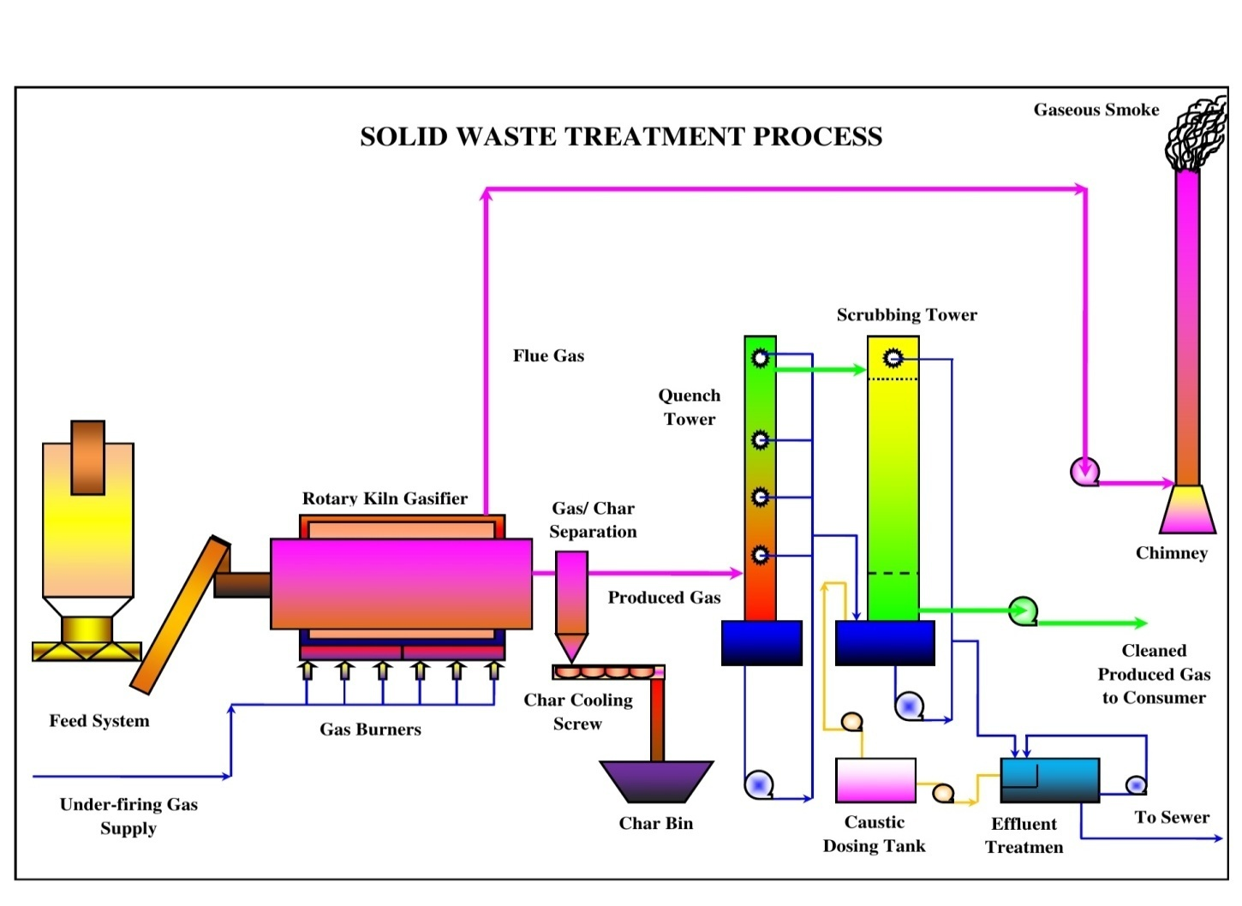

Figure 9: Pyrolysis – Method in Compacted and Discarded Aquatic – Water Handling Performance.

Pyrolysis – Process Technique: – Pyrolysis – Method is demarcated as warm air deprivation of unwanted relationships aquatic – water or compacted – hard in nonappearance of mid – air to yield carbonize – char materials, pyrolysis – processing lubricants e.g., adaptation of firewood to charcoal – carbonize is likewise distinct by way of vicious extraction of leftover in nonexistence of nascent oxygen – gas [18]. Peripheral basis of temperature is engaged in the Pyrolysis – Process Technique, for the reason that maximum carbon – based constituents are updraft unbalanced manners as be able to yield – upon central heating procedure trendy with an oxygen free air – environment remain fragmented over amalgamation of warm air found to be furious with cracking – sound and condensation – process responses obsessed by vaporous, liquefied and compacted segment state.

- Burning practice system;
- Compaction – practice system;
- Pyrolysis – practice system;
- Gasification – practice system;
- Composting - practice system.

Proper Concrete Discarded Material Treatment Practices: Appropriate and accurate technique ought to be implemented aimed at organization of compacted leftover discarding materials of topsoil. Engineering trashes may be preserved materially, bio – chemically and geographically up until found to be not as much of perilous. Acid and basic trashes ought to be foremost counterbalanced; unsolvable substantial matters, uncertainty decomposable ought to be permissible to reduce beneath well – ordered circumstances formerly being predisposed – off as hooked on topsoil. Preceding option, novel parts meant for storing of perilous leftover ought to be examined like bottomless – well vaccination method and additional protected land – fills. Concealing discarded sites located far – away since domestic zones is very humblest and furthermost extensively recycled method of compacted rock – solid discarded materials organization practice. Ecological and artistic thoughts necessity be engaged keenly on contemplation earlier choosing discarding location’s topsoil ailment and excellence. Burning of additional trashes is luxurious and leave enormous remainder and enhances to air – environment, water – environment and soil - environment by way of chief contaminant {including carbon soot particles of materials like volatile organic compounds (VOC) substances and ingredients}. Pyrolysis – Method or Procedure remains progression of incineration in the nonappearance of nascent – oxygen or quantifiable matters overcooked underneath organized atmospheric – environment of nascent – oxygen as Compacted Discarded Treatment Pyrolysis – Practice exposed in Figure 10. This process is substitute to ignition and vapor and liquefied substances therefore achieved may be recycled as gasolines byproduct. Pyrolysis – Method or Procedure of carbon generated trashes alike wood, coconut waste, palm leftover, corn – combs, wheat – pod, cashew – shell, rice – husk, paddy – straw, barley – pod, maize – husk and saw – dust, produces carbonaceous – charcoal laterally through yields corresponding asphalt, methyl – alcohol, acetic – acid, acetone – complex and fuel – gases etc. [19].

Figure 10: Solid Waste Handling Pyrolysis Technique OR Scheme.

Atmospheric – Environs Model: Ecological, environmental, biological are communal sketches of revision province of scheme site be present constructed on subordinate information investigation of Physio – graphic, Topological – Quality, Climatic – Conditions, Water – Quality, Biological – processes are the framework of township or district. Study has been amalgamated concerning manure handling platforms (MHP) mutually hypothetically and theoretically applied specifically for regions/ localities for waste materials handling process under the construction work site or camp. Employed prototypical category of manure handling platforms (MHP) or foremost theme material have been pragmatic now at many towns/ regions/ locality consequently this plays substantial character on large scale aimed at individuals and traditional sophistication about civilization system is publicized in Figure 11. Vegetation and wildlife documented in revision for commercial places remain universally originated and even – not exact to region owing to insufficiency of forestry explicit revision area.

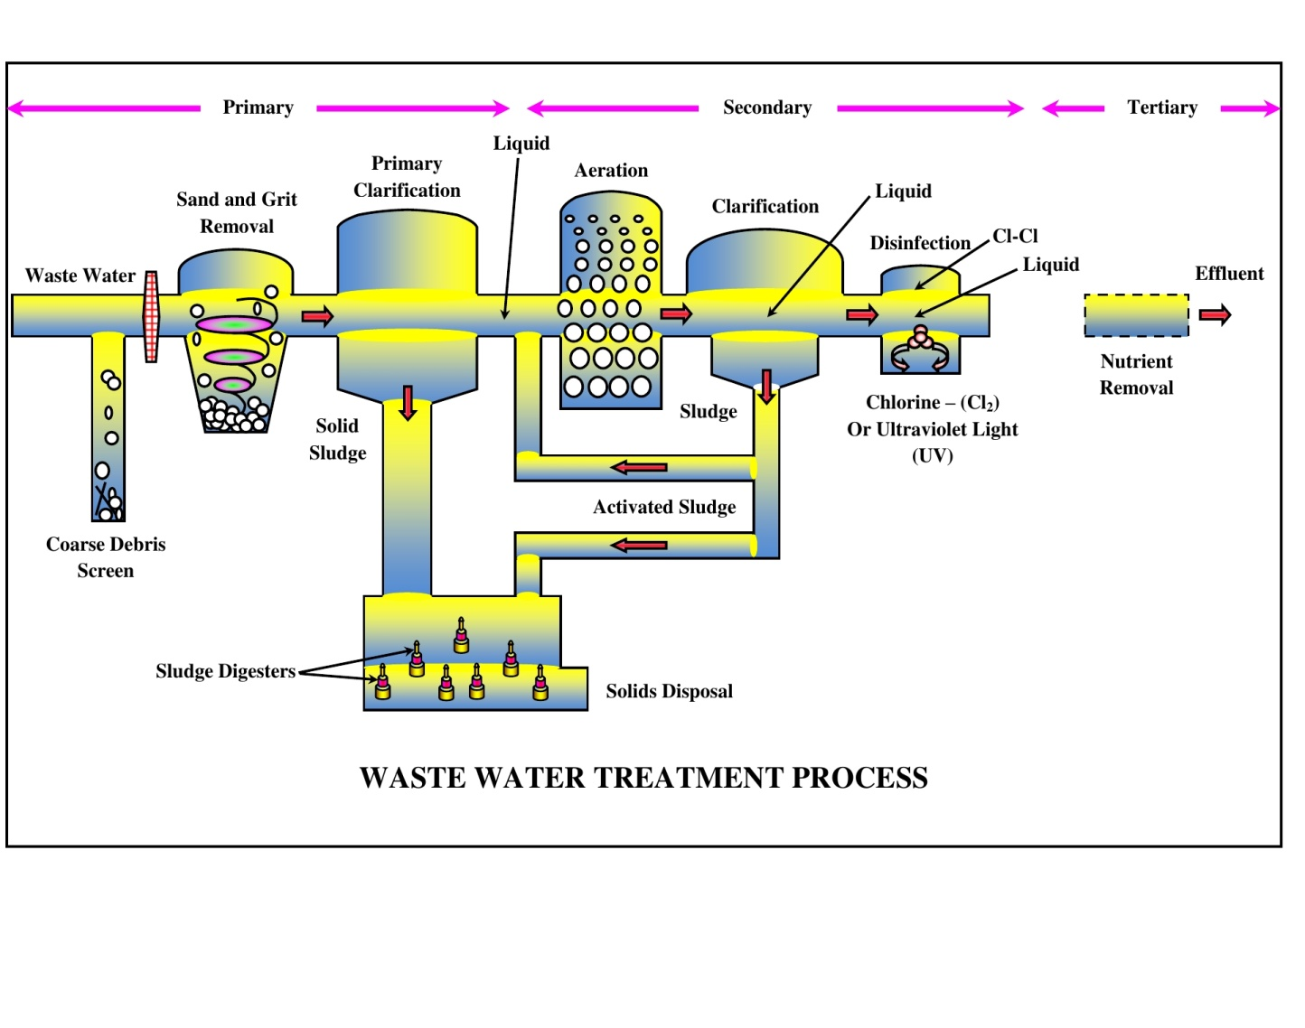

Figure 11: Manure Handling Platforms (MHP) of Waste – Water Design Practices.

ENVIRONMENTAL MONITORING PLAN AND COST – {Kurkuti – Ghamsali – Niti Highway in Uttarakhand State}: Constructed on ground investigation the information obtainable on or after subordinate analysis foundations, and it may be decided that scheme motivation would not devise noteworthy deleterious ecological influences. Subject matters of concerned scheme are well – organised throughout period of erection of circumvents, realignments, bridges, dams and land – acquisition of private – land and forestry terrestrial zones etc. Appropriate ecological supervision platforms (ESPs) amenability wants to be as safeguarded policy matter [20]. Subject’s matters interrelated to land – living procurement resettlement have to be assessed and satisfactory reimbursement has to be recommended in reserve apportionment package (RAP) manuscript bureaucracies. The Ecological Extenuation and Checking Supplies remain specified in Table 14.

Table 14: Ecological Extenuation and Checking Supplies.

Ecological Specifics | Projected Amount (in ₹) | Entire Price (in ₹ Lakhs)
Ecological Checking throughout Erection and Operation Stage | Inflammation Amount | 5.0 – 6.0
Ecological Preparation Agendas | Inflammation Amount | 2.0 – 3.0
Cultivated Area of 14,150 Saplings Including Preservation Price Aimed at 3 Years | ₹ 1,000 for Each Sapling Counting Preservation | 260
Aquatic – Water Scattering intended in lieu of Dirt Discharge Conquest | 80,000 – 90,000 for Each Km | 54.4 – 55.4
Solid Noise Barrier Installation by Trees in Places | Inflammation Amount | -------
Improvement of Aquatic – Water Forms Bases and Assets | Amount of ₹ 1.0 Lakh Collectively | -------
Security Cryptograms and Necessities next to Diverse Sites/ Places/ Areas | ------- | Providing in Municipal as well as Public Working Agreements
Price Towards Comprised in Civil – Manufacturing | ------- | -------
Altogether Passageways OR Circumvents/ Transportations/ Techniques | Encompassed in Civil Works | -------
Dust Emission Suppression by Watering | Incidental to Effort through Servicer | -------
Ecological Actions at Workers’ Camps throughout Location Visit | Incidental to Effort through Servicer | -------
Vegetation Turf at Slopes along Roadsides/ Roadways | Municipal or Civil Public Workings | -------
Operation Phase
Environmental Monitoring and Evaluation Plans | ------- | ₹ 1.0 for Each per Year
Sapling Conservation and Observing Strategies | Comprised Overhead | -------
Preparation for Separation; Extenuation and Observations etc. | ------- | ₹ 2.0 for Each per Year
Highway Preservation Price not at All Deliberated as For Each Unambiguous Aims - Goals OR Planned Effort | ------- | -------
Deputize Entire Amount | Aimed at Agreement Retro = (3.0 × 3) Years | Total 9 Designed for 3 on Yearly Basis
Entire Amount l | ₹ 27,00000/- Twenty Seven Lakhs Only | ₹ 27,00000/- Twenty Seven Lakhs Only
Outstanding Entire Amount | ------- | ₹ 425.40 Lakhs Rupees Only

Grounded on ecological – conservational valuation plus reviews or else appointments to Kurkuti – Ghamsali – Niti Highway to establish, construct, build and accompanied on behalf of scheme, related prospective or potential opposing ecological influences may be alleviated to satisfactory/ reasonable equal by sufficient application of events/ approaches/ habits/ procedures by way of specified in ecological influence valuation (EIV) Statement with Chapters [21]. Satisfactory supplies has remained completed to shelter the ecological – environment extenuation and observing necessities (counting a forestation price), furthermore it is estimated to be around ₹ 4.25 Crores or ₹ 425.40 Lakhs Rupees Only.

- RESULTS AND DISCUSSIONS

Result analysis from numerous study areas as per research initiatives taken place to confirms the benefits of confined aggregate within the civil construction engineering system verses unconfined aggregate for Kurkuti – Ghamsali – Niti Roads’ network. Reduces thickness and weight of structural support element by 50% or more allows subgrade material to withstand more than 10 time the number of cyclic – load applications before accumulating the same amount of everlasting refraction. Provides over 30% stress reduction when supporting aggregate under the pavement have been studied under civil engineering road construction work comes across the challenges that has to be faced for implementing the system. The advantages and disadvantages of the civil engineering in road construction there are two major challenges were pavement drainage and subgrade strength system, strata proposed along with supported pavement section, which shows that the civil engineering materials can be used as reinforcement, pavement, which can unquestionably improve by providing civil engineering network at one – third to the base of the pavement. Civil engineering also helps in the less permanent displacement in the subgrade layer by distributing the traffic load over a large capacity of the subgrade. Approximately half of the base reduction from civil engineering reinforcement by interlocking is being actually taken place. Design result of 20% to 40% thickness reduction is possible by civil engineering network in pavement design, grater thickness reduction stronger subgrade material.

Cleaner/ greener environmental and civil engineering technologies will be fruitful in operational design models and methodologies. The climate – friendly technologies, meteorological climatic aviation conditions not only will be helpful for civil engineering construction road network. Aviation/ weather meteorological challenges/ events may be used to study geographical information system (GIS) and remote sensing (RS) technology (Stereo Photogrammetric) not only in plan terrains, but also for hill terrains too for civil engineering construction work. The environmental sustainability enhancements, environmental management practices, civil road highways construction engineering and work – life cycle are the standard parameters for more significant and valuable studies in civil engineering road highways construction network program etc. In case of any civil engineering construction work done for Kurkuti – Ghamsali – Niti Roads’ network to hand remain 2 straightforward standards’ that has to be shadowed, initially construction ought to be harmless in contradiction of somewhat category of disappointment also additional stands as construction ought to be inexpensive as extreme as conceivable. Whenever construction remains erected for finished moveable or feeble topsoil becomes actual problematic to monitor such straightforward principles’ and deprived topsoil disorder typically with aim behindhand as nonexistence of asset and accompanying de – formability. Un – paved highway maintenance and strengthening by means of 3D – techniques imprisonment schemes steadies substantial of highway subgrade, substitute similar partial – inflexible lump, masses remain dispersed recently plummeting subgrade interaction stresses and minimalizing distortions and reimbursement. Topsoil maintenance through civil engineering highway, road erection, progresses consignment dissemination physiognomies taking place at cemented and un – paved exteriors. Experimental usage with geographical information system (GIS) and remote sensing (RS) technology (Stereo Photogrammetric) in road construction work is to be carried out at by non – government Organisation at Kurkuti – Ghamsali – Niti Roads. The model has prepared for road pavement construction using civil engineering applications and approaches on weak soil filled with concrete. The results are compared with road pavement without it with reference to cost, material required etc. The result shows the use of civil engineering methodologies as discussed above with applications in road pavement is for Research and Innovation program, which seems to be very economical as compared to concrete constructed and water bound macadam (WBM) roads’ network in civil construction of highway roads in engineering network.

- CONCLUSIONS

Remote Sensing (RS) Technology (Stereo Photogrammetric) OR Geographical Information System (GIS): Has been proved to be the extremely fastest method of carrying out the topographical survey within the hilly terrain areas, thus considering the same advantages the RS technology has been used for Kurkuti – Ghamsali – Niti Road to establish, construct, build as major road highways’ network projects’ good civil engineering (GCE) practices:

- The overall investigation intended to formulate custom of superior categories of un – ordinary ingredients through concluding impartial of declining price of pavement and preservation, custody exceptional collective material aimed at lengthiest retro of interval and diminishing terrestrial interplanetary obligatory on behalf of terrestrial substantial of degradable contaminants emissions’ loads {e.g., in the form of Black Carbon Soot Particles OR Black Carbon OR volatile organic compounds (VOC) from various kinds of line/ area and point sources/ resources} [22]. Accomplish the goal, with almost 5%age upto 15%age to each category of leftover materials like poly – propylene and polyester – constituent remain use in bitumen adapting method. Extraordinary absorptive aggregate and marble fillers were used in mixes preparation instead of ordering materials such as normal absorptive – aggregate and sandstone plaster.
- These achieved consequences presented as entirely such categories of unwanted polymers – constituent and compacted ingredients use in revision zones are appropriate in highway pavement and erection accomplishments. Combinations obey within values – principles and devise abridged temperature – rise vulnerability. As the greatest modernizer remained poly – propylene leftover material and polyester – constituent leftover stood in actual very hard. This combination may be in use as base – course or additional drive in slight variety of erection and civic engineering effort [23]. Even though the areas are of very complex geography and terrain, the RS technology was able to provide highly fastest and reliable DEM – Digital Elevation Model, Topographical features and base data to prepare such complex geography of road projects.
- In the project, 50 cm Very High Resolution Multispectral Satellite Imagery (World View – 2) from Digital Globe – USA has been used precisely. This imagery was procured through National Remote Sensing Agency – INDIA. The processing of the above imagery was undertaken in software’s such as SOCETSET, ERDAS, and Global Mapped respectively. After satellite image processing the products delivered are DTM/ DEM, 3D – Topographical Features, Ortho – photo, which has further been used in finalization of road alignment as per IRC: standard guidelines has been followed constantly [24].
- The products from RS has also been played a very critical role in identifying the water bodies crossing the alignments in order to provide cross drainage works to cater for the runoff [25]. Details of the structures for the same are mentioned above in project details. Examination surveys entire amount of contamination below regulator (CBR) next to 2 sites takes or crisscrossed the verge boundary (under 15,000 PCU) project facility capacity on behalf of 2 way highways through cemented shoulder – formation by way of IRC: typical strategies drive which may be pursued trendy yearly basis 2041 [26].
- As per projected highway is not solitary significant transportation connection on behalf of enrooted inhabitations contained by Uttarakhand State – run, nonetheless having imperative regional connections. These current highway takes elasticities who is having geometrics – parameters which doesn’t imitate to Indian road congress (IRC) moral – values willpower certainly want to be better by wealth of realignments and reconstruction accomplishments [27]. Hence highway permits concluded stretch expansion next to sites, wherever transportable haste don’t encounter nationwide road values, henceforth circumvents has to be planned on behalf of realignments and reconstruction accomplishments. Topsoil circumstances laterally for proposed highway remain usually decent and erection ingredients similar topsoil along with aggregate – materials are obtainable proximate zone of national.

REFERENCES

[1] | Anthes, R. A. & Ray, P. S. (1986). The general question of predictability. Mesoscale Meteorology and Forecasting, Ed., Amer. Meteor. Soc., 636-656.
[2] | Christopher, B., & Holtz, R. (2017). Geotextile Engineering Manual US Federal Highway. Administration, Washington, D.C., Report No. FHWA-TS-86/ 2031985,
[3] | Collins, W. D., & Coauthors, (2006). The formulation and atmospheric simulation of the Community Atmosphere Model Version 3 (CAM3). J. Climate, 19, 2144-2161.
[4] | Crozier, J. M. (1997). The climate – landslide couple: a southern hemisphere perspective, Rapid mass movement as a source of climatic evidence for the Holocene, Gustav Fischer Verlag, 333-354.
[5] | Dahal, R. K., & Hasegwa, S. (2008). Reprehensive Rainfall thresholds for landslide in Nepal Himalaya, Geomorphology, 100 (3-4), 429-433.
[6] | Elachi, C., & Van Zyl, J. (2006). Introduction to the Physics and Techniques of Remote Sensing. 2nd edn. Hoboken, New Jersey: Wiley-Interscience.
[7] | Farr, T. G., Rosen, P. A., & Caro, E., et al. (2007). The Shuttle Radar Topography Mission. Reviews of Geophysics 45, RG2004.
[8] | Feynman, R. P., Leighton, R. B., & Sands, M. (2005). The Feynman Lectures on Physics. 2nd edn. 3 Vols.
[9] | Hausman, J., & Zlotnicki, V. (2010). Sea state bias in radar altimetry revisited. Marine Geodesy 33, 336-347.
[10] | Hirschberg, P. (1988). The saline flow into the Atlantic. M.S. thesis, Dept. of Oceanographic Studies, The Pennsylvania State University, 207.
[11] | Jol, H. M. (2009). Ground Penetrating Radar: Theory and Applications. Amsterdam: Elsevier.
[12] | Kanamitsu, M., Ebisuzaki, W., Woollen, J., Yang, S. K., Hnilo, J., Fiorino, J. M., & Potter, G. L. (2002). NCEP-DOE AMIP-II Reanalysis (R-2). Bull. Amer. Meteor. Soc., 83, 1631-1643.
[13] | Knutti, R. (2014). IPCC Working Group I AR5 snapshot: The rcp85 experiment. DKRZ World Data Center for Climate, accessed on 14th October 2014.
[14] | Kumar Gunjan, Sahoo, G. & Tiwari, R. K. (2012). Identity Management in Cloud Computing-A Review, International Journal of Engineering Research & Technology, Vol. 1 (4).
[15] | Longair, M. S. (2003). Theoretical Concepts in Physics. 2nd edn. Cambridge: in Cambridge University Press.
[16] | Murad Al Qurishee (2017). Application of Geoweb in pavement Design. IRJET (VOL4) 7 July 2017.
[17] | Pavlis, N. K., Holmes, S. A., Kenyon, S. C., & Factor, J. K. (2008). An Earth gravitational model to degree 2160: EGM2008. EGU General Assembly, Vienna.
[18] | Pokhare Sanat K. (2016). Experimental evaluation of geoweb reinforced base under repeated loading methods, IJPRT, 9 September 2016, 1409-1416.
[19] | Rajesh Kumar Tiwari & Sahoo, G. (2011). A Novel Steganographic Methodology for High Capacity Data Hiding in Executable Files, International Journal of Internet Technology and Secured Transactions, 3 (2) 210-222.
[20] | Rayner, N. A., Parker, D. E., Horton, B., Folland, C. K., Alexander, L. V., Rowell, D. P., Kent, E. C., & Kaplan, A. (2003). Global analyses of sea surface temperature, sea ice, and night marine air temperature since the late nineteenth century. J. Geophys. Res., 108, 4407.
[21] | Skamarock, W. C., & Coauthors, (2008). A description of the Advanced Research WRF Version 3. NCAR Tech. Note NCAR/TN-475+STR, 113.
[22] | Tiwari Rajesh Kumar & Sahoo, G. (2012). Data Hiding in Microsoft Word File, International Journal of Information and Computer Security, Volume 4 Issue 3.
[23] | Wallace, J. M., & Hobbs, P. V. (1977). Atmospheric Science: An Introductory Survey. Academic Press, 350.
[24] | White, I. D., Mottershead, D. N. & Harrison, J. J. (1996). Environmental Systems, London: Chapman and Hall.
[25] | Wieczorek, F. G. (1996). Landslide triggering mechanisms, National Research Council, 247 (76-79).
[26] | Zeljko, A. & Sanja, D. J. (2010). Landslide risk increasing caused by highway construction, Taiei: International Research Society INTERPRAEVENT, 333-343.
[27] | Zhang, Y. (2011). Mean global and regional distributions of MOPITT carbon monoxide during 2000-2009 and during ENSO. Atmospheric Environment 45 (6), 1347-1358.

