INSIGHT INTO ALZHEIMER'S DISEASE DIAGNOSIS AND PROGRESSION

Mumtaz*
Department of Pharmacology,
School of Pharmaceutical Education and Research
Jamia Hamdard, New Delhi 110062, India
Email address: - mk5590348@gmail.com

Mohd Humair Ali*
Department of Pharmaceutics,
School of Pharmaceutical Education and Research
Jamia Hamdard, New Delhi 110062, India
Email address: - humair1997@gmail.com

Princi
Department of Botany,
School of Chemical and Life Sciences,
Jamia Hamdard, New Delhi 110062, India
Email address: - princisharma984@gmail.com

Shelly Sinha
Department of Botany,
Rabindra Mahavidyalaya,
Champadanga, Hooghly
(W.B)-712401, India
Email address: - shellysoham@gmail.com

Dr. Mohammad Ahmed khan
Department of Pharmacology,
School of Pharmaceutical Education and Research
Jamia Hamdard, New Delhi 110062, India
Email address: - drm.ahmedkhan@jamiahamdard.ac.in

*These authors have contributed equally to this chapter

ABSTRACT

Alzheimer's disease (AD) is a neurological ailment that causes cognitive decline and memory loss. Early and precise diagnosis of Alzheimer's disease is crucial for prompt intervention and better patient outcomes. Fluid-based biomarkers have emerged as useful tools for studying AD pathophysiology, assisting in early diagnosis, forecasting disease progression, and evaluating therapy success in recent years. This chapter presents an in-depth examination of fluid-based biomarkers in AD with an emphasis on cerebrospinal fluid (CSF), blood, and salivary indicators. We cover the most recent research findings on these biomarkers' diagnostic and prognostic usefulness, their potential as disease progression monitors, and their utility in assessing therapy response. The chapter focuses on the constraints and prospects of using fluid-based biomarkers to promote precise diagnosis of AD.

Keywords: Alzheimer's disease, Fluid biomarkers, Cerebrospinal fluid

- INTRODUCTION

AD is a complicated neurodegenerative condition of the brain that causes cognitive and behavioral symptoms. It is distinguished by the formation in the brain of two aberrant protein deposits: beta-amyloid plaques and tau tangles. Tau protein, which is normally found in healthy neurons, suffers aberrant modifications, forming twisted filaments that clump together to create tau tangles [1]. These tangles interfere with neuron communication and contribute to cell malfunction and death. In contrast, beta-amyloid plaques are aberrant deposits of beta-amyloid protein fragments that form between nerve cells [2]. These plaques disrupt neuronal function and are a defining feature of AD. The macroscopic pathology of AD is characterized by a considerable reduction in cortical size, with particularly noticeable abnormalities in the medial cortex [1], [3]. Affected brain regions show symptoms of inflammation, granulovacuolar degeneration, and the presence of peculiar structures known as Hirano bodies under a microscope. AD is a serious global health issue, affecting around 40 million people globally, and is expected to grow every 20 years until 2050 [4], [5]. In the United States, around 6 million people aged 65 and older have AD, with an estimated 500,000 new cases each year. The global prevalence of dementia among those aged 60 and up ranges from 2% to 8.5% [5]. Despite substantial studies, effective Alzheimer's treatments remain elusive. One of the most difficult issues in AD research is the early and precise diagnosis of the condition because therapies are more likely to be beneficial if started early, while neuropathological alterations are modest [6]. Fluid-based biomarkers, such as CSF markers, blood-based markers, and developing salivary indicators, have the potential to improve AD understanding, aid in early diagnosis, monitor disease progression, and evaluate treatments. These biomarkers provide non-invasive and accessible methods for evaluating disease-related changes [7]. This chapter seeks to provide a comprehensive review of significant fluid-based biomarkers in AD and investigate their roles in early diagnosis, disease monitoring, and therapy evaluation, as well as discuss obstacles and potential in improving precision in treatment [4].

- BIOMARKER

Biomarkers are quantifiable compounds or indications present in biological samples like blood, urine, or tissue that can provide information about a biological process, condition, or illness [8]. A biomarker could be molecules, proteins, genetic material, and imaging features. Biomarkers have a wide range of uses in disease diagnosis, particularly in disease identification, characterization, and monitoring [6]. Biomarkers play an important role in clinical settings by assisting healthcare practitioners in making accurate and timely diagnoses. They give objective and quantitative measurements that aid in the differentiation of distinct diseases or subtypes, the assessment of disease severity, and the prediction of therapy response [6], [8]. Biomarkers allow for earlier disease detection, guiding appropriate therapeutic actions, and evaluating therapy efficacy. Their significance stems from their ability to increase diagnostic accuracy, improve patient care, and, ultimately, improve clinical results [8].

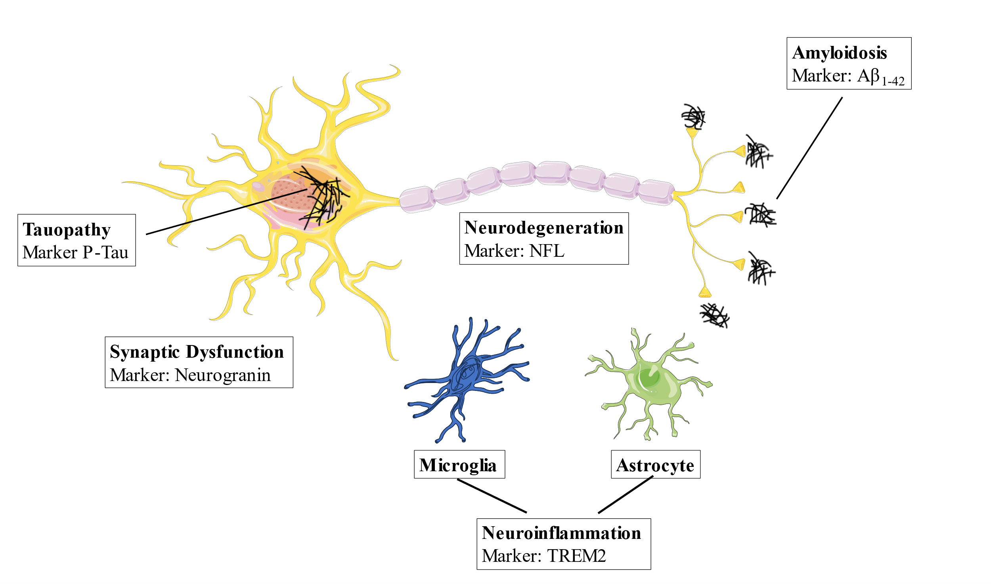

Fig1. The histopathological changes in AD. Senile plaques are composed of aggregated Aβ peptide, while neurofibrillary tangles consist of fibrillar deposits of p-Tau. neuroinflammation, synaptic dysfunction, and neurodegeneration.

- FUNCTIONS OF BIOMARKERS

Biomarkers play an essential role in medical research and clinical practice. They are employed in disease diagnostics, assisting healthcare experts in determining whether a specific disease or condition exists in an individual [6]. Biomarkers give useful diagnostic information, allowing for prompt and accurate diagnosis. Biomarkers influence disease prognosis. They can provide information about the likely course and prognosis of an illness, such as disease progression, severity, and responsiveness to treatment [8]. This information aids in therapy planning and patient management. Biomarkers play an important role in treatment selection and monitoring. They aid in the selection of the best treatment for a specific patient based on their biomarker profile. Biomarkers also help monitor the effectiveness of the chosen treatment, allowing adjustments to be made if needed [6], [8]. Biomarkers are essential in the field of therapeutic development. They aid in the identification of potential pharmacological targets, the assessment of drug safety and effectiveness, and the monitoring of treatment effects during clinical trials [9]. Biomarkers are extremely important in the development of new therapies and medications. Biomarkers are also useful for risk assessment, as they provide information about a person's likelihood of getting a specific disease or condition. This knowledge aids in the implementation of risk-mitigation measures and early intervention initiatives. Biomarkers, in general, serve an important role in improving healthcare outcomes and promoting medical research [6].

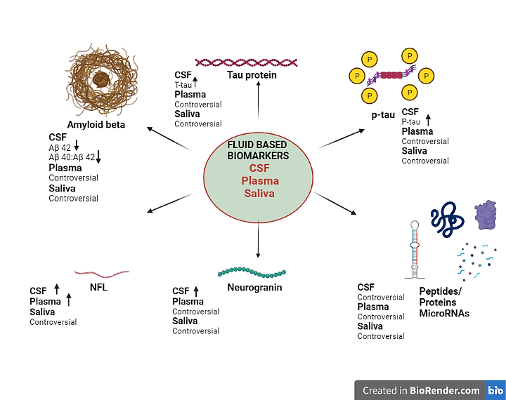

Fig 2. It shows the ATN (Amyloid, tau, neuroinflammation) system of classification of the biomarkers

- FLUID BASED BIOMARKERS

AD is an advancing neurodegenerative condition distinguished by a gradual deterioration of cognitive function and the loss of memory [10]. The timely identification and precise diagnosis of AD are crucial to facilitate prompt intervention and enhance patient outcomes. In recent times, there has been a growing interest in the utilization of fluid-based biomarkers as potential diagnostic aids for AD [11]. Fluid-based biomarkers, including CSF markers, blood-based markers, and arising salivary markers, have become increasingly important in the diagnosis of AD. In the context of CSF, certain biomarkers such as Aβ42, t-tau, and phosphorylated tau p-tau exhibit modified concentrations among individuals with AD, thereby facilitating the distinction between AD and other types of dementia [12]. Blood-based biomarkers provide a readily available alternative for the diagnosis of AD, though with potentially lower sensitivity compared to CSF markers. In recent times, scholars have initiated investigations into salivary `alterations in the central nervous system [13]. Although still in the preliminary stages of the investigation, salivary biomarkers such as Aβ42 and p-tau exhibit potential for future diagnostic applications in AD. In general, biomarkers based on fluid samples offer novel opportunities for early and precise diagnosis, potentially resulting in improved approaches for treatment and the overall management of this neurodegenerative disorder [14].

- CSF BIOMARKERS

- CSF t- tau and p-tau

The identification of biomarkers, namely t-tau and p-tau, in CSF provides significant implications for the diagnosis and comprehension of AD [15], [16]. Elevated levels of t-tau have been regularly seen in individuals with MCI and those diagnosed with AD, in comparison to individuals who do not exhibit cognitive impairments [17]. The detection of this increase is possible even during the initial phases of AD and exhibits a very consistent pattern over a period of time. Significantly, the levels of t-tau exhibit a strong correlation with memory function, rendering it a significant indicator in the evaluation of cognitive decline [12], [18]

In contrast, it has been observed that p-tau, a distinct variant of the tau protein, has markedly elevated concentrations in CSF among individuals diagnosed with AD in comparison to those who are deemed healthy [15]. The compelling aspect of p-tau lies in its robust correlation with the fundamental pathogenic mechanisms of AD, including the development of NFTs within the brain. In contrast to t-tau, which serves as an indicator of axonal damage, p-tau is more closely associated with the characteristic aspects of AD progression [19], [20]. The association between p-tau and the pathophysiology of AD renders it a more dependable indicator for the early detection of the condition [14]

It is noteworthy that recent research has demonstrated that p-tau exhibits a superior discriminatory ability in distinguishing between individuals with AD and those without the condition, compared to t-tau, when evaluating diagnostic accuracy [14], [21] Consequently, the utilization of CSF biomarkers, such as Aβ42 (associated with amyloid plaques), t-tau, and p-tau, presents a robust diagnostic instrument. The aforementioned combination demonstrates a sensitivity rate of 95% and a specificity rate of 83% in its ability to predict the onset of AD [22]–[24] Through the integration of these biomarkers, researchers and physicians are equipped with a comprehensive and precise set of tools to diagnose, monitor, and comprehend the advancement of AD [13]

- Aβ Peptides

Aβ peptides play a critical role as CSF biomarkers in AD research, specifically indicating the presence of amyloid plaque accumulation in the brain [15]. Considerable research has been conducted on CSF Aβ peptides, specifically Aβ42, Aβ40, and the Aβ42/Aβ40 ratio, to explore their potential as biomarkers for AD [15], [24]. Aβ peptides are generated through the proteolytic processing of the APP and constitute the principal constituents of amyloid plaques. Numerous studies have consistently provided evidence that a reduction in CSF levels of Aβ42 and an elevation in the Aβ42/Aβ40 ratio are closely linked to the accumulation of amyloid plaques in the brain, thus serving as strong indicators of AD pathology [12]. Moreover, the integration of CSF Aβ42 measurements with tau biomarkers has demonstrated enhanced diagnostic precision, particularly during the initial phases of AD[25]

- Neurogranin (Ng)

Ng is a protein located in the postsynaptic region of neurons, which is involved in the modulation of synaptic activity, plasticity, and long-term potentiation (LTP) through the regulation of calcium-mediated signaling pathways [26]. Synaptic impairment makes neurogranin a viable CSF biomarker for AD. Ng in the CSF indicates synaptic loss, making it a useful diagnostic for disease severity. It distinguishes AD from other dementias and predicts moderate cognitive MCI to AD [27]. Ng exhibits a strong association with synaptic loss in individuals diagnosed with AD and its expression is predominantly observed in the cortex, hippocampus, and amygdala which are particularly susceptible to AD-related pathology. The levels of neurogranin in CSF exhibit an elevation in people diagnosed with MCI and AD in comparison to normal individuals [28]. Combining Ng with established biomarkers like Aβ42, t-Tau, and p-tau improves diagnostic accuracy and sensitivity, helping diagnose early AD and measure therapy response [26], [27]. Ng application is difficult since measurement needs sophisticated laboratory methods, limiting its clinical application. Defining normal and abnormal Ng levels is difficult due to the lack of established cutoff values and inter-laboratory heterogeneity.

- BLOOD-BASED BIOMARKERS

Blood-based biomarkers present a potentially fruitful path for the identification of AD. In contrast to the study of CSF, blood tests provide the advantages of reproducibility, convenience, and reduced invasiveness, rendering them appropriate for extensive early identification and screening initiatives [20]. While blood-based biomarkers are generally considered to be less accurate than CSF indicators, current research endeavors to enhance their sensitivity and specificity in diagnosing AD [22]. Prominent plasma proteins such as α2M, CFH, α1-antitrypsin, α1-antichymotrypsin, and Apolipoprotein A1 demonstrate modified expressions in individuals with AD in comparison to control subjects [29]. However, the existence of obstacles remains due to the utilization of diverse analytical techniques, variations in anticoagulant selection, and discrepancies in storage settings [30]. Extensive research has been conducted on plasma Aβ, a crucial constituent of cerebral plaques. The results of studies investigating the detection of plasma Aβ using enzyme-linked immunosorbent assay (ELISA) exhibit variability. Several studies have reported a modest elevation in Aβ42 or Aβ40 levels in patients with AD, however, other research has found no significant differences compared to control groups. It is worth noting that any alteration in the Aβ42/Aβ40 ratio may potentially serve as an indicator of AD risk [29].

Promisingly, a group of 18 plasma proteins effectively distinguished those with AD and anticipated the start of AD in those with MCI, suggesting the potential for preclinical diagnosis, but with the need for additional refinement [14], [25]. The integration of blood-based biomarkers with other methodologies has the potential to augment their precision and effectiveness in evaluating the risk and advancement of AD [25].

  - Neurofilament Light Chain (NfL)

NfL has emerged as a potentially valuable biomarker for AD research, as it has shown promise in detecting neurodegeneration and axonal damage using blood-based analysis. The presence of this substance in the bloodstream is indicative of the degeneration of neurons, facilitating the monitoring of the progression and severity of the sickness [31]. The non-invasive nature of NfL has the potential to increase disease management and assessment of therapy response in the context of AD, hence offering the possibility of improved diagnosis and patient outcomes [32], [33]. Studies suggest higher NfL levels in individuals with AD, and these levels are associated with cognitive decline in both Alzheimer's and other neurodegenerative diseases [34].

Plasma NFL may serve as a promising biomarker for cognitive decline. Although the potential of NfL is extensive, some problems need to be addressed [33]. These challenges include the standardization of measuring techniques across different laboratories. However, additional longitudinal research is required to confirm its predictive capacity for the progression of dementia in patients with MCI and AD [32], [34].

  - Plasma Aβ and Tau

Blood-based assays have the potential to serve as substitutes for CSF biomarkers, as they can detect plasma levels of Aβ42, pTau181, and NfL using ultra-sensitive single-molecule array (Simoa) tests [35]. AD patients can be distinguished through the measurement of the plasma Aβ42/Aβ40 ratio. However, it is important to note that the accuracy of this method is not as high as that of CSF testing [9]. There is a favorable association between blood t-tau levels and the likelihood of AD, indicating that blood t-tau levels can accurately predict tau-PET status across different cognitive stages [31], [36]. In the field of CSF analysis, the measurement of p-tau217 using the standard ELISA demonstrates superior performance compared to p-tau181 in predicting the status of Aβ and differentiating AD from other kinds of dementia [31]. Additionally, plasma p-tau231 shows promising accuracy in discriminating between individuals with AD and individuals with non-AD. It is worth mentioning that the autoptic investigation of individuals with AD have demonstrated a discernible rise in plasma p-tau231 concentration before the increase observed in p-tau181 [31], [33], [36].

- SALIVARY BIOMARKERS

Salivary biomarkers exhibit considerable potential for the detection of AD, albeit being in the nascent phases of development. Saliva, due to its non-invasive collection method and abundant presence of proteins, nucleic acids, and metabolites, presents itself as a promising diagnostic medium [37]. It is worth mentioning that persons with AD display discernible variations in salivary levels of Aβ peptide, tau protein, and microRNA in comparison to those who are in good condition. Elevated levels of tau and Aβ42 in saliva have been linked to the presence of amyloid deposition and cognitive deterioration in individuals with AD [38]. The simplicity of collecting saliva enables frequent monitoring and facilitates longitudinal research, hence assisting in the assessment of therapy responses. Salivary biomarkers have the potential to distinguish AD from other neurodegenerative disorders, hence enhancing the precision of diagnostic procedures [37], [39]. The identification, validation, and standardization of salivary biomarkers present significant challenges, necessitating careful consideration of potential confounding factors such as nutrition, medication usage, and mouth health. Notwithstanding these challenges, the use of salivary biomarkers in standard AD diagnosis and care has the potential to improve individualized therapies by utilizing indicators of amyloid cascade and axonal injury to gain valuable knowledge [37].

Studies examining the salivary ratio of p-tau to t-tau, levels of α-synuclein, and the neuroprotective mediator heme oxygenase-1 have yielded significant findings. However, the practical application of these findings in therapeutic settings has not been fully achieved at now (Ferrer et al., 2005).

- URINARY BIOMARKERS

Urine is a highly valuable biofluid that can be effectively employed as a viable source of biomarkers to diagnose neurodegenerative disorders [40]. Nevertheless, urine has traditionally been considered an unsuitable biomarker for neurodegenerative illnesses due to its anatomical distance from the CNS, which is a primary site of pathology for these diseases. This sets it apart from other biofluids such as CSF and plasma [40], [41]. Recent research has presented a counterargument to this prevailing belief, suggesting that urine may possess untapped potential when analyzed using metabolomic and proteomic methodologies. Although osteopontin, gelsolin, and insulin-like growth factor-binding protein 7 have been identified in the urine of individuals with AD in early studies, there is still a hurdle in obtaining the desired level of specificity and sensitivity [42]. It is worth mentioning that the hyperphosphorylation of tau, which plays a crucial role in the development of AD, has been detected in the urine exosomes of individuals affected by this condition [43]. The potential of technological developments in urine analysis to facilitate the identification of new biomarkers is significant, as it allows for the full characterization of RNA, gene, protein, and metabolite components [44]. Certain biomarkers, such as urine formaldehyde and 8-OHdG, exhibit a correlation with the severity of diseases, hence suggesting their potential as predictive indicators [44]. However, it is important to conduct independent validation to establish their reliability and accuracy. As scientific investigations progress, the previously overlooked potential of urine as a valuable reservoir of biomarkers for neurodegenerative diseases becomes more evident [42]–[44].

V. CONCLUSION

Over the last two decades, fluid-based biomarkers for AD have shown promise for early diagnosis, disease-specific therapy, and disease monitoring, even without disease-modifying medications. This progress shows the importance of fluid-based biomarkers like CSF, blood, and salivary indicators in AD research and treatment. These biomarkers have transformed our understanding of AD biology, enabling accurate and early diagnosis, disease progression tracking, and treatment evaluation. The combination of non-invasive, cost-effective blood analysis with biomarkers improves diagnosis accuracy and longitudinal biologic monitoring. Emerging non-amyloid CSF or blood biomarkers may be next-generation AD indicators, although they need more validation. Using blood-based biomarkers for clinical application could lead to advancements in diagnosis and therapy. Amyloid or tau-based techniques can improve diagnosis and lead to new treatments. These novel biomarkers help design tailored AD treatments and disease-modifying approaches. With improved analytical capabilities, biomarker research can drive more efficient clinical trials and optimize biomarker-guided techniques, resulting in their seamless incorporation into AD diagnosis and care in clinical practice. Future biomarker profiles, precision-guided medications, and a better knowledge of AD's complex terrain promise a new era in individualized AD therapy.

