**Innovations in irrigation automation for sustainable agriculture**

V K Sindhu

*Centre for Water Technology & Management* Department of Agronomy, Punjab Agricultural University, Ludhiana, India

vinay.sindhu@pau.edu

A S Brar

*Centre for Water Technology & Management* Department of Agronomy, Punjab Agricultural University, Ludhiana, India

braras@pau.edu

Norah Johal

*Centre for Water Technology & Management* Department of Agronomy, Punjab Agricultural University, Ludhiana, India

norah-cobsbot@pau.edu

Priyanka Sahoo

*Centre for Water Technology & Management* Department of Agronomy, Punjab Agricultural University, Ludhiana, India

priyankasahoo52@gmail.com

Harjeet Kaur

*Centre for Water Technology & Management*

Department of Agronomy, Punjab Agricultural

University, Ludhiana, India

[harjeet-bcm@pau.edu](mailto:harjeet-bcm@pau.edu)

ABSTRACT

Irrigation plays a critical role in global food security, with over 70% of water usage dedicated to irrigating crops. Developing countries heavily rely on irrigation, accounting for over 80% of freshwater withdrawals, and improving water use efficiency in these regions could significantly conserve water resources. With the world's population projected to increase, particularly in South Asia, where India alone will account for a substantial portion, the demand for irrigation water is expected to rise, emphasizing the need for sustainable practices to meet future food production needs while addressing the challenges posed by climate change. The implementation of automated irrigation systems holds promise in addressing various challenges associated with irrigation. While automated irrigation has been widely used in different water distribution systems, its adoption in flood irrigation systems has been limited. This chapter aims to assess the current state and advancements in automated irrigation for crops, including its components and technologies. Additionally, it identifies potential factors that may impede the widespread adoption of existing systems and highlights the need for additional features in automated irrigation systems to maximize water savings in commercial crop production. To fully realize the socio-economic and environmental paybacks of automation, further research is obligatory to determine optimal parameters for irrigation scheduling. Resolving the research and technical gaps could facilitate the extensive adoption of automated irrigation practices, leading to improved water use efficiency, crop productivity, profitability, reduced labor requirements, and minimized environmental impact.

Keywords—Efficient water use; Precision irrigation; Sensors; Smart irrigation systems; Water management

**I. INTRODUCTION**

Around the world, the largest share of water usage, accounting for 70%, is dedicated to irrigating crops, making irrigation the most significant consumer of freshwater. In developing countries, over 80% of freshwater withdrawals are allocated for irrigation purposes. Remarkably, irrigated agriculture, which occupies less than 20% of the cultivated land, manages to contribute 40% of the global food supply, underscoring the crucial role of irrigation in ensuring global food security [1]. According the UN report 2019, the global population is projected to reach 9.15 billion by 2050, up from the current 7.79 billion. South Asia will constitute significant portion (about 25%) of the world's population, with India alone accounting for about 18%. Consequently, the annual production of cereals, an important part of human diet, will need to be increased by 3 billion tons from the current 2.1 billion tons [2]. The impact of global climate change is anticipated to further escalate the demand for irrigation water due to increased variability in annual precipitation levels [3]. In developing regions, particularly in South-east Asia, irrigation systems play a vital role in food production. Asia, as a whole, accounts for more than 70% of the world's irrigated land, with China and India alone contributing to 60% of the total irrigated area. Studies indicate that India, in particular, utilizes approximately four times more water to produce a single unit of a major food crop compared to water usage in the USA and Europe. This highlights the potential for significant water conservation in the developing world by enhancing water use efficiency.

**A. Need for Irrigation Automation in Agriculture:**

In today's world, the agricultural sector faces numerous challenges that necessitate the adoption of automation in irrigation practices. Traditional methods of irrigation, such as flood irrigation or manual control systems, are often inefficient, resulting in water wastage and environmental degradation. By understanding the need for automation in agriculture, we can recognize the benefits it offers and the problems it aims to solve.

**a) Inefficient water use:** Conventional irrigation practices often lead to inefficient water use, with significant amounts of water being lost through runoff, evaporation, and deep percolation. This inefficiency is not only wasteful but also contributes to water scarcity issues, particularly in water-stressed regions.

**b) Environmental impacts:** Traditional irrigation methods can have adverse environmental effects, such as soil erosion, waterlogging, and the leaching of fertilizers and chemicals into water bodies. These impacts degrade soil quality, harm aquatic ecosystems, and contribute to water pollution.

**c) Increasing water demand:** The increasing demand for water, coupled with the scarcity of this vital resource, poses a significant challenge for agriculture. As the global population grows and urbanization expands, the competition for water resources intensifies. Therefore, efficient water management practices are essential to ensure sustainable agricultural production.

**d) Energy consumption:** Conventional irrigation systems often require significant human labor and energy inputs. The use of automated systems can reduce energy consumption by optimizing water delivery, minimizing pumping requirements, and utilizing renewable energy sources.

**B. Sustainable Agriculture and its Challenges:**

To understand the context in which irrigation automation operates, it is crucial to grasp the concept of sustainable agriculture and the challenges it addresses. Sustainable agriculture aims to meet present and future agricultural needs while preserving natural resources, supporting rural communities, and maintaining ecological balance.

**a)** **Conservation of natural resource:** Sustainable agriculture emphasizes the efficient use of resources, including water, soil, and energy. It seeks to minimize waste, reduce resource depletion, and promote long-term resource conservation.

**b)** **Food security and quality:** Sustainable agriculture aims to ensure long-term food security by promoting diverse and resilient food systems. It focuses on producing nutritious and safe food, reducing food waste, and improving access to food for all.

**c)** **Biodiversity and ecosystem services:** Sustainable agriculture recognizes the importance of biodiversity and ecosystem services in supporting agricultural productivity. It seeks to maintain ecological balance, protect wildlife habitats, and enhance pollination and natural pest control.

**d)** **Climate change resilience:** Agriculture is vulnerable to the impacts of climate change, such as droughts, floods, and changing weather patterns. Sustainable agriculture aims to enhance resilience and adaptability, ensuring that agricultural systems can withstand and recover from these challenges.

**e)** **Socio-economic considerations:** Sustainable agriculture recognizes the social and economic aspects of farming communities. It emphasizes fair labor practices, rural development, food security, and equitable access to resources, ensuring the well-being of farmers and rural populations.

Understanding an overview of sustainable agriculture and its challenges, we establish the broader framework in which irrigation automation plays a vital role. The integration of automation technologies in irrigation practices aligns with the objectives of sustainable agriculture by promoting efficient resource utilization, minimizing environmental impacts, and enhancing agricultural productivity in a sustainable manner.

**II. AGRICULTURE AND IRRIGATION PRACTICES: LIMITATIONS AND CHALLENGES**

**A. Water Resource Management** **Challenges in Agriculture**

Water serves as a vital component in agricultural production systems, playing multiple roles such as being a fundamental element in plant food synthesis and translocation. Additionally, water helps mitigate stress and enhances resilience against climatic risks. Approximately 97.5% of the Earth's water is saline, found in oceans and seas, while the remaining 2.5% is freshwater. The majority of freshwater is stored in glaciers and ice caps (68.7%), only a small fraction (0.3%) of freshwater is accessible as surface water in lakes, rivers, and swamps, while the rest is groundwater (30.1%) or atmospheric water vapor (0.001%). In South Asian countries, irrigated agriculture holds a significant portion of food grain production, highlighting the importance of water in ensuring agricultural productivity and food security. However, the disparity between the supply of water and the demand for it results in a state of water scarcity, which is recognized as one of the pressing global concerns [4]. The average water availability of any country or region is largely dependent on geological and hydro-meteorological factors. India receives an annual precipitation of approximately 3880 billion cubic metres (BCM) [5]. After accounting for evaporation, the average annual water resource in the basin, which includes over 20 major rivers and numerous tributaries, amounts to 1999.20 BCM. However, due to various constraints such as physiographic limitations, the usable annual surface water in the country is estimated to be 690 BCM. In addition to surface water, there is an estimated replenishable groundwater resource of 438 BCM, but considering natural discharge, the annual utilizable groundwater resource is 398 BCM [6]. Currently, the total water utilization stands at approximately 710 BCM, with agriculture, domestic use, industry, and other sectors demanding 557, 56, 43, and 54 BCM, respectively [7]. With the rapid increase in population, urbanization, industrial development, and inefficient irrigation practices, the demand for freshwater is continuously rising. The per capita availability of water in India has been declining, from 1820 m3 in 2001 to 1486 m3 in 2021, and it is projected to further reduce to 1367 m3 and 1228 m3 by 2031 and 2051, respectively. The total water demand is expected to reach 843 BCM by 2025 and 1180 BCM by 2050. Agriculture accounts for the largest share of water demand, followed by domestic and industrial sectors, which require 611, 62, and 67 BCM, respectively, by 2025, and 807, 111, and 81 BCM, respectively, by 2050. Furthermore, there is significant spatial variation in water availability. The latest assessment by the Central Groundwater Board of India reveals that out of 7,089 Development Blocks in the country, 1,006 are over-exploited, 260 are critical, 885 are semi-critical, and 158 are saline. [6]. The northwestern regions of the country, often considered the country's breadbasket due to their substantial agricultural output and farm incomes, are facing increasing challenges due to groundwater depletion.

Punjab, the largest contributor of foodgrains to the central pool, with just 1.5 per cent of the total geographical area of the India, have been contributing approximately 35-40 percent of wheat and 25-30 percent of rice to the central pool over the last decade. In the green revolution era, the reliable irrigation water supply led to increase in the acreage of input intensive crops and consequently rice-wheat cropping system emerged as the predominant system in the 1970s. Adverse effects of this change on natural resources and ago-ecology begun to realize in the mid-1980s. The cultivation of paddy crop is a major contributor to the over-stressed water resources in the region. Paddy requires a significant amount of irrigation water, ranging from 140 to 160 cm, primarily due to its high-water percolation rates in the state. Additionally, paddy is grown during the peak hot season when water evaporation rates are also high. Despite these factors, the area under paddy cultivation has increased nearly tenfold since the early 1970s, reaching over 31 lakh hectares. This expansion has also been accompanied by a simultaneous increase in the number of tubewells, rising from 70,000 in 1960-61 to about 14.82 lakh in 2019-20 [8]. Meanwhile, infrastructure for surface water irrigation was largely overlooked rather incentives were provided for groundwater withdrawal. Continuous decline of groundwater levels enforced farmers to drill deeper and deeper to tap older aquifers and resulted in a large-scale replacement of centrifugal pumps with submersible pumps which have greater energy needs for water extraction. As per recent report of Central Ground Water Board (2022), out of 153 assessment units of Punjab (150 blocks + 3 urban areas), 114 blocks and 3 urban areas are over-exploited, 04 blocks are critical, 15 blocks are semi-critical and only 17 blocks are in safe category. In fact, among the safe blocks, only 9 blocks adjoining three major dams in the sub-mountainous regions are truly safe whereas groundwater in remaining 8 blocks of the south-western districts is of poor quality and unfit for utilization. Agriculture is the most significant sector that constitutes major share (95%) of water demand in the state. Evidently, the groundwater is declining, power subsidies are mounting and canal irrigation system is deteriorating.

Water use in a region is determined by the demand and supply of water. Recent estimates regarding the annual water use and balance in Punjab are as follows: water demand - 66.12 BCM, billion cubic metres (Domestic and urban use- 2.41, Industrial- 1.13, Agricultural- 62.58 BCM); water availability- 53.06 BCM (Canals/Dams- 14.8, rainfall- 26.3, STP- 1.26, return flow- 10.7 BCM); water deficit/gap- 13.06 BCM. The canal water availability has remained almost static over the years, rather there has been some decline due to reduced surface water flow. Therefore, the actual water deficit of 13.0 BCM is met through over-exploitation of groundwater every year. Consequently, about 79% area of the state is over-exploited with the overall stage of groundwater extraction of 164.4%.

**B. Limitations of Conventional Irrigation Methods**

Irrigation is the artificial application of the water to the plant root zone to meet its moisture need for growth and development which cannot be fulfilled by the rainfall. Adequate water supply is crucial for optimal plant growth and development. In cases where rainfall is insufficient, irrigation becomes necessary to provide water to crops. Various irrigation methods, as depicted in Figure 1, can be employed to deliver water to plants. These methods are classified into traditional and modern techniques, based on their ability to conserve water, facilitate precise monitoring, scheduling, and control. The quantity of irrigation water required depends on the chosen irrigation system, plant water demand, and soil type. The selected irrigation method affects infiltration rate, evaporation rate, water absorption patterns, deep percolation and nutrient distribution within the soil. Traditional surface irrigation methods, as shown in Figure 1, involve applying and distributing water across the soil surface solely through gravity flow, without employing any sensing or control mechanisms.

The traditional surface irrigation method, considered the oldest and most widely used technique globally [9]. is characterized by the application of water directly to crops by allowing it to flow over the soil surface. This method, includes flood, furrow, border, check basin, wild flooding and manual watering, which are commonly employed by small-scale farmers. However, successful implementation of these methods relies on proper soil surface leveling to ensure even water distribution and prevent excessive drainage. Unfortunately, these traditional surface irrigation techniques have limited water-saving capabilities due to high water losses caused by evaporation and uncontrolled irrigation volumes. Traditional surface irrigation practices often result in excessive water supply to plants, leading to issues such as surface runoff, deep percolation, leaching, and reduced soil nutrient levels, ultimately impacting crop yields.

Flood irrigation is a traditional method commonly practiced in South Asia including India, despite its poor water use efficiency and transport of pesticides and nutrients to water sources. The water infiltrates into the soil and moves laterally to wet the entire root zone. This approach involves conveyance of water from the source which could be a tubewell or outlet of canal water distributary to the irrigating fields using either unlined or brick-lined channels, or underground cement, concrete, or high-density polyethylene (HDPE) pipes. When unlined channels are used for flood irrigation, conveyance losses tend to be higher compared to using lined channels or pipes. The effectiveness of flood irrigation is further influenced by factors such as field size and soil type. The primary water loss in flood irrigation occurs through leaching beyond the root zone. When fields are uneven, flood irrigation can result in temporary waterlogging in low-lying areas, negatively impacting the productivity of upland field crops like wheat, maize, and pulses. The adverse effects of waterlogging are more pronounced and prolonged in soils used for cultivating rice due to the formation of a compacted layer (hard pan) with low permeability at shallow depths. This hard pan formation is a consequence of the puddling process in rice fields and can have detrimental effects on the subsequent productivity of upland crops, such as wheat, following rice cultivation [10].

Furrow irrigation is commonly employed for cultivating row crops like vegetables, spring maize, cotton, and sunflower. In this method, small channels or furrows are created between crop rows. Water is released into these furrows, and it flows down the slope, wetting the soil and reaching the root zone. Furrow-irrigated raised beds (FIRB) are also being utilized to some extent for growing crops such as wheat, maize, and others. Across South Asia, multiple research studies have demonstrated significant reductions (ranging from 20% to 30%) in irrigation water usage through furrow irrigation methods in different cereal crops and cropping systems as compared to flat flood irrigation [11]. Border irrigation involves creating long, narrow strips or borders across the field. These borders are leveled and surrounded by low ridges to hold water. Water is applied at one end of the border, and it advances slowly, covering the entire border and infiltrating into the soil. Basin method is suitable for flat or gently sloping fields. Small basins are constructed around individual plants or groups of plants. Water is applied directly into these basins, allowing it to infiltrate and reach the root zone. Basin irrigation is commonly used for tree crops and orchards. Wild flooding is a simple form of flood irrigation where water is released directly from a natural source such as a river or stream. Fields are flooded by diverting water from the source onto the field. This method is mainly practiced in areas with abundant water supply.

These traditional methods of surface irrigation have been used for centuries and are still employed in many agricultural regions worldwide. However, modern irrigation techniques, such as sprinkler and drip irrigation, are becoming increasingly popular due to their efficiency in water use, better monitoring and control to achieve higher crop yield and precision irrigation.

**C. Micro Irrigation Systems: Progress and Prospects**

Conventional flood irrigation is especially wasteful, with over 55% of the water being wasted. As an alternative, it is recommended to adopt piped irrigation systems, which offer more efficient and targeted water delivery to crops, helping to conserve water and minimize environmental impacts. Micro irrigation systems, also known as drip irrigation or trickle irrigation, are irrigation methods that deliver water directly to the root zone of plants in small, precise quantities. These systems use a network of tubes or pipes with emitters or drippers spaced along them to provide water to individual plants or specific areas. The water is applied slowly and uniformly, allowing for efficient water use and reduced water loss through evaporation or runoff. Micro irrigation systems can be used in various agricultural, horticultural, and landscaping applications, providing targeted irrigation that minimizes water wastage and optimizes plant growth and productivity.

**Figure 1: Different methods of irrigation**

Drip irrigation systems offer numerous advantages compared to other irrigation methods. They provide water savings with high application efficiency, delivering water directly to the root zones of plants while minimizing losses due to evaporation, runoff, and percolation [12]. Drip irrigation has been associated with increased crop yield, improved produce quality, enhanced nutrient use efficiency, energy consumption savings, and reduced carbon footprints. Although most studies have focused on horticulture and vegetable crops, surface drip irrigation has been assessed and recommended for major cereal crops such as maize, wheat, and rice. Subsurface drip irrigation (SSDI) has emerged as a viable practice, minimizing water losses and providing targeted application of water and nutrients to the active root zone [12]. Subsurface drip irrigation (SSDI) systems offer advantages over surface drip irrigation by minimizing water losses through direct evaporation from the soil surface. These systems provide precise and targeted delivery of water and nutrients to the active root zone of plants, optimizing the utilization of farming inputs. In contrast to surface drip irrigation, SSDI significantly reduces water losses caused by evaporation from the soil surface. This targeted application of water and nutrients promotes improved water uptake and nutrient use efficiency. Furthermore, SSDI systems offer benefits such as reduced labor costs and environmental advantages compared to traditional flood irrigation methods. Overall, SSDI enables efficient resource management in agriculture and has demonstrated positive outcomes in terms of water conservation, nutrient optimization, cost savings, and environmental sustainability. Replacing flood irrigation with SSDI in rice cultivation in Brazil led to a 50% reduction in water usage, a 90% decrease in electricity consumption, a 66% reduction in acidification, a 30% decrease in eutrophication, a 66% decrease in greenhouse gas emissions, and a 15% increase in grain yield [13]. These findings highlight the positive environmental and agronomic impacts of adopting SSDI as an irrigation method.

**Advantages of sub-surface drip irrigation and fertigation (SSDI)** [14, 15]**:**

1. Since the water is applied below the soil surface as opposed to surface flood or surface drip irrigation, the effect of surface infiltration, such as crusting, saturated condition of ponding water, and water losses via evaporation and surface runoff (including soil erosion) are minimal.
2. SSDI system allows water and nutrient placement directly into the plant root zone in the required quantity which not only increases the fertilizer use efficiency but also maintains optimal nutrient levels and water supply throughout crop growing period.
3. Significant saving of water, nutrients, labour and energy besides optimized soil air water relations and consequently enhanced crop productivity.
4. SSDF system offers additional advantages like less nitrate leaching compared to surface irrigation, a dry soil surface for improved weed control and better utilization of rain water.
5. Once installed SSDI system can be used for long time, without any need to remove laterals as required in surface drip after harvesting and before cropping for the next season. SSDI system is least prone to rodent’s damage.
6. Since any farm machinery can run without hassle, it also facilitates mechanized farming. However, during the tillage operations using cultivator and disc harrow, care should be taken to avoid damage/cutting of buried drip inline. Use of rotavator for land preparation is most compatible/safe with SSDI system.

**D. Criteria for Scheduling Irrigation or Approaches for Irrigation Scheduling**

An optimal irrigation schedule must specify the timing, quantity and method of water application. Scientists and farmers have employed various approaches for scheduling irrigation. One such approach is based on soil moisture depletion.

**a) Soil moisture depletion approach:**

In this method, the soil moisture within the root zone serves as a reliable criterion for irrigation scheduling. When the soil moisture in a specific depth of the root zone reaches a certain level, which varies for different crops, it is replenished through irrigation. Soil moisture-based irrigation scheduling involves evaluating the soil moisture status (volumetric soil water content or matric potential) within the root zone and knowing the wilting point specific to the crop. The soil in the root zone has upper and lower limits for water storage that are crucial for crop utilization. The upper limit is referred to as field capacity (FC), which represents the maximum amount of water the soil can hold against gravity after saturation and drainage. It is typically achieved within one day for sandy soils and two to three days for soils with higher silt and clay content. The lower limit is known as the permanent wilting point (PWP), which indicates the amount of water left in the soil when plants permanently wilt due to inadequate water availability. The difference between FC and PWP is called the available water capacity (AWC), representing the maximum amount of soil water that can be utilized by plants (AWC = FC - PWP). To ensure optimal crop yield from most of the crops, irrigation should commence when approximately 40-50 percent of the available moisture in the soil root zone has been depleted. Soil moisture deficit refers to the difference in moisture content between field capacity and the point prior to irrigation.

Several techniques are used to determine volumetric soil water content, such as neutron attenuation, time-domain reflectometry (TDR), and capacitance. Alternatively, irrigation can be scheduled based on soil matric potential (SMP) at a specific depth in the soil profile. SMP is directly related to the energy required by plants to extract moisture from the soil. Tensiometers and granular matrix sensors are commonly employed to determine SMP, and these measurements can be obtained either through logging or manual reading [16]. A tube tensiometer is a cost-effective, robust, and easy-to-use device. It consists of a plastic tube connected to a porous ceramic cup on one end and a vacuum gauge on the other. Tensiometers provide real-time, in situ soil moisture content and accurate measures of SMP in the moisture range from 0 to approximately -80 kPa, which is suitable for major crops. The threshold SMP value for irrigation scheduling depends on the specific crop. For example, critical threshold value of SMP equal to -16 kPa at a soil depth of 20 cm is recommended for scheduling irrigation of puddled transplanted rice (PTR) [17]. An SMP of -35 kPa at a soil depth of 32.5 cm was reported optimum for wheat under different tillage and mulch treatments whereas an SMP of -15 kPa at a 17.5 cm soil depth was critical for dry-seeded rice [18].

**b) Plant-based or plant indices:**

The plant itself, as the recipient of water, can serve as a guide for irrigation scheduling. Signs of water deficit, such as wilting, leaf curling, or changes in foliage color, can indicate the need for irrigation. However, these symptoms only provide qualitative indications and do not allow for quantitative estimation of moisture deficit. Various growth indicators, including cell elongation rates, plant water content, leaf water potential, plant temperature, and leaf diffusion resistance, are also utilized to determine the optimal timing for irrigation. Additionally, certain indicator plants, like sunflower, are employed to estimate the permanent wilting point (PWP) of the soil. For example, in Hawaii, sunflower was used as an indicator plant to schedule irrigation for sugarcane.

Plant-based irrigation scheduling revolves around the physiological and phenological conditions of the crop. Plant physiologic monitoring can be categorized into two types: (i) direct measurement of leaf, xylem, or stem water potential, and (ii) measurement of related parameters such as stomatal conductance, thermal sensing, sap flow, and xylem cavitation [19]. The physiological condition, or water stress level, can be assessed through measurements such as canopy temperature depression relative to air temperature (using infrared thermometry). Cumulative stress degree days (SDD) and crop water stress index (CWSI) calculations can be employed for irrigation scheduling based on these measurements. Phenological stages of the crop can also be used to determine the appropriate timing for irrigation. In wheat, critical growth stages for irrigation include crown root initiation (CRI), tillering, jointing, flowering, and grain filling. Studies have shown that canopy temperature minus air temperature (Tc-Ta) can explain a significant variation in wheat yield and can serve as an indicator for assessing crop water status and scheduling irrigation. However, this technique can be expensive and may not be economically feasible for smallholder farmers. Furthermore, all irrigation techniques require a thorough understanding of crop sensitivity to water stress, taking into account ecological and physiological factors that vary across different stages of crop growth.

Plant-based approaches and indices are utilized for irrigation scheduling, considering both physiological and phenological aspects of the crop. Signs of water deficit and growth indicators aid in determining the optimal timing for irrigation, while specific indicator plants and measurements like canopy temperature provide valuable insights. However, the implementation of these techniques should consider the cost-effectiveness and the varying sensitivity of crops to water stress throughout their growth stages.

**c) Climatological approach:**

Climate-based approaches for irrigation scheduling rely on cumulative potential evaporation measurements, typically determined using open-pan evaporation and calculated through the modified Penman-Monteith method [20]. Instead of fixed schedule irrigation, which involves supplying water on a weekly basis through canal commands, soil moisture availability; the evapotranspiration (ET)-based crop water demand is considered more scientifically sound practices due to the lower volume of irrigation water required. Reference evapotranspiration (ET) is derived from meteorological data, and crop ET is obtained by applying crop factors to potential ET values. Irrigation is scheduled once a certain threshold of ET has been reached, with the specific threshold varying based on factors such as soil type (plant available water capacity), crop type, and growth stage [20]. Optimal irrigation involves applying water precisely equal to the crop's ET.

Evapotranspiration is predominantly influenced by climate, and irrigation is scheduled based on reaching a particular level of ET estimated from climatological data. The amount of irrigation water applied can be equal to the ET or a fraction thereof. Two common methods used in the climatological approach are the IW/CPE ratio method and the pan evaporimeter method. In the IW/CPE ratio method, a predetermined level of cumulative pan evaporation (CPE) is used as a trigger for irrigation. Typically, a known amount of irrigation water ranging from 4 to 6 cm, with 5 cm being the most common, is applied at each irrigation event. Irrigation is scheduled at an IW/CPE ratio of 1.0 with 5 cm of irrigation water, although ratios of 0.75 to 0.8 with 5 cm of irrigation water are commonly used as well.

Evaporation-based irrigation scheduling involves applying IW based on the soil profile's moisture deficit without negatively impacting crop growth. The frequency of irrigation is determined to replenish the moisture depletion in the soil to approximately 50% of the field capacity. To ensure plant health, the estimated soil moisture reduction due to evapotranspiration is compensated for. Deficit-irrigation strategies, which carefully manage water deficit in crops, have significant potential to reduce IW demand, considering the vast acreage under various crops. The successful implementation of deficit-irrigation practices will require advanced irrigation technologies and state-of-the-art delivery systems. Parihar et al [21] proposed a simple concept for scheduling wheat irrigation based on the ratio of a fixed depth of IW to the cumulative pan evaporation (CPE) since the previous irrigation event, considering open pan evaporation (Pan E) and the amount of rain. The quantity of IW is determined based on the allowable moisture deficit in the soil profile.

Weather-based monitoring involves real-time estimation of reference evapotranspiration (ETo) by utilizing measured weather parameters to determine the water lost through evapo-transpiration. Factors such as relative humidity, air temperature, wind speed, and solar radiation influence the amount of water lost. The dynamic nature of evapo-transpiration on hourly or daily scales is valuable for determining crop water usage in smart irrigation systems. In cases where soil- or plant-based measurements are not feasible, weather parameters can be used for irrigation scheduling. ETo can be measured by using the FAO Penman-Monteith equation using weather measurements of that particular location.

**III. AUTOMATED IRRIGATION SYSTEMS: TYPES AND COMPONENTS**

Groover [22] provides a definition of automation as the process of employing machines to perform tasks that were previously accomplished by humans. This involves the integration of machines into a self-governing system, where they can operate independently and carry out their designated functions. Automatic irrigation involves utilizing a device to operate irrigation systems, allowing for the control of water flow without the presence of the irrigator. Automation can be employed in various ways, including initiating and ceasing irrigation through outlet points in the water supply channel, starting and stopping water pumps, and diverting water from one irrigation area to another. These adjustments occur automatically, thus eliminating the need for direct manual intervention. However, some initial setup and ongoing maintenance of the system may be required to ensure its proper functioning.

In essence, the basic components of an automated irrigation system designed to reduce or replace human labor consist of a water outlet controller, sensors for measuring various parameters (such as soil moisture, leaf water potential, and canopy temperature), a supervisory system for processing and interpreting sensor data, a user interface, and a communication network to facilitate device connectivity with the supervisory system [23, 24]. In the context of gravity surface irrigation in rice, automation could potentially involve dynamically controlling water without constant human intervention. Given that gravity surface irrigation covers over 83% of the world's irrigated area and accounts for 95% of irrigated water use, the incorporation of affordable sensing and automation into these systems has the potential to significantly reduce global water consumption and alleviate the labor-intensive nature of high-frequency flush irrigation.

The adoption of automated irrigation systems, which integrate sensors, controlling and communication technologies, is rapidly expanding across various crop scenarios, driven by decreasing costs and labor shortages. This technology has been widely implemented in pressurized irrigation systems (both surface and subsurface) worldwide, as automating actuators in these systems is relatively straightforward. Recent advancements in sensor technology facilitated by the Internet of Things (IoT) have enabled the integration of soil moisture sensing with automation infrastructure, leading to the development of closed-loop, fully automated micro irrigation systems. This integration allows for automatic delivery of irrigation and fertilizer based on sensed data, offering significant water and labor-saving advantages at the farm level.

An automated irrigation system typically consists of several key components that work together to automate the process of delivering water to plants. These components may vary depending on the specific system design and requirements, but generally include:

1. **Water Source:** The water source provides the water supply for the irrigation system. It can be a tube well, a reservoir, municipal water supply or any other sources. The water supplied to the irrigation system should be available without human interference. The system may include additional components such as filters or pumps to ensure water quality and proper water pressure.
2. **Sensors:** Various sensors are used to gather important data about the environment and plant conditions. Common sensors include soil moisture sensors, weather sensors (such as rain or temperature sensors), humidity sensors, and solar radiation sensors. These sensors provide real-time information to the controller, allowing it to make informed decisions about when and how much water to deliver.
3. **Irrigation** **controller:** The controller serves as the brain of the automated irrigation system. It is responsible for programming and scheduling irrigation events based on factors such as time, day, weather conditions, and specific plant needs. The controller may be a standalone unit or integrated into a larger irrigation management system.
4. **Communication system:** Various communication technologies (wired or wireless) are employed to facilitate data exchange and control between different components of the automation system.
5. **Irrigation system/water distribution system:** This could be gravity surface flood irrigation system or pipes system that distribute water from the water source to the plants. These are typically equipped with drippers/emitters or sprinklers that release water at specific intervals and rates. The design and layout of the irrigation system depend the size of the field to be irrigated, crop water requirement, and the desired level of water use efficiency. Control valves are the essential part of water distribution system. Valve control the flow of water within the irrigation system. They can open and close to allow water to flow from the water source to the irrigation pipes/channels and ultimately to the plants. Valves are usually operated by the controller, which sends signals to open or close them based on the irrigation schedule and sensor inputs.
6. **Power supply:** An automated irrigation system requires a power source to operate the controller, valves, sensors, and other electrical components. This can be an electrical connection from the grid, a battery, or a solar panel.
7. **Optional components:** Depending on the specific needs and complexity of the irrigation system, additional components may be included. These can include water flow meters to measure water usage, fertigation venturis for fertilizer application or other additives into the irrigation water, and remote monitoring systems for accessing and controlling the irrigation system from a distance.

It is important to note that the components of an automated irrigation system can be customized and expanded based on the scale and requirements of the irrigation project, as well as the available budget and technology. The advantages of automatic irrigation are manifold. It reduces the labor burden, facilitates timely and precise irrigation, minimizes runoff of water and nutrients, thereby conserving these valuable resources. However, higher costs are involved in purchasing, installing, and maintaining the equipment required for automation.

**IV. REAL-TIME SENSING, CONTROLLING AND COMMUNICATION TECHNOLOGIES**

**A. Sensors and their Applications**

To achieve an efficient real-time irrigation schedule, it is crucial to observe the variables (climate, soil or plant) that impact plant development and implement a method to regulate the supply of appropriate quantity of irrigation water. Real-time monitoring in smart irrigation encompasses the collection of up-to-date information regarding soil conditions, plant health, and weather patterns, facilitated by advanced communication technologies. Creating a real-time monitoring system entail integrating sensors with a communication network or an Internet of Things (IoT) framework. Monitoring within smart irrigation systems can be categorized as soil-based, weather-based, or plant-based monitoring (Figure 2).

**Soil-based monitoring**

Soil moisture monitoring involves the measurement of soil water potential or soil water content. Recent advancements in microcomputer and communication technology have led to the availability of various soil sensors, including ground, aerial, and satellite moisture sensors, which serve as useful tools for irrigation. These sensors have a small footprint on the field and can be placed at multiple depths to capture soil moisture dynamics. By installing sensors at different depths, the accuracy of measurements is enhanced, and it also facilitates understanding the changes in soil functions in response to irrigation and crop water usage [25].

In recent years, various measurement techniques have been developed to determine the spatiotemporal variability of soil moisture content. Volumetric moisture content is commonly used as a measure of soil moisture, and sensors infer this content by assessing changes in the thermal or electrical properties of the soil such as Frequency Domain Reflectometry (FDR), Time-Domain Reflectometry (TDR), capacitance, and resistance-based sensors [26]. Electrical-based sensors, such FDR also known as soil moisture probes and TDR rely on the propagation of electromagnetic waves in the soil. These sensors provide data on the dielectric constant and help determine parameters like the maximum allowable depletion limit of soil moisture. Dataloggers collect sensor data at regular intervals and transmit it through wired or wireless sensor networks (WSN) or Internet of Things (IoT) frameworks to online data access portals/server. However, soil moisture-based irrigation scheduling has limitations, as factors beyond soil water content, such as atmospheric conditions, nutrient availability and root zone salinity also affect plant water uptake and stress. To overcome the issue of soil heterogeneity and improve irrigation scheduling accuracy, researchers are combining ground sensors with remote sensing techniques [27].

**Plant-based monitoring**

In irrigation scheduling, real time monitoring of plant water status indices is an important approach that relies on the correlation between plant water stress and soil water deficit. Leaf turgor pressure sensors, such as the ZIM-Probe, play a crucial role in detecting leaf water stress. These sensors measure changes in leaf turgor pressure, which is affected by factors like root water uptake, transpiration, and osmotic pressure. These sensors enable real-time monitoring of even minor fluctuations in turgor pressure within leaves. In addition, advancements in electronic technologies have led to the development of small leaf thickness sensors as well. The use of heat pulse and energy balance thermal sensors for sap-flow measurement in plant stems has provided an alternative approach to irrigation scheduling [19]. The Dynagage Sap Flow Sensors, accurately measure real-time sap flow in plants without causing harm. They are particularly sensitive to water deficits and stomatal closure, making them valuable for irrigation scheduling in various crops. Stem and fruit diameters fluctuate in response to water content, and changes in fruit diameter have been used to determine irrigation needs. Daily shrinkage and growth rate measurements provide insights into water status, although they are more suitable for low-frequency irrigation systems only. Maximum daily shrinkage (MDS) techniques have shown promising results in this regard.

In recent developments, plant-based monitoring techniques have witnessed emerging trends that involve the application of optical sensors for assessing various aspects such as plant water stress, nutrient deficiency, and pest and disease infestation. These optical sensors can be classified into contact and non-contact types. Contact sensors are physically attached to the plants, while non-contact sensors can be either proximal (handheld, fixed, or mounted on vehicles) or remote (utilizing aerial or satellite platforms). A notable application of high-resolution cameras mounted on unmanned aerial vehicles has been demonstrated by researchers to generate irrigation maps through vegetation monitoring [28]. Additionally, spectral reflectance sensors have been employed to evaluate plant health, and their integration with soil moisture sensing has shown promise in achieving optimized irrigation control. However, a limitation of plant-based sensors in commercial irrigation scheduling is their inability to directly measure the precise amount of irrigation water required. To address this limitation, plant-based irrigation scheduling approaches often combine soil moisture measurements with the use of soil water balance models. This combination allows for a more comprehensive and effective approach to irrigation management.

Various plant-based sensors such as stem diameter gauges, sap-flow sensors, acoustic emission sensors, psychrometers etc. have been investigated for incorporation into irrigation control systems [29]. However, non-contact sensors such as thermal sensors, have attracted the most interest [28]. Researchers have mounted an array of infrared thermometers on a center pivot irrigation system to monitor irrigation efficiency, but automation was not fully implemented. Recent development of automated image analysis systems for extracting physiological parameters from images of leaf surfaces, soil, and other objects, can aid in the advancement of thermal infrared imaging methods for irrigation control. A cutting-edge robotic platform equipped with a variety of sensors has been established at Rothamsted Research in Harpenden, UK [30]. Its purpose is to enable precise and consistent measurements of growth and canopy development, ensuring accuracy and reproducibility. Despite the numerous potential benefits of plant-based sensing, the practical challenges have hindered the progress of commercially viable irrigation systems.

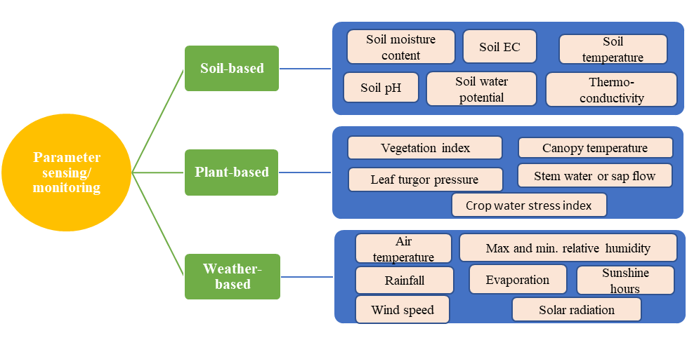

**Figure 2: Basis of monitoring techniques in smart irrigation systems**

**Weather-based monitoring**

Real-time weather-based monitoring systems typically consist of automatic weather stations equipped with sensors for relative humidity, air temperature, wind speed, atmospheric pressure and solar radiation [31]. The collected data is received by smart irrigation controllers that take into account site-specific variables like soil type to adjust irrigation schedules accordingly. Wasson et al. [32] employed a weather-based monitoring system and utilized wireless communication to transmit real-time data on air temperature, solar radiation, wind speed, and humidity. Several IoT-based systems have been developed for integrated monitoring of soil moisture and environmental parameters [27, 29]. While weather measurements are commonly used for irrigation scheduling, it is important to consider soil characteristics beyond just soil texture, as factors like soil structure and organic matter content can significantly impact available soil moisture.

**B. Irrigation Control technologies/decision support system**

Irrigation controllers are devices used in automated irrigation systems to control the timing and duration of irrigation events. These devices receive an input from deployed sensors from the field and use that data to initiate and/or terminate the irrigation process. They adjust the irrigation schedule and duration based on specific parameters which could be such as preset schedules or soil moisture levels or plant or weather conditions or combination of two or more. Irrigation controllers typically consist of a control panel, a programming interface, and a power source. The control panel contains the user interface and programming buttons, while the programming interface enables users to set watering schedules, adjust settings, and incorporate sensor data if available. The power source supplies electricity to operate the controller. The controller's working principle involves receiving input from the user (programmed schedules or sensor data) and initiating irrigation events accordingly. Depending on the type of controller, it may activate valves, pumps, or other irrigation system components to deliver water to the designated zones or areas. The controller continuously monitors and updates the irrigation schedules based on the programmed settings or sensor inputs. Some advanced controllers can also learn and adapt to the specific irrigation needs of different plants or zones over time. There are two types of irrigation controllers (i) Open-looped and (ii) Closed looped [27, 29].

**(i) Open-looped:** Open-loop irrigation control systems are relatively simple and operate based on predetermined schedules or time-based settings. They do not utilize real-time feedback or sensor data to adjust irrigation cycles. Instead, the irrigation events are programmed to occur at specific times and durations without considering the actual moisture levels or environmental conditions. This type of system is less precise and can result in overwatering or underwatering if the programmed schedule does not align with the actual water needs of the plants. Open-loop systems are commonly used in situations where sensor-based or real-time feedback systems are not available or not deemed necessary. They are often seen in smaller residential gardens or landscapes where the water requirements are relatively consistent and can be estimated based on general knowledge.

**(ii) Closed-looped:** Closed-loop irrigation control systems, also known as feedback-based or sensor-based systems, utilize real-time data from sensors (soil/plant/weather) to adjust irrigation cycles based on the actual needs of the plants and soil. By continuously monitoring and responding to the real-time feedback, closed-loop systems can optimize water usage, prevent overwatering or underwatering, and promote efficient irrigation practices. They provide more precise control over irrigation events and help conserve water by tailoring the irrigation schedule to the specific needs of the plants and soil. Closed-loop irrigation control devices are commonly used in larger agricultural fields, commercial landscapes, and advanced irrigation systems where water efficiency and precise irrigation management are crucial. It's important to note that while closed-loop systems offer more advanced control and water management capabilities, they require proper installation, calibration, and maintenance of the sensors to ensure accurate data and reliable operation. The nonlinear nature and changing dynamics of soil-plant-atmospheric continuum, make the programming and implementation of closed loop controllers extremely cumbersome. Researcher have also investigated the closed-loop control approach, where soil, plant, and weather variables were combined to measure water demand of the crop and for irrigation scheduling and optimization. Similarly, the combination of both open-loop and closed-loop and control method is known as hybrid control.

Closed-loop control strategies in irrigation can be classified into various types, including linear control, intelligent control, optimal control, and other strategies. Linear control, a subset of closed-loop control, can be further divided into linear quadratic control and Proportional-Integral-Derivative (PID) control.

**Proportional-Integral-Derivative (PID)**: PID based irrigation controllers have gained popularity due to their simplicity, low cost, and extensive control algorithm. These controllers read the sensor input and calculate the desired actuator output by considering proportional, integral, and derivative responses. While they may face challenges with external disturbances and nonlinear systems, PID controllers are efficient in controlling the actual output of a process.

Researchers have implemented PID controllers in irrigation systems to achieve reliable control and predictive purposes. For example, decentralized feedback discrete PID controller have been integrated with a hydraulic model, effectively capturing stochastic phenomena and obtaining desired water levels. Arauz et al. [33] designed a PI controller for irrigation canals based on linear matrix inequalities, resulting in improved PID tuning and satisfactory control of water levels. They developed a smart irrigation mobile robot with a soil moisture sensor and employed a PID controller for simulation analysis, successfully producing the desired output parameters. To address the linearity and non-linearity associated with irrigation dynamics, researchers have proposed PID fuzzy control strategies for precise water and fertilizer application. These strategies combine PID controllers with fuzzy rules and self-parameter tuning. The results have shown better controller robustness, stability, and control precision in achieving precision irrigation. Overall, closed-loop controllers, including PID-based controllers and PID fuzzy control strategies, offer effective control solutions in irrigation systems by considering feedback and optimizing water and fertilizer application.

**Artificial intelligence**

Artificial Intelligence (AI) is a rapidly evolving technology that has made significant advancements in the agricultural domain, particularly in closed-loop irrigation systems. AI possesses the ability to address complex problems in closed-loop irrigation systems that involve non-linear relationships, multiple variables, and time-dependent dynamics. By employing AI algorithms, it becomes possible to emulate human decision-making processes in the field of irrigation. AI has been effectively utilized to enable adaptive decision-making in irrigation through various approaches such as Artificial Neural Networks (ANNs), fuzzy logic, and expert systems [34, 35].

**Artificial Neural Networks:** One application of AI in closed-loop irrigation is the use of Artificial Neural Networks (ANNs), which emulate the neural network of the human brain. ANNs employ weights and biased connections to establish the relationship between inputs and outputs. These models possess learning and adaptation capabilities, making them well-suited for irrigation control systems. Studies have demonstrated the effectiveness of ANNs in irrigation scheduling. For instance, King et al. [36] utilized ANN modeling to develop data-driven models for predicting reference canopy temperatures, enabling the assessment of crop water stress. Adeyemi et al. [37] employed Dynamic Neural Networks to model soil moisture content and reported significant water savings in a simulation of a potato growing season. A limitation of ANN systems is their dependence on large datasets for training. The accuracy of ANN-based irrigation scheduling relies on the representativeness of the collected data, emphasizing the need for meticulous data collection using precise instruments.

**Fuzzy logic-based:** Fuzzy logic-based approaches are another facet of AI in closed-loop irrigation. Fuzzy logic enables decision-making by expressing values between true and false, addressing uncertainty and non-linearity in real-world problems. Fuzzy logic systems utilize a set of classes to classify input data and apply decision rules to generate human-like outputs. These systems have been successfully employed in irrigation control. For example, Mendes et al. [38] developed a fuzzy inference system that determined the speed adjustments of a central pivot based on the spatial variability of the field, resulting in efficient operation. The accuracy and performance of the predictions heavily rely on the designer's expertise in understanding plant dynamics and formulating appropriate fuzzy rules.

**Expert systems:** These systems represent another aspect of AI in closed-loop irrigation. These systems simulate the judgment and behavior of human experts in a specific field and incorporate a knowledge base and rules engine to make informed decisions. Expert-controlled irrigation systems provide farmers with expertise in determining the precise amount of water required based on factors such as weather conditions, humidity, temperature, and soil types. Researchers have utilized expert systems in various agricultural applications, including irrigation. The performance of expert systems heavily relies on the effectiveness of the knowledge acquisition process, as errors in this phase can impact the reliability and performance of the system.

**Model Predictive Control (MPC):** Model Predictive Control is an optimal control approach that uses a dynamic model to forecast system behavior and optimize decisions based on the forecast. It is a flexible framework capable of handling multivariate processes and addressing constraints. MPC has been widely applied in manufacturing industries and has shown promise in controlling air temperature in greenhouses. However, its application in irrigation scheduling is still limited, with most studies focusing on simulations. There is a need to explore stochastic and Hybrid MPC strategies for efficient irrigation scheduling in open-field agriculture, where environmental uncertainties and disturbances are present. Model Predictive Control (MPC) is sometimes considered separately from general AI applications in irrigation due to its distinct characteristics and focus., however both MPC and other AI approaches involve intelligent decision-making.

**Genetic Algorithm (GA):** Genetic Algorithm**-**based irrigation controller utilizes principles of evolution and inheritance to optimize irrigation systems. It is a stochastic global search technique that mimics natural evolution by selecting the fittest individuals for reproduction in a population-based approach. GA has been applied in optimizing water systems, irrigation networks, and operational scheduling of irrigation canals. Compared to traditional methods, GA provides faster response time, improved stability, and robustness. In addition to these applications, GA has also been successfully used in tuning controllers such as PID (Proportional-Integral-Derivative) and other optimal controllers. By integrating evolutionary algorithms, the computational complexity of advanced controllers can be effectively managed, making them more suitable for irrigation control. Overall, GA-based irrigation controllers leverage the principles of natural evolution to find globally optimal solutions and enhance the performance of irrigation control algorithms.

**Particle Swarm Optimization (PSO):** Particle Swarm Optimization based irrigation controller utilizes the concept of swarm intelligence inspired by the social behavior of animals like fishes and birds. PSO is an intelligent evolutionary algorithm and a robust stochastic optimization method. It has been successfully applied in various fields, including agriculture, science, and engineering. PSO was developed as an alternative to mathematical models for solving optimization problems. It is based on the movement and interaction of particles in a swarm, where each particle adjusts its position based on its previous experience and the best position found so far. This algorithm allows for efficient exploration and achievement of optimization goals. PSO has been applied in various irrigation control scenarios. For example, it has been used to tune the proportional-integral (PI) control of irrigation pump speed, resulting in improved response, efficiency, reduced overshoot, and robust stability compared to traditional methods [39]. PSO has also been employed for optimal irrigation scheduling, offering the potential to tune irrigation controllers for optimal performance. By utilizing PSO for controller tuning, the computational burden can be reduced as it accelerates convergence to global minima and efficiently searches under multiple constraints.

Hybrid intelligent systems combine multiple artificial intelligence algorithms to improve system performance. For example, combination of neural networks and fuzzy logic referred to as neuro-fuzzy. Researchers have proposed combining algorithms such as artificial bee colony, genetic algorithms, and particle swarm optimization to optimize critical parameters in neural network models. This approach accelerates learning, improves system robustness, and reduces deviation from the global minimum. In the context of irrigation control, hybrid intelligent systems have been used to analyze aerial agricultural images and adjust irrigation levels based on soil moisture conditions [29]. By employing machine learning algorithms, water consumption can be significantly reduced while maintaining robustness against errors. Another application involves using a combination of dynamic artificial neural networks, Bayesian frameworks, and genetic algorithms to forecast short-term daily irrigation water demand in hydroponics. This hybrid approach improves the precision of the forecasts compared to traditional methods. Integration of farmer's knowledge, the Internet of Things (IoT), and image processing has also been explored for deficit irrigation control. The overall aim of hybrid intelligent systems is to enhance the performance and smartness of existing irrigation controllers by combining multiple AI algorithms and integrating domain knowledge. This allows for more efficient decision-making and control, leading to improved resource utilization and fresh food production.

Overall, AI-based approaches, including ANNs, fuzzy logic, expert systems and other approaches, have significantly improved decision-making in closed-loop irrigation systems. These technologies offer advanced capabilities for water management, optimization of crop yield, and efficient resource utilization. Ongoing advancements in AI hold great potential for revolutionizing agriculture and addressing the challenges faced by the industry.

**Cloud Computing in Irrigation Automation**

Cloud computing is a technology that enables the delivery of computing resources, such as servers, storage, databases, software, and analytics, through the internet. When applied to irrigation automation, cloud computing presents numerous advantages and opportunities to enhance the efficiency and effectiveness of irrigation systems. One of the primary benefits of cloud computing in irrigation automation is the ability to centralize and store data securely in the cloud. Sensor data collected from various sources like soil moisture sensors, weather stations, and crop sensors can be transmitted to the cloud for storage and analysis. This centralized approach offers farmers a comprehensive view of their irrigation system, allowing them to monitor and manage operations remotely from any location with internet access. Moreover, cloud computing provides scalable computing power and storage capabilities. With ample computational resources available in the cloud, complex algorithms and analytics can be applied to the collected data. This enables advanced data processing and modeling techniques such as machine learning and predictive analytics to optimize irrigation strategies and support data-driven decision-making [40]. By utilizing cloud-based analytics platforms, farmers can gain valuable insights into crop water requirements, improve irrigation scheduling, and identify potential issues or anomalies within their irrigation system.

Cloud computing also facilitates real-time data processing and instantaneous feedback. Sensor data can be processed in real-time within the cloud, enabling immediate notifications and alerts to be sent to farmers or irrigation system operators. For instance, if a sudden change in soil moisture levels is detected, an alert can be generated and delivered to the farmer's mobile device, prompting them to take immediate action. This timely response helps prevent water wastage, enhance irrigation efficiency, and address potential crop stress or water-related issues promptly. Another advantage of cloud computing in irrigation automation is its collaborative nature. Multiple stakeholders, including farmers, agronomists, irrigation consultants, and researchers, can access and share data and insights through the cloud platform. This fosters collaboration and knowledge sharing, leading to improved decision-making and enhanced irrigation practices. Experts can remotely analyze data, provide recommendations, and collaborate with farmers to optimize irrigation strategies and overall water management practices. Furthermore, cloud computing offers cost-effectiveness and flexibility. By leveraging cloud-based services, farmers can avoid upfront investment and maintenance costs associated with establishing and managing on-premises IT infrastructure [41]. They can scale their computing and storage resources based on their needs, paying only for the resources they utilize. This flexibility enables farmers to adapt to changing requirements and easily expand their irrigation systems as their operations grow. In summary, cloud computing provides a robust platform for irrigation automation by offering centralized data storage, scalable computing power, real-time data processing, collaboration, and cost-effectiveness. By harnessing the capabilities of the cloud, farmers can utilize advanced analytics, optimize irrigation strategies, improve water management practices, and achieve sustainable and efficient irrigation automation.

**C. Communication technologies**

In irrigation automation for crops, various communication technologies are employed to facilitate data exchange and control between different components of the system [29, 42]. Three basic categories of communication technology commonly used in agriculture include:

**(i) Wired Communication:** This category includes technologies that use physical cables or wired connections for communication. Examples include Ethernet, RS-485, and powerline communication. Wired communication can provide reliable and high-speed data transmission but has limitations including the need for infrastructure installation, limited mobility of devices, vulnerability to damage, restricted range, maintenance challenges, scalability issues, and dependency on power supply. These factors can make wired communication systems costly, less flexible, and more prone to disruptions, especially in large or remote agricultural areas.

**(ii) Wireless Communication:** This category includes technologies that enable communication without the need for physical cables. Wireless communication allows flexibility and mobility in data transmission. Examples include:

**Radio Frequency (RF)**

RF communication includes technologies such as Wi-Fi (IEEE 802.11), Bluetooth, Zigbee (IEEE 802.15.4), and LoRa (Long Range). These technologies operate in different frequency bands and have varying range, data rates, and power requirements.

**Wireless Sensor Networks (WSN):** WSN technology enables the deployment of a network of wireless sensors throughout the agricultural field. WSN consist of components such as sensor nodes, master nodes, databases, and base stations. These networks, powered by communication technology and microcontrollers, offer improvements in monitoring methods for real-time response in various applications [43]. The data collected by the sensors is wirelessly transmitted to a central control system for analysis and decision-making.

**LoRaWAN:** LoRaWAN (Long Range Wide Area Network) is a low-power, wide-area wireless communication technology suitable for long-range applications. It is often utilized in large-scale agricultural settings for irrigation automation. LoRaWAN enables the deployment of low-cost, battery-powered sensors over vast areas, providing connectivity for remote monitoring of soil moisture, climate conditions, and water usage.

**Zigbee:** Zigbee is a low-power, short-range wireless communication technology commonly used in agricultural applications. Zigbee networks are typically used for localized monitoring and control of irrigation systems within a specific area or a small farm. Zigbee technology operates on a globally available 2.4 GHz frequency band that is free from licensing requirements and protocols built upon the cost-effective, digital radio based on the IEEE 802.15.4 standard.

**Wi-Fi:** Wi-Fi technology is commonly used for local area communication within the farm premises. Wi-Fi networks enable connectivity between different components of an irrigation automation system, including sensors, controllers, and user interfaces. Wi-Fi provides high-speed data transfer and can be leveraged for real-time monitoring and control of irrigation operations. Wi-Fi is preferred for larger areas with multiple sensors.

**Cellular Networks:** Cellular networks, such as 2G, 3G, 4G, LTE and emerging 5G technologies through GPRS protocol, provide wide-area coverage and reliable connectivity for irrigation automation systems. Cellular communication enables data transmission between field devices, such as sensors and control units, and central management systems. It allows for remote monitoring, control, and data analysis, even in areas with limited infrastructure.

**Satellite Communication:**

Satellite communication involves the use of communication satellites to transmit signals between devices. It provides coverage in remote or inaccessible areas but may have higher latency and cost.

**(c) Internet of Things (IoT):** IoT refers to the network of interconnected physical devices embedded with sensors, software, and connectivity, enabling them to collect and exchange data. IoT communication technologies are specifically designed for devices connected to the internet. IoT devices such as soil moisture sensors, weather stations, and actuators are connected to the internet, allowing for seamless communication and data sharing. These devices can transmit real-time data to cloud-based platforms or local control systems, enabling remote monitoring and control of irrigation operations. In the context of irrigation water management, IoT is used to create smart irrigation systems that leverage sensor data and connectivity to optimize water usage. IoT technology enables the monitoring of various parameters such as soil moisture, weather conditions, and crop water requirements in real-time [44, 45]. This data is then processed and analyzed to make informed decisions about irrigation scheduling, water delivery, and resource management. Through mobile applications or web-based interfaces, farmers can access real-time data on soil moisture, irrigation status, and system performance. They can remotely monitor the irrigation process, receive alerts or notifications about any issues, and make necessary adjustments to optimize water usage.

These categories encompass a wide range of communication technologies, each with its own advantages and limitations. The selection of the appropriate communication technology depends on factors such as data requirements, range, power consumption, infrastructure availability, and cost considerations. In irrigation automation, a combination of wired and wireless communication technologies, such as Zigbee or LoRA for local sensor network communication and Wi-Fi or cellular networks for internet connectivity, is often used to achieve reliable and efficient data transfer and control.

**V. CASE STUDIES: SUCCESSFUL IMPLEMENTATIONS OF AUTOMATED IRRIGATION**

**A. Automation in rice-wheat cropping system in Punjab**

During 2019-20, ultrasonic and capacitance sensors were utilized to monitor the water level in rice fields and soil moisture in wheat fields, respectively [46]. The study on automation was conducted in three districts of Punjab, namely Ludhiana, Taran Taran, and Bathinda. A total of ten progressive farmers were selected in each district, along with three Research Farms/Centres of the Punjab Agricultural University in these districts, to ensure efficient monitoring and data collection. The experimental setup consisted of two plots: a control plot following the conventional irrigation schedule, and another plot with fully automated irrigation using sensor and IoT tools using alternate wetting and drying (AWD). To integrate the IoT tools, water distribution system, pump starters, a dynamic website and mobile application were developed and connected with server and local cellular network (Figure 3 and 4). These tools allow users to access and monitor the collected data, as well as remotely control or automate the water pumps. At the farmers' fields, thirty pulse water meters were installed to measure irrigation water. The water level data obtained from the AWD system was carefully compared and matched to ensure that the crop's water requirements were met during both wetting and drying periods. During the wet period, the IoT system maintained the AWD water level or field water level within predetermined limits. If the field water level fell below the minimum requirement during the specified wet or dry period, the IoT system triggered the operation of the water pump. Conversely, when the field water level exceeded the maximum requirement, the pump was automatically stopped. In the dry period, the threshold limit for the decrease in soil moisture (water level) ranged from ≥ -10 cm to ≤ -15 cm, while for the rise in water level, it was set at ≤ 3 cm (Figure 5). For the wet period, the standing water level for paddy fields was maintained between ≥ 5 cm and ≤ 10 cm. The IoT system continuously monitored and recorded water levels at 15-minute intervals. Similarly, start and stop triggers were used based on soil water potential (Figure 6). The real-time information was then shared on the website, which was accessible to the public, including farmers who could use it for making informed decisions. Moreover, the IoT system generated SMS notifications based on the desired water levels required in the field, following the AWD schedule.

**Figure 3: Basis sensors and IoT tools used**

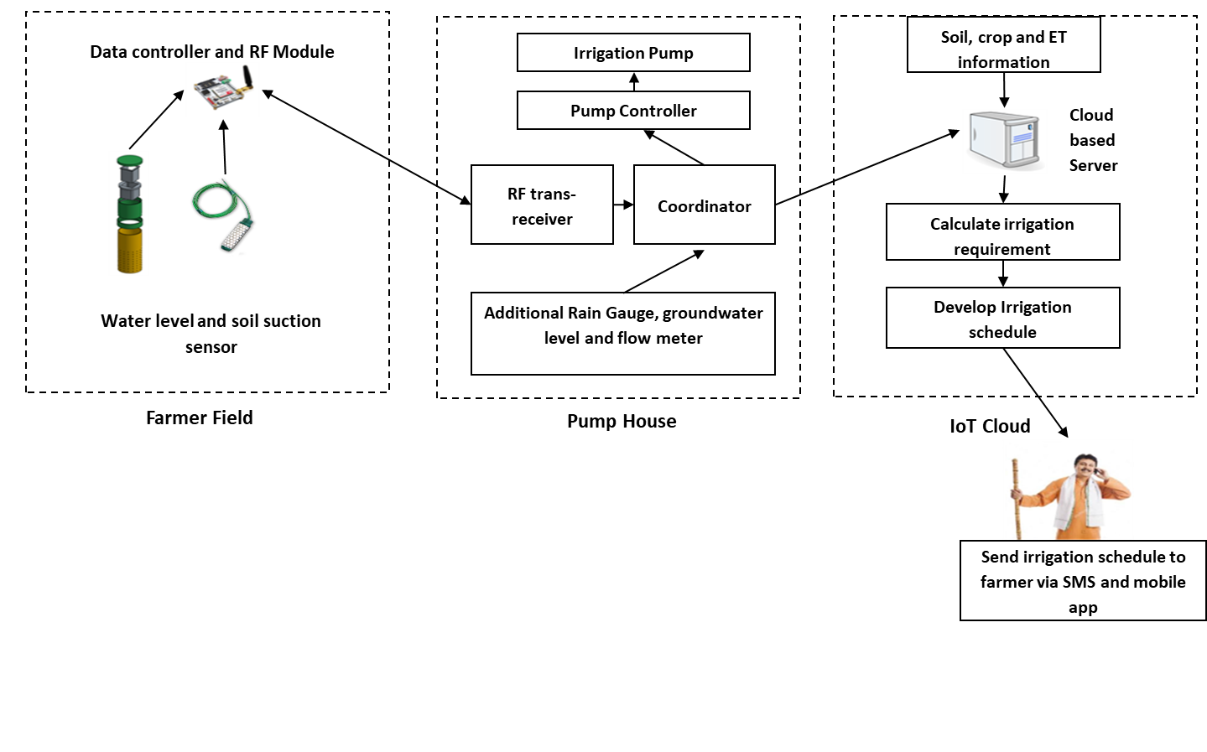

**Figure 4: IoT based irrigation automation platform sequence**



**Figure 5: Algorithms for irrigation scheduling in rice**

**Figure 6: Algorithms for irrigation scheduling in wheat**

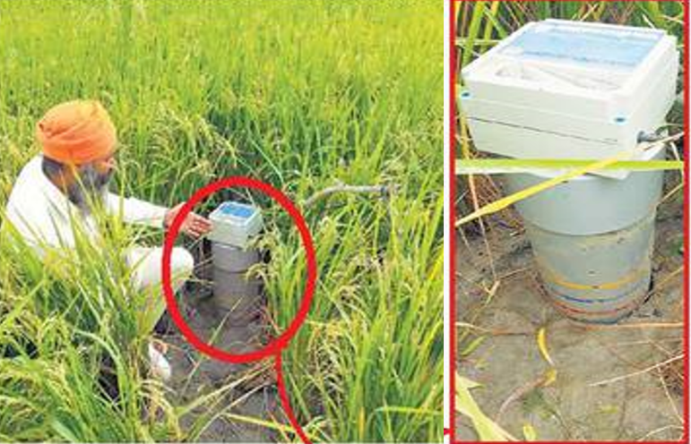

**Figure 7: Ultrasonic sensor at farmer’s field**

The implementation of IoT-based irrigation systems for coarse grain rice resulted in about 5% increase in grain yield and saved approximately 17% irrigation water as compared to conventional method of irrigation. For basmati rice, there was a 2-5% improvement in grain yield with a 10% reduction in irrigation water usage. The development and implementation of "START the irrigation" triggers were successful. However, challenges were encountered in developing the "STOP the irrigation" trigger due to factors such as the positioning of sensors in relation to the water entry point in the field, frequent electrical power interruptions to pumps, and limitations in the number of sensors per average plot size (Figure 7).

**B. Irrigation Automation in spring maize integrating sub-surface drip system, soil moisture sensors and IoT**

Spring maize is cultivated during hot and dry season amid high evaporative demand which results in high water requirement. High temperature and dry winds are detrimental to maize and crop needs about 15-18 irrigations to combat these harsh conditions. Consequently, sustainable management practices in spring maize need to be developed to reduce irrigation water demand for the conservation of water resources besides maintaining farm profitability. Hence, a fully automated subsurface drip irrigation system, incorporating FDR-based soil moisture sensors, LoRA, and other IoT tools, has been developed and is currently under evaluation at the research farm of the Centre for Water Management & Technology, Department of Agronomy, Punjab Agricultural University, Ludhiana, Punjab, India (Figure 8 and 9). Initial results from the first year of experimentation demonstrated the successful performance of the new automation system, ensuring the automated delivery of the required amount of irrigation water whenever soil moisture levels in the root zone (at a depth of 20 cm) dropped below the predetermined threshold value of 30% depletion of available soil moisture (DASM) (data not yet published, author’s own experiment). IoT-enabled smart water flow meter are also installed to measure, monitor and record the real-time consumption of irrigation water along with real-time change in soil moisture content/sensor readings, which are displayed on dashboard (Figure 10). The system is undergoing further assessment to evaluate its overall performance and identify any areas where enhancements may be required.

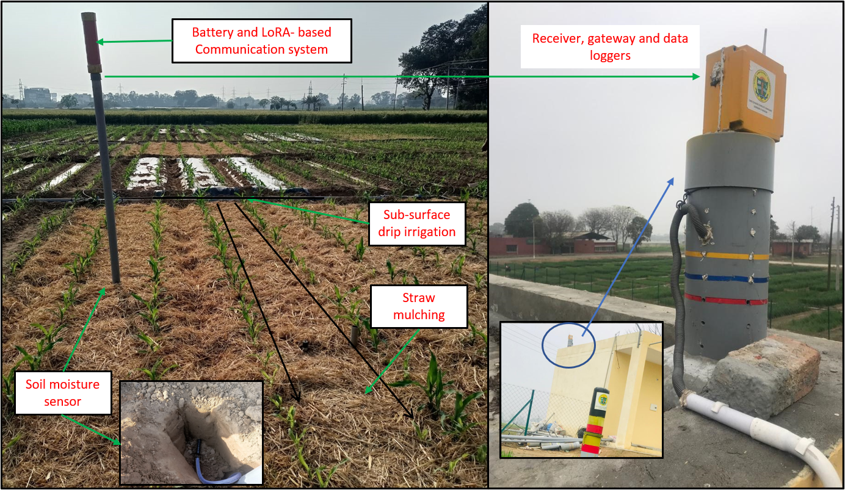

**Figure 8: Automated sub-surface drip irrigation in pneumatically planted spring maize + straw mulching**

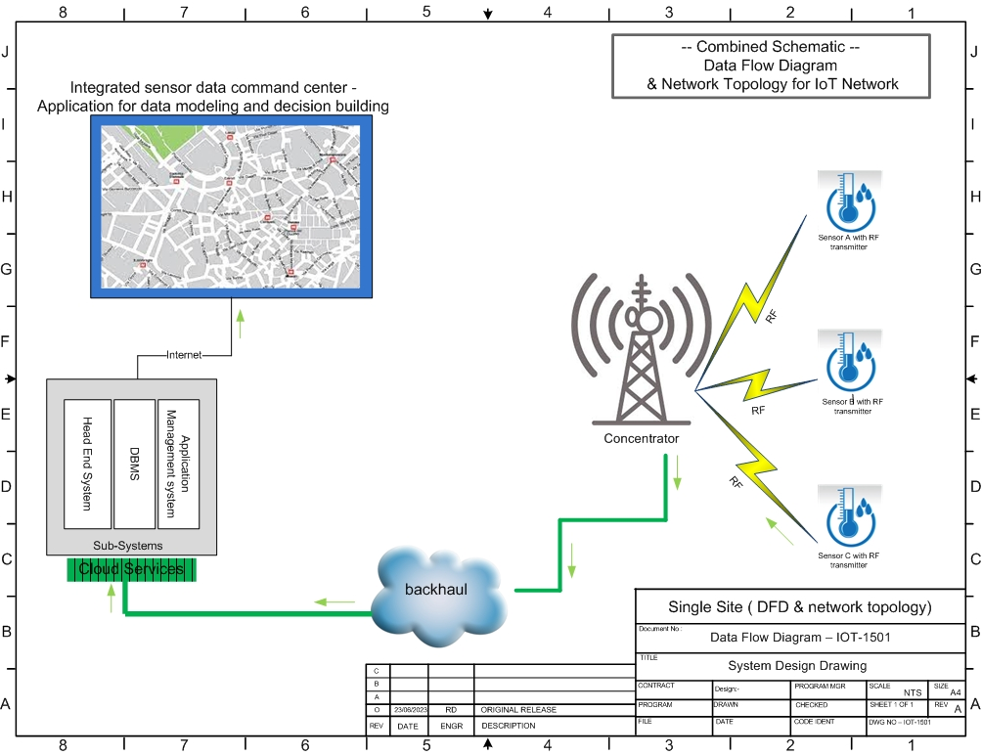

**Figure 9: Data flow diagram**

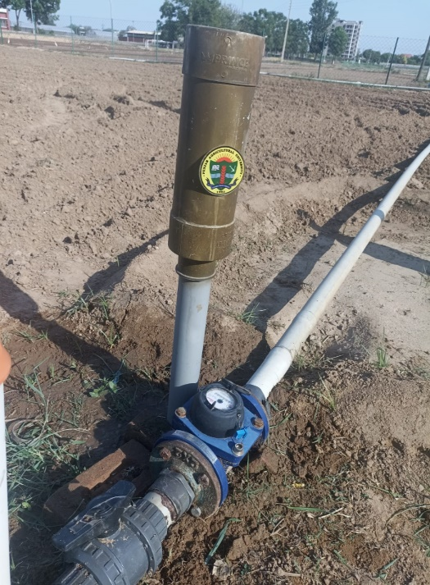 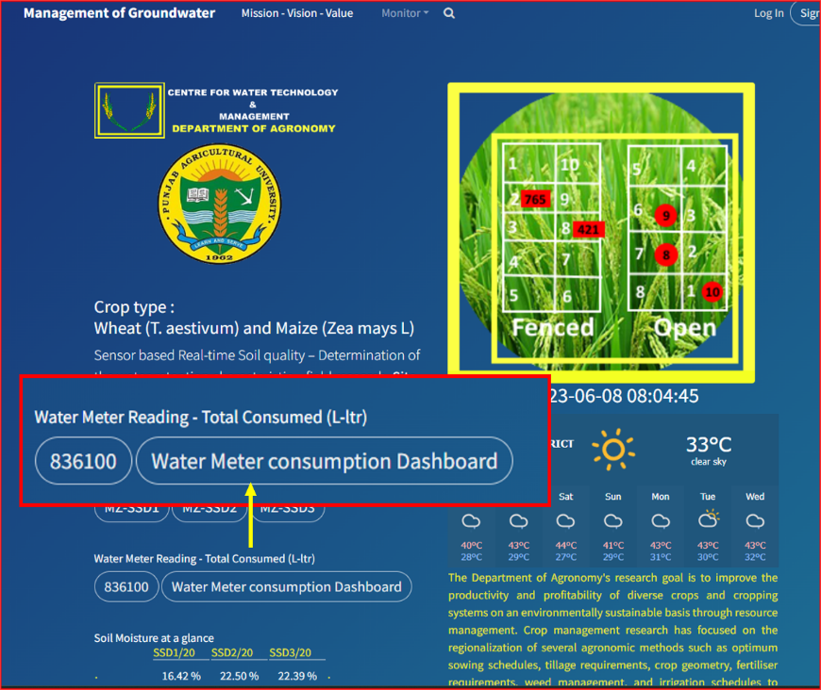

**Figure 10:** **IoT-enabled smart flow meter (L) for real-time consumption of irrigation water, and real-time soil moisture content/sensor readings on dashboard (R) (**[**www.cwtnm.org**](http://www.cwtnm.org/)**)**

**VI. EMERGING AND POTENTIAL OPPURTUNITES OF IRRIGATION AUTOMATION IN SUSTAINABLE AGRICULTURE**

Investments in research and development, along with technological advancements, have created new possibilities for enhancing water use efficiency in irrigated agriculture. This involves the creation of advanced equipment, techniques, and cost-effective alternatives. A promising approach that is gaining traction is the utilization of remotely sensed data for estimating crop water status and optimizing irrigation scheduling over a large area. Satellite imagery, notably from satellites like Landsat, has been effectively employed to derive vegetation indices and estimate evapotranspiration across extensive agricultural areas, leading to improved management of irrigation water. However, the complete potential of remote sensing in irrigation water monitoring and management is yet to be fully realized due to challenges related to spatial and temporal resolution and result quality. The availability of satellites with higher spatial resolution, such as Sentinel-2 and Planet, holds great potential for agricultural applications. NISAR (NASA-ISRO Synthetic Aperture Radar), a joint satellite mission between NASA and ISRO can support irrigation automation in future through its advanced radar imaging technology enabling it to collect high-resolution data on soil moisture, crop characteristics and surface water bodies. By monitoring soil moisture levels, mapping water bodies and integrating data with other remote sensing technologies, NISAR can contribute to optimizing irrigation practices and conserving water resources in agriculture.

Remote sensing provides a distinct advantage by enabling the estimation of crop water status over large spatial scales, surpassing the limitations of conventional methods like soil probes or plant-based techniques [47]. As drone technology becomes more accessible and affordable, its integration with remote sensing presents significant opportunities. However, concerted efforts are required to facilitate the integration of remote sensors with farmers' practices to achieve economies of scale. Promising prospects and advancements in remote sensing include the acquisition of very high-resolution data through hyperspectral sensors, seamless data access from multiple sensors, and the integration of remote sensing data through streaming technology. These advancements have the potential to further enhance the accuracy and efficiency of irrigation water management in agriculture.

The availability of affordable and accurate sensors has significantly broadened the scope of imaging techniques in monitoring plant water relations for irrigation management and physiological studies. This development has opened up new possibilities for leveraging spectral imaging in irrigation management. Notably, the advent of smaller cameras that can be easily mounted on Unmanned Aerial Vehicles (UAVs) has greatly enhanced the feasibility and practicality of using spectral imaging in agricultural applications. Another area of ongoing research is the use of thermal and multispectral imagery acquired through unmanned aerial vehicles (UAVs) or drones to assess crop water status. The correlation between canopy temperature and plant water status has been established, offering valuable insights for irrigation management. Additionally, the reflectance of near and mid-infrared regions of the electromagnetic spectrum has shown promise in evaluating water status in diverse crops.

The integration of Artificial Intelligence (AI) algorithms has further revolutionized the field by improving the efficiency and accuracy of image processing. These algorithms enable advanced tasks such as image segmentation, object detection and identification, classification based on spectral signatures, and the development of predictive models. By leveraging AI, spectral imaging data can be processed and analyzed with unprecedented speed and precision, providing valuable insights into various aspects of crop health, water requirements, and growth patterns.

With the integration of AI algorithms, agronomists and researchers can efficiently extract relevant information from spectral images captured by UAV-mounted cameras. They can analyze the images to identify specific plant characteristics, detect stress indicators, assess crop health, monitor water availability in real-time and subsequent automation of irrigation. As technology continues to evolve, the integration of imaging techniques with AI algorithms is expected to further enhance the efficiency and effectiveness of agricultural practices, contributing to sustainable and optimized crop production systems.

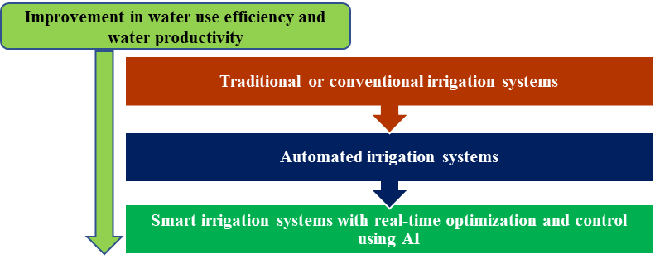

**Figure 11: Basis of monitoring techniques in smart irrigation systems**

The future prospects of irrigation automation are promising, with several key advancements and potential benefits. Firstly, automation technologies, such as IoT-based systems, advanced sensors, and data analytics, enable precise and efficient irrigation management. By monitoring soil moisture levels, weather conditions, and crop water requirements in real-time, automated systems can deliver the right amount of water at the right time, reducing water wastage and improving water use efficiency. By integrating irrigation automation with other smart farming techniques, such as precision agriculture and integrated pest management, farmers can optimize resource allocation, minimize chemical inputs, and reduce energy consumption. This integrated approach promotes sustainable use of resources, minimizes environmental pollution, and protects ecosystem health. Moreover, irrigation automation facilitates decision-making processes for farmers. In addition, automation can contribute to labor optimization and cost reduction. Automated systems can efficiently perform repetitive tasks, such as irrigation scheduling, monitoring, and control, reducing the need for manual labor. This allows farmers to allocate their resources more effectively, focus on higher-value activities, and reduce operational costs. Furthermore, the integration of irrigation automation with renewable energy sources, such as solar power, can further enhance sustainability by reducing dependence on fossil fuels and minimizing greenhouse gas emissions. Overall, the future prospects of irrigation automation in sustainable agriculture are highly promising. By harnessing advanced technologies and data-driven approaches, irrigation automation can optimize water use, improve crop productivity, reduce environmental impact, and contribute to the overall sustainability of agricultural practices.

**REFERENCES**

1. H. Turral, M. Svendsen, and J.M. Faures, "Investing in irrigation: Reviewing the past and looking to the future," Agric. Water. Manag., vol. 97, pp. 551-560, 2010.
2. J. Diouf, "FAO's director-general on how to feed the world in 2050," Popul. Dev. Rev., vol. 35, pp. 837-839, 2009.
3. P. Doll, "Impact of climate change and variability on irrigation requirements: A global perspective," Clim. Change., vol. 54, pp. 269-293, 2002.
4. S.K. Sun, C. Li, P.T. Wu, X.N. Zhao, and Y.B. Wang, "Evaluation of agricultural water demand under future climate change scenarios in the Loess Plateau of Northern Shaanxi, China," Ecol. Indic., vol. 84, pp. 811-819, 2018.
5. CWC, "Reassessment of water availability in India using space inputs." Basin Planning & Management Organization, Central Water Commission, New Delhi, 2019, pp. 99.
6. CGWB, "Dynamic Ground Water Resources of India-2022." Department of Water Resources, River Development and Ganga Rejuvenation, New Delhi: Ministry of Jal Shakti, Government of India, 2022, pp. 395.
7. NITI Aayog, "Water resources sector report." Development Monitoring and Evaluation Office, NITI Aayog, Government of India, 2021, pp. 196.
8. Punjab Agricultural University, "Statistics of Punjab Agriculture." Ludhiana: Punjab Agricultural University, 2020a, pp. 1-41.
9. C.D. Yonts, "Surface irrigation," in Encyclopedia of Agricultural, Food, and Biological Engineering, pp. 979-981, 1994.
10. S.S. Kukal, G.C. Aggarwal, "Puddling depth and intensity effects in rice-wheat system on a sandy loam soil. I. Development of subsurface compaction," Soil. Tillage. Res., vol. 72, pp. 1-8, 2003.
11. E. Humphreys, S.S. Kukal, E.W. Christen, G.S. Hira, B. Singh, S. Yadav, R.K. Sharma, "Halting the groundwater decline in North West India - which crop technologies will be winners?" Adv. Agron., vol. 109, pp. 155-217, 2010.
12. J.E. Ayars, C.J. Phene, R.B. Hutmacher, K.R. Davis, R.A. Schoneman, S.S. Vail, R.M. Mead, "Subsurface drip irrigation of row crops: A review of 15 years of research at the Water Management Research Laboratory," Agric. Water. Manag., vol. 42, no. 1, pp. 1-27, 1999.
13. L. Coltro, L.F.M. Marton, F.P. Pilecco, A.C. Pilecco, L.F. Mattei, "Environmental profile of rice production in Southern Brazil: A comparison between irrigated and subsurface drip irrigated cropping systems," J. Clean. Prod., vol. 153, pp. 491-505, 2017.
14. J.E. Ayars, A. Fulton, B. Taylor, "Subsurface drip irrigation in California - Here to stay?" Agric. Water. Manag., vol. 157, pp. 39-47, 2015.
15. A.S. Brar, K. Kaur, V.K. Sindhu, N. Tsolakis, and J.S. Srai, "Sustainable water use through multiple cropping systems and precision irrigation," J. Clean. Prod., vol. 333, 130117, 2022.
16. R.K. Sidhu, R. Kumar, P.S. Rana, and M.L. Jat, "Automation in drip irrigation for enhancing water use efficiency in cereal systems of South Asia: Status and prospects," Adv. Agron., vol. 167, pp. 247-291, 2022. [Online]. Available: <https://doi.org/10.1016/bs.agron.2021.01.002>
17. S.S. Kukal, G.S. Hira, and A.S. Sidhu, "Soil matric potential-based irrigation scheduling to rice (*Oryza sativa*)," Irrig. Sci., vol. 23, pp. 153-159, 2005.
18. N. Gupta, S. Yadav, E. Humphreys, S.S. Kukal, B. Singh, and P.L. Eberbach, "Effects of tillage and mulch on the growth, yield and irrigation water productivity of a dry seeded rice-wheat cropping system in north-west India," Field. Crop. Res., vol. 196, pp. 219-236, 2016.
19. H.M. Jones, "Irrigation scheduling: advantages and pitfalls of plant-based methods," J. Exp. Bot., vol. 55, pp. 2427-2436, 2004.
20. R.G. Allen, L.S. Pereira, D. Raes, and M. Smith, "Crop Evapotranspiration: Guidelines for Computing Crop Water Requirements – FAO Irrigation and Drainage Paper 56," Rome: Food and Agriculture Organization of the United Nations, 1998. Available at: <http://www.fao.org/3/x0490e/x0490e00.htm> (accessed 05 July 2021).
21. S.S. Prihar, P.R. Gajri, and R.S. Narang, "Scheduling irrigation to wheat using open pan evaporation," Indian. J. Agric. Sci., vol. 44, pp. 567-571, 1974.
22. M.P. Groover, "Automation," Encyclopedia Britannica. Encyclopedia Britannica, Inc. Available at: <https://www.britannica.com/technology/automation>. (Accessed: 1 May 2023).
23. M. Champness, C. Ballester-Lurbe, R. Filev-Maia, and J. Hornbuckle, "Smart sensing and automated irrigation for sustainable rice systems: A state of the art review," Adv. Agron., vol. 177, pp. 259-285, 2023.
24. M. Champness, L. Vial, C. Ballester, and J. Hornbuckle, "Evaluating the performance and opportunity cost of a smart-sensed automated irrigation system for water-saving rice cultivation in temperate Australia," Agric., vol. 13, pp. 903, 2023. [Online]. Available: <https://doi.org/10.3390/agriculture13040903>.
25. N.E.Q. Silveiro, J.A.M. Demattea, B. Minasnyb, N.A. Rosina, J.G. Nascimentoc, H.S.R. Albarracína, H. Bellinasoa, and A.M.R. Gómeza, "Sensing technologies for characterizing and monitoring soil functions: A review," Advan. Agron., vol. 177, pp. 125-168.
26. S.R. Peddinti, J.W. Hopmans, M.A. Najm, and I. Kisekka, "Assessing effects of salinity on the performance of a low-cost wireless soil water sensor," Sensors, vol. 20, pp. 1–14, 2020. [Online]. Available: <https://doi.org/10.3390/s20247041>.
27. E. Bwambale, F.K. Abagale, G.K. Anornu, "Smart irrigation monitoring and control strategies for improving water use efficiency in precision agriculture: A review," Agric. Water. Manag., vol. 260, pp. 107324, 2022.
28. G. Hamlyn, A.G. Jones, S. Rachid, B.R. Loveys, L. Xiong, A. Wheaton, and A.H. Price, "Thermal infrared imaging of crop canopies for the remote diagnosis and quantification of plant responses to water stress in the field," Funct. Plant. Biol., vol. 36, pp. 978–989, 2009.
29. E.A. Abioye, M.S.Z. Abidin, M.S.A. Mahmud, S. Buyamin, M.H.I. Ishak, M.K. I.A. Rahman, A.O. Otuoze, P. Onotu, and M.S.A. Ramli, "A review on monitoring and advanced control strategies for precision irrigation," Comput. Electron. Agric., vol. 173, pp. 105441, 2020. [Online]. Available: <https://doi.org/10.1016/j.compag.2020.105441>.
30. N. Virlet, K. Sabermanesh, P. Sadeghi-Tehran, and M. J. Hawkesford, "Field Scanalyzer: An automated robotic field phenotyping platform for detailed crop monitoring," Funct. Plant. Biol., vol. 44, pp. 143–153, 2017. [Online]. Available: <http://dx.doi.org/10.1071/FP16163>.
31. O. Adeyemi, I. Grove, S. Peets, and T. Norton, "Advanced monitoring and management systems for improving sustainability in Precision Irrigation," Sustainability, vol. 9, no. 3.
32. T. Wasson, T. Choudhury, S. Sharma, and P. Kumar, "Integration of RFID and sensor in agriculture using IOT," in Proceedings of the 2017 International Conference on Smart Technology for Smart Nation, SmartTechCon 2017, 2017, pp. 217–222. [Online]. Available: <https://doi.org/10.1109/SmartTechCon.2017.8358372>.
33. T. Arauz, J. Maestre, X. Tian, and G. Guan, "Design of PI controllers for irrigation canals based on linear matrix inequalities," Water., vol. 12, pp. 117, 2020. [Online]. Available: <https://doi.org/10.3390/w12030855>.
34. T. Talaviya, D. Shah, N. Patel, and H. Yagnik, "Implementation of artificial intelligence in agriculture for optimization of irrigation and application of pesticides and herbicides," Artif. Intell. Agric., vol. 4, pp. 58–73, 2020.
35. K. Jha, A. Doshi, P. Patel, and M. Shah, "A comprehensive review on automation in agriculture using artificial intelligence," Artif. Intell. Agric., vol. 2, pp. 1–12, 2019.
36. B. A. King, K. C. Shellie, D. D. Tarkalson, A. D. Levin, V. Sharma, and D. L. Bjorneberg, "Data-driven models for canopy temperature-based irrigation scheduling," Trans. ASABE., vol. 63, pp. 1579–1592, 2020. [Online]. Available: <https://doi.org/10.13031/TRANS.13901>.
37. O. Adeyemi, I. Grove, S. Peets, Y. Domun, and T. Norton, "Dynamic neural network modeling of soil moisture content for predictive irrigation scheduling," Sensors., vol. 18. [Online]. Available: <https://doi.org/10.3390/s18103408>.
38. W. R. Mendes, F. M. U. Araújo, R. Dutta, and D. M. Heeren, "Fuzzy control system for variable rate irrigation using remote sensing," Expert. Syst. Appl., vol. 124, pp. 13–24, 2019. [Online]. Available: <https://doi.org/10.1016/j.eswa.2019.01.043>.
39. Moubarak, G. El-Saady, and E. N. A. Ibrahim, "Optimal operation of renewable energy irrigation system using particle swarm optimization," ARPN. J. Eng.Appl. Sci., vol. 13, no. 24, pp. 9318–9327,
40. R. F. Maia, C. B. Lurbe, and J. Hornbuckle, "Machine learning approach to estimate soil matric potential in the plant root zone based on remote sensing data," Front. Plant Sci., vol. 13, p. 931491, 2022. [Online]. Available: doi: 10.3389/fpls.2022.931491.
41. R. F. Maia, C. B. Lurbe, A. A. Baniya, and J. Hornbuckle, "IRRISENS: An IoT Platform Based on Microservices Applied in Commercial-Scale Crops Working in a Multi-Cloud Environment," Sensors., vol. 20, p. 7163, 2020. [Online]. Available: doi: 10.3390/s20247163.
42. R. Koech and P. Langat, "Improving Irrigation Water Use Efficiency: A Review of Advances, Challenges and Opportunities in the Australian Context," Water., vol. 10, p. 1771, 2018. [Online]. Available: doi: 10.3390/w10121771.
43. L. Hamami, B. Nassereddine, "Application of wireless sensor networks in the field of irrigation: A review," Comput. Electron. Agric., vol. 179, p. 105782, 2020.
44. G. S. Prasanna Lakshmi, P. N. Asha, G. Sandhya, S. Vivek Sharma, S. Shilpashree, and S. G. Subramanya, "An intelligent IOT sensor coupled precision irrigation model for agriculture," Measurement: Sensors., vol. 25, p. 100608, 2023.
45. A. Abdelmoneim, R. Khadra, B. Derardja, and G. Dragonetti, "Internet of Things (IoT) for Soil Moisture Tensiometer Automation," Micromachines., vol. 14, p. 263, 2023. [Online]. Available: <https://doi.org/10.3390/mi14020263>.
46. S. Brar, V. K. Sindhu, S. Kaur, S. K. Brar, K. Kaur, D. Tiwari, K. B. Singh, Ritu, S. Singh, and V. Tuli, "Enhancing water productivity of rice using Internet of Things in rice-wheat cropping system in Punjab," Extended Summaries. 1st Indian Rice Congress on "Rice Research and Development for Achieving Sustainable Development Goals" held on December 8-9, 2020, pp. 448-449.
47. Ballester, J. Brinkhoff, W. C. Quayle, and J. Hornbuckle, "Monitoring the Effects of Water Stress in Cotton using the Green Red Vegetation Index and Red Edge Ratio," Remote. Sens., vol. 11, p. 873, 2019. [Online]. Available: doi: 10.3390/rs11070873.