Exploring Transcranial Direct Current Stimulation's Potential in Neurological Conditions
Rituporna Bhattacharjee¹, Sanjam Narayan Mishra²
Assistant Professor, Department of Physiotherapy, Chandigarh University, UIAHS¹
Prosthetist and Orthotist, RCI-A68635²
INTRODUCTION
The study of current remnants of the past, such as artifacts, equipment, written documents, data books, photographs, memoirs, and so forth, serves as the foundation for the history of neuroscience. (Gross, C. G.)
A technique known as TDCS is one in which the dose is delivered to the head as a single sustained direct current (DC) waveform, with the exception of one ramp-up and one ramp-down interval, employing at least one cephalic electrode. The electrode and skin must be separated by an electrolyte buffer during tDCS, a non-invasive treatment. (Bikson, M., Grossman, P ; et.al). tDCS protocols should contain information on current type and strength, electrode size, and stimulation duration to allow for research comparison. (Nitsche, M. A.; et.al)
PHYSIOLOGY OF tDCS
The fundamental mechanism of DC stimulation of the cerebral cortex is subthreshold modulation of neuronal resting membrane potential. Anodal stimulation results in subthreshold depolarization, whereas cathodal stimulation results in neuronal membrane hyperpolarization in animal experiments. Since anodal tDCS has no influence on cathodal tDCS effects, but completely eliminates any anodal tDCS effect on cortical excitability when applied pharmacologically, the situation in people is likely same. During tDCS, direct currents are typically delivered via two surface conductive rubber electrodes that are wrapped in saline-soaked sponges. (Antal, A., Paulus, W; et.al)
WORKING
Transcranial direct current stimulation (tDCS) modulates cortical excitability with a low current of 1-2 mA, whereas anodal tDCS (A-tDCS) increases cortical excitability. It functions by stimulating certain brain regions' neurons, which causes a cortical alteration that lasts even after the stimulation stops.
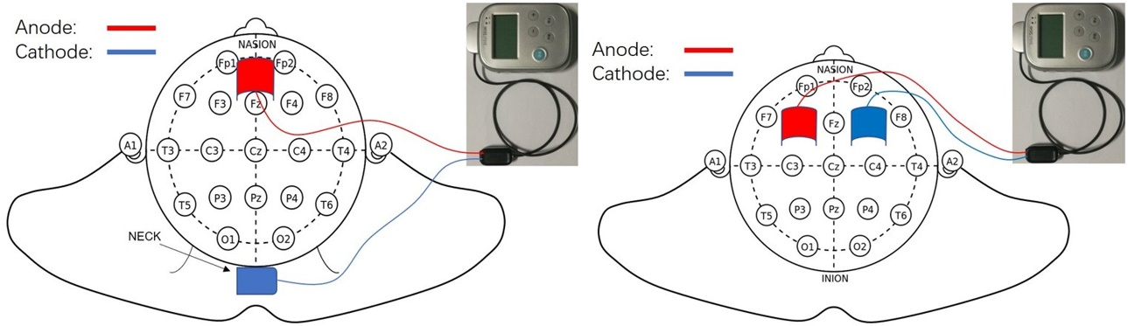
FIG: tDCS (Zhang, X., Liu, B; et.al)
EFFECTS
People with neurological diseases have abnormal resting-state functional connectivity (rsFC), which has been found to be related to the patients' persistent functional impairment. Although the results are inconsistent, transcranial direct current stimulation (tDCS) has recently been shown to improve rsFC. (Chan, M. M., & Han, Y. M).
BRAIN FUNCTION
Establishing non-invasive causal relationships between certain brain regions and the underlying perceptual, cognitive, and motor processes they support is attainable with the aid of tDCS. When tDCS is applied to the primary motor cortex in humans, anodal stimulation enhances neuronal excitability, whereas cathodal stimulation decreases neural excitability, as demonstrated by motor evoked potentials (MEPs) and transcranial magnetic stimulation (TMS) evoked potentials. (Filmer, H. L., Dux; et.al). Only a small number of functional neuroimaging studies have demonstrated changes in cortical activity brought on by performing motor tasks following Tdcs administration. fMRI's main objective is to spot variations in blood flow. According to fMRI studies, the long-term consequences of tDCS activation may have an impact on a motor performance. (Jang, S. H., Ahn, S. H; et.al).
STROKE
A stroke can impair gait by affecting the mobility and function of the lower limbs in a manner similar to how it affects the upper limb. In chronic stroke patients, the primary motor cortex of the ipsilesional leg area received anodal transcranial direct current stimulation (tDCS), which statistically enhanced knee extensor strength in the hemiplegic side. (Min Kyun Sohn; et.al). Transcranial direct current stimulation (tDCS), a novel non-invasive brain stimulation technique, has been proposed as a strategy to improve cognitive function after an ischemic stroke. The primary mechanism of tDCS is to depolarize or hyperpolarize brain tissue, which makes it an effective tool for modifying synaptic plasticity in stroke. (Shaker, H. A; et.al).
PARKINSON
Dopamine-producing cells of the substantia nigra, a part of the brainstem, die, resulting in Parkinson disease (PD), a degenerative neurological illness. The effectiveness of the motor system can be increased by tDCS in both healthy people and people with central nervous system illnesses like Parkinson's disease, according to studies. Many tDCS research have shown how well it works to improve muscle strength and gait speed. (Yotnuengnit, P., Bhidayasiri; et.al) Clinical trials have demonstrated a significant improvement in motor function in patients with Parkinson's disease (PD) when tDCS is combined with anodal stimulation of the primary motor cortex (M1). However, research has paid relatively little attention to the fine-tuning of variables that significantly influenced the therapeutic benefits of tDCS and the examination of the underlying neuronal mechanisms. (Li, H., Lei; et.al).
BALANCE
The central nervous system (CNS) plays a number of roles in postural control. The basic posture and movement patterns are produced by spinal neural networks called central pattern generators (CPGs). With encouraging results for changes in human postural control, transcranial direct current stimulation (tDCS) has grown in favor as a potential therapeutic approach to improve rehabilitation procedures and balance. (de Moura, M. C. D. S; et.al). According to study utilizing magnetic resonance spectroscopy (MRS), cathodal tDCS lowers levels of the excitatory neurotransmitter glutamate whereas anodal tDCS lowers levels of the inhibitory neurotransmitter gamma-aminobutyric acid (GABA). By using tDCS, it is hoped that a proper E/I balance will be reestablished, allowing for adequate homeostatic plasticity in learning and thought.If this keeps happening, there are a number of clinical disorders, like abnormal brain development, that can be successfully treated with tDCS. (Krause, B; et.al)
GAIT
Restoration of gait function is one of the key goals of neurological rehabilitation, even in the chronic stage of illness. You can walk more easily by using robot-assisted gait training (RAGT). Anodal tDCS appears to have no further effects on patients' RAGT, according to preliminary studies. The peculiar neurological architecture of movement, which mixes spinal and brain control, may be the cause of this. In neurological patients, combining it with tDCS and tsDCS may have a significant additional impact on RAGT. (Picelli, A., Chemello, E; et.al). According to the scientists, tDCS of the primary motor cortex paired with treadmill training can increase the advantages on static balance and effectiveness of gait training. (Duarte, N. D. A. C; et.al).
CEREBRAL PALSY
An imbalance between the agonist and antagonist muscles of movement, coordination problems, sensory abnormalities, and weakness are all brought on by the absence of selective motor control and aberrant muscle tone that come along with cerebral palsy (CP) brought on by a brain injury. It is believed that tDCS can enhance motor gains by increasing cortical excitability of the motor area during physical exercise and thus encouraging motor learning and neuroplasticity. (Lazzari, R. D; et.al). The majority of studies found that anodal tDCS combined with other treatments improved spasticity, gait speed and cadence, body sway speed, and balance. School-aged children with Hemiplegic CP saw safe improvements in hand function following anodal transcranial direct current stimulation (tDCS), which is commonly administered alone or in conjunction with other conventional therapies, unilaterally across the main motor cortex (M1) of the affected or more affected hemisphere. (He, W., Huang; et.al).
ILLUSTRATION OF THE EFFECTS
BRAIN
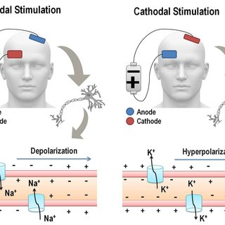
FIG 1 (Rozisky, J. R.; et.al)
STROKE
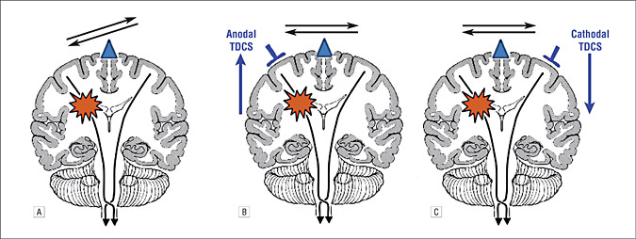
FIG 2 (Schlaug, G., Renga, V; et.al)
PARKINSON
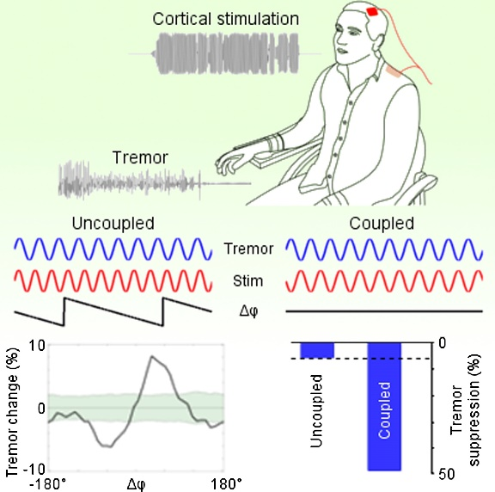
FIG 3 (Brittain, J. S; et.al)
BALANCE AND GAIT
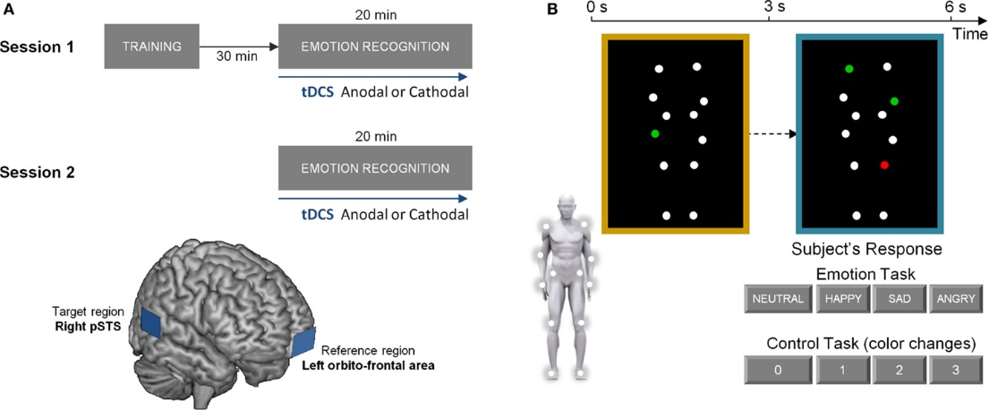
FIG 4 (Vonck, S., Swinnen; et.al)
CEREBRAL PALSY
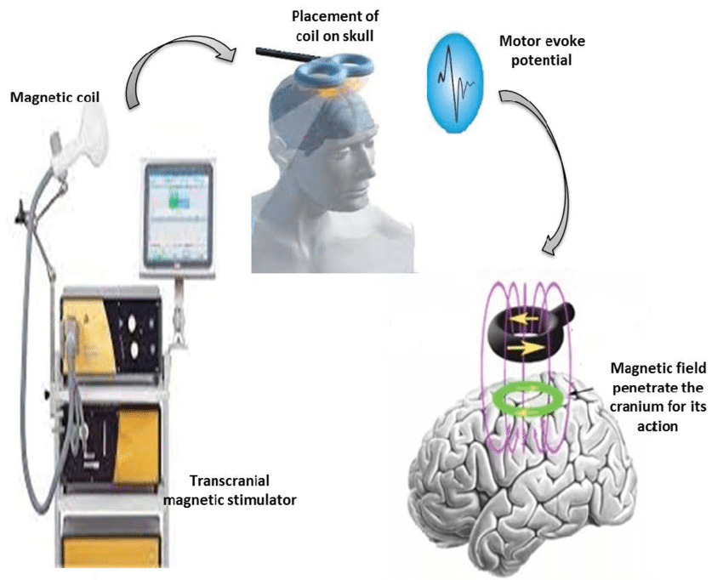
FIG 5 (Gupta, M., Bhatia, D; et.al)
A FEW CITED EXAMPLES OF TDCS CURRENT IN NEUROLOGICAL CONDITIONS
- The methodology used by t-DCS techniques in neurocognitive rehabilitation is described in the current review in terms of its similarities and differences. We evaluate the efficacy of t-DCS for the treatment of specific cognitive deficits in four significant neurological disorders by providing a critical analysis of recent studies that used t-DCS to enhance cognition in patients with Parkinson's disease, Alzheimer's disease, hemi-spatial neglect, and aphasia. There is proof that tDCS can affect cognition thanks to this innovative way of cognitive rehabilitation. We come to the conclusion that more studies using a standardized approach are necessary to properly understand the efficacy of tDCS as a novel tool for the rehabilitation of cognitive deficiencies in a range of neurological disorders. (Cappon, D., Jahanshahi, M; et.al)
- The cerebellum is necessary for both motor and cognitive control. There is a lot of promise for controlling cerebellar excitability with transcranial direct current stimulation (ctDCS). Because it may be used to examine human cerebellum function, is easy to give, is well tolerated, and hasn't shown any appreciable detrimental effects, this technique has gained popularity recently. Notably, the ability of ctDCS to change behavior makes it an appealing technique with a potential therapeutic role for neurological patients. The inferior and posterior areas of the cerebellum (lobules VI–VIII) seem to be most susceptible to ctDCS modulation. As a result, studies into ctDCS as a potential therapy for persons with neurological issues have begun. (Grimaldi, G., Argyropoulos; et.al)
- Motor deficits are a defining feature of Parkinson's disease (PD) development; over time, these deficits become less responsive to dopaminergic treatment and hence pose a therapeutic challenge. We investigated the effects of 8 sessions of anodal tDCS over 2.5 weeks on the motor and prefrontal cortices. The examination was conducted over a period of three months and comprised timed tests of gait (the main outcome measure), bradykinesia in the upper limbs, UPDRS, Serial Reaction Time Task, Beck Depression Inventory, Health Survey, and self-evaluation of mobility. 13 tDCS treatments and 12 sham stimulations. TDCS improved bradykinesia in both the on- and off-states for more than three months, and it temporarily improved gait in several aspects. Changes to the UPDRS, response time, physical and mental health, or self-assessed mobility did not differ between tDCS and sham. The method needs better stimulation parameters in order to be therapeutically effective. There may be therapeutic potential for TDCS of the motor and prefrontal cortices in PD. (Benninger, D. H; et.al)
- To 10 patients with suspected AD, we applied anodal, cathodal, and sham tDCS to the temporoparietal regions over the course of three sessions. Each session included assessments of visual attention and recognition memory at baseline (prestimulation) and 30 minutes later (poststimulation). Following AtDCS, the word recognition memory task's accuracy increased, it decreased following CtDCS, and it remained constant following StDCS. Performance on a recognition memory test can be specifically affected in people with Alzheimer dementia (AD) when transcranial direct current stimulation (tDCS) is delivered over the temporoparietal areas. (Ferrucci, R., Mameli; et.al).
CONCLUSION
It reached the following conclusion after an extensive list of references:
- A new study reveals that tDCS impacts various cortical and subcortical systems in addition to the cortical regions directly below the electrodes. (Yavari, F., Jamil, A; et.al)
- Anodal tDCS may have a considerable impact on the rehabilitation of Working Memory (WM) in mental illnesses, particularly schizophrenia. (Mulquiney, P. G., Hoy; et.al).
- tDCS can help with language processing and articulation, two additional serious issues that arise after a stroke. (Gomez Palacio Schjetnan; et.al)
REFERENCES
- Antal, A., Paulus, W., & Nitsche, M. A. (2009). Principle and mechanisms of transcranial direct current stimulation (tDCS). J Pain Manag, 2(3), 249-58.
- Benninger, D. H., Lomarev, M., Lopez, G., Wassermann, E. M., Li, X., Considine, E., & Hallett, M. (2010). Transcranial direct current stimulation for the treatment of Parkinson's disease. Journal of Neurology, Neurosurgery & Psychiatry, 81(10), 1105-1111.
- Bikson, M., Grossman, P., Thomas, C., Zannou, A. L., Jiang, J., Adnan, T., ... & Woods, A. J. (2016). Safety of transcranial direct current stimulation: evidence based update 2016. Brain stimulation, 9(5), 641-661
- Brittain, J. S., Probert-Smith, P., Aziz, T. Z., & Brown, P. (2013). Tremor suppression by rhythmic transcranial current stimulation. Current Biology, 23(5), 436-440.
- Cappon, D., Jahanshahi, M., & Bisiacchi, P. (2016). Value and efficacy of transcranial direct current stimulation in the cognitive rehabilitation: a critical review since 2000. Frontiers in neuroscience, 10, 157.
- Chan, M. M., & Han, Y. M. (2020). The effect of transcranial direct current stimulation in changing resting-state functional connectivity in patients with neurological disorders: A Systematic review. Journal of central nervous system disease, 12, 1179573520976832.
- de Moura, M. C. D. S., Hazime, F. A., Marotti Aparicio, L. V., Grecco, L. A., Brunoni, A. R., & Hasue, R. H. (2019). Effects of transcranial direct current stimulation (tDCS) on balance improvement: a systematic review and meta-analysis. Somatosensory & motor research, 36(2), 122-135.
- Duarte, N. D. A. C., Grecco, L. A. C., Galli, M., Fregni, F., & Oliveira, C. S. (2014). Effect of transcranial direct-current stimulation combined with treadmill training on balance and functional performance in children with cerebral palsy: a double-blind randomized controlled trial. PloS one, 9(8), e105777.
- Ferrucci, R., Mameli, F., Guidi, I., Mrakic-Sposta, S., Vergari, M., Marceglia, S. E. E. A., ... & Priori, A. (2008). Transcranial direct current stimulation improves recognition memory in Alzheimer disease. Neurology, 71(7), 493-498.
- Filmer, H. L., Dux, P. E., & Mattingley, J. B. (2014). Applications of transcranial direct current stimulation for understanding brain function. Trends in neurosciences, 37(12), 742-753.
- Gomez Palacio Schjetnan, A., Faraji, J., Metz, G. A., Tatsuno, M., & Luczak, A. (2013). Transcranial direct current stimulation in stroke rehabilitation: a review of recent advancements. Stroke research and treatment, 2013.
- Grimaldi, G., Argyropoulos, G. P., Bastian, A., Cortes, M., Davis, N. J., Edwards, D. J., ... & Celnik, P. (2016). Cerebellar transcranial direct current stimulation (ctDCS) a novel approach to understanding cerebellar function in health and disease. The Neuroscientist, 22(1), 83-97
- Gross, C. G. (2012). A hole in the head: more tales in the history of neuroscience. MIT Press.
- Gupta, M., Bhatia, D., & Rajak, B. L. (2017). Study of available intervention technique to improve cognitive function in cerebral palsy patients. Curr Neurobiol, 8(1), 51-59.
- He, W., Huang, Y., He, L., Liu, L., Zeng, P., Qiu, H., ... & Xu, K. (2022). Safety and effects of transcranial direct current stimulation on hand function in preschool children with hemiplegic cerebral palsy: A pilot study. Frontiers in Behavioral Neuroscience, 16, 925122.
- Jang, S. H., Ahn, S. H., Byun, W. M., Kim, C. S., Lee, M. Y., & Kwon, Y. H. (2009). The effect of transcranial direct current stimulation on the cortical activation by motor task in the human brain: an fMRI study. Neuroscience letters, 460(2), 117-120.
- Krause, B., Márquez-Ruiz, J., & Kadosh, R. C. (2013). The effect of transcranial direct current stimulation: a role for cortical excitation/inhibition balance?. Frontiers in human neuroscience, 7, 602.
- Lazzari, R. D., Politti, F., Belina, S. F., Collange Grecco, L. A., Santos, C. A., Dumont, A. J. L., ... & Santos Oliveira, C. (2017). Effect of transcranial direct current stimulation combined with virtual reality training on balance in children with cerebral palsy: a randomized, controlled, double-blind, clinical trial. Journal of motor behavior, 49(3), 329-336.
- Li, H., Lei, X., Yan, T., Li, H., Huang, B., Li, L., ... & Hu, X. (2015). The temporary and accumulated effects of transcranial direct current stimulation for the treatment of advanced Parkinson’s disease monkeys. Scientific reports, 5(1), 12178.
- Mulquiney, P. G., Hoy, K. E., Daskalakis, Z. J., & Fitzgerald, P. B. (2011). Improving working memory: exploring the effect of transcranial random noise stimulation and transcranial direct current stimulation on the dorsolateral prefrontal cortex. Clinical Neurophysiology, 122(12), 2384-2389.
- Nitsche, M. A., Cohen, L. G., Wassermann, E. M., Priori, A., Lang, N., Antal, A., ... & Pascual-Leone, A. (2008). Transcranial direct current stimulation: state of the art 2008. Brain stimulation, 1(3), 206-223.
- Picelli, A., Chemello, E., Castellazzi, P., Roncari, L., Waldner, A., Saltuari, L., & Smania, N. (2015). Combined effects of transcranial direct current stimulation (tDCS) and transcutaneous spinal direct current stimulation (tsDCS) on robot-assisted gait training in patients with chronic stroke: a pilot, double blind, randomized controlled trial. Restorative Neurology and Neuroscience, 33(3), 357-368.
- Rozisky, J. R., Antunes, L. D. C., Brietzke, A. P., de Sousa, A. C., & Caumo, W. (2015). Transcranial direct current stimulation and neuroplasticity. Transcranial direct current stimulation (tDCS): Emerging Used, Safety and Neurobiological Effects. New York: Nova Science Publishers Inc, 1-26
- Schlaug, G., Renga, V., & Nair, D. (2008). Transcranial direct current stimulation in stroke recovery. Archives of neurology, 65(12), 1571-1576.
- Shaker, H. A., Sawan, S. A. E., Fahmy, E. M., Ismail, R. S., & Elrahman, S. A. E. A. (2018). Effect of transcranial direct current stimulation on cognitive function in stroke patients. The Egyptian journal of neurology, psychiatry and neurosurgery, 54(1), 1-8.
- Sohn, M. K., Jee, S. J., & Kim, Y. W. (2013). Effect of transcranial direct current stimulation on postural stability and lower extremity strength in hemiplegic stroke patients. Annals of rehabilitation medicine, 37(6), 759-765.
- Vonck, S., Swinnen, S. P., Wenderoth, N., & Alaerts, K. (2015). Effects of transcranial direct current stimulation on the recognition of bodily emotions from point-light displays. Frontiers in human neuroscience, 9, 438.
- Yavari, F., Jamil, A., Samani, M. M., Vidor, L. P., & Nitsche, M. A. (2018). Basic and functional effects of transcranial Electrical Stimulation (tES)—An introduction. Neuroscience & Biobehavioral Reviews, 85, 81-92.
- Yotnuengnit, P., Bhidayasiri, R., Donkhan, R., Chaluaysrimuang, J., & Piravej, K. (2018). Effects of transcranial direct current stimulation plus physical therapy on gait in patients with Parkinson disease: a randomized controlled trial. American journal of physical medicine & rehabilitation, 97(1), 7-15.
- Zhang, X., Liu, B., Li, N., Li, Y., Hou, J., Duan, G., & Wu, D. (2020). Transcranial direct current stimulation over prefrontal areas improves psychomotor inhibition state in patients with traumatic brain injury: a pilot study. Frontiers in neuroscience, 14, 386.

