IN VITRO ANTI-INFLAMMATORY AND ANTIDIABETIC ACTIVITY OF HIBISCUS ROSA SINENSIS
N V L Suvarchala Reddy V, Ganga Raju M, Konaparthi Sree Bhavya, Korra Anasuya, Polagoni Shrivani, Polisetty Amrutha
Department of Pharmacology
Gokaraju Rangaraju college of Pharmacy
Hyderabad, India.

ABSTRACT
Natural plant products are growing in popularity nowadays as a result of increase in the number of illnesses. The Malvaceae family includes the plant Hibiscus rosa sinensis Linn, which may exist everywhere in the globe. Its leaves, bark, roots, and flowers have been employed to treat a number of ailments in traditional Indian medicine. Hibiscus rosa sinensis, commonly known as the Chinese hibiscus, a plant whose traditional medical uses date back a long time. This research sought to determine if an extract of Hibiscus rosa sinensis (Red tea) would have any in vitro anti-inflammatory and anti-diabetic properties. Through an in vitro experiment that measured the suppression of protein denaturation and anti-proteinase activity, the anti-inflammatory efficacy was assessed. The anti-diabetic activity was assessed through in vitro suppression of the enzymes α-glucosidase and α-amylase. Hibiscus rosa sinensis red tea was used for the activity and compared to acarbose in doses of 10, 20, 30, 40, and 50 g/ml. Anti-proteinase and Protein denaturation model's activity was measured and compared to diclofenac sodium 10–50 g/ml. The findings showed that extracts of Hibiscus rosa sinensis had strong anti-inflammatory and anti-diabetic effects that varied with dosage. Both the anti-inflammatory and the antidiabetic effects of red tea were notable. However, to effectively use these effects as medicinal treatments, these effects must first be verified using in vivo models.
Keywords: Hibiscus rosa-sinensis, Antidiabetic activity, Anti-inflammatory activity, Red Tea.
- INTRODUCTION
The prevalence of diabetes, a fatal and incurable condition, is rising globally. Diabetes incidence is steady [1]. The critical factor controlling blood sugar is insulin. In the case of diabetes mellitus, the body cannot utilize or create enough insulin on its own. Blood sugar is a result of this. Diabetes can cause major health issues like amputations, heart disease, blindness, and kidney failure. It is the seventh most frequent cause of death in the United States. In adults over the age of 18, diabetes was expected to affect 9% of people worldwide in 2014.Over 80% of fatalities from diabetes take place in low- and middle-income nations [2]. In 2030 diabetes will overtake smoking as the seventh biggest cause of death, according to the WHO [3]. The prevalence of diabetes is expected to more than triple from 171 million cases in 2000 to 366 million cases in 2030, with India experiencing the biggest rise [4]. Up to 79.4 million Indians are expected to have diabetes by 2030. Due to the negative side effects of using insulin and oral hypoglycaemic medications, there is an increasing demand from the market for alternative diabetes treatment options such as herbal remedies [5]. More than 200 plants are thought to possess anti-diabetic qualities. The 21,000 plant species used as medicines worldwide are recorded by the World Health Organization (WHO) [7]. The capacity to reduce glucose levels has been found in more than 400 medicinal plants [8]. Different civilizations throughout the world have employed herbal plants for treating diabetes for a number of years [9].
Heat, redness, discomfort, swelling, and altered physiological processes are all signs of inflammation, which is a complicated biological reaction of human tissues to adverse stimuli such pathogens, damaged cells, irritants, injury, infection, or destruction [10]. Chemical mediators released from the damaged tissue and migratory cells serve as its trigger. Non-steroidal anti-inflammatory medicines (NSAIDs) are often prescribed medications for the treatment of inflammatory disorders. These medications inhibit COX-1 and COX-2 enzymes from producing prostaglandins. NSAIDs have a number of side effects, but stomach irritation and subsequent gastric ulcer development are among the most serious. The liver, gastrointestinal tract and other human biological systems are damaged when these medications are used over an extended period of time. Therefore, a novel anti-inflammatory medicine that is safe, effective, nontoxic or less toxic is needed. In many impoverished nations, plant medicines are quite significant in primary healthcare. Anti-inflammatory medications function as stabilizers of the lysosomal membrane. The in vitro anti-diabetic and anti-inflammatory activities of Hibiscus rosa-sinensis flowers were assessed in the current work. The red tea obtained from the flowers was tested for α-glucosidase inhibition activity, α-amylase inhibition activity, anti-proteinase, and protein denaturation ability.
- MATERIALS AND METHODS
Collection of Hibiscus Flowers
Flowers from Hibiscus rosa-sinensis were acquired in February in Hyderabad, Telangana, and were verified by botanist Harikrishna from Osmania University.
Preparation of Red Tea:
Pick fresh hibiscus flowers separate all the petals from the flowers and add the petals into a sufficient quantity of water to allow it to boil for some time (purplish pink color). Allow it to cool; filter it to get red tea extract [11] represented in Figure 1
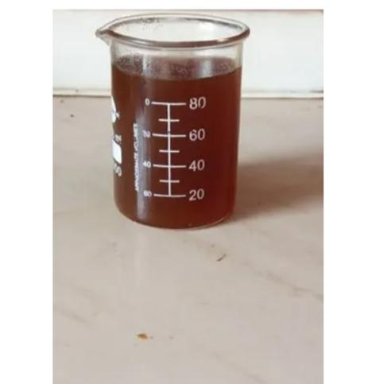
Figure 1: Red tea extract obtained from Hibiscus rosa-sinensis flowers
Calculation of the Extraction Yield:
The extraction yield was calculated using the following equation (%)

$Extraction yield =\frac{weight of the extract following solvent evaporation and freeze drying}{dry mass of the sample }$ × 100

Phytochemical Screening

Screening for phytochemicals was done for the red tea [12].

Proteinase inhibitory assay

The Oyedepo and Femurewa-modified technique for the proteinase inhibitory test was used. The reaction mixture (2 ml) contained varied concentrations of the test plant extract sample, 0.06 mg of trypsin, and 1 ml of Tris-HCl buffer (20 mM, pH 7.4). The reaction mixture received 1 ml of 0.8% (w/v) casein after 5 minutes at 37 °C of incubation. For an additional 20 minutes, the mixture was incubated. To halt the process, 2 ml of 70% perchloric acid was added. The supernatant's absorbance at 210 nm was measured using a Tris-HCl buffer as a reference after centrifuging the cloudy solution. Three times the experiment was run. [13].

Inhibition of protein denaturation method

With minor adjustments, the approach was used to determine the inhibition of protein denaturation. The reaction mixture included 1% BSA (aqueous solution) and various amounts of the test extract. 1 N HCl was used to change the pH of the reaction mixture. The samples were heated for 20 minutes at 37 °C, followed by 20 minutes at 57 °C, and then allowed to cool [14]. At 660 nm, the samples' turbidity was determined. Three duplicates of the experiment were run.
The following formula was used to compute the percent inhibition of protein denaturation:
Percentage inhibition = (A_{C} of control–A_{C} of test sample) × 100/A_{C}), where A_{C} and A_{S} represent the absorbances of the control and sample, respectively, at 600 nm.
α-amylase inhibitory activity
Red tea's ability to inhibit α-amylase was tested using the conventional procedure with a few minor modifications. The reaction mixture was preincubated at 37°C for 20 min using the following ingredients: 50 μl phosphate buffer (100 mM, pH = 6.8), 10 μl -amylase (2 U/ml), and 20 μl of various concentrations of red tea (10, 20, 30, 40, and 50 μg/ml). The substrate was then added, 20 μl of 1% soluble starch (100 mM phosphate buffer pH 6.8), and incubated for a further 30 minutes at 37°C. Next, 100 μl of the DNS color reagent was added and heated for 10 minutes. Using a UV Spectrophotometer, the mixture's absorbance at 540 nm was determined. As a standard, acarbose was utilized in a range of concentrations (10, 20, 30, 40, and 50 μg/ml). Each experiment run in triplicates and uses a control drug (red tea) in parallel to the test substance.
Percentage inhibition was used to express the results, and it was computed using the method [15].
Inhibitory activity (%) = (1 − A_{s}/A_{c}) ×100, Both A_{s} and A_{c} represent the absorbances in the presence of the test material and control, respectively.

α-glucosidase inhibitory activity
Red tea's α-glucosidase inhibitory activity was tested using the conventional procedure with a few minor modifications. The reaction mixture was pre-incubated at 37°C for 15 minutes and contained 50 μl of phosphate buffer (100 mM, pH = 6. 8), 10 μl of α-glucosidase (1 U/ml), and 20 μl of various quantities of extract and fractions (0.1, 0.2, 0.3, 0.4, and 0.5 mg/ml). The reaction was then preceded for a further 20 minutes at 37°C with the addition of the substrate to 20 μl of P-NPG (5 mM). With the addition of 50 μl of 0.1 M Na2 CO3, the reaction was stopped. Using a UV Spectrophotometer, the emitted p-nitrophenol's absorbance was determined at 405 nm. As a standard, acarbose was added at various quantities (10, 20, 30, 40, and 50 μg/ml). A control configuration that was parallel to the test setup was used to conduct each experiment three times. The findings were obtained using the formula [16]
Inhibitory activity (%) = (1 − A_{s}/A_{c}) ×100, Where, A_{s} represents the absorbance while the test drug is present and A_{c} represents the absorbance of the control.

RESULTS

According to phytochemical study, the flavonoids, tannins, terpenoids, saponins, and alkaloids listed in Table 1 are the principal bioactive chemicals responsible for the chemical composition.
Table 1: Preliminary phytochemical screening
Phytochemical constituents | Results
Flavonoids | ++
Tannins | +
Terpenoids | +++
Saponins | ++
Alkaloids | +
Note: + indicates presence
Assessment of in-vitro anti-inflammatory activity
Different Hibiscus rosa sinensis extracts were tested for their ability to reduce protein denaturation, proteinase activity, and in vitro anti-inflammatory potential was estimated.
Antiproteinase action
In this method the red tea extract from Hibiscus rosa sinensis showed graded inhibition which was found to be increasing with increasing concentrations i.e., at 10 µg/ml it showed 15% inhibition and at 50 µg/ml it exhibited 71% when compared to the standard Diclofenac Sodium at 10 µg/ml it showed 10% inhibition and at 50 µg/ml it exhibited 57%. Comparing the IC50 value of red tea to that of diclofenac sodium, which was determined to be 34.09 µg/ml in Table 2, the red tea value was found to be 38.46 µg/ml.
Table 2: Antiproteinase activity of Hibiscus rosa sinensis red tea and standard drug
Name of the compound | Concentration (µg/ml) | % inhibition | IC ₅₀
Hibiscus rosa sinensis  red tea | 10 | 15 | 38.46
 | 20 | 23
 | 30 | 39
 | 40 | 57
 | 50 | 71
Diclofenac Sodium | 10 | 10 | 34.09
 | 20 | 15
 | 30 | 44
 | 40 | 52
 | 50 | 57
Inhibition of protein denaturation method
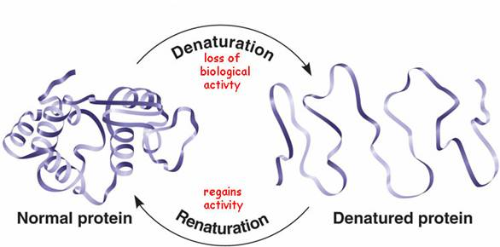
Figure 2: The way that the protein denaturates
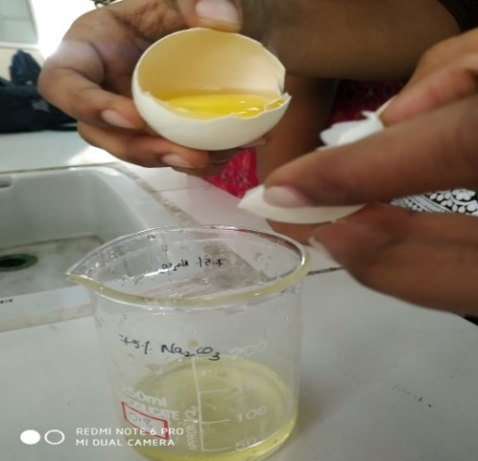
Figure 3: Extraction of egg albumin

Protein denaturation inhibition
In this method, the red tea extract from Hibiscus rosa sinensis showed graded inhibition, which was found to be increasing with increasing concentrations, i.e., at 10 µg/ml it showed 29% inhibition, and at 50 µg/ml it exhibited 69% when compared to the standard Diclofenac Sodium at 10 µg/ml it showed 24% inhibition and at 50 µg/ml it exhibited 90%. According to Table 3, red tea's IC50 value was determined to be 31.323 µg/ml, which was higher than diclofenac sodium's IC50 value of 3.479 µg/ml Figure 2 depicts the denaturation process, while Figure 3 shows how to remove albumin from eggs.
Table 3: Protein denaturation of Hibiscus rosa sinensis red tea and standard drug
Name of the compound | Concentration (µg/ml) | % inhibition | IC ₅₀
Diclofenac sodium | 10 | 29 | 31.323
 | 20 | 38
 | 30 | 47
 | 40 | 53
 | 50 | 69
Hibiscus rosa sinensis red tea | 10 | 24 | 39.47
 | 20 | 25
 | 30 | 38
 | 40 | 68
 | 50 | 90
Assessment of in vitro Anti diabetic Activity
α-Amylase inhibition assay
In this method, the red tea extract from Hibiscus rosa sinensis showed graded inhibition, which was found to be increasing with increasing concentrations, i.e., at 10 µg/ml it showed 31% inhibition, and at 50 µg/ml it exhibited 85% of the standard acarbose, and at 50 µg/ml it exhibited 80% inhibition. In comparison to acarbose, which exhibited an IC50 value of 21.6 µg/ml, red tea was discovered to have an IC50 value of 38.46 µg/ml, as shown in Table 4. Figure 4 shows the method by which it functions.
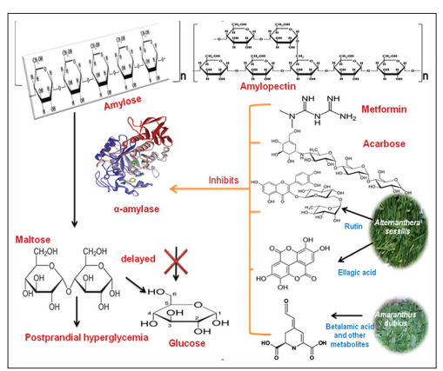
Figure 4: Mechanism of α-amylase enzyme in inhibition assay

Table 4: α-amylase activity of Hibiscus rosa sinensis red tea and standard drug
Name of the compound | Concentration (µg/ml) | % inhibition | IC₅₀
Acarbose | 10 | 31 | 21.6
 | 20 | 46
 | 30 | 55
 | 40 | 83
 | 50 | 85
Hibiscus rosa sinensis (red tea) | 10 | 14 | 38.6
 | 20 | 26
 | 30 | 39
 | 40 | 53
 | 50 | 80
Percentage inhibition = (Abs control –Abs sample) X 100/ Abs control
α-Glucosidase inhibition assay
In this method, the red tea extract from Hibiscus rosa sinensis showed graded inhibition, which was found to be increasing with increasing concentrations, i.e., at 10 µg/ml it showed 31% inhibition, and at 50 µg/ml it exhibited 89% of the standard acarbose, and at 50 µg/ml it exhibited 78%. According to Table 5, red tea's IC50 value was discovered to be 44.1 µg/ml, which was higher than acarbose's IC50 value of 27.7 µg/ml.
Table 5: α-Glucosidase inhibition assay of Hibiscus rosa sinensis red tea and standard drug
Name of the compound | Concentration  (µg/ml) | % inhibition | IC₅₀
Acarbose | 10 | 31 | 27.7
 | 20 | 36
 | 30 | 57
 | 40 | 78
 | 50 | 89
Hibiscus rosa sinensis (red tea) | 10 | 10 | 44.11
 | 20 | 21
 | 30 | 34
 | 40 | 63
 | 50 | 78

Percentage inhibition = (Abs control –Abs sample) X 100/ Abs control
- DISCUSSION
Hibiscus rosa sinensis red tea extract was tested for its anti-inflammatory properties using the anti-proteinase and protein denaturation method. Alkaloids, tannins, flavonoids, steroids, and phenols, which are polyphenolic chemicals found in the plant extract, imply that the extract has potent anti-inflammatory properties. The well-understood cause of inflammation is the denaturation of proteins. Plant extracts ability to stop the denaturation of protein is investigated. When compared to the standard medication diclofenac sodium, the extract was efficient at preventing protein denaturation [17]. Proteinase inhibitors have been demonstrated to provide a high level of protection against tissue damage, which has been linked to leukocyte proteinase's role in the occurrence of inflammatory reactions. Contrasting the red tea extract with the generic medication [18].
The Pancreatic α-amylase and intestinal α-glucosidase enzyme are responsible for the carbohydrate metabolism, which raises blood sugar levels. When these enzymes are inhibited, the metabolism of carbohydrates slows down, which reduces the amount of glucose absorbed from the gut. The main phytoconstituents such as phenols, flavonoids, tannins and other bioactive substances possess α-amylase and α-glucosidase inhibitory activity resulting in regulation of postprandial hyperglycaemia. The efficacy of the red tea extract of Hibiscus rosa sinensis to inhibit alpha-amylase and alpha-glucosidase was investigated in this work. As a result, the current findings show that Hibiscus rosa sinensis may be useful in the treatment of postprandial hyperglycemia. [19].
- CONCLUSION
Flowers contain a lot of flavonoids and other bioactive substances, which may explain why they have a hypoglycaemic impact. Additional research is required to clarify the mechanism of action and establish its anti-diabetic potential in people. The red tea extract stopped heat-induced denaturation of proteins and proteinase activity from occurring due to the existence of polyphenolic compounds such alkaloids, flavonoids, tannins, steroids, and phenols that have significant anti-inflammatory characteristics. This study suggests that a constituent of the Hibiscus rosa sinensis plant may provide the basis for the creation of potent anti-inflammatory and anti-diabetic drugs that may potentially be utilized to treat other ailments.
REFERENCES
- Subramonium, A., Babu, V., Standardised phytomedicines for Diabetes. In: Role of Biotechnology in Medicinal and Aromatic plants, 2003, pp. 3-46.
- World Health Organization. Global Health Estimates: Deaths by Cause, Age, Sex and Country, 2014, Geneva.
- Mathers, C. D., Loncar, D., Projections of global mortality and burden of disease from 2002 to 2030. PLoS Med. 2006;3(11):442.
- Wild S, Roglic G, Green A, Sicree R, King H. Global prevalence of diabetes-estimates for the year 2000 and projections for 2030. Diabetes Care. 2004;27(3):1047–1053.
- Ali H, Houghton PJ, Soumyanath A. α-amylase inhibitory activity of some Malaysian plants used to treat diabetes with particular reference to Phyllanthus amarus. Journal of Ethnopharmacology. 2006;107:449-455.
- Karthic K, Kirthiram KS, Sadasivam S, Thayumanavan B. Identification of α-amylase inhibitors from Syzygium cumini Linn seeds. Indian Journal of Experimental Biology. 2008;46:677-680.
- Modak M, Dixit P, Londhe J, Ghaskadbi S, Devasagayam TPA. Indian herbs and herbal drugs used for the treatment of diabetes. Journal of Clinical Biochemistry and Nutrition. 2007;40:163-173.
- Luo Q, Cai Y, Yan J, Sun M, Corke H. Hypoglycemic and hypolipidemic effects and antioxidant activity of fruit extracts from Lycium barbarum. Life Sciences. 2004;76:137-149.
- Bhandari MR, Anurakkum NJ, Hong G, Kawabata J. α-Glucosidase and α-amylase inhibitory activities of Nepalese medicinal herb pakhanbhed (Bergenia ciliate Haw.). Food Chemistry. 2008; 106:247-252.
- Ferrero-Miliani L, Nielsen OH, Andersen PS, Girardin SE, Anderse N, Girardin. Chronic inflammation: importance of NOD2 and NALP3 in interleukin-1beta generation. Clin. Exp. Immunol. 2007;147 (2):227–235.
- Sanadheera S, Subasinghe D, Solangaarachchi MN, Suraweera M, Suraweera NY, Tharangika N. Hibiscus rosa-sinensis L. (red Hibiscus) Tea, Can It Be Used as A Home-Remedy to Control Diabetes and Hypercholesterolemia? Biology, Medicine, & Natural Product Chemistry 2021;10 (1): 59-65.
- Suvarchala Reddy NVL, Anarthe SJ, Raghavendra NM. In vitro Antioxidant and antidiabetic activity of Asystasia gangetica (Chinese violet) Linn. (Acanthaceae). International Journal of Research in Pharmaceutical and Biomedical Sciences. 2010; 1(2): 72-75.
- Leelaprakash G, Dass SM. In vitro anti-inflammatory activity of methanol extract of Enicostemma axillare. International Journal of Drug Development and Research. 2011 Jul;3(3):189-96.
- Chirumamilla P, Taduri S. Assessment of in vitro anti-inflammatory, antioxidant and antidiabetic activities of Solanum khasianum Clarke. Vegetos. 2023;36:575–582.
- Suvarchala Reddy NVL, Mary JL, Raghavendra NM and Subrahmanyam CVS. Antidiabetic and Antioxidant activity of Rhynchosia beddomei Baker. American Journal of Phytomedicine and Clinical Therapeutics. 2014; 2(11):1323-1332.
- Suvarchala Reddy NVL, Akhila M, Subrahmanyam CVS, Trimurtulu G and Raghavendra NM. Isolation, in vitro antidiabetic, antioxidant activity and molecular docking studies of pentacyclic triterpenoids from Syzygium alternifolium (wt.) Walp. Journal of Pharmacy and Biological Sciences. 2015; 10(6): 22-27.
- Begum Z, Younus I, Khan H. Analgesic and anti-inflammatory activities of the ethanol extract of Hibiscus rosa sinensis Linn (roots). Pak J Pharm Sci. 2018;31(5):1927-1933.
- Viado AEE, Purnamasari L, and dela Cruz JF. Anti-Diabetic Effects of Hibiscus spp. Extract in Rat and Mice Models: A Review. Jurnal Gizi Indonesia (The Indonesian Journal of Nutrition). 2022;11(1):39-48.
- Anieska Eunice E. Viado, Listya Purnamasari, Joseph F. Dela Cruz, Anti-Diabetic Effects of Hibiscus spp. Extracts in Rat and Mice Models &amp; Jurnal Gizi Indonesia, 2022 Dec; vol. 11: 38-48

