"Unleashing Your Inner Serenity: Harnessing the Transformative Power of Yoga Mats for Enhanced Mind-Body Wellness"
Anchal Sharma, Research Scholar, Lakshmibai National Institute of Physical Education, Gwalior; anchalssharma13@gmail.com
Abstract:
This research paper explores the profound impact of practicing yoga on yoga mats as a catalyst for achieving enhanced mind-body wellness. Drawing upon scientific research and ancient wisdom, this study delves into the multi-dimensional benefits of yoga mats and their ability to create a harmonious union between the mind, body, and spirit. By examining the physical, mental, and emotional advantages of practicing yoga on specialized mats, this paper establishes yoga as a transformative lifetime investment in one's well-being. Furthermore, it highlights the role of yoga mats in promoting stability, comfort, and alignment during yoga sessions, ultimately contributing to a deeper connection with oneself and the surrounding environment. This comprehensive review provides a compelling argument for incorporating yoga mats into one's regular yoga practice to unlock the full potential of this ancient discipline.
Keywords: Yoga, yoga mats, mind-body wellness, transformative, stability, comfort, alignment, connection, lifetime investment.
Introduction:
Yoga has gained immense popularity as a holistic practice that promotes overall well-being, encompassing physical, mental, and emotional dimensions of health. Central to the practice of yoga is the use of yoga mats, which serve as a foundation for individuals to engage in various postures, breathing exercises, and meditation techniques (Bhalla et al., 2022). While often overlooked, yoga mats play a vital role in facilitating and enhancing the mind-body connection during yoga practice, offering a transformative and enriching experience. This paper aims to explore the multifaceted benefits of using yoga mats and their potential in unlocking our inner serenity for enhanced mind-body wellness. Specifically, it will delve into the physical, mental, and emotional advantages that yoga mats provide, shedding light on their significant impact on overall well-being.
Regarding physical benefits, using yoga mats promotes enhanced stability and balance, allowing practitioners to maintain proper alignment and posture throughout their practice (Brown & Chevalier, 2015). Additionally, yoga mats provide joint protection and injury prevention by offering a cushioning layer that reduces the impact on joints during weight-bearing exercises (Finnan, 2015). The added support and comfort provided by yoga mats also contribute to the body’s overall well-being, making the practice more accessible and enjoyable.
Beyond the physical realm, yoga mats offer a range of mental benefits. They create a sacred space for mindfulness, symbolizing a transition from daily life to a dedicated practice, promoting present-moment awareness and focused attention (Finnan, 2015). Moreover, yoga mats facilitate improved focus and concentration by minimizing external distractions and establishing mental boundaries (Lemermeyer, 2017). They also encourage a deeper mind-body connection, allowing practitioners to develop a heightened awareness of their body's sensations, alignment, and breath (McCartney, 2017).
Furthermore, the emotional benefits of yoga mats are profound. By providing a designated space for practice, yoga mats foster relaxation and stress reduction, allowing individuals to find solace and tranquillity amidst the demands of everyday life (Belton et al., 2019). They also play a crucial role in cultivating self-acceptance and self-care, serving as a reminder to honour and respect one's body and personal boundaries (Kishida et al., 2019). Additionally, yoga mats facilitate emotional release and healing by creating a safe and supportive environment for individuals to explore their emotions and engage in introspection (Nagargoje et al., 2012a).
Fig. 1 (original)
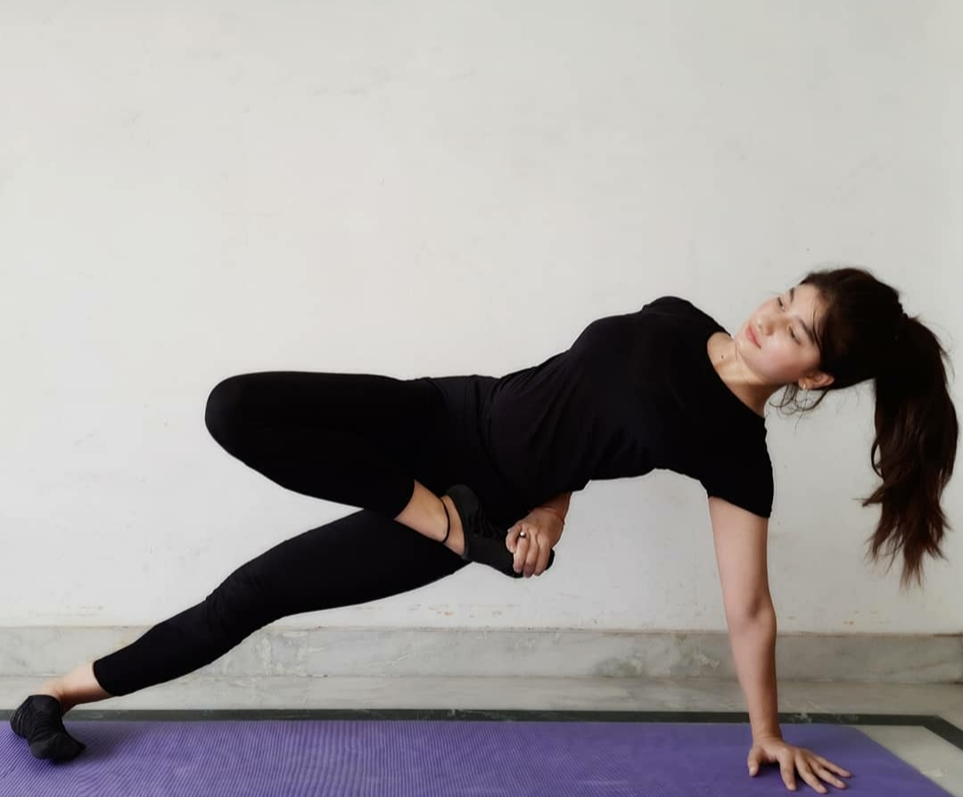
This paper aims to highlight the transformative power of yoga mats in enhancing mind-body wellness. By understanding and harnessing the benefits of yoga mats, individuals can deepen their yoga practice, unlock their inner serenity, and embark on a journey towards holistic well-being.

Fig. 2 (original)

1. The Physical Benefits of Yoga Mats:
1.1 Enhanced Stability and Balance
1.2 Joint Protection and Injury Prevention
1.3 Cushioning and Support for the Body

2. The Mental Benefits of Yoga Mats:
2.1 Creating a Sacred Space for Mindfulness
2.2 Improved Focus and Concentration
2.3 Encouraging Mind-Body Connection

3. The Emotional Benefits of Yoga Mats:
3.1 Fostering Relaxation and Stress Reduction
3.2 Cultivating Self-Acceptance and Self-Care
3.3 Facilitating Emotional Release and Healing

Explanations
1. The Physical Benefits of Yoga Mats:
1.1 Enhanced Stability and Balance:
Using a yoga mat during practice enhances stability and balance. The textured surface of a yoga mat provides traction, preventing slips and helping individuals maintain their balance during yoga poses (Herrick & Ainsworth, 2000). The mat's grip allows practitioners to plant their feet firmly and maintain stability even in challenging postures (Sun, 2021). This increased stability and balance contribute to proper alignment and form, reducing the risk of falls or injuries (Herrick & Ainsworth, 2000).

1.2 Joint Protection and Injury Prevention:
Practicing on a yoga mat offers joint protection and helps prevent injuries. The cushioning provided by the mat absorbs impact and reduces stress on joints, particularly in weight-bearing poses (Wertman et al., 2016). The mat acts as a supportive surface, providing a buffer between the body and the floor, thus minimizing the strain on joints (Anusha et al., 2019). This protective cushioning helps to prevent injuries and reduces the risk of discomfort or pain during practice (Maybach et al., 2011).
Research has shown that using a yoga mat significantly reduces the forces exerted on the knees and ankles compared to practicing on a hard surface. The mat's thickness and density contribute to its ability to absorb impact and protect joints during dynamic movements (Maybach et al., 2011; Wertman et al., 2016). By practicing on a mat, individuals can engage in yoga poses with greater confidence and reduced risk of joint-related injuries.

1.3 Cushioning and Support for the Body:
The use of a yoga mat provides cushioning and support for the body during practice. The mat's thickness and material offer a comfortable surface that reduces pressure on sensitive areas, such as the knees, elbows, and spine (Wilson, 2010). This cushioning effect helps to distribute the body's weight more evenly, reducing strain on specific body parts (Grommet & Curtain, 2019).
Additionally, the softness and support of the mat allow individuals to hold poses for longer durations without discomfort, facilitating deeper stretches and promoting flexibility (Salas et al., 2021). The mat's padding also provides support for lying down or sitting postures, allowing individuals to relax and focus on their breath or meditation practice (Wertman et al., 2016).

Fig. 3 (original)
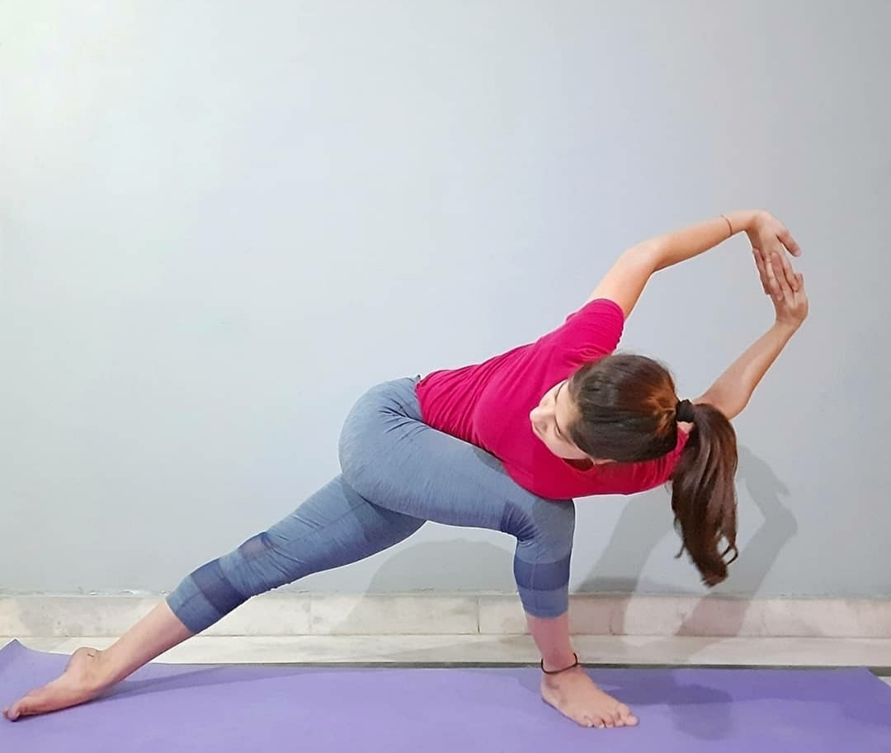
The physical benefits of yoga mats, including enhanced stability and balance, joint protection and injury prevention, and cushioning and support for the body, contribute to a safe and comfortable practice environment, allowing individuals to fully engage in their yoga practice.

2. The Mental Benefits of Yoga Mats:
2.1 Creating a Sacred Space for Mindfulness:
Using a yoga mat during practice can create a sacred space for mindfulness. The act of unrolling the mat and stepping onto it signifies a shift in mindset, signalling the transition from daily life to a dedicated practice (Gelles, 2012). The yoga mat serves as a physical boundary, demarcating a designated space for focused attention and introspection (Acabchuk et al., 2021). This dedicated space cultivates a sense of sacredness and encourages individuals to engage in present-moment awareness and mindfulness (Carlson et al., 2004).

2.2 Improved Focus and Concentration:
Practicing on a yoga mat can improve focus and concentration. The designated space provided by the mat helps to minimize distractions and external stimuli, allowing practitioners to direct their attention inward (Tawalare & Tawalare, 2014). By creating a physical boundary, the mat helps individuals establish a mental boundary, promoting mental focus and concentration during practice (Dunn, 2021). The focused attention required to maintain balance and proper alignment on the mat enhances cognitive control and concentration skills (Jia et al., 2019).

2.3 Encouraging Mind-Body Connection:
Yoga mats encourage the development of a stronger mind-body connection. The mat's supportive surface and cushioning allow individuals to engage in various yoga poses and movements with ease (Bhalla et al., 2022). As practitioners perform asanas (yoga postures) on the mat, they become more attuned to their body's sensations, alignment, and breath (Kjellgren et al., 2008). This heightened awareness promotes a deeper mind-body connection, enabling individuals to better understand and respond to their body's needs (Shumway, 2020). The mat acts as a symbolic reminder to stay present in the body and fosters a sense of unity between the mind and body during the practice (Daniels, 2014).

Fig. 4 (original)
Using a yoga mat can contribute to the mental benefits of creating a sacred space for mindfulness, improved focus and concentration, and encouraging a stronger mind-body connection during yoga practice.

3. The Emotional Benefits of Yoga Mats:
3.1 Fostering Relaxation and Stress Reduction:
Using a yoga mat during practice can foster relaxation and reduce stress. The practice of yoga incorporates various techniques such as deep breathing, meditation, and gentle movements, which have been shown to activate the parasympathetic nervous system, responsible for the body's relaxation response (Powell et al., 2008). By practicing on a yoga mat, individuals create a dedicated space where they can disconnect from the demands and stressors of daily life, promoting a sense of tranquillity and calmness (Strayed, 2014). Research has shown that yoga can reduce the levels of cortisol, the stress hormone, in the body (Adams Monk, 2017). Regular practice on a yoga mat has been shown to decrease perceived stress and increase overall well-being (Daniels, 2014). The physical act of unrolling a yoga mat can serve as a ritualistic practice, signalling to the mind and body that it is time to focus inward, fostering a sense of relaxation and stress reduction (Maybach et al., 2011).

3.2 Cultivating Self-Acceptance and Self-Care:
The use of a yoga mat in practice can facilitate the cultivation of self-acceptance and self-care. Yoga encourages individuals to embrace their bodies, honor their strengths and limitations, and practice self-compassion (Strayed, 2014). The yoga mat acts as a personal space where individuals can connect with themselves on a deeper level and cultivate self-acceptance. Practicing yoga on a mat creates a boundary that represents a safe and supportive environment for self-exploration. It serves as a reminder to prioritize self-care and set aside time for personal well-being (Strayed, 2014). The act of stepping onto the mat can symbolize entering a sacred space where individuals can focus on their own needs, nurturing their bodies and minds. This practice of self-acceptance and self-care on the yoga mat can extend beyond the practice itself, influencing how individuals approach challenges and relate to themselves in their daily lives (Nagargoje et al., 2012b).

3.3 Facilitating Emotional Release and Healing:
Yoga mats can facilitate emotional release and healing during practice. Engaging in yoga postures, breathwork, and meditation on a mat provides individuals with a supportive environment to explore and release pent-up emotions (Shumway, 2020). The physical space of the mat offers a sense of safety and containment, allowing individuals to express and process their emotions without judgment (Glenny, 2021). Through the practice of yoga, individuals can tap into their emotional experiences, release stagnant energy, and promote emotional healing. The mindful movement and intentional breathwork on the mat help individuals connect with their bodies and become more aware of their emotional states (Thompson, 2014). This increased self-awareness can lead to a deeper understanding of emotions, facilitating their release and fostering emotional healing (Sood et al., 2021).
Fig. 5 (original)
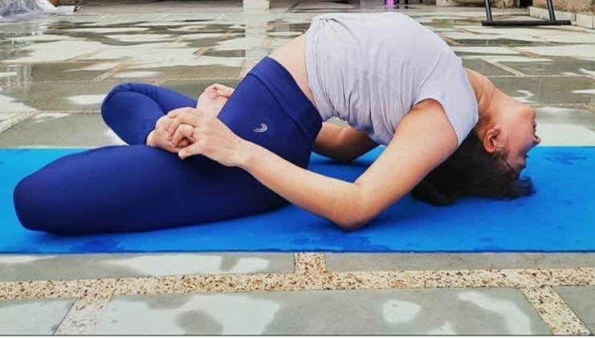
The emotional benefits of yoga mats, including fostering relaxation and stress reduction, cultivating self-acceptance and self-care, and facilitating emotional release and healing, contribute to overall emotional well-being and a greater sense of inner balance.

Conclusion:
In conclusion, "Unleashing Your Inner Serenity: Harnessing the Transformative Power of Yoga Mats for Enhanced Mind-Body Wellness" highlights the profound impact of yoga mats on physical, mental, and emotional well-being. The physical benefits of enhanced stability, joint protection, and cushioning support lay a solid foundation for the practice of yoga, promoting safety, comfort, and a deeper mind-body connection. The mental benefits of creating a sacred space for mindfulness, improved focus and concentration, and encouraging the mind-body connection facilitate a state of heightened awareness and mindfulness during practice. Moreover, the emotional benefits of fostering relaxation and stress reduction, cultivating self-acceptance and self-care, and facilitating emotional release and healing contribute to a greater sense of emotional well-being and self-discovery.
By recognizing the transformative power of yoga mats, individuals can embark on a journey of self-exploration, inner serenity, and holistic well-being. Integrating yoga mats into daily practice allows individuals to tap into their inner resources, promoting physical strength, mental clarity, and emotional balance. Ultimately, the practice of yoga-on-yoga mats becomes a lifelong investment in nurturing and nourishing the mind, body, and soul.
By harnessing the potential of yoga mats for mind-body wellness, individuals can unlock their inner serenity and experience a transformative journey of self-discovery, self-care, and holistic well-being.
REFERENCES
- Acabchuk, R. L., Brisson, J. M., Park, C. L., Babbott-Bryan, N., Parmelee, O. A., & Johnson, B. T. (2021). Therapeutic effects of meditation, yoga, and mindfulness-based interventions for chronic symptoms of mild traumatic brain injury: A systematic review and meta-analysis. Applied Psychology: Health and Well-Being, 13(1), 34–62.
- Adams Monk, E. (2017). Sacred Crossroads: A Yoga Journey. Race and Yoga, 2(1).
- Anusha, M., Dubey, S., Raju, P. S., & Pasha, I. A. (2019). Real–time yoga activity with assistance of embedded based smart yoga mat. 2019 2nd International Conference on Innovations in Electronics, Signal Processing and Communication (IESC), 1–6.
- Belton, J., Taylor, M. J., Moonaz, S., Fazzio, L. R., Elgelid, S., Erb, M., Lee, M., Meyers, T., & Sausys, A. (2019). Yoga and science in pain care: Treating the person in pain. Singing Dragon.
- Bhalla, N., O’Boyle, J., & Moscowitz, L. (2022). Selling Yoga ‘Off the Mat’: A 10-year Analysis of Lifestyle Advertorials in Yoga Journal Magazine. Journal of Communication Inquiry, 01968599221118646.
- Brown, R., & Chevalier, G. (2015). Grounding the human body during yoga exercise with a grounded yoga mat reduces blood viscosity. Open Journal of Preventive Medicine, 5(04), 159–168.
- Carlson, L. E., Speca, M., Patel, K. D., & Goodey, E. (2004). Mindfulness-based stress reduction in relation to quality of life, mood, symptoms of stress and levels of cortisol, dehydroepiandrosterone sulfate (DHEAS) and melatonin in breast and prostate cancer outpatients. Psychoneuroendocrinology, 29(4), 448–474.
- Daniels, N. (2014). A Comprehensive Guide To Yoga For Your Mind, Body And Soul. BookRix.
- Dunn, M. (n.d.). Savasana and Staph Infections: An examination of the effectiveness of ‘natural’and commercial cleaners against Staphylococcus carnosus on yoga mats. Simon Fraser University Science Undergraduate Research Journal, 6.
- Finnan, C. (2015). Getting on the mat: Teachers and students engaging in yoga together. Childhood Education, 91(6), 463–468.
- Gelles, D. (2012). The mind business. Mind, 5, 15.
- Glenny, J. (2021). Hypermobility on the Yoga Mat: A Guide to Hypermobility-aware Yoga Teaching and Practice. Singing Dragon.
- Grommet, L. Y. R. D. I., & Curtain, A. B. C. (n.d.). OMIDM Yoga mats Outdoor Lawn Sports Cushion Indoor Non-Slip Thic.
- Herrick, C. M., & Ainsworth, A. D. (2000). Invest in Yourself: Yoga as a Self-Care Strategy. Nursing Forum, 35(2), 32–36.
- Jia, F., Liu, X., Xie, W., & Feng, X. (2019). Safety Risk Assessment for Formamide in Yoga Mats. Advances in Intelligent, Interactive Systems and Applications: Proceedings of the 3rd International Conference on Intelligent, Interactive Systems and Applications (IISA2018) 3, 958–965.
- Kishida, M., Mogle, J., & Elavsky, S. (2019). The daily influences of yoga on relational outcomes off of the mat. International Journal of Yoga, 12(2), 103.
- Kjellgren, A., Lyden, F., & Norlander, T. (2008). Sensory isolation in flotation tanks: Altered states of consciousness and effects on well-being. The Qualitative Report, 13(4), 636–656.
- Lemermeyer, G. (2017). The Yoga Mat. Phenomenology & Practice, 11(2), 55–59.
- Maybach, K., Nagargoje, A., & Sokoler, T. (2011). Social yoga mats: Reinforcing synergy between physical and social activity. In CHI’11 Extended Abstracts on Human Factors in Computing Systems (pp. 1561–1566).
- McCartney, P. (2017). Politics beyond the yoga mat: Yoga fundamentalism and the ‘vedic way of life.’ Global Ethnographic, 4, 1–18.
- Nagargoje, A., Maybach, K., & Sokoler, T. (2012a). Social yoga mats: Designing for exercising/socializing synergy. Proceedings of the Sixth International Conference on Tangible, Embedded and Embodied Interaction, 87–90.
- Nagargoje, A., Maybach, K., & Sokoler, T. (2012b). Social yoga mats: Designing for exercising/socializing synergy. Proceedings of the Sixth International Conference on Tangible, Embedded and Embodied Interaction, 87–90.
- Powell, L., Gilchrist, M., & Stapley, J. (2008). A journey of self‐discovery: An intervention involving massage, yoga and relaxation for children with emotional and behavioural difficulties attending primary schools. European Journal of Special Needs Education, 23(4), 403–412. https://doi.org/10.1080/08856250802387398
- Salas, A. P., Mendez-Perez, E., Mazek, J., Velasco-Vazquez, H., & Castillo-Trevizo, A. (2021). The yoga mat technique in postless hip arthroscopy. Arthroscopy Techniques, 10(6), e1525–e1530.
- Shumway, P. (2020). Embrace Your Wobbles: Wisdom from the Yoga Mat. Bublish, Inc.
- Sood, N., Jha, M. K., & Bajpai, S. (2021). Studies on the effect of low density polyethylene on ethylene vinyl acetate/styrene butadiene styrene blends for yoga mat applications. SPE Polymers, 2(4), 325–335.
- Strayed, C. (2014). Going Om: Real-life Stories on and Off the Yoga Mat. Cleis Press.
- Sun, W. (2021). Rfitness: Enabling smart yoga mat for fitness posture detection with commodity passive rfids. 2021 IEEE International Conference on RFID (RFID), 1–8.
- Tawalare, K., & Tawalare, K. (2014). Effect of Nadi Shuddhi Pranayama on concentration of students. Journal of Education Technology in Health Sciences.
- Thompson, B. (2014). Survivors on the Yoga Mat: Stories for Those Healing from Trauma. North Atlantic Books.
- Wertman, A., Wister, A. V., & Mitchell, B. A. (2016). On and off the mat: Yoga experiences of middle-aged and older adults. Canadian Journal on Aging/La Revue Canadienne Du Vieillissement, 35(2), 190–205.
- Wilson, K. (2010). Hip Tranquil Chick: A Guide to Life on and Off the Yoga Mat. New World Library.

