Stress-Strain Analysis of Cubic Crystals
Maninder Kaur
PG Department of Physics,
DAV College,
Katra Shar Singh, Amritsar,
Punjab, India.
mannu_711@yahoo.co.in

I. INTRODUCTION

Condensed matter physics is the branch of physics that is concerned with the microscopic and macroscopic physical properties of the condensed phases of matter. We study condensed matter physics because it explains the properties of solids and fluids in our day-to-day life. Most of the objects around us are in the condensed phase e.g., metals, glass, sugar, salt, and liquids. All of these have different properties. Metals are lustrous, glass is transparent and fluids wet the surface in contact with them. The reason behind the different properties of these materials is the underlying arrangements of their constituent atoms, which is well explained by condensed matter physics.
Finally, it is a very worthwhile branch to cater to our need for new materials. Over the last few years, with the help of condensed matter physics, we have engineered new materials to revolutionize our world completely. The most prominent example is the progress in semiconductor technology, which is the backbone of computers, iPhones, and the whole e-world.

- Motivation behind this chapter
We need to know Bulk Modulus, Poisson’s Ratio, Young’s Modulus, and Rigidity Modulus for engineering work. These are expressed in terms of the elastic compliance constant and elastic stiffness constant. The relation between elastic compliance constant and elastic stiffness constant has been derived only partially in all the leading textbooks like R.L. Singhal [4], A.J. Dekker [6], & Charles Kittel [1], etc. This chapter aims to fully derive the relation between the elastic compliance constant and elastic stiffness constant to facilitate understanding this topic of the Post Graduate Condensed Matter Physics 1.

- Stress-strain analysis
Stress-Strain Analysis aims to determine the stresses and strains in materials and structures when they are under the effect of some force. As a reaction to the applied force, a restoring force emerges in the material. Stress is defined as the restoring force per unit area, produced in the body against deformation [2,3].
Thus, Stress is the ratio of force per unit area i.e., S=R/A, where S → Stress, R → Internal resisting force, and A → cross-sectional area. Stress has dimensions: [force/area]=[ M¹L⁻¹T⁻² ], and units: [Newton/meter²]=[N/m²].
Moreover, the applied force has the tendency to change the dimensions as well as the shape of the body. This change is measured in terms of a physical quantity known as Strain. Strain is defined as the ratio of change in dimensions to the original dimension of the body when it is subjected to some external force. Since strain is the fraction of two identical quantities, it carries no dimensions or units.

- General principle
In condensed matter physics, the target of stress analysis is to evaluate the stress-strain values for solid objects. It is not applicable to fluids as it is. The study of stresses in fluids is concerned with fluid mechanics. Stress analysis considers the bulk portion of materials and the characteristics of continuum mechanics. The bulk is further imagined to be made of small cubes which contain a large number of atoms, and its properties are averages of the properties of those atoms. In stress analysis, we ignore the cause of forces or the nature of the materials undertaken. We also assume the stresses and the resulting strain in the materials are related through known mathematical equations.

II. ELASTIC CONSTANTS

When a material, considered as an elastic body is subjected to a force, stress is built up in the material. This stress generates a strain on the material. The ratio of the applied stresses to the strains produced is always constant. Further, there are two types of stress i.e., Normal Stress (tensile or compressive) and Shear Stress. Similarly, strain is of four types; longitudinal strain, lateral strain, volumetric strain, and shear strain. The ratio of specific stress and strain is represented in terms of quantities known as Elastic constants. There are four types of elastic constants: -
- Young’s Modulus
- Bulk Modulus
- Rigidity Modulus
- Poisson’s Ratio

- Young’s Modulus
According to Hook’s Law, when a body is subjected to tensile stress ( where the applied force is perpendicular to the cross-section area of the body and results in an increase in the length,), the strain produced is directly proportional to the stress within the elastic limits of that body. The ratio of applied stress to the strain is constant and is known as Young’s modulus [2]. The stretching of a rubber band exemplifies this constant quite well. When the rubber band is pulled, it elongates proportional to the applied stress.
Young’s Modulus(E) = Stress/Strain

- Bulk Modulus
When equal and identical, mutually perpendicular normal stresses are applied to a body, within its elastic limits, volumetric strain is produced. Bulk modulus is defined as the ratio of direct stress to the corresponding volumetric strain [1]. It expresses the incompressibility of material under different stresses. The use of special crane ropes instead of normal ropes utilizes the benefits of high Bulk Modulus elastic materials.
Bulk Modulus(K) = Direct Stress/Volumetric Strain

- Rigidity Modulus
When a body is subjected to shear stress (where the force applied is along the area of cross-section), it results in shear strain i.e., the shape of the body changes. The ratio of shear stress to the resulting shear strain is called rigidity modulus [3]. It conveys the rigidness of the body. As steel is more rigid than plastic it is used in making vehicle exteriors.
Rigidity Modulus (G) = Shear Stress/Shear Strain

- Poisson’s Ratio
When a simple tensile stress is applied to a body within its elastic limits, then there is a change in the measurements of the body in the direction of the load as well as in the perpendicular direction. When these changed measurements are compared with their original ones, longitudinal strain, and lateral strain are obtained. The ratio of the Lateral strain to the Longitudinal strain is called Poisson’ ratio.
Poisson's ratio is a necessary factor because it gives the information of material's reaction on being affected by load. For example, any material with Poisson's ratio lesser than 0.3 will be brittle and stiff, whereas material having a high Poisson's ratio i.e., greater than 0.3 is going to be flexible and more ductile. Rubber and clay have Poisson’s ratio ranging from 0.3-0.455 [7] and are extremely flexible and hence can be shaped as pleased. On the other hand, concrete has Poisson’s ratio of 0.1 [7] hence is brittle and breaks when force is applied.
Poisson’s Ratio(µ) = Lateral Strain/Longitudinal Strain

III. COMPONENTS OF STRESS

Let us Imagine a small cube of sides dx, dy, and dz removed from the solid, on which stress is applied. On each face of the cube, the forces can be resolved into three mutually perpendicular components, one is normal to face which results in normal stress and two are lying in the plane of the face that form shear stress.

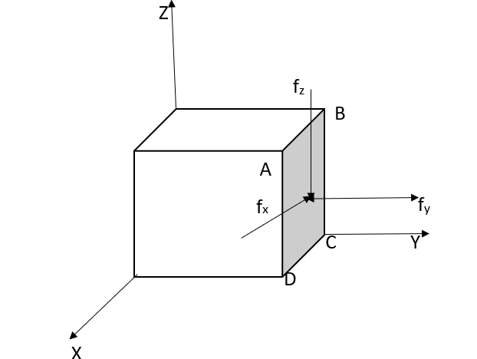
Figure 1: Components of force

Here f_{y} results in normal stress, and both f_{x} and f_{z} result in shear stress. However, when the cube is in dynamic equilibrium, forces on opposite faces must be equal in magnitude and opposite in sign.

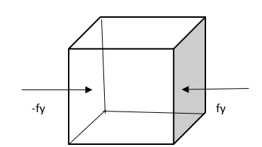
Figure 2: Dynamic Equilibrium
Thus, to describe the stress condition of the cube Nine components are required. Three stresses are normal to cube faces and Six stresses act across the cube faces [4].
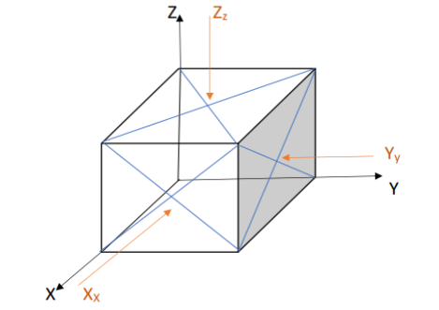
Figure 3: Components of stress

Stress components in matrix form are,
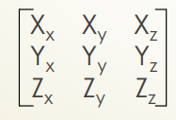
Figure 4: Stress Matrix

Where the Uppercase alphabets indicate the direction of force and the subscripts denote the direction of normal to the plane on which force is acting. The number of independent stress components are further reduced to six when it is a cube in static equilibrium, i.e., the cube does not rotate.
- Under this condition
X_{y} = Y_{x} ; Z_{y} = Y_{z} ; Z_{x} = X_{z}
- The six independent stress components then are, X_{x}, Y_{y}, Z_{z}, X_{y}, Y_{z}, Z_{x}
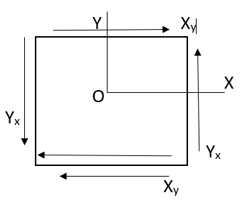
Figure 5: Static Equilibrium
IV. Components of strain
Consider an unstrained solid with orthogonal unit vectors i, j, and k as shown in Figure 6. For an orthogonal system, Δa, Δb, Δc, Δα, Δβ, Δϒ correctly define the six components of elastic strain. Where α,β, ϒ is the angle between the unit cell axes a,b,c.
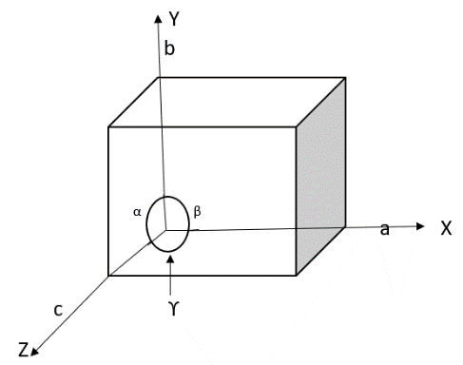
Figure 6: Orthogonal System

However, for the non-orthogonal axis, this leads to mathematical complications. Hence, a general situation strain is specified with the use of six elements e_{xx}, e_{yy}, e_{zz}, e_{xy}, e_{yz}, and e_{zx} as described afterward [4].
Suppose a small uniform deformation i.e., deformation in which each primitive cell of crystal is deformed in the same way, of the solid that results in distorted orientation and length of axes as shown in figure.7,
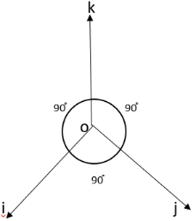
Figure 7: Non-Orthogonal System
The new axis i’, j’, k’ is expressed in terms of the old axis as given below
i’ = (1+ϵ_{xx})i + ϵ_{xy}j + ϵ_{xz}k 1(a)
j’ = ϵ_{yx} i + (1+ϵ_{yy})j + ϵ_{yz}k 1(b)
k’ = ϵ_{zx}i + ϵ_{zy}j + (1+ϵ_{zz})k 1(c)

where the coefficients ϵ_{xx}, ϵ_{xy}, ϵ_{xz,} etc. identify the deformation; and are dimensionless quantities with values that are very less than unity, i.e. the strain is meager. Also, the fractional changes in the length of axis i, to the first order, is ϵ_{xx}, and that of j and k axes are ϵ_{yy} and ϵ_{zz}. Thus ϵ_{xx}, ϵ_{yy}, ϵ_{zz} represents linear strain components which are defined as
e_{xx} = ϵ_{xx}, e_{yy} = ϵ_{yy}, e_{zz} = ϵ_{zz} (2)
Similarly, i’. j’ ≅ ϵ_{yx} + ϵ_{xy}, which gives a measure of change in orientation between i’& j’ due to stress. Thus, e_{xy} = change in angle between axes i’& j’.
Thus
e_{xy} = i’. j’ ≅ ϵ_{yx} + ϵ_{xy}
e_{yz} = j’. k’ ≅ ϵ_{yz} + ϵ_{zy}
e_{zx} = k’.i’ ≅ ϵ_{zx} + ϵ_{xz} (3)
Now merely rotating the axes does not change the angle between them. So using “(3),” a pure rotation represented by ϵ_{yx} = -ϵ_{xy}, ϵ_{zy} = -ϵ_{yz} & ϵ_{zx} = -ϵ_{xz} are excluded. Further taking ϵ_{yx} = ϵ_{xy}, ϵ_{zy} = ϵ_{yz} & ϵ_{zx} = ϵ_{xz} .values in “(3),” we get
e_{xy} = 2ϵ_{xy}; e_{yz} = 2ϵ_{yz}; e_{zx} = 2ϵ_{zx} (4)

V. RELATION BETWEEN STRESS ANS STRAIN COMPONENTS

According to Hook’s Law, when tensile stress is applied to a body, the strain produced is directly proportional to the stress under the elastic point of that body. Hence, the strain components can be expressed as linear functions of stress components[5] :

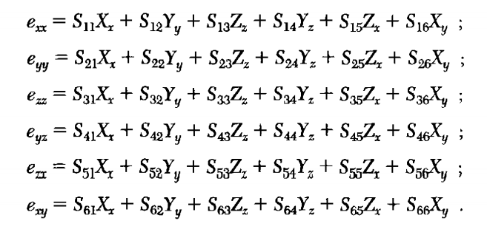
(5)
Conversely, the stress components are expressed as linear functions of the strain components [5]:

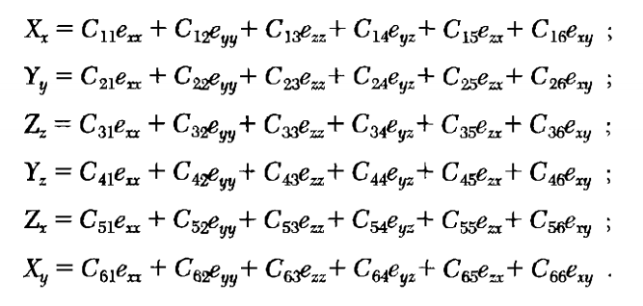
(6)
The coefficients S₁₁, S_{12,} and extra are termed as ELASTIC COMPLIANCE CONSTANT, and the coefficients C₁₁, C₁₂ and extra are termed as ELASTIC STIFFNESS CONSTANT. The Elastic Compliance Constants have the dimensions of [strain/stress]= [1/(force/area)]= [area/force] or [area x length/force x length]= [volume/energy]. The Elastic Stiffness Constants have the dimensions of [stress/strain] =[force/area] or [energy/volume].

VI. DERIVATION OF STRESS-STRAIN COMPONENTS FOR CUBIC CRYSTAL

We will prove that cubic crystals have only three independent stiffness constants [4]. We begin with the declaration that the elastic energy density of a cube crystal is given as

U = 1/2C₁₁(e²_{xx} + e²_{yy} + e²_{zz}) + 1/2C₄₄(e²_{yz} + e²_{zx} + e²_{xy}) + C₁₂(e_{yy}e_{zz} + e_{zz}e_{xx} + e_{xx}e_{yy})
(7)
and it does not include any other quadratic terms like

(e_{xx}e_{xy} + ……..); (e_{yz}e_{zx} + ……..); (e_{xx}e_{yz} + ………); (8)

This result is a consequence of the minimum symmetry requirement of a cubic crystal, which is based on th four three-fold rotation axes passing through the body’s diagonal directions. One such rotation axis is shown in Figure 7. If we rotate by an angle of 120֯ about this body diagonal the x-axis changes to y, the y-axis changes to z, and z -axis changes to x. Replacing x by y, y by z, z by x in “(7),” gives

U = 1/2C₁₁(e²_{yy} + e²_{zz} + e²_{xx}) + 1/2C₄₄(e²_{zx} + e²_{xy} + e²_{yz}) + C₁₂(e_{zz}e_{xx} + e_{xx}e_{yy} + e_{yy}e_{zz})

Hence, “(7),” does not vary under the operation considered.
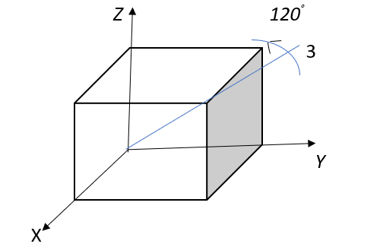
Figure 7: Rotation by 2π/3 about body diagonal
Hence, “(7),” does not vary under the operation considered. Similar rotations about the other axis of rotations change:
[ -x-axis changes to z, z-axis changes to -y and -y -axis changes to -x];
[ x-axis changes to z, z -axis changes to -y and -y -axis changes to x];
[ -x -axis changes to y, y-axis changes to z and z -axis changes to -x].

These rotations will again leave “(7),” invariant. However, if the odd terms as in “(8),” are included in the energy density term, it may result in a change of sign after the rotation operations. E.g., e_{xy} = -e_{x(-y)}. Hence the terms in “(8),”are not invariant under the rotation operations, and hence should not be considered in the energy density expression. This proves that our assertion is true.
Now, differentiating “(7),” w.r.t. e_{xx}, we get

$$\frac{∂U}{∂e_{xx}}=C_{11 }e_{xx}+ C_{12}(e_{yy}+ e_{zz})$$
But,
$\frac{∂U}{∂e_{xx}}= X_{x}$
Hence $,$
$$X_{x}=C_{11 }e_{xx}+ C_{12}(e_{yy}+ e_{zz})$$
Comparing it with,

$X_{x}=C_{11 }e_{xx}+ C_{12}e_{yy}+C_{13}e_{zz}+ C_{14}e_{yz}+ C_{15}e_{zx}+ C_{16}e_{xy}$
we get,
C₁₂ = C₁₃ and C₁₄ = C₁₅ =C₁₆ = 0 (9)
Similarly Comparing
$X_{y}=$ $\frac{∂U}{∂e_{xy}}=C_{44 }e_{xy}$
With,
$X_{y}=C_{61 }e_{xx}+ C_{62}e_{yy}+C_{63}e_{zz}+ C_{64}e_{yz}+ C_{65}e_{zx}+ C_{66}e_{xy}$
we get,
C₆₁ = C₆₂ = C₆₃ = C₆₄ = C₆₅ = 0 and C₆₆ = C₄₄ (10)
Proceeding with the similar calculation we find that array depicted by “(6),” takes the form of a simpler matrix for a cubic crystal as given below,

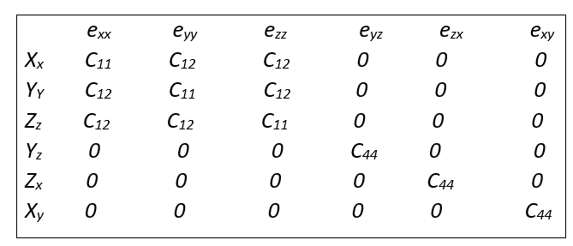 (11)

This proves our declaration that for a cubic crystal C₁₁, C_{12,} and C₄₄ are the only three independent elastic stiffness constants. Here constants C₁₁ relate the compression stress and strain along the X, Y, or Z axis, while C₄₄ relates the shear stress applied to a certain direction to the strain in the same direction i.e., Y_{z} = C₄₄e_{yz}, Z_{x} = C₄₄e_{zx} and so on. The constant C₁₂ relates the compression stress in one direction to the strain in other perpendicular directions i.e., e_{yy} with X_{x}, e_{zz} with X_{x}, e_{xx} with Y_{y} & Z_{z}, e_{zz} with X_{x} & Y_{y} as seen from matrix (11).

Similarly, the inverse matrix matrix takes the form as;
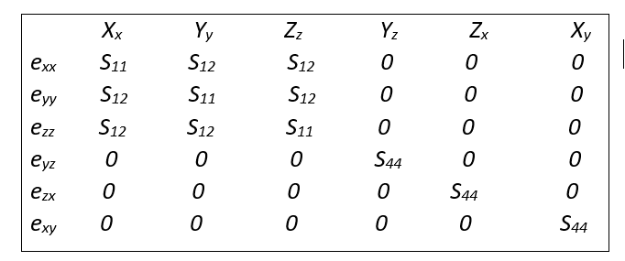 (12)

Now from matrix (11)
$$X_{x}=C_{11 }e_{xx}+ C_{12}e_{yy}+C_{12}e_{zz}$$
$$Y_{y}=C_{12 }e_{xx}+ C_{11}e_{yy}+C_{12}e_{zz}$$
$$Z_{z}=C_{12 }e_{xx}+ C_{12}e_{yy}+C_{11}e_{zz}$$
(13)
Also from matrix (12)
$$e_{xx}= S_{11}X_{x}+ S_{12}Y_{y}+ S_{12}Z_{z}$$
(14)
From “(13),” and “(14),”
$e_{xx}= S_{11}\left(C_{11 }e_{xx}+ C_{12}e_{yy}+C_{12}e_{zz}\right)+ S_{12}\left(C_{12 }e_{xx}+ C_{11}e_{yy}+ C_{12}e_{zz}\right)+ S_{12}($ $C_{12 }e_{xx}+ C_{12}e_{yy}+C_{11}e_{zz})$ (15)
$e_{xx}= \left(S_{11 }C_{11}+ S_{12}C_{12}+S_{12}C_{12}\right)e_{xx}+\left({ S_{11}C}_{12}+ S_{12}C_{11}+S_{12}C_{12}\right)e_{yy}+ ($ $S_{11 }C_{12}+ S_{12}C_{12}+S_{12}C_{11})e_{zz}$ (16)

Equating coefficients on L.H.S. & R.H.S.
$\left(S_{11 }C_{11}+ S_{12}C_{12}+S_{12}C_{12}\right)$ = 1 (17)
$\left({ S_{11}C}_{12}+ S_{12}C_{11}+ S_{12}C_{12}\right)$ = 0 (18)
Rearranging “(18),” $S_{11}= \frac{-S_{12}(C_{11}+ C_{12}) }{C_{12}}$ (19)
Putting “(19),” in “(17),” $\frac{-S_{12}(C_{11}+ C_{12}) }{C_{12}}+ 2S_{12}C_{12}=1$ (20)
$$S_{12}\left[2C_{12}- {C_{11}}/{C_{12}}\left(C_{11}+C_{12}\right)\right]=1$$
$$-S_{12}\left[C_{11}^{2}+C_{11}C_{12}-2C_{12}^{2}\right]=C_{12}$$
$$-S_{12}\left[C_{11}^{2}+2C_{11}C_{12}-C_{11}C_{12}-2C_{12}^{2}\right]=C_{12}$$
$$-S_{12}\left[ C_{11}\left(C_{11}+2C_{12}\right)-C_{12}{(C}_{11}+2C_{12})\right]=C_{12}$$
$S_{12}=\frac{-C_{12}}{{(C}_{11}-C_{12})(C_{11}+2C_{12})}$ (21)
Putting “(21),” in “(19),”
$$S_{11}=\frac{(-1)({-C}_{12})}{{(C}_{11}-C_{12})(C_{11}+2C_{12})} \left(\frac{C_{11}+C_{12}}{C_{12}}\right)$$

$$S_{11}=\frac{C_{11}{+C}_{12}}{{(C}_{11}-C_{12})(C_{11}+2C_{12})}$$

(22)

Similarly from matrix (11)
$Y_{z}=e_{yz }C_{44};$ $Z_{x}=e_{zx }C_{44};$ $X_{y}=e_{xy }C_{44}$.
and from matrix (12)
$e_{yz}=S_{44 }Y_{z};$ $e_{zx}=S_{44 }Z_{x};$ $e_{xy}=S_{44 }X_{y}.$
Which leads to,
$$Y_{z}=C_{44 }S_{44} Y_{z}$$
$$S_{44}=\frac{1}{C_{44 }}$$

(23)

From matrix (12), it is clear that tensile stresses X_{x}, Y_{y}, Z_{z} does not produce any shear strain i.e. e_{yz} = e_{zx} =e_{xy} = 0 for X_{x}, Y_{y}, Z_{z}. Also pure shear stresses Y_{z}, Z_{x}, X_{y} produce the pure shear strain only i.e. $e_{yz}=S_{44 }Y_{z};$ $e_{zx}=S_{44 }Z_{x};$ $e_{xy}=S_{44 }X_{y}$. Thus it is concluded that terms S₁₁ gives the amount of tensile strain in x-direction generated due to tensile stress of unit magnitude along the x-axis. And term S₁₂ gives the extent of y-axis or z-axis strain tha comes out from the x-axis tensile stress.
The two-dimensional view is like,
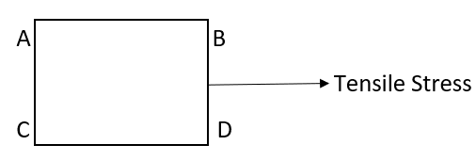
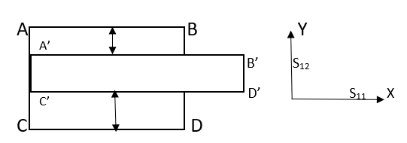
Thus, S₁₂ is equivalent to the lateral strain which acts perpendicular to the direction of applied stress.

- Knowing the properties of cubic crystals in terms of stress-strain components
We know that Young’s Modulus or modulus of elasticity is expressed as the fraction of tensile or compressive stress and the resultant strain i.e.
Young’s Modulus(E) = Tensile Stress/Tensile Strain
Hence, it is clear that
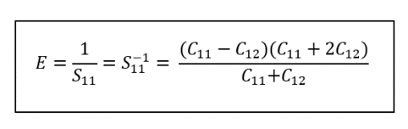 (24)
Similarly, Poisson’s ratio is expressed as the fraction of lateral strain and longitudinal strain i.e.
Poissons’s ratio (µ) = lateral strain/longitudinal strain
Hence, it is clear that.
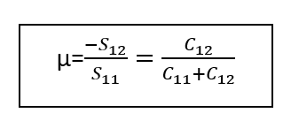 (25)
Also, the shear modulus or modulus or modulus of rigidity G is expressed as the fraction of shear stress and shear strain i.e.
Rigidity Modulus (G) = Shear Stress/Shear Strain
Hence, it is clear that

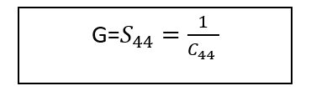 (26) Further the bulk modulus is expressed in terms of the the change in volume of a body as a result of unit compressive or tensile stress.
For this condition a uniform dilation of crystal:
$$e_{xx}=e_{yy}=e_{zz}=\frac{1}{3}δ$$
Hence,
$$U=\frac{1}{2}C_{11}\left[\frac{1}{9}δ^{2}+\frac{1}{9}δ^{2}+\frac{1}{9}δ^{2}\right]+C_{12}\left[\frac{1}{9}δ^{2}+\frac{1}{9}δ^{2}+\frac{1}{9}δ^{2}\right]$$
U = $\frac{1}{2}C_{11}\left[\frac{3}{9}δ^{2}\right]+C_{12}\left[\frac{3}{9}δ^{2}\right]$
U = $\frac{1}{6}C_{11}δ^{2}+\frac{1}{3}C_{12}δ^{2}$
U = $\frac{1}{6}(C_{11}+2C_{12})δ^{2}$
Now the Bulk Modulus is produced by the equation.
$$U= \frac{1}{2}Bδ^{2}$$
Hence,
$B=\frac{1}{3}(C_{11}+C_{12})$ (27)
Further, the compressibility K is the defined as
$K=\frac{1}{B}=\frac{3}{C_{11}+2C_{12}}$ (28)
If C₁₂=0, from “(24),”, “(25),”, “(27),” & “(28),”, We get
E=C₁₁, µ=0, B=1/3 C₁₁ & K=3/C₁₁
Which happens when there is no transverse contraction even when there exists a longitudinal expansion. This approximation is useful when one is handling a one-dimensional lattice.
Further, if the crystal is an isotropic [4],
C₁₂ + 2C₄₄ = C₁₁ [ or S₄₄ = 2(S₁₁ – S₁₂)]
i.e. there are only two independent moduli.

VII. APPLICATIONS
- Stress-Strain Analysis is important when we design the constructions such as tunnel, bridges and dams etc.
- It is primarily used for civil mechanics and aerospace engineers.
- It is used for the upkeep constructions and to diagnose the reasons of structural failures.

VIII. REFERENCES

- Introduction to Solid State Physics by Charles Kittel, 1953.

- Elements of Solid-State Physics by J.P. Srivastava, 2004.

- Fundamentals of Solid-State Physics by Saxena, Gupta, Saxena, Mandal, 2019.

- Solid State Physics by R.L. Singhal, 2003.

- Introduction to Solids by Leonid V. Azaroff, 2003.

- Solid State Physics by A.J. Dekker, 2002.

- https://whatispiping.com/poissons-ratio.

