Performance of DF Relay Assisted Dual-Hop System over Generalized-K along with κ-μ Fading Environments

Rajkishur Mudoi

Department of Electronics and Communication Engineering, North-Eastern Hill University, Shillong, India

ABSTRACT
The outage probability (OP), average bit-error probability (ABEP) as well as ergodic capacity of decode- and-forward (DF) relay-based dual-hop transmission are evaluated in this analysis. The mixed fading channel environments are considered to study the system performance. The channel connecting the source to relay experiences Generalized-K (KG) distribution, whereas the link joining the relay with the destination is assumed as κ- μ distribution. To analyse the system’s performance, the probability density function (PDF) based approach is used. The BPSK as well as QPSK modulation schemes are applied to analyse the ABEP of the system. The results are validated by computer simulations.

Keywords: Dual-hop relaying, Generalized-K, Decode- and–forward, k − μ fading, Outage probability, Ergodic
capacity, ABEP.

INTRODUCTION
In dual-hop cooperative communication, a source node transmits to the destination node via an additional node named as relay node [1]. Whenever the direct transmission between the base station and the end user or the destination node is in a deep fade, the relay is suitable to improve the SNR. The relay is used to cooperate the communication process by retransmitting the signal and thereby improving the SNR at the destination. Communication can take place in dual phases. Dual-hop networks improve the data rate in wireless networks. There are several relay transmission protocols. The standard protocols are amplify and forward (AF) as well as decode and forward (DF) protocols. In case of AF protocol, the signal is amplified by a relay and later retransmit. It blindly amplifies the input signal and forwards it. Therefore the external input noise gets amplified in AF protocol. In DF communication, relay decodes the symbols transmitted by the source node and subsequently sends the symbols to end user [2]. The advantage of using DF communication is that it does not amplify the noise of the environment. [3].
In the available literature, cooperative transmission systems operating over fading channels are analysed in several works. In [4], the analysis of the dual-hop AF
carried out. Asymptotic analysis at high SNR for ABEP was performed to depict the effect of channel parameters on the communication system behaviour. Dual-hop transmission models with the DF technique under Nakagami-m fading channels were analysed in [5] [6] [7]. Dual-hop transmissions under Gamma fading channels were investigated in [8]. The performance of a dual-hop AF variable gain relaying system under Gamma distribution was investigated in [9]. The performance of DF based cooperative free-space optical (FSO) network with multiple relays was investigated in [10]. The asymptotic ABER and asymptotic OP analysis were derived for the source to relay links. In [11], the performance of dual-hop AF transmission operating in a non-identical Rician fading environment was presented. A generic moment-based approach for the evaluation of dual- hop wireless communication employing AF systems nder generalized fading channels was presented in [12]. In [13], the performance of multi-hop communication links was
investigated under KG fading environment. An expression for the MGF of the SNR of dual-hop with non- regenerative wireless communication systems over i.i.d α– μ fading channels was derived in [14]. The expressions for outage probability and ABER of the system were derived from the SNR expression. These works are based on symmetric fading condition, which is not suitable for fundamental wireless communication environment characteristics.
Nevertheless, several articles have also mentioned the performance of dual-hop relaying techniques over asymmetric fading conditions. The asymmetric channel models mean wireless channel conditions of every hop are different because of the possibility that receiving signals may be different for the two relay links [15]. These mixed fading propagation channels are more realistic for precisely modelling numerous practical dual-hop communications scenarios.
The performance of a two-hop AF system was studied in [16], considering links undergo Rayleigh and Rician fading, respectively. The performance of a two-hop AF cooperative system was presented in [17] for source-to-
relay experience η − μ fading, whereas the relay-to-
destination undergoes k − μ fading environment. The

system subject to k − μ shadowed distribution was
expressions were derived for both fixed-gain and CSI-

assisted transmission. The expressions for ASEP in addition to OP of two-hop AF relay system under
The SNR of S − R
P h ²
and R − D

P h ²
links are

Nakagami-m as well as Rician faded wireless system
γ = 1 SR
and
γ = 2 RD
respectively [16].

environments were presented in [18]. The AF 1 N 2
N
transmission scheme, where the links undergo Rayleigh, as ⁰ ⁰
well as Rician fading distribution, was analysed in [19]. Where, P₁ as well as P₂ are the transmit power of S and

The outage probability of dual-hop communication with AF system under consideration that relay node is corrupted
R respectively.
hSR
as well as
hRD
are the fading

by co-channel interferences was studied in [20]. The outage probability was examined for instantaneous signal- to-interference and noise ratio (SINR) of a dual-hop
amplitudes of the channels in the S − R and R − D
links respectively. N0 is the power of the AWGN. The

scheme with channel-state-information (CSI) operated
S − R link undergoes K_{G}
fading distribution, whereas

relay under asymmetric fading conditions. The system performance of a dual-hop system was also carried over Nakagami-m as well as Rician fading scenarios in [21] for the AF scheme. In [22], expressions for ABEP and outage probability of an AF relaying-based transmission model
the R − D
of SNR γ ₁
link is modeled by k − μ fading. The PDF for KG fading is given as [26]
β +1 β −1
2Ξ ² γ 2 ⎡ ¹ ⎤

was investigated in mixed Rayleigh with Hoyt fading.
f_{γ} (γ₁ ) = ¹ K_{α} ⎢2(Ξγ₁ )2 ⎥ ,γ₁ ≥ 0
(1)

The analysis of an asymmetric dual-hop the DF 1
relaying phenomena composed of radio-frequency (RF) and FSO links was carried out in [23]. The transmitted RF
Γ(m)Γ(k1 ) ⎣ ⎦
Where, m and k1 are the distribution shaping

signal from the source was decoded by the relay and then generated an optical signal applying the sub-carrier
parameters,
Γ (.)
is the Gamma function,

intensity-modulation (SIM) scheme. The optical signal was transmitted under the FSO link. For mixed RF/FSO system, the end-to-end SNR expression was derived using
β = k1
+ m −1 ,
α = k1
- m ,
Ξ = mk1 , and
γ 1
K_{α} (.)

Meijer’s G function. In [24], the OP of the dual-hop relay assisted DF transmission model was investigated under Rayleigh as well as generalized Gamma fading distributions. In [25], the outage probability under
asymmetric k − μ as well as η − μ fading channels
is the modified Bessel function of order α . Furthermore,
γ 1 is the average SNR. The expression (1) can narrate various fading as well as shadowing models by utilizing different values for k1 and/or m . The KG is an adaptable

was acquired for DF relaying, employing the CDF-based expression of η − μ distribution. The analysis of two-
hop DF relaying protocol experiencing mixed faded distributions was also explained in [15]. It was considered that the channel from the source to the relay node was
distribution that includes many of the familiar models for multipath and shadow fading. This fading model can
approximate numerous fading distributions, such as, Rayleigh, Nakagami- m , Nakagami- n , and Rayleigh- Lognormal (R-L) [26].

subject to Rayleigh fading; however, the Weibull distributed fading model was between the relay and
If the link experiences k − μ
fading distribution, the

destination node. The expressions were derived for ABEP, the OP and ergodic capacity of the specified system model.
PDF of SNR γ ₂ is given as [27]
μ −
μ (1+k₂ )γ ₂

The ABEP performance was studied for M-ary PSK
signalling considering different constellation sizes.
μ +1
μ 1+ k2 2
1 −
γ 2 2 e 2
( )
γ

This work uses KG fading along with k − μ

fading
f_{γ} (γ ₂ ) =

μ −1
(
k 2 γ

μ +1 2
2
)

eμk2

distribution for the two hops, with DF intermediate relay
assisted communication system which is not available in literature

SYSTEM AND CHANNEL DESCRIPTION
A dual-hop communication system is considered where the transmission from a source node S to the destination node D takes place through the cooperation of a relay node R. Transmission from S to D occurs in two different time slots. The source node S sends a signal to the relay node R in the first time slot whereas, in the second time slot, R decodes the received signal and sends the resulting decoded signal to D. The S is situated in an intensely shadowed environment; therefore it is considered that there is no direct sight between S and D node.
2 2

×I ⎛ 2μ k₂ (1+ k₂ )γ ₂ ⎞
γ
μ −1 ⎜ ⎟ . (2)

⎜ ⎟
⎝ 2 ⎠
The parameter k2 is the ratio between total power of
the dominant component and total power of the scattered waves. The symbol μ represents the number of multipath
clusters, whereas I_{ν} (.) is the modified Bessel function of the first kind and ν th order [28]. The k − μ shadowed physical model comprises clusters of multipath waves, that travel in a non-homogeneous environment. Within a cluster, the waves consist of one dominant
conversely a line of sight (LOS) component in addition to

multiple scattered components. The scattered multipath components have random phases, same power, and similar time delays. The power of the dominant components is treated as arbitrary. The LOS components available in the
Pr (γ1 > γ th ) = Γ(m)Γ(k )
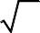1−2β +2 j ⎛ 1 ⎞
π
1

clusters fluctuate randomly due to shadowing. Intracluster
α − 1 2 2
⎜ j + α − ⎟!

scattered multipath components have relatively shorter
× ∑2 ⎝ 2 ⎠

delay times as compared to intercluster scattered components [4].

j =0
4 ^{j} j!⎛ − j + α

⎝
⎜
− 1 ⎞!
⎠
2 ⎟

OP ANALYSIS
The OP is a prime performance metric that is utilized
⎛ 2β +1− 2 j ¹ ⎞
⎜ 2 th 2 ⎟ . (7)
×Γ ,2 (Ξγ )

to specify a wireless communication system. It is ⎝ ⎠

explained as the probability that the received SNR drops
If the R − D
link experiences k − μ
fading

under a certain threshold constant
γ th
[29]. An outage
distribution, Pr (γ ₂ > γ _{th} )
is determined as

happens in the DF relaying system, whenever the instantaneous SNR of one or two of the hops falls under
γ . Therefore, it ( P ) can be described based on total
γ
2
∞
Pr (γ ₂ > γ _{th} ) = ∫
γ
f (γ ₂ ) dγ ₂ . (8)

th
SNR [8][15] as
out
th

Putting the value of
f_{γ} (γ ₂ )

from (2) into (8) and

Pout
= Pr{min(γ₁,γ ₂
) ≤ γ
th }

2
converting the involved Bessel function as infinite series

= 1− Pr(γ₁ > γ _{th} )Pr(γ ₂ > γ _{th} ) . (3)
[31, (8.445)], the expression of (8) is can be given as

Whereby Pr (γ₁ > γ _{th} )

can be evaluated according
Pr (γ > γ
) = ∑
μμ +2t (1+ k

μ +t t
2 2
∞
) k

to KG
fading for the S − R
∞
link as
2 th
t =0 t!Γ(μ + t )(γ 2
∞ − μ(1+k₂ )γ ₂
)μ +t eμk2

Pr (γ₁ > γ _{th} ) = ∫ f_{γ}
(γ₁ ) dγ₁ . (4)
× γ μ +t −1e
γ 2 dγ
. (9)

1
γ th
∫ 2 2
γ th

Expressing the modified Bessel function as given in
Simplifying (9), by making use of [31, (3.381.3)],

[30, (03.04.03.0004.01)], the PDF expression in (1) can be
found as
Pr (γ ₂ > γ _{th} ) = ∑
μtk t
μ
∞
2

α − 1
1
e−2(Ξγ₁ )2
π

⎛ j + α −
1 ⎞!
_{t=0} t!Γ(μ + t )e ^{k}2

2 ⎜ 2 ⎟
⎛ μ (1+ k γ ⎞

f_{γ} (γ₁ ) =
∑ ⎝ ⎠

×Γ μ + t,
2 ) th

. (10)

1 Γ(m)Γ(k ) j =0 j ⎛ 1 ⎞ ⎜ ⎟

1 4 j!⎜ − j + α − ⎟!
⎝ γ 2 ⎠

2β +1−2 j

⎝ 2 ⎠
2β −3−2 j
Inserting (7) and (10) into (3), Pout can be derived as

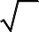×Ξ 4
π
γ1 4
. (5) ⎡

Putting the value of f
(γ )

from (5) into (4) and
Pout = 1− ⎢Γ(m)Γ(k )e^{μk}2

γ1 1
after simplification, the expression of (4) is written as
π
⎜
⎣
α − 1
2 ∞
1
1−2β −2 j
2 2
μ^{t}k ^{t} ⎛ j + α 1 ⎞

Pr (γ₁ > γ _{th} ) =
Γ(m)Γ(k₁ )
× ∑ ∑ ⎛

² ⎝ 2 ⎠
1 ⎞
!
−
⎟

α − 1 ⎛ j + α

− 1 ⎞!Ξ

2β +1−2 j
4
j =0
t =0
j! t!⎜ − j + α −

⎝
⎟!Γ(μ + t )

⎠
2

2 ⎜ ⎟
2
× ∑ ⎝ ⎠
×Γ⎛ 2β +1− 2 j
,2 (Ξγ
)1 ⎞
2

j =0 j ⎛ 1 ⎞
⎜ 2 th ⎟

4 j!⎜ − j + α
⎜
− 2 ⎟! ⎝ ⎠

⎝ ⎠
∞ 1 2β −3−2 j
−
×Γ⎛ μ + t,
μ (1+ k₂ )γ _{th} ⎞⎤
⎟⎥ . (11)

× e 2(Ξγ₁ )2 γ
4 dγ
. (6)
⎝ γ ⎠⎥

∫ 1 1 2 ⎦
γ th
Using [31, (3.381.9)] in (6), the expression of 4. ABEP ANALYSIS

Pr (γ₁ > γ _{th} )
is simplified as
The ABEP of distinct digital modulation systems under fading channels can be determined using [16, (12)] as

1 ∞ ⎛

ω² ⎞ ⎛ ω² ⎞

1 2 β +1−2 j

p−β − j ⎛ 1 ⎞

Pe = ∫ exp⎜ −
⎟Fγ ⎜ ⎟ dω . (12)

equ
α −
2 ∞ 2
−1 μ +t −1 2
⎜ j + α − 2 ⎟!

2π ₀
⎝ 2 ⎠ ⎝ ξ ⎠
× ∑ ∑ ∑ ∑ ⎝ ⎠

Where
ξ = 1
and
ξ = 2
for QPSK and BPSK
j =0
t =0
p=0
n=0
j!p! n!t!⎛ − j + α

− 1 ⎞!
2
⎟

modulation schemes, respectively. Based on (11), the ⎝ ⎠
⎜

expression of (12) can be written as

⎛ 2β −1− 2 j ⎞!μt +nk t (Ξ) p (1+ k )n

1 ∞ ⎛ ω² ⎞ ⎡ 1

⎜ 2 ⎟ 2 2 2

Pe = ∫exp⎜ − ⎟dω − ⎢
)
μk × ⎝ ⎠

2π ₀

⎝ 2 ⎠

⎛
⎣Γ(m)Γ(k₁ )e 2

1 ⎞

(ξγ
2 + 2μ (1+ k2
p+2n+1
) 2

α − 1 2− β − j ⎜ j + α −
⎟!μt k t
p+1

× 2 ∞ ⎝
2 ⎠ 2
×(γ
) 2 Γ( p + 2n +1) D
( z ) . (17)

∑∑ ⎛ 1 ⎞ 2 Λ

j =0
t =0
j!t! ⎜ − j + α −

⎝
⎟!Γ(μ + t )

⎠
2

Where
D_{Λ} ( z )

is the parabolic cylinder function.

∞ ω2 ⎛

2 1 ⎞

×∫ e− 2 Γ⎜ 2β +1− 2 j ⎛Ξ ω ⎞2 ⎟
4Ξγ ₂
ξγ ₂ + 2μ (1+ k₂ )
Λ = −( p + 2n +1) and z = .

⎜ ,2⎜ ⎟ ⎟

0 ⎜ 2
⎝ ξ ⎠ ⎟

⎝ ⎠

⎛ μ (1+ k
)ω² ⎞ ⎤

5. ERGODIC CAPACITY ANALYSIS

×Γ⎜ μ + t, ² ⎟ dω⎥ . (13)

⎝ ξγ ₂

⎠ ⎥⎦
The ergodic capacity is achieved as [32]

The expression of (13) is rewritten as

P = W −W
CB ∞

e 1 2 . (14)
Applying [31, (3.321.3)], the first term in (14)
C_{erg} = 2 ln (2) ∫ln (1+ γ ) f_{γ}t (γ ) dγ , (18)

becomes
1
2π
0
∞ ⎛ ω² ⎞

where, CB is the bandwidth of the channel as well as

W1 =
∫ exp⎜ − 2 ⎟dω = 0.5 . (15)
f (γ ) is the SNR PDF at the system output as written

0 ⎝ ⎠ γ t

Using [29, (8.352.7)], the second term in (14) is
below [33]

written as
f_{γ} (γ ) = P δ (γ ) + (1− P ) f
(γ ) . (19)

W =1

_{t} SR SR γ 2

² Γ(m)Γ(k )e^{μk}2
1
Here, PSR is the probability for arising outage with S − R

α − 1 2β +1−2 j −

γ
p−β − j ⎛
1 ⎞ link and f (γ ) stands for SNR PDF of R − D link. By
2

2 ∞ 2
1 μ +t −1 2
⎜ j + α

− 2 ⎟!
definition P
= F (γ
) , considering CDF of SNR for

× ∑ ∑ ∑ ∑ ⎝ ⎠

SR γ1 th

j =0
t =0
p=0
n=0
j!p! n!t!⎛ − j + α

− 1 ⎞!
2
⎟
S − R link as F
1
γ
(⋅) . With the help of (5) and applying

⎝ ⎠ [31, (3.381.8)], the following expression can be obtained.
⎜

⎛ 2β +1− 2 j

⎞ t +n t
p n
1 ⎛ 1 ⎞

⎜ 2 −1⎟!μ
k₂ (Ξ)2 (1+ k₂ )
α −
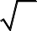
π 2
⎜ j + α

− 2 ⎟!

× ⎝ ⎠
n

F_{γ} (γ th ) =
∑ ⎝ ⎠

p +n
ξ 2
1

(γ 2 )
1 Γ(m)Γ(k )
j =0
j!⎛ − j + α

⎝
⎜
− 1 ⎞!
⎠
2 ⎟

∞ −2ω⎛ Ξ ⎞2 −
⎜ ⎟
ξ
ξ γ ₂ω ² +2μ (1+k2 )ω ²
2ξγ
p+2n
g ⎛ 2β +1− 2 j

,2(Ξγ
)1 ⎞
2

×∫ e ⎝ ⎠
2 ω dω . (16) ⎜2
th ⎟

⎝ ⎠
. (20)
×
0 2β −1+2 j

Solving the integration term, with the help of [31, (3.462.1)] and after simplification, the expression of (16) can be written as
Where,
(2) 2
g (⋅,⋅) is the lower incomplete Gamma function.

1 Ξγ 2 −μk
2

Placing (19) into (18), and writing

ξ 2 eξ γ ₂ +2 μ (1+k2 )
W2 = Γ(m)Γ(k )
1
ln (1+ϖ ) = G^{1,2} ⎛ϖ

⎝
⎜2,2
simplified as

1,1 ⎞
1, 0 ⎟ from [34],
⎠
Cerg can be

CB (1− P ) ∞ ⎛
∫ 2,2

1,1 ⎞
predicted, the increment in parameter μ boosts the performance of the system.

Cerg =
SR
2 ln (2)
G1,2 ⎜ γ

1, 0
⎟ fγ 2
(γ ) dγ . (21)
In Fig. 3, ABEP versus average SNR per hop is

0 ⎝ ⎠
presented for k2 = 2 and μ = 1 , considering BPSK and

Where G^{w,x} (⋅ ⋅) is the Meijer G function. Putting (2) into
y,z
(21) and expressing I_{ν} (.) as infinite series [31, (8.445)],
QPSK modulation techniques. It can be noticed that ABEP performance is improving for BPSK modulation as compared to a QPSK modulation scheme. The ABEP

C = CB (1− P_{SR} ) ∑
∞
μμ +2t (1+ k
μ +t t
2 2
) k
performance of the analyzed system is better for larger the
values of k1 and m .

erg
2 ln (2)

t =0 t!Γ(μ + t )(γ )μ +t eμk2

In Fig. 4, ABEP versus average SNR per hop is plotted

∞ − μ (1+k₂ )γ

⎛ 1,1 ⎞
for
k1 = 5.5 and
m = 2
employing BPSK and QPSK

×∫γ μ +t −1e γ
0
1,2
2,2

⎝

1, 0
⎟ dγ . (22)

⎠
modulation techniques. It is shown in Fig. 4 that the ABEP of BPSK improves as compared to QPSK for two-hop DF

Simplifying with the aid of [31, (7.813.1)],
G ⎜γ
relaying over considered fading environments. As

Cerg =
CB (1− P_{SR} ) ∞
2 ln (2)
∑
t t
2
μ k
t!Γ(μ + t )e^{μk}2
expected, ABEP performance enhances with an addition in the values of k2 and μ .

1,3
t =0
γ 1− μ − t,1,1⎞
⎛
In Fig. 5, Cerg versus average SNR per hop is framed
for k = 2 and μ = 1 with γ = 2dB and γ = 6dB .

×G3,2 ⎜ μ (1+ k
) 1, 0
⎟ . (23) 2
th th

⎝ 2 ⎠

RESULTS AND DISCUSSIONS
The derived expressions of OP, ergodic capacity as
The ergodic capacity increases with an increment in the values of k1 as well as m . It is noticed that Cerg degrades when the outage threshold SNR value is high.
In Fig. 6, Cerg versus average SNR per hop is plotted

well as ABEP in the aforesaid sections for dual-hop DF
for
k1 = 5.5
and m = 2 . The
Cerg
increases with an

relay system under KG as well as k − μ
fading links
advancement in the values of k2 as well as μ . The

are evaluated. In Fig. 1 and Fig. 2,
Pout
versus average
ergodic capacity improves with the decrease in threshold

SNR per hop are depicted for the outage threshold values
SNR from γ _{th} = 6dB to γ _{th} = 2dB .

γ _{th} = 2dB and γ _{th} = 6dB . It is detected that outage
In the analytical computation of derived expressions,

performance develops when the outage threshold SNR value is low. In Fig. 1, k2 = 2 and μ = 1 are kept constant. The outage performance boosts with the advance in the values of k1 as well as m . An increase in k1 means reduced in the shadowing effect, hence as expected, the
the infinite series terms are truncated to obtain correctness up to the 7th place of decimal digit. The explanatory curves are plotted from (11) and (13), considering 21 summations and in case of (23), the number of 51 summations are considered to obtain the correctness of the results.

system’s outage improves with an enhance in k1
and for

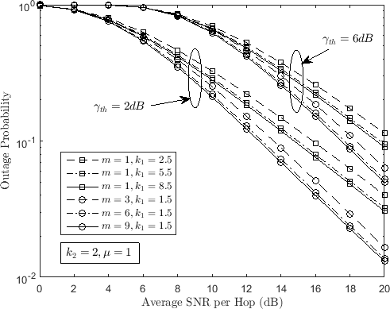
a fixed value of m . Furthermore, for the constant weight of k1 = 1.5 , the outage performance strengthens as the amount of m hikes, analogous to the small-scale fading becoming less severe.

In Fig. 2,
Pout
versus average SNR per hop is

depicted for
k1 = 5.5
and m = 2 . The outage

performance increases with an advance in the values of k2

as well as μ . The k − μ
fading model is activated for

LOS wireless communications and the parameter k2
points out the power of the dominant component. Consequently, the outage improves with the increment in
k2 and for a fixed value of μ . The parameter μ is the
actual expansion of the quantity of clusters [27]. As

Fig. 1: Outage probability Pout
of dual-hop DF relay

system over KG
along with k − μ
fading channels for

k2 = 2 , μ = 1 and γ 1 = γ 2 .

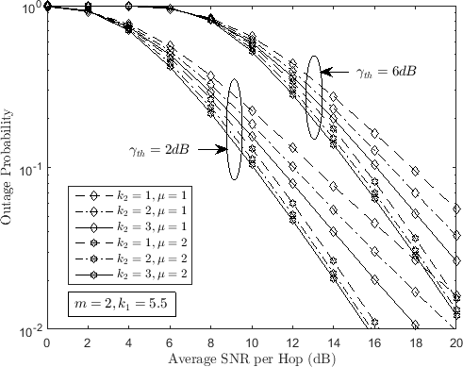
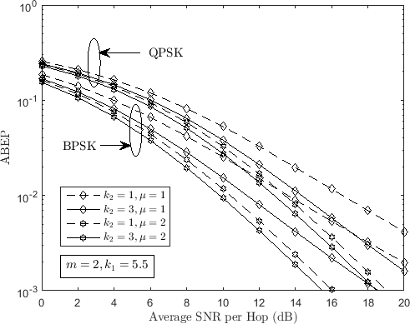
Fig. 4: ABEP of dual-hop DF relay system over KG

Fig. 2: Outage probability Pout

of dual-hop DF relay
along with k − μ


and γ 1 = γ 2 .
fading channels for
k1 = 5.5 ,
m = 2

system under KG
along with k − μ
fading channels for

k1 = 5.5 , m = 2 and γ 1 = γ 2 .

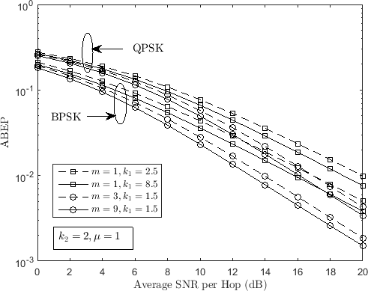
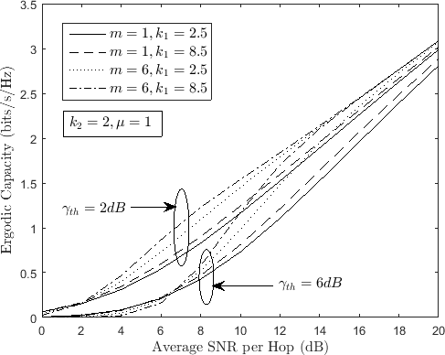
Fig. 5: Cerg of dual-hop DF relay system over KG

Fig. 3: ABEP of dual-hop DF relay system over KG
along with k − μ


γ 1 = γ 2 .
fading channels for k2 = 2 , μ = 1 and

along with k − μ


γ 1 = γ 2 .
fading channels for k2 = 2 , μ = 1 and

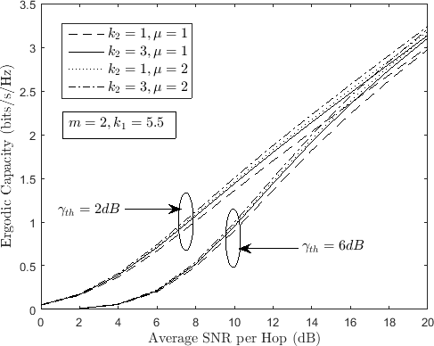
Fig. 6: Cerg of dual-hop DF relay system over KG along with k − μ fading channels for k₁ = 5.5 , m = 2 and γ 1 = γ 2 .
- D. B. da Costa, and S. Aissa, “Cooperative dual-hop relaying systems with beamforming over Nakagami- m fading channels,” IEEE Transactions Wireless Communications, Vol. 8, No. 8, pp. 3950–3954, 2009.
- Mohammed A. Hankal, Islam A. Eshrah, and Hazim
M. Tawfik. “Performance of the dual-hop decode and forward relaying systems over Nakagami-m fading channels,” 31st National Radio Science Conference (NRSC 2014), pp. 219-227, 2014.
- S. S. Ikki, and M. H. Ahmed, “Performance analysis of dual hop relaying communications over generalized Gamma fading channels,” in Proc. IEEE Global Telecommunications Conf. (GLOBECOM 2007), Washington, USA, pp. 3888–3893, 2007.
- Weijun Cheng, “Dual-hop Amplify-and-forward Variable Gain Relaying over Mixture Gamma Fading Channels,” Applied Mechanics and Materials, Vols. 719-720, pp. 767-772, 2015.
- Deepti Agarwal, Ankur Bansal, and Ashwni Kumar, “Analyzing selective relaying for multiple-relay– based differential DF-FSO network with pointing errors,” Transactions on Emerging

CONCLUSIONS
Closed-form Pout , ABEP and

Cerg

expressions of
Telecommunications Technologies, Vol. 29, No. 9, pp. 1-17, 2018.
- Maja Delibasic, Milica Pejanovic-Djurisic, and

dual-hop DF relay system over KG as well as k − μ fading channels have been derived using a PDF-based approach. This combined fading channels model is suitable for precisely modelling numerous practical scenarios of two-hop wireless communication systems. The ABEP of the system is determined by employing BPSK and QPSK signalling schemes. The expression of ABEP is presented in terms of parabolic cylinder function. All the expressions are validated by computer simulations.

REFERENCES
- Amer M. Magableh, Taimour Aldalgamouni, and Nemah M. Jafreh. “Capacity analysis of dual-hop wireless communication systems over α–μ fading channels,” Computers & Electrical Engineering, Vol. 40, pp. 399-406, 2014.
- Liu, Gang, Liusheng Huang, Yu-e Sun, Hongli Xu, He Huang, and Xueyong Xu. “Truthful Relay Assignment for Cooperative Communication in Wireless Networks with Selfish Source-Destination Pairs,” International Journal of Distributed Sensor Networks, pp. 1-14, 2012.
- K. P. Peppas, C. K. Datsikas, H. E. Nistazakis, and G.
S. Tombras, “Dual-hop relaying communications over generalized-K (KG) fading channels,” Journal of the Franklin Institute, Vol. 347, pp. 1643–1653, 2010.
- R. H. Shaik, and K. R. Naidu, “Performance evaluation of dual hop amplify-and-forward scheme over k − μ shadowed fading channels,” Physical
Communication, Vol. 33, pp. 206-214, 2019.
- D. B. da Costa, and S. Aissa “Dual-hop decode-and- forward relaying systems with relay selection and maximal-ratio schemes,” Electron. Letters, Vol. 45, No. 9, pp. 460–461, 2009.
Ramjee Prasad, “Performance Analysis of Dual-Hop Relay System over Ricean Fading Channels,” Telfor Journal, Vol. 6, No. 2, pp. 92-96, 2014.
- K. P. Peppas, F. Lazarakis, A. Alexandridis, and K. Dangakis, “Moments-based analysis of dual-hop amplify-and-forward relaying communications systems over generalised fading channels,” IET Communications, Vol. 6, No. 13, pp. 2040-2047, 2012.
- Jianfei Cao, Lie-Liang Yang, and Zhangdui Zhong, “Performance Analysis of Multihop Wireless Links Over Generalized-K Fading Channels,” IEEE Transactions on Vehicular Technology, Vol. 61, No. 4, pp 1590-1598, May 2012.
- Amer M. Magableh, Taimour Aldalgamouni, and Nemah M. Jafreh, “Performance of dual-hop wireless communication systems over the α–μ fading channels,” International Journal of Electronics, Vol. 101, No. 6, pp. 808–819, 2014.
- N. Kapucu, M. Bilim, I. Develi, and Y. Kabalci,
“Performance of Two-Hop Relay Assisted Decode- and-Forward Transmission under Mixed Fading Environments,” Elektroknika IR Elektrotechnika, Vol. 21, No. 1, pp. 60-63, 2015.
- H. A. Suraweera, R. H. Y. Louie, Y. Li, G. K.
Karagiannidis, and B. Vucetic, “Two-hop amplify- and-forward transmission in mixed Rayleigh and Rician fading channels,” IEEE Communication. Letters, Vol. 13, No. 4, pp. 227–229, 2009.
- K. P. Peppas, G. C. Alexandropoulos, and P. T. Mathiopoulos, “Performance Analysis of Dual-Hop AF Relaying Systems over Mixed η − μ and k − μ
Fading Channels,” IEEE Transactions on Vehicular Technology, Vol. 62, No. 7, pp. 3149-3163, Sept.
2013.

- W. Xu, J. Zhang, and P. Zhang “Performance analysis of dual-hop amplify-and-forward relay system in mixed Nakagami-m and Rician fading channels,” Electron. Letters, Vol. 46, No. 17, pp. 1231–1232, 2010.
- H. A. Suraweera, G. K. Karagiannidis, and P. J. Smith, “Performance analysis of the dual-hop asymmetric fading channel,” IEEE Trans. Wire. Commun., Vol. 8, No. 6, pp. 2783–2788, 2009.
- Aleksandra M. Cvetković, Jelena A. Anastasov, Goran T. Đorđević, and Dejan Milić, “Dual-hop Transmissions corrupted by Interferences over Asymmetric Fading Channels,” 10th International Conference on Telecommunication in Modern Satellite Cable and Broadcasting Services (TELSIKS), pp. 471-474, 2011.
- Arun K. Gurung, Fawaz S. AI-Qahtani, and Zahir M. Hussain, and Hussein Alnuweiri, “Performance Analysis of Amplify-Forward Relay in Mixed Nakagami-m and Rician Fading Channels,” The 2010 International Conference on Advanced Technologies for Communications, pp. 321-326, 2010.
- P. Spalevic, M. Stefanovic, S. Panic, S. Minic, and Lj. Spalevic, “Amplify-and-forward relay transmission system over mixed Rayleigh and Hoyt fading channels,” Elektronika ir Elektrotechnika, No. 4, pp. 21–25, 2012.
- Nikhil Sharma, Ankur Bansal, and Parul Garg
Communication over Fading Channels, 2nd ed. New York, NY, USA: Wiley, 2005.
- http://functions.wolfram.com/03.04.03.0004.01.
- I. S. Gradshteyn and I. M. Ryzhik, Table of Integrals, Series, and Products, 6th ed., New York: Academic, 2000.
- Andrea Goldsmith, Wireless Communications, USA: Cambridge University Press, 2005.
- N. C. Beaulieu and J. Hu, “A closed-form expression for the outage probability of decode-and-forward relaying in dissimilar Rayleigh fading channels,” IEEE Communications Letters, vol. 10, no. 12, pp. 813–815, Dec. 2006.
- Adamchik V.S. and Marichev O. I., The Algorithm for Calculating Integrals of Hypergeometric Type Functions and Its Realization in Reduce System, Minsk, USSR

“Decode-and-forward relaying in mixed η − μ and
gamma–gamma dual hop transmission system,” IET Communications, Vol.10, No. 14, pp. 1769-1776,
2016.
- Nuri Kapucu, Mehmet Bilim, and Ibrahim Develi, “Outage Probability Analysis of Dual-Hop Decode- and-Forward Relaying Over Mixed Rayleigh and Generalized Gamma Fading Channels,” Wireless Personal Communications, Vol. 71, No. 2, pp. 947– 954, 2013.
- M. K. Fikadu, P. C. Sofotasios, M. Valkama, Q. Cui,
S. Muhaidat, and G. K. Karagiannidis, “Outage Probability Analysis of Full-Duplex Regenerative Relaying over Generalized Asymmetric Fading Channels,” 2015 IEEE Global Communications Conference (GLOBECOM), 2015.
- P. S. Bithas, N. C. Sagias, P. T. Mathiopoulos, G. K. Karagiannidis, and A. A. Rontogiannis “On the Performance Analysis of Digital Communications over Generalized-K Fading Channels,” IEEE Communications Letters, Vol. 10, No. 5, pp. 353-355, May 2006.
- M. D. Yacoub, “The k − μ distribution and the
η − μ distribution,” IEEE Antennas and Propagation Magazine, Vol. 49, No. 1, pp. 68-81, Feb. 2007.
- K. P. Peppas, H. E. Nistazakis, and G. S. Tombras,
“An Overview of the Physical Insight and the Various Performance Metrics of Fading Channels in Wireless Communication Systems,” Advanced Trends in Wireless Communications, pp. 1-22, 2011.
- M. K. Simon and M.-S. Alouini, Digital

