Chemistry of Azo dyes: History, classification, properties and recent developments
Partha Pratim Das
P. G. Dept. of Chemistry, Magadh University, Bodh-Gaya
Abstract:
Dyeing has been around for centuries and plays a significant role in everyday life. The dye companies initially relied on naturally grown plants and animal resources before quickly switching to artificial methods of production. Sadly, a number of artificial dyes, particularly azo dyes, have recently been shown to be poisonous and harmful and are now outlawed globally. However, azo dyes are still used and produced nowadays for their affordability and additional desired qualities. The realisation that azo dyes make up over sixty percent of all dye systems known to be produced shows the significance of azo dyes. These dyes' chemistry encompasses straightforward monoazo molecules to intricate polyazo complexes with large molecular weights and as a result, their characteristics also differ. Azo dyes are frequently utilised in a range of sectors, including those that produce food, medicines, paper, beauty products, fabrics, leather, and others. We have provided an in-depth description of the history of dyes and various classifications of azo dyes in this chapter as a function of the quantity of azo units and the associated groups for functionality. Then we discussed the chemical characteristics of these dyes, including their reactive nature, isomerization, tautomerism, etc. We provide a summary of several recent azo dye preparations. We emphasized about the Gewald reaction's basic idea and how it relates to the production new azo dyes.

- Introduction:
One of most widespread class of synthetic dyes is azo dyes. Since the discovery of diazo compounds by Peter Greiss in 1858, series of different types of azo dyes have been synthesized and marketed. The most significant artificial colourants, azo dyes are used extensively in the production of textiles, paper, and other materials¹. Azo dyes are identified by the existence of one or more azo groups (-N=N-) that serve as linkages connecting organic moieties, usually including minimum one aromatic center. This linkage brings extensive resonance or conjugation between two aromatic rings, resulting intense color. To generate hydroxyazo or aminoazo products and related tautomeric counterparts, diazonium compounds are typically coupled with phenols, naphthols, arylamines, pyrazolones, or other appropriate constituents². The azo group serves as the auxochrome in the resultant dyes, while the hydroxyl or amino group serves as the chromophore [General formula: R-N=N-R’]. An azo dye's foundation includes auxochrome groups, chromophoric group, and solubilizing groups, as its chemical components [Figure 1]³. The azo bonds and the chromophores and auxochromes they are connected to, are what give azo dyes their colour. One general method of synthesizing azo dye [Phenyl azo-β-naphthol] is shown in Scheme 1.
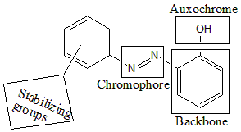
Figure 1
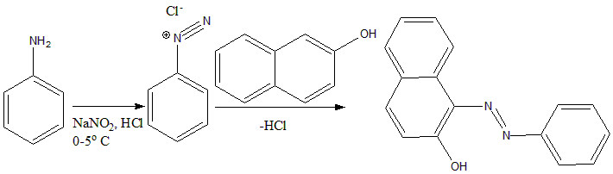
Scheme 1
In the first step, aniline is reacted with sodium nitrite and hydrochloric acid to produce diazonium salt, which further reacts with 10% Sodium hydroxide solution of b-naphthol, producing Phenyl azo-β-naphthol.
- Brief History:
By reacting arylamines in acidic media with half of an equivalent number of nitrous acid, half of the base was diazotized and the remaining portion acted as a coupling constituent, the earlier azo dyes had been made. A distinct coupling reagent, m-phenylenediamine was first used during synthesis of Chrysoidine [Figure 2A] by coupling with diazotized aniline. Roussin then developed a line of orange dyes recognised as Oranges I [Figure 2B], II [Figure 2C], III [[Figure 2D], and IV [Figure 2E]. Such dyes were made by combining diazotised sulphanilic acid with the appropriate amounts of α-naphthol, β-naphthol, N,N-dimethylaniline, and diphenylamine, respectively. The achievement of such dyes sparked a fast growth in the chemistry of azo dyes and the production of naphthalene derivatives. By mixing diazotised 4-aminoazobenzene-3,4'-disulphonic acid and β-naphthol, Nietzki created the very first disazo dye, naming Biebrich Scarlet [Figure 2F]. Couple of years later, Wallach developed a second kind of disazo dye by combining resorcinol with one molecule of diazotized sulphanilic acid and one molecule of diazotized crude 2,4-xylidine. Resorcin Brown [Figure 2G] was the name of this dye, which is still applied on leather.
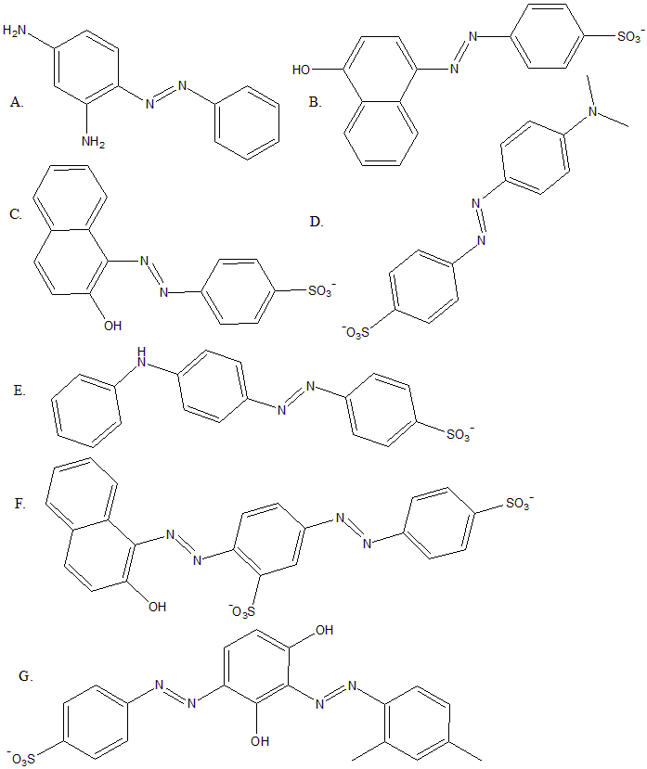
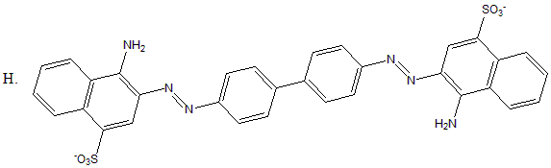
Figure 2
Such dyes were treated to silk or wool using light acid baths, but cotton could only be stained following a mordant-preparation step. The fibre was addressed with a tannic acid bath, followed by a tartar emetic solution, causing antimony tannate to precipitate inside the fibre. This chemical then reacted with later-applied basic dyes like Bismarck Brown or Chrysoidine to create insoluble colours, and the fibre that had been dyed in this way demonstrated serious opposition to washing. Griess found that disazo dyes might be treated to cotton with no need for a mordant by combining tetrazotised benzidinedisulphonic acid plus ingredients like naphthionic acid. Bottiger made the first straightforward cotton dye that was valuable commercially. Congo Red [Figure 2H] was created by combining two molecules of naphthionic acid with one component of tetrazotized benzidine. The dye is quite well recognised as a laboratory indicator and is particularly sensitive towards acids. There are numerous other significant cellulosic fiber dyes that have been produced. Numerous azo dyes have indeed been created for various uses as a result of the continuous need for fresh dyes brought on by the development of new synthetic materials.
- Nomenclature and Classification:
The five primary types of precursors used in the production of azo dyes are simply identified by the following code symbols; (i) A: Diazotisable primary amine, (ii) D: Tetrazotisable diamine, (iii) E: Coupling component capable to couple with one equivalent of a diazonium species, (iv) M: Primary aromatic amine capable of forming an aminoazo molecule by coupling with a diazonium compound, which can then be diazotized and coupled once more and (v) Z: Coupling component capable to couple with two or more equivalents of a diazonium entities. “” Sign denotes “diazotised and coupled with”. To easily distinguish between the many types of azo dyes, code letters and arrows are utilised. For example; type “AE” indicates monoazo dyes made by diazotizing an amine and combining with an suitable end compound, such as “anilineβ-naphthol”. Complex dyes' structures can be demonstrated succinctly and accurately.
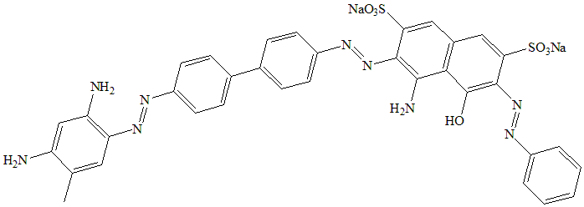
Figure 3
Arrows in polyazo dyes could be numbered to reflect the coupling order and when coupling is done in an acidic or alkaline media, which may have an impact on the coupling location, this is particularly helpful. For example; trisazo dye (Direct Black 4) [Figure 3] can be represented as above.
  - Classification according to number of azo groups:
Depending on how many azo connections are present in a single compound, azo dyes are classified as monoazo, disazo, trisazo, polyazo, and azoic.
    - Monoazo dyes:
All dyes of classes ‘AE’ with the structural formula ‘Z-N=N-W’ fall within this category⁴.
      - Z, W = benzene/ heterocyclic derrivatives
The historic member of this group, known for their orange coloration and used to dye cotton⁵, is chrysoidine [Figure 2A]. For colouring cellulosic fibres other variant [Figure 4A] is often used, whereas, for cellulose acetate, polyamides, polyesters, etc. dye shown in Figure 4B is used. Mono azoic acid dyes Orange IV [Figure 2E] and yellow dye [Figure 4C] are used for dying purpose of wools and nylons.
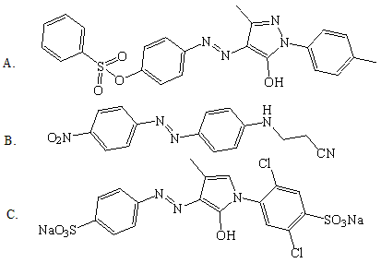
Figure 4
      - Z = benzene, W = naphthenic
Figure 5 displays this category of dyes, where the first one [Figure 5A] is a mordant red dye and the others [Figure 5B, 5C] are blue dyes.
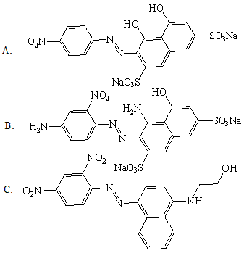

Figure 5

      - Z, W = Naphthalene
They are frequently employed upon polyamide components to colour black. Mordant Black 17 [Figure 6]⁶, which is utilised extensively by numerous textile and dyeing sectors, is a member of this group.
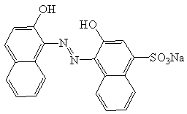
Figure 6

    - Disazo dyes
The three processes listed below can be used to create the diazo dyes, which have two groups with the formula N=N.
      - Dyes synthesized by the type A₁ZA₂:
Naphthalene Black 12B [Figure 7A], used for coloring wools, represents this class of dye, synthesized by coupling between diazotized p-nitroaniline and 4-amino-5-hydroxynaphthyl-2,7-disulfonic acid in acidic condition, followed by coupling with diazotized aniline in basic condition.
Special subdivision in this category appears such as A₁Z-X-ZA₂, where Z-X-Z is a bifunctional linking substance, like the urea counterpart produced by the interaction of two aminonaphthol units with phosgene [Carbonyl J acid, Figure 7B].
      - Dyes synthesized by the type E₁DE₂:

Example of dye of this category is Chlorazol Bordeaux B [Figure 7C], which provides bluish red coloration to cellulose fibres, synthesized by coupling of tetrazotised benzidine with naphthionic acid in alkaline medium followed by coupling with 6-Amino-4-hydroxy-2-naphthalenesulfonic acid in acidic medium. One diazonium unit in tetrazotized benzidines stimulates another, making the very first coupling stronger than the latter. First, the less aggressive coupling element is employed.

Dyes synthesized by the type AME:

Dispersol Fast Orange B [Figure 7D] represents this category. This orange dye is produced by combining aniline that has been diazotized with a-naphthylamine in an acidic medium, followed by diazotizing the resultant aminoazo molecule and linking it with phenol in a basic medium. To dye nylon or acetate fibres, it is applied as an aqueous dispersion.
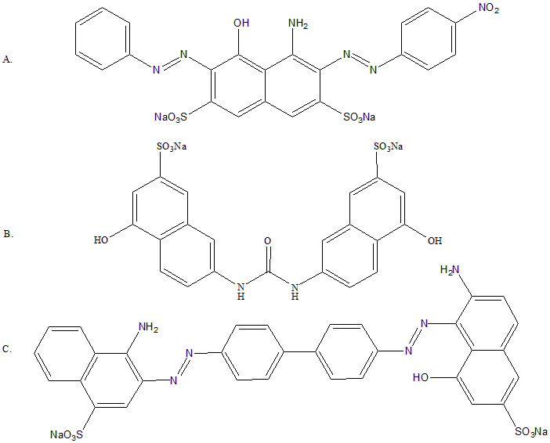
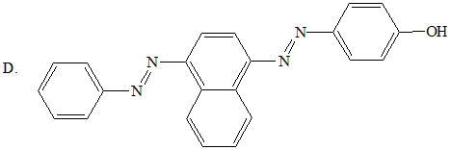
Figure 7
From symmetry point of view disazo dyes are categorized in further three categories, such as;
      - Primary diazo:
Two equivalents of diazoic acid were coupled together using the same coupling term to create this sort of dye. Those dyes are resorcinol and m-phenylenediamine variants on a worldwide scale. Figure 8A represents such dye used for wool.
      - Secondary diazoic – Symmetrical:
Compared to the few acid and mordant dyes, this category has a significant variety of direct dyes. They originate from a diamine that has undergone two diazotizations and been coupled with same entities. Examples⁷ are shown in Figure 8B, which contains benzidine function.
      - Secondary diazoic – Assymmetrical:
This type of dye was created by combining an amino azoic acid with a phenolic coupler during dye synthesis. Figure 8C shows one such example⁸.
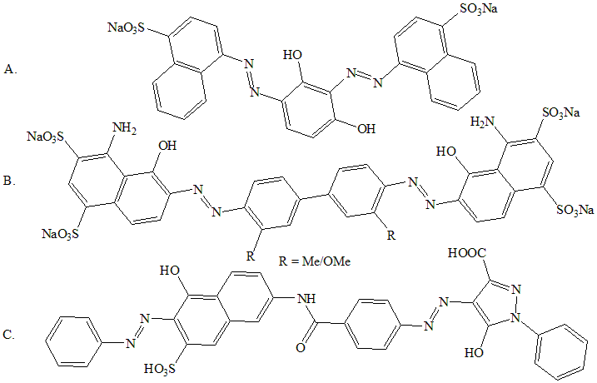
Figure 8
    - Trisazo Dyes:
The following three categories comprise the majority of marketed trisazo dyes:
      - Dyes synthesized by the type EDZA:
One such colourant, Chlorazol Orange Brown X [Figure 9A], is produced by combining tetrazotized benzidine with one proportion of salicylic acid in basic condition, followed by addition of one equivalent of the product of combining diazotized sulphanilic acid with m-tolylenediamine. It is a multipurpose brown dye that is mostly used on cellulosic fibres.
      - Dyes synthesized by the type E₁DME₂:
One such example is Chlorazol Drab RH [Figure 9B]. This dye is made by combining tetrazotized benzidine with first salicylic acid in basic condition, then with mixed Cleve's acids [such as 1-naphthylamine-6-sulphonic acid, 1-naphthylamine-7-sulphonic acid], diazotizing, and combining with 6-amino-4-hydroxynaphthalene-2-sulfonic acid in basic condition. The result is a gloomy brownish olive color on cellulosic fibres.
      - Dyes of the type AM₁M₂E:
Durazol Blue 2R [Figure 9C] represents this class of dyes. This dye is made by combining diazotized 3-aminonaphthalene-1,5-disulphonic acid with 1-naphthylamine, followed by diazotizing itself and combining with 1-naphthylamine-7-sulphonic acid. The generated species is diazotized again and combined with 6-amino-4-hydroxynaphthalene-2-sulfonic acid in basic condition. The dye is mostly used on cellulosic fibres to produce pale blue colours.
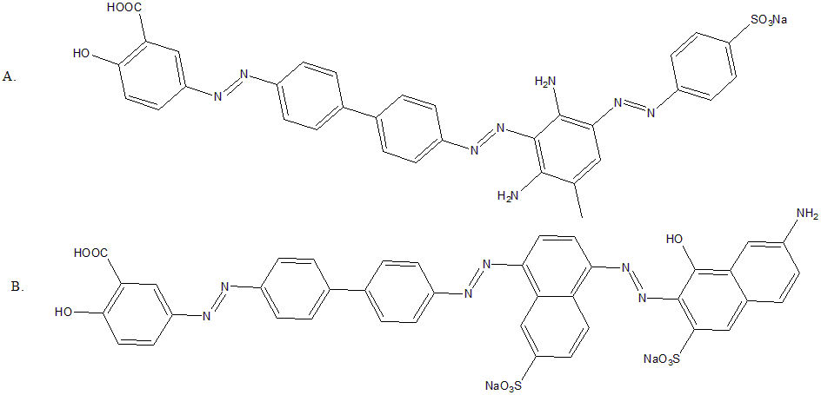

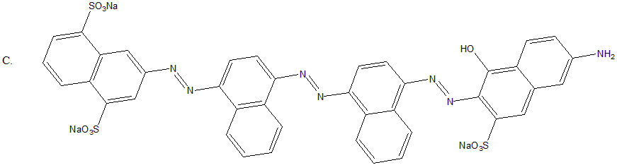
Figure 9

    - Tetrakisazo Dyes:
It gets more challenging to obtain the target molecule in a pure state as the count of azo groups in a dye molecule increases, in part since coupling tends to occur at more than one site and in part since some diazo breakdown happens at every step. They are primarily employed to create brown or black hues on leather or cellulosic fibres. One such example, Direct Brown 44 [Figure 10] can be synthesized by coupling two equivalent of diazotized sulphanilic acid with Bismarck brown.
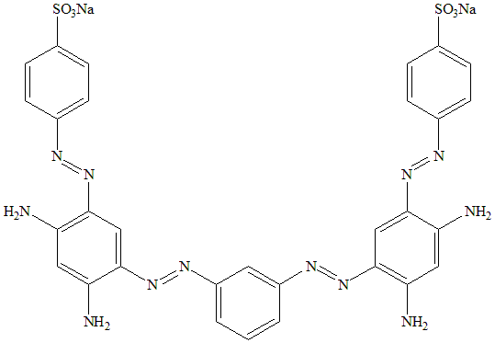
Figure 10
    - Polyazo Dyes
The repeating of the azo groups within the same structure defines polyazo dyes. They are designed to dye leather in deep hues. One such example is Direct Red dye⁹ [Figure 11].
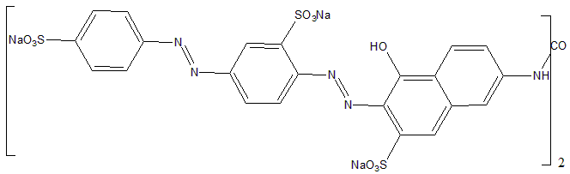

Figure 11
  - Classification according to reactive functional groupings

    - Mono and dichlorotriazine:
Figure 12A and 12B display examples of mono and dichlorotriazine dyes¹⁰, respectively. At 20 to 30ºC, those dyes have a strong compatibility towards cellulose. Scheme 2 shows the synthetic route for monochlorotriazine dye¹¹. Hydrolysis [Scheme 3] deactivates the carbon carrying the Cl atom in basic medium. Reactivity of the other Cl is noticeably reduced when one Cl is swapped out for a hyrdoxyl or cellulose ion. The properties and the solubility of the dye are affected by the -NH- linkage connecting the chromophore and the reactive group.
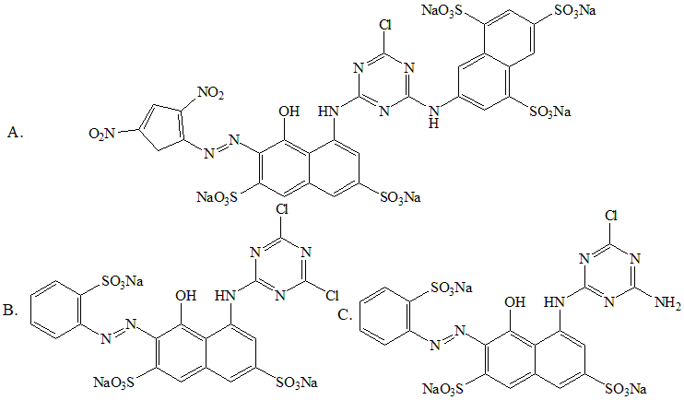
Figure 12
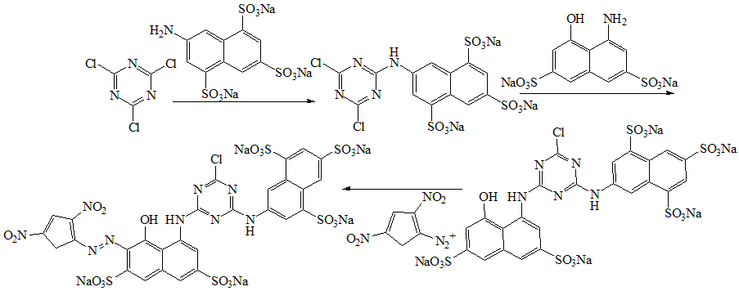
Scheme 2
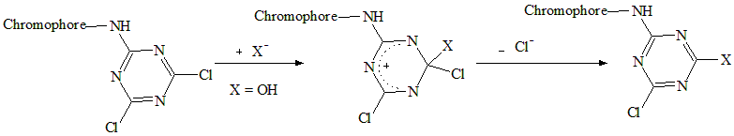
Scheme 3
    - Mono-amino-chlorotriazine:
The chromophoric units are identical to those of dichlorotriazine. It contains one amine and one active Cl. These entities become less active than dichlorotriazine¹². Figure 12C shows one such example.

    - Pyrimidines:

      - Trichloro Pyrimidines:
By nucleophilically substituting one Cl in tetrachloropyrimidine with an arylamine, trichloropyrimidine [Figure 13a] was produced. For effective fixation on a cellulosic kind of textile material, these colourants need a lighter temperature range. These withstand hydrolysis better.
      - Chlorofluoropyrimidine:
The addition of fluorine instead of chlorine increased this type of dyes' [Figure 13B] reactivity. In an acidic environment, the bond created with the fibre of the textile has been more stable, but upon irradiation of light, this bond becomes susceptible to oxidation by the peroxide chemicals¹². This kind of dye needs to be fixed at a temperature of 40-50ºC.
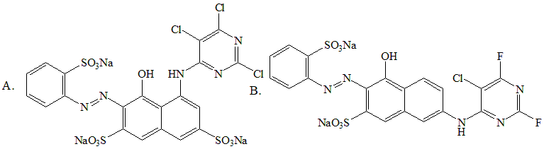
Figure 13
    - Dichloroquinoxaline:
High reactivity than dichloro pyrimidine, dichloro triazine and difluoro pyrimidine dyes is a characteristic of this kind of dye [Figure 14]. The fiber-dye bonding has shown lower resistance when peroxides, as well as when light and/or heat is used. The ideal temperature for a successful fixation is around 50ºC.
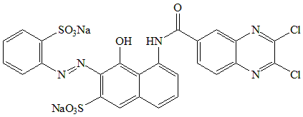
Figure 14
    - Vinylsulfone:
The functional group [SO₂-(CH₂)₂-O-SO₃Na] is what makes up the reactive portion of these types of cores. According to the mechanism depicted in Scheme 4, the functionality is inactive in an acidic/neutral solution, but, becomes active in basic condition. Nucleophilic addition [Scheme 5], which results in the production of a cellulose ether^{12,13}, is the binding process with the cellulosic fibres. Because it contains [-O-SO₃Na] group, the sulphatoethylsulfone entity has superior water solubility. After the sulfone group was removed in basic condition, the solubility was reduced and the propensity for cellulose increased. Remazol [Figure 15] is one of the examples of this class of dye.
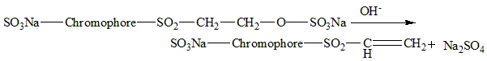
Scheme 4
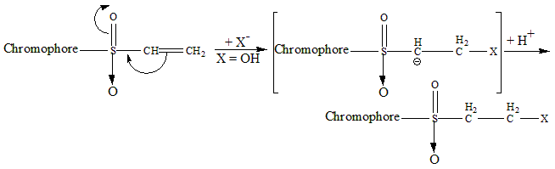
Scheme 5
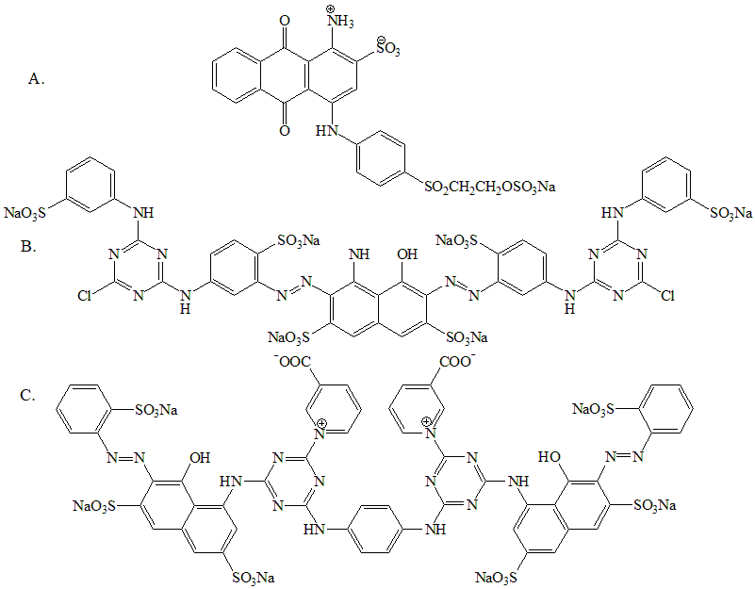
Figure 15
    - Bis-mono chlorotriazine:
This type of dyes is distinguished from its homo-functional equivalent, mono-chlorotriazine, for having a doubled dimensionality^{12,14} [Figure 15B]. Due to its higher affinity for depleting, they are used on interfaces made of cellulosic fiber.
    - Bis-amino nicotinotriazine:
These kinds of dyes [Figure 15C] were created through a substitution reaction by using pyridine carboxylic acid and Cl of triazine core. Comparable to mono chlorotriazine dyes, such dyes exhibit color and solidity when used towards cellulosic surfaces. In addition to being more advantageous chemicals than dichloro triazines and dichloro quinoxalines, bis aminonicotinotriazine has better reactivity than vinyl sulfones and chlorodifluoropyrimidines.
    - Monochlorotriazine–sulphatoethylsulphone:
Dichlorotriazine reacts with an arylamine that contains a sulphatoethylsulfone unit to produce monochlorotriazine-sulphatoethylsulfone¹⁵. The reacting groups facilitate strong cellulosic fiber binding. Due to their strong affinity, sulphatoethylsulfone binds to fibers in a bifunctional configuration. Distinct amounts of firmness are promoted by the presence of two different fiber-dye linkages. Supra-gloss Sumifixe red 2BF¹⁶ [Figure 16A] is one illustration of this class of dye.
    - Monofluorotriazine–sulphatoethylsulfone:
Generally consists of an aliphatic moiety linked to the second reactive site of mono fluoro triazine and bound to the sulphatoethylsulfone entity. These are more expensive to produce than other dyes. Their excellent attachment, moderate to high efficiency washability, and stability make up for it. One such example of Ciba C¹² is shown in Figure 16B.
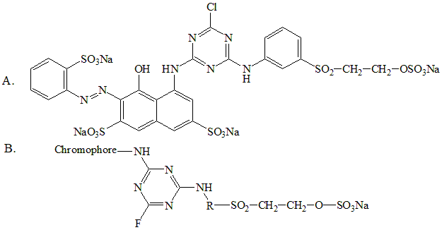
Figure 16
- Properties:
  - Reactivity:
Products of addition of hydrogen or hydrogenation of an azo group are shown in Scheme 6. Scheme 7 displays the product after addition of oxidizing agents like hydrogen peroxide or peracid to the same. The architecture of a dye's reactive component determines how active it is. The most reactive compounds are dichlorotriazines, next by dichloroquinoxalines, difluoropyrimidines, and monofluorotriazines, in that order. Vinylsulfones stand in for the moderate reactive dyes. The least reactive compounds are trichloropyrimidines. The ability to absorb a dye on a fabric supporting substrate is known as substantialivity, which also depends on the reactive components involved¹⁷. The degree of substantivity follows the following¹⁸ order: sulphatoethylsulphone > Trichloropyrimidine > fluorotriazine > dichloroquinoxaline > dichlorotriazine > aminochlorotriazine.
Scheme 6
Scheme 7
  - Isomerism:
Double bond within azo compounds promotes stereoisomerism, resulting in confirmation of both cis- and trans- counterparts in some circumstances. Azobenzene, for instance, can be recovered in two varieties with distinct physical characteristics: cis- (E- form) and trans- (Z- form) [Scheme 8]. Their melting points are 71.4 and 68ºC, respectively.
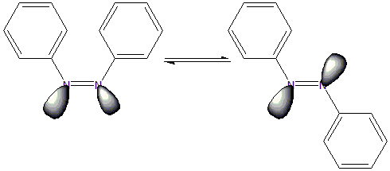
Scheme 8
The phenomena of “phototropy” or “Photo isomerization”^{8,19} are made possible by the stereoisomerism of azo dyes, which is important in practise. When treated on non-polar materials like cellulose acetate and subjected to bright light, several dyes exhibit a noticeable shift in hue; the shift is undone after preservation in dark. It is thought that exposure causes a substantial transformation of the trans- into the cis- state, and that the opposite happens when the activating effects of light are removed.
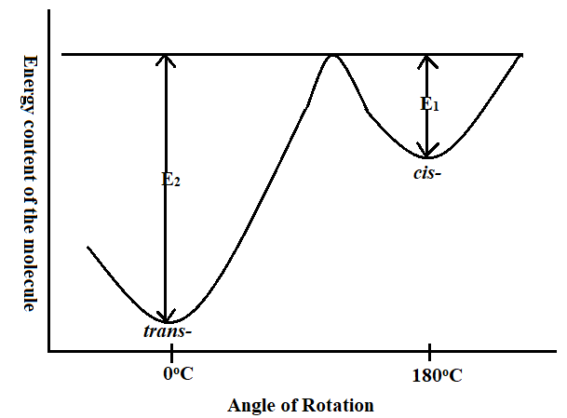
Figure 17
Figure 17 is a schematic picture that Atherton and Peters used to describe the phenomenon named “phototropy” in azo dyes. It depicts that the cis- and trans- versions as reasonably stable configurations with different energy contents. The energy required in twisting the molecule via the intermediary strained regions of the azo linkage separates the two forms by an energy barrier. For a component in the cis- configuration to transition into the trans- configuration, energy E₁ is needed, while energy E₂ is needed for the opposite transformation. Both E₁ and E₂ are significantly more than and close to the energy that a dye unit in situ at room temperature possesses. As a result, compounds in the cis- state easily gain the energy required to switch into the trans- state, but few trans- entities are adequately energised to effect the opposite transformation unless energy is available from outside. As a result of irradiation of light, equilibrium shifts in support of the cis- form.
  - Tautomerism:
The final outcome of the reaction between diazobenzene chloride and α-naphthol is identical to that produced by the condensation of 1,4-naphthoquinone and phenylhydrazine²⁰. It has been demonstrated that both hydroxyl and keto units exist, and that the two forms coexist in equilibrium in each reaction's final product [Scheme 9A]. One more such example is shown in Scheme 9B. The intramolecular movement of the hydrogen from one component to the next is the outcome of azo/hydrazone tautomerism^{21,22,23}. Interconversion occurs quickly. Such tautomerism is significant for azo dyes because it causes the emergence of properties like lightfastness and dye tinctorial potency.
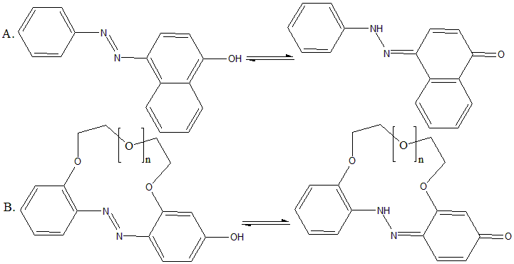
Scheme 9
The azo form is significantly favoured through equilibrium in hydroxyazo substances in the benzene series, although generally seen increased fraction of hydrazone type in polycyclic chemicals upon the increase in the quantity of rings. 1-arylazo-2-naphthols are produced by combining diazotized arylamines with p-naphthol; the isomeric 2-arylazo-1-naphthols are produced by condensation of 1,2-naphthoquinone with arylhydrazines. The p-hydroxyazo products in the benzene & naphthalene series act like acids and thus are soluble in aq. NaOH, whereas the o-hydroxyazo species, like 1-phenylazo-2-naphthol, remain unchanged by basic environment. It is claimed that a hydrogen bond formed here between azo N atom and the -OH group. The tautomeric equilibrium in question can be illustrated by Scheme 10.
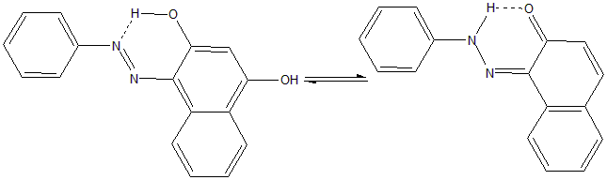
Scheme 10
Additionally, o- and p-aminoazo compounds exhibit tautomerism²⁴ [Scheme 11]. These substances often stay in the aminoazo configuration. H bonds between individual molecules happen in o-aminoazo compounds. H bond does not impede the diazotization of o-aminoazo substances of benzene family; however the equivalent naphthalene counterparts cannot undergo this process. However, p-amino compounds are easily diazotized in both classes. Other tautomers exist, such as azonium/ammonium²⁵ dyes when azo dyes are protonated²⁶ [Scheme 12].
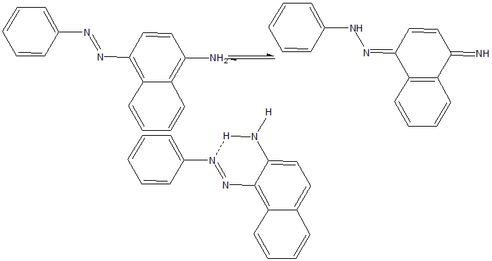
Scheme 11
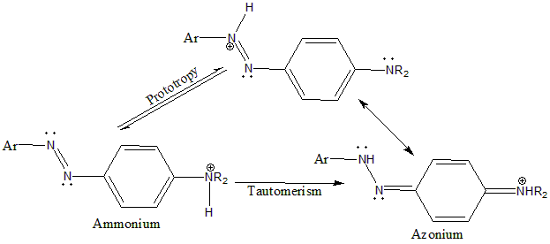
Scheme 12
The three main groups of dyes; azo-acetoacetanilide²⁷, azo-pyrazolone²⁸, and azo-pyridone²⁹, in hydrazone pattern are shown in Figure 18A. The azo derivative of many dyes results from the imino group's instability [Figure 18B]. With reference to the diazo dyes made of amino-naphthol, the two groups, one in azo form and the other in hydrazo form, are seen to cohabit [Figure 18C].
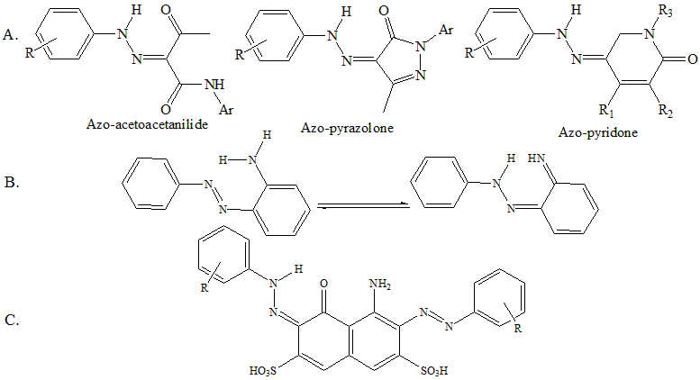
Figure 18

- Synthesis
  - Using Gewald Reaction:
In Gewald's synthesis, α-cyano ester is condensed with a ketone or an aldehyde (apart from formaldehyde) to produce poly-substituted 2-aminothiophene. The crucial intermediary for diazotization and subsequent azodye production is this 2-amino thiophene. This methodology has been used for synthesizing several conventional and functional dyes^{30,31}. R. W. Sabnis et al. described several such synthesis methods. Few of them are depicted in Scheme 13, 14, 15, 16 and 17. Benzo-thiophene-3(2H)-one-1,1-dioxide was combined with ethyl cyanoacetate to produce the adduct, which was then diazotized employing nitrosyl sulfuric acid followed by coupling with N, N-dialkyl aryl amines in acidic condition to produce Azo dyes 26 [Scheme 13]³². Similar process produced a crucial precursor, 5-amino-6-cyano-2-phenylthienooxazole, which had been diazotized using nitrosyl sulfuric acid and linked to N, N-dialkyl modified arylamines at an acidic pH to produce azo-thieno-oxazoles dyes [Scheme 14]³³. The same group also reported that 2-amino-3-cyano- and 2-amino-3-carbethoxy-4, 5, 6, 7-tetrahydrobenzothiophene were diazotized at low temperature using HCl and NaNO₂ and combined to N, N-dialkyl-substituted aryl amines to produce monoazo dyes. Arylamino monoazothiophenes were produced of monoazo dyes in basic condition. These compounds were then diazotized with nitrosylsulfuric acid and combined with 2-naphthol and N, N-dimethylaniline to produce intensely colored disazo dispersion dyes 38 [Scheme 15]³². The same team also published additional series of reactions employing 2-aminothiophene through the Gewald reaction, as shown in Scheme 16³². By combining diazotized aniline with the appropriate 2-amino-3-cyano-4-aryl-modified thiophenes at the fifth position, Wardakhan et al. described the production of azothiophene dyes 42 [Scheme 17]³⁴.
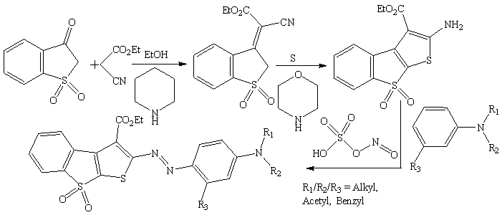
Scheme 13
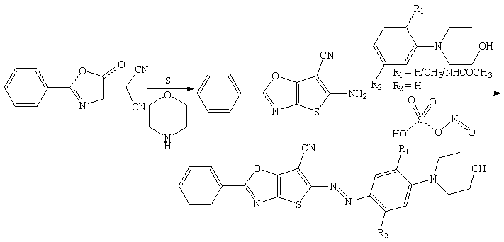
Scheme 14
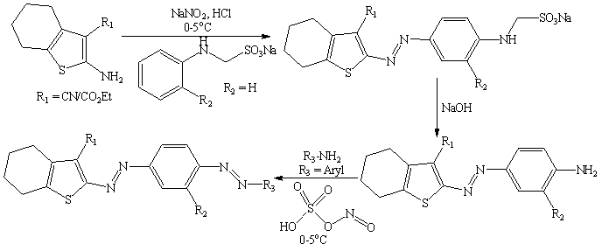
Scheme 15
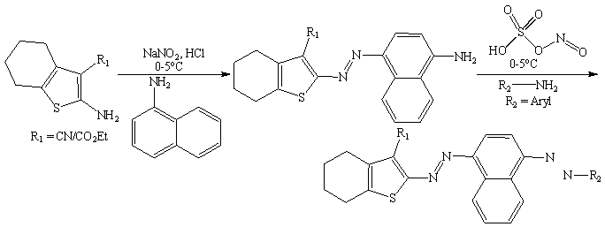
Scheme 16
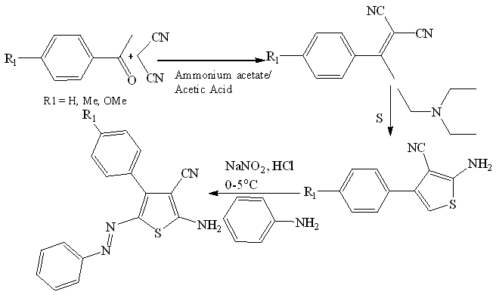
Scheme 17
  - By the diazotization/coupling reaction:
General synthetic scheme via coupling reaction between diazo salt compounds and aryl amines/phenols mainly has already been shown in scheme 1. One of the most significant reactions in the growth of industrial organic chemistry is this one. The majority of diazonium compounds are fragile and potentially explosive when dry. They are constantly created at ~ 0℃ in an acidic medium with vigorous stirring in order to reduce exposure to water, which would otherwise generate phenol, and are then employed right away in the condensation reactions. The diazonium compound interacts as an electrophile with a coupling component (a phenol or an aniline or their derivatives) that is abundant in electrons to finish the production of the azo dye. An electrophilic aromatic substitution route drove this event. If the para site is available and not occupied, the hydroxyl or amine group leads the aryl diasonium ion there; otherwise, it will bind to the ortho location.
  - Alternative methods:
Alternative procedures for making azo dyes include reducing nitroaromatic compounds in basic condition, reducing nitrosated substances, oxidizing primary amines, condensing hydrazines and quinones, and condensing primary amines and nitrosated analogues. Presence of a catalyst (Cuprous Chloride/Pyridine)³⁵ and under photocatalytic circumstances aided by Titanium dioxide³⁶, Ferric oxide³⁷, Mercuric oxide³⁸, or oxidizing substances like potassium permanganate³⁹, Manganese dioxide⁴⁰, Sodium perborate⁴¹, Potassium superoxide⁴², Potassium Ferrate⁴³, Silver oxide⁴⁴, or Lead acetate⁴⁵, the oxidative coupling process of two amines will occur. Zn or Stannous chloride in a alkaline condition^{46,47}, Lithium Aluminum hydride⁴⁸, ethylenediamine⁴⁹, Sodium Telluride⁵⁰, or Pb, either with triethylammonium formate, or NH₄OAc^{51,52}, are the reduction chemicals utilized.
- Recent azo dyes:
  - Azo dyes with hydrazine group:
For commercial use, azo dyes exhibiting azo-hydrazone tautomerism are crucial²¹. Since the two azo-hydrazone tautomers have different technological features and varied dyeing capabilities, the aspects of these tautomeric units are of considerable significance⁵³. When 3-ethylthio-5-cyanomethyl-4-phenyl-1,2,4-triazole is combined with benzene diazonium chloride, a good percentage of 5-ethylthio-N', 4-diphenyl-4H-1, 2, 4-triazole-3-carbohydrazonoyl cyanide is produced⁵⁴. There are three different tautomeric versions of the dye that can exist: the azo species, the hydrazone type, as well as the azo-enamine form [Scheme 18]. The equilibrium seen among three forms is influenced by substitution at the para- position of the aryl moiety in the diazonium salt. The amount of azo formations is raised by electron-releasing substituents in the para position and concentration of the hydrazone state is promoted by electron-withdrawing moieties⁵⁵. When diazotized product of 4-methyl aniline is used instead of aniline, azo product is formed in major quantity in similar reaction condition [Scheme 19], but, surprisingly, when diazotized product of 4-chloro aniline is used, azo tautomer forms in major quantity [Scheme 20] here too⁵⁴. Two methods²¹ shown in Scheme 21, were used to generate arylazo pyridone dyes. Scheme 22 depicts literature reports of a few unique azo-hydrazone tautomeric dyes and associated production processes⁵⁶. Aromatic groups for this bisazo dyes are shown there. The first compound shows five possible tautomeric structures, whereas the rest compounds show three possible tautomeric structures. These tautomeric structures are shown in Scheme 23 and 24, respectively.
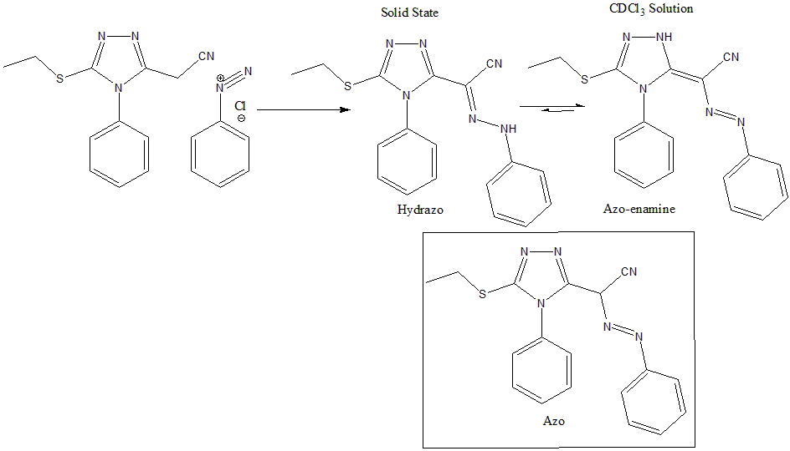
Scheme 18
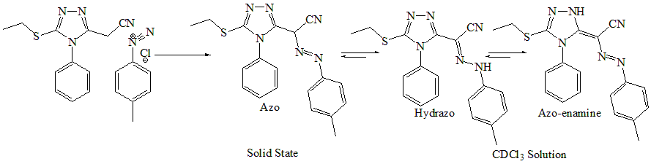
Scheme 19
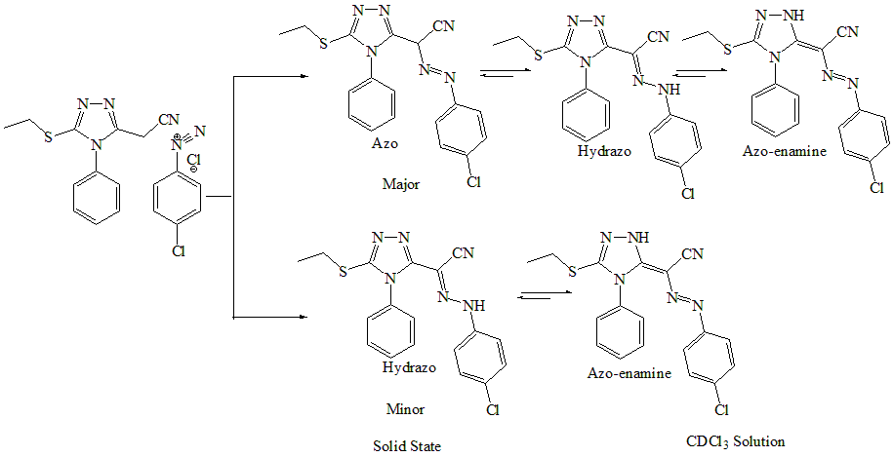
Scheme 20
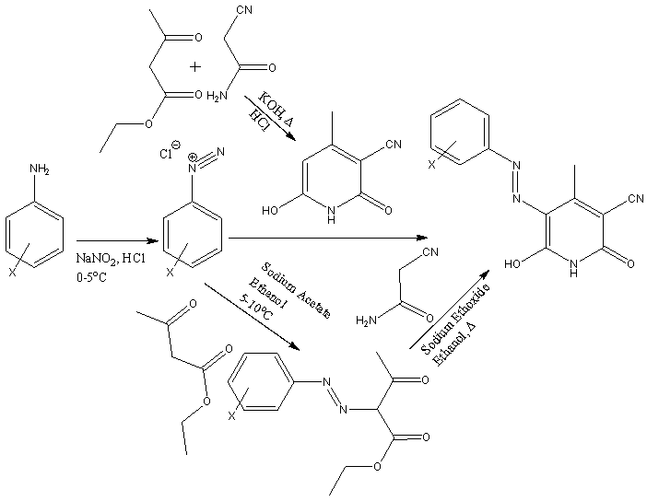

Scheme 21
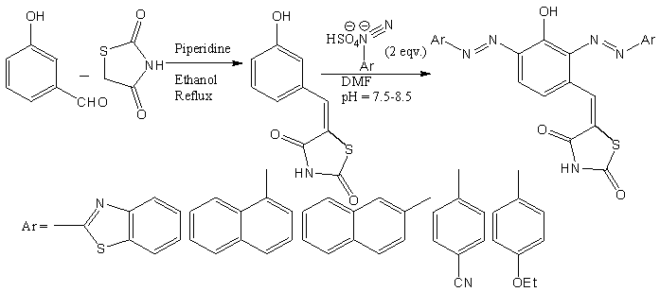
Scheme 22
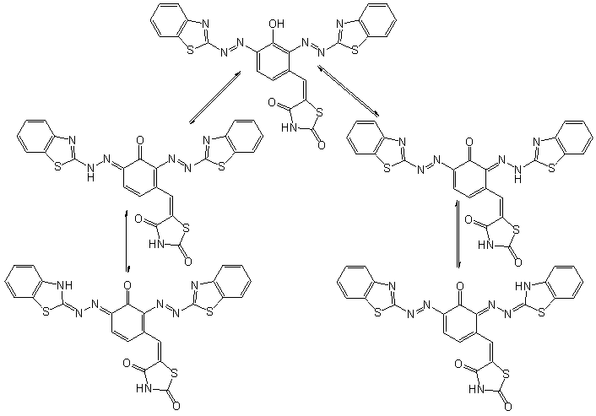
Scheme 23
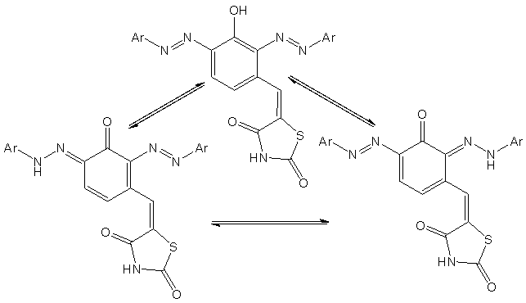
Scheme 24
  - Azo dyes with chromene group:
Such dyes are made by combining 2-hydroxybenzaldehyde with substituted diazotized anilines, followed by reaction with acetylacetone in presence of Cu-SBA-15 catalyst⁵⁷ in 2:1 CH₂Cl₂/EtOH mixture⁵⁸ [Scheme 25]. Oner more chromene based important type of dye based on 2-amino-7-hydroxy-4-phenyl-4H-chromene-3-carbonitrile and cyanuric chloride was reported by Badrey et al.⁵⁹. These were synthesized by two different methodologies shown in Scheme 26.
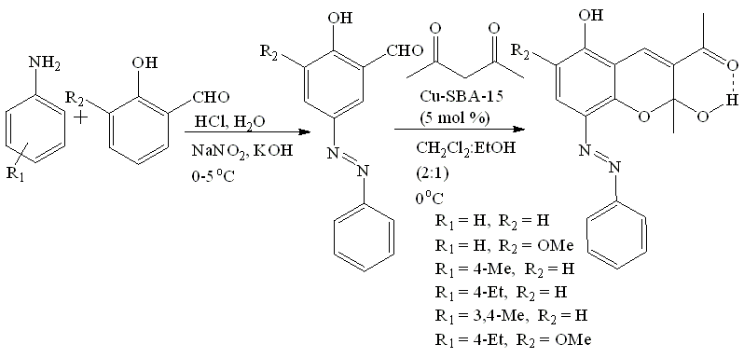
Scheme 25
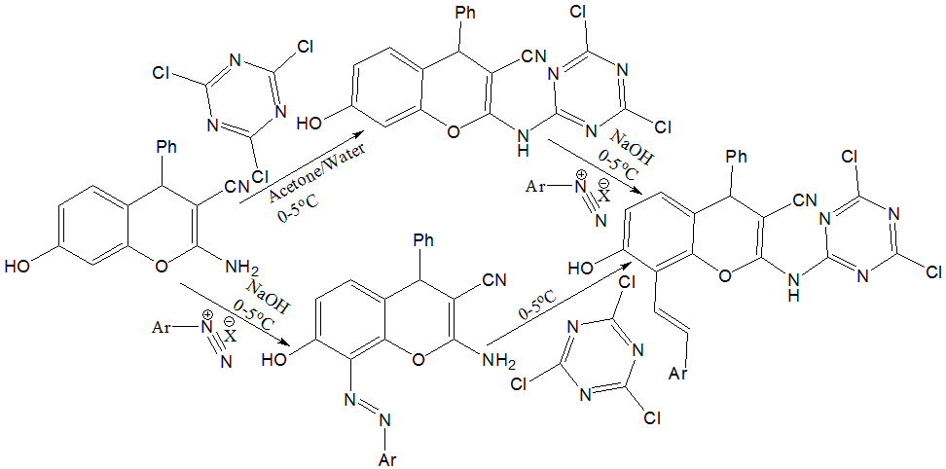
Scheme 26
  - Azo dyes with 2-aminothiophene and 2-aminothiazoles group:

Hallas et al. published synthesis of several 2-aminothiophene and 2-aminothiazole based dyes. Their general synthetic routes⁶⁰ are shown in scheme 27. Aminothiophenes and aminothiazoles with diazo-nitro substituents proved to be of extremely significance for their practical use as diazo components.

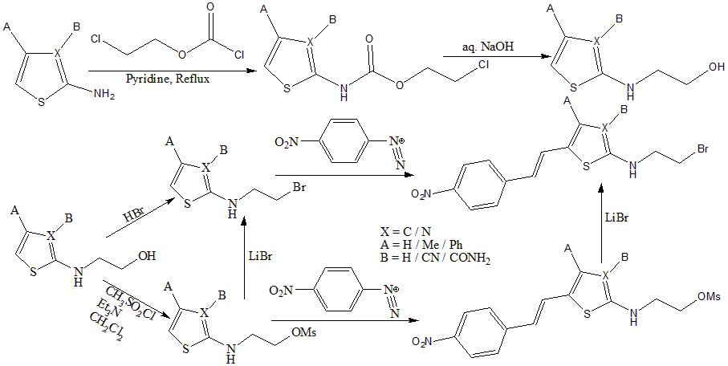
Scheme 27
- Applications:
Azo dyes are the most diverse class of synthetic dyes, and they are very popular for numerous industrial purposes. Azo dyes currently account for the majority of dye chemical manufacturing, and significance may potentially rise in the near future. These are employed in high-tech products including lasers and nonlinear optical systems⁶¹, thermal transfer printers, and fuel cells⁶², as well as in the sectors of pharmacy and pharmacological activities⁶³, as well as biology⁶⁴. Also susceptible to dyeing of textiles⁶⁵, leather, paper, food^{66,67}, cosmetics⁶⁸, and medications^{69,70}. These are also susceptible to photodynamic treatment⁶², metallochromic indicators⁷¹, solar cells⁷² etc.
References:
[1] S. Benkhaya, S. El Harfi and A. El Harfi, “Classifications, properties and applications of textile dyes: a review”, Appl. J. Environ. Eng. Sci., Vol. 3, pp. 311–320, 2017.
[2] A. Gürses, M. Açıkyıldız, K. Günes and M. S. Gürses, “Classification of dye and pigments”, in: “Dyes and Pigment”, Springer, pp. 31–45, 2016.
[3] L. Al-Rubaie and R.J. Mhessn, “Synthesis and characterization of azo dye para red and new derivatives”, J. Chem., Vol. 9, pp. 465–470, 2012.
[4] M. Hedayatullah, J. P. Dechatre and L. Denivelle, “Oxydation des amines aromatiquesprimaires. VII. Sur l’oxydation d’anilines substituees par le carbonate d’argent sur celite”, Tetrahedron Lett., Vol. 16, pp. 2039–2042, 1975.
[5] H. Duan, L. Li, X. Wang, Y. Wang, J. Li and C. Luo, “CdTe quantum dots@ luminol as signal amplification system for chrysoidine with chemiluminescence-chitosan/graphene oxide-magnetite-molecularly imprinting sensor”, Spectrochim. Acta A Mol. Biomol. Spectrosc., Vol. 153, pp. 535–541, 2016.
[6] A. Karunya, C. Rose, C. V. Nachiyar, “Biodegradation of the textile dye Mordant Black 17 (Calcon) by Moraxella osloensis isolated from textile effluentcontaminated site”, World J. Microbiol. Biotechnol., Vol. 30, pp. 915–924, 2014.
[7] S. P. Mulliken, A Method for the Identification of Pure Organic Compounds by a Systematic Analytical Procedure Based on Physical Properties and Chemical Reactions”, J. Wiley & sons, Incorporated, 1916.
[8] M. Hedayatullah, “Les Colorants Synthetiques”, Presses universitaires de France, 1976.
[9] A. L. Forster, J. L. Bitter, S. Rosenthal, S. Brooks and S. S. Watson, “Photofading in cotton fibers dyed using red, yellow, and blue direct dyes during examination with Microspectrophotometry (MSP)”, Forensic Chem. Vol. 5, pp. 72-78, 2017.
[10] K. Xie, A. Gao, C. Li and M. Li, “Highly water-soluble and pH-sensitive colorimetric sensors based on a D–π–A heterocyclic azo chromosphere”, Sens. Actuators B Chem., Vol. 204, pp. 167–174, 2014.
[11] J. Shore, “Dyeing with reactive dyes” in “Cellulosics Dyeing”, pp. 189–245, 1995.
[12] J. Shore, “Cellulosics Dyeing”, Soc. Dye. Colour., 1995.
[13] T. Vickerstaff, “Physical Chemistry of Dyeing”, 1954.
[14] S. Akhtar, A. A. Khan and Q. Husain, “Potential of immobilized bitter gourd (Momordica charantia) peroxidases in the decolorization and removal of textile dyes from polluted wastewater and dyeing effluent”, Chemosphere, Vol. 60, pp. 291–301, 2005.
[15] A. Mousa, “Synthesis and application of a polyfunctional bis (monochlorotriazine/ sulphatoethylsulphone) reactive dye”, Dyes Pigments, Vol. 75, pp. 747–752, 2007.
[16] S. Gül, O. Ozcan and O. Erbatur, “Ozonation of CI Reactive Red 194 and CI Reactive Yellow 145 in aqueous solution in the presence of granular activated carbon”, Dyes Pigments, Vol. 75, pp. 426–431, 2007.
[17] K. Wojciechowski and A. Wolska, “Substantivity and spatial structure of soluble polycyclic dyes for dyeing cellulose fibres”, Dyes Pigments, Vol. 65, pp. 111–116, 2005.
[18] S. Burkinshaw and M. Paraskevas, “The dyeing of silk: Part 4 heterobifunctional dyes”, Dyes Pigments, Vol. 88, pp. 396–402, 2011.
[19] H. Zollinger, “Azo and Diazo Chemistry: Aliphatic and Aromatic Compounds”, New York Interscience publishers, 1961.
[20] P. Ball and C. Nicholls, “Azo-hydrazone tautomerism of hydroxyazo compounds - a review”, Dyes Pigments, Vol. 3, pp. 5–26, 1982.
[21] J. M. Mirkovic, G. S. Uscumlic, A. D. Marinkovic and D. Z. Mijin, “Azo-hydrazone tautomerism of aryl azo pyridone dyes/Azo-hidrazon tautomerija arilazo piridonskih boja”, Hem. Ind., Vol. 67, pp. 1–16, 2013.
[22] A. S. Shawali, M. A. Abdallah, M. A. Mosselhi and Y. F. Mohamed, “Synthesis and Tautomeric Structure of 1, 2-Bis-(7-arylhydrazono-7H-[1, 2, 4] triazolo [3, 4-b][1, 3, 4] thiadiazin-3-yl)ethanes”, Z. Naturforschung B, Vol. 57, pp. 552–556, 2002.
[23] B. Hu, G. Wang, W. You, W. Huang and X. -Z. You, “Azo-hydrazone tautomerism by in situ Cu^{II} ion catalysis and complexation with the H₂O₂ oxidant of C.I. Disperse Yellow 79”, Dyes Pigments Vol. 91, pp. 105–111, 2011.
[24] M. Kose, N. Kurtoglu, O. Gümüssu, M. Tutak, V. McKee, D. Karakas and M. Kurtoglu, “Synthesis, characterization and antimicrobial studies of 2-{(E)-[(2-hydroxy-5-methylphenyl) imino] methyl}-4-[(E)-phenyldiazenyl] phenol as a novel azoazomethine dye”, J. Mol. Struct., Vol. 1053, pp. 89–99, 2013.
[25] T. Stoyanova, S. Stoyanov, L. Antonov and V. Petrova, “Ammonium-azonium tautomerism in some N, N-dialkylaminoazo dyes. Part 1: general considerations”, Dyes Pigments, Vol. 31, pp. 1–12, 1996.
[26] P. F. Gordon and P. Gregory, “Organic Chemistry in Colour”, Springer Science & Business Media, 2012.
[27] C. I. Pearce, J. T. Guthrie and J. R. Lloyd, “Reduction of pigment dispersions by Shewanella strain J18 143”, Dyes Pigments, Vol. 76 pp. 696–705, 2008.
[28] A. K. Khalil, M. A. Hassan, M. M. Mohamed and A. M. El-Sayed, “Metal salt-catalyzed diazocoupling of 3-substituted-1H-pyrazol-2-in-5-ones in aqueous medium”, Dyes Pigments, Vol. 66, pp. 241–245, 2005.
[29] N. Ertan and P. Gürkan, “Synthesis and properties of some azo pyridone dyes and their Cu (II) complexes”, Dyes Pigments, Vol. 33, pp. 137–147, 1997.
[30] S. Balalaie, S. Ramezanpour, M. Bararjanian and J. H. Gross, “DABCO-catalyzed efficient synthesis of naphthopyran derivatives via One-Pot three-component condensation reaction at room temperature”, Synth. Commun., Vol. 38, pp. 1078–1089, 2008.
[31] B. Dhungana, H. Peng, S. Kutarna, G. Umbuzeiro, S. Shrestha, J. Liu, P. D. Jones, B. Subedi, J. P. Giesy and G. P. Cobb, “Abundances and concentrations of brominated azo dyes detected in indoor dust”, Environ. Pollut., Vol. 252 pp. 784–793, 2019.
[32] R. Sabnis, D. Rangnekar and N. Sonawane, “2-Aminothiophenes by the Gewald reaction”, J. Heterocycl. Chem., Vol. 36, pp. 333–345, 1999.
[33] V. Kanetkar and R. Walavalkar, “Synthetic utility of 5-amino-6-cyano-2-phenylthieno [2, 3-d] oxazole”, J. Serb. Chem. Soc., Vol. 70, pp. 1249–1253, 2005.
[34] W. W. Wardakhan, H. Z. Shams and H. E. Moustafa, “Synthesis of polyfunctionally substituted thiophene, thieno [2,3-b] pyridine and thieno [2,3-d] pyrimidine derivatives”, Phosphorus, Sulfur, and Silicon and the Related Elements, Vol. 180, pp. 1815–1827, 2005.
[35] B. Jousselme, P. Blanchard, N. Gallego-Planas, E. Levillain, J. Delaunay, M. Allain, P. Richomme and J. Roncali, “Photomechanical control of the electronic properties of linear π-conjugated systems”, Chem. Eur J., Vol. 9, pp. 5297–5306, 2003.
[36] M. A. Ferguson, M. R. Hoffmann and J. G. Hering, “TiO₂-photocatalyzed as (III) oxidation in aqueous suspensions: reaction kinetics and effects of adsorption”, Environ. Sci. Technol., Vol. 39, pp. 1880–1886, 2005.
[37] C. Karunakaran and S. Senthilvelan, “Fe₂O₃-photocatalysis with sunlight and UV light: oxidation of aniline”, Electrochem. Commun., Vol. 8, pp. 95–101, 2006.
[38] S. Farhadi, P. Zaringhadama and R. Z. Sahamieh, “Photo-assisted oxidation of anilines and other primary aromatic amines to azo compounds using Mercury (II) oxide as a photo-oxidant”, Acta Chim. Slov., Vol. 54, pp. 647-653, 2007.
[39] N. A. Noureldin and J. W. Bellegarde, “A novel method. The synthesis of ketones and azobenzenes using supported permanganate”, Synthesis, Vol. 1999, pp. 939–942, 1999.
[40] I. Bhatnagar and M. V. George, “Oxidation with metal oxides. III. Oxidation of diamines and hydrazines with manganese dioxide”, J. Org. Chem., Vol. 33, pp. 2407–2411, 1968.
[41] S. M. Mehta and M. V. Vakilwala, “Sodium perborate as a reagent in organic chemistry. I. Preparation of azo-compounds”, J. Am. Chem. Soc., Vol. 74, pp. 563–564, 1952.
[42] G. Crank and M. I. H. Makin, “Organic chemistry of superoxide. I. Oxidations of aromatic compounds”, Tetrahedron Lett., Vol. 20, 2169–2170, 1979.
[43] H. Huang, D. Sommerfeld, B. C. Dunn, C. R. Lloyd and E. M. Eyring, “Ferrate (VI) oxidation of aniline”, J. Chem. Soc., Dalton Trans., Issue 8, pp. 1301–1305, 2001.
[44] B. Ortiz, P. Villanueva and F. Walls, “Silver (II) oxide as a reagent. Reactions with aromatic amines and miscellaneous related compounds”, J. Org. Chem., Vol. 37, pp. 2748–2750, 1972.
[45] K. Pausacker and J. Scroggie, “Oxidations with lead tetra-acetate. Part II. The oxidation of primary aromatic amines”, J. Chem. Soc., pp. 4003–4006, 1954.
[46] H. Bigelow and D. Robinson, “Azobenzene”, Org. Synth., Vol. 22, pp. 28, 1942.
[47] E. Luboch, E. Wagner-Wysiecka, Z. Poleska-Muchlado and V. C. Kravtsov, “Synthesis and properties of azobenzocrown ethers with π-electron donor, or π-electron donor and π-electron acceptor group(s) on benzene ring(s)”, Tetrahedron, Vol. 61, pp. 10738–10747, 2005.
[48] R. K. Ahmad, D. Faure, P. Goddard, R. Oda and D. M. Bassani, “Photosensitive vesicles from a cis-azobenzene gemini surfactant show high photoresponse”, Org. Biomol. Chem., Vol. 7, pp. 3173–3178, 2009.
[49] T. F. Chung, Y. M. Wu and C. H. Cheng, “Reduction of aromatic nitro compounds by ethylenediamine. A new selective reagent for the synthesis of symmetric azo compounds”, J. Org. Chem., Vol. 49, pp. 1215–1217, 1984.
[50] H. Suzuki, H. Manabe, T. Kawaguchi and M. Inouye, “Reduction of aromatic nitro compounds and thioketones with sodium telluride under aprotic conditions”, Bull. Chem. Soc. Jpn., Vol. 60, pp. 771–772, 1987.
[51] H. M. D. Bandara and S. C. Burdette, “Photoisomerization in different classes of azobenzene”, Chem. Soc. Rev., Vol. 41, pp. 1809–1825, 2012.
[52] M. C. Spiridon, F. A. Jerca, V. V. Jerca, D. S. Vasilescu and D. M. Vuluga, “2-Oxazoline based photo-responsive azo-polymers. Synthesis, characterization and isomerization kinetics”, Eur. Polym. J., Vol. 49, pp. 452–463, 2013.
[53] P. Gregory, “Azo dyes: structure-carcinogenicity relationships”, Dyes Pigments, Vol. 7, pp. 45–56, 1986.
[54] M. Al-Sheikh, H. Y. Medrasi, K. U. Sadek and R. A. Mekheimer, “Synthesis and spectroscopic properties of new azo dyes derived from 3-Ethylthio-5-cyanomethyl-4-phenyl-1, 2, 4-triazole”, Molecules, Vol. 19, pp. 2993–3003, 2014.
[55] G. Pavlović, L. Racané, H. Čičak and V. Tralić-Kulenović, “The synthesis and structural study of two benzothiazolyl azo dyes: X-ray crystallographic and computational study of azo-hydrazone tautomerism”. Dyes Pigments, Vol. 83, pp. 354–362, 2009.
[56] A. Mohammadi, “Novel triazene dyes based on N-phenylpiperazine: synthesis, antibacterial activity and solvatochromic properties”, J. Mol. Liq., Vol. 193, pp. 69–73, 2014.
[57] L. –F, Chen, P. –J. Guo, L. –J. Zhu, M. –H. Qiao, W. Shen, H. –L. Xu, K. –N. Fan, Appl. Catal. A. Gen., Vol. 356, pp. 129-136, 2009.
[58] S. F. Kamazani and S. S. Soltani, “Highly efficient synthesis of new 2H-chromene dyes using Cu-SBA-15”, Orient. J. Chem., Vol. 32, pp. 2543–2548, 2016.
[59] M. G. Badrey, S. M. Gomha and H. M. Mashaly, “Synthesis and studies on chromene based reactive azo dyes and their applications on different fabrics”, Eur. J. Chem., Vol. 7, pp. 146–151, 2016.
[60] G. Hallas and J. -H. Choi, “Synthesis and spectral properties of azo dyes derived from 2-aminothiophenes and 2-aminothiazoles”, Dyes Pigments, Vol. 42, pp. 249–265, 1999.
[61] M. Matsuoka, “Infrared Absorbing Dyes”, Springer Science & Business Media, 2013.
[62] P. Gregory, “Modem reprographics”, Color. Technol., Vol. 24, pp. 1–16, 1994.
[63] V. M. Dembitsky, T. A. Gloriozova and V. V. Poroikov, “Pharmacological and predicted activities of natural azo compounds”, Nat. Prod. Bioprospecting, Vol. 7, pp. 151–169, 2017.
[64] H. Hamidian, “Synthesis of novel compounds as new potent tyrosinase inhibitors”, BioMed Res. Int. Vol. 2013, Article ID 207181, 2013.
[65] H. Etesami, M. Mansouri, A. Habibi and F. Jahantigh, “Synthesis and investigation of double alternating azo group in novel para-azo dyes containing nitro anchoring group for solar cell application”, J. Mol. Struct., Vol. 1203, Article 127432, 2019.
[66] B. Dhungana, H. Peng, S. Kutarna, G. Umbuzeiro, S. Shrestha, J. Liu, P. D. Jones, B. Subedi, J. P. Giesy and G. P. Cobb, “Abundances and concentrations of brominated azo dyes detected in indoor dust”, Environ. Pollut., Vol. 252, pp. 784–793, 2019.
[67] M. S. Lucas, A. A. Dias, A. Sampaio, C. Amaral and J. A. Peres, “Degradation of a textile reactive Azo dye by a combined chemical–biological process: Fenton’s reagent-yeast”, Water Res., Vol. 41, pp. 1103–1109, 2007.
[68] Y. Zhi-Gang, Z. Chun-Xia, Z. De-Feng, H.S. Freeman, C. Pei-Tong and H. Jie, “Monoazo dyes based on 5, 10-dihydrophenophosphazine, Part 2: azo acid dyes”, Dyes Pigments, Vol. 81, pp. 137–143, 2009.
[69] A. Khalid, M. Arshad and D. E. Crowley, “Accelerated decolorization of structurally different azo dyes by newly isolated bacterial strains”, Appl. Microbiol. Biotechnol., Vol. 78, pp. 361–369, 2008.
[70] T. A. Farghaly and Z. A. Abdallah, “Synthesis, azo-hydrazone tautomerism and antitumor screening of N-(3-ethoxycarbonyl-4,5,6,7-tetrahydro-benzo[b]thien-2-yl)-2-arylhydrazono-3-oxobutanamide derivatives”, Arkivoc, Vol. 17, pp. 295–305, 2008.
[71] E. Marchevsky, R. Olsina and C. Marone, “2-[2-(5-Chloropyridyl) azo]-5-dimethylaminophenol as indicator for the complexometric determination of zinc”, Talanta, Vol. 32, pp. 54–56, 1985.
[72] D. El Mekkawi, M. S. A. Abdel-Mottaleb, “The interaction and photostability of some xanthenes and selected azo sensitizing dyes with TiO₂ nanoparticles”, Int. J. Photoenergy, Vol. 7 (2005) 95–101, 2005.

