Main Power Supply Failure Alarm Circuit
1st Harish Deepak Nerkar
Dept. of Electrical Engineering
G H Raisoni Institute of Engineering & Business Management
Jalgaon, India
nerkar.harish40@gmail.com
4th Priyanka Gajare
Dept. of Electrical Engineering
G H Raisoni Institute of Engineering & Business Management
Jalgaon, India
priyanka.gajare@raisoni.net
2nd Imran Ramjan Nadaf Dept. of Electrical Engineering
G H Raisoni Institute of Engineering & Business Management
Jalgaon, India
786imrannadaf@gmail.com
5th Bipasa Bimalendu Patra Dept. of Electrical Engineering
G H Raisoni Institute of Engineering & Business Management
Jalgaon, India
akasvora@gmail.com
3rd Om Anil Ingale Dept. of Electrical Engineering
G H Raisoni Institute of Engineering & Business Management
Jalgaon, India
ingaleom4847@gmail.com

Abstract—"Mains Power Supply Failure Alarm Circuit" is a circuit used to detect failures in the primary power source and alert the user with an alarm. This circuit is designed to be integrated into devices that require a continuous and reliable source of power. The alarm is triggered when the primary power source fails, signaling the need to switch to a secondary power source or take other action to restore power. The circuit is composed of several components, including a rectifier system, battery, and monitoring device. This circuit provides an effective solution to detect power failures and ensure uninterrupted operation of critical devices.
array.
Keywords— IoT, Smart Agriculture, Aurdino, Weather monitoring

INTRODUCTION
A Mains Power Supply Failure Alarm Circuit is a simple electronic circuit that alerts the user when there is a failure in the main power supply. It is a very useful circuit that helps diagnose cuts in power supply during power outages or other blackouts. The circuit is typically powered by a battery or some other backup power supply and can be configured to trigger an alarm or alert the user in various ways when the main power supply is down. Some versions of the circuit may also include voltage regulation or other features to protect the connected equipment from power surges or dips. There are different ways to design the Mains Power Supply Failure Alarm Circuit, and different manufacturers may offer various types of circuits with different features and specifications. Overall, the Mains Power Supply Failure Alarm Circuit is an essential electronic component that can provide additional security during power outages and blackouts..

LITERATURE SURVEY
. The circuit is powered directly by a 9V PP3/6F22 compact battery. Pressing of switch S1 provides the 9V power supply to the circuit. A red LED (LED2), in conjunction with zener diode ZD1 (6V), is used to indicate the battery power level. Resistor R9 limits the operating current (and hence the brightness) of LED2.
Initially, in standby state, both the LEDs are off and the buzzer does not sound. The 230V AC mains is directly fed to mains-voltage detection optocoupler IC MCT2E (IC1) via resistors R1, R2 and R3, bridge rectifier BR1 and capacitor C1. Illumination of the LED inside opt coupler IC1 activates its internal phototransistor and clock input pin 12 of IC2 (connected to 9V via N/C contact of relay RL1) is pulled low. Note that only one monostable of dual-monostable multivibrator IC CD4538 (IC2) is used here
TABLE I. DESIGN SPECIFICATION
item | QUANTITY | PRICE/UNIT | PRICE (TOTAL)
RELAY (12V dc) | 1 | 20 | 20
2000$μF$ & 0.1 $μF$ capicator | 2 | 10 | 20
BUZZER | 1 | 50 | 50
WHITE BOX | 1 | 20 | 20
TRANSFORMER (120120) 1A | 1 | 100 | 100
PCB BOARD | 1 | 30 | 30
4007 DIODE | 5 | 1 | 5
WIRE | 1 | 15 | 15
SOCKET PIN | 1 | 15 | 15
 |  | TOTAL | 275

METHODOLOGY
Material Information;- Relay is a switching device which can be operated either electronically or electromechanically. It is a 5 terminal device which is made up of electromagnets, movable armature, contacts, yoke and a frame. It works on the principle of magnetic property of inductor. So, when the inside coil gets energized then a magnetic field is generated around it and pulls the armature to connect the normally open terminal (NO) to Common (COM) terminal as shown in the image below.
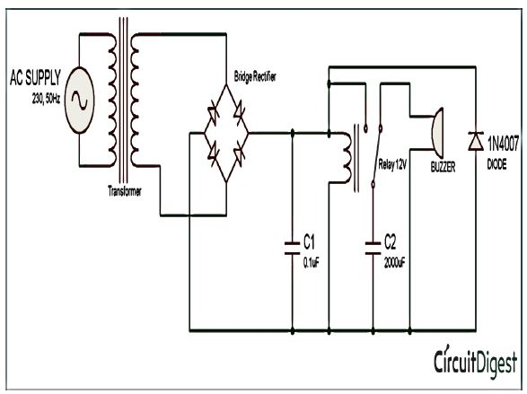

Here we are using a step-down center tapped 12-0-12 transformer. The center tapped transformer is similar to the normal transformer. It is just having an additional wire at the center of the secondary coil where, the voltage is zero. It implies that if we use a 12-0-12 transformer, then the voltage across the first two terminals or last two terminals will be 12V but the voltage across the first and the last terminal will be 24V. Its operation is also similar to normal transformer. A primary voltage induced in primary coil causes a secondary voltage in secondary coil, due to magnetic induction Now when the power goes off, the relay will come back to its previous position and the buzzer-capacitor circuit gets completed and capacitor will start discharging to buzzer so it will start beeping till the capacitor discharge completely. You can increase beeping duration by using a greater value capacitor. The current configuration gives a current of .310 Amperes across the buzzer. If you want to use this circuit with DC input then, remove the transformer and bridge rectifier circuit.
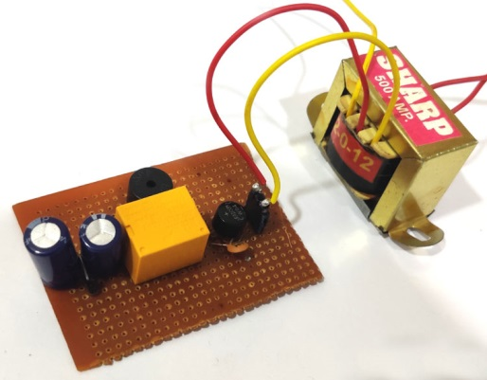
Figure 1 main power supply failure alarm circuit.
Components used:- The implementation of the project was implemented by using the following electronic components:

- Relay (12VDC)
- 2000μF and 0.1 μF Capacitors
- Buzzer
- 4007 Diode
- Transformer
- PCB board
- Socket Pin
- White Box
- Wire

Circuit for this Mains Supply Failure Alarm is simple. You just need to follow the circuit diagram and solder it up on PCB board. Firstly a capacitor of 2000μF is connected between the common terminal of the relay and the ground. Then a buzzer is connected with positive terminal connected to normally connected (NC) and negative terminal to the ground.
A bridge rectifier diode is used to convert the Alternating current into Direct current. Connect the positive and negative terminal of the diode to positive and negative terminal of relay and the AC terminals to the AC power supply. Also connect a diode (1n4007) in reverse bias with relay. This diode D1 is called Freewheel diode. It blocks any reverse voltage developed in relay to prevent any accident. A 0.1μF capacitor is used to smooth out the output DC voltage.
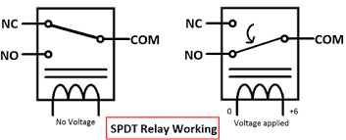

MATERIAL INFORMATION
Relay:- Relay is a switching device which can be operated either electronically or electromechanically. It is a 5 terminal device which is made up of electromagnets, movable armature, contacts, yoke and a frame. It works on the principle of magnetic property of inductor. So, when the inside coil gets energized then a magnetic field is generated around it and pulls the armature to connect the normally open terminal (NO) to Common (COM) terminal as shown in the image below. In this power failure alarm, we are using the relay to switch between two circuits - capacitor charging circuit and capacitor discharging circuit (capacitor-buzzer circuit).
Transformer:- Here we are using a step-down center tapped 12-0-12 transformer. The center tapped transformer is similar to the normal transformer. It is just having an additional wire at the center of the secondary coil where, the voltage is zero. It implies that if we use a 12-0-12 transformer, then the voltage across the first two terminals or last two terminals will be 12V but the voltage across the first and the last terminal will be 24V. Its operation is also similar to normal transformer. A primary voltage induced in primary coil causes a secondary voltage in secondary coil, due to magnetic induction.
Buzzer:- A piezo buzzer is an electric device used to produce a tone. These lightweight and simply-constructed buzzers are inexpensive yet reliable and come in a range of sizes and frequencies to meet the needs of nearly any application.
The core characteristic that defines this type of buzzer is its piezoelectric component. Piezoelectric components are made of special materials that exhibit the piezoelectric effect (where the material can convert some energy from applied mechanical strain into an electric charge). These materials also exhibit the reverse piezoelectric effect where the material deforms when an electric charge is applied.
Capacitor:- A capacitor is a two-terminal electrical device that can store energy in the form of an electric charge. It consists of two electrical conductors that are separated by a distance. The space between the conductors may be filled by vacuum or with an insulating material known as a dielectric. The ability of the capacitor to store charges is known as capacitance.
Capacitors store energy by holding apart pairs of opposite charges. The simplest design for a capacitor is a parallel plate, which consists of two metal plates with a gap between them. But, different types of capacitors are manufactured in many forms, styles, lengths, girths, and materials.
Circuit Diagram and Explanation:- Circuit for this Mains Supply Failure Alarm is simple. You just need to follow the circuit diagram and solder it up on PCB board. Firstly a capacitor of 2000µF is connected between the common terminal of the relay and the ground. Then a buzzer is connected with positive terminal connected to normally connected (NC) and negative terminal to the ground. A bridge rectifier diode is used to convert the Alternating current into Direct current. Connect the positive and negative terminal of the diode to positive and negative terminal of relay and the AC terminals to the AC power supply. Also connect a diode (1n4007) in reverse bias with relay. This diode D1 is called Freewheel diode. It blocks any reverse voltage developed in relay to prevent any accident. A 0.1µF capacitor is used to smooth out the output DC voltage.
WORKING
After soldering the components as per circuit diagram, connect the power supply and turn it on. Then to check the system, turn off the power supply and you will see buzzer start beeping as soon as you turn off the power. The working is same like an emergency light, which also turns on as soon as the power goes off. The working of the circuit is also very simple. When we turn on the supply, transformer converts the 220v AC to 12v AC. Then, the current coming from transformer is rectified by the bridge rectifier diode. The bridge rectifier consists of four rectifier diodes inside it and they are connected in series with only two diodes allowing current in a half cycle, either positive or negative. But this does not change the polarity of the output current. Hence the AC current is converted into DC, to learn more follow this simple bridge rectifier circuit. There is one more advantage of using bridge rectifier circuit that it does not require a center tapped transformer. After rectifying, the current is passed through a capacitor C2. This capacitor works as a filter capacitor, so that no unwanted frequency comes along with the rectification. It is sometimes called as smoothing capacitor. Complete process to convert AC into DC is explained in this Cell phone charger circuit. Now, as the current comes to relay, it triggers and the capacitor C1 starts charging as shown below.
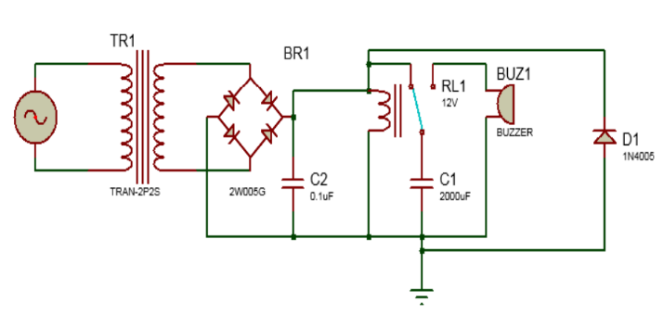

ADVANTAGE
Early warning: The alarm circuit can provide an immediate alert in case of a mains power failure, allowing for timely responses and quick actions to prevent further complications;
Safety: The alarm can help maintain safety and prevent accidents, such as those caused by darkness during power outages or unexpected shutdowns of critical equipment;
Affordable: Most power supply failure alarm circuits can be built with simple and affordable components, making them cost-effective solutions for both residential and commercial applications;
.
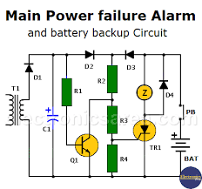

DISADVANTAGE;-
False alarms: The alarm circuit might occasionally trigger false alarms due to errors, sensitivity issues, or interference, which can be annoying and inconvenient to users;
Limited coverage: Mains power supply failure alarm circuits are usually limited to monitoring a specific circuit, and multiple devices may be needed for a comprehensive coverage;
No power restoration: While an alarm circuit can alert users to power failures, it cannot restore power automatically or address the cause of the outage;
Maintenance: Like any electronic device, the components of a power supply failure alarm circuit may wear, degrade, or fail over time, necessitating periodic check-ups and maintenance
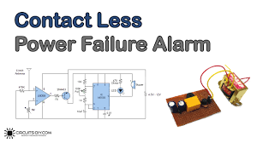
CONCLUSION
From the present report it can be said that the projec reached the objectives initially proposed, and that even though the project presents some disadvantages, its advantages have greater impact on its implementation, working and an application Based on the given information, it can be inferred that the mains power supply failure alarm circuit is designed to detect and sound an alert when there is a disruption or interruption in the flow of electricity from the main power source. This circuit is useful in situations where power outages or fluctuations can cause damage to sensitive electronic equipment or disrupt critical processes.
The circuit likely includes components such as a transformer, rectifier, voltage regulator, and an alarm mechanism such as a buzzer or LED indicator. The transformer steps down the AC voltage from the mains supply, which is then rectified to DC voltage. The voltage regulator ensures that the DC voltage remains constant within a specified range. When there is a failure in the mains power supply, the voltage output will drop below the normal range, triggering the alarm mechanism to sound an alert.
Overall, the mains power supply failure alarm circuit provides a simple and effective solution for monitoring the stability of the mains power supply and alerting users to potential disruptions.

REFERENCES
- Guruprasad P. Sali, Mohini J. Deshmukh, Mrunalini S. Wankhede, Bipasa B. Patra, "Smart IOT Automation for Advanced Home Security”, International Journal of Engineering Research in Electrical and Electronic Engineering (IJEREEE), Vol 6, Issue 4, IFERP, April 2020, ISSN (Online) - 2395-2717, pp.1-6, doi: 01.1617/vol7/iss4/pid4582
- Patil, Divyang R., Harish U. Jawale, Paresh D. Shirsath, and Bipasa Patra. "UV FLOOR SANITIZATION." (2021). IRJET ISSN – 2395-0057Vol 08, Issue 03, mar 2021, pp.419-422.
- Aditi Shinde, Toshita Nehete, Bipasa Patra, “Robot Navigation system with RFID and sensors” (2021). IRJET ISSN – 2395-0057Vol 08, Issue 04, Apr 2021, pp. 249-252.

- Patra, Bipasa, et al. "Optimization of solar energy using MPPT techniques and industry 4.0 modelling." Sustainable Operations and Computers 4 (2023): 22-28.
- Bipasa Patra and Dr. Pragya Nema, "Analysis of Solar Integrated Multilevel Inverter for Smart Grid Power Filters"- Published in IEEE Xplore on 06 April 2021 Proceedings of ICAECT 2021, Bhilai, Chhattisgarh. Doi: 1109/ICAECT49130.2021.9392527
- B. Patra, P. Nema, et al., "Eleven-Level Inverter Topology with Photovoltaic Interface," Published in IEEE Xplore on 04 Feb 2022 Proceedings of ICEPES 2021 MANIT, Bhopal, pp. 1-5, doi: 10.1109/ICEPES52894.2021.9699805.
- Patra, Bipasa, and Pragya Nema. "Comprehensive topological analysis of solar integrated multilevel inverter for power filters." Smart Technologies for Energy, Environment and Sustainable Development, Vol 1: Select Proceedings of ICSTEESD 2020. Singapore: Springer Nature Singapore, 2022. 475-485.
- Patra, Bipasa Bimalendu. "Necessity for Future Smarter Nation with a Sustainable Trend-Smart Grid." BUSINESS AND TECHNOLOGY (IJSSBT), Volume 6, No. 2, September 2018 ISSN (Print) 2277-7261:
- [6].Hammed, O.S. and Ademola, A.K. (2008). Design and Construction of an Emergency Rechargeable Lamp
- Incorporated with a Battery Overcharging Preventer Circuit. Medwell Journal of Engineering and Applied
- Sciences. 3(9):684-687.
- [7].Theraja, B.L. and Theraja, A.K. (2002). A Textbook of Electrical Technology. 23rd ed. S. Chand: New Delhi,
- India.
- [8].Wikipedia. (2012). Comparators. Retrieved February 2012 from:(http://en.wikipedia.org/wiki/comparators)
- [9].Penfold, R. (2007). Everyday Practical Electronics Magazine. February 2007. Wimborne Publishing Ltd.:
- Dorset, U.K.
- [10].National. (2012). LM317 Regulator Datasheet Data Sheet. Retrieved March 10, 2012, from
- (http://www.national.com/pf/LM/LM317.html )

