MODERN PHARMACEUTICAL ANALYTICAL TECHNIQUES –RECENT ADVANCEMENTS AND APPLICATIONS

Dr Kalepu Swathi¹ , Dr Mitta Chaitanya², Dr Sneha thakur³,Dr Koduru Swathi⁴,Rushitha Gollapalli⁵

1,2,4-Associate Professor, Bojjam Narasimhulu Pharmacy College forWomen, Saidabad, Hyderabad-500059

3- Associate Professor, HOD, Department of Pharmacognosy, St. Pauls college of Pharmacy, Turkayamjal, R.R Dist, Hyderabad-501510, Telangana

5-Student, Bojjam Narasimhulu Pharmacy College forWomen, Saidabad, Hyderabad-500059

INTRODUCTION
For the separation, estimation, and quantification of chemical substances received from both natural and artificial sources, analytical chemistry uses drug analysis. These substances typically consist of one or more chemical substances. Qualitative and quantitative analysis are the first two main categories in the analytical chemistry process. Only the samples that can be obtained are estimated in qualitative analysis, and the total number of elements in a compound should be identified in quantitative analysis. For instance, because it considers life, the examination of a wide range of chemicals or products is beneficial for the analysis of medications. The market has seen the introduction of a significant number of medications, and demand for them is rising quickly. The recently developed pharmaceuticals are either a brand-new variety or a modified version of ones that are already on the market. These medications are described with reference to the commercially available medications and pharmacopeial scenarios. In order to report on the better therapeutic agents for withdrawal that are currently on the market, pharmacopoeia have to be used in the medication development process. The analytical profile of a drug may occasionally not be present in pharmacopoeias during drug development. In that situation, it is required to prepare the crucial analytical methods for the creation of new medications. Many compounds are created by inventors during the medication development process, and they can simply assess their structure, behaviour, and help detect impurities in a molecule. The drug's bioassays will be conducted to determine if all the parameters have been set up to target it.
High throughput experimentation (HTE) is a notion that several industries and scientific fields have embraced recently in order to accommodate the ever-increasing demand for speedier data creation and acceleration of product development cycles. HTE has been used in the pharmaceutical industry for a variety of purposes, including the discovery of biomarkers and new chemical entities in drug discovery, as a tool to expedite the characterization of new pharmaceutical compounds as well as the development of small- molecule chemical processes, in the analysis of bio-therapeutics, forced degradation studies of therapeutic peptides, and the qualification of analytical methods.
High Performance Liquid Chromatography (HPLC), High Performance Thin Layer Chromatography (HPTLC), Liquid Chromatography-Mass Spectrometry (LC-MS), and other techniques are suitable for the analysis of these large or small compounds. These analytical methods are frequently employed for the detection of substances using mass spectrometry and the other methods previously discussed. High performance liquid chromatography (HPLC), a highly helpful technique, was a key and improved method for drug analysis. The liquid chromatography-mass spectrometry approach was also crucial for the analysis of pharmaceutical medications and helpful for research into the metabolism of drugs.
These methods can also be used to analyse, estimate, and identify pharmaceutical products that contain impurities, products that have undergone degradation, or products that are utilised to separate out and characterise a drug's potential from diverse natural and synthetic sources.
The following requirements are important for the analyst to build the best, appropriate, simple, and accurate method:
- To address any analytical challenge, data is necessary.
- It's crucial to work accurately and with sensitivity.
- The ideal range for drug analysis
- When developing a procedure, accuracy is necessary.
The method validation process, in which the documents are checked as part of any method development process, is also included in the method development process. In order to analyse the method, the many needs for the validation of documents include:
- Quality control
- Approval by the specified international organisations for product development
- Registration of pharmaceutical or pesticide products should be necessary.
- Only when acceptance is accomplished through testing does the validation procedure take place.
- The product should also be validated after the quality control division completes its required tasks.
If analytics are not to be the bottleneck, highly automated systems that can quickly perform several experiments in parallel also need to boost the rate at which the needed analytical data can be generated and analyzed.
For the majority of analytical procedures, there is a trade-off between the quality or accuracy of the data and the speed at which it can be generated. Therefore, for any HTE workflow, it is important to find the ideal balance between these two elements.
High throughput analytical (HTA) approaches that may generate datasets in as little as a minute or seconds are crucial for HTE workflows, even though conventional analytical tools like HPLC or NMR spectroscopy normally require measurement periods in the order of several minutes per sample.
Therefore, HTA is a crucial part of HTE, and the effectiveness of any HTE platform depends on the technique and implementation choices made. Even though chromatography-based techniques offer a wealth of data for a specific experiment, their throughput is sometimes insufficient to support HTE setups where, for instance, numerous 96-, 384-, or even 1536-well microplates need to be examined in a single day.
The analytical cycle time has already decreased significantly in recent years, making same or next-day analysis possible, which is necessary for the majority of HTE procedures. However, more development of analytical methods will be required to support future HTE configurations in order to prevent analytics from becoming a time-limiting factor. Along with efficiency, choosing the right analytical tools should take into account a technique's applicability across the board and its capacity to produce "quantitative" data (absolute concentrations). The core of an HTA setup frequently consists of chromatography-based techniques due to its adaptability and selectivity.
Because relative concentrations may be obtained without the use of standards and absolute concentrations of components within a mixture can be established with a single standard, NMR is the ideal approach for quantification. NMR is still a relatively slow method, usually taking several minutes per sample. Due to its ability to combine rapid sample throughput (in the range of a few samples per second) and great selectivity, MS has become widely used in HTA workflows. The drawback of MS-based approaches is that they cannot easily give precise quantification and may experience problems such ion suppression and other matrix effects.

Previous evaluations of HTA have been released, covering the period up to 2019. A comprehensive evaluation of the material that was published between January 2019 and September 2020 is what this study intends to do. Survey on overview of the quickly developing field of HTA, covering both well-established chromatographic methods and recently emerging spectroscopic and microfluidics-based strategies; the study was organised appropriately. In the area of small molecule drug discovery and chemical and pharmaceutical development, the focus was on HTA platforms and techniques.

CHROMATOGRAPHIC TECHNIQUES:
- HIGH PERFORMANCE THIN LAYER CHROMATOGRAPHY (HPTLC):

This method was employed all around the world to identify, estimate, and verify the analytical profile of pharmacological compounds. It is a very sophisticated method that will be acknowledged as a key instrumental method for drug analysis. In the pharmaceutical industry, it is able to test a variety of medicinal components because of its quick separation action and adaptable nature. The key benefit of this technique is the ability to quickly test drugs while also making crude drug sample handling and cleaning simple. This method enables us to characterise the chromatogram for a wide number of parameters without time constraints.

HIGH PERFORMANCE LIQUID CHROMATOGRAPHY (HPLC):
One important technology for separating complicated mixtures of chemicals and their molecules is High performance liquid chromatography. The biological elements and chemical molecules can be encountered by this method quite effectively. Due to the adoption of HPLC, this method, which was developed in the year 1980, became the first to analyse the assay of bulk drug materials from the USP-1980.
Prior to the examination of medicines, the HPLC method called for beginning their process in terms of accuracy, precision, and a wide variety of samples were analysed before doing the HPLC. An UV detector was utilised to estimate samples using HPLC, and it was successful in determining the sample's wavelength. UV detector operation won't begin until many wavelength scanning programmes have been used.

THIN LAYER CHROMATOGRAPHY (TLC):
A very old method for analysing chemicals in medicines is called thin layer chromatography. In this method, two phases—one known as the mobile phase and the other as the stationary phase—were used. Solid phase, adsorbent, and a thin layer of silica gel were distributed on a glass plate while carrying an aluminium support during the sample preparation process. For both inorganic and organic chemical analyses, this method is employed frequently. Due to its benefit over minimal cleaning, various mobile phase selections, flexibility, capacity to load large numbers of samples, and lower cost, TLC was chosen to investigate the chemicals. This approach was particularly useful for the examination of bulk drug components.

LIQUID CHROMATOGRAPHY (LC):
Liquid chromatography is a crucial analysis method in many HTE analytical procedures. Reducing the measurement time per sample is the simplest technique to increase the analytical platform's throughput. Many methods have been used to reduce the length of the
LC analysis, including applying high temperatures using monolithic columns or using parallel segmented flow columns. The pace of the analysis is increased by these modifications, but only modestly.

Ultrahigh-Pressure LC:
Although major efforts are currently being made to speed up and boost the throughput of the LC technique for HTA purposes, ultrahigh-pressure LC (UHPLC) equipment and sub-2 um diameter stationary phase particles were developed several years ago. Armstrong and coworkers have lowered separation speeds to the sub-second timeframe (Figure 1) and are getting close to sensor-like throughput by using specially constructed machines with very short bed lengths, optimised geometries, and the use of signal processing tools.
Although commercially available column technology and instrumentation have undergone a significant amount of development, more advancements that lessen the peak dispersion introduced by frits, tubing, and other components of the instrumentation are required to make such advances in performance accessible to users in the industry. Recent studies on the gain that may be projected from extremely high-pressure separations show that the separation speed can be doubled when systems are capable of operating at pressures up to 3000 bar and when using columns loaded with 1um diameter particles (Figure 2).
Any advancement in this field appears to follow the "law of diminishing returns," according to which an increasing amount of effort is needed to produce progressively smaller or less significant improvements. This is shown by the forecast that a two-fold improvement in separation speed can be expected vs a three-fold rise in pumping pressure. The development of uniform, mechanically strong 1-mm particles, large-scale production of well-packed 1-1.2 mm internal diameter columns, the creation of uniform 1-mm particles, the design of instruments and detectors with significantly lower overall dispersion, pressure-tolerant column housings, connectors, and valves, and sufficiently accurate pressure-compliant flow metres are all things that the authors noted as being necessary for further advancements.
Employing currently available/commercially available equipment and columns, it has been possible to accelerate LC analysis to times of less than a minute by using very short columns filled with tiny particles and high flow rates.
While achiral analysis quickly adopted the use of small particle sizes, chiral analysis lagged somewhat behind until sub-2 m immobilised chiral stationary phases (CSPs) were commercially available in 2016. Since then, a number of groups have begun to investigate the use of sub-2 m completely porous particles (FPPs) for quick enantioselective LC procedures, which allowed the analysis time to be cut down to a few minutes (Figure 3).
High mobile phase velocities and back pressures are used in columns filled with extremely tiny particles to create peak broadening because of friction between the mobile and stationary phases. Lesko et al., who recently addressed this issue, demonstrated that the use of a more heat-conductive diamond-based stationary phase might be used to reduce the influence of viscous heating.

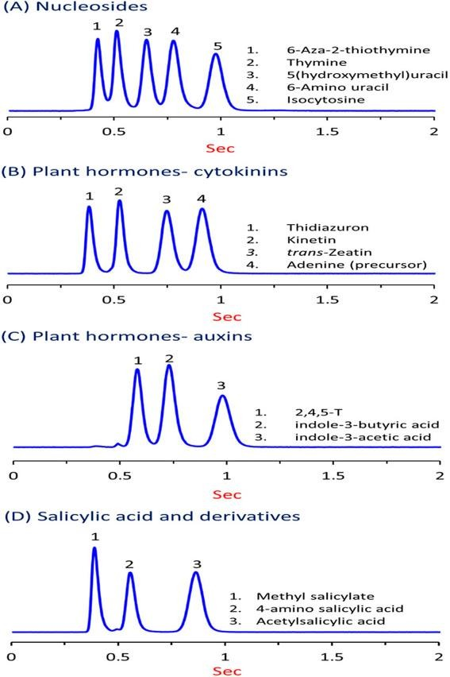

Fig: 1

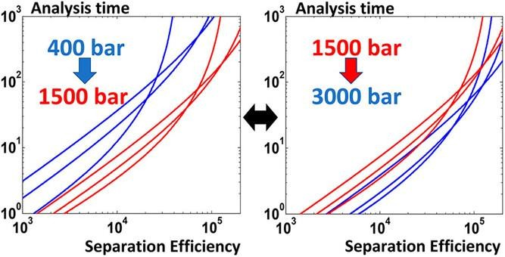
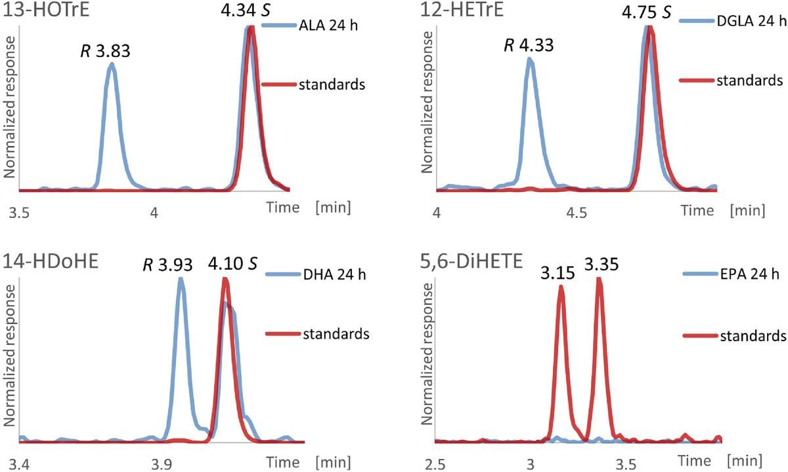

Fig: 3

Superficially Porous Particles:
The use of superficially porous particles (SPPs), also referred to as core-shell particles, has been a well-liked method to carry out rapid analyses without the need for high-pressure equipment, in contrast to the use of small-diameter particles, which requires instruments capable of working at high pressures (> 1000 bar). The benefit of SPP columns is that, as a result of a shortening of the analyte diffusion route, the stationary phase particles offer much lower plate heights, comparable to those of sub-2 um particles. The latter has an impact on the van Deemter equation's terms A (eddy diffusion) and C (barrier to mass transfer). The better separation efficiency is attained without the utilisation of high column pressures due to the bigger total particle diameter.
Modern SPPs were initially proposed in the 1970s, but they weren't commercially released until 2006 with 2.7 um Halo particles that had a 1.7 um nonporous silica core and a 0.5 um thick porous silica shell.
Most researchers have discovered that SPPs provide greater chances for higher throughput than FPPs when comparing FPP and SPP particles. Columns with SPP particles out performed FPP columns when the chromatographic performance was assessed using van Deemter curves. SPP columns are the best compromise in terms of speed, efficiency, and pressure drop, allowing for sub-minute separations with substantially smaller pressure dips, according to a kinetic plot-based study.
SPPs were investigated by Godinho et al for the study of polycyclic aromatic hydrocarbons. They found that, with identical levels of selectivity, both fully porous 1.8 um particles and superficially porous 2.7 um particles performed equally well, while the latter produced less back pressure on the SPP column. Throughput was enhanced by using the SPP column, which allowed them to separate a 16-component sample mixture in just one minute (Figure 4). SPP columns advantages for supercritical fluid chromatography (SFC) separations have also been no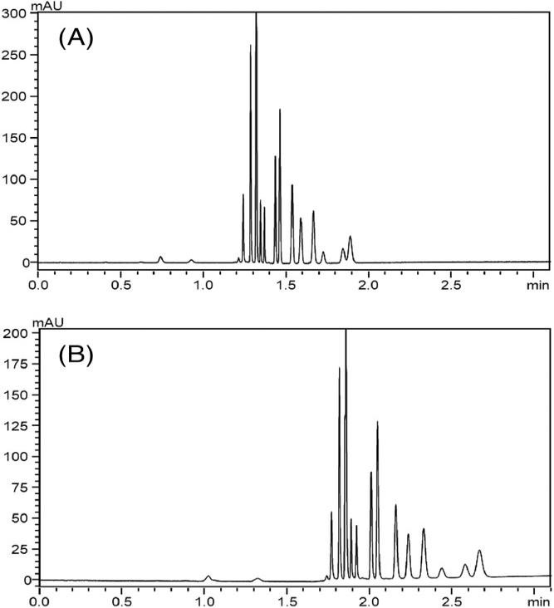ted.
Fig: 4

Open Tubular Columns:

Another strategy for cutting down on analysis time is to switch from the popular packed-bed configuration used in LC to the open tubular (OT) column format, which is typically associated with GC. The OT format, which was first presented in the 1970s, supposedly results in lower plate heights because eddy dispersion is not present, and it may also provide improved kinetic performance. Due to the trade-off between high efficiency (using very narrow capillaries) and the limited mass load capacity of such small internal diameter columns, which causes problems with detection, the format never gained popularity.
By balancing their kinetic performance and loadability, calculations by Causon et al. provided guidance on the design of OT columns. By applying thin, porous (octadecylsilylated) silica films to the inner surface of an OT capillary column, it has been possible to increase the loadability of OT columns, leading to efficiency gains of around 15%.
Since then, only a few writers have shown that OT columns can be used for rapid LC separations. Recently, Xiang et al. used an OT column that was 2.7 cm long and 2 um broad to illustrate the theory. Six peptides could be resolved in 0.7 seconds using this downsized column and an improved laser-induced fluorescence detection method (Figure 5), and trypsin- digested cytochrome C separations might take 10–50 seconds.

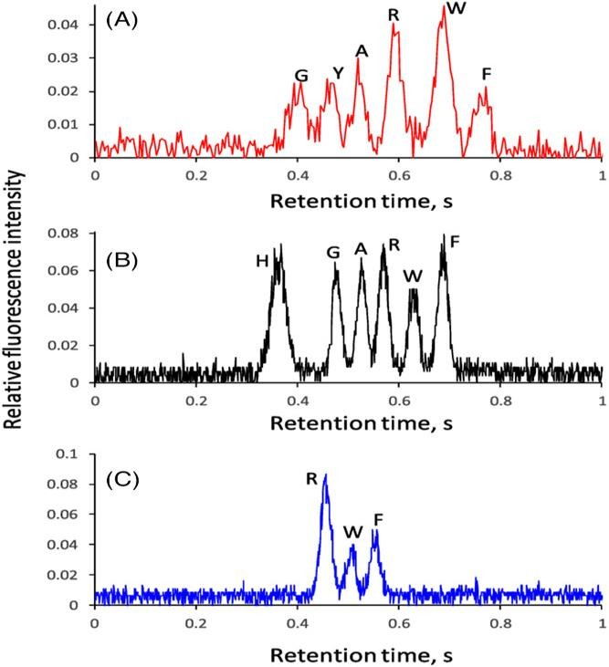
Fig: 5 fluorescence detection me

SUPERCRITICAL FLUID CHROMATOGRAPHY (SFC):
Fast or ultrafast separations have frequently been associated with the use of SFC, and it is possible to achieve analysis times on the order of minutes or even seconds. SFC- based techniques typically produce higher throughput than LC-based ones. Armstrong and colleagues used high-efficiency, narrow particle-size distribution silica packed in short columns and extremely high flow rates to demonstrate separations that took only a few seconds (up to 19 mL min-1). The scientists did note that as the analysis time decreases in the order of seconds, various unanticipated characteristics that are not present in ultrafast LC are observed and have an impact on the system's apparent efficiency. Such effects are caused by the mobile phase's compressibility, and careful consideration must be given to the system's design, tubing selection, and back-pressure regulator design in order to fully capitalise on the advantages of ultrafast SFC separations. It appears there is a general consensus that, at this time, column technology is ahead of instrumentation capabilities and that any further increase in performance will likely need to come from further instrument optimization.
In order to address the necessity to lessen extra-column dispersion, Berger reported on the rapid SFC separation of achiral solutes utilising short 20–30 mm columns filled with sub–2 um particles. He was able to acquire lowered plate heights as low as 2.2 and resolve 7 solutes on a 2 cm long column in less than 8 seconds by decreasing the system's extra-column dispersion from 80 to 5 uL2. The injection solvent and volume used for the experiment both had a significant impact on efficiency. Similar to the advantages for LC mentioned above, utilising SPPs in SFC mode has been shown to be advantageous. In a study that looked at the chiral analysis of pesticides and their stereoisomers, Hellinghausen et al. stated that the majority of the chemicals they looked at employing 2.7 um SPPs separated in less than a minute. Roy and Armstrong were able to complete chiral separations in 13 seconds by taking advantage of the CO2/MeOH mobile phase's low viscosity advantage, using extremely high flow rates (up to 14 mL/min), and utilising high-efficiency 2.7u m chiral SPPs. According to the authors, even faster separations would be possible if improvements in SFC instrumentation could resolve some issues with extra-column effects and pressure restrictions. The full potential of SPPs and other small particle supports would be unlocked with such advancements. Recently, reports on the application of SPPs under SFC settings for chiral analysis have also been made by other organisations. With a teicoplanin-based chiral selector bonded on either 2.0 um SPPs with a wide particle-size distribution or 1.9 um FPPs with a narrow particle-size distribution, Mazzoccanti et al. studied a set of 31 racemates of derivatized amino acids, with the SPP phase showing superior performance to the FPP version. Similar teicoplanin-based SPP-packed chiral columns have been used by Folprechtova et al. for SFC separations of phytoalexins, substituted tryptophans, and ketamine derivatives. Galietti et al. performed ultrafast separations and screening of chiral compounds employing OT columns in SFC mode under turbulent flow conditions. To create turbulent flow conditions, the authors employed GC OT columns and CO2 at a relatively high flow rate. They saw a decrease in plate height as the flow regime changed from laminar to turbulent, which increased peak capacity by almost three times. The observation was explained by the faster analyte dispersion over the OT column and the more effective mass transfer in the mobile phase as a result of a flatter flow profile. It was possible to isolate four polycyclic aromatic hydrocarbons within a 2.2-second timeframe by using turbulent flow conditions in OT columns (Figure 6).
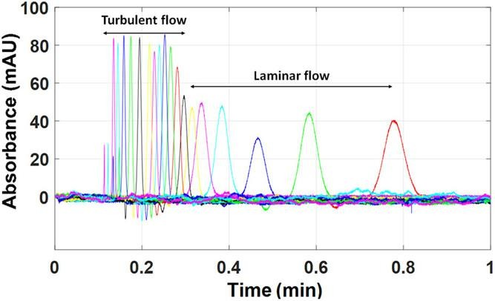
Fig 6:

MULTIPLE INJECTIONS IN A SINGLE EXPERIMENTAL RUN CHROMATOGRAPHY (MISER):
The so-called "Multiple Injections in a Single Experimental Run" (MISER) method was developed by Christopher Welch while he was employed by Merck & Co. It is a well-liked and straightforward technique for high throughput monitoring of a wide range of studies by LC or LC-MS.
The use of MISER chromatography, which depends on successive sample injections and little chromatographic separation of the analytes of interest from interfering chemicals, is well suited for kinetic analysis and profiling. A MISER run's solvent concentration is adjusted so that there is less interaction with the stationary phase, allowing the analyte(s) to move through the column more quickly. The goal is to resolve matrix or interfering peaks and minimise or eliminate any potential ion-suppression or other matrix effects rather than totally separate all peaks. After the mobile phase has been tuned, the autosampler's injection rate is practically the sole factor limiting how quickly samples may be evaluated.
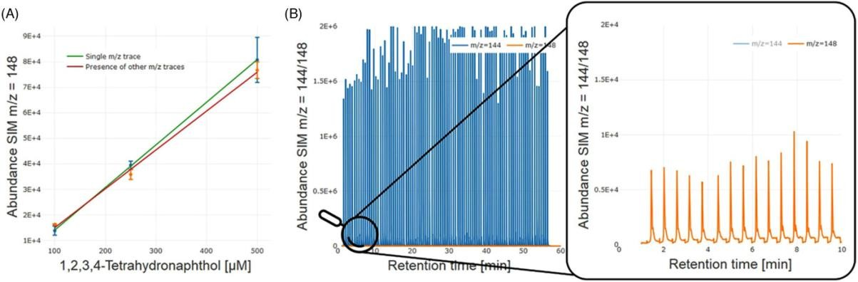
When comparing comparable samples that contain the same substance of interest but were produced under various conditions, MISER analysis is frequently utilised. A "misergram" (Figure 7) is a compilation of results that enables quick analysis of the data. The method has been highly effective in the field of catalyst discovery, where a huge number of reactions must be screened. Although SFC- and GC-based MISER procedures have also been documented, LC or LC-MS is the method most frequently employed with them. A 96-well microplate can be analysed using a MISER-GC-MS setup, such as the one described by Knorrscheidt et al., in 60 minutes.
Fig:7

ON-CHIP CHROMATOGRAPHY:
The negative impact of so-called extra-column volumes (tubing, detector, etc.) on peak broadening is a key factor affecting separation efficiency and, consequently, speed and throughput. Utilizing microfluidic systems, in which all of the components are combined on a chip, is one technique to lessen these effects. Significant improvements in chip design and fabrication have been accomplished since the first demonstration of microfluidic chip-based LC. The performance of these devices has been greatly improved by the application of greater pressures and unique on-chip injection and detection methodologies. The development of fabrication techniques like 3D printing has also cleared the path for the affordable production

of such devices. The enhanced heat transmission provided by the planar chip format is one of its advantages. In both isocratic and gradient HPLC modes, this characteristic has been used to separate analytes at high temperatures in under 30 seconds.
Ion mobility spectrometer (IMS) application as a new detection method for chip-based HPLC was demonstrated by connecting a chip-based chromatographic separation device to an IMS in under a minute. Zheng et al. were successful in automating a high throughput drug screening platform used in the pharmaceutical business using a TOF-MS connected to chip-based LC.
Throughput can be raised by constructing devices with numerous, parallel separation channels in addition to using downsizing to accomplish quicker separations. Recently, Komendova et al. published a study on a titanium device with four parallel channels that was made via 3D printing and had an electrochemical detector that could analyse dopamine precursors and metabolites simultaneously.

GAS CHROMATOGRAPHY (GC):
In the field of HTA, gas chromatography (GC) is a widely used analytical technique that is particularly helpful for the examination of more volatile chemicals. Although traditional GC systems don't have the necessary speed to handle HTE operations, certain strategies that allow for faster analysis have been developed. Fialkov et al. recently combined low-pressure (vacuum outlet) GC-MS (LPGC-MS) with low thermal mass (LTM) resistive heating for quick heating and cooling of the capillary column to achieve reasonably acceptable separations with cycle times of less than 1 min. They inserted the analytical column into an "LTM Fast GC" module that was put onto a detector port of a conventional GC system. This module contained LTM thin-walled metal tubing.
The GC injector and MS transfer line were linked to the column's inlet and exit, respectively (Figure 8). The analytical column is under vacuum while the inlet runs at standard GC pressures, increasing the ideal helium carrier gas flow velocity and speed of full range separations while maintaining a tolerable level of chromatographic separation quality. The LTM-LPGC-MS combination could cut the analysis time from minutes to seconds in some common applications while providing a 64-fold increase in analysis speed compared to ordinary GC-MS (Figure 9).

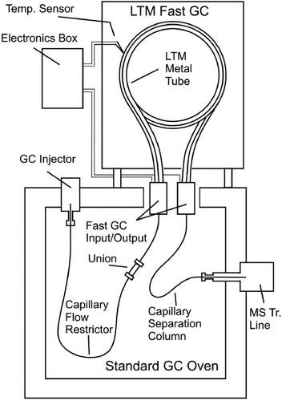
Fig: 8
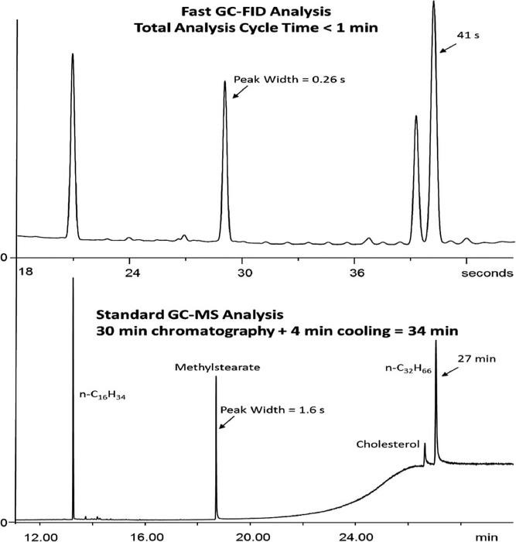

Fig: 9

ANALYTICAL METHOD DEVELOPMENT TECHNIQUES:
Various techniques were utilised in analytical chemistry for the quantitative and qualitative determination of pharmaceuticals with their precision for developing methods.

SPECTROSCOPIC METHODS:
The most crucial technology for the method development procedure was spectroscopic technique. In our pharmacopoeias This method is based on the organic UV light absorption as well as other chemical processes. The entire foundation of spectroscopy is the quantitative measurement, transmission characteristics, and wavelength function. This strategy has been quite helpful for saving time, or the exertion of labour. Moreover, this approach has excellent accuracy and precision. This is a pharmacological analysis a unique methodology was used to examine the dose forms in the pharmaceutical industry has consistently grown. Additionally, there are a few aspects for colorimetric techniques.include:
  - Complex reaction formation
  - Oxidation and reduction processes
  - The catalytic ions impact

ULTRAVIOLET (UV) SPECTROSCOPY:
The energy, radiation, or excitation of electrons is the foundation of the UV visible spectroscopy technique. In the UV-Visible technique, the energy light used to excite electrons is what determines the sample's wavelength. The absorbance ranges from 200 to 800 nm. Only when conjugated pielectrons are present does the absorption take place.

FTIR SPECTROSCOPY:

A few atoms and molecules vibrate or are excited when infrared spectroscopy causes the absorption to move into its lower energy state.
way by identifying the functional group and the original peaks with relation to the molecule.

MASS SPECTROSCOPY (MS):
When it comes to HTA, MS-based analysis offers advantages that are extremely desirable, such as fast speed and the capacity to detect and quantify the chemicals in a combination. For example, hit and lead detection or chemical reaction screening, the ability to specifically monitor the mass of a certain target is highly helpful. These benefits have accelerated the industry's adoption and development of MS-based solutions in HTE operations and have encouraged university research efforts to create novel methodologies. By automating the sample preparation stages and employing optimised, brief UHPLC methods, considerable increases in analysis speed have been made in standard LC-MS setups that rely on ionisation techniques like ESI, APCI, or APPI.
Kempa et al. and Pu et al. have provided more detailed reviews on novel MS-based tools and approaches for HTA that were more focused on sample preparation processes that are automated or eliminated in hit and lead generation or reaction screening and optimization.
Agilent's "RapidFire MS," which combines a SPE-based sample-cleanup robotics workflow with ESI-MS detection and allows for analysis times as low as 5–10 s per sample, is one example of a commercially available MS system for HTA. When a throughput of up to 5000 samples per day is required for screening or chemical profiling operations, such platforms are frequently used. The technique, however, cannot handle the demands of screening assays, which require the daily analysis of tens of thousands to millions of samples.
Due to these demands, methods like surface-based MS and microfluidics devices, which require little to no sample preparation and accelerate analysis speed into the sub-second range, have been developed. For instance, direct infusion (DI) MS techniques or flow-injection (FI) MS, in which samples are directly injected into the ionisation source, were quickly adopted in the HTA field. The introduction of samples without prior separation or purification has the disadvantage of perhaps causing ion competition, reducing sensitivity, or obscuring the outcome. By examining the distribution of ion m/z values and computationally generating a series of ideal scan ranges in metabolomics and lipidomics investigations of serum samples, Sarvin et al. described a method to get around this impact.
The sample rate is the most frequent bottleneck in DI or FI analysis, and is frequently much slower than the actual capture of MS data. In order to properly utilise the MS system's characteristics, the instrument needs to be quickly fed with small amounts of material. New methods of sample introduction were created since the speed at which each experiment may be sampled by an autoinjector and introduced into the MS ionisation chamber naturally limits the speed of classic LC-MS methodologies. Due to this, a new class of ionisation techniques called "ambient ionisation MS" (AIMS), in which samples are ionised at atmospheric pressure, has emerged.
In order for quick in situ analysis to be possible with some surface/plate-based procedures, materials must first be deposited onto a suitable carrier or integrated into a suitable matrix. Because AIMS approaches provide throughputs orders of magnitude higher than those of standard LC-MS equipment, reaching analytical speeds that are feasible with fluorescence- based techniques but without the need for fluorescent labels, these advancements have completely transformed the HTA field. Several surface-based MS techniques, such as matrix- assisted laser desorption/ionization (MALDI), direct analysis in real-time (DART), desorption electrospray ionisation (DESI), secondary ion mass spectrometry (SIMS), and self-assembled monolayers coupled with desorption/ionization, can directly ionise analytes with little to no sample preparation (SAMDI).

Kuo et al. have given a thorough analysis on the numerous AIMS strategies that have been described up to this point. We'll concentrate on a few of the more popular methods down below. Some AIMS techniques, such as surface-assisted laser desorption/ionization mass spectrometry (SALDI), have been used for online monitoring of photocatalytic processes and ultrafast photocatalyst screening. In this investigation, the substrate for starting and monitoring the processes simultaneously was a photocatalytic nanomaterial. The experiments showed a reaction acceleration effect: interfacial reactions happened in seconds as opposed to traditional reactions in the bulk phase taking hours, which is appealing for ultrafast reaction screening.

Matrix-assisted laser desorption/ionization:
One of the first and most proven examples of ambient, surface-based MS is MALDI-MS. The analyte is co-crystallized on a surface with an appropriate matrix before being exposed to UV laser light, which causes the analytes to desorb and ionise. For ultrahigh-throughput screening of big molecules, MALDI coupled with time-of-flight (MALDI-TOF) MS has been widely employed. Numerous literature examples pertain to drug target identification proteomics and analysis of DNA/RNA, lipids, oligosaccharides, and synthetic polymers. Due to matrix interferences and the fragmentation of organic matrix molecules in the lower mass range, conventional MALDI-TOF-MS has a number of disadvantages when investigating tiny compounds.
As a result, its application to the study of tiny molecules has not been explored as thoroughly. However, other teams have shown that MALDI may be used for small molecule applications, even for the quick analysis of reaction mixtures that include catalysts, salts, and bases (for example, 1536 reactions in under 10 minutes). Park et al. used MALDI-TOF-MS for the high throughput quantification and analysis of small-molecule cancer biomarkers using a parylene- matrix chip. A practical manual for bench chemists on how to create and assess high throughput MALDI-TOF-MS techniques for the screening of chemical processes on well plates without using any MALDI plate modification or product tagging was recently released by Blincoe et al (Figure 10).
The use of automated, direct MALDI-TOF-MS as a readout approach for extensive drug discovery HTS campaigns was proven by Simon and colleagues. They swiftly, robustly, and precisely identified inhibitors of human cyclic GMP-AMP synthase using a MALDI-TOF- based screening method in conjunction with a 1536-well format.
Different MS ionisation techniques have difficulty analysing or assaying chemicals in biological matrices. The problem could be caused by the matrix's ability to suppress ion signals or by a general incompatibility with the MS technique, such as the presence of nonvolatile salts or, in the case of MALDI, a matrix crystallisation inhibitor. In a study published in 1987, Krenkel et al. looked at the application of liquid support matrices for the MALDI-MS detection of peptides, antibiotics, and lipids in complex biological fluids.
The complexity of the sample composition and the present hardware constraints were shown to be the key determinants of throughput and robustness. It was demonstrated that conventional label-based, non-MS assays could be modified for MALDI-MS analysis and that adding a second MALDI spot washing phase could lower buffer concentrations and enable the use of MALDI-MS for more experiments. The analytical speed of traditional solid-state AP-MALDI and the adaptability of ESI are conveniently combined by the liquid atmospheric pressure MALDI.

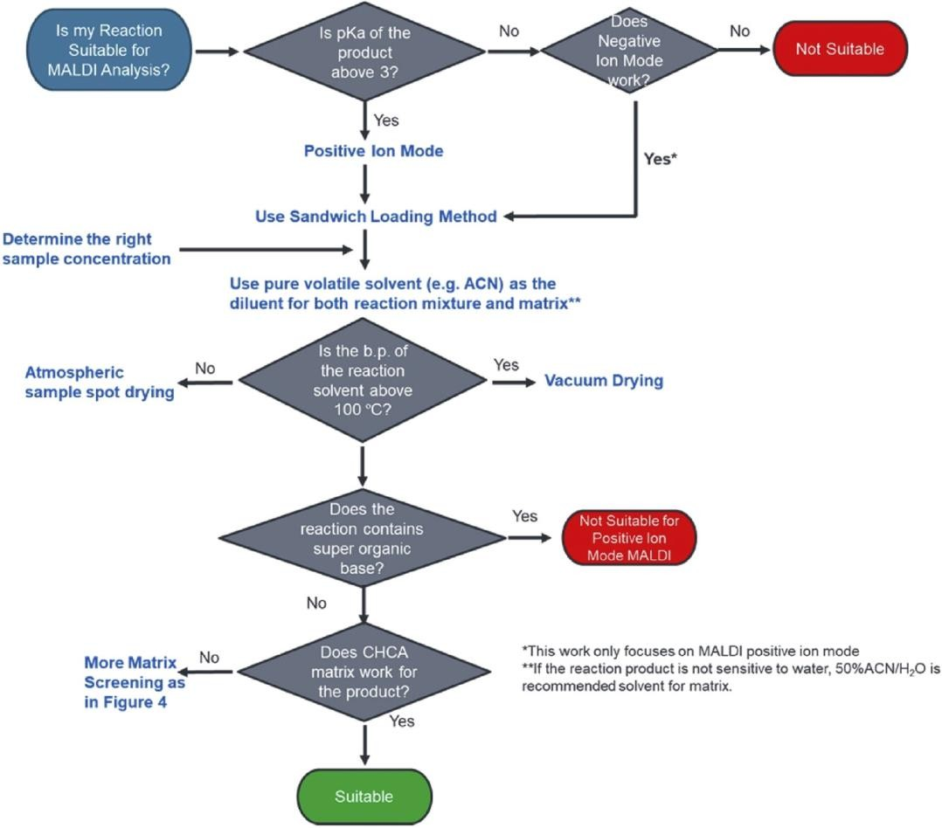

Fig: 10
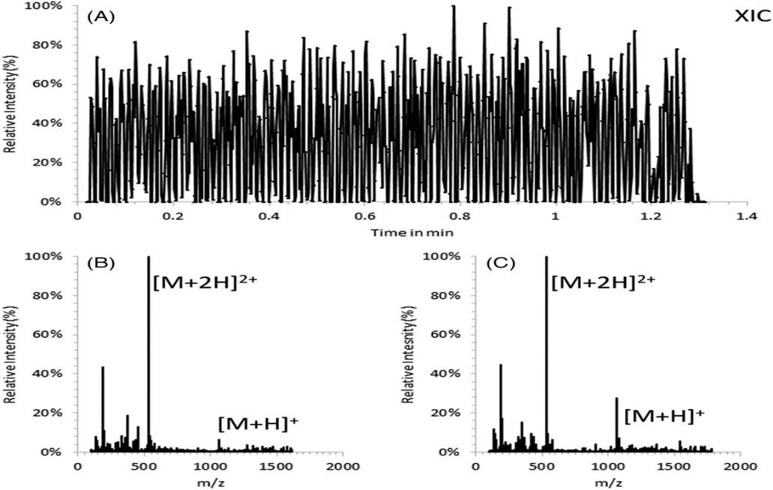
According to the authors' estimates, liquid AP-MALDI could theoretically process more than 10–20 samples per second (Figure 11), making it a very competitive technology when compared to existing label-free MS techniques.
Fig:11

Direct analysis in real time/desorption electrospray ionization:
Other MS techniques, like desorption electrospray ionisation (DESI) and direct analysis in real time (DART), were developed from the MALDI approach. DART has gained popularity as a tool in fields like food safety monitoring, environmental applications, and the detection of tainted or counterfeit drugs due to its ability to rapidly screen analytes in complicated matrices with little sample preparation. For the purpose of screening multiresidue pharmaceutical medicines in samples of bovine tissue, Khaled et al. adopted an SPME- DART-based HTS methodology. They showed that 53% of the 98 target analytes could be effectively ionised by DART and quantified at the necessary level, and that overall analysis times might be as little as one minute per sample thanks to the fully automated sample preparation approach. Their research demonstrates the potential value of SPME-DART- MS/MS as a tool for quick analysis in food safety monitoring applications, even if DART demonstrated limited capabilities in terms of analyte coverage.
DESI is a different ambient ionisation method that has gained a lot of interest. It has been a hot research issue in the HTA field ever since its start in 2004. An aqueous spray aimed onto an insulating sample or an analyte coated on an insulating surface, such as polytetrafluoroethylene, is used in the simplest DESI-MS setup (PTFE). A 2D chemical information map in the form of full mass spectra can then be produced by moving the DESI- MS inlet across the surface using an x-y stage.
The DESI approach has two advantages over MALDI-MS: it doesn't require a matrix to conduct the experiment, and it can produce multiply charged ions, which extends the mass range of the detector needed for large molecules or biological materials. A commercial ion trap mass spectrometer that has an air interface coupled to a long, ideally flexible ion transfer line made of metal or an insulator is used to sample the desorbed ions. Peptides and proteins that are found on metal, polymer, and mineral surfaces have all been effectively ionised using DESI. With no need for sample preparation by producing ions outside the instrument, the ability to record mass spectra of samples in their natural environment permits exceptionally quick analysis with high sensitivity and high chemical specificity, qualities that are highly desired for HTA. The DESI approach has been heavily utilised in recent years in HTA for small molecule response screening and optimization. For instance, employing methanol as the DESI spray/analysis solvent, Cooks and colleagues optimised amine alkylation processes on PTFE membrane substrates.
Reagents that can only react with particular functional groups present in the mixture are added to the spray solvent in one type of DESI, known as "reactive DESI," which is employed in the screening of chemical reactions. Microdroplet-surface collisions can produce more reactions than bulk solutions do.
Loren et al. employed DESI-MS as a tool to qualitatively forecast the results of quick screening of N-alkylation processes based on microfluidics. They were able to rapidly reduce the number of crucial reaction parameters, such as the kind of solvent, by using DESI-MS HTA. Fedick et al. published similar research with a focus on the Suzuki-Miyaura cross- coupling and reductive amination reactions. Thesy were able to test numerous reagents, bases, and stoichiometries using their DESI-MS technology, which used microdroplet-based reaction acceleration, at rates that were almost 10,000 reaction mixes per hour (i.e., approximately 3 Hz).
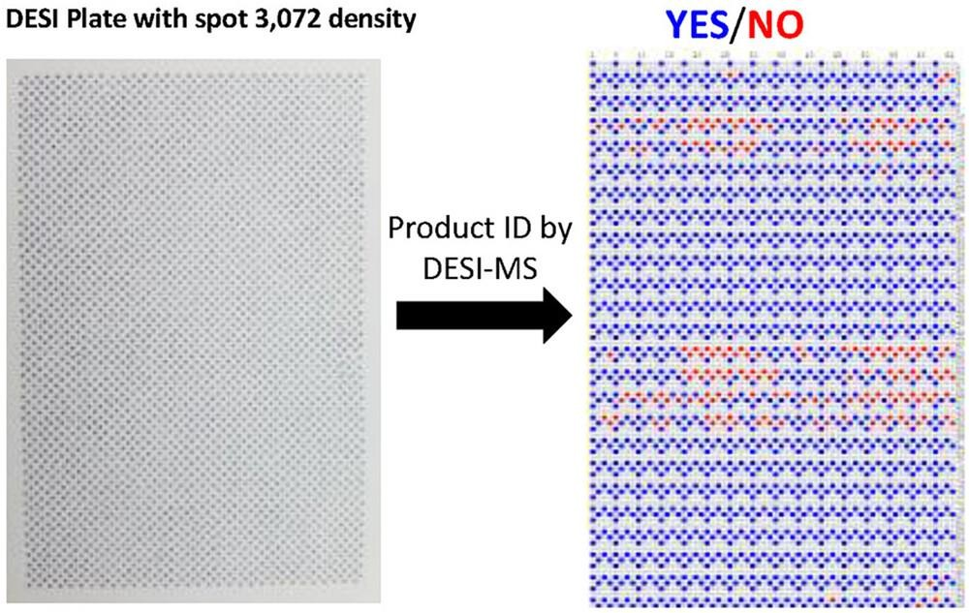
Cooks, Thompson, and colleagues used HTE in flow settings to optimise nucleophilic aromatic substitution processes. A system that includes both a liquid handling robot for the preparation of the reaction mixture and a DESI-MS module allowed them to analyse 3072 different reactions at a rate of about 3.5 seconds per reaction. Microtiter arrays were used to carry out the reactions. Heat maps were created from the MS data using proprietary algorithms, allowing for quick examination and selection of the most favourable situations (Figure 12). Similar methods were employed by authors from the same research group to screen 3840 different reductive amination reactions.

Fig:12

In a study of N-alkylation, N-acylation, and N-sulfonylation reactions, Sobreira and coworkers achieved analytical times of up to 1 reaction mixture per second using DESI-MS. The measurements revealed strong repeatability (94–97%) and an about 6% false negative rate (depending on the chosen noise threshold).
For enzymatic experiments, which are typically carried out using labelled chemicals and plate readers, Cooks and colleagues employed DESI-MS. With an effective analysis time of 0.3 s per sample, DESI-MS enabled the performance of analyses directly from the bioassay matrix. After an external calibration, the substrate and product were monitored to study the enzymatic process.

Acoustic droplet ejection:
By eliminating the requirement for spotting samples onto a surface or plate prior to the actual analysis, recent developments in acoustic sample handling and the advent of MS interfaces have significantly decreased the overall analysis time. These acoustic ejection MS (AEMS) systems are now commercially available, such as the Acoustic Mist Interface (AMI) from LabCyte/Waters and the Echo MS system from SCIEX. AEMS uses a continuous fluid

transfer open-port interface (OPI) to acoustically dispense (i.e., eject in a contactless manner) femto- to nanoliter volume sample droplets for subsequent ionisation at atmospheric pressure. In the AMI format, electrically charged droplets are ejected directly from well plates into a specialised transfer interface where desolvation and ionisation take place in ESI mode.
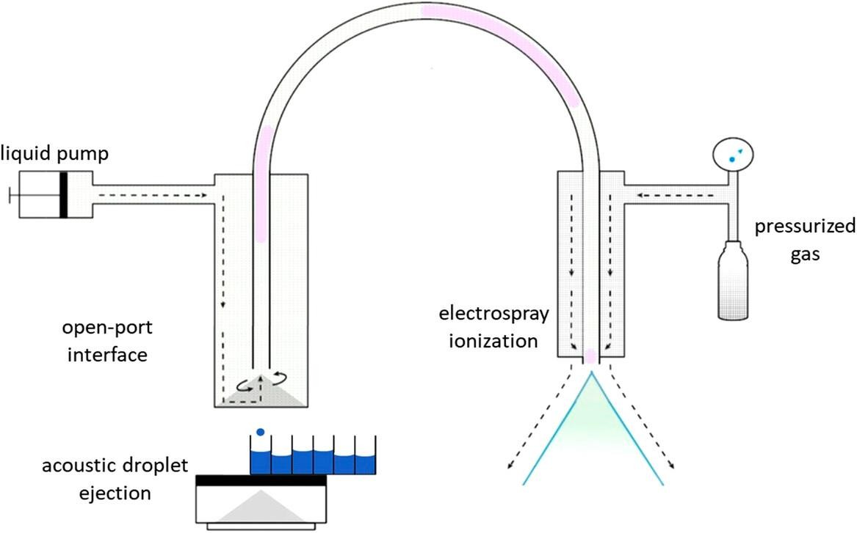
In the area of drug discovery, researchers from AstraZeneca have discussed the creation and use of an AMI interface for triage assays and metabolic profiling. The technology could transmit up to three samples into a mass detector at a rate of three nanoliters per second without making contact. A single mass spectrometer was able to process 100,000 samples per day thanks to automated plate handling. AstraZeneca's collection of 2 million small compounds was utilised to find inhibitors of a human histone deacetylase as a proof of concept. DiRico and associates at Pfizer more recently published a study on the application of an ultrahigh-throughput reader platform based on ADE-OPI-MS for reaction screening in the context of drug discovery (Figure 13).

Fig:13
AEMS has also been used to analyse polar analytes in the field of bioanalysis. Due to their poor chromatographic retention and the ion suppression caused by co-eluting matrix components, it is difficult to quantify these analytes in biological matrices using standard LC- MS/MS. An AEMS-based technology for performing ultrahigh-throughput and chromatography-free bioanalysis of polar substances was introduced by Wagner et al. from
Bristol-Myers Squibb. A 15-fold speed advantage and roughly 500-fold lower sample consumption were shown when comparing the results from actual assay samples acquired by AEMS to those obtained by the quickest previously published LC-MS/MS technology.
Boehringer Ingelheim's Häbe et al. published a study on an AEMS system that was employed in HTS and could achieve maximum sampling rates of 6 Hz.
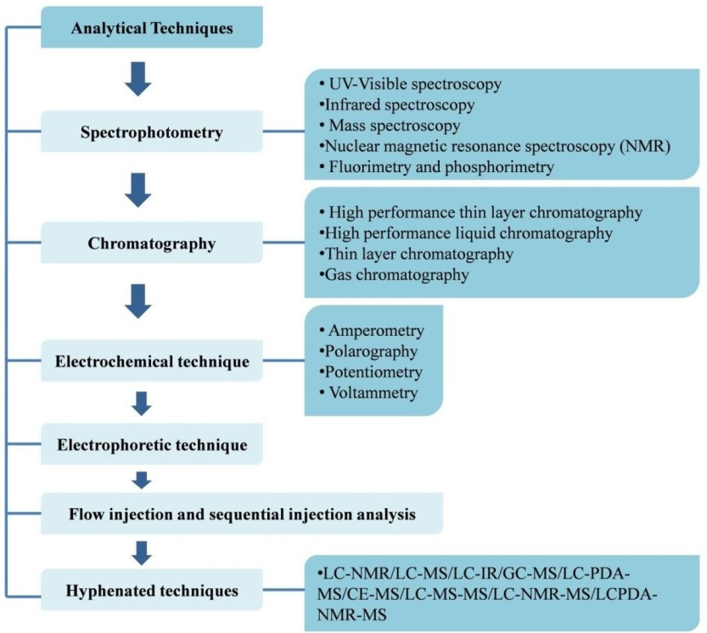
AEMS-based platforms have recently been the subject of a number of intriguing articles that highlight their exciting potential for HT compound screening and profiling. In order to help with technique validation and adjustment of the acoustic dispensing parameters for samples having a wide range of viscosities and surface tensions, Liu et al. proposed a new approach to measure the volume of individually dispersed droplets. They also evaluated some key performance metrics, such as well-to-well sampling speed, droplet volume calibration, precision, and reproducibility, of an in-house built system. They talked about the different operating modes and showed how a 1536-well plate format was used for the first time in AEMS. They also discussed strategies for expanding the detection dynamic range and a "continuous infusion" mode that offered an improved ion statistics, a greater signal-to-noise ratio, and a maintained steady-state signal for analyte detection optimization. For maximum throughput, their configuration had a much reduced transmission distance between the OPI and the ESI electrode, and it was capable of sampling at rates of up to

Fig:14 - Method development techniques at hand

NUCLEAR MAGNETIC RESONANCE SPECTROSCOPY (NMR):
In the recent years, scientists have developed a variety of ways to solve the analysis issues with novel pharmacological compounds. For the creation of pharmaceuticals, the nuclear magnetic resonance spectroscopy method was extensively used. This method helped with drug identification and quantitative drug analysis to identify compounds in the medications. Additionally, this method's technique helped describe the chemical products, identify the medications employed in pharmaceutical formulations, and identify biological fluids.

PHOSPHORIMETRY and FLUORIMETRY:
Fluorimetry and phosphorimetry techniques were continuously improving in our pharmaceutical sectors for the study of tiny samples. Fluorimetry allows for the analysis of highly sensitive systems without sacrificing method specificity or precision. In earlier investigations, a steady increase in the number of applications for fluorometry or phosphorimetry was seen. These methods for estimating various medications quantitatively that are available in the form of biological fluids have been used for some time.

ELECTROPHORETIC TECHNIQUE:
Capillary electrophoresis is the correct name for this method, which is crucial for drug analysis in the pharmaceutical industry (CE). The entire basis of the capillary electrophoresis technology is the electromagnetic field applied to electric charge ions. For the separation and analysis of medication components, this method was helpful. The area of traversing the components of a particular peak during the electrophoresis process is directly proportional to the compound concentration, and because of this phenomenon the quantitative analysis of samples were done using this practical technique.

FLOW INJECTION ANALYSIS:
Ruzicka and Hansen introduced the flow injection analysis technique (FIA) in the US and Denmark. This method is based on the automatic chemical experiments. Therefore, the study's authors claimed that FIA has a strong interest in automating chemical analysis.
Additionally, it is the primary tool utilised for chemical analysis or measurement when there is chemical and physical equilibrium.

ELECTROCHEMICAL TECHNIQUES:
Currently, there is a greater need for electrochemical methodology in the pharmaceutical industry than there was in the past for the analysis of medicinal molecules. Additionally, a variety of samples are provided for both the quantitative examination of pharmaceutical ingredients as well as drug analysis. Recent advancements in electrochemical techniques have made it possible to analyse medications like trimipramine, desipramine, and imipramine, among others, using amberlite XAD-2, titanium dioxide nanoparticles, and carbon plates containing glassy carbon. The following methods, including chronocoulometry, cyclic voltammetry, electrochemical impedence spectroscopy, and adsorptive strip pulse voltammetry, were employed to ascertain the electrochemical behaviour of these compounds
Technique | Drug | Electrode nature
Polarography | Ciclopirox olamine | Static mercury drop electrode (SMDE) or Dropping mercury electrode (DME)
 | Anti-cancer drug, Vitamin K3 | Polished glassy carbon electrode (GCE)
Potentiometry | Pentoxifylline | Multi walled carbon nanotube paste electrode
 | N-acetyl-L-  cysteine | Mercury film electrode
Amperometry | Verapamil | Dropping mercury electrode
 | Diclofenac | Carbon paste electrode
Voltammetry | Leucovorin | Silver solid amalgam electrode
 | Dopamine | Diﬀerential pulse stripping Voltammetry

Table: drug detection using a range of electrochemical methods

KINETIC ANALYSIS TECHNIQUE:
The kinetic approach was created in 1950 and is utilised in automated devices for the analysis of numerous pharmaceutical components. The notion of kinetic methodology, which aids scientists in chemical instrumentation processes or is highly relevant in pharmaceutical drug analysis, data analysis, and method creation, was the major implementation made. Because the available procedures for drug analysis could halt their flow system and adding reagent continuously was slow, this method was entirely dependent on an automatic system.

HYPHENATED TECHNIQUES:
A new approach for drug analysis known as hyphenated techniques will be developed using the separation technique based on the coupling of offline and online separation. This method has been used extensively throughout the years in analytical research to progress, develop, and apply pharmaceuticals in pharmaceutical analysis. The primary analysis phase for the development of novel pharmaceuticals and drug products is the determination of the medication's base material from biological sources. The following hyphenated strategies were employed to boost the possibility of drug analysis:
- Liquid chromatography-Nuclear magnetic resonance (LCNMR)
- Liquid chromatography
- -Mass spectrometry (LC-MS)
- Liquid chromatography-Infrared spectrometry (LC-IR)
- Gas chromatography-Mass spectrometry (GS-MS)
- Capillary electrophoresis-Mass spectrometry (CE-MS)
- Liquid chromatography-Photodiode array-Mass spectrometry (LC-PDA-MS)
- Liquid chromatography-Mass spectrometry-Mass spectrometry (LC-MS-MS)
- Liquid chromatography-Nuclear magnetic resonance Mass spectrometry (LC-NMR-MS)
- Liquid chromatography photodiode array-Nuclear magnetic resonance-Mass spectrometry (LCPDA-NMRMS)

MICROFLUIDICS:
The application of microfluidics for ultrahigh-throughput testing and analysis is another area that has experienced tremendous progress, particularly in the last ten years. Similar to acoustic ejection technology, using microfluidic devices and droplet producers eliminates the need to deposit samples onto a substrate before inserting them into the MS detector. With the use of this technology, it is possible to precisely alter sample quantities in the microliter to femtoliter range, which is valuable for automating routine laboratory tasks in a droplet-based, miniature format. Chemical reactions, for instance, can be carried out inside isolated droplets rather than individual wells employing segmented flow and two immiscible fluids. Each droplet can then be subjected to direct coupling to MS detection for analysis.

A multiwell plate workflow and droplet microfluidics technology were coupled to MS detection utilising both ESI and MALDI, as described by Sun and Kennedy in 2014. They developed segmented flow microdroplets from a 384-well plate using a multichannel syringe pump and capillary tubing in their initial, quite basic setup. A single channel's individual droplets were fed into an ESI-MS detector at a rate of 0.58 Hz. They were able to achieve an overall analytical rate of 4.5 Hz in ESI mode by using eight parallel channels. In a more recent publication, utilising a "nanoESI" emitter at nL/min flow rates, the reaction volume was further reduced to a few nL or even the pL range, producing throughputs of up to 10 droplets per second. For as long as 2.5 hours, or the analysis of more than 20 000 samples, continuous infusion of droplets into the nanoESI emitter for monitoring in-droplet enzymatic reactions was demonstrated. Additionally demonstrated were a sample-to-sample carryover of 3% and a linear concentration-based response. A method known as "mass activated droplet sorting" was employed in an even more advanced setup to sort nanoliter droplets in a high throughput manner using direct ESI-MS detection (MADS).
- The produced droplets are divided into two sections, unlike fluorescence-activated droplet sorting (FADS), one for MS detection and the other for sorting and collection. The range of detectable analytes can now include almost any molecule that can be ionised via ESI when MS is used in place of fluorescence-based detection. The stated setup had a throughput of 0.7 samples/sec, although it was determined that speed might be increased by addressing current MS system restrictions. In applications where sample preparation and analysis are bottlenecks, such as in the directed evolution of enzymes, the ability of microfluidic
- to produce, analyse, and sort microscale samples is appealing. Traditional well-plate methods cannot compare in speed or volume to the high throughput screening and selection of water- in-oil microreactors made possible by microfluidic droplet sorting.

REFERENCES:
- References 1. Kupiec T. Quality-control analytical methods: High-performance liquid chromatography. International journal of pharmaceutical compounding. 2004; 8:223-7.
- Siddiqui MR, AlOthman ZA, Rahman N. Analytical techniques in pharmaceutical analysis: A review. Arabian Journal of chemistry. 2017; 10:S1409-21.
- Anderson DJ. High-performance liquid chromatography in clinical analysis. Analytical chemistry. 1999; 71(12):314-27.
- Ravisankar P, Navya CN, Pravallika D, Sri DN. A review on stepby-step analytical method validation. IOSR J Pharm. 2015; 5(10):7-19.
- Lal B, Kapoor D, Jaimini M. A review on analytical method validation and its regulatory perspectives. Journal of Drug Delivery and Therapeutics. 2019; 9(2):501-6.
- Ramana Rao G, Murthy SS, Khadgapathi P. High performance liquid chromatography and its role in pharmaceutical analysis. Eastern Pharmacist. 1986; 29(346):53.
- Carr GP, Wahlich JC. A practical approach to method validation in pharmaceutical analysis. Journal of pharmaceutical and biomedical analysis. 1990; 8(8-12):613-8.
- Jatto E, Okhamafe AO. An Overview of Pharmaceutical Validation and Process Controls in Drug Development. Tropical Journal of Pharmaceutical Research. 2002; 1(2):115-22.
- Al-Akkam EJ. Applying of a modified and validated highperformance liquid chromatographic/ultraviolet method for quantification of cetirizine in human plasma for pharmacokinetics studies. Drug Invention Today. 2020; 14(1).
- Chauhan A, Mittu B, Chauhan P. Analytical method development and validation: a concise review. J Anal Bioanal Tech. 2015; 6(1):5.
- Lacrok PM, Curran NM, Sy WW, Goreck DK, Thibault P, Blay PK. Liquid chromatographic determination of amiodarone hydrochloride and related compounds in raw materials and tablets. Journal of AOAC International. 1994; 77(6):1447-53.
- Thyagarajapuram N, Alexander KS. A simplified method for the estimation of amiodarone hydrochloride by reverse-phase high performance liquid chromatography. Journal of liquid chromatography & related technologies. 2003; 26(8):1315-26.
- Christopherson MJ, Yoder KJ, Miller RB. Validation of a Stability-Indicating HPLC Method for the Determination of Amiodarone HCl and Its Related Substances in Amiodarone HCl Injection. Journal of liquid chromatography & related technologies. 2004; 27(1):95-111.

- Sistla R, Tata VS, Kashyap YV, Chandrasekar D, Diwan PV. Development and validation of a reversed-phase HPLC method for the determination of ezetimibe in pharmaceutical dosage forms. Journal of pharmaceutical and biomedical analysis. 2005; 39(3-4):517-22.
- Kumar DA, Sujan DP, Vijayasree V, Rao JV. Simultaneous determination of simvastatin and ezetimibe in tablets by HPLC. E-journal of chemistry. 2009; 6.
- Vishwanathan K, Bartlett MG, Stewart JT. Determination of gatifloxacin in human plasma by liquid chromatography/electrospray tandem mass spectrometry. Rapid Communications in Mass Spectrometry. 2001; 15(12):915-9.
- Elbarbry FA, Mabrouk MM, El-Dway MA, Determination of the analgesic components of Spasmomigraine tablet by liquid chromatography with ultraviolet detection. J AOAC Int 2007; 90:94- 101.
- Sethi PD, Charegaonkar D, editors. Identification of drugs in pharmaceutical formulations by thin layer chromatography. CBS Publishers; 1999.
- Singh RK, Rathnam MV, Singh SJ, Vegesna RV. Determination of Camylofin dihydrochloride and Nimesulide in Pharmaceutical preparation by Gas chromatography. American Journal of Analytical Chemistry. 2011; 2(8):944.
- Natesan S, Thanasekaran D, Krishnaswami V, Ponnusamy C. Improved RP-HPLC method for the simultaneous estimation of tranexamic acid and mefenamic acid in tablet dosage form. Pharm. Anal. Acta. 2011; 2(1):115.
- Puozzo C, Filaquier C, Zorza G. Determination of milnacipran, a serotonin and noradrenaline reuptake inhibitor, in human plasma using liquid chromatography with spectrofluorimetric detection. Journal of Chromatography B. 2004; 806(2):221-8.
- Shinozuka T, Terada M, Tanaka E. Solid-phase extraction and analysis of 20 antidepressant drugs in human plasma by LC/MS with SSI method. Forensic science international. 2006; 162(1- 3):108-12.
- Zhang LJ, Yao YM, Sun JJ, Chen J, Jia XF. An LC–MS/MS Method for Simultaneous Quantification of Seven Anti-HIV Medicines in Plasma of HIV-infected Patients. Pharm Anal Acta. 2010; 1(1):1.
- Rajender G, Narayana NG. Liquid Chromatography-Tandem Mass Spectrometry Method for Determination of Paclitaxel in Human Plasma. Pharm Anal Acta. 2010; 1:101.
- Sharma HK, Jain N, Jain SK. Development of spectrophotometric method for quantitative estimation of Amlodipine besylate, olmesartan medoxomil and hydrochlorthiazide in tablet dosage form. Pharm Anal Acta. 2011; 2(126):2.
- Chen P, Atkinson R, Wolf WR. Single-laboratory validation of a high-performance liquid chromatographic-diode array detectorfluorescence detector/mass spectrometric method for simultaneous determination of water-soluble vitamins in multivitamin dietary tablets. Journal of AOAC International. 2009; 92(2):680-8.
- Schellens JH, Meerum Terwogt JM, Ten Bokkel Huinink WW, Rosing H, Van Tellingen O, Swart M, Duchin KL, Beijnen JH. Cyclosporin A (CsA) strongly enhances oral bioavailability of paclitaxel (pac) in cancer patients. InProc Am Soc Clin Oncol 1998 (Vol. 17, p. 186a).
- Sharma A, Conway WD, Straubinger RM. Reversed-phase highperformance liquid chromatographic determination of taxol in mouse plasma. Journal of Chromatography B: Biomedical Sciences and Applications. 1994; 655(2):315-9.
- Singh N, Goyal K, Sondhi S, Jindal S. Development and Characterization of Barbaloin Gel for the Safe and Effective Treatment of Psoriasis. Journal of Drug Delivery and Therapeutics. 2020; 10(5):188- 97.
- Arjanova OV, Prihoda ND, Yurchenko LV, Sokolenko NI, Frolov VM, Tarakanovskaya MG, Jirathitikal V, Bourinbaiar AS. Phase 2 trial of V-5 Immunitor (V5) in patients with chronic hepatitis C co-infected with HIV and Mycobacterium tuberculosis. Journal of Vaccines and Vaccination. 2010; 1(1).
- Nannan Panday VR, Meerum Terwot JM, Ten Bokkel Huinink WW. The role of pro drug therapy in the treatment of cancer. InProc Am Soc Clin Oncol 1998 (Vol. 17, p. 742a).
- Georgiou CA, Valsami GN, Macheras PE, Koupparis MA. Automated flow-injection technique for use in dissolution studies of sustained-release formulations: application to iron (II) formulations. Journal of pharmaceutical and biomedical analysis. 1994; 12(5):635-41.
- Hauck WW, Anderson S. Types of bioequivalence and related statistical considerations. International Journal of Clinical Pharmacology, Therapy, and Toxicology. 1992; 30(5):181-7.
- Khandave SS, Joshi SS, Sawant SV, Onkar SV. Evaluation of Bioequivalence and Cardio-Hepatic Safety of a Single Dose of Fixed Dose Combination of Artemether and Lumefantrine. J Bioequiv Availab 2:081-085.
- Gul W. Metformin: methods of analysis and its role in lowering the risk of cancer. J Bioequiv Availab. 2016; 8:254-9.
- Mahapatra L, Sahoo GR, Panda MK, Parija S. Pharmacokinetic profile of nimesulide in bovine calves. Journal of Bioequivalence & Bioavailability. 2009; 1:121-.
- Moreno RA, Sverdloff CE, Oliveira RA, Oliveira SE, Borges DC. Comparative bioavailability and pharmacodynamic aspects of cyclobenzaprine and caffeine in healthy subjects and the effect on drowsiness intensity. J Bioequiv Availab. 2009; 1:086-92.
- Singh N, Goyal K, Sondhi S, Jindal S. Traditional and medicinal use of Barbaloin: potential for the management of various diseases. Journal of Applied Pharmaceutical Research. 2020; 8(3):21-30.
- Najib NM, Salem I, Hasan R, Idkaidek NM. Effect of truncated AUC method on drug bioequivalence in humans. J Bioequiv Availab. 2009; 1:112-4.
- Shah D, Nandakumar S, Jaishankar GB, Chilakala S, Wang K, Kumaraguru U. Pre-Term Exposure Patterns in Neonatal Intensive Care Unit Alters Immunological Outcome in Neonates. J Aller Ther. 2011; 2(7). Sharma et al Journal of Drug Delivery & Therapeutics. 2021; 11(1-s):121-130 ISSN: 2250- 1177 [130] CODEN (USA): JDDTAO
- Swartz ME, Krull IS, editors. Analytical method development and validation. CRC Press; 2018 Oct 3.
- Singh R. HPLC method development and validation-an overview. Journal of Pharmaceutical Education & Research. 2013; 4(1).

- Breaux J, Jones K, Boulas P. Analytical methods development and validation. Pharm. Technol. 2003; 1:6-13.
- Grubbs FE. Errors of measurement, precision, accuracy and the statistical comparison of measuring instruments. Technometrics. 1973; 15(1):53-66.
- Karnes HT, March C. Precision, accuracy, and data acceptance criteria in biopharmaceutical analysis. Pharmaceutical research. 1993; 10(10):1420-6.
- Naz S, Vallejo M, García A, Barbas C. Method validation strategies involved in non-targeted metabolomics. Journal of Chromatography A. 2014; 1353:99-105.
- Garsuch V, Breitkreutz J. Novel analytical methods for the characterization of oral wafers. European Journal of Pharmaceutics and Biopharmaceutics. 2009; 73(1):195-201.
- Snyder LR, Kirkland JJ, Glajch JL. Practical HPLC method development. John Wiley & Sons; 2012 Dec 3.
- Hema SR. A Review On New Analytical Method Development And Validation By Rp-HPLC. Int Res J Pharm Biosci. 2017; 4:41- 50.
- Kumar DA, Sujan DP, Vijayasree V, Rao JV. Simultaneous determination of simvastatin and ezetimibe in tablets by HPLC. E-journal of chemistry. 2009; 6.
- Gupta V, Jain AD, Gill NS, Guptan K. Development and validation of HPLC method-a review. International research journal of pharmaceutical and applied sciences. 2012; 2(4):17-25.
- Bhardwaj SK, Dwivedia K, Agarwala DD. A review: HPLC method development and validation. International Journal of Analytical and Bioanalytical Chemistry. 2015; 5(4):76-81.
- Zakeri-Milani P, Barzegar-Jalali M, Tajerzadeh H, Azarmi Y, Valizadeh H. Simultaneous determination of naproxen, ketoprofen and phenol red in samples from rat intestinal permeability studies: HPLC method development and validation. Journal of pharmaceutical and biomedical analysis. 2005; 39(3- 4):624-30.
- Jain V, Shah VK, Jain PK. HPLC method development and validation for the estimation of
esomeprazole in bulk and pharmaceutical dosage form. Journal of Drug Delivery and Therapeutics. 2019; 9(4):292-5.
- Çelebier M, Reçber T, Koçak E, Altinöz S. RP-HPLC method development and validation for estimation of rivaroxaban in pharmaceutical dosage forms. Brazilian Journal of Pharmaceutical Sciences. 2013; 49(2):359-66.
- Pharne AB, Santhakumari B, Ghemud AS, Jain HK, Kulkarni MJ. Bioanalytical method development and validation of vildagliptin a novel dipeptidyl peptidase IV inhibitor by RP-HPLC method. International Journal of Pharmacy and Pharmaceutical Sciences. 2012; 4(3):119-23.
- Taverniers I, Van Bockstaele E, De Loose M. Analytical method validation and quality assurance. Pharmaceutical Sciences Encyclopedia: Drug Discovery, Development, and Manufacturing. 2010:1- 48.
- Green JM. Peer reviewed: a practical guide to analytical method validation. Analytical chemistry. 1996; 68(9):305A-9A.
- Magnusson B. The fitness for purpose of analytical methods: a laboratory guide to method validation and related topics (2014).
- Shabir GA, John Lough W, Arain SA, Bradshaw TK. Evaluation and application of best practice in analytical method validation. Journal of liquid chromatography & related technologies. 2007; 30(3):311-33.
- Carr GP, Wahlich JC. A practical approach to method validation in pharmaceutical analysis. Journal of pharmaceutical and biomedical analysis. 1990; 8(8-12):613-8.
- Peters FT, Drummer OH, Musshoff F. Validation of new methods. Forensic science international. 2007; 165(2-3):216-24.
- Bruce P, Minkkinen P, Riekkola ML. Practical method validation: validation sufficient for an analysis method. Microchimica Acta. 1998; 128(1-2):93-106.
- Chandran S, Singh RS. Comparison of various international guidelines for analytical method validation. Die Pharmazie-An International Journal of Pharmaceutical Sciences. 2007; 62(1):4- 14.
- Rozet E, Ceccato A, Hubert C, Ziemons E, Oprean R, Rudaz S, Boulanger B, Hubert P. Analysis of recent pharmaceutical regulatory documents on analytical method validation. Journal of Chromatography A. 2007; 1158(1-2):111-25.
- Araujo P. Key aspects of analytical method validation and linearity evaluation. 9Li Y, Hu Y, Logsdon DL, Liu Y, Zhao Y, Cooks RG. Accelerated forced degradation of therapeutic peptides in levitated microdroplets. Pharm Res. 2020;
- Kresge GA, Grosse S, Zimmer A, et al. Strategies in developing high-throughput liquid chromatography protocols for method qualification of pharmacopeial monographs. J Sep Sci. 2020;
- Welch CJ. High throughput analysis enables high throughput experimentation in pharmaceutical process research. React Chem Eng. 2019

