PRELIMINARY PHYTOCHEMICAL SCREENING FOR VARIOUS MEDICINAL PLANTS LEAF EXTRACT

S.VIJIPRIYA, V. RAGURAMAN,
PG & Research Department of Physics, PG & Research Department of Chemistry,
Thiru. Vi. Ka. Government Arts College, Edayanthangudy G. S. Pillay Arts and Thriuvarur- 610003. College, Nagapattinam-611002.
drsvip2022@gmail.com raguram.vr@gmail.com
ABSTRACT

Objective: An essential first step in discovering the bioactive elements present in medicinal plants that can then result in the discovery and creation of novel medications is the preliminary screening of phytochemicals. The principal phytoconstituents of five medicinal plants from different families were chosen for the current study, and their presence was connected to the bioactivities of the plants.
Methods: Using standard techniques, a phytochemical screening of five chosen medicinal plants was performed to check for the presence of flavonoids, alkaloids, carbohydrates, phenols, glycosides, proteins, saponins, phenols.
Result: As a result, phenols were present in every leaf extract from the chosen five medicinal plants. Furthermore, all of the selected plants with the exception of Ruellia prostrata contained flavonoids. All plants, with the exception of Pongamia pinnata, contained saponins. Alkaloids, cardiac glycosides, carbohydrates and steroids were present in all the selected plants except Ruellia prostrata, Erythrina indica and Hygrophila auriculata. However, none of the five medicinal plants we chose contained any proteins and terpenoids.
Conclusion: According to the study, Ruellia prostrata has the least number of phytochemical components, whereas Pongamia pinnata and Aegle marmelos leaf extract have the most. Secondary metabolites like phenols, saponins and flavonoids which are virtually present in all five medicinal plants, have been shown to act as a capping, reducing, and bio-reducers for the formation of metal and metal oxide nanoparticles.

Keywords: Medicinal plants, phytochemical, screening.

INTRODUCTION

Plant-derived chemicals have recently gained popularity due to their numerous applications. Medicinal plants are the most abundant bio-resource for conventional and contemporary medications, pharmaceutical intermediates, and chemical building blocks for pharmaceutical synthesis [1]. Phytochemicals which are substance found naturally in plants and have advantageous health benefits. They are known as secondary metabolites, and they typically share substrates with primary metabolites or originate from primary metabolites [2]. Alkaloids, carbohydrates, glycosides, saponins, phenols, flavonoids, proteins, terpenoids, steroids, and other compounds all help to give plants their color, aroma, and flavor, as well as to protect them from illness. They contribute to preserving human health when they consume a lot of nutritious foods. Dietary phytochemicals are present in all fruits, vegetables, legumes, whole grains, nuts, seeds, fungi, herbs and spices. They have anti-inflammatory, anti-cancer, antioxidant and antibacterial effects [3].
In this chapter we discussed about extraction procedure and preliminary phytochemical screening test for five medicinal plants leaf extract.

MATERIALS

Aagle marmelous:
Common name: Bilwa or Bael
Tamil name: Vilvam
Botanical name: Aegle marmelos

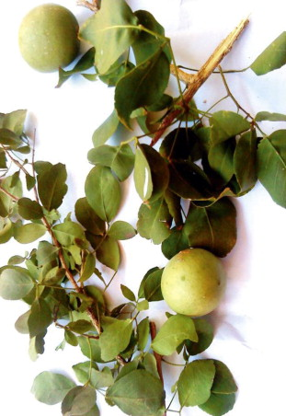

Figure 1.1 Aegle marmelos plant

Aegle marmelos, also called Bael and a member of the Rutaceae family, has been widely used in conventional Indian medicinal practices because of its many therapeutic properties. A tree with trifoliate leaves and greenish-white blooms that is spiny, deciduous, and scented. Additionally, trees are planted as avenue trees next to temples and in gardens. The tree’s fruit and bark are both used [4].

Medicinal Uses:
- The dried fruit pulp from Aegle marmelos is used in various regions of India to make summer beverages that prevent sunburn.
- Salads are prepared using bael leaves.
- Bael can be used in the composition of ayurvedic medications for the loss of appetite.
- To treat respiratory issues, bael extract oil is used.
- It has anti-inflammatory properties, like Aegle marmelos. When applied to the exposed area, it helps to treat inflammation.
- Antioxidants found in abundance in Aegle marmelos aid in insulin secretion, which lowers blood sugar levels [4].

Erythrina variegata:
Common name: Tiger’s claw or Indian coral tree
Tamil name: Kalyana murungai
Botanical name: Erythrina variegata

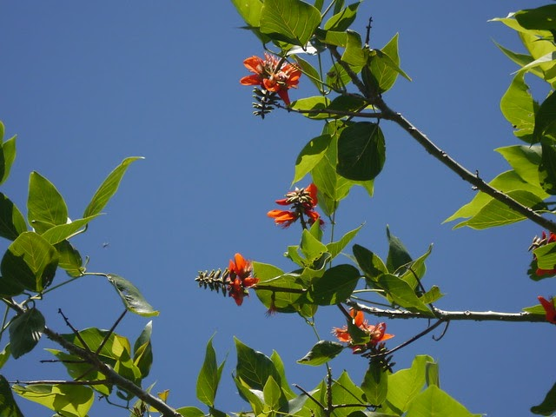

Figure 1.2 Erythrina variegata plant

Erythrina variegata, also known as Erythrina indica, is a thorny deciduous tree that grows to a height of 50-60 feet and is wide. It has 6-inch-long, leaves are green and yellow, which produce a waste canopy but have spiny branches. Before the leaves emerge in spring, coral trees are covered in colorful red blossoms that are 2.5 inches long and grouped in thick, six-inch-long racemes. Twelve-inch-long, reddish-brown seedpods with toxic seeds follow these blossoms [5].

Medicinal uses:
- In traditional medicine, several portions of E. variegata have been employed as nervine sedatives, febrifuges, anti-asthmatics, and antiepileptics.
- It has shown promise in several studies as a treatment for conditions such as convulsions, fever, inflammation, bacterial infections, sleeplessness, helminthiasis, cough, cuts, and wounds [5].

Hygrophila auriculata:
Common name: Hygrophila or Marsh barbel
Tamil name: Neermulli
Botanical name: Hygrophila auriculata

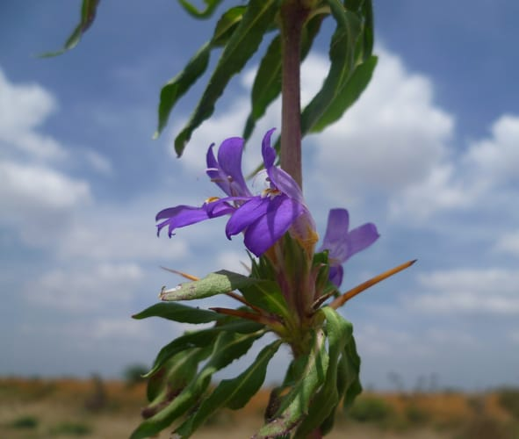

Figure 1.3 Hygrophila auriculata plant

Hygrophila, also known as Marshal Barbel, is frequently referred to as Neermulli in Tamil. An annual herbal plant can reach a height of 60 cm. Tetragonal, hairy, and hardened at the nodes, a plant stem. The leaves are elliptic-lanceolate and hispid, while the bark is dark brown. The flowers are purple-blue with violet undertones. The fruit has a four-sided shape, is linear, glabrous and about contains roughly 1 cm long, orbicularly hairy and brown seeds [6].

Medicinal uses:
- Its leaves can help with a cough.
- In an anal fistula, it is helpful.
- Consuming a root decoction helps with jaundice.
- In anemia, vegetables are helpful.
- Its root and a decoction of all of its parts are useful in rheumatoid arthritis [6].

Pongamia pinnata:
Common name: Karanj, Indian beech tree, Pongam tree
Tamil name: Pungai
Botanical name: Pongamia pinnata

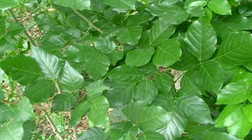

Figure 1.4 Pongamia pinnata plant

In tropical Asia, Australia, Polynesia, and the Philippine Islands, Pongamia pinnata, a member of the Fabaceae (Papilionaceae) family widely spread. The bark, leaves, seeds, roots, flowers, and stem of Pongamia pinnata are among the several plants parts that have historically been employed in numerous traditional medical systems [7].

Medicinal uses:
- It has been discovered that this plant’s blossoms have lipid peroxidation and anti-hyperglycemic capabilities.
- The leaves work well as a medicinal bath and for rheumatic aches, and the bark is used in heaps. The seeds are beneficial for rheumatoid arthiritis, bronchitis, whooping cough, skin disorders, and hypertension.
- Gum cleaning and the treatment of gonorrhea both benefit from roots [7].

Ruellia prostrata:
Common name: Bell weed
Tamil name: Kiranthi nayagam, Pottakanchi
Botanical name: Ruellia prostrata

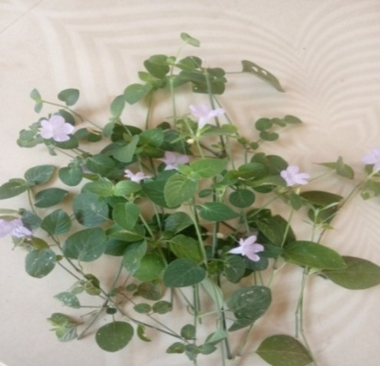

Figure 1.5 Ruellia prostrata plant

A perennial prostrate plant known as bell weed, whose stems commonly root at the nodes. 2-10 cm long, ovate green leaves with a notably darker underside. The leaf stem is 5-30 mm in diameter. Oblanceolate to ovate, 1.5-2.3 cm long bracts enclose the solitary flowers that emerge in the leaf axils. 5, 6-10 mm long sepals. Flowers are densely covered with microscopic hairs and range in color from violet blue to almost white [8].

Medicinal uses:
- Considered to be moderately hypoglycemic and anticancer for the nasopharynx region’s epidermis.

METHODS

Procedure for Extraction:
Using the extraction process used in the pharmaceutical industry, the medicinally active components of the plant tissues are separated from the inactive/inert components of the tissues. During extraction, solvents seep into the solid plant material and solubilize components with identical polarities [9]. To acquire the therapeutically necessary components of crude medicines (medicinal plant parts), standardized extraction techniques are used. Unwanted chemicals are removed through treatment with the selective solvent menstrum. As a result, the acquired extract may be prepared to be added to any dosage from, such as pills and capsules, or it may be used as a therapeutic agent, such as in the form of tinctures or fluid extracts. Alkaloids, glycosides, terpenoids, flavonoids and lignans are only a few of the many plant metabolites present in these goods [10].

The following processes are used to extract substances:
Percolation, digestion, decotion, Soxhlet extraction (hot continuous extraction), aqueous-alcoholic extraction by fermentation, counter-current extraction, microwave-assisted extraction, and phytonetic extraction (using hydroflurocarbon solvents) [10].

The following are the key elements that determine an extract’s quality:
Plant component used as starting material, extraction technique and extraction solvent [9].

Plant phytochemicals depends on:
The nature of the plant material, its origin, processing intensity, moisture content, and particle size [9].

The quantity and secondary metabolite composition of an extract will vary depending on the following factors:
Types of extraction, extraction time, temperature, solvent type, solvent concentration and polarity [9]

Selection of Solvents:
The outcome of the extraction procedure and the identification of biologically active compounds from plant material are strongly influenced by the type of solvent used. An appropriate solvent for plant extractions should have the following characteristics: low toxicity, ease of evaporation at low heat, promotion of fast physiologic absorption of the extract, preservative activity, and inability to cause the extract to complex or dissociate [11].

The many solvents utilized in the extraction methods include:
Water, Acetone, Alcohol, Chloroform, Ether and so on [9].

In this study, we used water as solvent and Soxhlet extraction procedure were involved for extraction procedure.
A range of medicinal plant components with antibacterial action can be extracted using water, an all-purpose solvent. Although water is typically used by traditional healers, it has been found that plant extracts from organic solvents have more consistent antibacterial action [12].
Soxhlet extraction is only required when the target component has a restricted solubility in a solvent and the impurity is insoluble in that solvent. Filtration can be used to quickly separate the target component from the insoluble material if it is highly soluble in the solvent. The advantage of this method is that only one batch of warm solvent is recycled, as opposed to multiple portions being passed through the sample [13].

Preparation of various medicinal plant leaf extract:
The leaves of five different medicinal plants were chosen, harvested, and and properly washed two to three times under running water before being sterilized with double-distilled water. The leaf samples were allowed to dry at room temperature and without any dust. The leaves were powdered after being dried and pulverized. 50 ml of distilled water and 5 g of the leaf powder were cooked for 5 hours at 100 ⁰C. Following the boiling process, the brown-hued solution was filtered using Whatman filter paper and maintained in the refrigerator, creating a light-brown colored solution that was cool to touch at room temperature [14].

Qualitative techniques for the determination of phytochemicals:
According to the accepted practices, the preliminary screening test was used to find the presence of secondary metabolites in the leaf extract of different medicinal plants [15].

- Test for Saponins:
Froth test: 2 to 3 ml of double distilled water and 1 ml of extract were gently mixed together. The mixture was then vigorously shaken after that. The development of foam is the last piece of evidence that saponins are present in the leaf extracts.

- Test for Alkaloids:
Filtering after each extract was treated in diluted hydrochloric acid served as an alkaloids test.
Hager’s Test: A small amount of Hager’s reagent is combined with the extract. A yellow precipitate’s appearance denotes the presence of alkaloids.

- Test for flavonoids:
Lead acetate Test: A few drops of lead acetate solution are applied to the extract. The yellow color of the precipitate indicates the presence of flavonoids.
- Test for Phenol:
Ferric Chloride test: Three to four drops of ferric chloride solution were added to the extracts. The creation of a bluish black tints denotes the presence of phenols.

- Test for Proteins:
Xanthoproteic test: 2 ml of extract turns yellow when a few drops of strong nitric acid (HNO₃) acid are added, showing the presence of proteins.

- Test for Cardial Glycosides:
Keller Killani test: The presence of cardial glycosides by reacting 2 ml of leaf extract with 2 ml of glacial acetic acid and a drop of FeCl₃ to produce a brown-colored product.

- Test for carbohydrate:
Dilute each extract with 5 ml of distilled water before being filtering it to check for carbohydrates. The presence of carbohydrates in the filtrates was examined.
Benedict’s test: Filtrates were treated with Benedict’s reagent and then gently heated. When an orange red precipitate appears, carbohydrates are present.

- Test for steroids:
Perform a steroid test by mixing 2 ml of leaf extract and 10 ml of chloroform in a test tube. Using a side wall of the test tube, an equivalent volume of concentrated H₂SO₄ acid was introduced to the mixture.The H₂SO₄ acid layer in the upper layer of the solution changed, turning yellow with green fluorescence, indicating the presence of steroids.

IV. RESULT

Table 1.1 Analyses of selected medicinal plant leaf extract preliminary qualitative screening

S. No. | Test | Aegle marmelos | Erythrina variegata | Hygrophila auriculata | Pongamia pinnata | Ruellia prostrata
1 | Saponins | + | + | + | - | +
2 | Alkaloids | + | - | - | + | -
3 | Flavonoids | + | + | + | + | -
4 | Phenol | + | + | + | + | +
5 | Proteins | - | - | - | - | -
6 | Cardiac glycosides | + | - | - | + | -
7 | Carbohydrate | + | - | - | + | -
8 | Steroids | + | - | - | + | -

(+) = Presence
(-) = Absence

V. RESULT AND DISCUSSION

The enormous range of phytochemicals found in plant origin have been considered as a bioactive laboratory with numerous applications. As a result, from ancient times, these plant origins have played a key role in the treatment of numerous ailments. The therapeutic plants are generally available, inexpensive, have less side effects, and are straight forwardly effective. Researching the therapeutic characteristic of phytochemicals found in plants can lead to the discovery and development of novel molecules [16].

Plant extract is frequently used as a potential replacement for the stabilizing and reducing agent due to the combination of its bio-components, such as terpenoids, alkaloids, phenolics, tannins, proteins, aminoacids, polysaccharides, enzymes, vitamins and saponins [17]. As shown in table 1.1, phenols, saponins, and flavonoids are the main chemical constituents of the essential extract derived from leaf extracts of five medicinal plants from diverse families that have been chosen. Numerous studies have shown that phenols and flavonoids play a role in the bio-reduction, production, and stability of metal and metal oxide nanoparticles [18-20]. To reduce metal into metal oxide nanoparticles, large OH groups found in phenol and flavonoids are employed. Phenols, saponins, and flavonoids found in the aqueous leaf extract attach to the surface of metal precursors and promote the synthesis of metal oxide nanoparticles [21]. For the creation of metal and metal oxide nanoparticles, the -OH groups from phenol, saponins and flavonoids are secondary metabolites can act as a reducing and capping agent [22].
In this study, the phytochemical screening test was carried out by using five medicinal plant leaf extract of different family such as Aegle marmelos, Erythrina variegata, Hygrophila auriculata, Pongamia pinnata and Ruellia prostrata.
The phytochemical screening test result revealed that all of the selected medicinal plants have been found to contain phenols in their leaf extracts. However, it is important to note that Ruellia prostrata is the only plant among them that does not contain in flavonoids. Similarly, Pongamia pinnata is the only plant that does contain saponins. Furthermore, alkaloids, cardiac glycosides, carbohydrates and steroids are present in all plants, except for Ruellia prostrata, Erythrina variegate and Hygrophila auriculata leaf extract. Lastly, it is worth mentioning that proteins are absent in all five medicinal plant leaf extract.

VI. CONCLUSION

The phytochemical analysis of five different medicinal plants clearly reveals that Aegle marmelos and Pongamia pinnata leaf extracts have the major phytoconstituents in comparison to the other three plant extracts. As a result, it is possible to analyze the maximal phytoconstituents in these two plant’s leaf extracts, which are crucial reducing and capping agents during the production of nanoparticles. The other three plants were chosen because they also contain essential phytoconstituents, making them equally significant. These plants have been used in the manufacture of metal and metal oxide nanoparticles as reducing and capping agents. Nanoparticles can bind phytochemicals to their surfaces, enhancing their solubility, stopping them from oxidizing or degrading, and vastly increasing their absorption and bioavailability while preserving their medicinal value.

REFERENCE

[1] Ncube NS, Afolayan AJ, Okoh Al, African Journal of Biotechnology 2008; 7 (12): 1797-1806.
[2] Kabera JN, Semana E, Mussa AR, He X, Journal of pharmacy and pharmacology, 2014; 2:377-392.
[3] Gusthinnadura Oshadie De Silva, Achala Theekshana Abeysundara and Malamige Minoli Weroshana Aponso, Ameican Journal of Essential Oils and Natural Products, 2017, 5(2):29-32
[4] https://www.dabur.com/ayurveda/ayurvedic-medicnal-plants/bael
[5] A.Kumar, S.Lingadurai, A.Jain and N.R. Barman, Pharmacogn Rev.2010 Jul-Dec; 4(8): 147-152.
[6] L.Sarvananda, Amal D. Premarathna, Journal of Ayurvedic and Herbal medicine 2018; 4(4): 185-188.
[7] Zahid Iqbal Sajid, Farooq Anwar, Ghulam Shabir, Ghulam Rasul, Khalid M.Alkharfy and Anwarul-Hussan Gilani, Molecules 2012, 17, 3917-3932; doi:10.3390/molecules17043917
[8] http://www.flowersofindia.net/catalog/slides/Bell%20weed.html
[9] Tiwari P, Kumar B, Kaur M, Kaur G, Kaur H, Internationale Pharmaceutia Sciencia, 2011; 1(1):98-106.
[10] Handa SS, Khanuja SPS, Shrivastava DK, Journal of medicinal Plants Research 2010; 4(2): 104-111.
[11] Eloff JN, Journal of Ethnopharmacology 1998; 60: 1-8
[12] Das.K, Tiwari RKS, Shrivastava DK, Journal of Medicinal Plants Research 2010; 4(2): 104-111.
[13] Nikal SB, Dambe PA, Ghongade DB, Goupale DC, International Journal of Pharmaceutical Sciences 2010; 2(1): 30-32.
[14] K. Elumalai, S. Velmurugan, Applied Surface Science (2015), http://dx.doi.org/10.1016/j.apsusc.2015.03.176
[15] K. Senthilarasan, V. Raguraman, V. Senthilmurugan, D. Sowmiya, International Research Journal of Multidisciplinary Scope (IRJMS), 2022, 3(2): 35-40.
[16] A.Umamaheswari, S.Lakshmana Prabhu, S. Adharsh John, A. Puratchikody, Biotechnology Reports 29 (2021) e00595
[17] S. Ahamed, M.Ahmad, B. L. Swami and S.Ikram, Journal of Advanced Research, 2016, 7, 17-28.
[18] F. Luo, D. Yang, Z. L. Chen, M.Megharaj, R.Naidu, J. Hazard, Mater. 303 (2016) 145-153.
[19] A. K. Mittal, Y. Chisti, U.C. Banerjee, Biotechnol, Adv. 31 (2013) 346-356.
[20] X. Weng, M. Guo, F. Luo and Z. Chen, Chemical Engineering Journal, 2017, 308, 904-911.
[21] N. Bala, S. Saha, M. Chakraborty, M. Maiti, S. Das, R. Basu and P. Nandy, RSC Adv., 2015, 5, 4993-5003.
[22] K. Aoki, J. Chen, N. Yang, H. Nagasava, Langmuir, 2003, 19, 9904-9905.

