**Title: Microgreens an emerging superfood packed with health promoting nutrients**

**Sibani Das**

Assam Agricultural University, Horticultural Research Station, Kahikuchi, Guwahati,17Assam India

**Corresponding author ph no : 9706692785 and email: sibanidas01@gmail.com**

**Abstract**

The next generation of “smart” foods, microgreens are becoming more and more well liked as food ingredients in recent times for their high nutritional value and benefits of having diverse organoleptic properties. Variety of vegetables, herbs and plants can be used to grow microgreens which are edible fresh greens. Chefs now favour microgreens, and they are also becoming more commonin upscale grocery stores. Therefore, the expansion of microgreens offers enormous market opportunities on a global scale. They are appealing to growers because of their nutritional benefits, simple production processes, and quick production cycles among other factors. When compared with their mature- leaf counterparts, microgreens can offer higher levels of phytonutrients ascorbic acid, β-carotene, α-tocopherol, and phylloquinone as well as the minerals calcium, magnesiumg, iron, manganese, zinc, selenium and molybdenum. Microgreens can be grown all year round because they do not require any particular nutrients for growth. Since microgreens have a limited shelf life therefore better storage and transportation methods are required. The greens are packed in biodegradable clamshell containers because they are delicate and susceptible to bruishing. Microgreens should be packaged in bags with enough room at the top to safeguard the tender young shoots. Cut microgreens can be packaged in modified atmosphere packaging and kept at low temperatures to maintain their consistency and quality. Depending on their sensitivity or temperature tolerance, different species of microgreens are stored at various temperatures.

One of the main limitations to the growth of the microgreen industry is the rapid deterioration in quality that occurs soon after harvest when they are ready to be harvested 7-14 days after germination, which drives high prices and trade restrictions on local sales. Once harvested, microgreens are prone to dehydration, wilting, decomposition, and rapid lose of some nutrients. Research has explored pre- and pos-tharvest interventions, such as calcium treatment, modified atmopsphere packaging and temperature and light control, to maintain quality, increase nutritional value and extend shelf life. However, further research is needed to optimize both production and storage conditions to improve the safety, quality, and shelf life of microgreens, thereby expanding the potential market.

**Key words:** Microgreens, greem leafy vegetables, growing media, nutrition facts.

.

**What are Microgreens:**

Microgreens are immature edible green leafy vegetables of about two inches tall consisting of the stem, cotyledons and first pair of fully grown or partially developed true leaves. Like sprouts microgreens are young vegetables. However sprouts and microgreens are not the same. In general sprouts are the germinated seeds that are eaten along with the embryonic roots and the seeds. In contrast microgreens grow from sprouts and have leaves. Microgreens differ from baby greens in their size and are much smaller than baby greens. They are classified according to the degree of development between “sprouts” and “baby greens”. It is smaller than baby greens because they are eaten very soon after germination rather than after the plants has matured to produce many leaves. Sprout, Microgreen, and babygreen are simply green vegetables that are harvested and eaten in their immature form. Sprouts are the smallest and the youngest, microgreens are slightly larger and older usually 1- 3 in. tall (2.5 to 7.6 cm). Larger than this size it is called petite greens (Oh, M. M, 2010; Anonymous, 2013). It is also known as vegetable confetti. Compared to sprouts microgreens are harvested(Anonymous, 2014; Millard, E. 2014). Microgreens tender green shoots are harvested for consumption within 10 to 20 days of seedlings emergence. Cotyledon development takes place in10 to 14 days from seedling.

Unlike sprouts that are obtained by embryonic roots and seeds, the difference is that sprouts are seeds that have already germinated. Baby greens are significantly larger than microgreens which are significantly smaller. Their condition remains between the sprout and baby greens.

 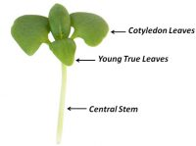

Fig 1:Typical 1-14 days old microgreens. Fig 2: The edible parts :

Central stem, cotyledon

leaves and young true leaves.

**Source :** Fig taken from Riggio et al (2019)

Over the few past years using microgreens in cooking has become increasingly popular. Microgreens despite their size, may deliver unexpectedly potent flavors, a varietyof colors, and a crisp texture. They can be used as a fresh salad item or a tasty garnish.It is alsoused to improve the appearance feel color, or flavour of salads and major courses, as well as to flavour food by adding sugar and spices.

**List of the various crops grown as Microgreen**

Microgreens can be obtained from different sorts of seeds. The well known species are harvested using seeds from the following plant families (View & Club, 2019).

|  |  |  |  |
| --- | --- | --- | --- |
| **SL.No** | **Common Name** | **Scientific Name** | **Family** |
| 1. | Broccoli | *Brassica oleracea var. italica* | Brassicaceae |
| 2. | Cabbage | *Brassica oleracia L. var capitata L.* |
| 3. | Cauliflower | *Brassica oleracia L. var botrytis L.* |
| 4. | Raddish | *Raphanus sativus* |
| 5. | Carrot | *Daucus carota* | Apiaceae |
| 6. | Beet | *Beta vulgaris L.* | Amaranthaceae |
| 7. | Chick pea | *Cicer arietium L.* | Fabaceae |
| 8. | Fenugreek | *Trigonella foenicum-graecum L.* |
| 9. | Green gram | *Vigna radiata* |
| 10. | Pea | *Pisum sativum* |
| 11. | Spinach | *Spinacia oleracea L.* | Chenopodiaceae |

Sometimes, legumes such as chickpeas, beans and lentils as well as grains such as rice, oats, wheat and corn are grown as microgreens. Depending on the type of microgreen the taste can range from spicy, pungent or even bitter. As one of the healthiest food microgreens pea shoots are occasionally included in our seasonal microgreens list. The beta-carotene present in pea shoots is converted by our bodies into the important vitamins A, C and folate as well as fibre.

**Production of Microgreens**

In small space microgreens are simple to grow and cultivate in farm or. Microgreens can be grown in soil or soilless media outdoor or indoor under natural or artificial light sources. Microgreens can be grown on small or large scale or in industrial production systems by individuals for personel use or for commercialization.

Microgreens are adaptable to a variety of temperatures. Usually a temperature range of 20 to 22°C is ideal for the growth of all summer and winter species. *Brassica* species seeds, however can germinate at a slightly lower temperatures. As the temperature drops, it takes the seedlings longer to reach the marketable stage. Microgreens develop more quickly in warmer conditions. In order to produce higher quality microgreens, a farmer first choice for microgreensis is to decide whether the outdoor or the indoor conditions are ideal for the production which can be accomplished by creating a perfect and controlled environment. As per the experienced farmers, indoor conditions are far better for the production of superior quality microgreens because they can be readily managed and the temperature, humidity and light levels can be kept according to the needs of the microgreens. From seedling to harvest, different crops require very different amounts of time.

When growing a mixture of crops in a growing plate, growers should choose plants with a similar growth rates so that whole plate can be harvested at the same time. In addition, growers can sow different crops individually and mix them after harvesting. It can be grown in a sterile, loose, soilless standard germination medium, can be used successfully with peat moss, vermiculite, perlite, coconut fiber, and the other half of the tray is filled with the media of choice to a depth of 1or 2 inches., depending on watering schedule. Generally, this media system uses an overhead mist irrigation. Use of one of various materials such as mat or lining which is placed on the bottom of the base or expanded by an alternative production system. In general, these materials are fibrous and make an excellent seedling medium. For some crops, mats alone may be sufficient or light cover may be required after sowing. Sowing can be done by broadcast method or in rows. The frequency of sowing is difficult to accept. Most growers note that they want to plant as thickly as possible to maximize production, but not too thick as compactness promotes stem elongation and increase the risk of disease. Therefore the seeding rate per unit area is the most important factor in the production of microgreens, since the seeding frequency affects the yield of microgreens. As the seeding rate increases, the weight of an individual seedling decreases due to competition between seedlings, but the total yield per unit area increases. In general, microgreen seeds do not require much nutrients to germinate, although they only ideal environmental conditions (temperature and adequate humidity) for further germination and growth. However, providing mineral nutrients in solution increases the yield of microgreens.

**Growing Media**

Media such as soil, tissue paper, hydroponics, etc. can be used to grow microgreens. However a mixture of cocopeat, vermiculite and perlite in the ratio 5:2:1, can be used for growing microgreens because it releases nutrients very slowly. Thus the same medium can be reused several times to grow young greens.

**Health Benefits and nutrition facts**

1. **Microgreens provide more nutrients than mature leaves** and have been found to have four to six times more nutrient density than their mature leaves. Microgreens with bright-coloured have been proven to be more nutrient dense than those with milder hues.
2. Microgreen peas are rich in **phytoestrogens** that help reduce the risk of heart disease, cancer and osteoporosis.They are also rich in vitamin C and contain a significant amount of Iron**.**
3. In comparison to sprouts, microgreens have a higher content of protein, iron, zinc, α-carotene, β-carotene, violaxanthin, lutein and neoxanthin.
4. Vitamins A, B, C, E & K are abundant in microgreens. In addition to containing calcium, phosphorous, iron, vitamins A and C, sulforaphane, a phytochemical that reduces inflammation is abundant in broccoli.
5. Microgreens are an essential source of fiber and roughage.
6. Chlorophylls, which are another major group of antioxidants in microgreens, have been reported to exhibit chemoprotective activity in carcinogenic conditions

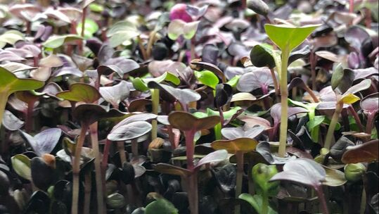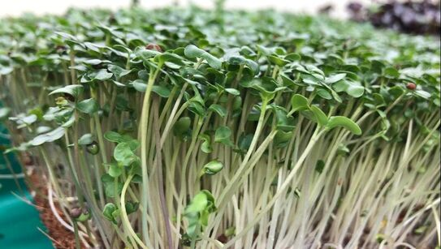 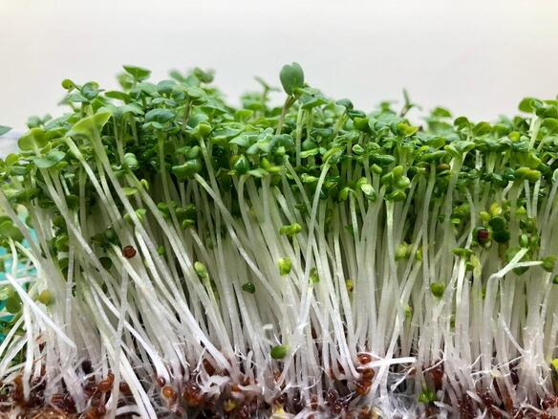

**Pea Raddish Broccoli**

**Harvesting of Microgreens**

Depending on the kind of crop and other climatic factors, microgreens are available for harvest 7-14 days after germination under tropical environments and slightly longer (14-28 days) in temperate environments. When microgreens reach a height of 2.5 to 7.6 cm they are cut with a sharp knife just above the media’s surface because microgreens have a limited shelf life, better storage and transport facilities are needed. Given that microgreens are delicate and prone to bruising,they are therefore packed in biodegradable clamshell containers. To safeguard the delicate shoots air space is left at the top of the bags when microgreens are packaged. The consistency and quality of cut microgreens can be preserved by packing in modified atmospheric packaging and storing at low temperature. Microgreens of different species are stored at different temperature based on their susceptibility or tolerance to temperature

**Benefits of Growing Microgreens as a business:**

People all over the world becoming aware of the benefits of including leafy greens and microgreens in their diet, ensuring that demand will continue to increase.There is a future for agriculture indoors because we are also witnessing an increase in problems and crop failure of greens cultivated outside.

**Low start-up costs :**

Farmers may start their business with very low capital by growing just enough microgreens to sell at weekly farmer’s market or to supply one restaurant and then increasing their output in response customer demand.

**Quick turnaround**  :

Microgreens take around 7-14 days to grow from seed to harvest. For harvesting a farmer doesn't have to wait for a whole season or longer.

**Growing year- round:**

Farmers may utilize microgreens to diversify their business and increase profits by using them to supplement their regular income.

**Higher nutrition** :

Microgreens are ‘functional foods’ which have nutritional value. They include all the necessary vitamins and minerals.

**High-value crop :**

A farmer can charge more for their microgreens since they are a local grower in addition to selling them to upscale restaurants and grocery shops at higher rates.

**Some examples of Microgreen start ups**

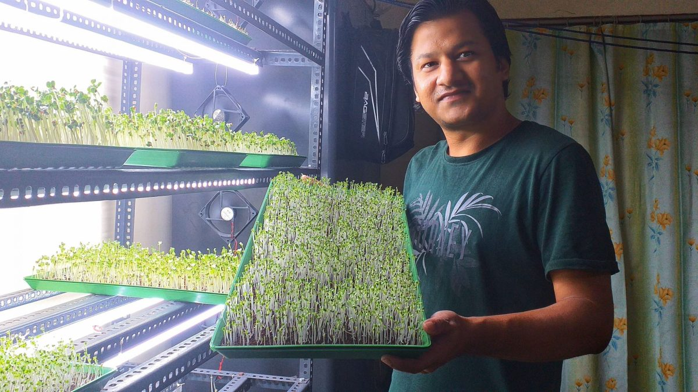

* Rahul Sharma runs a microgreen startup called “**Guwahati Microgreens**”. It is grown hydroponically in a controlled environment using a coco-peat medium and just clean filtered water. They grow microgreen on a pre-order basis and distributes them to the people of Guwahati to improve the immunity and health of people in his community.
* **Farm 2 Fam** is a Mumbai based starup which grows microgreens. The microgreens are free from pesticides, herbicides and chemicals and delivered straight to the customers doorstep.It was founded in Jan 2019.

**Summary**

Microgreens are new generation of smart foods, that are growing in popularity. They are edible forms of small immature green leafy vegetables obtained from different kinds of vegetable, herbs and plants and popularized as new culinary ingredients, having a high content of minerals, vitamins and many compounds non-nutritive bioactive substances are higher and are more nutritious than their mature counterparts. These fresh and healthy microgreens have a high market acceptance due to their attractive appearance, rich flavor flavour texture and essential nutrient content. So they can be summarized as follows

1. Microgreens can help ensure global nutrition security.
2. The microgreens have become popular among consumers due to their nutritional composition and high content of antioxidant compounds.
3. Consumers can produce microgreens at home using simple tools available in the home with ease.

**Reference**

View, M. and Club, G. 2019. *Microgreens What Will We Cover/?*

Manish Reddy, Krishna Vadlamudi, Anjali, and Bagathi Ganesh.Role of Microgreens and their potential health benefits : A Review 2021 JETIR May 2021, Volume 8, Issue 5.

Riggio GM, Wang Q, Kniel KE and Gibson KE (2019) Microgreens—A review of food safety considerations along the farm to fork continuum. International Journal of Food Microbiology 290, 76–85.

Kalpana Yadav, May- June 2021. Microgreens An ultimate Superfood:Indian Horticulture 26-28

Deepika kalal, 2Sandhya Verma and 3Dr. Hitesh A. Solanki (2021). Microgreen -as a potential food source: A ReviewIJCRT | Volume 9, Issue 3 March 2021 | ISSN: 2320-2882