CHAPTER: RECENT TRENDS OF NANOTECHNOLOGY IN DRUG DISCOVERY
Vijayshri Rokde* Kishor Danao
Department of Pharmaceutical Chemistry Department of Pharmaceutical Chemistry
Dadasaheb Balpande College of Pharmacy, Dadasaheb Balpande College of Pharmacy,
Besa, Nagpur-440037 Besa, Nagpur-440037
Email id- vijayshritekade@gmail.com Email id- kishordanao@gmail.com
Deweshri Nandurkar Monali Dumore
Department of Pharmaceutical Chemistry Department of Pharmaceutics
Dadasaheb Balpande College of Pharmacy, Dadasaheb Balpande College of Pharmacy,
Besa, Nagpur-440037 Besa, Nagpur-440037
Email id-kerzarepritee@gmail.com Email id- mndumore@gmail.com
Diptanshu Sawai
Department of Pharmaceutical Chemistry
Dadasaheb Balpande College of Pharmacy,
Besa, Nagpur-440037

ABSTRACT
One of the most essential subject to come up is nanotechnology. The rational for this is that some type of cell target treatment, such as efficient drug delivery to the target cell and competent sickness detection, benefits from its size in the nanometer range, which makes it easy to enter into human body cells. In 1959, Noble prize winner Richard Feymann introduced the idea of nanotechnology. Prospective uses for nanotechnology in the biological science, notably nanobiotechnology include those for drug discovery. Recent development in physics, chemistry, and material sciences have given a variety of nanomaterial special features that are anticipated to enhance the treatment of many tumors that are now resistant to conventional treatments. They will be able to transport therapeutic molecule like medicine proteins, nucleic acids, or immunological agents by acting as nanocarriers, which will be made feasible by their inherent cytotoxicity activity. The utilization of numerous nanotechnology, including nanoparticles and various nanodevices like, nanobiosensors, nanobiochips, and nanoarrays. Nanoliter tests at the nanoscale volume contributes to cost saving. Some nanosubstances such as fullerenes are drug candidates to enhance drug discovery is describe in this chapter.
Keywords: Nanotechnology, drug discovery, nanocarriers, nanobiosensors, nanochips, nanoarrays
- INTRODUCTION
Richard Zsigmondy, the 1925 winner of the Nobel Prize in chemistry, was the one who initially coined the term "nanometer." He is credited with being the first to use a microscope to measure the size of particles like gold colloids, and he also invented the term nanometer specifically to describe particle size. The inventor of contemporary nanotechnology is physicist Richard Feynman, who won the Nobel Prize in physics in 1965. He proposed the idea of influencing matter at the atomic level in a talk titled "There's Plenty of Room at the Bottom" during the 1959 American Physical Society meeting held at Caltech. With this innovative concept, new methods of thinking were presented, and Feynman's theories were later found to be true. He is regarded as the founding father of contemporary nanotechnology because of these factors.[ Hulla, J.E] The term nanotechnology was cast-off by Norio Taniguchi in 1974. He was studied the development and advancement in machine technology. He was worked over three decades for the development and advancement in machine technologies. He used term nanotechnology for future reference. Number of significant discoveries and innovations were produced between the second decade of the 1980s and the early 1990s, which had a significant influence on the advancement of nanotechnology. Since then, there has been a significant increase in the amount of research and development being done in the field of nanotechnology. Additionally, there has been a sharp increase of the number of publications on the topic, as well as an expansion of the use of nanotechnology in practical applications. The first National Scientific Fund nanotechnology programme launched in the USA in 1991. The United States' National Nanotechnological Initiative (NNI) was approved in 2001. The National Nanotechnological Approach was created with the following main idea by using: "National Nanotechnological Initiative defines the strategy of interaction between federal departments of the USA with the purpose of prioritising nanotechnology development, which should become in the first half of the 21st century a foundation for the economy and national security of the USA.". Xu et al. by inadvertently discovered a new class of carbon nanomaterials named carbon dots (C-dots) with size below 10 nm in 2004 while purifying single-walled carbon nanotubes. Due to their beneficial, plentiful, and affordable nature, C-dots with intriguing features have steadily become a rising star as a new nanocarbon component. [Bayda, S.]
One of the most interesting examples of nanotechnology in the ancient world was presented by the Romans in the fourth century AD, who employed nanoparticles and structures.One of the most remarkable works of ancient glass art is the Lycurgus cup, which is part of the British Museum collection. It is the earliest well-known instance of dichroic glass. Dichroic glass refers to two distinct glass kinds that, depending on the illumination, can change colour. Thus, the Cup has two distinct colours: green in direct light and reddish-purple when light is shining through the glass. [Zelzer, M]
. Initially, the researcher of physics and engineers were innovators of nanotechnology. Around the world, nanotechnology has gradually but significantly dominated several industries. Particularly in the industrialized world, where markets at the nanoscale have quickly displaced larger markets over the past ten years, this rapid pace of technological innovation is evident. Since it is currently a widely used technology, it is not a brand-new idea. In transdisciplinary scientific domains, active and passive nanoassemblies, general nanosystems, and small-scale molecular nanosystems are the four generations of nanomaterials that have surfaced [Anselmo, A.C.]. The fact that nanoscience is developing so quickly is evidence that soon nearly all areas of science and technology will use nano-scale manufacturing. This chapter will discuss the most cutting-edge uses of nanotechnology in a variety of sectors, with a focus on those in the chemical, mechanical, oil and gas, food, cosmetics, healthcare, automotive, and oil and gas industries [Rickerby, D. and Bhushan, B]. In addition, a brief overview of nanotechnology's negative aspects will be provided for each industry to enable the scientific community to understand both its limitations and advantages. The fundamental characteristics of biological, physical, and chemical sciences are combined through the process of nanotechnology. At the nanoscale, these processes take place. Physically, the size is reduced, chemically, new bonds and chemical characteristics are controlled, and biological effects, like drug bonding and distribution at specific places, are formed at the nano scale [Kumar, S, and McNeil, S.E,]. In a murky region known as a mesoscopic system, nanotechnology bridges the gap between classical and quantum mechanics. In the medical business, this mesoscopic technology is utilized to create nanoassemblies that are similar to those found in nature, such as agricultural products, nanomedicine, and nanotools for treatment and diagnostic reasons [de Charles, P.P.].
Drugs and diagnostic tools based on nanotechnology are currently being used to treat diseases that were previously incurable. Additionally, this technique had a significant impact on industrial output and manufacturing in general. It employs the reverse engineering concept, which occurs in nature, to create materials rather than using large amounts of material that must be cut out. It permits the production of items at the micro scale, such as atoms, and subsequently develops items that function at a deeper scale [Schulte, J,]. To fully use the enormous potential of this brand-new science, millions and billions of dollars and euros are being invested worldwide in nanotechnology, particularly in the industrialized nations of China, Europe, and the United States [Lemley, A.M]. However, emerging countries continue to lag behind since they cannot even keep up with the industrial advancement of the preceding era [Salamanca-Buentello, F.]. This delay is primarily attributable to the fact that these nations are currently experiencing economic hardship and require some time to advance in nanotechnology. It is important to emphasize, however, that the scientific communities of the developed and developing worlds both concur that nanotechnology will be the next stage in technological development [Roco, M.C,]. Consequently, in the upcoming years, additional industrial modernization and investment in the field of nanotechnology will become essential. Science and technology advancements lead to the adoption of technologies and goods that are more affordable, secure, and environment friendly than earlier ones. They are also concerned about the financial viability of technologies because the world's natural resources are depleting too quickly [Singh, N.A]. Thus, nanotechnology offers a solution to this issue. Comparing this technology to earlier mass bulking and expensive apparatus, it is clearer, cleaner, and more accessible. The application of nanotechnology to all facets of life is also possible. Nanomaterial sciences, Nano electronics, and nanomedicine will be primarily affected by this as they are ingrained in all facets of chemistry as well as the natural and artificial worlds [El Naschie, M.S]. Therefore, making the assumption that nanotechnology will become a subject that all students must learn in the future is not incorrect [Waldron, A]. The basic uses of nanotechnology in significant global industries and their implications for subsequent industrial advancement [Hulla, J]. A wide range of industries where nanotechnology is delivering astonishing applications have been examined, reviewed, and chosen to be included in this review after rigorous and careful assessments. It should be noted that in order to expound on the extensive applications of nanotechnology in various industries, multiple subcategories of industrial connections may be explored under one category. Microengineering ideas from physics and material sciences served as the foundation for nanotechnology [De Crozals, G.]. The idea of "nanoscaling" is not new to the computer business; in fact, engineers and technicians have been working on creating customized versions of computer-based technologies for a long time that take up the least amount of space while still performing the best function. As a result, using nanotubes in place of silicon chips is being tested more and more in computer hardware. Computer scientists have been immensely inspired by Feynman and Drexler's work to develop ground-breaking nanocomputers that potentially yield significant benefits [Waldron, A].
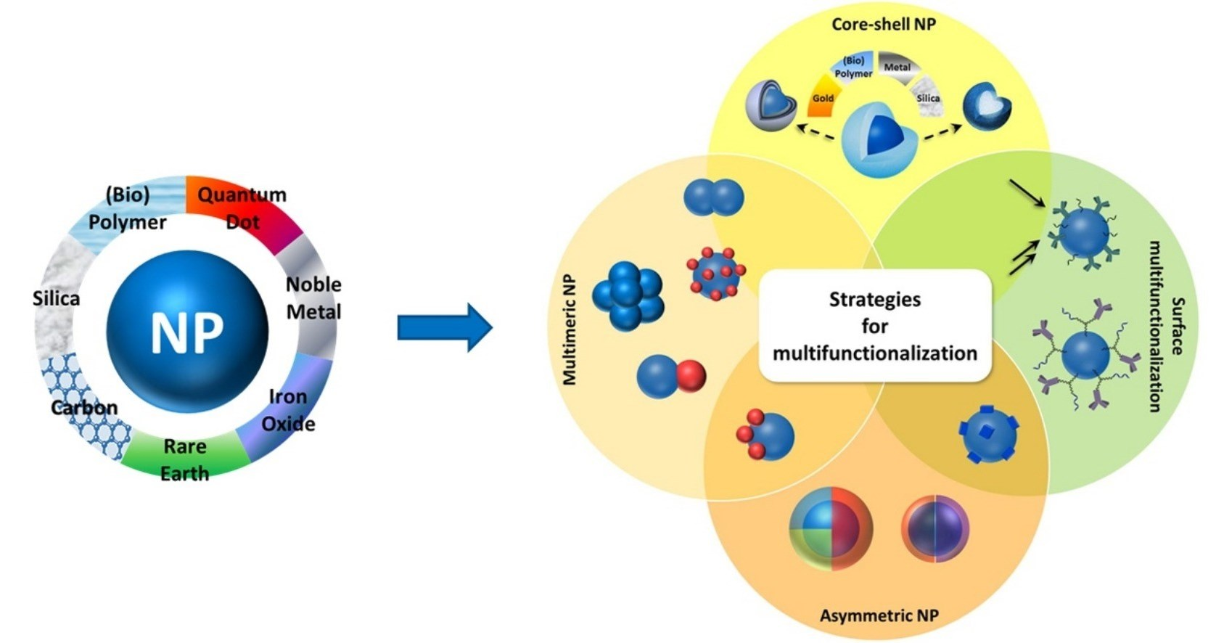

Figure 1: Nanoparticles with multiple properties for biomedical applications [De Crozals, G.]

- IMPORTANCE OF NANOTECHNOLOGY IN DRUG DISCOVERY
There have been many new pharma companies established that can provide expertise in creative delivery technology. Additionally, a lot of well-organized pharmaceutical companies are gearing up their efforts to develop new, more effective, and potent medicine delivery systems. By 2007, it is anticipated that the desire for medication delivery systems in only the US would increase by over 9% annually, totaling more than US$82 billion. [Sahoo, S. K]
In the area of medicine and the health sciences, nanotechnology has begun a new revolution. It is an advanced method for both delivery of drugs and drug discovery. Nanoparticle applications are straightforward and effective. Though, nothing is known about the toxicity of nanomaterials. [Sahu, T.]
In the target identification and validation stages of the drug development process, proteomics is crucial. Most existing techniques, such as purifying proteins and/or display and automated identification systems, provide severely lesser recoveries, which restricts the process overall in terms of sensitivity, speed, and the need for vast volumes of starting material. In order to determine the peptide fragments' molecular masses, less common proteins and proteins that can only be isolated from scarce source materials (such as biopsies and body fluids) can be subjected to nanoscale protein analysis, nanocapture of the targeted proteins and/or complexes, and optimisation of all subsequent sample-handling steps. [Jain, K]

Table 1: Different NanoTechnology with company [Jain, K]
Company | Technology | Applications
Caliper Life sciences (Hopkinton, MA, USA) | Labchips and sciclone | Molecular diagnostics
Drug Discovery CombiMatrix Corporation (Mukiteo WA, USA) | Nanoarrays By microelectrodes and electrochemical synthesis | Life- sciences research and drug discovery
Nanolytics | Biochips containg 10, 000 nanodroplets wells and computer controlled microactuator | Assay density is increased 50-200 fold compared with traditional plates
Bioforce nanosciences | Nano array spot contain 25, 000,000 spots per cm | It detect protein-protein interaction
SuNlyx | Nanostructures surfaces | Analytical biochips

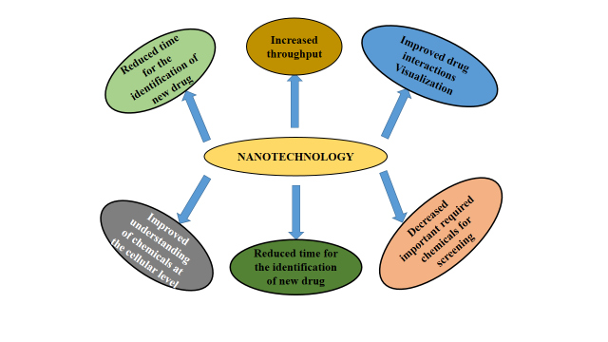

FIGURE 2: DRUG DISCOVERY PROCESS BENEFITS FROM NANOTECHNOLOGY [LaVan, D. A.]

- DIFFERENT DEVICES OF NANOTECHNOLOGY
- NANOCHIPS
A nanochip is a particular form of microchip created by the atomic and molecular level manipulation of materials known as nanotechnology. A nanochip has dimensions measured in nanometers (billionths of a meter), which are often substantially smaller than a conventional microchip. [Fu, Y] Like conventional microchips, these chips are constructed from semiconductor materials and have an electronic component network of transistors. Nanochips, on the other hand, are able to provide higher levels of performance and functionality than conventional microchips due to their small size. [Kelly, K.L.] Which are small, miniature computers, are increasingly being used to make storage components for portable electronics. [Shaoli, Z] It is a miniature electronic integrated circuit with parts that are nanometer-sized. At a nanometer scale, current technology can produce parts of a device, but not the entire thing. Every component of a chip needs to be produced at the atomic level in order to construct a whole chip. That means that in order to make microscopic components, each atom of the material needs to be changed. This procedure can cost a lot of money and take several years. [Savage, N] An extremely tiny electronic integrated circuit is known as a nanochip. A nanochip needs a very high degree of precision to function effectively due to its small size. In order to diagnose and treat a number of physiological conditions, nanochips offers diagnostic testing, sensing, and therapeutic functionality. [Hoefflinger, B.]
Nanochips (Figure 3) are still an important piece of electronics technology despite their small size. They are the little digital gadgets that are capable of doing difficult jobs. They are the most potent electronic devices ever created, and they are smaller than a human hair. Although they are not the only kind of chips, they are the smallest. As a result, smartphones and other mobile phones can store them with ease. Additionally, they use energy considerably more effectively. [Murmann, B. and Zoraida, P. A.] Numerous methods can be used to create nanochips. The fabrication procedure is often carried out using a 3D printer or other specialized equipment. [Kricka, L. J,]
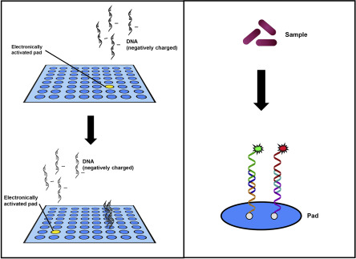
Figure 3: Nanochips [Kricka, L. J,]

There are lots of applications of these nanochips in different sectors like healthcare sector, electronic and communication centres, food science, space flight, fuel cell, healing of cell tissues, injurious and to grow organs. It can alter body cells and this procedure, known as tissue nanotransfection which can regenerate whole organs and heal damaged tissues. This innovative technology is non-intrusive and absolutely painless. Nanochips could eventually be employed during surgical procedures like the replacement of heart valves. For people who require organ transplants, this is welcome news, but there are still a lot of unanswered issues. [Vogel, H.G] The procedure of mending organs with nanochips entails introducing DNA into the damaged organ, in contrast to conventional surgery. The skin can develop and work properly owing to the new DNA. The goal of scientists is to advance this technology and make it workable in clinical situations.
The researchers have successfully transformed skin cells into nerve and muscle cells. They think that this technology could be used to treat chronic disorders as well as other types of tissus. Although it have many uses in the human body, it's vital to remember that these gadgets won't be sold right away. For implants, the technology is not yet developed sufficiently. However, scientists remain confident in their abilities and still pursue this field of study. These technologies do not, however, come without risk. Before these implants are used, a number of safety concerns must be resolved. Before the general population can accept these implantable devices, there are still a number of concerns that need to be resolved, including corrosion, infection risks, and MRI abnormalities. This technology is utilized for genetic engineering, cytogenetics, hereditary anomalies, and illness of predisposition, clinical neurology, and responsiveness to drug therapy. [Barman, J.]

B. NANOARRAY
The use of biomolecular array technology for quick screening of nucleic acid combinations is invaluable. This strategy has been incredibly effective in terms of both its commercial value and its range of applications. The human genome has been examined in its entirety using molecular array techniques. Arrays are a quick and common way to analyze expression patterns and link them to physiological conditions. The development of our fundamental understanding of the link between gene expression and organismal function, as well as our comprehension of the genetic component of disease states and the predisposition to disease, depend on such a quick, high throughput examination of cellular expression. [Martzen, M.R.] A variety of biological substances that are found in places that are micron or submicron in size are used in nanoarrays. In this approach, one microarray spot can be replaced by 100 molecular binding sites in the same space. The nanoarray can feature spots that range in size from 500 nm to 2-3 microns. [Yang, J,] They are structurally robust and have extremely specific target-binding characteristics. Additionally, because the process is almost entirely automated, less trained labor, process knowledge, and personnel expenses are required. The approach delivers biologically pertinent information as it operates in physiological contexts. [Binnig, G.] It is an array of biological molecules placed in micron or sub-micron spatial addresses, is a crucial component of this new technological platform. In order to create the NanoArrays depicted in Figure 1. The size of a single spot on a modern microarray is contrasted in the figure with that of a 10X10 spot of NanoArray. A standard microarray spot can be replaced by 100 molecular binding tests in the same space. [Mosher, C.]
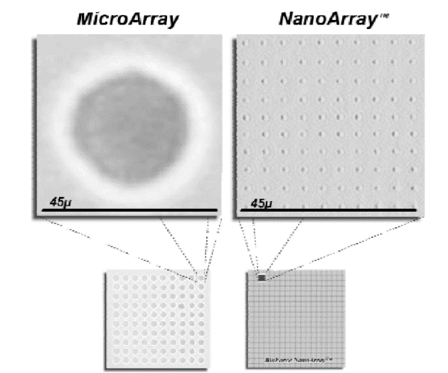
Figure 4: Nanoarray [Mosher, C. Mosher, C.]
The nanoarray technology was used in many areas of the medicine like drug discovery, diagnostics and proteomics. In this perspective, nanoarrays methodologies was used in gene activations, organelle genomics, mithocondrial DNA (mtDNA), pharmacogenetic genes depending on the actual status of encoding genes related to pharmacophore interactions or necessary treatments, HLA genes (human leukocyte antigen), analysis of Structural Variant (SV) or CNV, and density of single polymorphisms, were used for clinical applications. [Di, G.]
C. NANOCARRIERS
Nanocarriers are colloidal drug delivery that typically have 500 nm sized particles. [Neubert R.H.] Over the past few decades, there has been a lot of research done on nanocarriers since they have shown great promise for medication delivery. Due to their high surface area to volume ratio, nanocarriers can change the fundamental characteristics and bioactivity of medicines. Some of the characteristics that nanocarriers can include in drug delivery systems include enhanced pharmacokinetics and biodistribution, lower toxicities, improved solubility and stability, controlled release, and site-specific delivery of therapeutic agents. Furthermore, by changing the composition of nanocarriers (organic, inorganic, or hybrid), their sizes (small or large), their shapes (sphere, rod, or cube), and their surface characteristics (surface charge, functional groups, Pegylation or other coating, attachment of targeting moieties), it is possible to modify their physiochemical properties. [Sun, T] In order to effectively cure an illness with the fewest adverse effects possible, nanocarriers are used in drug delivery. [Fakharud Din]
Nanocarriers to increase the therapeutical efficacy of drug candidates
The collaboration of medicinal chemists and drug delivery scientists to create more efficient delivery techniques in order to overcome the drawbacks of existing dosage forms is motivated by the number of lead compounds that repeatedly fail to develop into marketable medications. As a result, numerous types of nanocarriers have been extensively investigated to improve the in vivo performance and therapeutic outcome of drug molecules, forging a strong link between drug development and drug delivery applications of nanotechnology. [Suhair, Sunoqrot]The main classes of nanocarriers that have been investigated and verified to increase the therapeutic efficacy of a range of medicinal molecules are summarised in the sections that follow.
- LIPOSOMES
The first class of nanocarriers being researched for medication delivery are liposomes. [Sessa, G] Liposomes are spherical, closed lipid bilayer vesicles with aqueous compartments inside. Through the EPR effect, these colloidal carriers have been demonstrated to facilitate the targeted administration of chemotherapeutics, altering the biodistribution profile of free drug molecules and significantly lowering their systemic side effects. Over the past few decades, liposomes have drawn significant attention in biomedicine, particularly as a method of delivering anticancer medications. They demonstrated a number of advantages over conventional systems, including improved drug delivery, protection of the active ingredient from environmental factors, enhanced product performance features, preventing early encapsulated drug degradation, cost-effective formulations of pricey medications, and effective treatment with lower systemic toxicity. Medicines coupled with liposomes have significantly different pharmacokinetic characteristics from free medicines in solution. [Sunoqrot, S.] liposomes are recognised with major four categories: (1) Traditional liposomes: These have an aqueous core material encased in a lipid bilayer that can be anionic, cationic, or neutral and contain phospholipids and cholesterol. In this situation, hydrophobic or hydrophilic materials can be used to fill the aqueous gap or the lipid bilayer, respectively. (2) PEGylated types: To achieve steric equilibrium, polyethylene glycol (PEG) is inserted into the surface of the liposome, (3) ligand-targeted type: ligands, such as antibodies, sugars, and peptides, are joined to the liposome's surface or to the tip of previously connected PEG chains, and (4) Theranostic liposome type: It combines the preceding three liposome kinds and typically includes a nanoparticle as well as targeting, imaging, and other components. [Sercombe, L, Patra, J. K.]
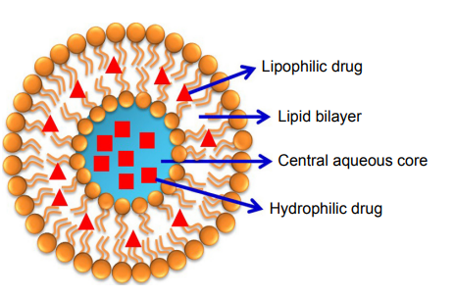

Figure 5: Structure of liposomes

- CONJUGATES OF POLYMERS AND DRUGS
In medicine, hydrophilic water-soluble polymers are frequently employed to modify the surface of biomaterials and as transporters for pharmaceuticals, peptides/proteins, and oligonucleotides, either alone or in conjunction with other treatments. Polymer conjugates are among the first classes of nanomedicines to be used in clinical settings, along with liposomes. Low MW medications can be targeted to tumours and inflammatory regions via the EPR effect by conjugating them to hydrophilic polymers like PEG and N- (2-hydroxypropyl) methacrylamide (HPMA), which has been proven to change their biodistribution. The conjugation of peptide and protein medicines to polymers lengthens their half-lives, lowers immunogenicity, and permits passive targeting [Khandare, J, Kopecek, J].
- PEG-DRUG CONJUGATES
Due to its beneficial characteristics, including good solubility, biocompatibility, minimal immunogenicity, and relatively low cost, PEG is one of the most widely used synthetic polymers for conjugation. PEGylation, which was first investigated for the modification of peptides and proteins, is now a widely utilised drug delivery method for a variety of macromolecules as well as tiny MW medicines .The restricted loading capacity of PEG, which has resulted in the development of branched and multi-armed structures, is the main disadvantage of PEG as a drug carrier. [Greenwald, R.B.]
- DENDRIMER-DRUG CONJUGATES
Dendrimers are extremely monodispersed, routinely hyperbranched, nanoscale (2–10 nm), and multifunctional macromolecules. Their distinctive structural characteristics have made them useful in a variety of biomedical applications [Greenwald, R.B, Suhair Sunoqrot).Different surface functional groups can be used to create dendrimers, which makes it easier to conjugate numerous therapeutic molecules and target ligands to surfaces inclusion complexes can be formed when drug molecules are alternatively enclosed inside the internal dendritic structure [Myung, J, Choi, S.K.].A further distinguishing quality of dendrimers is their deformability and flexibility, which enable the multivalent binding of surface molecules and have been shown to significantly improve the affinity of ligands for their targets .For use in drug delivery systems, numerous kinds of dendrimers have been created. The most popular of them are polyamidoamine (PAMAM) dendrimers. [Kaur A, Jain, Esfand, R] Dendrimers have recently been widely used in biomedical domains including as gene transfer, immunology, magnetic resonance imaging, vaccinations, and the delivery of antiviral, antibacterial, and anticancer drugs. [Din, F.] When a drug is covalently bound to a dendrimer at the core, on the terminal groups, or very rarely in the inner layers, i.e. at the branching sites, a dendrimer-drug is created. If a medicine is connected to multiple peripheral groups in a dendrimer, its effective concentration is noticeably enhanced at the targeted spot. Dendrimers-drug conjugates are preferred to traditional polymeric drug delivery carriers because they are monodispersed, structurally controlled macromolecules with a known size and molecular weight. If a medication is connected to the outer groups of a dendrimer, the linker between the drug and dendrimer is of utmost importance. This is due to the requirement that the medicine be released at the site of action in an active state. [Esfand, R Svenson, S]
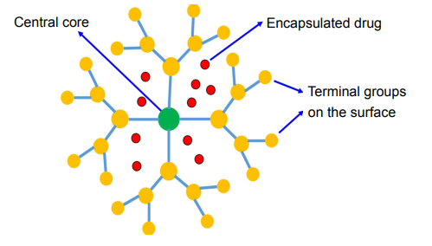

Figure 6: Structure of dendrimer
- POLYMERIC MICELLES
In an aqueous solution, amphiphilic block copolymers come together to produce polymeric micelles, which are nanostructures with a core shell structure. The hydrophobic core of the system can be filled with hydrophobic medications (such as camptothecin, docetaxel, or paclitaxel), while the hydrophilic shell makes the system soluble in water and stabilises the core. Polymeric micelles typically have a restricted distribution and are under 100 nm in size to prevent rapid renal elimination, which allows them to accumulate in tumour tissues due to the EPR effect. They also prevent general interactions with biological components due to their polymeric coating. Since their internal core structure allows for the assimilation of certain types of medications, these nanostructures have a significant potential for the delivery of hydrophobic pharmaceuticals, which can improve stability and bioavailability.[ Jayanta Kumar Patra]
- INORGANIC NANOPARTICLES
Silver, gold, iron oxide, and silica nanoparticles are examples of inorganic nanoparticles. Despite having some potential uses, there aren't as many studies on them as there are on the other types of nanoparticles covered in this area. However, only a small number of nanoparticles have been approved for use in clinical settings, and the majority of them are still undergoing clinical trials. Silver and gold metal nanoparticles contain unique qualities like surface plasmon resonance (SPR) that liposomes, dendrimers, and micelles do not. They demonstrated a number of benefits, including strong biocompatibility and adaptability when it comes to surface functionalization. [Kong F-Y,]
- NANOCRYSTALS
Pure solid drug particles in the range of 1000 nm are known as nanocrystals. These are 100% drugs, with no carriers or other molecules linked to them. They are often stabilised by surfactants or polymeric steric stabilisers. Nano-suspension, a surfactant agent, is typically added to improve nanocrystal suspension in a poor liquid media. Water or any other aqueous or non-aqueous medium, such as liquid polyethylene glycol and oils, serve as the dispersing medium in this situation Increased saturation solubility, increased dissolution velocity, and increased glueyness to surface/cell membranes are just a few of the challenges that nanocrystals' unique properties enable them to overcome. [Junyapraser, VB, Du, J, Li, X].
- METAL NANOPARTICLES
The use of metallic nanoparticles in several medical applications, including bioimaging, biosensors, target/sustained drug delivery, hyperthermia, and photoablation treatment, has gained popularity recently [McNamara K] Additionally, these nanoparticles have been modified and functionalized with particular functional groups that enable them to bind to medicines, antibodies, and other ligands, making these systems more promising for use in biomedical applications . Although gold, silver, iron, and copper are the most studied metallic nanoparticles, a growing interest has been shown in other types of metallic nanoparticles, including cerium dioxide, zinc oxide, titanium oxide, platinum, selenium, gadolinium, and others [Kudr, J,]
- QUANTUM DOTS
Quantum dots (QDs), semiconductor nanocrystals with a diameter range of 2 to 10 nm, exhibit size-dependent optical characteristics like absorbance and photoluminescence. The QDs has attracted a lot of interest in the field of nanomedicine because, in contrast to conventional organic dyes, the QDs exhibit emission in the near-infrared region (650 nm), a very desirable characteristic in the field of biomedical images because of the low tissue absorption and reduction in light scattering [Volkov, Y.]. Additionally, the same light source can excite QDs of various sizes and/or compositions, producing distinct emission colours over a broad-spectrum range In this regard, QDs are excellent candidates for multiplex imaging. Within the medical field, QDs as been extensively studied as targeted drug delivery, sensors and bioimaging. . [Liu, J, Xu, G].
- NANOPARTICLES OF PROTEINS AND CARBOHYDRATES
Natural biopolymers, which include polysaccharides and proteins, come from biological sources such plants, animals, microbes, and marine sources [Bassas-Galia, M]. The majority of protein-based nanoparticles may be broken down, metabolised, and easily functionalized for attachment to certain medicines and other targeted ligands. They are often synthesised using two distinct methods: (a) from insoluble proteins like zein and gliadin and (b) from water-soluble ones like bovine and human serum albumin. In order to integrate targeting ligands that specifically identify specific cells and tissues to support and enhance their targeting mechanism, protein-based nanoparticles are chemically changed. The properties of polysaccharides' deterioration (oxidation) are one of the major drawbacks of their usage in nanomedicine. (Lohcharoenkal, W)
- TARGETING MECHANISMS OF NANOCARRIERS
Passive Targeting
It is attained by the embedment of therapeutic substance in a macromolecule or nanoparticle that passively travels to the target organ. The effectiveness of the medicine in passive targeting is inversely proportional to the length of circulation. [Sagnella, S.] To do this, a coating of some kind is applied to the nanoparticle. A number of chemicals, including polyethylene glycol (PEG), can accomplish this. The nanoparticle can become hydrophilic by adding PEG to its surface, which enables water molecules to form hydrogen bonds with the oxygen molecules on PEG. This connection causes the nanoparticle to hydrate and form an antiphagocytic coating surrounding it. These interactions, which are typical of the reticuloendothelial system (RES), give the particles this feature. Consequently, the drug-loaded nanoparticle can remain in the bloodstream for a longer time. [L. E.] It has been discovered that nanoparticles between 10 and 100 nanometers in size circulate systemically for extended periods of time to cooperate with this passive targeting mechanism. [Gullotti, E]
Actively Targeting
The effects of passive targeting are enhanced by active targeting of drug-loaded nanoparticles, which increases the target site specificity of the nanoparticle. Active targeting can be achieved in a variety of ways. Knowing the characteristics of a cell's receptor for the medicine that will be used to target it is one technique to actively target just sick tissue in the body.The nanoparticle may then precisely connect to the cell that contains the complementary receptor using cell-specific ligands, which can be used by researchers. Transferrin has been proven to work well as the cell-specific ligand in this type of active targeting. Magnetoliposomes, which are often used in magnetic resonance imaging as a contrast agent, can also be used to perform active targeting. Thus, Magnetic placement could therefore help with this process by grafting these liposomes with a chosen medicine to deliver to a specific area of the body. [Galvin, P.]

Figure 7: Active and passive targeting of nanocarriers
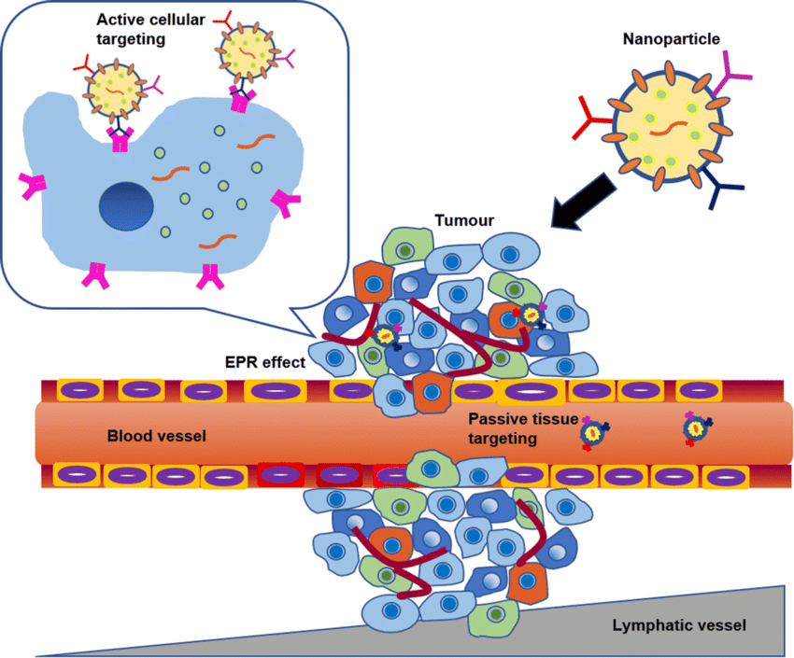

D. NANOBIOSENSORS
Nanobiosensors are responsive, non-intrusive, and created using cutting-edge nano and biotechnology techniques. These sensors' real-time sensitive indicators can be easily collected and examined. Three modules make up the nanobiosensor: a genetic probe made of components with affinities such as enzyme-substrate, antibody-antigen, DNA, and cell-based interactions. Additionally, a transducer converts biological data into an electrical signal, and a data footage unit load and sends the data. Enzymes, antibodies, and nucleic acids are examples of biological components. Biological probes connected to various synthesised nanomaterials, such as magnetic, metallic, graphene oxide, quantum dots, and CNTs, can detect bioanalytes. Transducers that use electrochemical signals include fluorescence, colorimetric, and optical fibres as well as potentiometric, amperometric, and voltam metric signals. Advanced nanomaterials of many types have been employed for the production of novel nanobiosensor[[Su, H].
The development of the nanobiosensor involves converting biological or chemical reactions into electrical output in order to detect biological, biomaterial, and electrochemical products like cholesterol, choline, dopamine, vitamin, blood glucose, creatinine, albumin, drugs, enzymes, protein, and nucleic acid [Jain, U.] This provides information on the composition or concentration, rheological characteristics, amplitude, energy, pH, polarisation, and decay time depending on stability and sensitivity within a short period of time. Platinum, diamond, silver, and gold nanoparticles are used in the creation of nanobiosensors due to their distinctively different behaviours. The transducers can take the form of certain objects like plastics, fibres, metals, ceramics, silicon, and glasses. They transform the medium into specific signals like piezoelectric, electrochemical, optoelectronic, and thermal [Chadha, U]. The dynamic range is additionally included in the optimisation constraints of sensitivity and concentration, response sample volume, sensory nanomaterials, temperature, pH, detection period, and rheological variables. [Miller, C. A.]
Table 2. Different types of nanomaterials are used to create nanobiosensors
Nanomaterial | Advantages | Disadvantages | Ref
Quantum dots | Excellent fluorescence, quantum confinement of charge carriers, and size tunable band energy | High toxicity using for in vitro system, Blinking effect | J. Wang
Nanowires | Highly versatile, good electrical and sensing properties for bio- and chemical sensing; charge conduction is better | No Fluorescence, Large amount of surfactant | Y. Cui,
Nanorods | Good plasmonic materials which can couple sensing phenomenon well and size tunable energy regulation, can be coupled with MEMS, and induce specific field response | Metabolism varies with different material, few in vivo study | R. MacKenzie
Nanoparticles | Aid in immobilization, enable better loading of bioanalyte, and also possess good catalytic properties | Biocompatibility, Average optical signal | X. Luo,
Carbon nanotubes | Improved enzyme loading, higher aspect ratios, ability to be functionalized, and better electrical communication | Less solubility in an aqueous environment, lack of sensitivity | J. J. Davis
Metal Oxide nanomaterial | Beter electric conductivity, UV absorption, antimicrobial, Ability of Photocatalytic | Limited transfection efficiency | Ouyang, D

E. ADVANCEMENTS, PAST AND FUTURE APPLICATIONS OF NANOBIOSENSORS
a). Biomedical and Diagnostic Applications
Since their introduction, nanobiosensors have been widely employed for the biological identification of serum carcinogens, antigens, and the causative organisms of a number of metabolic disorders. The use of nanobiosensors in regular diagnostic applications is most suited for diseases including cancer, diabetes, allergic responses, and other disorders reliant on serum analysis. Clinically speaking, POCT principally enables the majority of the researched and com pelling advantages of nanobiosensors, which include various therapeutic applications. Detecting uti, cardiovascular disease (CVD), tissue regeneration, glucose in diabetic patients, and HIV-AIDS are only a few of the applications, according to J. C. Pickup. Additionally, the diagnosis of cancer, chronic kidney disease (CKD), and tuberculosis has advanced quickly since the invention of the nanobiosensor [Bolinder, J. Kulkarni, M. B.].
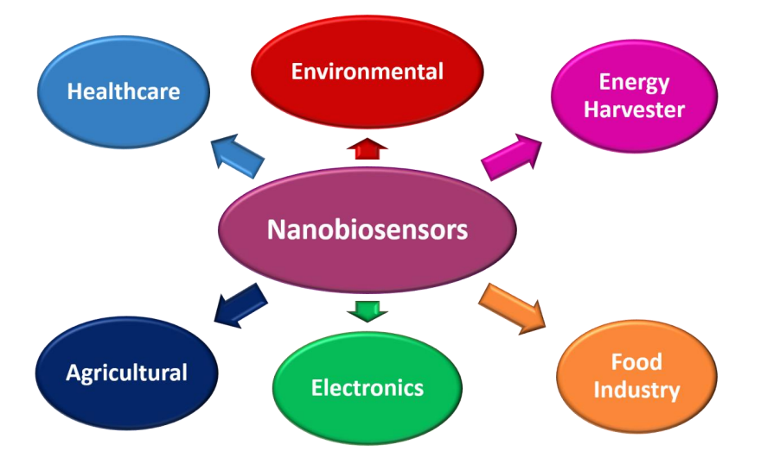
Figure 8: Application of Nano-biosensors
b. Applications in the environment
There is a wider range of applications for this. This is because the environment experiences numerous, swift scale changes virtually every second. It takes a lot of time and effort to detect pollutants, hazardous intermediates, heavy metals from waste streams, and to monitor environmental factors like humidity estimation and other crucial aspects of the weather. Nanomaterial-based sensors have a wide range of detection and monitoring capabilities. Technology is being effectively invaded by the use of tools like cantilever-based electronic probes and provisions that call for very little analyte. The specific type of detrimental extent of a material present or predominant in can be determined using the nanomaterials-based sensing methods or dominant in the surroundings. When these applications are created using nanomaterials, they might be far more beneficial and useful. Biosensors have been created for the detection of nitrates, inorganic phosphates, and biological oxygen demand-like parameters using the substrate-specific detection mechanism, and it has been demonstrated that these biosensors' operational principles are environmentally friendly. [Tian, J., Chen, J., and M.J. Ndolomingo]
c. Miscellaneous Applications.
Additionally, nanobiosensors can be used to enhance a number of other detections. These sensors can be used in the industrial operations to control the feeding of nutrition media and substrate combinations into the bioreactors for a variety of purposes. These sensors can improve a variety of commercial preparations and separations on an industrial scale. By experimenting with various sensing enzyme designs, nanobiosensors can be employed, for instance, in metallurgical operations that call for the selective separation of impurities that are present in a complexed form coupled in the form of ores. Applications of these sensing materials include creating microbiological and biochemical assays as well as bioengineering-based advancements. [Kulkarni, M. B.].
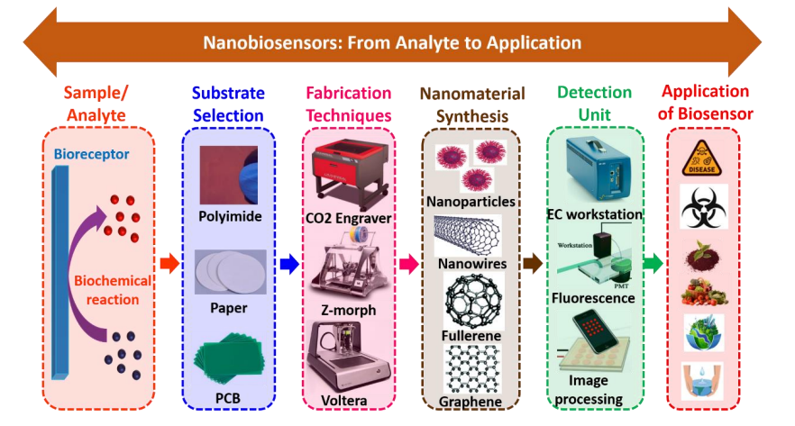
Figure 9: Schematic representation of nanobiosensors from analyte to application
Table 3: Some biomedical applications of Different types of nanobiosensors
Nanobiosensors | Nanomaterial Used | Type of sensors | Application  (Detection) | Limit of Detection | Ref
QD nanosensor | QDs | Florescence | Pathogens | - | Zhao, X
QD nanosensor | Quantum dots | Florescence | Pathogens and viruses | - | Efros, A.L
Nucleic acid nanosensor | CNTs | Immunosensors | Gnoderma boninse | 2mg/L | Taylor, P.
Antibiotic residue sensor | Au, Pt and SiO₂ Nps | Nano enzyme coupled with MIP as a Bio- Inspires body | Sulfadiazine | IC15: 0.08mg and IC50 6.1 mg/L | Ankri, S
Artificial nasal sensor | Carbon | Profile of volatile organic compound | Pathogens depending on organic compounds released | Sensitivity of 85%-95% | Kim, S
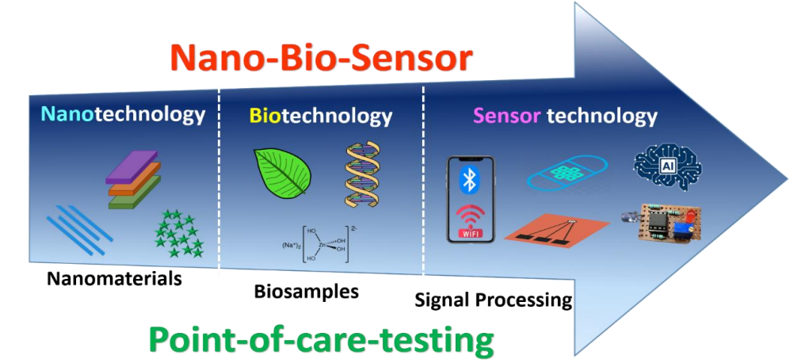
Figure 10: Future Scope of Nanobiosensors

F. CONCLUSION

Nanobiotechnology is now in its early stages of development. It is having a significant influence on many scientific and technological disciplines as a result of its widespread application and ongoing inventive research. A number of novel opportunities in medicine, diagnostics, and the biomedical sciences are being presented by nano-biotechnology. With the advent of something new as a result of nano-biotechnology innovation in drug delivery systems, it now appears viable to treat certain incurable diseases. Despite the great likelihood of advantages from nanobiotechnology, the future of nanomedicine is not yet clear. In actuality, regulatory agencies lack the proper rules to balance the aspects affecting risk and safety. It's safe to state that nano-biotechnology will play a great and distinctive function in the future.

REFERENCES
- Hulla, J.E. Hulla, S. C. Sahu, A. W.Hayes, “Nanotechnology: history and future,” human and experimental toxicology, volume 34(12), pp. 1318–1321, 2015. (references)
- Bayda, S. Adeel, M. Tuccinardi, T. Cordani, M. Rizzolio, F, “The history of nanoscience and nanotechnology: from chemical-physical applications to nanomedicine,” Molecules, volume 25(1), pp. 112, 2019. (references)
- Zelzer, M. Ulijn, R.V, “Next-generation peptide nanomaterials molecular networks, interfaces and supramolecular functionality,” Chem. Soc. Rev. 39, pp. 3351–3357, 2010. (references)
- Anselmo, A.C. Mitragotri, S, “Nanoparticles in the clinic: an update,” Bioeng. Transl. Med. Volume 4, pp. e10143, 2019. (references)
- Rickerby, D. Morrison, M, “Nanotechnology and the environment: A European perspective,” Sci. Technol. Adv. Mater. Volume8, pp. 19, 2007. (references)
- Bhushan, B, “Introduction to nanotechnology. In Handbook of Nanotechnology,” Springer Handbook of Nanotechnology: Berlin/Heidelberg, Germany, pp. 1–19, 2017. (references)
- Kumar, S, “Nanotechnology in computers,” Int. J. Inf. Comput. Technol, volume 4 pp. 974–2239, 2014. (references)
- McNeil, S.E, “Nanotechnology for the biologist,” J. Leukoc. Bio, 78, 585–594, 2005. (references)
- De Charles, P.P. Jr. Owens, F.J, “Introduction to Nanotechnology,” John Wiley & Sons: Hoboken, NJ, USA, 2003. (references)
- Schulte, J, “Nanotechnology: global strategies, industry trends and applications,” John Wiley & Sons: Hoboken, NJ, USA, 2005.
- Lemley, A.M, “Patenting nanotechnology,” Stanf. Law Rev, 58, pp. 601–630, 2005. (references)
- Salamanca-Buentello, F. Persad, D.L. Court, E.B. Martin, D.K. Daar, A.S. Singer, P.A, “Nanotechnology and the developing world,” PLoS Med, volume 2, pp. e97, 2005. (references)
- Roco, M.C, “The long view of nanotechnology development: the national nanotechnology initiative at 10 years. in nanotechnology research directions for societal needs in 2020,” Springer: Berlin/Heidelberg, Germany, pp. 1–28, 2011. (references)
- Singh, N.A, “Nanotechnology innovations, industrial applications and patents,” Environ. Chem. Lett, volume 15, pp. 185–191, 2017. (references)
- El Naschie, M.S, “Nanotechnology for the developing world,” Chaos Solitons Fractals, volume 30, pp. 769–773, 2006. (references)
- Waldron, A. Spencer, D. Batt, C, “The current state of public understanding of nanotechnology,” J. Nanopart. Res, volume 8, pp. 569–575, 2006. (references)
- Hulla, J. Sahu, S. Hayes, A, “Nanotechnology: history and future,” Hum. Exp. Toxicol, volume 34, pp. 1318–1321, 2015. (references)
- De Crozals, G. Bonnet, R. Farre, C. Chaix, C, “Nanoparticles with multiple properties for biomedical applications: a strategic guide, Nano Today, volume 11(4), pp. 435-463, 2016. (references)
- Sahoo, S. K. and Labhasetwar, V, “Nanotech approaches to drug delivery and imaging,” Drug Discovery Today, volume 8(24), pp. 1112–1120, 2003. (references)
- Sahu, T. Ratre, Y. K. Chauhan, S. Bhaskar, L. V. K. S. Nair, M. P. Verma, H. K, “Nanotechnology based drug delivery system: Current strategies and emerging therapeutic potential for medical science,” Journal of Drug Delivery Science and Technology,volume 63, pp. 102487, 2021. (references)
- Jain, K. K, “The role of nanobiotechnology in drug discovery,” Drug discovery today, volume 10(21), pp. 1435-1442, 2005.
- LaVan, D. A. Lynn, D. M. Langer, R, “Moving smaller in drug discovery and delivery,” Nature Reviews Drug Discovery, volume 1(1), pp. 77-84, 2002. (references)
- Fu, Y, “Metallic Nanoparticles-Based Biochip with Multi-Channel for Immunoassay,” J Biochips Tiss Chips, Volume 4 pp. 108, 2014. (references)
- Kelly, K.L. Coronado, E. Zhao, L.L. Schatz, G.C, “The optical properties of metal nanostructures: The influence of size, shape, and dielectric environment,” J Phys Chem B, 107, pp. 668-677, 2003. (references)
- Shaoli, Z. Fei, L. Xiangang, L. Chunlei, D. Yongqi, F, “A Localized Surface Plasmon Resonance Nanosensor Based on Rhombic Ag Nanoparticle Array,” Sensors Actuators B Chem, volume 134, pp. 193-198, 2008.
- Savage, N, “How AI and neuroscience drive each other forwards,” Nature, 571, pp. S15–S17, 2019. (references)
- Hoefflinger, B. (ed.), in CHIPS 2020—A Guide to the Future of Microelectronics (Springer Science and Business Media, ISBN 978-3-642-22399-0, 2012. (references)
- Murmann, B. Hoefflinger, B. Murmann, E, “Nano-chips, Springer International Publishing, pp. 91-192, 2020. (references)
- Zoraida, P. A, “Chapter 6 - Nanomedical Devices, Nanomaterials for Medical Applications,” Elsevier, pp. 235-292, ISBN 9780123850898, 2013. (references)
- Kricka, L. J, “Microchips, microarrays, biochips and nanochips: personal laboratories for the 21st century,” Clinica Chimica Acta, volume 307(1-2), pp. 219-223, 2001. (references)
- Vogel, H.G. Maas, J. Gebauer, A, “Nanotechnology in medicine. In Drug Discovery and Evaluation: Methods in Clinical Pharmacology,” Springer: Berlin/Heidelberg, Germany, pp. 533–546, 2020. (references)
- Barman, J. Tirkey, A. Batra, S. Paul, A.A. Panda, K. Deka, R. Babu, P.J, “The role of nanotechnology based wearable electronic textiles in biomedical and healthcare applications,” Mater. Today Commun, volume 32, pp. 104055, 2022. (references)
- Martzen, M.R. McCraith, S.M. Spinelli, S.L. Torres, F.M. Fields, S. Grayhack, E.J. Phizicky, E.M, “ A biochemical genomics approach for identifying genes by the activity of their products,” Science, volume 286 (5442), pp. 1153–1155, 1999. (references)
- Yang, J, “Nanofluidic Aptamer Nanoarray to Enable Stochastic Capture of Single Proteins at Normal Concentrations,” Small, 2023. (references)
- Binnig, G. Quate, C.F. Gerber, C, “Atomic force microscope,” Physical Review Letters, volume 56, pp. 930–933, 1986. (references)
- Mosher, C. Lynch, M. Nettikadan, S, “NanoArrays, the Next Generation Molecular Array Format for High Throughput Proteomics, Diagnostics and Drug Discover,” Journal of the Association for Laboratory Automation, volume 5(5), pp. 75-78, 2000. (references)
- Di, G. Linfei, L. Anmin, C. Huakun, L. Shixue, D. Jianmin, M, “Nanoarrays: design, preparation and supercapacitor applications,” RSC Adv, volume 5, pp. 55856-55869, 2015. (references)
- Neubert, RHH, “Potentials of new nanocarriers for dermal and transdermal drug delivery,” Eur J Pharm Biopharm, vol.77, no.1, pp.1–2, 2011. (references)
- Sun, T. Zhang, Y.S. Pang, B. Hyun, D.C. Yang, M. Xia, Y,“Engineered nanoparticles for drug delivery in cancer therapy,” Angew Chem Int Ed, vol.53, no.46, pp.12320–12364, 2014. (references)
- Din, F.U. Aman, W. Ullah, I. Qureshi, O.S. Mustapha, O. Shafique, S. Zeb, A,” Effective use of nanocarriers as drug delivery systems for the treatment of selected tumors,” International Journal of Nanomedicine, vol.5(12), pp, 7291–7309, 2017. (references)
- Sunoqrot, S. Hamed, R. Halim, H.A. Tarawneh, O, “Synergistic Interplay of Medicinal Chemistry and Formulation Strategies in Nanotechnology – From Drug Discovery to Nanocarrier Design and Development,” Current Topics in Medicinal Chemistry, vol.17, pp.1-18, 2017. (references)
- G. Sessa, G. Weissmann, “Phospholipid spherules (liposomes) as a model for biological membranes,” J. Lipid Res, vol.9, no. 3, pp. 310-318, 1968. (references)
- Sercombe, L. Veerati, T. Moheimani, F. Wu, S.Y. Sood, A. K. Hua, S,“Advances and challenges of liposome assisted drug delivery, “Front Pharm 2015; vol. 6, pp.286, 2015. (references)
- Patra, J. K, “Nano based drug delivery systems: recent developments and future prospects,” J Nanobiotechnol, vol. 16, pp.71, 2018. (references)
- Khandare, J. Minko, T, “Polymer–drug conjugates: Progress in polymeric prodrugs,” Prog. Polym. Sci., vol.31, no. 4, pp. 359-397, 2006. (references)
- Kopecek, J, “Polymer-drug conjugates: Origins, progress to date and future directions,” Adv. Drug Deliver Rev, vol. 65, no.1, pp. 49-59, 2013. (references)
- Greenwald, R. B. Choe, Y. H. McGuire, J. Conover, C. D, “Effective drug delivery by PEGylated drug conjugates,” Adv. Drug Deliver. Rev, vol.55, no.2, pp.17-250, 2003. (references)
- Myung, J. Gajjar, K. A. Saric, J. Eddington, D.T. Hong, S, “Dendrimer-mediated multivalent binding for the enhanced capture of tumor cells,” Angew. Chem. Int. Ed., vol.50, no.49, pp.11769-11772, 2011. (references)
- Choi, S. K. Myc, A. Silpe, J. E, “Dendrimer-based multivalent vancomycin nanoplatform for targeting the drug-resistant bacterial surface,” ACS Nano, vol.7, no.1, pp.214-228, 2013. (references)
- Kaur, A. Jain, K. Mehra, N. K. Jain, N, “Development and characterization of surface engineered PPI dendrimers for targeted drug delivery,” Artif Cells Nanomed Biotechnol, vol. 45, pp. 414–25, 2017. (references)
- Esfand, R. Tomalia, D. A, “Poly (amidoamine) (PAMAM) dendrimers: from biomimicry to drug delivery and biomedical applications,” Drug Discov Today, vol. 6, no. 8, pp.427-436, 2001. (references)
- Svenson, S. Tomalia, D.A, “Dendrimers in biomedical applications--Reflections on the field,” Adv. Drug Deliver. Rev, vol. 57, no. 15, pp. 2106-29, 2005. (references)
- Kong, F. Y. Zhang, J.W. Wang, R. F. Wang, W.J. Wang, W, “Unique roles of gold nanoparticles in drug delivery, targeting and imaging applications,” Molecules, vol.22, pp. 1445, 2017. (references)
- Junyaprasert, V. B. Morakul, B, “Nanocrystals for enhancement of oral bioavailability of poorly water-soluble drugs,” Asian J Pharm Sci,vol. 10, pp. 13–23, 2015. (references)
- Du, J. Li, X. Zhao, H. Zhou, Y. Wang, L. Tian, S. Wang,Y, “Nanosuspensions of poorly water-soluble drugs prepared by bottom-up technologies”, Int J Pharm, vol. 495, pp. 738–49, 2015. (references)
- McNamara, K. Tofail, S. A, ”Nanoparticles in biomedical applications,” Adv Phys. Vol, 2, pp. 54–88, 2017. (references)
- Kudr, J. Haddad, Y. Richtera, L. Heger, Z. Cernak, M. Adam, V. Zitka, O, “Magnetic nanoparticles: from design and synthesis to real world applications,” Nanomaterials, vol.7, pp.243, 2017. (references)
- Volkov, Y, “Quantum dots in nanomedicine: recent trends, advances and unresolved issues,” Biochem Biophys Res Commun, vol.468, pp. 419–427, 2015. (references)
- Liu, J. Lau, S. K. Varma, V.A. Moftt , R.A, “Molecular mapping of tumor heterogene- ity on clinical tissue specimens with multiplexed quantum dots, “ACS Nano, vol.4, pp. 2755–2765, 2010. (references)
- Xu, G. Zeng, S. Zhang, B. Swihart, M. T. Yong, K. T. Prasad, P. N, “New generation cadmium-free quantum dots for biophotonics and nanomedicine,” Chem Rev, vol. 116, pp. 12234–327, 2016. (references)
- Bassas-Galia, M. Follonier, S. Pusnik, M. Zinn, M, “Natural polymers: a source of inspiration. In: Bioresorbable polymers for biomedical applications,” New York: Elsevier, pp. 31–64, 2017. (references)
- Lohcharoenkal, W. Wang, L. Chen, Y. C. Rojanasakul, Y, “Protein nanoparticles as drug delivery carriers for cancer therapy,” BioMed Res Int, pp. 180549, 2014. (references)
- Sagnella, S. Drummond, C, “Drug Delivery: A Nanomedicine Approach. Australian Biochemist, volume 43, 5–8, pp. 20, 2012. (references)
- Vlerken, L.E. Vyas, T.K. Amiji, M.M, “Poly (Ethylene Glycol)-Modified Nanocarriers for Tumor-Targeted and Intracellular Delivery,” Pharm. Res, vol.24, pp.1405–1414, 2007. (references)
- Gullotti, E. Yeo, Y, “Extracellularly Activated Nanocarriers: A New Paradigm of Tumor Targeted Drug Delivery,” Mol. Pharm, vol. 6, pp. 1041-1051, 2009. (references)
- Galvin, P. Thompson, D. Ryan, K.B. Mccarthy, A, “Nanoparticle-Based Drug Delivery: Case Studies for Cancer and Cardiovascular Applications” Cell. Mol. Life Sci., vol. 69, pp.389–404, 2011. (references)
- Jain, U. Saxena, K. Hooda, V. Balayan, S. Singh, A. P. Tikadar, M. Chauhan, N, “Emerging vistas on pesticides detection based on electrochemical biosensors—An update,” Food Chem, vol. 371, pp.131126, 2021. (references)
- Chadha, U. Bhardwaj, P. Agarwal, R. Rawat, P. Agarwal, R. Gupta, I. Panjwani, M. Singh, S. Ahuja, C. Selvaraj, S. K, “Recent progress and growth in biosensors technology: A critical review,” J. Ind. Eng. Chem, Vol. 109, pp.21–51, 2022. (references)
- Miller, C. A. Ho, J. M. Bennett, M. R,“Strategies for Improving Small-Molecule Biosensors in Bacteri,” Biosensors, Vol. 12, pp. 64, 2022. (references)
- Wang, J. Liu, G. Polsky, R. Merkoc, A,“Electrochemical stripping detection of DNA hybridization based on cadmium sulfide nanoparticle tags,” Electrochemistry Communications, vol. 4, no. 9, pp. 722–726, 2002. (references)
- Cui, Y. Wei, Q. Park, H. Lieber, C. M, “Nanowire nanosensors for highly sensitive and selective detection of biological and chemical species,” Science, vol. 293, no. 5533, pp. 1289–1292, 2001. (references)
- MacKenzie, R. Auzelyte, V. Olliges, S, “Nanowire development and characterization for applications in biosensing,” Nanosystems Design and Technology, pp. 143–173, 2009. (references)
- Luo, X. Morrin, A. Killard, A. J. Smyth, M. R, “Application of nanoparticles in electrochemical sensors and biosensors,” Electroanalysis, vol. 18, no. 4, pp. 319–326, 2006. (references)
- Davis, J. J. Coleman, K. S. Azamian,B. R. Bagshaw, C. B. Green, M. L, “Chemical and biochemical sensing with modified single walled carbon nanotubes,” Chemistry, vol. 9, no. 16, pp. 3732–3739, 2003. (references)
- Ouyang, D. Huang, Z. Choy, W. C, “Solution-Processed Metal Oxide Nanocrystals as Carrier Transport Layers in Organic and Perovskite Solar Cells,” Adv. Funct. Mater, vol.29, pp. 1–18, 2018. (references)
- Bolinder, J. Ungerstedt, U. Arner, P, “Microdialysis measurement of the absolute glucose concentration in subcutaneous adipose tissue allowing glucose monitoring in diabetic patients,” Diabetologia, vol. 35, no. 12, pp. 1177–1180, 1992. (references)
- Kulkarni, M. B. Ayachit, N. H. Aminabhavi, T. M, “Recent Advancements in Nanobiosensors: Current Trends, Challenges, Applications, and Future Scope,” Biosensors, Vol. 12, pp. 892. 2022. (references)
- Tian, J. Li, Y. Dong, J. Huang, M. Lu, J, “Photoelectrochemical TiO2 nanotube arrays biosensor for asulam determination based on in-situ generation of quantum dots,” Biosens. Bioelectron, vol. 110, pp.1–7, 2018. (references)
- Chen, J. Fan, L. Yang, C. Wang, S. Zhang, M. Xu, J. Luo, S,“Facile synthesis of Ag nanoparticles-loaded chitosan antibacterial nanocomposite and its application in polypropylene” Int. J. Biol. Macromol, vol. 161, pp. 1286–1295, 2020. (references)
- Zhao, X. Li, M. Liu, Y, “Microfluidic-Based Approaches for Foodborne Pathogen Detection,” Microorganisms, vol. 7, pp. 381, 2019. (references)
- Efros, A. L. Delehanty, J.B. Huston, A. L. Medintz, I.L. Barbic, M. Harris, T.D, “Evaluating the potential of using quantum dots for monitoring electrical signals in neurons,” Nat. Nanotechnol, vol.13, pp, 278–288, 2018. (references)
- Taylor, P. Safarpour, H. Rad, F. Basirat, M. Shahryari, F, “Development of a quantum dots FRET-based biosensor for efficient detection of Polymyxa betae Development of a quantum dots FRET-based biosensor for efficient detection of Polymyxa betae,” Can. J. Plant Pathol, Vol. 34, pp.507–515, 2012
- Ankri, S. Mirelman, D, “Antimicrobial properties of allicin from garlic,” Microbes Infect, vol.1, pp.125–129, 1999. (references)
- S. Kim, J.Brady, F. Al-Badani, S. Yu, J. Hart, S. Jung, T.T. Tran, N.V. Myung, “Nanoengineering Approaches Toward Artificial Nose” Front. Chem., vol.9, pp.1–29, 2021. (references)

