Dr. SUJATA DEEPAK JAGTAP
ASSISTANT PROFESSOR
D.Y.PATIL TECHNICAL CAMPUS,
TALSANDE KOLHAPUR.
MBA DEPARTEMENT

THEORETICAL FRAMEWORK FOR HOLISTIC DEVELOPMENT: NEP 2020
Abstract
The National Education policy was formulated in the year 1968, and they have used the regional language for schools. Education is an important factor to developing skills, so that the Indian government has launched education policy system for the students to develop their knowledge. Before independence, India was ruled by the British people, during that time Indian people were illiteracy and even they didn’t know about what is education and its system. The comprehensive approach to education known as holistic development has as its main goal the multiplication of capacities in the human mind. It fosters kids' social, emotional, intellectual, and physical growth as well as their learning style and higher-order skill development. Holistic development combines an improved educational approach that empowers student success with various teacher tactics. Its advantages help to raise educational standards, and these standards will support achievement in the process of establishing a nation.
Keywords: NEP 2020, Holistic, Education policy system.
Introduction:
The Indian government has formulated the National policy of education. In Indian government has announced that their aim is to bring several changes in our education system both in rural and urban area from the schooling level to college level. It goes without saying that education is important and useful in one's life. The goal of the government of India's flagship initiative for achieving universalization of elementary education (UEE) is to provide free and mandatory education to children in the age range of 6 to 14. Our Indian government has given an opportunity to all the students to get a free education. Because every child has a unique quality like strength, personality, inner talent, and ability, education is a process where each person learns the things according to their capacity and interest. We must create an activity-based curriculum for the pupils to support this special quality. The syllabus is a crucial component of the teaching-learning process and the process of child development. The main focus of education is on the growth of children. Through a flexible curriculum that creatively blends diverse subjects, NEP 2020 will alter this approach. The learner will have a language option as well as the option to combine applied science, mathematics, and business studies with humanities and the arts.
Why Holistic development Important
In Teaching –learning process teacher can improve their audio-visual perception, language awareness and proficiency, fine motor skills, List sting and responding skills, focuses and attention towards work. Academic skill build only with the help of social physical mental and intellectual. Social emotional skills are very much important to learn to regulate owns emotion and secure it. Express their emotion in good, positive and healthy way in accurate place. It is imperative for exposing children to opportunities to find and develop their strengths to the best of their abilities, as well as strengthen their weaker skills.
In order for students to actively participate in all aspects of the curriculum, it is important to ensure that their physical and mental capabilities are improved. Children must be given the chance to identify and develop their strengths to the fullest extent possible, as well as to hone their weaker capabilities (Mcilroy, 2022). Learning is the process of picking up new information simultaneously, and it's tied to other learning activities like seeing, hearing, and observing.
A Holistic Development
Holistic development is beneficial for fostering curiosity and enables learning and understanding of the topic in a natural, creative, and practical way. Additionally, it helps them develop their abilities and get the confidence they need to take part fully in school activities. Increasing the caliber of pupils will help them navigate the educational system and build a connection between classroom instruction and real-world information. As a result, their problem-solving abilities improve in many ways.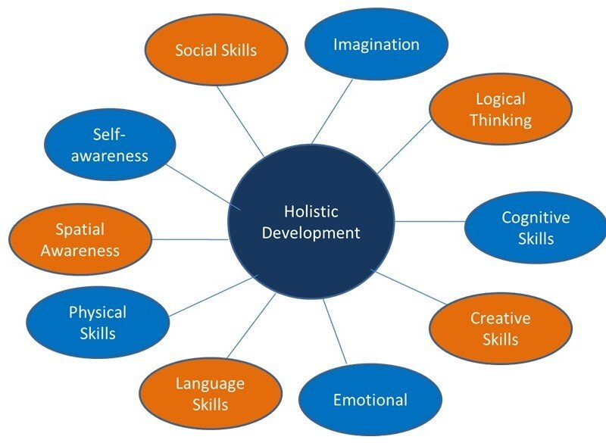

It is an encouraging environment that teaches people both what to learn and how to learn it. encouraging the pupils' self-directed inquiry into their understanding and raising the questions. Also looking into the curriers' goals-setting interests, passions, and knowledge. to shift the focus of education away from content-based instruction and toward experiential learning. Techniques and tactics that are effective for fostering a positive learning environment and student involvement. The development of talents should be based on instructor expertise, student pre-test results, experiential learning in pedagogy, and a flexible curriculum. a good and positive school infrastructure
The Government has implemented to use their mother tongue as their first language and they use English as their second language. Most of the schools gave much important to their first language. In India they use the three language formula. The Education system was formulated all over India. Students have rights to choose their language; it may be local or a regional language. In India especially in Tamilnadu they were using the Tamil an English language as a medium of instruction. The Government has equipping the students by using various high quality technologies such as textbooks, Audio aids, charts, Audio visual aids, etc... Not only have that, but the student they need to known about the transformation of language from the teaching. As a teacher He/she need to use the bilingual method, which could be made the students be interactive and attentive in the classroom.

Key Elements for Holistic Development

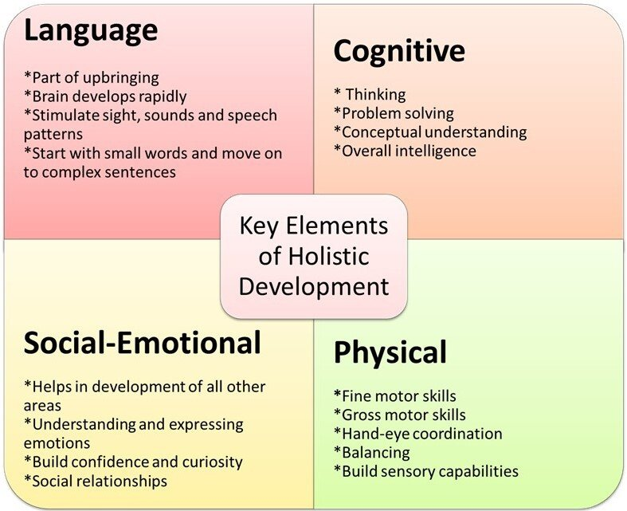

Cognitive

It is an encouraging environment that teaches people both what to learn and how to learn it. encouraging the pupils' self-directed inquiry into their understanding and raising the questions. Also looking into the curriers' goals-setting interests, passions, and knowledge. to shift the focus of education away from content-based instruction and toward experiential learning. Techniques and tactics that are effective for fostering a positive learning environment and student involvement. The development of talents should be based on instructor expertise, student pre-test results, experiential learning in pedagogy, and a flexible curriculum. a good and positive school infrastructure

Language

Speech and language development are essential components of raising. Today's environment demands the ability to articulate oneself well and speak clearly. Children under the age of five quickly pick up language skills and develop them. The brain develops quickly, thus it's important to stimulate speech, sound, and visual patterns. Children gradually progress from simple words in their native speech to complicated phrases. The second most important factor in a child's overall development is the gradual movement toward other languages, usually English or a third language.

Social-Emotional

Students must go through experiences that allow for constructive relationships while exercising emotional control in order to develop their social and emotional brains. Without these, a kid may develop into an unstable adult. Trust and security are essential components of development. A child that is still developing is particularly weak and needs love and care. As they learn to feel confident and secure in their skills and sense of self, they develop attachments and a solid basis for future emotional bonds as a result of the security they find with reliable adults. In order to promote holistic development, which is the third most crucial component, instructors and parents must provide a safe and welcoming atmosphere for children.

Physical
It is well known that kids are little balls of uncontrollable energy. Making the necessary brain connections for comprehensive holistic growth requires this energy. As a result, every type of activity or exercise increases blood flow throughout the body. The child can learn new facts and concepts as the blood supply to the brain increases. A youngster can become healthy and fit by developing their gross and fine motor skills. Children also learn to identify the consequences of their sensory understandings in order to put them into good use in the future.
Conclusion
All-encompassing growth refers to holistic development. The only way to build a strong and healthy environment where people can understand the relationship between a positive and negative environment is through teaching and learning processes. Education is an internal component because only an education system can change behaviors and help students understand their psychological pressure. Educationists, policymakers, and stakeholders guarantee that the curriculum is not only linked with theory-based but also with a significant number of activities (social and mental) and practice. They also work to promote self-reliance, teamwork, and honest communication. A system like this raises students who support the nation's expansion and development. The entire development of pupils is therefore crucial from the start of their academic careers.
Reference
PBNS. (2022, July 11). NEP 2020;A more holistic approach to education. News On AIR. Retrieved from http://newsonair.com/2022/07/11/nep-2020-a-more-holistic-approach-to-eduaction/
Sarkar, D. (2022). NEP 2020 holistic education to reboot Society. The New Indian Express. Retrieved from http://www.newindianexpress.com/opinions/2022/jul/28/nep-2020-holistic-educationto-reboot-society-2481715.html#:~:text=increasingly%20complex%20world.
ScholarBase. (2014, March 5). Scholistic Approach to Learning. Why holistic Education is important. Retrieved from http://scholar-base.com/homeschooling-educational-trend/
https://www.edristi.in/national-education-policy-nep-2020/
https://www.aplustopper.com/education-system-in-india/

