Dual source and Dual energy computed tomography
Sanjay Yadav
M.Sc. Radio-Imaging Technology
SGT University, Gurugram
Ydvsanjay880@gmail.com

Nakul Tyagi
M.Sc. Radio-Imaging Technology
SGT University, Gurugram
Tyaginakul876@gmail.com

Hitesh Sharma
M.Sc. Radio-Imaging Technology
SGT University, Gurugram
Hiteshsharma2201@gmail.com

Yogita Janghu
M.Sc. Radio-Imaging Technology
SGT University, Gurugram
yogitajanghu28@gmail.com

Navreet Boora
Assistant Professor
Department of Paramedical
SGT University, Gurugram
Navreet999@gmail.com

Mohit Deswal
Assistant Professor
Department of Paramedical
SGT University, Gurugram
Mohitdeswal.md.md@gmail.com

Differentiating and categorizing various types of tissues in computed tomographic (CT) imaging is exceedingly difficult since materials with varied elemental compositions can be represented by the same or very similar CT numbers. The challenge of distinguishing between calcified plaques and blood that contains iodine is a well-known example. Despite having very different atomic numbers, calcified plaque or nearby bone may seem identical to iodinated blood on a CT scan depending on the mass density or iodine concentration of the two materials. Multiple tissue kinds make it harder to distinguish and categories different tissue types, and they also reduce the precision with which material concentration can be evaluated. The measured mean CT number over the lesion, for instance, indicates both the enhancement from the iodine as well as the CT number of the underlying tissue when determining the amount of iodine enhancement of a soft-tissue lesion.

In dual-energy CT, attenuation data at a second energy allow a mixture of two or three materials to be broken down into its component constituents. There are several technical methods for collecting dual energy data, such as quick tube potential switching, multilayer detectors, sequential acquisition of two separate scans, and dual x-ray sources. A new method of collecting more than two energy measurements is represented by energy-resolving, photon-counting detectors; this could lead to new applications like K-edge energy subtraction methods. Dual energy CT has a variety of current and future clinical uses, such as virtual monoenergetic imaging, automated bone removal in CT angiography, perfused blood volume imaging, virtual noncontrast material-enhanced imaging, plaque removal, virtual non-calcium imaging, urinary stone characterization, imaging of crystalline arthropathies, and silicone from breast implant detection.

Approaches Technical to Dual-Energy CT
Alvarez and Macovski later looked into dual-energy CT techniques in 1976. They showed that it was still possible to distinguish between the contributions from the photoelectric effect and Compton scattering mechanisms in the measured attenuation coefficients even when using polyenergetic x-ray spectra. Since this early work, a number of technical methods for gathering the dual-energy data set have been developed.

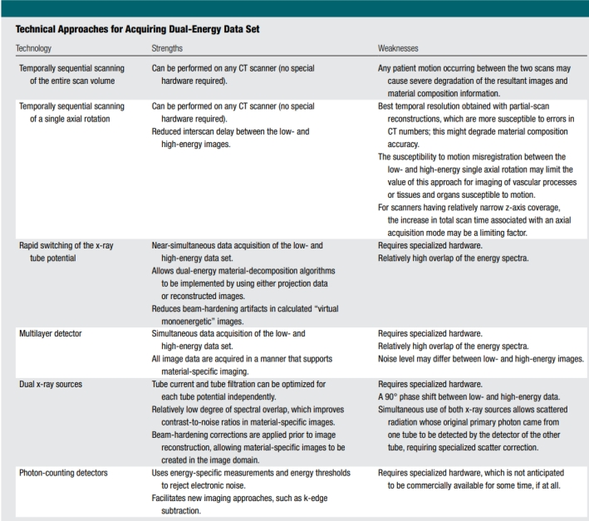

1) Two Temporally Sequential
Scans The characterization of lung, liver, and soft-tissue composition was the main emphasis of the initial applications. The data was collected at each of the two tube potentials using two temporally sequential scans. Patient movement between the two scans, which was not recorded concurrently, severely degraded the final pictures and the information on the material composition. A modified approach has been proposed, where one axial scan (i.e., one tube rotation) is carried out at each tube potential prior to table incrementation, in order to reduce the time delay inherent in two consecutive scans of the full anatomic volume of interest. This shortens the time between scans of the low- and high-energy pictures. Using partial scan reconstruction techniques, the best temporal resolution may be achieved in this case.
This method collects 180°+ fan projection data for every single tube prospective having a brief lag from shots to allow changing among tube possibilities and tabulation. This method may be beneficial for organs or tissues that are often immobile. However, because the time between scans is quite significant, mis-registration of motion between minimal and a high-energy data sets might restrict the use of this method for dual-energy scanning of vascular processes, tissues, and organs. The increase in overall scan duration can potentially be a limiting problem for scanners with a fairly small z-axis coverage.

2) Rapid Switching of X-Ray Tube Potential
This technique's clinical use was largely focused on bone densitometry readings. Nevertheless, the tube's current was unable to rise rapidly enough to obtain equivalent levels of noise in each of the high as well as low tube possible information sets. This disparity in noise limits the technique's use beyond bone densitometry. Shifting the tube's potential between successive views necessitates a transition time of just over a millisecond from the low to the high tube potential. Furthermore, shifting must be as quick as possible in order to maximize the energetic separation between the measured data, despite the fact that the difficulties in swiftly adjusting the radiation source's current can result in significant distortion levels in the lower-energy data or inappropriate dosage from the higher-energy projections. This issue can be solved by employing asymmetric sampling for low- and high-energy forecasts.

In this method, the necessary rise in tubes current-time combination to perform low-energy predictions is attained without abruptly increasing the tube current by employing a longer sampling period for the low-energy data. However, because the exact same x-ray tube is utilised for each of the low- & high-energy data sets, optimising the spectrum filtering of both of low- and high-energy pictures is technically problematic.
Finally, highly quick data sampling is required to prevent lowering in-plane spatial resolution after allocating a portion of the obtained samples to each energy's data set. The very short time delay (less than 1 millisecond) separating the lower- and high-energy views enables near-simultaneous data gathering of the lower and high-energy data sets. To eliminate streak artefacts, a correction must be made to the one-view misregistration; nonetheless, this permits dual-energy material decomposition techniques to be created with in two ways extension data or reconstructed pictures. The ability to employ projection data aids in the reduction of beam-hardening artefacts in derived "virtual monoenergetic" pictures.

3) Multilayer Detector
A single high tube potential radiation and layered or "sandwich" scintillation detectors are used in a third technique for collecting dual-energy CT projection data. The first or closest detector layer collects low-energy data, whereas the rear or furthest detector layer collects high-energy data. This is similar to using layered sensors for dual-energy radiography.
Various detector thicknesses are utilised to achieve equivalent noise in low- and high-energy pictures. This method has the benefit of concurrently acquiring low- and high-energies data sets, as well as continuously recording data from both the inside and outside detector layers. This enables dual-energy analysis on every data set collected. In other words, the system is constantly in "dual-energy mode."
Approaches to Multi-Energy CT on a Technical Level
Photon-counting Detectors
Photon counting detectors with energy resolution may be the most resilient alternative enabling dual-energy, or multi-energy, collection of data. These detection devices, that allow for distinct photons interactions, are still in development and are not yet economically accessible through CT systems, but they are used in radiation therapy and spectral mammography. Counts are given to specific energy criterion data sets depending on the amount of energy thresholds selected and the energy associated with each photon. Data associated with particular power windows are obtained by deleting separate energy threshold data. In the case of n = 2 energy windows, photon-counting sensors can be used for dual-energy imaging.
Utilising pulse-height discrimination, the transmitted x-ray spectrum is divided into a number of unique energy bins, the number of which is determined by the layout within the specific to the application embedded circuit which is connected to the energy-resolving detector. Cadmium telluride (CdTe) and cadmium zinc telluride have been considered to be the most plausible materials for converting the radiation energy of an absorption x-ray onto a signal of electricity whose amplitude is proportional to the incoming photon's energy. Despite the fact that identical detectors are already available and used in other sectors, dealing with the radiation rates necessary in CT imaging offers challenges. Present detector lose counts due to spike accumulation effects at the peak levels of x-ray radiation employed for CT imaging (approximately 109 counts/sec/mm2) and can eventually become completely paralysed. The uneven distribution of a photon's value across several sensors pixel (popularly referred as energy splitting) either that reemission of a distinctive x-ray (popularly referred as K-escape) may diminish the recorded energy's accuracy.
To mitigate the effects of charge sharing, a charging-summing mode has been developed in where interaction among close detector pixels is generated using hardware circuits.
Charges from nearby pixels with simultaneous frequencies are combined together, and the entire charge is assigned to the pixel with the highest charge.
Significant gains in wideband performance have been recorded using this method.
A wide range of potential benefits, such as improved spectrum separation and dose efficiency, are driving substantial studies and developments in this field. Photon-counting detectors, in instance, have a higher geometric efficiency (by about 30%) than energy-integrating detectors, and the application of an energy threshold permits the rejection of counts that are solely due to detectable electronic noise.
Past the threshold level, electronic noise has no influence on photon counts and only changes the calculated energy of each photon. This detector technique can also do K-edge imaging.
Material Decomposition Algorithms
Dual-energy or multi-energy The vitality & element-dependent characteristics of x-ray attenuation underpins CT's ability to breakdown a substance into its component components. In the medical energy range (E, 150 keV), the photoelectric impact and Compton scattering processes are the principal drivers of an x-ray attenuation by matter.
For components that lack K- or L-edges that are useful for diagnostic x-ray imaging, that is a monotone and smoothly changing function. In the event of the lack of a K- or L-edge, the attenuation coefficient of a particular material may be represented as a linear combination of photonic and Compton collisions.
A rZ map may be created and material-specific information obtained by simulating the photovoltaic and Compton interaction processes' dependence on material density of mass (r) and atomic number (Z).
Because both of these processes of interaction dominate x-ray attenuation, the coefficient of attenuation of every substance may be described as a straight-line sum of the absorption coefficient of two underlying fundamental materials. Early dual energy CT material breakdown research focused on methods used in pre-reconstruction (projection) field to create whether rZ pair images or basis material image pairs.
Using projection data offers the theoretical advantage of reducing beam-hardening artefacts from reconstructed images. However, because of insufficient equipment calibration sessions, beam-hardening distortions may not be completely eliminated in practise.
This demonstrates the need of consistent system calibrations, which provide a relationship across presentation metrics and established densities of foundation resources, or CT numbers and recognised depths of basis substances, regardless of the algorithm's realm (projection or imaging space).++++++++here.

REFFERENCE
- Johnson, T. R. C. (2012). Dual-energy CT: General principles. AJR. American Journal of Roentgenology, 199(5_supplement), S3–S8. https://doi.org/10.2214/ajr.12.9116
- Kambadakone, A., Andrabi, Y., Patino, M., Das, C., Eisner, B., & Sahani, D. (2015). Advances in CT imaging for urolithiasis. Indian Journal of Urology: IJU: Journal of the Urological Society of India, 31(3), 185. (Hsu, 2014)https://doi.org/10.4103/0970-1591.156924
- Parakh, A., Lennartz, S., An, C., Rajiah, P., Yeh, B. M., Simeone, F. J., Sahani, D. V., & Kambadakone, A. R. (2021). Dual-energy CT images: Pearls and pitfalls. Radiographics: A Review Publication of the Radiological Society of North America, Inc, 41(1), 98–119. https://doi.org/10.1148/rg.2021200102
- Hsu C, Sharma R, Murphy A, et al. Dual energy CT. Reference article, Radiopaedia.org (Accessed on 25 Aug 2023) https://doi.org/10.53347/rID-31353
- Hacking, C., & Hsu, C. (2014). Dual energy CT. In Radiopaedia.org. Radiopaedia.org. https://doi.org/10.53347/rID-31353
- McCollough, C. H., Leng, S., Yu, L., & Fletcher, J. G. (2015). Dual- and multi-energy CT: Principles, technical approaches, and clinical applications. Radiology, 276(3), 637–653. https://doi.org/10.1148/radiol.2015142631
- Sanghavi, P. S., & Jankharia, B. G. (2019). Applications of dual energy CT in clinical practice: A pictorial essay. The Indian Journal of Radiology & Imaging, 29(03), 289–298.

