MRI-LINEAR ACCELERATOR (MR-LINAC)
Mr. Mayank pal singh¹, Mr. Raushan kumar², Ms. Mamta verma³, Mr. Neeraj kumar sah⁴ ,khush jain⁵
¹M.Sc.Research fellow, Department of radiology and imaging techniques, college of paramedical sciences, Teerthanker Mahaveer University, Moradabad, India.
²Assistant professor, Department of radiology and imaging techniques, college of paramedical sciences, Teerthanker Mahaveer University, Moradabad ,India.
³Assistant professor, Department of radiology and imaging techniques, college of paramedical sciences, Teerthanker Mahaveer University, Moradabad ,India.
⁴Assistant professor, Department of radiology and imaging techniques, college of paramedical sciences, Teerthanker Mahaveer University, Moradabad, India.
⁵M.Sc.Research fellow, Department of radiology and imaging techniques, college of paramedical sciences, Teerthanker Mahaveer University, Moradabad, India.

Introduction
Radiation therapy (RT) delivery & magnetic resonance imaging (MRI) imaging are now combined in hybrid systems. Four distinct photon MR-guided radiotherapy (MRgRT) systems with various magnetic field intensities, as well as beam orientations, have been developed. With particular benefits for soft-tissue tumors, the Magnetic Resonance Imaging Guided Linear Accelerator (MRI-LINAC) employs magnetic resonance imaging, or MRI, in combination with radiotherapy to treat tumors across the body. The MRI-LINAC's radiation delivery system is completely integrated with the MRI.
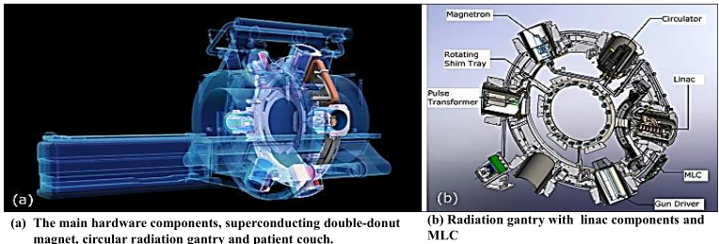
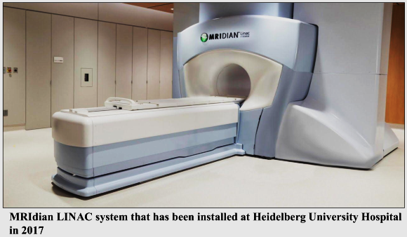
MRIdian linac system (system design)
The bore
Within the allowed bore limits, the system's bore is 70 cm wide. The treatment beam is emitted perpendicular to the static magnetic field thanks to the placement of the spherical gantry arrangement carrying all linac elements at the space between the two magnet sections.
0.35T split superconducting magnet
28 cm of space separates the two magnet sides of a 0.35 T split superconducting magnet. Both parts are mechanically as well as thermally linked for stability purposes.
Linac and MLC
The linac runs in the S-band & produces a 90 cm source-to-axis distance (SAD) 6 MV FFF (flattening filter free) photon beam with a dosage rate of 600 cGy/min. Without extra jaws, a double stack, double-focus multi-leaf collimator (MLC) shapes the treatment beam; the MLC's virtual focusing point is 15 mm above the linac's focal spot. The MLC is made up of 138 tungsten alloy leaves overall, which are split between the two stacks. The physical leaf height of each stack is 5.5 cm, making the overall MLC leaf height 11 cm. There are no tongues or grooves on the sides of the leaves.
Gradient coil
The treatment beam is subjected to only a small amount of attenuating material due to the gradient coil being divided and narrowing to a 5 mm thick connecting fiberglass section at the magnet gap.The gradient system displays a slew rate of 200 T/m/s and a gradient strength of 18 mT m-1.
Six shielding compartments (so-called buckets)
Six shielding compartments (also known as buckets), which house the linac in addition to linac components like the magnetron, are positioned upon the gantry since the linear accelerator could not operate correctly in the presence of a static magnetic field.
Magnetron
A microwave-powered electron tube that accelerates electrons. Preferred for linacs with lower electron energy, between 4 and 6 MeV.
Ferromagnetic cylinders
The interior of each compartment is well protected from the magnetic field by the presence of several concentric ferromagnetic cylinders.
Room lasers
The system includes room lasers that project to a virtual isocenter outside the bore that is typically 155 cm away from the isocenter of the treatment.
Patient couch
All three dimensions allow for movement of the patient on the couch. The range of potential couch heights is 20 cm below the isocenter to the isocenter, and the range of potential lateral movements is dependent on the actual couch height.
Whole-body RF transmit coil and surface receive coils
Coils are received by the patient's surface in the patient's front and back. The receive coils are implanted in low-density foam and are made up of radiolucent phased arrays with 2 x 5 channels (anterior and posterior) for the head and neck and 2 x 6 channels for the torso.
Pulse sequence
A balanced steady-state free precession (bSSFP) sequence known as True Fast Imaging with Steady State Precession (TRUFI) sequence produces a T2/T1-weighted contrast. The user can select from predefined field of views (FOVs) for volumetric imaging that have slice thicknesses of 1.5 mm and 3 mm and an in-plane resolution of 1.5 mm x 1.5 mm. During treatment, two-dimensional cine MR images can be continuously recorded in one sagittal plane at four frames per second or in three sagittal planes at two frames per second. Additional pulse sequences can be employed for quality assurance (QA) and research modes.
FEATURE | MRIDIAN | UNITY
Construction | Split magnet design | Single magnet design
Imaging | TRUFI sequence imaging based | Range of imaging sequences available
Gating | Real time tracking and automatic gating | Real time tracking without automatic gating
Treatment | Gantry rotation maximum speed of 0.5 rpm | Gantry rotation maximum speed of 6.0 rpm
Table-01 Comparison of the MRIdian and unity MRI-linac radiotherapy platforms

Treatment planning and delivery
The MRIdian uses coplanar static IMRT fields and has a 650MU/min dosage rate for radiation delivery. With no collimator rotation, the gantry rotates at a speed of 0.5 rpm. The dose is quickly calculated using a Monte Carlo technique, with the option to account for a uniform magnetic field. Both computed tomography (CT) scans and MR simulation scans can be used as the main images for treatment planning.
Existing MRI-linac systems
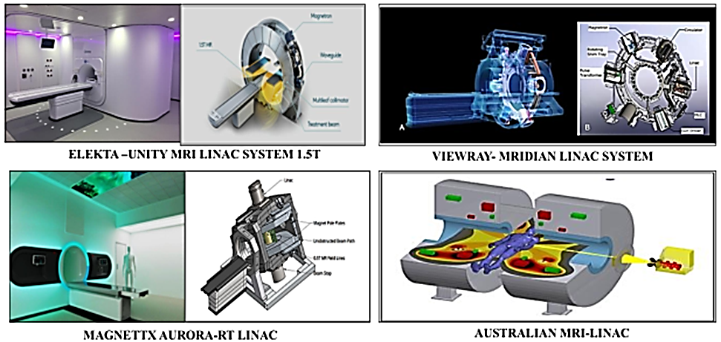
Advantages of the MRI-linac technology
- Imaging for therapy guidance
- Planning a customized course of treatment for inter-fractional management
- Gating as well as real-time imaging for intra-fractional treatment
Limitations of the MRI-linac technology
- Capital expenditures
- Treatment time as well as throughput
- Lack of delivery of non-coplanar beams and other delivery restrictions
- MR imaging contraindications
Clinical applications
- Prostate cancer
- Lung cancer
- Liver malignancies
- Pancreatic cancer
- Breast cancer
- Central nervous system tumors
References
- Klüter S. Technical design and concept of a 0.35 T MR-Linac. Clinical and translational radiation oncology. 2019 Sep 1; 18:98-101.
- Keall PJ, Glide-Hurst CK, Cao M, Lee P, Murray B, Raaymakers BW, Tree A, van der Heide UA. ICRU REPORT 97: MRI-Guided Radiation Therapy Using MRI-Linear Accelerators. Journal of the ICRU. 2022 Dec; 22(1):1-00.

