Electric Vehicles: Scenario and Technological Developments in India

Mr. Aniruddha S. Joshi¹
Assistant Professor & HOD
Automobile Engineering Department
Rajendra Mane College of Engineering and Technology, Ambav, Maharashtra, India. joshias@rmcet.com
Mrs. Yugashri A. Joshi
Swami E-Wheels
AP. Gadmudshingi, Tal. Karveer,
Dist. Kolhapur-Maharashtra, India
Yugashri93@gmail.com

ABSTRACT
Government arrangements and measures play an imperative part in opening modern mechanical potential and opening up unused openings in Maharashtra. Moreover, specialized benchmarks play an critical part within the specialized improvement and compatibility of different systems and components utilized within the electric vehicle industry. In expansion, the security and unwavering quality of modern improvements are ensured, expanding client certainty. At the turn of the 21st century, unused companies are taking advantage of the nonappearance of major automakers within the electric vehicle showcase. All inclusive, these new companies have all propelled one or more electric models of their claim, changing the scene of the auto industry. Looking at the Indian situation, there's still a long way to go. In such a setting, all parties should work together within the coming a long time to guarantee that the industry can make the proper choices to extend generation capacity which the government can make positive choices to back auto development. It is imperative to get it the pace of electric vehicle entrance in Japan.
This article gives an diagram of the electric vehicle showcase, advertise members with later mechanical improvements and current status. Besides, this chapter centers on highlighting different approach and administrative measures taken by a number of state government offices to advance advertise infiltration of electric portability vehicles in India. The case ponder report incorporates a fetched examination to get it the reality on the ground.
Keywords— Costumer, Electric Vehicle Market, Policy, Case study etc.

INTRODUCTION
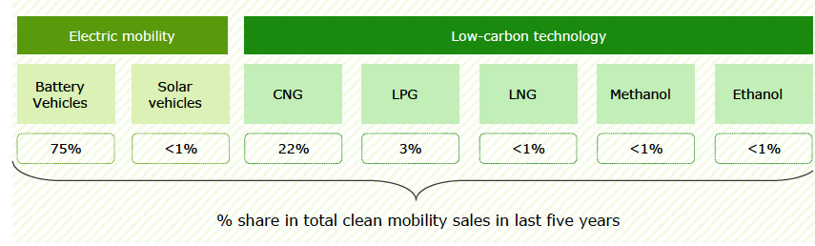
Electric vehicles are a modern item in India with a 0.1% advertise share compared to major players such as China, Europe and the Joined together States. The government points to go totally electric in India, and with the government's participation, the move to electric vehicles seem before long gotten to be a reality in India as well. By 2025, the capacity capacity of electric vehicles is anticipated to extend to 5.7 GW. Almost 200 stations are anticipated to be built around Delhi, Jaipur and Chandigarh. Among the existing clean/low-carbon portability advances, its electric and CNG vehicles are the foremost prevalent in India. The presence of assess motivations for electric vehicles and moo CNG costs compared to gasoline and diesel may clarify why these advances are so well known

Fig. 1. Clean and low carbon technologies on road with share in sales (Source: Vahan Dashboard)
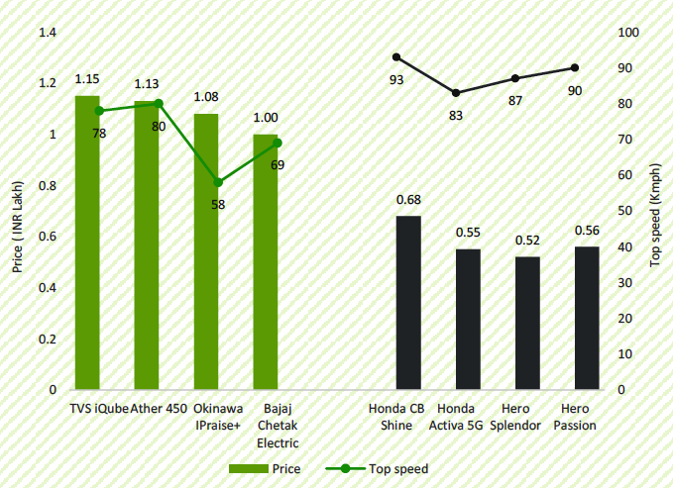
Maharashtra has the most elevated number of 2W electric vehicles among other Indian states. Electric vehicles show up as a promising elective that can diminish the negative natural affect of ordinary vehicles. The number of electric vehicles within the nation is expanding, but the acknowledgment among diverse sorts of vehicles is uneven. In spite of the fact that two-wheelers make up as it were 17% of the state's add up to electric vehicles, they may be taking after a comparable drift to that seen in today's customary vehicle showcase [06]. So distant, there are concerns around modern innovation, the generally tall cost of electric vehicles (comparable in execution to inside combustion motor vehicles), run issues, and the accessibility of full charging alternatives. . It foiled the presentation of two-wheeled electric vehicles. Be that as it may, with the development of electric vehicle innovation, the accomplishment of cost equality, and the advancement of fringe foundation, the share of electric two-wheelers is anticipated to extend. In expansion, OEMs progressively see their 2WD electric vehicle showcase as an appealing showcase, which is why numerous new businesses such as Ather, Revolt, Okinawa and Evolet are entering the field. Due to the higher cost of electric vehicles compared to ICE vehicles, selection remains a major challenge. The taken a toll comparison between electric vehicles and 2W ICE vehicles of comparative execution is appeared in Figure 2. The Government of India is additionally supporting the presentation of two-wheelers beneath the Popularity II plot. Under this arrange, the government will give a appropriation of up to INR 30,000 for him to purchase a 2W electric car. Be that as it may, the framework is pointed at 2W tall speed vehicles, so the showcase is anticipated to move to tall speed vehicles.[9]. Fig. 2. Variation in cost of 2W EV and conventional vehicles (ICE)

The electric tricycle fragment accounts for 79% of all electric vehicles in India. This section is right now driving the zap of the Indian auto industry. The four-wheel electric vehicle section accounts for as it were 3% of the overall number of electric vehicles within the nation. A restricted demonstrate will be accessible within the 4W EV portion. In any case, major OEMs are arranging to dispatch more electric vehicle models appropriate for the Indian advertise within the future, which may lead to expanded showcase competition and expanded entrance. As with the rest of the electric vehicle section, large-scale arrangement of 4W electric vehicles comes at a strong cost tag. One of the most reasons for the tall price of electric vehicles is the powerless nearness of OEMs in India. Most auto parts for these vehicles are imported and China is the most provider of electric vehicle parts to India, which is driving up the cost of electric vehicles. Subsequently, the improvement of neighborhood generation centers for electric vehicle components can play an vital part in diminishing future electric vehicle costs and making the electric vehicle industry more versatile to supply disturbances due to geopolitical instability. Electric buses are the slightest prevalent section of electric vehicles in India. Looking at the drift of offering electric buses in Indian states, it can be seen that Maharashtra, West Bengal and Himachal Pradesh are the primary states to present electric buses. The Indian government has set a target of accomplishing an electric vehicle advertise penetration rate of 30% by 2030. Be that as it may, accomplishing this objective will require exceptional and transformative action from policymakers within the division. Electric Vehicles (EVs), Crossover Electric Vehicles (HEVs) and Plug-in Half breed Electric Vehicles (PHEVs) are as of now on deal in India and Maharashtra. In any case, in any case of whether EV/HEV/PHEV is more useful for street activity in India or not, EV deals are not exceptionally positive for the taking after reasons [11].
1. Half breed or electric powertrains are much more effective than India's low-speed inner combustion (ICE) motors.
2. In a half breed electric vehicle (HEV) or an electric vehicle (regenerative braking), braking expends most of the vitality per stroke, and most of that vitality is recuperated.
3. HEVs and EVs expend no fuel at lingering, and in Maharashtra the rate of time the activity is sitting is much higher.
4. Since the average range in India is much lower than within the US or Europe, electric vehicles are much more helpful and run on a single charge isn't an issue.
5. Vehicle utilization and distance traveled – The urban driving cycle is characterized by frequent takeoffs and stops as well as favorable activity conditions to guarantee tall proficiency of electric vehicles. In this article, we are going detail the status quo, arrangements, challenges and trends of the electric vehicle advertise in India. In expansion, specialized guidelines and client sees will be displayed with case considers.

EV Market Scenario
A nitty gritty think about of the determinations of the IC motor and electric two-wheelers accessible within the advertise (as in Eminent 2022) was made. The vehicles were categorized in terms of their control and sort of impetus. The gotten agent comes about are given underneath in Table 1.
Table. 1. Specifications of available vehicles
Category Name | Vehicle Class | Ex-showroom Price (Rs.) | Traction Battery Kwh | Power (W) | Fuel Economy (kmpl) | Fuel Per km* | Range (km)
ICScooter110 | Scooter | 63000 | - | 6000 | 55.45 | 0.018 | 266
ICScooter125 | Scooter | 73000 | - | 6120 | 51.02 | 0.02 | 271
ICMotCycle100 | MotorCycle | 53000 | - | 5810 | 82.6 | 0.012 | 867
ICMotCycle110 | MotorCycle | 58000 | - | 6330 | 84.03 | 0.012 | 882
ICMotCycle125 | MotorCycle | 73000 | - | 8000 | 58.85 | 0.017 | 706
ICMotCycle150 | MotorCycle | 98000 | - | 10300 | 55.51 | 0.018 | 833
EVScooter1200 | Scooter | 60000 | 1.68 | 1200 | NA | 0.015 | 87
EVScooter2020 | Scooter | 94500 | 2.09 | 2020 | NA | 0.014 | 120
EVMotCycle1500 | Motorcycle | 95000 | 2.7 | 1500 | NA | 0.02 | 110
EVMotCycle3000 | MotorCycle | 90800 | 3.24 | 3000 | NA | 0.017 | 150

A. Current status of electric vehicle ecosystem and electric two-wheeler production plan
Endeavors to present electric two-wheelers started in India within the 1990s. Companies such as Bajaj Auto, Bikes India Ltd. and Legend Engine Enterprise, etc. created an electric two-wheeler. The Office of Modern and Renewable Vitality (MNRE) presented appropriations for electric vehicles in 2010-2012. In any case, these endeavors were not supported, and electric vehicle deals fell drastically after the appropriation was expelled. Taking after the dispatch of the Popularity program, numerous unused producers of electric two-wheelers developed, and indeed the most seasoned producers joined the race. New businesses like Ather Vitality, Okinawa, Immaculate EV and Ampere Vehicle, etc. has set up generation capacity of 2/3-wheel electric vehicles and plans to create them encourage. Ola has reported an driven arrange for generation and companies like Saint Electric and Bajaj Auto, and more. too built up generation offices for 2/3-wheel electric vehicles. In terms of framework, as of Walk 2021, there are approximately 1800 charging stations in India. A endorse was allowed for the establishment of an extra 3300 charging stations inside the system of the Acclaim program [14].
Whereas this data gives an initial reference for creating a number of conceivable toll-base deployment scenarios, we moreover note that the declarations are for the most part short-term which more such plans may emerge within the coming a long time. A few factors impact yearly showcase infiltration forecasts for electric two-wheelers, and different scenarios can be created employing a Dealer-based model. Of all the components, batteries contribute the foremost to electric vehicle generation costs. As a result, battery costs are anticipated to have a major affect on the utilize of electric two-wheelers in India. The fetched of lithium-ion batteries has dropped drastically over the past decade. Be that as it may, exceptionally as of late, with concerns around lithium accessibility, the downward direction of lithium-ion batteries has been ended to a few degree. There's indeed a slight increment in costs as well. Expanded utilize of electric vehicles can too be driven by progressed execution through mechanical development. Higher particular vitality batteries can progress vehicle run, and made strides electric engines can convey higher control and speed, bridging the hole between electric vehicles and ordinary inner combustion motor vehicles. The implementation of charging framework is one of the key components for electric vehicle selection, because it is specifically connected to the so-called “range anxiety” of clients. Industry availability is another important impacting calculate for electric vehicle showcase infiltration. Be that as it may, as the e-mobility industry develops in India, a few more seasoned carmakers as well as modern participants may come up with plans to add more capacity. To consider these conceivable outcomes, three diverse levels of generation were considered in each of the fundamental scenarios. They are appeared in Figure 3
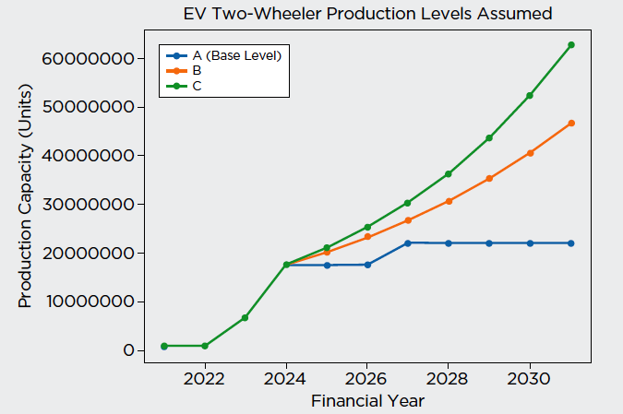
Fig. 3. Assumed production scenarios for EV two-wheelers
B. Cost of an electric vehicle
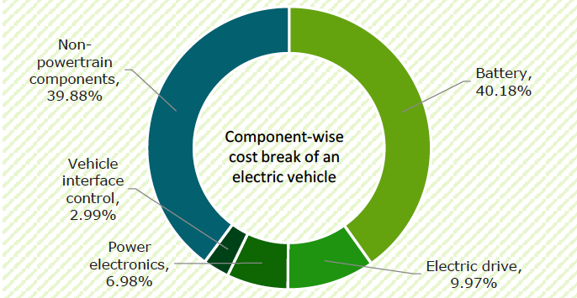
The fetched of an electric vehicle is as of now higher than that of a customary vehicle with comparable characteristics and execution. One of the most reasons is the tall cost of batteries, which account for almost 40% of the overall taken a toll of electric vehicles. In spite of the fact that battery costs have dropped significantly over the past decade, they are still at a level that creates it troublesome for electric vehicles to taken a toll comparable to routine batteries.

Fig.4. Category-wise cost breaking

III. Technological Development, Review of Policies and Technical Standards
The usage of approaches and directions will play an imperative part in saddling the potential of modern advances and clearing the way for modern openings. In 2016, worldwide electric vehicle deals come to 1 million units, and in 2018, worldwide deals of little electric vehicles and plug-in half breed electric vehicles surpassed 5 million units. Popular car producers such as Volkswagen, Mercedes, Passage have desire to advance electric vehicles. Electric vehicles primarily incorporate immaculate electric vehicles (PEVs), crossover electric vehicles (HEVs) and fuel cell electric vehicles (FCEVs). At the conclusion of 2018, the worldwide number of FCEVs come to 11,200 units. The writing of later a long time gives an outline of the innovative improvement of electric vehicles, centering not as it were on the specialized challenges of the most components but too considering conceivable future advancement headings to overcome these impediments. [04].
A. Battery Technology of EVs:
Mechanical improvements in footing batteries have had a critical affect on the electric vehicle industry, as they are utilized to control electric vehicle impetus frameworks. As before long as rechargeable lead-acid batteries got to be accessible, they were introduced in electric vehicles. With the advancement of battery innovation, increasingly distinctive sorts of vitality batteries show up on the battery showcase. In spite of modern battery innovation, the necessities for footing batteries have not changed altogether. Not at all like starter, lighting and start batteries, have electric vehicle batteries required a consistent supply of power. Hence, higher control capacity is exceptionally vital. In expansion, tall particular control, tall particular vitality and tall vitality thickness are moreover vital. As of now, electric vehicles primarily utilize lead-acid batteries, nickel-metal hydride (Ni-MH) batteries and lithium-ion batteries.
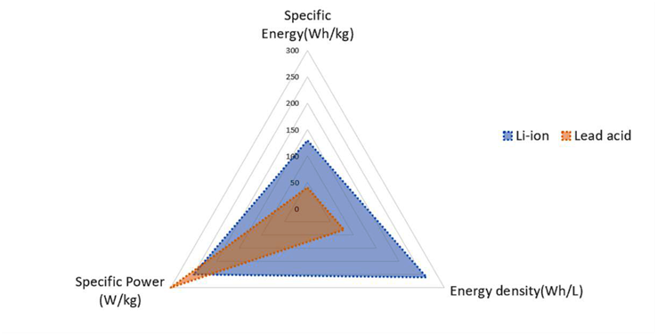

Figure 5. Comparison of lithium-ion and lead-acid batteries.
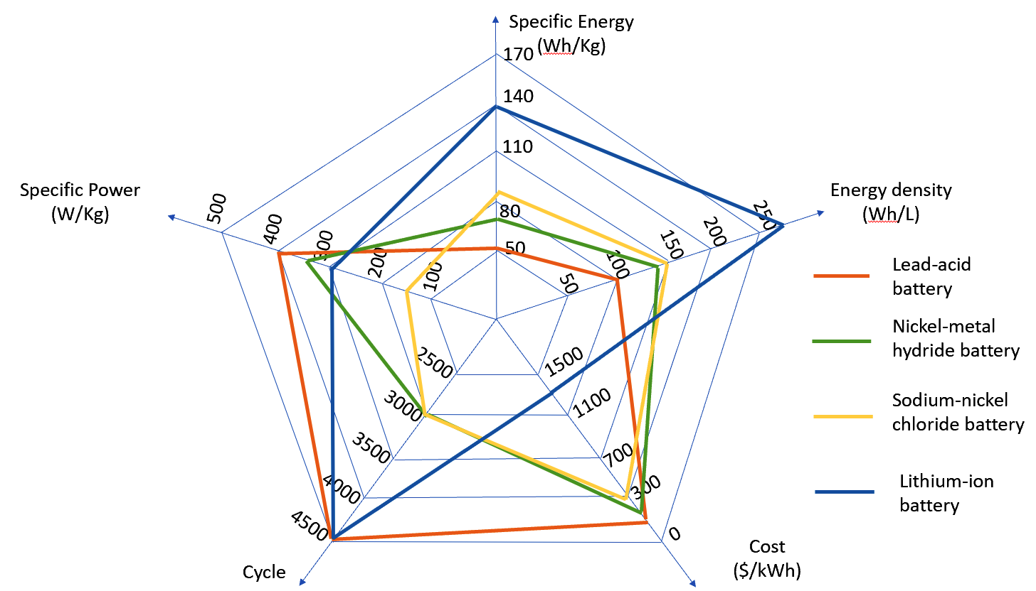

Figure 6. Comparison of the characteristics of various power batteries.

B. Charging Technology
In expansion to battery capacity, battery charging is another challenge for BEVs. Charging innovation and battery innovation complement each other. In arrange to soothe the “range anxiety” of electric vehicle drivers, charging innovation is exceptionally vital and plays an vital part within the BEV industry. With the quick improvement of charging innovation and the ubiquity of charging foundation, charging has gotten to be more helpful and quick. Agreeing to distinctive control transmission modes, electric vehicle battery charger can be classified into conductive charging, inductive charging and battery swapping. Depending on the charging strategy, electric vehicles require diverse charging framework and hardware. Conductive charging, inductive charging and battery swapping are considered the three charging choices accessible for BEV applications. With the advancement of charging innovation, electric vehicle charging has ended up more productive and helpful. Energetic charging encourage expands extend and decreases battery measure. The savvy network kills the charging affect of electric vehicle charging and gives distant better;a much better;a higher;a stronger;an improved">a higher control dispersion concept. EV keen network integration and EV savvy charging can give a more profound understanding into the EV encounter. As an critical provider of EV applications, charging innovation plays an vital part [07].
C. Electric Motors
The electric engine is at the heart of the electric vehicle drive framework, changing over electrical vitality from the battery into mechanical vitality to control the vehicle. The most necessities recorded within the reference for drive are strength, tall torque, tall control, tall effectiveness, wide speed run, strength, ease of taking care of, moo taken a toll, moo commotion and little estimate. A few sorts of electric engines of distinctive developments and advances have been utilized for electric vehicles. These incorporate acceptance (IM) engines, changeless magnet (PM) and exchanging hesitance (SRM) engines. The PM lesson is most planned to meet car prerequisites. Changeless magnet brushless DC (PMBLDC) engines are broadly utilized in electric vehicles due to their tall control thickness and tall effectiveness. Tall quality uncommon soil lasting magnet materials such as samarium cobalt (Sm–Co) and neodymium–iron–boron (Nd–Fe–B) have been utilized on its rotor. Since the rotor has no windings, there's no copper misfortune within the rotor. Since the PMBLDC engine has the characteristics of wide speed extend, tall proficiency, controllability and security, it has pulled in significant consideration for EV applications, particularly with respect to the wheel innovation of electric impetus framework.
D. Charging Infrastructure
Charging foundation played a key part within the presentation of electric vehicles. Electric vehicle organizations ought to consider building a vigorous arrange of charging foundation. Building a strong charging foundation organize implies altering to the current state of the charging foundation, understanding the affect of charging on the arrange, and considering presenting fitting charging frameworks. To encourage advance electric vehicle charging systems, numerous nations have propelled different programs and ventures that give budgetary and political bolster for the improvement of charging framework. The improvement of electric charging systems not as it were encourages the presentation of electric vehicles, but moreover postures numerous challenges to open arrange. The most subjects are the affect of charging on the arrange and the location of the charging foundation. The capacity to get a reasonable compensate for charging an electric vehicle is additionally an critical thought for electric vehicles, because it depends on the condition and life of the battery. The battery administration framework "BMS" permits to get information almost the battery's status. Each driver ought to know how long they can utilize their car after charging. Other components such as battery capacity, charging speed and power taken a toll ought to too be considered.
In spite of the fact that electric vehicles have pulled in a parcel of intrigued as of late, there are still a few key specialized challenges to move the advancement of electric vehicles. One of the greatest boundaries is the inquire about and mass generation of batteries with tall vitality thickness, tall vitality thickness, and security.

Case Study: EV Vs Conventional Vehicle

There are certain assumptions to be made;

1. On-road price of vehicle is subjective to owner, hence not taken into accounts.

2. One person having his Petrol Scooter with 100cc capacity
3. Costumer drive their vehicle 40 km per day (Approximately)

4. Cost of 1L petrol is Rs. 100 (Approximate)

5. The per km cost of running this petrol scooter is Rs 2.5 per km (40 kmpl, Rs 100 per liter)

A. Now for same condition the electric scooter gives extremely less operating costs;
- The per km cost of running an electric scooter is only Rs 0.25 per km.
- Cost of electricity is fairly cheap at Rs 10 per unit in the commercial location of cities and Rs 3 - 4 small
towns and villages.
Table. 2. Comparative Details of EV and Petrol Scooter
 | Electric Scooter | Petrol Scooter
Per Km Cost | Rs. 0.25 | Rs. 2.5
4 years | 40,000 Km | 40,000 Km
Fuel Cost | Rs. 10,000 | Rs. 1,00,000
Savings | Rs. 90000 for fuel use

B. Maintenance Expenses

About maintenance costs associated with this petrol scooter for a period of 5 years.

Petrol scooters have maintenance costs of Rs 6000 per annum, which results in Rs 30,000 for 5 year period.

Remember, petrol scooters also have a lot of parts - engine, transmission, gearbox, convertors, filters, engine parts etc. These can go wrong and will lead to replacement or repairs. Consider repair/replacement costs of Rs 10,000 over a 5 year period.

So total maintenance cost for your petrol scooter could be Rs 40,000 for period of 5 years.

About maintenance costs associated with this electric scooter for a period of 5 years.

Electric scooters have far less moving parts compared to petrol scooters.

Most electric scooters come with 3 years/60,000 km battery warranty, so there would be no battery related maintenance for 3 years.

After the warranty period, what maintenance costs can you expect, with respect to the battery in 4th and 5th year?

Internally battery pack might be damaged due to a physical damage

BMS board might need replacing or repairs

Lithium cells can go off balance. Some cells due to age might have less voltage when fully charged. So these cells will need cell boosting or in worse cases cell replacement. For the 4th and 5th year, let’s keep an amount of Rs 5000 as battery pack maintenance.

Electronic parts like controller, Motor, DC-DC converter, charger, wiring harness etc might get faulty and might need replacement or repairs. So let’s set aside Rs 15,000 for part replacements.

Regular annual service would cost Rs 5000 (Rs 1000 per year).

So total maintenance cost for your electric scooter could be around Rs 25,000.

So overall details mentioned in following table.
Table. 3. Total Costing with Saving Details
 | Electric Scooter | Petrol Scooter
Vehicle Cost | Rs. 80000 | Rs. 80000
General Servicing | Rs. 5000 | Rs. 30000
Part Replacements | Rs. 15000 | Rs. 10000
Battery Replacement | Rs. 30000 | Rs. 0
Fuel Cost | Rs. 10000 | Rs. 100000
TCO  (Total Cost of Ownership) | Rs. 140000 | Rs. 220000
Savings | Rs. 80000 Cost Saving by using Electric Scooter
It is observed from Table 2 & 3 that there is saving in using electric scooter.

IV. Conclusions
This article provides an overview of the evolution of electric vehicle technology in key areas such as batteries, charging, electric motors, charging infrastructure, and emerging technologies. The development of battery technology is crucial to the market penetration of electric vehicles. Lithium-ion batteries are most commonly used today. The heart of the power train is the electric motor that is also of interest to many researchers. PMBLDC is very attractive for EV applications, especially in the field of wheel technology. Charging infrastructure plays an important role in electric vehicle applications. The Billing Infrastructure Network is about the organization of the charging network, the technical challenges of the infrastructure, and the fairness of the billing process. Today, electric vehicles are not only a means of transporting people and goods like traditional vehicles, but also a communication bridge between electric vehicles and all smart devices. Governments should focus on raising awareness about e-scooters by providing articles, sessions and subsidies for e-scooters. At some point in the future, a suitable ecosystem may emerge to enforce regulations on electric mobility and other clean modes of transportation. However, as this analysis shows, there are many opportunities to accelerate the use of electric vehicles through improved technology and other means. While developing electric vehicles is beneficial and economical for customers, it faces many technical challenges, including: B. We believe that with the integration of battery technology, charging technology, electric motor technology and other new technologies, electric vehicles will play an important role in people's lives in the future.

REFERENCES
[1] BP. 2020. “BP Statistical Review of World Energy 2019”. 69th Edition, The British Petroleum Company. Accessed June 2020. http://www.bp.com/content/dam/bp/business
sites/en/global/corporate/pdfs/energyeconomics/statistical-review/bp-stats-review-2020-full-report.pdf
[2] Martins, F., Felgueiras, C., Smitkova, M., Caetano, N. 2019. “Analysis of Fossil Fuel Energy Consumption and Environmental Impacts in European Countries”. MDPI Energies. DOI: 10.3390/en12060964
[3] Maini, C., Gopal, K., Prakash, R. 2013. “Making of ‘all reason’ Electric vehicle”. In Proc. World electric vehicle Symposium and Exhibition, Barcelona, Spain. http://ieeexplore.ieee.org/abstract/document/6915015
[4] Tiwari, A., Jaga, O. P. 2017. “Component Selection for An Electric Vehicle”. A Review. In Proc. International Conference on Computation of Power, Energy, Information and Communication, 492-499, Melmaruvathur, India. http://ieeexplore.ieee.org/abstract/document/8290416
[5] Bhatta, P. N., Mehar, H., Sahajwani, M. 2019. “Electrical Motors for Electric Vehicle – A Comparative Study”. In Proc. International Conference on “Recent Advances in Interdisciplinary Trends in Engineering & Applications. DOI: 10.2139/ssrn.3364887
[6] Lulhe, A. M., Date, T. N. 2015. “A Technological review paper for drives used in electric vehicle (EV) and hybrid electric vehicles (HEV)”. In Proc. International Conference on Control, Instrumentation, Communication and Computational Technologies, 700-705, Kumaracoil, India. http://ieeexplore.ieee.org/document/7475355
[7] Ehsani, M., Gao, Y., Longo, S. and Ebrahimi, K. 2018. Modern electric, hybrid electric, and fuel cell vehicles. CRC press.
[8] Warake, K., Bhahulikar, S. R., Satpute, N. V. 2018. “Design & Development of Regenerative Braking System at Rear Axle”. International Journal of Advanced Mechanical Engineering, 8(2), 165-172. https://www.ripublication.com/ijame18/ijamev8n2_04.pdf.
[9] Bhalla, P., Ali, I. S., & Nazneen, A. (2018). A study of consumer perception and purchase intention of electric vehicles. European Journal of Scientific Research, 149(4), 362-368.
[10] Chan, C. C. (1993). An overview of electric vehicle technology. Proceedings of the IEEE, 81(9), 1202-1213.
[11] Chan, C. C., Chau, K. T., & Chau, K. T. (2001). Modern electric vehicle technology (Vol. 47). Oxford University Press on Demand.
[12] Ding, N., Prasad, K., & Lie, T. T. (2017). The electric vehicle: a review. International Journal of Electric and Hybrid Vehicles, 9(1), 49-66.
[13] Junquera, B., Moreno, B., & Álvarez, R. (2016). Analyzing consumer attitudes towards electric vehicle purchasing intentions in Spain: Technological limitations and vehicle confidence. Technological Forecasting and Social Change, 109, 6-14.
[14] Propelling Electric Vehicles in India: Technical study of Electric Vehicles and Charging Infrastructure (BEE)
[15] Ding, N., Prasad, K., & Lie, T. T. (2017). The electric vehicle: a review. International Journal of Electric and Hybrid Vehicles, 9(1), 49-66.
[16] Situ, L. (2009, May). Electric vehicle development: the past, present & future. In 2009 3rd International Conference on Power Electronics Systems and Applications (PESA) (pp. 1-3). IEEE.

