A Review : Machine Learning Algorithms

Aditya Vishwakarma Shiv Kumar Tiwari Pinkal Jain

M.tech, SRIT,Jabalpur ASST. Prof. GGCT, Jbp. ASST. Prof. GGCT, Jbp.

**Abstract: *In this lessons, various machine learning technique have been discussed. Several jobs, such as data mining, image processing, predictive analytics, etc. The main advantage of mechanism learning is the ability of an algorithm to function independently once it has learned the utilization of data.***

**Keywords:** Machine learning, algorithms, SVM.

# Introduction

To educate machines how to handle data more efficiently, machine learning is utilized. There are instances when we are unable to detect a pattern or draw conclusions from the data, even after viewing it. We use machine learning in that situation [1]. The need for machine learning has expanded due to the abundance of datasets. To obtain pertinent data, machine learning is used in numerous industries, including the military and healthcare. Machine learning seeks to get information from data. Several experiments have taught robots to learn on their own [2][3]. Numerous mathematicians and programmers approach this issue in various ways. Fig. 1 depicts a number of them in use. Each machine learning approach is explained in Section 2.

1. **Learning Methods**

Trees that aggregate qualities by sorting them according to their values are known as decision trees. Decision trees are mostly used for classification. In every tree, there are nodes and branches. Each node in a graph represents an attribute.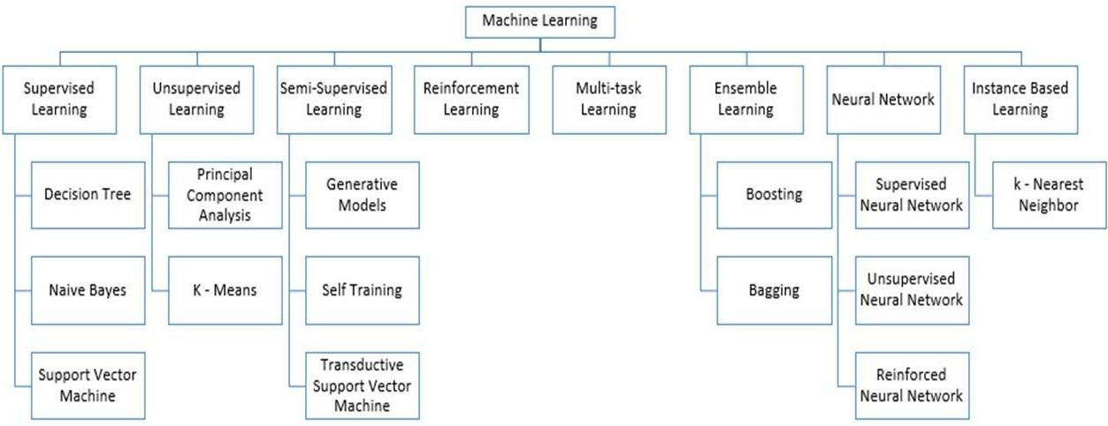

**Figure 1:** Types of Learning [2] [3]

## Supervised Machine Learning

The algorithms that call for outside assistance are those for supervised machine learning. For the dataset, there are train and test datasets. The output variable from the train dataset has to be predicted or classified. To predict or classify the test dataset, every algorithm uses a certain type of pattern from the training dataset [4]. Fig. 2 depicts the process for supervised machine learning algorithms. This article examines three of the most popular supervised machine learning methods. As the name implies, supervision is the cornerstone of supervised machine learning. The "labeled" dataset is used to train the computers using supervised learning, and after training, the computer predicts the outcome.

Using the data shown here, one can assess which inputs have been transformed into which outputs. Simply said, we train the computer with input and its matching output before asking it to predict the results using test datasets. Let's use an illustration to clarify supervised learning. Remember that both cats and dogs are included in the dataset we are utilizing as our input. Following training, we enter a cat image and ask the computer to recognize it and forecast the outcome. The machine will conclude that the object is a cat after learning more about it and analyzing its height, shape, color, eyes, ears, tail, and other traits.

During supervised learning, the computer uses this technique to identify the objects.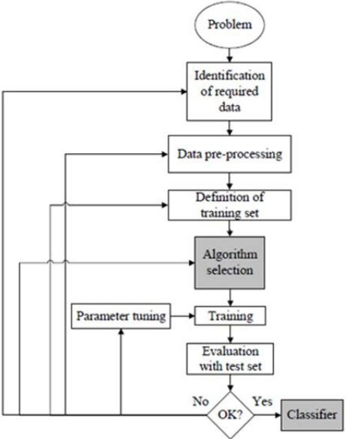

**Figure 2:** Workflow of supervised machine learning algorithm [4]

The creation of a map between the input variable (x) and the output variable (y) is the primary objective of the supervised learning technique. Applications for supervised learning that are employed in the real world include risk assessment, fraud detection, and spam filtering. 

**Figure 3:** Decision Tree [5]

### 1. Supervised Machine Learning Categories

### The following lists two categories of supervised machine learning problems:

### Classification

### Regression

### Classification - When the output variable is categorical, such as "Yes" or "No," Male or Female, Red or Blue, etc., classification algorithms are employed to address the problem. The categories that are present in the dataset are predicted by the categorization algorithms. Systems for categorizing content are currently in use, including spam detection and email filtering.

### The list of popular classification algorithms is as follows:

### ****Decision trees,****

### ****Random Forest algorithm****

### ****Logistic Regression algorithm****

1. **Regression**

Regression methods are used to address problems when the input and output variables are linearly related. They are used, among other things, to anticipate variables with predictable results, such market trends and weather predictions.

The popular regression algorithms on the list below include:

* Decision Tree Algorithm
* Multivariate Regression Algorithm
* Simple Linear Regression Algorithm
* Lashing Regression

**The benefits and drawbacks of supervised learning:**

* The training data will make it easier for you to comprehend the lessons.
* You have little trouble grasping the principles of supervised learning. In the case of unsupervised learning, it is difficult for us to comprehend the inner workings of the computer, how it learns, etc.
  + The specific number of classes may be determined before supplying the data for training.
  + You may train the classifier to have a flawless decision boundary that allows it to differentiate between different classes with great accuracy, enabling you to be extremely specific when describing the classes.
  + Once the entire programme is through, you don't necessarily need to keep the training data in your memory. The mathematical expression for the decision boundary can still be used.

## ****Disadvantages:****

## ****-** Supervised learning has certain limitations that can hinder its effectiveness in addressing complex machine learning tasks:**

## **1. Inability to Handle Complex Tasks: Supervised learning may struggle with some of the most intricate and challenging machine learning tasks.**

## **2. Lack of Discovery: Unlike unsupervised learning, supervised learning is not equipped to uncover previously unknown or hidden patterns or information within the training data.**

## **3. Dependence on Predefined Labels: Supervised learning relies heavily on predefined class labels. It cannot autonomously organize or categorize data based on intrinsic characteristics unless these labels are provided.**

## **4. Potential for Erroneous Labelling: When presented with input data that doesn't fit any of the predefined classes in the training data, supervised learning can generate incorrect class labels. For instance, if an image classifier is trained exclusively on data for dogs and cats and then presented with an image of a giraffe, it may erroneously classify it as either a cat or a dog.**

## **In summary, while supervised learning is a valuable and widely used approach in machine learning, it has limitations that make it less suitable for certain complex tasks and scenarios where inherent patterns are not readily apparent or predefined labels may be insufficient or erroneous.**

## ****Applications of Supervised Learning**:**

## **Here are some common examples of applications for supervised learning:**

## **- Image Segmentation: Supervised learning algorithms are employed for image segmentation, where images are categorized based on predefined labels. This is often used in computer vision applications.**

## **- Medical Diagnosis: In the field of medicine, supervised algorithms are frequently used for diagnostic purposes. These algorithms make diagnoses based on historical data that include labelled information about diseases and treatments, allowing the system to detect illnesses in new patients.**

## **- Fraud Detection: Supervised learning algorithms play a crucial role in identifying fraudulent activities, whether in consumer behaviour or financial transactions. Historical data is used to identify patterns and trends indicative of fraudulent behaviour.**

## **- Spam Detection: Spam detection and email filtering rely on classification techniques offered by supervised learning to distinguish between spam and legitimate emails.**

## **In summary, while supervised learning has its limitations, it remains a valuable tool for a wide range of applications, from image analysis to medical diagnosis and fraud detection, where labelled data and explicit guidance are available.**

## 2. Unsupervised Machine Learning

Unsupervised learning stands apart from supervised learning in that it operates without the need for explicit guidance or supervision. In unsupervised machine learning, a system autonomously extracts insights from unlabeled data and subsequently makes predictions without human intervention. This approach grants models the ability to work with data that lacks predefined labels or categories once they have been trained.

The primary objective of unsupervised learning is to organize or group unstructured data into clusters based on inherent patterns, similarities, and disparities. Essentially, computers are tasked with mining unsorted input data to uncover concealed patterns.

To illustrate this concept more vividly, consider providing a machine learning model with a collection of images depicting a fruit basket. Without any prior information about the images, the model's task is to discern groupings of items and detect patterns within the images. Consequently, the computer would learn to recognize distinctions like variations in colour and shape, enabling it to make predictions when presented with new, unseen data.

In essence, unsupervised learning empowers computers to independently uncover patterns and relationships within data, making it a valuable technique for various applications where labelled data is scarce or unavailable.

**Unsupervised Machine Learning Categories**

### Unsupervised learning may be further divided into the following two categories:

### Clustering

### Association

### 1) Clustering

We use the clustering approach to identify the logical groupings in the data. It is a method of grouping things such that those who are most similar to one another stay together and are barely related to those in other groupings. It is described how to categorise customers depending on how frequently they make purchases. The list below includes examples of common clustering techniques.

**K-Means Clustering algorithm**

* **Mean-shift algorithm**
* **DBSCAN Algorithm**
* **Principal Component Analysis**
* **Independent Component Analysis**

### 2) Association

Association rule learning, an unsupervised learning technique, reveals astonishing correlations between variables in a huge sample. Finding correlations between the data points and then mapping the variables for optimum gain are the major goals of this learning approach. There are several applications for this technique, including continuous production, web usage mining, market basket research, and more. Apriority, Éclat, and FP-growth are a few well-known algorithms for learning association rules.

**The benefits and drawbacks of using an unsupervised learning algorithm**

**Advantages:**

* Since they operate on unlabeled datasets, these algorithms, as opposed to supervised ones, can be applied to more difficult issues.
* For many applications, unsupervised methods are chosen since obtaining the unlabeled dataset is easier than obtaining the labeled dataset.

**Disadvantages:**

• The output of an unsupervised algorithm could be less accurate because the dataset is not tagged and the algorithms are not trained using the precise output in advance.

• Why since unsupervised learning employs a dataset that is unlabeled and does not match the result, working with it is more difficult.

## Applications of Unsupervised Learning

## • Network Systems: Unsupervised learning techniques are employed in network systems to detect instances of plagiarism and copyright violations within textual data from academic papers. This is accomplished through document network analysis.

## • Recommendation Systems: In the realm of recommendation systems, which are prevalent in various online applications and e-commerce platforms, unsupervised learning methods are used to develop recommendation algorithms. These algorithms suggest products or content to users based on their preferences and behaviors.

## • Anomaly Detection: Unsupervised learning plays a pivotal role in anomaly detection, where the objective is to identify unusual or anomalous data points within a dataset. It is commonly utilized to detect fraudulent transactions in financial systems, among other applications.

## • Singular Value Decomposition (SVD): Singular Value Decomposition is a technique used for data extraction from databases. It helps obtain specific information, such as details about users located in a particular place, by decomposing data matrices into constituent parts.

## In essence, unsupervised learning methods are applied across various domains, ranging from network systems and recommendation engines to anomaly detection and data extraction, to uncover meaningful patterns and insights within data without the need for explicit labels or supervision.

## Semi-Supervised Learning

## Semi-supervised learning occupies a middle ground between supervised and unsupervised machine learning approaches. It leverages both labeled and unlabeled datasets during the training phase, making it distinct from purely supervised learning (which relies on labeled data) and unsupervised learning (which operates without labeled data).

## In semi-supervised learning, the emphasis is on utilizing the available data as efficiently as possible, particularly when obtaining labels for data can be costly or resource-intensive. Instead of depending solely on labeled data, semi-supervised learning incorporates a limited number of labels. This approach seeks to overcome the limitations of both supervised and unsupervised learning methods.

## One strategy in semi-supervised learning involves clustering similar data using unsupervised learning techniques before assigning labels to unlabeled data. This is because obtaining labels is often more expensive than acquiring unlabeled data.

## An analogy can help illustrate these concepts: Supervised learning is akin to a student closely supervised by a teacher, while unsupervised learning corresponds to a student conducting independent research without guidance.

## Advantages and Disadvantages of Semi-Supervised Learning:

## Advantages:

## - Semi-supervised learning is straightforward and easy to comprehend while remaining effective.

## - It provides a solution to challenges encountered in both supervised and unsupervised learning algorithms.

## Disadvantages:

## - The stability of results from iterations can be uncertain.

## - These techniques may not be suitable for network-level data analysis.

## - Semi-supervised learning may yield lower accuracy compared to fully supervised methods.

## In summary, semi-supervised learning offers a pragmatic approach that combines labeled and unlabeled data to address the limitations of purely supervised or unsupervised methods. While it simplifies certain aspects of the learning process, it may not always yield the highest accuracy, and its stability can vary depending on the dataset and methodology employed.

# 2. Reinforcement Learning

# Reinforcement learning is a technique utilized by software components to autonomously explore their environments, take actions, learn from their mistakes, and improve their performance through practice. The core concept in reinforcement learning is feedback. In this paradigm, a reinforcement learning agent's objective is to maximize rewards by receiving positive rewards for successful actions and penalties for unsuccessful ones. Unlike supervised learning, where labeled data is provided, reinforcement learning relies entirely on the experiences of agents.

# Reinforcement learning operates in a manner akin to human learning. For instance, it resembles how a young child learns through everyday experiences. An illustrative example is playing a game where an agent's actions lead to different states, and the environment serves as the game's setting.

# Categories of Reinforcement Learning:

# In reinforcement learning, there are essentially two categories of methods or algorithms:

# - Positive Reinforcement Learning: This involves adding something positive to encourage a desired behavior, increasing the likelihood of its recurrence.

# 

# - Negative Reinforcement Learning: In contrast, this approach discourages undesirable behavior by reducing the likelihood of negative consequences.

# Real-world Applications of Reinforcement Learning:

# - Video Games: Many gaming applications utilize real-time learning techniques, enabling the achievement of superhuman performance. Examples include AlphaGO and AlphaGO Zero.

# - Resource Management: Research such as "Resource Management with Deep Reinforcement Learning" demonstrates how RL can automate resource allocation for various workloads, reducing job slowness in computer systems.

# - Robotics: RL is commonly used in robotics applications, enhancing robot performance in manufacturing and industrial settings. Numerous industries aim to develop intelligent robots using AI and machine learning technologies.

# - Data Mining: Text mining, a significant application of NLP, is enabled by RL.

# Advantages and Disadvantages of Reinforcement Learning:

# Advantages:

# - RL models parallel human learning processes, leading to highly accurate outcomes.

# - It addresses complex real-world problems that require innovative solutions.

# - It can provide lasting results.

# Disadvantages:

# - RL algorithms may not be suitable for simple tasks.

# - They consume significant computational and data resources.

# - Aggressive reinforcement learning can generate an excessive number of states.

# In summary, reinforcement learning is a powerful paradigm for autonomous learning and decision-making, with applications spanning from gaming to robotics and resource management. It offers unique advantages but also poses challenges related to resource consumption and state proliferation.

# Feature Engineering for Machine Learning

**Feature engineering is a critical pre-processing step in machine learning, where features are extracted from raw data to construct prediction models, utilizing either statistical modelling or machine learning techniques. The development of these machine learning components serves to enhance model performance. In this discussion, we will delve into the intricacies of feature engineering in machine learning. But before we proceed, let's establish a clear understanding of what features are. Consequently, we must address the question of why feature engineering is necessary.**

**The feature engineering phase in machine learning entails the extraction of features from raw data, addressing a pivotal challenge for predictive models: improving model accuracy when dealing with unseen data. Utilizing feature engineering techniques, we construct the model, which comprises the most relevant predictor variables along with an outcome variable. This process optimizes the model's capability to understand and represent complex relationships in the data, ultimately leading to more accurate predictions.**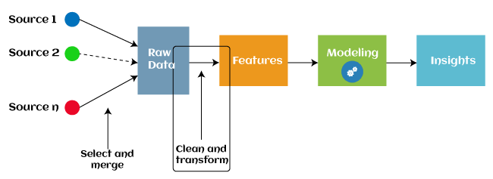

Since 2016, many machine learning programs have leveraged automated feature engineering to assist in the automatic extraction of features from raw data. Feature engineering in machine learning typically involves four key operations, each serving a specific purpose:

1. Feature Generation: This phase involves creating new features for a predictive model. It can be a combination of random processes and human intervention, often involving mathematical operations like addition, subtraction, and ratios. The resulting features are highly adaptable.

2. Transformations: During feature engineering, predictor variables are modified to enhance the model's effectiveness and accuracy. This can include scaling variables to the same range or making the model more versatile in handling inputs from diverse sources.

3. Feature Extraction: Feature extraction is a technique that replaces existing variables with new ones, typically aimed at reducing the data's complexity while maintaining its usefulness for modelling. Various methods, such as Principal Component Analysis (PCA), cluster analysis, text analytics, and edge detection algorithms, are used to achieve this.

4. Feature Selection: Not all variables in a dataset are equally valuable for building a machine learning model, and using all of them can decrease model effectiveness and accuracy. Feature selection is employed to identify and retain only the most important features while discarding irrelevant or redundant ones. This process optimizes the dataset for modelling by choosing a subset of the most relevant features.

Benefits of machine feature selection include:

- Enhanced model efficiency and accuracy.

- Reduction of data complexity and computational resources required.

- Improved model interpretability by focusing on the most meaningful features.

- Mitigation of the risk of over fitting, which can occur when using too many features.

- Overall, feature selection is a crucial step in the feature engineering process, contributing to more efficient and effective machine learning models.

## Types of ML Classification Algorithms:

## Classification algorithms can be further categorized into two main groups:

## 1. Linear Models:

## - Logistic Regression: A common linear model used for classification tasks.

## 2. Non-Linear Models:

## - Support Vector Machines (SVM): A non-linear classification algorithm.

## - K-Nearest Neighbours (KNN): Another non-linear method for classification.

## - Kernel SVM: A variant of SVM that can handle non-linear data.

## - Naive Bayes: A probabilistic classification algorithm.

## - Decision Tree Classification: A tree-based model for classification.

## - Random Forest Classification: An ensemble method for classification tasks.

## These examples represent various machine learning techniques used for classification purposes, with some falling into the linear category, while others belong to the non-linear category.

## Evaluating a Classification model:

When we've completed our model, it's crucial to assess its performance, whether it's a classification or regression model. For classification models, we have several options for evaluation:

1. Cross-Entropy Loss or Log Loss:

- This metric is employed to gauge the performance of a classifier, providing a probability value.

- In a binary classification scenario, a desirable model should yield a log loss value close to 0.

- Log loss increases as the predicted and actual values diverge.

- Reducing log loss corresponds to improved model accuracy.

- The formula for binary classification cross-entropy is: (log(p) + (1 - y) log(1 - p)), where y is the actual output, and p is the predicted output.

2. Confusion Matrix:

- The confusion matrix, also known as the error matrix, presents a summary of the model's performance.

- It tabulates the model's predictions, including the count of correct and incorrect predictions.

- Accuracy can be calculated as: (TP + TN) / Total Population.

3. AUC-ROC Curve (Area Under the Curve - Receiver Operating Characteristics Curve):

- AUC and ROC are terms used interchangeably and represent the performance of a classification model.

- The AUC-ROC curve is a graphical representation of the model's performance at various thresholds.

- It is used to assess multi-class classification models.

- The ROC curve is plotted with True Positive Rate (TPR) on the Y-axis and False Positive Rate (FPR) on the X-axis.

In summary, these methods provide comprehensive ways to evaluate the effectiveness of classification models, ensuring that we can make informed decisions about their performance.

**Use Cases of Classification Algorithms:**

**-** Classification algorithms find application in various scenarios. Here are some common use cases for classification algorithms:

- Voice Recognition

- Detecting Spam Emails

- Identifying Tumor Cells in Cancer Diagnosis

- Drug Classification

- Biometric Identification, and more.

**Logistic Regression in Machine Learning:**

- Logistic regression is one of the most widely used machine learning algorithms when combined with supervised learning techniques. It is employed to predict categorical dependent variables using a predefined set of independent factors.

- Logistic regression predicts outcomes for categorical dependent variables, producing results that are discrete or categorical. Instead of exact values ranging between 0 and 1, it provides probabilistic values within that range. It can yield outcomes like Yes or No, True or False, 0 or 1, among others.

- The primary distinction between logistic regression and linear regression lies in their application. Logistic regression is utilized for regression problems, while linear regression is employed for addressing classification challenges.

- Logistic regression can be applied across various data formats to categorize observations and swiftly identify the factors that are most effective for classification.

**The K-Nearest Neighbor**

KNN algorithm is a fundamental supervised machine learning technique that excels in categorizing new data by comparing it to existing categories. KNN relies on the assumption that the new data point is akin to prior examples. It retains all previous data to swiftly and accurately classify new data.

Primarily, KNN is employed for classification tasks, although it can also handle regression problems. Its non-parametric approach is noteworthy because it refrains from making any assumptions about the data's underlying distribution.

In the training phase, KNN simply stores the dataset and then places new data into a category closely resembling its characteristics.

Consider the scenario where an entity exhibits traits of both a dog and a cat, making its identification uncertain. KNN comes to the rescue in such cases, as it relies on similarity measures. Using our KNN model, we can seek similarities in the new data to make an informedidentification.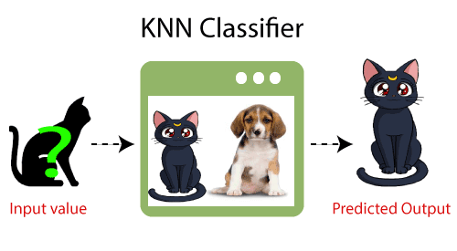

**How does K-NN function?**

• The K-NN algorithm follows these steps:

1. Initially, choose the phone number of the Kth neighbor.

2. In the second step, compute the Euclidean distance between the K neighbors.

3. In step three, pick the K neighbors with the shortest Euclidean distance to your location.

4. Among these K neighbors, tally the number of data points within each category.

5. Allocate any additional data points to the category that has the highest number of neighbors.

6. The model is finalized in the sixth step.

**Conclusion**

# This paper explores various machine learning algorithms, showcasing their widespread application in everyday life, often without individuals even realizing it. Whether it's changing your profile picture on social media platforms or receiving personalized product suggestions while shopping online, machine learning has become an integral part of our daily experiences. This study introduces a comprehensive overview of the most widely recognized machine learning methods.

# References

1. W. Richert, L. P. Coelho, “*Building Machine Learning Systems with Python*”, Packt Publishing Ltd., ISBN 978-1-78216-140-0
2. M. Welling, “*A First Encounter with Machine Learning*”
3. M. Bowles, “*Machine Learning in Python: Essential Techniques for Predictive Analytics*”, John Wiley & Sons Inc., ISBN: 978-1-118-96174-2
4. S.B. Kotsiantis, “*Supervised Machine Learning: A Review of Classification Techniques*”, Informatica 31 (2007) 249-268
5. L. Rokach, O. Maimon, “*Top – Down Induction of Decision Trees Classifiers – A Survey*”, IEEE Transactions on Systems, D. Lowd, P. Domingos, “Naïve Bayes Models for Probability Estimation” https://webdocs.cs.ualberta.ca/~greiner/C- 651/Homework2_Fall2008.html
6. D. Meyer, “Support Vector Machines – The Interface to libsvm in package e1071”, August 2015
7. S. S. Shwartz, Y. Singer, N. Srebro, “*Pegasos: Primal Estimated sub - Gradient Solver for SVM*”, Proceedings of the 24th International Conference on Machine Learning, Corvallis, OR, 2007.

<http://www.simplilearn.com/what-is-machine-learning-> and-why-it-matters-article

1. P. Harrington, “*Machine Learning in action*”, Manning Publications Co., Shelter Island, New York, 2012 <http://pypr.sourceforge.net/kmeans.html>
2. K. Alsabati, S. Ranaka, V. Singh, “*An efficient k- means clustering algorithm*”, Electrical Engineering and Computer Science, 1997
3. M. Andrecut, “*Parallel GPU Implementation of Iterative PCA Algorithms*”, Institute of Biocomplexity and Informatics, University of Calgary, Canada, 2008
4. X. Zhu, A. B. Goldberg, “*Introduction to Semi – Supervised Learning*”, Synthesis Lectures on Artificial Intelligence and Machine Learning, 2009, Vol. 3, No. 1, Pages 1-130
5. X. Zhu, “*Semi-Supervised Learning Literature Survey*”, Computer Sciences, University of Wisconsin-

Madison, No. 1530, 2005

1. R. S. Sutton, “*Introduction: The Challenge of Reinforcement Learning*”, Machine Learning, 8, Page 225-227, Kluwer Academic Publishers, Boston, 1992
2. L. P. Kaelbing, M. L. Littman, A. W. Moore, “*Reinforcement Learning: A Survey*”, Journal of Artificial Intelligence Research, 4, Page 237-285, 1996
3. R. Caruana, “*Multitask Learning*”, Machine Learning, 28, 41-75, Kluwer Academic Publishers, 1997
4. D. Opitz, R. Maclin, “*Popular Ensemble Methods: An Empirical Study*”, Journal of Artificial Intelligence Research, 11, Pages 169-198, 1999
5. Z. H. Zhou, “*Ensemble Learning*”, National Key Laboratory for Novel Software Technology, Nanjing University, Nanjing, China https://en.wikipedia.org/wiki/Boosting_(machine_learn ing) https://en.wikipedia.org/wiki/Bootstrap_aggregating
6. V. Sharma, S. Rai, A. Dev, “*A Comprehensive Study of Artificial Neural Networks*”, International Journal of Advanced Research in Computer Science and Software Engineering, ISSN 2277128X, Volume 2, Issue 10,

October 2012

1. S. B. Hiregoudar, K. Manjunath, K. S. Patil, “*A Survey: Research Summary on Neural Networks*”, International Journal of Research in Engineering and Technology, ISSN: 2319 1163, Volume 03, Special Issue 03, pages 385-389, May, 2014 https://en.wikipedia.org/wiki/Instance-based_learning
2. P. Harrington,“ Machine Learning in Action”, Manning Publications Co., Shelter Island, New York,

ISBN 9781617290183, 2012

1. J. M. Keller, M. R. Gray, J. A. Givens Jr., “*A Fuzzy K- Nearest Neighbor Algorithm*”, IEEE Transactions on Systems, Man and Cybernetics, Vol. SMC-15, No. 4, August 1985.

[24] Tiwari, S.K., Neogi, S.G., Mishra, A. (2023). Design and Implementation of Security Enhancement for Trusted Cloud Computing. In: Kumar, A., Mozar, S., Haase, J. (eds) Advances in Cognitive Science and Communications. ICCCE 2022. Cognitive Science and Technology. Springer, Singapore.

[25] Tiwari,S.K. Sao,N., Kushwaha, A.,Book Title “[Fundamental of Machine Learning](https://scholar.google.com/citations?view_op=view_citation&hl=en&user=gpoUlO4AAAAJ&citation_for_view=gpoUlO4AAAAJ:eQOLeE2rZwMC)”,lambert Publication, ISBN: 9789391265335, Oct. 2022,

[26] [Tiwari, S.K.](https://www.scopus.com/authid/detail.uri?authorId=58140299900), [Neogi, S.G.](https://www.scopus.com/authid/detail.uri?authorId=35759211300)Design and Implementation of Enhanced Security Algorithm for Hybrid Cloud using Kerberos[SN Computer Science](https://www.scopus.com/authid/detail.uri?authorId=58140299900#disabled) , 2023, 4(5), 430.

[27] [Tiwari, S.K.](https://www.scopus.com/authid/detail.uri?authorId=58140299900), [Neogi, S.G.](https://www.scopus.com/authid/detail.uri?authorId=35759211300), [Mishra, A.](https://www.scopus.com/authid/detail.uri?authorId=58280425700)Design and Implementation of Security Enhancement for Trusted Cloud Computing[Cognitive Science and Technology](https://www.scopus.com/authid/detail.uri?authorId=58140299900#disabled)  , 2023, pp. 1047–1057