Nanostructures
Atif Suhail
Center for Nanotechnology, Indian Institute of Technology Roorkee, India-247667
Email: asuhail@mt.iitr.ac.in

Abstract
In the past years, the concept of artificially designing distinct surface morphologies at the nanoscale was deemed challenging and impractical. However, recent advancements in materials chemistry and engineering have revolutionized the field of materials science, enabling the manipulation and design of materials at the molecular and atomic levels. This progress has led to the emergence of real-time and commercial applications of quantum physics and quantum materials in various aspects of our everyday lives. Notably, devices based on quantum dots have gained popularity in nanotechnology-based industries. Inspired by the possibility of molecular manipulation and surface engineering at the nanoscale, material scientists have successfully designed unique nanostructures of one-dimensional (1D), two-dimensional (2D), and three-dimensional (3D) with special physical and chemical properties. These nanostructures, including nanobelts, nanosheets, nanoribbons, nanoplates, nanoneedles, nano-dumbbells, nanodots, nanowires, nanorices, nanotubes, nanorods, and nanoflowers, have found extensive engineering applications as sensors, catalysts, nanodevices, optoelectronics, magnetic materials, drug delivery systems, and more. This book chapter focuses on the synthesis and applications of various 1D and 2D nanostructures materials such as nanorods, nanoflowers, nanotubes, and nanosheets based on various materials such as gold, nickel, iron, zinc, molybdenum, titanium, stannous, bismuth, copper, and others. Nanostructures such as nanotubes, nanoflowers, nanorods, and nanosheets of these materials are discussed, along with their respective synthesis protocols and characterization using FESEM and TEM imaging. Key applications of these nanostructures are highlighted, and recent updates, new nanosystems, and references are provided for further exploration.
Keywords: Nanostructures materials, 1D and 2D nanomaterials, FESEM, TEM

Introduction
Over the past few decades, significant progress in nanoscience and technology has led to the exploration of various low-dimensional nanostructures due to their potential applications in diverse fields. Nanomaterials were traditionally classified into three-dimensional (3D) nanostructures, quasi-one-dimensional (1D) nanowires and nanotubes, and "zero-dimensional" (0D) nanoparticles and quantum dots.¹ However, the discovery of graphene introduced a new category of materials, known as two-dimensional (2D) materials or nanosheets, which extend beyond the nanometric range. Nanosheets are molecularly thin structures with substantial lateral dimensions.²
Over the preceding decades, nanostructures with one-dimensional (1D) characteristics, such as nanorods, nanowires, nanotubes, nanowhiskers, and nanofibers, have garnered escalating interest due to their distinctive physical and chemical attributes. This interest has been amplified since the revelation of carbon nanotubes (CNTs) by Ijima.³ Diverse physical and chemical techniques have effectively created extensive arrays of these 1D nanomaterials. On the other hand, In the case of 2D materials, Graphene, being the most well-known 2D material, consists of a monolayer sheet with a honeycomb lattice of carbon atoms capable of reaching millimeter-scale lateral sizes in monocrystalline form. Compared to their 3D counterparts, 2D materials exhibit significantly higher surface-to-volume ratios, leading to unique shape-dependent characteristics based on their specific geometries.⁴ Over time, various types of 2D materials have been synthesized and documented in scientific literature, such as graphene and graphene oxide, layered dichalcogenides, layered oxides, layered double hydroxides (LDHs), hexagonal boron nitride, (h-BN), MXenes (2D transition-metal carbides and/or nitrides), layered zeolites, 2D polymers, and 2D metal-organic frameworks (MOFs).^{5–7}
These 1D nanomaterials and 2D have found applications as integral elements or connectors in the construction of nanoscale electronic, optical, optoelectronic, electrochemical, and electromechanical devices.^{8,9} Notable examples include photodetectors, single-electron transistors, electron emitters, field-effect transistors (FETs), light-emitting diodes (LEDs), as well as biological and chemical sensors, alongside ultraviolet nanolasers.^{10–15} This chapter discusses various physical and chemical properties, their synthesis approach, and their applications to produce nanostructured materials, which are elaborated upon in the subsequent section.

Synthesis of nanostructure materials
There are several synthesis and processing methods have been established to synthesize nanostructured materials, emphasizing tailoring them according to the specific material to be produced. This level of customization might be considered more limited compared to conventional production methods. Generally, the fabrication of nanostructured materials can be categorized into two primary strategies: (i) the "bottom-up" and (ii) the "top-down" approaches.^{16,17} These strategies differ in terms of the processes employed for constructing the nanostructures. In the bottom-up approach, small units are assembled to form the final structure, whereas, in the top-down approach, larger units are reduced in size to achieve the desired structure, as depicted in Figure 1. While the top-down approach encompasses a few feasible fabrication techniques that draw from experiences and technologies developed in other industries, numerous fabrication methods utilize the bottom-up approach. In this method, nanoparticles or clusters serve as building blocks, initially prepared through suitable techniques, which are then organized into composites, coatings, layers, or consolidated into bulk materials under precisely controlled conditions.¹⁸ The fabrication of nanostructured materials can also involve a hybrid of these two approaches, which will be discussed further.
The top-down approach typically involves the disassembly of larger materials through a sequence of physical and chemical procedures.¹⁹ In the physical top-down approach, photons, electrons, and ions are utilized, whereas the chemical top-down strategy primarily relies on chemical reactions triggered by chemical etchants or the application of heat.¹⁷ This approach finds utility in creating diverse devices distinguished by their reliability and integrity. Consequently, it is frequently employed in the semiconductor device industry. Innovative structures like nanowires, which can detect biological samples without labeling, have been successfully produced using this methodology.²⁰ Similarly, nanopores, employed for detecting and measuring biophysical attributes of molecules like DNA, proteins, and others as they pass through the pores, have also been crafted using the top-down approach.²¹ The fundamental fabrication process in the top-down approach encompasses lithography, laser ablation, chemical etching, milling processes, and thermal decomposition.¹⁶
In the bottom-up approach, the organization of fundamental building blocks, comprising atoms or molecules, into arrays of nanostructures through attractive forces.²² This methodology promises to create functional devices with multiple components via the self-assembly of atoms and molecules, obviating the need for wastage or the removal of any parts from the system. The arrangement of these foundational building blocks is typically controlled through mechanisms like physical aggregation, chemical reactions, or the utilization of templates.^{20,23} In controlled chemical reactions, they orchestrate the self-assembly of building blocks to create nanostructures such as nanotubes, nanoribbons, nanosheets, nanoflowers, and quantum dots.²⁴ The bottom-up approach exhibits the potential to fabricate nanostructured materials in scenarios where the top-down approach encounters limitations. However, achieving predetermined structures with precise shapes and sizes is a significant challenge.²⁰ There are several bottom-up approaches for the synthesis of nanostructured materials, which includes chemical vapor deposition (CVD), sol-gel, spray method, molecular condensation, and aerogel process which is also illustrated in Figure1.¹⁶
Figure 1. Schematic illustration of top-down and bottom-up approaches for the synthesis of nanostructured materials. (Reproduced with permission from ref.16)

Characterization of Nanostructures
Nanostructures are most commonly characterized materials based on their configuration and structure, but given their extremely diminutive dimensions, specific tools and specialized methods are generally requisite. This data is typically procured through diverse imaging techniques. To illustrate, X-ray diffraction spectroscopy is a common approach to unveil details about the crystalline arrangement of the fabricated nanostructured material and ascertain particle sizes.²⁵ Consequently, it is well-suited for investigating how nanoparticles' sizes change as a result of varying dopants, temperature shifts, synthesis durations, and other factors.²⁶ Similarly, Raman spectroscopy is employed to analyze shifts in crystallinity within synthesized nanostructures, which can be attributed to alterations in dopant concentrations.²⁶ These shifts manifest as modifications in the vibration modes of the nanomaterial due to structural variations (like surface defects) caused by diverse dopant compositions. These changes could involve alterations in signal characteristics such as resolution, broadening, or shifting. Furthermore, transmission electron microscopy (TEM) and field emission scanning electron microscopy (FESEM) furnish insights into the microstructure, offering varying perspectives as dopant percentages change while also delivering estimates of particle sizes.²⁷ Both TEM and SEM can also disclose information regarding the degree of aggregation or lack thereof within the synthesized nanostructures. For example, observations reveal that MnFe₂O₄ nanoparticles tend to aggregate, but when coated with an Mn–Co oxide layer, the nanoparticles become non-aggregated.²⁸
Another very important characterization technique for nanostructure materials, X-ray photoelectron spectroscopy (XPS), facilitating the determination of their atomic composition. As the properties of nanomaterials can be notably altered by modifying the atomic makeup of the core material or incorporating dopants, XPS becomes instrumental in fine-tuning the relative proportions of each species within the nanomaterial. Gaining a deeper comprehension of the internal structural properties of nanocomposites holds significance, as they dictate the available adsorption sites. Insights into microporosity and specific surface areas are obtained through the examination of appropriate adsorption isotherms, including the Langmuir adsorption isotherm, Freundlich adsorption models, and Brunauer-Dening-Dening-Teller equation.^{25,27} Techniques such as atomic force microscopy (AFM), TEM, and laser confocal microscopy (LCM) are employed to investigate the interaction between nanostructures and bacteria. This investigation involves observing alterations in cell membrane integrity, leading to bacterial cell death. Inductively coupled plasma mass spectrometry (ICP-MS) can be employed to quantify the concentration of silver ions released from the nanocomposite matrix after specific contact periods with water samples containing the target microorganism.²⁹ Fourier transform infrared (FTIR) spectroscopy is also utilized to examine the chemical interactions of distinct functional groups during synthesis and verify the nanocomposites' successful surface modification.³⁰
- Different morphology of nanostructure materials

4.1 Nanosheet morphology
During the past decades, two-dimensional (2D) nanomaterials with nanosheet morphology have attracted a great interest in research fields due to their potential applications in different areas. There are different types of nanosheets morphology in both organic and inorganic 2D nanomaterials have been explored till now such as graphene, ³¹ metal nanosheets,³²³³ metal oxide nanosheets,³⁴ perovskite sheets,³⁵ sulfide/selenide nanosheets,³⁶³⁷ zeolites ³⁸ and hybrid materials.³⁹ Such nanosheets have a high specific surface area as well as remarkable optical, electrical, mechanical and thermal properties, and hence a lot of potential applications in the fields of energy conversion and storage, catalysis, sensing, optoelectronics and photovoltaic devices. ^{40–43}
Wenzel et al. reported a new alkylamine based synthesis method for nanocrystalline tungsten nitride (WN_{x}) aggregates and nanosheets with controlled morphology.⁴⁴ WN_{x} nanosheets and nanocrystalline aggregates produced depend on the concentration of long-chain amine surfactants. The N content of the synthesized materials increases as the amine concentration increases, resulting in the phase shift from the cubic WN_{x} phase with concentration up to 50 atomic % N to the hexagonal phase with higher N concentration. The morphology of the materials changes from nanocrystalline aggregates to nanosheets as a result of this process. Fig.1 shows the WN_{x} nanosheets with several inhomogeneities of length approximately 450 nm. Figure.2(a) shows bright-field scanning transmission electron microscopy (BF-STEM) image in which contrast inhomogeneities within the sheet and on the lacey film can be partially attributed to contaminations. Figure.2(b) shows topography sensitive secondary-electron scanning electron microscopy (SE-SEM) image which exhibits irregular bright and dark spots on the nanosheets. The inset (Fig.2(c)) shows the bright rims around the dark region indicates that they are on the nanosheet’s surface. The atomic-number and material density dependence of SE imaging could explain why they have a darker contrast while being above WN_{x}.
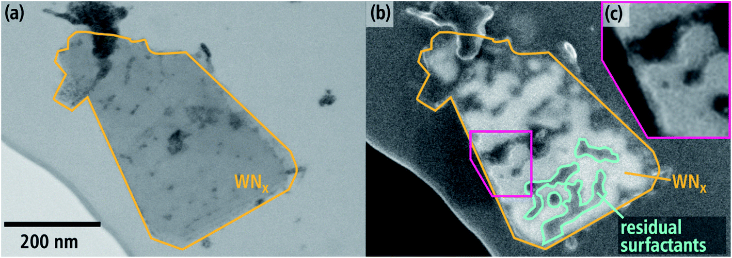
Figure 2. (a) BF-STEM and (b) SE-SEM images of WNx nanosheet with several inhomogeneities taken from the same region at 30 keV in a scanning electron microscope. Inset (c) shows a magnified region of (b). (Reproduced with permission from ref. ⁴⁴)
Shu et al. reported a simple one-step hydrothermal process for the synthesis of 2D ultrathin nickel-cobalt phosphate nanosheets for electrochemical sensing.⁴⁵ They found that the thinnest nickel-cobalt phosphate nanosheets generated with Ni/Co ratio of 2:5 exhibits the highest electrocatalytic activity for glucose oxidation. Figure. 3 shows the SEM images of as synthesized nanosheets. It shows that by increasing nickel acetate concentrations, the morphology changes from rectangular nanosheets (Figure.3(a)) to elliptical nanosheets (figure.3(b)).
They used as prepared nanosheets as an electrode material for the nonenzymatic electrochemical glucose sensor. The sensor performs a large linear range (2−4470 μM) and a low detection limit (0.4 μM) as well as high sensitivity of 302.99 μA·mM⁻¹·cm⁻². The nonenzymatic electrochemical sensor based on nickel cobalt phosphate nanosheets as fabricated showed excellent performance, including a low detection limit, high sensitivity, wide linear range, long-term stability, and outstanding reproducibility.

(a)
(b)
Figure 3. SEM images of synthesized Nickel-cobalt phosphate nanosheets (a) rectangular nanosheets, (b) elliptical nanosheets. (Reproduced with permission from ref ⁴⁵)
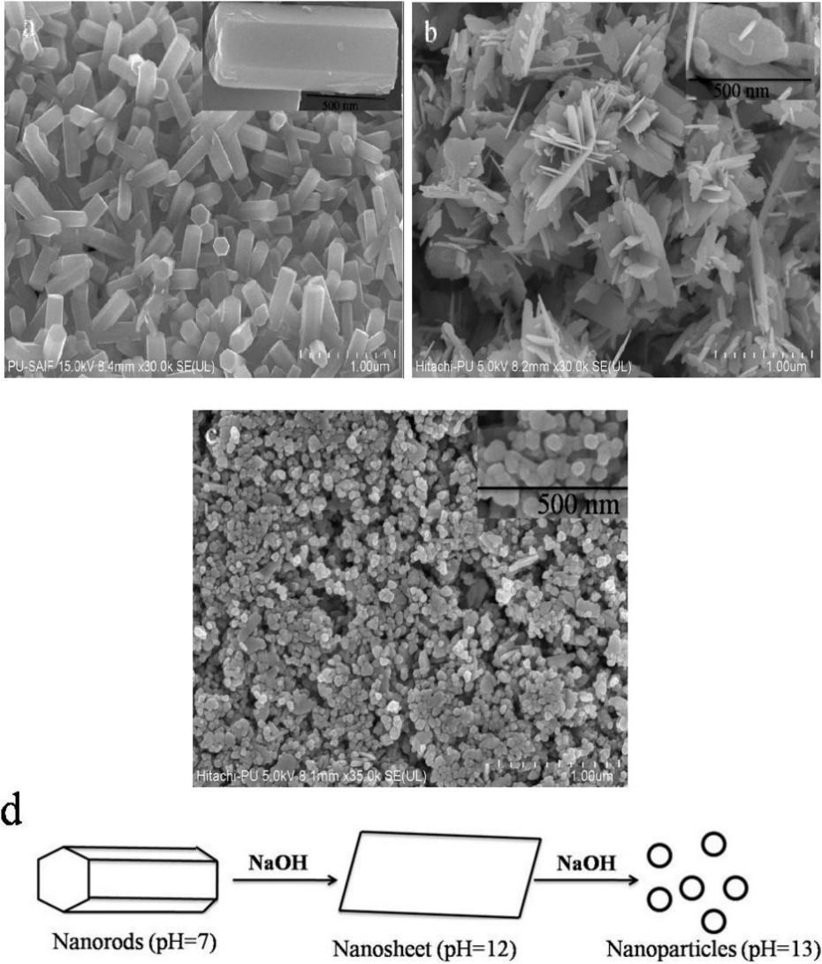
In another article, Singh et al. studied that different nanostructure of ZnO Nanoparticles prepared by coprecipitation method for removal of water contamination from different dyes and unwanted bacterial growth in different food items. ⁴⁶ They showed surface morphology of ZnO nanoparticles prepared at different pH using FESEM. The morphology of ZnO nanostructures is directly dependent on the concentration of NaOH in the solution, as seen in Figure 4, with variations in pH leading to the development of different forms of nanostructures. It shows that hexagonal rod morphology (figure.4(a)) obtained at pH=7, which have average length and width of 432.94 nm & 155.0 nm respectively. The transformation from nanorods to nanosheets morphology (figure.4(b)) occurs as the NaOH content in the zinc precursor is increased. The as obtained nanosheets have average dimension of two sides viz. 214.38 nm×178.22 nm. The change in morphology from nanosheets to spherical shape nanoparticles occurs due to further increase of NaOH content in the solution mainly in basic medium as shown in figure.4 (c). The average size of spherical nanoparticle is found 53.99 nm.
Figure 4. FESEM images of ZnO nanoparticles: (a) nanorods morphology at pH=7, (b) nanosheets at pH=12, (c) nanoparticles at pH=13 and (d) depicts the schematic representation of different shapes with change in pH respectively. (Reproduced with permission from ref ⁴⁶)

4.2 Nanorod morphology
Recently, Selim et al. reported nanorods morphology of γ-Al₂O₃ with single crystallinity prepared by surfactant directed solvothermal process.⁴⁷ The process comprises hydrolysis and precipitation reaction involving the precursor AlCl₃·6H₂O, dodecylbenzene sulfonate (SDBS) as a surfactant directed solvothermal agent and NaOH as the precipitating agent over 24 hours at 200 ⁰C to get nanorods of γ-AlOOH. The transformation of nanorods of γ-AlOOH to nanorods of γ-Al₂O₃ through calcination reaction at 500 ⁰C for 3 hours. HRTEM images of uniform γ-Al₂O₃ nanorods single crystal with average width and mean length are 10 nm and 150 nm respectively are shown in Figure 5.

In another article, Liu et al. reported an effective method to design and construction of hierarchical H-MoS2/MoP nanorods to develop efficient electrocatalysts for energy related applications using sacrifice template strategy. ⁴⁸ They found that as synthesized H-MoS2/MoP nanorods exhibits good stability and excellent hydrogen evolution reaction (HER) activity with low overpotential of 92 mV at current density of 10 mA cm⁻² in 1 M KOH. Their work showed a new perspective on the link between activity and structure, as well as compositional characteristic to allow for the development of effective HER electrocatalysts for energy conversion applications. Figure.6 (a and b) shows the SEM images of as synthesized H-MoS2/MoP nanorods and figure. 6(c) shows schematic representation of synthesis procedure for H-MoS2/MoP nanorods.
Figure 5. HRTEM images of γ–Al₂O₃ nanorods at different magnification. (Reproduced with permission from ref.⁴⁷)

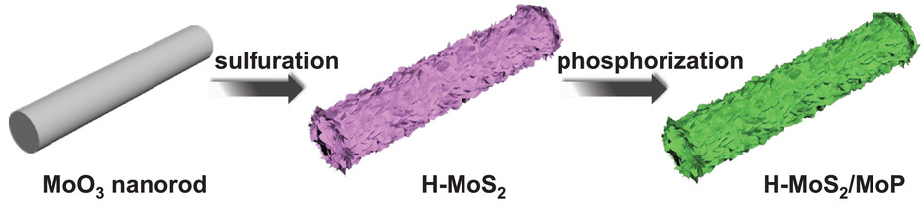
c
Figure 6. (a, b) SEM images, of H-MoS2/MoP nanorods, (c) schematic representation of the synthesis procedure of H-MoS2/MoP nanorods. (Reproduced with permission from ref.⁴⁸)
Y Liang and W Zhao reported a simple two-step process using sputtering and hydrothermal crystal growth for synthesis of 3D TiO₂-ZnO nanorods. ⁴⁹ They showed that the morphological development of hydrothermally derived ZnO nanorods was significantly influenced by the sputtering growth temperature of the ZnO seed layer on TiO₂ nanorod templates. Their work showed the synthesized three-dimensional TiO₂-ZnO nanoarchitectures will be promising device for photocatalytic and gas-sensing application. SEM images of synthesized TiO₂ and TiO2-ZnO nanorods shown in figure 7.
(c)
(d)
Figure 7. SEM images of top view and cross-sectional (a) and (b) TiO₂ nanorods, (c) and (d) TiO₂-ZnO nanorods. (Reproduced with permission from ref.⁴⁹)

Nanoflower morphology
The emergence of flower-like structures at the nanoscale level is both remarkably potent and efficient within materials chemistry, owing to their increased porous attributes and heightened surface area. This specific morphology has proven exceptionally advantageous across a range of applications, encompassing energy, biomedical, and sensing fields, among others. Virk et al. proposed a dual approach for creating copper nanoflowers and nanocrystals, involving two methods: electrodeposition using a template and a hydrothermal technique assisted by cetrimonium bromide (CTAB).⁵⁰ In the SEM image presented in Figure 8 (a), the copper nanoflowers are visible, produced through electrodeposition using a polymer template. In this process, nanoflakes originated from a nucleus and evolved into nano-sized petals. The researchers highlighted the interdependence of nanoflower growth on two factors: cathode conductivity and over-potential. A conductive cathode film expedited the deposition of Cu ions. When the cathode potential dropped below the equilibrium electrode potential of the electrolytic cell, a greater number of Cu ions were deposited. Similarly, Figure 8 (b) illustrates CuO nanoflowers acquired through the CTAB-assisted hydrothermal approach. The resulting CuO nanoflowers exhibited a polycrystalline nature.
Figure 8. (a) FESEM image of copper nanoflowers grown in polymer template of 100 nm Pores. (b) FESEM image of copper oxide (CuO) nanoflowers prepared by hydrothermal Method (Reproduced with permission from ref.50). (c) SEM images of hNFs synthesized at different incubation temperatures +4 °C. Inset: the FESEM image of a hNF of with 25.00k× magnification, (d) the FESEM image of an hNF at room temperature. Inset: with 25.00k× magnification. (Reproduced with permission from ref.51)
In another study, Somturk et al. detailed the synthesis, catalytic performance, and durability assessment of a novel hybrid nanoflower (hNF) originating from the interaction between horseradish peroxidase (HRP) enzyme and copper ions (Cu²⁺).⁵¹ The formation of these hNFs involves the amalgamation of three primary constituents: phosphate ions sourced from the PBS solution, Cu2⁺ ions, and the HRP enzyme. Investigations into hNF morphology were conducted across various temperature and pH conditions. Under a temperature of +4°C and pH=7.4 (Fig. 8c), the hNFs exhibited a spherical morphology with diameters around 5.5 μm, whereas at room temperature (RT), they displayed blossom-like structures with dimensions of approximately 6.5 μm (Fig. 8d). Additionally, the effects of copper (Cu²⁺) ion concentrations, chloride ions (Cl⁻), HRP enzyme concentration, and buffer solution pH on hNF morphology were explored. Spherical hNFs were obtained at pH=6 and 8, while at pH=9, hNFs with a spread-out configuration were observed. Interestingly, no hNF formation occurred at pH levels of 10 and above, a phenomenon attributed to robust negative repulsions that lead to the separation rather than binding of HRP petal-like structures.

Applications of nanostructured materials
Nanostructured materials find a wide array of applications across various fields due to their unique properties and enhanced functionalities. These applications underscore the versatile nature of nanostructured materials, making them integral to advancements in various fields and driving innovation across industries. Some of the notable applications are discussed in details below:

5.1 Nanostructures in supercapacitors
In recent times, electrochemical supercapacitors have garnered significant interest as potential solutions for energy storage applications. Their performance often matches or even surpasses that of conventional batteries and standard electrolytic capacitors. This is attributed to their impressive attributes, including high-power density, reasonable energy density, secure operational characteristics, and extended lifecycle. Nanostructured materials are ideal candidates for supercapacitors. These nanomaterials include graphene, carbon nanotubes, and metal oxides exhibit large surface areas and excellent electrical conductivity, leading to enhanced energy storage capabilities.⁵²
As an illustration, the combination of metal oxides and conducting polymers has been explored in the fabrication of supercapacitors. Among these, polyaniline (PANI) has been a focal point due to its noteworthy attributes. It exhibits relatively high conductivity, cost-effective, easy synthesis process, and boasts rapid doping/dedoping kinetics. Research investigations indicate that an assemblage of PANI nanowires and TiO2 nanotube arrays, produced through an economical electrochemical deposition process, showcases exceptional supercapacitor characteristics.⁵³

5.2 Nanostructured materials in Sensors
A sensor represents a device with the ability to electronically detect variable quantities and subsequently convert the measurements into distinct signals. Sensors are characterized by critical attributes such as diversity, sensitivity, accuracy in data acquisition, selectivity, and stability.⁵⁴ These qualities empower us to observe our surrounding environment and utilize the acquired information for diverse objectives. The demand for novel sensor devices featuring specific attributes like heightened sensitivity, cost-effectiveness, rapid response, dependability, swift recovery, compact size, in situ analysis, and user-friendly operation has been consistently on the rise.⁵⁵ Nanostructured materials have emerged as promising candidates for enhancing these properties in chemical and biological sensors.⁵⁶ An assortment of nanostructured materials has been harnessed in the fabrication of nanosensors.⁵⁷ For instance, nanoscale wires offer the advantage of heightened detection sensitivity, while carbon nanotubes exhibit a vast surface area and excellent electron conductivity.⁵⁸ Additionally, thin films, nanoparticles of metals and metal oxides, polymers, and biomaterials play pivotal roles.
Hu et al. reported that the sensitivity of Ag-TiO₂ nanobelt-based one-dimensional TiO₂ nanostructured surface heterostructures (NSHs) exhibited a notable correlation with exposure to ethanol, even when at relatively modest concentrations (20 ppm), as depicted in Figure 9.⁵⁹ In addition to TiO₂ nanobelts, the utilization of TiO₂ nanotubes has also been explored for constructing one-dimensional TiO₂ NSHs in the context of gas sensor applications. Examples include a-Fe₂O₃/TiO₂ nanotube heterostructures, Co₃O₄/TiO₂ nanotube p–n heterostructures, and SnO₂-Pd/TiO₂ nanotube multi-heterostructures. These structures have all showcased considerable improvements in gas sensor properties.⁶⁰ The outcomes of their study demonstrate that one-dimensional TiO₂ NSHs can enhance the gas sensing capabilities of TiO₂, encompassing heightened sensitivity and a reduction in the temperature required for gas activity.
Figure 9. Sensitivity (Ra/Rg) variation with a working temperature of four distinct types of sensors based on (a) TiO₂ nanobelts, (b) Ag-TiO₂ nanobelts, (c) surface-coarsened TiO₂ nanobelts, and (d) surface coarsened Ag-TiO₂ nanobelts, to ethanol vapor of different concentrations; (e) sensing mechanism of Ag-TiO₂ nanobelts to ethanol. Reproduced with permission from ref.59)

5.3 Nanostructured in optoelectronics applications
Nanostructured materials play a pivotal role in optoelectronic devices such as light-emitting diodes (LEDs), photodetectors, and displays. Over the past decades, the focus of electronics advancement has shifted from one-dimensional nanomaterials, specifically carbon nanotubes (CNTs) and silicon nanowires, to ultrathin two-dimensional (2D) nanomaterials, following the breakthrough discovery of graphene.⁶¹ These materials, including graphene and other ultrathin 2D semiconducting nanomaterials like transition metal dichalcogenides (TMDs) and black phosphorus (BP) nanosheets, have become central to the pursuit of a new generation of electronics.^{61,62} While graphene exhibits ultrahigh electron mobility, its lack of a bandgap hampers its electronic applications. In contrast, emerging 2D semiconducting materials like TMDs and BP nanosheets offer solutions due to their relatively high carrier mobility and tunable band structures.⁶³ These ultrathin 2D semiconductors, with their single- to few-layer thickness, have gained significant attention in nanoelectronic research due to their fascinating mechanical and electronic attributes.^{63,64} Their thin nature provides resistance against short-channel effects and offers flexibility. Furthermore, the absence of dangling bonds on the surfaces of layered 2D nanomaterials mitigates surface scattering effects. As a result of these distinctive features, a variety of 2D semiconductors have been thoroughly explored across various electronic and optoelectronic applications.

6 Conclusions
This chapter delves into the synthesis, properties, and applications of various 1D and 2D nanostructures based on diverse materials like gold, iron, titanium, and copper. Synthesis protocols, characterization techniques, different shapes and morphology, and key applications are discussed, providing valuable insights into the dynamic world of nanomaterials. The diverse applications discussed here underscore the pivotal role of nanostructure materials in shaping the landscape of technology across various domains. These materials have become indispensable building blocks for innovative devices, promoting advancement in energy storage, sensing, and optoelectronics. As research and development in nanostructure materials continue to evolve, they hold the promise of even greater breakthroughs and transformative contribution to future technologies.

References
1 A. A. Abuhabib, A. W. Mohammad, N. Hilal, R. A. Rahman and A. H. Shafie, Desalination, 2012, 295, 16–25.
2 L. Puro, M. Mänttäri, A. Pihlajamäki and M. Nyström, Chem. Eng. Res. Des., 2006, 84, 87–96.
3 S. Iijima, Nature, 1991, 354, 56–58.
4 A. R. Moghadassi, P. Koranian, S. M. Hosseini, M. Askari and S. S. Madaeni, J. Ind. Eng. Chem., 2014, 20, 2710–2718.
5 M. Safarpour, S. Arefi-Oskoui and A. Khataee, J. Ind. Eng. Chem., 2020, 82, 31–41.
6 V. Vatanpour, M. Safarpour, A. Khataee, H. Zarrabi, M. E. Yekavalangi and M. Kavian, Sep. Purif. Technol., 2017, 184, 135–143.
7 A. Suhail and I. Lahiri, in Layered 2D Advanced Materials and Their Allied Applications, 2020, pp. 303–336.
8 J. Hu, T. W. Odom and C. M. Lieber, Acc. Chem. Res., 1999, 32, 435–445.
9 Z. W. Pan, Z. R. Dai and Z. L. Wang, Science (80-. )., 2001, 291, 1947–1949.
10 Y. Li, X.-Y. Yang, Y. Feng, Z.-Y. Yuan and B.-L. Su, Crit. Rev. Solid State Mater. Sci., 2012, 37, 1–74.
11 Y. Wu, H. Yan, M. Huang, B. Messer, J. H. Song and P. Yang, Chem. – A Eur. J., 2002, 8, 1260–1268.
12 X. Duan, Y. Huang, Y. Cui, J. Wang and C. M. Lieber, Nature, 2001, 409, 66–69.
13 D. N. Davydov, P. A. Sattari, D. AlMawlawi, A. Osika, T. L. Haslett and M. Moskovits, J. Appl. Phys., 1999, 86, 3983–3987.
14 S. J. Tans, A. R. M. Verschueren and C. Dekker, Nature, 1998, 393, 49–52.
15 V. Panwar, A. Suhail and I. Lahiri, in Nanogenerators, CRC Press, 2022, pp. 335–360.
16 N. M. Noah, J. Nanomater., 2020, 2020, 8855321.
17 H.-D. Yu, M. D. Regulacio, E. Ye and M.-Y. Han, Chem. Soc. Rev., 2013, 42, 6006–6018.
18 A. A. Yadav, Y. M. Hunge and S.-W. Kang, in Noble Metal-Free Electrocatalysts: Fundamentals and Recent Advances in Electrocatalysts for Energy Applications. Volume 1, ACS Publications, 2022, pp. 31–51.
19 B. M. Venkatesan and R. Bashir, Solid-state nanopore sensors for nucleic acid analysis, Springer, 2011.
20 M. M. Bellah, S. M. Christensen and S. M. Iqbal, J. Nanomater., 2012, 2012, 1–21.
21 E. Stern, J. F. Klemic, D. A. Routenberg, P. N. Wyrembak, D. B. Turner-Evans, A. D. Hamilton, D. A. LaVan, T. M. Fahmy and M. A. Reed, Nature, 2007, 445, 519–522.
22 J. L. Liu and S. Bashir, .
23 A. Biswas, I. S. Bayer, A. S. Biris, T. Wang, E. Dervishi and F. Faupel, Adv. Colloid Interface Sci., 2012, 170, 2–27.
24 S. Rauf, A. Glidle and J. M. Cooper, Adv. Mater., 2009, 21, 4020–4024.
25 B. Chouchene, T. Ben Chaabane, K. Mozet, E. Girot, S. Corbel, L. Balan, G. Medjahdi and R. Schneider, Appl. Surf. Sci., 2017, 409, 102–110.
26 R. Vinodkumar, I. Navas, S. R. Chalana, K. G. Gopchandran, V. Ganesan, R. Philip, S. K. Sudheer and V. P. M. Pillai, Appl. Surf. Sci., 2010, 257, 708–716.
27 H. A. Sani, M. B. Ahmad, M. Z. Hussein, N. A. Ibrahim, A. Musa and T. A. Saleh, Process Saf. Environ. Prot., 2017, 109, 97–105.
28 Z. Ma, D. Zhao, Y. Chang, S. Xing, Y. Wu and Y. Gao, Dalt. Trans., 2013, 42, 14261–14267.
29 L. A. D. Koslowski, A. L. Nogueira, S. Licodiedoff, A. T. Comper and M. V. Folgueras, Rev. Ambient. Água, 2018, 13, e1947.
30 M. Kokate, K. Garadkar and A. Gole, J. Mater. Chem. A, 2013, 1, 2022–2029.
31 I. V. G. and A. A. F. K. S. Novoselov, A. K. Geim, S. V. Morozov, D. Jiang, Y. Zhang, S. V. Dubonos, 2016, 306, 666–669.
32 X. Huang, S. Tang, X. Mu, Y. Dai, G. Chen, Z. Zhou, F. Ruan, Z. Yang and N. Zheng, Nat. Nanotechnol., 2011, 6, 28–32.
33 J. Niu, D. Wang, H. Qin, X. Xiong, P. Tan, Y. Li, R. Liu, X. Lu, J. Wu, T. Zhang, W. Ni and J. Jin, Nat. Commun., 2014, 5, 1–7.
34 Z. Sun, T. Liao, Y. Dou, S. M. Hwang, M. S. Park, L. Jiang, J. H. Kim and S. X. Dou, Nat. Commun., , DOI:10.1038/ncomms4813.
35 C. Wu, X. Lu, L. Peng, K. Xu, X. Peng, J. Huang, G. Yu and Y. Xie, Nat. Commun., 2013, 4, 1–7.
36 M. Chhowalla, H. S. Shin, G. Eda, L. J. Li, K. P. Loh and H. Zhang, Nat. Chem., 2013, 5, 263–275.
37 K. Xu, P. Chen, X. Li, C. Wu, Y. Guo, J. Zhao, X. Wu and Y. Xie, Angew. Chemie, 2013, 125, 10671–10675.
38 W. J. Roth, P. Nachtigall, R. E. Morris and C. Jir, .
39 X. Huang, C. Tan, Z. Yin and H. Zhang, Adv. Mater., 2014, 26, 2185–2204.
40 D. Chen, H. Feng and J. Li, .
41 V. Georgakilas, M. Otyepka, A. B. Bourlinos, V. Chandra, N. Kim, K. C. Kemp, P. Hobza, R. Zboril and K. S. Kim, .
42 T. Review, 2013, 4532–4542.
43 C. N. R. Rao, H. S. S. R. Matte and U. Maitra, 2013, 13162–13185.
44 O. Wenzel, V. Rein and M. Hugenschmidt, 2021, 28198–28210.
45 Y. Shu, B. Li, J. Chen, Q. Xu, H. Pang and X. Hu, , DOI:10.1021/acsami.7b17005.
46 R. Singh, K. Verma, A. Patyal, I. Sharma, P. B. Barman and D. Sharma, Solid State Sci., 2019, 89, 1–14.
47 M. S. Selim, P. Jing, Y. Ping, Z. Hao and H. Wen, Ceram. Int., 2020, 46, 9289–9296.
48 Q. Liu, Z. Xue, B. Jia, Q. Liu, K. Liu, Y. Lin, M. Liu, Y. Li and G. Li, 2020, 2002482, 1–6.
49 Y. Liang and W. Zhao, 2020, 7575–7589.
50 H. S. Virk, J. Nanosci. Nanoeng. Appl., 2012, 2, 23-37p.
51 B. Somturk, M. Hancer, I. Ocsoy and N. Özdemir, Dalt. Trans., 2015, 44, 13845–13852.
52 J. Tian, Z. Zhao, A. Kumar, R. I. Boughton and H. Liu, Chem. Soc. Rev., 2014, 43, 6920–6937.
53 K. Xie, J. Li, Y. Lai, Y. Liu, G. Zhang and H. Huang, Nanoscale, 2011, 3, 2202–2207.
54 A. J. Saleh Ahammad, J.-J. Lee and M. A. Rahman, sensors, 2009, 9, 2289–2319.
55 A. I. Ayesh, J. Nanomater.
56 Y.-P. Zhao, S.-H. Li, S. B. Chaney, S. Shanmukh, J.-G. Fan, R. A. Dluhy and W. Kisaalita, J. Electron. Mater., 2006, 35, 846–851.
57 S. Su, W. Wu, J. Gao, J. Lu and C. Fan, J. Mater. Chem., 2012, 22, 18101–18110.
58 R. Abdel-Karim, Y. Reda and A. Abdel-Fattah, J. Electrochem. Soc., 2020, 167, 37554.
59 P. Hu, G. Du, W. Zhou, J. Cui, J. Lin, H. Liu, D. Liu, J. Wang and S. Chen, ACS Appl. Mater. Interfaces, 2010, 2, 3263–3269.
60 C. Wang, L. Yin, L. Zhang, D. Xiang and R. Gao, sensors, 2010, 10, 2088–2106.
61 M. P. Anantram and F. Leonard, Reports Prog. Phys., 2006, 69, 507.
62 V. Schmidt, J. V Wittemann, S. Senz and U. Gösele, Adv. Mater., 2009, 21, 2681–2702.
63 G. Fiori, F. Bonaccorso, G. Iannaccone, T. Palacios, D. Neumaier, A. Seabaugh, S. K. Banerjee and L. Colombo, Nat. Nanotechnol., 2014, 9, 768–779.
64 S. Lee and Z. Zhong, Nanoscale, 2014, 6, 13283–13300.

