Sustainable Farming using Aeroponics Cultivation
Dr. Somashekhar G C  Assistant Professor  Department of ECE  Rajiv Gandhi Institute of Technology  Bangalore  gcsomu@gmail.com | Dr. Keshavamurthy  Professor  Department of ECE  Atria Institute of Technology  Bangalore  keshavamurthy_s@yahoo.com | Prakash R L  Assistant Professor  Department of ECE  Rajiv Gandhi Institute of Technology  Bangalore  prakashrl444@gmail.com
ABSTRACT
Aeroponics, a soilless farming method derived from the Latin words 'aero' (air) and 'ponic' (labor), offers a promising solution to address the future food crisis. It is gaining popularity among many individuals due to its speed, cost-effectiveness, and innovative approach. As a form of hydroponic technique and vertical farming, aeroponics allows precise control of root zone nutrients, water regimes, and environmental conditions throughout the entire crop's life. In this modern farming system, plants are cultivated without or with minimal use of soil. The roots of the plants are suspended in the air, and essential nutrients are delivered to them through a nutrient chamber, where they are sprayed onto the roots. Aeroponic farming boasts numerous advantages, including excellent aeration, efficient water use, reduced time, space requirements, and independence from seasonal constraints, disease-free plant propagation, and large-scale plant production capabilities.
To facilitate easy monitoring and automation, a LCD display provides details of temperature and humidity, with data transmitted to a computer. The computer, in turn, helps regulate actuators responsible for distributing water and nutrients, further optimizing the growth conditions for the plants. Aeroponic techniques have proven to be commercially successful for various applications, including propagation, seed germination, seed potato production, tomato production, leaf crops, and micro-greens. Notably, vegetable crops like potatoes, yams, tomatoes, lettuce, and leafy greens are being cultivated with great success in aeroponic systems. This method has demonstrated its feasibility in producing both aerial parts and roots of plants efficiently and effectively. As a result, aeroponics shows great promise in revolutionizing farming practices and contributing to sustainable food production for the future.
Keywords: Aeroponics, farming, nutrient chamber, food production, aeration
- INTRODUCTION
As the world's population continues to grow, so does the demand for food production. However, traditional agricultural methods are often constrained by limited land resources, making it challenging to meet the global food demand sustainably. In response to this dilemma, aeroponics emerges as a promising solution, offering an innovative and efficient way to grow plants without the need for vast amounts of land or traditional soil.
Traditional agriculture relies on farmland, soil, and water as its fundamental resources. However, conventional greenhouses face limitations such as uncontrolled environments, smaller farmland, soil degradation, and a lack of resources, resulting in reduced crop production. With the growing demand for food, agriculture needs to become more resource-efficient and productive. One potential solution lies in stress monitoring and identifying stress-causing factors during cultivation.
Enter various cutting-edge technologies that have revolutionized farming. Wireless sensor networks (WSN), cloud computing, fog computing, embedded systems, big data, machine-to-machine (M2M) and human-machine communication (H2M), communication protocols, application programming interfaces (API), and advanced encryption standards (AES) are some of the game-changers. Additionally, geo-location, satellites, and servers play essential roles in optimizing agricultural practices.
In Mexico, increasing agricultural production by 70% by 2050 while reducing water consumption is a pressing challenge. To address this, organizations such as the Secretaría de Agricultura y Desarrollo Rural, Conacyt, and INIFAP collaborate on technology transfer for cultivating semi-arid areas. Climate change and water scarcity further emphasize the need for strategies to boost crop yield despite adverse conditions [1].
A promising solution to address these challenges is aeroponics – a vertical cultivation method where plants grow suspended over a container, and nutrient mist is sprayed onto their roots in a protective chamber. The nutrient solution is recirculated, and it requires regular monitoring and adjustments of pH and electrical conductivity (EC) to ensure successful plant growth. Aeroponics offers advantages such as reduced labor costs, up to 98% water savings, 60% less fertilizer, 10% fewer pesticides and herbicides, and significantly higher crop yields compared to traditional methods.
Aeroponics, a form of hydroponics, is an advanced farming technique that creates an enclosed air and water/nutrient ecosystem, providing an ideal environment for plant growth. By suspending the roots in the air and delivering essential nutrients through a finely controlled misting system, aeroponic systems foster rapid plant growth, consuming significantly less water and space than even the most efficient hydroponic methods.
One of the key benefits of aeroponics is its capacity to enhance the nutritional value of plants. Research has shown that plants grown in aeroponic systems uptake more minerals and vitamins, resulting in healthier and potentially more nutritious produce. This aspect holds tremendous potential for addressing malnutrition and enhancing food quality.
Moreover, aeroponic systems optimize resource utilization. With plants receiving 100 percent of available oxygen and carbon dioxide in their root zone, stems, and leaves, they experience accelerated biomass growth and reduced rooting times. This efficiency leads to higher yields and quicker harvests, making aeroponics an attractive option for both commercial and individual growers.
The adaptability of Aeroponics is another standout feature. The microenvironment in an aeroponic system can be finely controlled, making it suitable for cultivating a wide range of plant species. From leafy greens to root crops, any plant can thrive in a true aeroponic setup. This versatility opens up new possibilities for urban farming, rooftop gardens, and even space agriculture, where resources are inherently limited.
Furthermore, aeroponics has shown great promise in specific agricultural applications. For instance, using aeroponics for seed production has led to more efficient high-quality seed production methods. In the realm of biopharming, aeroponics has been utilized to grow pharmaceutical medicines within plant, paving the way for sustainable and cost-effective pharmaceutical production. Additionally, aeroponics has proven beneficial in the process of cloning plants. It improves root growth, survival rates, growth rates, and maturation times, contributing to the propagation of genetically identical and healthy plant clones.
To optimize aeroponics, IoT technology comes into play. IoT tools are particularly beneficial in Mexico, where a significant percentage of the population has internet access. IoT-based sensors can help determine the best irrigation intervals and atomization times for each plant. Detecting water stress in crops can be achieved through various parameters like crop temperature, transpiration, crop water stress index (CWSI), and vapor pressure deficit (VPD). Monitoring and controlling these factors with IoT sensors enable precise adjustments to achieve optimal growth conditions.
Non-invasive monitoring systems have been proposed for studying vegetative growth parameters in roots and leaves in greenhouses. Implementing IoT-based technologies for aeroponics requires monitoring devices capable of acquiring and analyzing environmental, nutritional, and crop data. The proposed system integrates intelligent sensors for measuring temperature, humidity, VPD, luminosity, and nutrient solution parameters.
For experimentation, Batavia lettuce was chosen due to its relatively short cultivation process. The monitoring system includes a mobile application that displays sensor data, environmental conditions, nutrient solution status, and irrigation controls. It also incorporates a thermographic camera for viewing images of the crops remotely.
The proposed system offers several advantages, such as remote administration of system actuators, monitoring of greenhouse sensors, remote image capture of crops, and visualization of historical data. The Android application allows users to modify irrigation and inspection schedules, turn on/off sprinklers and nutrient recirculation, and perform maintenance tasks.
Integrating smart IoT technology into aeroponics revolutionizes agriculture by optimizing resource usage, increasing crop yield, and addressing water stress. With advanced monitoring and control capabilities, farmers can produce higher quantities of higher-quality crops while conserving resources and adapting to challenging climatic conditions.
As the current world population of 7.2 billion is projected to increase by almost one billion people within the next twelve years, reaching 8.1 billion in 2025 and 9.6 billion in 2050, the demand for food and agricultural production is ever-increasing. With limited and expensive prime agricultural land, finding innovative solutions becomes crucial. This is where aeroponics comes in as a technological leap forward from traditional hydroponics. By adopting aeroponics, farmers can maximize crop production while using less water, reducing the need for extensive land usage, and minimizing the environmental impact. Additionally, aeroponics enables cultivation in areas where traditional farming is not feasible due to unsuitable soil conditions or limited access to arable land.[2]
The benefits of aeroponics include higher crop yields, reduced water consumption (up to 98% compared to traditional methods), decreased use of fertilizers and pesticides (up to 60% and 10%, respectively), and the potential to grow crops faster and in a controlled environment. Moreover, since aeroponics can be practiced in vertical systems, it offers the possibility of cultivating food in urban settings, bringing agriculture closer to where the food is consumed, reducing transportation costs, and enhancing food security.
As the global population continues to grow, the adoption of advanced agricultural technologies like aeroponics becomes imperative. Governments, organizations, and farmers must embrace and invest in innovative farming techniques to meet the rising food demand sustainably and efficiently. Aeroponics offers a promising solution to help feed the world's growing population while conserving resources and preserving the environment for future generations.
There are different types of aeroponics systems, each with its unique characteristics and applications. Here are some common types of aeroponics [3]:
- High-Pressure Aeroponics (HPA):
High-Pressure Aeroponics is one of the most popular and advanced forms of aeroponics. In this system, the nutrient solution is atomized into very fine droplets using high-pressure pumps and specialized nozzles. The fine mist surrounds the plant roots, providing them with optimal moisture and nutrients. HPA systems typically maintain a high level of oxygenation around the roots, promoting healthy plant growth and faster development.
- Low-Pressure Aeroponics (LPA):
Low-Pressure Aeroponics operates at a lower pressure compared to HPA. Instead of using high-pressure pumps, LPA systems use low-pressure misters to deliver the nutrient solution. While LPA can be more straightforward and cost-effective than HPA, it may not achieve the same level of root oxygenation and nutrient delivery efficiency.
- Fogponics:
Fogponics is a variant of aeroponics where the nutrient solution is converted into fog or mist through ultrasonic humidifiers. The fine fog envelops the plant roots, providing a high surface area for nutrient absorption and oxygenation. Fogponics systems can offer excellent nutrient delivery to the roots, making it an efficient method for plant cultivation.
- Dry Fog Aeroponics:
Dry Fog Aeroponics is similar to regular fogponics, but it uses a drier mist, which is created through specific nozzles. The drier fog helps in reducing water wastage and can be particularly useful in water-scarce regions.

- Vertical Aeroponics:
Vertical Aeroponics involves arranging plants in stacked or vertical towers, allowing for maximum space utilization and high-density cultivation. These systems are well-suited for urban agriculture and vertical farming setups, where limited space is available.
- Commercial Aeroponics Systems:
Commercial Aeroponics systems are designed for large-scale agricultural production. These systems often incorporate automation and sophisticated monitoring tools to optimize plant growth and streamline operations. They are commonly used in commercial greenhouse operations and indoor farming facilities.
- DIY Aeroponics Systems:
DIY Aeroponics systems are homemade setups created by enthusiasts and small-scale growers. These systems can be simple or complex, depending on the individual's resources and expertise. DIY aeroponics allows for customization and experimentation in a cost-effective manner.
Each type of aeroponics system has its advantages and disadvantages, and the choice of system depends on factors such as available resources, scale of cultivation, crop type, and specific goals of the grower. Regardless of the type, aeroponics remains an innovative and sustainable method for growing plants with reduced water usage and increased crop productivity.
DIFFERENT COMPONENTS OF AEROPONICS:
- Nutrients used in aeroponics: Mainly N-NH4 (0.54 g/L), N-NO3 (0.35 g/L), P(0.40 g/L), K (0.35 g/L), Ca (0.17 g/L), Mg(0.08 g/L), Na(0.04 g/L), Fe (0.09 g/L), Zn (0.03 g/L) and B(0.03g/L) are commercially being used in most of the crops.

- Water used in aeroponics: Water to be used in aeroponics should ideally have a low Electrical Conductivity (EC) value, not exceeding one millisiemens per centimeter (mS/cm). The EC is a measure of the water's ability to conduct electricity, which is directly related to the concentration of dissolved salts and minerals in the water. High EC levels can indicate the presence of excessive minerals, which may not be suitable for aeroponic systems. Additionally, the pH of the water is an essential factor to consider. Water sources with a pH value of over eight are considered questionable for aeroponics. pH measures the acidity or alkalinity of the water and affects the availability of nutrients to plants in the aeroponic system. Extremely alkaline water can hinder nutrient uptake and cause imbalances in the nutrient solution. Conducting a water chemical analysis to determine EC and pH levels is highly recommended, even if they appear to be within acceptable ranges. This analysis helps ensure that the water meets the specific needs of the plants grown in the aeroponic system. Another concern when using water for aeroponics is biological contamination. Water from deep wells is generally less likely to be contaminated compared to water from superficial wells, especially those located near urban areas. Superficial wells have a higher risk of containing coliform bacteria, including Pectobacterium, which can be harmful to plant health. It is advisable to conduct a microbiological analysis of water from suspicious sources to assess its safety. Special filters can be used to minimize the risk of biological contamination in the water. Filtration is an essential step before using water in the aeroponic system to ensure the absence of harmful pathogens. water used in aeroponics should have a low EC not exceeding one mS/cm, a pH below eight, and be free from biological contaminants. Regular water testing and appropriate filtration can help maintain the water quality necessary for healthy plant growth in aeroponic systems [4-9].

- The plant material used in aeroponics: For aeroponics, using optimum plant material is crucial to ensure healthy and productive growth. In vitro plants are preferred due to their sanitary condition, but they require careful handling by experienced technicians. These in vitro plants should be of appropriate age and size and must undergo a thorough acclimatization period before being introduced to the aeroponic system.In addition to in vitro plants, other plant materials like rooted cuttings and tuber sprouts can also be used in aeroponics, but they need to meet certain criteria. They should be clean and free from any diseases or symptoms of diseases. If any kind of symptom is observed, the entire batch of plants should be discarded to prevent the spread of potential diseases in the aeroponic system. When transplanting the plants into the aeroponic boxes, it should be ensured that the underground part of the tissue coming from the sand trays is completely clean and free from sand particles. Any debris or contamination from the sand should be removed to maintain the cleanliness of the system and prevent clogging of the aeroponic nozzles or misters. Before placing the plants into the aeroponic system, they should be carefully managed in a clean greenhouse environment. Greenhouses should be kept free from pests, diseases, and weeds to minimize the risk of introducing any contaminants into the aeroponic setup. Proper sanitation practices and regular inspections are essential to maintain a healthy plant environment.using clean and disease-free plant material is vital for successful aeroponic cultivation. In vitro plants offer the advantage of being sanitary, but all plant materials, including rooted cuttings and tuber sprouts, should be carefully inspected and undergo an acclimatization process before being introduced to the aeroponic system. Maintaining a clean and controlled environment throughout the plant management process is essential to ensure optimal results in aeroponics
- RELATED WORK
Aeroponics is a unique plant growing technique that involves suspending the plant roots in the air instead of using soil or another growing medium. The roots are then regularly sprayed or misted with a nutrient-rich solution to provide essential nutrients to the plant. While the concept of aeroponics was first explored by botanists in the 1920s to study root structures, it gained more attention in the 1990s when NASA funded research on aeroponics operations.
One of the main advantages of aeroponics is the increased growth rate of plants due to the roots having a greater surface area exposed to oxygen and nutrients. Additionally, having the roots suspended in the air allows for more efficient use of space, enabling growers to fit more plants in a given area compared to traditional soil-based farming.
In recent years, indoor growing has seen a rise in popularity, with hydroponics and aquaponics being widely used techniques. While aeroponics has been primarily limited to large-scale industrial setups, this project aims to bridge the gap by offering an automated indoor growing system at a similar price point to consumer hydroponic systems. By combining the benefits of aeroponics with the convenience and efficiency of automation, this project seeks to provide consumers with an accessible and sustainable growing solution.
One of the key advantages of aeroponics over hydroponics is its significantly lower water usage. By utilizing a misting system to deliver nutrients directly to the plant roots, aeroponics minimizes water wastage, making it an environmentally friendly choice for indoor cultivation.
Ultimately, this project's goal is to democratize aeroponics and make it accessible to everyday consumers, providing them with an efficient, water-saving, and productive method for indoor growing. By bringing aeroponics to the consumer market, individuals can enjoy the benefits of this innovative farming technique and contribute to a more sustainable and resource-efficient future.
Singh et al. (2010) mentioned that several soil-less techniques have been widely adopted for growing plants under controlled conditions. Two of the prominent methods discussed were Hydroponics and Aeroponics. Both hydroponics and aeroponics offer significant advantages over traditional soil-based cultivation. By eliminating soil, they reduce the risk of soil-borne diseases, allow for better nutrient control, and optimize resource utilization. Additionally, these soil-less techniques can be implemented in various environments, including urban settings, greenhouses, and vertical farming systems, making them popular choices for modern agriculture.The study by Singh et al. likely highlighted the growing popularity and significance of hydroponics and aeroponics in the realm of controlled environment agriculture, emphasizing their potential to revolutionize how we grow plants in the future [10].
In the context of the transpiration of a growing crop, the transpiration rate can be influenced by various atmospheric conditions, with one crucial factor being the Vapor Pressure Deficit (VPD). VPD refers to the difference between the amount of moisture in the air and the maximum amount of moisture the air can hold at a specific temperature. As VPD increases, the rate of transpiration in the crop also increases. However, excessively high VPD levels can lead to several adverse effects [11].
One significant concern is excessive water consumption by the crop due to the accelerated transpiration rate caused by a high VPD. This can result in increased water demand and potential water stress on the crop, even if it is adequately irrigated at the root level. The excessive loss of water through transpiration can lead to reduced water availability for the crop, potentially compromising its overall health and growth.
Moreover, elevated VPD levels can lead to a phenomenon known as photosynthetic limitation. This occurs when the rate of transpiration surpasses the crop's ability to perform photosynthesis effectively. As a consequence, the crop may not be able to produce enough energy to support its growth and development, leading to suboptimal yields and reduced overall productivity.
A critical threshold to consider is a VPD above 1 kPa, which is considered potentially harmful for the crop. At this level, stomatal conductance, which refers to the opening and closing of tiny pores (stomata) on the crop's leaves, tends to decrease. When stomatal conductance reduces, the exchange of gases, such as carbon dioxide and oxygen, between the crop and the atmosphere is restricted. This can result in a situation where photosynthesis becomes severely impaired, hindering the crop's ability to synthesize food and sustain itself. Maintaining appropriate VPD levels is essential for optimal crop growth and health. Extremely high VPD can lead to excessive water consumption, photosynthetic limitations, and water stress, negatively impacting the crop's productivity and overall performance. It is crucial for farmers and agricultural practitioners to monitor VPD levels and implement appropriate measures to mitigate any potential harm to the crop caused by unfavorable atmospheric conditions [11].
To address water stress in crops, researchers have employed techniques based on temperature measurement using infrared sensors [12] and thermographic cameras, as mentioned in the literature [12]. One commonly used approach with thermal imaging involves simultaneously capturing visible spectrum (RGB) and multispectral images. By analyzing these images, it becomes possible to determine the threshold of color components, which enables the generation of a binary mask. This binary mask is then applied to the thermal image, allowing for the isolation of information related only to the vegetative components [12]. The use of infrared sensors and thermographic cameras provides valuable insights into the crop's thermal behavior, which can be indicative of water stress. Water-stressed plants often exhibit different thermal patterns compared to well-hydrated ones. By identifying and segmenting the vegetative content in the thermal images using the binary mask generated from visible spectrum images, researchers can focus specifically on the regions of interest and extract relevant data related to the crop's water stress. This technique holds promise as a non-invasive and efficient way to monitor water stress in crops. By understanding the thermal characteristics of the vegetation, farmers and agricultural practitioners can make informed decisions about irrigation strategies and water management practices. This approach may help optimize water usage, mitigate water stress, and ultimately improve crop health and productivity, contributing to sustainable and resource-efficient agriculture.
In aeroponics systems, the root development process plays a critical role in determining the overall growth performance of plants. To maximize the plant's above-ground parts in aeroponic culture, it is essential to define appropriate values for irrigation water pressure, droplet size, and fogging interval. These factors are crucial for enhancing continuous water and nutrient availability to the plants [13,14].
In recent times, non-invasive monitoring systems have been introduced to study vegetative growth parameters in both roots and leaves that develop within greenhouses [14]. These monitoring systems offer a non-destructive and precise way to observe and analyze the growth of plant roots and aerial parts in aeroponic setups. By using these techniques, researchers and growers can gain valuable insights into the health and development of the plants without disturbing their natural growth environment. With the help of non-invasive monitoring systems, it becomes possible to optimize various aspects of aeroponic cultivation. By carefully adjusting the irrigation water pressure, droplet size, and fogging interval, growers can fine-tune the delivery of water and nutrients to the plants, ensuring a constant and ideal supply. This, in turn, promotes healthy root development and robust above-ground growth, leading to improved overall plant performance. Non-invasive monitoring systems offer a powerful tool to investigate and optimize the growth parameters of plants in aeroponic systems. By accurately defining the irrigation settings and understanding the vegetative growth parameters, growers can create an optimal growth environment that fosters vigorous root development and enhances the productivity of the aerial parts, leading to successful and thriving aeroponic cultures.

- METHODOLOGY
In our chapter, we successfully designed and implemented a smart vertical farm module that utilizes a combination of sensors and controllers to monitor and optimize critical factors affecting crop yield. This innovative vertical farm module is based on aeroponic technology, which involves soilless farming methods known for their efficiency and sustainability.
To create the module, we constructed a transparent glass frame measuring 18*9 cm to facilitate easy observation and monitoring. Inside this frame, we carefully arranged vertical stacks of silicon pipes to form horizontal layers. Equidistant holes of fixed diameter were drilled along each pipe row, serving as designated spots for placing the plants.
To ensure efficient water distribution, the pipes were connected using connectors, allowing for precise regulation of water flow between them. At the top of the frame, the plants were strategically placed, and at the bottom, a hole was incorporated to facilitate water flow from the tank to the silicon pipe layer below.
By integrating various sensors and controllers into this smart vertical farm module, we can constantly monitor and adjust essential parameters such as water flow, nutrient levels, and environmental conditions. This sophisticated monitoring system enables us to create an ideal growth environment for the crops, ultimately leading to improved crop yields and resource-efficient farming practices.
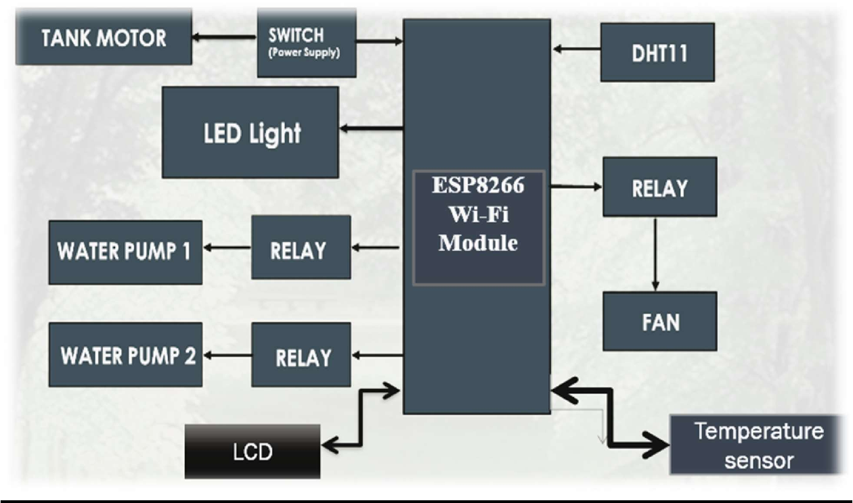
Figure 1: Block Diagram
The use of aeroponic technology in combination with advanced automation offers numerous benefits, including reduced water usage, optimal nutrient delivery, and the ability to grow crops in limited spaces. With the transparency of the glass frame, we can easily track the growth progress of the plants and make data-driven decisions to enhance overall productivity and sustainability in modern agriculture as shown in Fig 1 The details of the smart vertical farm module and its components:
- Smart Vertical Farm Module: The smart vertical farm module is a cutting-edge agricultural setup designed to optimize crop yield by leveraging technology and automation. It provides an innovative and space-efficient solution for growing crops, making it ideal for urban and indoor farming applications.

- Aeroponic Technology: The chosen method for this vertical farm module is aeroponic technology. Unlike traditional soil-based farming, aeroponics is a soilless technique that involves suspending plant roots in the air and providing them with a fine mist of nutrient-rich water. This approach maximizes nutrient uptake and oxygenation, leading to faster growth rates and higher yields.

- Glass Frame Construction: The vertical farm module is constructed using a glass frame with dimensions of 18*9 cm. The use of glass provides transparency, allowing researchers and farmers to observe the plants' growth and health easily. This real-time monitoring capability is essential for making data-driven decisions and ensuring optimal conditions for the crops.

- Vertical Silicon Pipe Stacks: Inside the glass frame, silicon pipes are stacked vertically to form multiple horizontal layers. These layers create a multi-tiered growing space, maximizing the use of available vertical area and increasing the overall crop production capacity.

- Plant Placement: Equidistant holes of fixed diameter are drilled along each silicon pipe row to accommodate the plants. These holes serve as designated spots for placing the plant roots, securely holding them in place while allowing their access to the nutrient-rich mist.

- Connectors for Water Regulation: To ensure efficient water distribution and nutrient delivery, the silicon pipes are connected using connectors. These connectors play a crucial role in regulating the water flow between the pipes, ensuring that each plant receives the required amount of water and nutrients.

- Top Plant Placement and Water Inlet: At the top of the glass frame, plants are strategically placed. This location ensures that the plants receive ample light for photosynthesis and proper growth. At the bottom of the frame, a hole is incorporated to allow water flow from a central tank into the silicon pipe layer below.

- Sensor and Controller Integration: One of the defining features of this smart vertical farm module is the integration of various sensors and controllers. These sensors continuously monitor crucial factors such as temperature, humidity, pH levels, and nutrient concentrations. The data collected is then analyzed and used to make real-time adjustments to the water flow, nutrient supply, and environmental conditions to maintain the ideal growth environment for the crops.
Overall, the smart vertical farm module based on aeroponic technology and enhanced with sensor-driven automation offers a sustainable and highly efficient method of crop cultivation. By optimizing water and nutrient delivery, minimizing resource usage, and maximizing space utilization, this innovative farming approach holds great promise in addressing the challenges of food production in urban environments and contributing to a more sustainable future..
- IMPLEMANTATION & RESULTS
DHT 11:
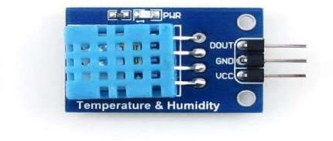
The DHT11 is a popular and inexpensive digital temperature and humidity sensor. It is commonly used in various electronic projects and IoT (Internet of Things) applications to measure and monitor temperature and relative humidity levels shown in Fig 2.
Figure 2: DHT11 Sensor

Key features of the DHT11 sensor include:
- Temperature Measurement: The DHT11 can measure temperature with a reasonable accuracy range. It typically has a temperature measurement range of 0°C to 50°C (32°F to 122°F) with an accuracy of ±2°C.
- Humidity Measurement: The sensor can also measure relative humidity in the air. Its humidity measurement range is generally from 20% to 90% with an accuracy of ±5%.
- Digital Output: The DHT11 provides digital output, which means it communicates temperature and humidity values as binary data that can be read and processed by a microcontroller or a digital device.
- Single-Wire Communication: It uses a single-wire communication protocol (one-wire interface) to transmit data, making it easy to integrate into various projects without requiring multiple pins.
- Low Power Consumption: The DHT11 operates on low power, making it suitable for battery-powered applications and energy-efficient systems.
- Simple to Use: The sensor comes in a compact package and requires minimal external components to operate. It is easy to interface with popular development boards and microcontrollers.
Limitations: While the DHT11 is affordable and straightforward to use, it does have some limitations in terms of accuracy and response time. For more demanding applications where higher accuracy is required, other sensors like the DHT22 or more advanced sensors may be preferred.
Due to its low cost and ease of use, the DHT11 sensor is widely used in various projects, including weather stations, home automation systems, greenhouse monitoring, and other applications where temperature and humidity data are essential for analysis and control.
Node MCU ESP8266:
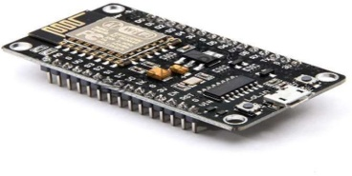
The Node MCU ESP8266 is a popular development board widely used in the field of Internet of Things (IoT) and home automation projects. It is based on the ESP8266 microcontroller chip, which features built-in Wi-Fi connectivity, making it ideal for connecting devices to the internet and enabling wireless communication as shown in Fig 3.

Figure 3: Node MCU ESP8266
Key features and characteristics of the Node MCU ESP8266 include:
- Wi-Fi Connectivity: One of the main advantages of the Node MCU ESP8266 is its integrated Wi-Fi module. This allows the board to connect to Wi-Fi networks and communicate with other devices or internet servers, making it suitable for IoT applications.
- Microcontroller: The Node MCU ESP8266 is powered by the ESP8266 microcontroller chip, which is a low-cost, low-power, and high-performance chip with a built-in TCP/IP protocol stack, enabling easy internet connectivity.
- Arduino-Compatible: The Node MCU ESP8266 can be programmed using the Arduino IDE (Integrated Development Environment), making it accessible to a vast community of developers and hobbyists familiar with Arduino programming.
- GPIO Pins: The board comes with several General Purpose Input/Output (GPIO) pins, allowing users to interface with various sensors, actuators, and other electronic components.
- USB Interface: It has a built-in USB interface that facilitates easy programming and communication with a computer.
- Lua Scripting Support: The Node MCU firmware can be flashed with Lua scripting, which allows for quick and straightforward programming of the board using the Lua programming language.
- Open-Source and Extensible: The NodeMCU ESP8266 platform is open-source, and its firmware can be modified and customized to suit specific project requirements. Additionally, it supports over-the-air (OTA) updates, enabling firmware updates without the need for physical connections.
- Cost-Effective: The Node MCU ESP8266 is a cost-effective solution, making it an excellent choice for budget-friendly IoT projects and prototypes.
Applications of the Node MCU ESP8266 board include smart home devices, home automation systems, weather stations, remote monitoring systems, Wi-Fi-controlled robots, and various IoT-related projects.
Overall, the Node MCU ESP8266 is a versatile and powerful development board, offering a convenient way to add Wi-Fi capabilities and IoT functionalities to electronic projects, and it has become a popular choice among makers, hobbyists, and professionals alike
DS18B20 Digital Temperature Sensor.
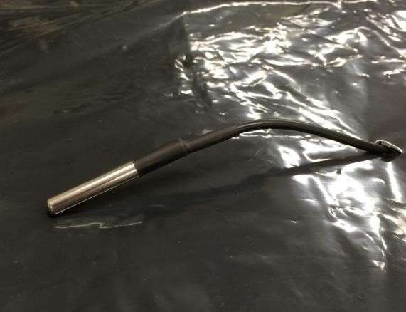
The DS18B20 as shown in Fig 4 is a popular and widely used digital temperature sensor manufactured by Maxim Integrated. It is commonly used in various electronic projects and applications to accurately measure temperature with digital output.

Figure 4 DS18B20 Digital Temperature Sensor
Key features and characteristics of the DS18B20 digital temperature sensor include:
- Digital Output: The DS18B20 provides a digital output, meaning it communicates temperature readings as binary data that can be easily interpreted by microcontrollers and digital devices.
- One-Wire Interface: It uses a one-wire communication protocol, which enables multiple DS18B20 sensors to be connected to a single microcontroller pin, making it convenient for applications where multiple sensors are required.
- High Precision: The DS18B20 offers high precision temperature measurements with a resolution of up to 12 bits. his results in accurate temperature readings, allowing for precise control in temperature-sensitive applications.
- Wide Temperature Range: The sensor has a wide temperature measurement range, typically from -55°C to +125°C, making it suitable for a broad range of temperature monitoring applications.
- Multiple Packaging Options: The DS18B20 is available in different package types, including TO-92, TO-92S, and surface-mount packages, providing flexibility in mounting and integration into various projects.
- Parasitic Power Mode: The sensor can operate in parasitic power mode, where it draws power from the data line during temperature conversion. This feature simplifies the wiring and reduces the number of required pins for sensor connections.
- Programmable Alarm Function: The DS18B20 has a built-in alarm function that allows users to set upper and lower temperature limits. When the temperature exceeds these limits, the sensor triggers an alarm condition.
- Compatibility: The DS18B20 is compatible with various microcontrollers and development platforms, including Arduino, Raspberry Pi, and other popular platforms, making it easy to integrate into existing projects.
The DS18B20 is commonly used in temperature monitoring and control systems, weather stations, environmental monitoring, industrial automation, and many other applications where accurate and digital temperature sensing is required. Its high precision, wide temperature range, and digital interface make it a reliable choice for temperature-critical projects and IoT applications.

With the working model shown in Fig 5 and 6 Aeroponics has shown promising results and benefits in various agricultural applications. Some of the notable implementation results include:
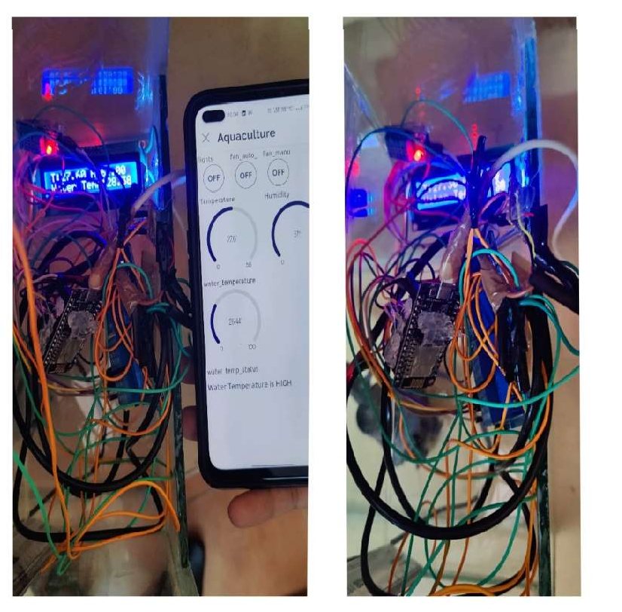
- Higher Crop Yields: Aeroponic systems have demonstrated the ability to produce higher crop yields compared to conventional farming methods. The precise control over nutrient delivery and aeration promotes robust plant growth and optimal resource utilization.
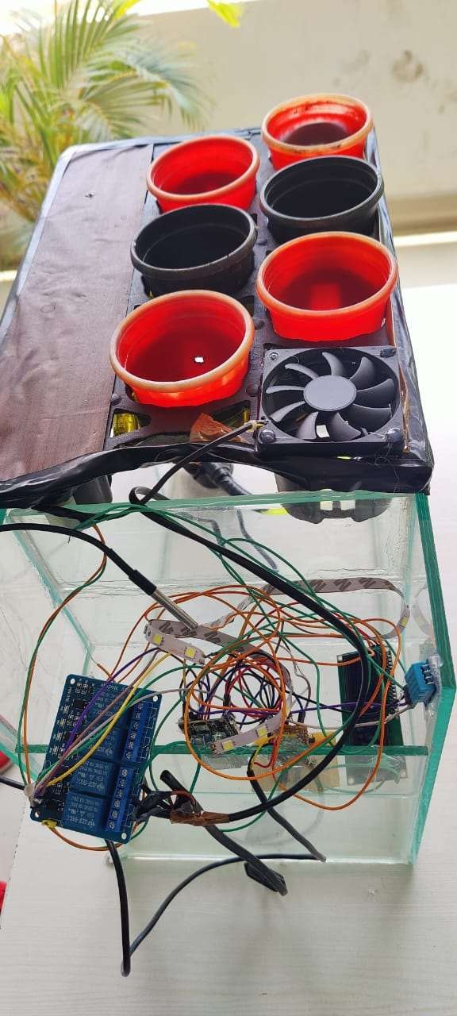
Figure 5: Model of Sustainable Farming Figure 6: Working Model

- Water Efficiency: Aeroponics is known for its efficient water usage. By misting the plant roots with a nutrient-rich solution, water consumption is significantly reduced compared to traditional soil-based irrigation methods.

- Faster Growth: Due to the increased oxygen and nutrient availability in the root zone, plants in aeroponic systems often experience accelerated growth rates, leading to quicker harvest cycles.

- Space Optimization: Aeroponic systems allow for vertical farming and stackable layers, enabling growers to maximize space utilization. This is especially beneficial in urban areas or limited agricultural spaces.

- Disease Control: Aeroponic systems can minimize the risk of soil-borne diseases as the plants are grown in a soilless environment. This can reduce the need for pesticides and promote healthier crops.

- Year-Round Production: The controlled environment in aeroponic setups offers the opportunity for year-round crop production, regardless of external weather conditions or seasonal limitations.

- Propagation Success: Aeroponics has proven to be successful in propagating plants, including cuttings, seeds, and tissue cultures, with higher success rates compared to conventional propagation methods.

- Commercial Viability: Aeroponics has been implemented commercially in various settings for the production of a wide range of crops, including leafy greens, herbs, tomatoes, and other vegetables. Its efficiency and productivity make it an attractive choice for commercial growers.
It's important to note that the successful implementation of aeroponics depends on various factors such as the design of the system, precise control of environmental conditions, nutrient formulation, and proper maintenance. While aeroponics offers numerous advantages, its adoption may vary depending on specific agricultural goals and the resources available to the growers and some of the crops grown using aeroponics are shown in Fig 7 & 8.
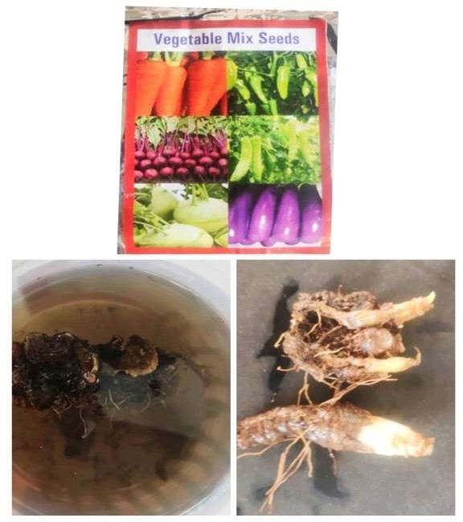
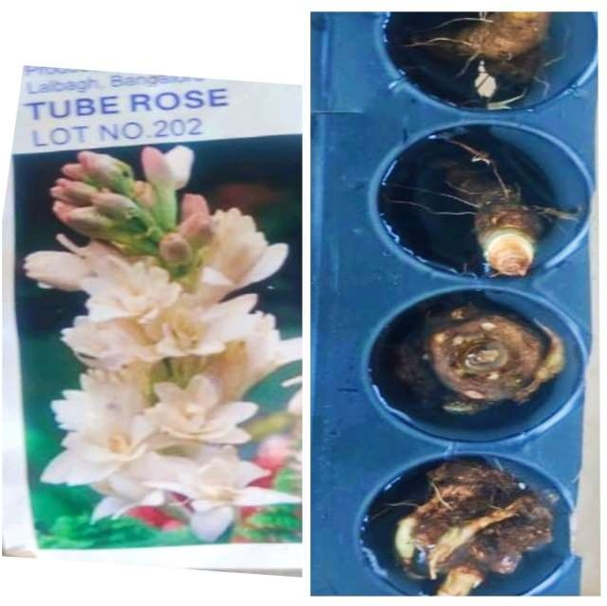
Figure 7: Tube Rose and Mix Vegetable
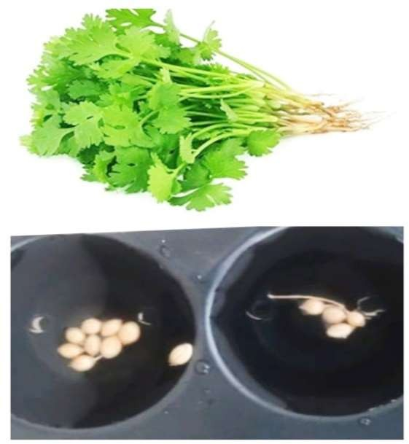
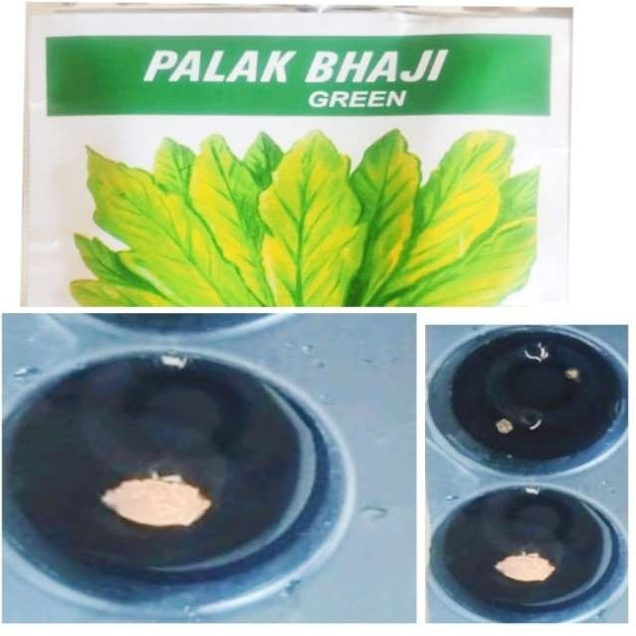
Figure 8: Palak Bhaji & Coriander

- CONCLUSION AND FUTURE SCOPE
In conclusion, aeroponics offers several advantages, especially in controlled environments, making it a favorable method for studying plant growth, particularly in urban areas. For urban dwellers with limited space due to high-rise buildings, aeroponics serves as an excellent alternative for gardening and organic vegetable production. While the initial setup cost for conventional farmers may be higher compared to traditional methods, it is a more cost-effective option than acquiring large plots of farmland that may not guarantee crop quality. In arid regions, aeroponics proves to be the best alternative for effective plant growth. Aeroponic systems promote disease-free plant cultivation as they eliminate the need for pesticides. The plants grow in a natural and healthy manner, mimicking ideal environmental conditions. Moreover, aeroponics conserves water, land, and nutrients, making it a sustainable and future-oriented approach to crop cultivation. For industries such as herbal dietary supplements and phytopharmaceuticals, aeroponics provides a viable method for producing both aerial parts and roots of plants as raw materials. In summary, aeroponics has the potential to revolutionize agriculture, offering efficient and resource-friendly techniques to cultivate crops and produce high-quality yields. With its numerous benefits and adaptability to various settings, aeroponics is paving the way for a more sustainable and productive future in agriculture.
Artificial Intelligence (AI) in agriculture is considered a highly promising and advanced technique for improving decision-making processes in the field of agriculture. In recent studies, the implementation of aeroponic systems has been integrated with wireless sensor networks using various communication technologies such as ZigBee, Arduino system with Bluetooth, global systems of mobile and WiFi, and communication modules. These AI-driven techniques offer numerous advantages to users, making them an attractive option for modern agricultural practices.
Some key advantages of using AI-based techniques in agriculture, particularly in aeroponic systems, include:
- Cost Reduction: AI-powered systems can optimize resource allocation and reduce initial setup costs. By efficiently managing resources on-demand, farmers can save on water, nutrients, and energy, leading to cost-effective cultivation.

- Smart Maintenance and Upgrades: AI allows for intelligent monitoring and predictive maintenance of the aeroponic system. It can detect potential issues early on, allowing timely repairs or upgrades to ensure smooth operation and prevent crop loss.

- Rapid Development and Flexibility: AI-based systems offer easy and rapid development of the aeroponic setup. Farmers can adapt and customize the system to suit their specific crop requirements and environmental conditions.

- Remote Access and Connectivity: The integration of AI and wireless communication technologies enables operators to stay connected with the system from anywhere via the internet. Access through smartphones, tablets, and PCs is not limited by conditions, locations, or time, allowing real-time monitoring and control.

- Data-Driven Decision Making: AI algorithms can analyze sensor data, weather patterns, and historical information to make data-driven decisions for irrigation, nutrient delivery, and other critical aspects of crop management. This leads to optimized crop growth and increased yields.

- Precision Agriculture: AI empowers farmers to implement precision agriculture techniques by tailoring the aeroponic system's parameters to the specific needs of each plant or crop. This level of precision enhances resource efficiency and minimizes waste.

- Sustainability and Environmental Benefits: By optimizing resource utilization and reducing wastage, AI-driven agriculture techniques promote sustainability and environmental conservation.
In summary, AI-driven techniques, particularly in the context of aeroponic systems, offer numerous advantages to the agriculture sector. They enable data-driven decision-making, remote access and monitoring, cost reduction, and increased productivity. With the potential to revolutionize agriculture practices, AI technologies are paving the way for a more efficient, sustainable, and connected future in agriculture.
REFERENCES
- National Agricultural Planning 2017–2030. SAGARPA. Available online: https://www.gob.mx/cms/ uploads/attachment/file/255627/Planeaci_n_Agr_cola_Nacional_2017-2030-_parte_uno.pdf
- Ali Al-Shrouf. (2017). Hydroponics, aeroponic and aquaponic as compared with conventional farming. American Scientific Research Journal for Engineering, Technology, and Sciences 27(1): 247-255.
- Cooper A. (1976). Nutrient film technique for growing crops. Grower books. London. England.
- Jeff Birkby. (2016). Vertical farming. ATTRA Sustainable Agriculture. National Centre for Appropriate Technology. www.attra.ncat.org.
- KA El-Kazzaz and AA El-Kazzaz. (2017). Soilless agriculture a new and advanced method for agriculture development: an Introduction. Agri Res & Tech 3(2). DOI: 10.19080/ARTOAJ.2017.03.555610 004.
- Kaur Gagandeep and Kumar Dilip. (2014). Aeroponic technology: blessing or curse. International Journal of Engineering Research & Technology 3(7): 691-693.
- Lakhiar Imran Ali, Gao Jianmin, Syed Tabinda Naz, Chandio Farman Ali and Buttar Noman Ali. (2018). Modern plant cultivation technologies in agriculture under controlled environment: a review on aeroponics. Journal of Plant Interactions 13(1): 338-352. DOI:10.1080/17429145.2018.1472308.
- P Gopinath, P Irene Vethamoni and M Gomathi. (2017). Aeroponics soilless cultivation system for vegetable crops. Chem Sci Rev Lett 6(22): 838-849.
- Richa Sbhnam, Kumari Arpita, Bedanga Bikash Saikia and Kumari Udita. (2018).Aeroponics- A step towards sustainable farming. International Journal of Advance Research, Ideas and Innovations in Technology 466-472.
- Singh S, Singh V, Singh SK.2010. Aeroponic for potato seed production.ICAR News a Sci, Technol Newsl, New Delhi. 16:1–2
- Amitrano, C.; Rouphael, Y.; Pannico, A.; De Pascale, S.; De Micco, V. Reducing the Evaporative Demand Improves Photosynthesis and Water Use Efficiency of Indoor Cultivated Lettuce. Agronomy 2021, 11, 1396.
- Zhou, Z.; Majeed, Y.; Naranjo, G.D.; Gambacorta, E. Assessment for crop water stress with infrared thermal imagery in precision agriculture: A review and future prospects for deep learning applications. Comput. Electron. Agric. 2021, 182, 106019
- Kuncoro, C.B.D.; Sutandi, T.; Adristi, C.; Kuan, Y.-D. Aeroponics Root Chamber Temperature Conditioning Design for Smart Mini-Tuber Potato Seed Cultivation. Sustainability 2021, 13, 5140.
- Martinez-Nolasco, C.; Padilla-Medina, J.A.; Nolasco, J.J.M.; Guevara-Gonzalez, R.G.; Barranco-Gutiérrez, A.I.; Diaz-Carmona, J.J. Non-Invasive Monitoring of the Thermal and Morphometric Characteristics of Lettuce Grown in an Aeroponic System through Multispectral Image System. Appl. Sci. 2022, 12, 6540.

