Spectroscopic techniques for the identification of drugs in different pharmaceutical preparations
Swapnja B. Gunjarkar, Juhi Rinke, Ankit Kaikade, Chetana M. Waghale, Shubham P. Bhute and Nikhil D. Amnerkar
Adv. V. R. Manohar Institute of Diploma in Pharmacy (Govt- Aided), Wanadongri, Hingna Road, Nagpur -441 110 (M.S.)

Abstract
To precisely examine the chemical structure of an analyte, spectroscopic techniques are frequently used. Each technique allows the molecule to engage in interaction with the electromagnetic energy employed. The electric and magnetic properties of radiation interact with chemical substances that have similar properties. As a result, the analyte is recognised and described based on the presence of atoms, bonds, functional groups, basic nuclei, molecular formula, and molecular weight. The study is quite vital to have a reference that covers the majority of the significant analytical methods. The investigation includes information on the fundamentals of spectrum interpretation, rules and laws that must be followed, sampling methods, sample cells, measurement mechanisms, spectral ranges, light sources, types of samples to be analysed, types of used solvents, appearance of spectra, and important applications of individual spectroscopic analysis. These reflect qualitative and quantitative factors that are essential for the research and experiments conducted by the particular spectrum process, and they also encompass every key component of the numerous spectroscopic procedures. As a result, a study of the complete spectroscopic concept, apparatus, and applications will provide all analytical persons with useful information.

Keywords: Spectroscopic Analysis, UV Spectroscopy, Atomic Absorption Spectroscopy, Atomic emission Spectroscopy, Flouroscence Spectroscopy, Infrared Spectroscopy, Nuclear Magnetic Resonance Spectroscopy, Mass Spectroscopy.

Introduction
Spectroscopy is the branch of science dealing with the study of interaction of electromagnetic radiation with matter. The most significant result of such interaction is that energy is absorbed or emitted by the matter as discrete amounts called quanta. From the gamma region (nuclear resonance absorption or the Mossbauer effect) to the radio area (nuclear magnetic resonance), the absorption or emission mechanisms are well understood over the whole electromagnetic spectrum. When radiation frequency is measured experimentally, it provides a value for the change in energy involved, and one can infer the set of potential discrete energy levels of the matter from this. The science of spectroscopy is the experimental measurement of radiation frequency (emitted or absorbed) and the inference of energy levels from these measurements (Chatwal. G, 2002).

1. UV SPECTROSCOPY
1.1 Introduction:
UV-Vis (ultraviolet visible) spectroscopy is often used to provide characterisation information for a range of materials. UV-Visible spectroscopy can be used to detect inorganic or organic, solid or liquid groups, such as organic molecules and functional groups, as well as reflectance measurements for coatings, paints, textiles, biochemical analysis, dissolution kinetics, band gap measurements, etc (J. L. Aldabib, 2020).
1.2 Principle:
The object will show absorption in the visible or ultraviolet spectrum when radiation causes an electronic change in the structure of a molecule or ion. Because of this, when a sample absorbs light in the visible or ultraviolet range, the molecules inside the sample go through an electronic state transition. The energy from the light, or anti-bonding orbital, will boost electrons from their ground state orbital to a higher energy, excited state orbital (Verma, G. 2018).
1.3 Instrumentation (Fig No. 1)
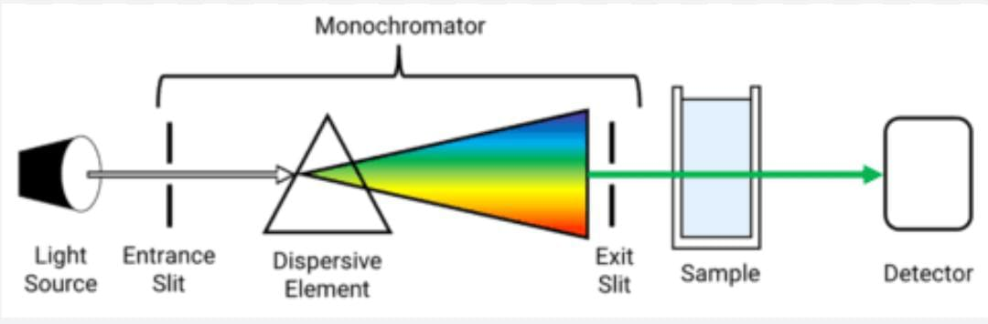
Fig No. 1: Instrumentation of UV- VIS Spectroscopy
The Essential components of UV-VIS Spectrophotometer are as follows:
- Sources (UV and visible)
- Monochromator
- Sample containers (Cuvette)
- Detector
- Amplifier and recorder

1. SOURCES:
UV-Vis Spectroscopy requires a continuous source or one that emits radiation at a range of wavelengths. The following are many sources of UV radiation:
1) Hydrogen lamp: Between 160 and 380 nm, radiation from hydrogen lamps is consistently produced and is reliable. High-pressure hydrogen gas is what it is made of; this gas then discharges electricity. Radiation is produced by excited hydrogen atoms.
2) Deuterium lamp: Deuterium lamps, a type of gas discharge lamp, are often used as UV sources. It radiates between 160 and 450 nm. It costs more than a lamp made of hydrogen.
3) Tungsten lamp: The tungsten lamp is the type of light source most frequently used in spectrophotometers. It uses a tungsten filament enclosed in a glass envelope with a wavelength range of around 330 to 900 nm and is used for the visible spectrum.
4) Xenon discharge lamp: A discharge light source with xenon gas inside a bulb is known as a xenon lamp. The wavelength range of xenon radiation is 250–600 nm.
2. MONOCHROMATOR:
A monochromator generates monochromatic light by removing unwanted wavelengths from the radiation source light. Multi-wavelength polychromatic light enters the monochromator through the entrance slit. The beam is angled in the direction of the dispersion component after collimation. The grating or prism divides the wavelengths of the beam into their component parts. When either the dispersing element or the exit slit are changed, only radiation of a particular wavelength leaves the monochromator through the slit.

Types of monochromators:
- Prism monochromator
- Grating monochromator

All Monochromator contain the following component parts:
1. An entrance slit
2. A collimating lens
3. A dispersing device
4. A focusing lens
5. An exit slit
Through the entrance slit, polychromatic radiation, or radiation with many wavelengths, enters the monochromator. The beam turns towards the dispersion element after collimation. The grating or prism divides the wavelengths of the beam into their component parts. By altering the dispersing element or the exit slit, only radiation of a particular wavelength leaves the monochromator through it.

3. SAMPLE CONTAINERS (CUVETTE):
Cuvettes are sample containers used to hold samples for spectroscopic investigations. They are transparent to all wavelengths of light passing through them. The cuvette can be used for wavelengths between 190 and 200 nm, has a square form, a 1 cm route length, and is made of quartz.
4. DETECTORS:
Detectors transform light energy into electrical impulses that read out on readout equipment. The amount of radiation absorbed by the sample is calculated by the detector once the transmitted radiation hits it. The equipment of the absorption spectrophotometer employs the following categories of detectors.
Types of Detectors:
1. Barrier layer cell/Photovoltaic cell
2. Phototubes/ Photo emissive tube
3. Photomultiplier tube (Verma, G. 2018).

1.4 Advantages:
1. The core advantage is the accuracy of the UV-VIS spectrophotometer
2. The UV-VIS spectrometer is easy to handling and use
3. Provide robust operation
4. UV-VIS spectroscopy is simple to operate
5. Cost effective instrument
6. Cover the entire of ultraviolet and visible
7. It can be utilized in the qualitative and quantitative analysis
8. The Derivative graph can be obtained by UV-VIS spectrophotometer
9. It can be used in the degradation study of drug
10. Only possible for the analytes which have a chromophore (M. Patil, 2018).

1.5 Disadvantages:
1. Only those molecules are analyzed which have chromophores
2. The results of the absorption can be affected by pH, temperature, contaminants, and impurities.
3. Only liquid samples are possible to analyze
4. It takes time to get ready to use it
5. Cuvette handling can affect the reading of the sample (M. Patil, 2018).

1.6 Applications:
UV –Vis spectroscopy has many different application
1. Detection of impurities
2. Structural elucidation of organic compounds
3. Quantitative analysis
4. Qualitative analysis
5. Chemical analysis
6. Quantitative analysis of pharmaceutical substance
7. Dissociation constant of acids and bases
8. Molecular weight determination
9. As HPLC detector
10. Deviations from the Beer-Lambert law (Verma, G. 2018).

2. ATOMIC ABSORPTION SPECTROSCOPY (AAS)
2.1 Introduction:
Atomic absorption spectroscopy (AAS) uses the absorption of optical radiation (light) by free atoms in the gaseous state to quantitatively determine the chemical elements. The foundation of atomic absorption spectroscopy is the light absorption of free metallic ions. The method is employed in analytical chemistry to establish the concentration of a specific element (the analyte) in a sample that will be subjected to analysis. AAS is utilised in pharmacology, biophysics, archaeology, and toxicology studies to identify over 70 distinct elements in solution or directly in solid samples via electrothermal vaporisation (Paudel S, 2021).
2.2 Principle:
The method makes use of the sample's atomic absorption spectra to determine the concentration of particular analytes within. The Beer-Lambert law is used to determine the relationship between the observed absorbance and the analyte concentration since it depends on standards with known analyte contents (Paudel S, 2021).
2.3 Types of AAS:
2.3.1 Flame Atomic Absorption Spectroscopy (FAAS): To estimate the concentration of metals in solution in the parts per million (ppm) or parts per billion (ppb) levels, FAAS is frequently utilised. The metal ions are reduced to their atoms, which then selectively absorb light from an element-specific hollow cathode lamp, by being nebulized as a fine spray into a high temperature flame. The key shortcomings of this method are its restricted linearity, low sensitivity, and capacity to only measure one element at a time. Despite these obstacles, it has proven to be a great, reliable method for everyday mental calculations (Paudel S, 2021).
2.3.2 Graphite Furnace Atomic Absorption Spectroscopy (GFAAS): GFAAS is a more sensitive technique frequently employed for the identification of metals at extremely low concentrations (below 1 ppb) in small sample volumes. Instead of using a flame to atomize the sample, a narrow carbon tube is employed, increasing the sensitivity and limit of detection due to the lack of spectral noise from the flame and guaranteeing that a greater portion of the sample is atomized.
2.4 Instrumentation: (Fig No. 2)
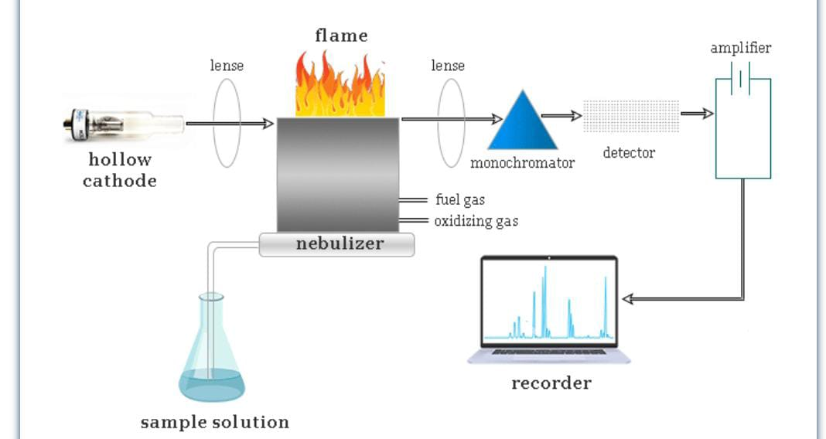
Fig No. 2: Instrumentation of Atomic Absorption Spectroscopy
2.4.1 Radiation Source: Either a white light source with a double monochromator is utilised, or a hollow cathode discharge lamp, to provide a beam of radiation with a very narrow band width. The analysis of the element is done using discharge lamps. A tungston anode and a metal cup cathode are holding a sample of the elements that need to be stimulated. To create an elemental spectrum, argon carrier gases are utilised at high voltage and low pressure.
2.4.2 Nebuliser/Automiser: Nebulizers are aroma spray devices where the sample is sprayed into the flame by forcing air through a capillary tube dipped in the sample solution.
2.4.3 Flame: Burners may be used in series to lengthen the sample's optical path.
2.4.4 Monochromator: Monochromators are used for work that requires greater precision, however basic filters can be used in place of monochromators for ordinary, straightforward analysis.
2.4.5 Detector: Photocell or photomultiplier tube are generally used (Paudel S, 2021).

2.5 Advantage and Disadvantage of AAS:
Among the benefits are the machine's affordability, relative ease of use, sensitivity, which allows many elements to be determined at ppm level or even less, high precision and accuracy obtained by the calibration curves, and, most importantly, the fact that metal atoms absorb at a well-defined wavelength and over a constrained bandwidth, preventing isotopes of the same element from absorption at each other's wavelengths. The limited use of this technology, which has only detected roughly 70 elements besides earth metals, is one of its drawbacks. One more drawback is that AAS cannot currently detect non-metals (Paudel S, 2021).
2.6 Applications:
Atomic absorption spectroscopy is used in a wide range of sectors and is essential for identifying metals in samples. Consequently, this procedure is frequently applied in:
- Pharmacology
- Archaeology
- Manufacturing
- Mining
- Forensic (Paudel S, 2021).

3. ATOMIC EMISSION SPECTROSCOPY (AES):
3.1 Introduction:
Atomic Emission Spectroscopy (AES) is a chemical analysis technique that measures the concentration of an element in a sample by measuring the intensity of light emitted at a certain wavelength from a flame, plasma, arc, or spark. While the intensity of the emitted light is connected to the number of atoms in the element, the wavelength of the atomic spectral line in the emission spectrum is used to identify the element (Y. Anithakumari, 2021).
3.2 Principle:
AES is based on the idea that molecules are energised and shift from a lower energy level state to a higher energy level one when energy is delivered to them in the form of light or heat. The molecules are unstable at the higher energy level state and jump back to the lower energy level state when they release radiation in the form of photons. The emission spectrometer logs the photons' wavelengths as they are released. The energy difference between the excited energy and lower stable energy determines a molecule's degree of emissions. The level of emission frequencies that each element emits determines how well it may be detected. The emission spectrometer keeps track of the emissions frequency (Y. Anithakumari, 2021).

3.3 Instrumentation: (Fig No. 3)
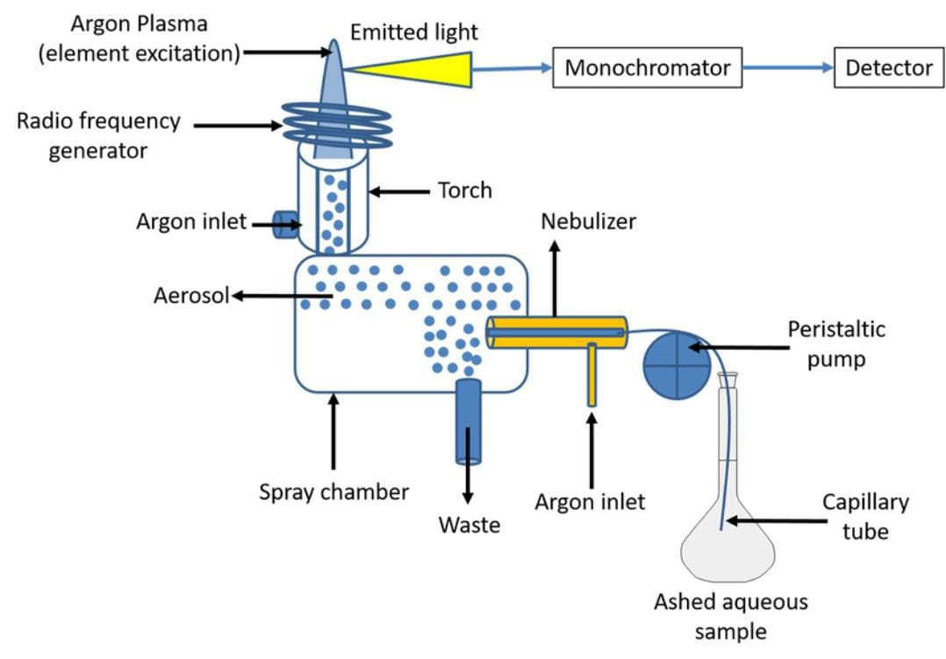
Fig No. 3: Instrumentation of Atomic Emission Spectroscopy
3.3.1 Sample Introduction:
The crucial step in the analytical process of AES is sample preparation and sample injection into the plasma. Prior to analysis, the sample should be transformed into highly excited free atoms. An inert gas is injected to move the liquid samples to the source of excitation, typically Argon flowing at 0.3 to 1.5 L/min. Aerosolizing liquids from a nebulizer is the most practical way to add them to the gas stream. An ultrasonic transducer, for example, might be used to create the aerosol instead of a high-speed jet crossing the tip of the narrow aperture. These droplet sizes have a significant impact on the stability of the spectrum emission. Therefore, choosing the right kind of nebulizer is essential for producing droplet sizes that are uniform.The properties of the sample, such as density, viscosity, organic content, total dissolved solids, and total sample volume, determine the best nebulizer to use.

3.3.2 Excitation Sources:
The sample's atoms are dissolved, atomized, and excited using an excitation source. All of the elements in the sample should be able to be excited, and the ideal excitation source should allow this to happen repeatedly until all of the elements are excited in the sample. Various sources of excitation were used for these purposes.
3.3.3 Spectrometer:
A sample's spectrometer is used to inspect and evaluate a variety of specified properties. The atoms or ions will be excited from a lower energy stable state to a higher energy one by the atomic emission source. After that, the excited atoms or ions will return on their own to a stable or lower energy state. A photon of energy is created during this transition, which results in the creation of an emission spectrum. The amount of atoms or ions present in the sample directly correlates with the amount of energy that is emitted. By utilising optics to isolate the distinctive elemental wavelengths from the plasma background, the spectrometer measures this energy. A high-resolution spectrometer is needed to separate the spectra of neighbouring atomic transitions since the spectra of samples containing several elements might be extremely crowded. A dispersive element and image transfer assembly make up the spectrometer. The gratings are utilised as a dispersive element in the AES spectrometer to separate the incident light into its component wavelengths. The way that this grating operates is by reflecting light off its angled surface, which causes constructive interference to disperse the wavelengths at wavelength-dependent diffraction angles. Since all of the atoms in a sample from different elements are excited at the same time, they can either be detected sequentially with a monochromator or simultaneously with a polychromator and numerous detectors. The spectrometer's image transfer assembly is made up of concave mirrors or lenses and entrance and exit slits through which light passes to create a line distinct from the rest of the spectrum.
3.3.4 Detector:
Detectors are transducers that change the spectrometer's analogue output into an electric signal that a computer can view and analyse. In order to measure the intensity of the emission line, photon detectors either cause electrons to be emitted or produce a current when photons impact the detector surface. Examples include a charge-coupled device (CCD), a charge-injection device (CID), and a photomultiplier tube (PMT). In inductively coupled plasma atomic emission spectroscopy (ICP-AES), PMTs are the most frequently utilised detectors. When exposed to light, the photocathode in the vacuum tube that houses the PMT detector releases electrons. These electrons move to a dynode, where they strike it and create secondary electrons, which then strike another diode and create secondary electrons again, and so on. The last end of the last dynode that catches electrons is where the anode is located. When a photon collides with the photocathode in the tube, it generates around a million secondary electrons. Elemental line intensity per unit time is used in the phototube to measure the electrical current at the anode. The development of multichannel solid-state detectors gives researchers additional freedom to conduct various elemental studies. For elemental analysis, PMT detectors are dependable and long-lasting. Due to the need for a different detector for each wavelength, they do, however, limit the number of elements that may be calculated simultaneously. Modern AES devices come with solid state detectors to help them overcome this obstacle. These solid-state detectors can gauge the spectra of continuously emitted light. CID and CCD are the two different categories of solid-state detectors. These detectors have several light-sensitive rows of pixels. Both of these detectors produce and store charge in response to radiation. The amount of charge produced in the detectors is inversely proportional to the radiation's intensity when it strikes them. The way the signal is read from the chip differs significantly between these two detectors. The charge is moved from the detector element, where it is collected by a charge-sending amplifier, in CCD detectors, and then the charge is measured. CID detectors, on the other hand, measure charge in terms of voltage changes brought on by the movement of the charge inside the detector element. The benefit of CID detectors is that they can capture signals at their ideal signal-to-noise ratio. CCDs are used to measure extremely delicate and low-level light applications and are capable of monitoring any wavelength between 170 and 780 nm. Between 165 and 800 nm, CIDs can monitor any wave length.
3.3.5 Data processing and instrumentation control:
The electrical current detected at the photomultiplier tube's anode is transformed into a signal that can be sent to a computer and promptly accessed for analysis. The spectrometer is managed by a computer, which is also used by the current generation of AES equipment to gather, process, and output the analytical results. Different models have varying degrees of computer control over each of these functions (Y. Anithakumari, 2021).

3.4 Advantages of atomic emission spectroscopy:
1. It is a sensitive method capable of detecting concentrations as low as 1 ppm.
2. The analysis requires a small sample.
3. If proper comparison standards are provided, working time is reduced.
4. There is no need to prepare the sample.
5. Solid and liquid samples are easily examined (Y. Anithakumari, 2021).

3.5 Disadvantages of atomic emission spectroscopy:
1. It only applies to metals and metalloids. Nonmetals cannot be examined.
2. The instrument is quite expensive.
3. It is a destructive procedure that results in the destruction of the sample.
4. Concentrated solutions are undetectable (Y. Anithakumari, 2021).

3.6 Applications:
1. Agricultural and food products can be analysed using the ICP-AES method.
2. It can be applied to the study of rare earth elements discovered in rocks in earth science.
3. Trace metals from alloys, steel, lubricating fluids, and petrol can be examined using the ICP-AES technique.
4. In biology, the ICP-AES method can assess salt from breast milk, selenium from the liver, copper from brain tissue, and aluminium from blood.
5. Beer and wine can include trace amounts of metals like calcium (Ca), copper (Cu), iron (Fe), manganese (Mn), magnesium (Mg), phosphorus (P), potassium (K), and zinc (Zn). These metals can all be found using inductively coupled plasma atomic emission spectroscopy.
6. The Na+ and K+ ion concentrations in the human body are essential for carrying out a variety of metabolic processes. By dilution and aspiration into the flame, one can calculate the concentrations of these chemicals in a sample of blood serum.
7. The quantities of different metals and elements in soft drinks, fruit juices, and alcoholic beverages can be calculated using flame photometry.
8. Flame photometry can also be used to estimate the concentrations of different metals and elements in soft drinks, fruit juices, and alcoholic beverages.
9. The calcium and magnesium content of cement is determined by AES.
10. Lead in petrol is measured using AES.
11. AES was used to examine the amounts of Ca, Mg, Na, and K in blood serum and plasma.
12. AES is a reliable way to find metals poisons, according to WHO.
13. AES can identify the soil's metallic concentration.
15. Adulteration in petroleum products can be found using AES (Y. Anithakumari, 2021).

4. FLUORESCENCE SPECTROSCOPY:
4.1 Introduction:
A quick and sensitive technique for describing molecular environments and events in samples is fluorescence spectroscopy. Fluorimetry is preferred over other analytical methods because to its exceptional sensitivity, high specificity, ease of use, and low cost. It is a well-known and effective approach that is applied in a wide range of biotechnology, forensic, environmental, industrial, and medical diagnostic applications. Both quantitative and qualitative analyses can benefit from using this useful analytical tool (N. Kommu, 2014).
4.2 Principle:
The transition of electrons from the singlet ground state to the singlet excited state is caused by the absorption of UV or visible light. This state emits energy in the form of UV or visible light since it is not stable, and it then decays back to the singlet ground state. As the fluorophore decays from the singlet electronic excited states to an acceptable vibrational level in the electronic ground state, fluorescence emission takes place. The vibrational level structures in the ground and excited electronic states, respectively, are reflected in the fluorescence excitation and emission spectra (BK Sharma, 2011).
4.3 Instrumentation of spectrofluorometer: (Fig No. 4)
A. Source of light:
a) Mercury vapour lamp
b) Xenon arc lamp
c) Tungsten film

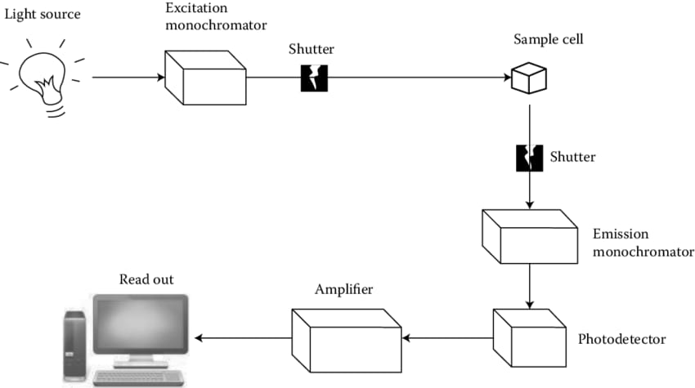
Fig No. 4: Instrumentation of Fluorescence Spectroscopy
B. Filters:
a) Primary filters
b) Secondary filters
C. Monochromators:
a) Excitation monochromators
b) Emission monochromators
D. Sample cells
E. Detectors (BK Sharma, 2011).

4.4 Advantages:
1. It is one of the more recent techniques, and its potential is yet mostly unexplored.
2. It has an impact on accuracy. In Flourimetric, 1% is easily attainable.
3. Because there is a choice of wavelength for both the light that excites it and the radiation that is emitted, the approach is exceedingly sensitive and specific (BK Sharma, 2011).

4.5 Disadvantages:
1. Because fluorescence intensity may be substantially dependant, careful buffering is required.
2. The fluorescent molecule may undergo photochemical modifications or perhaps be destroyed by the ultraviolet light utilised for excitation.
3. Increased photochemical degradation may result from the presence of dissolved oxygen.
4. Iodide and nitrogen oxide traces act as effective quenchers and interfere.
5. Because the method's accuracy is very low for big volumes, it is not appropriate for identifying a sample's main ingredients.
6. Since not all elements and compounds can display fluorescence, this technique's range of usefulness is constrained (BK Sharma, 2011).

4.6 Applications:
1. Determination of ruthenium
2. Determination of boron in steel
3. Determination of aluminium in alloys
4. Determination of chromium and manganese in steel
5. Determination of uranium salts
6. Estimation of rare earth terbium
7. Estimation of bismuth
8. Determination of beryllium in silicates
9. Estimation of 3, 4 benzpyrene
10. Determination of zinc
11. Determination of cadmium (BK Sharma, 2011).

5. IR SPECTROSCOPY
5.1 Introduction:
The study of the interaction of infrared radiation with materials by absorption, emission, or reflection is known as infrared spectroscopy (also known as IR spectroscopy or vibrational spectroscopy). Chemical compounds or functional groups in solid, liquid, or gaseous forms are studied and identified using this technique. An equipment known as an infrared spectrometer (or spectrophotometer), which generates an infrared spectrum, is used to perform the infrared spectroscopy method or procedure. A graph of infrared light transmittance (or absorbance) v/s frequency or wavelength on the horizontal axis can be used to depict an IR spectrum. Reciprocal centimetres, sometimes known as wave numbers, are frequently employed in IR spectra and have the notation cm1. The sign m, which stands for micrometres (formerly known as "microns"), is frequently used to represent IR wavelength units. Micrometres and wave numbers are reciprocally related (C. Conti, 2008).
5.2 Principle:
The IR spectroscopy theory is based on the idea that molecules have a tendency to absorb particular light frequencies that are unique to the corresponding structure of the molecules. The energies depend on the atomic masses, the related vibronic coupling, and the geometry of the molecular surfaces. For instance, the molecule may be able to absorb the energy present in the incident light, which will cause it to rotate more quickly or vibrate more loudly (C. Conti, 2008).
5.3 Instrumentation: (Fig No. 5)
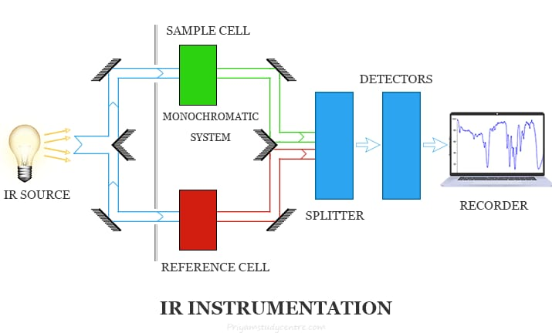
Fig No. 5: Instrumentation of Infrared Spectroscopy
Glass and quartz, which are common optical materials, absorb considerably in the infrared area; as a result, the equipment for detecting infrared spectra differs noticeably from that for the visible and ultraviolet regions. An IR spectrometer's essential components are as follows.
1. IR radiation sources
2. Monochromators
3. Sample cells and sampling of substances
4. Detectors
1. IR Radiation Sources: Infrared instruments, like other kinds of absorption spectrometers, need a source of radiant light that enables the isolation of specific narrow frequency bands.
IR radiation must be produced by the radiation source and must be:
(i) Intensive enough for detection
(ii) Steady
(iii) Extend over the desired wavelength
Despite the fact that these radiations are continuous, the sample will only absorb some of the frequencies.
The various popular sources of IR radiations are:
(a)Incandescent lamp
(b)Nernst Glower
(c) Globar source
(d)Mercury Arc
2. Monochromators: Different frequencies of radiation are emitted by the radiation source. It is vital to choose desirable frequencies from the radiation source and reject the radiations of other frequencies since the sample in IR spectroscopy absorbs only at particular frequencies. This selection was made using monochromators, which mostly come in two varieties:
a. Prism Monochromator
b. Grating Monochromator
3. Sample cells and sampling of substances:
Since samples of all phases must be treated since infrared spectroscopy has been used to characterise solid, liquid, and gas samples. However, some samples need to be handled differently. The substance carrying the sample, however, must be transparent to IR light. This is the single aspect of sampling distinct phases that is universal.
A. Sampling of solids: Four techniques are generally employed for preparing solid samples.
These are as follows:
a. Solid Run-in solution
b. Solid Films
c. Mull technique
d. Pressed Pellet Technique
B. Sampling of Liquids
C. Sampling of Gases
4 Detectors
a) Bolometer
b) Thermocouple
c) Thermistors
d) Semiconductor Detectors
e) Pyroelectric Detector (C. Conti, 2008).

5.4 Applications of IR spectroscopy:
1. Identification of an organic substance. If two chemicals exhibit identical I.R spectra under comparable circumstances, they must be the same material.
2. Establishing the structure.This tecquine aids in determining the structure of an unidentified substance.
3. Verifying the compound's purity. A pure chemical produces a distinct I.R spectrum, whereas an impure compound produces a muddled spectrum combined with numerous unintelligible bands.
4. Monitoring the development of the reaction can be aided by looking at the I.R spectrum.
5. Differentiate between intramolecular and intermolecular hydrogen bonds. The easiest way to learn more about the type of hydrogen bonds that exist in an organic chemical is to analyse it in diluted solutions using non-polar solvents. (C. Conti, 2008).

6. NUCLEAR MAGNETIC RESONANCE SPECTROSCOPY (NMR)
6.1 Introduction:
One of the most important analytical methods to be developed in recent years is nuclear magnetic resonance (NMR) spectroscopy. Through NMR, a wide range of biological and non-biological applications, from a single cell to organs and tissues, have been studied. Many parts of this technology are still being researched, and many NMR functions still need to be clarified and acknowledged (J. Keeler, 2011).
6.2 Principle:
The basic principle of NMR is that the nuclei of various substances, which have their own unique magnetic field, may be used to determine their structural and chemical makeup. The fundamental NMR spectrometer measures changes using a magnetic field and a specialised detector. Electrically charged nuclei migrate from a lower energy level (E1) to a higher energy level (E2) as a result of the strength of the external magnetic field, and the difference between E2 and E1 is represented by the symbol E, which depends on the strength of the magnetic field and the size of the nuclear field moment. The nuclei migrate to a higher energy level (E1/E2) when the electromagnetic radiation rhythm, which has a frequency (v), reaches the NMR signal (J. Keeler, 2011).
6.3 Instrumentation: (Fig No. 6)
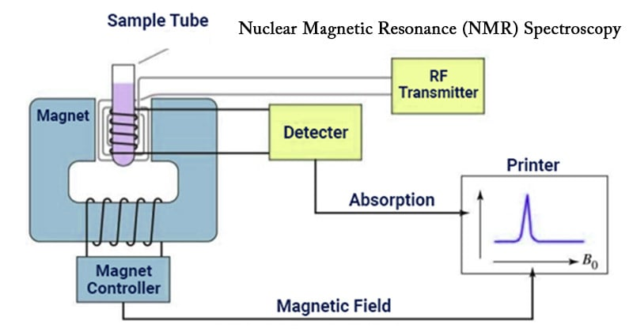
Fig No. 6: Instrumentation of Nuclear Magnetic Resonance Spectroscopy
The Nuclear Magnetic Resonance Spectrophotometers are two types based on the parameters that are measured.
1. Single coil spectrometers: It measures absorption.
2. Double coil spectrometers: It measures resonant radiation.
The resolution of an NMR spectrometer can alternatively be classified as low resolution or high resolution, with the former being able to do quantitative element analysis and also known as a wide line spectrometer.
The major components of NMR instrument are as follows:
a) Sample Holder: Typically, sample holders have dimensions of 8.5 cm in length and 0.3 mm in diameter. Since glass tubes are more affordable, they are frequently employed as sample holders. The sample holder possesses the aforementioned essential qualities.
· It should be sturdy.
· It should be practical.
· It should be cheap.
· It should be transparent to radio frequency radiations.
· It should be chemically inert.
b) Sample probe: It rotates the sample tube along its axis while holding it in a magnetic field, which produces finer lines with improved resolution since the effects of magnetic field homogeneities are reduced. Depending on the equipment, the probe could be a single coil or a network of coils.
c) Permanent Magnet: The most important feature of a permanent magnet or electromagnet is that it should produce a homogenous magnetic field, meaning that the strength and direction of the magnetic field shouldn't vary from one location to another. The field strength must be at least 20,000 guass since it is inversely related to the chemical changes.
d) Magnetic Coils: In order to create NMR spectra, it is used. Either a pair of Helmholtz coils placed on either side of the sample probe or the coils that are looped around the magnetic pole are used to accomplish this.
The following equation describes the relationship between the nucleus' resonance frequency and the strength of the magnetic field (H0):
V = constant x H0
According to that equation, the relationship between frequency and magnetic field intensity (H0) is a direct one. Keeping H0 constant fixes the precession frequency. The resonance frequency of the nucleus must be altered by altering H0 if radiofrequency is maintained constant.
e) Sweep Generator: The nucleus resonates if the precession frequency is identical to the applied frequency radiations. The magnetic field can be changed using the sweep generator approach, which is simpler than changing the radio frequency.
f) Radio Frequency Generator: Radio frequency transmitter is another name for radio frequency generator. A radio frequency oscillator is used to produce radio frequency radiation, which irradiates the sample molecules. The nucleus transitions from the ground state to the excited state as a result of the radiofrequency being applied. Resonance signals are produced by the coil enclosing the sample.
g) Radio Frequency Receiver: Absorption and dispersion are two processes that may happen when radio frequency radiation passes through a magnetised sample. It will be possible to determine the resonance frequency by looking at either absorption or dispersion.
For the detection of resonance signal following methods are used:
a) Under single coil instruments, Radio Frequency Bridge is employed. It enables the output of EMF across the bridge to appear as absorption and dispersion signals. Signals can be mechanically recorded.
b) This technique, which is also known as the crossed coil or nuclear induction method and uses a separate receiver coil, uses electromagnetic induction. In this, the coils for the transmitter and receiver are positioned perpendicularly to the magnetic field's direction and to one another.
h) Amplifier: The radio frequency receiver's absorption signal is incredibly feeble. As a result, data needs to be amplified significantly before being sent into a chart recorder, which uses an amplifier to amplify weak signals.
i) Read Out: The NMR spectra obtained from the equipment are mechanically or even electronically directly recorded (G. Chatwal, 2022).

6.4 Advantages:
• It is the most effective method for examining nuclear structure.
• Easy sample preparation before the measurement itself.
• Both organic and inorganic compounds can be analysed in a wide range of ways.
• Used in the fingerprint approach for chemical identification (G. Chatwal, 2022).

6.5 Disadvantages:
• Less sensitivity
• When spectra overlap, it is challenging to analyse the desired spectra.
• It is impossible to determine a compound's molecular weight.
• The price is high.
• A substantial sample size is needed.
• Mainly employed for liquid compound analysis (G. Chatwal, 2022).

6.6 Applications:
1. Structural diagnosis: There are numerous established rules that can be used to infer the structure of an unknown from its NMR spectrum. Here are a few of these examples:
- The total number of comparable protons in unidentified compounds should equal the total number of primary NMR signals.
- Chemical shift indicates types of H-atoms present.
E.g.: Methylene, Methyl, Ethers etc.
- Spin-spin splitting or multiplicity reveals potential group configurations in molecules.
- The number of hydrogen nuclei in each group can be calculated from the area of peaks.
2. Quantitative Analysis:
- Assay of component or % purity: This technique is used to calculate the active medicinal ingredient's purity in percent. NMR spectra of the chemicals used in this standard and sample are reported. The percent purity of the substance is calculated from that spectrum by comparing the peak areas of the sample and the standard.
- Chain length of surfactants: The chain length of the surfactant can be easily ascertained by looking at the NMR spectra. If we look at the spectrum of the aforementioned chemical, we can see that it has four peaks, which means that it includes four different types of hydrogen. We can determine the surfactants' chain length from this.
- Hydrogen analysis: We can quickly ascertain the quantity of hydrogen present in any substance by using its spectra.
- Moisture analysis: The molecular formula of Water contains two hydrogen atoms and one oxygen atom. Due to the extremely electronegative atom's connection, the hydrogen is deshielded. The absorption peak is moved downfield for such deshielding.
- Hydrogen Bonding: The distinction between intramolecular and intermolecular hydrogen bonds, including chelation, has been made using NMR in a straightforward manner. The hydrogen atom undergoes a deshielding and shifts to the downfield because hydrogen bonding entails the transfer of electron clouds from the hydrogen atom to nearby electronegative atoms like F, N, and O.
3. Determination of Keto-EnolTautomerism:
E.g.: Acetyl acetone
Keto-Enol form of any compound can be identified by NMR spectra, according to the peaks count.
4. Study of Isotopes other than Protons: Nuclear magnetic resonance spectroscopy can be used to study nuclei that have magnetic moments in addition to the proton's.
E.g.: fluorine and phosphorus. The ³¹P bearing spin number ½ exhibits sharp nuclear magnetic resonance peaks, with a resonance frequency of 24.3 MHz at 1400 guass.
Medical related applications: NMR is used in medical field for diagnosis of human body in two ways:
- Used for diagnosis for inborn errors of metabolism in urine like, phenyl ketonuria, Maple's urine syndrome.
- Magnetic resonance imaging (MRI) is an important medical diagnostic tool used to study the function and structure of the human body which is very safe to administer (G. Chatwal, 2022).

7. MASS SPECTROSCOPY:
7.1 Introduction:
Mass spectroscopy is a method of analysis that helps researchers study protein-protein interactions by identifying the biomolecules or proteins that are present in biological samples. Molecular weight of the material is measured by an analytical instrument. There are only picomolar doses needed. With excellent precision and tiny organic molecular precision within 5 ppm of Standard error. In biological systems, it can identify post-translational modifications and amino acid alterations. This method involves bombarding molecules with an intense electron beam. The molecules are ionised and fragmented into numerous pieces. There is a specific mass to charge ratio for each type of ion. Its value is the m/e ratio. The molecular mass of the ion is what the m/e ratio refers to (P. Dharmadhikari, 2022).
7.2 Principle:
A substance or molecule is broken up into charged species in accordance with their mass to charge ratio, which is then accelerated, deflected, and eventually focussed on a detector. Ion separation is based on the mass to charge (m/z) ratio, ion deflection is based on charge, mass, and velocity, and detection is proportional to ion abundance (P. Dharmadhikari, 2022).
7.3 Instrumentation: (Fig No. 7)
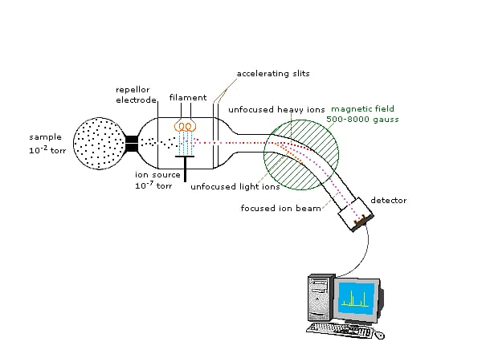
Fig No. 7: Instrumentation of Mass Spectroscopy
7.3.1 Intel system /sample handling system: In order to ensure that the sample enters the ionisation chamber, the mass spectrometer should have a vapour sample. In the gaseous state, the sample is transformed also has a heated inlet system. Before introducing the sample into the ionisation chamber, less volatile samples may be heated in the flask. In this situation, it's important to keep in mind that no sample is thermally stable. Less volatile materials and liquids may be immediately vaporised inside the ionisation chamber. Only a little portion of this will actually get through the ionisation chamber, and only approximately 0.1% of it is ionised there.
7.3.2 Ion source: Sample is introduced into the ionisation chamber from the inlet system. The sample molecules are exposed to an electron beam, which causes the molecules to ionise.
Ion sources:
1. Knudsen cell
2. Surface ionization
3. Spark source ionization
4. Chemical ionization
7.3.3 Magnetic Field: As the particles from the electric field that have been accelerated enter the magnetic field. They must travel in a curved path due to the magnetic field's influence.
7.3.4 Analyzer:
In that separate the ions according to their masses.
It must have a high rate of transmission ions.
It should have high resolution.
7.3.5 Detector:
1. The relative abundance of each mass's ion fragments is determined by the ion collection mechanism.
2. Mass spectrometers can use a variety of detector types. The electron multiplier serves as the detector in the majority of common experiments.
3. Photographic plates covered in a silver bromide emulsion, which are sensitive to energetic ions, are another form of detector.
4. Compared to an electrical detector, a photographic plate can provide a higher resolution (P. Dharmadhikari, 2022).
7.4 Advantages:
- High Sensitivity- Ability To Detect Very Small Amounts)
- High Selectivity- Ability To Tell Molecules Apart In A Mixture High Time Resolution
- Low Cost
- Small Sample Size
- Fast
- Differentiates Isotopes
- Can Be Combined With GC And LC To Runmixtures, Or Can Also Be Run In Tandem For Proteins Or Peptides Etc (P. Dharmadhikari, 2022).
7.5 Disadvantages:
- Doesn't Directly Give Structural Information (Although We Can Often Figure It Out)
- Needs Pure Compounds.
- Difficult With Non-Volatile Compounds (P. Dharmadhikari, 2022).
7.6 Applications:
1. The molecular weight, molecular formula, and fragmentation pattern in the mass spectra of a pure chemical all contribute to identify the substance. One of the greatest methods for figuring out a substance's molecular weight is mass spectrometry. The mass of the peak at the highest m/e in a mass spectrum of a substance after it has been bombarded with moving electrons precisely identifies the molecular mass. This aids in determining molecular weight. Similar to that, one can discover a compound's molecular formula.
2. High polymers, natural compounds, and the manufacture of pure isotopes can all be examined using mass spectrometry.
3. Since the stability of the ions produced for cis and trans ions may differ noticeably, mass spectrometry can also be used to discriminate between cis and trans isomers.
4. Mass spectrometry is also helpful in studying free radicals, determining bond strength, assessing sublimation heat, and other related tasks.
5. Analysis of closely related chemicals such hydrocarbons, petroleum products, lubricating lubricants, etc. can be done very well using mass spectrometry.
6. Mass spectrometry can be utilised for trace element analysis of elements in alloys, minerals, and super conductors in inorganic trace analysis (A. V. Kasture, 2008).

Bibliography:
- Arthus , Vogel, Text book of quantitative analysis ,page no;855.
- B. K. Sharma; A text book of instrumental methods of chemical analysis; Page.No:619 - 736.
- BK Sharma, Instrumental methods of chemical analysis, Molecular fluorescence spectroscopy [2011] page no: S537-S568.
- C. Conti, P. Ferraris, E. Giorgini, C. Rubini, S. Sabbatini, G. Tosi, J. Anastassopoulou, P. Arapantoni, E. Boukaki, S FT-IR, T. Theophanides, C. Valavanis, FT-IR Microimaging Spectroscopy: Discrimination between healthy and neoplastic human colon tissues , J. Mol Struc, 2008; 881: 46-51.
- Diletta Amia, Tui Nerib, Antonino Natalelloa, Paolo Mereghettic, Silvia Maria Dogliaa, Mario Zanonib, Maurizio Zuccottid, Silvia Garagnab, and Carlo Alberto Redib. ―Embryonic Stem Cell Differentiation Studied by FT-IR Spectroscopy‖ Biochimica et Biophysica Acta, 2008; 1783: 98-106.
- Douglas A Skoog, Donald M west, F James holler, Stanley R crouch, Molecular fluorescence spectroscopy ,Text book of Fundamentals of analytical chemistry ,edition:8, page no:826-838 .
- Dr. A. V. Kasture, Dr. K. R. Mahadik, Dr. S. G. Wadodkar, Dr. H. N. More; Pharmaceutical Analysis; volume-II; page. No: 222 – 233.
- Dr. A. V. Kasture, Dr. K. R. Mahadik, Dr. S. G. Wadodkar, Dr. H. N. More; Pharmaceutical Analysis; volume-II; page. No: 249.
- Dr.S. Ravishankar, Text book of pharmaceutical analysis: Flurimetry, edition 4, page no:3-18.
- G Verma, DR. M Mishra, “Development and Optimization of UV VIS Spectroscopy-A Review”, World Journal of Pharmaceutical Research, 2018,7(11),1170-1180.
- G. Vergoten and T. Theophanides, Biomolecular Structure and Dynamics: Recent experimental and Τheoretical Αdvances, NATO Advanced Study Institute, Kluwer Academic Publishers, The Netherlands, 1997; 327.
- Ganesh S, et al. “A Review on Advances in UV Spectroscopy”, Research J. Science and Tech. 2020,12(1),47-51
- Gurdeep R. Chatwal, Anand Sharma Instrumental method of Analysis 5th edition, Himalaya publishing house PVT.LTD, 2002 pp 2.566-2.587.
- Gurdeep R. Chatwal, Sham K. Anand; A text book of instrumental methods of chemical analysis; Page. No: 2.185-2.220.
- https://chem.libretexts.org/Bookshelves/Analytical_Chemistry/Analytical_Chemistry_2.1_(Harvey)/10%3A_Spectroscopic_Methods/10.07%3A_Atomic_Emission_Spectroscopy.
- https://www.chemistrylearner.com/atomic-emission-spectroscopy.html. Dodrecht, 1984. Publishing Co. Dodrecht, 1989; 415.States of America. McGraw Hill, 1999. Study Institute, D. Reidel Publishing Co. Dodrecht, 1984, 646.
- J L Aldabib, M F Edbeib, “The Effects of Concentration based on the absorbance form the Ultraviolet Visible Spectroscopy”, International Journal of Science Letters, 2020, 2(1): 1-11.
- John A. Dean. ―Lange’s Handbook of Chemistry‖ Section 7.5. Fifteenth Edition. United
- Keeler J. Chichester: John Wiley & Sons; 2011. Understanding NMR Spectroscopy.
- Kommu Naresh, Applications of Fluorescence spectroscopy, Journal of Chemical and Pharmaceutical sciences, [2014], page no: 18-21.
- M. Patil, “Advantages and Disadvantages of UV Visible Spectroscopy”, NOV 2018, https://chrominfo.blogspot.com/2018/11/advantages-and-disadvantages-of-uv.html?m=1.
- M. Petra, J. Anastassopoulou, T. Theologis & T. Theophanides, Synchrotron micro-FTIR spectroscopic evaluation of normal paediatric human bone, J. Mol Structure, 2005; 78: 101.
- Melissa A. Page and W. Tandy Grubbs, J. Educ, 1999; 76(5): 666.
- Modern Spectroscopy, 2nd Edition, J.Michael Hollas, ISBN: 471-93076-8.
- P. Kolovou and J. Anastassopoulou, ―Synchrotron FT-IR spectroscopy of human bones. The effect of aging‖. Brilliant Light in Life and Material Sciences, Eds. V. Tsakanov and H. Wiedemann, Springer, 2007; 267-272.
- Paudel S, Kumar S, Mallik A. Atomic Absorption Spectroscopy: A Short Review. EPRA Int. J. Res. Dev.(IJRD). 2021;6:322-7.
- Petru Pascuta, Lidia Pop, Simona Rada, Maria Bosca, and Eugen Culea. ―The Local Structure of Bismuth Borate Glasses Doped with Europium Ions Evidenced by FT-IR Spectroscopy‖ Journal of Materials Science: Materials in Electronics, 2008; 19: 424-428.
- Pooja A.Dharmadhikari, Prof. Santosh Waghamare, Dr.H.V.Kamble, Review Article on: Mass Spectrometry, International Journal of Pharmaceutical Research and Applications, Volume 7, Issue 3 May-June 2022, pp: 410-416.
- Schuster, K.C., Mertens, F., Gapes, J.R., ―FT-IR spectroscopy applied to bacterial cells as a novel method for monitoring complex biotechnological processes‖, Vibrational Spectroscopy, 1999; 19: 467-477.
- T. Theophanides Fourier Transform Infrared Spectroscopy, D. Reidel Publishing Co.
- T. Theophanides, C. Sandorfy) Spectroscopy of Biological Molecules, NATO Advanced
- T. Theophanides, Infrared and Raman Spectra of Biological Molecules, NATO Advanced Study Institute, D. Reidel Publishing Co. Dodrecht, 1978; 372.
- T. Theophanides, Inorganic Bioactivators, NATO Advanced Study Institute, D. Reidel
- T. Theophanides, J. Anastassopoulou and N. Fotopoulos, Fifth International Conference on the Spectroscopy of Biological Molecules, Kluwer Academic Publishers, Dodrecht, 1991; 409.
- U. Holzgrabe, I. Wawer, B. Diehl; A text book of NMR spectroscopy in Pharmaceutical analysis; Page. No: 277-279.
- Wikipedia, the free encyclopedia. Infrared spectroscopy http://en.wikipedia.org, July 28, 2007. Mount Holyoke College, South Hadley, Massachusetts. Forensic applications of IR http://www.mtholyoke.edu July 28, 2007.
- Willard, Merritt Dean; seltte; Instrumental method of analysis; 6th edition; Page. No: 422 – 454.
- Y. Anithakumari, Dr. M Sathishkumar, REVIEW ON ATOMIC EMISSION SPECTROSCOPY, Vol. 6 Issue. 10 (October-2021) EPRA International Journal of Research & Development (IJRD). https://doi.org/10.36713/epra2016.

