Versatile Holding Fixture for Keyway Cutting on VMC Machine

Dr. Pradnya Prakash More¹ Dr. Hredeya Mishra²
Lecturer in MED Lecturer in MED
MVPS’s RSM Polytechnic Nashik MVPS’s RSM Polytechnic Nashik
pradnya.more@rsmpoly.org 1002mishrahk@gmail.com

Abstract—The Fixture are work holding Device used to Locate and fix the position of work pieces for machining, Assembly, Inspection, and other operations. A Fixture consists of an arrangement of Clamping and locators. A clamping system that uses high-pressure liquids to power clamps and hold a work piece in place. Hydraulically clamped fixtures have many advantages over manually clamped fixtures.

Keywords- Hydraulic Fixture, Single Acting Spring Return Cylinder, clamping, Clamping on VMC machine, Fixture.

- INTRODUCTION
From the simplest fixture to robotic assisted machining centers, Enerpac workholding products can perform the positioning, support, and clamping functions in a wide array of manufacturing processes. With a setup time per part of only 5-10% of manual methods, hydraulic workholding offers a huge productivity increase in processes such as machining, punching, pressing, and many others. Not only are fabrication processes accelerated, but less parts are rejected and results are more consistent because each part is positioned, supported, and clamped in exactly the same manner. And, the automated nature of hydraulic workholding systems allows them to be readily integrated with operator safety systems. The benefits of hydraulic workholding don’t apply just to high-volume manufacturing; it’s often attractive for short and medium run production. A system can be set up quickly and inexpensively for short runs. Center-hole cylinders utilize standard stud thread sizes and are easily interchanged with manual clamps. Many manual elements can be used directly with hydraulic cylinders. Add a simple air-operated pump and controls, and your fixture is converted to a hydraulic setup. For medium runs, a little more automation pays off. For example, swing cylinders allow easy loading and removal of parts.

LITERATURE REVIEW
A Hydraulic fixture is a work-holding or support device used in the manufacturing industry. Fixtures are used to securely locate (position in a specific location or orientation) and support the work, ensuring that all parts produced using the fixture will maintain conformity and interchangeability. Using a fixture improves the economy of production by allowing smooth operation and quick transition from part to part, reducing the requirement for skilled
labor by simplifying how workpieces are mounted, and increasing conformity across a production run.
A fixture differs from a jig in that when a fixture is used, the tool must move relative to the workpiece; a jig moves the piece while the tool remains stationary. A fixture's primary purpose is to create a secure mounting point for a workpiece, allowing for support during operation and increased accuracy, precision, reliability, and interchangeability in the finished parts. It also serves to reduce working time by allowing quick set-up, and by smoothing the transition from part to part.^{[3]} It frequently reduces the complexity of a process, allowing for unskilled workers to perform it and effectively transferring the skill of the tool maker to the unskilled worker. Fixtures also allow for a higher degree of operator safety by reducing the concentration and effort required to hold a piece steady.
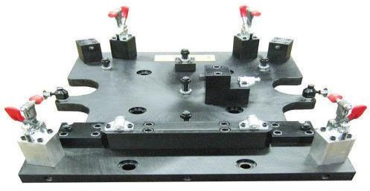
Fig.no.01 Manual clamping fixture.

Drawbacks
The Drawbacks of Manual Clamping are as Follows
  - It takes more time
  - Equal Force is not Acted
  - It can damage the jobs
  - Job is not clamped properly
  - Low rate of Production.
  - Job work time increases, it results in increasing in machining time
  - Labour work increases

Proposed System
We proposed this type of system since, by the usage of hydraulic fixture we can easily clamp the jobs and it is time saving it reduced the extra wages paid to the labour. The Hydraulic Fixture functions more efficiently than the manual clamping fixture Hydraulic fixture saves time which is required for the manual clamping.

First National Conference on Emerging Trends in Engineering and Technology 2021 Page 1 of 4

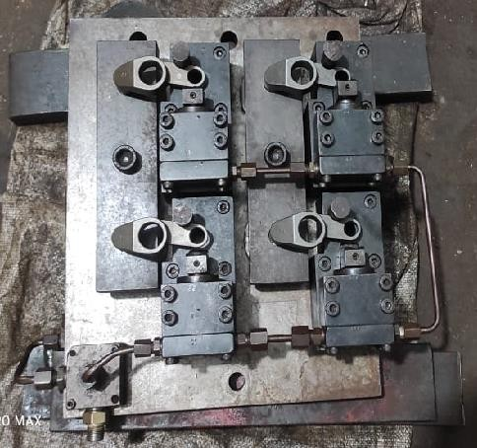
Fig.no.02 Hydraulic Clamping Fixture

Working of Hydraulic Fixture.
The Fixture showed in fig.02 is the hydraulic fixture this fixture is proposed to save the time and increase the productivity. The hydraulic oil is entered in the system through inlet valve and through the manifold valve it enters the semeless tube and after entering the simless tube it enters the spring return single acting cylinder and due to the pressure of the hydraulic oil the forward moment of the piston occur and the spring get compressed and job gets clamped.

METHODOLOGY
We are going to make a Hydraulic clamping Fixture for VMC Machine that is very easy to use and as compared to the existing manual clamping fixture. It saves time.

Major components Inovled in the Model are showned in table no.01.

Sr.no | Components | Quantity
01 | Support liver Fixture | 1
02 | Single Acting Spring Return  Cylinder | 4
03 | Manifold Block | 1
04 | Semens Job | 4
05 | Hose Pipe | 3
06 | Semeless tubes | 4
07 | Pressure Gauge | 1
08 | Hydraulic Hand Pump | 1
09 | Alan Bolts M6 | 4
10 | Alan Bolts M8 | 20
11 | Alan Bolts M10 | 20
12 | Alan Bolts M16 | 2
Table no.01. Components of Hydraulic Fixture.

Survey of Reasearch Paper and Finalization of Topic.
During the survey of various types of research papers. We found that many companies and workers in companies are facing many such problems regarding the fixture, so our team started searching about the easiest method of fixture and then we started doing the survey of many research papers such as, ‘Design and development of hydraulic fixture for machining’ by S.S Panchbhai and L.P Raut, ‘Analysis of Hydraulic Fixture by G. Vamshrikrishna and K.S.S Gurudatta’ and so many, after the researching these research papers we finalized our topic.

- Analysis of Materials /parts.

We analysis the following materials

  - Support Liver Fixture
  - Single Acting Spring Return Hydraulic Cylinder Top & Bottom
  - Manifold block for top and bottom Cylinder connection line,
  - Clamp cylinder mounting block S
  - EN8 Material.
  - Hydraulic Hand pump
  - Hose Pipe
  - Semeless tube
  - Pressure Gauge
  - Alan Bolt - M6, M8, M10, M16.

Design (Descripation) of Components.
  - Support Liver Fixture: Support Liver Fixture is used to Support the whole Fixture.
  - Single Acting Spring Return Cylinder: They are used in the fixture to hold the job tightly.
  - Manifold Block: It is used to control the flow of Hydraulic Oil in fixture.
  - Clamp Cylinder Mounting Block: It is used for the purpose of clamping and the cylinder are mounted on this block.
  - Hydraulic Hand Pump: It is used to Pressurized the hydraulic oil and transfer it into the hydraulic fixture. (It is operated Manually)
  - Semeless Tube: It is used to supply the Hydraulic oil in Single Acting Spring Return Cylinder.
  - Pressure Gauge: It is used to measure the pressure of hydraulic oil.

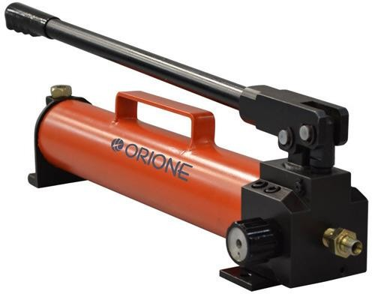

Fig.no.03 Hydraulic Hand Pump.

EXISTING SYSTEM
A fixture is a work-holding or support device used in the manufacturing industry. Fixtures are used to securely locate (position in a specific location or orientation) and support the work, ensuring that all parts produced using the fixture will maintain conformity and interchangeability. Using a fixture improves the economy of production by allowing smooth operation and quick transition from part to part, reducing the requirement for skilled labor by simplifying how workpieces are mounted, and increasing conformity across a production run. A fixture differs from a jig in that when a fixture is used, the tool must move relative to the workpiece; a jig moves the piece while the tool remains stationary. The main purpose of a fixture is to locate and in some cases hold a workpiece during either a machining operation or some other industrial process.
A jig differs from a fixture in that as it guides the tool to its correct position in addition to locating and supporting the workpiece. Fixtures should be designed with economics in mind; the purpose of these devices is often to reduce costs, and so they should be designed in such a way that the cost reduction outweighs the cost of implementing the fixture. It is usually better, from an economic standpoint, for a fixture to result in a small cost reduction for a process in constant use, than for a large cost reduction for a process used only occasionally. Most fixtures have a solid component, affixed to the floor or to the body of the machine and considered immovable relative to the motion of the machining bit, and one or more movable components known as clamps.
These clamps (which may be operated by many different mechanical means) allow workpieces to be easily placed in the machine or removed, and yet stay secure during operation. Many are also adjustable, allowing for workpieces of different sizes to be used for different operations. Fixtures must be designed such that the pressure or motion of the machining operation (usually known as the feed) is directed primarily against the solid component of the fixture. This reduces the likelihood that the fixture will fail, interrupting the operation and potentially causing damage to infrastructure, components, or operators.
Fixtures are used to hold the work piece during machining operations. It is also used during the time of inspection, welding and assembling process. This paper presents, design analysis and development of hydraulic fixture for real industrial fixture. The component is hydraulic lift housing which is tractor part. The operations to be performed are milling, drilling, reaming & chambering on VMC.
In existing design, the fixture set up is done by hydraulic. The existing fixture design is vibration occurs from the machining process, so product quality is less. From existing research analysis in this area, our project idea is extra hinge clamp device has to be added. Hydraulic fixture to reduce vibration and increase the product quality. In this research is analyzed by ANSYS we have found that the new fixture design will be better than existing model because the new model will give the less amount of vibration than existing model.

In order to have interchangeable parts in mass production, jigs and fixtures play a vital role in manufacturing process. A fixture is a special tool designed for specific purpose and for specific component for operation. The present work deals with the design of machining fixture for milling and drilling operations for a crank case.
A fixture is a special tool designed for specific purpose and specific component for operation. The present work deals with the design of machining fixture for milling and drilling operations for a Wabco body housing. The cutting forces involved in the operations are taken into consideration for designing the fixture. The present fixture designed is hydraulic operated and used for operation like face milling, drilling and boring of the body housing.
The cutting forces involved in the operations are taken into consideration for designing the fixture. The present fixture designed is hydraulic operated and used for operation like face milling, drilling, Tapping, Rough &Finish Boring of the crank case.
Design standards are taken from Makino for designing this machining fixture. In the design process based on the geometry of the component to be machined, the machine, the table layout and corresponding clamping slot positions are then selected.
Since the final component cannot be produced by a single operation it is necessary to plan for various operations to get the final shape. The fixture is then designed by considering all the clamping forces from various cutting operations.
Design standards are taken from Makino for designing this machining fixture. In the design process based on the geometry of the component to be machined, the machine, the table layout and corresponding clamping slot positions are then selected. Since the final component cannot be produced by a single operation, it is necessary to plan for various operations to get the final shape.

VI. RESULT AND DISCUSSIO
The system proposed by our group is very effective and time saving it leads in increasing of production in minimum time and high accuracy is obtained. The graph showed below in fig.no.04 tells us about the rate of production increased by the Hydraulic Fixture that is the proposed System in comparsion with the existing system that is manual fixture.
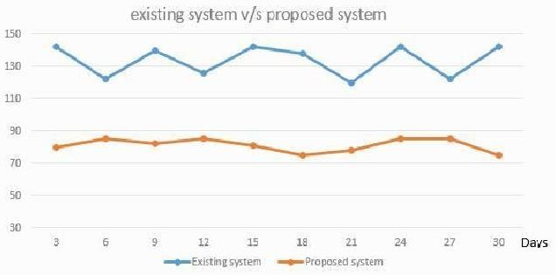

V.DESIGN ANALYSIS
Fixtures are workholding devices designed to hold, locate and support workpieces during manufacturing operations. Fixtures provide a means to reference and align the cutting tool to the workpiece but they do not guide the tool. Fixtures are used to securely locate and support the work, ensuring that all parts produced using the fixture will maintain conformity and interchangeability.

Fig.no.04. Graph of Existing system and proposed System

Rate of production is increased due to the implementation of the hydraulic fixture the rate of production of manual fixture and the hydraulic fixture is showed below in the form of graph. The Graph is showed below.

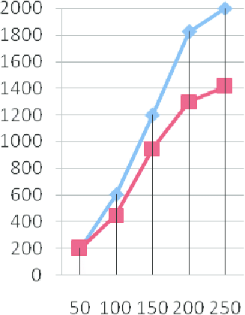

Fig.no.05 Graph of rate of production

VII CONCLUSION
Thus the method of manual fixture is very time consuming and difficult it requires lots of human efforts to clamp the job manually, and hence our group proposed this type of Hydraulic Fixture which is very easy to used and very easy used to handle, also it takes very less time in clamping of job

FUTURE SCOPE
Our fixture is a Hydraulic Fixture it requires very less amount of effort and at this moment it working on manual operated hydraulic pump, a manual operated Hydraulic pump is used to pressurise the hydraulic oil in the fixture to produce work that is to clamp the job. But in Future it can be work on Automated Hydraulic pumps, Electric Hydraulic pump and it can even work on the hydraulic power pack.
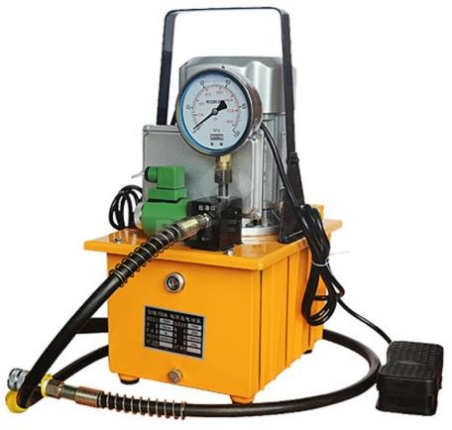
Fig.no.06. Electric Hydraulic Pump
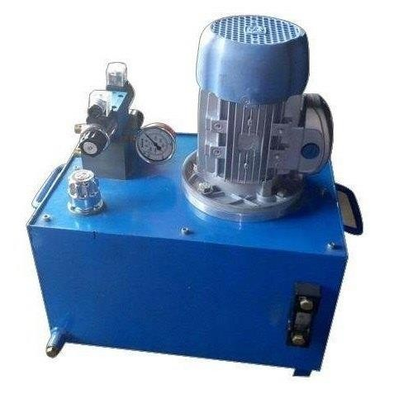
Fig.no.07 Hydraulic Power Pack

REFERENCES
- Sridharakeshava K B, Ramesh Babu. K, “An Advanced Treatise on Jigs and Fixture Design” International Journal of Engineering Research & Technology (IJERT) ISSN: 2278- 0181Vol. 2 Issue 8, August – 2013.
- S.D.V.V.S.B. Reddy, P. Satish Reddy, V. Subrahmanyam, “Design And Analysis Of Machining (Hydraulic) Fixture For AVTEC Transmission Case Component” International Journal of Science Engineering and Advance Technology IJSEAT, Vol 2, Issue 7, July - 2014 ISSN 2321-6905.
- Shailesh S Pachbhai and Laukik P Raut, “DESIGN AND DEVELOPMENT OF HYDRAULIC FIXTURE FOR MACHINING HYDRAULIC LIFT HOUSING”, International Journal of Mechanical Engineering and Robotics Research ISSN 2278 – 0149 Vol. 3, No. 3, July, 2014.
- Shailesh S Pachbhai and Laukik P Raut, “A Review on Design of Fixtures”, International Journal of Engineering Research and General Science Volume 2, Issue 2, Feb-Mar 2014, ISSN 2091-2730 Department of Mechanical Engineering, G.H.Raisoni college of Engineering, Nagpur 440016.
- Nagaraj Anand Shet, Prasad U Raikar, “Design and Development of Hydraulic Fixture for Basak Cylinder Head Machining”, International Advanced Research Journal in Science, Engineering and Technology, ISO 3297:2007 Certified Vol. 4, Issue 10, October 2017, Product Design &Manufacturing Engineering VTU Belagavi, India.

