Assessment of Fish Diversity and Anthropogenic pressure on Kopra wetland of Bilaspur District of Chhattisgarh
Ajay Kumar Singh, Manisha Shyamchetti, Sudhir Ranjan Choudhury*, Ashutosh Anand, Vagmare Baswanth
Department of Forestry, Wildlife and Environmental Science,
Guru Ghasidas Vishwavidyalaya, Bilaspur, Chhattisgarh
*Corresponding author, Email: sudhirranjanchoudhury@gmail.com
INODUCTION
Wetlands are extensively important for ground water recharge, recreational activity, retention, and regulation of pollutants and it support many aquatic floral and faunal species for sustaining their life (Crisman 2001). The water-dependent avifauna and their habitat are affected by various factors like food availability, hunting and poaching threats, the size of the wetland (Paracuellos, 2006), and the Abiotic changes in the wetlands (Jaksic 2004). In a wetland ecosystem, these biotic factors are mostly dependent on the seasons and hydrology. The Freshwater ecosystem is the natural habitat for numerous organisms. They can survive in all types of aquatic habitats. They play a significant role in the tropical guild of the aquatic ecosystem. Fishes are highly sensitive to environmental changes (Simon and Lyons, 1995). Fishes play a significant role in maintaining and existence of Aquatic ecosystem. Fishes act as a bio-monitoring tool due to their prolonged existence and Septo-temporal effect. According to IUCN, 868 species of fish are found in freshwater ecosystem of India, out of which 192 species are endemic and 327 species are in threatened category (Lakra et al., 2010).
Reservoirs often provide new habitats for fish species that were not present in the original river or stream. They can support a diverse range of aquatic plants, insects, and other organisms, which in turn attract various fish species. Reservoirs typically have abundant food resources, such as plankton, algae, and aquatic invertebrates. This can lead to increased productivity and provide a food source for a wide variety of fish species. Reservoirs can facilitate the expansion of fish species' ranges by creating new water bodies connected to existing river systems. This can enhance fish diversity by allowing species to colonize previously inaccessible areas. Reservoirs often provide new habitats for fish species that were not present in the original river or stream. They can support a diverse range of aquatic plants, insects, and other organisms, which in turn attract various fish species. Reservoirs typically have abundant food resources, such as plankton, algae, and aquatic invertebrates. This can lead to increased productivity and provide a food source for a wide variety of fish species. Reservoirs can facilitate the expansion of fish species' ranges by creating new water bodies connected to existing river systems. This can enhance fish diversity by allowing species to colonize previously inaccessible areas. The water quality of a reservoir can vary depending on various factors, including its location, surrounding land use, water sources, and management practices.
Natural calamities, anthropogenic activities and pollution may destroy or modify the habitat of freshwater fishes (Sarkar, 2021). These are the major threats for aquatic ecosystems (Cowx, 2002). Overfishing or indiscriminate fishing (use of mosquito net, dynamite and electrofishing) causes mass mortality of fish species and huge reduction of their population size (Sarkar et 2008) and introduction of exotic fish may cause the introduction of new diseases and parasites in new habitat. They also increase the conflict between exotic and Indigenous fishes and finally the introduced exotic fishes may reduce the population size of indigenous fish species. Reservoir water derives its composition from the feeding river system, weathering and geochemical processes operating in the catchments and anthropogenic sources. Natural composition of reservoir waters are essentially regulated by the breakdown of rock matrix in response to the reactive rainwater containing dissolved carbon-dioxide; however, deviations in natural water chemistry could be introduced by man at any stage or location in the drainage basin. Reservoirs and lakes could be the main resources exploited for inland fisheries. The understanding of fish faunal diversity is a major aspect for the exploitation of freshwater reservoirs and sustainable as well as economical management (Battul et.al.2007). Lakes in India support rich variety of fish species, which, in turn, support the commercial exploitation of the fisheries potential .
A reservoir is a water body formed either by the accumulation of flowing water behind a constructed dam (river reservoir) or less commonly by pumping water into an artificial impoundment formed by a manmade embankment around its entire perimeter to create a fully bunded dam (storage reservoir). As the worldwide demand for water increases, the construction of more reservoirs is inevitable, despite the controversy and opposition they create.
Anthropogenic pressure refers to the impact or influence that human activities have on the environment. Reservoirs, which are artificial bodies of water created by the construction of dams, can be subject to various anthropogenic pressures. Reservoirs are often built to provide a reliable water supply for human consumption, agriculture, and industrial use. The extraction of water from reservoirs can put pressure on their water levels, leading to reduced storage capacity and potential water scarcity. Human activities near or within the catchment area of a reservoir can result in the introduction of pollutants. Industrial discharges, agricultural runoff, and improper waste disposal can contaminate the water in reservoirs, affecting their quality and making them less suitable for various purpose. The construction of dams and reservoirs can interrupt the natural flow of rivers, causing sediment to accumulate in the reservoirs. Over time, this sedimentation reduces the storage capacity of the reservoir, affecting its efficiency and lifespan. It is important to note that the specific anthropogenic pressures on reservoirs can vary depending on the region, local regulations, and the nature of human activities in the vicinity of the reservoir. The fresh water reservoirs made with this purpose are underutilized and except water utility management no further use of such water sheets is done.
In India, there are 19,370 reservoirs spread over 15 states, covering 3.15 million ha. The area is expected to grow further to 6 million ha in due course of 25 years. State of Chhattisgarh has 1.707 million ha water area. Out of the total water spread area in Chhattisgarh 54 percent is in the form of reservoirs. Total number of reservoirs in the state are 1,690 (85,188 ha), out of which 1,657 (37,432 ha) are small, 21 (25,610 ha) medium and 12 (22,146 ha) are large ones covering an area of 56.72 percent, 20.83 percent and 22.45 percent respectively. (Annon, 2008). Fish production from these resources in India is currently very low (average about 20 kg / ha /yr) against their potential. This is due to lack of understanding of reservoir ecology, proper management and exploitation policies.
Chhattisgarh state consist of 27,823 wetlands (including smaller than 2.25 ha) and area covered by wetlands are 337,966 ha that is around 2.5% of the total geographical area of the state. The major wetland types are River/Stream accounting for about 53% of the wetlands (179,088 ha), Reservoirs (90,389ha), and Tanks/Ponds (40,226ha)(http://chtenvis.nic.in/Forest.html). Kopra wetland is a unique habitat matrix that changes throughout the year.
Kopra reservoir is one of the suitable habitats for water-birds and fishes near Bilaspur city, Chhattisgarh and it was established in the year 1993 in the Mahanadi basin for the purpose of irrigation. The main purpose of establishing this dam was to provide irrigation facilities to surrounding villages for the purpose of agriculture. These reservoir play a crucial role in the overall development of the region by providing water resources for agriculture, drinking water supply, and supporting the local ecology. Reservoir contribute significantly to the socio-economic growth of Bilaspur district in Chhattisgarh (India-WRIS 2014).
The present study is based on the documentation and estimation of fish diversity, water quality of Kopra wetland and how the diversity changes throughout the year with a focus on the pre-monsoon season. By performing the community interaction, fisherman community interaction and socio-economic survey in kopra and khairadhih villages. Kopra village is located in south west of the kopra reservoir and khairadhih village located in north east of the kopra reservoir.
Objective :-
1. Survey of pre-monsoon Fish diversity of Kopra reservoir of Bilaspur district.
2. To evaluate the water quality of the Kopra reservoir.
3. To study the anthropogenic pressure on the reservoir.
MATERIAL AND METHODOLOGY
Description of study area :- Bilaspur district is located in the state of Chhattisgarh, India. The district is known for its rich natural resources, including several reservoirs that serve as important water sources and provide irrigation and drinking water to the region. Kopra reservoir is established in the year 2000-2001 in the Mahanadi basin for the purpose of irrigation. This is a seasonal wetland which is placed in the GPS coordinate 22°304000 Nto22°401500 N latitude and 82°203000 E to 82°303100 E longitude geo-graphical location. The Kopra wetland is situated in the Raipur–Bilaspur bypass in Sakri Village of Bilaspur district of Chhattisgarh, India. It is around 10 km from Bilaspur city. The Length of the wetland is 1680 m and113 TCM total volume content (India-WRIS 2012).
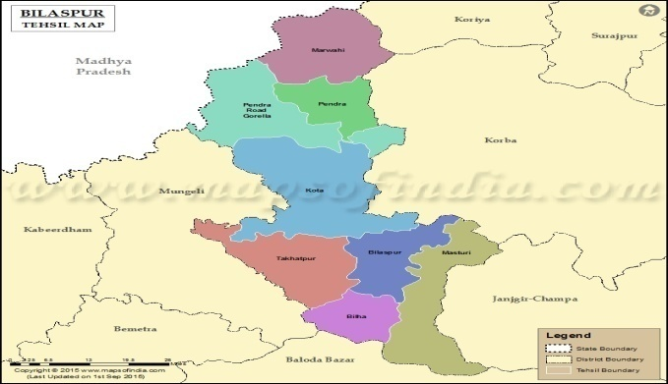
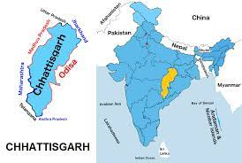
Sampling sites as a map:-
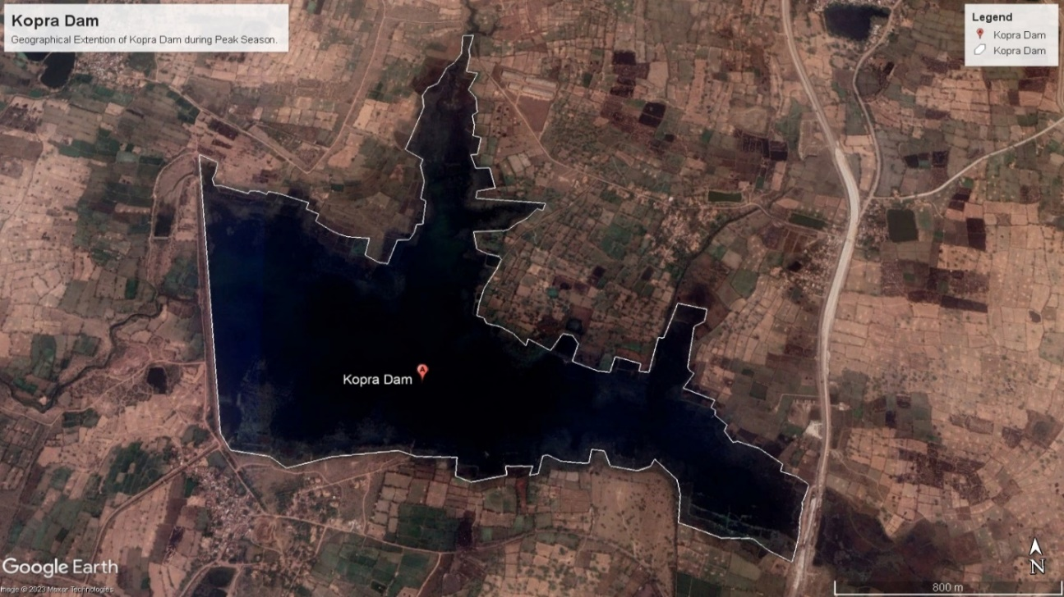
Map.1 : kopra reservoir map of Bilaspur.

Method: Survey of Kopra dam and nearby area was carried out from April 2023 to July 2023. The survey was done based on a general interview of fisherman and local peoples. Primary data was collected through personal interviews of fisher community families. Samples were collected at regular intervals with fishermen community interaction and local village peoples. Evening 5pm fishermen lay the fishing nets in water. After overnight, in the early morning fishermen take out the fishing nets. Collected fishes all identified by its colour patterns, Spots, size, shape, position of fins or the number of scales in a specific series and designs have been noted when they are in fresh condition. And took some pictures for identification and confirmation of species. than prepared a list of fishes in field diary with its local names. Morphological characters includes total length of body, standard length of the body, length and dept of the head, position and diameter of the eye, length of snout, maximum and minimum width and girth, length of pre dorsal fin, pre pectoral fin, pre anal fin and pre caudal fin. Descriptive character includes profile and shape of the body, skin texture and coloration, position and shape of the mouth, lips and snout and jaws, scales and lateral line system. Shape, size and type of median, paired and caudal fins, fin rays and fin formula, tail and special marking. A field kit measuring tape, rope, preservative, digital camera etc.
Water samples are collected from different points on kopra reservoir. The water quality Parameters such as water pH, oxygen reduction potential (ORP), Dissolved Oxygen (DO), Total Dissolved Solids (TDS), temperature, Conductivity are measured by multi-parameter instrument. During general interviews with village people observations have been noted and observed how they depend on reservoir and asked some question for relate the anthropogenic presser on Kopra reservoir. And also collected samples of ground water from near villages; Kopra village and Khairadhih village.
RESULT
Data analysis:-
Survey of pre-monsoon Fish diversity of Kopra reservoir of Bilaspur district.
The collected data show different types fish species are present in Kopra reservoir. Total 27 species, 11 family and 6 order of fishes are present. In this species 14 species are LR-nt (lower risk near threatened), 8 species are VU (Vulnerable), 1 species are LR-Ic (lower risk least concern and 3 species are EN (endangered species).
To evaluate the water quality of the Kopra reservoir.
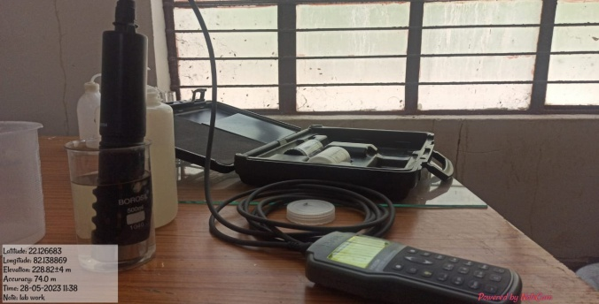
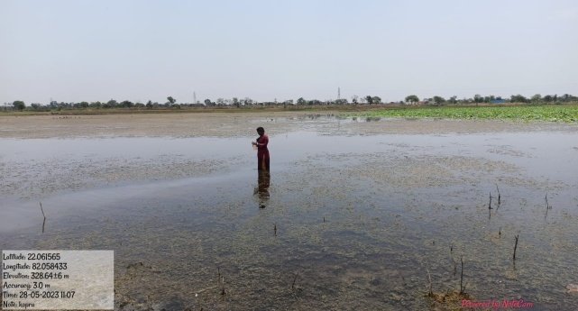
Reservoir water quality refers to the chemical, physical, and biological characteristics of water in a reservoir. The quality of reservoir water is important because it directly impacts the ecosystem within and around the reservoir, as well as the suitability of the water for various uses such as drinking water supply, irrigation, industrial processes, and recreation.

Here are some key factors that affect reservoir water quality:
- Temperature: Reservoir water temperature can influence the growth and survival of aquatic organisms. Higher temperatures can lead to reduced oxygen levels, increased algal growth, and changes in species composition. A average temperature in kopra reservoir water is 32˚C in summer season and in rainy season temperature is 26˚C. and ground water temperature are 26.58 kopra and 26.79 is khairadhih village.
- Dissolved Oxygen (DO): DO is essential for the survival of aquatic organisms. It enters the water through atmospheric diffusion and photosynthesis by aquatic plants. Factors such as temperature, organic matter decomposition, and algal blooms can affect DO levels. Low DO concentrations can lead to fish kills and other negative impacts on aquatic life.DO is essential for the survival of aquatic organisms. It is the amount of oxygen dissolved in the water, and it is necessary for fish and other aquatic organisms to respire. Low DO levels can result from pollution, high temperatures, or excessive algal growth. Average DO in kopra reservoir water 7.32 in ppm. Kopra village water DO is and 5.81 ppm DO , is kharadhih water DO and 5.01ppm DO.
- pH: pH is a measure of the acidity or alkalinity of water. It can influence the availability of nutrients and the toxicity of certain substances to aquatic organisms. Most aquatic species thrive within a specific pH range, and significant deviations from that range can harm them. The pH level indicates the acidity or alkalinity of water. It is an important factor that affects the survival and growth of aquatic organisms. Some species are more sensitive to changes in pH than others. in kopra reservoir water pH is 9.2 water is slightly basic or alkaline. In terms of water quality, a pH of 9.2 is generally considered acceptable and safe for most purposes. Kopra village ground water pH is 7.68 and khairadhih village ground pH is 7.28. However, the ideal pH for drinking water is typically in the neutral range of 6.5 to 8.5. Water with a pH slightly above or below this range is still generally safe to drink.
- ORP: stands for Oxidation-Reduction Potential, which is a measure of the ability of a substance to oxidize or reduce another substance. In the context of water, ORP refers to the water's potential to either gain or lose electrons during a chemical reaction. It is typically measured in millivolts (mV). In kopra reservoir -24. ORP. And kopra village ground water -9.3, khairadhih village ground water -2.9. A positive ORP value indicates that the water has the potential to oxidize substances, while a negative ORP value suggests that the water has the potential to reduce substance effect the taste and could potentially indicate other water quality issues.
- Water conductivity: also known as electrical conductivity (EC), is a measure of the ability of water to conduct an electrical current. It is a fundamental parameter used to assess the overall quality and purity of water. Conductivity is typically measured in units of Siemens per meter (S/m) or micro siemens per centimeter (μS/cm). kopra reservoir water EC is 240μS/cm and kopra village ground water 809μS/cm and khairadhih village ground water 2403μS/cm . The electrical conductivity of water is influenced by the presence of dissolved ions, such as salts and minerals. When these ions are dissolved in water, they become charged particles called ions. These ions facilitate the flow of electrical current through the water. According parameter khairadhih groung water conductivity is very high, Water conductivity of 2403 μS/cm (microsiemens per centimeter) indicates that the water has a relatively high level of dissolved salts or ions. Conductivity is a measure of how well water can conduct an electrical current, and it is influenced by the presence of dissolved substances.
- TDS: stands for Total Dissolved Solids, and it is a measure of the total concentration of all dissolved substances in water. These substances can include minerals, salts, metals, organic compounds, and other dissolved solids. TDS is typically measured in units of milligrams per liter (mg/L) or parts per million (ppm). In kopra reservoir water TDS is 104.74ppm, kopra village ground water TDS is 404 ppm, khairadhih village ground water is 1202ppm. The measurement of TDS provides important information about the overall quality of water, as it reflects the total amount of dissolved substances present. Generally, higher TDS levels can indicate a higher concentration of dissolved solids in the water.1204 ppm (parts per million) indicates the presence of various dissolved substances in the water, such as salts, minerals, metals, and other ions. The TDS level can have several implications,
- Biological Contaminants: Reservoirs may be affected by pathogens, such as bacteria, viruses, and parasites, which can be introduced through sewage discharge, animal waste, or other sources. Proper disinfection and water treatment are necessary to ensure safe drinking water. Bacterial and Pathogen Contamination: Reservoirs can be susceptible to bacterial contamination, such as from fecal coliform bacteria, which can indicate the presence of harmful pathogens. This can occur due to inadequate wastewater treatment or the runoff of animal waste from agricultural activities. Reservoirs can be susceptible to bacterial contamination, such as from fecal coliform bacteria, which can indicate the presence of harmful pathogens. This can occur due to inadequate wastewater treatment or the runoff of animal waste from agricultural activities.
Monitoring and managing reservoir water quality is crucial to maintain a healthy ecosystem and to ensure the safety of water supplies. Water resource management agencies often conduct regular water quality testing, implement pollution control measures, and enforce regulations to protect reservoirs and the surrounding environment. To ensure and maintain good reservoir water quality, regular monitoring, testing, and appropriate management practices are necessary. This includes implementing water treatment processes, regulating pollutant discharges, and implementing conservation measures to protect the watershed and prevent pollution sources from entering the reservoir.
3. To study the anthropogenic pressure on the reservoir:-
Anthropogenic pressure refers to the impact and influence of human activities on the environment. These pressures can have various forms and can affect different aspects of the environment, including air, water, land, and ecosystems. Here are some examples of anthropogenic pressures
- Pollution: Human activities such as industrial processes, transportation, agriculture, and waste disposal can release pollutants into the environment. This includes air pollution from vehicle emissions and industrial smokestacks, water pollution from chemical runoff and wastewater discharge, and soil contamination from improper waste disposal. Kopra reservoir is free from pollution like industrial processes or other activities, it’s very peaceful place and human interaptions is very less. That’s why in kopra reservoir is one of the highly bird diversity wetland.
- Deforestation: Clearing forests for agricultural purposes, urban development, or logging contributes to deforestation. This results in the loss of habitats for numerous plant and animal species, disrupts ecosystems and contributes to climate change by reducing the capacity of forests to absorb carbon dioxide. In kopra reservoir deforestation activity is less.
- Overfishing: Overfishing occurs when fishing practices exceed sustainable levels, depleting fish populations and disrupting marine ecosystems. It can result in the collapse of fish stocks, affecting the livelihoods of communities dependent on fishing and the overall health of marine ecosystems. There on overfishing done in Kopra reservoir.
- Habitat Destruction: Human activities, such as urbanization, agriculture, and infrastructure development, can lead to the destruction and fragmentation of natural habitats. This results in the loss of biodiversity, as many species depend on specific habitats for their survival.
- Land Use Changes: Conversion of natural landscapes, such as forests or grasslands, into agricultural fields, urban areas, or industrial zones, alters the natural balance of ecosystems. This can lead to habitat loss, soil erosion, and changes in water availability. Addressing anthropogenic pressures requires sustainable practices, environmental regulations, conservation efforts, and the adoption of cleaner technologies. It involves promoting resource efficiency, reducing pollution, protecting natural habitats, and mitigating climate change through measures such as renewable energy adoption and carbon sequestration. part of the Kopra reservoir has been excluded due to construction of the NH130 highway. For such reason pollution increases at high rate, ecosystem has been disturbed and feeding habits of fauna shifted. And main component disturbed by this were aquatic vertebrates.
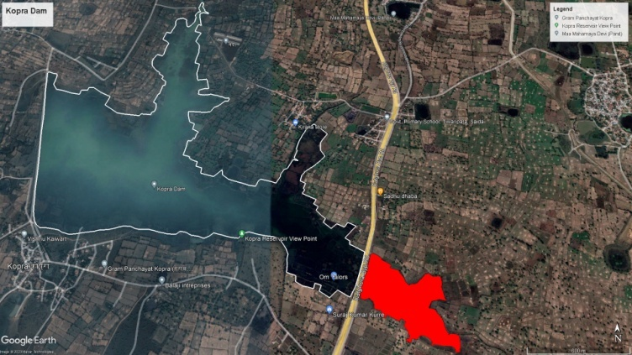
Fig no.4 kopra reservoir
Tables and graph :-
Table no. 1:-List of fish diversity of kopra reservoir-
S.N | Common/local name | zoological name | Family | order | IUCN status
1 | Tilapia | Oreochromis mossambicus | cichlidae | cichliformes | LR-nt
2 | Catla | Catla catla | cyprinidae | cyriniformes | LR-nt
3 | Mrigal | Cirrhinus mrigala |  |  | LR-nt
4 | Borai/Reba | Cirrhinus reba |  |  | VU
5 | Komal carp | Cyprinus carpio |  |  | VU
6 | Bata | Labeo bata |  |  | LR-nt
7 | Kamach/Kariya | Labeo calbasu |  |  | LR-nt
8 | Rohu | Labea rohita |  |  | LR-ic
9 | Bata | Labeo boggut |  |  | LR-nt
10 | Amachaini | Labeo dyocheilus
11 | Kotri | Puntius chola |  |  | LR-nt
12 | Puthia/Kotra | Puntius saranasarana |  |  | VU
13 | JarhiKotra | Puntius sophore |  |  | LR-nt
14 | Sanwal/Sol | Channa marulius | channidae | ophiecephaliformes | VU
15 | Khoksi | Channa punctatus |  |  | LR-nt
16 | Bhunda | Channa striatus |  |  | LR-nt
17 | Kevai | Anabus testudineus | anabantidae |  | LR-nt
18 | Chital | Chitala chitala | notopteridae | osteoglossiformes | EN
19 | Patola | Notopterus notopterus |  |  | EN
20 | Mongri/Mangur | Clarias batrachus | claridae | siluriformes | VU
21 | Singhi | Heteropneustes fossilis | saccobranchidae |  | VU
22 | Tengna | Mystus gulio | bagridae |  | LR-nt
23 | Botia | Ompok bimaculatus |  |  | EN
24 | Padhan/lonch | Wallago attu | siluridae |  | LR-nt
25 | Kewai | Heteropneustes fossilis | heteropneustidae |  | VU
26 | Bami | Mastacembelus armatus | mastacembelidae | synbranchiforms | VU
27 | Choti Bami | Mastacembelus pancalus |  |  | LR-nt
Abbreviation-EN=endangered; LR-ic=Lower risk least concern; LR-nt=Lower risk near threatened; VU-vulnerable

Table no.2 water quality parameters:-
Name sites | Temperature | pH | DO ppm | conductivity | ORP(oxygen reduction potential) | TDSppm(total dissolve solids)
Site_1 | 33.11 | 9.3 | 7.08 | 231 | -17.7 | 100
Site_2 | 31.7 | 9.04 | 7.45 | 205 | -20.7 | 91
Site_3 | 32.24 | 9.42 | 7.37 | 235 | -32.2 | 102
Site_4 | 32.6 | 9.22 | 7.28 | 289 | -25.8 | 126
Ground water kopra | 26.58 | 7.68 | 5.81 | 809 | -9.3 | 404
Ground water khairadih | 26.79 | 7.28 | 5.01 | 2403 | -2.9 | 1202

Ghaph no.2 showing the kopra reservoir and both villages groung water pH

Graph no.5 showing the kopra reservoir and villages ground water conductivity

Graph no. 7 showing the kopra reservoir water and villages ground water TDS
Reservoirs play a crucial role in maintaining healthy aquatic ecosystems, supporting biodiversity, and providing recreational opportunities for anglers and nature enthusiasts. High water quality is vital for supporting diverse fish populations. Clean and well-oxygenated water is essential for the survival of various fish species.kopra reservoir is contains high number of fish diversity and Consideration of water level fluctuations, as some fish species rely on specific water depths and seasonal variations for breeding and feeding. Without anthropogenic inputs such as pollution, industrial runoff, or agricultural discharges, the water quality remains high and free from harmful contaminants. This leads to better oxygen levels, clear water, and suitable conditions for aquatic life. Reservoirs without anthropogenic activity would likely have unobstructed migration routes for fish, facilitating natural movements between different habitats and contributing to gene flow among populations. Implementing responsible and sustainable fishing practices helps maintain fish populations at healthy levels. Fishing regulations, such as catch limits and size restrictions, can prevent overfishing and ensure the sustainability of fish populations. Overall, kopra reservoir well-managed fish diversity reservoir, balance the needs of human use, conservation, and ecological health. Reservoir is essential to work towards preserving the natural balance and diversity of fish species to ensure the reservoir's long-term sustainability and the well-being of the surrounding ecosystem.
Discussion:- A total of 27 species representing 11 family and 6 order (table 1). Were recorded; of 14 species are LR-nt(lower risk near threatened), 8 species are VU (Vulnerable), 1 species are LR-Ic (lower risk least concern and 3 species are EN (endangered species). some following fish species found in kopra reservoir. The main shallow-water fishes are Labeo rohita, Labeo gonius, Ompok bimaculatus and deepwater fish are Catla catla, Chita lachitala and Notopterus notopterus etc. On the basis of their feeding habit, the collected fishes have been categorized into three categories viz. surface feeder Catla catla, middle feeder Labe orohita, Wallego attu, Mystessps. and Bottom feeder Labeo calbasu ,L. bata, Labeo gonius, Cirhinnus mrigala.
Water parameters are collected from different sites representing on (table 2), reservoir water Temperature is 32.4˚C, pH is 9.24, DO is 7.32ppm, conductivity-240, ORP -24.1μS/cm, TDS 104.75ppm. kopra village ground water parameters are 26.58˚C, pH is 7.68 , DO is 5.81ppm , conductivity 809, ORP -9.31μS/cm, TDS 404ppm. Khairadih village ground water is very hard water temperature is 26.79˚C, pH 7.28, DO 5.01ppm, conductivity of water is 2403, ORP is-2.91μS/cm, TDS of water is 1202ppm. TDS includes a wide range of dissolved substances, such as minerals (e.g., calcium, magnesium, potassium), salts (e.g., sodium chloride), metals (e.g., iron, manganese), and other organic and inorganic compounds. In some cases, elevated TDS levels may be naturally occurring and might not necessarily be harmful to health. For example, certain minerals in water can contribute to its taste and have some health benefits. khairadhih village peoples for drinking water and cooking purpose use kopra reservoir , they only use for bathing and washing purposes of ground water. Mostly khairadhih village peoples are directly and indirectly depended on kopra reservoir.
For irrigation few villages are use kopra reservoir water in kharif crop, sakara, sarseni, amsena and medpara village peoples are use reservoir water for irrigation. Anthropogenic presser on reservoir is not that much found. kopra reservoir is pollution free and any type of presser free reservoir. The reservoir is away from urban influences and partially protected from heavy traffic of the state highway and agriculture field. The reservoir is used as a source of irrigation and also for domestic purposes.
Kopra reservoir is rich in fish diversity but the conversation of it very important,from last 1 year fishermens suffering with aquatic plants high amount of aquatic plants spread across the areas in reservoir. Due to aquatic plants fish net does not disperse in water properly. Some days fisher man get less fish.
Conclution:-
There are a total of 27 species in the kopra reservoir, representing 11 families and 6 orders (table 1). 14 species were identified; of those, LR-nt (lower risk near threatened) species, VU (vulnerable) species, LR-Ic (lower risk least concern) species, and EN (endangered species) species were documented. In the kopra reservoir, the following fish species can be found. Deepwater fish include Catla catla, Chitala chitala, and Notopterus notopterus among others, whereas the principal shallow water fish are Labeo rohita, Labeo gonius, and Ombok bimaculatus. The collected fish have been divided into three groups based on their eating habits: surface feeders Catla catla, middle feeders Labeo rohita, Wallego attu, and Mystessps, and bottom feeders Labeo calbasu, L.bata, Labeogonius, and Cirhinnus mrigala. The study needs further investigation regarding fish diversity in other natural waters. It needs to be informed of the perilous state of biodiversity in our inland waters and the causes of biodiversity decline. It needs to further develop and apply methods to estimate the environment, social and economic values of the ecosystems and their consequent impacts on biodiversity inland waters. Researcher and managers needs to work together to clarify biodiversity in operational terms and to develop and test rigorous inventory, assessment and monitoring protocols across a range of spatial scales.After assessment of water quality of Kopra Reservoir there are many different parameters found water pH, DO, TDS, ORP and temperature of reservoir water and ground water of kopra and khairadhih villages. Khairadhih water parameters are highly increased parameters, water contains TDS and ORP is more. the water from this village is very unsafe and must be used only after suitable treatment process.

REFERENCE
Battul P N, Rao K R, Navale R A,Bagale M B and N V Shah. 2007. Fish diversity from Ekrukh lake near Solapur, Maharashtra, J Aqua Biol., 22(2): 68-72.
Cowx, I.G., 2002, Analysis of threats to freshwater fish conservation past and present challenges. In: Conservation of freshwater fishes, Options for the future. (Eds M.J. Collares Pereira, I.G. Cowx, & M.M. Coelho). Blackwell Scientific Press, UK, P. 201-220.
Crisman, T. L. (2001). Wetlands of East Africa: biodiversity, exploitation, and policy perspectives
India-WRIS, Bhawan, S., & Puram, R. K. (2014). Watershed atlas of India. New Delhi: Central Water Commision.
Jaksic, F. (2004). El Nin~o e_ects on avian ecology: lesson learned from the southeastern Paci_c. Ornitologia Neotropical, 15,61_72 .
Lakra, W.S., Sarkar, U.K., Gopalakrishnan, A. and Kathirvelpandian, A., 2010, Threatened Freshwater Fishes of India, National Bureau of Fish Genetic Resources, Lucknow.
Paracuellos, M. (2006). How can habitat selection affect the use of a wetland complex by water birds? Biodiversity and Conservation, 15, 4569-4582 .
Sarkar, T., 2021, Coldwater fish diversity and their conservation status in the Teesta, Jaldhak, Torsa, Kaljani and Sankosh Rivers of the Dooars region, West Bengal, India, Asian Journal of Conservation Biology, 10 (1), 146-152.
Sarkar, U. K., Pathak, A. K and Lakra, W. S., 2008. Conservation of freshwater fish resources of India: new approaches, assessment and challenges, Biodiversity Conservation, 17: 2495-2511.
Simon, T. P., Lyons, J. 1995, Application of the index of biotic integrity to evaluate water resource integrity in freshwater ecosystems. In Davis, W.S. and Simon, T.P. (eds), Biological Assessment and Criteria: Tools for Water Resource Planning and Decision Making. Lewis Publishers, Boca Raton, F.L., pp. 245–262.

