Transdermal drug delivery system
Shailendra Singh Narwariya*¹, Pradyumn Tiwari ¹, Tirthankar Choudhury¹, Vinod Sahu¹, Ravi Bhushan Vishwakarma²
ITM University Gwalior, RKDF University Bhopal
Definition-
Transdermal therapy systems are self-contained, non-obtrusive forms of medicine that, when put on healthy skin, slowly release medicine into the body's bloodstream. a straightforward patch that you apply to your skin like an adhesive bandage and that delivers medication to the skin by passive diffusion.
History of Transdermal drug delivery system-
- To prevent nausea and vomiting brought on by motion sickness, the first transdermal patch was approved in 1981.
- The FDA approved more than 13 molecules' worth of transdermal patch products up until 2003.
- Nearly $1.2 billion was spent on transdermal products in the US in 2001.
- A contraceptive patch containing ethinyl estradiol and norelgestromin, as well as an overactive bladder patch containing oxybutynin, are two novel transdermal patch products that were recently authorized. Fentanyl, nitroglycerin, estradiol, ethinyl estradiol, nor-ethindroneacetate, testosterone, clonidine, nicotine, and lidocaine were the 11 drug molecules that served as the foundation.
- Transdermal medicine administration methods were first introduced more than 30 years ago. Top pharmaceutical companies paid close attention to the method throughout the 1980s and 1990s.
- More than 35 transdermal patch therapies, comprising 13 different chemicals, have been approved by the FDA since the first transdermal patch was originally used to treat motion sickness in 1981.
- The NDDS may call for creating a patch form in place of injections or reducing the dosage from three times daily to one time daily.
- The transdermal patch has made a name for itself over the past 20 years as a device with a number of significant therapeutic advantages over different dosing methods.
- When compared to standard dose forms, transdermal pharmaceutical administration allows for a steady blood-level profile and controlled drug release, which reduces systemic side effects and, in certain situations, increases effectiveness.
Introduction-
Topically applied pharmaceuticals in the form of patches known as transdermal drug delivery systems release medications for systemic effects at a predetermined and controlled rate. A transdermal drug delivery device, which can be active or passive in nature, provides an alternative means of medication administration. Thanks to these devices, pharmaceuticals can now be administered across the skin barrier. In theory, transdermal patches work very simply. An extremely high dosage of medication is injected into a patch that is worn on the skin for an extended period of time. Through a diffusion technique, the medication enters the bloodstream straight through the skin. The medicine will continue to diffuse into the blood for a substantial amount of time, maintaining a steady concentration in the blood flow because it is present in a low concentration in the blood and a high concentration on the patch.

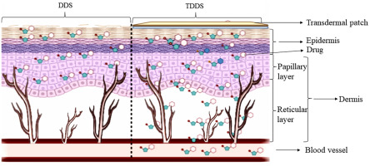
Anatomy of the Skin-
The skin is the largest organ in the body. The three main layers are the epidermis, dermis, and subcutaneous layers.

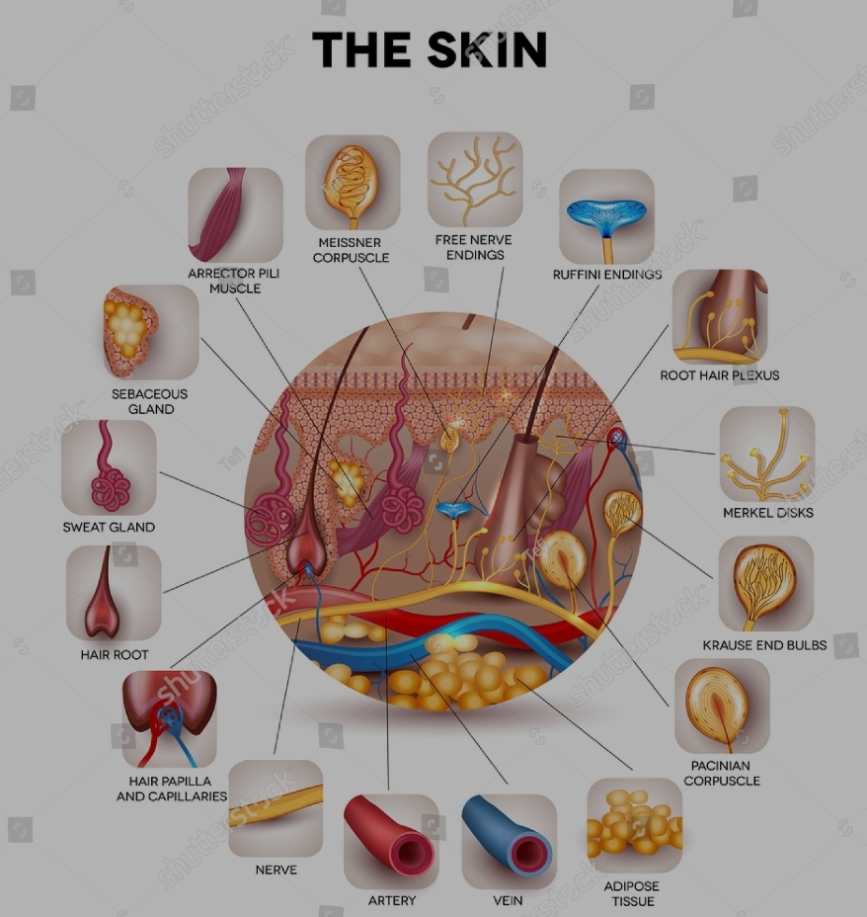
Information about skin
The skin is the largest organ in the body. It encompasses the entire body. Heat, light, injury, and disease are all kept out by it acting as a barrier. Additionally, the skin controls body temperature, stores fat and water and it increases the production of Vitamin D during the exposure of light
Your skin takes on a variety of thicknesses, colors, and textures all throughout your body. For instance, compared to other places, your head has the most hair follicles. But the soles of your feet are bereft of them. Additionally, the skin on your hands, feet, and palms is noticeably thicker than the skin on the rest of your body.
The skin has three outermost layers. Those layers have the following function:
The fat layer under the skin (hypodermis), the epidermis, and the dermis
1. Epidermis: The epidermis is the thin outermost layer of the skin. There are three different types of cells in it:
Squamous cells: The topmost layer that is constantly losing material is the stratum corneum.
Squamous cells, which are basal cells, are an immediate
Melanocytes- These cells are found at the base of the epidermis and produce melanin.
2. Dermis: The dermis is the middle layer of skin. Blood vessels, fibroblasts, sweat glands, lymphatic vessels, and sebaceous glands.
A protein called collagen keeps the dermis together. The skin has strength and flexibility because of this layer. Additionally, the dermis has touch and pain receptors.
- Layer of subcutaneous fat (hypodermis):
The skin's lowest layer is the subcutaneous fat layer. It is made up of a network of fat and collagen cells. It serves as a shock absorber, preventing damage, and aids in maintaining body heat.
Advantages-
- Reduces the need for first-pass hepatic metabolism.
- Keeps blood pressure steady for a longer period of time.
- Reduce the administration's dosage.
- Reduces gastrointestinal side effects. Reduces unwanted side effects.
- Simple to stop using in the event of hazardous effects.
- A rise in patient adherence.
- A significant benefit for people who are unconscious.
- Gives the option to change biological barriers' characteristics to increase absorption.
- Compared to the buccal/nasal cavity, this is a comparatively large region of application.
Disadvantages-
- To pass through the stratum conium, a medication needs to possess certain favorable physicochemical features.
- Drugs with a daily dose of less than 5 mg are ideal; the TDD will be challenging for drugs with a dose of more than 10–25 mg.
- Drugs, adhesives, or other excipients in the patch may cause local irritation at the administration site.
- Clinical requirements must be identified.
- The barrier function of skin varies depending on the site, the individual, and their age.
- The number of medications that can be given via this route is constrained by poor skin permeability.
- Ionic medicines cannot be delivered by TDD.
- Drugs with large molecular sizes cannot be formulated as TDD, and TDD cannot attain high drug levels in blood or plasma.
- TDD is unable to pulse-deliver medications.
Evaluation of three different routes of drug administration: orally, intra-venous, Parenteral and trans dermally.
The creation of drug delivery systems is a crucial strategy for enhancing the bioavailability of all new active pharmaceutical excipients (APIs). Oral delivery methods continue to be the go-to method for giving API due to advantages such a variety of dose forms, painless administration, simplicity, self-administered, high safety, and patient compliance.
Oral administration techniques have low gastrointestinal drug stability and are susceptible to first-pass metabolism despite these advantages. For instance, pharmaceutical degradation may result via interactions with enzymes or exposure to the stomach's acidic environment. As rate-limiting variables in medication absorption, issues with a drug's solubility in the lining of the intestine and its capacity to pass through the membrane of the intestine can reduce its bioavailability. These faults are frequently noticeable when giving medications made of peptides or proteins. Intravenously (IV) injection is regarded as one of the most advantageous methods for delivering medications because to its capacity to achieve up to 100% bioavailability, precise dosing, and avoidance of hepatic metabolism.
Therefore, is not surprising that the IV method of administration may have a few downsides. For instance, the delivery method used to provide sharps waste is intrusive, uncomfortable for patients, and expensive to dispose of. To possibly solve some of these issues, the transdermal route has been researched as an additional potential technique for enhancing the administration of peptide medications.
In trans dermally drug deliveries the skin applied topically. The medicine can enter the systemically circulation through blood vessels via skin layer and then distributes throughout the bodies. Transdermal offer patients the opportunity for less frequent usage, the avoidance of first-pass metabolism, simplicity in application and administration, and lack of a need for trained staff. Some methods even fully avoid being intrusive. Numerous drugs, including hydrophilic and hydrophobic chemicals, have been administered using this technique.

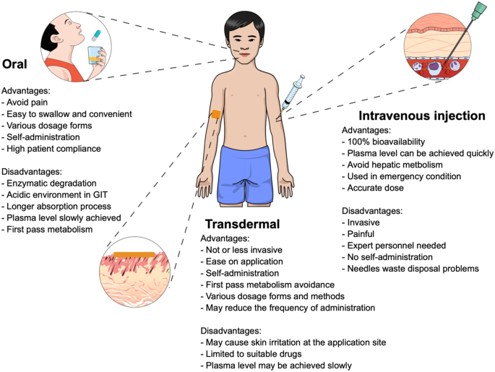

Drug absorption through the skin:
An area with more epidermal surface area may be more conducive to medication absorption. When applied to the skin, dosage forms containing drugs will release their contents. The SC is the first obstacle that must be cleared in order for medications to be absorbed through the skin. Degenerated keratinocytes, which make up the SC's structural foundation, combine with the ceramide lipid component to form a compact structure known as a "brick-and-mortar" pattern. The keratinocytes' production of keratin, an acidic, basic, or neutral protein, serves as the "brick" and lipids as the "mortar" of the SC.
Corneodesmosomes, also known as glycoprotein desmosomes, connect the keratinocytes. Delivered medications must first pass through this molecular architecture and enter the epidermis in order to enter the bloodstream. Medication absorption from the epidermis via the SC may generally be divided into trans epidermal and trans appendageal pathways. The initial pathway and main absorption route are trans epidermal. Thanks to the extensive surface area of the SC, the transdermal patch's medicament can disperse over the skin's surface and infiltrate cells or the spaces between cells. The trans epidermal pathway can be further divided into transcellular and intercellular routes. The transcellular pathway for absorption causes drugs to permeate into SC cells.
Because membranes are composed of lipid bilayers, drugs must pass through them. The drugs must first diffuse across the second channel, also known as the intercellular one, transports the keratinocyte-containing lipid matrix of the SC's intercellular space. Small molecules or hydrophilic compounds can be delivered to dermal vascular capillaries via this channel. The most frequent route for medication absorption is through the intercellular channel, which mostly depends on the drug's molecule possessing the proper ratios of lipid and water solubility.
The second way for medications to enter the body through the skin and be absorbed is through trans appendageal drug delivery, which involves sweat glands or hair follicles in the skin. This pathway aids as well as those that are difficult to pass via epidermal cells. Compared to the trans epidermal route, this approach has a smaller absorption area (0.1% of the total skin surface), but its use is still rather limited. As a result, we created techniques to improve medicine absorption.
Sections that follow discuss the advancement of transdermal products and a number of strategies for enhancing medicine absorption through the skin.

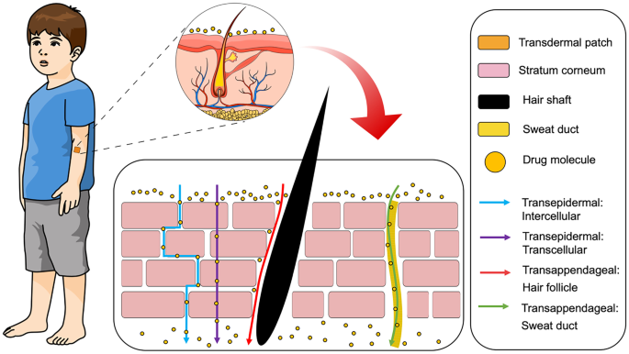
Classifications of TDDS-
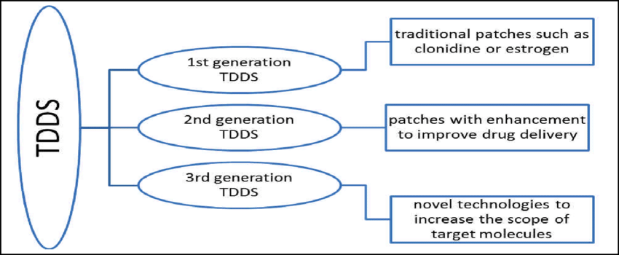

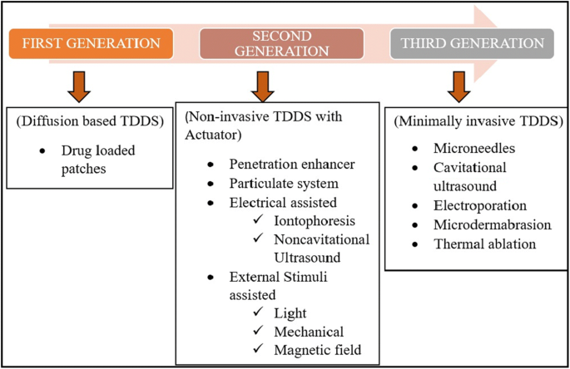

Basic Components of TDDS-
The following are the parts of a typical transdermal drug delivery system:
- Matrix of polymers.
- Drugs.
- Permeation Facilitators.
- PSAs, or pressure-sensitive adhesives.
- Laminates for backings.
- Liner Release.
- Additional Excipients.

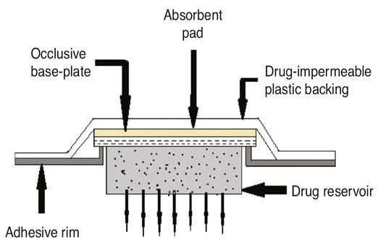
- Polymer Matrix:
The polymer regulates how quickly the medication leaves the device.
The following polymers may be suitable for transdermal devices:
- Natural Polymers
Such as cellullose derivatives, Natural gelatin, shellac ally , zein, waxes, proteineous substance, gums and their derivatives, natural rubber, starch, gums and their derivatives, natural rubber, starch etc.
- Synthetic Elastomers:
- Polybutadiene,
- Hydrin rubber,
- Polysiloxane,
- Silicone rubber,
- Nitrile,
- Acrylonitrile,
- Butyl rubber,
- Styrene Butadiene rubber,
- Neoprene etc.
- Synthetic Polymers:
- PVA
- PVC
- PE,
- PP
- PA
- Polyamide,
- Polyurea,
- PVP
- PM
- Epoxy etc.
- Drugs:
- Suitability characteristics for transdermal medication delivery.
- The drug's molecular weight should be below 1000 Daltons.
- The medication must be compatible with both hydrophilic and lipophilic phases.
- Partitioning traits are useless for effective drug distribution via the skin.
- Drug's melting point needs to be low.
- Drugs should not irritate users or have a short half-life.
- Permeation Enhancers:
- These substances work to increase skin permeability by modifying how well a desired penetrant can pass through the skin.
- Pressure-sensitive adhesives (PSAs):
- PSAs can be used to attach any transdermal device to the skin. The first strategy entails the creation of novel polymers, such as polyurethanes and hydrophilic hydrogel polymers.
- The second strategy involves physically or chemically altering the PSAs' existing chemistries (such as those of silicones and acrylates).
To improve drug delivery rates, functional monomers are chemically grafted onto or incorporated into traditional PSA polymers. Physical modification is the process of enhancing the skin-adhesion capabilities of base adhesives by adding specialist additives.

- Laminate Backings:

- The leaching out of backing additives and the diffusion of substances through the backing are major areas of concern.
- An excessive focus on chemical resistance frequently results in stiffness and high occlusivity to moisture vapor and air, which lifts the TDDS and may irritate the skin when used repeatedly.
- Release the liner first.
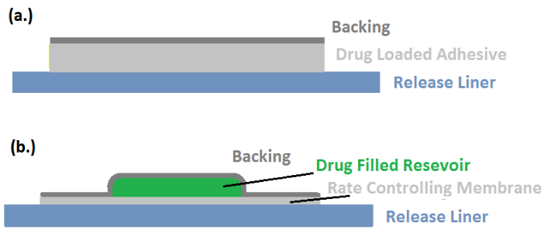

- The liner must be chemically inert because it can comes directly contact with the drug trans dermally.
- The release liner occupies silicon- or teflon-based release coating layer on top of a base layer that may be either occlusive or non-occlusive (for example, paper fabric or polyethylene).
- Metalized laminate and polyester foil are additional components utilized in TDDS liners to safeguard the patch during storage.
- The liner is only taken out before use.
- Additional Excipients
- To produce drug reservoirs, a variety of solvents, including chloroform, methanol, acetone, isopropanol, and dichloromethane, are utilized.
- To give the transdermal patch some plasticity, additional plasticizers like dibutyl phthalate, triethyl citrate, polyethylene glycol, and propylene glycol are added.
- TDDS Formulation Methodologies
- Transdermal deliveries containing polymeric substances
- TDDS with polymer matrix diffusion control.
- Systems of the adhesive dispersion kind.
- TDDS with micro reservoir dissolution control.
- TDDS is regulated by polymer membrane permeation:
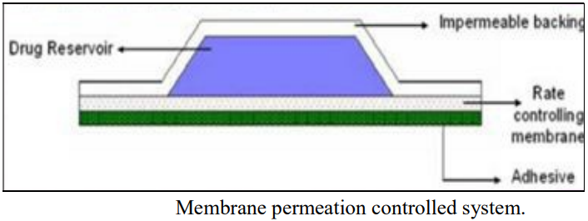
- polymeric membrane that regulates the flow rate.
- The formula {dq/dt} = Cr/1/Pm+1/Pa describes the intrinsic rate of drug release from this kind of drug delivery device.
Where
- Cr is the drug reservoir's concentration of the active ingredient.
- The sticky layer's permeation coefficient is Pa.
- Pm stands for the rate-regulating membrane's permeation coefficient.
- TDD system with polymer matrix diffusion control:
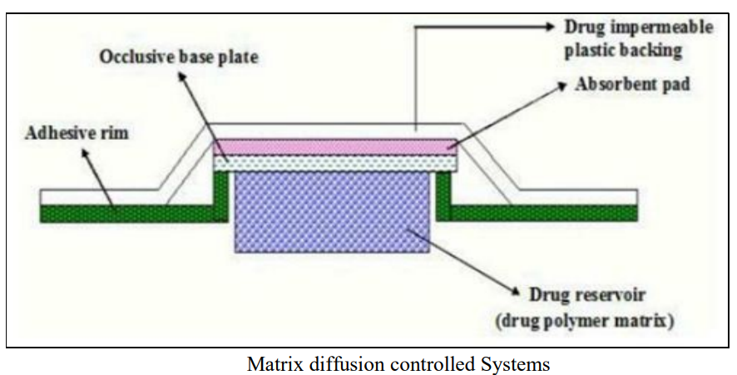
- To produce the drug reservoir using this technique, drug particles are uniformly dispersed in a hydrophilic (or lipophilic) polymer matrix.
- The resulting polymer matrix is then used to create a disc with a predetermined surface area and thickness.
- The drug-impermeable compartment housing the medicated disc is then molded onto an occlusive base plate.
- An adhesive polymer is then applied all the way around the film.
- Examples include the daily dosage of 0.5g/cm2 of the transdermal treatment device that releases nitroglycerine for angina pectoris.
dq/dt = {ACpDp/2t}1/2,
Where
- A is the initial drug loading dosage dispersed in a polymer matrix and Cp is the drug's solubility in polymer, determines the rate of drug release in this system. Since Cp = Cr, Dp is the drug's polymer diffusivity.

- Systems of the adhesive dispersion type
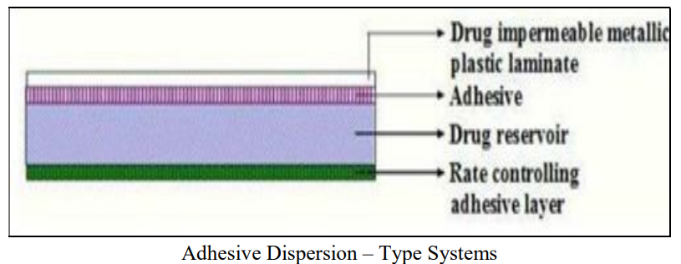
- These membrane permeation-controlled systems have been simplified.
- In this approach, the adhesive solution is immediately supplemented with the medicine and specific excipients.
- The banking laminate and the rate-regulating adhesive polymer membrane are then positioned on either side of the drug reservoir (film).
- The rate of drug release from this system is given by,
dq/dt = Cr.Ka/r.Da/ha
where,
- Ka/r = Interfacial drug partitioning coefficient from the reservoir layer to the adhesive layer.
- ha = Adhesive layer thickness.
- Da = the diffusion-derived layer's coefficient.
- Examples are isosorbide dinitrate, used to treat angina pectoris, and verapamil, used to treat hypertension, both of which release TDDS after 24 hours.

- TDD system with micro reservoir dissolution control
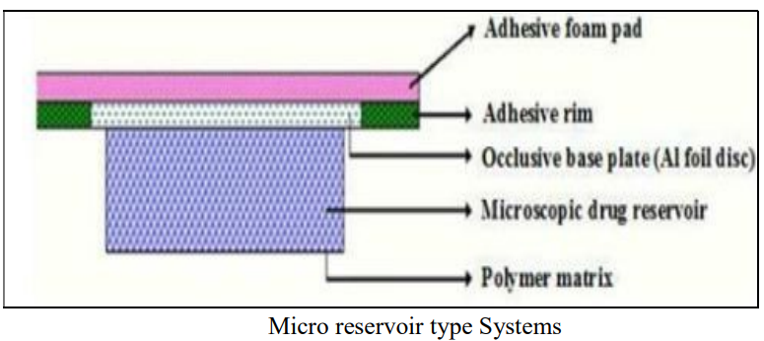
It is a hybrid technology that combines matrix dispersion and reservoir drug delivery. In this system, the drug reservoir is made by first suspending the solid drug in an aqueous solution of a drug solubilizer that mixes with water, like polyethylene glycol. Next, the drug suspension is homogeneously dispersed with a controlled aqueous soluble lipophilic polymer using high shear mechanical force to create thousands of unleachable microscopic drug reservoirs.

References-
- Raj GM, Raveendran R. Introduction to basics of pharmacology and toxicology. 1st vol. Singapore: Springer Nature Singapore Pte Ltd. 2019.
- Marschütz MK, Bernkop-Schnürch A. Oral peptide drug delivery: polymer-inhibitor conjugates protecting insulin from enzymatic degradation in vitro. Biomaterials. 2000;21:1499–507.
- Dahan A, Miller JM, Amidon GL. Prediction of solubility and permeability class membership: provisional BCS classification of the world’s top oral drugs. AAPS J. 2009;11:740–6.
- Patel A, Cholkar K, Mitra AK. Recent developments in protein and peptide parenteral delivery approaches. Ther Deliv. 2014;5:337–65.
- McDonald TA, Zepeda ML, Tomlinson MJ, Bee WH, Ivens IA. Subcutaneous administration of biotherapeutics: current experience in animal models. Curr Opin Mol Ther. 2010;12:461–70.
- Wen NX, Venkatraman S. Protein delivery options: how well have we succeeded? Ther Deliv. 2015;6:537–9.
- Alkilani AZ, Mccrudden MTC, Donnelly RF. Transdermal drug delivery: innovative pharmaceutical developments based on disruption of the barrier properties of the stratum corneum. Pharmaceutics. 2015;7:438–70.
- X. Wang et al. Differences of first-pass effect in the liver and intestine contribute to the stereoselective pharmacokinetics of rhynchophylline and isorhynchophylline epimers in rats
- S.T. Sanjay et al.Recent advances of controlled drug delivery using microfluidic platforms
- Lee W-R, Shen S-C, Al-Suwayeh SA, Yang H-H, Li Y-C, Fang J-Y. Skin permeation of small-molecule drugs, macromolecules, and nanoparticles mediated by a fractional carbon dioxide laser: the role of hair follicles. Pharm Res. 2013;30:792–802.
- Scheiblhofer S, Strobl A, Hoepflinger V, Thalhamer T, Steiner M, Thalhamer J, et al. Skin vaccination via fractional infrared laser ablation-optimization of laser-parameters and adjuvantation. Vaccine. 2017;35:1802–9.
- Lee HJ, Liu Y, Zhao J, Zhou M, Bouchard RR, Mitcham T, Wallace M, Stafford RJ, Li C, Gupta S. Marites P. Melancon. In vitro and in vivo mapping of drug release after laser ablation thermal therapy with doxorubicin-loaded hollow gold nanoshells using fluorescence and photoacoustic imaging. J Control Release 2013; 172:152–158.
- Liu C, Zhang J, Yue Y, Luo Q, Zhu D. 1064 nm-Nd:YAG lasers with different output modes enhancing transdermal delivery: physical and physiological mechanisms. J Biomed Opt. 2013; 18:061228.
- https://www.simplepharmanotes.com/2022/10/formulation-approaches-of-tdds.html?fbclid=IwAR0K82TbnzF6BOiPpXc4rZyXvufRkHY0GbrqMIj5QzMj0xGaG1IVzhAC7fY
- https://www.simplepharmanotes.com/2022/10/basic-components-of-tdds.html

