Edited by
Patil Sachin Sambhajirao, Waghmode Ahilya vitthal and Patil Manasi Shirish
Department of Food Science
S. G. M. College Karad
E.Mail : sachinpatilfoodtech@gmail.com
waghmode.algae@gmail.com

WHEAT BREAD

Content
- Introduction
- Definitions
- Functional ingredients
- Role of each Major and minor ingredient
- Methods of bread making
- Faults in bread with their remedies
- Quality checking of dough rheology for quality wheat bread

Introduction
Wheat belongs to the genus Triticum of the grass family Gramineae. Wheat is the third cereal grain after maize & rice as a staple food. India ranks IInd in wheat production (112.74 MT) during 2022 – 23. Uttar Pradesh is the largest wheat producing state in India. China is the Ist world’s largest producer of wheat ( 134.33 MT).There are more than 30,000 species & varieties. It is cultivated from prehistoric times (5000 B.C.).The average length of wheat grain is about 8mm.Average weight of single wheat kernel is 35mg.It is ovoid in shape with the germ or embryo at one end & a bundle of hair at another end, along one side there is a furrow like part. Wheat grain have either a dark orange brown appearance or a light yellowish color. Bread is one of the spongy, porous food item. It can be variable from different grain flour for providing a lot of nutrients.
Definition of Bread
A staple food in western country which is made by baking dough made with flour & water & additional ingredients.
Definition of Baking
A technique of prolonged cooking of foods by dry heat through convection normally in oven under controlled condition.
Functional Ingredients used in bread making
- Structure builders
- Provide the structure & texture to the cake
- Flour, eggs & milk
- Tenderizers
- Provide softness & shortness in the product
- Fat, butter, vegetable oil, sugar
- Leaveners
- It makes porous by leavening CO₂.
- Baking powder, Baking soda & Yeast
- Moisteners
- Provide moisture & keeping quality.
- Milk, water, eggs & syrup
- Driers
- Absorb & retain moisture & provide the body of the product
- Milk solids & starches
- Flavors
- Provide natural flavor
- Cocoa, chocolate, butter,& other natural flavor bearing ingredients.
The different ingredients used in bakery are:
- Flour
- Sugar
- Shortenings
- Leavening agents
- Eggs
- Water
- Salt
- Milk and milk derivatives
- Minor ingredients
- Flour
- Wheat flour is the basic structural component of most batter & dough products.
- It is able to perform this textural function because of gluten content which allows expansion of air cells & provide rigidity after baking.
- Flour is obtained through the milling process in which bran part of wheat grains are removed as far as possible.
- When wheat flour mixed with water in correct proportions, the protein will form an elastic dough which is capable of holding gas & which will set to a spongy structure when heated in oven.
- Two types of Wheat 1. Hard wheat 2. Soft wheat
- Hard wheat – Mostly desirable in bread production. High in good quality protein. Hard wheat dough has high water absorptive capacity, excellent gas holding properties & will yield bread with good volume, grain & texture.
- Soft wheat - Soft wheat is low in protein & yields flour having low water absorption capacity & poor tolerance to mixing & fermentation. They are undesirable for bread production but are highly desirablein production of cakes, pastries & cookies.
Colour – The flour should have a trace of creamish colour.
Strength – Capable of producing a bold, large volume, well risen loaf.
Tolerance – To produce a satisfactory loaf .
Water absorption – 60 to 65 %
Uniformity – Uniform flour to obtain good quality & product
pH – Flour with pH value below 5.0 are generally too acid & give poor result in bread baking. The pH of flour should between pH 5.5 & 6.5.
Composition – Major components of flour are starch (70% ), protein (11.5%), water (14%) & minor components are such Ash(4%), sugar (1%) & fat (1%). Gluten protein (glutenin & gliadin) is insoluble in water or dilute solution.
2. Sugar
- It imparts sweet taste.
- It has tenderizing action on flour proteins & it makes the cake tender.
- Being hygroscopic, sugar helps to retain moisture in cakes, which improve its shelf life.
- The golden brown crust & colour of cakes is due to caramelization of sugar.
- Sugar has lubrication effect on gluten strands & helps in acquiring volume in cakes.
- Sugar is essential for fermentation activity of yeast to produce CO₂ gas which raises the dough & imparts proper volume to the bread.
- It enhances flavor & helps in moisture retention due to its hygroscopicity.
- Sucrose is superior to the other sweeteners.
- Sugar does not act as softening agent but by developing crust colour quickly it makes possible a reduction in baking time retention of more moisture in the bread.
- As sugar percentage is increased, the crust becomes darker i.e. results in more reddish brown crust.
- High concentration of sugar interferes with gluten formation.
Uses of Sugar
- Gives the necessary sweetness in cakes.
- Serves as a form of food for the yeast in fermentation
- It is used in the preparation of variety of icings.
- Assists in the creaming & whipping process of mixing .
- Provides good grain texture in the product.
- Aids in the retention of moisture & prolongs freshness.
- Promotes a good crust colour.
- Adds nutritional values to the product.
- It increases gas production.
- Shortenings
- Fat lubricates the structure of a baked product.
- Lard, butter & some vegetable oils.
- It has tenderizing effect on flour proteins & makes the product tender.
- It is fat part of the mixture which holds large number of air cells incorporated during creaming.
- Vegetable oil is also used for shortening e.g. coconut oil, corn oil, cottonseed oil, peanut oil & soybean oil.
Use of Shortenings
- Impart shortness, richness & tenderness to the product
- Improve the eating qualities of the product
- Provide aeration
- Contribute to flavor, particularly special fats such as butter
- Promote a desirable grain & texture.
- Develop flakiness in product
- Lubricate the gluten for development of yeast raised dough.
- Act as emulsifiers for holding of liquids.
Properties Of Shortening
It should have
- Bland flavor
- White appearance
- Good plasticity
- Flavor & oxidative stability
Butter
- It is the best of all baking shortenings .
- It imparts desirable flavor to the finished baked products.
- It is widely used for specially breads, sweet goods, cookies & pastries.
Lard
- Fat rendered from fresh, clean, fatty tissues from hogs in good health at the time of slaughter.
- Margarine is prepared by blending lard & shortening.
4. Leavening agents
Biological agents – Yeast
Yeast
- Baker yeast is one celled, colorless microorganism called as Saccharomyces cerevisiae.
- Characters of Yeast
- Yeast exists & is active in air as well as in absence of air.
- In presence of air it grows rapidly & forms little alcohol.
- In absence of air it grows slowly but alcohol formation increases.
- Yeast grows & ferment best in acidic environment, tolerating acidities as low as pH 2.
- The role of yeast in bread making is to lighten or raise the dough.
Disadvantage
- It is difficult to control & fermentation flavor can be undesirable.
- It is also more expensive than chemical agents.
- Eggs
- Most important function of eggs is to provide structure to the cake.
- It provides moisture to the cake.
- It improves the taste and nutritive value of cake.
- Eggs used in excess amount will give abnormal volume to the cake.
- Crust will be dark, thick & peeled off as a flake, Texture will be dry & rough due to evaporation of moisture.
- Proteins of eggs are of particular importance.
- Coagulation of protein during baking contributes to the structure of finished product & reduces tenderness.
Function of Eggs
- Binding action
- Leavening action
- Emulsifying action
- Flavor
- Colour
- Nutritive value
Egg white
- It has ability to form foam which is stable enough to support large quantities of flour or sugar.
- These foams must be capable of holding the other ingredients until heat coagulation can occur in the oven & a stable protein matrix develops.
- As foam develops bubbles become smaller, surface is greatly enlarged & ovomucin (protein) undergoes surface denaturation to form a solid film, which contributes to the stability of the unheated foam & volume of foam increases.
- Ovalbumin, which is readily heat coagulable, set up in heat & supports many times its weight of sugar & flour.
- Albumin having pH 6.5 to 9.5 has greatest foaming power.
- The pH of egg white is 7.6.
Egg Yolk
- Yolk is not commonly employed as a foaming agent with the exception of a yellow sponge type baked product.
- It has emulsifying property (oil water air emulsion).
- Globulins are primarily responsible for lowering surface tension & increase viscosity where air gets incorporated.
- It is mostly used in manufacture of mayonnaise & salad dressings.
- pH of egg yolk is 6.0.
Following actions should be kept in mind while using egg as ingredients:
- Weight of sugar should exceed the weight of flour
- Weight of total liquid should equal or slightly exceed the weight of sugar
- In pound cake / layer cake , the weight of Egg solids should approximately 1/4th of the weight of shortening
- In white cake the weight of egg white solids should exceed 1/10th of the weight of shortening.
6. Water
- In its pure form, water is a tasteless, odorless & colorless liquid.
- It is an essential dough ingredient which helps to form gluten, starch swelling process & to bring dough ingredients into intimate contact with each other.
Functions of water in Bakery
- It makes possible the formation of gluten.
- Gluten as such does not exist in flour , only when flour proteins are hydrated, gluten is formed.
- Water controls the consistency of the dough.
- Water wets & swells starch & renders it digestible.
- Water also makes possible enzyme activity.
- It dissolves salts, sugar & suspends other material in dough.
- Salt
- Common salt is used for bringing out the flavor of other ingredients.
Functions of Salt
- It increases gluten stability
- Controls fermentation
- Develops flavor
- Retains water
- Contributes to the crust & crumb formation
Common salt should have the following characteristics:
- It should be completely soluble in water
- It should be free from lumps
- It should be pure
- It should be free from a bitter or biting taste
- Milk & Milk derivatives
- Role in structure formation in cakes.
- It contributes to the crust browning because of protein & sugar content.
- Improves flavor, richness also.
- Improved nutritional value.
- Minor Ingredients
Flour improver / Dough improver
Definition
A bread improver is a coherent, balanced combination of baking ingredients chosen from among various manufacturing aids and raw ingredients (both cereal-based and other), mixed together in an appropriate formula.
Five types of elements are used in baking ingredients:
- reducing agents to restructure gluten;
- oxidants to strengthen gluten for optimal gas retention;
- enzymes, including amylase, to release fermentable sugars that feed the yeast;
- emulsifiers to consolidate gluten for increased tolerance;
- various baking ingredients with specific effects: bean flour, malt, etc.

Better baking performance
- Bread improvers boost dough enhancer and reinforce tolerance during the different manufacturing stages.
- They make the work safer and simplify production, enabling bakers to prepare quality, standardized end products.
- Bread improvers can also act on the following properties of dough:
- rheological properties: by increasing the dough’s handling, strength or extensibility, so as to better tolerate its time in the machine;
- fermentation properties: by optimizing the yeast’s action through stabilized fermentation and increased gas retention capacity.
Purpose for addition of bread improvers
- Bread improvers simplify the work of bakers, allowing them to show off their full expertise. They can be used with any technology, under the most widely varying production conditions. As needed, they can:
- smooth out the dough more quickly;
- enhance machinability;
- boost tolerance in control proofing, especially for raw frozen and pre-cooked specialty breads;
- increase yields.
- This gives consumers the benefit of a product that is as attractive to the eye as it is to the palate and that retains the mark of the baker’s expertise.
- Flour bleaching agent is a food additive added to flour in order to make it appear whiter (freshly milled flour has a yellowish tint) and to oxidize the surfaces of the flour grains and help with developing of gluten.
Major flour bleaching agents are:
- Organic peroxides, namely benzoyl peroxide
- Benzoyl peroxide and hydrogen peroxide are used as bleaching and "maturing" agents for treating flour to make its grain release gluten more easily
- Calcium peroxide
- As a solid, it is relatively stable against decomposition. In contact with water however it hydrolyzes with release of oxygen. Upon treatment with acid, it forms hydrogen peroxide.
- Atmospheric oxygen, used during natural aging of flour
- Use of chlorine, bromates, and peroxides is not allowed in the European Union.
- Chlorinated cake flour improves the structure-forming capacity, allowing the use of dough formulas with lower proportions of flour and higher proportions of sugar. Inbiscuit manufacturing, use of chlorinated flour reduces the "spread" and provides a tighter surface. The changes of functional properties of the flour proteins are likely to be caused by their oxidation.
- In countries where bleached flour is prohibited, plain flour can be treated in a microwave oven to produce similar chemical changes to the bleaching process. This improves the final texture of baked goods made to recipes intended for bleached flours.

- Oxidizing Agent
- Oxidizing agents are added to flour to help with gluten development.
- They may or may not also act as bleaching agents.
- Originally flour was naturally aged through exposure to the atmosphere.
- Oxidizing agents primarily affect sulfur-containing amino acids, ultimately helping to form disulfide bridges between the gluten molecules.
- The addition of these agents to flour will create a stronger dough.
Common oxidizing agents are:
- Ascorbic acid (Ascorbic acid converts into its oxidizing form, dehydroascorbic acid (DHAA) during mixing.)
- Azodicarbonamide (E927)
- Potassium bromate (E924, the component which gives bromated flour its name, used mainly in the U.S. East and Midwest, acts as a bleaching agent, banned in some areas)
- Potassium iodate
- Flour reducing agent
Reducing agents help to weaken the flour by breaking the protein network. This will help with various aspects of handling a strong dough. The benefits of adding these agents are reduced mixing time, reduced dough elasticity, reduced proofing time, and improved machinability.
Common reducing agents are:
- L-cysteine (E920, E921; quantities in the tens of ppm range help soften the dough and thus reduce processing time)
- fumaric acid
- sodium bisulfite
- non-leavening yeast (ruptured cells)

Methods of Bread making
- Straight dough Method
- Sponge dough Method
- Delayed salt Method
- No time dough Method
- Ferment & dough Method
- Straight dough method
- All essential & optional ingredients are mixed together.
Flow Sheet
Scaling → Mixing →Fermentation →Punching →Scaling →Rounding →Benching →Panning →Proofing→ Baking → Cooling
Explanation
- Scaling
- Four basic ingredients Flour, Yeast, Salt & Water. Optional ingredients are sugar , fat & milk. These ingredients are weighed as per the standard recipe.
- Mixing
- Sifted flour is poured into an industrial mixer. Temperature controlled water is piped into mixer.
- Flour start to absorb liquid & start to form a dough.
- Check the dough for proper hydration by falling the dough.
- The mixer rotates at speed 35 to 75 rpm. & mixing for 12 min.
- Experienced person will be able to determine the consistency by sound of dough as it rolls around the mixer.
- Fermentation
- Fermentation is the process in which complex nutrients especially carbohydrate & protein is converted in to simple nutrients.
- Starch → Sugar → CO₂ + alcohol As dough ferment, acidity get develop & leads to stretch the dough.
- Fermentation is carried out by different ways
- High speed machinery – extreme forces the yeast cells to multiply rapidly.
- Fermentation by addition of L – Cystein & Vit – C.
- Dough is placed in covered metal bowl & stored in temperature controlled room 25ºC to 26ºC RH – 70% . Dough should be covered with wet cloth. Yeast is more active at 43.33ºC.
- Making a ferment separately
- Punching
- After fermentation dough is punched to expel gas & to redistribute food for yeast.
- It is also called as Knock back stage.
- Scaling
- Using bench knife portion of dough is cut & take a weight.
- Rounding
- Round to restretched the gluten & also make balls / rounds.
- Benching
- Baker then benches the dough before final shaping.
- Panning
- Place the dough on to baking pans.
- Proofing
- Place in proofing unit where 35ºC temperature & relative humidity 85 to 90%.
Main functions
- To relax the dough
- Helps in production & retention of gas during fermentation.
- To improve strength of gluten & to improve extensibility.
- To give higher volume to the dough.
- Baking
- Baker then slides the dough into the hot oven directly on the hearth.
- The temperature should be 218.33ºC for 25 to 30 min.
Changes during baking
- Increased temperature causes CO₂ of dough to expand & increases the size.
- Moisture loss surface ultimately causes caramelization of sugar.
- Enzymatic & yeast action are stopped.
- Right amount of moisture is lost & loaf holds it shape.
- Cooling of baked loaf
- It should not too dry or warm environment for cooling.
- Sponge dough Method
- Here part of flour, water , yeast , sugar mixed together.
- In this method two mixing periods & fermentation periods are used.
Advantage – Fermentation in 2 stages so better control on speed of fermentation.
Disadvantages – More space requirement
Flow sheet
Scaling → Mixing → Sponge mixed → Sponge placed in trough → Sponge allowed to mature / Fermentation →Sponge placed in mixer → Sponge broken up & mixed with dough ingredients → Final dough is placed in trough → Allowed to rise / Fermentation → Sometimes turned & folded → Punching →Scaling →Rounding →Benching →Panning →Proofing→ Baking →Cooling
- Delayed Salt Method
- Same as straight method where ingredients are mixed except salt.
- Speed of fermentation faster (saltless)
- Salt added at Knock back stage
- Salt used in different ways
- Sifted dry on dough & mixed
- Creamed with fat & then mixed
- Some four & water in mixed, then salt is added
- No time dough Method
- Dough is not fermented after mixing.
- Allowed to rest only for 30 min.
- Quantity of yeast is increased 2 to 3 times more than in other method.
Disadvantage – poor keeping quality & lack in aroma.
- Ferment & dough method
Ferment making separately & then mixed it to make a dough

Bread faults, their causes and remedy
The following gives some of the more prominent faults in white bread production:

1. Lack of volume  a) Use of weak flour  b) Too much salt  c) Lack of shortening  d) Yeast dissolved in hot water  e) Too much or not enough dough for the mixer  f) Under mixing  g) Over mixing  h) Young dough  i) Extremely old dough  j) Too much machine punishment  k) Too long an intermediate proof  l) Insufficient pan proof  m) Excessive steam pressure in oven  n) Oven too hot  2. Too much volume  a) Not enough salt  b) Use of wrong type of flour  c) Dough slightly overaged  d) Too much dough for pans  e) Over proofing  f) Cool oven  3. Crust colour too dark  a) Too much sugar  b) High milk content  c) Old dough  d) Oven too hot  e) Over baking  4. Crust colour too pale  a) Too lean formula  b) Flour lacking diastatic activity  c) Excessive mineral yeast food  d) Old dough  e) Insufficient humidity in proof box  f) Cool oven  g) Under baking | 5. Blisters under the crust  a) Young dough  b) Excessive steam in proof box  c) Over proofed  d) Rough handling at oven  6. Crust too thick  a) Insufficient shortening  b) Low sugar content  c) Old dough  d) Lack of moisture in proof box  e) Excess steam in proof box  f) Cool oven  g) Over baking  7. Shell tops  a) Green or new flour  b) Stiff dough  c) Dough too young  d) Lack of moisture in proof box  e) Not enough pan proof  f) Excessive top heat  8. Lack of break and shred  a) Weak flour  b) Excessive amount of mineral yeast  c) Young dough  d) Extremely old dough  e) Excessive proof  9. Crumb is grey  a) Use of too much malt  b) Old dough  c) Excessive proofing  d) Pans too large for amount of dough  10. Streaked crumb  a) Improper incorporation of ingredients  b) Sponge or dough crusted over during fermentation  c) Sponge not broken up properly  d) Excessive trough grease

11. Coarse grain  a) Weak flour  b) Improper mixing  c) Slack dough  d) Young dough  e) Old dough  f) Improper moulding  g) Excessive proof  h) Rough handling at oven  i) Cool oven  12. Poor Texture  a) Weak flour  b) Lack of shortening  c) Improper mixing  d) Slack dough  e) Excessive trough grase  f) Young dough  g) Old dough  h) Excessive use of divider oil  i) Excessive dusting flour  j) Improper moulding  k) Cool oven  13. Flavour and taste are poor  a) Improper storage of ingredients  b) Poor quality ingredients  c) Off-flavoured ingredients  d) Improper amount of oil  e) Under fermented dough  f) Old dough  g) Unsanitary shop  h) Dirty pans  i) Under-baking  j) Over baking  k) Bread cooled under unsanitary conditions | 14. Poor keeping qualities  a) Too lean formula  b) Poor quality ingredients  c) Improper storage of ingredients  d) Old dough  e) Stiff dough  f) Over proofing  g) Cool oven  h) Bread cooled too long before wrapping  15. Holes in Bread  a) Unbalanced formula  b) Flour too strong  c) Improper incorporation of ingredients  d) Under mixing  e) Over mixing  f) Excessive trough grease  g) Young dough  h) Old dough  l) Excessive use of divider oil  m) Excessive dusting flour  i) Too much machine punishment  j) Proof box too hot  k) Over proofing

In checking these faults an analysis of the various causes will show inferior ingredients, unbalanced formula, improper mixing, incorrect fermentation time, poor control of temperature, time and humidity throughout the production process, poor makeup procedures, poor oven conditions as well as improper handling in cooling, wrapping and shipping account for most of bread faults.
A process of elimination must be instituted, the possible cause or causes determined and the proper remedy applied.

Measurement of Dough rheological properties
Rheological tests are used to predict baking performance and behavior of the dough during processing before baking.
These measure the following mechanical properties of dough with the help of Farinograph, mixograph, extensograph, alveograph and amylograp etc.
- Farinograph
- Alveograph
- Mixograph
- Amylograph
- Extensiograph

- Farinograph
- It is the most commonly used flour quality test in the world.
- It is used to estimate the amount of water required to make a dough.
- To evaluate the effects of ingredients on mixing properties.
- To evaluate flour blending requirements.
- To check flour uniformity.
- To predict finished product texture characteristic.
The Farinograph Test
- Measures & records the resistance of a dough to mix with paddles.
- Absorption
- The amount of water required to center the farinograph curve on the 500BU (Brabender Unit) line.
- The amount of water needed for a flour to be optimally processed into end products.
- Absorption is expressed as a percentage.
- Peak time
- It indicates dough development time, beginning the amount of water is added until the dough reaches maximum consistency.
- It gives an indication of optimum mixing time under standardized condition.
- Peak time is expressed in minutes.
- Arrival time
- The time when the top of the curve touches the 500 BU line.
- This indicates the rate of flour hydration.
- Arrival time is expressed in minutes.

- Departure time
- The time when the top of the curve leaves the 500BU.
- This indicates the time when the dough is beginning to break down & is an indication of dough consistency during processing.
- Departure time is expressed in minutes.
- Stability time
- The difference in between arrival time & departure time.
- This indicates the time of dough maintains maximum consistency & is a good indication of dough strength.
- Stability time is expressed in minutes.
- Mixing Tolerance Index
- The difference in BU value at the top of the curve at peak time & the value at the top of the curve 5 minutes after the peak.
- This indicates the degree of softening during mixing.
- MTI is expressed in minutes.
- Weak gluten flour has a lower water absorption & shorter stability time than strong gluten flour.

Method
- A flour sample of 50 or 300 grams on a 14% moisture basis is weighed & placed into the corresponding farinograph mixing bowl.
- Water from a burette is added to the flour & mixed to form a dough.
- As the dough is mixed, the farinograph records a curve on graph paper.
- The amount of water added (absorption) affects the position of the curve on the graph paper. Less water increases dough consistency & moves the curve upward.
- The curve is centered on the 500 BU line ± 20 BU by adding the appropriate amount of water & is run until the curve leaves the 500 BU line.
- Strong Gluten Flour
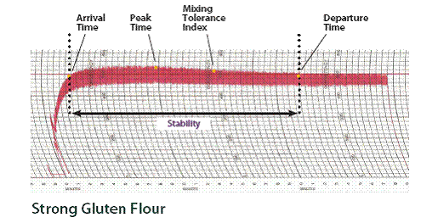

- Weak Gluten Flour
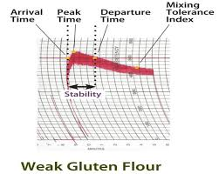
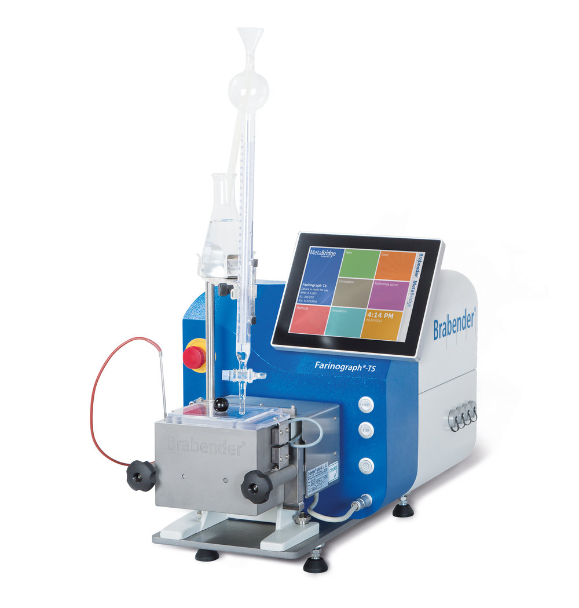
- Extensiograph
- It is useful in determining the gluten strength & bread making characteristics of flour.
- To evaluate on dough performance.

The Extensiograph Test
- Measures & records the resistance of a dough to stretching.
- Resistance to Extension
- It is R value & is indicated by the maximum height of the curve.
- It is expressed in centimeters, BU or EU.
- Extensibility
- The E value & is indicated by the length of the curve.
- It is expressed in millimeters(mm) or centimeters (cm).
- R/E ratio
- It indicates the balance between dough strength (resistance to extension) & the extent to which the dough can be stretched before breaking (extensibility).
- Area under the curve
- A combination of resistance & extensibility.
- It is expressed in square centimeters.
- Weak gluten flour has a lower resistance to extension (R value) than strong gluten flour.
Method
- A 300gm flour sample on a 14% moisture basis is combined with a salt solution & mixed in the farinograph to form a dough.
- After the dough is rested for 5 minutes, it is mixed to maximum consistency (peak time).
Analysis
- A 150 sample of prepared dough is placed on the extensiograph rounded & shaped into a ball.
- The ball of dough is removed from the rounder & shaped into a cylinder.
- The dough cylinder is placed into the extensiograph dough cradle, secured with pin, & rested for 45 minutes in a controlled environment.
- A hook is drawn through the dough, stretching it downwards until it breaks.
- The extensigraph records a curve on graph paper as the test is run.
- The same dough is shaped & stretched two more times, at 90 minutes & at 135 minutes.
- Strong gluten flour
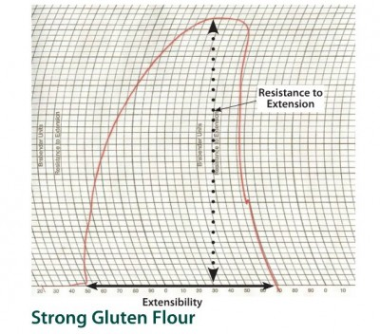

- Weak gluten flour
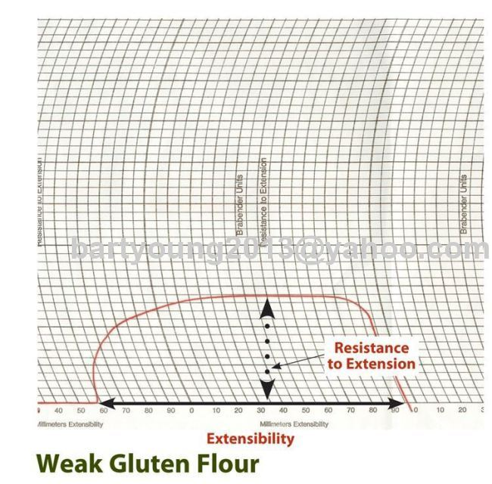

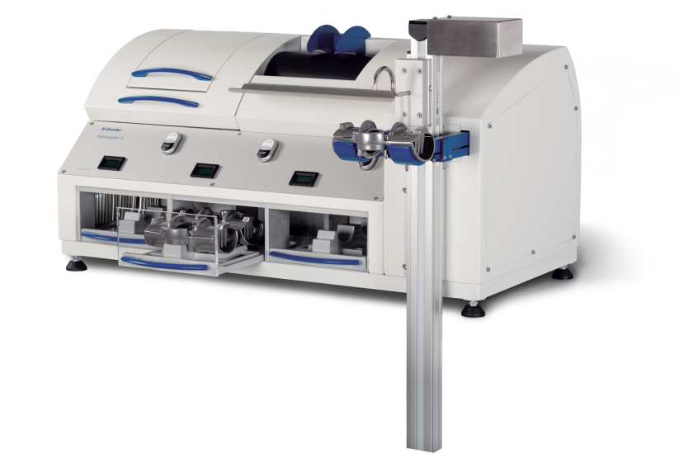
- Alveograph
- It ensures a more consistent process & product.
- Weak gluten flour with low P value (strength of gluten) & long L value (extensibility) is preferred for cakes & other confectionary products.
- Strong gluten flour will have high P values & preferred for breads.

The Alveograph Test
- Measures & records the force required to blow & break a bubble of dough.
- P – value – The force required to blow the bubble of dough. It is indicated by the length of the curve & is expressed in millimeters (mm).
- L – value – The extensibility of the dough before the bubble breaks. It is indicated by the length of the curve & is expressed in millimeters (mm).
- P / L Ratio – The balance between dough strength & extensibility.
- W – value – The area under the curve . It is a combination of dough strength (P – value) & extensibility (L – value) & is expressed in joules.
- Weak gluten flour has lower P values than strong gluten flour.
Method
- A sample of 250 gms of flour is mixed with a salt solution to form a dough.
- Five 4.5cm circular dough patties are formed & then rested in the alveograph in a temperature regulated compartment at 25ºC for approximately 20 minutes.
- Each dough patty is tested individually. The alveograph blows air into a dough patty which expands into a bubble that eventually breaks.
- The pressure inside the bubble is recorded as a curve on graph paper.
- Fig – Alveograph 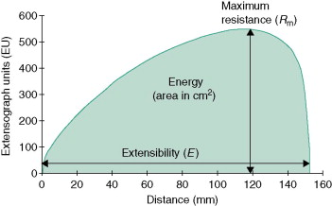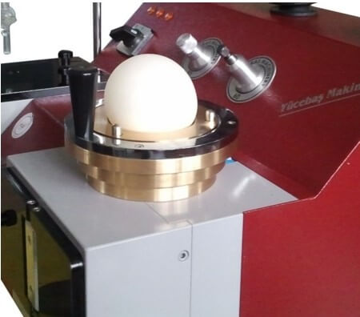
4. Mixograph
- It analyzes small quantities of flour for dough gluten strength quickly.
- Flour water absorption measured by the mixograph often serves as bake absorption in bread baking tests.
The Mixograph Test
- Measures & records the resistance of a dough mixing with pins.
- Peak time
- Mixing tolerance
- Peak time
- The dough development time beginning the moment the mixer & recorder are started & continuing until the dough reaches maximum consistency.
- It indicates optimum mixing time & is expressed in minutes.
- Mixing tolerance
- The resistance of the dough to breakdown during continued mixing & affects the shape of the curve.
- It indicates tolerance to over mixing.
- Weak gluten flour has a shorter peak time & less mixing tolerance than strong gluten flour.

Method
- A sample of 35gms of flour on a 14% moisture basis is weighed & placed in a mixograph bowl.
- Water is added to the flour from a burette & the bowl is inserted into the mixograph.
- The flour & water are mixed together to form a dough.
- As the dough is mixed, the mixograph records a curve on graph paper.
- Strong Gluten Flour –
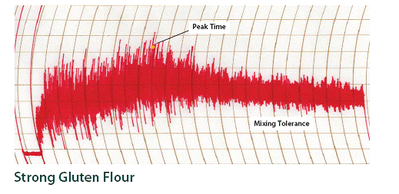

- Weak Gluten Flour –
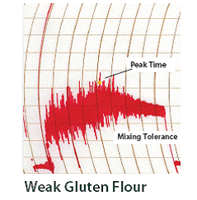
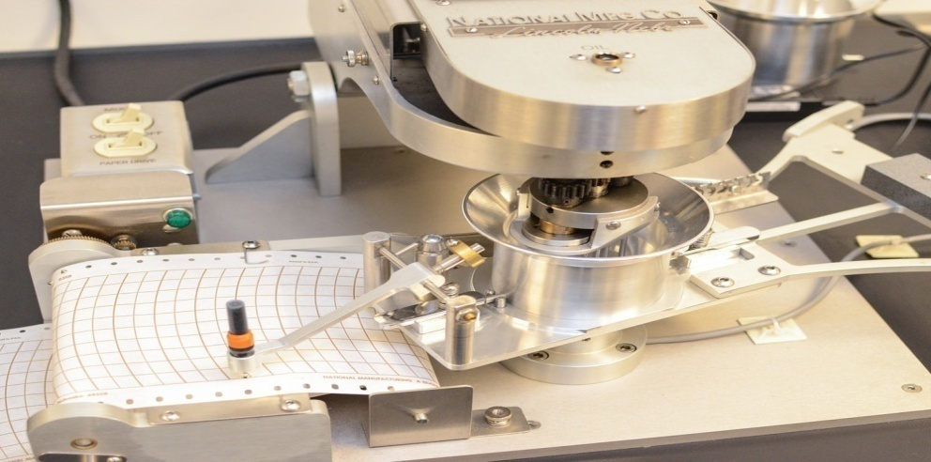

- Amylograph :
- This instrument measures the relative viscosity of a flour water suspension as it is heated at a constant rate.
- This test measures the change in viscosity as the starch granules gelatinize & swell during heating.
- A suspension of flour & water is prepared according to standard procedures.
- The mixture is heated from 30ºC to 92ºC in a rotating bowl at a heating rate of 1.5ºC / min.
- A paddle inside the bowl is attached to a force measuring device, which records relative viscosity as Brabender Amylograph (AU) against time or temperature.
- Good bread making performance is related to a gelatinization maximum between 300 & 700 AU.
- If the flour has very low levels of alpha amylase activity (corresponding to a Falling Number Value ˂ 300), the bread making quality of the flour is adversely affected, & alpha amylase is added to the flour as an improver.
- A recent alternative to amylograph is the Rapid Visco-Analyzer.
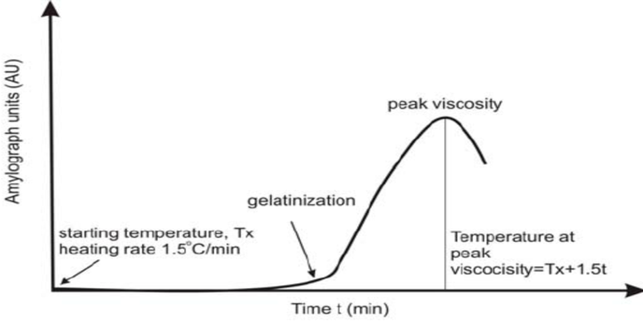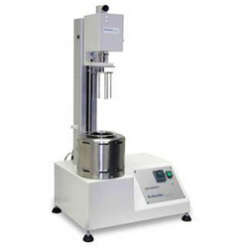

References
  - Khetarpaul N.(2020) Manufacture of bread “Bakery science and Cereal Technology” book.
  - Manay N. S. , Shadakshraswamy M. “Food facts and Principles” page no. 279 – 280.
  - Shrilakshmi B., “ Food Science” page no. 35.
  - Rodgers R, ed (2001) Yeast Breads and Flatbreads, The Baker's Dozen. THE BAKER'S DOZEN COOKBOOK: United States of America: HarperCollins Publishers Inc.
  - Fance W. J. and Wragg BH. Up - to - date Bread Making, Maclaren and Sons, London
  - Link : https://ecourses.icar.gov.in
  - www.aarushijain.com/baking_ingredients.html

