Synbiotics: A Novel Approach in Managing Oral Diseases
Dr. Subhashree Mohapatra, Dr. Rahul Mohandas
Department of Public Health Dentistry, Department of Oral and Maxillofacial Pathology and Oral Microbiology
Dr. D.Y. Patil Dental College and Hospital, Dr. D.Y. Patil Vidyapeeth
Pune, India

ABSTRACT
The use of antibiotics has led to surging levels of multidrug resistance among pathogenic organisms, thereby increasing the demand for natural substitutes. In the past few years, there has been a rise in clinical evidence showing the efficacy and effectiveness of some prebiotics and probiotic strains in improving oral health. Recently, it has been proposed that fusing prebiotics and probiotics can potentially develop novel synbiotics that may act effectively against oral microorganisms. According to the FAO/WHO (2001), probiotics are defined as “live microorganisms when administered in adequate amounts, confer a health benefit on the host”. According to Gibson and Roberfroid (1995), prebiotics are defined as “non-digestible food ingredient that beneficially affects the host by selectively stimulating the growth and/or activity of one or a limited number of bacteria in the colon, and thus improves host health”. Synbiotics are defined as “mixtures of probiotics and prebiotics that beneficially affects the host by improving the survival and implantation of live microbial dietary supplements”. The development of synbiotics may impart a synergistic effect in improving oral health and compensate for the drawbacks of the individual components. The current available data on the role of synbiotics in maintaining oral health, recommendations, and future scope have been has been discussed in this article.
Key words: probiotics, prebiotics, synbiotics, oral health, dental caries, periodontitis, oral cancer
I. INTRODUCTION
Antibiotic therapy was introduced in the mid-20th century and since then it has been used extensively to inhibit the growth of several micro-organisms. (1) In dental practice, antibiotics are routinely used to treat odontogenic and non-odontogenic infections, focal infections, and to prevent the spread of infection to neighbouring tissues and organs. (2)
However, the use of antibiotics has led to surging levels of multidrug resistance among pathogenic organisms, thereby increasing the demand for natural substitutes. (3) In the past few years, there has been a rise in clinical evidence showing the efficacy and effectiveness of some prebiotics and probiotic strains in improving oral health. (3) Recently, it has been proposed that fusing prebiotics and probiotics can potentially develop novel synbiotics that may act effectively against oral microorganisms. (4)
A. Probiotics and Prebiotics: Shaping the Future of Dentistry
According to the FAO/WHO (2001), probiotics are defined as “live microorganisms when administered in adequate amounts, confer a health benefit on the host”. (5) Probiotics like L. acidophilus, L. reuteri, L. paracasei, L. salivarius strains WB21 and T1271, L. paracasei SD1, Streptococcus thermophiles and L. bulgaricus, Lactobacillus rhamnosus, L. salivarius strains WB21 and T12711, Lactococcus lactis, L. plantarum strain 299v, L. helveticus, L. salivarius WB21 and L. fermentum, Bacillus subtilis and L. salivarius, E. faecium WB2000, S. thermophiles, S. salivarius K12 have proved to be a potential substitute for antibiotics in several oral conditions such as dental caries, halitosis, and periodontitis. (6) However, the exact mechanism of action of probiotics is unknown. A proposed mechanism of action suggests that the probiotic organisms either damage the pathogenic organism directly or modulate the host response towards the pathogens (Figure 1). (6)
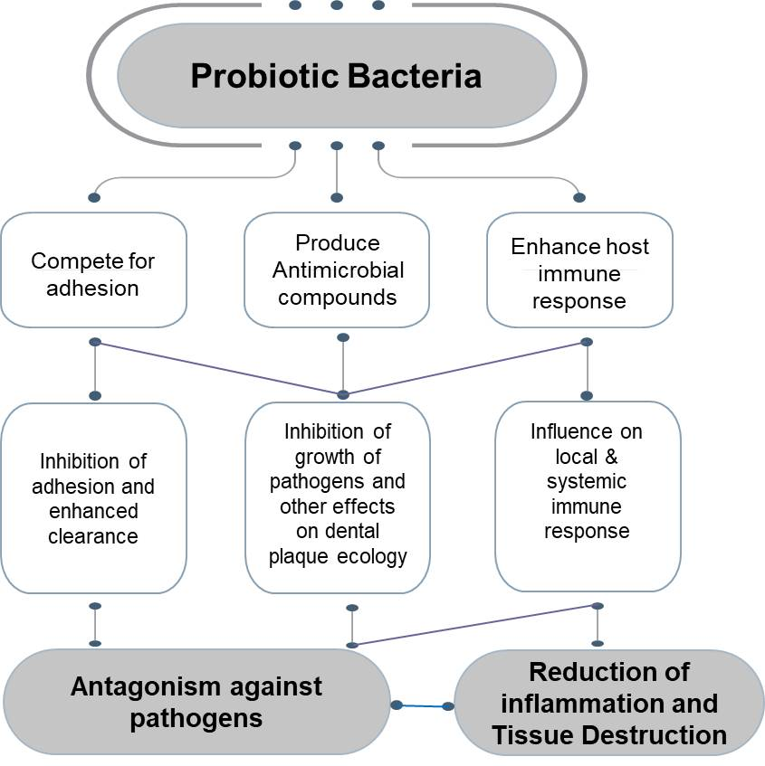
Figure 1: Proposed mechanism of action of probiotics
The ‘prebiotic approach’ has been introduced more recently. According to Gibson and Roberfroid (1995), prebiotics are defined as “non-digestible food ingredient that beneficially affects the host by selectively stimulating the growth and/or activity of one or a limited number of bacteria in the colon, and thus improves host health”. (7) Prebiotics selectively promote the growth of certain probiotics. They are neither hydrolyzed nor absorbed by mammalian enzymes, they should be able to alter intestinal microbial flora and its activity, and modify systemic aspects of the host defense system. (8)
Prebiotics have shown potential scope in various aspects of health such as improving calcium absorption, (9) immune system, (10) and reducing colorectal cancer. (11) However, limited research has been done to assess the effect of prebiotics on oral health. Prebiotics operate as a nutrition supply to aid in the colonisation of oral-beneficial bacteria in the oral cavity, promoting the growth of these organisms. (12) In a study, 14 oral bacterial species were used to grow biofilms, which subsequently were treated with prebiotic solutions. Succinic acid, N-acetyl-D-mannosamine, and Met-Pro proved to be promising prebiotic substrates, that resulted in a biofilm composed of >95% of beneficial oral bacterial species. N-acetyl-D-mannosamine was identified as the most promising oral prebiotic substrate as it showed significant changes in bacterial composition. (13) Similar findings were seen in another study, where a comparison was done between the effects of structural analogues N-acetyl-d-mannosamine (NADM) and N-acetyl-d-glucosamine (NADG) on multispecies oral biofilms. NADM showed a beneficial microbial compositional shift, reduced virulence of microorganisms, altered metabolism, and decreased inflammatory potential. (14) Recently, arginine-containing prebiotics have shown superior effect in caries prevention as compared to the controls. L-arginine administration to supragingival biofilms has been demonstrated to interfere with the formation of the biofilm matrix and the microbial interactions that lead to the growth of cariogenic biofilms. (15) However, long-term use of arginine may have an increased risk of plaque alkalization and overgrowth of oral anaerobes such as Porphyromonas gingivalis. (16)
B. Relationship between probiotics and prebiotics
An essential requirement of a microorganism to be considered as an oral probiotic is its ability to colonize oral cavity surfaces. However, microorganisms generally considered as probiotics may not be able to adhere to oral surfaces and hence their ability to improve oral health is questionable. (17) Prebiotics selectively stimulate the growth of probiotic bacteria and suppress the outgrowth of pathogenic bacteria. Hence, the combination of probiotics and prebiotics may have a synergistic effect in improving oral health conditions. (17)

II. SYNBIOTICS: THE BEST OF BOTH THE WORLDS
Synbiotics are defined as “mixtures of probiotics and prebiotics that beneficially affects the host by improving the survival and implantation of live microbial dietary supplements” (Figure 2). (18) Prebiotics work by selectively favouring healthy bacteria like Lactobacilli and Bifidobacteria at the expense of potential adhesion sites for pathogenic strains. This results in anti-adhesive properties that reduce the virulence of human pathogens as a whole. (19) The evidence of prebiotics and probiotics in improving oral health has been reported separately in several studies. (20,21,22) However, the development of synbiotics may impart a synergistic effect in improving oral health and compensate for the drawbacks of the individual components. (23) The current available data on the role of synbiotics in maintaining oral health has been summarized below (Figure 3).
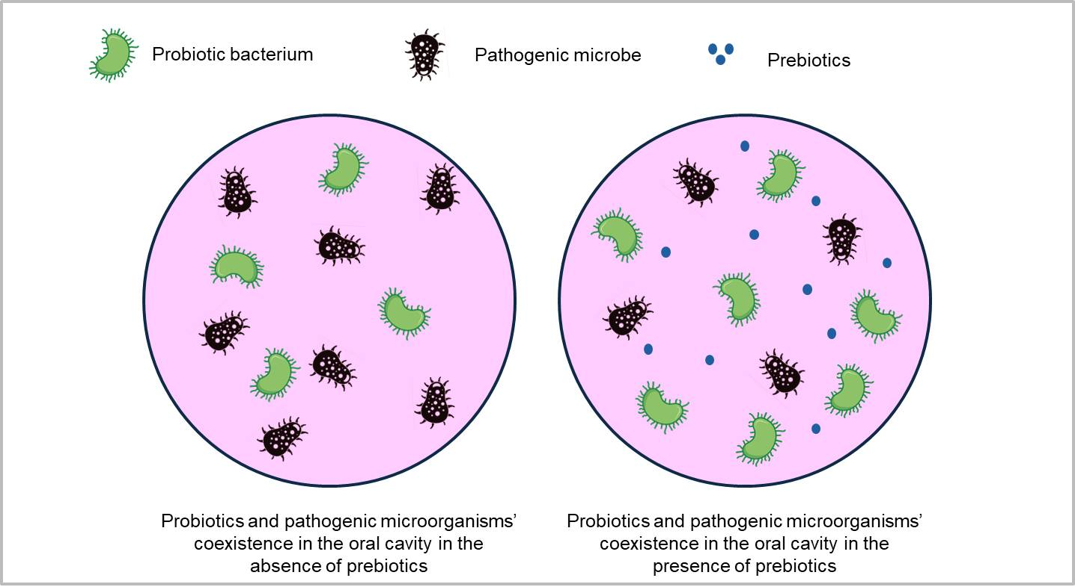
Figure 2: Synbiotics-products containing both probiotics and prebiotics

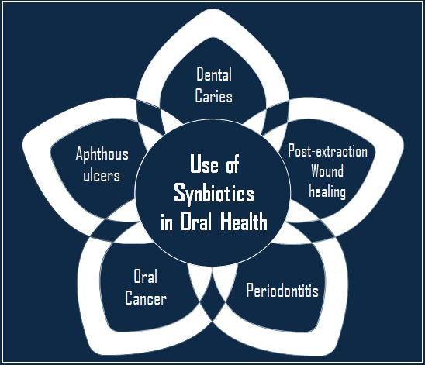
Figure 3: Role of synbiotics in oral health
A. Dental caries
According to the 2019 Global Burden of Disease Study, there were 3.09 billion incident cases of caries in permanent teeth. (24). Dental caries has a negative impact on psychosocial well-being and oral health-related quality of life (25). Along with a negative impact on quality of life, treating dental cavities and ongoing maintenance come at an additional financial cost. Therefore, widespread caries prevention is necessary to lessen the burden of caries globally and its adverse effects.
Dental caries is a multifactorial disease caused by the presence of excessive cariogenic microorganisms as compared to healthy oral commensals. The cariogenic pathogens metabolize fermentable carbohydrates and cause a prolonged acidic microenvironment in the oral cavity, thus leading to demineralization of the tooth. (26) It is well known that topical fluoride application inhibits enamel demineralization and promotes remineralization. (27) However, limited biofilm control is offered by fluorides. (28) Therefore, topical fluoride application needs to be supplemented with biofilm-targeted strategies for maintaining ecological symbiosis.
Biofilm inhibition and biofilm modulation are the two types of biofilm targeted strategies. Biofilm inhibition using antimicrobial agents for a long term may cause antimicrobial resistance and disrupt the oral microbial ecology. In biofilm modulation, the growth of healthy commensals is enhanced, and the presence of pathogens is attenuated, thus maintaining the oral ecology. Therefore, biofilm modulation is a desirable approach to restore homeostasis in the oral cavity. (23) External supplementation of beneficial synbiotics may act synergistically and can be a good option to trigger biofilm modulation.
In several studies, synbiotics have been found to be effective in suppressing the growth of Streptococcus mutans. It has been reported in a study that the combination of 2% L-arginine (prebiotic) and L.rhamnosus GG (LrG) (probiotic) works synergistically to inhibit the growth of Streptococcus mutans. (29) The combination of Lactobacillus acidophilus and glucomannan hydrolysate, (30) 3% galacto-oligosaccharides and 1% fructo-oligosaccharides along with Lactobacillus acidophilus, (31) have been found to suppress the growth of S.mutans. Prebiotic arginine and arginolytic probiotics have also shown promising results in preventing dental caries. (32) In contrast, a study has reported that the combination of galacto-oligosaccharides and Lactobacillus acidophilus does not inhibit the growth of S. mutans. (33) In a quasi-experimental clinical trial, it has been found that synbiotics decrease salivary viscosity and improve the saliva buffering capacity of individuals with active tooth decay. (34) However, in a randomized controlled trial, the inhibition of S. mutans growth has been found to be better in children who consume probiotic curd as compared to those consuming symbiotic curd. (35) Currently, the scientific evidence of the role of synbiotics in suppressing Streptococcus mutans growth and preventing dental caries is preliminary, since majority of the studies conducted on this aspect are in-vitro in nature.
B. Periodontitis
One of the most prevalent conditions that affects teeth, periodontitis causes the surrounding and supporting tooth structure to be destroyed. (36) The word "periodontitis" is made up of the two terms "periodont-" and "itis," where "periodont-" stands for "structure surrounding the teeth" and "itis" stands for "inflammation." Periodontitis is a condition that initially affects the gingival tissue and, if ignored, spreads to deeper tissues, affecting the bone's normal homeostasis and leading to tooth loss. (37) The aetiology of periodontal disease is multifactorial. (37) The bacterial biofilm that is developing on the tooth surfaces has been recognised as the primary cause of periodontitis. (38) While the host response, combined with local variables like plaque and calculus, influences the disease's course, genetics, environmental factors, the patient's systemic health, lifestyle choices, and many socioeconomic determinants also play a part. (39) Periodontopathogens have negative effects that extend beyond the periodontium and have an adverse impact on patients' overall health. (40)
Mechanical sub-gingival debridement followed by antibiotic therapy is the standard strategy for periodontal disease as it shifts sub-gingival flora to a less pathogenic composition. However, re-colonisation of more aggressive microorganisms occurs within one-two weeks. The long-term effect of periodontal therapy may not be really improved by antibiotics or antiseptics. Hence, an alternative strategy needs to be developed for plaque-induced periodontitis. (41)
A randomized controlled trial (RCT) was conducted to assess the effect of synbiotics in the treatment of smokers and non-smokers with gingivitis. It was found that IL-8, IL-6, and IL-10 levels in the gingival crevicular fluid were lower in patients in the treatment group (who received symbiotic tablets) as compared to the control group (who received placebo tablets). However, no significant difference was found in gingival and plaque index between the groups. (42)
In another RCT conducted among diabetes mellitus patients being treated with non-surgical periodontal therapy (NSPT), symbiotic supplementation with a combination of multispecies probiotics and 100 mg fructo-oligosaccharide was found to significantly decrease the levels of pocket depth (PD), clinical attachment loss (CAL), plaque index, malondialdehyde (MDA), and IL-1β. The serum levels of glutathione peroxidase (GPx), superoxide dismutase (SOD), and total antioxidant capacity (TAC) increased significantly. (43) Similarly, another RCT conducted among patients with aggressive periodontitis (AP) revealed that co-administration of synbiotic lozenge along with standard therapy (doxycycline) was highly efficacious in improving periodontal health. (44) In a study, guided periodontal pocket recolonization (GPR) was done using synbiotics as an adjunct to scaling and root planing in patients with chronic periodontitis. Synbiotic therapy was found to improve clinical, microbiological, and biochemical parameters in patients with chronic periodontitis. (45)
C. Aphthous ulcers
Since ancient times, medical and dental practitioners have frequently recognised painful oral aphthous ulcers in otherwise healthy patients as aphthae or canker sores. They affect the oral mucosa the most frequently in the general population. (46) The word "aphthae" is derived from the Greek verb "aphthi," which meaning "to set on fire" or "to inflame," and it is believed that Hippocrates originally used it to describe the discomfort brought on by a common oral condition that was prevalent in his time (possibly, aphthous stomatitis). (47) The aetiology of repeated mouth ulcerations has been linked to local trauma, hereditary factors, nutritional inadequacies, viral and bacterial infections, as well as immunological or endocrine disorders. Recurrent aphthous stomatitis (RAS) is a term used to describe situations in which no cause can be determined and a diagnosis of exclusion must be made. There are three types of RAS: herpetiform (10%), major (10%), and minor (>70% of cases). (48) The form, location, severity, and prognosis of these subgroups vary.
The standard treatment for treating recurrent aphthous ulcers is long term administration of steroids. However, it is associated with several adverse effects such as immunity deficiency, and oral mucosa atrophy. Therefore, alternative therapies with lower side effects and higher efficiency need to be developed. (49) In a study, it has been found that symbiotic lozenges along with mucopain gel and Cap. Becasules are more effective in resolving aphthous stomatitis with no adverse effects, as compared to the standard therapy alone. (50)
D. Post-extraction wound healing
A RCT was conducted to assess the effectiveness of synbiotics, antibiotics, and analgesics in post-extraction wound healing in tooth sockets. The effectiveness of synbiotics was found to be equal to that of standard analgesic-antibiotic regimen. (51)
E. Oral cancer
For dental surgeons in particular, oral cancer is a vitally relevant issue of worldwide public health. According to data from the Global Cancer Observatory (GCO), there were 377,713 OSCC cases annually in 2020, with Asia recording the most instances (248,360), followed by Europe (65,279) and North America (27,469). (52) The majority of oral cancers are linked to tobacco use, alcohol consumption, or both. Oral cancers that are HPV-positive have become more common recently. (53)
Till date, no study has evaluated the effect of synbiotics on oral cancer prevention. However, they have been found to be effective in preventing colorectal cancer. (54) The exact mechanism of synbiotics in inhibiting colorectal cancer has not been established yet. However, there are two proposed mechanisms of action: (i) formation of complementary synbiotics, in which probiotics and prebiotics work together to produce an additive antioxidant effect at the host, and (ii) synergistic synbiotics, in which prebiotics, whether or not they are antioxidants, support and enhance probiotics antioxidant performance to produce higher properties than either component alone (Figure 4). (55) They have also shown prophylactic effects post gastrointestinal cancer surgery. (56) These findings are preliminary and carefully designed human trials need to be planned. Also, the findings cannot be generalized to all cases, as each individual has a unique microflora composition.
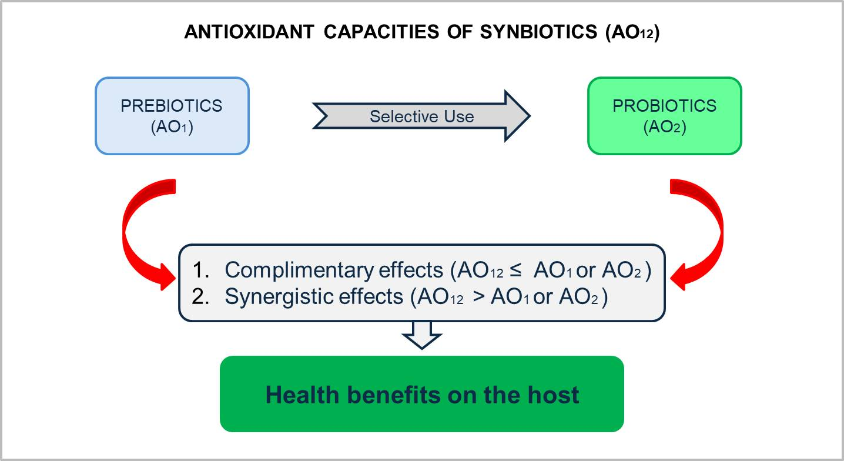
Figure 4: Antioxidant activities (AO) of synbiotics
III. RECOMMENDATIONS AND FUTURE SCOPE
- The exact mechanism of action of synbiotics against cariogenic pathogens needs to be identified.
- Although several synbiotics have been proposed for dental caries prevention, we need to assess how far they can be classified as true synbiotics.
- Although several in-vitro studies have shown promising results, human trials need to be conducted to assess the clinical effectiveness of synbiotics in dental caries prevention.
- In several RCTs, synbiotic supplementations have shown promising results in improving periodontal health. In future research, they can be included in mouthwashes and checked for clinical effectiveness.
- For future synbiotic research, the efficacy of specific strains of probiotics, the effective dosage of probiotics and prebiotics, and the duration of treatment need to be assessed.
- Arginine-based synbiotics have shown promising results in caries prevention. However, prospective, longitudinal studies need to be conducted to assess their long-term efficacy.
- Future research can be done to assess the role of synbiotics in oral cancer as they have shown promising results in colorectal and gastrointestinal cancer.

IV. CONCLUSION
Based on the available evidence, it can be concluded that synbiotics hold great potential for improving oral health. However, future studies are required to optimize and quantify the extent of this benefit. In addition, the role of prebiotics in improving oral health also needs to be investigated. Moreover, the selection of synbiotics, or probiotics and prebiotics separately, depends on the broad ecological changes in the mouth induced by their ingestion and their long-term effect on oral health.
REFERENCES
[1] Morcillo E, Cortijo J, Villagrasa V. Bases farmacológicas de la antibioticoterapia en infecciones odontogénicas. Med Oral. 1996; 1:15-23.
[2] Roda RP, Bagán JV, Bielsa JMS, Pastor EC. Antibiotic use in dental practice. A review. Med Oral Patol Oral Cir Bucal. 2007;12:E186-92.
[3] Mehta K, Mehta H. Synbiotics in oral immunity: a review. International Journal of Otorhinolaryngology and Head and Neck Surgery Mehta K. Int J Otorhinolaryngol Head Neck Surg. 2021;7(5):915-91.
[4] Kojima Y, Ohshima T, Seneviratne C. J, Maeda N. Combining prebiotics and probiotics to develop novel synbiotics that suppress oral pathogens. J. Oral Biosci.2015; 58, 27–32.
[5] FAO/WHO (2001). Evaluation of Health and Nutritional Properties of Probiotics in Food Including Powder Milk with Live Lactic Acid Bacteria. Report of a Joint FAO/WHO Expert Consultation.
[6] Nanavati G, Prasanth T, Kosala M, Bhandari SK, Banotra P. Effect of Probiotics and Prebiotics on Oral Health. Dental Journal of Advance Studies. 2021;9(1):1-6.
[7] Gibson G. R, and Roberfroid M. B. Dietary modulation of the human colonic microbiota: introducing the concept of prebiotics. J. Nutr. 1995;125: 1401–1412.
[8] Pandey KR, Naik SR, Vakil BV. Probiotics, prebiotics and synbiotics- a review. J Food Sci Technol 2015;52(12):7577–7587.
[9] Scholz-Ahrens KE, Schrezenmeir J. Inulin and oligofructose and mineral metabolism: the evidence from animal trials. J. Nutr. 2007;137 (11 Suppl): 2513S–23S.
[10] Lomax AR, Calder PC. Prebiotics, immune function, infection and inflammation: a review of the evidence. Br J Nutr. 2009; 101 (5): 633–58.
[11] Geier MS, Butler RN, Howarth GS. Probiotics, prebiotics and synbiotics: a role in chemoprevention for colorectal cancer? Cancer Biol. Ther. 2006;5(10):1265-1269.
[12] Mohd Fuad A.S, Amran N.A, Nasruddin N.S.The Mechanisms of Probiotics, Prebiotics, Synbiotics, and Postbiotics in Oral Cancer Management. Probiotics & Antimicro. Prot. 2022.
[13] Slomka V, Herrero ER, Boon N, Bernaets K, Trivedi H, Daep C. Oral prebiotics and the influence of environmental conditions in vitro. J Periodontol. 2018;89(6):708-717.
[14] He J, Hwang G, Liu Y, Gao L, Kilpatrick-Liverman L, Santarpia P, Zhou X, Koo H. L-arginine modifies the exopolysaccharides matrix and thwarts Streptococcus mutans outgrowth within mixed-species oral biofilms. J Bacteriol. 2016;198(19):2651–2661.
[15] Verspecht T, Holm WV, Boon N, Baernaets K, Daep C, Zayed N. Comparison of the modulatory effects of three structurally similar potential prebiotic substrates on an in vitro multi-species oral biofilm. Sci. Rep.2021:11(1);15033.
[16] Zheng X, Cheng X, Wang L, Qiu W, Wang S, Zhou Y. Combinatorial effects of arginine and fluoride on oral bacteria. J Dent Res. 2015;94: 344–53.
[17] Manigandan T, Mangaiyarkarasi SP, Hemalatha R, Hemalatha VT, Murali NP. Probiotics, Prebiotics and synbiotics-A Review. Biomed Pharmacol J. 2012;5(2).
[18] Andersson H, Asp NG, Bruce Å, Roos S, Wadström T, Wold AE. Health effects of probiotics and prebiotics a literature review on human studies. Scand J Nutr. 2001;45: 58–75.
[19] Gibson, G.R, McCartney A.L, Rastall R.A. Prebiotics and resistance to gastrointestinal infections. Br. J. Nutr. 2005, 93, S31–S34.
[20] Astvaldsdottir A, Naimi-Akbar A, Davidson T, Brolund A, Lintamo L, Attergren Granath A. Arginine and Caries Prevention: A Systematic Review. Caries Res. 2016;50: 383–393.
[21] Li J, Huang Z, Mei L, Li G, Li H. Anti-caries effect of arginine-containing formulations in vivo: A systematic review and meta-analysis. Caries Res. 2015;49: 606–617.
[22] Cagetti MG, Mastroberardino S, Milia E, Cocco F, Lingström P, Campus G. The use of probiotic strains in caries prevention: A systematic review. Nutrients. 2013;5: 2530–2550.
[23] Bijle MN, Ekambaram M, CO Lo E, Yiu C. Synbiotics in caries prevention: A scoping review. PLoS One. 2020;15(8):e0237547.
[24] Qin X, Zi H, Zeng X. Changes in the global burden of untreated dental caries from 1990 to 2019: A systematic analysis for the Global Burden of Disease study. Heliyon. 2022;8(9):e10714.
[25] Mota-Veloso I, Soares MEC, Alencar BM, Marques LS, Ramos-Jorge ML, Ramos-Jorge J. Impact of untreated dental caries and its clinical consequences on the oral health-related quality of life of schoolchildren aged 8–10 years. Qual Life Res. 2016;25: 193–199.
[26] Bowen WH. The Stephan Curve revisited. Odontology. 2013;101: 2–8.
[27] Ten Cate JM, Buzalaf MAR. Fluoride mode of action: Once there was an observant Dentist. J Dent Res. 2019;98: 725–730.
[28] Dang MH, Jung JE, Lee DW, Song KY, Jeon JG. Recovery of acid production in Streptococcus mutans biofilms after short-term fluoride treatment. Caries Res. 2016;50: 363–371.
[29] Bijle MN, Neelakantan P, Ekambaram M, CO Lo E, Yiu C. Effect of novel symbiotic on Streptococcus mutans. Scientific Reports.2020;14(10): 7951.
[30] Tester RF, Al-Ghazzewi FH. A preliminary study of the synbiotic effects of konjac glucomannan hydrolysates (GMH) and lactobacilli on the growth of the oral bacterium Streptococcus mutans. Nutr Food Sci. 2011;41: 234–237.
[31] Nunpan S, Suwannachart C, Wayakanon K. Effect of prebiotics-enhanced probiotics on the growth of Streptococcus mutans. Int J Microbiol. 2019;2019: 4623807
[32] Zaura E, Twetman S. Critical appraisal of oral pre- and probiotics for caries prevention and care. Caries Res. 2019;53: 514–526.
[33] Nunpan S, Suwannachart C, Wayakanon K. The inhibition of dental caries pathogen by using prebiotic and probiotic combination. JDAT. 2017;67: 31–38.
[34] Hernández Y, Medina B, Mendoza E, Sánchez-Vargas LO, Alvarado D, Aranda-Romo S. Short-term effect of a synbiotic in salivary viscosity and buffering capacity; a quasi-experimental study. J Oral Res. 2020;9: 96–101.
[35] Duraisamy V, Geethapriya P R, Bharath C, Niveditha R S, John J B. Role of probiotics and synbiotics on inhibiting Streptococcus mutans level in saliva of children: A randomized controlled trial. J Indian Soc Pedod Prev Dent. 2021;39:275-278.
[36] Hajishengallis G, Darveau RP, Curtis MA. The keystone-pathogen hypothesis. Nat Rev Microbiol. 2012 Oct;10(10):717-25.
[37] Petersen PE, Baehni PC. Periodontal health and global public health. Periodontol 2000. 2012 Oct;60(1):7-14.
[38] Bartold PM, Van Dyke TE. Periodontitis: a host-mediated disruption of microbial homeostasis. Unlearning learned concepts. Periodontol 2000. 2013 Jun;62(1):203-17.
[39] Socransky SS, Haffajee AD, Cugini MA, Smith C, Kent RL. Microbial complexes in subgingival plaque. J Clin Periodontol. 1998 Feb;25(2):134-44.
[40] Darveau RP. Periodontitis: a polymicrobial disruption of host homeostasis. Nat Rev Microbiol. 2010 Jul;8(7):481-90
[41] Parihar AS, Vatoch V. Probiotics in oral health: A Review. Journal of Advanced Medical and Dental Sciences Research. 2015;3(1):57-65.
[42] N Ercan, E Olgun, U Kisa, M Yalim. Effect of synbiotics in the treatment of smokers and non-smokers with gingivitis: randomized controlled trial. Aust. Dent.J.2020;65(3):210-219.
[43] H Bazyar, LM Norouzabad, M Yarahmadi, H Gholinezhad, L Moradhi, P Salehi. The Impacts of Synbiotic Supplementation on Periodontal Indices and Biomarkers of Oxidative Stress in Type 2 Diabetes Mellitus Patients with Chronic Periodontitis Under Non-Surgical Periodontal Therapy. A Double-Blind, Placebo-Controlled Trial. Diabetes Metab Syndr Obes. 2020;13:19-29.
[44] G Murugesan, KM Sudha, MK Subaramoniam, T Dutta, KR Dhanasekar. A comparative study of synbiotic as an add-on therapy to standard treatment in patients with aggressive periodontitis. J Indian Soc Periodontol. 2018;22(5):438-441.
[45] S. Shetty, SK Srigiri, KH Sheikh. A Comparative Clinical, Microbiological and Biochemical Evaluation of Guided Periodontal Pocket Recolonisation (GPR) using Synbiotics as an Adjunct to Scaling and Root Planing in Patients with Chronic Periodontitis: A Pilot Project. Int J Med Res Health Sci. 2020; 9(5): 20-32.
[46] Femanio F, Lanz A, Buonaiuto A. Guidelines for diagnosis and management of aphthous stomatitis. Pediatr Infect Dis J. 2007;26(8):728–732.
[47] Compilato D1, Carroccio A, Calvino F. Hematological deficiencies in patients with recurrent aphthosis. J Eur Acad Dermatol Venereol. 2010;24(6):667–673.
[48] Belenguer-Guallar I, Jiménez-Soriano Y, Claramunt-Lozano A. Treatment of recurrent aphthous stomatitis. A literature review. J Clin Exp Dent. 2014;6(2):e168–e174.
[49] Jinbu, Y., Demitsu, T. Oral ulcerations due to drug medications. Jpn. Dent. Sci. Rev. 2014; 50(2):40-46.
[50] Aswath N, Praveen Kumar ST, Raghavendra JS, Manigandan T, Sarumathi T. A randomized, open label, clinical study of synbiotics in patients with recurrent minor aphthous ulcers. Research Journal of Pharmaceutical, Biological, and Chemical Sciences. 2014;5(2):1900-1905.
[51] Singh S, Sahana S, Kumar S, Gupta NK, Comparative evaluation of the synbiotics, antibiotics, analgesics in post extraction healing of tooth sockets-A randomized controlled trial. Int J Oral Health Dent. 2020;6(4):279-282.
[52] SiegelR, MillerKD, WagleNS, JemalA. Cancerstatistics 2023. CACancerJClin. 2023;73(1):17‐48.
[53] Johnson, D.E., Burtness, B., Leemans, C.R. Head and neck squamous cell carcinoma. Nat Rev Dis Primers.2020; 6(92).
[54] Fotiadis CI, Stoidis CN, Spyropoulos BG, Zografos ED. Role of probiotics, prebiotics and synbiotics in chemoprevention for colorectal cancer. World J Gastroenterol. 2008;14(42):6453-6457.
[55] Chan, M.Z.A.; Liu, S.-Q. Fortifying Foods with Synbiotic and Postbiotic Preparations of the Probiotic Yeast, Saccharomyces Boulardii. Curr. Opin. Food Sci. 2022, 43, 216–224.
[56] Tang G, Huang W, Tao J, Wei Z. Prophylactic effects of probiotics or synbiotics on postoperative ileus after gastrointestinal cancer surgery: A meta-analysis of randomized controlled trials. PLoS ONE. 2022; 17(3): e0264759.

