Posttraumatic stress disorder and its managment
Ruqeeb jan¹
Msc.Mental Health Nursing, tutor
college of nursing ,GMC ,Srinagar,
ruqeeb1235jan@gmail.com,8491864279/ 9622755489.
Sufoora Yaseen²
Msc. Nursing, Tutor
college of nursing ,GMC ,Srinagar
Introduction
It’s normal to have distressing memories, nervousness, or trouble in falling sleep after a Traumatic situation. At initial stage of trauma person may feel difficulty in activities of daily living. However most of the people feel better after a week or month. If it remains more than a month with clinical symptoms, it is called as Post Traumatic Stress Disorder. Previously it was considered as anxiety disorder which is now recognized as Trauma and Stress-related Disorders
Post-traumatic Stress Disorder is a depleting mental health problem that is caused by catastrophic and traumatic events, like earthquake, death of loved ones or sexual assault, e.t.c. presented with the following symptoms
Behavioral Symptoms | Agitations, irritability, hostility, self-destructive behavior, e.t.c.
Psychological symptoms | Fear, extreme anxiety, mistrust, and flashback
Mood and sleep | Insomnia, loss of interest, guilt, or loneliness

Defnitions:
PTSD as a reaction to extreme trauma which causes pervasive distress to everyone. PTSD symptoms are not related to common experiences such as bereavement, marital disharmony or chronic illnesses but are associated with events that markedly cause distress and individual may experience trauma alone or in presence of others.
Puri & Treasaden (2011)
PTSD is defined as protracted response to a stressful event or situation of exceptionally threatening or catastrophic nature, which is likely to cause pervasive distress in almost everyone.
ICD-10,
CLINICAL MANIFESTATIONS
DSM-V has divided PTSD into four categories
- Intrusion .
- Avoidance of thoughts and behavior.
- Negative changes in thought and mood.
- Change in arousal and reactivity.
Intrusion . | Re-experiencing the traumatic event,  Flashbacks  Nightmares  Distressed feeling. Physical symptoms to trauma
Avoidance  of thoughts  and behavior. | Avoiding daily activities, situations, thoughts, or feelings that remind you of the event.  Inability to recall important aspects of the trauma.  Detached feeling from self and others
Negative changes in thought and mood | Guilt, , or self-blame  Alienated and alone feeling  Mistrust and betrayal feelings  Difficulty concentration .
4.Change in arousal and reactivity | Trouble in Sleep.  Irritability or anger outburst  Hyper-vigilance  Aggressive, self-destructive

PTSD symptoms in children
- Separation Anxiety
- Losing acquired skills (such as toilet training)
- Sleep issues and nightmares
- Sad and serious mood while playing.
- Unknown phobias and anxieties.
- Physical symptoms with no apparent cause
- Irritability and aggression

DSM-V PTSD Diagnostic Criteria:
Criteria A:Stressor: exposure to traumatic event
Criteria B: Intrusion: One or more symptoms
Criteria C: Avoidance of thoughts and behavior: one symptom needed.
Criteria D: Negative changes in thought and mood (two symptoms required)
Criteria E: Alteration in arousal and reactivity
Criteria F: Symptoms last for more than one month.
Criteria G: functional significance(social and occupational)
Criteria H: Exclusion(symptoms not caused by medication or substance abuse).

ETIOLOGICAL FACTORS:
There are different causes — comprises of biological, neurological and psychosocial.
Neurobilogical cause:
Different Brain imaging studies have shown that amydala and hippocampus are activily involued .Amydala is associated with fear and it triggers with the traumatic situations among hyperactive people.While as hippocampus plays essential role in formation of memory and it is found that people with PTSD have loss of volume in their structure, that may contribute memory deficits and other symptoms of PTSD. It is also evidenced that hypothalamic-pituitary-adrenal (HPA) axis is disrupted among people with PTSD.
Psychosocial Cause: PTSD is most likely caused by :
- Traumatic events especially when there is severe threat to life or personal safety.
- History of physical or sexual abuse, or substance abuse
- History of family PTSD Or Depression are leading causes of ptsd in person.
- Divorce/parental sepeartion.
- Torture by force.Voilence etc

Other risk factors for PTSD include:
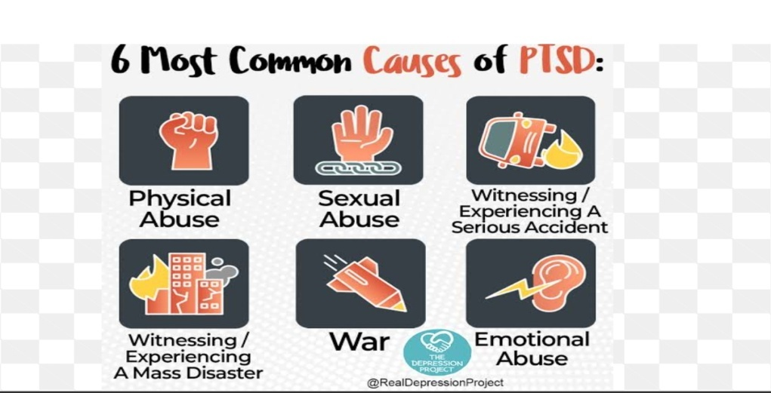

Types of post traumatic stress disorder
Acute PTSD | This recovers after a period of few weeks to 3 months
Chronic PTSD | symptoms continue more than three months
Delayed PTSD | It improves from months to years after the event

There are five main types of post-traumatic stress disorder:
Normal Stress Response: occurs when healthy adults are exposed to distinct traumatic event in adulthood and experience intense bad memories, feeling numb, unreality, being cut off from relationships or bodily tension. within a few weeks individuals usually achieve complete recovery.
Acute Stress disorder: It is characterized by panic reactions, mental confusion, dissociation, severe insomnia, suspiciousness, and being unable to manage even basic self care, work, and relationship activities. Single traumas have more severe reaction. This occur within one month after experiencing a traumatic event. Treatment includes immediate support, removal from the place of the trauma, use of medication for grief, anxiety, and insomnia, and use of brief supportive psychotherapy..
Uncomplicated PTSD: Re-experiencing of persistent traumatic event, stimuli avoidance associated with the trauma, numbing, and symptoms of increased arousal. Treatment includes group, psychodynamic, cognitive-behavioral, pharmacological therapy or combination approaches.
Co-morbid PTSD: PTSD is usually associated with at least one other major psychiatric disorder such as depression, substance abuse, panic disorder, and anxiety disorders. The best results are achieved when both PTSD and the other disorder(s) are treated together rather than one after the other.
Complex PTSD: Complex PTSD (“Disorder of Extreme Stress”) is found in those individuals who are exposed to long term traumatic circumstances, especially during childhood. They might have co morbidity with borderline or antisocial personality disorder or dissociative disorders. They manifest difficulties in behavior ,emotions & feelings
Management of PTSD

- Post traumatic stress disorder is treated with psychotropic medication like selective serotonin reuptake inhibitor (SSRI) antidepressants like fluoxetine, sertraline and paroxetine.
- Other Medications: Commonly alternative antidepressants are the atypical antipsychotics like risperidone, olanzapine, and quetiapine
- Benzodiazepines are used for certain symptoms of PTSD.

Psychological intervention
Trauma-focused cognitive-behavioral therapy
Family therapy.
EMDR (Eye Movement Desensitization and Reprocessing)

NURSING MANAGEMENT OF PTSD
NURSING DIAGNOSIS FOR A PATIENT WITH PTSD
Nursing diagnoses that are appropriate to the patient suffering from PTSD include, but are not limited to includes:
* Hopelessness/powerlessness
* Ineffective coping
* Sleep pattern disturbance
* Dysfunctional grieving
* Impaired social interaction
* Ineffective relationships
* Impaired individual resilience
* Risk for suicide

- CONCLUSION
PTSD is one of the unnoticed and debilitating mental illness that results dysfunctional state or maladaptive response to stressors which is characterized by partial or complete disintegration of individual's personality. Nurses have important role in noticing the symptoms of PTSD and application of different therapies .

REFERENCES:
- www.ptsd.va.gov | February 2018 cited on 5/5/2018
- Kukkonen Rinat Sharifullin , Bachelor’s Degree Programme in Nursing
- (Bachelor’s Thesis )May 2017
- LAHTI UNIVERSITY OF APPLIED SCIENCES ,cited on 6/5/18 cited on 10/5/18
- American Psychiatric Association. (2013). Diagnostic and statistical manual of mental disorders: Fifth edition. Arlington, VA.
- National Center for PTSD. (2018). DSM 5 Criteria for PTSD. Retrieved on February 20, 2018. PTSD causes cited on 10/5/18
- Hohn M. Grohol, Psy.D. on 9 Nov 2017 PsychCentral.com cited on 9/5/18
- Nurse Dedrey Ogunnoiki ,Management Of Post Traumatic Stress Disorder (PTSD) : January 05, 2018.
- Mary C. Townsend ,concepts of care in Evidence Based Practice (MHN) ,8TH Edition page no 560-561
- Dorothy D. Theodore Text Book of Mental Health Nursing 1st edition 2015 page no.227

.

