**Overview of recent environmental catalytic materials**

V T Vasantha1, C K Madhusudhan2, and R S Praveen Kumar2

1Department of Chemistry, Vemana Institute of Technology, Bangalore-560034, Koramangala, Karnataka, India

2Department of Physics, Vemana Institute of Technology, 560034, Koramangala, Karnataka, Bangalore, India.

***Abstract:***

This chapter encompasses a brief introduction to catalytic technology, an overview of the various aspects of the present study, and a review of published and patented literature on the alteration of the acido-basic properties of metal oxides, mixed metal oxides and their anion/cation-treated forms, their characterization using a variety of physico-chemical techniques, and their catalytic activity in various organic reactions. Additionally, a review of the use of microwave heating for organic liquid phase reaction that are heterogeneously catalysed is included.

Keywords: Catalytic technology,microwave chemistry, Honeycomb monolith

***1.1 Introduction***

The past few decades have seen significant improvements in the chemical industry, primarily due to concerns regarding the environment along with the economy on a global level. Emphasis is now on making processes efficient in terms of consumption of both energy and raw materials with minimal waste. This has been proposed that powerful catalytic technologies could achieve this. These catalytic technologies have long been utilized in sectors like the synthesis of chemicals and polymers, energy and petroleum, pollution management, and in the food and pharmaceutical sectors.



J.J. Berzelius first proposed the term "catalyst" in 1836. He described it as a material that alters the rate of chemical reaction, while itself remaining chemically unchanged at the end of the reaction [1,2]. Substances help loosen the bonds that hold atoms together in the reactants together. As a result, he originated the term catalysis. Wilhelm Ostwald proposed its powerful definition as far as the ideas of chemical kinetics. In 1909, Ostwald was granted the Nobel Prize in science for his commitments to catalysis. Recently, the main focus has been on developing novel solid acid catalysts through research and development in order to enhance selectivity and accelerate up the production of the desired product. By changing their surface properties, various new catalysts are being synthesized in this way [3-6]. The primary benefits of solid acids over traditional liquid acid catalysts are their total recovery from the reaction mixture and easy separation from reaction mixture. [7-9].

***1.2 Catalysed processes***

A chemical reaction is referred to as catalytic when, in a thermodynamically sensible reaction, the little amount of a chemical substance accelerates the rate at which chemical equilibrium is reached without changing the substance chemically. A material that quickens reactions is known as a catalyst. Catalysts function through providing an alternative mechanism with a separate transition state at a lower energy. Consequently, as Figure 1.1 shows, the catalytic reaction's activation energy is lower than that of the uncatalyzed reaction.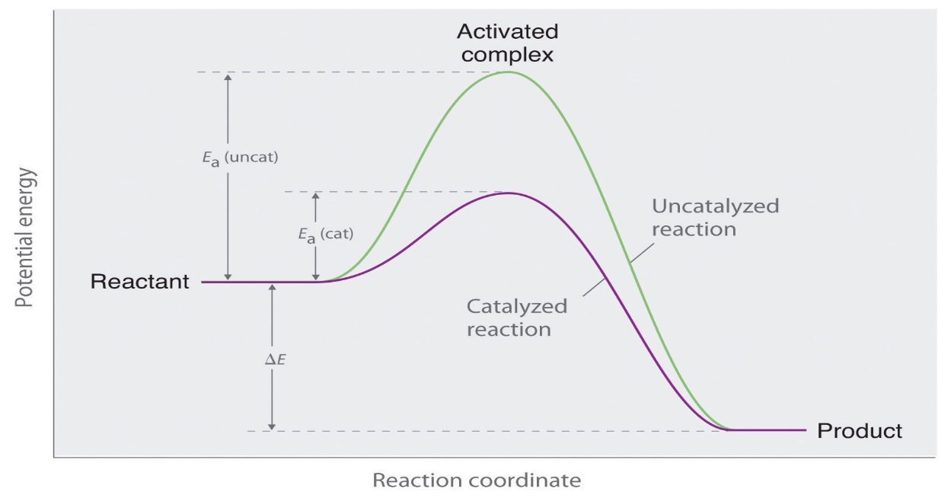

**Figure 1.1Energy diagram showing that the presence of a catalyst reduces activation energy by bringing it up a new reaction path.**

Ea (uncat) = activation energy for uncatalysed reaction

Eac (cat) = activation energy for catalysed reaction

ΔE= Energy change accompanying the reaction

By giving an alternative route for the reaction, a catalyst alters the activation energy E of a reaction. Thermal energy kT, where k is the Boltzmann's constant and T is the temperature, normally provides the activation energy E. Only a portion of all molecule contacts, denoted by the probability factor e-E/kT. Therefore, if the activation energy E is reduced, either by raising the temperature or by employing a catalyst, the reaction rate can be increased [2]. Collision theory states that a catalyst initially mix with one of the reactants generating an intermediate compound, this intermediate compound is extremely reactive. Hence it react with the second reactant to form the product and there by the catalyst is regenerated.

E.g.: reaction between two reactants A and B in presence of catalyst C

A + C $→$ [AC]

One of the Catalyst Highly reactive intermediate Reactant

[A C] + B $→$ AB + C

Other reactant Product regenerated catalyst

Over all reaction:

A + B + [C] $→$ AB + [C]

***1.2.1 Catalytic reaction types***

In general there are two categories of catalysis:

(a) Homogeneous catalysis

(b) Heterogeneous catalysis

***1.2.1.1 Homogeneous catalysis***

In a homogeneous catalytic reaction, the reactants and catalyst will be in the same phase.Usually, there is only one liquid phase or one gas phase containing all of the reactants and catalysts.Hence, reuse, recover and separation of homogeneous catalysts are less possible or more expensive Ex: HCl, H2SO4, H3PO4, AlCl3, TiCl4, FeCl3, p-toluene sulfonic acid, CF3SO3H etc. These are less environment friendly due to the formation of highly toxic waste product during chemical reactions.

***1.2.1.2 Heterogeneous catalysis***

The phases of the reactants and catalysts in a heterogeneous catalytic process will be different. Typical examples are liquid-gas reactions that occur in the presence of solid catalysts. The Contact Process, which produces sulphur trioxide by passing sulphur dioxide and oxygen over a solid Vanadium oxide catalyst, is one example of how sulfuric acid is synthesised. Thus, it can be easy to take out heterogeneous catalysts from the reaction mixture, due to the fact that they can be reused and recycled multiple times without losing their catalytic properties, they are considered as beneficial to the environment. For example, heteropolyacids, clays, zeolites, metal oxides, mixed metal oxides, etc. Nobel Prizes in heterogeneous catalysis have been awarded on several times: Fritz Haber in 1918, Card Bosch in 1931, Irving Langmuir in 1932, and Gerhard Ertl in 2007. Several significant heterogeneous catalysts can be broadly categorised as follows [10].

1. Transition metals, alloys, and bimetallic clusters (such as Pt-Sn in petrochemical refining, Ti-Zeigler-Natta catalyst in olefin polymerization, and vanadium in the manufacture of sulfuric acid)Metal oxides (TiO2 in automobile exhaust, V2O5 in oxidation of xylene to phthalic acid)

2. Complex oxides (Perovskite type) catalysts (photocatalysis, Pt/Al2O3 catalyst-induced alkane-to-alkene dehydrogenation, and automobiles exhaust)

3. Zeolites (Petrochemical industry and isomerisation of xylenes and toluene’s to p-xylene).

The three primary categories of heterogeneous catalysis are electrocatalysis, photocatalysis, and environmental catalysis. Maintaining the environment is the primary goal of environmental catalysis. As examples, consider the reduction of NOx in mass gases using ammonia on V2O5-TiO2 as catalyst, or the removal of CO and hydrocarbons from vehicle exhaust gases using so-called "three-way" catalysts, which are ceramic honey combs layered with Rh-Pt-CeO2-Al2O3. In photocatalysis, light is absorbed during a reaction by either the reactant or the catalysis. Using semiconductor catalysts (iron, zinc, and titanium oxides) for the photochemical breakdown of organic materials on self-cleaning surfaces is one example. Oxidation and reduction through electron transfer are included in electrocatalysis. Examples include the utilisation of catalytically active electrodes in chlor-alkali electrolysis and fuel cells.

***1.3 Solid acid-base catalysts***

When compared with liquid Lewis and Bronsted acid and base catalysts, solid acid-base catalysts have a number of advantages. They are less hazardous to the environment, easily removed from the liquid reaction mixture, and can be used again. They could also be made to offer greater activity, selectivity, and catalyst life. While a solid base has a tendency to take an electron pair or take a proton, a solid acid has a tendency to give an electron pair or receive an electron pair. Bronsted bases are proton acceptors, Lewis bases are electron-pair donors, and Bronsted acids are proton donors. Lewis bases are also electron-pair acceptors. These explanations are useful for providing a clear thinking of solid acid and base catalysis and are suitable for comprehending the acid-base phenomena exhibited by different materials. It should be indicated, nevertheless, that depending on the type of adsorbate in the reaction, the same site could function as both a Lewis and a Brønsted base [11].

***1.3.1 Catalysts for solid acid***

Clays, zeolites, metal oxides, mixed metal oxides, etc. all have acidic sites on their surfaces Modification of these oxides and mixed oxides with sulphate, phosphate, and borate anions and Al3+, Mo6+, and W6+ cations were found to form strongly acidic and super-acidic sites; for this purpose, they are referred to as solid acids. The structure, texture, and surface modification of solid acids significantly affect how strong their acidity is. Table1.1 [12] gives an example list of solid acids along with examples.

**Table 1.1.** Types of solid acid catalysts and examples.

|  |  |  |
| --- | --- | --- |
| **Sl. No.** | **Solid acid catalysts** | **Examples** |
| 1 | Natural clay minerals | Montmorillonite, Kaolinite |
| 2 | Simple metal oxides and sulphides | ZrO2, Al2O3, SiO2, Fe2O3, TiO2, V2O5, MnOx, ZnS, CdS |
| 3 | Metal salts | MgSO4 |
| 4 | Mixed metal oxides | ZrO2-Al2O3, SiO2-Al2O3, ZrO2-SiO2, V2O5- ZrO2, MoO3- ZrO2, WO3- ZrO2 |
| 5 | Sulfated promoted metal oxides | SO42--ZrO2, SO42--Al2O3, SO42--SiO2, SO42-- Fe2O3, SO42--TiO2 |
| 6 | Mounted acids | Porous oxides, graphite, metal salts, combined or treated with H2SO4, SbF5, AlCl3, H3PO4, H3BO3 |
| 7 | Metal phosphates | Alumina phosphates (AlPO4), silicoalumino phosphates (SAPOs) |
| 8 | Carbon | Carbon nanotubes, activated charcoal |
| 9 | Cation exchange resins | Amberlyst-15, nafion-H |
| 10 | Heteropolyacids | H3PW12O40.24H2O, 12-tungstophosphoric acid |

***1.3.2 catalytic solid bases***

Solid acid catalysts have attracted a lot of research. and used in many different types of reactions up to this point due to the tremendous advancements in the oil and petrochemical industries over the past forty years. Solid base catalysts have, however, been the focus of a lot more research than solid acid catalysts. The numbers 103, 10, and 14 correspond to the categories of solid acid, solid base, and solid acid-base bi-functional catalysts, respectively, according to a quantifiable investigation carried out by Tanabe and Hölderich up until 1999 [13]. It seems like there are a lot less solid acid catalysts overall than there are solid base-related catalysts, as well as solid base and acid-base bi-functional catalysts. Actually, liquid bases catalysts are used in the industrial process of several processes, including addition, condensation, cyclization, isomerization, and alkylation. Table 1.2 provides an example list of solid bases and examples.

**Table 1.2:** Types of solid base catalysts and examples.

|  |  |  |
| --- | --- | --- |
| **Sl. No.** | **Solid base catalysts** | **Examples** |
| 1 | Single metal oxides | MgO, CaO, SrO, BaO, La2O3, ZrO2 |
| 2 | Mixed oxides | ZrO2/MgO, ZrO2/CaO, MgO- Al2O3 MgO-TiO2 |
| 3 | Mesoporous material | MgO/SBA-15  MCM-41 functionalized with amino groups |
| 4 | Zeolite | Cs-occluded zeolite X, Y  Cs-exchanged zeolite X, |
| 5 | Oxinitride | SiON, AlPON, ZrPON |
| 6 | Supported catalyst | KF/Al2O3, Na/NaOH/Al2O3, Na /MgO |
| 7 | Clay and modified clay | Mg-Al hydrotalcites |
| 8 | Other | Calcined NaNO3 |

***1.3.3 Super acids***

The chemistry of super acids, i.e, acids stronger than 100% Bronsted acids such as sulphuric acid or Lewis acids like aluminum trichloride. i.e., (Hammett acidity) H0 ≤ -12 [14]. Acid strength of some solid and liquid acids are shown in Fig. 2. Hall and J.B. Conant proposed the term ‘super acid’ in 1927 [15].

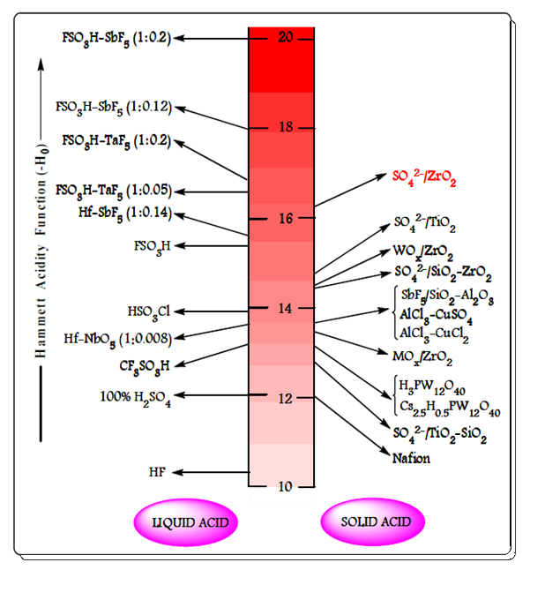

**Figure 1.2.** The acidity of various liquid and solid acids.

***1.3.3 Metal oxides in catalysts***

Due to adaptability metal oxides contribute a significant class of industrial catalysts [16]. Metal oxides may be acidic or basic and also exhibit redox properties. The acidic or basic strength of metal oxides depends on the surface with M–OH, M–O–M, M=O or M-( ) functionalities where M is metal and M-( ) represents an oxygen vacancy. Metal oxides such as ZrO2, MoO3, Al2O3, V2O5, TiO2, Fe2O3, WO3, CaO, MgO, etc., are crucial to the field of catalysis used in chemical and petrochemical industries because they act as catalysts as well as catalytic supports [17-20].

***1.3.4 oxides of mixed metals***

Due to their active acidic or basic sites, high thermal stability, and large surface area, which enhance reactant conversion, product yield, and reaction time reduction, mixed metal oxides serve as vital heterogeneous catalysts in both practical and industrial research [21–23]. Mixed metal oxides have wide range of applications such as catalysts in fine chemical synthesis, green chemistry technology and petroleum industry [24]. Figure 1.3 shows a schematic representation of mixed metal oxide applications.

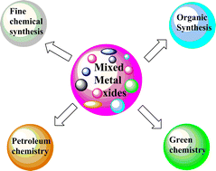

**Figure1.3**. A representation of mixed metal oxide uses.

***1.4 Brief description of materials used as catalysts for the research work presented in this thesis***

***1.4.1 Zirconia (ZrO2) and modified zirconia materials***

Zirconia (ZrO2) has high thermal stability and tensile strength, corrosion resistance and hardness. In the field of heterogeneous catalysis, as catalysts, ZrO2 and its modified forms have been utilised and catalytic supports in reactions that are catalysed by both acids and bases [25–26].The acidic and basic properties of ZrO2 can be altered by the addition of cationic or anionic materials. Drastic improvement in acidic properties can be seen by the addition of sulfate, molybdenum, vanadium and tungsten ions to produce solid “super-acids" [27] and drastic improvement in basic properties can be seen by addition of calcium, magnesium ions, etc.

ZrO2 exists in three different phases or crystal structures such as monoclinic, tetragonal and monoclinic crystalline phases. In the monoclinic phase of ZrO2, the Zr4+ ion has seven-fold coordination (it is surrounded by seven oxygen atoms), and in the tetragonal and monoclinic phases, it has eight-fold coordination.. The size of Zr4+ ion in crystal structure is 0.79 Å, 1.32 Å is the radius of O2- ion and 0.6 is the cation and anion radius ratio. A schematic crystal structure of monoclinic, tetragonal and monoclinic phases showed in Figure 1. 4.

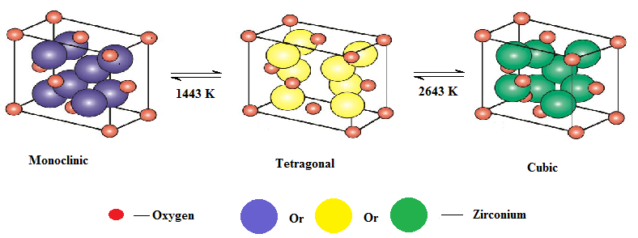

**Figure 1.4.** Schematic crystal structure of monoclinic, tetragonal and monoclinic phases.

It has been found that zirconia's tetragonal phase exhibits catalytic activity. This phase has been successfully stabilised over a number of attempts at various pressures and temperatures. At ambient temperature, the oxide is monoclinic at standard atmospheric pressure. Then, when the temperature rises, it changes into the tetragonal and cubic phases. The monoclinic-tetragonal phase shift has been thoroughly studied due to its practical and theoretical importance [28]. The zirconia powder's particle size and preparation method have an impact on the pace of transformation from the monoclinic to the tetragonal phase [29, 30]. The phase transition occurs more rapidly depending on the prepared zirconia's particle size. Phase transformation may also be significantly affected by the addition of sulphate anions. Since it can deferral the development of oxo-bonds between zirconium atoms and oxygen atoms, bridging sulphate ions stabilise the structure of zirconia (Figure.1.5).

**Figure.1.5.** Structure of sulphated zirconia [42]

This will stabilise the surface area and stop rapid phase transformation by avoiding sintering at elevated temperatures [31, 32]. A precursor, pH, and ageing duration are some of the factors which influence the phase transition [32]. The sample showed a rapid change in phase from tetragonal to monoclinic when it precipitated at low pH. An amphoteric oxide with strong acid-base properties is zirconia. The Lewis acidity is created by the bridging cations. Brønsted acid sites are a result from terminal coordinated water molecules. The typical types of acidity at lower and higher temperatures, respectively, are Lewis acid sites and Bronsted acid sites [33]. Numerous studies have been conducted in this area to examine surface modification and zirconia's ability to withstand acidity. The most well-known of these involves adding cationic or anionic materials, such as WO3, SO42-, and MoO3, at the sub-monolayer level to create new acidic sites, and attaching catalytically active metal oxides.

Because these modifications can produce strength of the order of 100% H2SO4, which is exceptional in any heterogeneous catalyst, the results achieved in recent years are really impressive [35]. The highly acidic sites that result from grafting sulphate species onto ZrO2 are referred to be "super acidic" on their surfaces. Arata and co-investigators [36] reported in 1979 that zirconia, when properly treated with sulfuric acid or ammonium sulphate, exhibits extremely strong acidity and is capable of catalysing the isomerization of n-butane to isobutane at room temperature. As a result of this, among the promoted zirconia-based solid acid catalysts, the SO42- /ZrO2 (SZ) catalyst gained greater attraction. Several chemical synthesis and transformation processes, such as multicomponent reactions, isomerization, alkylation, acetylation, esterification, glycosidation, and some other economically important reactions, have been shown to be very active for the SZ catalyst throughout time [37, 38]. However, an important disadvantage of SZ catalyst is its fast deactivation in reducing conditions and at high temperatures due to SOx and H2S production, respectively. Many efforts were made to improve the stability and activity of the SZ catalyst, including carbon molecular sieves, noble metal Pt, and transition metals including Fe, Mn, and Cr [39]. Under specific preparation circumstances, Arata and Hino (1988) claimed that solid super acids may be synthesised by adding WOx or MOx to the Zr- or Ti-hydroxides [40, 41]. Their findings were also supported by our thorough research, and we have investigated a few of these catalysts for different chemical processes.

**1.4.2 Alumina (Al2O3)**

The Alumina (Al2O3) as a catalyst and catalytic support has been widely recognized. Al2O3 has been regarded as an acid-type catalyst and its role has been studied in a number of catalytic applications [43]. As a support, alumina is used in many catalytic processes of industrial importance such as isomerization, alkylation, catalytic cracking, hydroforming, etc., [43]. Al2O3 is [amphoteric](https://en.wikipedia.org/wiki/Amphoteric) in nature which means that Al2O3 can behaves as both acid and a base. When alumina is heated at different temperatures, alumina transforms into seven forms such as gamma, delta, theta, kappa, chi, eta and rho, and these seven aluminas are called “Transition Aluminas” (Figure 1.6) [44]. Transition aluminas are used as catalysts as well as catalytic supports in heterogeneous catalysis, because they are porous in nature, less expensive, mechanically more stable at high temperature and possesses good physical strength**.** Due to [amphoteric](https://en.wikipedia.org/wiki/Amphoteric) nature, Al2O3 and its modified forms can be used as catalysts in many organic transformations such as dehydrogenation [46], [synthesis of functionalized 1,4-dihydropyridine derivatives](http://www.sciencedirect.com/science/article/pii/S1381116914003185) [47], transesterification reactions [48], esterification reactions [49], synthesis of biodiesel [50], epoxy cleavage reactions [51], hydrodeoxygenation [52], acylation reaction [53], etc.

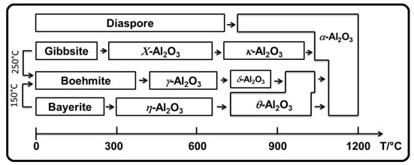

**Figure1.6.** Temperature transformation sequence of the aluminum hydroxides (Al2O3) [45].

***1.5 Introduction to cordierite honeycomb (HM)***

Cordierites (2Al2O3.2MgO.5SiO2) have naturally very low thermal expansion co-efficient over a wide range of temperatures, which contains MgO, SiO2 and Al2O3 in this ratio of 2:5:2. Cordierite honeycomb monolith (HM) can have used as heterogeneous catalyst after the modification [54]. They can be circular shapes with interconnected repeating cells or channels [55]. In comparison to powder catalysts, the catalyst coated honeycomb monoliths have benefits such as the formation of a thin layer with a high active surface area, a lower catalyst load on the monolith, facile separation, and complete removal of the catalyst from the reaction mixture.. Supported honeycomb monolith catalysts were initially developed for gas phase reactions in automobile emission control systems like catalytic converters in diesel and gasoline engines, ozone abatement in aircrafts, and selective NOx reduction. Their application in liquid phase/vapor phase organic synthesis has attracted the least attention [34, 57–61]

**Advantages of honeycomb monoliths**

When compared to other multiphase reactors or the pellet packed fixed-bed reactors frequently employed in the petroleum refining sector, monolith catalysts have some characteristics in the majority of applications. They have the following advantages.

1. for mass transfer and reactions, a higher specific external catalyst surface area.

2. External mass transfer is reduced when multiphase reactors are employed.

3. Internal diffusion restrictions are eliminated when using thin walls.

4. Reduced pressure drop when significant fluid throughputs are present..

5. Easy scale up.

6. Cleaning up the dirt that has collected on the channel walls will be simpler.

7. High product selectivity due to lower axial dispersion and back-mixing.

8. A reduction in fouling and clogging, which lengthened the catalysts' lifetime.

The support exhibits excellent working characteristics with regard to ceramic monoliths, including high mechanical strength, high temperature resistance, low thermal expansion coefficients, low pressure drop, and availability in a variety of sizes or shapes [62]. Different procedures have been performed coating the monoliths walls with support materials called wash coat like gamma Al2O3, TiO2, ZrO2 or zeolites, to obtain a higher surface area and abundant pores, since cordierite itself exhibits negligible porosity and offers little contribution to catalytic action [63].

***1.6 Methodologies***

One of the significant features in the catalysis research is generally three interconnected characteristics that are intricate, such as, preparation, characterization and reactivity of the catalysts. A triangular association between these three aspects has been shown by many authors [64-81].

***1.6.1 Catalyst preparation***

The following catalysts were prepared in this investigation:

Metal oxide: ZrO2

Mixed metal oxides: ZrO2-Al2O3, MgO-ZrO2, CaO-ZrO2

Modified oxides: SO42-/ZrO2, Mo(VI)/ZrO2, W(VI)/ZrO2 ,Mg(II)/ZrO2, Ca(II)/ZrO2 and Ba(II)/ZrO2

***1.6.2 Preparation of catalytic materials on honeycomb monoliths***

***1.6.2.1 Coating of ZrO2, 5%W(VI)/ZrO2, 5%Mo(VI)/ZrO2 and SO42-/ZrO2 on honeycomb monoliths***

Using the "dip and dry" approach, catalytic materials were coated on honeycomb monoliths (HM) [82]. Typically, a diluted solution of zirconyl nitrate [ZrO(NO3)3. 8H2O] has been prepared in order to coat ZrO2 on an uncoated HM. By immersing the final product and drying it in a muffle furnace heated to 400oC, the solution was coated onto an HM. The 'dip and dry' stages were done 6–8 times, coating the HM with 0.02 g of catalyst (ZrO2). Similarly, using diluted solutions containing known concentrations of ZrO(NO3)3. 8H2O, ammonium molybdate [(NH4)6Mo7O24.4H2O], and ammonium tungstate [(NH4)10H2W12O42.4H2O], uncoated HMs were coated with 5%Mo(VI)/ZrO2 and

A slurry of 1.5 g of Zr(OH)4 and 0.75 mL of 3M H2SO4 was prepared with deionized water to coat SO42-/ZrO2 on a bare HM. The slurry was thoroughly mixed and coated to the HM..

***1.6.2.2 Coating of MgO/ZrO2 and CaO/ZrO2 on honeycomb monolith***

MgO/ZrO2 or CaO/ZrO2 was coated to honeycomb monoliths (HMs) using the "dip and dry" method. In a typical procedure, known concentrations of zirconyl nitrate with magnesium nitrate and calcium nitrate were taken in a 125 ml beaker and made into a solution with 30 mL of deionized water. A bare honeycomb was coated with the outcome using the 'dip and dry' method in a muffle furnace that had been warmed to 400 oC. In order to coat the HM with 0.2 g of the solid base catalyst, "dip and dry" processes were repeated 10–12 times.

***1.6.2.3 Coating of binary oxides on honeycomb monolith***

HMs were coated with different percentage binary oxides like 40%ZrO2-60%Al2O3 and 60%ZrO2-40%Al2O3 utilising diluted solutions with known amount of Al(NO3)3 and Zr(NO3)3.

***1.6.2.4Coating of 5%Mg(II)/ZrO2,5%Ca(II)/ZrO2and 5%Ba(II)/ZrO2 on HMs***

It prepared from diluted solutions with known concentrations of barium nitrate, calcium nitrate, and magnesium nitrate as well as zirconyl nitrate. In a furnace that was heated to 4000C, these solutions were coated on HMs using the "dip and dry" approach. Up to 0.15 g of 5% Mg(II)/ZrO2, 5% Ca(II)/ZrO2, or 5% Ba(II)ZrO2 were coated on the HMs, the "dip & dry" stages were repeated 6–8 times.

Before being utilized as catalysts, the HMs indicated above were calcined at 550 oC for 5 hours in a muffle furnace.

***1.7 Catalyst characterization***

The following methods were utilised to characterise all the prepared catalysts used in the current investigation:

* Surface acidity measurement using the temperature-programmed desorption of ammonia (TPD-NH3) and n-butyl amine back titration method
* Temperature programmed desorption of carbon dioxide (TPD-CO2)
* Powder X-ray diffraction for crystallinity (PXRD)
* Functional group analysis using Fourier Transform Infrared (FTIR) spectroscopy
* For specific surface area, use the Barunauer-Emmett-Teller (BET) method.
* Surface morphology using scanning electron microscopy (SEM)
* Technique for elemental analysis using an inductively coupled plasma-optical emission spectrometer (ICP-OES)

The brief description of experimental procedures of characterization techniques involved in the work carried out for present thesis is given below.

***1.7.1 Temperature programmed desorption of ammonia (TPD-NH3)***

Analysis of the type, number, and strength of active acid sites present on the surface (surface acidity) of catalytic materials is done using temperature-programmed desorption (TPD). In this experiment, 0.1 g of catalyst was degassed under helium stream for 1 h at 100 °C, then ammonia gas (99.99%) was added to the stream until saturation was reached, and the stream was cooled to 50 °C. After the system was kept at 50 °C for 30 min, the catalyst surface was flushed with helium for two hours while the system was still at 50 °C. The catalyst was heated to 700 °C in helium at a rate of 5 °C min-1. The peak area of the calibrated thermal conductivity detector signals was used to calculate the change in NH3 concentration. More loosely held than molecules that desorb at higher temperatures are molecules that desorb at low temperatures. As a result, the TPD experiment describes both the number and strength of acid sites.

Early in the 1960s, temperature-programmed desorption (TPD) techniques were developed for quantitative investigation of model surfaces. Using the pulse chemisorb instrument Mayura NH3 - TPD unit, it is one of the flexible methods for determining the overall acidity and the strength of acid sites present in the catalyst [83, 84].

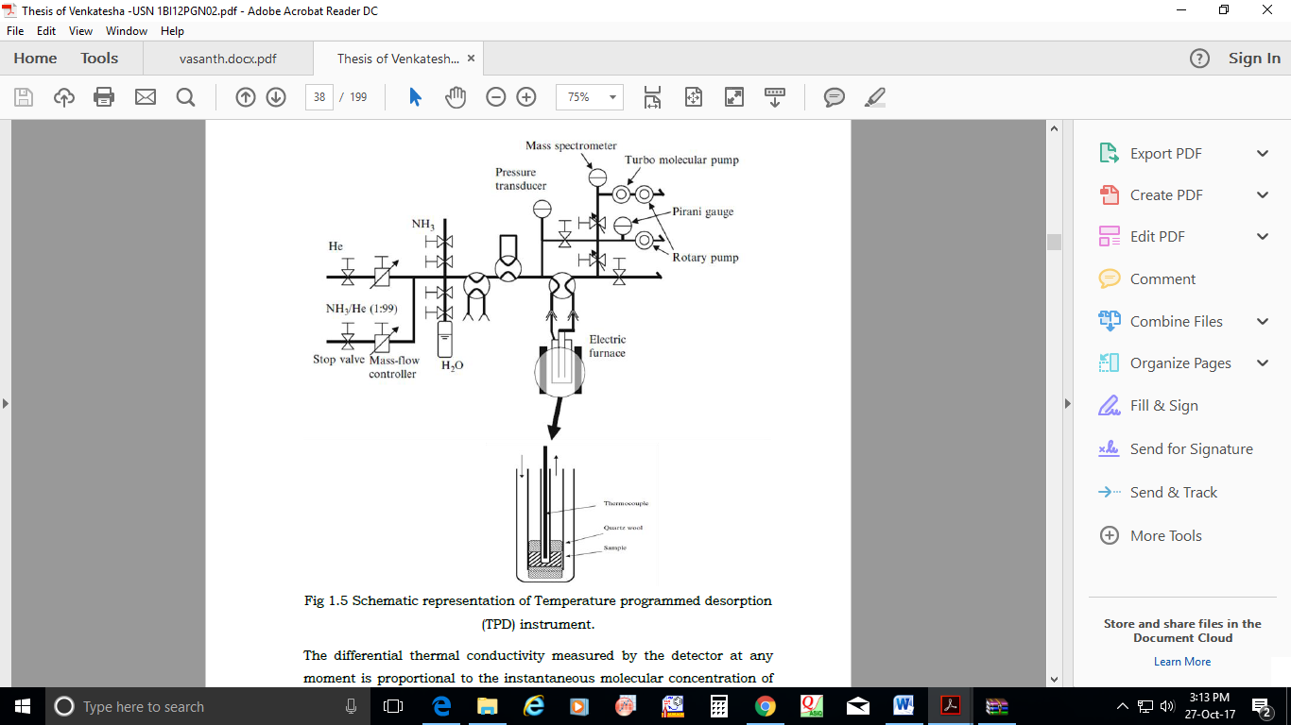

**Figure 1.7**.. Schematic representation of Temperature programmed desorption (TPD) instrument.

***1.7.2 n-butyl amine back titration method***

The n-butyl amine back titration method can also be used to determine the total surface acidity of solid catalytic materials. In this procedure, 25 ml of dry benzene solution containing 0.05 M n-butyl amine were used to suspend 0.5 g of the catalyst. 24 hours were given to the combination. All of the acid sites on the solid's surface are neutralized during this time. 0.05 M HCl was used to titrate the unreacted n-butyl amine, and bromothymol blue was utilized as an indicator. The decrease in n-butyl amine concentration was used to compute the surface acidity of the solid catalyst. Using the following formula, the total surface acidity (TSA) was determined:

|  |
| --- |
| $$Total surface acidity of the catalyst=\frac{(x-y) 1000}{W}mmol/g$$ |

Where,

Molarity of n- butyl amine before adding the catalyst = x

Molarity of n- butyl amine after treating with the catalyst = y

Weight of the catalyst = W (g)

***1.7.3 Temperature programmed desorption of carbon dioxide (TPD-CO2)***

In order to determine the kind, number, and strength of active basic sites that are present on the surface of catalytic materials (surface basicity), desorption of carbon dioxide is usually performed. The desorption temperature and the strength of the basic sites were related. Frequently, qualitative measurements are conducted for various experiments under the same circumstances. TPD of adsorbed CO2 has been extensively employed to examine basic materials. For example, stepwise TPD of CO2 has been used to study supports modified with rubidium. The addition of Rb species to supports like MgO, Al2O3, TiO2 and SiO2, via the decomposition of supported rubidium acetate, increases the surface density of adsorbed CO2 over that pure support. Because of the high desorption temperatures needed to release CO2 from RbO/MgO, it was determined that very strong basic sites had formed. Because of this, Mayura Analytical Centre utilises the CO2 -TPD unit. Various alkali metals-containing (exchanged and occluded) zeolites have had their base strengths measured using carbon dioxide temperature programmed desorption [89]. Comparison is made between TPD plots of carbon dioxide desorbed from alkaline earth oxides. Adsorption of carbon dioxide and the subsequent treatment were carried out under identical circumstances prior to each TPD run [88].

***1.7.4*** Powder X-ray diffraction for crystallinity (PXRD)

The primary purposes of PXRD experiments were to determine the materials' structural integrity, d-spacing (planar distance), and planar orientation. PXRD patterns of catalytic materials were produced using a graphite crystal monochromator with a scanning range of 5-80° and a scanning rate of 2° min-1 on a Philips X'pert Pro diffractometer with a Ni filtered Cu-K radiation with =1.5418. The process of phase identification involves comparing the relevant peaks to accepted references.

𝑛𝜆 = 2d(ℎ𝑘𝑙) sinθ

According to Bragg's law, the distance between lattice planes (d) with an orientation denoted by Miller's indices (hkl) is related to every reflection observed at a 2° angle in the diffraction pattern of a crystalline sample produced by an X-ray of wavelength (λ).

A crystal's lattice is made up of layers with a uniform distribution of atoms, which are present throughout the crystal structure. A high atomic density plane signifies a high electron density plane. When a monochromatic beam of radiation strikes the high atomic density layers, scattering will take place because it happens between impinging X-ray photons and the loosely bound outer orbital electrons. The scattered waves coming from the individual atoms, or scattering points, must be in phase with one another in order to satisfy the requirements for constructive interference. In Figure.1.8, the geometric prerequisites for the occurrence of this condition are depicted.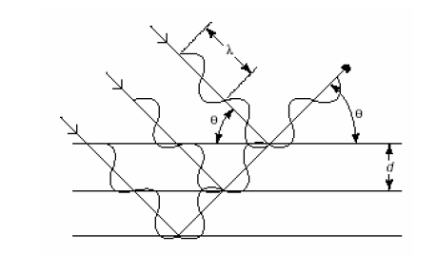

**Figure1.8**. Diffraction from an ordered arrangement of atoms.

***1.7.5 Functional group analysis using Fourier Transform Infrared (FTIR) spectroscopy***

The FTIR method was invented in the early 1800s by the French mathematician Jean Baptiste Fourier. Practically all covalent compounds, organic or inorganic, absorb different infrared wavelengths in the region of the electromagnetic spectrum. This spectrum is typically utilised to investigate the structure's fundamental vibrations and related vibrational-rotational levels. A single beam of IR radiation from the source is supplied to a Michelson interferometer, which creates an interferogram by moving a mirror, and the FT-IR spectrums were recorded using a Nicolet IR200 FT-IR spectrometer with a resolution of 4 cm-1 (Figure 1.9). The highly effective method of infrared spectroscopy (IR Spectroscopy) provides fingerprint information on the chemical composition of the sample [85].****

**Figure 1.9**. Schematic representation of IR- spectrophotometer.

One of the most significant and cutting-edge techniques for examining the structure and composition of the surface functional groups of supported metal catalysts is the FTIR spectroscopy of adsorbed probe molecules. Different types of hydroxyl groups, Lewis acid sites (coordinately unsaturated surface cations), base sites (bridging oxygen atoms or oxygen atoms of OH groups), structures formed by impurity anions that are left over after synthesis (sulphate, ammonia, and nitrate groups), or structures formed from contact with air (carbonate- carboxylate structures), can all be found living on the support surface [86, 87]

***1.7.6 Brunauer-Emmett-Teller (BET) method***

The total surface area of the catalystic material is important for catalytic activity because it determines how reacting molecules will adhere to the active sites on the surface of the catalyst. Catalytic materials' activity and selectivity in organic reactions are closely correlated with their surface properties. This approach involves measuring the amount of N2 adsorbed over the adsorbent as a function of pressure at liquid nitrogen temperature (77K). The high-speed gas sorption analyzer NOVA 1000 Quanta chrome equipment was used to measure the specific surface area of each obtained catalyst.

In this method, a pre-adsorbed gas is removed by degassing a known quantity of catalytic material in a U-shaped glass tube for five hours at 523 K (Figure 1.10). The material inside the U-shaped glass tube was subsequently cooled using liquid nitrogen to room temperature and then to 77 K. The catalytic material sample was completely saturated with nitrogen, which physically adsorbs to the surface of the sample at 77 K. Using a detector, the amount of N2 adsorbed was measured, and the surface area was computed using the equation below;

|  |
| --- |
| $$\text{Specific surface area= }\frac{V_{m}\text{ x N}}{22414 x W}xA_{m}{(m}^{2}/g)$$ |

Where,

N stands for the Avagadro number (6.022 x 1023 mole-1), W for the catalyst's mass in grammes, Am for the adsorbed molecule's cross section (0.162 nm2 in the case of N2), and Vm for the volume of the associated monolayer covering.



**Figure 1.10.** Schematic representation of BET Surface area measurement Instrument.

***1.7.7 Scanning electron microscopy (SEM)***

By utilising a JEOL JSM-7500F microscope operating at 20 kV and an 8 mm working distance, field-emission scanning electron microscopy was used to examine the catalyst particle marphology. The physical characterization of catalytic materials, such as the size, shape, surface structure, porosity, and dispersion of particles, is often accomplished using a scanning electron microscope (SEM). A narrow electron beam is projected over the surface during SEM, and the yield of secondary or backscattered electrons is then detected depending on the position of the primary beam. The majority of the secondary electrons, which have energies ranging from 5 to 50 eV, come from the sample's surface. Backscattered electrons are emitted from deeper locations and are capable of carrying chemical information. In comparison to TEM, the resolution and magnification of the SEM are comparatively low.

***1.7.8******Inductively Coupled Plasma-Optical Emission Spectrometer (ICP-OES)***

The process used for optical emission spectroscopy (OES) is called inductively coupled plasma (ICP). Thermo-iCAP 6000 Series equipment could be used to estimate the amount of metals present in catalyst sample. The elements or atoms in the samples absorb the plasma energy and become excited. They then return to their original positions by producing photons. Using suitable acid solvents such HNO3, HF, or HCl, standard solutions of catalysts in the 20–140 ppm range were created. The solution was then filtered through 0.45 (micron) membrane filters and used for further investigation.

***1.8 Catalytic activity studies***

In the various organic reaction, the synthesised and characterised catalytic materials' catalytic activity was examined.

The organic reactions were conducted in a reactor vessel that was particularly made to hold a honeycomb monolithic catalyst. Figures 1.11(a) and 1.11(b) illustrate a ceramic monolithic structure example and a reactor vessel specifically made to hold a honeycomb monolithic catalyst.



**Figure 1. 11(a):** Photograph of (a) Cordierite honeycomb monolith. (b) Reactor with monolithic catalyst.

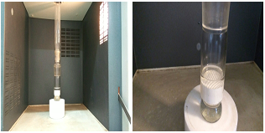

**Figure1.11 (b)**: Microwave reactor and reactor vessel to accommodate HM catalyst.

***1.9 Introduction to microwave chemistry***

Recent years have seen a significant increase in interest in the ability of microwave irradiation to accelerate both organic and inorganic reactions and shorten reaction times from hours or days to minutes. This is due to the molecules' ability to selectively absorb microwave energy. It provides rapid results and significantly speeds up response times. The material is heated uniformly throughout, with excellent heating efficiency, leading to greater product yield and improved purity in the finished product by minimising unfavourable side effects. When compared with conventional heating methods. The polar ends of these molecules or ions undergo a rapid rotation as a result of molecular friction between the moving molecules, which is caused by the microwave radiation activating even the smallest degree of variation in polar molecules and ions like alcohol with the constantly changing magnetic field and the changing electric field.

Within the frequency range of 0.3 to 300 GHz, microwave radiation is a form of electromagnetic radiation. This frequency's microwave photons have an energy of 0.0016 eV. This energy is lower than the energy of Brownian motion and is too low to break down any chemical bond. Molecular structure is not broken, rather the molecules' rotational energy changes. This shows clearly that chemical reactions cannot be induced by microwave radiation. According to the loss factors, solvents can generally be categorised as having high (tan > 0.5), medium (tan 0.1–0.5), or low (tan 0.1) microwave absorption properties. Benzene, dioxane, and other frequently used solvents without a permanent dipole moment are mostly microwave transparent. These molecules should be utilised in a microwave heated reaction along with other polar reagents or catalysts that are expected to be polar so that the reaction medium's overall dielectric characteristics will allow for adequate microwave heating [90].

Conductive heating is carried out by an external source in conventional methods of chemical synthesis. In this, heat is transferred first to the reactor vessel's walls before moving through the reaction mixture. The reactant molecules are instantly heated using microwave aided synthesis, which is not dependent on the reactor's thermal conductivity. This is a result of the direct interaction between reactant molecules and microwave energy. The scientific community is becoming more aware of the use of microwaves in a wide range of chemical reactions, and it is predicted that in a few years, the majority of chemists would likely use microwave radiation to heat chemical reactions on a laboratory scale.

***1.10 Conclusion***

* Synthesis and characterisation of solid catalysts that are benign to the environment, such as cordierite-supported zirconia and its modified forms.
* The catalytic activity of zirconia and its modified forms supported by cordierite in the synthesis of several fine chemicals is compared.
* A comparison of the % yields of the main chemical reactions, including condensation, acetalization, and transesterification, etc.
* Study of synthesising fine chemicals using microwave technology.
* Determining which catalyst is best for certain reactions.
* Optimizing the reaction conditions with a chosen catalyst.
* Find the correlation between the types of acid and basic sites needed for reactions and catalytic activity.

**Reference:**

1. B. Lindstrom., L.J. Pettersson, [A brief history of catalysis](http://www.springerlink.com/index/wl51463803777448.pdf), Cattech 7, (2003), 130.
2. G. Ertl. Angew., Reactions at Surfaces: From Atoms to Complexity, Chem. Int. Ed. 47, (2008), 3524.
3. C. Christ. Ed., Production-Integrated Enviornamental Protective and waste management in the chemical industry, Wiley-VCH. Weinheim, (1999).
4. P.T. Anastas, J.C. Warner. Eds., Green Chemistry; theory and practice, Oxford Uni. Press, Oxford. (1998).
5. P.T. Anastas, T.C Williamson. Eds., Green Chemistry; frontiers in Chemical Synthesis and process. Oxford Uni. Press. Oxford. (1998).
6. R.A. Sheldon, H. Bekkum., Fine chemicals through heterogeneous Catalysis, Willey-VCH, New York, (2007).
7. R.A. Sheldon, H. Bekkum., Fine chemicals through heterogeneous Willey-VCH, New York Catalysis, (2007).
8. G. Ertl, H. Knozinger, F. Schuth, J. Weitkamp (Editors)., Handbook of Heterogeneous Catalysis, Second Enlarged Edition, Volume 1, Wiley-VCH Verlag GmbH& Co. KGaA, Weinheim, Germany, (2008).
9. S.M. Auerbach, K.A. Carrado, P.K.Dutta., Handbook of layered materials, Marcel Dekker, Inc. New York, Basel, (2004).
10. J. M. Thomas, W. J. Thomas., Principles and Practice of Heterogeneous Catalysis, VCH Wenhheim and New York, (1997).
11. K. Tanabe, M. Misono, Y. Ono, H. Hattori., New solid acids and base, Kodansha-Elsevier, Tokyo- Amsterdam, (1989).
12. K. Tanabe., “Solid Acids and Bases”, Academic Press, New York, (1990) 136.
13. K. Tanabe, W.F. Hölderich., Industrial application of solid acid–base catalysts, Appl. Catal. A 181 (1999) 399.
14. R. J. Gillespie, T E Peel., Hammett acidity function for some superacid systems. II. Systems sulfuric acid-[fsa], potassium fluorosulfate-[fsa], [fsa]-sulfur trioxide, [fsa]-arsenic pentafluoride, [sfa]-antimony pentafluoride and [fsa]-antimonypentafluoride-sulfur trioxide, J. Am. Chem. Soc. 95, (1973), 5173.
15. N. F. Hall, J. B. Conant., A study of superacid solutions. i. the use of the chloranil electrode in glacial acetic acid and the strength of certain weak bases, J. Am. Chem. Soc. 49(12), 1927, 3047.
16. M.T. Migawa, J.-L. Girardet, J.A. Walker, G.W. Koszalka, S.D. Chamberlain, J.C. Drach, L.B, Townsend., Design, Synthesis and Antiviral Activity of α-Nucleosides:  d- and l-Isomers of Lyxofuranosyl- and (5-Deoxylyxofuranosyl)benzimidazoles, J. Med. Chem. 41 (1998) 1242.
17. [T. M. Miller](http://pubs.acs.org/action/doSearch?ContribStored=Miller%2C+T.+M.), [V. H. Grassian](http://pubs.acs.org/action/doSearch?ContribStored=Grassian%2C+V.+H.)., Environmental Catalysis: Adsorption and Decomposition of Nitrous Oxide on Zirconia, J. Am. Chem. Soc. 117 (44) (1995) 10969.
18. [N. Pernicone](http://www.sciencedirect.com/science/article/pii/0021951769903315), [F. Lazzerin](http://www.sciencedirect.com/science/article/pii/0021951769903315), [G. Liberti](http://www.sciencedirect.com/science/article/pii/0021951769903315), [G. Lanzavecchia](http://www.sciencedirect.com/science/article/pii/0021951769903315)., The oxidation of methanol over pure MoO3 catalyst, J. Catal. 14 (4) (1969) 391.
19. O. Rahmanpour, A Shariati, M. R. K. Nikou., New Method for Synthesis Nano Size γ-Al2O3 Catalyst for Dehydration of Methanol to Dimethyl Ether, International J. Chem. Eng and App. 3 (2) (2012) 125.
20. B. Rosana, D. Valderez, S. Wido, P. Luiz,J. Braz., Synthesis and Structure-Activity Relationship of a WO3 Catalyst for the Total Oxidation of BTX, Chem. Soc. 25 (11) (2014) 2026.
21. A. V. Biradar, S. B. Umbarkar, M. K. Dongare., Transesterification of diethyl oxalate with phenol using MoO3/SiO2 catalyst, Appl. Catal. A. 285 (2005) 190.
22. A. P. Amrute, A. Bordoloi, N. Lucas, K. Palraj, S. B. Halligudi., Sol–Gel Synthesis of MoO3/SiO2 Composite for Catalytic Application in Condensation of Anisole with Paraformaldehyde, Catal. Lett. 126 (2008) 286.
23. S.J.Singh, R.V.Jayaram.,Chemoselective*O*-*tert*-butoxycarbonylation of hydroxy compounds using NaLaTiO4 as a heterogeneous and reusable catalyst, Tetrahedron Lett. 49 (2008) 4249.
24. B. G. Manoj, K. P. Rajesh, V. J. Radha., Role of mixed metal [oxides](javascript:popupOBO('CHEBI:25741','C2CY00490A','http://www.ebi.ac.uk/chebi/searchId.do?chebiId=25741')) in catalysis science—versatile applications in organic synthesis, Catal. Sci. Technol. 2 (2012) 1113.
25. L. E. Davies, N. A. Bonini, S. Locatelli, E. E. Gonzo., Characterization and catalytic activity of zirconium dioxide prepared by sol-gel, Latin Am. Appl. Res. 35 (2005) 23.
26. B. M. Reddy, K. V. R. Chary, B. Rama Rao, V. S. Subrahmanyam, C. S. Sunandanat, Subrahmanyam, C. S. Sunandanat., ESR, oxygen chemisorption and activity studies on MoO3ZrO2 catalysts, Polyhedm. 5 (112) (1986) 191.
27. K. Arata., Solid Superacids, Adv. Catal. 37 (1990) 165.
28. F. Heshmatpour, R. B. Aghakhanpour., Synthesis and characterization of nanocrystalline zirconia powder by simple sol–gel method with glucose and fructose as organic additives, Powder. Technol. 205 (2011) 193.
29. K. Ishid, K. Hirotu, O. Yagamuchi., [Formation of zirconia solid solutions containing alumina prepared by new preparation method](http://onlinelibrary.wiley.com/doi/10.1111/j.1151-2916.1994.tb05425.x/full) J. Am. Ceram. Soc. 77 (1994) 1391.
30. M. Trunec., Effect of grain size on mechanical properties of 3y-tzp, Ceramics – Silikaty. 52 (2008) 165.
31. C. Norman, P. Goulding and I. Mc Alpine., [Role of anions in the surface area stabilisation of zirconia](https://www.sciencedirect.com/science/article/pii/092058619480009X/pdf?md5=c4668015b8f321e2c383abb344e9f889&isDTMRedir=Y&pid=1-s2.0-092058619480009X-main.pdf&_valck=1), Catal. Today, 20 (1994) 313.
32. C. Norman, P. Goulding, P. Moles.Stud., the Role of Sulphate in the Stabilisation of Zirconia, Surf. Sci. Catal. 90 (1994) 269.
33. A. F. Bedilo, M. A. Plotnikov, N.V. Mezentseva, A. M. Volodin, G.M. Zhidomirov, I. M. Rybkina, K. J. Klabundeb., Superoxide radical anions on the surface of zirconia and sulfated zirconia: formation mechanisms, properties and structure, Phys. Chem. Chem. Phys.7 (2005) 3059.
34. Nijhuis T A, Kreutzer M T, Romijn A C J, Kapteijn F & Moulijn J A., Monolithic catalysts as efficient three-phase reactors, J Chem Eng Sci, 56 (2001) 823.
35. K. Tanabe., "Solid Acid and Bases", Academic Press, New York (1990) 136.
36. K. J. Ratnam. R. S. Reddy. N. S. Sekhar, M. L. Kantam, F. Figureuéras., [Sulphated zirconia catalyzed acylation of phenols, alcohols and amines under solvent free conditions](http://www.sciencedirect.com/science/article/pii/S1381116907004116), J. Mol. Catal. A: Chem. 27 (2007) 230.
37. B. M. Reddy, M. K. Patil., Organic Syntheses and Transformations Catalyzed by Sulfated Zirconia, Chem. Rev. 109 (2009) 2185.
38. K. Toshima, K.I- Kasumi, S. Matsumura., Novel Stereocontrolled Glycosidations of 2-Deoxyglucopyranosyl Fluoride Using a Heterogeneous Solid Acid, Sulfated Zirconia (SO4/ZrO2), Synlett, (1999), 813.
39. B. Tyagi, M. K. Mishra, R. V. Jasra., Synthesis of 7-substituted 4-methyl coumarins by Pechmann reaction using nano-crystalline sulfated-zirconia, J. Mol. Catal. A: Chem.,(2007), 276, 47.
40. C. Y. Hsu, C. R. Heimbuch, C. T. Armes, B. C. Gates., A highly active solid superacid catalyst for n-butane isomerization: a sulfated oxide containing iron, manganese and zirconium, J. Chem. Soc. Chem. Commun. (1992) 1645.
41. M. Hino, K. Arata., Synthesis of solid superacid of tungsten oxide supported on zirconia and its catalytic action for reactions of butane and pentane, J. Chem. Soc. Chem. Commun. (1988) 1259.
42. R. Srinivasan, M. Harris, S. Simpson, R. De Angelis, B. Davis., Zirconium oxide crystal phase: The role of the pH and time to attain the final pH for precipitation of the hydrous oxides, J. Mater. Res.3.(1988) 787.
43. H. Pines, W. O. Haag., Catalyst and Support. I. Alumina, its Intrinsic Acidity and Catalytic Activity, J. Am. Chem. Soc. 82 (1960) 2471
44. P. S. Santos, H. S. Santos, S. P. Toledo., Standard transition aluminas. Electron microscopy studies, Mat. Res. 3 (4) (2000) 104.
45. A. J. Leonard, F V. Cauwlaert, J. J. Fripiat., Structure and Properties of Amorphous Silicoaluminas. III. Hydrated Aluminas and Transition Aluminas, J. Phys. Chem. 71 (1967) 435.
46. H. Zhao, H. Song, Z. Miao, L. Chou., Isobutane dehydrogenation over chromia alumina catalysts prepared from MIL-101: Insight into chromium species on activity and selectivity**,** J. Ener. Chem. 23 (6) (2014)708.
47. N. Ahmed, Z. N. Siddiqui., Mesoporous alumina sulphuric acid: A novel and efficient catalyst for on-water synthesis of functionalized 1,4-dihydropyridine derivatives via β-enaminones, J. Mol. Catal. J. Mol. Catal. A: Chem. 394 (2014) 232.
48. A. S, Badday, A. Z. Abdullah, K. T. Lee., Ultrasound-assisted transesterification of crude Jatropha oil using alumina-supported heteropolyacid catalyst, Appl. Energy. 105 (2013) 380.
49. G. Mitran, E. M. A. Redey, I. C. Marcu., Esterification of acetic acid with n-Butanol using vanadium oxides supported on γ-alumina, Comptes Rendus Chimie, 15 (9) (2012) 793.
50. I. Lukic, J. Krstic, D. Jovanovic, D. Skala., Alumina/silica supported K2CO3 as a catalyst for biodiesel synthesis from sunflower oil, Bioresource Tech.100 (20) (2009) 4690.
51. H. Naeimi, M. Moradian., Alumina-supported metal(II) Schiff base complexes as heterogeneous catalysts in the high-regioselective cleavage of epoxides to halohydrins by using elemental halogen, Polyhedron, 27 (18) (2008) 3639.
52. L. Faba, E. Diaz, S. Ordonez., Hydrodeoxygenation of acetone–furfural condensation adducts over alumina-supported noble metal catalysts, Appl. Catal. B: Environ.160–161 (2014) 436.
53. R. Fang, G. Harvey, H. W. Kouwenhoven, R. Prins., Effects of non-framework alumina in the acylation of xylene over USY, Appl. Catal. A: Gen.130 (1) (1995) 67.
54. P.O Thevenin, P.G.Menon and S.G Jaras., Catalytic Total Oxidation of Methane. Part II. Catalytic Processes to Convert Methane: Partial or Total Oxidation, Cattech7 (2003) 10.
55. K. Arata, M. Hino., Synthesis of Solid Superacid of Molybdenum Oxide Supported on Zirconia and Its Catalytic Action, Chem. Lett. (1989) 971.
56. M. A. Subramanian, D.R. Corbin, U. Chowdhry., Better ceramic substrates through zeolites, Bull. Mater. Sci. 16 (6) (1993) 665.
57. R.M. Heck, S. Gulati, R.J. Rarranto., The application of monoliths for gas phase catalytic reactions, J. Chem. Eng. 82 (2001) 149.
58. I.M. Lachmann., Cordierite honeycomb structural bodies, Sprechsaal 119 (1986) 1116.
59. I.M. Lachmann, R.N. McNally. High Temperature Monolithic Supports for Automobile Exhaust Catalyst. Chem. Eng. Progr. 18 (1985) 29.
60. I.M. Lachmann, J.L. Willians., Extruded monolithic catalyst supports, Catal. Today 14 (1992) 317.
61. A.A. Klinghoffer, R.L. Cerro, M.A. Abraham., Catalytic wet oxidation of acetic acid using platinum on alumina monolith catalyst, Catal. Today 40 (1998) 59.
62. T. A. Nijuis, A. E. W. Beers, T. Vergunst, I. Hoek, F. Kaptejin, J.A Moujlin., Preparation of monolithic catalysts, Catal. Rev. Sci. Eng. 43 (2001) 345.
63. O. Öhrman, J. Hedlund, J. Sterte., Synthesis and evaluation of ZSM-5 films on cordierite monoliths, Appl. Catal., A, 270(2004) 193.
64. J. M. Dominguez, J. L. Hernandez, G. Sandoval.,Surface and catalytic properties of Al2O3–ZrO2 solid solutions prepared by sol–gel methods, Appl. Catal. A. 197 (2000) 119.
65. K. V. R. Chary, C. P. Kumar, P. V. R. Rao, V. V. Rao., Dispersion and reactivity of V2O5 catalysts supported on Al2O3–ZrO2,Catal. Commun. 5 (2004) 479.
66. J. L. Lakshmi, T. R. B. Jones, M. Gurgi, J. M. Miller., Synthesis, characterization and activity studies of vanadia catalysts supported on sol–gel derived Al2O3–ZrO2 mixed oxide, J. Mol. Catal. A: Chem. 152 (2000) 99.
67. K. V. R. Chary, C. P. Kumar, D. Naresh, T. Bhaskar, Y. Sakata., Characterization and reactivity of Al2O3–ZrO2 supported vanadium oxide catalysts, J. Mol. Catal. 243 (2006) 149.
68. G. Li, W. Li, M. Zhang, K. Tao., Characterization and catalytic application of homogeneous nano-composite oxides ZrO2–Al2O3, Catal. Today, 93–95 (2004) 595.
69. X. Song, A. Sayari., Sulfated Zirconia-Based Strong Solid-Acid Catalysts: Recent Progress, Catal. Rev. Sci. Eng. 38 (1996) 329.
70. G. D. Yadav, J. J. Nair, Sulfated zirconia and its modified versions as promising catalysts for industrial processes, Micropor. Mesopor. Mater. 33 (1999) 1.
71. S. Sugunan, C. R. K. Seena, T. M. Jyothi., Acid-base, electron donating and catalytic properties of sulfated zirconia, React. Kinet. Catal. Lett. 67(1999) 49.
72. K. Tanabe, H. Hattori, T. Yamaguchi., Crit. Rev. Surf. Chem. 1 (1990) 1.
73. A. Corma, A. I. Juan-Rajadell, J. M. Lopez Nieto., Influence of preparation conditions on the structure and catalytic properties of SO42−/ZrO2 superacid catalysts, Appl. Catal. A 116 (1994) 151.
74. M. R. Gonzalez, J. Kobe, K. B. Fogash, J. A. Dumesic., J, Promotion ofn-Butane Isomerization Activity by Hydration of Sulfated Zirconia, Catal. 160 (1996) 290.
75. A. F. Bedilo, M. A. Plotnikov, N. V. Mezentseva, A. M. Volodin, G. M. Zhidomirov, I. M. Rybkina, K. J. Klabundeb., Superoxide radical anions on the surface of zirconia and sulfated zirconia: formation mechanisms, properties and structure, Phys. Chem. Chem.Phys.7 (2005) 3059.
76. C. Norman, P. Goulding and I. Mc Alpine., Role of anions in the surface area stabilisation of zirconia**,** Catal. Today, 20 (1994) 313.
77. C. Norman, P. Goulding, P. Moles., the Role of Sulphate in the Stabilisation of Zirconia, Stud. Surf. Sci. Catal. 90 (1994) 269.
78. K. Saravanan, B. Thyagi, H. C. Bajaj., Sulfated zirconia: an efficient solid acid [catalyst](javascript:popupOBO('CHEBI:35223','C2CY20462B','http://www.ebi.ac.uk/chebi/searchId.do?chebiId=35223')) for esterification of [myristic acid](http://www.chemspider.com/Chemical-Structure.10539.html) with short chain alcohols, Catal. Sci. Technol. 2 (2012) 2512.
79. A. Clearfield, G. P. D. Serrette, A. H. Khazi-Syed., Nature of hydrous zirconia and sulfated hydrous zirconia, Catal. Today 20 (1994) 295.
80. T. K. Cheung, B. C. Gates., Sulfated zirconia and iron- and manganese-promoted sulfated zirconia: do they protonate alkanes, Top. Catal. 6 (1998) 41.
81. J. A. Melero, J. Iglesias, G. Morales., Heterogeneous acid catalysts for biodiesel production: current status and future challenges, Green Chem. 11 (2009) 1285.
82. M Shyamsundar, SZ Mohamed Shamshuddin, C U Aniz., [Cordierite Honeycomb Monoliths Coated with Zirconia and Its Modified Forms for Biodiesel Synthesis from Pongamia glabra](http://pubag.nal.usda.gov/pubag/article.xhtml?id=1214481&searchText=subject_term%3A%22transesterification%22), J Amer Oil Chem Soc., (2015), 335.
83. D. K. Chakrabarty, B. Vishwanathan., “Heterogeneous catalysis”, New Age International Publishers, (2008).
84. R. J.Cvetnovic, Y. Amenomia., Application of a Temperature-Programmed Desorption Technique to Catalyst Studies, Adv. Catal. 17 (1967) 103
85. G.M. Lampan, D.L. Pavia, G.S. Kriz, J.R. Vyvyan., Spectrscopy, 4thedition, Cengage Learning (2012).
86. O.B. Belskaya, I.G. Danilova, M.O. Kazakov, R.M. Mironenko, A.V. Laverno, V.A. Likholobov., FTIR Spetroscopy of Adsorbed probe molecules for analyzing the surface properties of supported Pt (Pd) catalysis, Chapter-7,intech,open science,(2012).
87. W.H. Chen, H.H. Ko, A. Sakthivel, S.J. Huang, S.H. Liu, A.y. Lo, T.C. Tsai, S.B. Liu., A solid-state NMR,FT-IR and TPD study on acid properties of sulphated and metal promoted zirconia: Influences of promoter and sulphation treatment, Catalysis Today, 116,111-120,(2006)
88. R. J. Cvetnovic, Y. Amenomia., Application of a Temperature-Programmed Desorption Technique to Catalyst Studies, Adv. Catal. 17 (1977) 103.
89. J. A. Schwarz, J. L. Falconer., Temperature-Programmed Desorption and Reaction: Applications to Supported Catalysts, Catal. Rev. 25 (1983) 141.
90. A. Loupy (Ed.)., Microwaves in Organic Synthesis, Wiley–VCH, Weinheim, (2006).