**Synthesis, Characterization and Physicochemical Studies of Terpolymer Resin SATF-I Derived from Sulphanilic Acid, Thiourea and Formaldehyde**

**Damini Shedmake1, Jyotsna V. Khobragade2, W. B. Gurnule3**

Department of Chemistry, JanataMahavidyalaya, Chandrapur, India

Department of Chemistry, GuruNanak College of Science, Ballarpur, India

E-mail: [jdr2105@gmail.com](mailto:jdr2105@gmail.com) (corresponding Authour)

Department of Chemistry, Kamla Nehru Mahavidyalaya, Nagpur-440024

E-mail: [wbgurnule@yahoo.co.in](mailto:wbgurnule@yahoo.co.in)

**Abstract**

Using sulphanilic acid, thiourea and formaldehyde, the terpolymerresin SATF-I in acidic medium with molar ratio of 1:1:2 of monomer and refluxing in oil bath at 124 $°$ C for 5 hours has been synthesized in this work. Its structures were then determined using elemental analysis, molecular weight determination by non-aqueous conductometric titration, spectral methods (UV-visible, FTIR, H1 NMR, SEM, XRD), and thermal (TGA) methods. The antibacterial activities of the terpolymer resin against four bacteria, *Escherichia coli, Staphylococcus aureus, Proteus*, and *Klbesiella*were studied. SATF-I copolymer acts as a good photoluminescent material, according to studies on photoluminescence.

*Keywords: antibacterial activities, photoluminescence, characterization, SATF-I, thermal analysis.*

1. **INTRODUCTION**

Strong covalent connections hold together small repeating units that make up copolymers, which have high molecular weights. They have an extensive list of uses, including in packaging, adhesives, coating resources, electroluminescent devices, epoxy resin hardners, and ion exchangers [1].The synthesis and analysis of copolymers containing thioureahave been the subject of extensive research. A review of the literature finds that copolymers made from substituted hydroxy or dihydroxy-dithioxamide-formaldehyde resin exhibit better thermal resistance, coordination, and storage stability features, among other characteristics [2]. Numerous researchers, particularly Terpolymer, have focused their attention on novel materials that combine the features of these resins in light of the enhanced properties of copolymers. Three different monomers combine to produce a terpolymer, which is a kind of copolymer [3].

To determine surface processes in the field of photocatalysis for semiconductors, a photoluminescence method has been used. It shall also provide important information about the optical and photochemical properties of semiconductors as well as their electronic structure.The potential for photoelectronic devices or fluorescence sensors and probes has recently increased interest in photoluminescentsupramolecular architecture [4]. Polymers have started to be employed in the fabrication of LEDs and liquid crystals, as sensors for bacteria, biomolecules, and metal ion warfare agents, as well as in environmental photocatalysis as a link between PL and photocatalytic activity toward certain processes was found.The characterization of semiconductors in contact with solutions is generally aided by PL. Nowadays, fluorescence imaging of molecules close to surfaces is used more often than in-depth spectrum analysis. Due to their critical significance in the electrical industry, the majority of photoluminescent materials are pi-conjugated semiconducting materials. As a result, there is a great deal of interest in the synthesis and investigation of the structure-property connection of pi conjugated polymers. The most stable luminous polymer, which is suitable for electroluminescent displays, is blue, as opposed to green, red, and green. LECs, supramolecular assemblies, a method for converting sunlight into electricity, biological investigation, and oxygen detection[5].

Patle et al. developed and tested p-Hydroxybenzaldehyde-biuret-formaldehyde copolymer resin for its antimicrobial and antifungal properties. Escherichia coli, Klebsiella sp. (NCIM 2719), Pseudomonas aeruginosa, and Candida albicans are only a few of the bacteria and fungi that the resin effectively inhibits [6]. Resorcinol-melamine-formaldehyde was created synthetically and used by Rahagandale et al. [7] to evaluate the substance's antibacterial abilities against Staphylococcus aureus, Escherichia coli, A. Niger, and Candida albicans.

  To assess the thermal stability and determine the thermal degradation characteristics of 2-hydroxy, 4-methoxybenzophenone-1,5-diaminonaphthalene-formaldehyde (2-H,4-MBP-1,5-DANF-III), thermogravimetric analysis was conducted. The assessment of kinetic parameters has been done using the Sharp-Wentworth and Freeman-Carroll approaches. Both the Sharp-Wentworth and Freeman-Carroll techniques for calculating thermal activation energy Ea are in excellent agreement with one another [8].The thermal stability of the 8-Hydroxyquinoline 5-sulphonic acid-semicarbazide-formaldehyde resin has been determined by thorough thermal degradation investigations. Thermal stability and activation energy have been calculated using the Sharp-Wentworth and Freeman-Carroll techniques, respectively. These approaches agree with each other when used to compute thermal activation energy (Ea). Other thermodynamic parameters, such as the free energy change (F), entropy change (S), apparent entropy change (S*), and frequency factor (z), are also estimated [9] based on the TG curves and using the findings of the Freeman-Carroll technique.

1. **MATERIAL AND MATERIAL METHODS**
2. **Materials**

Important ingredients such sulphanilic acid, thiourea, and formaldehyde were purchased from the market and were of a chemically pure grade; when necessary, the purity was checked and validated by thin layer chromatography. These chemicals are utilized in the creation of novel SATF-I copolymer resins.

1. **Synthesis of Copolymer Resin**

By condensation polymerizing sulphanilic acid (0.1 mol), thiourea (0.1 mol), and formaldehyde (0.2 mol) in acetic acid medium at 124 ± 2 °C in an oil bath for five hours, the SATF-I resin was synthesized. As soon as the reaction period was finished, the solid product was formed was immediately taken from the flask. It was dried and powdered after being rinsed in cold water. To get rid of any potential unreacted monomers that could have been present along with the resin produced, the powder was repeatedly washed in hot water. In order to further purify the dried resin, it was dissolved in 8% NaOH and then regenerated in a 1:1(v/v) HCl/water solution. Finally, the purified copolymer resin was maintained in a vacuum over silica gel and powdered sufficiently to pass through a 300 mesh size screen. Further characterization was done using the sieved resin. Figure 1 depicts the series of reactions involved in the manufacture of SATF-I copolymer resin.

Sulphanilic acid Thiourea Formaldehyde

(0.1M) (0.1M) (0.2M)

2M Acetic acid



124± 2

**Fig. 1. Reaction of sulphalinic acid-thiourea-formaldehyde-I copolymer**

1. **Characterization**

The copolymer resin was subjected to a C, H, and N microanalysis utilizing an Elementar Vario EL III Carlo Erba 1108 elemental analyzer. By doing a conductometric titration in DMF medium using ethanolic KOH as the titrant and 100 mg of sample, the number average molecular weight ($\overline{Mn}$) was ascertained. In order to neutralize 100 mg of terpolymer, the specific conductance was plotted versus the milliequivalents of potassium hydroxide needed. An examination of such a plan uncovered several plot breakdowns. The initial break and the last break in this narrative were highlighted. The first break observed due to the neutralizing of the first acidic phenolic hydroxyl group and the last break occurred on the graph by neutralizing all of the repeating units' hydroxyl groups. These considerations form the basis for the calculation of $\overline{Mn}$ using this method [10]. The average molecular weight that must be calculated using eq. (1) based on the average degree of polymerization ($\overline{Dp}$) is as follows…

$\overline{Dp}$**= Total milliquivalents of base required for complete neutralization**

**Milliquivalents of base required for smallest interval**

$\overline{Mn}$**= $\overline{Dp}$ × molecular weight of the repeating units**

1. **Spectral and surface analysis**

Shimadzu UV-1800 spectrophotometer have been used for studying UV-Visible spectra,which covered the wavelength range of 230 to 800 nm. Shimadzu Affinity-1 FTIR Spectrophotometer was used to record the infrared spectrum in the 500-4000 cm-1 range, and Kochi's superior analytical equipment facility's BrukerAdanve-II 400 NMR spectrophotometer was used to record proton NMR data while utilizing DMSO-d6 as the solvent. Various magnifications of a scanning electron microscope were used to analyze the surface. In a state-of-the-art analytical instrument facility called Konchi, SEM images has been taken by using a JEOL JSM-6380A analytical scanning electron microscope and XRD studied graph in kochi.

## Antimicrobial studied at Kamla Nehru Mahavidyalaya, Nagpur for *E.coli, S.aureus, Proteus and klebsiella* bacteria at four different concentration.

Shimadzu RF-5301 Photoluminescence spectrophotometer has been used to study the Photoluminescence nature SATF-I terpolymer resin at Kamla Nehru Mahavidyalaya, Nagpur.

**Thermogravimetric analysis**

At STIC Konchi, the non-isothermal thermogravimetric analysis of the SATF-I sample was carried out in an air atmosphere with a heating rate of 100 c min-1 using 5-6 mg of samples in platinum crucible from temperature of 420 C to 800 $℃$ and thermograms are recorded. The thermal activation energies (Ea) and order of reaction (n) were determined using thermogravimetric data. Other thermodynamic parameters measured include entropy change (∆S), apparent entropy change (S*), and frequency factor (z).

1. **RESULTS AND DISCUSSION**

A light yellow color resin sample was observed, which was insoluble in generally organic solvents, partially soluble in concentrated H2SO4, tetrahydrofuran, and pyridine, but entirely soluble in DMSO and DMF. These copolymer's melting temperatures were discovered to be between 430 and 480 K utilizing electrically heated melting point equipment. The carbon, hydrogen, and nitrogen contents of these resins were examined (Table 1).

**Table 1. Elemental analysis and empirical formula of copolymer resin**

|  |  |  |  |  |  |  |
| --- | --- | --- | --- | --- | --- | --- |
| Polymer  Name | % of C | % of H | % of N | % of S | Empirical  Formula | Formula  Weight |
| SATF-I | 27.38 (Found)  27.57 (Cal.) | 4.11 (Found)  4.24 (Cal.) | 16.01 (Found)  16.07 (Cal.) | 24.32 (Found)  24.53 (Cal.) | C6H11N3O3S2 | 261.33 |

By using a non-aqueous conductometric titration of DMF against KOH in a combination of 50% (v/v) DMF and alcohol, it was possible to measure the molecular weight ($\overline{Mn}$)) of these copolymers [11]. By dividing the $\overline{Dp}$ by the formula weight of the repeating unit, the average molecular weight ($\overline{Mn}$)) may be calculated. The SATF-I copolymer has a molecular weight of 261.33.

In pure DMF, the UV-visible spectra of SATF-I copolymer samples were captured between 200 and 800 nm. At 230-235 nm and 335-345 nm, the SATF-I copolymer resins showed two typical wide bands. Due to their very wide character, both of these bands seem to have been combined. The location of the detected absorption bands points to the existence of a (>C=S) group of thiourea, which has a double bond made of carbon and sulfur and is conjugated to the -NH group. The less intense band at 320-330 nm may be caused by a n* transition, but the more intense band at 210-225 cm-1 may be accounted for by a *transition. [12]. The bathochromic shift, or shift towards the longer wavelength in which the value of λmax rises, is seen in the UV-visible spectra of SATF-I copolymer resins.



2.6

2.4

2.2

2.0

1.8

1.6

1.4

10411230327-01(SATF1)1Smoothing

1.2

1.0

0.8

0.6

0.4

0.2

0.0

300

400

500

600

700

800

900

1000

1100

Wavelength(nm)

**Fig.2. UV-Visible Spectra of SATF-I Terpolymer**

The most direct method of polymer identification is infrared spectroscopy. An unknown polymer may be easily recognized by using the following flowchart and making reference to the spectral descriptions above. The SATF-I copolymer resin exhibits a wide band in the range of 3313.85 cm-1, which may be attributed to the stretching vibration of phenyl –NH stretching that are displaying intramolecular hydrogen bonding with –NH groups [13].The stretch of Aryl C-H may be the cause of the band at 3033.71 cm-1. Stretching of –NH bridge. is what causes the band at 2922.32 cm-1. Stretching of C=S at 1709.26 cm-1 and >CH2 methylene bridge at may be present in the band at 1324.69-1266.61 cm-1.The aromatic ring with the sulphanilic acid group may be the cause of the band at 1709.26 -1533.81-cm-1.The band between 1033.71 cm-1 and 963.05 cm-1 and 664.01 and 518.71 cm-1 could be the result of CH2 bending (wagging and twisting), as well as CH2 plane bending.

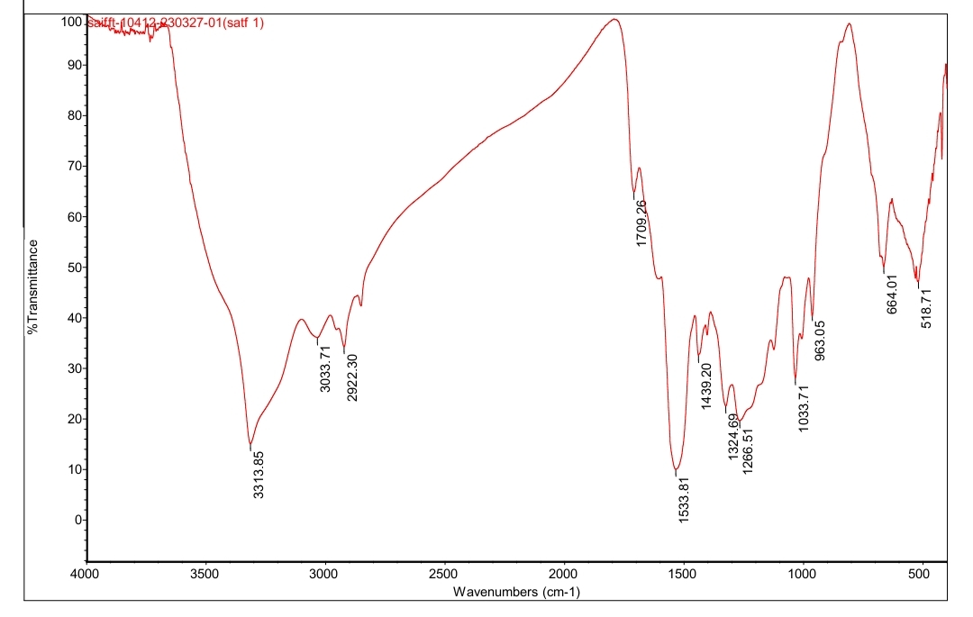

**Fig 3. Infrared Spectra of SATF-I Copolymer resin**

When all SATF-I copolymer resins' 1H NMR spectra were scanned in DMSO-d6, the bands that occurred at 620-250, 750-850, and 800-950cm-1 may have been the result of 1, 2, and 3 substitutions in the aromatic benzene ring.



**Fig 4. NMR Spectra of SATF-I Copolymer Resin**

The spectra show that SATF-I copolymer resin has a specific set of protons with a variety of electronic environments. The chemical shift (δ) ppm observed is provided based on information from the literature [14]. Ar-NH protons may be the cause of the resonance signal that was detected in the 9.01(δ) ppm range. The intramolecular hydrogen bonding of the -NH group is clearly shown by the significantly downfield chemical shift for phenylic -NH. The protons of the -NH bridge found in the ligand structure are responsible for the signals in the area of 5.05 (δ) ppm, whereas the methylene protons found in the Ar-CH2-N moiety are responsible for the signals in the range of 2.4 to 2.5 ppm. Aromatic proton (Ar-H) may be responsible for the faint multiplate signals (unsymmetrical pattern) in the range of 6.4 to 6.6 (δ) ppm. The proton of -SO3H groups is responsible for the signals in the range of 10.01(δ) ppm.

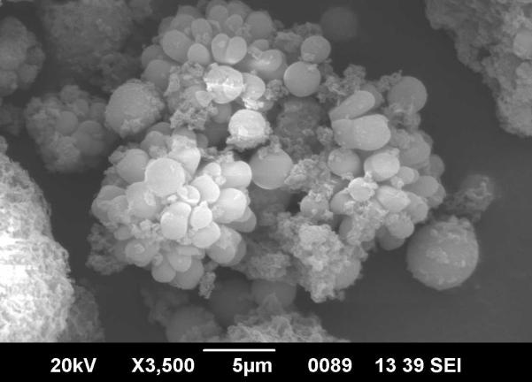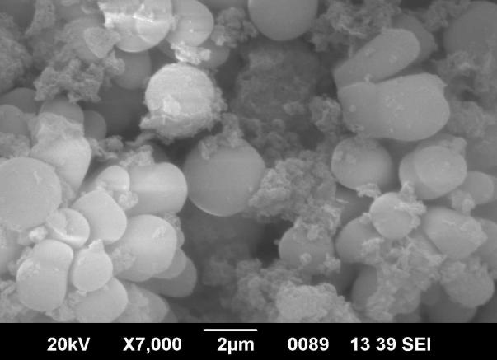

**Fig. 5. SEM images of SATF-I copolymer resin.**

Understanding the surface aspects of the materials has greatly benefited from surface analysis. Scanning electron micrographs taken at various magnifications to examine the morphology of the reported SATF-I resin sample are presented in Fig.5. It provides information on surface topography and structural flaws. It seemed like the resin had a dark hue. The polymer resin's morphology exhibits spherulites and fringed models. The spherules have a nice and smooth surface and are a complicated polycrystalline structure. This demonstrates that the SATF-I copolymer resin sample is crystalline. Additionally, a realistic model of the crystalline amorphous structure may be seen in the resin polymer's morphology. The acidity of the monomer affects how crystalline the substance is. However, the image depicts a nature that is scatted and bordered with small pits that stand in for the transition between crystalline and amorphous. More amorphous figures with a closed-packed surface and deep holes may be seen in the resin. Thus, the SATF-I copolymer resin is amorphous in nature than [15], which results in increased metal ion exchange capacity. SEM micrographs of the resin's morphology thus illustrate the transition between crystalline and amorphous nature.

X-ray diffraction pattern observed for SATF-I showed transition between amorphous and crystalline nature of polymer. If high intensity with narrow band graph it characterize crystalline state and broadness shows amorphous. Fig.6 XRD graph shows both feature high intensity with narrow band and small broadness[16].

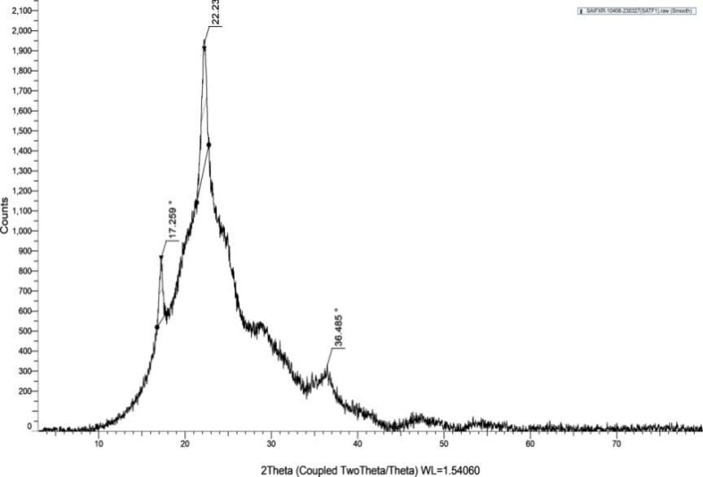

**Fig 6. XRD Pattern of SATF-I Polymer Resin**

Since the polymer under examination is a copolymer, it is particularly challenging to pinpoint its precise structure. The most likely structures for copolymer resin have been presented based on the nature and reactiveness, location of the monomer, elemental analysis, electronic, FT-IR, 1H NMR, spectra, SEM, XRD and molecular weight.

## By using the disc diffusion technique [20], the biological properties of the SATF-I copolymer were tested for their antibacterial activity against four bacterial strains, including Escherichia coli, Klebsiella species (NCIM 2719), Staphylococcus aureus (ATCC 25923), and Proteus. The filter paper disc diffusion method was used to assess the antimicrobial activity while cultivating the chosen organisms for 24 hours. The bacterial medium was Mueller Hinton agar number 2 (Hi Media, India), and the fungal medium was sterile yeast nitrogen base with 2% agar (Hi Media, India). In sterile dimethyl sulfoxide (DMSO) solvent, test solutions of the terpolymer and its metal complexes were created for the investigation.Highest Zone of inhibition was observed against *E.coli* at 100ul (20mm) & also against *S.aureus* maximum at 100 ul (15mm) ,minimum at 50 ul (12mm) & against *Proteus* at 100ul (15mm), no zone observed against *klebsiella* at any concentration. So our findings suggested that the given test sample shows best result against E.coli at 100 ul.

Recently created yellow SATF-I copolymer resin's photoluminescence characteristics have been researched. The discussion of the interpreted copolymer's luminous activity is a key component of photoluminescence research. It should be kept in mind that the condensation procedure is used to create the copolymer metal complex used in the photoluminescence analysis. Additionally, the corresponding peak intensities for each peak are often determined by the effectiveness of a radiative recombination. As a result, the photoluminescence spectrum analysis of these samples reveals that the created product has certain qualities to be employed as a precursor for research on semi-conductors and optical devices. The SATF-I terpolymer's photoluminescence spectrum displays emission bands at 470 and 484 nm combined with blue color emission in the UV region. At 275 nm, SATF-I terpolymer is stimulated.

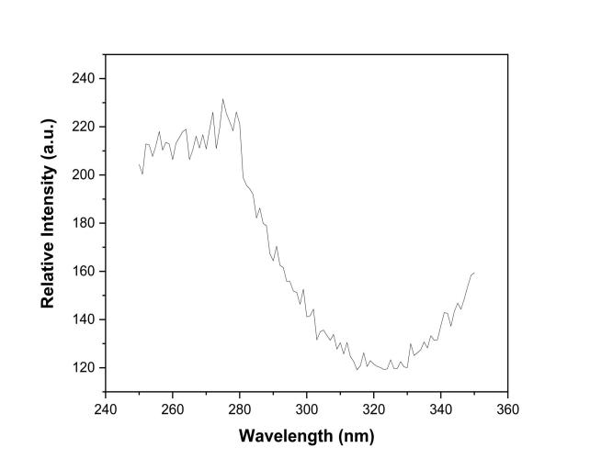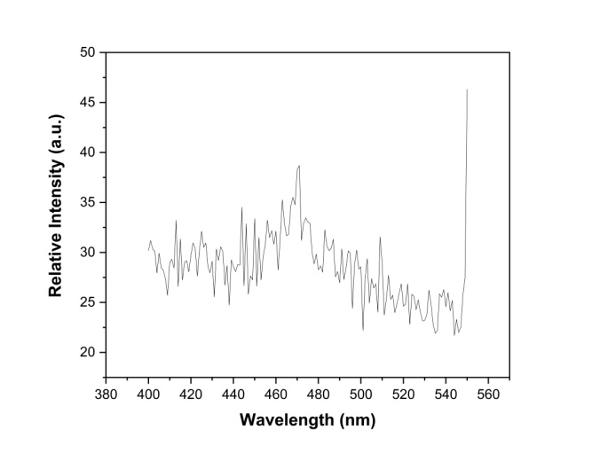**Fig. 8: (a) PL Excitation Spectra of SATF-I (b) PL Emission Spectra of SATF-I**

According to the aforementioned research, SATF-I terpolymer is an excellent photoluminescence material. It may be utilized as a cheap starting material for the chemical synthesis of the different copolymer emitters, and because of its convenience, this kind of material is preferred.

The thermal stability of copolymers is evaluated using dynamic thermogravimetric analysis in an atmosphere with a heating rate of 10/min. The thermogram of SATF-I copolymer resin reveals three stages in the breakdown process after losing one crystalline water molecule that was trapped inside the polymer molecule (5.23% found and 6.27% estimated). The first stage of breakdown occurs between 1100 C and 150 $℃$, resulting in a progressive mass loss of 34.01% found and 34.25% computed. This slow loss of amine group and one sulphanilic acid group connected to the aromatic ring may be the cause. The fast mass loss of 74.78% observed and 74.54% estimated in the second stage of degradation occurs between 1500 and 530 $℃$ and may be caused by the degradation of one aromatic benzene ring and methylene. The third stage of breakdown occurs between 5300 and 7500C, correlating to a gradual loss of 98.26% observed and 100.00% computed. This gradual loss is brought on by the thiourea moiety's degradation, which leaves behind a carbon-containing residue. As the temperature rises, molecules may become more unstable, cross-link, and degrade due to increased strain and thermal vibration. The resin goes through a process of degradation to lessen the strain and maintain stability.

**Theoretical considerations**

By using an analytical technique suggested by Sharp-Wentworth and Freeman-Carroll, we developed the TG curves to give further proof about the degradation mechanism of the examined substances.

**Freeman–Carroll method:**

Freeman and Carroll's straight-line equation, which has the form of

Δ log (dw/dt)] / Δ log Wr Vs Δ (1/T) / Δ log Wr

Δ log (dw/dt)] / Δ log Wr = n- E/2.303R Δ (1/T) / Δ log Wr……….(1)

Where,

dW/dt = rate of change of weight with time.

Wr = Wc-W, Wc = weight loss at completion of reaction.

W = fraction of weight loss at time t.

Ea = energy of activation.

n = order of reaction.

We calculated the activation energy (Ea) by slope, slope m = -E/2.303R, and from whose Y-axis intercept we calculated the order of reaction (n).

By using the data of above method, the different thermodynamic parameters, like, entropy changes, free energy changes, apparent entropy changes and frequency factor have been calculated by using relationship with Ea.

**Sharp-Wentworth Method:**

Making use of the formula created by Sharp and Wentworth,

Log [(dc/dt)/ (1-c) = log (α /β) – [Ea/2.303RT] ……. (2)

logK= logA – [Ea/2.303RT]

where, K = dC/dT/(1-C) and A = α /β

Where

dc/dt = rate of change of fraction of weight with change in temperature

β = linear heating rate dT/dt.

By plotting the graph log [(dc/dt)/ (1-c) vs 1/T we were able to construct a straight line whose slope gives the energy of activation (Ea) by slope Ea/R may be calculated, and whose intercept gives the value of A.

Where T is the absolute temperature and R is the gas constant (8.314 J.mol-1.K-1), the plot of ln(dc/dt) against 1/T should be linear since a linear relationship confirms the validity of the assumption that order (n) = 1.

The activation energy (Ea) is computed using thermal decomposition data and the aforementioned techniques, however the results are not entirely consistent [17]. However, the "average Ea" determined by Freeman-Carroll and Sharp-Wentworth is almost identical. Table 2 shows the activation energy computed using different techniques. The Sharp-Wentworth (Fig. 7) and Freeman-Carroll (Figures 8 and 9) methods' representative thermal activation energy plots for the copolymer are shown. Equations (3), (4), and (5) are used to determine thermodynamic parameters including entropy change (S), frequency factor (z), and apparent entropy change (S*) based on thermal activation energy (Ea). These numbers are listed in Table.

1. **Entropy change**

Intercept = [log KR/hфE] + ΔS / 2.303 R…………(3)

Where,

K = 1.3806 x 10-16 erg/deg/mole

R = 1.987 cal/deg/mole (8.314 J/K/Mol)

h = 6.625 x 10-27 erg sec Φ= 0.166

∆S= change in entropy

Ea = activation energy from graph

1. **Free energy change (∆F)**

ΔF = ΔH – TΔS ……. (4)

Where,

∆H = Enthalpy change = Activation energy

T = Temperature in K

∆S = Entropy change {from (3) used}

1. **Frequency Factor (Z)**

B2/3 = Log ZEa / фR ……. (5)

B2/3 = log 3 + log [ 1 – 3 √1-α ] – log P (x) ……. (6)

Where,

Z = Frequency factor

B = Calculated from equation (6)

log p(x) = Calculated from Doyle’s table corresponding to activation energy.

α = degree of transformation (α= w/Wc)

1. **Apparent entropy change (S*)**

S* = 2.303 log Zh / KT* ……. (7)

Where,

Z = from relation (5)

T* = Temperature at which a compound loses half of its entire composition.

Given the unusually low frequency factor value, it is possible to classify the breakdown reaction of the SATF-I copolymer as a "slow" reaction. There isn't any other clear explanation [18]. The two techniques result in rather nice straight-line charts. This is predicted since it is known that the breakdown of copolymers does not fully satisfy first order kinetics.

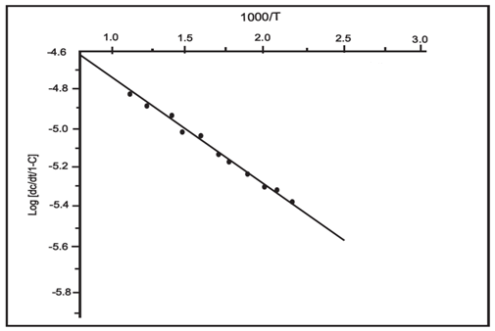

**Fig.7.Sharp-Wentworthplotof SATF-I copolymer resin**



**Fig.8. Freeman-Carroll Plot of SATF-I copolymer resin for order of reaction**

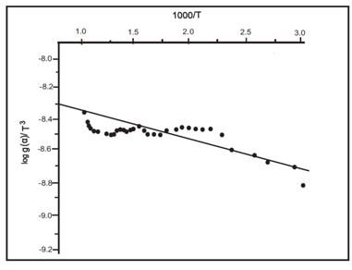

**Fig.9.Freeman-Carroll activation energy plot of SATF-I copolymer resin**

Numerous thermodynamic parameters have been derived using the Freeman-Carroll data (Table 2). These thermodynamic characteristics are about the same for all copolymers. Due to the unusually low values of the frequency factor and the similarity of the data, it can be said that the breakdown reaction of SATF-I copolymers may be categorized as a "slow" reaction. There isn't any other clear explanation [19]. Using the two techniques, rather decent straight line graphs may be produced. This was anticipated. Terpolymer decomposition is reported to not completely satisfy first order kinetics [21].

**Table 2: Result of Thermogravimetric Analysis of STAF-I Copolymer Resin**

|  |  |  |  |  |  |  |  |  |
| --- | --- | --- | --- | --- | --- | --- | --- | --- |
| Copolymer resin | Half decomposition rate (K) | Activation energy  Ea (KJ)/mol | | Entropy change $∆S$ (J) | Free energy ∆F (KJ) | Frequency factor (Z)  (sec.-1) | Apparent entropy  (S*)  (KJ) | Order  Reaction  (n) |
| FC | SW |
| SATF-I | 479 | 14.41 | 14.74 | -62.95 | 98.31 | 660 | -18.14 | 0.99 |

SW-Sharp-Wentworth Method, FC-Freeman-Carroll Method

1. **CONCLUSION**

The SATF-I copolymer has been created using the condensation polymerization of formaldehyde, thiourea, and sulphanilic acid in the appearance of an acid catalyst. The SATF-I copolymer's suggested structure has been established using FT-IR, 1H NMR, XRD and UV-visible spectrum investigations. In TGA, the kinetic parameters derived using the Freeman-Carroll approach are found to be comparable, and the energy of activation assessed using the Sharp-Wentworth and Freeman-Carroll methods are found to be substantially equivalent, suggesting the same reaction mechanism. It is challenging to get any original conclusions on the breakdown process, nevertheless.lower frequency factor values lead to the conclusion that the sulphanilic acid-thiourea-formaldehyde copolymer's breakdown reaction may be categorized as a "slow reaction." According to thermogravimetric research, this copolymer is thermally stable at high temperatures.

**REFERENCES**

1. W. B.Gurnule and Y. U. Rathod, “Synthesis, Characterization and Thermal Behaviour Studies of Terpolymer Resin Derived from 8-Hydroxyquinoline-5-Sulphonic Acid and Anthranilic Acid,” CurrApplPolymSci, vol. 4, 1-8,2020.
2. J. Khobragade., M. Ahamed, and W. B. Gurnule, “Synthesis and characterization of copolymer resin derived from pthallic acid and melamine,” Rasayan J. Chem., vol. 7, 413-419, 2014.
3. W. B. Gurnule, andD. B. Patle,“Metal ion binding properties of a copolymer resin: synthesis, characterization, and its applications,” Polymer Bulletine, Vol. 66, 803-820, 2011.
4. S. P. Chakole1, K. A.Nandekar, and W B Gurnule.“Photoluminescent studies of 2, 2’-dihydroxybiphenyl, ethylenediamine - formaldehyde copolymer,” In Journal of Physics: Conference Series, Vol. 1913, No. 012062, 2021.
5. W. B. Gurnule, Y. U. Rathod, A. D. Belsare, and N. C. Das, “Thermal degradation and antibacterial study of transition metal complexes derived from novel terpolymer ligand,” Material Today: Proceedings, Vol. 29, 1044-1049, 2020.
6. D. B. Patle and W. B. Gurnule, “An eco-friendly synthesis, characterization, morphology and ion exchange properties of terpolymer resin derived from p-hydroxybenzaldehyde,” Arabian Journal of Chemistry, Vol. 9, S648-S658, 2016.
7. S. S. Rahangdale, “Synthesis, characterizationand antimicrobial activity of resorcinol-melamine-formaldehyde resin,” Journal of chemical and pharmaceutical research, Vol. 4(10), 4451-4458, 2012.
8. W. B. Gurnule, N. C. Das, S. Vajpai, and Y. U. Rathod,“Synthesis, characterization and thermal degradation study of copolymer resin,” Material Today: Proceeding, Vol. 29, 1071-1076, 2020.
9. W. B.Gurnule, J.Khobragade, and M.Ahamed,“Thermal degradation studies of high performance copolymer resin derived from 8-hydroxyquinoline 5 sulphonic acid, semicarbazide and formaldehyde,” Der PharmaChem, Vol. 6, 334-342, 2014.
10. R. Thengane, J. V. khobragade, and W. B. Gurnule, “Ion exchange properties of copolymer resin derived from phthalic acid, thiosemicarbazide and formaldehyde,” International journal of researches in biosciences, agriculture and technology, Vol. II, 256-266, 2023
11. D. Shedmake, J. V. khobragade, & W. B. Gurnule, “Synthesis, characterization and antimicrobial activity of copolymer metal complexes and their thermal studies,”International journal of researches in biosciences, agriculture and technology,” Vol. II, 67-79, 2023.
12. V. D. Mane, N. J. Wahane, and W. B. Gurnule, “Copolymer resin. VII. 8‐hydroxyquinoline‐5‐sulfonic acid–thiourea–formaldehyde copolymer resins and their ion‐exchange properties,” Journal of Applied Polymer Science, Vol. 111(6) *Journal of Applied Polymer Science*, *111*(6), 3039-3049, 2009.
13. W. B. Gurnule, J. V.Khobragade, and M. Ahamed, “Synthesis, Spectral, Morphology and Thermal Degradation Kinetics Studies of Copolymer,” Chemical Science Review and Letters, Vol. 3(12), 1329-1340, 2015.
14. S. P. Chakole, K. A. Nandekar, and W. B. Gurnule, “Photoluminescent studi
15. es of 2, 2’-dihydroxybiphenyl, ethylenediamine-formaldehyde copolymer,” In Journal of Physics, In *Journal of Physics,* Vol. 1913, No. 1, p. 012062, 2021.
16. P. M. Gupta, Y. U. Rathod, V. U. Pandit, R. H. Gupta, and W. B. Gurnule,“Non-isothermal decomposition study of copolymer derived from 2-amino 6-nitrobenzothiazole, melamine, and formaldehyde,” Material Today: Proceedings, Vol. 53, 101-106, 2022.
17. W. B. Gurnule, and V. R. Bisen, “Thermal Degradation Study of Copolymer Resin Derived from 4-Hydroxybenzaldehyde, Phenyl Hydrazine and Formaldehyde,” International journal of researches in biosciences, agriculture and technology. Vol V, 2017.
18. S. P. Chakole, Y. U. Rathod, V. U. Pandit, V and W. B. Gurnule,“Synthesis, characterization and thermal behavior of 2, 2′-dihydroxybiphenyl-formaldehyde-phenylenediamine copolymer,” Material Today: Proceedings, Vol. 53, 96-100, 2022.
19. W. B. Gurnule, and N. Das, “Kinetic study of non-isothermal decomposition of copolymer resin derived from 2, 4-dihydroxypropiophenone, 1, 5-diaminonaphthalene and formaldehyde,” Material Today: Proceedings, Vol. 15, 611-619, 2019.
20. P. A. Mishra, Y. U. Rathod,V. U. Pandit, and W. B. Gurnule, “Thermal degradation studies of 2-hydroxy-4-methoxy acetophenone, guanidine and formaldehyde copolymer,” Material Today: Proceedings, Vol. 53, 86-90, 2022.
21. W. B. Gurnule, Y.U. Rathod, A.D. Belasare and N.C.Das, “Thermal degradation and antibacterial study of transition metal complexes derived from novel terpolymer ligand”, Materials Today, vol. 29, pp.1044-1049, 2020.
22. M. B. Thakre, and W. B. Gurnule, “Synthesis and Characterisation of New Copolymer Resin Derived from 4-Hydroxybenzoic Acid and Adipamide,” Material Today: Proceedings, Vol. 15,516-525, 2019.

[[32]](https://www.sciencedirect.com/science/article/pii/S1319610314000866#bb0160)

[[33]](https://www.sciencedirect.com/science/article/pii/S1319610314000866#bb0165)

[[34]](https://www.sciencedirect.com/science/article/pii/S1319610314000866#bb0170)

[[35]](https://www.sciencedirect.com/science/article/pii/S1319610314000866#bb0175)