CASE STUDY ON MARKET SHARE OF EV IN INDIA

¹AMOL SHINDE
Mechanical Engineering Department
A. P. Shah Institute of Technology, Thane, INDIA
amolshinde01991@gmail.com

²ATHARVA AMBRE
Mechanical Engineering Department
A. P. Shah Institute of Technology, Thane, INDIA
athrava.ambre1506@gmail.com,

²CHIRAG NOR
Mechanical Engineering Department
A. P. Shah Institute of Technology, Thane, INDIA
chiragnor2017@gmail.com

ABSTRACT
A 30% EV shift in 2030 is predicted to have a major influence on India's economy and offer huge investment opportunities. EV sales are expected to climb nine times in four years, while vehicle stock is expected to increase approximately 2.7 times between 2016 and 2030. The Indian government's national and state FAME initiatives emphasize EV adoption. The Indian EV strategy should include job-creating activities outside manufacturing. The Indian EV sector risks supply chain disruption, job creation, and income diversification. The government should prepare accordingly. Over 75% of India's 250 million automobiles are two-wheelers. The EV shift might boost economic development and employment creation.
Indian electric vehicle sales are likely to expand fast in the next two years, with three-wheelers having the highest penetration. More than half of the burgeoning e-rickshaw sector is unregulated and controlled by tiny firms. Only 3,400 of the 2.77 million passenger cars sold in FY202021 were electric four-wheelers. Uttar Pradesh has the most electric two-wheelers, Maharashtra the most, and Delhi the most electric commercial vehicles. The paper emphasizes income diversification and government actions to promote EV adoption.
Keywords: Electric Vehicle, Two Wheeler EV, Three Wheeler EV, EV Market
- INTRODUCTION
The shift to electric vehicles (EVs) has enormous potential for investment and quick market expansion, and it is one of the options for economic recovery and sustainable growth once the COVID-19 epidemic subsides. We analyze the potential effects on oil import, value-added, employment, public finances, market size for EV components, environmental benefits from reduced local air pollutants, and greenhouse gas (GHG) emissions, and more as a result of the 30% EV transition in 2030. We make an effort to deconstruct these concerns by supposing the 2030 vehicle stock in BAU and a scenario with 30% EV uptake.[1]
Also, we examine the industry, economy, and environment under three distinct mobility paradigms: (i) heavy reliance on public transportation; (ii) heavy reliance on private vehicles; and (iii) heavy reliance on shared mobility - to get a feel for the breadth of the impact of mode-share paired with 30% EV sales in 2030. The following is a summary of our main conclusions and suggestions. Between 2016 (the base year) and 2030 (the predicted year), we expect the number of vehicles on the road (passenger and freight alike) to rise by roughly 2.7 times. In comparison to a business as usual (BAU) scenario, we investigated the effects of a 30% increase in EV sales (35% in e-two-wheelers [e-2Ws] and e-three-wheelers [e-3Ws]; 30% in electric buses [e-buses]; 25% in electric taxis [e-taxis]; and 13% in electric automobiles [e-cars]).[2]

- INCREASE IN EV SALE

Five million and thirty-five hundred and sixty electric vehicles (e-2W, e-3W, e-rickshaws, e-cars, and e-buses) were sold in India between 2010 and 2020, according to the Centre for Energy Economics and the Environment (CEEW) and the International Energy Agency (IEA). This is still quite a ways off from the NEMMP 2020 goal of 6-7 million EV and hybrid sales. Figure 3 displays a continuous increase in EV sales beginning in 2017. Several high-voltage electric vehicles, such as the Tata Altroz EV, Mahindra eKUV100, and MG Marvel X (Carandbike 2020), were released towards the end of 2019, with many more models on display at the Auto-Expo 2020. Wood Mackenzie 2020 reports that the sudden COVID-19 pandemic outbreak and its aftermath have wreaked havoc on global supply chains for electric vehicle (EV) components, particularly power electronics, batteries, and the minerals required to make these items. All of the automotive industry, not only EVs, is feeling the effects of the supply chain disruption (ETAuto 2020). The future of India's burgeoning electric vehicle (EV) industry is uncertain, with experts giving conflicting predictions about the sector's eventual trajectory: some predict continued stagnation, while others hold out hope that India could emerge as a major player in the global electric mobility manufacturing space (Panday and Ghosh 2020; Inc42 2020).[3]
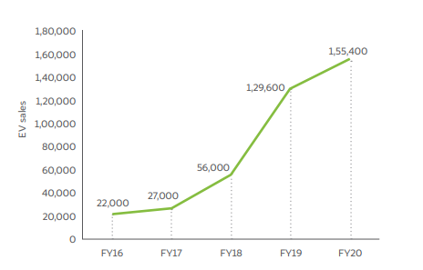
Figure 1 EV sales in India have grown by at least nine times in four years [1]

- BENEFITS OF EV SECTOR
When comparing the number of direct jobs before and after the change, more jobs are lost than gained. Jobs in the electrical industry, as well as those directly related with the production of electric vehicles' powertrains, batteries, and charging infrastructure, are excluded from this analysis. We haven't accounted for the direct and indirect employment created by things like installation and operation, charging infrastructure, battery recycling, telemetry, and other service-related activities. However, we propose that the EV road plan for India should highlight opportunities for employment across the whole EV value chain, not just manufacturing. The federal and state governments stand to lose 15 percent of their revenue from petrol and diesel taxes by 2030 if EVs account for 30 percent of car sales. Government efforts to encourage the switch to EVs should also involve strategies to diversify the country's income base.[4]
- GOVERNMENT POLICIES
The shift to electric cars is a top goal for both the central and state governments in India. The Indian government has shown its dedication to meeting its Paris Climate Agreement commitments by establishing national and state-level "Faster Adoption and Manufacturing of (Hybrid &) Electric Vehicles" (FAME) schemes. Thankfully, there is a lot that UK businesses can contribute to this field as well, such as innovative battery technologies and management systems, electric micro-mobility solutions, and software solutions for better managing EV fleets and the power grid.[5]
- TYPE OF VEHICLE AND MARKET SHARE
Two- and three-wheeler ownership rates are among the highest in the world, whereas vehicle ownership is extremely low (at about 22 cars per 1000 inhabitants). Last-mile transportation in Indian cities is provided by a broad variety of vehicles, including rickshaws (either pedal or largely powered by CNG (compressed natural gas) or diesel), taxis, buses, and vans. Forbes (2019) estimates that out of the 250 million cars registered in India, more than 75 million are two-wheelers, making the country the world's second-largest market for two-wheelers behind only China.[3]
With 21.6 million automobiles sold in FY20, the domestic market expanded at a pace of 1.2% between FY2015 and FY20. Two-wheeled vehicles accounted for 80% of sales, while sales of four-wheeled vehicles (including passenger and commercial) accounted for 16%. India is the seventh largest producer of commercial vehicles and the fourth largest producer of passenger automobiles in the world in 2019. With an expected 26.4 million automobiles to be produced in FY2020 (IBEF, 2020), domestic manufacturing has expanded by 2.4% between FY2016 and FY2020.Air pollution in India is exacerbated by the transportation sector, and congestion is a serious problem in many cities during rush hour. Verma et al. (2015) found that during rush hour, the average speed in Indian cities is between 15 and 20 kilometers per hour.[5]

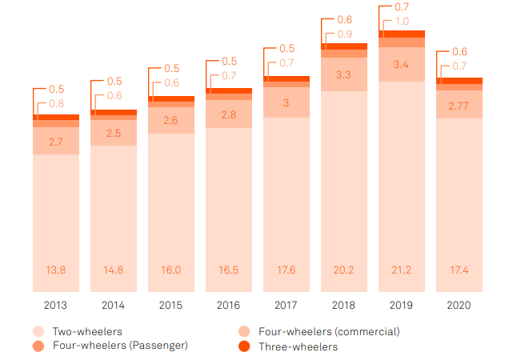
Figure 2: Vehicle Types and Market Share [5]
Like traditional two-wheelers, electric motorcycles and scooters are popular choices in the electric two-wheeler market because they offer more maneuverability on India's often-clogged highways. Most of these cars and trucks have detachable batteries that can be charged in standard electrical outlets. The production of electric two-wheelers was hampered by COVID-19 throughout the most of FY2020, but production has been picking up steam in recent months. Most of the vehicles sold in this market are electric scooters (97%) and motorcycles and e-bikes (3%). From a speed perspective, the market is dominated by low speed (up to 25 km/hr) and medium speed (up to 40 kmph) electric two-wheelers powered by traditional lead-acid batteries. The primary reason for this is that their initial purchase price is now comparable to that of internal combustion engine cars. But 152,000 items 90,000 units 3,400 units 126,000 units 100,000 units 3,600 units Dual-purpose Vehicles for the 2020 Budget Year. [6]
Threewheelers Transport for the Public FY19 0.9% 14.1% 0.12% 0.6% 14.3% 0.11% 22 Market Analysis of Electric Vehicles The demand for high-speed versions is anticipated to skyrocket over the next two years as more businesses become eligible for FAME-IIvi incentives in 2020. There is the largest penetration of electric vehicles in the three-wheelers market, with an estimated 14 electric three-wheelers for every 100 three-wheelers (penetration of 14%). However, the anticipated $0.7 million20 in yearly sales of e-rickshaws is excluded from our analysis. The problem is that more than half of the market is unchecked and controlled by a few large firms. With a penetration rate of approximately 0.12%, electric four-wheelers may be expected to account for only 3.4% of the 2.77 million passenger cars delivered in FY202021. High entry barriers and a dearth of market-ready models that are eligible for government incentives (described in Section 7.2) are to blame for this slow uptake. In addition, demographics, income, the regulatory environment, and urbanization all have a role in how developed a state's market is. Even in Uttar Pradesh, which has one of the country's lowest urbanization rates, the popularity of electric scooters and mopeds is clearly on the rise. However, electric three-wheelers and passenger automobiles are more common in Maharashtra than everywhere else in India because of the state's greater urbanization rate. Due to increased demand, Delhi now has the world's largest fleet of electric commercial vehicles. Figure 6 illustrates how national EV policy (FAME-I) influenced EV sales across the country.[7]
Over the past two years, startups in this space have raised over $600 million in funding (a full list of key investments can be seen in the annex). Consortiums of investment businesses including Westbridge Capital, Ant Financial, Astrend India Investment, and Nexus Venture Partners typically provide the greatest inflows of capital. In order to keep the price of EVs down for consumers, these expenditures have been employed for things like initial assembly and supply chain setup (JMK Research, 2020)31. There has been significant foreign involvement in the market as well. For instance, in May of 2020, Ola Electric Mobility bought the electric scooter company Etergo BV, located out of Amsterdam. Ola Electric also has ambitions to build the largest electric scooter manufacturing in the world in the Indian state of Tamil Nadu. The likes of Hero Electric, Ather Energy, Ampere, and Okinawa are among the other major companies setting up shop in various locations around the country.[6]
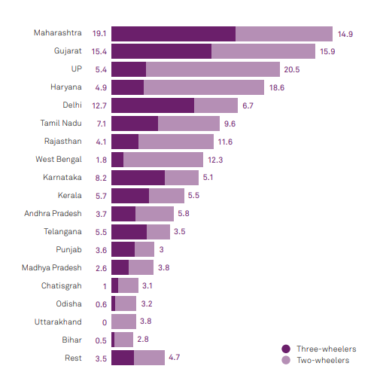
Figure 3: State wise adoption [6]
Table: 1 EV Industry and Specification of Respective Vehicle
Company | Price | Motor | Battery | Range | Charging Time | Warranty | Max Speed
TVS iQube | 1 Lakh | 4.4 kW | 4.56 KWh | 75 km | 6 Hours | 3 YEARS/50000 Km | 85
Ola S1 | 1.10 Lakh | 8.5 KW | 3.97 KWh | 181 km | 6.30 Hours | 3 YEARS/40000 Km | 95
Ather 450X | 1.13 - 1.32 Lakh | 6.0 KW | 2.9 kwh | 116 km | 3.35 Hours | 5  YEARS/60000 Km | 80
Revolt RV400 | 90,799* | 3.0 KW | 3.24 KWh | 150 km | 4.5 Hours | 5 YEARS/75000 Km | 85
Bajaj Chetak | 1.15 Lakh* | 4 KW | 48 V, 60.3 Ah | 95 km | 5 Hours | 3 YEARS/50000 Km | 63
Simple One | 1.09 Lakh | 4.5 KW | 4.8 kwh | 236 km | 1 hour | 3 YEARS/30000 Km | 105
Hero Electric Flash | 56,940 | 0.250 KW | 51.2 V, 30 Ah | 85 km | 4-5 hours | 3 YEARS/  UNLIMITED Km | 25
OKINAWA R30 | 65000 | 0.250 KW | 1.25 KWH | 60 km | 4-5 hrs | 3 YEARS/30000 Km | 25
OKINAWA IPRAZE | 1,05,990 | 1 KW | 3.3 kWh | 139 km | 4-5 hrs | 3 YEARS/30000 Km | 58
TUNWAL  LITHINO LI | 75000 | 1.2 KW | 12 V, 28 Ah | 75 | 3-4 hrs | 3 YEARS/  UNLIMITED Km | 25
PURE EV EPLUTO 7G | 80000 | 1.5 KW | 2.5 KWH | 85 | 4-5 hrs | 3 YEARS/40000 Km | 45

- CONCLUSION
In conclusion, this detailed case study shows how electric vehicles (EVs) might revolutionize India's post-COVID-19 economic recovery approach. This analysis uncovers complicated economic, environmental, and social repercussions by concentrating on the lofty target of 30% EV uptake by 2030. It examines oil imports, value addition, jobs, governmental budgets, and EV component market size via careful research. The study of EV sales growth, sector advantages, government regulations, and vehicle type market shares deepens knowledge of India's EV ecosystem. Data shows the market's development, resistance to challenges, and ability to become a global electric mobility manufacturing player.
The report stresses EV value chain auxiliary employment generation outside direct production. It also shows the need of income diversification for a seamless transition. Also emphasizes government initiatives, focusing on the national Faster Adoption and Manufacturing of (Hybrid &) Electric Vehicles (FAME) programs. The report addresses the particular characteristics of the Indian market, where two-wheelers dominate, to outline the difficulties and possibilities ahead. Investment inflows and foreign interactions show India's EV market's rising confidence.
This report guides policymakers, investors, and industry stakeholders as India transforms its transportation. The findings of this research may help the country manage the complex intersection of economic recovery, environmental stewardship, and technical innovation to create a greener, more prosperous future via broad EV adoption.
REFERENCES
- Abhinav Soman, Harsimran Kaur, Himani Jain, and Karthik Ganesan, “ India’s Electric Vehicle Transition: Can Electric Mobility Support India’s Sustainable Economic Recovery Post COVID-19?”, CEEW Report November 2020.
- Lovedeep Brar Bob Burgoyne Lovisa Eriksson Rimaljit Likhari Thalia Skoufa Lowri Williams, “The India Electric Vehicle Opportunity: Market Entry Toolkit”, CPC india report, March 2021.
- Randheer Singh, NITI Aayog Akshima Ghate, RMI India Isha Kulkarni, RMI India Clay Stranger, RMI Ryan Laemel, RMI, Banking on Electric Vehicles in India, A Blueprint for Inclusion of EVs in Priority Sector Lending Guidelines, Report/ Jan 2022.
- Shifting gears: the evolving electric vehicle landscape in India, KPMG CII Report, October 2020.
- IESA, India Electric Vehicle Market Overview Report: 2019-2026.
- IESA, India Electric Vehicle Market Overview Report: 2020-2027.
- GR EV POLICY 2021, MAHARASHTRA STATE.

