Characterization and Investigation of mechanical properties of aluminium matrix hybrid nano-composite: Novel approach of utilizing waste particles to reduce cost of material

Seshappa A¹
¹ Department of Mechanical Engineering, Jawaharlal Nehru Technological University Hyderabad, College of Engineering, Hyderabad-500 085, India.
Email:seshurambollimi@gmail.com

B. Anjaneya Prasad²
² Department of Mechanical Engineering, Jawaharlal Nehru Technological University Hyderabad, College of Engineering, Hyderabad-500 085, India.

ABSTRACT
An lightweight metals have risen in significant prominence throughout the modern technological world primarily as a result of their effectiveness as well as sustainability in recent decades. The primary emphasis of this investigation will be on the measures implemented by local governments in the country to manage toxic garbage in a way that is both cost-effective as well as environmentally beneficial. This study aimed to find ways to recycle Al₂O₃/SiC nano Particles from solid waste products (PKSA) for utilisation effective reinforcements at low-cost, high-volume automobile parts. Employing an altered injection of gas ultrasound sensor double-stir casting technique, an effort has been undertaken to manufacture aluminum-based nano-composite with various composition proportions of 0% (zero), 3% (three), 6% (six), 9% (ten), and 12% (twelve). When reinforcements % was introduced into aluminum alloys, Micro-hardness, tensile strength, impact resistance, & flexural stiffness comprised some of the various mechanical characteristics tested. Al alloy and aluminium nano-composites were analysed for their dimensions variation and high physical factors including TGA, porosity, and density. XRD and SEM/EDS microstructure analyses have been performed. This research serves as the standard by which other suitable compounds/implants made of metal are evaluated.

Key words: -Physical characteristics, dimension transportation, interface morphological TGA examination, and solid waste

INTRODUCTION
A hybrid substance objectives consists of an microscopic mixture involving more than one material with a visible connection. Composites, also known were “tailor-made” substances with more than one stage give qualities not available from components alone. Composites include electrical, thermal, tribological, and environmental uses in addition to structural ones[1]. The alloys of aluminum are flexible yet reusable, helping the industry improve innovation. Alloys 2XXX, 6XXX, and 7XXX aluminium alloys are popular hybrid substrate components. Similar to different metals, 7075 has excellent particular durability, stiffness, excellent resistance to corrosion[2]. Nano-composites are popular because they are lightweight, strong, wear-resistant, and fatigue-resistant. More research is being done on aluminium-based nanoparticles for automotive and engineering applications [3]. During these existing subsequent ones, heterogeneous nano-compositions were widely employed in manufacturing mechanical parts that overcome MMC limits. Due to its cheap cost and capacity to make many complex-shaped industrial components, stir casting is the most preferred handling method for aluminium matrix composites. Nano-composite materials including silicon carbides & aluminum oxides were used as either main & additional reinforcements to help optimize characteristics. It includes ensuring homogeneous reinforcement component redistribution within liquid matrices, increasing matrix reinforcement the wettability or bonding, promoting solid solution strengthening via interfacial chemical processes, and minimising porosity [4].
However, increased focus has resulted in the enhancement within study methods on top of green consciousness. Identified the solid waste from palm kernel shell ashes (PKSA) be produced in large quantities during the production of raw palm oil[5]. Mechanical and non-structural components may be made lighter and stronger by incorporating palm kernel shell material into their design[6] to make Aluminium-SiC/Gr nanocompositions also discovered that liquid metallurgy can add up to 12wt.% reinforcing particles, thanks to the stir casting approach. Increased wettability by adding reinforcing nanoparticles enhanced durability against wear mechanical characteristics[7] investigated mechanical characteristics using Al matrix and PKSA reinforcement. It was shown that 10% PKSA improves Al matrix mechanical characteristics and homogeneity. In order to achieve outstanding efficiency using lightweight components and use waste as raw materials, the automotive and aerospace sectors have extensively researched aluminum nano-composites. This research aims to enhance Al 7075 alloy mechanical qualities and use waste materials as source materials to reduce costs, preserve the environment, and save materials.

EXPERIMENTAL PROCEDURE
The purpose of this study is to investigate the influence that the distribution of reinforcement particles in aluminium alloy has, as well as to determine the mechanical characteristics of the material and various factors, such as the size with the as-cast composition with reinforcing weight materials. The thermogravimetric analysis (TGA), Fourier transform infrared spectroscopy (FTIR), and electron dispersion spectroscopy (EDS) methods were used to anticipate the optimal process parameters that would result in the hybrid nano-composites with the greatest mechanical and physical qualities.

Materials (Al+Al₂O₃+SiC)
The automobile sector was incentivized to reduce vehicle weight using lightweight materials. Al 7075 alloy is a popular composite material due to its outstanding durability, relatively low coefficient of expansion under heat, enhanced wear strength, and outstanding durability at high temperatures compared to monolithic materials. This piece uses Al 7075 alloy by Treadwell Ferromet Private Limited, Mumbai, India. Tables 1 and 2 show the chemical formula and physical parameters of the Al 7075alloy.SiC and Al₂O₃ are widely manufactured to increase component strength, however, all-silicon carbide/aluminum oxides include significant quantities of silica (silicon dioxide, SiO2). The Private limited company like Nano Wings at Hyderabad in India, supplied SiC and Al₂O₃ nanopowder for this investigation.
Table 1. Physical makeup from Aluminium 7075 material
constituent | Mg | Zn | Cu | Cr | Mn | Fe | SiC | Al
% Wt | 2.1-2.7 | 4.8 -5.6 | 1.2-2.0 | 0.18-0.23 | 0.3 | 0.5 | 0.4 | Balance
Table 2. Mechanical characteristics of the Al 7075 material
Testing Parameters | Density (g/cm³) | Melting point (ºC) | Specific gravity (J/gºC) | Electrical conductivity (%) | Thermal  Conductivity (W/mk) | Coefficient of thermal expansion (µm/mºK)
Physical properties | 2.81 | 530 | 2.53 | 14.2 | 78 | 26.2

Methods

Preparation of palm kernel shell into ash
Palm kernel shell (PKS) and oil palm kernel shell (OPKS) are highly agro-waste from crude palm oil processing. Palm kernel shell content increases mechanical qualities by reducing weight and strengthening structural non-structural parts. Palms kernels Shells in Nandi Cashew, Rajahmundry utilized in India. Image 1a exhibits palm kernels washed using methanol and drying at ambient temps. Then heated up with a muffle oven at 300⁰C over two hours to remove fragrance and impurities to form fine powder[8]. The material was squeezed through a 25μm filter following heating. Morphological features including FTIR, EDS, and scanning electron microscopy helped characterize palm kernel shell ash particles. Finally, a chemical solution was developed.

Ash from palm kernels is chemically processed to create PKSA.

This pH-raising solution of alkaline was prepared as described in [9]. Industrial treatment of palm kernel ash was performed using 1M NaOH in a shaker water bath under the conditions described. Fig. 1b shows the pre-heated ash conditioned at 650⁰C to reduce impulsive and carbonaceous elements. Chemical treatment improves palm kernel shell ash's mechanical and physical qualities.

The Synthesis of Nanocomposites within an Aluminium Matrix
MMC production techniques. Powder metallurgy, composite casting, and swirl molding, diffusing connecting, etc. are all used in the fabrication process. One of the best ways to improve material qualities at minimal cost and produce attractive forms is stir casting. To obtain a consistent matrix and distribution of reinforcing particles, this study employed a changed gas-infused ultrasound probing double-stir moulding technique. The novel method aims to avoid poor wettability from a graphite crucible bottom and uneven SiC, Al2O3, also PKSA reinforcement particle distribution within the melt.
Initial Steps:
The reinforced material granules were dried out by being warmed in a muffled oven at 220 degrees Celsius for 2 hours. After charging thisAl-7075 alloy within crucible and heating an oven with argon gas at above liquidus temperature (> 620⁰C), the ultrasonic probe mechanical stirrer melted entirely. After purging hexachloroethane, argon gas was introduced straight keen on an oven at 2cc/min to minimise high-temperature oxidation[10]. After that, an ultrasonic probe stirs the pre-heated aluminium reinforcement particles into the crucible. After stirring, the melt was cooled to 600⁰C to semi-solidify.
Secondary Stage:
A second 15-minute stirring treatment using an ultrasonic device at 1200 W, 20.20 kHz, and 720°C improved homogeneous allocation among strengthening constituent part with Al7075[11]. Ultrasonic probe churning reduces porosity and homogeneously. to conclude, an compound liquid was put into a 120-mm-long, 15-mm-diameter mild steel die to solidify (Fig. 2).

Physiomechanical property description

Tensile Test
Tensile testing is widely employed in drug evaluation. Tensile testing determines aluminium nano-composite strength. Tensile testing usually involves holding opposing ends of the object. The load causes elongation and breakage. All formulations were tensile tested according to ASTM E8M-04 standards in this article [12]. every test specimen make with an 10 mm measure and 30 mm length on a universal tensile machine at 100 KN. Tensile specimens were constructed for percentage elongation, yield stress, and strength.

Micro-hardness Test
Hardness is measured by taking an regular consignment through an enormity with notch (depth or area). There are several testing procedures, but Vickers micro-hardness is popular since it quickly and easily determines material strength. In this investigation, all materials were tested for Vickers micro-hardness. Microhardness was measured at 100 g for 10 s on Al-7075 also mixture of nano-composites according to ASTM E384 criteria[13]. evaluation be carried on test specimen that had been polished, and measurements were obtained from five distinct locations before calculating the average results.

Impact Test
Impact testing is done in order to determine the nature of the material (brittle or ductile). When a pendulum is used to hit a specimen, this method also calculates this sum force that is fascinated in an material throughout the fissure process. This Charpy experiment be carried out by measuring the length as 55 millimetres and the diameter as 10 millimetres. Additionally, a Charpy V-notch with a depth of 2 millimetres and a notch radius were constructed[14]. Since the specimen splits into two parts when it is struck, the impact strength of a material may be determined by notching the cross-section of the specimen and using a simple pendulum to take the measurement.
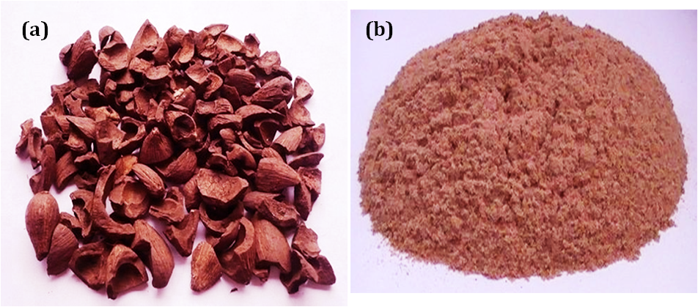
Figure. 1. (a) Before treatment PKS (b) After treatment PKS Ash

Flexural Test
In the 4-point bending test, or bending strength test, is the kind of flexure test that is performed the most often. A three-point bending experiment uses a two-point specimen situated below with only a singular station for force on it to bend the test to form 'V'. The measurements for the samples used in the testing were 3 millimetres by 4 millimetres by 50 millimetres, as required by the requirements of ASTM D790-17[15]. The following equation was used to determine the flexural strength of the material:
(1)
$$KIC=\frac{{6Ma}^{1/2}}{{db}^{2}}y$$
M denotes is the moment, d and b the width and height, and y the equation for a/b.

Permeability Examination
Permeability means a fundamental forming mechanism, and it is possible to generate very uniform structures using this method. The amount of porosity in the product must be kept under control throughout its swirl cast method. This single majority critical component within effective production of its product. In accordance with the requirements of ASTM B962-13, the level of porosity of each sample is determined by using the following equation (2)[16].
(2)
A saturated weight, denoted by w_{sat}, is contrasted with a dry weight, denoted by w_{d}, and a suspended immersed weight, denoted by w_{sus}.

Bulk Density Test
It is usual practice to quantify bulk density in order to identify differences in structural and compositional elements. In addition to this, it may be used to evaluate the quality of raw materials before they are incorporated into a variety of finished products. The Archimedes method is a water incursion technique that is being used in the process of determining the bulk density of various types of materials. In the present study, a technique based on Archimedes' principle was used to investigate bulk density[17] adopting the standards established by ASTM , B-962-13 intended for in cooperation the al-7075 also the mixture nano-composites. This following equation (3) may exist use headed for get an mass density of the material.
$Bulkdensity=\frac{Dry weight}{Saturated weight-Suspendedweight}Xdensityofwater$(3)

TGA analysis
Thermo gravimetric analytics is a method of heat characterization measures weight variations from continual overheating on the sample to assess its thermal durability. This portion with substance that as composed of volatile matter is also determined using this method. Gravimetric instrumentation was used to determine its interactions with the strengthening constituent part. Each sample, which is 20 by 20 by 10 millimeters in size, is subjected to a nitrogen environment that is heated to 400 degrees Celsius at a rate of 10 degrees Celsius per minute[18]. A balancing flow metre is calibrated to 20 psi of synthetic air pressure, and a function of the temperature is used to record any variations in the weight of a material.
Figure. 2. Double-stir casting enhanced gas infusion transducer instrument

EDS psychoanalysis
A JSM-5310BV spectrograph, or X-ray energy-dispersive analysis, can visualise the specimen's chemical makeup. The surface of each specimen is raster-scanned by a focused electron beam using a device that consists of a deflection coil to scan the beam. The materials had been analysed in an air space, then photographed and demonstrated upon display. The primary reason for its peculiarities is the fundamental fact to all changeable comprises an unique nuclear constitution; as a result, the electromagnetic emission of each variable is characterised by a singular collection of peaks.

XRD analysis
By analyzing the way in which x-rays scatter off of metal atoms, a technique known as X-ray diffraction, or XRD, may be used to investigate and quantify the crystallite size of various substances. Both the orientation of the specimen and the angle of incidence of the X-rays that are diffracted have a role in determining the intensity of the X-rays that are diffracted. At Mepco Engineering College in Coimbatore, Tamil Nadu, India, an X'PERT PRO (k = 1.5406) diffractometer recorded the aluminium samples' X-ray diffraction patterns.
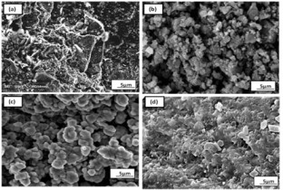
Figure. 3 preliminary microstructure of [a], Al-7075 , [b] SiC, [c] (Al₂O₃) also [d] PKS ash elements
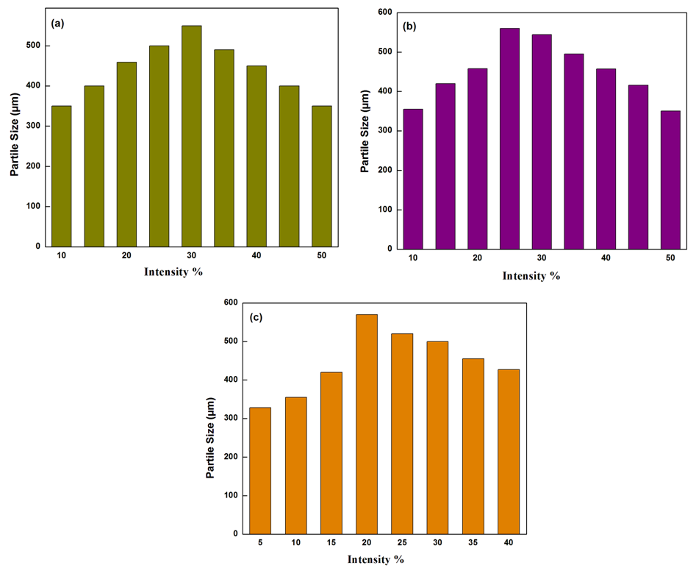
Figure. 4 constituent parts allocation with[a] SiC, [b](Al₂O₃) also [c] Palm kernel shell ash (PKSA) particles

SEM psychoanalysis
SEM, is a kind of testing procedure that produces a magnified picture for the purpose of examination by scanning the surface of its example by electron rays. It is able to concentrate its light on a sizable portion of the sample all at once and generates images with varying degrees of magnification. Prior to the testing, the specimen has to have a coating applied to it in order to boost the conductivity also to its high voltage limits that will be functional on its specimen. This specimens were covered with a very tiny coating of conductive metal, measuring somewhere between 20 and 30 nanometers thick. Mepco engineering college in Coimbatore, Tamil Nadu, India was used as the location for the acquisition of the SEM images utilising the SEM-ZEISS SIGMA instrument.

EXPERIMENTAL STUDIES

Initial microstructural analysis
Vehicle manufacturers may integrate new innovative components by using lighter materials and creating distinctive elements. The alloy of (Al-5.6Zn-2.5Mg) is used into space nozzles, notably in SRB space shuttles, to reduce vehicle weight. Al 7075alloy microstructure is depicted at 3a. figure. The first reinforcement material micrograph (Figure 3) displays high-silica SiC particles, PKSA, and Al₂O₃ particles. Using nanoparticles enhances matrix material's unique properties. Solid trash, agro-waste, and synthetic particles may reinforce materials. These hybrid nano-composites from rice husk ash, coir, bamboo ash, PKSA, and coconut shell ash appear promising. Because it is non-toxic and suitable for hybrid manufacturing methods, this research uses waste material like PKSA as reinforcing filler [19]. Synthetic nanomaterials like SiC, Al₂O₃, TiO2, Gr are mostly utilised to improve mechanical and physical qualities. SiC with Al₂O₃ may increase durability, thermal conductivity, and density, saving material costs in building resources, pin, cargo dispatch, grease production, also vehicles. The initial reinforcement particle microstructure is depicted at 3(b-d) figure.

Particle dimensions distributions study
An particle size allocation (PSA) with materials are identify and the powder allocation of those substances. This definition has several major consequences for the properties of a powder and the dispersions. Because of their one-of-a-kind mechanical and tribological qualities, nanoparticles like a SiC, Al₂O₃, and (PKSA) are selected into a reinforcing components in composites. As can be seen at image 4, its size of SiC also Al₂O₃ subdivisions used this study ranges from 20-30 µm. While PKSA was used as nano-reinforced materials at percentages of 3, 6, 9, and 12 weight percent, the size of the nano-reinforced material was 25-30 µm. Therefore, the primary needs for uniform distribution take place in particles of varied sizes and produce a high level of wettability, both of which have a tendency to enhance the quality of a variety of industrially manufactured goods.

Effect of Mechanical and Physical properties

Tensile Test
The computerised UTM testing equipment be employ into carry out an elongation experiments on both its Al 7075 alloy and the 7075/(SiC/Al₂O₃/PKSA) hybrid nano-composite samples. When evaluate Al-7075 alloy, the hybrid nano-composites show significantly enhanced tensile strength characteristics. Two different samples are analysed with all composition test, also the outcomes be summarised at table number-3, along with their averages[20], improving the material's mechanical characteristics may be credited to adding reinforcement in the form of nano SiC and Al₂O₃ particles at a weight percent range of 0 to 5%. This elongation potency with Al-7075 alloy may be attained at 222 MPa and climbs to 240 MPa when reinforcing particles are being added. Because of the large (9%) quantity with SiC also Al₂O₃, its material have 255MPa of elongation strength, which is much greater than average. In addition to an increase in PKSA content, simultaneous improvements were made to the material's elongation percentage and yield strength.

Table 3Tensile Behaviour of aluminium hybrid nano-composite
Base Material &mixture nano-composites | Al-7075 | 7075,3% -(SiC/Al₂O₃/PKSA) | 7075,6%-(SiC/Al₂O₃/PKSA) | 7075,9% -(SiC/Al₂O₃/PKSA) | 7075,12%-(SiC/Al₂O₃/PKSA)
Yield stress-MPa | 222 | 240 | 242 | 255 | 248
Tensile strength -MPa | 125 | 133 | 137 | 146 | 142
Elongation(%) | 13.8 | 13.4 | 12.8 | 10.9 | 12.3

Figure. 5 Al-7075/hybrid nano-composites micro-hardness | Figure. 6 Al-7075 alloy/hybrid nano-composites impact strength

Hardness Test
A micro-hardness investigation may exist employ while an alternative to a Brinell hardness test to monitor the capability of the material coming from a standard. This allows the test to be employed on the broadest scale possible in the calculation. On polished specimens, the micro-hardness of its Al-7075, also the 7075/(SiC/ Al₂O₃/PKSA) mixture nanocomposites is examined. By means of an Kroll reagent (50 ml of water, 7 ml of hydrogen fluoride, and 3 ml of hydrogen nitrate), the samples have been dipped by hand and polished with a chemical coating. In order to avoid the possible impacts of Indenter, the analyses are carried out in three different locations, and a total of five analyses are both acquired and reported. Figure 5 illustrates that the presence of PKSA, silica, and titanium dioxide particles contributes to an increase in the hybrid nano-composite's tenacity, which in turn contributes to an enhancement in reinforcing. As a result, the microhardness of the material increases as the percentage of hybrid nano-composite's weight that is increased up to 102 MPa. Because of the creation of a high porosity degree in the matrix, the hybrid nano-composite with a composition of 7075/12% (SiC/Al₂O₃/PKSA) showed decreased microhardness. While a low porosity level is usually associated to high hardness and is seen in figure 5, this is not always the case21] It has been shown that the incorporation of 10 weight percent silicon carbide particles into a 7075 alloy using a typical casting method results in an increase in the material's hardness. It was also stated that there was a tendency towards an increase in the hardness of the aluminium alloy while the titanium dioxide particles were strengthening it [22].

Impact
The Charpy technique, which is commonly intended for together jagged also un-jagged samples, was chosen for use in an crash examinations compound. This approach was also intended for examinations metals. In order to carry out investigation, Its Al-7075 also the 7075/(SiC/Al₂O₃/PKSA) mixture nanocomposites be utilized, with its % Wt division of its four components being varied. The findings are shown at figure 6, and it can be seen that Al-7075 (6.72 J/mm2) strength was relatively small. This is because its entire amount of power consumption was divided keen on two parts, the first of which led to the highest possible fracture start. Despite this, an potency were increased as its adding up with tough strengthening subdivision was being made, as can be seen in figure 6. The addition of 9% (SiC/Al₂O₃/PKSA) to 7075 alloy increases its strength by 10.02 J/mm2 due to its high silicon-carbide content and low porosity. An additional adding with 12% mixture nano-composite causes an decrease in strength because of significant agglomeration, which in turn causes poor hardness, which ultimately results in a fracture surface[23]. Therefore, the Al-7075/9%(SiC/Al₂O₃/PKSA)mixture nanocomposite demonstrates superior stiffness also crash potency in comparison into alloys also further types of mixture nanocomposites.

Flexural
The refined examples with Al-7075 also aluminum nano-composites were put throughout a flexural investigation setup to determine their flexural strength. The results of this testing are shown in figure 7. While compare into Al cast alloy, the strength of materials made of aluminium nanocomposites is much greater. In order to minimise the possible impact with an quiescent functional weight on top of its tough strengthening model, two specimens be carry outs at every specimens, also an normal readings be indicated. An Al-7075 has a flexural strength of 402Mpa. It does so by adding tough reinforcing particles made of silica carbide and titanium dioxide, which causes a rise in content [24]. The flexural strength of the 7075 alloy was increased by 3% and 6% thanks to the inclusion of hybrid nano-composite made of SiC,Al₂O₃,and PKSA. The new value was 426 MPa. In addition to 9% (439 MPa), the high PKSA content together with the presence of silica and aluminium oxide contributed to the achievement of the maximum flexural strength. If the percentage is increased over 9%, the material has a tendency to become brittle, which raises the risk of fracture and lowers its flexural strength.
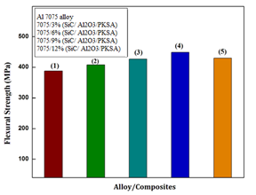
Figure. 7 Flexural strength micrograph/Al-7075/hybrid nanocomposites

Porosity
When scientists identified microscopic spaces, depths, also cracks within aluminium, they discovered that porosity acting an essential influence into influencing an mechanical characteristics with its material. While reducing an amount for porosity in the material to an acceptable level is required in order to achieve the greatest desired degree of machining efficiency. Equation (2) is what is used to determine the porosity [25]. Figure 8 depicts an porosity with its Al0-7075 also the SiC/Al₂O₃/PKSA strengthening within Al-7075 at (0, 3, 6, 9, and 12) of wt% . Both the 7075/3% (SiC/Al₂O₃/PKSA) and the 7075/6% (SiC/Al₂O₃/PKSA) porosities come in at 2.24% and 2.18%, respectively. When compared intoAl-7075 (2.34%) also other mixture of nanocomposites, the 9% toughened Al-7075(1.92%) have achieved its minimal pores stages possible. This is proven by the findings that were observed. The results reveal that the inclusion of 9% has a lower porosity quantity owing into the constant allocation involving strengthening also Al-7075 particles; as a result, increase nanocomposite mechanical properties. In addition, adding 12% leads to an increase in the porosity level, which may be ascribed to the poor wettability and agglomeration of the material. Therefore, porosity is the most important aspect that acting an responsibility to influential its material characteristics with the nano-composites.
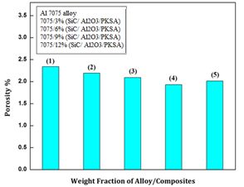
Figure. 8 Porosity graph for Al 7075 alloy/hybrid nanocomposites.

Density
Within categorize into conclude its density with an materials, it must first be correctly weighted in air and then the dislocation into water or liquid must be compared. This equation (3) is what is used to determine the density of each and every sample [26] indicating that 7075 is an alloy with high strength and silicon as one of the primary alloying constituents. The determination of a product's bulk density serves the purpose of determining its weight percentage with the invention into the number of apertures decreases while the bulk amount increases. The ASTM standards use the Archimedes principle to compute the bulk density of both aluminium alloys and hybrid nanocomposites. The physical characteristics Al-7075 also Al-7075/(SiC/ Al₂O₃/PKSA) mixture nano-composites were compared and contrasted in Table 4. The density tends to grow as a result of its adding up with 12% mixture nanocomposite, but its density progressively decreases as the focus of reinforcing particles increases to roughly 9% nanocomposite (2.97%). The higher experimental density is responsible for the effect that particle wrapping has. The powder's permeability will be improved as a result of the small particles that are dispersed among the bigger ones, and the distance that separates the particles that are dominated by pores will be reduced. When 9% (SiC/Al₂O₃/PKSA) was added to 7075 alloy, it resulted in low experimental density in comparison to the other concentrations. This contradictory trend was found in the bulk density data. As a result, the density measured in the lab is lower than the density predicted by theory in both the 7075 alloy and the 7075/(SiC/Al₂O₃/PKSA) hybrid nano-composites shown in table 4.

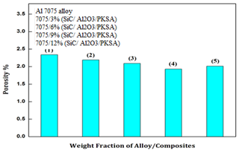
Figure. 9 Al-7075,also mixture nano-composites-TGA analysis

Table. 4 Physical properties of aluminiumhybrid nano-composites
Alloy/mixture nano-composites | Al-7075 | Al-7075,3%  (SiC/Al₂O₃/PKSA) | Al-7075,6%  (SiC/Al₂O₃/PKSA) | Al-7075,9%  (SiC/Al₂O₃/PKSA) | A-7075,12%  (SiC/Al₂O₃/PKSA)
Theoretical density (g/cm3) | 2.81 | 2.93 | 2.97 | 3.03 | 2.96
Experimental density (g/cm3) | 2.73 | 2.84 | 2.89 | 2.97 | 2.91

TGA analysis
TGA methods evaluate material characteristics after weight reducing at a specified temperature. Under 49%CO2, 1% SF6, and 50% dry air shielding, the thermogravimetric analysis (TGA) of an aluminium 7075 alloy reinforced with SiC/Al₂O₃/PKSA hybrid nano-composite at varying weight fractions (0-12 wt%) is investigated. Cut to 12 x 12 x 10 mm, physically itched with 600-1000 grit SiC abrasive sheets, and oxidised at 400⁰C for 5 hours. An heating system examination was permits when its surface appears to determine the commencement of rapid oxidation. All samples undergo the TGA test by measuring weight increase (mg/cm2) and oxidation time (min). Test results were analysed during boiler test. Due to its porosity and poor hardness, 7075 alloy gains weight quickly. Hard reinforcement particles decreased it, as illustrated in Fig. 9. This adding up with 9% mixture nanocomposite increased SiC and Al₂O₃ content, reducing weight gain by roughly 10 times (0.08 mg/cm2). The critical durations were 21 hours with Al-7075, 68 hrs for 3% (SiC/ Al₂O₃/PKSA), 87 hrs for 6%, 96 hrs for 9%, and 73 hrs for 12%. With reinforcing particles increased by 9%, the primary oxide flaw with an large-scale is postponed substantially. Due of poor wettability, adding 12% mixture nanocomposite increases mass granule (0.15 mg/cm2). MgO growth is initially regulated by Al-cation transport and then by oxygen response in the gas interface. A temperature of 450⁰C accelerates Al evaporation and Al-cation diffusion [27] As Al vaporisation increases, film breaking and oxidation accelerate. Thus, Al-7075/9%,SiC/ Al₂O₃/PKSA mixture nanocomposite extends its protective incubation duration better than other nano-composites.

Surface morphology
Powerful and flexible scanning electron microscopes (SEMs) can determine material properties. The samples are first acetone-dried in air. Fig. 10(a-d) shows Al-7075, also mixture nanocomposites base microstructures. The worked structure in Figure 10a has elongated grains and non-uniform, acicular particles. It seems numerous globular apatite particles create Al-7075 macro-cracks. The distributes segments uniformly throughout the matrix. The matrix-incorporating reinforcing particle microstructure was well preserved. While apatite nucleation causes alloy holes and fissures. SiC, Al₂O₃, and PKSA particles diminish it, as seen in Fig.10b. Several interfacial particles are also detected near SiC subdivisions. This exterior morphology demonstrates that its homogeneous allocation medium through strengthening elements embeds many silica fume particles, demonstrating the effectiveness of PKSA particles disseminated during mixing. The surface grain size of apatite particles may decrease with 6% hybrid nano-composite. The main goal is homogeneous constituent part dispersion also subdivisions separation in metallurgy. An stronger sector has equalised morphology, reducing surface cracks and holes[28]. The refined microstructure, exhibited in Fig.10c, has fine grain owing to 9% hybrid nanocomposite. However, the apatite pieces are much larger than the soft surface area, and Fig. 10d shows fissures caused through restrictions increases within strata. After adding 12% mixture nanocomposite (Fig. 10e), concentration rises and surface shape changes owing to non-homogeneity and porosity. This implies that reinforcing particles reduce aluminium alloy's main grain size. Thus, the automotive and industrial industries choose an mixture nanocomposite with Al-7075/9%,(SiC/Al₂O₃/PKSA).

XRD analysis
Crystalline materials are analysed using non-destructive X-Ray Diffraction. All samples undergo XRD examination to determine SiC, Al₂O₃, and PKSA production using various wt% division, as illustrated in Figure. 11 (a-d). A Al-7075-Fig. 11a, has an significant Al segments for 2θ = 23°, 31°, 39° orientations. Thus, those direction statistics match JCPDS card 89-4184 [29]. Although limited reflection strength relative to matrix gave a qualitative assessment of sample crystallinity. Within adding up to 3 -6 wt.% mixture nanocomposite, razor-sharp segment also powerful indications imply Si phase rises [30]. circumstances to ignition (over 5% Al2O3) substance turn into very crystalline at illustrated in Fig. (11b-c) by strong XRD reflections. The 9% mixture nanocomposite reveals strong indications, with recent peaks at 2θ= 20°, 30°, and 68° -Fig. 11d, due to increased silica content and decreased density, enhancing material strength. Due to titanium dioxide and PKSA particles, C and O peaks dominate. Adding 12% mixture nanocomposite might enhance Al segment also decrease Si and C phases owing into excessive reinforcements-Fig. 11e. extremely pathetic crest create the rupture surface. The data imply that new brittle phases with increased intensity have a substantial effect to adding up into rigid strengthening subdivisions. Thus, an XRD trend demonstrates that these crystalline phases improve hybrid nano-composites' mechanical efficiency as the support weight percentage increases.

EDS analysis
SEM thermo-analysis uses X-ray spectrum (EDS). The EDS technique analyses x-rays from an electromagnetic field during illumination to identify a material's chemical characteristics. Fig.12 (a-d) shows Al alloy and aluminium hybrid nano-composites EDS spectra.
The Aluminum, Fe, and C max out in aluminium alloy be depicted in Fig.12a. Early on, aluminium peaks are powerful, but reinforcing particles weaken them. Fig.12(b-c) illustrate an EDS continuums of Al-7075/[SiC/ Al₂O₃/PKSA) hybrid nano-composites with Al, Fe, C, Si, and O peaks. An Si and O max out rise through harder-constituent part. As illustrated in Fig.12d, a greater (9%) SiC, also Al₂O₃ concentration results at a shorter Al peak and bigger Si and O peaks. Aluminium dominates and silica content decreases in 12% mixture nanocomposite owing into poor wettability, which increases porosity and affects durability (Fig. 12e). However, SiC and Al₂O₃ with in examples indicate Al₂O₃ and PKSA[31]. Thus, 9% (SiC/ Al₂O₃/PKSA) particles increase material strength.

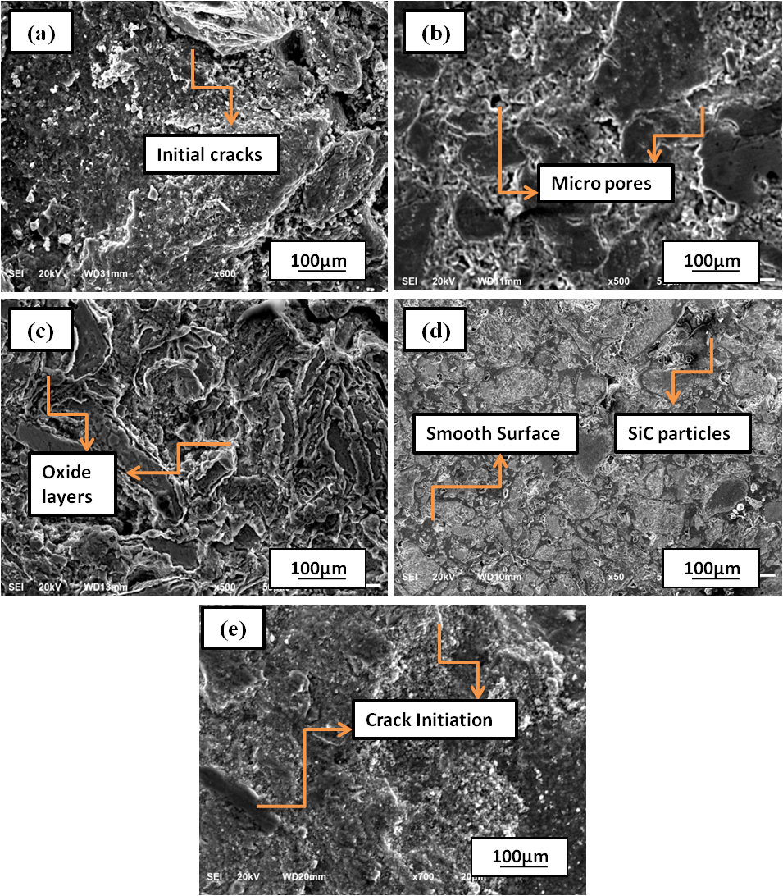
Figure. 10 Surface Morphology with[a]Al-7075,[b]Al-7075/3%,[SiC/Al₂O₃/PKSA],[c]Al-7075/6% [SiC/Al₂O₃/PKSA],[d]Al-7075/9%[SiC/Al₂O₃/PKSA], also,[e]Al-7075/12%,[SiC/Al₂O₃/PKSA] mixture nanocomposites

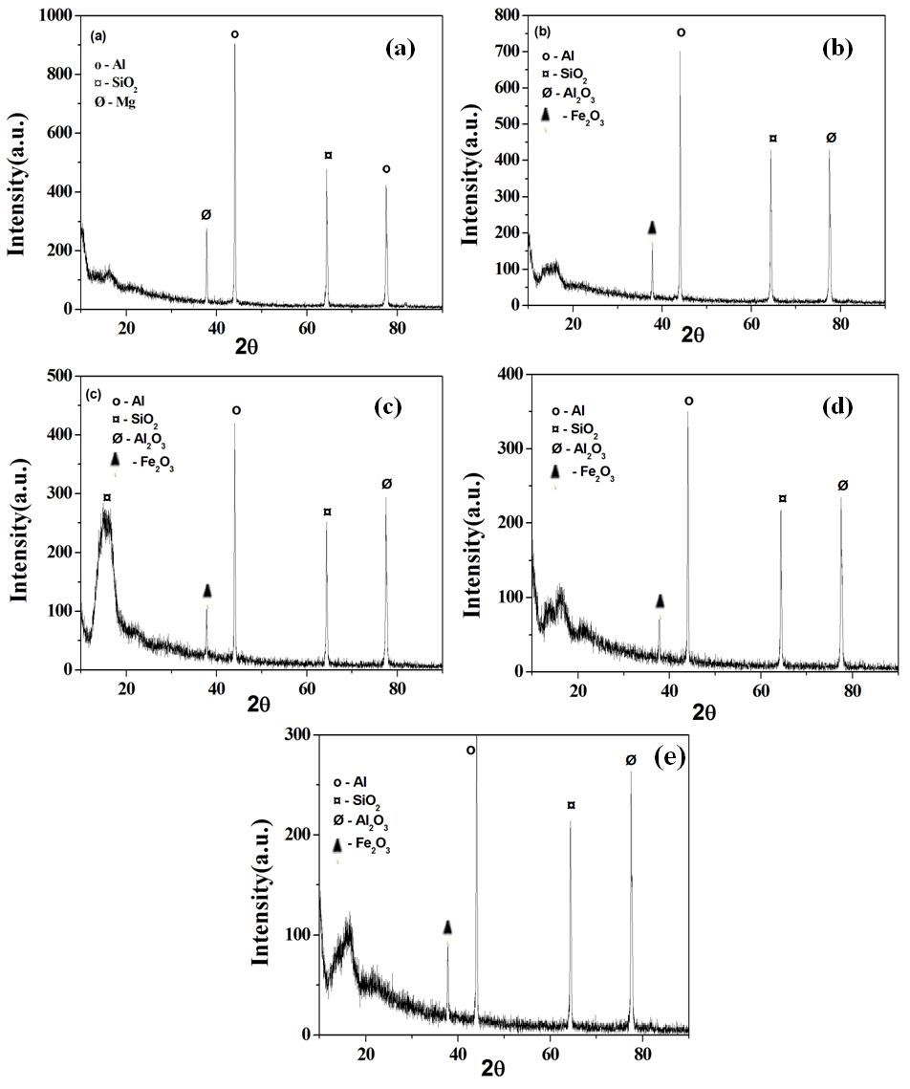
Figure. 11[a]Al-7075, [b]Al-7075/3%,[SiC/Al₂O₃/PKSA],[c]Al-7075/6%,[SiC/Al₂O₃/PKSA],[d]Al-7075/9%,[SiC/Al₂O₃/PKSA], also [e]Al-7075/12%,[SiC/Al₂O₃/PKSA]mixture nanocomposites XRD Analysis
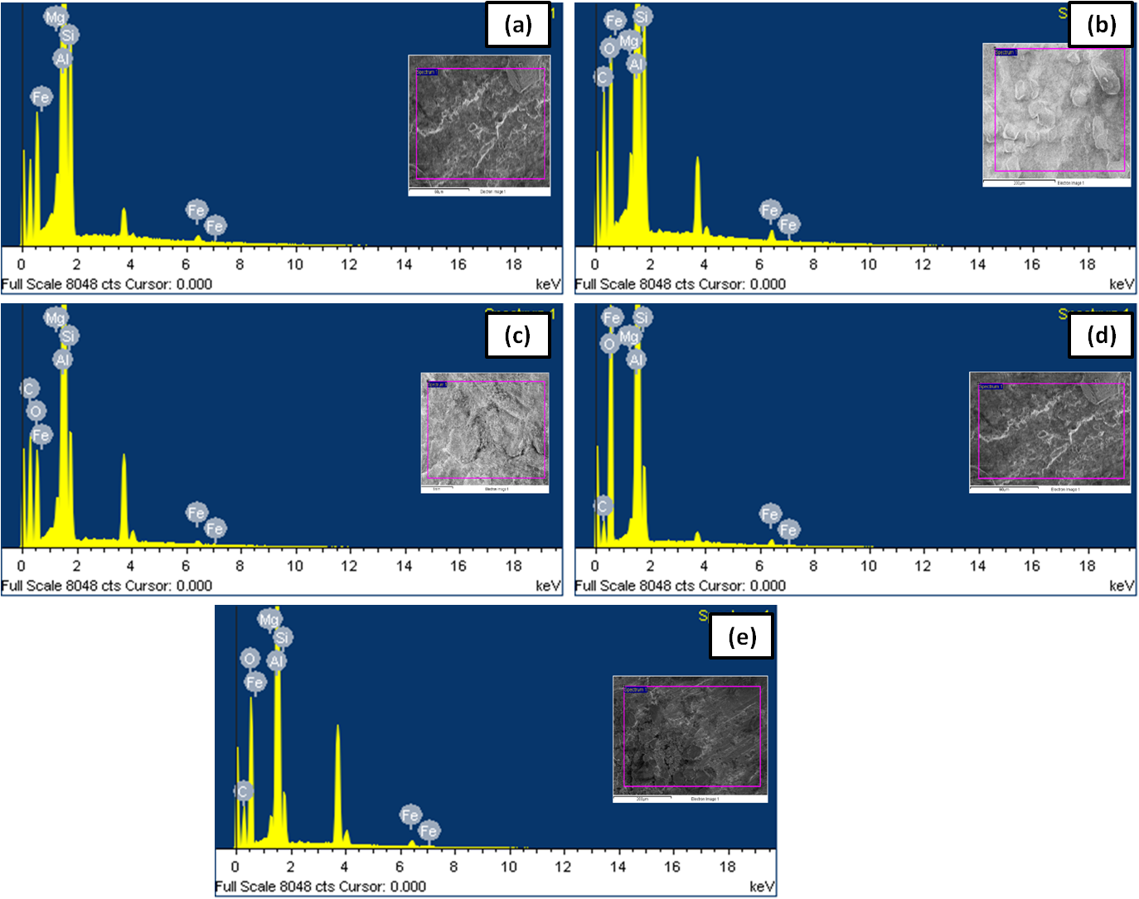
Figure. 12[a]Al-7075, [b]Al-7075/3%,[SiC/Al₂O₃/PKSA],[c]Al-7075/6%,[SiC/Al₂O₃/PKSA],[d]Al-7075/9%,[SiC/Al₂O₃/PKSA], also [e]Al-7075/12%,[SiC/Al₂O₃/PKSA]mixture nanocomposites EDS Analysis

CONCLUSIONS
This current study's purpose is to determine if the conversion of waste products into raw materials is useful for the removal of hazards from their respective environments and whether this conversion results in cost savings for the materials themselves. Titanium dioxide and silicon carbide with 7075 alloy are explored in this study to investigate the impact of PKSA. This is done through enchanting dissimilar wt% with order to forecast how the material would behave. The automotive industry makes extensive use of this particular kind of material for the production of engine components.

- An PKSA has been effectively converted into ash and chemically processed for the purposes of this study..
- Mechanical and physical characteristics were successfully assessed after manufacturing was completed utilising a modified gas injection ultrasonic probe double-stir casting method.
- It was found that the 9% (SiC/ Al₂O₃/PKSA) alloy reinforced with Al-7075 alloy had lower porosity values (1.92%) than the Al-7075 alloy alone (2.34%). When compared to a matrix and other nano-composites, the addition of amorphous silica improved microhardness (89%) and strength (with the addition of 9% hybrid nano-composite). The inclusion of amorphous silica content was responsible for this.
- When compared to alloy, the tensile strength is greater(26%), also an crash potency be advanced (22%), with an inclusion of 9% AHNC. This is because of the existence of Al₂O₃/PKSA and a high quantity of silica carbide.
- Comparing the flexural strength of the 9% (SiC/Al₂O₃/PKSA) mixture nanocomposite into flexural strength of the other nano-composites reveals that it has a higher value of 439 MPa.
- Due to the presence of hard reinforcement particles, the EDS verifies the existence of Si and C peaks, and XRD examination identifies novel phases that were not present in the base alloy.
- The microstructural study shows that the inclusion of 9% mixture nanocomposite results in improved substance characteristics . This is supported by the observation of smooth grooves in the material. In addition, the incorporation of 12% mixture nanocomposite material resulted in a fracture surface that might be attributable to the elevated porosity level.
- Because of this, the hybrid nano-composite made of 7075/9%(SiC/Al₂O₃/PKSA) exhibits much more significant physical and mechanical characteristics than the matrix and other nano-composites.
Acknowledgment
The author who is responsible for correspondence would like to extend their gratitude to the Department of Mechanical Engineering at the Jawaharlal Nehru Technological University College of Engineering in Hyderabad for their assistance in providing the required facilities and support for the research work, which included performing experiments and participating in discussions.

REFERENCES

- Dey A, Pandey KM (2015) Magnesium Metal Matrix Composites-A Review. Rev Adv Mater 42:58-67
- Imran M, Khan AA (2019) Characterization of Al-7075 metal matrix composites: a review. J Mater Res and Tech 8:3347-56
- Subramaniam B, Natarajan B, Kaliyaperumal B, Chelladurai SJ (2018) Investigation on mechanical properties of aluminium 7075-boron carbide-coconut shell fly ash reinforced hybrid metal matrix composites. China Foundry 15:449-56
- Itam Z, Beddu S, Kamal NL, Alam MA, Ayash UI (2016) The feasibility of palm kernel shell as a replacement for coarse aggregate in lightweight concrete. In IOP Conf Series: Earth and EnvirSci 32:0-4
- Olanipekun EA, Olusola KO, Ata O (2006) A comparative study of concrete properties using coconut shell and palm kernel shell as coarse aggregates. Building and envir 41:297-301
- Mosleh-Shirazi S, Akhlaghi F (2019) Tribological behavior of Al/SiC and Al/SiC/2vol%Gr nanocomposites containing different amounts of nanoSiC particles. Mater Res Express. 6:065039.
- Oyejobi DO, Jameel M, Sulong NH, Raji SA, Ibrahim HA (2019) Prediction of optimum compressive strength of light-weight concrete containing Nigerian palm kernel shells. J King Saud Univ-EngSci 32:303-309
- Choong TS, Wong TN, Chuah TG, Idris A (2006) Film-pore-concentration-dependent surface diffusion model for the adsorption of dye onto palm kernel shell activated carbon. J colloid and inter sci 301:436-40
- Oladele IO, Okoro AM (2016) The effect of palm kernel shell ash on the mechanical properties of as-cast aluminium alloy matrix composites. Leonardo J Sci 15:15-30
- Vinod B, Ramanathan S, Ananthi V, Selvakumar N (2019) Fabrication and characterization of organic and in-organic reinforced A356 aluminium matrix hybrid composite by improved double-stir casting. Silicon 11:817-29
- Vinod B, Ramanathan S. Effect of Zener-Hollomon parameter on the flow behaviour and microstructure evolution of Al alloy with organic-inorganic hybrid composites (2018) Inter J Plastics Techn 22:137-60
- Balaji V, Sateesh N, Hussain MM (2015) Manufacture of aluminium metal matrix composite (Al7075-SiC) by stir casting technique. Mater Today: Proceedings 2:3403-8
- Imran M, Khan AA, Megeri S, Sadik S (2016) Study of hardness and tensile strength of Aluminium-7075 percentage varying reinforced with graphite and bagasse-ash composites. Res-Efficient Tech 2:81-8
- Kalkanlı A, Yılmaz S (2008) Synthesis and characterization of aluminum alloy 7075 reinforced with silicon carbide particulates. Mater & Design 29:775-80
- Daoud A, Abou El-Khair MT, Abdel-Azim AN (2004) Effect of Al₂O₃ particles on the microstructure and sliding wear of 7075 Al alloy manufactured by squeeze casting method. J Mater Eng and Perfor 13:135-43
- Wilczek A, Długosz P, Hebda M (2015) Porosity characterization of aluminium castings by using particular non-destructive techniques. J Nondestructive Evalu 34:26
- Fan Z, Song W, Zhang HR, Zhou BS, Wu XY, Jia LN, Zhang H (2019) Effect of holding pressure on density and cooling rate of cast Al-Si alloy during additive pressure casting. China Foundry 16:363-70
- Zhorin VA, Kiselev MR, Roldugin VI (2013) Thermogravimetric analysis of the aluminum-polypropylene mixtures after plastic deformation under high pressure. Russian J App Chem 86:15-9
- Bhushan RK, Kumar S, Das S (2013) Fabrication and characterization of 7075 Al alloy reinforced with SiC particulates. The Inter J AdvManuf Tech 65:611-24
- Kumar MR, Reddappa HN, Suresh R, Gangadharappa M (2018) Effect of Heat Treatment on Tensile Strength of Al7075/Al₂O₃/SiC_{p} Hybrid Composite by Stir Casting Technique. Mater Today: Proceedings 5:22460-5
- Keshavamurthy R, Pavan M, Abdul TazamulHaq M, Zinge D, Mohammed Y (2015) Hardness and tensile behavior of forged Al7075-SiC composite. Int J ApplEng Res 10:3769-72
- Alagarsamy SV, Ravichandran M (2019) Synthesis, microstructure and properties of TiO₂ reinforced AA7075 matrix composites via stir casting route. Mater Res Express 6(8):086519
- Murthy KS, Girish DP, Keshavamurthy R, Varol T, Koppad PG (2017) Mechanical and thermal properties of AA7075/TiO₂/Fly ash hybrid composites obtained by hot forging. Progress in Natural Sci: Mater Inter 27:474-81
- Shivananda Murthy KV, Girish DP, Keshavamurthy R (2015) Investigation on mechanical Behavior of hot forged AL7075-TiO₂-flyash hybrid metal matrix composites. Inter J App Eng Res 10:4105-9
- Vinod B, Ramanathan S, Anandajothi M (2019) Constitutive Equation and Processing Maps of Al-7Si-0.3 Mg Hybrid Composites: a Novel Approach to Reduce Cost of Material by Using Agro-Industrial Wastes. Silicon 11:2633-46
- Kulkarni SG, Menghani JV, Lal A (2016) Investigation of mechanical properties of fly ash and Al₂O₃ reinforced A356 alloy matrix hybrid composite manufactured by improved stir casting. IJEMS 23:27-36
- Radha A, Suresh S, Ramanan G, Mohanavel V, Prema CE (2020) Processing and characterization of mechanical and wear behavior of Al7075 reinforced with B₄C and nanographene hybrid composite. Mater Res Express 6:1265c5.
- Kumar GP, Keshavamurthy R, Tambrallimath V, Biswas R, Andhale YS (2018) Mechanical Properties of Al7075-SiC-TiO₂ Hybrid Metal Matrix Composite. In AdvManuf and Mater Sci 1:301-307
- Sambathkumar M, Navaneethakrishnan P, Ponappa KS, Sasikumar KS (2017) Mechanical and corrosion behavior of Al7075 (hybrid) metal matrix composites by two step stir casting process. Latin Amer J of Solids and Struct 14:243-55
- Murali M, Sambathkumar M, Saravanan MS (2014) Micro structural and mechanical properties of AA 7075/TiO₂ in situ composites. Univer J of Mater Sci 2:49-53
- Sudhakara D, Suresh S, Vinod B (2020) Experimental Study on Abrasive Flow Machining (AFM): New Approach for Investigation on Nano-SiC in the Improvement of Material Removal and Surface Finishing. J of Bio-and Tribo-Corr 6:24

