Form Filling Module of Online Application Management System in Micro Service Architecture

Dr. P.G. Naik¹, Dr. Ajay D. Shinde¹, Mr. R.T.Thorat
¹Department of Computer Studies,
CSIBER, Kolhapur

Abstract:
COVID-19 pandemic terribly affected virtually all the sections. Among them the education sector was the most affected. To restore back the smooth functioning of academics it was inevitable to shift all the tasks to online mode. The functioning of any education system starts with admission process. When the tasks are conducted remotely in online mode many new challenges automatically creep in which need to be addressed in order to ensure that virtual platform offers the same security and reliability as its offline counterpart. Few security challenges that need to be addressed are authenticity, integrity, confidentiality and non-repudiation. Further when the application is hosted in online mode, the additional software testing techniques pertaining to load testing, proactive measures for unexpected network traffic, concurrency control mechanisms, transaction control mechanisms, security testing need to be performed. In the current research, the authors have designed and developed an online application module. The current work focuses on form filling module which is crucial part of the application. The conceptual design focusing on data persistence, module dependency, business rules employed in the middle tier of scalable N-Tier architecture, workflow, module functionalities and module executions are dealt with at depth.

Keywords:
Authentication Module, Data Concurrency, Data Persistence, Module Dependency, , Scalable N-Tier Architecture.

1.Introduction
The covid pandemic has changed the lifestyle and working style of every domain. Its impact also felt by education field, the academicians are working on new ways and new style for academics during and after covid. If we look at academic work flow, it starts with admission process that includes inviting applications for various programs, conducting entrance examination generating merit list and admitting students as per the merit list. Earlier physical attendance for all the processes under admission process was possible but due to pandemic and social distancing the processes need to be changed. We cannot force the applicants to be physically present for the entire process. Keeping this in mind the Chhatrapati Shahu Institute of Business Education and Research, Kolhapur, Maharashtra, India (CSIBER) decided to go for online application system for various programs. The task is assigned to department of computer studies, the department decided to go for web application that will allow access to applicants from any place to the link on institute website. This link will provide them with information necessary for admission process and fill application form in simplest possible way.

1.1 Software Design considerations
The life of any system depends to a large extent on its internal system design. May it be an architecture of a building or design of engine of vehicle. The internals of design are known completely only to the designer. The end user is primarily concerned with the look of a building or a vehicle such as its color, shape etc. The same analogy applies to the software design process. The design of a software depends on a large extent on its design part. In scalable N-tiered application architecture, the designer works in business logic and data tiers whereas the end user is primarily interacts with the presentation tier which constitutes the GUI part of the software. There are many underlying technologies such as UI/UX which play a key role in designing a user friendly and attractive user interfaces. Over the years the software design process has undergone revolutionary changes. The concepts such as software design patterns, clean coding, SOLID (S – Single Responsibility Principle, O – Open Closed Principle, L – Liskov Substitution Principle, I – Interface Segregation Principle, D – Dependency Inversion Principle.) principles, code optimization help in designing the robust, highly maintainable and manageable softwares. In the current system design the authors have focused on rendering the system extremely robust employing the software design best practices currently available in the market. These design strategies are summarized below:

Strategy 1: Employing decoupled micro service application architecture.
Majority of the softwares designed so far depend on monolithic systems which suffers from the major drawback of high degree of cohesivity between different modules of the application. There is a tight coupling between different modules that constitute an application. Any slight change in the module functionality requires the entire software to be tested again. Integration testing needs to be repeated for every minor change in any of the modules of the application. Further the software cannot be deployed until all the modules are in perfect working condition which increases time-to-market time. All these limitations are convincingly addressed by Micro service application architecture which enables micro services to be tested and deployed independently of other micro services and makes them immediately available to the public. The coupling between different micro services is extremely loose or none.

Strategy 2: Integration of payment gateway with the application management system.
There are plethora of third party payment gateways available in market today which can be purchased and integrated with the existing system. However, majority of the payment gateways available today are monolithic in nature which are less flexible due to the same reason stated above. An ideal payment gateway should enable plugging and unplugging of payment methods on need basis. The price paid should be only for the services availed. Since the authors could not find such payment gateway in market today, the decision was made to implement the custom gateway for the purpose. Each payment method is implemented as a micro service using different REST APIs each of which generate JSON as an output. Activating and deactivating payment method merely boiled down to plugging and unplugging of micro service to and from the application. Further, RTGS information was automated without involving any user intervention. This is achieved by acquiring client auth and client secret details from the concerned bank.

Strategy 3: Multi server session management using JWT (JSON Web Token).
Multi server session management is not an immediate requirement as the no. of programmes and departments are limited. But as a measure of future requirement, in the case no. of expansion of departments and no. of programmes, the authors decided to explore JWT for session management on web farms.

Strategy 4: Deployment Strategy.
Normally, coding experts operate in development environment in which all the dependencies, tools, editors requirement for development purpose are installed. After the micro services are implemented they are moved to the production environment for bet testing. But on many occasions, production environments are not the true simulators of development environment due to the reason that few dependencies may be missing or few may be of outdated version. This causes the software to crash or may not work as per expectations. In this scenario DevOp technology comes to the rescue which supports Continuous Integration (CI) and Continuous Deployment (CD). CI/CD pipeline operates as follows. After the micro services are designed and implemented, they are deployed as docker images in the docker container. Jenkins detects the changes and executes the code. Different automation test cases are executed and any differences in expected results and actual results, the code is pushed back to the client suggesting the required changes. This constitutes the CI/CD cycle. The cycles are repeated till the satisfactory results are obtained. Once the code works as per expectations, it is deployed and made available to the public without any user intervention.
Micro service architecture along with the DeveOps technology tremendously brings down the time-to-market period. Figure 1. shows a workflow in CI/CD pipeline employing docker and Jenkins.

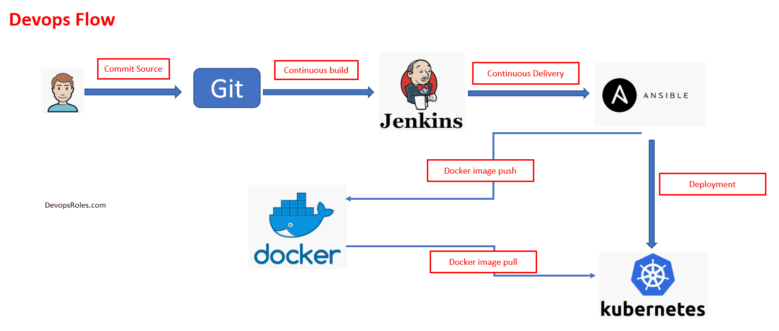
Figure 1. Workflow in CI/CD Pipeline

1.2 Objectives of the System
Following are the objectives set for the system
- To provide remote access to the applicants for entrance process of various programs employing the cutting edge technologies.
- To provide information about entrance examination and payment process.
- To gather and validate payment information.\
- To allow applicants to register themselves for entrance examination.
- To allow participant to take hard copy of application form.
- To record and maintain program wise information about the applicants
- To generate necessary information for accounts officer and admission committee.

2.0 Literature Review
In academics the examinations are conducted to assess the performance of the students in each head of passing this gives an idea about the students ability to grasp concepts related to various courses. But the manual process is error prone there can be leakage of questions, human errors in assessing and recording the scores of the students, knowledge and mood of examiners etc. These problems in manual system can be removed by designing online examinations system. Many researchers have contributed to design and development of online examinations system this section reviews some of the research papers published by various researchers.
In [6] authors have presented online examination system designed by them the system where teacher can decide weightage and type of questions to be asked, the examination system generates the question paper automatically based on the nature and weightage given by the teacher. The student can logon to the system from the campus network and take the test immediately the performance is presented to the students. This system is used to assess the effectiveness of teaching method adopted by teacher for a particular course. The system architecture proposed by the authors is

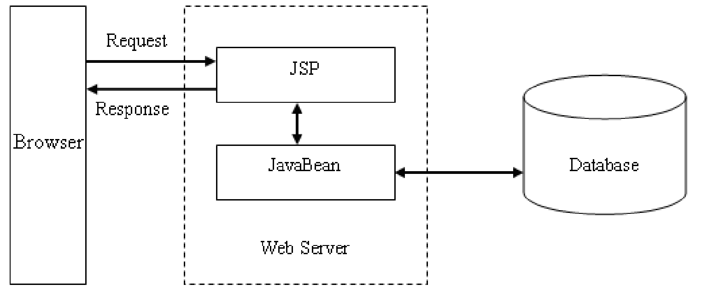
Figure 2. JSP model 1 architecture [6]

In another paper [5] authors have presented design of web based examination system here they have used HTML, CSS and PHP (for the front-end interface) and MYSQL (for the backend) and served through a web server, APACHE. They have proposed three layer architecture presentation layer, business layer and database layer. A login page is designed where two user roles are defined and based on the role system decides the interface to present. Admin can set examinations and students can take examinations.
User authentication is an important issue that needs to be addressed while designing and developing examination system. In [4] authors have presented robust authentication techniques in online examination they discuss three techniques for authentication knowledge-based authentication (NBA), possession-based authentication (PBA) and biometrics-based authentication (BBA). They have proposed preferences-based authentication (PrBA) that uses personal characteristics of user based on it presents personalized use interface.
In his thesis [1] author presents work related to design of web portal the automation of the manual entrance examination for a course “Preparatory studies of mathematics” at Laurea University of Applied Science. The project was planned to deploy the system the portal within Laurea’s internal network to allow students to take the test online. For deploying they have planned to use Microsoft Azure where client will be responsible for deployment and has to be through formal process. In [3] author presents the work related to evaluation of use of online examinations in college courses from both instructor and student perspectives. The author has identified two benefits of online examination (1) the large cost savings of the substitution of machines for labour in grading, and (2) the potential for enhanced student learning due to more frequent assessment. The author also highlights other benefits such as instant feedback to the student about the learning level in addition to this the online examination system makes the entire process paperless. This ultimately results in cost saving as copying and distribution cost can be removed.
In [2] authors have presented the work related to Web based Online Examination System where the system implements functions required for conducting online examination. The functions are divided broadly in two categories administrator and students where the administrator is allowed to configure the examination that includes question management and student management. Whereas the student is allowed to give examination and see the result.
Although the system for online examination were presented by various researchers there is one thing common all system have two user roles admin and students and functions are based on the roles of user. Every system has provision for setting up examination and students and give examination and see the result.

3.0 Conceptual Model Design
3.1 Entity-Relationship Diagram
The different entities in the application and the relationship between those entities along with the cardinality between the relationships are depicted in the following Figure 3.
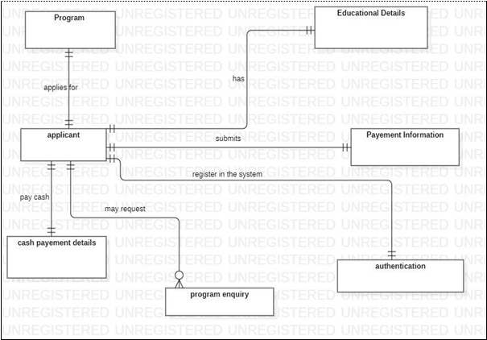
Figure 3. Entity Relationship Diagram

3.2 Use Case Diagram
The following actors are identified:
- Applicant
- Accounts Officer
- Exam Committee

Different actors, use cases and the relationship between them are modeled as shown in the following Figure 4.
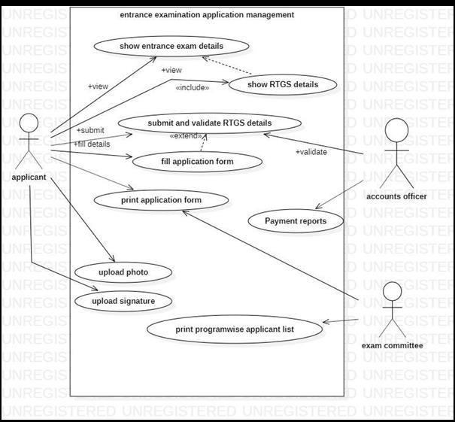
Figure 4. Use Case Diagram
3.3 Sequence Diagram
The sequence diagram revealing the interaction between different objects involved in the scenario organized in a time sequence is depicted in the following Figure 5.
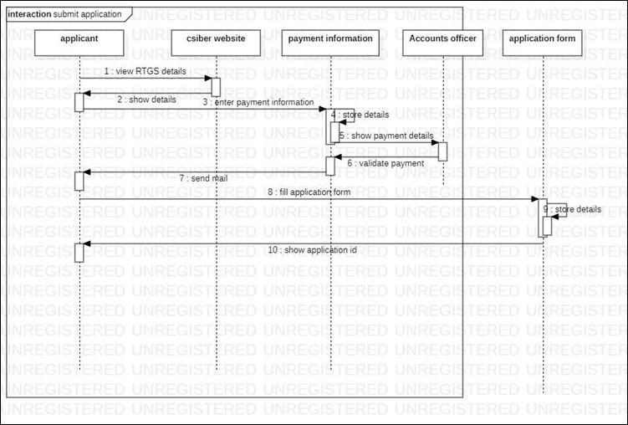
Figure 5. Sequence Diagram.
3.4 Module Implementation
Folder Structure
The different files employed in the module design along with the different folders in which they reside is depicted in Figure 6.
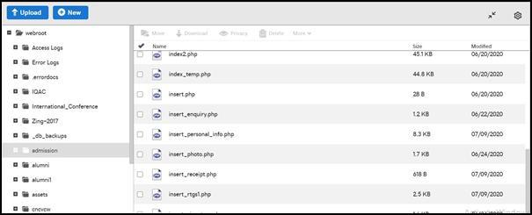
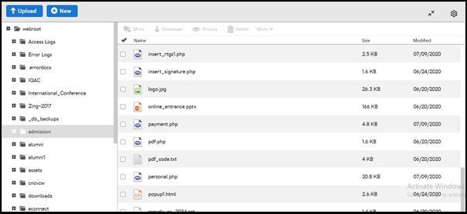
Figure 6. Folder Structures of Form Filling Module.

3.5 Data Persistence Issues
Menu Structure
The menu structure of internet application is depicted in the following Figure 7.
Figure 7. Menu Structure

Different Files Used in the Module
The different files used in the module along with their purpose and location are listed in Table 1.
Table 1. Different Files Used in the Form Filling Module
File Name | Purpose | File Location
index.php | Displays the home page with the menu | ‘admission’ folder on Godaddy Server
personal.php | Accepts personal information from end user and  sends data to insert_personal_info.php for inserting in ‘applicant_details’ table of ‘admission’ database
insert_personal_info.php | Accepts data from ‘personal.php’ file and  inserts it into ‘insert_personal_info.php’ for inserting in ‘applicant_details’ table of ‘admission’ database
upload_photo_sign.php | Enables the user to upload photo and signature  and send the data to ‘insert_photo.php’ and ‘insert_signature.php’ files for inserting the path in ‘applicants_data’ table of ‘admission’ database
insert_photo.php | Accepts photo information from  ‘upload_photo_sign.php’ file and inserts it into ‘applicant_details’ table of ‘admission’ database
insert_signature.php | Accepts signature information from  ‘upload_photo_sign.php’ file and inserts it into ‘applicant_details’ table of ‘admission’ database
payment.php | Accept payment receipt and payment
insert_rtgs1.php | Accepts RTGS information from
‘payment.php’ file and inserts it into
‘rtgs_details’ table of ‘admission’ database
popup1.html | Displays popup windows containing  instructions to fill the form along with RTGS details.

3.6 Module Functionalities
The salient features of the module are listed below:
- When the following URL is entered in the address bar or a browser, http://www.siberindia.edu.in/admission
the popup containing the instructions for filling up form along with RTGS details is displayed.
- The application ID is auto generated by the system and displayed in a message box so that the applicant can use that app_id for all future communications.
- The personal data entered by the user in the first screen is stored in the tables ‘applicant_details’ and ‘educational_details’ of ‘admission’ database which are connected through a common key ‘app_id’
- Without payment receipt, the user cannot submit payment details.
- The tran_no entered by the user in payment form is inserted in ‘applicant_details’ table to connect the two tables.

3.7 Business Rules and Validation Procedures

Business rules and validation checks are listed below:

• On visiting the URL, http://www.siberindia.edu.in/admission, a popup window containing instructions for filling up the form and RTGS payment information is displayed.

• On clicking the ‘Fill Application Form’ menu option, a form for collecting personal and academic information is displayed to an end user. The personal and academic information entered by the user is stored in two separate tables, ‘applicant_details’ and ‘educational_details’.

• A unique application ID is generated and displayed to the user which can be used for all future communications.

• The photo and sign are optional and can be uploaded by the user during form updation.

• On the payment form, the payment receipt photo is mandatory, without which the applicant will not be able to submit the form. The receipt can be tracked by using the application ID which is prefixed to the name of the file as shown in the Figure 7.

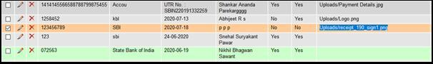
Figure 7. Tracking Fee Receipt

- On final submission, an appropriate descriptive message is displayed to an applicant.
- The date when the record is inserted into the database is tracked by including a field with the name ‘app_date’ in the ‘applicant_details’ table whose field type is ‘TIMESTAMP’ and default value is current date and time (Set by checking the ‘CURRENT_TIMESTAMP’ check box in default value field) as shown in the Figure 8.

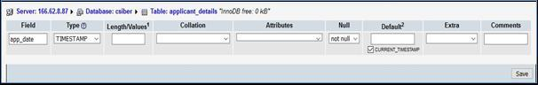
Figure 8. Tracking Form Filling Date

3.8 Workflow in the Modules
The Figure 9 depicts the interaction between different functional sub-modules of authentication module.
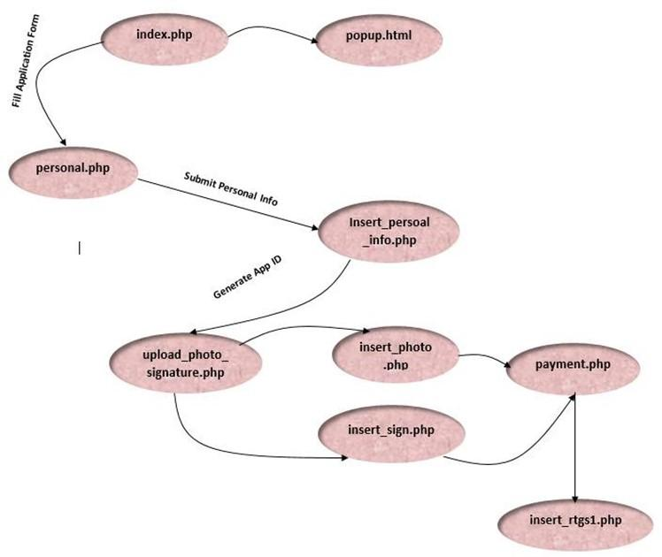

Figure 9. Module Workflow and interaction between Different Modules of the Application

4. Experimental Results and Discussions
On clicking ‘Fill Application’ menu option the application connects to the webpage ‘http://www.siberindia.edu.in/admission’ and the following page is displayed. The popup contains the requisite instructions and RTGS payment details as shown in the Figure 10.
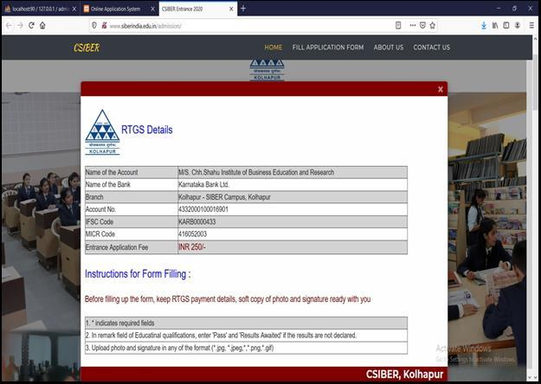
Figure 10. Home Page of Online Application Web Portal

On clicking ‘Fill Application’ menu option. The web page navigates to the following section.
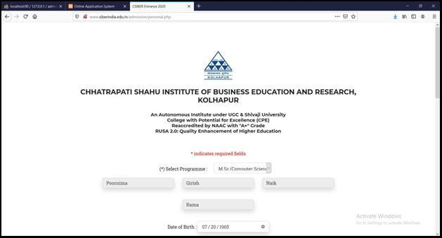
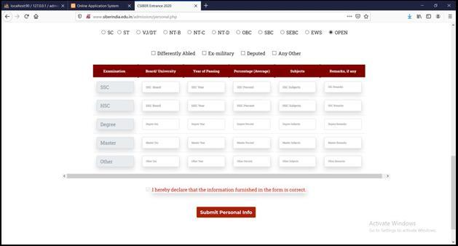
Figure 11. Filling Online Application Form

On clicking ‘Submit Personal Info’ button, the application ID is auto generated. the message ‘Personal and Academic Information inserted successfully. For all future communication your Application ID is 155’ is displayed.
The personal and academic data entered by the user is stored in ‘applicant_details’ and ‘education_details’ tables of ‘admission’ database. The application ID generated above is stored in the session for future use. and the application navigates to the next section for accepting the photo and signature as depicted in Figure 14(a) – 14(c).
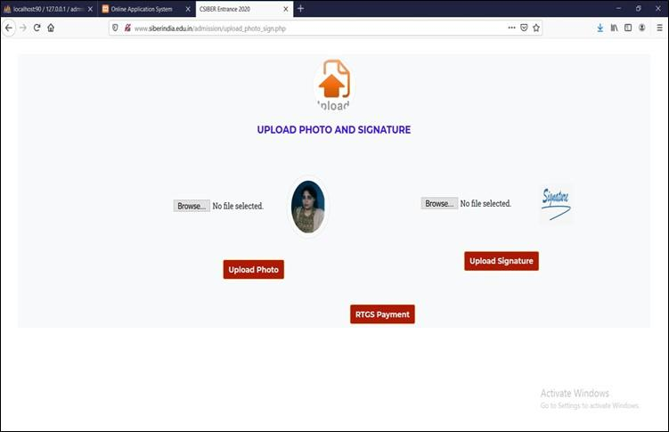

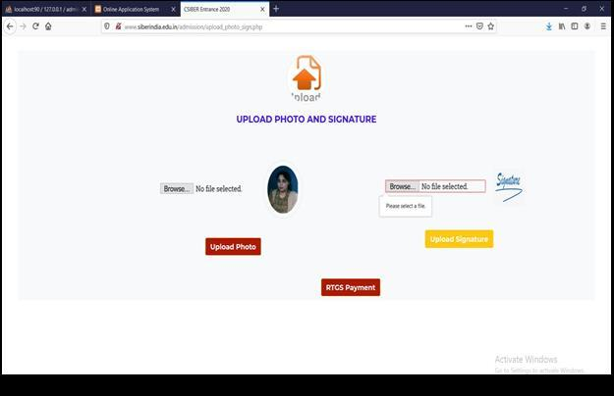
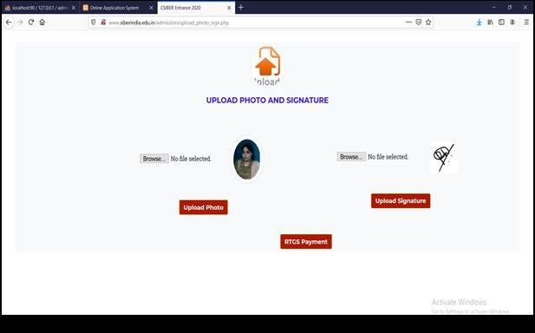
Figure 14(a)-14(c) Uploading Photo and Signature

On uploading photo and signature and clicking on ‘RTGS Payment’ option, the application navigates to payment section as shown in Figure 15(a)-.
The application id is retrieved from the session and ‘photo’ and ‘sign’ corresponding to the application id are updated with the filenames selected by the user above.
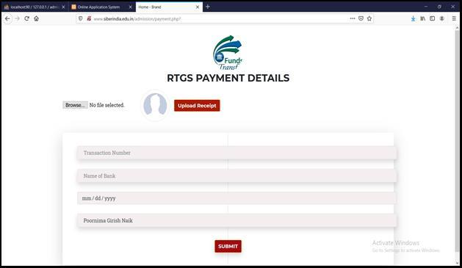
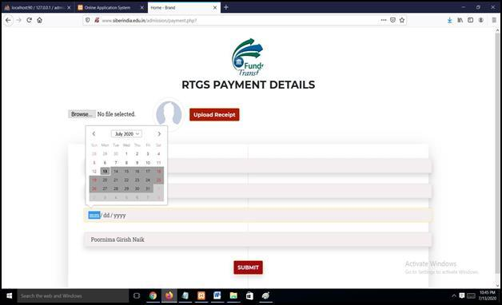

Case 1:
If the user clicks on ‘Submit’ button without uploading payment receipt, the message ‘Upload RTGS Receipt’ message is displayed. On browsing and selecting payment receipt and clicking ‘Upload Signature’ button, the message is displayed
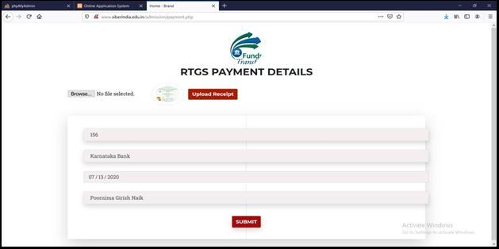

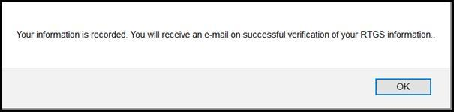
On uploading the payment receipt, entering transaction details and clicking on ‘Submit’ button, the message ‘RTGS Details Recorded Successfully’ is displayed as shown in the Figure 16.
The RTGS transaction record is inserted in ‘rtgs_details’ table, the application id is retrieved from the session and ‘tr_no’ column corresponding to the application id are updated with the transaction no. entered by the user in payment form.
On clicking ‘Contact Us’ menu option. The web page navigates to the following section.
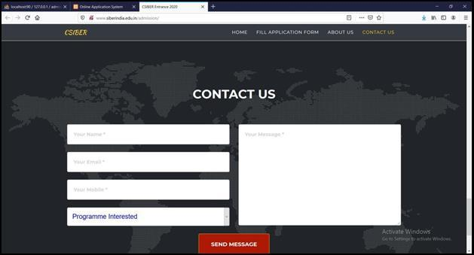
Figure 16. Filling Up of Enquiry Form

On entering name, email, mobile, programme and message and on clicking ‘Send Message’ button, the record is inserted in ‘enquiry’ table of ‘admission’ database.

5.0 Conclusion and Scope for Future Work:
Due to the COVID-19 pandemic academics, example schedules were extensively disturbed and many of the activities which were carried out in offline mode were to be shifted to online mode without hampering the workflow process. One such task is submission of online examination form. In the current research, authors have designed and developed scalable N-Tier architecture for managing the workflow of online application submission system in Micro Service architecture. The payment option is integrated into the system which facilitates the user from filing up application form and completing the payment procedure remotely without physically visiting the institute. The future research focuses on integrating the system with the existing institutional ERP system.

References :
[1] Abu Hasnat Wasim Sayeed, “Creating a web portal for an online entrance exam and learning material”, Bachelor’s degree thesis, Laurea University of Applied Sciences, Business information technology Thesis, November, 2020.
[2] Anjali Choubeya, Avinash Kumarb, Ayush Ranjan Behrac, Anil Raj Kiskud,Asha Rabidase and Beas Bhadraf, “A study on Web based Online Examination System” , International conference on Recent Trends in Artificial Intelligence, IOT, Smart Cities & Applications (ICAISC-2020)
[3] Andrew P. Barkley, “An Analysis of Online Examinations in College Courses” , Paper presented at the Western Agricultural Economics Association Annual Meetings, Logan, Utah, July, 2001
[4] Nader Abdel Karim, Hasan Kanaker, Shadi Almasadeh,Jamal Zarqou “A Robust User Authentication Technique in Online Examination”, of publication DEC-31, 2021, date of current version JAN-17, 2021. www.computingonline.net / computing@computingonline.net, Print ISSN 1727-6209, Online ISSN 2312-5381, DOI 10.47839/ijc.20.4.2441
[5] Olalere A. ABASS, Samuel A. OLAJIDE, Babafemi O. SAMUEL, “Development of web-based examination system using open source programming model” Turkish Online Journal of Distance Education-TOJDE April 2017 ISSN 1302-6488 Volume: 18 Number: 2 Article 3
[6] Zhao Qiao-fang and Li Yong-fei, “Research and Development of Online Examination System” , Proceedings of the 2012 2nd International Conference on Computer and Information Application (ICCIA 2012) Published by Atlantis Press, Paris, France.

