Ozone Layer Depletion and Its Effects-2023

K. Peddulaiah
Department of Humanities and Sciences
per 1st Affiliation (Author)
Srinivasa Ramanujan Institute of Technology Anantapur, Andhra Pradesh, India-515701
E-mail: prudhvi.msc@gmail.com

Dr. Chandra Sekhar Espenti* (Corresponding author)
Department of Chemistry, Sreenidhi University, Yamnampet, Hyderabad,
India-501301,
E-mail address: chandu.ac.in@gmail.com

ABSTRACT
There are a variety of contexts in which human actions have the potential to have major impacts on the surrounding environment. One of them is the depletion of the ozone layer. The purpose of this study is to investigate and review. The purpose of this study is to investigate the background, causes, processes, and biological implications of ozone layer depletion, as well as the preventative steps that have been taken to safeguard this layer of the atmosphere. Both chlorofluorocarbons and halons are very effective ozone-depleting substances. The expected increase in the levels of UV radiation received at the surface of the planet and the impact that this will have on both human health and the environment is one of the primary reasons for the widespread worry over the depletion of the ozone layer. The outlook for the ozone layer's recovery is still unknown. As a result of regulation, halogen loading is expected to decrease, which should lead to an increase in the quantity of stratospheric ozone in the future, assuming that no other changes take place. However, the future behaviour of ozone will also be influenced by other factors, such as the changing abundances of methane, nitrous oxide, water vapour, and sulphate aerosol in the atmosphere, as well as the changing temperature.
Keywords: Ozone layer depletion, Environment, UV radiation, Ozone layer recovery and Climate change.

INTRODUCTION

The stratosphere, which extends from about 10 to 50 kilometers above the Earth's surface, is where the ozone layer resides. It plays a crucial role in protecting life on Earth by absorbing the overwhelming majority of the sun's potentially harmful ultraviolet (UV) light [1, 2]. UV radiation is known to cause a wide range of health issues in humans, including cancer, cataracts, and immune system suppression. It's also common knowledge that prolonged exposure to ultraviolet (UV) light may be harmful to living things. In contrast, scientists saw a significant drop in ozone levels in the stratosphere starting in the second half of the twentieth century. A common term for this phenomenon is "Ozone Layer Depletion". The most striking manifestation of ozone depletion was the finding of the "ozone hole" over Antarctica, which was first reported in the 1980s [3, 4]. Depletion of the ozone layer is mostly caused by human activity, namely the production of chemicals like chlorofluorocarbons (CFCs), halons, and other ODS. Refrigeration, air conditioning, aerosol propellant, foam-blowing agents, and several industrial uses were common places to find these compounds put to use [5]. If released into the atmosphere, ODS will swiftly reach the stratosphere, where they will take part in a series of complex chemical reactions that will deplete ozone. The quantity of ozone in the atmosphere decreases because a single CFC molecule may catalytically destroy hundreds of ozone molecules.
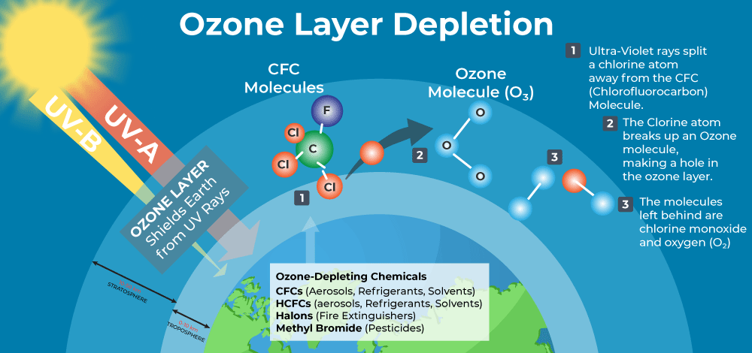

Figure 1: Ozone depleting substances and their mechanism in the depletion. (Source: https://www.geeksforgeeks.org/ozone-depletion/)

The consequences of ozone layer depletion are far-reaching and include:
Increasing of UV Radiation by ozone layer depletion: The ozone layer is an important part of Earth's atmosphere that floats in the stratosphere, between about 6 and 30 miles above the surface [6, 7]. Because it blocks out so much of the sun's dangerous ultraviolet (UV) radiation, it's crucial for keeping life on Earth safe. This is especially true of UV-B and UV-C rays. As the ozone layer depletes, more dangerous ultraviolet radiation is allowed to penetrate to the surface of the earth, which in turn causes a rise in the number of occurrences of eye cataracts, skin cancer, and other health issues in people. Additionally, it has the potential to affect marine species as well as ecosystems on land. Chlorofluorocarbons (CFCs) and halons are two examples of synthetic compounds that contribute to ozone depletion when they are discharged into the atmosphere. These compounds may stay in the air for long periods of time because of their stability. When they reach the stratosphere, the sun's powerful UV rays break them down, releasing chlorine and bromine atoms [8, 9]. Ozone molecules are vulnerable to being destroyed by the extremely reactive chlorine and bromine atoms that are emitted. Depletion of the ozone layer reduces the layer's ability to block damaging ultraviolet (UV) radiation, in particular UV-B and UV-C rays. This causes more ultraviolet light to reach Earth's surface, which may have a number of negative impacts on nature and its inhabitants i.e., increased risk of skin cancer, damage to marine life, impact on terrestrial ecosystems, eye damage, impact on atmospheric chemistry and damage to materials.
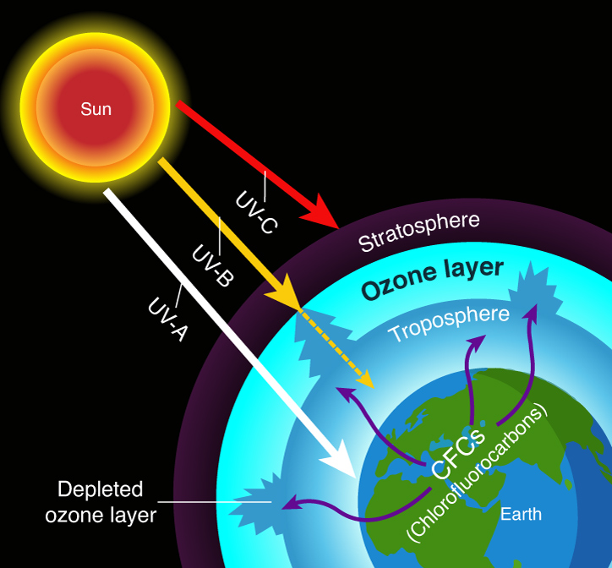
Figure 2: Releasing of different types of UV rays from sun and their mechanism in the depletion. (Source: https://www.sciencefacts.net/ozone-layer-depletion.html)

Climate change by ozone layer depletion: As powerful glasshouse gases, compounds that deplete the ozone layer are a contributor to both global warming and climate change, which in turn have repercussions for weather patterns and ecosystems.
Long-term shifts in Earth's temperature, known as climate change, are principally driven by the amplified glasshouse effect due to rising glasshouse gas concentrations in the atmosphere. CO₂, methane (CH₄), nitrous oxide (N₂O), and fluorinated gases are all examples of glasshouse gases that contribute to climate change and global warming [10, 11]. As a result of human activities including burning fossil fuels, deforestation, and industrial operations, glasshouse gas concentrations have increased, causing average world temperatures to rise. Rising sea levels are a serious hazard to low-lying islands and coastal communities as a result of melting polar ice caps and glaciers caused by warming temperatures across the world. Rise in frequency and severity of hurricanes, heat waves, droughts, and heavy rainfall events climate change is linked to a rise in the frequency and severity of severe weather events like these [12-14]. When the seas take in too much carbon dioxide, a process known as ocean acidification occurs, which may be harmful to marine ecosystems, most notably coral reefs and species that produce skeletons and shells. Climate change has the potential to cause disruptions in ecosystems, shifts in species ranges, and negative effects on biodiversity.
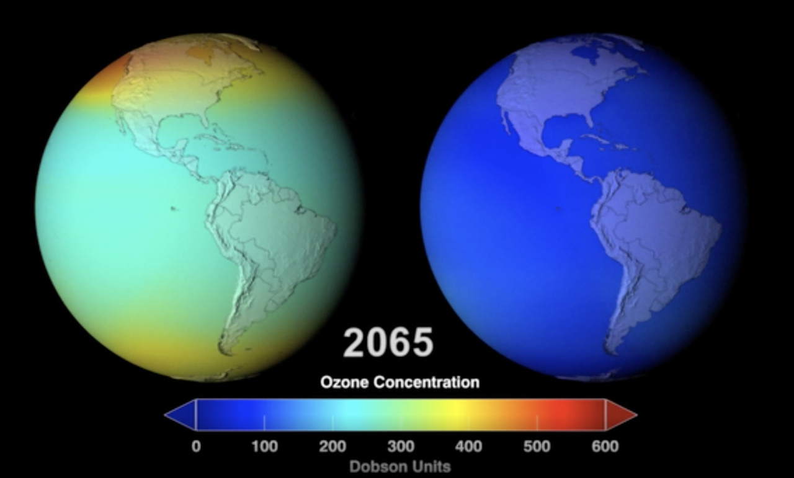
Figure 3: Expected climatic changes of the globe with respect to the ozone concentration by 2065. (Source: https://climate.nasa.gov/news/3112/protecting-the-ozone-layer-also-protects-earths-ability-to-sequester-carbon/).
Impact on wildlife by ozone layer depletion: The loss of the ozone layer may have a negative impact on many different kinds of animals, including marine life, birds, and amphibians, which can cause disturbances in food chains and ecosystems. Depletion of the ozone layer may have devastating effects on biodiversity, especially on several animal species and the habitats in which they live. Thinner ozone allows more ultraviolet (UV) radiation to reach the Earth's surface, which has devastating consequences for species. Among the many potential negative consequences of ozone depletion on animals are the following:
Eye and Skin Damage: Excessive sun exposure may harm the eyes and skin of animals, just as it does in people. Many animals' skin, hair, or feathers might not provide enough protection in the face of rising UV levels [15]. Animals of many species are susceptible to UV damage to the eyes. The effects of ultraviolet light are especially harmful to amphibians like frogs and salamanders. Their eggs and larvae are especially vulnerable to harm from increased UV radiation in aquatic conditions, which may cause developmental defects and lower survival rates [16]. Increased UV radiation may have a deleterious effect on marine life, such as phytoplankton, zooplankton, and coral reefs. Since phytoplankton are the foundation of marine food webs, a decline in their survival due to UV exposure may have far-reaching consequences for marine ecosystems. In a similar manner, UV radiation and ocean warming may have a greater impact on coral reefs that are already susceptible to other stressors, causing more bleaching and death [17]. Animals that live on land may also feel the effects of ozone depletion, including mammals, birds, and reptiles [18]. Exposure to UV radiation may cause changes in population sizes, diets, and habitat preferences, as well as interactions among species. Influence on birds: birds' ability to see in the UV spectrum is important for a variety of reasons, including foraging and mating. UV radiation changes have the potential to interfere with migratory and nesting habits by impairing the animals' ability to locate food and navigate. Depletion of the ozone layer's effect on many different species has the potential to shift the equilibrium of ecosystems. Predator-prey dynamics and ecosystem vitality are both sensitive to fluctuations in species' numbers and patterns of behaviour. The ozone layer is steadily recovering because of international efforts to kerb emissions of ozone-depleting compounds, such as the Montreal Protocol [19]. However, it is crucial to keep an eye on the possible effects on animals and ecosystems and to keep conserving endangered species and their natural environments. Safeguarding biodiversity and sustaining the health of ecosystems throughout the globe requires tackling climate change, which is a major driver of environmental effects on animals.
In order to solve this serious environmental problem, efforts have been made on a global scale to eliminate the production and use of ozone-depleting substances (ODS). The most important of these attempts was the 1987 signing of the Montreal Protocol, which was an international pact with the goal of eventually eliminating both the manufacturing and use of chemicals that deplete the ozone layer. The Montreal Protocol has had a significant amount of success in preventing more harm to the ozone layer, and it serves as an example for international collaboration to solve environmental concerns.
Ozone layer depletion can have several adverse effects on crops and agricultural productivity:
Crop damage by ozone layer depletion: An increase in UV radiation may have a detrimental effect on the development of plants and agricultural production, which can ultimately result in lower crop yields. While it is true that ozone depletion may have some tangential impacts on crops, climate change is the greater immediate threat to agricultural production [20, 21]. Depletion of the ozone layer largely affects the absorption of damaging UV radiation, and its effects on crops are negligible in comparison to the larger repercussions of climate change, as we described before. It is crucial to maintain efforts to minimize ozone-depleting compounds and kerb glasshouse gas emissions in order to lessen the effects of both ozone layer depletion and temperature change on agriculture. Protecting global food security in the face of environmental issues requires taking measures such as implementing sustainable farming practices, producing climate-resilient crop types, and improving water management [22].
The primary way in which ozone depletion affects crops is through an increase in harmful ultraviolet-B (UV-B) radiation reaching the Earth's surface. As the ozone layer thins, it allows more UV-B radiation to penetrate the atmosphere, which can lead to the following crop-related issues:
- Reduced Photosynthesis: High levels of UV-B radiation can inhibit photosynthesis in plants. Photosynthesis is the process by which plants convert sunlight into energy, and it is vital for plant growth and productivity. Reduced photosynthesis can lead to stunted growth and lower crop yields.
- Damage to plant DNA and Proteins: UV-B radiation can directly damage the DNA and proteins in plant cells. This damage can disrupt essential cellular processes and weaken the plant's ability to grow and defend against diseases and pests.
- Changes in Plant Physiology: UV-B radiation can alter the physiological characteristics of plants. For example, it may affect leaf development, nutrient uptake, and water use efficiency, all of which can impact crop growth and quality.
- Increased Susceptibility to Pests and Diseases: Ozone depletion can weaken the plant's natural defense mechanisms against pests and diseases. This makes crops more vulnerable to various pathogens and insects, leading to potential crop losses.
- Impact on Crop Varieties: Some crop varieties may be more sensitive to increased UV-B radiation than others. If ozone layer depletion leads to substantial changes in UV-B exposure, certain crop varieties may become less viable, requiring farmers to adapt their choices of crops.
- Reduced Food Security: Crop damage and lower yields due to ozone layer depletion can lead to food shortages and decreased food security in affected regions.
It is essential to note that the extent of crop damage caused by ozone layer depletion can vary based on several factors, such as geographical location, climate, and the level of ozone layer depletion. Regions closer to the poles, where ozone depletion is more pronounced, may experience more significant impacts on crops.
Efforts to mitigate ozone layer depletion, such as the implementation of the Montreal Protocol and subsequent amendments, have been successful in reducing the production and consumption of ozone-depleting substances [23]. As a result, there have been improvements in the recovery of the ozone layer in recent years. However, continued vigilance and adherence to international agreements are necessary to fully restore the ozone layer and protect crops and ecosystems from the harmful effects of increased UV-B radiation. Additionally, sustainable agricultural practices and the development of UV-resistant crop varieties can also help mitigate the impacts of ozone layer depletion on crops [24].
Options for Restoring the Ozone Layer: Ozone depletion is a major problem; hence, several nations' governments have started initiatives to stop it. However, it is also up to individuals to take action to prevent the ozone layer from being depleted.
The following are some suggestions for avoiding this worldwide:
Avoid using ozone depleting substances, Lessen your consumption of ozone-depleting chemicals. Examples include switching to halon-free fire extinguishers and discontinuing the use of chlorofluorocarbons (CFCs) in refrigerators and air conditioners. Reduce the number of cars you use: Automobiles contribute significantly to global warming and ozone depletion via their exhaust emissions [25]. As a result, people should try to limit their car use. Green cleaning products should be used: The ozone layer is negatively impacted since most cleaning products release chemicals like chlorine and bromine into the air. To avoid further damage to the planet, they should be replaced with natural alternatives. Prohibit the use of nitrous oxide: To protect the ozone layer, the government should ban the production and release of nitrous oxide. To reduce nitrous oxide emissions, it is important to educate the public about the hazards of the gas and the goods that release it.
Ozone layer recovery progress:
International efforts to minimize emissions of ODS via the Montreal Protocol and its later revisions have been yielding positive results, as of my most recent knowledge update in September 2021. Ozone-depleting chemicals, including chlorofluorocarbons (CFCs) and halons, were targeted in an international pact signed in 1987 called the Montreal Protocol.
Some highlights of the ozone layer's recovery up to the year 2021 are as follows:
Production and use of ozone-depleting compounds have decreased significantly across the world as a result of measures enacted under the Montreal Protocol. This has led to a gradual reduction in the amount of these chemicals released into the air. Thicker Ozone Layer: Scientists have noticed that as ozone-depleting compound concentrations in the atmosphere have decreased, the ozone layer has thickened [26]. For instance, the Antarctic ozone hole has been mending, and there are hints that it is becoming smaller. The scientific assessment panel for the Montreal Protocol predicts that the ozone layer will fully rebound to pre-1980 levels by the middle of the 21st century, between the years 2050 and 2070 [27]. Future ODS emissions and the efficacy of actions to prevent them are two variables that might affect the pace of recovery. Differences by Region: The ozone layer's recovery is not the same in all parts of the world. Different meteorological and climatic circumstances may cause certain locations to recover more quickly than others. Ozone-depleting compounds have lengthy atmospheric lives, so even though we've come a long way, we still have some work to do to get rid of them entirely. Also, keeping an eye out for prospective substitutes with even higher global warming potential is essential to halting the unlawful manufacturing and usage of ODS.
Reliable research and monitoring are essential for keeping tabs on the ozone layer's recovery and for anticipating and adapting to any changes or new difficulties that may develop. Scientists and officials are still working together to keep the ozone layer safe, and they want to keep up the good work in order to maintain the favourable trends that have been shown thus far. In order to get the most up-to-date data on the ozone layer's recovery beyond 2021, it's best to look at recent publications and evaluations from authoritative organizations like the World Meteorological Organization (WMO) and the United Nations Environment Programme (UNEP) [28].

Conclusion:
The Montreal Protocol on Substances that deplete the ozone layer was signed in 1987 under the auspices of the United Nations Environment Programme (UNEP), and it was a cooperative effort amongst the governments of the world to put a halt to the depletion of the ozone layer. This effort included participation from the United States. Scientists are afraid that sustained global warming may hasten the disintegration of the ozone layer and lead to an increase in the amount of ozone depletion in the stratosphere. The photochemical reactions taking place in the surrounding environment have just released a significant amount of visible radiation and are expected to release some infrared heat as well. There is no question that the safety of the whole planet is now in jeopardy, and in order to eliminate this risk, we need to immediately cease the use of ozone-depleting compounds such as chlorine, CFCs, halons, and methyl bromide, amongst other such chemicals. In addition to this, we need to identify the safe options in order to restore the natural ozone layer that is found in the stratosphere. The thinning of the ozone layer is made worse when the stratosphere, which is where the ozone layer is located, grows colder. Since global warming cause’s temperature to get trapped in the troposphere, less temperature will be able to reach the stratosphere, causing it to become colder. In other words, the effects of global warming might make the ozone layer's depletion much worse just as it is scheduled to start making progress towards its recovery over the course of the next century. Maintain programmes to guarantee that ozone-depleting compounds are not discharged into the environment, and constant attention is essential to ensure that this does not happen.
References:
- Aucamp, P. J. (2007). Questions and answers about the effects of the depletion of the ozone layer on humans and the environment. Photochemical & Photobiological Sciences, 6, 319-330.
- Petrescu, R. V., Aversa, R., Apicella, A., & Petrescu, F. I. (2018). NASA sees first in 2018 the direct proof of ozone hole recovery. Journal of Aircraft and Spacecraft Technology, 2(1), 53-64.
- Kuttippurath, J., & Nair, P. J. (2017). The signs of Antarctic ozone hole recovery. Scientific reports, 7(1), 585.
- Solomon, S. (1999). Stratospheric ozone depletion: A review of concepts and history. Reviews of geophysics, 37(3), 275-316.
- Li, S., Kim, J., Park, S., Kim, S. K., Park, M. K., Mühle, J., & Kim, K. R. (2014). Source identification and apportionment of halogenated compounds observed at a remote site in East Asia. Environmental science & technology, 48(1), 491-498.
- Rowland, F. S. (2006). Stratospheric ozone depletion. Philosophical Transactions of the Royal Society B: Biological Sciences, 361(1469), 769-790.
- Adcock, K. E., Fraser, P. J., Hall, B. D., Langenfelds, R. L., Lee, G., Montzka, S. A., ... & Laube, J. C. (2021). Aircraft‐based observations of ozone‐depleting substances in the upper troposphere and lower stratosphere in and above the Asian summer monsoon. Journal of Geophysical Research: Atmospheres, 126(1), e2020JD033137.
- Langematz, U. (2019). Stratospheric ozone: down and up through the anthropocene. ChemTexts, 5, 1-12.
- Dey, P. (2022). Department of Geography, Birpara College, Alipurduar, West Bengal, Pin-735204 Email: pranoy. dey93@ gmail. com. Current and Future Perspectives of Environmental Pollution and its Remediation.
- Kweku, D. W., Bismark, O., Maxwell, A., Desmond, K. A., Danso, K. B., Oti-Mensah, E. A., ... & Adormaa, B. B. (2018). Greenhouse effect: greenhouse gases and their impact on global warming. Journal of Scientific research and reports, 17(6), 1-9.
- Caillol, S. (2011). Fighting global warming: the potential of photocatalysis against CO2, CH4, N2O, CFCs, tropospheric O3, BC and other major contributors to climate change. Journal of Photochemistry and Photobiology C: Photochemistry Reviews, 12(1), 1-19.
- Banholzer, S., Kossin, J., & Donner, S. (2014). The impact of climate change on natural disasters. Reducing disaster: Early warning systems for climate change, 21-49.
- Goodess, C. M. (2013). How is the frequency, location and severity of extreme events likely to change up to 2060?. Environmental science & policy, 27, S4-S14.
- Bell, J. E., Brown, C. L., Conlon, K., Herring, S., Kunkel, K. E., Lawrimore, J., & Uejio, C. (2018). Changes in extreme events and the potential impacts on human health. Journal of the Air & Waste Management Association, 68(4), 265-287.
- Hamouda, S. A., Alshawish, N. K., Abdalla, Y. K., & Ibrahim, M. K. (2022). Ultraviolet Radiation: Health Risks and Benefits. Saudi J Eng Technol, 7(10), 533-41.
- Blaustein, A. R., Romansic, J. M., Kiesecker, J. M., & Hatch, A. C. (2003). Ultraviolet radiation, toxic chemicals and amphibian population declines. Diversity and distributions, 9(2), 123-140.
- Baker, A. C., Glynn, P. W., & Riegl, B. (2008). Climate change and coral reef bleaching: An ecological assessment of long-term impacts, recovery trends and future outlook. Estuarine, coastal and shelf science, 80(4), 435-471.
- Downie, A. T., Wu, N. C., Cramp, R. L., & Franklin, C. E. (2023). Sublethal consequences of ultraviolet radiation exposure on vertebrates: Synthesis through meta‐analysis. Global Change Biology.
- Andersen, S. O., Gao, S., Carvalho, S., Ferris, T., Gonzalez, M., Sherman, N. J., & Zaelke, D. (2021). Narrowing feedstock exemptions under the Montreal Protocol has multiple environmental benefits. Proceedings of the National Academy of Sciences, 118(49), e2022668118.
- Kanter, D. R., Ogle, S. M., & Winiwarter, W. (2020). Building on Paris: integrating nitrous oxide mitigation into future climate policy. Current Opinion in Environmental Sustainability, 47, 7-12.
- Zhang, B. (2020). The effect of aerosols to climate change and society. Journal of Geoscience and Environment Protection, 8(08), 55.
- Srivastav, A. L., Dhyani, R., Ranjan, M., Madhav, S., & Sillanpaa, M. (2021). Climate-resilient strategies for sustainable management of water resources and agriculture. Environmental Science and Pollution Research, 28(31), 41576-41595.
- Fang, X., Ravishankara, A. R., Velders, G. J., Molina, M. J., Su, S., Zhang, J., & Prinn, R. G. (2018). Changes in emissions of ozone-depleting substances from China due to implementation of the Montreal Protocol. Environmental science & technology, 52(19), 11359-11366.
- Sharma, S., Chatterjee, S., Kataria, S., Joshi, J., Datta, S., Vairale, M. G., & Veer, V. (2017). A review on responses of plants to UV‐B radiation related stress. UV‐B Radiation: From Environmental Stressor to Regulator of Plant Growth, 75-97.
- Bicer, Y., & Dincer, I. (2018). Life cycle environmental impact assessments and comparisons of alternative fuels for clean vehicles. Resources, Conservation and Recycling, 132, 141-157.
- Singh, A. K., & Bhargawa, A. (2019). Atmospheric burden of ozone depleting substances (ODSs) and forecasting ozone layer recovery. Atmospheric Pollution Research, 10(3), 802-807.
- Miller, A., Zaelke, D., & Andersen, S. O. (2021). Cut Super Climate Pollutants Now!: The Ozone Treaty’s Urgent Lessons for Speeding Up Climate Action. John Hunt Publishing.
- Moore Jr, J. A., & Pubantz, J. (2022). The new United Nations: International organization in the twenty-first century. Routledge.

