Spectroscopic and DFT study of(1R*,2R* ,4S* )-5-(5,5-Dimethyl-1,3-dioxan-2-yl)- 8,8-dimethoxy-7-
oxobicyclo[2.2.2]oct-5-en-2-yl cyanide

D. Praveena¹, P. Venkata Ramana Rao² and K. Srishailam^{2*}
Department of Chemistry, Physical Sciences, Kakatiya Institute Of Technology & Science,Warangal-506015, Telangana, India.
Deprtment of Physics, School of Sciences, SR University, Warangal-506371, Telangana, India
*Corresponding author: kanugula86@gmail.com
Abstract. Proton (¹H) and Carbon (¹³C)Nuclear magnetic resonance and Ultraviolet-Visible spectrumwassimulated for (1R*,2R*,4S*)-5-(5,5-Dimethyl-1,3-dioxan-2-yl)-8, 8-dimethoxy -7-oxobicyclo [2.2.2]oct-5en-2-yl Cyanide (DDO). By using Gauge Independent Atomic Orbital method,chemical shifts were generated and compared with its corresponding experimental valuesof DDO. To understand the origin of chemical reactivity and Ultraviolet-Visible spectrum, FMO parameters measured. Non-linear optical parameters were calculated.
INTRODUCTION
(1R*, 2R*, 4S*)-5-(5,5-Dimethyl-1,3-dioxan-2-yl)-8, 8-dimethoxy -7-oxobicyclo [2.2.2]oct-5en-2-yl Cyanide (DDO) and synthesis part and experimental data reported by Santhosh et al.¹ This compound comes under the category of (MOBs) masked o-benzo-quinones.² A Cylcoaddition reaction plays a vital role in preparation of antiglaucoma compounds³ and many natural products.^{4,5} It is well knowledge that nitrile groups, which are valuable and significant functionalities in organic synthesis, may be converted into a variety of functional groups, including carboxylic acid, amide, amine, aldehyde, ketone, and alcohol. In the creation of the antiviral aphidicolane diterpene (+/-)-scopadulin, a nitrile was converted into a methyl group.9 The amide functionality of a nitrile was changed during the synthesis of epolactaene. We recently reported the results of such biologically active molecules.⁶⁻¹⁶ Hence, we undertook this work with the following goals.
- calculate NMR shifts (¹H and ¹³C) and examine their relationship with measured¹ values,
- simulated UV-Visible spectrum and,
- NLO, MESP and FMO parameters to make the investigation comprehensive.
Computational aspects
This article's findings were all produced using the Gaussian 09W/DFT software suite. Key elements that were combined in calculations were (a) Becke's three-parameter hybrid exchange functional B3; (b) Lee-Young-Parr gradient corrected correlation functional; and (c) the split valence basis set, 6-311++G(d, p), which was expanded by adding d-polarization functions on heavy atoms (carbon, oxygen, and sulfur) and p-polarization functions on hydrogen atoms to achieve better description for polar bonds. The formalism for this is DFT/B3LYP/6-311++G(d,p).¹⁸⁻²⁵
Results
Most stable conformer
Chosen sample is optimized with the above mentioned method. The calculated geometrical parameters compared with observed values¹ and are shown in Table.1.Its optimized energy: -2869.026×10⁻³ k Jmol⁻¹. DDO comes under C₁ symmetry point groupstructure and is depicted in figure 1.
NMR signals

To verify the correlation between the calculated and experimentally observed NMR shifts, we drawn the graphs of observed chemical shifts verses computed chemical shifts for DDO. These are straight lines as shown in figure 2 and 3 for ¹³C and ¹H NMR spectra. Coefficient of association r² is extremely close up agreement to accord for ¹H and ¹³C NMR spectra of chosen molecule. It is clear that the theoretical and experimental chemical signals are well agreed, and can be evidenced from figure 2 and 3.

FIGURE 1: Optimized geometricalstructure of DDO (E_{DDO} = -2869.026×10⁻³ k J mol⁻¹)

TABLE 1: Geometrical parameters of DDO

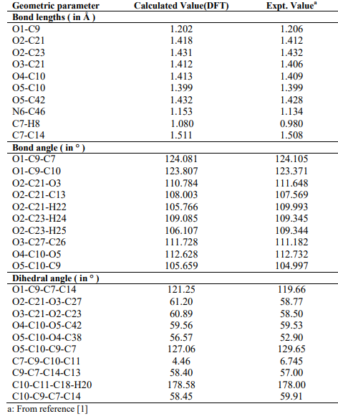

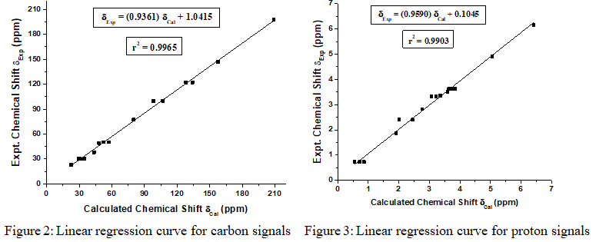
UV-Visible peaks

Computed UV-Vis absorption peaks obtained in the computations are due to the electronic transitions. HOMO and LUMO determine the reactivity of the selected compound.²⁶ Electron donor is HOMO and acceptor is LUMO.^{27,28} The calculated peaks at λ_{max} = 318.35 nm, its oscillator strength, f = 0.0060 and another one observed at λ_{max} = 240.84 with f = 0.0416 and are shown in figure 4. The origin of the signals is mainly due to the transitions of H→L and H-1→L for DDO.

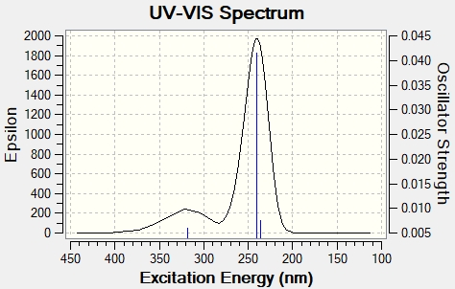

FIGURE 3: UV-Vis peaks

Chemical reactivity of the molecule DDO

Frontier molecular orbital energy gap plays vital role in understanding the chemical reactivity such as reactants kinetic characteristics and chemical reactions of the molecule. The calculated energy gap between H and L: 4.040 eV (figure 5) and the chemical potential (μ = -7.238 eV) is negative for DDO, and is chemically stable.^{29,30} These parameters describe aspects like drug design and toxicological behavior of eco system.

Figure 4: HOMO and LUMO plots of DDO
Molecular electrostatic surface potential of DDO
The total electron density plot of DDO (see figure.6) shows the difference between charge distributions among various parts of a given molecule³¹. In figure 5, relatively negative regions are shown in red and relatively positive region is shown in green. The negative region, indicated in red is primarily over the N and O atomic positions, caused by the donation of oxygenandatoms of nitrogen (lone-pair electrons), whereas the positive section designated in green is over the remaining atoms.

FIGURE 5: Total electron density plots of DDO
Non-Linear Optical (NLO)behaviour
NLObehaviour of chosen sample confirmed by comparing the Urea values of μ_{t}and β_{t.} (Urea μ_{t} :1.3732 Debye and β_{t}: 372.8×10⁻³³ cm⁵/e.s.u). Values of DDO are μ_{t}: 3.279 Debye and β_{t}: 391.279×10⁻³³ cm⁵/e.s.u. Hence it can be concluded that DDO is agood NLO materials.³²⁻³⁶
CONCLUSION
The following inferences are drawn from the computations:
- DDO molecule has the non-planar structure acquiring point group of C₁ symmetry. Theoretical computed geometric parameters of DDO are good in agreement with the values of XRD.
- Good correlation between the theoretical and experimental NMR signals.
- Theoretical UV-Vis peaks identified.
- Electron density plot was drawn and thermal energies were also estimated for DDO.
- DDO is a excellent contender for enlargement of novel NLO materials.
REFERENCES
- Ch.Santhosh Kumar, and Chun-Chen Liao, Tetrahedron 59, 4039–4046(2003).
- S.Sharma, N.Ram Tilak and R.Peddinti, RSC Adv 5, 100060-100069(2015).
- Michael E. Jung and Michael H. Parker, Total synthesis of Bao Gong Teng A, a natural antiglaucoma compound J. Org. Chem. 57, 13, 3528–3530(1992).
- D.-S Hsu., P.-Y Hsu. and C.-C Liao, 3, 263–265(2001).
- S.Dong, E.Hamel, R.Bai, D. G.Covell, J.A.Beutler and J.A.Porco, Jr., Angew. Chem., Int. Ed., 48, 1494–1497(2009).
- K. Srishailam, P. Venkata Ramana Rao, L. Ravindranath, B. Venkatram Reddy, G. Ramana Rao J. Mol. Struct. 1178, 142 (2019).
- P. Venkata Ramana Rao, K. Srishailam, L. Ravindranath, B. Venkatram Reddy, G. Ramana Rao. J. Mol. Struct. 1180, 665-675 (2019).
- K. Ramaiah, K. Srishailam, K. Laxma Reddy, B. Venkatram Reddy, G. Ramana Rao J. Mol. Struct. 1184, 405-417 (2019).
- K. Srishailam, B. Venkatram Reddy, G. Ramana Rao J. Mol. Struct. 1196, 139-161 (2019).
- G. Padmaja, G. Devarajulu, B. Deva Prasad Raju, G. R. Turpu, K. Srishailam, B. Venkatram Reddy, G. Pavan Kumar, J. Mol. Struct. 1220, 128660 (2020).
- P. Venkata Ramana Rao, K. Srishailam, G. Ramesh, B. Venkatram Reddy, G. Ramana Rao, Asian Journal of Chemistry; 32, 12 , 3057-3062 (2020).
- P. Venkata Ramana Rao, K. Srishailam, A. Rajesh. Mater.Sci.Eng.981,022087(2020).
- K. Srishailam, K. Ramaiah, K. Laxma Reddy, B. Venkatram Reddy, G. Ramana Rao, .Chemical Papers, 75(7), 3635-3647(2021).
- K. Srishailam, K. Ramaiah, K. Laxma Reddy, B. Venkatram Reddy, G. Ramana Rao, Mol Molecular Simulation 14, 1-15(2022)
- B.Sreenivas, L.Ravindranath, K.Srishailam, B. Venkatram Reddy, Jai Kishan Ojha, Molecular Simulation,48 1017-1030(2022).
- P. Venkata Ramana Rao, K. Srishailam, B. Venkatram Reddy, G. Ramana Rao J. Mol. Struc. 1240, 130617(2021)
- Gaussian 09, Revision B.01, M.J. Frisch M. J et al, Gaussian, Inc., Wallingford CT(2010)
- A. D. Becke, J. Chem. Phys. 98, 5648(1993)
- C.Lee, W.T.Yang, R.G.Parr, Phys. Rev. B 37, 785-790(1988).
- G. Scalmania and M. J. Frisch, J. Chem. Phys. 132, 114110(2010).
- R. Improta, V. Barone, G. Scalmani and M. J. Frisch. J. Chem. Phys., 125 , 1-9 (2006).
- R. Improta, G. Scalmani and M. J. Frisch, V. Barone, J. Chem. Phys., 127, 1-9(2007).
- G. Gece, , Corros. Sci. 50, 2981–2992(2008)
- R. G. Parr, L. V. Szentpa´ly, S. Liu, J. Am. Chem. Soc.121, 1922-1924(1999)
- AB. Ahmed, H. Feki, Y. Abid, H. Boughzala, C. Minot, A., Mlayah A, J. Mol. Struct. 920, 1-7(2009).
- JP.Abraham, D.Sajan, V.Shettigar, SM.Dharmaprakash, I.Neˇmec, IH.Joe, VS.Jayakumar, J. Mol. Sruct. 917, 27-36(2009).
- SG.Sagdinc, A.Esme,Spectrochim. Acta A 75, 1370-1376(2010).
- AB. Ahmed, H. Feki, Y. Abid, H. Boughzala, C. Minot,Spectrochim. Acta A 75, 293-298(2010).
- K. Fukui, Science 218, 747-754(1982).
- T. A. Koopmans, Physica 1, 104-113(1933).
- N. Ö zdemira, B. Erenb, M. Dinc¸era and Y. Bekdemir, Mol. Phys. 108, 13-24(2010)
- Sun Y-X, Hao Q-L, Wei W-X, Yu Z-X, Lu L-D, Wang X, Wang Y-S, J. Mol. Struct. Theochem 904, 74-82(2009).
- C.Andraud, T.Brotin, C.Garcia, F.Pelle, P.Goldner, B.Bigot, A.Collet, J. Am. Chem. Soc. 116, 2094-2102(1994).
- V.M Geskin, C.Lambert, J-L.Bre´das, J. Am. Chem. Soc. 125, 15651-15658(2003).
- M. Nakano, H. Fujita, M. Takahata, K. Yamaguchi, J. Am. Chem. Soc. 124, 9648-9655(2002).
- D. Sajan, H. Joe, V. S. Jayakumar, J. Zaleski, J. Mol. Struct. 785, 43-53(2006).

