A taxonomy and survey of high-performance computing management system

Dr. Ashish Tiwari Aastha Tripathi Kalyani Singh
Computer Science & Engineering Computer Science & Engineering Computer Science & Engineering
Amity University Lucknow, India Amity University Lucknow, India Amity University Lucknow, India
Atiwari3@lko.amity.edu aasthatripathi54@gmail.com singhkalyani1608@gmail.com

Yuvraj Singh
Computer Science & Engineering
Amity University Lucknow, India
yuvrajsingh090703@gmail.com

ABSTRACT
The administration of open, private, or crossover cloud administrations and assets is known as cloud computing administration. Stack adjusting, execution, capacity, reinforcements, capacity, sending, and other angles are among its components. A cloud supervisor must have full get to all cloud resources' capabilities in arrange to achieve this. A bound together cloud administration procedure and strategy is made conceivable by combining a assortment of program items and innovations. Cloud computing is an innovation that permits clients to get to registering assets over the web. These assets incorporate programming, stockpiling, and handling power. Cloud computing has become progressively well-known lately because of its many advantages, including cost investment funds, versatility, and adaptability. Technology has advanced at an astonishing rate in the world of computers and networked communication, allowing us to reach new connectivity and user experience heights. One such innovation is the Internet of Things (IoT), which has reformed the universe of registering by interfacing savvy gadgets together and empowering them to trade information and control guidelines in a consistent and coordinated manner. In the accompanying article, we will talk about the ideas driving IoT, the conventions that empower it, and the applications that are being created around it. Tools for simulation simulate these computing technologies.

Keywords—High-performance system, Service management, parameters of computing, Simulation system.

INTRODUCTION

Cloud computing and emerging IT platforms aim to deliver computing as the 5th utility, similar to electricity or water. The vision is to provide on-demand access to computing resources and services, enabling scalability, flexibility, and cost-effectiveness for organizations. In reality, cloud computing has become an integral part of modern IT infrastructure. It offers agility, global accessibility, and facilitates rapid innovation. Cloud platforms like AWS, Azure, and Google Cloud have revolutionized the technology landscape, enabling advanced technologies such as AI, big data analytics, and IoT. In short, cloud computing has fulfilled its vision of delivering computing as a utility, though some hype has surrounded it [2]. It has become a crucial component of IT, empowering businesses to achieve their goals efficiently. Cloud computing is playing an important role in AI. Provides powerful computer resources for AI model training and inference. Enables elastic scaling to handle varying workloads and data sizes. Offers cost efficiency with pay-as-you-go pricing models. Facilitates collaboration and remote access to AI projects. Integrates AI services and APIs for easy integration into AI applications. Streamlines deployment and management of AI models. Enhances accessibility and availability of AI capabilities to organizations of all sizes [3]. Nowadays, big businesses prefer to store their data in the cloud. The businesses can suffer a significant amount of loss and inconvenience from even a minor error or downtime. To configuration, handle and keep distributed computing administration explicit individuals are capable who ensure the work sort out as assumed and all emerging issues are tended to [1].
IoT relies on technologies like sensors, connectivity options, cloud computing, and data analytics. Various protocols such as MQTT, CoAP, HTTP, and Zigbee enable communication in IoT systems. IoT has applications in smart homes, industrial automation, healthcare, agriculture, and transportation. Data generated by IoT devices can be analyzed to gain insights and optimize processes. Security and privacy are critical considerations in IoT to protect data and ensure trust. IOT plays an important role in AI. Data Collection: IoT devices generate vast amounts of real-time data from sensors, devices, and systems. This data serves as valuable input for AI algorithms, enabling them to learn and make informed decisions. Enhanced Connectivity: IoT provides connectivity between devices, enabling seamless communication and data exchange. Intelligent Automation: By combining AI and IoT, devices can be programmed to operate autonomously, making decisions, and taking actions based on AI algorithms. Predictive Analytics: AI algorithms can analyze the data collected from IoT devices to identify patterns, trends, and anomalies [7]. This helps in predicting future outcomes. Personalization and Adaptability: IoT devices equipped with AI capabilities can learn from user behavior, preferences, and environmental data to personalize experiences and adapt to changing circumstances. Real-time Monitoring and Control: IoT-connected sensors can continuously monitor and collect data from various sources[9].
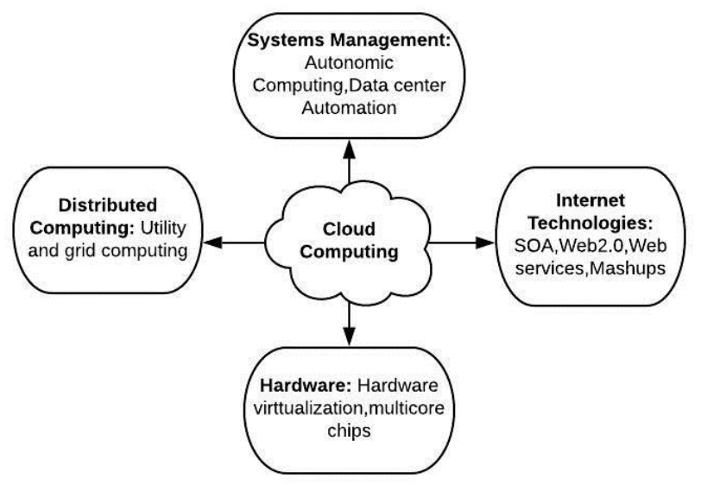
Figure 1: Technologies working with Computing.

Figure 1 shows, for instance, how cloud computing services can learn when you're home and automatically adjust the temperature. To connect to the internet without the use of wires, IoT devices make use of wireless technologies like Bluetooth and Wi-Fi. Small computers inside IoT devices control their functions. Microcontrollers are the names of these computers. Data from IoT devices is sent to massive cloud-based computers for storage, processing, and analysis. This assists us in making sense of all the data gathered by IoT devices [7].

Computing Management system

A computer program arrangement called a cloud administration stage incorporates a strong and broad set of APIs that let it drag information from each portion of the IT framework. A CMP licenses an IT affiliation to lay out an organized way to bargain with security and IT organization that can be executed over the association's entirety cloud climate. Reviewing Framework Reinforcements: In arrange to ensure the rebuilding of haphazardly chosen records having a place to different clients, it is essential to occasionally review the reinforcements. This may be wrapped up by the affiliation or by the cloud provider. Information stream within the framework: It is the managers' obligation to make a information stream graph that demonstrates the organization's expected information stream. The chiefs must know how to move their data from one server to one more within the occasion that the affiliation chooses to switch providers. The chiefs must realize the security plans of the provider, especially Multitenant utilize, Web trade dealing with, Laborer screening and Encryption technique.
Checking the Capacity, Arranging, and Scaling Capabilities: The chief ought to be mindful of their current cloud provider's capacity, arranging, and scaling capabilities. Observing the review log: The supervisors routinely review the logs to discover framework blunders. Arrangement Testing and Approval: The cloud administrations must be tried, their comes about checked, and error-free arrangements found.

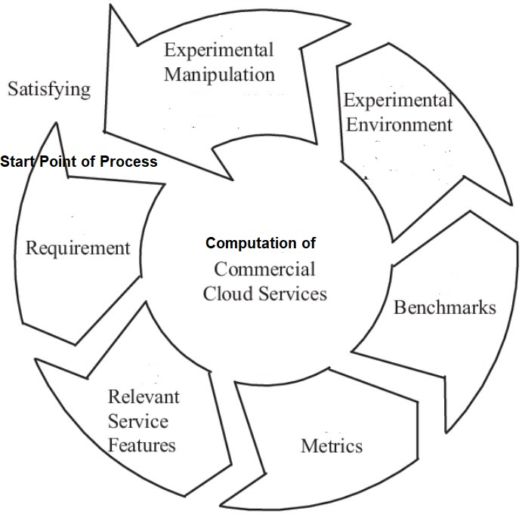
Figure 2: Computational Cycle of Cloud services.

Control over public, private, or hybrid cloud infrastructure resources and services is referred to as cloud management. A very much planned cloud the board methodology can assist IT experts with controlling those dynamic and versatile processing conditions. Additionally, cloud management can assist businesses in achieving three objectives: When IT professionals access cloud resources, create new ones, monitor usage and costs, and adjust resource allocations, they achieve self-service flexibility. Operations teams can manage cloud instances without the need for human intervention thanks to workflow automation. Cloud workloads and user experiences can be tracked using cloud analysis. Without an equipped IT staff set up, it's hard for any cloud the executives methodology to succeed. While keeping the business's cloud management goals in mind, these individuals must be familiar with the appropriate tools and best practices.
When businesses adhere to tried-and-true cloud optimization practices, they are more likely to improve cloud computing performance, reliability, cost containment, and environmental sustainability. There are numerous ways of moving toward cloud the board, and they are unmistakably carried out in show. IT companies can use cost-monitoring tools to navigate complicated vendor pricing models. Applications run faster when they use tools for performance optimization and architectures built with tried-and-true methods. A significant number of these instruments and methodologies dovetail with naturally economical structural techniques to bring down energy utilization. Cloud the executives choices should at last depend on individual corporate needs and targets, as there is no single methodology. Seemingly the greatest test to cloud the executives is cloud spread, which is precisely exact thing it seems like: IT staff forgets about cloud assets, which then increase uncontrolled all through the association. IT departments need governance policies and role-based access controls because cloud sprawl can raise costs and cause security and management issues. Components of cloud management Automated and orchestrated instances and configurations, secure access, adherence to policies, and all-level monitoring—all done at the lowest possible cost—are essential components of cloud management. Begin with a cloud relocation procedure that consolidates legitimate documentation and guarantees just essential information and jobs are moved off premises. Discuss self-service user portals, multi-cloud management, and other types of provisioning and orchestration. Cloud the executives stages give a typical view across all cloud assets to assist with observing both interior and outer cloud administrations. Tools for management platforms can assist in directing all parties involved in an application's lifecycle. Resources can be controlled through regular audits. At last, consider outsider instruments to help adjust undertaking utilization, execution, cost and business benefits. Metrics should be set to help you find patterns and decide what you want to measure and track over time. There are a lot of possible data points, but each business should choose the ones that are most important to them. Information about how the volume and performance of a compute instance are being used (processor, memory, disk, etc.) gives knowledge about the application's general wellbeing. Storage associated with compute instances is referred to as storage consumption. Load-adjusting administrations disperse approaching organization traffic. Database instances aid in data pooling and analysis. Cache instances store data that is frequently accessed in memory, eliminating the need for slower media like disk storage. Functions, which are also known as serverless computing services, are used to set up workloads without having to buy and maintain compute instances. The cloud supplier works the assistance that heaps, executes and empties the capability when it meets trigger boundaries. Management of security The major public cloud providers continue to make investments in their services and enhance cloud security, including their capacity to withstand distributed denial-of-service attacks. Because cloud attacks typically limit themselves to a single misconfigured service, whereas a local attack could destroy an entire infrastructure, some experts contend that today's on-premises attacks are significantly more destructive.
Despite this, IT companies need to keep an eye out for security risks. Google, AWS and Microsoft, among others, don't assume complete ownership to protect cloud information. Cloud clients should comprehend their common obligation in the cloud to safeguard their information. Configuration management, automated security updates for SaaS, and improved logging and access management are among the best practices for cloud security. Today's cloud configurations are more common, and they are easier to protect. The cloud security model depicts which areas of cloud security ultimately depend on cloud suppliers to guarantee and which are the obligations of clients. Security dashboards and pattern investigation devices let undertakings investigate their current circumstance to assist it with remaining secure. Compared to on-premises tools, cloud versions are significantly more adaptable. For instance, an organization can quickly gain insight into an online attack by activating the online dashboard of a service provider.

Computing Principles
The victory of any cloud administration technique depends not fair on the right utilize of instruments and computerization but moreover on having a competent IT staff input. IT and trade groups must collaborate in arrange to absorb to a cloud culture and get it the business's objectives. IT groups must moreover test cloud application execution, screen cloud computing measurements, make foundation choices, address fix and security vulnerabilities, and upgrade the trade rules that drive cloud administration. Organizations too must reconsider their alter administration arrangements for the cloud, where utilization of assets can be much faster and more spread out versus an on-premises IT environment. Companies that need gifted IT staff can look for help from third parties. Third-party apps back budget edge alarms that can inform back and line-of-business partners so they can screen their cloud investing. Cloud brokerages regularly have a benefit catalog and a few budgetary administration apparatuses. The time to scrutinize cloud investing is early on when apps go into generation. Cloud administration preparation ought to expand past IT and into other divisions, from the supply chain to bookkeeping staff. Staff can advantage from cloud preparing, such as certifications accessible through the CompTIA Cloud Basics and AWS Cloud Professional programs. In case conventional certification programs fetched as well much, consider online programs counting LinkedIn Learning, A Cloud Master, Linux Institute and others. As cloud computing extends over the venture, a common cloud administration stage can offer assistance convey, oversee and screen all cloud assets. Venture IT must shape a clear thought on what it needs to screen some time recently assessing cloud administration stages to fit those needs -- whether it's person devices that fathom a single issue, such as arrange execution or activity investigation, or a comprehensive suite that looks at everything. A few of these choices will weigh instruments from cloud suppliers, such as security devices from cloud stage sellers or from third-party suppliers. The foremost comprehensive cloud administration items offer highlights that cover these five categories: computerization and coordination for applications and person VMs; security, counting character administration and information security and encryption; approach administration and compliance, counting reviews and service-level understandings; execution checking; and taken a toll administration. Numerous multi-cloud administration sellers offer a run of apparatuses, each with qualities and shortcomings. A few of the more conspicuous ones are VMware, CloudBolt Program, Snow Program, Morpheus Information, Scalr and Flexera. Moreover, in this blend are conventional IT benefit administration sellers, such as BMC Program, CA Advances, Smaller scale Center and ServiceNow, which regularly serve huge companies with ITSM administration forms.
IT shops that utilize a single open cloud might need to stay with instruments advertised by that benefit supplier since such apparatuses are planned to improve those local administration stages. For cloud checking, Google Cloud Operations (once Stackdriver) screens Google Cloud as well as applications and VMsthat run on AWS Flexible Compute Cloud. Microsoft Sky blue Screen collects and analyzes information and resources from the Purplish blue cloud. AWS clients have Amazon CloudWatch. Other alternatives incorporate Prophet Cloud Infrastructure's Application Execution Observing benefit and Cisco CloudCenter, as well as apparatuses such as Datadog for cloud analytics and checking, and Modern Antique to track web apps. There are moreover numerous open source cloud checking alternatives for ventures comfortable working with open source apparatuses. For private cloud administration, ventures regularly utilize in-house devices. Applications that run in a private cloud do not get the advantage of boundless flexibility picked up from open cloud administrations built on an colossal scale of foundation. The IT group must be certain that it has satisfactory, accessible assets to run the app, and must carefully oversee situations to guarantee that no one app devours numerous corporate computing assets as well. Cloud security challenges
Cloud security breaks episodes actually happen even as security advances improve and specialist organizations brace their organizations. Individuals can go after network has and web applications really quick invigorated. The most recent security audits and reports should be available to cloud administrators, who should test their environments. Take care while embracing new advancements, for example, artificial intelligence and AI, which utilize numerous information sources and in this way expand the reach for possible assaults. cloud computing expenses can wind in the event that they are not overseen all along. Various present moment and long-haul cost improvement systems for cloud arrangements can assist with keeping spending plans in line. Begin by selecting the appropriate provider. There are various ways of running an application: hosted in a serverless computing environment, containerized, or hosted on VMs on a service. Each has differing cost and the executive’s intricacy. Try to find the right harmony among cost and undertaking needs. Consider the following factors: One method for accomplishing cloud overt repetitiveness is to pick a facilitating choice that circulates responsibilities across various server farms inside a district. This strategy is the least redundant and has the lowest cost. Another way is for clients to reflect responsibilities across more than one district, which offers more overt repetitiveness yet at a greater expense. Decide the fitting size and scale for your establishment. Tools can help you find a VM instance that is more cost-effective and more efficient for the workload you want to run. Saved occasions cost not exactly on-request VMs, however they should be reserved ahead of time. Preemptible examples are least expensive however risk interference by the cloud specialist co-op, so they are definitely not a fit for reliable responsibilities that require uptime. Autoscaling, commonly a piece of a cloud merchant's general system, can increment or decline assets as request shifts. Limit the movement of data. Data egress fees are charged by cloud providers. Choose the best cloud services configuration for your needs if you frequently move data. Additionally, perceive that moving information can increment security chances. Consider outsider instruments. Cost-management tools from third parties may have superior management, monitoring, and security capabilities than the native services of a cloud platform. Additionally, they frequently operate in multi-cloud settings. Seek trend setting innovations for help. Even if you do everything right, cloud management can be difficult. Artificial intelligence and machine learning, according to some users and experts, can effectively and significantly cut cloud costs. Sellers currently offer apparatuses that integrate capacities to check cloud jobs, immediately distinguish abnormalities and ready chairmen about an issue that could influence the cloud bill.

Simulation of cloud services

Computer based intelligence instruments and AI supplement the activities of people however don't supplant them. Software can find additional information that staff might miss, but when analyzing cloud cost strategies, people need to work together and make decisions based on resources and experience. In both IT and business lines, in-house employees ought to be aware of the ways in which cloud use affects profitability. IT geniuses have their hands full keeping up in the ongoing administrative climate. The sheer volume of requests is overwhelming data protection teams worldwide, increasing their workload, particularly in light of the GDPR. The erroneous belief that compliance guarantees security must also be dispelled; compliance with standards does not prevent phishing attacks or other cloud breaches. Sharpen your association's arrangement with guidelines and rules with a cloud administration structure. Orchestration for the cloud reduces the repetitive, manual work required to manage cloud workloads with cloud automation. The principal thought is to help functional efficiencies, speed up application arrangement and decrease any human mistake that can cut down applications. To accomplish this, IT stars need arrangement or robotization devices. Legitimate asset designation begins with right-measuring occurrences and VMs for proper adaptability, which in a perfect world happens during the improvement stage. Streamlined cloud limit boundaries guarantee responsibilities run effectively, yet additionally can forestall a ton of squandered cash. Reduce anything that isn't necessary by determining what an application needs to function properly. Tools and templates are provided by cloud providers to further optimize resource deployments. There are three sorts of cloud provisioning models, with contrasts in the assets offered and how they are conveyed and paid. The cloud service provider delivers the resources and services agreed upon after the customer signs a formal service contract. The customer is either billed monthly or charged a one-time lump sum. Cloud assets are sent to match a client's fluctuating requests, normally increased to deal with spikes in use and downsized when requests decline. Pay-per-Use billing applies to the customer. Through a cloud brokerage portal or web interface, the customer purchases resources from the cloud provider. Resources are readily available for use, frequently within minutes or hours.
Similar to cloud monitoring, cloud observability aids in assessing cloud health. Metrics are less important than what can be learned from a workload based on its externally visible properties when it comes to observability. There are two parts of cloud perceptibility: philosophy and working state. Metrics, tracing, and log analysis are just some of the specifics that methodology focuses on. Working state depends on following and addresses state recognizable proof and occasion connections, the last option of which is a piece of DevOps. Problems with cloud monitoring One of the biggest problems that IT departments face is keeping up with the latest distributed application designs. IT teams must adjust their monitoring strategies in response to application development. Monitoring the cloud effectively is a difficult task. Because different kinds of applications will need to be monitored in different ways, the tools an organization uses now may no longer be what they need. Application management aims to maximize application performance as its primary objective. Event-driven architectures, also known as serverless computing, can run on cloud services like AWS Lambda, Azure Functions, and Google Cloud Functions. Here, software developers embed code into the cloud platform for particular software features and behaviors. It only works when something actually happens. When the function is finished, cloud resources are no longer used. Load balancing, which distributes network traffic to ensure that each instance operates at its maximum potential, is yet another method by which IT departments can control application performance in the cloud. In earlier days, load balancers worked locally as a server farm machine. Today, ordinarily an application lives on a server and is presented as an organization administration.

CONCLUSION AND FUTURE USE

In conclusion, cloud computing gives businesses versatile and cost-effective arrangements, improved adaptability, and openness, moved forward security and unwavering quality, and openings for advancement. It has changed the way organizations store, handle, and get information, revolutionizing the advanced scene. The benefits of IoT incorporate expanded proficiency, progressed security, and upgraded information collection and examination. IoT is changing the world by interfacing gadgets and leveraging information to upgrade productivity and streamline assignments. Its enormous potential is distant from completely realized, and as IoT frameworks become more modern, the benefits for businesses and society will as it was proceeded to develop. Cloud computing frequently serves as the spine for information capacity, preparation, and analytics in IoT biological systems, encouraging the consistent integration and administration of large-scale IoT arrangements. IoT is an energizing innovation that interfaces regular objects to the web, making them more intelligent and more valuable. In web improvement, IoT can improve client encounters, computerize errands, and give important bits of knowledge. By leveraging IoT, web engineers can make more intelligent and personalized applications that make our lives less demanding and more associated.

REFERENCES

- Kushwah, R., Batra, P. K., & Jain, A. (2020, March). Internet of things architectural elements, challenges and future directions. In 2020 6th International Conference on Signal Processing and Communication (ICSC) (pp. 1-5). IEEE.
- Buyya, R., Broberg, J., & Goscinski, A. M. (Eds.). (2010). Cloud computing: Principles and paradigms. John Wiley & Sons.
- Tiwari, A., & Garg, R. (2022). Adaptive Ontology-Based IoT Resource Provisioning in Computing Systems. International Journal on Semantic Web and Information Systems (IJSWIS), 18(1), 1-18.
- Buyya, R., & Srirama, S. N. (Eds.). (2019). Fog and edge computing: principles and paradigms. John Wiley & Sons.
- Rochwerger, B., Vázquez, C., Breitgand, D., Hadas, D., Villari, M., Massonet, P., ... & Galán, F. (2011). An architecture for federated cloud computing. Cloud computing: principles and paradigms, 391-411.
- Buyya, R., Yeo, C. S., Venugopal, S., Broberg, J., & Brandic, I. (2009). Cloud computing and emerging IT platforms: Vision, hype, and reality for delivering computing as the 5th utility. Future Generation computer systems, 25(6), 599-616.
- Gubbi, J., Buyya, R., Marusic, S., & Palaniswami, M. (2013). Internet of Things (IoT): A vision, architectural elements, and future directions. Future generation computer systems, 29(7), 1645-1660.
- G. Eason, B. Noble, and I.N. Sneddon, “On certain integrals of Lipschitz-Hankel type involving products of Bessel functions,” Phil. Trans. Roy. Soc. London, vol. A247, pp. 529-551, April 1955. (references)
- Buyya, R., Yeo, C. S., & Venugopal, S. (2008, September). Market-oriented cloud computing: Vision, hype, and reality for delivering it services as computing utilities. In 2008 10th IEEE international conference on high performance computing and communications (pp. 5-13). Ieee.
- Tiwari, A., & Garg, R. (2022). A Optimized Taxonomy on Spot Sale Services Using Mathematical Methodology. International Journal of Security and Privacy in Pervasive Computing (IJSPPC), 14(1), 1-21.
- Aversa, R., Di Martino, B., Rak, M., Venticinque, S., & Villano, U. (2011). Performance prediction for HPC on clouds. Cloud Computing: Principles and Paradigms, 437-456.
- Bose, S., Pasala, A., Ramanujam A, D., Murthy, S., & Malaiyandisamy, G. (2011). Sla management in cloud computing: A service provider's perspective. Cloud Computing: Principles and Paradigms, 413-436.
- Bowen, J. A. (2011). Legal issues in cloud computing. Cloud Computing: Principles and Paradigms, 593-613.
- Tiwari, A., & Garg, R. (2022). Reservation System for Cloud Computing Resources (RSCC): Immediate Reservation of the Computing Mechanism. International Journal of Cloud Applications and Computing (IJCAC), 12(1), 1-22.

