EFFICACY OF YOGA NIDRA ON MINDFULNESS AND ATTENTION FOR UNDER GRADUATES

DISSERTATION
In Partial Fulfilment of the Requirement for
The Degree of Master of Science in Yoga, 2022

by
Mr. Bikram Garai

Guided by
Dr. Amaravathi Eraballi, PhD, MPT, IYA, IAP, ERYT

Department of Yogic Art & Science
Vinaya Bhavana
Visva-Bharati
(A Central University of National Importance)
Santiniketan-731235, West Bengal, Bharat

ACKNOWLEDGEMENT

First and foremost, I would like to thank the Almighty God for his blessings, helping and guiding me throughout my study.

I would like to thank my father (Goutam Garai) and mother (Krishna Garai), for always supporting me throughout my study and education.

I convey my deep sense of gratitude to Dr. Amaravathi Eraballi qualification of PhD in yoga & life sciences for the able guidance in completion of the project.

Mr. Bikram Garai

CERTIFICATE

This is to certify that the project of Efficacy of Yoga Nidra on Mindfulness and Attention for Under Graduates has been carried out by the candidate under my direct supervision and the findings have been checked thoroughly.

I am satisfied with the work of Mr. Bikram Garai, M.Sc. in Yogic Art and Science and Reg No: VB-1760 of 2017-18 is submitted to Visva-Bharati, Santiniketan, West Bengal, INDIA.
It is further certified that Bikram Garai has undergone the prescribed course of studies leading to Master of Science Degree Examinations in accordance with the university regulations.

Date:

Guide: Dr. Amaravathi Eraballi

CONTENT
S. No | Title & Subtitles |  |  |  |  | Page. no.
1. | Title Page |  |  |  |  | I
2. | Acknowledgement |  |  |  |  | II
3. | Certificate |  |  |  |  | III
4. | Transliterate Sanskrit and Bengali Words |  |  |  |  | IV
5. | Content |  |  |  |  | V-VI
6. | Abstract |  |  |  |  | VII-IX
CHAPTER-1
1. | Introduction |  |  |  |  | 1-4
 | 1.1 | What is Yoga? |  |  |  | 1
 | 1.2 | Yoga Nidra
 | 1.3 | Mindfulness |  |  |  | 2
 | 1.4 | Attention
 | 1.5 | Review keyword search on PubMed, Google Scholar etc.
 | 1.6 | Anatomy and Physiology |  |  |  | 3
 |  | 1.6.1 | Frontal Cortex
 |  | 1.6.2 | Basal Ganglia
 |  | 1.6.3 | Reticular activating system (RAS)
 |  | 1.6.3 | Pineal Gland |  |  | 4
CHAPTER-2
2. | Literature Review |  |  |  |  | 5-11
 | 2.1 | Ancient Literature |  |  |  | 5-7
 |  | 2.1.1 |  |  | Markandeya Purana | 5
 |  | 2.2.2 |  |  | Patanjali Yoga Sutras | 6
 |  | 2.2.3 |  |  | Mandukya Upanishad
 |  | 2.2.4 |  |  | Hatha Ratnavali Text
 |  | 2.2.5 |  |  | Hatha Yoga Pradipika | 7
 |  | 2.2.6 |  |  | Yoga nidra Text Book
 | 2.2 | Scientific Literature |  |  |  | 8-11
 |  | 2.2.1 |  | Researchers employed hierarchical regression analyses to explore the connections between stress experiences and indicators of obesity. |  | 8
 |  | 2.2.2 |  | The effects of adding long-term Yoga and Lifestyle Support Program. |  | 8-9
 |  | 2.2.3 |  | Effects of a six-week yoga and meditation program on college students' stress and anxiety levels. |  | 9
 |  | 2.2.4 |  | Effects of yoga on cognitive functions in adolescent schoolchildren. |  | 10
 |  | 2.2.5 |  | Effects of Yoga Nidra on consciousness using an integrated approach that combines phenomenological and neurophysiological aspects. |  | 10-11
CHAPTER-3
3. | Methodology |  |  |  |  | 12-15
 | 3.1 | Aims |  |  |  | 12
 | 3.2 | Objectives
 | 3.3 | Hypothesis
 | 3.4 | Study Design
 | 3.5 | Sampling Methods
 | 3.6 | Inclusion criteria
 | 3.7 | Exclusion criteria
 | 3.8 | Parameter |  |  |  | 13
 | 3.9 | FFMQ (Five Facet Mindfulness Questionnaire)
 | 3.10 | TMT (Trail Making Test)
 | 3.11 | Data collection |  |  |  | 14
 | 3.12 | Lesson Plan of Agnisara Kriya |  |  |  | 14-15
CHAPTER-4
4. | Results |  |  |  |  | 16-22
 | 4.1 | Demographic data |  |  |  | 17
 | 4.2 | General parameters: PDP, RP, C-V P |  |  |  | 18
 | 4.3 | Specific Parameter FFMQ, TMT A & B |  |  |  | 19
CHAPTER-5
5. | Discussion |  |  |  |  | 20-23
 | 5.1 | Positive effects with Yoga Nidra |  |  |  | 20-23
 | 5.2 | Natural effects of Yoga Nidra |  |  |  | 23
 | 5.3 | Adverse effects of Yoga Nidra
6. | Conclusion |  |  |  |  | 24
7. | Limitations |  |  |  |  | 24
8. | Strengths |  |  |  |  | 24
9. | Acknowledgement |  |  |  |  | 24
10. | References |  |  |  |  | 25-26
11. | Bibliography |  |  |  |  | 26-27
12. | Annexure |  |  |  |  | 28-33
 | 12.1 | Five Facet Mindfulness Questionnaire (FFMQ) |  |  |  | 28
 | 12.2 | Trail Making Test A & B |  |  |  | 29-30
 | 12.3 | Sample Five Facet Mindfulness Questionnaire and Trail Making Test A & B |  |  |  | 31-32
 | 12.4 | Sample Data collection form |  |  |  | 33

EFFICACY OF YOGA NIDRA ON MINDFULLNESS AND ATTENTION FOR UNDER GRADUATES
ABSTRACT
Background: The present situation most of the students lost their main aim and destination of life tend to go towards wrong path. Usage of smart phones so reduce attention level day by day and they do not notice the actual direction. This situation may reduce their performance of lifestyle. So, the yoga treatment will help undergraduate students to show their correct way of life and improve Overall personality or balanced personality or Sattvic personality of students Focussing on the student’s mindfulness about day works and get normal sleeping pattern is mandatory because they are the future of our world.
Need: Yoga nidra helps one to improve Undergraduates mindfulness and keep them focused on their studies and further important things in their life.
Aim: In this yoga treatment, we have aimed to bring sound sleep as a basic of lifestyle and also make them focused and attentive.
Objective: By comparing FFMQ (Five Facet Mindfulness Questionnaire) before and after the yoga nidra and comparing TMT (Trial making Test) score before and after the yoga nidra.
Type of Research: Observational and Experimental Research.
METHODOLOGY
Sampling methods: Sample size- 20, University yoga students, Study Design- Pre - Post, Sample collection- University students of Yoga department were invited for the testing.
Null Hypothesis (H0): FFMQ & TMT may or may not be changed with Yoga Nidra.

Assessment Tools:
- General Parameters:
Body weight, Body height, BMI, Blood Pressure, SpO₂, Pulse Rate, Respiratory Rate.
- Specific Parameters:
FFMQ, (Five Facet Mindfulness Questionnaire)
TMT (Trial Making Test)
Intervention: Yoga Nidra with sequence.
Data Collection: Parameters will be checked on first day prior to the practice and 10th day of practice. During the practice if the mindfulness, attention, tiredness, pain or any tingling sensation will be asked as points of beginner level during training period. Later these symptoms will be monitored on daily basis as routine feedback.
Results: The data will be entered into MS-Excel sheet and calculated Mean, Standard deviation and percentage change and Comparison of pre and post data of specific and general parameters will be done with t-test.
Conclusion: Through this study it has been found that there has been improvement in wields a significant influence on mindfulness and attention after giving the 10 days of Yoga Nidra practice. Through its systematic approach, it enables individuals to explore the depths of their consciousness and develop a heightened sense of self-awareness. By leading practitioners through a journey of Observing, Describing, Acting with Awareness, Nonjudging and Nonreactivity, Yoga Nidra nurtures a state of heightened mindfulness that extends into everyday life. Furthermore, the practice encourages the cultivation of sustained attention, as it trains the mind to remain alert and engaged even in states of profound relaxation.
Key words: Yoga Nidra, Under graduate students, Mindfulness, Attention.

CHAPTER-1
1: INTRODUCTION

  - What is Yoga?
The term "yoga" finds its origins in the ancient Sanskrit root "yuj," which translates to "to yoke" or "to unite." This fundamental concept underpins the practice's purpose, which revolves around establishing a profound union between various aspects of human existence. Yoga endeavours to foster harmony between the body, mind, and spirit, as well as to forge a connection between the individual self and the universal consciousness that permeates all existence. ^{[16]}

  - Yoga Nidra:
Yoga Nidra is a guided relaxation technique derived from ancient yogic practices that leads practitioners into a state of profound physical, mental, and emotional relaxation while maintaining a state of conscious awareness. During Yoga Nidra, individuals are encouraged to cultivate a state of non-reactive observation, allowing them to explore and release deeply held tensions, fears, and unconscious patterns. The practice is designed to induce a state of calm, promote healing, enhance creativity, and facilitate self-awareness. yoga nidra word first derive in Vishnu-purana, there mention as the Lord Vishnu sleep in an infinity context but he is totally aware on about the creation which was created by him. There have very few information about yoga nidra and its technique in ancient Indian methods of knowledge". But in the very much early scriptures the techniques of yoga nidra was scripted in tantric philosophy. In yoga nidra, the consciousness is in a state between waking and sleep, but it is subject to neither. In modern psychology this has been termed 'the hypnagogic state' The Yoga nidra is an ancient technique of meditation or too aware on about self by withdrawing the five scenes. It is among the deepest possible states of relaxation while still maintaining full consciousness which is called Pranjna or Turiya in the Mandukya Upanishad. The Yoga Nidra is a state of consciousness between awaking & sleeping, also a process of sleeping with a full state of awareness. ^{[15]}
  - Mindfulness:
Mindfulness is the psychological state of being fully present and engaged in the present moment, with a non-judgmental and accepting attitude towards one's thoughts, emotions, and sensations. It involves intentionally directing one's attention to the present experience and cultivating an attitude of openness and curiosity. ^{[1]}

  - Attention:
Attention refers to the cognitive process of selectively focusing on specific stimuli or information while filtering out irrelevant or distracting stimuli. It involves the ability to concentrate and sustain mental effort on a particular task or object. ^{[1]}

1.5. Review keyword search on PubMed, Google Scholar, ScienceDirect, Shodhganga, IJOY
SL  No. | Keywords | Journal Result
 |  | PubMed | Google Scholar | Science Direct | Shodhganga | IJOY
1. | Yoga Nidra | 56 | 6350 | 146 | 4794 | 26
2. | Yoga Nidra on Mindfulness | 2 | 2410 | 3 | 4801 | 9
3. | Yoga nidra on Attention | 1 | 3260 | 100 | 25931 | 12
4. | Yoga Nidra on Brain Sleep | 1 | 2350 | 59 | 21956 | 5
4. | Trial making test of Brain | 1730 | 241000 | 130 | 105908 | 15

  - Anatomy and Physiology:
    - Frontal Cortex:
The frontal cortex, or frontal lobe, is a region of the brain situated at the anterior (front) part of each cerebral hemisphere. It encompasses a diverse array of functions related to executive control, emotion regulation, motor planning and execution, attention, and social interactions. The frontal cortex is responsible for higher-order cognitive processes and complex behaviour’s that contribute to an individual's personality, reasoning, and self-awareness. ^{[17]}

    - Basal Ganglia:
The basal ganglia are a group of subcortical nuclei located deep within the brain, primarily in the forebrain, and is crucial for various functions such as motor control, cognition, emotions, and reward processing. It consists of several interconnected nuclei, including the striatum, globus pallidus, substantia nigra, and subthalamic nucleus. The basal ganglia play a key role in coordinating voluntary movements, regulating muscle tone, facilitating learning, and influencing emotional and cognitive processes. ^{[18]}
    - Reticular activating system (RAS):
The reticular activating system (RAS) is a complex network of neurons located in the brainstem that plays a crucial role in regulating the sleep-wake cycle, arousal, attention, and consciousness. It serves as a "gateway" for sensory information entering the brain, filtering and modulating sensory input to determine the level of wakefulness and awareness. The RAS also influences the activation of higher brain regions and is essential for maintaining an optimal level of alertness and responsiveness. ^{[19]}

    - Pineal Gland:
The pineal gland or epiphysis cerebri is a small, reddish-grey organ, occupying a depression between the superior colliculi. It's inferior to the splenium of the corpus callosum, from which it's separated by the Tela choro idea of the third ventricle and the contained cerebral modes. It's enveloped by the lower subcaste of the Tela, which is reflected from the gland to the tectum. The pineal is about 8 mm long. Its base, directed anteriorly, is attached by a peduncle, which divides into inferior and superior laminae, separated by the pineal recess of the third ventricle, and containing the posterior and habenular commissures respectively. Aberrant commissural fibres may foray the gland but don't terminate near parenchymal cells. The pineal gland was described as the “Seat of the Soul” by Renee Descartes and it is located in the center of the brain. The main function of the pineal gland is to admit information about the state of the light-dark cycle from the terrain and convey this information to produce and secrete the hormone melatonin. ^{[20]}

CHAPTER-2

- LITERATURE REVIEW

  - ANCIENT LITERATURE REVIEW:

The material from different texts is given is Sanskrit as they are in original text for better reference or proof like pramana.
The information taken as it is in the ancient texts like Markandeya Purana, Patanjali Yoga Sutras, Upanishad etc. The phrases of explanation are in Sanskrit.
The literature was been translated from Sanskrit to Transliteration (form of English).

    - Markandeya Purana

उथपन्नेति ठदा लोके सा नित्याप्यभिधीयाथे
योगनिध्राम याद विष्णुर जगत्यकारणविकृथे ॥ Chapter-१-४९,५०॥
Meaning: "Yoga Nidra" is first mentioned in the Devi Mahatmya, which is a significant part of the Markandeya Purana.
According to the visualizations described by Maharshi Markandeya in the Markandeya Purana, "at the end of Kalpa, when the entire universe was in a state of profound repose, Lord Vishnu reclined on the serpent bed in a state of absolute consciousness." He goes on to explain in his Purana that the divine goddess Yoga Nidra resides in the eyes of Lord Vishnu. ^{[21]}

द्रुष्ट्वा थावसुरौ चोग्रौ प्रसुप्तं च जनार्धनम्
थुष्टवा योगनिध्रं ठमेकग्रं ह्रुद्य स्थीथः ॥ Chapter-१-५२॥
Meaning: Lord Brahma observed Lord Vishnu in the grip of Yoga Nidra and desired to awaken him, he began to pray to the goddess Yoga Nidra. This marked the first appearance of Yoga Nidra in the universe. As a result of her influence and Lord Brahma's prayers, Lord Vishnu regained consciousness and was able to defeat the two formidable evils known as Madhu and Kaitabh. ^{[21]}

2.1.2. Patanjali Yoga Sutra
अभावप्रत्ययालम्बना वृत्तित्तनिद्रा ॥ PYS. १.१० ॥
Meaning: Abhaya absence; pratyahara: content of mind; alambana: support; vrttih: modification; nidra: sleep.
Sleep is modification of mind which has the cause of nothingness as its support. ^{[16]}

2.1.3. Mandukya Upanishad

यत्र सुप्तो न कञ्चन कामं कामयते न कञ्चन स्वप्नं पश्यति तत्सुषुप्तम् ।
सुषुप्तस्थान एकीभूतः प्रज्ञानघन एवाऽऽनन्दमयो ह्यानन्दभुक् चेतोमुखः प्राज्ञस्तृतीयः पादः ॥ ५॥
Meaning: In this state of deep sleep, the sleeper has no desires for objects and does not experience any dreams. The third quarter (Pada) is the pranjna whose sphere is deep sleep, in whom all (experiences) become unified or undifferentiated, who is verily, a mass of consciousness entire, someone who is filled with joy, who undergoes moments of bliss, and who serves as the path to attain knowledge about these two states. ^{[22]}

2.1.4. Hatha Ratnavali Text

अथ योगनिद्रासनम्
पादाभ्यां वेष्टयेत्कण्ठं हस्ताभ्यां पृष्ठबन्धनम् ॥
तन्मध्ये शयनं कुर्याद् योगनिद्रा सुखप्रदा ॥ HRT. ३.७०॥

Meaning: Lie down with your legs wound around the neck and your hands tied behind your back. This is yoganidra, which offers wellbeing. ^{[23]}

2.1.5. Hatha Yoga Pradipika

अभ्यसेत् खेचरीं तावद्यावत् स्याद्योगनिद्रितः ।
संप्राप्तयोगनिद्रस्य कालो नास्ति कदाचन ॥ HYP. ४.४९॥

Meaning: Khechari should be practiced until yogic sleep occurs. For someone who has achieved yogic sleep, the concept of time becomes irrelevant. ^{[24]}

    - Yoga nidra Text Book

Swami Satyananda Saraswati explain the five different steps or deeper format on about the Yoga- nidra in his book. The systematic evolution of consciousness is explored in this book with modem mechanical evidences. ^{[15]}
The Shandilya Upanishad also mentioned the steps of yoga nidra, which is very essential for Pratyahara or withdrawing the scenes to bring the more relaxation, and this conscious sleeping or meditation brings to the higher state of consciousness. Also, the attentivity of body bring the psychomotor relation.^{[15]}
There have also many dialogs in the Mandukya upanishad. And the Buddhist meditation system, tantric meditation system. They mentioned that in this process the involuntary activities are become voluntary by gaining the consciousness on the physical and psychic dimension. ^{[15]}

  - SCIENTIFIC OR MODERN LITERATURE REVIEW

There are 13 studies on PubMed used TMT, FFMQ as the tool with yoga intervention.
2.2.1. According to Elizabeth W. Cotter et al. in 2018, the researchers employed hierarchical regression analyses to explore the connections between stress experiences and indicators of obesity. The study aimed to investigate whether stress-related eating played a mediating role in this relationship and whether the effects were influenced by gender, obesity status, and mindfulness. The findings of the study indicated that experiences of stress were associated with higher Body Mass Index (BMI) and waist circumference, even after accounting for other factors such as age, annual income, education level, sex, and race. Although the additional variance explained by stress was relatively small, the association remained statistically significant. The study also utilized a nonparametric bootstrapping approach to assess mediation, and the results suggested that stress-related eating mediated the link between stress experiences and indicators of obesity. This means that individuals who reported higher levels of stress were more likely to engage in stress-related eating behaviour’s, and these behaviour’s, in turn, were associated with higher BMI and waist circumference. ^{[2]}

2.2.2. According to Eraballi Amaravathi et al. in 2018, The effects of adding long-term Yoga and Lifestyle Support Program (YLSP) to conventional cardiac rehabilitation for individuals who had undergone Coronary Artery Bypass Grafting (CABG) surgery. The study aimed to assess the impact on participants' quality of life (QOL) and perceived stress levels over a five-year period. The study's findings indicated that there were notable improvements in both QOL and stress levels for participants who underwent long-term YLSP in addition to conventional cardiac rehabilitation. The statistical analysis revealed a p-value (P) of 0.05, suggesting that the observed effects were statistically significant. the addition of the long-term YLSP to the standard cardiac rehabilitation program led to better enhancements in participants' quality of life and a reduction in their perceived stress levels. These improvements were observed five years after the CABG surgery. In essence, the study suggests that integrating a long-term Yoga and Lifestyle Support Program into conventional cardiac rehabilitation can lead to significant benefits in terms of improved quality of life and reduced stress levels for individuals who have undergone CABG surgery. ^{[3]}

2.2.3. According to Virginia Lemay et al. in 2019, the researchers explored the effects of a six-week yoga and meditation program on college students' stress and anxiety levels, particularly in the context of final examinations. The study aimed to determine whether a mindfulness practice, even when engaged in once per week, could lead to reductions in stress and anxiety among college students. The researchers also suggested the importance of incorporating nonpharmacologic stress and anxiety reduction methods into curricula to support students' self-care. The study's findings indicated that students who participated in the six-week yoga and meditation program experienced a notable decrease in their levels of stress and anxiety. This reduction was observed in the lead-up to final examinations, a period known for increased academic pressure and stress. The results suggested that engaging in a mindfulness practice, even just once a week, could be effective in alleviating stress and anxiety among college students. The researchers concluded that academic institutions should consider integrating instruction on nonpharmacologic methods for reducing stress and anxiety into their curricula. This approach aligns with the broader concept of promoting student well-being and self-care as a part of education. By offering resources and practices such as yoga and meditation, colleges and universities can provide valuable tools to help students manage stress and anxiety, ultimately contributing to their overall mental health and academic success. ^{[4]}

2.2.4. According to Satish P. Vhavle et al. in 2019, the researchers aimed to investigate the effects of yoga on cognitive functions in adolescent schoolchildren. The study specifically compared the effects of yoga with those of a physical exercise intervention on executive function, attention, and working memory. The study's findings revealed that yoga interventions led to improvements in executive function, attention, and working memory among the adolescent schoolchildren. Importantly, these improvements were found to be comparable in effectiveness to the improvements observed with the physical exercise intervention. In essence, the study suggests that yoga can have positive effects on cognitive functions, specifically executive function, attention, and working memory, in a manner similar to the effects of engaging in physical exercise interventions among adolescent schoolchildren. ^{[5]}

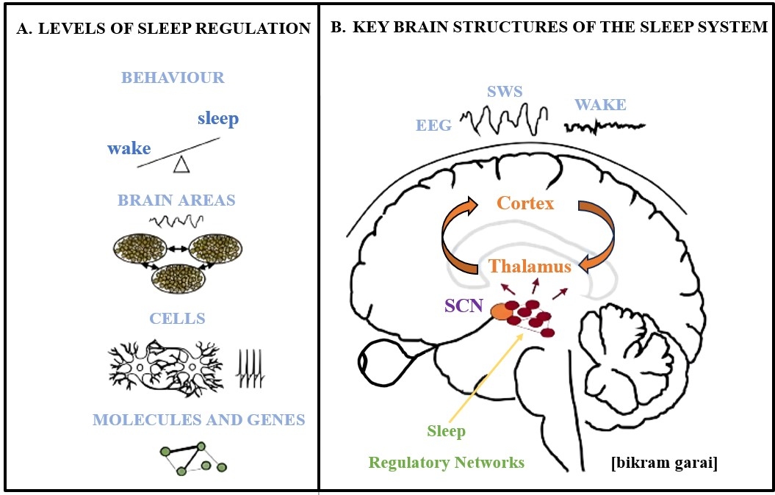
2.2.5. According to Andrea Zaccaro, André Riehl, in 2021 investigates the effects of Yoga Nidra on consciousness using an integrated approach that combines phenomenological and neurophysiological aspects. Here's a summary and analysis of the key findings and implications of this study. The study aimed to understand the altered states of consciousness induced by Yoga Nidra. Six healthy volunteers four females and two males with long-term Yoga Nidra practice participated in the study. The sessions included a 10-minute baseline resting state and a subsequent 2-hour group Yoga Nidra session. High-density EEG recordings were used to assess neurophysiological changes during yoga nidra. Phenomenological aspects were assessed through various subjective reports and questionnaires. Participants reported an altered state of consciousness during Yoga Nidra, characterized by dissociative effects, altered body perception, and increased perceived meaningfulness of the experience. This suggests that Yoga Nidra is effective in inducing a distinct state of consciousness. EEG recordings revealed specific patterns during Yoga Nidra sessions. An initial increase in alpha and beta power, followed by a progressive reduction. An early increase in theta power, with subsequent reduction. An increase in gamma power in the later stages of Yoga Nidra. Participants experienced increased dissociative effects during Yoga Nidra. This suggests that individuals may temporarily detach from their ordinary sense of self during the practice. Participants experienced increased dissociative effects during Yoga Nidra. This suggests that individuals may temporarily detach from their ordinary sense of self during the practice. Yoga Nidra was associated with reduced rational thinking and diminished volitional control of thoughts, indicating a shift towards a less analytical and more experiential state of mind. The study had a small sample size, which may limit the generalizability of the findings. EEG analysis was performed on one subject due to artifacts in other recordings, and this limits the ability to draw robust conclusions from the neurophysiological data as shown in the image-1and 2. ^{[6]}

Images-1: A. Levels of Sleep Regulation. B. Key Brain Structures of the Sleep System.
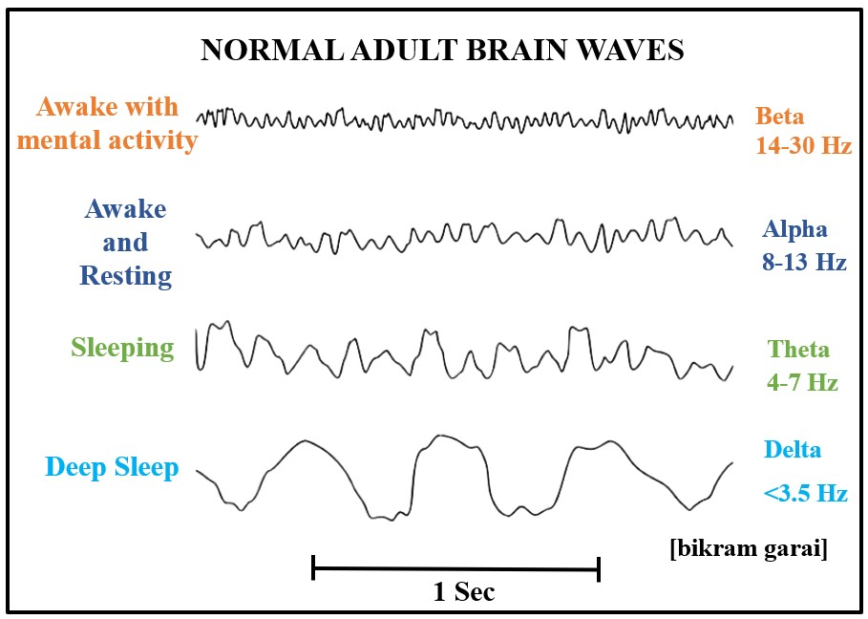

Images-2: Normal Adult Brain Waves.
CHAPTER-3
3. METHODOLOGY
3.1. Aim: In this yoga treatment, we have aimed to bring sound sleep as a basic of lifestyle and also make them focused and attentive.
3.2. Objective: By comparing FFMQ (Five Facet Mindfulness Questionnaire) before and after the yoga nidra and comparing TMT (Trial making Test) score before and after the yoga nidra.
3.3. Hypothesis:
    - Positive Hypothesis (H_{p}): Efficacy of Yoga Nidra for Mindfulness and Attention Index of Students may be successful.
    - Null Hypothesis (H₀): FFMQ & TMT may or may not be changed with yoga nidra.
    - Negative Hypothesis (H_{n}): FFMQ & TMT not be successful.
3.4. Study Design: Pre and Post Data.
3.5. Sampling Methods: Convenient Sampling. Total number of students 20. Place is offline testing and online training of B.Sc. yoga students in Visva Bharati. Students were willing and given consent randomly from 1st semester to 6th semester. Criteria were checked before obtaining the parameters as observational study. After 10 days of successful training, the matched student’s data alone was considered for further analysis.

3.6. Inclusion criteria:
- Gender: 55% male and 45 % female.
- Age: 18 to 22 years.

3.7. Exclusion criteria:
- Experience: More than undergraduate level.
3.8. Parameter:
3.8.1. General Parameters:
- Body weight
- Body height
- BMI
- Pulse Rate
- Respiratory Rate
- Blood Pressure.
- SpO₂
3.8.2. Specific Parameters:
- FFMQ
- TMT

3.9. FFMQ (Five Facet Mindfulness Questionnaire)
The FFMQ was created by Ruth A. Baer in 2006. The analysis has identified five factors that seem to encompass elements of mindfulness as it is presently understood. The five angles are observing, describing, acting with mindfulness, non-judging of inner experience, and non-reactivity to inner experience. ^{[7]}
3.10. TMT (Trail Making Test)
In 1963, an American cardiologist named Robert A. Bruce developed a test that can yield insights into visual search speed, scanning abilities, processing speed, mental flexibility, and executive functioning. This test is particularly adept at identifying cognitive impairment linked to conditions such as Alzheimer's disease, highlighting its sensitivity in this regard. ^{[8]}
3.12. Data collection:
3.12.1. Time of data collection
Pre data was taken for ten days. Every morning at 7.00am. A sample data collection was given in Annexure-12.4.
3.12.2. FFMQ (Five Facet Mindfulness Questionnaire)
Results Correspond of a total average score and five subscale. Average scores are calculated by summing the responses and dividing by the number of items, and indicate the average level of agreement with each subscale (1 = rarely true, 5 = always true).
3.12.3. TMT (Trail Making Test)
The Trails Making Test (Trails) is a neuropsychological assessment that measures visual attention and the ability to switch between tasks. It can furnish data regarding visual search speed, scanning capabilities, processing speed, mental flexibility, and executive functioning.
Step 1: Give the participant a copy of the TMT Part A & B worksheet and a pen or pencil.
Step 2: Demonstrate the test to the participant using the sample worksheet (TMT Part A & B sample).
Step 3: Time the patient they follow the “trail” made by the numbers on the test.
4: Record the time.

3.13. Lesson Planning of Yoga Nidra:
Guided Yoga Nidra
1. supine position on your back for the practice of yoga nidra. Bring your feet as wide as your mat.
2. ""I will stay alert during the yoga nidra session." Tell yourself, "I will not into sleep."
3. Focus your attention on your physical body and become conscious of its presence.
4. Feel your body get very heavy below are the stages of Yoga Nidra and how they affect us.
Stage 1: Initial Relaxation.
Stage 2: Intention, Sankalpa.
Stage 3: Body Rotation or Rotation of Consciousness.
Stage 4: Breath and Energy Awareness.
Stage 5: Sense Perception.
Stage 6: Visualization.
Stage 7: Samkalpa.

CHAPTER-4

- RESULTS
The data of 45 students was entered into excel sheet. After matching the availability of pre & post data, the total of 20 student’s data was considered for analysis. The data is tabulated and made into graphs for better understanding by using mean values. Percentage change also given in tables for more understanding. Tables are shown in three major divisions. Table-4.1: Demographic data, Table-4.2: General parameters, Table-4.3: Specific parameters. General parameters are sub-divided into three-parts. Table-4.2.1: Physical body, Table-4.2.2: Respiratory, Table-4.2.3: Cardio-Vascular. Specific parameters are shown in two separate divisions. Table-4.3.1: Five Facet Mindfulness Questionnaire (FFMQ) and Table-4.3.2: Trail Making Test A & B (TMT A & B) Graphs shown after every table. Abbreviations are given below every table and graph. The p-values were drawn from online SPSS software using t-test like, independent & paired t-test.
After noticing the results, the positive hypothesis was proved and failed in null hypothesis (Ho) and negative hypothesis (Hn).

4.1. Demographic data
No. | Demographic Data | Details
1. | Age Group | 18-22
2. | Sample size (n) | 20
3. | Male & Female | 11 & 9
4. | Education | Yoga Graduation Course
5. | B.Sc. Students | 20
Table-4.1: Demographic data

Abbreviations: Male, Female, Age Group, B.Sc. Students, Education.

4.2. General parameters: Physical body, Respiratory, Cardio-Vascular

Table- 4.2.1 Physical body Parameters
S. No | Parameter | (Mean ± SD)
1. | Weight | 52.45±5.58
2. | Height | 164.3±4.70
3. | BMI | 19.685±2.22

Abbreviations: Weight, Height, BMI- Body Mass Index, SD- Standard Deviation.

Table- 4.2.2: Respiratory Parameters
S. No | Parameter | Pre  (Mean ± SD) | Post  (Mean ± SD) | %  Change
1. | RR | 13.95±3.23 | 15.2±4.02 | 8.22
2. | PEFR | 405±129.06 | 431.5±139.29 | 6.14

Abbreviations: RR-Respiratory Rate, PEFR-Peak Expiratory Flow Rate, SD- Standard Deviation.

Table- 4.2.3 Cardio-Vascular Parameters
S. No | Parameter | Pre  (Mean ± SD) | Post  (Mean ± SD) | %  Change
1. | SBP | 112.65 ±10.24 | 114.25±4.85 | 1.40
2. | DBP | 75.95±7.74 | 75.5±7.50 | -0.59
3. | PR | 81.15±3.09 | 78.7±3.75 | -3.11
4. | SpO₂ | 97.05±1.31 | 97.6±1.31 | 0.56

Abbreviations: SBP – Systolic Blood Pressure, DBP- Diastolic Blood Pressure, PR- Pulse Rate, SpO₂- Saturation of Peripheral Oxygen, SD- Standard Deviation.

4.3. Specific Parameter- Five Facet Mindfulness Questionnaire (FFMQ) and Trail Making Test A & B (TMT A & B)
Table- 4.3.1: Five Facet Mindfulness Questionnaire (FFMQ)
Specific Parameter | Pre  (Mean ± SD) | Post  (Mean ± SD) | %  Change
Observing | 29.5±2.70 | 31.1±3.14 | 5.14
Describing | 24.6± 3.73 | 26.2± 3.47 | 6.10
Acting with Awareness | 27± 3.30 | 28.15± 2.68 | 4.08
Nonjudging | 25±3.17 | 26.3±3.43 | 4.94
Nonreactivity | 21.8±2.46 | 23.85±2.49 | 8.59

Abbreviations: FFMQ- Five Facet Mindfulness Questionnaire, SD- Standard Deviation,
**- p-value is highly significant.

OBSERVING

NONREACTIVITY

NONJUDGING

DESCRIBING

ACTING WITH AWARENESS

Table- 4.3.2: Trail Making Test A & B
Specific Parameter | Pre  (Mean ± SD) | Post  (Mean ± SD) | %  Change
TMT A | 26.78±5.11 | 21.48±4.51 | -24.65
TMT B | 43.24±11.04 | 34.77±10.25 | -24.36

Abbreviations: TMT A & B- Trail Making Test A & B, SD- Standard Deviation, **- p-value is highly significant.

CHAPTER-5
- DISCUSSION
After ten days of practicing yoga nidra, all participants showed improvement in both pre and post phases.
After dividing the sample into two groups, one with equal or more than 2 years of experience, the following changes were observed. Specifically, there were improvements in the FFMQ parameters: Observing by 1.6, Describing by 1.6, Acting with Awareness by 1.15, Nonjudging by 1.3, and Nonreactivity by 2.05. Additionally, TMT A decreased by 5.3 and TMT B by 8.47. These results, observed over a 10-day training and testing period, support the positive shifts in general parameters. For a more comprehensive understanding, we discuss these findings in terms of improvements, neutral outcomes, and adverse changes.
5.1. Positive effects with Yoga Nidra

Present study findings indicate a measurable improvement across all five dimensions of the Five Facet Mindfulness Questionnaire (FFMQ). Each of these facets captures a different element of mindfulness, and an improvement in scores participants. Observing 29.5 to 31.1 (5.14%) as shown in Table 4.3.1. and Graph 4.3.1. Observing refers to noticing or attending to internal and external experiences, such as sensations, thoughts, or emotions. Describing 24.6 to 26.2 (6.10%) as shown in Table 4.3.1. and Graph 4.3.1. This facet concerns the ability to label internal experiences with words. An increase in the describing score indicates that participants might have improved in articulating their feelings and thoughts, which is an essential skill in understanding and managing emotions. Acting with Awareness 27 to 28.15 (4.08%) as shown in Table 4.3.1. and Graph 4.3.1. Acting with awareness is about focusing on the present activity instead of behaving automatically. Non-Judging 25 to 26.3 (4.94%) as shown in Table 4.3.1. and Graph 4.3.1. This facet relates to taking a non-evaluative stance toward thoughts and feelings. Non-Reactivity 21.8 to 23.85 (9.09%) as shown in Table 4.3.1. and Graph 4.3.1. Non-reactivity pertains to allowing thoughts and feelings to come and go, without getting caught up in them. Previous study when compared to scores according to Virginia Lemay aim of assessing the effects of a six-week yoga and meditation program on stress perception, anxiety levels, and mindfulness. the study indicated significant positive changes in the participants' well-being. Specifically, students reported decreased anxiety and stress levels, while their overall mindfulness scores significantly improved. More specifically, the scores on the FFMQ showed notable improvements, "observing" increased 4.6 points, "Describing" increased 1.6 points, "awareness and Nonreactivity increased 3.9 points. "Nonjudging increased 6.8 points. ^{[9]}

TMT-A score improved from 26.78 to 21.48 (-24.65%) as shown in Table 4.3.2. and Graph 4.3.2. shows the perception of numerical information and TMT-B score improved from 43.24 to 34.77 (-24.36%) as shown in Table 4.3.2. and Graph 4.3.2. shows the perception of alphabetical information. The similar study by Satish P. et al.J Yoga . may-aug 2019 shown 4.8% improvement that was less than the present study. ^{[10]}

In the previous study conducted by Sabine K S Illi in 2012, it was observed that there might be an improvement in respiratory muscle endurance among individuals who are less physically fit as well as those engaged in long-duration sports activities. present study, you've found an increase in respiratory rate from 13.95 to 15.2 (8.22%) as shown in Table 4.2.2. and Graph 4.2.3. immediately after practicing yoga nidra. This increase in respiratory rate is likely aimed at providing sufficient oxygen in response to the training's time and intensity. present study suggests that yoga nidra can help establish a vital balance in university students who practice it. Consequently, yoga nidra could potentially serve as an effective warm-up routine for university-level individuals and those who are less physically fit before engaging in general physical activities. ^{[11]}

In the previous study conducted by Jenna B. Gillen in 2016, it was observed that peak oxygen uptake improved by 19% after 12 weeks of spring training. Sprinting engages the entire body and involves factors like body area, weight, and gravitational force, which lead to increased oxygen consumption and subsequently an improvement in Peak Expiratory Flow Rate (PEFR). Present study, you found an increase in PEFR, from 405 to 431.5 (6.14%). as shown in Table 4.2.2. and Graph 4.2.2. This study suggests that when yoga nidra is incorporated into such intense training, the demand for oxygen or oxygen uptake increases significantly and rapidly, which, in turn, leads to an initiation of rapid breathing. ^{[12]}

According to K Anjana, eighty hypertensive patients were enlisted and divided equally into an experimental group and a control group. After the two-month period, the experimental group displayed a notable reduction in blood pressure (BP) and lipid levels compared to the control group, with the results being statistically significant (p < 0.05). Furthermore, the decline in systolic and diastolic BP and LDL levels in the experimental group was even more pronounced, achieving a higher level of statistical significance (p < 0.001). This concept aligns with the findings observed in the current study, where the mean systolic blood pressure (SBP) improved from 112.65 to 114.25 (1.40%) as shown in Table 4.2.3. and Graph 4.2.3. Additionally, the mean diastolic blood pressure (DBP) decreased from 75.95 to 75.5 (-0.59%) as indicated in Table 4.2.3. a and Graph 4.2.3. ^{[13]}

Present study, you've observed an improvement in the mean value of Peripheral Oxygen Saturation (SpO2) from 97.05 to 97.6 (0.56%) as shown in Table-4.2.3. and Graph-4.2.3. Previous study by T Field in 2011, oxygen saturation decreased by 19% during a meditation session characterized by rest and stimulation. These findings provide insights into the aerobic capacity before engaging in further yoga nidra practices. Moreover, understanding potential hypoxic changes in the brain, which can manifest as dizziness, is crucial. To address these changes, it might be more appropriate to practice Shavasana rather than a typical asana session. Thus, the current study offers valuable information for tailoring yoga nidra practices in a more immediate and informed manner. ^{[13]}

Present study, you have observed an improvement in the mean value of Pulse Rate (PR), which decreased from 81.15 to 78.7 (3.11%) as shown in Table-4.2.3. and Graph-4.2.3. This decrease in pulse rate suggests a positive effect of the intervention, possibly related to baroreceptor activation. Baroreceptors, which are sensitive to changes in central volume, are known to play a crucial role in regulating the cardiovascular system. Their activation during alterations in central blood volume can induce reflex changes in peripheral sympathetic nerve activity. These reflex responses contribute to orthostatic adjustments, helping the body maintain blood pressure and heart rate when transitioning from different positions, such as lying down to standing up. This regulation of sodium and water reabsorption also plays a role in controlling blood volume, as demonstrated in a study by Seravalle G in 2019. ^{[14]}

5.2. Neutral effects of Yoga Nidra
All the parameters shown changes in the present study. This counters the null hypothesis (Ho).
5.3. Adverse effects of Yoga Nidra

Yoga Nidra is a relaxation and meditation technique that is generally considered safe and has many potential benefits for mental and physical well-being. However, like any practice, there can be some adverse effects, although they are relatively rare. Here are some potential adverse effects of Yoga Nidra.

- CONCLUSION
Through this study it has been found that there has been improvement in wields a significant influence on mindfulness and attention after giving the 10 days of Yoga Nidra practice. Through its systematic approach, it enables individuals to explore the depths of their consciousness and develop a heightened sense of self-awareness. By leading practitioners through a journey of Observing, Describing, Acting with Awareness, Nonjudging and Nonreactivity, Yoga Nidra nurtures a state of heightened mindfulness that extends into everyday life. Furthermore, the practice encourages the cultivation of sustained attention, as it trains the mind to remain alert and engaged even in states of profound relaxation.
- LIMITATIONS

- Sampling is from known institution and could not access control group. from other institutions.

- STRENGTHS
- There is a relatively limited amount of research specifically examining the effects of Yoga Nidra on undergraduates.
- This is the best way to have internal journey or inward practice.
- Regular practice of Yoga Nidra can heighten mindfulness, which is the conscious awareness of the present moment without judgment.

- ACKNOWLEDGEMENT
Specially thanking to Somnath Sah, Swapnadeep Majumder, Pritilata Saha, for helping me to collect data.
I would like to thank Santanu dada Xerox Shop he did a good quality print.

- REFERENCE
- Prakash R. S. (2021). Mindfulness Meditation: Impact on Attentional Control and Emotion Dysregulation. Archives of clinical neuropsychology: the official journal of the National Academy of Neuropsychologists, 36(7), 1283–1290. https://doi.org/10.1093/arclin/acab053

- Cotter, E. W., & Kelly, N. R. (2018). Stress-related eating, mindfulness, and obesity. Health psychology: official journal of the Division of Health Psychology, American Psychological Association, 37(6), 516–525. https://doi.org/10.1037/hea0000614

- Amaravathi, E., Ramarao, N. H., et. al. (2018). Yoga-Based Postoperative Cardiac Rehabilitation Program for Improving Quality of Life and Stress Levels: Fifth-Year Follow-up through a Randomized Controlled Trial. International journal of yoga, 11(1), 44–52. https://doi.org/10.4103/ijoy.IJOY_57_16

- Lemay, V., Hoolahan, J., et. al. (2019). Impact of a Yoga and Meditation Intervention on Students' Stress and Anxiety Levels. American journal of pharmaceutical education, 83(5), 7001. https://doi.org/10.5688/ajpe7001

- Vhavle, S. P., Rao, R. M., et. al. (2019). Comparison of Yoga versus Physical Exercise on Executive Function, Attention, and Working Memory in Adolescent Schoolchildren: A Randomized Controlled Trial. International journal of yoga, 12(2), 172–173. https://doi.org/10.4103/ijoy.IJOY_61_18

- Zaccaro, A., Riehl, A., et. al. (2021). The Consciousness State of Traditional Nidrâ Yoga/Modern Yoga Nidra: Phenomenological Characterization and Preliminary Insights from an EEG Study. International journal of yoga therapy, 31(1), Article_14. https://doi.org/10.17761/2021-D-20-00014

- Gu, J., Strauss, C., Crane, C., Barnhofer, T., Karl, A., Cavanagh, K., & Kuyken, W. (2016). Examining the factor structure of the 39-item and 15-item versions of the Five Facet Mindfulness Questionnaire before and after mindfulness-based cognitive therapy for people with recurrent depression. Psychological assessment, 28(7), 791–802. https://doi.org/10.1037/pas0000263

- Bhatia, T., Shriharsh, V., Adlakha, S., Bisht, V., Garg, K., & Deshpande, S. N. (2007). The trail making test in India. Indian journal of psychiatry, 49(2), 113–116. https://doi.org/10.4103/0019-5545.33258

- Lemay, V., Hoolahan, J., & Buchanan, A. (2019). Impact of a Yoga and Meditation Intervention on Students' Stress and Anxiety Levels. American journal of pharmaceutical education, 83(5), 7001. https://doi.org/10.5688/ajpe7001

- Illi, S. K., Held, et. al. (2012). Effect of respiratory muscle training on exercise performance in healthy individuals: a systematic review and meta-analysis. Sports medicine (Auckland, N.Z.), 42(8), 707–724. https://doi.org/10.1007/BF03262290

- Gillen, J. B., Martin, B. J et. al. (2016). Twelve Weeks of Sprint Interval Training Improves Indices of Cardiometabolic Health Similar to Traditional Endurance Training despite a Five-Fold Lower Exercise Volume and Time Commitment. PloS one, 11(4), e0154075. https://doi.org/10.1371/journal.pone.0154075

- Anjana, K., Archana, R., & Mukkadan, J. K. (2022). Effect of om chanting and yoga nidra on blood pressure and lipid profile in hypertension - A randomized controlled trial. Journal of Ayurveda and integrative medicine, 13(4), 100657. https://doi.org/10.1016/j.jaim.2022.100657

- Field T. (2011). Yoga clinical research review. Complementary therapies in clinical practice, 17(1), 1–8. https://doi.org/10.1016/j.ctcp.2010.09.007

- Seravalle, G., Dell'Oro, et. al. (2019). Baroreflex activation therapy systems: current status and future prospects. Expert review of medical devices, 16(12), 1025–1033. https://doi.org/10.1080/17434440.2019.1697230

- BEBLOGRAPHY

- Saraswati Satyananda S, (2013), Yoga Nidra, Edition-(16), Yoga Publication Trust, Munger, Bihar, India, ISBN: 978-81-85787-12-1, Page no.71.

- Saraswati Satyananda S, (2013), Four Chapter on Freedom, Edition-(2), Yoga Publication Trust, Munger, Bihar, India, ISBN: 978-81-85787-18-2.

- Kolb, B., & Whishaw, I. Q. (2014). "Fundamentals of Human Neuropsychology." Worth Publishers. ISBN-13: 978-1429282956.

- Bear, M. F., Connors, B. W., & Paradiso, M. A. (2016). "Neuroscience: Exploring the Brain." Wolters Kluwer. ISBN-13: 978-1451109542.

- Kandel, E. R., Schwartz, J. H., & Jessell, T. M. (2012). "Principles of Neural Science." McGraw-Hill Education. ISBN-13: 978-0071390118.

- Standring S, (2016), Gray’s Anatomy the Anatomical Basis of Clinical Practice, Edition-(41), Elsevier, ISBN: 978-0-7020-5230-9.

- Debroy B, (2019), The Markandeya Purana, Edition (4), Penguin Random House India Private Limited, ISBN: 978935305671.

- Nikhilananda S, (2006), Mandukya Upanishad, Edition (6), Advaita Ashrama, ISBN: ‎ 8175050225

- Srinivasayogi, (2009), Hatharatnavali, Edition-(2), The Lonavla Yoga Institute (India), ISBN: 81-901176-96.

- Muktibodhananda S, (2006), Hatha Yoga Pradipika, Edition-(4), Yoga Publication Trust, Munger, Bihar, India, ISBN: 978-81-85787-38-1.

- ANNEXURES

Annexure-12.1: Five Facet Mindfulness Questionnaire (FFMQ)

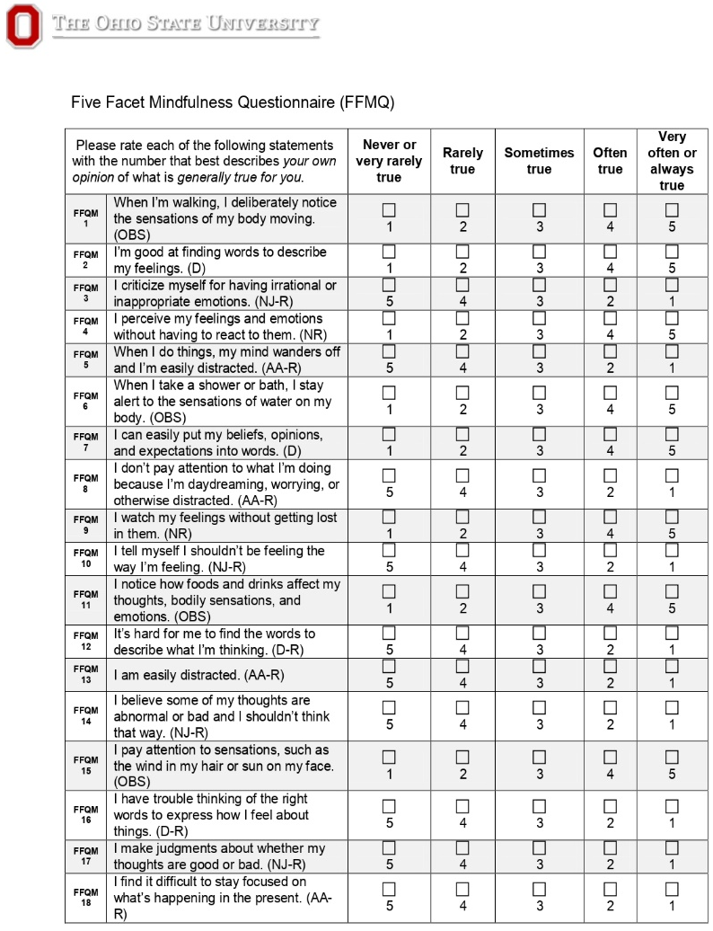
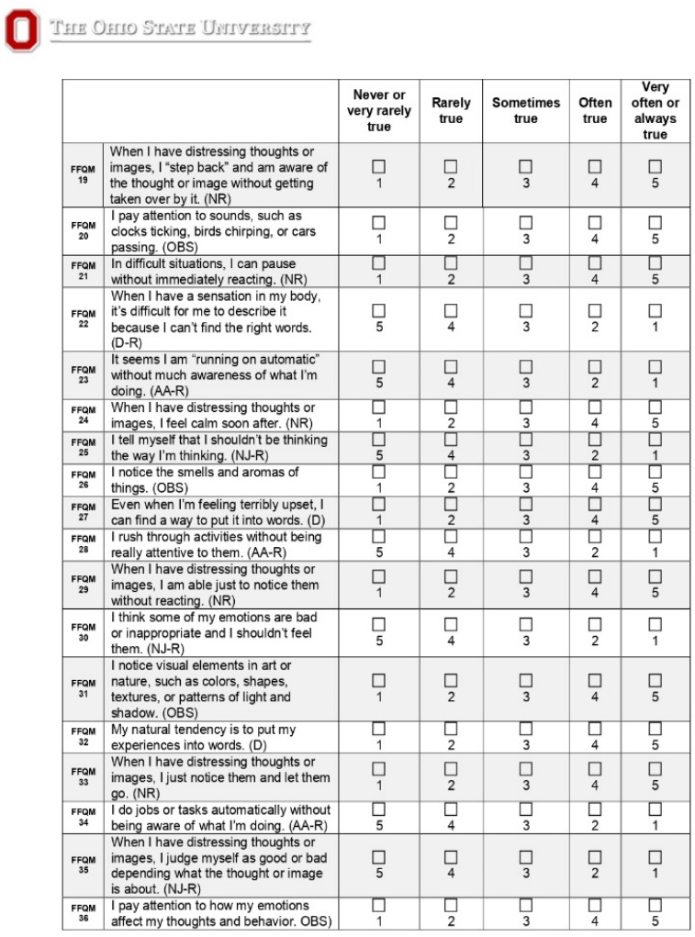

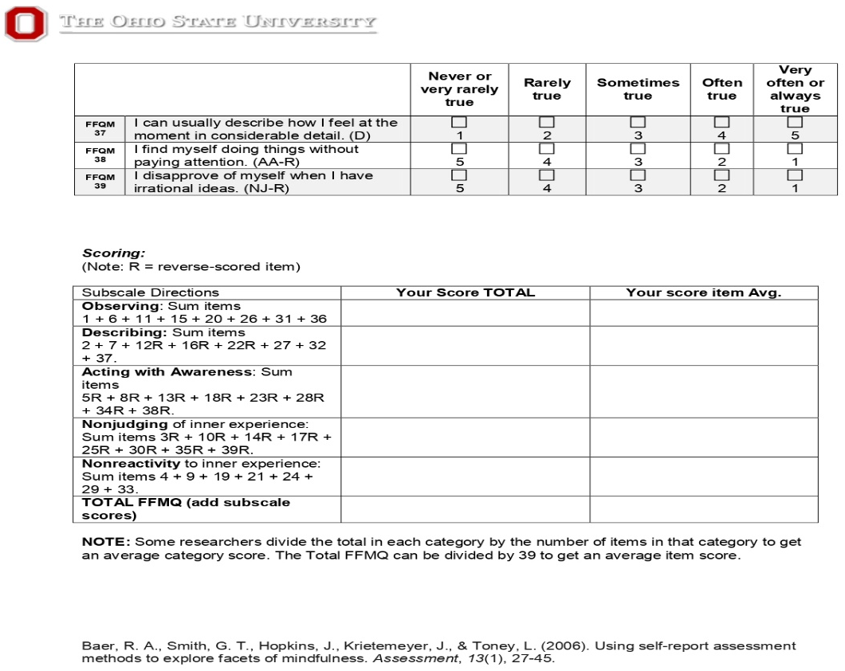

Annexure-12.2: Trail Making Test A & B (TMT A & B)
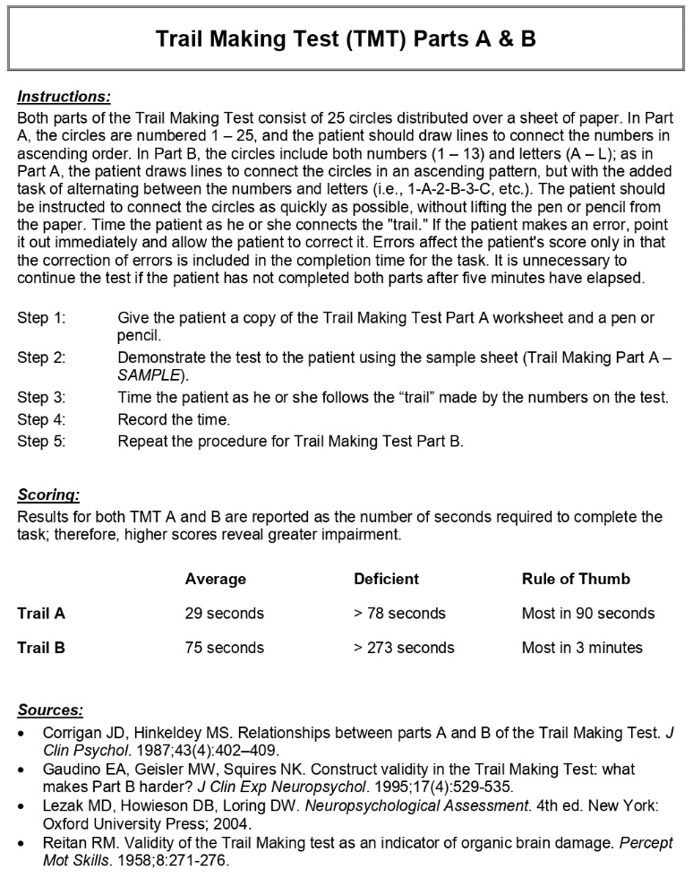
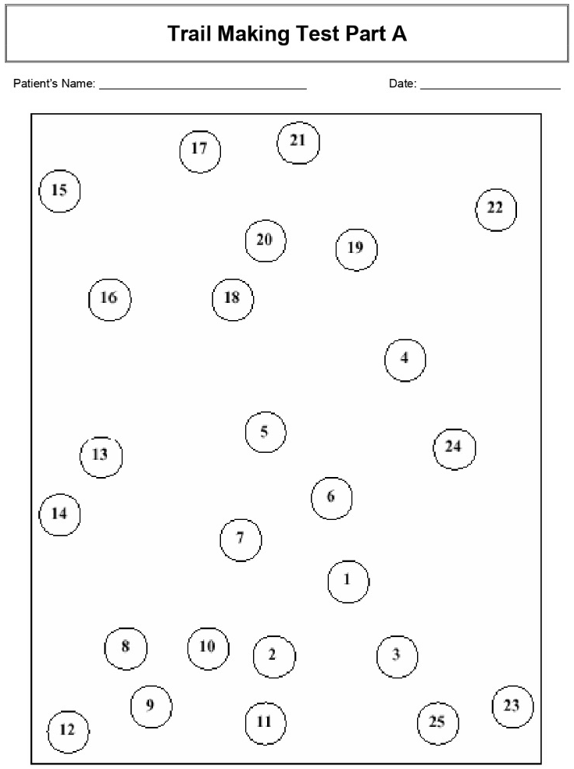

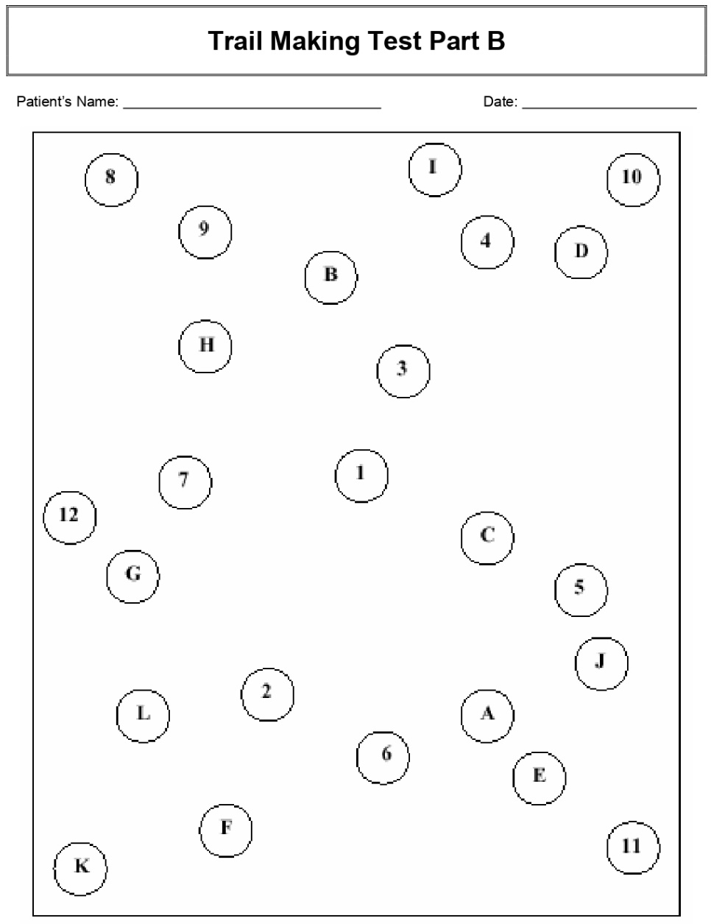

Annexure-12.3: Sample Five Facet Mindfulness Questionnaire and Trail Making Test A & B

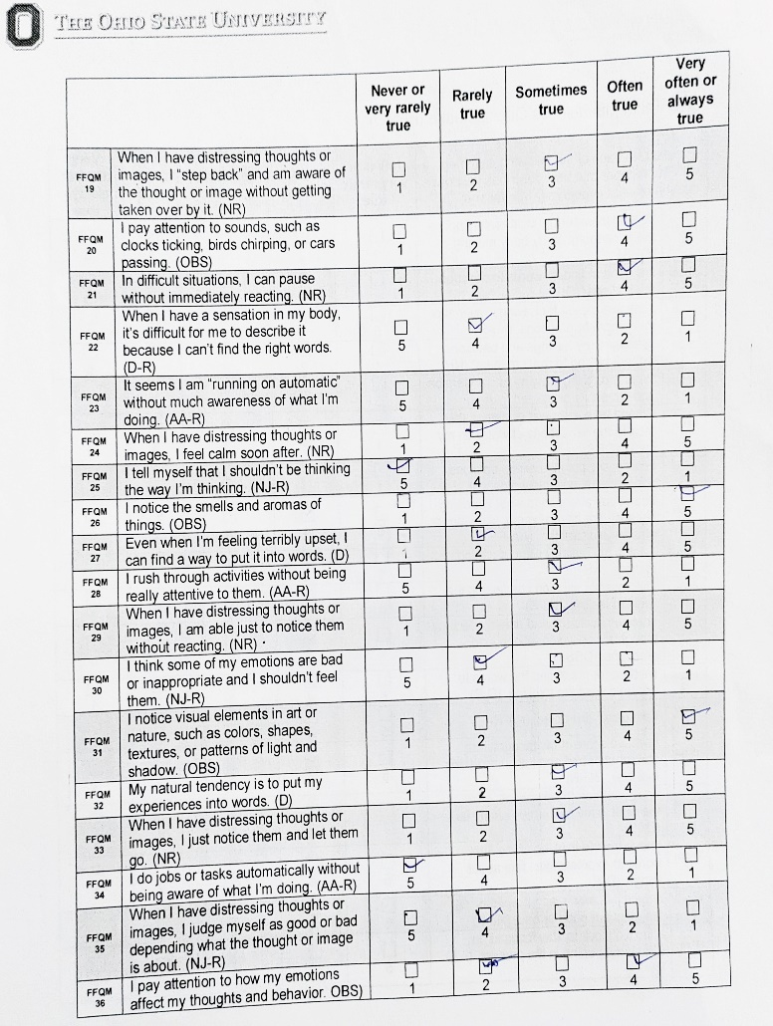
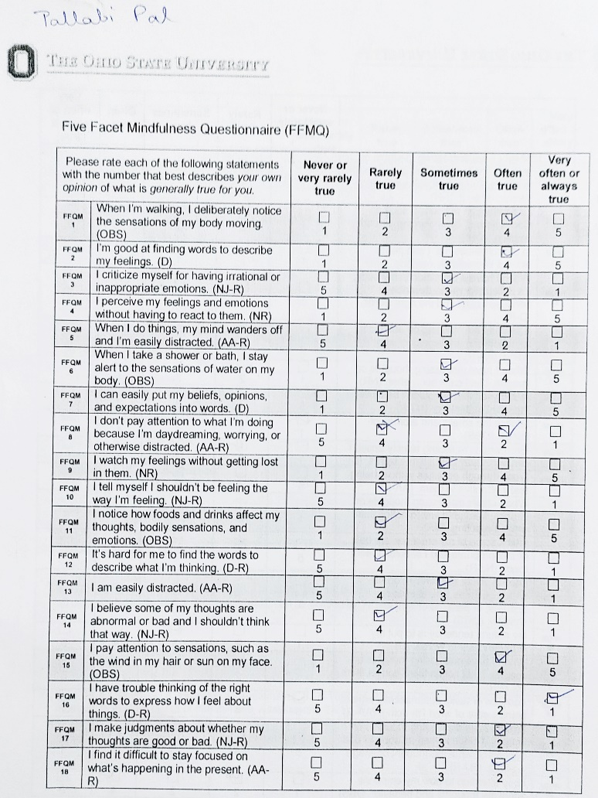

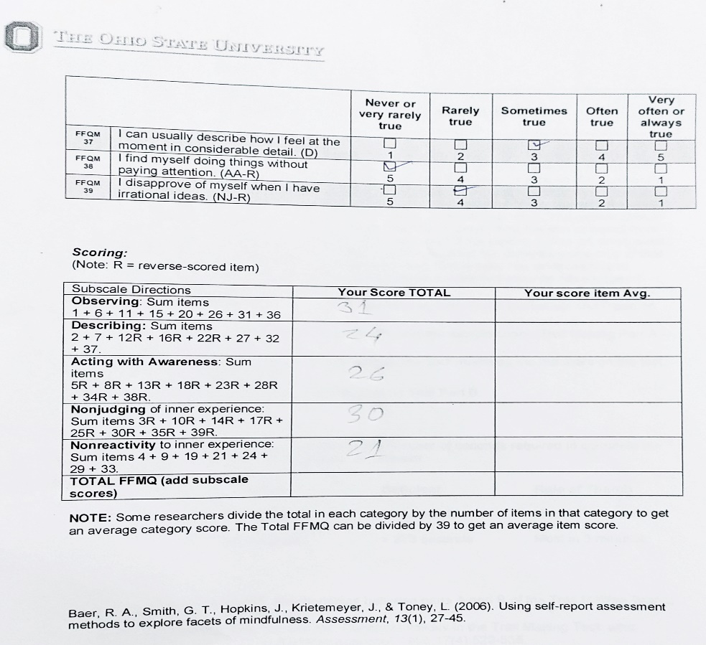

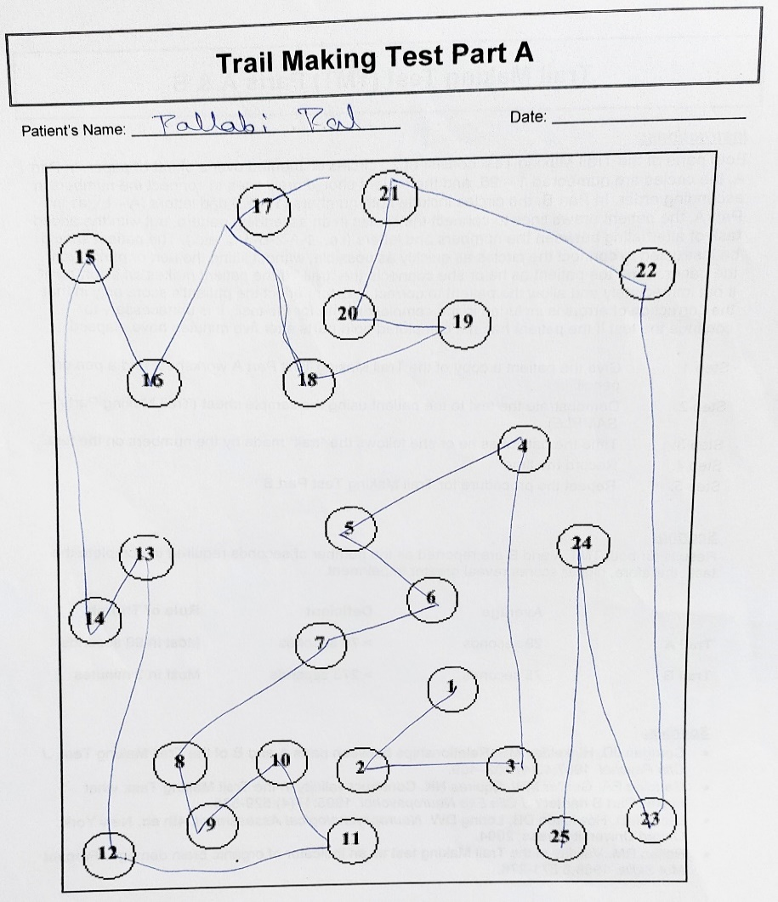

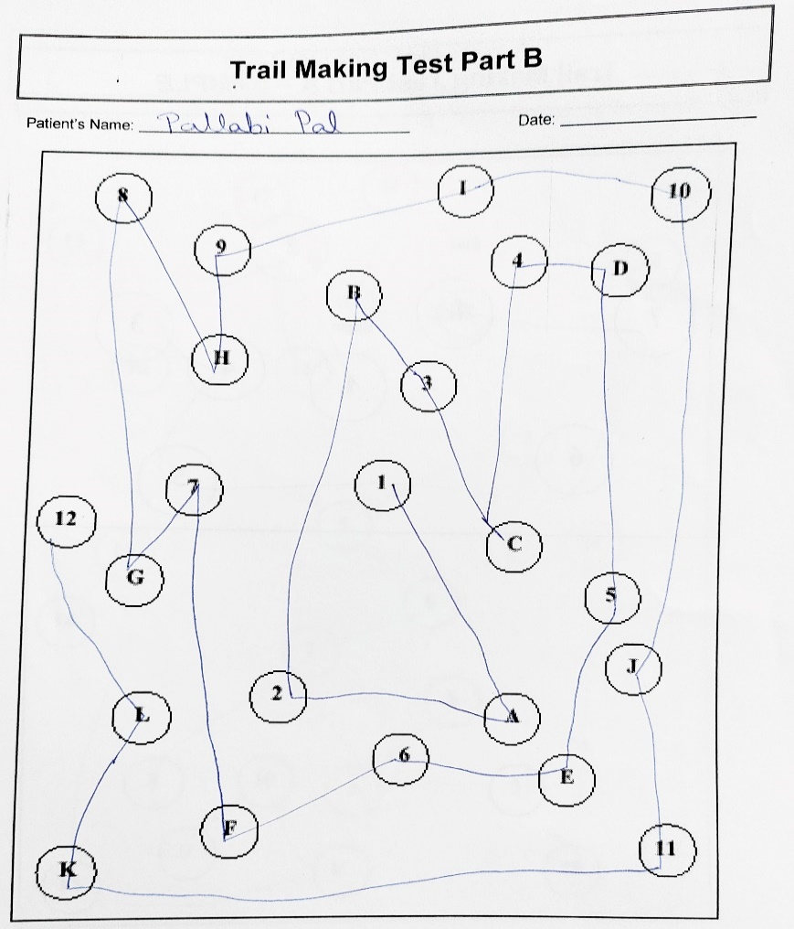

Annexure-12.4: Sample Data collection form

