A SMART WASTE MANAGEMENT SYSTEM FOR MONITORING, COLLECTION, AND PROPER DISPOSAL
Shazia Akhtar and Suman Naithani
Department of Environmental Science
Graphic era deemed to be University, Dehradun

Abstract
The ability of smart cities to deal with environmental issues in general, and trash management in particular, is an important topic that requires scientific investigation. Any unpleasant, harmful, or wasteful substance produced by daily human activities and municipal events is considered solid waste. Solid waste management is the approach for managing solid waste creation, storage, collection, transport, treatment, and disposal. Solid waste management is characterized based on the availability of economic capital and the degree of industrialization progress.
This article proposes and explains a smart solid waste monitoring and collection system. The system consists of smart containers, also known as smart bins, each with an Arduino Uno, ultrasonic sensor, and Radio Frequency (RF) transmitter set on top. When a container is full of garbage, it sends a signal to the control center, which contains information about the quantity of waste in the containers, and a message (SMS) is sent to the truck driver's mobile phone, indicating which trash bin is full and has to be empty. Finally, an efficient system and waste disposal strategy are shown that might be used in the future to increase performance and cost-effectiveness.
Keywords: SolidWaste Management, Sustainable and Smart Cities, Environment, smart bins.

Introduction
The rapid growth of industrialisation and human population has resulted in increased amounts of rubbish generation in metropolitan areas. To conserve the environment, the number of garbage cans should be raised and strategically positioned for real-time monitoring and pickup. Without adequate trash collection and disposal, rubbish containers would be overfilled and spill out into the surrounding area, causing health hazards for humans and the environment (Akhil 2017). In city life one of the most important components is Municipal Solid Waste (MSW) . Annual solid waste creation is expected to exceed 1.3 billion tons, with a projected increase to 4.3 billion tons by 2025, when 50% of the world population would be present (Hoornweg and Bada, 2012). Due to the massive amount of solid waste created by residential and commercial-industrial regions, coordinating garbage collection is one of the most difficult jobs in the rural environment. Furthermore, garbage collection accounts for 50-70% of total solid waste management costs. Because of the enormous amount spent on collecting, there is only a little amount accessible for collection enhancement (Tchobanglas and Kreith ,2002). The waste management cycle begins with the production of rubbish from companies, homes, markets, and other sources, which is subsequently disposed of in garbage cans. Municipalities gather this trash and dispose of it in dumping zones and landfills. Some waste is not collected because to a lack of resources and an ineffective foundation, causing a significant health danger to the local environment. Cleaning at regular intervals may be able to solve this problem. Manually tracking the status of the bin, on the other hand, is a difficult operation (Singh et al,.2016). A smart garbage monitoring and collecting system is being created in order to save money and time on waste collection while simultaneously protecting the public environment,public health, and providing a safe living environment. Waste collection and monitoring employing cutting-edge technology such as Radio Frequency (RF), ultrasonic sensors, GSM/GPRS, and Arduino provide a fresh viewpoint on waste management system optimization.
Current status of India
According to the CPCB Report 2013, no Indian city achieves 100% waste segregation, with just 70% of total rubbish collected and segregated at housing complexes. The remaining 30% of uncollected garbage is dumped in the environment or mixed together with other garbage. The main issue is that only 12.45 percent of collected waste is treated scientifically, while the rest is thrown in open areas, as seen in Figure 1.
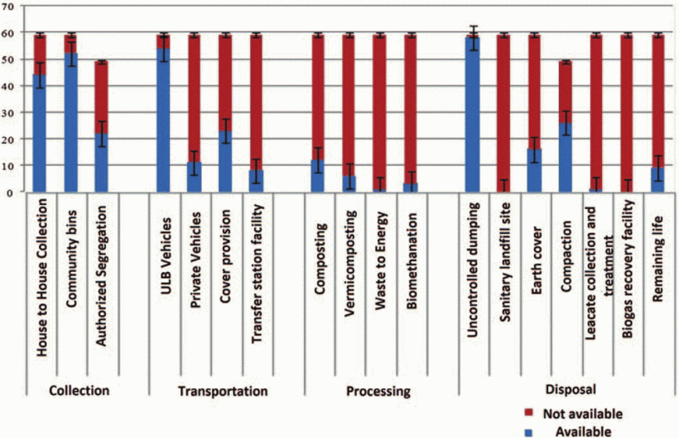
Figure :-1 Current waste management statistics of indian cities (Joshi et al., 2016).
India's waste generation
India is growing more urbanized while retaining its physical, climatic, geographic, ecological, social, cultural, and linguistic variety (Bhalla 2013). The population of India grew from 1028 million in 2001 to 1252 million in 2013. According to India's 2011 Census, growing MSW is mostly due to population growth. India's megacities are growing in size. The growth of megacities (ISWA) (International Solid Waste Association 2012) is a recent trend connected to economic, cultural, and technical globalization. Some of India's megacities include Ahmedabad (6.3 million), Hyderabad (7.7 million), Bangalore (8.4 million), Chennai (8.6 million), Kolkata (14.1 million), Delhi (16.3 million), and Greater Mumbai (18.4 million). From generation to final disposal, municipal solid waste management operations may be divided into six functional areas (Ashish et al., 2014).

Waste production
Waste storage
Gathering
Transportation
Sorting & Processing
Disposal
Waste segregation
Lopes and Machado introduced IoT for garbage sorting in 2019. Furthermore, at the family unit level, the framework examines the look of rubbish and categorizes it as dry, moist, or metallic waste. It also aids in the constant monitoring of trash levels in garbage cans. Furthermore, it employs GSM and Arduino to display the quantity of garbage in the trash cans on an LCD screen and send a message to clean up when it becomes full. Bharadwaj B et al. created a basic rubbish monitoring system to help the Swachh Bharat Abhiyan.The work's fundamental concept is to segregate rubbish of the same type and place it in a transit line with wet waste gathered containers on one side and dry waste gathered containers on the other. The information will be made available to the public. Using this technology, we can quickly validate the data and follow the vehicle. Glouche and Couderc (2013) created smart garbage management using self-describing items. The primary purpose of the framework is to consistently minimize and reuse waste. RFID technology is used to trace the arrival of each item. It also makes use of low-cost QR code technology.The collected data is used to divide rubbish into three categories: glass, plastic, and paper/cardboard. Throughout the recycling process, the information about the rubbish in each container is crucial. Singh et al. (2014) discuss the considerable increase in Municipal Solid Waste. Handpicking is a method of separating municipal solid waste. Its sole function is to separate bulk materials. Inorganic minerals are separated using trammel screens, whereas ferrous and nonferrous metals are separated using magnetic and electromechanical devices. Segregated waste is reduced by incineration to recover energy. Solid waste can be classified and separated into components suitable for thermal conversion.
Waste collection
The researchers want to identify problems with the waste collection process and provide methods to increase efficiency. The model is divided into three sections: a data collecting layer, a waste disposal approach, and trash disposal zones. The ultimate product is a comprehensive framework with Inputs, Outputs, Guides, and Enables. The data is stored on a cloud server managed by the local government (Lokuliyana et al.,2017). RFID, GPRS, GPS, and a camera are all part of the planned trash identification system. The device recognizes the RFID waste tag and sends data about the rubbish in the bin. The transmitted data is saved in a central monitoring station and utilized to regulate the waste disposal operation. The bin images are gathered with the use of MATLAB image processing tools and the MySQL data server (Islam et al., 2012). The developer created an IOT-based clean organization system that monitors waste levels above dustbins using Sensor structures. This system responded as soon as the GSM/GPRS concern was noticed. The result is subsequently shown in an Android application, where the user may obtain information on the location of the bin. As part of the improvement interaction, the model investigates factors such as fuel utilization, toxin releases, truck speed, and carried limit.
Waste collection using solar methods
Kabir et al.,2020 presented a smart waste system based on IOT and regulated by sunlight. There are five receptacles nearby that are wired to the Arduino Mega. The sun-oriented force provides each waste with controlled DC capability. When the canisters reach an abnormally high amount of waste, a warning is sent by both electronic and SMS alerts.
Waste collection using machine learning
Estrada Elsa.,2018 used machine learning to construct a smart city visualization tool. The author concentrated on three frameworks: smart tracking, which detects typical urban occurrences, smart citizen tools, which monitor people's everyday interactions, and smart visualization, which monitors the environment, energy, and transportation. Catania and Ventura (2014) created the Smart-M3 platform, which allows data to be exchanged between devices while remaining flexible. The clever framework depicted focuses on two structures: the first is aimed at governments and privately owned businesses in order to design an ideal asset management and waste collection arrangement; the second is aimed at residents in order to allow them to know the condition and location of the nearest canisters and encourage them to reuse.
Waste management using cloud
The method for controlling household waste was proposed by (Yusaf et al.,2017) The ultrasonic sensor detects the amount of rubbish in each canister and transmits the information to the Arduino Uno. Furthermore, several colored LEDs are integrated within the sensor platform of the bin to show the threshold level. The framework created is especially beneficial in enhancing local communities' competency in trash management. The author creates a revolutionary garbage sorting system using deep learning to encourage reuse and elimination. In the Darknet neural organizing system, the YOLOv3 computation was employed to produce a distinct set of data. YOLOv3 has difficulty distinguishing between things made of more than two materials according to Kumar and his colleagues (2002) shown in figure 2.
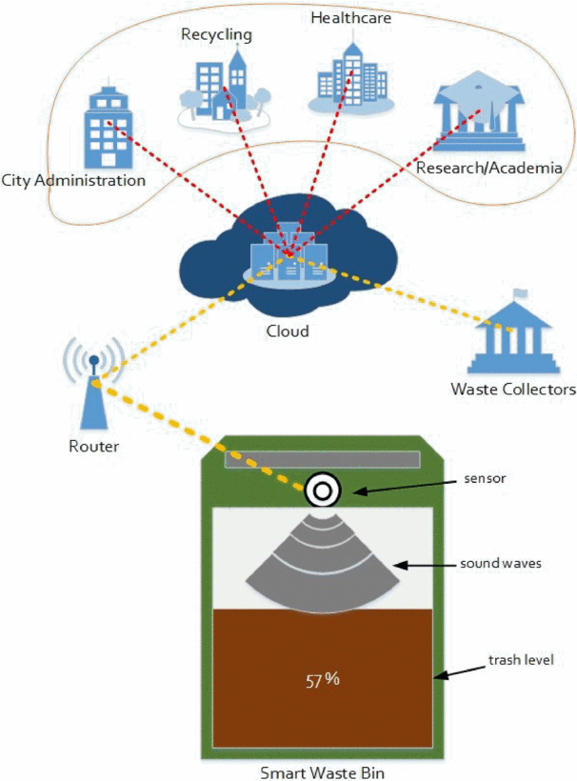
Figure: -2 Cloud-based smart waste management architecture (Aazam et al., 2016)

In the projected Cloud SWAM, sensors in each bin monitor the amount of rubbish in the container. Figure 3 depicts the smart bin, with (A), (B), and (C) indicating various bins for each waste category, namely organic, plastic/paper/bottle, and metal.
Each sort of rubbish is already segregated in this fashion, and the status displays how much waste is collected and what type of waste it is. This form of pre-separated rubbish is employed in places like Korea, to name a few, and it considerably assists waste management. In (D), an example of a warning message appears when the trash level exceeds a specified level at which garbage collectors must plan collection. While (E) shows that the bin is empty, the user and garbage collectors are kept up to date without having to reach for it or open it to verify the status.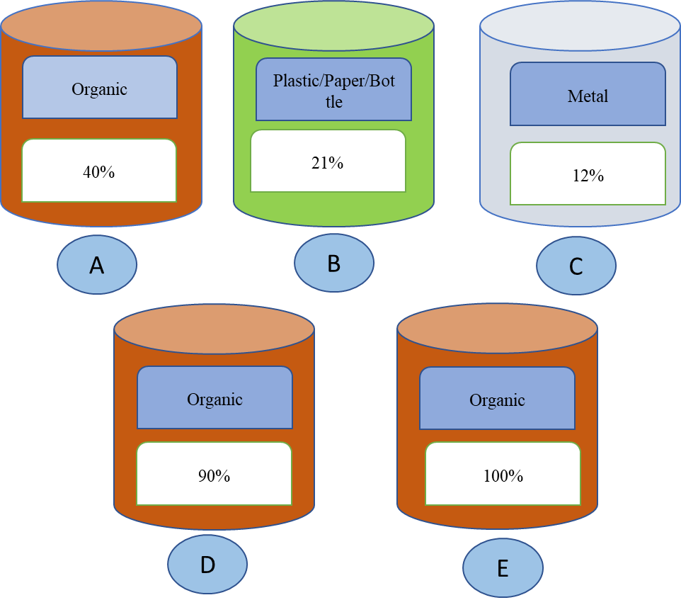Figure:-3 Smart bins for different waste categories, equipped with waste status notification.

Waste collection using Internet of Things (IoT)
Municipal governments and legislators are working hard to improve rubbish collection and disposal in cities. The bin is separated into three sub-canisters, each of which collects a distinct sort of rubbish. To recognize garbage in the bin, an infrared sensor is employed. A moisture and metal sensor is used to distinguish between wet and metal waste. Bins are located using GSM technology. The trash information obtained is transferred via the ESP8266 wife module. On the Thinkspeak server, the waste count is updated (Sowndharya and Savitha,2019) Chitluri Sai Srikanth et al. presented a smart waste management system-based rubbish collection solution based on IoT shown in Figure 4.As a result, we can maintain proper separation from the contaminants indicated by the trashcan, and waste stink is reduced (Jasmin et al.,2021). Waste management difficulties, according to the author, are increasingly deteriorating. Temperature and humidity sensors are used to distinguish between wet and dry waste. The junk data is processed using a Raspberry Pi microcontroller. The devices' master-slave design reduces connectivity problems in faraway locations (Elhassan et al.,2016).
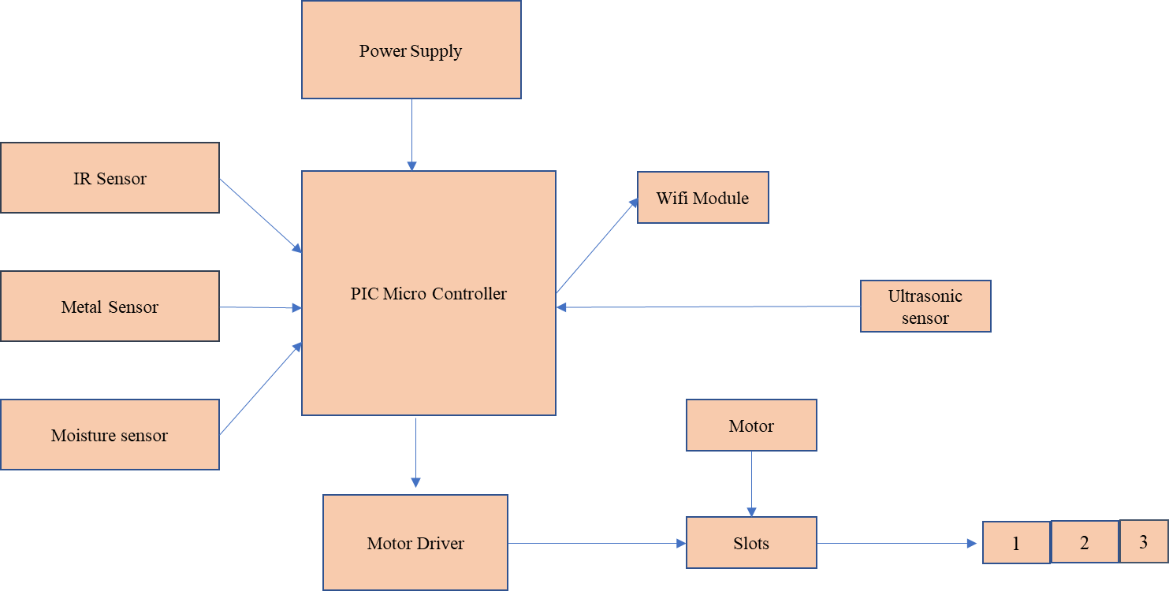

Figure: -4 Waste collection (source -Sowndharya,2019)

Waste monitoring
Navghane et al. (2016) guarantee that the trashcan will be cleaned as soon as the rubbish level reaches a crucial level. If the garbage can is not empty, an alert is sent to higher-ups, who can then take appropriate action. The strategy lowers total costs while also reducing corruption in the management system. The cloud maintains data about the volume and kind of rubbish. As a result, getting data from the cloud is straightforward. Furthermore, based on the state of the waste container, professionals can choose the collecting technique. It increases time efficiency (Aazam et al.,2016).
(Zavare et al., 2017) and colleagues presented a smart container with a unique ID as a rubbish management solution. When the compartment is full, the (GSM) warning signal notifies the waste management firm the holder ID and region. The status of the empty bin is also reported to the proper authorities following rubbish collection
Conclusion
Local urban solid waste avoidance and recycling are critical, rather than depending primarily on regional treatment and disposal. Although the specialized collection is necessary, it puts current waste collection systems under strain .To overcome this gap and create an efficient, effective, and sustainable scheme, this study established a smart and green system (SGS) that integrates the in-depth integration of multiple informatics with the strategy of sustainable waste management. Technological improvements in a wide range of disciplines have created new opportunities for enhanced service delivery. Waste management is another area where current technological capabilities may be put to better use as the population rises and lifestyles change.A number of environmental authorities and parties are involved in the waste management process. A solid waste management system is essential for improving not just the entire process but also garbage disposal. Resources for waste management may also benefit the food sector, healthcare, tourism, and other businesses. The suggested cloud-based waste management system provides a more effective manner of processing and disposing of garbage, as well as aiding in a variety of future research topics such as food, hygiene, the environment, socio-cultural challenges, lifestyle, and so on.
In the future, this study might be expanded to incorporate case studies or country-specific rubbish-generating trends. Big Data analysis may be used to data from a variety of sources.
Acknowledgments
We thank the Head of Department, Department of Environmental Science, Graphic Era (Deemed to be University), Dehradun for providing logistics support during this review writing.
Conflict of interest
There is no conflict of interest.
Funding
There is no specific funding was received for this research work.
References
Akhil, R.N., Valarmathie, P.N. IoT Based Waste Management System for Smart Cities. Int. J. Adv. Res. Ideas Innov. Technol. 2017, 3. [Google Scholar]
Hoornnweg, D. and Bhada-Tata, P., What a Waste a Global Review of Solid Waste Management, Washington, DC 20433 USA, 2012.
Tchobanglas, G., and Kreith, F., Handbook of Solid Waste Management, New York, San Francisco & London, 2002.
Tarandeep Singh, Rita Mahajan and Deepak Bagai “Smart Waste Management using Wireless Sensor Network” IJIRCCE, Vol. 4, Issue 6, June 2016.
Lopes, S. and Machado, S., 2019, December. IoT based Automatic Waste segregator. In 2019 International Conference on Advances in Computing, Communication and Control (ICAC3) (pp. 1-5). IEEE.
Bharadwaj, B., Kumudha, M. and Chaithra, G., 2017, February. Automation of Smart waste management using IoT to support “Swachh Bharat Abhiyan”-a practical approach. In 2017 2nd International Conference on Computing and Communications Technologies (ICCCT) (pp. 318- 320). IEEE.
Glouche, Y. and Couderc, P., 2013, June. A smart waste management with self-describing objects. In The Second International Conference on Smart Systems, Devices and Technologies (SMART'13).
Singh, G.K., Gupta, K. and Chaudhary, S., 2014. Solid waste management: its sources, collection, transportation and recycling. International Journal of Environmental Science and Development, 5(4), p.347.
Lokuliyana, S., Jayakody, J.A., Rupasinghe, L. and Kandawala, S., 2017, January. IGOE IoT framework for waste collection optimization. In 2017 6th National Conference on Technology and Management (NCTM) (pp. 12-16). IEEE.
Islam, M.S., Arebey, M., Hannan, M.A. and Basri, H., 2012, May. Overview for solid waste bin monitoring and collection system. In 2012 International Conference on Innovation Management and Technology Research (pp. 258-262). IEEE.
Kabir, M.H., Roy, S., Ahmed, M.T. and Alam, M., 2020. IoT Based Solar Powered Smart Waste Management System with Real Time Monitoring-An Advancement for Smart City Planning. Global Journal of Computer Science and Technology.
Estrada, Elsa. "Smart city visualization tool for the open data georeferenced analysis utilizing
machine learning." Instituto de CienciasSociales y Administración (2018).
Catania, V. and Ventura, D., 2014, April. An approch for monitoring and smart planning of
urban solid waste management using smart-M3 platform. In Proceedings of 15th conference of
open innovations association FRUCT (pp. 24-31). IEEE.
Yusof, N.M., Jidin, A.Z. and Rahim, M.I., 2017. Smart garbage monitoring system for waste
management. In MATEC Web of Conferences (Vol. 97, p. 01098). EDP Sciences.
Kumar, S., Yadav, D., Gupta, H., Verma, O.P., Ansari, I.A. and Ahn, C.W., 2021. A Novel
YOLOv3 Algorithm-Based Deep Learning Approach for Waste Segregation: Towards Smart
Waste Management. Electronics, 10(1), p.14.
Sowndharya, V. and Savitha, P., 2019. Smart waste segregation and monitoring system using
IoT. International Research Journal of Multidisciplinary Technovation, 1(2), pp.1-10.
Jasim, A.M., Qasim, H.H., Jasem, E.H. and Saihood, R.H., 2021. An internet of things based
smart waste system. International Journal of Electrical & Computer Engineering (2088-
8708), 11(3).
Elhassan, R., Ahmed, M.A. and AbdAlhalem, R., 2019, January. Smart Waste Management
System for Crowded area: Makkah and Holy Sites as a Model. In 2019 4th MEC International
Conference on Big Data and Smart City (ICBDSC) (pp. 1-5). IEEE.
Navghane, S.S., Killedar, M.S. and Rohokale, V.M., 2016. IoT based smart garbage and waste
collection bin. International Journal of Advanced Research in Electronics and Communication
Engineering (IJARECE), 5(5), pp.1576-1578.
Aazam, M., St-Hilaire, M., Lung, C.H. and Lambadaris, I., 2016, October. Cloud-based smart
waste management for smart cities. In 2016 IEEE 21st International Workshop on Computer
Aided Modelling and Design of Communication Links and Networks (CAMAD) (pp. 188-193).
IEEE.
Zavare, S., Parashare, R., Patil, S., Rathod, P. and Babanne, V., 2017. Smart City waste
management system using GSM. Int. J. Comput. Sci. Trends Technol, 5(3), pp.74-78.
Shilan Abdullah Hassan,Noor Ghazi M. Jameel,Boran Sekeroglu,Smart Solid Waste Monitoring and Collection System, International Journal of Advanced Research in Computer Science and Software Engineering, Volume 6, Issue 10, October 2016.
Yang, Rebecca Jing. "An investigation of stakeholder analysis in urban development projects: Empirical or rationalistic perspectives." International Journal of Project Management, 32, no. 5, 838-849, 2014.
Kollikkathara, Naushad, Huan Feng, and Eric Stern. "A purview of waste management evolution: special emphasis on USA." Waste Management, 29, no. 2, 974-985, 2009.

