IN-VITRO ANTI-DIABETIC AND
ANTIOXIDANT ACTIVITY OF
BOUGAINVILLEA SPECTABILIS
LEAVES
M. Ganga Raju, N V L Suvarchala Reddy V, Bairi Harika, Benadict Jeslina Roshni, Gaddam Kaveri

Department of Pharmacology, Gokaraju Rangaraju college of Pharmacy
Hyderabad, India.

ABSTRACT
Diabetes is a complex illness, as is well recognized. Diabetes (Type II) therapy is challenging because of the disease's underlying pathophysiological components. Diabetes has several consequences, including post-prandial hyperglycemia (PPHG). Glucosidase inhibitors, particularly alpha-amylase inhibitors, are a class of compounds that help manage PPHG. The goal of the current investigation was to ascertain the in vitro anti-diabetic and antioxidant activity of Bougainvillea spectabilis (Nyctanginaceae), which is a widely grown ornamental plant. From leaves, successive methanolic extracts were made. A methanolic extract's in vitro antioxidant activity of Bougainvillea spectabilis leaves was determined by hydroxyl radical scavenging activity and ferrous-reducing antioxidant capacity assays. Plasma proteins and collagen are only two examples of the structural and functional proteins that can get glycated when blood glucose levels are elevated. Proteins may fragment, nitrous acid and lipids may be oxidized as a result of free radicals created from glycation. The present review shows that the methanolic extract of leaves of Bougainvillea spectabilis exhibited significant anti-diabetic and antioxidant activity, which is comparable to known standards.
Keywords: Multifactorial disease, inherent pathophysiological factors, post-prandial hyperglycemia, glycation, free radicals, fragmentation.

I. INTRODUCTION
Diabetes, sometimes referred to as diabetes mellitus (DM), is a complicated metabolic disorder defined by hyperglycemia, a physiologically abnormal state marked by persistently elevated blood glucose levels. Anomalies in the metabolism of carbs, lipids, and proteins are among the chronic and diverse signs of hyperglycemia. Anomalies in insulin activity or secretion are what lead to hyperglycemia. Diabetes can manifest itself in different ways and has a complex pathophysiology that leads to its progression. [1, 2].
As a result of hyperglycemia and the associated protein, lipid, and carbohydrate metabolic dysfunctions, a number of physiological organs are affected and unable to operate correctly. One of the most prevalent side effects of diabetes and one of the main contributors to morbidity and mortality associated with diabetes is atherosclerotic cardiovascular disease, which encompasses cerebrovascular disease, peripheral arterial disease, and coronary heart disease [1, 3, 4].

A. Classification of Pathophysiology
The four essential types of diabetes are type 1 diabetes mellitus (T1DM), type 2 diabetes mellitus (T2DM), gestational diabetes mellitus (GDM), and diabetes brought on by or linked to certain diseases, pathologies, or syndromes.
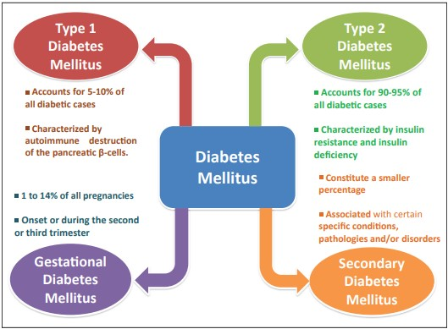

Figure 1: Types of diabetes mellitus

1. Type 1 diabetes mellitus
Insulin-dependent diabetes mellitus (IDDM), juvenile-onset diabetes, or type 1 diabetes are other names for type 1A diabetes mellitus (T1DM). It only accounts for 5–10% of all instances of diabetes and is brought on by an autoimmune disease that kills the beta cells in the pancreas, leaving the body without insulin and producing high blood sugar levels. Despite the fact that the precise etiology of this autoimmunity is not yet completely known, it is thought that both hereditary and environmental factors may be at play. Although it can sometimes develop slowly in adults (late onset), this autoimmune illness often manifests itself quickly in newborns and young children [5, 6].
One immunological sign that sets T1DM apart from other autoimmune disorders is autoantibodies in particular. The specific immune-mediated cell death that characterizes the illness is linked to these autoantibodies. The autoantibodies include glutamic acid decarboxylase autoantibodies (GADAs) such as GAD65, islet cell autoantibodies (ICAs) to β-cell cytoplasmic proteins such as autoantibodies to islet cell antigen 512 (ICA512), autoantibodies to the tyrosine phosphatases, IA-2 and IA2α, insulin autoantibodies (IAAs), and autoantibodies to islet-specific zinc transporter isoform 8 (ZnT8). Among these autoantibodies, one might be used in clinical [1, 7].

2. Type 2 diabetes mellitus
90–95% of all instances of diabetes are caused by T2DM, previously known as non-insulin-dependent diabetic mellitus (NIDDM) or adult-onset diabetes. There are two main anomalies of the insulin system that characterize this kind of diabetes:
- Insulin resistance
- Dysfunctional beta cells
Disruptions in numerous biological pathways that result in lower sensitivity of cells in peripheral organs including the liver, muscle, and adipose tissue to insulin are the cause of insulin resistance. To maintain normal blood sugar levels in the early stages of the illness, β-cells overproduce insulin due to reduced insulin sensitivity. This condition is called hyperinsulinemia and helps prevent hyperglycemia. However, as time passes, β-cell function begins to decline because the enhanced insulin release by these cells is unable to make up for the loss of insulin sensitivity. Eventually, β-cell dysfunction leads to an insulin shortage, causing hyperglycemia. Although insulin concentration is lower, the secretion of insulin usually prevents DKA (diabetic ketoacidosis) from occurring [8, 9, 10].
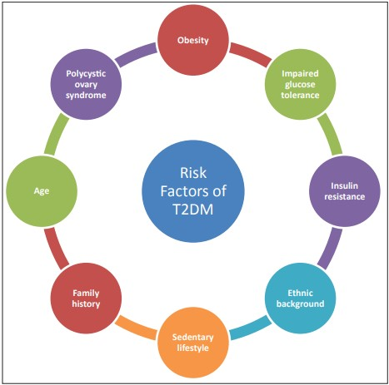
Figure 2: Risk factors of type 2 diabetes mellitus

3. Gestational diabetes mellitus (GDM)
GDM is the term for glucose intolerance or diabetes that is identified during pregnancy, typically in the second or third trimester. In the past, this also covered undiagnosed T2DM that might happen before or during pregnancy. The latest suggestions from the International Association of Diabetes and Pregnancy Study Groups, however, only take into account GDM in high-risk women, such as obese women, with any degree of glucose intolerance. GDM differs from diabetes that was already present while a woman was not pregnant and usually goes away after delivering or ending the pregnancy. Fasting and post-meal blood glucose levels are often lower than normal during the early stages of pregnancy. However, during the third trimester, blood glucose levels increase, and if they approach diabetic levels, it is called gestational diabetes mellitus (GDM) [1, 11].

4. Other types of diabetes
In addition to T1DM, T2DM, and GDM, diabetes has been associated with various other illnesses and disorders. However, these types of diabetes are less common compared to the overall incidence of diabetes. Endocrinopathies, exocrine pancreatic disorders, diabetes arising from genetic anomalies in insulin action, diabetes caused by monogenic deficits in -cell activity, and those are some of the various kinds of diabetes. Numerous drugs are utilized for diabetes treatment, such as insulin and Glucosidase inhibitors, metformin, sulfonyl, and froglitazone are a few examples of the different oral hypoglycemic medications. It is crucial to note that these drugs have been associated with numerous unwanted effects, also includes liver problems, lactic acidosis, and diarrhea [12]. Because of the adverse consequences of traditional medication, researchers have looked into the possibility of creating stronger natural hypoglycemic drugs. Traditional herbal medicine, one of the oldest cures known to mankind, has recently received a lot of attention. Because of their hypoglycemic and antioxidant properties, a variety of traditional medicines may help protect the organs implicated in diabetes mellitus [13].
The anomalies in physiology and biochemistry associated with diabetes, which are frequently linked to alterations in the lipid, protein, and carbohydrate metabolisms, have been extensively studied in vitro. Through a number of mechanisms, such as metabolic dysfunction and modifications to the DNA, proteins, and lipoproteins structure and properties, tissue damage is caused by oxidative stress with an increase in reactive oxygen species brought on by insulin resistance linked with decreased insulin production [17, 18].
A woody, thorny vine known as Bougainvillea spectabilis is cultivated in India's tropical and subtropical areas. The leaves of this plant contain a wide range of compounds that are active, such as saponins, flavonoids, quinones, sterols, phenols, triterpenoids, tannins, glycosides and minute quantities of sugars. Pinitol, a hypoglycemic agent with effects similar to those of insulin, is present in the leaf extract of this plant. Among the fundamental underlying processes of Bougainvillea spectabilis hypoglycemic effect is thought to be its glucosidase inhibitory activity against mouse pancreatic and intestine glucosidase. Although antioxidant activity has been demonstrated in extracts from leaves of bougainvillea, only a limited number of tests have been performed for its determination [14-16].
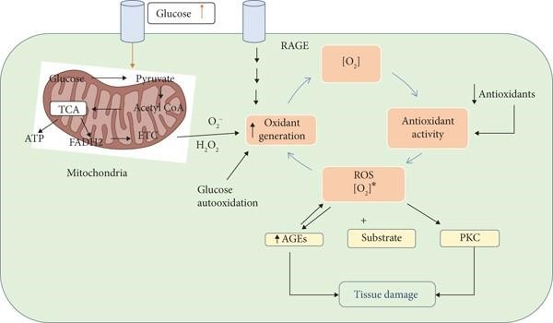
Figure 3: Mechanism of free radical generation

II. MATERIALS AND METHODS
To achieve the desired outcome while following established rules and standards, it's necessary to carry out a series of systematic actions when establishing a methodology. It involves the selection and gathering of medicinal plants, the choice of extraction solvents, the choice of dose, the standardization of the procedure, the use of instruments, the fabrication of reagents, the formulation of the protocol, and its ultimate implementation.

A. Plant collection and drying
The leaves and flowers of Bougainvillea spectabilis wild was collected from Hyderabad district, Telangana. After being dried in the shade for approximately six days, the leaves are ground into a rough powder utilizing a grinder mixer. The powdered substance was either removed or kept according to a set process.
B. Preparation of plant extract
Principle
Utilizing siphon and reflux, soxhlet extraction is a practical and affordable technique. The continual extraction of solid material using a pure solvent is a key component of the concepts. On thimble-shaped filter paper, a solid sample is placed in the Soxhlet device before being processed. The soluble portion of the sample mixes with the solvent during heating of the reservoir flask, which is then used to extract the sample from it. Until the extracted substance is concentrated, the extract-containing solvent is siphoned back and the procedure is repeated many times.
Procedure
A glass cylinder was used to store 500g of unprocessed plant powder, which was first deposited on filter paper before being put inside. Both an intake tube and a siphon tube are present in the cylinder. The top of the cylinder is also attached to a water condenser. This arrangement is then put into the neck of a flask with a circular bottom and methanol as the solvent. To stop solvent from bumping, porcelain bits are put into the flask. Heat the flask in a water bath while allowing solvent vapors to enter through the intake tube to dissolve an organic material. The organic material is dissolved by the resultant liquid once these vapors condense in the condenser. A constant supply is maintained as additional solvent vapors enter the cylinder as the solution rises to the top of the siphon tube. Back into the flask flows the dissolved organic component. Once complete, turn off the heat and distil the mixture to remove the solvent, leaving the organic component behind.

C. In vitro anti-diabetic activity

1. α-amylase inhibition assay
20 mM phosphate buffer (pH 6.9) included 0.5 mg/ml of alpha amylase that was dissolved to create the enzyme solution. One milliliter of an enzyme solution was combined with various doses of leaf extract and standard (acarbose) (250, 500, 750, and 1000 µg/ml). The combination of the solution was incubated for 10 minutes at 25 °C. After the solution mixture had been incubated, 1 ml of starch solution (0.5%) was added, which underwent a further 10 minutes of incubation at 25 °C. To stop the process, 2,5-dinitro salicylic acid was added to 2 ml of coloring solution. The reaction mixture was warmed for five minutes in a bain-marie of boiling water. After cooling, the absorbance at 565 nm was determined colorimetrically [19, 20].

2. α-glucosidase inhibition assay
For 5 min at 37°C, different dosages of plant extract were added to 2% w/v of maltose or sucrose in 1 ml of 0.2 M Tris buffer pH 8.0 as a starch substrate solution to determine the inhibitory activity. Alpha-glucosidase enzyme (1 U/ml) was added to start the reaction, which was then left to sit at 37 °C for 10 minutes. The reaction mixture was then boiled in a bath of boiling water for two minutes to halt it. Using the glucose oxidase peroxidase technique, released glucose is quantified [21-23].

Inhibitory Concentration (IC₅₀):
The percentage scavenging activities at five different extract concentrations were used to determine the concentration of plant extracts (IC₅₀) necessary to neutralize 50% of the radicals. I% = (Ac-As)/AC X 100 (24). To determine the percentage of inhibition (I%), this formula was employed. Where As is the sample's absorbance and Ac is the absorbance of the control.

D. In vitro antioxidant activity
- Hydroxyl radical scavenging activity
Application of the procedure described by Halliwell et al. [25] allowed for the evaluation of the extractives' capacity to scavenge hydroxyl radicals. The chemical system of Fe3+-ascorbate-EDTA-H2O2 was used to produce the hydroxyl radical. When heated with TBA at a low pH, the byproduct of 2-deoxy-D-ribose breakdown becomes pink, and this byproduct is what the test measures. In the reaction mixture, there were the following ingredients: 0.8 mL of phosphate buffer solution (50 mmol L⁻¹, pH 7.4), 0.2 mL of extractives or standards at various concentrations (12.5-150 µg/mL), 0.2 mL of EDTA (1.04 mmol L⁻¹), 0.2 mL of FeCl₃, and 0.2 mL of 2-deoxy-D-ribose (28 mmol L⁻¹). The combinations were kept submerged in a water bath heated to 37 °C, and 0.2 mL of ascorbic acid (AA) was added to begin the reaction. After being incubated at 37 °C for 1 hour, the reaction mixture was treated with 1.5 mL of cold thiobarbituric acid (10 g L⁻¹) and 1.5 mL of HCl (25%), respectively. Prior to cooling with water, the mixture was heated at 100 °C for 15 minutes. The solution's absorbance was measured using a spectrophotometer at 532 nm. To evaluate the capacity to scavenge hydroxyl radicals, it was necessary to reduce the proportion of 2-deoxy-D-ribose oxidation on the radicals.
The formula used to determine the percentage of hydroxyl radical scavenging activity is as follows:
% hydroxyl radical scavenging activity = [A0(A1-A2]100/A0
where A0 represents the control's absorbance in the absence of a sample. The absorbance at the sample and 2-deoxy-D-ribose addition is A1. The sample's absorbance without 2-deoxy-D-ribose is A2. After that, the concentration was plotted against the percentage of inhibition, and the IC₅₀ was determined from the graph. Three times at each concentration, the experiment was repeated.
- Ferrous reducing antioxidant capacity assay
The samples' ferrous-reducing antioxidant capacity (FRAC) was computed using Oyaizu's method [26]. The Fe2+ may be seen by keeping an eye on the Perl's Prussian Blue output near 700 nm. The test tubes comprised 0.625 mL of potassium buffer (0.2 M), 0.625 mL of a 1% solution of potassium ferricyanide [K3Fe (CN)6], 0.25 mL of samples or standard (aminoguanidine) solution at various concentrations (12.5–150 g/mL), and 0.625 mL of each solution. The reaction was completed by incubating the reaction mixtures for 20 minutes at 50 °C. The test tubes were then filled with 0.625 mL of trichloroacetic acid (TCA) in a 10% solution. The centrifuged mixture's supernatant, which weighed 1.8 mL, was blended with 0.36 mL of a 0.1% ferric chloride (FeCl₃) solution, 1.8 mL of purified water, and 1.8 mL of the mixture. The entire mixture was centrifuged at 3000 rpm for 10 minutes. The solution's absorbance at 700 nm in contrast to a control was measured using a spectrophotometer. The standard blank solution, which was incubated under the same conditions but did not include any standards or plant extracts, was prepared from the same solution combination. At 700nm the blank’s solution absorbance was determined. The reaction mixture's higher absorbance demonstrates the reaction mixture's enhanced reducing power. Three times at each concentration, the experiment was run.

III. RESULTS
Preliminary phytochemical screening: A first phytochemical analysis of MEBS found that it included a variety of phytoconstituents, including phenolic chemicals, alkaloids, flavonoids, saponins, terpenoids, tannins, carbohydrates, and others.

Table 1: Alpha amylase inhibtory activity of Bougainvillea spectabilis
S. No | Compound | Concentration (µg/mL) | % inhibition | IC₅₀ value (µg/mL)
1 | MEBS | 20 | 32.5 | 70.58
2 |  | 40 | 40.2
3 |  | 60 | 48.3
4 |  | 80 | 52.0
5 |  | 100 | 60.5
6 | Acarbose | 20 | 42.0 | 36.3
7 |  | 40 | 56.5
8 |  | 60 | 63.2
9 |  | 80 | 72.3
10 |  | 100 | 85.6
According to Table 1, the % inhibition against alpha amylase activity increased with concentration in the crude extract of B. spectabilis leaves. At doses of 20, 40, 60, 80, and 100 µg/ml, respectively, the crude extract showed a percentage inhibition of 32.5%, 40.2%, 48.3%, 52.0%, and 60.5%, reaching an IC₅₀ of 70.58 µg/ml.

Table 2: Alpha glucosidase inhibtory activity of Bougainvillea spectabilis
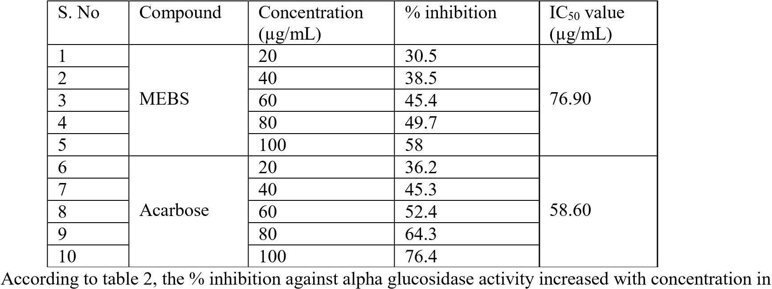
the crude extract of B. spectabilis leaves. At doses of 20, 40, 60, 80, and 100 µg/ml, respectively, the crude extract showed a percentage inhibition of 30.5%, 38.5%, 45.4%, 49.7%, and 58%, reaching an IC₅₀ of 76.90 µg/ml.

Table 3: Hydroxyl radical scavenging assay of the extract and standard
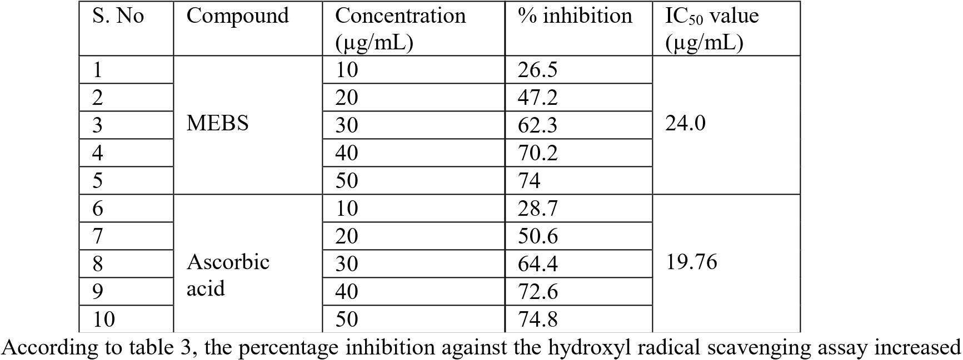
with concentration in the crude extract of B. spectabilis leaves. At doses of 10, 20, 30, 40, and 50 µg/ml, respectively, the crude extract showed a percentage inhibition of 26.5%, 47.2%, 62.3%, 70.2%, and 74%, reaching an IC₅₀ of 24.0 µg/ml.

Table 4: FRAP assay of the extract and standard
S. No | Compound | Concentration (µg/mL) | % inhibition | IC₅₀ value (µg/mL)
1 | MEBS | 10 | 26.3 | 24.5
2 |  | 20 | 46.2
3 |  | 30 | 61.0
4 |  | 40 | 69.2
5 |  | 50 | 75.6
6 | Ascorbic acid | 10 | 27.5 | 20.49
7 |  | 20 | 48.8
8 |  | 30 | 62.9
9 |  | 40 | 71.6
10 |  | 50 | 78.3
According to table 4, the percentage inhibition against the FRAP test increased when the concentration of the crude extract of B. spectabilis leaves was increased. At doses of 10, 20, 30, 40, and 50 µg/ml, respectively, the coarse extract showed a percentage inhibition of 26.3%, 46.2%, 61.0%, 69.2%, and 75.6%, reaching an IC₅₀ of 24.5µg/ml.

IV. DISCUSSION
Inhibiting the activities of the intestinal pancreatic enzymes α-glucosidase and α-amylase lowers postprandial hyperglycemia [27]. The reason for this is because absorbable monosaccharides have delayed carbohydrate digestion. From the current study, the coarse B. spectabilis concentrate demonstrated -amylase inhibitory activity. Finding new alpha amylase inhibitors from medicinal herbs is a noteworthy technique for treating post-meal hyperglycemia. Specialized metabolites including flavonoids, phenolic acids, and tannins have an inhibitory effect on alpha amylase that makes them the main phytochemicals [28]. A substantial quantity of polyphenolic compounds with α-amylase inhibitory effect is present in crude extract, according to a previous finding [29].
Additionally, it is possible to hypothesize that the rude extract included larger levels of phytonutrients that inhibit α-amylase. phenolic acids, coumarins, lignins, stilbenes, tannins, lignans, and flavonoids are only a few examples of the many phenolic chemicals that are often abundant in medicinal plants [30]. Inhibiting alpha glucosidase is one of the therapeutic options for DM to reduce hyperglycemia after a meal (putting off the uptake of glucose).The therapy for DM has included the use of alpha-glucosidase inhibitors, which account for a sizeable share of the anti-diabetic drug market [31].
Oxidative stress is brought on by the body's increased production of reactive oxygen and nitrogen species and diminished ability to fend off antioxidant attacks [32, 33]. For aerobic organisms and healthy tissues, creating reactive oxygen and nitrogen species (ROS/RNS) is unavoidable and happens at a regulated pace [34]. As a result of the substantial rise in ROS/RNS production under oxidative stress, phospholipids, nucleic acids and proteins are changed. Ageing and a number of pathogenic processes, such as atherosclerosis, cancer, ischemia reperfusion injury, and neurological illnesses, are linked to the oxidative degradation of these biomolecules [35].
This study also investigated the hydroxyl radical scavenging activity of plant extracts. By oxidizing thiol (-SH) groups, research has revealed that hydroxyl radicals directly denature bodily enzymes. The Fenton reaction results in the formation of hydroxyl radicals as follows; Fe²⁺ + H₂O₂ Fe³+ + OH + OH•. If a compound can scavenge for hydroxyl radicals in vitro, it is thought to be a strong antioxidant with potential advantages in vivo. In the current experiment, the FRAP test—decreasing antioxidant power of ferric—was employed. This approach relies on the crude extract's capacity to convert ferric ion (Fe3+) to ferrous ion (Fe2+) [36, 37]. As a result, the absorbance capacity at 700 nm may be used to analyze the Fe2+ formation [38]. An increase in reducing power is shown by increases in absorbance at this wavelength [39].
The findings of this experiment revealed that the methanolic extracts of Bougainvillea spectabilis increased in absorbance values in a concentration-dependent manner, indicating significant ferric reducing antioxidant potential.

V. CONCLUSION
Modern medications often have plant-based roots. In light of the rising popularity of herbal medicines, it's critical to search for fresh anti-diabetic components in plant extracts. Considering the outcomes, it is clear that the plant is a good candidate for the creation of novel anti-diabetic medications for the treatment of diabetes. Significant anti-diabetic and antioxidant action has been reported in Bougainvillea spectabilis methanolic extract.

REFERENCES
- American Diabetes Association. Diagnosis and classification of diabetes mellitus. Diabetes Care 2014;37:S81-90.
- American Diabetes Association. Introduction: Standards of medical care in diabetes—2018. Diabetes Care 2018;41:S1-2
- American Diabetes Association. Cardiovascular disease and risk management: Standards of medical care in diabetes—2018. Diabetes Care 2018;41:S86-104.
- A. Rawshani, S. Franzen, B. Eliasson, AM. Svensson AM, Miftaraj M, et al. Mortality and cardiovascular disease in type 1 and type 2 diabetes. N Engl J Med 2017;376:1407-18.
- Knip M, Siljander H. Autoimmune mechanisms in type 1 diabetes. Autoimmun Rev 2008;7:550-7.
- Kahaly GJ, Hansen MP. Type 1 diabetes associated autoimmunity. Autoimmun Rev 2016;15:644-8.
- Taplin CE, Barker JM. Autoantibodies in type 1 diabetes. Autoimmunity 2008;41:11-8.
- Leahy JL. Pathogenesis of type 2 diabetes mellitus. Arch Med Res 2005;36:197-209.
- DeFronzo RA. Pathogenesis of type 2 diabetes mellitus. Med Clin North Am 2004;88:787-835, ix.
- Muoio DM, Newgard CB. Mechanisms of disease:molecular and metabolic mechanisms of insulin resistance and beta-cell failure in type 2 diabetes. Nat Rev Mol Cell Biol 2008;9:193-205.
- Lawrence JM, Contreras R, Chen W, Sacks DA. Trends in the prevalence of preexisting diabetes and gestational diabetes mellitus among a racially/ethnically diverse population of pregnant women, 1999–2005. Diabetes Care 2008;31:899-904.
- Anbu, N., Musthafa and Velpandian, V. 2012. Anti-diabetic activity of polyherbal formulation aavraiyathi churnam in alloxan induced diabetic rats. Int. J. toxicol. phamacol. res., 4(4):77-80.
- Dorababu M, Prabha T, Priyambada S, Agrawal VK, Aryya NC, Goel RK. Effect of Bacopa monniera and Azadirachta indica on gastric ulceration and healing in experimental NIDDM rats. Indian J Exp Biol. 2004;42:389-397.
- Narayanan CR, Joshi DD, Mujumdar AM. Hypoglycaemic action of Bougainvillea spectabilis leaves. Curr Sci. 1984;53:579-581.
- Adebayo JO, Adesokan AA, Olatunji LA, et al. Effect of ethanolic extract of Bougainvillea spectabilis leaves on haematological and serum lipid variables in rats. Biochemistry. 2005;17:45-50.
- Bhat M, Zinjarde SS, Bhargava SY, Kumar AR, Joshi BN. Antidiabetic Indian plants: a good source of potent amylase inhibitors. Evid Based Complement Alternat Med. 2011;2011:810207. doi: 10.1093/ecam/nen040.
- Bhalodia YS, Sheth NR, Vaghasiya JD, Jivani NP. Hyperlipidemia enhanced oxidative stress and inflammatory. Int J Pharmacol. 2010;6:25-30. doi:10.3923/ijp.2010.25.30.
- Giacco F, Brownlee M. Oxidative stress and diabetic complications. Circ Res. 2010;107:1058-1070. doi:10.1161/CIRCRESAHA.110.223545.
- Thalapaneni NR, Chidambaram KA, Ellappan T, Sabapati ML, Mandal SC. Journal of Complementary and Integrative Medicine 2008; 5(1): 1-10.
- Heidari R, Zareae S, Heidarizadeh M. Pakistan Journal of Nutrition 2005; 4 (2): 101-105.
- Andrade-Cetto A, Becerra-Jimenez J, Cardenas-Vazquez R. Journal of Ethnopharmacology 2008; 116: 27-32.
- Matsuura H, Asakawa C, Kurimoto M, Mizutani J. Bioscience Biotechnology and Biochemistry 2002; 66(7): 1576-1578.
- Tietz, N.W., 1999. In: Burtis, C.A., Ashwood, E.R. (Eds.), Tietz Textbook of Clinical Chemistry, third ed. Saunders W.B., pp. 750–778.
- Shai LJ, Masoko P, Mokgotho MP, Magano SR, Mogale MA, Boaduo N, Eloff JN. South African Journal of Botany 2010; 76: 465–470.
- Halliwell B, Gutteridge JMC. Free radicals in biology and medicine. Clarendon Press. 1989;3:617–783.
- Oyaizu M. Studies on products of browning reactions: antioxidant activities of products of browning reaction prepared from glucose amine. Jpn J Nutr. 1986;44:307–15.
- A. Aloulou, K. Hamden, D. Elloumi et al., “Hypoglycemic and antilipidemic properties of kombucha tea in alloxan-induced diabetic rats,” BMC Complementary and Alternative Medicine, vol. 12, no. 1, p. 63, 2012.
- J.-S. Kim, C.-S. Kwon, and K. H. SoN, “Inhibition of alpha-glucosidase and amylase by luteolin, a flavonoid,” Bioscience, Biotechnology, and Biochemistry, vol. 64, no. 11, pp. 2458–2461, 2000.
- Z. D. Kifle, B. B. Kidanu, T. Y. Tadesse, T. F. Belachew, and S. A. Atnafie, “Evaluation of in vivo antidiarrheal activity of solvent fractions of Hagenia abyssinica (Rosaceae) in Swiss albino mice,” Evidence-based Complementary and Alternative Medicine, vol. 2021, Article ID 8828331, 9 pages, 2021.
- A. Celik, I. Arslan, E. N. Herken, and A. Ermis, “Constituents, oxidant-antioxidant profile, and antimicrobial capacity of the essential oil obtained from Ferulago sandrasica Peşmen and Quézel,” International Journal of Food Properties, vol. 16, no. 8, pp. 1655–1662, 2013.
- J. Yin, S.-I. Heo, and M.-H. Wang, “Antioxidant and antidiabetic activities of extracts from Cirsium japonicum roots,” Nutrition Research and Practice, vol. 2, no. 4, pp. 247–251, 2008.
- I. Fidrianny, S. Ramadhani, and R. Komar, “In vitro antioxidant capacities of three organs of bitter gourd (Momordica charantia L.) form west Java-Indonesia using DPPH and FRAP assays,” International Journal of Pharmacognosy and Phytochemical Research, vol. 7, no. 5, pp. 1034–1041, 2015.
- M. Ferry and A.-M. Roussel, “Micronutrient status and cognitive decline in ageing,” European Geriatric Medicine, vol. 2, no. 1, pp. 15–21, 2011.
- R. S. Sohal and W. C. Orr, “The redox stress hypothesis of aging,” Free Radical Biology and Medicine, vol. 52, no. 3, pp. 539–555, 2012.
- D. B. Graves, “The emerging role of reactive oxygen and nitrogen species in redox biology and some implications for plasma applications to medicine and biology,” Journal of Physics D: Applied Physics, vol. 45, no. 26, Article ID 263001, 2012.
- Y. Ogasawara, T. Namai, F. Yoshino, M.-C.-i. Lee, and K. Ishii, “Sialic acid is an essential moiety of mucin as a hydroxyl radical scavenger,” FEBS Letters, vol. 581, no. 13, pp. 2473–2477, 2007.
- C. M. Kibiti and A. J. Afolayan, “Herbal therapy: a review of emerging pharmacological tools in the management of diabetes mellitus in Africa,” Pharmacognosy Magazine, vol. 11, no. 2, p. S258, 2015.
- I. Gulçin, “Antioxidant properties of resveratrol: a structure-activity insight,” Innovative Food Science & Emerging Technologies, vol. 11, no. 1, pp. 210–218, 2010.
- L. K. MacDonald-Wicks, L. G. Wood, and M. L. Garg, “Methodology for the determination of biological antioxidant capacityin vitro: a review,” Journal of the Science of Food and Agriculture, vol. 86, no. 13, pp. 2046–2056, 2006.

