No other invention has changed the course of humanity like agriculture. Thousands of years ago, humans first started growing crops, freeing us from depending on wild plants and animals for food. Since then, agriculture has undergone a series of revolutions, each bringing about exciting new techniques and advances to provide more sustenance for the world. Let us explore more about what agricultural revolutions are and their impacts on the planet. When we talk about 'revolutions,' we mean an event that suddenly and dramatically changed life in some way. In politics, revolutions bring about significant changes in who has power. Regarding agriculture, revolutions are a series of inventions or discoveries that dramatically shift how we cultivate plants and raise animals.
Agricultural Revolution: The name for a series of shifts in human culture and practices that allowed for the invention and improvement of farming, including crop cultivation and animal husbandry.
The agricultural revolutions humans have gone through never happened very suddenly—there was never a "storming of the Bastille" moment like there was in the French Revolution. Instead, a series of inventions and techniques slowly spread over decades or centuries that collectively revolutionised agriculture. Several historical events are referred to as agricultural revolutions, and today we'll review the three most recognised and significant of them.
First Agricultural Revolution
Tens of thousands of years ago, humans lived off the land in what's known as hunter-gather societies, taking what they could find and moving around in search of new food sources. Humans relied entirely on wild plants and animals, limiting how much the population could grow and where humans could live. The First Agricultural Revolution, also known as the Neolithic Revolution, led humans out of this cycle of nomadism and dependence on the wild. Beginning about 10,000 years BC, humans started growing crops and settling down in one place, no longer needing to be in a constant quest for new food supplies.
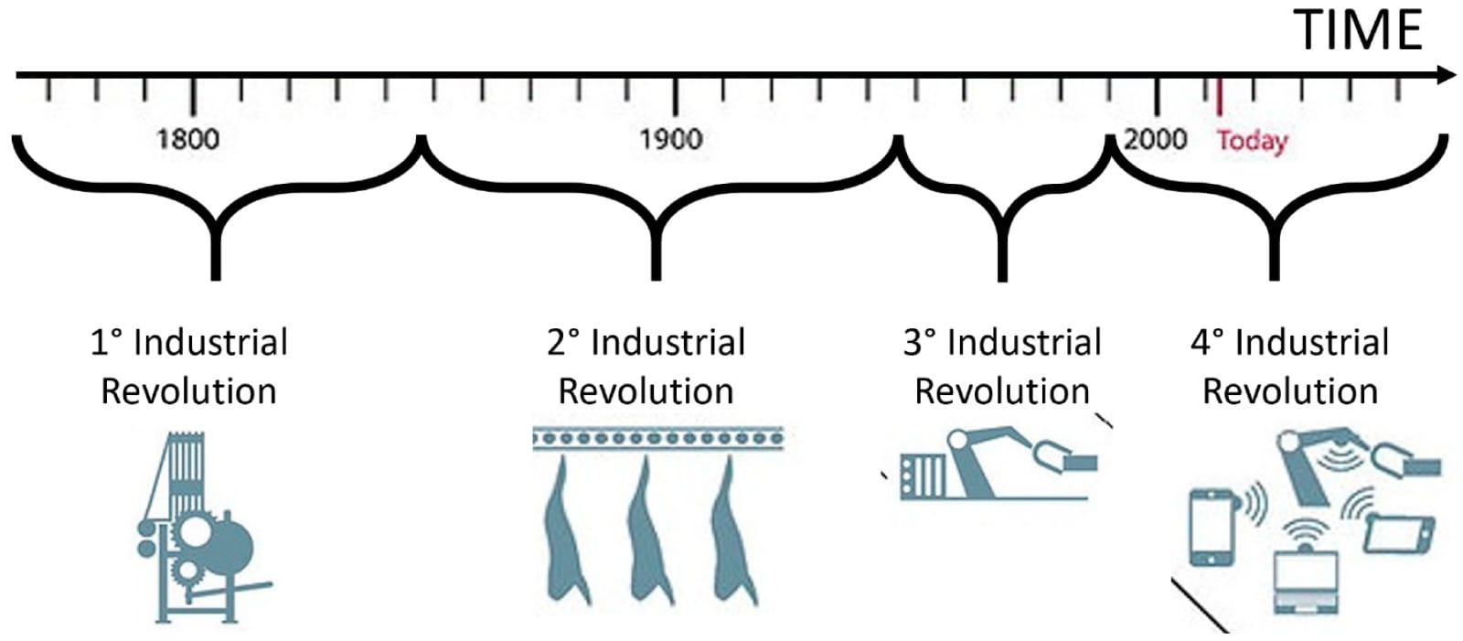
Second Agricultural Revolution
The thousands of years after agriculture was first invented brought about steady improvements in how humans farmed, like the plough, and changes to how farmland was owned and managed. The next major revolution started in the mid-1600s, now known as the Second Agricultural Revolution or British Agricultural Revolution. The event also coincided with the Industrial Revolution, with both having a symbiotic relationship. New industrial technologies increased agricultural yields, and a more significant, non-farm labour force enabled industrialisation. With farms becoming more productive owing to new technology and farming techniques, fewer people were required to work in agriculture. This led to more people moving to cities searching for work, a process called urbanisation.
Third Agricultural Revolution
The Third Agricultural Revolution, also known as the Green Revolution, brought about significant changes to agriculture. Of all the revolutions, this one happened over the shortest amount of time, spanning from the 1940s to the 1980s, but some changes from the Green Revolution are still making their way to developing countries today. The key innovations spurring the Third Agricultural Revolution were the cross-breeding of crops and the development of more effective agrochemicals. This revolution began with experiments undertaken in Mexico to create a higher-yielding variety of wheat and soon spread to different crops around the world. 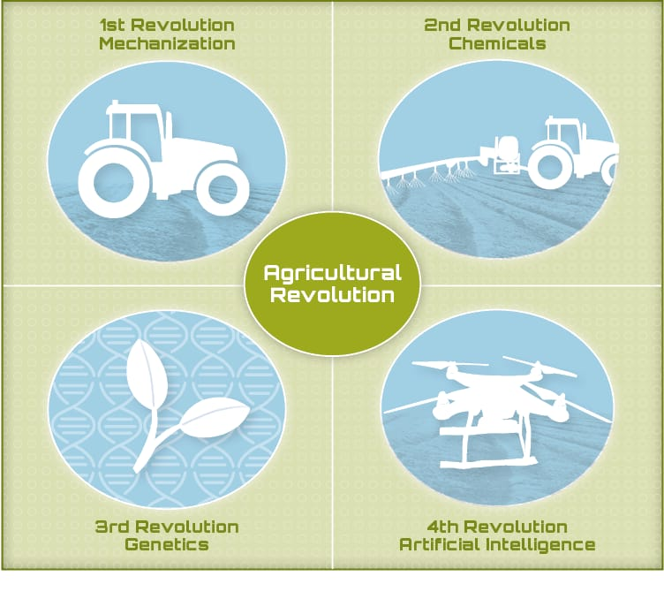Overall, the result of this revolution was a huge boost in the amount of food available worldwide, which reduced hunger and poverty. However, the benefits of the Third Agricultural Revolution haven't been equally felt. Some less-developed countries still don't have equal access to agrochemicals and newer farming equipment, so they don't have as high yields as they could. The boom in industrial farming stemming from the revolution has also led to smaller family farmers being unable to compete and struggling as a result.
Fourth agricultural revolution
- Technological Advances : Agricultural revolution, technological developments, such as artificial intelligence, the analysis of big data, drone development, machine learning, and robotics will allow us to improve productivity on traditionally farmed land.
- Farming Advances
155 countries’ food systems (covering 97% of the world population, 93% of global land area and 97% of GDP) into five categories with four indicators. These are the exhaustive, mutually exclusive five food system types that largely make up the world’s food and agricultural system.
- rural and traditional
- informal and expanding
- emerging and diversifying
- modernizing and formalizing
- industrial and consolidated

Agricultural revolutions were indeed true, it would imply that both the food systems - industrial and consolidated food systems and modernizing and formalizing systems - are indeed desirable goals for the rest of us living in, say, India, which has a rural and traditional food system.
But the revolutions have further increased the gap in labour Productivity, despite high yields because of over use of technology development.
AGRINUSINESS IN INDIA:
Agribusiness is the complete value chain in agriculture, from the raw materials and resources necessary to create biological products to distributors and retailers that get products to end consumers. It can be separated into four links: input providers, producers, processors, and other service providers (such as marketers, distributors, etc.). Each link adds value to the output of the previous link until the biological material is consumed or used by the end consumer.
Agribusiness covers all the value-added activities that link raw materials required for agriculture production to products and services that satisfy the demand of end consumers of agriculture products. Agribusiness involves four links: input providers, producers, processors, and other service providers. Although agriculture producers are central to agriculture, the agribusiness ecosystem enhances and adds value to its products to deliver compelling value to the end consumer.
- Agribusiness is a combination of the words "agriculture" and "business" and refers to any business related to farming and farming-related commercial activities.
- Agribusiness involves all the steps required to send an agricultural good to market, namely production, processing, and distribution.
- Companies in the agribusiness industry encompass all aspects of food production.
- Climate change has placed intensifying pressure on many companies in the agribusiness industry to successfully adapt to the large-scale shifts in weather patterns.
The purpose of agribusiness is to create and supply agricultural products for end-consumption. Agricultural products are naturally produced resources for human consumption or other uses.
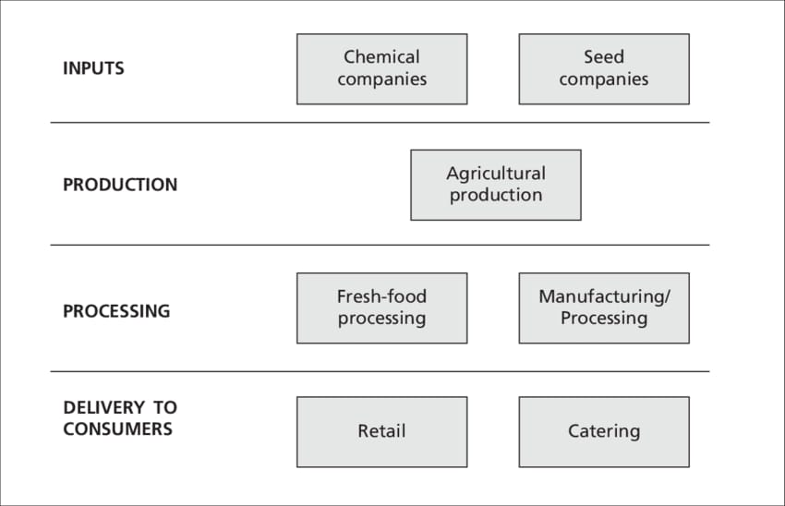
The products require a variety of sectors and industries to support the producers, which are central in this value chain. Each link adds value to the agricultural product.

KEY TRENDS TRANSFORMING AGRIBUSINESS SECTOR:
