Three Hericium Pers. from Ratanmahal Wildlife Sanctuary (RWS) of Gujarat, India
Praveen Kumar Nagadesi^{1*} Shraddha Olpadkar²
¹Department of Botany, School of Life Sciences, St. Joseph’s University, 36, Lalbagh Road, Bengaluru, Karnataka, India.
²Department of Botany, J.M. Shah Science College, Ring Road, Lilotri Bazar, Jambusar, Gujarat - 392150, India.
*Corresponding Author E-mail: nagadesipraveenkumar@yahoo.com
Abstract
A survey was undertaken during 2010-2011 to detect the various white rot fungi in Ratanmahal wildlife sanctuary of Gujarat. Detailed macroscopic and microscopic study of fungal samples was identified as Hericium abietis (Weir ex Hubert) K. Harrison, H. cirrhatum (Pers.) Nikol. H. erinaceus (Bull. ex Fr.) Pers. The two Hericium sp. was reported for the first time from the Eco-regions of Gujarat. For the first time H. abietis was reporting from India. All the three Hericium was used as food by tribal of Gujarat, so the conservation was done.
Key words: Conservation, Gujarat, Hericium, India, Medicinal, Mushrooms,
Introduction
The edible mushroom Hericium was first described as genus by Persoon (1794). It is a part of the Hydnum genus due to the spiny nature of hymenophore (Fries 1822, Miller 1933). It belong to the order Hericiales and Hericiaceae family (Donk 1964), but according to Index Fungorum the Hericiales was merged in the Russulales order (Kirk et al. 2001). In Index Fungorum, 34 species 66 taxon of Hericium was listed (Index Fungorum 2021), 71 species names was listed in Mycobank (2022) and 23 species records in Notes of Genera in Basidiomycota (He et al. 2019). The mega-diverse country of the world is India, being underexplored for Hericium macro-fungi, except some sporadic noteworthy mycologists’ contributions (Berkeley 1851; Bagchee et al. 1954, Thind & Khara 1975, Das & Sharma 2010, Das et al. 2011, 2013, Zutshi & Gupta 2013, Semwal et al. 2014, Karun & Sridhar 2016). The genus Hericium shows a peculiar morphology in fruit body like woolly surface. So they are called as bear's head mushroom i.e. H. americanum, monkey's head mushroom i.e. H. cirrhatum and lion's mane or goat's beard mushroom i.e, H. erinaceus and based on the nature of spines they are also called coral-spine mushroom i.e. H. coralloides, spine-face or tiered-tooth mushroom i.e. H. cirrhatum (Karun & Sridhar 2016). The basidiomata is white, fleshy, growing on dead trees or dried woods, the basidiomata was similar to iced thorns which hang from a branch, as a tough un-branched tissue cushion (Kuo 2014). In the present study the distribution, identification and conservation of some species of Hericium from RWS of Gujarat, India was reported.
Materials and Methods
Study area
The area of RWS is 55.65 Sq. Km with dry deciduous forest, lies between the river panama and orsang, in district Panchmahals, taluka Limkheda. It is 45 km away from Baria with 74º 37' to 70º 11' East longitude and 22º 32' to 22º 35' North latitude. The forest have 543 plant species, out of which 119 trees, 40 shrubs, 238 herbs, 48 grasses, 87 climbers, 2 partial parasites and 9 orchids. Among trees, the maximum density was teak plants and comprised 19.6 % of the total trees cover composition. The second highest density was the Badaro plants, constituting 15.7 %. The subtropical arid climate changes to humid during the monsoon from July to October. Gradually it becomes dry and cold from November to February, followed by a long hot summer in May and June. Mean annual temperature of the sanctuary is 25.3 ºC. Rain fall is about 980mm in June and September
Collection and identification
The basidiocarp was collected from Eco-regions of Gujarat, from July to September in the year 2015 to 2019. The habit, host, name of locality and other macro characters was recorded form samples. For the identification of basidiocarp, macroscopic characters like abhymenial, hymenial surfaces, context, and pore tubes and Microscopic characters like hyphae, basidiospores and pilear crust was recorded by preparing crush mounts and free-hand sections in water, 5% KOH solution, and staining was done with cotton blue (1%, in lactophenol), Congo red (1%, in distilled water), phloxine (1%, in distilled water), and Melzer’s reagent (Arya et al., 2008, Nagadesi and Arya,2012, 2016, Nagadesi 2019, Nagadesi et al 2014).
Results and Discussion
Hericium abietis (Weir ex Hubert) K. Harrison. Canad. Jour. Bot. 42: 1208. 1964. Plate 1 Fig. C,D
Sporophore up to 5 x 2.5 cm, solid tubercle; white to yellowish, buff when young, yellowish when bruised. sessile large, solid, massive, tubercle attached laterally to the wood by rooting strands, context firm, pallid; spines up to 1.2 cm long, very short and stout when young, pointed on ends in tufts. The basal mycelium is interwoven with rhizomorphic strands; hyphae on surface of basal tubercle non-amyloid, clamped, 2.65-3.75 µm wide, cells long, walls thin; no KOH reaction when dried; Melzer's reagent gave amyloid reaction to tramal context, branches, and spines. Hymenium and sub-hymenium non-amyloid, dull yellow in Melzer's; sub-hymenium compact, 20.85 - 30.65µm thick, consisting of a layer of thin-walled generative hypha 3.65-4.75 µm in diameter. Hyphae in basidiocarp is amyloid, flexuous, often bifurcating broadly, interwoven, variable in width, clamped at the septa, thick-walled, with wider lumen. Spores 4.65-5.56 x 4.25 - 4.75µm, sub-globose, white, smooth, amyloid with thick-walls, dextrinoid; Basidia 5-7 x 25-30 µm, with walls irregular wavy; cystidia flexuous, clavate. Gloeocystidia 8-12 µm; oleiferous hyphae 200 µm, thick-walled, exposed in hymenium, moniliform, usually burst in Melzer's reagent and exuding oily contents. Odor and taste was mild.
Specimen examination
India, Gujarat, RSW, on dead bamboo causing a white rot, 15th August 2010, collected by N. Praveen Kumar, (Acc no: MSUB Bot 120),
This fungus causing a white pocket rot in Abies grandis, A. lasiocarpa A. procera, Picea engelmannii, Tsuga heterophylla, Pseudotsuga menziesii in the Pacific Northwest. In Alaska, it is causing a rot in western hemlock, and Picea sitchensis. (Englerth 1947). In Canada of British Columbia it causes a trunk rots in western hemlock and true fir (Bier 1949). it causing a rot in western hemlock (Foster and Foster 1951). In the present study it is causing white rot on dead Bamboo.
Hericium cirrhatum (Pers.) Nikol. Acta Inst. Bot. Acad. Sci. USSR Plant Crypt., Fasc. II 6, 343 (1950) Plate 1 Fig. E
Sporophore: white in colour, bracket shaped caps, hairy-bristly upper surface and fertile flattened tiered teeth underneath. Solitary, annual, woody, rare, and measures 2.2 – 10.9 × 0.5 – 3.3 cm in size (Plate I Fig. E). Basidiomata initially small, pinkish-white eruption with fine hairs in young, at maturity becomes bracket-shaped, hairy and irregularly semicircular to lobed with wavy margin (Plate I Fig. E). Upper surface sterile, light-brown, hairy bristels and on ageing short-spined to warty (hairs get trimmed off due to heavy showers) (Plate I Fig. E). The lower white fertile hymenium bears deadaleoid to lamellate, incised, flattened teeth 5 - 18 mm tall, surface finely sulcate, tiered, crowded, spread over (Plate I Fig. E) and sometimes decurrent, sessile, laterally attached to substrate. Context is whitish and soft. Basidia elongated, club-shaped and 2- 4 spored. Spores was whitish, smooth, oval, 9.8 – 11.2 × 7.2–8.2 µm in size (Plate I Fig. E). Odor was almond; taste is not distinctive and edible.
Specimen examination
India, Gujarat, RSW, on dead and living tree of Madhuca indica causes a white rot, 15th August 2010, collected by N. Praveen Kumar, (Acc no: MSUB Bot 125),
Hericium erinaceus (Bull. ex Fr.) Pers. Mycol. Europ. 2: 153. 1825. Plate 1 Fig. A, B,
Basidiocarp an ovoid, solid, up to 5 cm wide, attached laterally; upper surface a tangle of coarse agglutinated strands of mycelium; white becoming yellowish and finally brownish. Margin of pileus indefinite, but marked by the bases of long pendent spines. Context fleshy, tough, watery, concolorous; Spines 1.5-4.2 cm long, pendent, beard-like, covering the sides. These are formed in a line as though the rows of spines originated in sequence during the enlargement of the tubercle. Stipe represented by a tough rooting attachment arising within the woody substrate. When KOH was applied to dried material there was no reaction; with Melzer's reagent, context surface and spores were amyloid, context usually amyloid but may not show any darkening in some sections. Spores 5.5-6.8 x 4.5-5.6 µm, subglobose, finely roughened to smooth; basidia 25-40 x 5.25-7.65 µm, 4-spored; Gloeocystidia arising in subhymenium, up to 7.75 µm wide, with dense contents exuding as oily appearing droplets in KOH. Hyphae in trama 3.65 – 20.75 µm in diameter, inflated, thick-walled, lumen almost closed, interwoven, giving rise to gloeocystidia in the spines. Inter-weaving hyphae 3.65-10 µm thick with some clamps, branched and thick-walled. odor and taste was mild.
Specimen examination
India, Gujarat, Rajpipla forest, on dead wood causing a white rot, 15th September 2011, coll. N. Praveen Kumar, (Acc no: MSUB Bot 128),
H. erinaceus is rare, native to North America, and also found in East Asia and India (Das et al. 2011), very rarely found in Europe. It is causing heart rot of oaks, frondose species, and found growing in knotholes of living trees. It is also found on Fagus in a number of states, on Acer spp. (Washington), Eucalyptus (California) and Platanus (Virginia). In 2003, it was recorded in red-listed by 13 of the 23 European countries because its natural habitats are disappearing (Thongbai et al. 2015). In the present study it is causing white rot in dead wood of Rajpipla forest area.
Distribution – 8 Hericium sp. were reported from the India on woody substrates in the Himalayan region (Thind and Khara 1975, Das and Sharma 2009, Das et al. 2011, 2013, Zutshi and Gupta 2013, Semwal et al. 2014, Das et al. 2013) (Table 2). H. erinaceus was also reported from the reserve forest of Western Ghats in July 2012 (Karun and Sridhar 2016). In the present study it is reported from reserved forest of Rajpipla area of Gujarat. H. cirrhatum, H. coralloides and H. erinaceus were reported from Asia, North America and Europe (Boddy et al. 2011). In the present paper it was recorded from the India country of Asian continent
Medicinal uses - Mostly the young Hericium sp. was edible, also known for their therapeutic potential especially in stimulation or synthesis of nerve growth factor (NGF) and used in treatment of dementia e.g. metabolites of H. erinaceus: (Kawagishi and Zhuang 2008, Ma et al. 2010, Friedman 2015, Thongbai et al. 2015). H. erinaceus have polysaccharide like beta-glucan groups used in antitumor activities (Seok et al. 2009).

Plate I
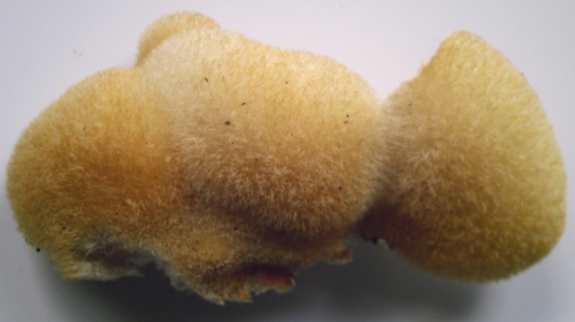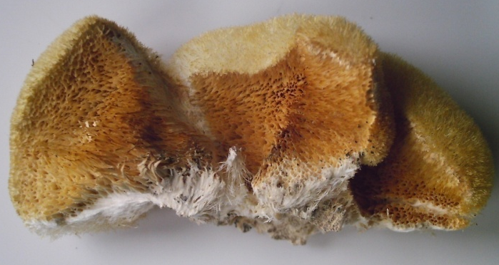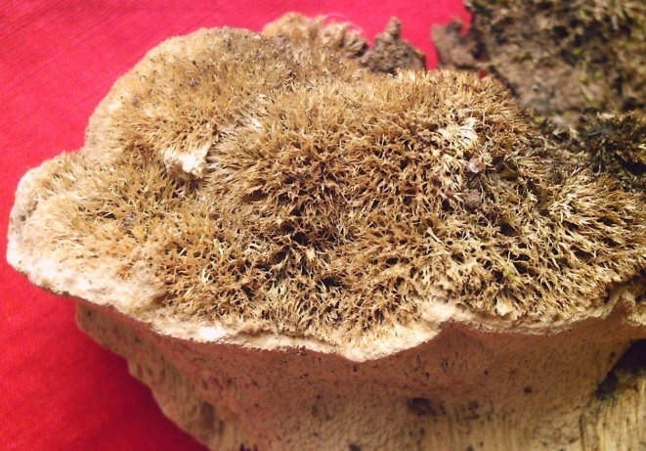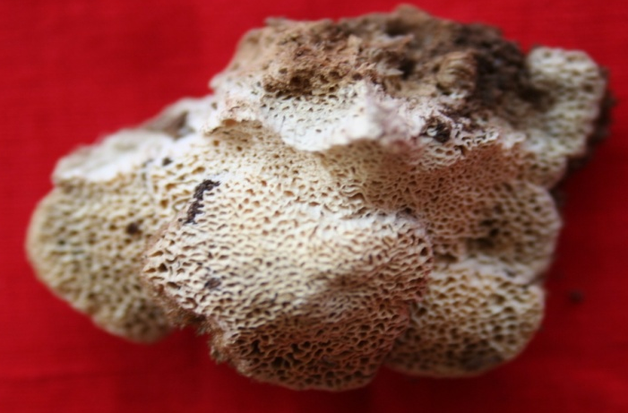
E
A
D
C
B
Plate I Fig. A: the sharp spinate surface of Hericium erinaceus; Fig. B: the context and sporocarp of H. erinaceus attached to substrate by broad base; Fig. C very sharp spinate surface of Hericium abietis; Fig. D: the hymenium surface with pores in H. abietis Fig. F. The spinate upper surface and porate to lamellate lower surface in Hericium cirrhatum.

Table 2. India Hericium mushroom distribution and substrate preferred for living on it
S. No | Species | Location | Habitat | Reference
1 | Hericium abietis | Gujarat, Rathanmahal, | Bamboo | Present study
2 | H. bharengense | Sikkim, Upper Bhareng, | Tsuga dumosa Logs | Das et al. (2011)
3 | H. cirrhatum. | Sikkim, Yuksom, | Alnus nepalensis Wood; Quercus sp Trunk | Das & Sharma (2010)
 |  | Karnataka, Makutta of Western Ghats | Euodia lunuankenda endemic tree | Karun and Sridhar (2016)
 |  | Gujarat, Rthanmahal, | Madhuca indica Living tree | Present work
4 | H. clathroides | Himachal Pradesh, Chamba, | Quercus incane Dead tree | Thind & Khara (1975)
5 | H. coralloides | West Bengal, Darjeeling; | unknown | Berkeley (1851)
 |  | Uttarakhand, Mussoorie Hills, | unknown | Bagchee et al. (1954)
 |  | Jammu-Kashmir, Pahalgam, | conifers Log | Thind & Khara (1975)
 |  | Jammu- Kashmir, Doda, | Quercus leucotrichophora Dead wood | Zutshi & Gupta (2013)
6 | H. erinaceus | Sikkim | Unknown | Berkeley (1851)
 |  | Uttarakhand, Mussoorie Hills, | Unknown | Bagchee et al. (1954)
 |  | Simla, Narkanda, | coniferous tree Log | Thind & Khara (1975)
 |  | Uttarakhand, Nainital, | Quercus incane | Thind & Khara (1975)
 |  | Uttarakhand, Pauri, | Cracks of live but decaying wood | Semwal et al. (2014)
 |  | Himachal Pradesh, Shimla, | Quercus leucotrichophora wood | Semwal et al. (2014)
 |  | Karnataka, Western Ghats | Unknown tree | Karun & Sridhar (2016)
 |  | Gujarat, Rajpipla, | Imported wood log | Present study
7 | H. rajendrae | Jammu- Kashmir, Himalayan, | Unknown wood | Upendra Singh and Kanad Das in 2019
8 | H. yumthangense | Sikkim, Yumthang, | Abies densa Wood | Das et al. (2013)
Conservation – H. coralloides and H. erinaceus are ‘vulnerable’ (VU) category in Red List from many European countries (Boddy et al. 2011). The Hericium sp. was edible, medicinally versatile and needed conservation during mass collection from wild; so several strategies and priorities of conservation of Hericium sp. was studied by Boddy et al. (2011). In the present study also the Hericium sp was used by tribal of Gujarat as food so it is edible. In the Western Ghats, H. cirrhatum was reported on dead wood and endemic living trees of Euodia lunuankenda. Besides, H. cirrhatum was recorded on unknown tree in July 2012 (Karun & Sridhar 2016). Western Ghats have some more Hericium sp. which need further exploration studies (Karun & Sridhar 2016). In the present work the H. cirrhatum was dead and living tree of Madhuca indica and this plant is used for making tribal drink alcohol in Gujarat.
Acknowledgement
The authors are greatly thanked the Head, Department of Botany, The Maharaja Sayajirao University of Baroda for all facilities to the lab work.
References
Arya A, Albert S and Nagadesi P K. New and Interesting Records of Basidiomycetous Fungi from Ratanmahal Wildlife Sanctuary, Gujarat, India. Journal of Mycology and Plant Pathology 2008, 38 (2), 221–226
Bagchee K, Puri YN, Bakshi BK. 1954 - Principal diseases and decays of oaks and other hard woods in India - II. Indian Phytopathology 7, 18-42.
Berkeley MJ. 1851. Decades of Fungi, Deca 35 (# 341-350), Sikkim-Himalayan Fungi collected by Dr. Hooker. Hooker Journal of Botany 3, 167-172.
Boddy L, Crockatt ME, Ainsworth AM. 2011 - Ecology of Hericium cirrhatum, H. coralloides and H. erinaceus in the UK. Fungal Ecology 4, 163-173.
Das K, Sharma JR. 2010 - Hericium cirrhatum (Pers.) Nikol. A new record to Indian mycoflora. Kavaka 37–38, 17–19.
Das K, Stalpers J, Eberhardt U. 2011 - A new species of Hericium from Sikkim Himalaya (India). Cryptogamie, Mycologie 32, 285-293.
Das K, Stalpers JA, Stielow JB. 2013 - Two new species of hydnoid fungi from India. IMA Fungus 4, 359–369.
Donk MA. 1964. A conspectus of the families of Aphyllophorales. Persoonia. 3(2):199–324
Friedman M. 2015 - Chemistry, Nutrition, and health-promoting properties of Hericium erinaceus (Lion’s Mane) mushroom fruiting bodies and mycelia and their bioactive compounds. Journal of Agricultural and Food Chemistry 63, 7108-7123.
Fries EM. 1822. Systema Mycologicum, sistens fungorum ordines, genera et species, huc usque cognitas. Vol.II. 1re partie. Gryphiswaldiae: Ernesti Mauritii.
He MQ, Zhao RL, Hyde KD, Begerow D et al. 2019 – Notes, outline and divergence times of Basidiomycota. Fungal Diversity 99, 105–367.
He MQ, Zhao RL, Hyde KD, Begerow D et al. 2019 – Notes, outline and divergence times of Basidiomycota. Fungal Diversity 99, 105–367.
Index Fungorum 2021 – http://www.indexfungorum.org/ (Accessed on July 6, 2021).
Index Fungorum 2021 – http://www.indexfungorum.org/ (Accessed on July 6, 2021).
Karun NC, Sridhar KR 2016 – Two new records of hydnoid fungi from the Western Ghats of India. Studies in Fungi 1(1), 135–141, Doi 10.5943/sif/1/1/14
Karun NC, Sridhar KR. 2016 - Spatial and temporal diversity of macrofungi in the Western Ghat forests of India. Applied Ecology and Environmental Research 14, 1-21.
Kawagishi H, Zhuang C. 2008 - Compounds for dementia from Hericium erinaceum. Drugs of the Future 33, 149155.
Kirk PM, Cannon PM, David JC, Stalpers JA. 2001. Ainsworth and Bisby’s dictionary of the fungi. 9th ed. Wallingford: CAB International.
Kokni F. K. and Solanki H. A. 2019. Wood Inhibiting Basidiomycetes Fungi found in the different parts of South Gujarat, India. International Journal of Research and Analytical Reviews 6(2):119-127.
Kuo M. 2014 – The Genus Hericium. http://mushroomexpert.com/hericium.html (Accessed October 6, 2020).
Kuo M. 2014 – The Genus Hericium. http://mushroomexpert.com/hericium.html (Accessed October 6, 2022).
Ma B-J, Shen J-W, Yu H-Y, Ruan Y, Wu T-T, Zhao X, 2010 - Hericenones and erinacines: stimulators of nerve growth factor (NGF) biosynthesis in Hericium erinaceus. Mycology 1, 92-98.
Miller LW. 1933. The genera of Hydnaceae. Mycologia. 25(4):286–302.
MycoBank (2022). https://www.mycobank.org/page/Simple%20names%20search (Accessed December 6, 2022).
Nagadesi PK, and Arya A. Lignicolous Macro Fungi from Gujarat, India. World Scientific News, 2016, 45 (2): 307-330.
Nagadesi PK, and Arya A. New records of lignicolous fungi deteriorating wood in India. Mycosphere 2012, 3(6), 997–1004, Doi 10.5943 /mycosphere/3/6/13
Nagadesi PK, Bhavani J, and Arya A. New records of Lignicolous fungi from Krishna District, Andhra Pradesh, India. Int Lett Nat Sci 2014, 12(1):55–69
Nagadesi PK. Phenotypical studies of lignicolous fungi from Kondapalli hill Central Eastern Ghats, South India. Indian Phytopathology. 2018, 71(4):589-597. https://doi.org/10.1007/s42360-018-0090-3,
Nikolajeva TL. 1950 - Acta Inst. Bod. Acad. Sci. USSR Plant. Crypt., Fasc. II 6, 222.
Persoon CH. 1794 - Neuer Versuch einer systematischen Einteilung der Schwämme.Neues Magazine fȕr der Botanik 1, 63–138.
Semwal KC, Stephenson SL, Bhatt VK, Bhatt RP. 2014 - Edible mushrooms of the Northwestern Himalaya, India: a study of indigenous knowledge, distribution and diversity. Mycosphere 5, 440-461.
Seok LJ, Min KM, Cho JY, Hong EK. 2009 - Study of macrophage activation and structural characteristics of purified polysaccharides from the fruiting body of Hericium erinaceus. Journal of Microbiology and Biotechnology 19, 951-959.
Singh, Upendra; Das, Kanad (2019). "Hericium rajendrae sp. nov. (Hericiaceae, Russulales): an edible mushroom from Indian Himalaya". Nova Hedwigia. 108 (3–4): 505–515. doi:10.1127/nova_hedwigia/2019/0527.
Thind KS, Khara HS. 1975 - The Hydnaceae of the North Western Himalayas–II. Indian Phytopathology 28, 57–65
Thongbai B, Rapior S, Hyde KD, Wittstein K, Stadler M 2015 - Hericium erinaceus, an amazing medicinal mushroom. Mycological Progress 14, 1-23.
Thongbai B, Rapior S, Hyde KD, Wittstein K, Stadler M. 2015. Hericium erinaceus, an amazing medicinal mushroom. Mycol Prog. 14(91):1–23.
Zutshi SK, Gupta V. 2013 - Occurrence and characterization of Hericium coralloides: a rare wild edible mushroom from Doda region of J & K, India. Journal of Mycopathological Research 51, 361-363.

