Bioremediation: A Remedial Measure for Pollution Free Environment

Raj Kumar
S.N. Sinha College Tekari,
Gaya Magadh University, Bihar-824236, India
Email. Address:- raj12140in@gmail.com

Dr. Kiran Bala
Department of Zoology
Deshbandhu College,
University of Delhi-110019, India.
Email. Address:- kbala@db.du.ac.in

Arushi Dogra
Faculty of Life Sciences and Biotechnology
South Asian University, Delhi-110068, India.
Email. Address:- dograarushi2001@gmail.com

Dr. Pushp Lata
Department of Zoology,
University of Delhi, Delhi -110 007, India.
Email. Address:- plata@zoology.du.ac.in

Dr. Shekhar Nagar
Department of Zoology, Deshbandhu College,
University of Delhi, Delhi110019, India
Email. Address:- snagar@db.du.ac.in

ABSTRACT
Over the last few decades, there has been an increase in environmental contamination as a result of the growth of anthropogenic activity. An appealing and effective cleansing method to get rid of harmful waste from a damaged environment is bioremediation. Through the inherent capacity and action of microorganisms, Bioremediation is a process whereby hazardous substances are removed from the environment via degradation, elimination, immobilization or detoxification of different chemical waste.
The main idea is to degrade and modify pollutants so that they are less dangerous. Some of the factors, such as costs, surrounding conditions, pollutant types and concentrations can be taken into account during bioremediation which may take place either at the site or ex situ. Therefore, a suitable bioremediation method was chosen. In addition, bioaugmentation, biostimulation, bioventing and biopiles are common approaches to create bioremediation because natural parameters determine the achievement of bioremediation. The most efficient, affordable, and environmentally suited method of managing a polluted environment is bioremediation. Due to its unique applications, each bioremediation technology has both advantages and disadvantages.
Keywords-Bioaugmentation, Biostimulation, Biopiles and Detoxification

- INTRODUCTION
Emerging contaminant issues are also thought to be solved through bioremediation and natural reduction; bacteria are particularly useful for cleaning up contaminated environments. The bioremediation techniques utilize numerous microbes, including aerobic, anaerobic bacteria in addition to fungus. Through the extensive dynamic activity of microorganisms, bioremediation intensively participates in the degeneration, elimination, detoxification or immobilization of many chemical and physically unsafe components of the nature, degrading and changing poisons into less hazardous shapes is the elemental thought. The biotic and abiotic conditions are two distinctive sorts of variables that influence the pace of degradation. Based on organisms used bioremediation is classified into 4 types as stated in figure below. Different strategies and technique are as of now utilized within the bioremediation parameters.

POLLUTION OF THE ENVIRONMENT

Due to practice, spontaneous urbanization, deforestation, quick industrialization, and careless utilize of energy assets, environmental pollution has increased over the past few years. Herbicides fertilizers, pesticides, Nuclear waste Insecticides, Greenhouse gases, Herbicides, Hydrocarbons are just a few toxicants whose toxicity poses problems for the environment and human health. It is expected that more hazardous waste sites will be discovered in the ensuing decades. There are already thousands of hazardous waste sites. Pollutants are illegally dumped into the environment by chemical corporations and other sectors. Many of the methods used in the past to clean up a site, include digging out the contaminated soil.

- Bioremediation in Gist
Bioremediation involves use of microorganisms to exterminate or deactivate toxins in the nature through a metabolic process. The term "biological" refers to microorganisms like fungi algae, and bacteria and the "remediation"—the method of fixing the pollutants. Microbes flourish in the broadest array of settings within the biosphere of the Earth. They prosper in environment with soil, water, plants, creatures, the profound ocean, and frosty conditions. Microorganisms are the perfect choice to see after our environment due to their sheer number and crave for an assortment of toxins.
Advances for bioremediation got to be broadly utilized and are still extending quickly nowadays. Due to its eco-friendly distinctiveness, bioremediation of contaminated areas has demonstrated to be viable and reliable method. Later progressions in bioremediation strategies have been made with the clear objective of effectively reestablishing harmed zones in a cost-effective, ecologically worthy way. Distinctive bioremediation strategies have been made by analysts to clean up contaminated environment. Bioremediation refers to the use of micro-creatures that are either native to the site of contamination or that have been imported and incorporated into the site. The majority of toxicant biodegradation/bioremediation problems can be resolved through the use of local microorganisms in the affected zones [1]. When compared to both chemical and mechanical strategies, bioremediation has a few noteworthy focal points.

Decreasing, detoxifying, degrading, mineralizing, or changing more perilous toxins into less harmful toxins may be an instrument of bioremediation. Examples of toxicants that fall under this category include pesticides, agro based chemicals, chlorinated compounds and xenobiotic compounds heavy metals, as well as heavy metals and greenhouse gases such as hydrocarbons and radioactive waste. Other examples include colors, plastics and sludge. To evacuate toxicants from a contaminated environment, cleaning methods are utilized. Bioremediation refers to the process of destroying, immobilizing, or detoxifying various chemical contaminants and physically contaminant materials from the environment by irreplaceable actions of microorganisms. (Figure 1).
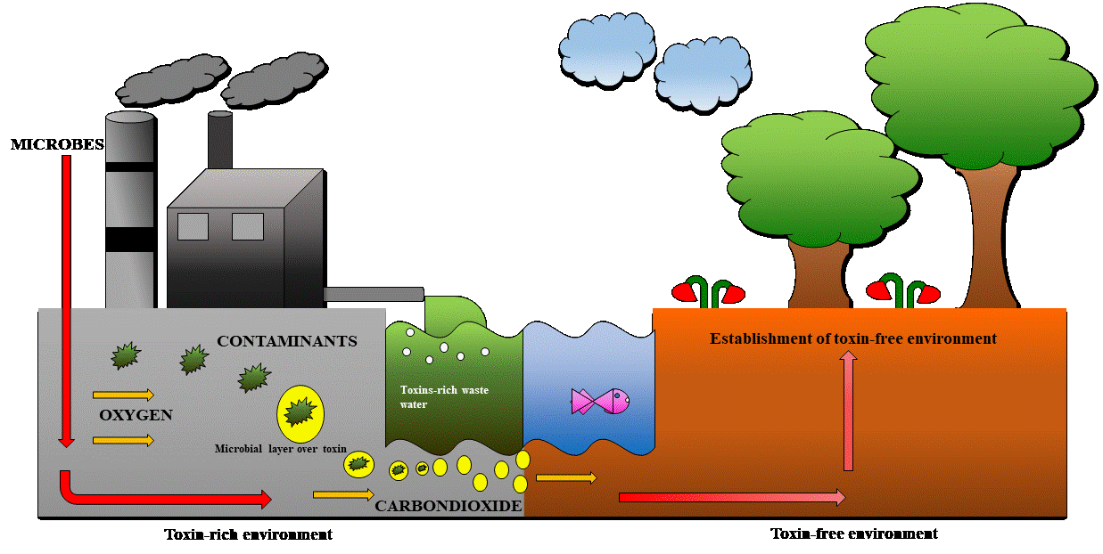

Figure 1: Overview of Bioremediation.

Various bacteria that are employed in bioremediation
The food chains that are a pivotal component of the natural balance in life depend intensely on microorganisms. With the help of microbes, fungi, yeast, and algae, contaminated materials are treated amid bioremediation. When in close contact with hazardous materials or toxic waste, these organisms are able to survive and multiply in extreme cold temperatures as well as extreme warm temperatures. The biological system and adaptability of microbes enables them suited for the clear out process [2]. The fundamental ingredient needed for microbial action is carbon. Microbial consortiums worked in many situations to do bioremediation. Achromobacter, Flavobacterium, Arthrobacter, Nitrosomonas, Alcaligenes, Xanthobacter Bacillus, Corynebacterium, Mycobacterium, Pseudomonas,etc. [3] are some of the microorganism that belong to this group.The following categories of microorganisms are employed in bioremediation (Figure 2)

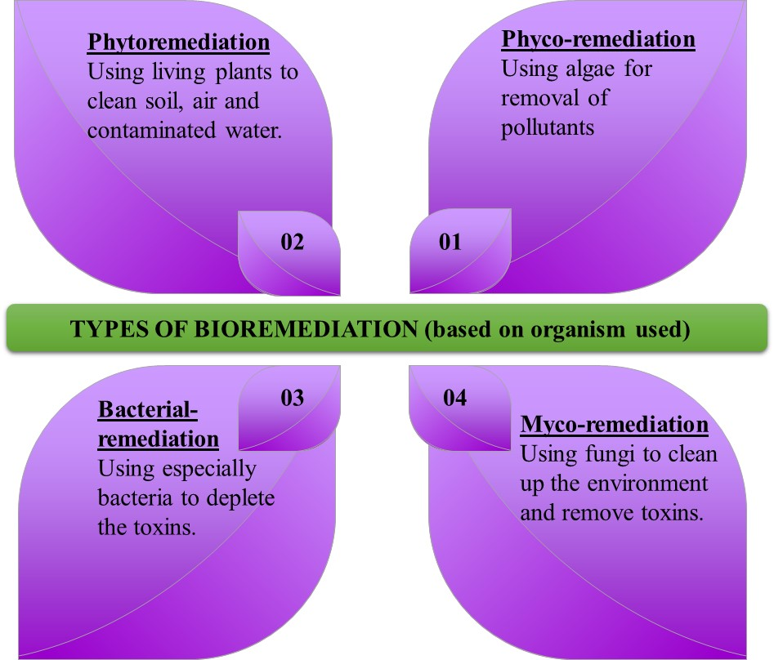
Figure 2: Classification of Bioremediation based on organism used.

Actinetobacter, Nocardia, Flavobacterium, Sphingomonas and Rhodococcus are just a few examples of aerobic bacteria that can break down complex chemicals. According to few reports these bacteria can break down polyaromatic chemicals, hydrocarbons, alkanes, and pesticides. Most of these bacteria utilize pollutants as carbon and energy sources. Compared to aerobic bacteria, anaerobic ones are not in use that frequently. In bioremediation, aerobic bacteria are used to break down contaminants and transform them into less harmful versions, including the solvents like chloroform and trichloroethylene, other chemicals like chlorinated aromatic compounds polychlorinated biphenyls.
- Elements that influence microbial bioremediation
During the exploit of fungi, bacteria, algae, and plants, the bioremediation process enables altering, removing, immobilizing, or neutralizing different physical and chemical pollutants from site of contamination. Metabolic pathways of microbes speed up the enzymatic processes that helps in degradation of pollutants, on coming in contact with substances that aid in their ability to produce energy and nutrients for cell division do they begin to react to contaminants. The variables influencing how effective bioremediation can be being only a few: the chemical composition and quantity of pollutants, the environment physiochemical characteristics, as well as their accessibility to already residing microbes, the availability of toxins to the remedial microorganism, the microbes’ population's capacity to degrade toxicants, and environmental conditions [4].

- Non-biological or abiotic Factors
Environmental toxicants effects on metabolic capabilities and the physicochemical composition of the microbes used in the process. The environmental conditions affect how successfully bacteria and pollutants interact. Variables that affect microbial growth graph and activity include temperature, pH, humidity, soil composition, water solubility, nutrients, oxygen and oxidizing ability, resource utilization, and physiochemical bio-availability (toxins), concentration, chemical composition, solubility, and toxicity. The aforementioned variables regulate the kinetics of deterioration [5,6]. In various terrestrial and aquatic environments, the range of pH (6.5-8.5) is in general suitable for contaminant degradation. Moisture has an impact on contaminant metabolism since it depends on the types and quantities of soluble components that are available as well as.
- Biological or biotic factors
The decomposition of organic compounds via microbes with inadequate carbon as energy sources, antagonistic relations between microbes, protozoans and bacteriophages are all included in biological factors. The rate at which contaminants will break down in a biochemical reaction is most often associated with the number of contaminants and quantities of catalyst. Enzymatic capabilities, interaction (predation, competition and succession), , its growth for biomass production, population size, , horizontal gene transfer mutation and composition are among the key biological determinants [ 5,7 ].

Bioremediation methods

On the surface, bioremediation using in-situ and ex-situ sites of application is possible. (Figure 3). A number of factors, including the nature of the pollutants, their extent and scope to contamination, the type of environment, its location, costs and environmental regulation will be taken into account when selecting bioremediation processes. Oxygen and additive concentration, temperature, pH or other variables have an influence on the suitability of this form of bioremediation. [9, 10].
Ex-situ bioremediation methods need the relocation of toxicants from polluted sites for restoration. When ex-situ bioremediation procedures are being examined, the deepness of pollution, variety of contamination, extent of contamination, cost incurred, and spot of the contaminated place are typically taken into account. Performance standards also play a role in the selection of ex-situ bio-mediation technology.
- Bioremediation using slurry-phase
To provide the ideal environment for microbes to break down the toxicant that is present in the soil, intoxicated soil is combined with oxygen, nutrients, and water in the bioreactor. In general, slurry phase bioremediation can be quicker than other handling techniques. In this manner of procedure, the stones and debris are separated from the intoxicated soil. Amount of toxicants, the pace of biodegradation, and the physicochemical characteristics of the soil all have an impact on how much extra water is present. Using centrifuge, vacuum filter and pressure filter, the soil is emptied and dried at the end of the process. Next, the soil is disposed of and the resulting liquids are treated. [11]

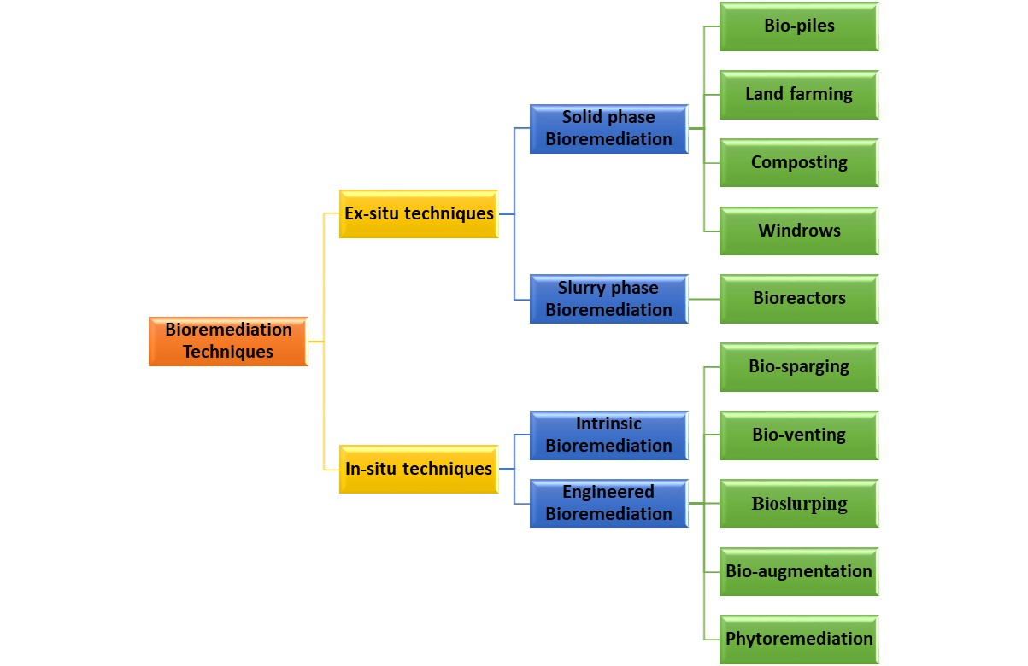
Figure 3: Classification of Bioremediation based on place of application.

- Solid-phase processing
The soil that has become contaminated is taken out of its native setting and piled up in solid-phase bioremediation. Additionally, listed in this category are organic wastes like animal manure, plants and trees exfoliate, and farming wastes in addition to home, industrial, and city garbage. Bacterial growth is carried by pipes scattered among the heaps. In order for the pipes to ventilate and allow for microbial respiration, air must be drawn through them. Solid-phase processes required a substantial amount of space and were longer to decontaminate than slurry-phase operations. Additional methods for treating solid-phase include windrows, land farming, composting, and biopiles [12].

Bioremediation types
Although there are many more types of bioremediation than only nine, these are the most typical applications.
- Windrows
One of the ways to enhance bioremediation is to use windrows. They are defined as a type of bioremediation that rotates the contaminated soil frequently. Windrows elevates the microbial decomposition of local and transient hydrocarbon clastic that is present in contaminated soil. The consistent transfer of nutrients, toxins and microbial activity, in addition to the occasional rotation of contaminated soil, improves air circulation by adding water, and increases the bioremediation rate, which is achieved through acclimation, biotransition and mineralization. In spite of the fact that the viability of the windrow for removing hydrocarbons from the soil was lower than that of the biopiles treatment, windrow treatment illustrated a quicker rate of hydrocarbon expulsion [13]. The perfect choice procedure to utilize within the bioremediation of soil contaminated with harmful unstable chemicals, in any case, is not the intermittent turning related with windrow treatment.
- Biopiles
Aeration and fertilizer enrichment are used in conjunction with over-ground piling of dug-up contaminated soil to enhance bioremediation through microbial metabolic processes. This method includes leachate collection, bed systems for treating leachate, nutrients, irrigation, and aeration. Due to its advantageous qualities and economic effectiveness, this particular ex-situ technology is increasingly being evaluated since it enables effective control of operational microbial degradation situation, including temperature, nutrient, aeration and pH. Biopiles process can be employed toward remediate polluted very cold harsh settings as well as volatile low molecular weight contaminants [ 14, 15].
Because heating systems can be included into biopile constructed on the way to boost microorganism’s activity and pollutant accessibility, which in turn increases the rate of biodegradation, remediation times can be decreased [16]. Biopile systems can also inject hot air in the biopile design to supply air and warmth at the same time. Agents that adds bulk like straw, bark, or wood chips and other organic waste have been introduced to the biopile structure to accelerate the remediation of the soil. Biopile systems were connected to other former-situ bio-remediation methods used in the arenas like land-farming, bio-venting, and biosparging. However, these methods were costly to operate and maintain due to remote locations' lack of electricity supply. Air pumps would have allowed constant circulation of air through intoxicated piles of land
- Farming on land
Because of its low operating costs and small apparatus necessities, land farming is considered kind of the direct and feasible bioremediation options. It can be used mainly in ex-situ bioremediation whereas it can also occur in a few cases of in-situ bioremediation depending on the location of the treatment. In land farming, whether it is in-situ or ex-situ, pollutant deepness plays a vital role. Contaminated soil is regularly excavated and tilled and the bioremediation type is completely controlled by the location of the treatment. Since it has additional features common to other ex-situ methods compared to when contaminated soil need digging up and treatment on spot, it is also ex-situ. Excavated, messy soils are cautiously placed on a settled layer supporting over the ground surface to promote aerobic biodegradation of toxins via microbes. [17].
- Bioreactor
A bioreactor is a container where unprocessed substances are transformed to certain yield as a result of a chain of biochemical reactions. There are several ways that bioreactors can be run, including fed-batch, batch, multistage sequencing batch, and continuous. The bioreactor offers the optimum growing environment for bioremediation. Polluted samples for the cleanup procedure are in the bioreactor. In contrast to ex-situ bioremediation procedure, the handling of intoxicated soil using bioreactors provides a number of benefits. Bioremediation time is significantly reduced by bioreactor-based methods that have excellent temperature control, pH control, agitation control and aeration control, inoculum concentration and substrate concentration control. A bioreactor is a device in which biochemical reactions are taking place due to its ability to control and adjust procedure parameters. Maximum biological degradation is possible while loss due to abiotic factors are kept to a minimum thanks to the adaptable nature of bioreactor designs [18].
- Techniques for in-situ bioremediation
These procedures engage treatment of contaminated materials at the point of the contamination. There is no call for excavation, and there is little to no soil building disruption. Perfectly, these methods have to be less pricey than ex-situ bioremediation methods. While few on site bioremediation methods, such as phytoremediation, biosparging, and other like bioventing, possibly elevates, others, for instance intrinsic bioremediation or spontaneous attenuation, possibly will advance unabatedly. Chlorinated solvents, heavy metals and other hydrocarbon-polluted sites are effectively eradicated with in-situ bioremediation approaches [19, 20, 21].
Engineered bioremediation and intrinsic bioremediation are examples of in-situ bioremediation methods

- Intrinsic Bioremediation
Natural reduction, refers to another name for inherent bioremediation. Natural reduction is a process which involves the passive eradication of contaminants from a site. without the required of exterior drive (human mediation). The incitement of the nearby or naturally found microbe’s populace is the center of this approach. The strategy for degrading resistant pollutants components that employments both oxygen consuming and anaerobic microbial activities. Since there's no external constrain, the cost-effectiveness of the method must be lower than that of additional in situ procedures.
- In-situ bioremediation that is engineered
The second-most effective technique involves introducing specific microbes to the polluted environment. In order to hasten the breakdown process, genetically engineered microbes are introduced in in-situ bioremediation, which improves the physicochemical environment to promote microorganism expansion.
- Bioslurping

By indirectly providing oxygen and empowering toxin biodegradation, this innovation includes soil vapor extraction, vacuum-enhanced pumping and bioventing to achieve groundwater and soil repair [22]. The recovery of materials from capillary, unsaturated, and saturated zones of light non-aqueous phase liquid (LNAPL) is the intended use of this technology. This technique can be used to clean up soil that has been contaminated with organic semi-volatile and volatile substances. The tactic makes use of a "slurp" that penetrates the free product layer and sucks liquids up from it. LNAPLs are raised to the surface by the pumping apparatus, where they are separated from air and water. This mechanism holds that soil wetness limits air porosity and O₂ transfer, which lowers microbial action. In spite of the fact that this approach is flawed.
By indirectly providing oxygen and empowering toxin biodegradation, this innovation includes soil vapor extraction, vacuum-enhanced pumping and others bioventing to attain soil and ground-water remediation [22]. This technology's intended application is the recovery of substances from capillary, unsaturated, and saturated zones of light non-aqueous phase liquid (LNAPL). This strategy is utilized to clean up soil that has been polluted with organic semi-volatile and volatile substances. This strategy utilizes a "slurp" that outspreads into the free product layer and withdraws liquids up from it. LNAPLs are carried towards the surface through the pumping gadget, where they are disintegrated from air and water. Agreeing to this procedure, moisture in soil limits air porosity and conserve the O₂ transport, which cuts down the activity of microbes. Indeed, despite the fact that this strategy is wrong.
- Bioventing
Bioventing strategies necessitate targeted stimulation of wind current by supplying oxygen to the unsaturated zone in enhance the action of surrounding microscopic organisms for bioremediation. In bioventing, adjustments are performed via including dampness and nourishment to boost bioremediation. By doing so, contaminants will be microbial changed over to a safe state. Comparatively to additional in-situ bioremediation approaches, this one has developed fame [23].
- Biosparging
Similar to bioventing, this technique involves injecting air beneath the surface of the soil to enhance the action of microbes and encourage pollution elimination from contaminated locations. Contrarily, when bioventing occurs, air is injected into the saturated zone, which could facilitate volatile organic molecules' upward migration to the unsaturated zone and so facilitate the biodegradation process. Soil porosity and pollutant biodegradability are the only two factors that directly affect how effective biosparging is in the context of bioventing and soil vapor extraction (SVE), in-situ air sparging (IAS), which depends on high air-flow rates for pollutant volatilization, and biosparging, which promotes biodegradation, are closely related processes. Diesel and kerosene-contaminated aquifers have often been treated with biosparging.
- Biological remediation
The root system of a plant, which can be fibrous or tap root system based on the deepness of the pollutant, over-ground biomass, the toxic nature of the contaminant towards plants, its sustenance and adaptability to the local environment, its development rate, site monitoring, and the crucial one, the amount of time it takes to get the desired cleanliness level. and the root system of a plant, which can be tap-like or fibrous are all important factors in determining a plant's capacity to act as a phytoremediation. The plant also needs to be immune to pests and illnesses [24]. Contaminant elimination in phytoremediation includes uptake and relocation from roots towards shoots. Additionally, partitioning and the transpiration are necessary for accumulation and translocation [25]. However, other variables, like the type of pollutant and the plant, may cause the procedure to alter.
Phytoremediation refers to the process of removing contaminants from toxin-rich soil. Phytoremediation involves the utilization of plant-derived substances, including physical, biochemical, biologicals, and chemicals, in contaminated soil to reduce the toxicity of contaminants. There are a number of mechanisms involved in phytoremediation, based on the type and quantity of the pollutant. These include extraction, break down, filtering, accumulation, stabilization, and volatilization. transformation, extraction and sequestration are frequently used to eliminate contaminants including radionuclides and heavy metals. Hydrocarbon and chlorinated organic pollutants are mostly eliminated through rhizoremediation, volatilization, degradation, and stabilization, with the likelihood of mineralization when certain plants, like Willow and Lucerne, are utilized [26, 27].
The majority of plants in polluted environments are efficient phytoremediators. Therefore, boosting the remediation capabilities of local plants growing in contaminated environments through bioaugmentation with endogenous or alien plants is essential for the success of any phytoremediation strategy. The ability of some important metals to bioaccumulate in particular plants and be recovered by phytomining is important key advantages of utilizing plants to clean up polluted areas.
- A reactive barrier that is permeable
The following strategy is used as often as possible utilized as a physical way to clean up contaminated groundwater. Precipitation degradation and sorption of toxicants elimination, in any case, are natural instruments exploited within the PRB procedure. In order to house the biotechnology & bioremediation part of the approach, the following alternative wording has been proposed: Biological PRB, biological enhanced PRB and Passive bio reactive barrier. Most talking PRB is in-situ strategy to remove heavy metals & chlorinated compounds from toxicated groundwater [27, 28].
- Profit of in-situ bioremediation
1. In-situ biological remediation procedures do not necessitate the removal of toxin-rich soil.
2. Volumetric management is given by this procedure, which can handle both solid pollutants and broken down
3. Accelerated in-situ bioremediation can regularly treat subsurface toxins more rapidly than pump and treat strategies.
4. Organic contaminants may be totally changed over to safe components like carbon dioxide, water, and ethane.
5. Considering how little site interruption there’s, it could be a cost-effective arrangement.
- In-situ bioremediation's limitations
- A few toxins might not totally be changed over into secure compounds depending on the location.
- On the off chance that a compound experiences change and stops at a middle, the halfway may be more dangerous and/or portable than the parent component; moreover, a few persistent pollutants are unfit of degrading.
- When despicably managed, the expansion of nutrients, electron donors, and electron acceptor may cause infusion wells to ended up stopped by voluminous microbial development.
- Local microorganism movement is hindered by the concentration of overwhelming metals and natural substances.
- Acclimatization of the microorganisms was regularly fundamental for in-situ bioremediation, which may not happen for spills and persistent substances.
- In-situ bioremediation is restricted.

Applications of bioremediation
- Bioremediation must be taken into account as a suitable method that can be useful to remediate all naturally occurring states of matter. Sludge, residue, and other solids are among the liquids, along with groundwater, surface water, and waste water from industries.
- Gas emissions from industries.
- Subsurface habitats (unsaturated and submerged zones). The three primary methods of bioremediation are:
The three fundamental strategies of bioremediation are
(i) Intrinsic (normal) bioremediation.
(ii) Biostimulation (natural changes brought around by the organization of supplements and air circulation).
(iii) Bioaugmentation (including microscopic organisms).
The organic community that is used in bioremediation is often composed of the typical soil micro flora. However, it is also feasible to manage larger plants to enhance toxicant disposal (phytoremediation), particularly for restoring soils that have been affected by metal.

Benefits and drawbacks
Due to its unique applications, each bioremediation technology has both advantages and disadvantages.
A. Benefits of bioremediation(Figure4)
1. It may be a natural process that requires a few time in arrange to legitimately treat waste from contaminated material like soil. Organisms can break down the toxin.
2. Commonly safe treatment byproducts include, CO₂ water, and cell biomass.
3 It takes very small endeavor and is done as frequently as possible on site, often, and without disrupting typical microbial processes. It also eliminates the need for off-site waste removal and potential environmental and human health risks.
4. Contrary to other traditional approaches that are often used to treat toxic perilous waste for oil- contaminated sites, it is practical and cost-effective. Additionally, it facilitates the breakdown of poisons; contaminated materials can be eliminated and a lot of risky compounds can be changed into less toxic yield.
5. It does not use any potentially harmful chemicals. Compost, in particular, is added as nutrients to encourage rapid and dynamic microbial growth. The harmful compounds are completely eliminated through bioremediations, which convert detrimental chemicals to water and safe gases.
6. Due to their natural put within the biological system, they are effortless, less manual and cheap.
7. Pollutants are disposed of, not as it were moved to another environment.
8. Non-intrusive, possibly allowing location usage to proceed.

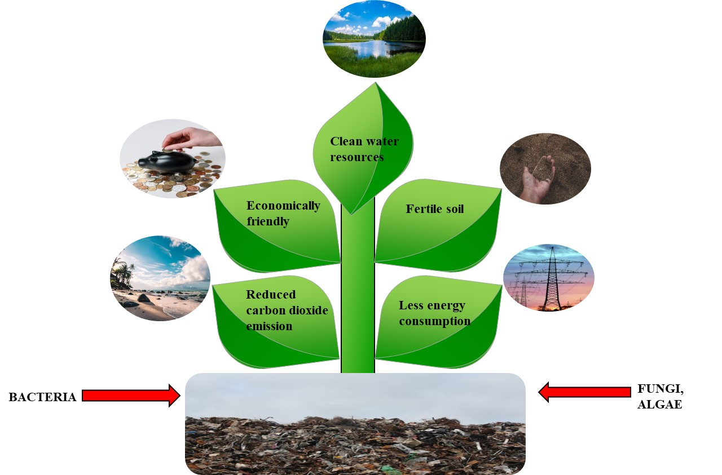
Figure 4: Advantages of Bioremediation

B. drawback of bioremediation
- It is only permitted for biodegradable substances. Not all chemicals experience a quick breakdown process.
- Some of the novel biodegradation items may be more destructive than the first chemicals and stay within the environment.
- The nearness of metabolically active microbial populaces, ideal natural development conditions, and availability to nutrients and toxins are all basic components of biological processes, which are highly specialized and ecologically friendly.
- This method is hard to promote through worktable and large scale work to large scale field work. Pollutants may exist within the framework of liquids, solids or gasses. This method typically involves long time than other management options like excavation, soil removal or incineration.
- Bioremediation can only be applied to products that have been biodegraded. Biodegradation is a process that results in quick and complete degradation. Products that undergo biodegradation can become more toxic or persistent in nature than their parent chemical.
- Regulatory investigation
- We are not sure that the bioremediation is 100% complete because there is no accepted description of cleanliness. Therefore, the evaluation of bioremediation efficiency is sensitive and bioremediation does not have a measurable endpoint.
- Limitation of scale- Measurement of bioremediation on the basis of batch and pilot data is sensitive to volume. Technology needs to be developed to develop advanced engineering technologies appropriate for sites where non-inversely partitioned combinations of pollutants are present in the environment. It can exist in solids, liquids and gasses phase.
- Time consuming process- The duration of bioremediation is longer than other methods of remediation, for instance dig and removal of contaminated soil.

Conclusion
Bioremediation techniques are the foundation of pollution eradication and restoration of contaminated sites. This field needs further exploration of microbes with inherent capabilities for bioremediation. Genetic transformation in these microbes can enhance their abilities to degrade pollutants with cautious supervision so that they do not transform into pathogenic strains. New engineering methods need to be developed for the massive treatment of pollutants within lesser time and at minimum expenditure. Further experimentation is required to investigate the efficiency of the catalysts to be utilized in the process. Mass-scale production of enzymes involved in biodegradation is required for direct treatment of contaminants. It is essential to educate people on how to separate the waste for disposal so that it may be treated without barriers. The first step in bioremediating a site is site description. Site description helps to identify the best and most promising ex-situ/in-situ (bioremediation) technique. Ex-situ considered to be costly because of the excavation and transport of the contaminated material. However, ex-situ can be used for many pollutants. On the other hand, in situ has no additional excavation costs. However, the costs connected with the installation of on-site equipment that effectively link and control the contaminated area’s surface area can reduce the effectiveness of some on-site ineffective bioremediations. Determining the best and most effective method for bioremediating contaminated sites should take into account the geology of the contaminated sites, soil composition, contaminant types and depths, habitat type, and the efficacy of each technique.
REFERENCES
[1] Varma JP and Jaiswal DK. Book review (2016): Advances in biodegradation and bioremediation of industrial waste. Frontiers in Microbiology. 2016; 6:1-2. DOI: 10.3389/fmicb.2015.01555
[2] Prescott LM, Harley JP, Klein DA. (2002) Microbiology. 5th ed. New York: McGraw Hill; pp. 10-14
[3] Singh R, Singh P and Sharma R. (2014) Microorganism as a tool of bioremediation technology for cleaning environment: A review. International Academy of Ecology and Environmental Science. 2014;4(1):1-6
[4] El Fantroussi S and Agathos SN (2005) Is bioaugmentation a feasible strategy for pollutant removal and site remediation? Current Opinion in Microbiology. 2005; 8:268-275.
[5] Madhavi GN and Mohini DD (2012) Review paper on parameters affecting bioremediation. International Journal of Life Science and Pharma Research. 2012; 2:77-80.
[6] Adams GO, Fufeyin PT, Okoro SE and Ehinomen I (2015) Bioremediation, biostimulation and bioaugmention: A review. International Journal of Environmental Bioremediation & Biodegradation.
[7} Boopathy R. (2000) Factors limiting bioremediation technologies. Bioresource Technology. 2000; 74:63-67.
[8] Frutos FJG, Pe’rez R and Escolano O (2012). Remediation trials for hydrocarbon-contaminated sludge from a soil washingprocess: Evaluation of bioremediation technologies. Journal of Hazardous Materials. 2012; 199:262-271. DOI: 10.1016/j.jhazmat.2011.11.017
[9] Smith E, Thavamani P, Ramadass K, Naidu R, Srivastava P, and Megharaj M (2015) Remediation trials for hydrocarbon-contaminated soils in arid environments: Evaluation of bioslurry and biopiling techniques. Integrated Journal of Biodeterioration Biodegradation. 2015; 101:56-65. DOI: 10.1016/j.ibiod.2015.03.029
[10]. Indu Sharma (2020) Bioremediation Techniques for Polluted Environment: Concept, Advantages, Limitations, and Prospects December 7th, 2020. DOI: 10.5772/intechopen.90453
[11]. Kulshreshtha A, Agrawal R, Barar M and Saxena S (2014). A review on bioremediation of heavy metals in contaminated water. IOSR Journal of Environmental Science Toxicology and food Technology (IOSR-JESTFT). 2014;8(7):44-50
[12] Coulon F, Al Awadi M, Cowie W, Mardlin D, Pollard S and Cunningham C (2009) When is a soil remediated? Comparison of biopiled and windrowed soils contaminated with bunker-fuel in a full-scale trial. Environmental Pollution. 2009;158:3032-3040. DOI: 10.1016/j.envpol.2010.06.001
[13] Dias RL, Ruberto L, Calabró A, Balbo AL, Del Panno MT and Mac Cormack WP (2015). Hydrocarbon removal and bacterial community structure in on-site biostimulated biopile systems designed for bioremediation of diesel-contaminated Antarctic soil. Polar Biology. 2015; 38:677-687. DOI: 10.1007/s00300-014-1630-7
[14] Whelan MJ, Coulon F, Hince G, Rayner J, McWatters R and Spedding T (2015) Fate and transport of petroleum hydrocarbons in engineered biopiles in polar regions. Chemosphere. 2015; 131:232-240. DOI: 10.1016/j.Chemosphere.2014.10.088
[15] Aislabie J, Saul DJ and Foght JM (2016) Bioremediation of hydrocarbon contaminated polar soils. Extremophiles. 2006; 10:171-179. DOI: 10.1007/s00792-2005-0498-4
[16] Silva-Castro GA, Uad I, Gὀnzalez-Lὀpez J, Fandiño CG, Toledo FL and Calvo C (2012) Application of selected microbial consortia combined with inorganic and oleophilic fertilizers to recuperate oil-polluted soil using land farming technology. Clean Technology of Environment Policy. 2012; 14:719-726. DOI: 10.1007/s10098-011-0439-0
[17] Mohan SV, Sirisha K, Rao NC, Sarma PN and Reddy SJ (2004) Degradation of chlorpyrifos contaminated soil by bioslurry reactor operated in sequencing batch mode: Bioprocess monitoring. Journal of Hazardous Materials. 2004; 116:39-48. DOI: 10.1016/j.jhazmat.2004.05.037
[18] Folch A, Vilaplana M, Amado L, Vicent R and Caminal G (2013) Fungal permeable reactive barrier to remediate groundwater in anartificial aquifer. Journal of Hazardous Materials. 2013; 262:554-560. DOI: 10.1016/j.jhazmat.2013.09.004
[19] Frascari D, Zanaroli G and Danko AS (2015) In situ aerobic cometabolism of chlorinated solvents: A review. Journal of Hazardous Materials. 2015; 283:382-399. DOI: 10.1016/j.jhazmat.2014.09.041
[20] Roy M, Giri AK, Dutta S and Mukherjee P. Integrated phytobial remediation for sustainable management of arsenic in soil and water. Environment International. 2005; 75:180-198. DOI: 10.1016/j.envint.2014.11.010
[21] Gidarakos E and Aivalioti M (2007) Large scale and long term application of bioslurping: The case of a Greek petroleum refinery site. Journal of Hazardous Materials. 2007; 149:574-581. DOI: 10.1016/j. jhazmat.2007.06.110
[22] Höhener P and Ponsin V (2014) In situ vadose zone bioremediation. Current Opinion in Biotechnology. 2014; 27:1-7. DOI: 10.1016/j.copbio.2013.08.018
[23] Lee JH (2013) An overview of phytoremediation as a potentially promising technology for environmental pollution control. Biotechnology and Bioprocess Engineering. 2013; 18:431-439. DOI: 10.1007/s12257-013-0193-8
[24] Miguel AS, Ravanel P and Raveton M (2013) A comparative study on the uptake and translocation of organochlorines by Phragmites australis. Journal of Hazardous Materials. 2013; 244:60-69. DOI: 10.1016/j.jhazmat.2012.11.025
[25] Meagher RB (2000). Phytoremediation of toxic elemental organic pollutants. Currant Opinion Plant Biology. 2000; 3:153-162. DOI: 10.1016/S1369-5266(99)00054-0
[26] Kuiper I, Lagendijk EL, Bloemberg GV, Lugtenberg BJ and Rhizoremediation (2004) A beneficial plant-microbe interaction. Molecular Plant Microbe Interactions. 2004; 7:6-15. DOI: 10.1094/MPMI.2004.17.1.6
[27] Thiruvenkatachari R, Vigneswaran S and Naidu R (2007) Permeable reactive barrier for groundwater remediation. Journal of Industrial and Engineering Chemistry. 2007; 14:145-156. DOI: 10.1016/j.jiec.2007.10.001
[28] Obiri-Nyarko F, Grajales-Mesa SJ and Malina G (2014) An overview of permeable reactive barriers for in situ sustainable groundwater remediation. Chemosphere. 2014; 111:243-259. DOI: 10.1016/j.chemosphere.2014.03.112

