GIS: INDENTIFYING OF GROUNDWATER RECHARGES AND SITES FOR SUITABLE WATER SUPPLY

Authors:
Debasish Roy¹, Niraj Biswakarma², Partha Pratim Maity³, Koushik Bag², Tridiv Ghosh³, Ananta Vashisth*³
Affiliation:
¹India Meteorological Department, Mausam Bhawan, New Delhi-110003
²ICAR-Research Complex for NEH Region, Umiam, Meghalaya-793103
³ICAR- Indian Agricultural Research Institute, New Delhi-110012
Email: ananta.iari@gmail.com (corresponding author)
ABSTRACT

In order to achieve enhanced water management for sustainable agriculture, food security, and healthy functioning of ecosystem, water productivity must be increased. The demand of fresh water rapidly increasing with the enormous amount ongoing development projects. Thus, judicious water management strategies adoption could be viable option that is possible when utilize include the geo-information. This chapter reviews opportunities for improving and identifying the ground water potential zones and sites for suitable water supply using geospatial modeling. Identifying the most promising combination of options for improving groundwater potential zones or sites is complex and largely determined by the economic capacity of the stakeholders or policymakers. However, exploitation of groundwater should be carried out together with artificial recharging in order to maintain the long-term sustainability of water resources. GIS approach was used to delineate potential artificial recharge sites and influential thematic maps such as rainfall, lineament, slope, drainage, land use/land cover, lithology, geomorphology and soil characteristics were integrated by using a weighted linear combination method.
Keywords: GIS; Ground water recharges; Hydrologic cycle; Evapotranspiration
- INTRODUCTION

Water is the driving force for food security, industrial production, and sustaining ecosystems as well as socio-development of a country. Groundwater accounts for about 30% of the earth’s freshwater, whereas surface water resources from lakes and rivers accounts for less than 0.3% [1]. Recent times, ever growing the population, rapid industrialization and urbanization coupled with poor water resources management have resulted in the escalation of water scarcity and environmental problems worldwide. This has led the water resources planning and management issue an increasingly complex and challenging task to address [2]. The Global Risks Report-2016, published by the World Economic Forum, states that water crisis is the biggest risk to the world for the coming decade. Hence, there is a pressing need to significantly improve water resources management worldwide so as to sustain liveable conditions on the earth for the present and future generations. Further, the introduction of high yielding varieties to meet increased agricultural demand during the early seventies as part of the green revolution, led to over-exploitation of groundwater beyond the naturally replenishable limit in some areas. Considering gradual decline of water resources, increasing water demand, widespread mismanagement and threat of climate change, there is a need to manage scarce and finite water resources more judiciously and efficiently. Among alternative water resources available for reuse, rainwater is most preferred by the people and hence, rainwater harvesting (RWH) has emerged as a widespread practice across the globe to address water scarcity and other environmental problems. Harvested rainwater is considered one of the best and cost-effective alternative water sources because rainwater can easily be collected and can be used for non-potable purposes without significant treatment. Therefore, the integration of Geographic Information System (GIS) and Multi-Criteria Decision Analysis (MCDA) approaches is necessary, which helps in developing a framework for the delineation and identification of rain water harvesting potential zones and groundwater recharge sites. GIS has the capability of storage, retrieval, processing and analysis of multi-source spatio-temporal datasets. On the other hand, MCDA provides a rich collection of techniques and procedures for structuring decision problems by designing, evaluating and prioritizing the alternatives [3].
- HYDROLOGIC CYCLE AND GROUND WATER RECHARGE

The water present in the pore space of regolith and beds rocks below the ground surface. The endless circulation of water as it moves in its various phases through the atmosphere, to the Earth, over and through the land, to the ocean, and back to the atmosphere is known as the hydrologic cycle. This cycle is powered by the Sun; through phase changes of water (i.e. evaporation and condensation) involving storage and release of latent heat, it affects the global circulation of both the atmosphere and oceans, and hence is instrumental in shaping weather and climate. The efficiency of water as a solvent makes geochemistry an intimate part of the hydrologic cycle; all water-soluble elements follow this cycle at least partially. Thus, the hydrologic cycle is the integrating process for the fluxes of water, energy, and the chemical elements. This cycle is the foundation of hydrological science and occurs over a wide range of space and time scale. Water enters the hydrologic system as precipitation, in the form of rainfall or snowmelt. It leaves the system as stream flow or runoff, and as evapotranspiration, a combination of evaporation from open bodies of water, evaporation from soil surfaces, and transpiration from the soil by plants. Precipitation is delivered to streams on the land surface as overland flow to tributary channels, and in the subsurface as interflow or Lateral subsurface flow and base flow following infiltration into the soil. A portion of the infiltrated water enters the groundwater or aquifer system by passing through the vadose or unsaturated zone, and it exits to the atmosphere, surface water, or to plants. As Figure 1 shows, the flow lines deliver groundwater from the high lands towards the valleys, or from the recharge areas to the discharge areas. As the figure also shows, in a recharge area there is a component to the direction of groundwater flow that is downward. Groundwater recharge is the entry to the saturated zone of water made available at the water table surface. Conversely, in a discharge area there is a component to the direction of groundwater flow that is upward (Figure. 1). Groundwater discharge is the removal of water from the saturated zone across the water table surface. The patterns of groundwater flow from the recharge to the discharge areas form groundwater flow systems, which constitute the framework for understanding recharge processes.
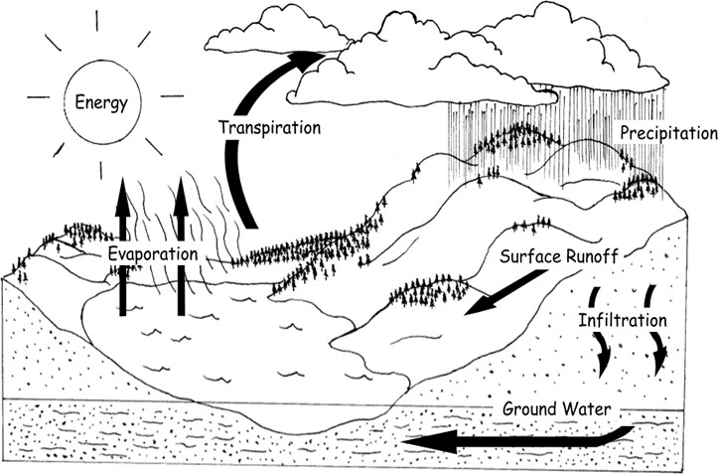
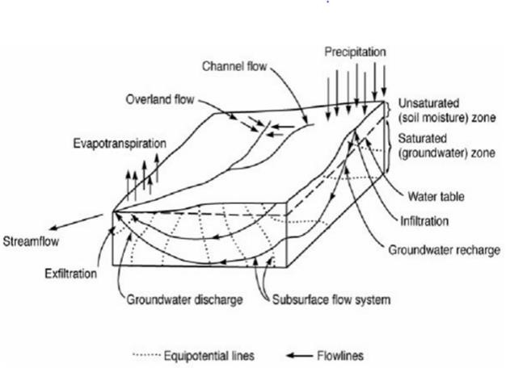
Fig1: Schematic representation of the hydrologic cycle and groundwater recharge (from Freeze, 1974)

THE IMPORTANCE OF GROUNDWATER?
  - Groundwater is important as drinking water, for irrigation, and in everyday use.
  - Groundwater is water that percolates through porous terrain, and is held underground in the soil, or in fractures and crevices in rock.
  - Groundwater is stored in, and moves through, layers of soil, sand and rock called aquifers. Water in aquifers is brought to the surface through natural springs, or can be discharged into lakes and streams.
  - Groundwater can also present itself on the surface as an oasis or wetlands.
  - Groundwater is more plentiful than surface water. Around 90 percent of freshwater supplies in the United States come from groundwater.
  - The United States uses 79.6 billion gallons per day of fresh groundwater for public supply, private supply, irrigation, livestock, manufacturing, mining, thermoelectric power, and other purposes. Of that total amount, California pumps 10.7 billion gallons per day.
  - Groundwater is also very important as it supplies springs, and much of the water in our ponds, marshland, swamps, streams, rivers and bays. Although it is “out of sight,” it is critical that we learn about groundwater, how it is part of the water cycle, and the importance of protecting and maintaining the quality and quantity of this water resource.

HOW CAN WE HELP MAINTAIN OUR WATER SUPPLY?
As part of the water cycle, some precipitation infiltrates the ground and percolates down until it reaches a depth where all the fractures, crevices and pore spaces are saturated with water. In this saturated zone – called an aquifer – the water is called groundwater. The upper surface of a zone of saturation is the water table. In other words, the water table is the first occurrence of groundwater. Above the water table is the zone of aeration (also called the unsaturated zone). There is some water in the zone of aeration, but it will not flow into a well. So successful wells need to be deeper than the water table. Aquifers are geologic formations – layers of sand, gravel and rock – where significant amounts of water can be stored, transported or supplied to well or a spring. They are irregular in shape, and can be close to the surface, or very deep. Under your home, there may be several aquifers layered one on top of another. Because of this, neighboring homes potentially can have their wells in different aquifers and experience different water quality. There are two types of aquifers: confined and unconfined. Unconfined aquifers, generally located near the land surface, have no layers of clay (or other impermeable geologic material) above their water table, although they do lie above relatively impermeable clay beds. The upper limit of groundwater within an unconfined aquifer is the water table. In many places, the water table is actually above the surface of land. Wetlands are a great example of where groundwater becomes surface water.
Groundwater in an unconfined aquifer (sometimes called a “water table aquifer”) is more vulnerable to contamination from surface pollution than a confined aquifer because pollutants on the land surface can enter the unconfined aquifer as water infiltrates the soil. Confined aquifers, on the other hand, have layers of impermeable material above and below them – so they are contained within these layers. The geologic barriers cause the water to be under pressure. Fractures, or cracks, in bedrock also are capable of bearing water. The bedrock aquifers can have large openings where groundwater has dissolved some of the rock. These openings can store large amounts of water, accounting for the high yields of wells in this area. Groundwater flows vertically and horizontally through the aquifers at rates that are influenced by gravity and the geologic formations of the area. Groundwater can remain in an aquifer for a short period measured in days, or for many centuries. In fact, the deep aquifers under parts of Virginia’s Coastal Plain are considered “fossil aquifers” as the water in them has been there for more than 10,000 years.

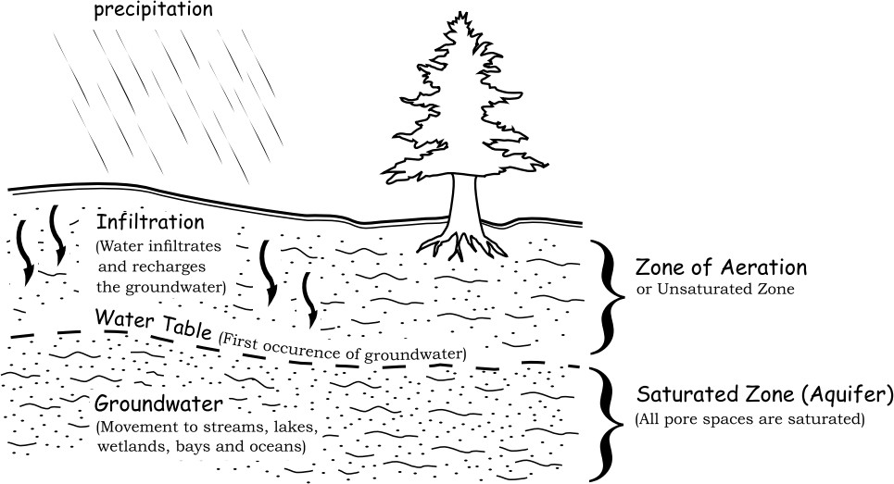
Fig 2: Components of groundwater recharge

Tecchnologies: Geo-statistical routines are implemented in the petroleum reservoir modelling and aquifer modelling packages like Petrel, Roxar’s Irap RMS; and GMS (Groundwater Modelling System) used in the generation of grids of facies, permeability (hydraulic conductivity), porosity, etc. for the reservoir or aquifer.
- Inverse Distance Weighting (IDW)- Weighted is provide according to distance.
- Stochastic simulation: use statistical technique to assess the error associated its predictions.
- Kriging: Optimal interpolation based on regression against observed z values of surrounding data points, weighted according to spatial covariance values.

WEIGHTED OVERLAY SUITABILITY MODEL TO DEVELOP PRIORITY MAP
 | $$S=\sum{W_{i}}X_{i}$$ | ₍₁₎

Where, W_{i} is weight of i^{th} factor map X_{i} = Criteria score of class of factor S = Suitability index for each pixel in the map. The total weights of each pixel of the final integrated layer were derived from the following equation:
 | $$S={SL}_{f}{SL}_{c}+{LU}_{f}{LU}_{c}+{LW}_{f}{LW}_{c}+{LT}_{f}{LT}_{c}+{LR}_{f}{LR}_{c}+L_{f}L_{c}+{PR}_{f}{PR}_{c}+{DG}_{f}{DG}_{c}$$ | ₍₂₎
Where, S=the dimensionless artificial groundwater recharge index for each pixel in the final integration layer, SL= Land slope, LU=distance to the urban (residential) areas, LW =distance to the supply wells, LT =the distance to the treatment plants, LR=the distance to the roads, L=the land use, PR=the pollution risk and DG= depth to groundwater. The subscript letter ‘f’ represents the weight of each factor, while ‘c’ represents the weight of each class of the individual factor.

- WEIGHTED LINEAR COMBINATION METHOD
Develop the groundwater recharge potential index of each pixel in the area utilizing the following equation:
 | $$Pr={RF}_{w}{RF}_{r}+{LG}_{W}{LG}_{R}+{GG}_{W}{GG}_{r}+{SG}_{W}{SG}_{R}+{LD}_{W}{LD}_{r}+{DD}_{W}{DD}_{r}+{LC}_{W}{LC}_{c}+{SC}_{W}{SC}_{r}$$ | ₍₃₎
Where, Pr =groundwater recharge potential index, RF =rainfall index, LG= lithology index GG= geomorphology index, SG= slope gradient index, LD=lineament density index D=drainage density index, LC=land cover/land use index and SC=soil cover index, ‘w’ and ‘r’ refer to the weight of a theme and the rank of individual features.
- MULTICRITERIA ANALYSIS AND GIS MODELLINING
Geographic information system based-multicriteria decision analysis (MCDA) to delineate potential areas for rainwater harvesting (RWH) map, water demand zones identify sites suitable for RWH and artificial recharge structures, and to prioritize zones/sites for easy implementation of RWH strategies in the study area. The integrated use of GIS and MCDA is very powerful and effective in handling complex real-world problems, and this approach is gaining popularity in the field of land and water resources management [4]; [5]. Some of the past studies used simply remote sensing (RS) and geographic information system (GIS) techniques for the selection of RWH and artificial recharge zones/sites. [6] proposed a GIS- based artificial recharge planning in a coastal aquifer of Gavbandi River basin, Southern part of Iran by integrating thematic layers such as geology, geomorphology, slope, land use, infiltration rate, electrical conductivity, electrical resistivity and depth to groundwater using Boolean logic and Fuzzy logic. However, [7] integrated application of RS, GIS and MCDA techniques for the delineation of RWH potential zones and the selection of recharge zones sites for artificial recharge has gained importance in recent times.
GIS-based MCDA method integrates and transforms spatial data (input) into the decision (output), where qualitative information of individual themes and features are converted into quantitative values using Saaty’s scale [8] by constructing pairwise comparison matrix. Weights were assigned to the themes and features based on the opinions of some experts in hydrology and hydrogeology along with local experiences. The weights of the themes and their features were assigned and normalized using Saaty’s Analytic Hierarchy Process. In order to check the consistency of weights assigned to different themes and their features, the ‘Consistency Ratio’ as suggested by [8] was calculated using following equation:
 | $$CR=\frac{CI}{RCI}$$ | ₍₄₎
Where, RCI is random consistency index and CI is consistency index. [8] recommended that the value of CR should be less than 10%; otherwise the weights should be re-evaluated to maintain consistency.

- GIS-BASED RUNOFF MODELING AND GENERATION OF RUNOFF POTENTIAL MAP

Soil and land use land cover maps along with rainfall data were used for GIS-based runoff modeling and generation of potential runoff map. The Natural Resources Conservation Service Curve Number (NRCS-CN) [9] technique was applied for estimation of direct runoff in the study area. The curve number (CN) is most commonly used the reliable and conceptual technique for estimating surface runoff [10]; [11]. The expression for computing runoff using curve number is given as:
 | $Q=\frac{{(p-ls)}^{2}}{p+\left(1-l\right)s} for p≥$_{1S} | ₍₅₎

Where, Q = direct surface runoff, [L]; P = precipitation, [L]; and S = potential maximum retention after runoff begins, [L], l = surface depression storage (initial abstraction ratio) (dimensionless). The value of surface depression storage, l in Eq. (5) was assumed to be 0.2 as a standard value by the Soil Conservation Service [9]. Eq. (1) has been modified for Indian conditions [12], where l = 0.1 is applicable for black soils under AMC (antecedent moisture condition) types II and III. While the value of l equal to 0.3 is valid for black soils under AMC-I condition and valid for all other soils under three AMC conditions. AMC is an indicator of watershed wetness and availability of soil storage prior to a storm. Thus, three levels of AMC conditions namely AMC-I, AMC-II and AMC-III that indicate dry, normal and wet conditions in the study area were considered, respectively. Previous five days rainfall amount was considered for determination of AMC using standard guidelines, S (in mm) is expressed in terms of a curve number (CN) and was computed by [13].

- DELINEATION OF RAINWATER HARVESTING POTENTIAL ZONES

Thematic layers runoff coefficient (normal rainfall year), slope and drainage density were integrated in GIS environment and the total weights for individual polygons were computed using Weighted Linear Combination (WLC).
 | $$RWHPI={RC}_{wt}{RC}_{wf}+{SL}_{Wt}{SL}_{Wf}+{DD}_{Wt}{DD}_{Wf}$$ | ₍₆₎

Where, RC_{wt} = normalized weight of the runoff coefficient theme, RC_{wf} = normalized weight of a feature of the runoff coefficient theme, SL_{wt} = normalized weight of the slope theme, SL_{wf} = normalized weight of a feature of the slope, DD_{wt} = normalized weight of the drainage density theme, and DD_{wf} = normalized weight of a feature of the drainage density theme.

- DELINEATION OF RAINWATER HARVESTING DEMAND ZONES

Thematic layers such as water demand, water table fluctuations and post-monsoon groundwater levels.
 | $$RWHDI={WD}_{wt}{WD}_{wf}+{PM}_{Wt}{PM}_{Wf}+{WF}_{Wt}{WF}_{Wf}$$ | ₍₇₎

Where, WD_{wt} = normalized weight of the water-demand theme,
WD_{wf} = normalized weights of the water-demand theme features,
PM_{wt} = normalized weight of the post-monsoon groundwater-level theme,
PM_{wf} = normalized weights of the post-monsoon groundwater-level theme features,
WF_{wt} = normalized weight of the groundwater-fluctuation theme, and
WF_{wf} = normalized weights of features of the groundwater-fluctuation theme

- CONCLUSIONS

From the above study it was concluded that using of GIS technique we can provide scientific guidelines for decision makers and water managers for the effective planning and management of rainwater at a large scale. Addresses environmental issues such as waterlogging/salinity and flooding. The resultant suitability map and the methodology employed in this study will serve as a guideline for future water management projects. Assist water managers in the efficient planning and execution of water harvesting schemes for improved and sustainable water supply. Replicated in other parts of developing and developed worlds to tackle water scarcity and climate change problems.
- REFERENCES

[1] Shiklomanov, I. A. (1991). The world’s water resources. In Proceedings of the international symposium to commemorate (Vol. 25, pp. 93-126). Paris, France: Unesco.
[2] Biswas, A. K., Tortajada, C., and Izquierdo-Avino, R. (Eds.). (2009). Water management in 2020 and beyond. Berlin: Springer.

[3] Malczewski, J. (2010). Multiple criteria decision analysis and geographic information systems. In Trends in multiple criteria decision analysis (pp. 369-395). Springer US.

[4] Chowdary, V. M., Ramakrishnan, D., Srivastava, Y. K., Chandran, V., & Jeyaram, A. (2009). Integrated water resource development plan for sustainable management of Mayurakshi watershed, India using remote sensing and GIS. Water resources management, 23(8), 1581-1602.

[5] Jha, M. K., Chowdary, V. M., Kulkarni, Y., & Mal, B. C. (2014). Rainwater harvesting planning using geospatial techniques and multicriteria decision analysis. Resources, Conservation and Recycling, 83, 96-111.

[6] Ghayoumian, J., Saravi, M. M., Feiznia, S., Nouri, B., & Malekian, A. (2007). Application of GIS techniques to determine areas most suitable for artificial groundwater recharge in a coastal aquifer in southern Iran. Journal of Asian Earth Sciences, 30(2), 364-374.

[7] Mbilinyi, B. P., Tumbo, S. D., Mahoo, H., & Mkiramwinyi, F. O. (2007). GIS-based decision support system for identifying potential sites for rainwater harvesting. Physics and Chemistry of the Earth, Parts a/b/c, 32(15-18), 1074-1081.
[8] Saaty, T. L. (1990). How to make a decision: the analytic hierarchy process. European journal of operational research, 48(1), 9-26.

[9] SCS, U. (1985). National engineering handbook, section 4: hydrology. US Soil Conservation Service, USDA, Washington, DC.

[10] D’Asaro, F., & Grillone, G. (2012). Empirical investigation of curve number method parameters in the Mediterranean area. Journal of Hydrologic Engineering, 17(10), 1141-1152.

[11] Ponce, V. M., & Hawkins, R. H. (1996). Runoff curve number: Has it reached maturity? Journal of hydrologic engineering, 1(1), 11-19.

[12] Subramanya, K. (2008). Engineering Hydrology. Tata McGraw-Hill Publishing Company Ltd., New Delhi, India, pp 155-160.

[13] Singh, V.P. (1992). Elementary Hydrology. Prentice-Hall of India Private Limited, New Delhi, India, pp. 474–482.

