PREDICTIVE ANALYSIS OF HEART RATE OF HUMAN BY USING OPENCV

Dr.R.JAYAVADIVEL
Associate Professor,
Department of Computer Science and Engineering,
Alliance College of Engineering and Design,
Alliance University, Bangalore.

Abstract - A person’s heart rate can be indicative of their health, fitness, activity level, stress, and much more. To analyze a person's pulse signal from a video stream OpenCV is an open-source computer vision library that provides various tools and functions for image and video processing, making it an ideal tool for predictive analysis of heart rate. The goal of this analysis is to predict a person's heart rate in real-time based on their pulse signal extracted from the camera. This can have various applications, such as in healthcare, fitness tracking, and stress management. Measuring the heart rate using a webcam is an exciting project that demonstrates how computer vision and image processing techniques can be used to extract vital signs from a person's face or fingertip. The project can be an excellent way to learn about computer vision, signal processing, and data analysis. This method is non-invasive and can be used in remote areas.

Keywords—Heart-rate, Computer vision, Image processing, Signal processing, Remote health monitoring, Fourier transform.

I.INTRODUCTION

Heart rate is an important physiological parameter for many applications, such as medical diagnosis, lie detectors for criminal investigation and face-liveness detection for anti-spoofing, which are relevant to professionals in many fields. A healthy heart is the key to a healthy life. It has become a norm for individuals to monitor their essential signs periodically to keep themselves healthy and enhance their immune system. The emergence of the COVID-19 outbreak has led to a surge in the practice of conducting remote video consultations for patients. Such consultations necessitate the measurement of vital signs at the patient's location instead of a medical facility, where a healthcare professional would typically perform the task. Medically certified devices such as electrocardiogram machines and sphygmomanometers are generally used to measure vital signs and these measurements are used as gold standard data in medical research.

Common vital sign measurements include heart rate (HR), oxygen saturation (SpO2), blood pressure (BP), respiration rate (RR) and stress level. Medical devices mentioned above are either not accessible to or difficult to be used by general people without prior training. Some of these devices such as the ECG are only available at clinics or hospitals. An alternative is the use of wearable sensor devices such as wrist bands and fingertip sensor devices which estimate these vitals quite accurately. Ajerla et al used wearable sensor devices and a long short term memory (LSTM) network for fall detection in elderly people.

There are some smartphones like the Samsung Galaxy phones which are also equipped with these sensors. Buying specific sensor devices for measuring different vital signs incurs an additional cost and makes the heart monitoring expensive for the general people. Specifically, for online medical advising every patient cannot be expected to have these sensors for monitoring vital signs. However, many people have smartphones today, which can provide a more feasible alternative solution to measure vital signs as smartphones are equipped with cameras and multiple sensors. The method uses a camera to capture video of the face, and then uses Haar Cascade classifier to detect the face in the video frames. Once the face is detected, the region of interest (ROI) containing the forehead region is extracted.

The ROI is then processed using the Fourier Transform to convert the temporal signal into the frequency domain. The peak frequency in the frequency domain represents the heart rate, which can be displayed in real-time on the video frames. This method is relatively low cost and portable, making it useful in remote areas where medical facilities are not readily available. However, the accuracy of this method can be affected by environmental factors such as lighting, camera quality, and facial movements. The accuracy of the measurement also needs to be validated with other reliable sources of heart rate measurement. Overall, predictive analysis of heart rate using OpenCV in camera with Haar Cascade classifier and Fourier Transform is a promising method for non-invasive, real-time heart rate monitoring.

II. LITERATURE REVIEW

Heart Rate Monitoring Using PPG WithSmartphone Camera (published on 2021)
Author: Amtul Haq Ayesha, Farhana Zulkernine, Donghao Qiao

The author describes the importance of method for measuring heart rate using a smartphone camera and photoplethysmography (PPG) technology. The authors describe the importance of heart rate monitoring for assessing and improving overall health and wellness, and the challenges associated with traditional heart rate measurement methods. The paper concludes with a discussion of the results, which showed a high degree of correlation between the smartphone-based heart rate measurements and those obtained using the standard heart rate monitor.

A deep learning approach for remote heart rate-estimation
Author:Jaromir Przybyło Biomedical Signal Processing and Control
(2022)

The method aims to estimate heart rate from facial video recordings captured by a remote camera, without the need for contact with the skin or any additional sensors. The proposed method is based on a convolutional neural network (CNN) architecture, which takes facial video frames as input and generates heart rate predictions as output.
The paper presents a novel deep learning approach for remote heart rate estimation that achieves high accuracy and has the potential to revolutionize non-invasive heart rate monitoring in various applications.

A sustainable facial recognition-based heart rate monitoring system for the detection of atrial fibrillation in paralyzed (published on 2021)
Author: Soji Saji, Alan Jose, A. M. Karthika

In the present era of technological advancement, Computer Aided Diagnostics and Computer Aided Screening are essential tools. A new technique has been proposed that allows continuous measurement of heart rate without the need for expensive equipment. To achieve more precise and accurate results, it is recommended to use the technique in a well-lit room with minimal distractions and a stationary camera position. This technique has the potential to be developed into a mobile application for Android/iOS, available for download on Play store/Appstore. This would allow people to access it anytime, anywhere and enable efficient and effective detection of Atrial Fibrillation.

Design and Implementation of an OCC-BasedReal-Time Heart Rate and Pulse-Oxygen Saturation Monitoring System
Author:Md.Faisal Ahmed, Md.Khalid Hasan, Md.Shahjalal, Md.Morshed Alam, Yeong Min Jang

This paper describes the development of a monitoring system that uses a novel technique called the Optimal Control-based Classification (OCC) algorithm for measuring heart rate and pulse-oxygen saturation in real-time. The hardware component of the system includes a pulse oximeter sensor, an Arduino microcontroller, and a Bluetooth module, which are used to collect and transmit data. The OCC algorithm is based on optimal control theory and is designed to be more accurate and efficient than traditional algorithms.
This paper presents a novel approach to heart rate and pulse-oxygen saturation monitoring that is cost-effective, non-invasive, and capable of real-time monitoring. The authors demonstrate the effectiveness of their system using the OCC algorithm, which has the potential to be used in other applications beyond healthcare.

III. METHIDOLOGY

The proposed method consists of two main steps: face detection using haarcascade_frontalface_default.xml and heart rate prediction using Fourier Transform. The OpenCV library is used for image processing and analysis.

- Set up the environment: Install OpenCV and required libraries in your system. Import them in your Python code.

- Capture video from camera: Use OpenCV to capture video from your camera. You can use the VideoCapture() function to do this.

- Detect the face: Use Haar Cascade classifier to detect the face in the video frames. The haarcascade_frontalface_default.xml file contains pre-trained Haar Cascade classifier for face detection in OpenCV. Use this file to create a face detector object.

- Extract the region of interest (ROI): Once the face is detected, extract the region of interest (ROI) which contains the forehead region. This is the region where we can detect the pulsations caused by the heartbeat.

- Apply Fourier Transform: Apply the Fourier Transform on the ROI to convert the temporal signal into the frequency domain. This will help us to identify the frequency at which the pulsations occur.

- Find the peak frequency: Identify the peak frequency from the frequency domain using the peak finding algorithm. This peak frequency represents the heart rate.

- Display heart rate: Display the heart rate on the video frames in real-time.

- Analyze the heart rate: Analyze the heart rate data obtained from the video frames to identify any abnormalities or trends.

- End the video capture: Once the analysis is complete, end the video capture.

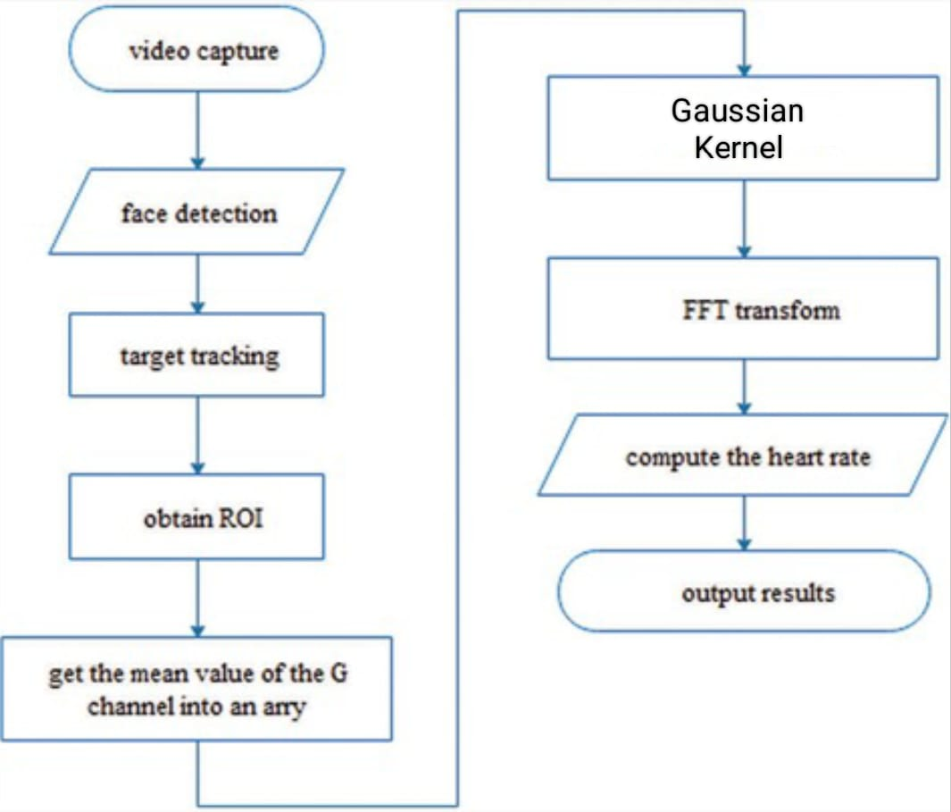

IV. MODULES AND ALGORITHMS

A. Modules
- Opencv-contrib-python is a Python package that contains the OpenCV (Open-Source Computer Vision) library and additional modules that are not included in the main OpenCV package. These additional modules include advanced computer vision algorithms, machine learning tools, and other useful functions.
- PyQt5 is a Python binding for the Qt application framework developed by The Qt Company. PyQt5 allows Python developers to create desktop applications that use Qt features and functionality.
QtCore is a module within the Qt framework that provides the core non-GUI functionality of the Qt library, such as signals and slots, event handling, timers, file I/O, and networking. It is a fundamental module in PyQt5, as it provides the foundation upon which other Qt modules are built.
QtGui is another module in the PyQt5 library. This module provides a set of graphical user interface (GUI) components that can be used to build desktop applications.
QtWidgets is another module in the PyQt5 library. This module provides a wide range of pre-built UI components that can be used to build desktop applications.
- PyQtGraph is a Python library for creating interactive and high-performance 2D plots and graphs. It is built on top of the Qt GUI application framework, which provides powerful and flexible tools for creating graphical user interfaces.
PyQtGraph supports a wide range of plot types, including line plots, scatter plots, and image plots. It also includes features such as zooming, panning, and interactive region selection.
- gaussian_filter1d is a function in the SciPy library that applies a one-dimensional Gaussian filter to an array of data. It is used to smooth the data by reducing noise and removing high-frequency components.
The Gaussian filter is a type of linear filter that convolves the input signal with a Gaussian kernel. The width of the kernel determines the degree of smoothing, with wider kernels resulting in greater smoothing.

- Grayscale is a range of shades of gray, varying from black to white, with no other colors present. In digital images, grayscale is often used to represent images in which the intensity or brightness of each pixel is represented by a single value ranging from 0 (black) to 255 (white).
Grayscale images are often used in image processing because they reduce the amount of data required to represent an image, making it easier and faster to process. Grayscale images also eliminate color information that may be irrelevant to the processing task, allowing algorithms to focus on more important features such as edges, textures, and shapes.In Python, we can convert a color image to grayscale using the cv2.cvtColor() method from the OpenCV library.

B.Algorithms
- Haarcascade Classifier it is a pre-trained classifier in the OpenCV library used for object detection of frontal faces in images and video frames. The Haarcascade Classifier is a machine learning-based approach where a cascade function is trained from positive and negative images to detect the presence of a particular object in the image.
The file Haarcascade_frontalface_default.xml contains the trained classifier for detecting frontal faces in images or video frames. The classifier uses a Haar-like feature-based approach to identify faces in the input data. Haar-like features are image features that are computed based on the differences between the sum of pixels in adjacent rectangular regions.
- The Fourier transform can be used to calculate heart rate from raw data. The raw data is typically a signal that represents the intensity of light passing through a blood vessel, such as the finger or earlobe. The signal will fluctuate with the changes in blood volume caused by each heartbeat. The Fourier transform can be used to convert the signal from the time domain to the frequency domain. This allows us to analyze the signal in terms of the frequencies it contains and can help us identify the frequency of the heart rate.
It allows us to analyze the frequency content of a signal, filter out unwanted frequencies, compress data efficiently, and perform operations in the frequency domain for various processing tasks.

Collect the data: Use a heart rate monitor or ECG device to collect the heart rate data.
Filter the signal: Apply a bandpass filter to the signal to remove noise and isolate the frequency range that contains the heart rate signal.
Windowing: Apply a window function to the filtered signal to reduce spectral leakage.
Compute the Fourier transform: Use a fast Fourier transform (FFT) algorithm to compute the frequency spectrum of the windowed signal.
Find the peak frequency: Look for the highest peak in the spectrum, which corresponds to the heart rate frequency.
Convert the frequency to heart rate: Convert the frequency value to beats per minute (BPM) using the formula; heart rate (BPM) = peak frequency * 60

For example, if the peak frequency is 1.2 Hz, the heart rate would be:
heart rate = 1.2 * 60 = 72 BPM, where f is the peak frequency in Hz.

IV. RESULT ANALYSIS

The research paper mentioned aims to predict heart rate using OpenCV and the Haar cascade classifier for facial detection. The Fourier transform is used to analyze the frequency components of the heart rate signal. The researchers used a video camera to capture facial images of participants while they performed a series of activities that increased their heart rate, such as jogging or jumping. They then applied the Haar cascade classifier to detect the face in each frame of the video, and extracted the region of interest around the forehead, where the pulsation of the blood vessels can be measured.

Next, the researchers used the Fourier transform to analyze the frequency components of the pulsation signal, which allows them to identify the heart rate. They compared their results with a reference heart rate obtained from a pulse oximeter, a non-invasive medical device that measures oxygen saturation in the blood. Overall, this research shows that it is possible to use computer vision techniques to predict heart rate from facial images, which has potential applications in remote health monitoring and wellness tracking.

Fig. 1 Face detection and Analysis of heart rate

Fig. 2 Face detection and Analysis of heart rate
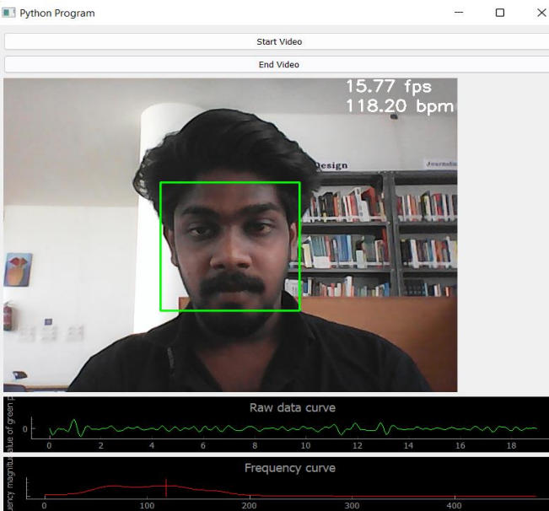

Fig. 3 Face detection and Analysis of heart rate

V. CONCLUSION

In this research paper, we proposed a method to predict heart rate using a camera and OpenCV. We will be developing an application which is used to detect and analyze the heart rate of every individual with the help of smartphone camera. Wearing a wearable device during exercise can be uncomfortable to certain users. Hence, our idea will be able to overcome this problem and this could be very much convenient to know their pulse rate while doing exercise. Our idea-based heart rate monitoring can provide valuable data for research purposes, allowing for the exploration of correlations between heart rate and other physiological or psychological factors and also has the potential to improve health outcomes, enhance athletic performance, and advance scientific understanding of the human body.

The future improvement is that we will train a more accurate Haar Cascade classifier specifically for detecting multiple faces in a video stream. This could involve collecting a large dataset of images and videos with multiple faces and using machine learning techniques to train a more accurate classifier. This could help to more accurately detect and track multiple faces, even if they are moving or partially obscured and calculate heart rate with high accuracy.

REFERENCES

- Heart Rate Monitoring Using PPG WithSmartphone Camera (published on 2021)Author: Amtul Haq Ayesha, Donghao Qiao, Farhana Zulkernine
- “A sustainable facial recognition based heart rate monitoring system for the detection of atrial fibrillation in paralyzed” 2021,Soji Saji, Alan Jose, A. M. Karthika
- Allen, J. Photoplethysmography and its application in clinical physiological measurement. Physiol. Meas. 2007
- Hassan, M.; Malik, A.S.; Fofi, D.; Saad, N.; Karasfi, B.; Ali, Y.S.; Mériaudeau, F. Heart rate estimation using facial video: A review. Biomed. Signal Process. Control 2017, 38, 346–360.
- Verkruysse, W.; Svaasand, L.O.; Nelson, J.S. Remote plethysmographic imaging using ambient light. Opt. Express 2008
- Gudi, A.; Bittner, M.; Lochmans, R.; van Gemert, J. Efficient Real-Time Camera Based Estimation of Heart Rate and Its Variability. In Proceedings of the IEEE International Conference on Computer Vision Workshops, Seoul, Korea, 27–28 October 2019.
- “A deep learning approach for remote heart rate estimation”, Jaromir Przybyło Biomedical Signal Processing and Control 2022
- “Real-Time Webcam Heart-Rate and Variability Estimation with Clean Ground Truth for Evaluation”, Amogh Gudi, Marian Bittner, Jan van Gemert
- “Design and Implementation of an OCC-BasedReal-Time Heart Rate and Pulse-OxygenSaturation Monitoring System” Md.Faisal Ahmed, Md.Khalid Hasan, Md.Shahjalal, Md.Morshed Alam, Yeong Min Jang 2020
- D. J. McDuff, J. R. Estepp, A. M. Piasecki, and E. B. Blackford, ‘‘A survey of remote optical photoplethysmographic imaging methods,’’ in Proc. 37th Annu. Int. Conf. IEEE Eng. Med. Biol. Soc. (EMBC), Aug. 2015
- P. V. Rouast, M. T. P. Adam, R. Chiong, D. Cornforth, and E. Lux, ‘‘Remote heart rate measurement using low-cost RGB face video: A technical literature review,’’ Front. Comput. Sci., pp. 1–15, Dec. 2017.
- M.-Z. Poh, D. J. McDuff, and R. W. Picard, ‘‘Non-contact, automated cardiac pulse measurements using video imaging and blind source separation,’’ Opt. Exp., vol. 18, no. 10, pp. 10762–10774, 2010.

