Big Data in Social and Economic Analyses

Abstract
This article explains the problems caused by the increasing volume and diversity of information in the modern business world and the integration of social studies, which has always been opposed to statistical methods because of its developments dating back to the Internet era. To solve this problem, scientists and researchers have developed the best analytical methods that can provide better business insight. This chapter focuses on the main features that underpin social big data analytics (SBD) and provides a framework for predictive modeling in this context.
Predictive analytics is of particular interest as an important part of SBD because it enables businesses to make informed decisions and forecasts based on data models and trends. The SBD estimation process will include a variety of methods, tools and techniques that help make accurate predictions and extract observed points from various social data.
Additionally, this section discusses various predictive analytics algorithms, their applications in core applications, and the use of high-level tools and APIs to facilitate data analysis in society. These algorithms and tools help companies extract valuable insights from big data communities to make better decisions and strategic plans. Experimental and research data will be presented in this section to reinforce the importance and value of estimation in the context of SBD. These experiments demonstrate real-world applications and show how predictive analytics can be used effectively to gain insights from data relationships and drive meaningful business results. Overall, this chapter focuses on clarifying the importance of predictive analytics in dealing with big data on social media, demonstrating its benefits, and how volunteering

can be used to solve world problems and improve the economy.

Keywords: ML, Predictive Learning, Integrity
Authors:
Mahadevi Somnath Namose
Research Scholar, at Department of Computer Science Sardar Patel University, Bhopal, MP, India
Dr. Tryambak Hiwarkar
Professor, Department of Computer Science Sardar Patel University, Bhopal, MP, India

- INTRODUCTION

The socio-financial gadget is a paradigm which may be defined as complex due to the fact conduct exchange of unfastened agents can bring about different people and groups experiencing chaotic dynamics, non-linear interactions and other cascading consequences. To include sustainability in this kind of paradigm calls for the adoption of emerging technologies which could cause the following quantum leap which includes the large data platform. Large data presents us with a movement of new and digitized statistics exploring the interactions between individuals, organizations and different businesses. However, to apprehend the underlying conduct of social and financial sellers, groups and researchers must manage big quantities of unstructured and heterogeneous statistics. To succeed in this mission requires careful planning and employer of the whole procedure of statistics analysis, taking into consideration the particularities of social and financial analyses inclusive of the extensive kind of heterogeneous assets of statistics and the lifestyles of strict governance policy.
In current years, many equipment for each qualitative and quantitative models were advanced to describe and better understand complicated systems. Those tools include stochastic and dynamic systems, multivariate information, community models, social network analysis, inference and stochastic strategies, fuzzy theory, relational calculus, partial order concept, multi-criteria decision strategies and different gear that have been widely used to address problems in socio-financial systems. Conventional quantitative methods for acquiring socio-economic data are confined of their potential to look at the complexities of socio-economic structures. Consequently, big data amassed from satellites, cell telephones, and social media, among different statistics sources, permit researchers to construct on and sometimes replace conventional methods presenting more frequency and timeliness, accuracy and objectiveness in addition to defining sustainable fashions.

- Socio-Economic Indicators
The importance of understanding and predicting the volatility of socio-economic indicators, particularly in developing nations. You highlight the negative impact of volatility on economic health, such as the drain on national coffers and the exacerbation of poverty. You also mention that commodity exports play a significant role in the revenue of certain countries, and fluctuations in commodity prices can have devastating effects. Additionally, you note that currency exchange rate instability can affect the cost of commodities.
To better comprehend and anticipate the volatility of socio-economic indicators, economists and computational scholars have employed various approaches. Economists often rely on established economic models to analyze and predict these variables. On the other hand, computational scholars have turned to computational modeling tools, particularly when examining structured time series data. One significant advancement in recent years has been the explosion of unstructured data streams on the internet, which provides a wealth of information for understanding economic and social shifts. Additionally, the development of cutting-edge computational linguistics algorithms has further enhanced the ability to analyze this unstructured data. These algorithms can automatically infer events, create knowledge graphs, and forecast outcomes based on unstructured news streams.
Overall, the integration of big data analytics algorithms with unstructured data sources holds promise for improving our understanding of socio-economic volatility and facilitating more accurate predictions in the field. In our chapter, our aim to address the challenge of dealing with unorganized text data on the web by mining relevant information and providing a concise and accurate depiction of the collected data. By extracting data from these texts, you propose a new approach that focuses on events as a lower dimensional representation of the information reported in web papers. Viewing events as discrete data points allows for a more precise representation of the occurrences taking place globally.
In our chapter also emphasizes the importance of understanding the connections between these events. By analyzing the context of time and space, hidden connections among events become apparent. To uncover these connections, you introduce a method for constructing knowledge graphs, which visually illustrate the relationships between various events.
Furthermore, in conjunction with observed time-series data of socio-economic indicators, you utilize the lower-dimensional representation of web text (events) and the latent relationships between them (knowledge graphs) to gain insights into the factors driving these indicators. By understanding the types of events that influence these phenomena, you aim to develop models that can analyze, describe, and forecast shifts in socio-economic indicators. Overall, in our chapter focuses on leveraging the structured representation of events and knowledge graphs derived from unstructured web text to enhance the understanding and prediction of socio-economic phenomena.
In our chapter, you aim to address the challenge of dealing with unorganized text data on the web and provide a concise and accurate representation of this vast amount of information. By mining relevant data from these texts, you propose new approaches to depict events, which serve as a more precise and lower-dimensional representation of the information found in web papers reporting on events and occurrences worldwide. Each of these events can be seen as discrete data points.
By analyzing events in the context of time and space, you highlight that many hidden connections between events become evident. To uncover these connections, you introduce a method for constructing knowledge graphs, which visually illustrate the relationships between various events. In conjunction with observed time-series data of socio-economic indicators, such as fluctuations in indicators, you utilize the lower-dimensional and precise representation of events derived from web text and the latent relationships captured in knowledge graphs. The goal is to understand the types of events driving these phenomena and leverage them for prediction purposes.
In our Chapter compares two forms of information at a high level: structured data of various socio-economic metrics and unstructured news feeds. Analyzing unstructured data presents challenges due to their sheer volume, noise, and lack of consistent patterns. However, your techniques have been developed to handle large datasets effectively and robustly, taking into account these challenges. The information extracted from unstructured news is condensed using events, visualization frameworks, and knowledge graphs, which can be understood by subject-matter specialists. This allows for the integration of third-party technologies with your data and enables the creation of forecasting and analysis tools for macroeconomic indicators.
The merging of structured and unstructured data presents additional difficulties, as these two forms of data have distinct structures and features. In our chapter addresses the challenges associated with efficiently and successfully combining them. Figure 1.1 provides an overview of the different Non-traditional data generation sources.
What exactly is “Big Data” in the context of economic applications? It could be described as datasets that require advanced computing hardware and/or software equipment to conduct the evaluation. One such tool is shipped computing that shares the processing of a task throughout numerous machines, in preference to a unmarried machine as normally executed by way of economists. Examples of large datasets used in financial evaluation are administrative facts (e.g. tax information for the complete populace of a country), commercial datasets (e.g. customer panels), and textual information (e.g. such as Twitter or information statistics) just to say some. In some instances, the datasets are structured and geared up for evaluation, even as in other instances (e.g. text), the records is unstructured and calls for a preliminary step to extract and organize the relevant facts. As mentioned in Einav and Levin (2014), economists are nonetheless within the early tiers of analyzing big information and are studying from tendencies in different disciplines. Particularly, there may be renewed interest in system studying (ML) algorithms after the early packages of the Nineties (Kuan & White, 1994). Varian (2014) discusses techniques that can be used to analyses large datasets.

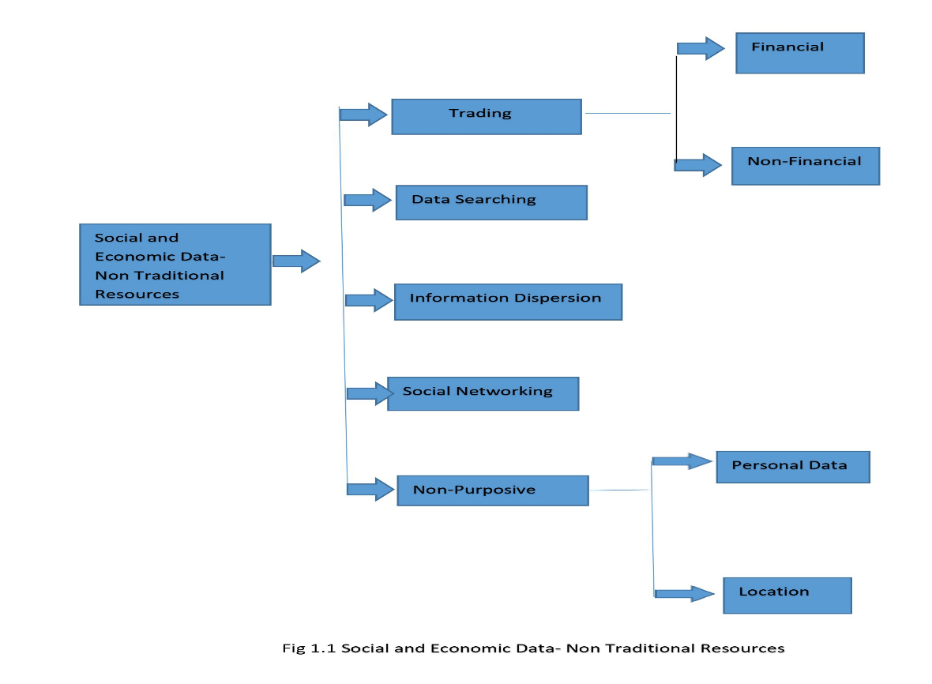
- CONCLUSION
The passage discusses the feasibility of using news articles as a data source for event extraction and the subsequent construction of knowledge graphs to represent event relationships in different analytic contexts. The dissertation introduces two types of event models and five strategies for building knowledge graphs, each tailored to varying levels of detail. These knowledge graphs can serve as valuable resources for both manual and automated analyses of news data.Event extraction involves identifying specific events or incidents from unstructured text, such as news articles. By extracting these events and representing their relationships through knowledge graphs, researchers and analysts can gain a deeper understanding of the interconnectedness between different events in the news domain.

The passage also highlights the various applications of event models and knowledge graphs. One significant application is the construction of prediction models for extraneous variables and indicators. By leveraging the information within knowledge graphs, researchers can build predictive models that have real-world implications. These models can help in forecasting future events, trends, or outcomes based on the relationships between events captured in the knowledge graphs.Overall, the dissertation likely explores the potential benefits of using news articles as a data source for event extraction and knowledge graph construction. It emphasizes the practicality of this approach and how it can be applied to a range of analytic contexts, enabling more informed decision-making, trend analysis, and predictive modeling in various domains. The utilization of knowledge graphs that incorporate event relationships from news data may prove to be a valuable tool in uncovering insights and predicting outcomes in real-world scenarios.

REFERENCES
- Al-Dohuki, S., Wu, Y., Kamw, F., Yang, J., Li, X., Zhao, Y., Ye, X., Chen, W., Ma, C., Wang, F.: SemanticTraj: a new approach to interacting with massive taxi trajectories. IEEE Trans. Vis. Comput. Graph. 23(1), 11–20 (2017). http://doi.org/10.1109/TVCG.2016.2598416. http://doi.ieeecomputersociety.org/10.1109/TVCG.2016.2598416
- Allen, J.F.: Maintaining knowledge about temporal intervals. Commun. ACM 26(11), 832–843 (1983). http://doi.org/10.1145/182.358434. http://doi.acm.org/10.1145/182.358434
- Alvares, L.O., Bogorny, V., Kuijpers, B., de Macêdo, J.A.F., Moelans, B., Vaisman, A.A.: A model for enriching trajectories with semantic geographical information. In: GIS, p. 22 (2007)
- Andrienko, G., Andrienko, N., Bak, P., Keim, D., Wrobel, S.: Visual Analytics of Movement. Springer Publishing Company, Incorporated, Berlin (2013)
- Andrienko, G., Andrienko, N., Chen, W., Maciejewski, R., Zhao, Y.: Visual analytics of mobility and transportation: state of the art and further research directions. IEEE Trans. Intell. Transp. Syst. 18(8), 2232–2249 (2017). http://doi.org/10.1109/TITS.2017.2683539
- Andrienko, G., Andrienko, N., Demsar, U., Dransch, D., Dykes, J., Fabrikant, S.I., Jern, M., Kraak, M.J., Schumann, H., Tominski, C.: Space, time and visual analytics. Int. J. Geogr. Inf. Sci. 24(10), 1577–1600 (2010). https://doi.org/10.1080/13658816.2010.508043
- Andrienko, G., Andrienko, N., Jankowski, P., Keim, D., Kraak, M., MacEachren, A., Wrobel, S.: Geovisual analytics for spatial decision support: setting the research agenda. Int. J. Geogr. Inf. Sci. 21(8), 839–857 (2007). https://doi.org/10.1080/1365881070134901
- Andrienko, N., Andrienko, G.: Visual analytics of movement: an overview of methods, tools and procedures. Inf. Vis. 12(1), 3–24 (2013). https://doi.org/10.1177/1473871612457601
- Baglioni, M., de Macêdo, J.A.F., Renso, C., Trasarti, R., Wachowicz, M.: Towards semantic interpretation of movement behavior. In: Advances in GIScience, pp. 271–288. Springer, Berlin (2009)
- Bogorny, V., Renso, C., de Aquino, A.R., de Lucca Siqueira, F., Alvares, L.O.: Constant - a conceptual data model for semantic trajectories of moving objects. Trans. GIS 18(1), 66–88 (2014)
- C. K. Vaca, A. Mantrach, A. Jaimes, and M. Saerens. A time-based collective factorization for topic discovery and monitoring in news. In Proceedings of the 23rd international conference on World wide web, pages 527–538. International World Wide Web Conferences Steering Committee, 2014.
- Chu, D., Sheets, D.A., Zhao, Y., Wu, Y., Yang, J., Zheng, M., Chen, G.: Visualizing hidden themes of taxi movement with semantic transformation. In: Proceedings of the 2014 IEEE Pacific Visualization Symposium, PACIFICVIS ’14, pp. 137–144. IEEE Computer Society, Washington, DC (2014). http://dx.doi.org/10.1109/PacificVis.2014.50
- D. M. Blei, A. Y. Ng, and M. I. Jordan. Latent dirichlet allocation. J. Mach. Learn. Res., 3:993–1022, Mar. 2003.
- F. Hogenboom, M. de Winter, F. Frasincar, and U. Kaymak. A news event-driven approach for thehistorical value at risk method. Expert Systems with Applications, 42(10):4667 – 4675, 2015
- Fileto, R., May, C., Renso, C., Pelekis, N., Klein, D., Theodoridis, Y.: The baquara2 knowledge-based framework for semantic enrichment and analysis of movement data. Data Knowl. Eng. 98, 104–122 (2015)
- H. Tanev, J. Piskorski, and M. Atkinson. Real-time news event extraction for global crisis monitoring. NLDB ’08, pages 207–218, 2008
- Hamad, K., Quiroga, C.: Geovisualization of archived ITS data-case studies. IEEE Trans. Intell. Transp. Syst. 17(1), 104–112 (2016). https://doi.org/10.1109/TITS.2015.2460995
- Hu, Y., Janowicz, K., Carral, D., Scheider, S., Kuhn, W., Berg-Cross, G., Hitzler, P., Dean, M., Kolas, D.: A geo-ontology design pattern for semantic trajectories. In: Tenbrink, T., Stell, J., Galton, A., Wood, Z. (eds.) Spatial Information Theory, pp. 438–456. Springer International Publishing, Cham (2013)
- K. Radinsky and E. Horvitz. Mining the web to predict future events. WSDM ’13, pages 255–264.ACM, 2013.
- Kotis, K., Vouros, G.A.: Human-centered ontology engineering: the HCOME methodology. Knowl. Inf. Syst. 10(1), 109–131 (2006)
- Kraak, M., Ormeling, F.: Cartography: Visualization of Spatial Data, 3 edn. Guilford Publications, New York (2010)
- M. Liu, Y. Liu, L. Xiang, X. Chen, and Q. Yang. Extracting key entities and significant events from online daily news. IDEAL ’08, pages 201–209, 2008.
- M. Okamoto and M. Kikuchi. Discovering volatile events in your neighborhood: Local-area topicextraction from blog entries. AIRS ’09, pages 181–192, 2009
- Nogueira, T.P., Martin, H.: Querying semantic trajectory episodes. In: Proc. of MobiGIS, pp. 23–30 (2015)
- Paiva Nogueira, T., Bezerra Braga, R., Martin, H.: An ontology-based approach to represent trajectory characteristics. In: Fifth International Conference on Computing for Geospatial Research and Application. Washington, DC (2014). https://hal.archives-ouvertes.fr/hal-01058269
- Parent, C., Spaccapietra, S., Renso, C., Andrienko, G.L., Andrienko, N.V., Bogorny, V., Damiani, M.L., Gkoulalas-Divanis, A., de Macêdo, J.A.F., Pelekis, N., Theodoridis, Y., Yan, Z.: Semantic trajectories modeling and analysis. ACM Comput. Surv. 45(4), 42 (2013)
- Peuquet, D.J.: It’s about time: a conceptual framework for the representation of temporal dynamics in geographic information systems. Ann. Assoc. Am. Geogr. 84(3), 441–461 (1994)
- Santipantakis, G., Doulkeridis, C., Vouros, G.A., Vlachou, A.: Masklink: Efficient link discovery for spatial relations via masking areas, arXiv:1803.01135v1 (2018)
- Santipantakis, G., Vouros, G., Glenis, A., Doulkeridis, C., Vlachou, A.: The datAcron ontology for semantic trajectories. In: ESWC-Poster Session (2017)
- Santipantakis, G.M., Glenis, A., Kalaitzian, N., Vlachou, A., Doulkeridis, C., Vouros, G.A.: FAIMUSS: flexible data transformation to RDF from multiple streaming sources. In: Proceedings of the 21th International Conference on Extending Database Technology, EDBT 2018, Vienna, 26–29 March 2018, pp. 662–665 (2018). https://doi.org/10.5441/002/edbt.2018.79
- Santipantakis, G.M., Kotis, K.I., Vouros, G.A., Doulkeridis, C.: RDF-gen: Generating RDF from streaming and archival data. In: Proceedings of the 8th International Conference on Web Intelligence, Mining and Semantics, WIMS ’18, pp. 28:1–28:10. ACM, New York (2018). http://doi.org/10.1145/3227609.3227658. http://doi.acm.org/10.1145/3227609.3227658
- Santipantakis, G.M., Vouros, G.A., Doulkeridis, C., Vlachou, A., Andrienko, G.L., Andrienko, N.V., Fuchs, G., Garcia, J.M.C., Martinez, M.G.: Specification of semantic trajectories supporting data transformations for analytics: The datacron ontology. In: Proceedings of the 13th International Conference on Semantic Systems, SEMANTICS 2017, Amsterdam, 11–14 Sept 2017, pp. 17–24 (2017). https://doi.org/10.1145/3132218.3132225
- Soltan Mohammadi, M., Mougenot, I., Thérèse, L., Christophe, F.: A semantic modeling of moving objects data to detect the remarkable behavior. In: AGILE 2017. Wageningen University, Chair group GIS & Remote Sensing (WUR-GRS), Wageningen (2017). https://hal.archives-ouvertes.fr/hal-01577679
- Spaccapietra, S., Parent, C., Damiani, M.L., de Macêdo, J.A.F., Porto, F., Vangenot, C.: A conceptual view on trajectories. Data Knowl. Eng. 65(1), 126–146 (2008)
- T. Hofmann. Probabilistic latent semantic indexing. SIGIR ’99, pages 50–57, 1999
- Vincenty, T.: Direct and inverse solutions of geodesics on the ellipsoid with application of nested equations. In: Survey Review XXII, pp. 88–93 (1975). https://doi.org/10.1179%2Fsre.1975.23.176.88. https://www.ngs.noaa.gov/PUBS_LIB/inverse.pdf
- Vouros, G., Santipantakis, G., Doulkeridis, C., Vlachou, A., Andrienko, G., Andrienko, N., Fuchs, G., Martinez, M.G., Cordero, J.M.G.: The datacron ontology for the specification of semantic trajectories: specification of semantic trajectories for data transformations supporting visual analytics. J. Data Semant. 8 (2019). http://doi.org/10.1007/s13740-019-00108-0. http://link.springer.com/article/10.1007/s13740-019-00108-0
- Wen, Y., Zhang, Y., Huang, L., Zhou, C., Xiao, C., Zhang, F., Peng, X., Zhan, W., Sui, Z.: Semantic modelling of ship behavior in harbor based on ontology and dynamic Bayesian network. ISPRS Int. J. Geo-Inf. 8(3) (2019). http://doi.org/10.3390/ijgi8030107. http://www.mdpi.com/2220-9964/8/3/107
- Y. Wang, E. Agichtein, and M. Benzi. Tm-lda: efficient online modeling of latent topic transitions in social media. In Proceedings of the 18th ACM SIGKDD international conference on Knowledgediscovery and data mining, pages 123–131. ACM, 2012.
- Yan, Z., Macedo, J., Parent, C., Spaccapietra, S.: Trajectory ontologies and queries. Trans. GIS 12(s1), 75–91 (2008). http://doi.org/10.1111/j.1467-9671.2008.01137.x. https://onlinelibrary.wiley.com/doi/abs/10.1111/j.1467-9671.2008.01137.x

