PRECISION MEDICINE: TYPES AND APPROACHES THAT CAN BE APPLIED IN HEALTHCARE

Rafiya yashfeen¹, Humera sadaf¹, Jyothsna kalwala¹, Harshitha Rathod, Nahiya Fathima, and Ayesha Siddiqua.

¹Jyothishmati Institute of Pharmaceutical Sciences, Thimmapur, Karimnagar, Telangana-India, 505001.

INTRODUCTION

Precision medicine, also known as personalized medicine, is an approach to healthcare that takes into account individual variations in genetics, environment, and lifestyle when diagnosing and treating diseases. It aims to provide targeted and customized healthcare interventions based on a person's unique characteristics, thereby improving patient outcomes and minimizing adverse effects[1].
Traditionally, medical treatments have been developed based on the average response of a population. However, individuals can differ significantly in how they respond to treatments due to genetic variations and other factors. Precision medicine seeks to address this variability by tailoring medical interventions to the specific needs of each patient[2].
One of the key components of precision medicine is the use of genomic information. Advances in DNA sequencing technologies have made it possible to rapidly and cost-effectively analyze an individual's genetic makeup. This information can help identify genetic mutations or variations that may be associated with certain diseases or influence drug responses.
By analyzing a person's genetic profile, doctors can gain insights into their risk for developing certain diseases, predict how they may respond to different treatments, and identify potential targets for therapies. This information can guide treatment decisions, allowing healthcare providers to select the most appropriate interventions for each patient.
Precision medicine also considers other factors beyond genetics, such as environmental and lifestyle influences. It recognizes that a person's surroundings, behaviors, and personal choices can impact their health and response to treatments. By integrating these factors into the healthcare decision-making process, precision medicine aims to create a more comprehensive and individualized approach to patient care.
The benefits of precision medicine are significant. It can lead to more accurate diagnoses, improved treatment outcomes, and reduced healthcare costs. By targeting therapies to individuals who are most likely to benefit from them, unnecessary treatments and their associated side effects can be minimized. Additionally, precision medicine research contributes to a better understanding of diseases and their underlying mechanisms, paving the way for the development of new and more effective treatments[3].
It's important to note that precision medicine is a rapidly evolving field, and its widespread implementation still faces some challenges. These include the availability and cost of genomic testing, data privacy concerns, and the need for robust evidence to support the efficacy and safety of personalized interventions. However, with continued advancements in technology, increased collaboration among researchers and healthcare professionals, and ongoing efforts to address these challenges, precision medicine holds great promise for the future of healthcare.

APPROACHES TO PRECISION MEDICINE:

Precision medicine encompasses various types and approaches that can be applied in healthcare. Here are some key types of precision medicine:

- Genomics-Based Precision Medicine: This type focuses on utilizing genomic information, including DNA sequencing, to understand how an individual's genetic makeup influences their health and response to treatments. It involves identifying genetic variants associated with diseases and using this information to guide personalized treatment decisions.
- Pharmacogenomics: Pharmacogenomics aims to predict an individual's response to medications based on their genetic profile. By analyzing genetic variations that affect drug metabolism, efficacy, or adverse reactions, healthcare providers can tailor medication choices and dosages to maximize effectiveness and minimize side effects.
- Molecular Profiling: Molecular profiling involves analyzing the molecular characteristics of a patient's disease, such as genetic mutations, gene expression patterns, or protein markers. This information helps guide treatment decisions by identifying targeted therapies or predicting treatment responses.
- Imaging-Based Precision Medicine: Imaging techniques, such as MRI, CT scans, or PET scans, can provide detailed information about a patient's anatomy, physiology, and disease progression. Imaging-based precision medicine utilizes these imaging modalities to guide treatment planning and monitor treatment response in a personalized manner.
- Digital Health and Wearables: The integration of digital health technologies and wearable devices allows for continuous monitoring of an individual's health parameters, such as heart rate, activity levels, or sleep patterns. These data can be used to personalize healthcare interventions, monitor treatment efficacy, and facilitate early detection of health issues.
- Data Analytics and Artificial Intelligence: Precision medicine leverages data analytics and artificial intelligence (AI) techniques to analyze large datasets, including genomic data, electronic health records, and clinical trial data. AI algorithms can identify patterns, correlations, and predictive models that aid in disease diagnosis, treatment selection, and patient outcome prediction.
- Preventive Precision Medicine: Precision medicine is not limited to disease treatment but also emphasizes disease prevention. By combining genetic and environmental data, individuals can receive personalized risk assessments and interventions to minimize the chances of developing specific diseases.

These types of precision medicine often overlap and complement each other, as they aim to provide personalized and targeted care based on individual characteristics. The integration of these approaches holds great potential for improving patient outcomes and advancing healthcare.

- GENOMICS BASED PRECISION MEDICINE

GENOMICS :

Genomics is the study of the total or part of the genetic or epigenetic sequence information of organisms and attempts to understand the structure and function of these sequences and of downstream biological products. Genomics in health examines the molecular mechanisms and the interplay of this molecular information and health interventions and environmental factors in disease.
Genomics is defined as the study of genes and their functions, and related techniques. It offers the long-term possibility of providing new approaches to the prevention and management of many diseases.
Genome-based precision medicine, often referred to as personalized medicine or genomic medicine, involves tailoring medical interventions to an individual's distinct genetic composition. it is an approach to medical care that takes into account an individual's unique genetic makeup. or specific genetic characteristics to inform choices regarding disease prevention, diagnosis, and treatment. The individual's genetic data can offer valuable understandings of their vulnerability to particular illnesses, their reactions to specific therapies, and their overall health risks[4].
Genomic-based precision medicine works on the concept of GENOMIC SEQUENCING

GENOMIC SEQUENCING :

Genomic sequencing is a laboratory process that involves determining the precise order of nucleotide bases (adenine, cytosine, guanine, and thymine) in an individual's DNA molecule. There are different levels of genomic sequencing. There are different levels of genome sequencing :

WHOLE-GENOME SEQUENCING:

Whole-genome sequencing (WGS) is a comprehensive method for analyzing entire genomes. Genomic information has been instrumental in identifying inherited disorders, characterizing the mutations that drive cancer progression, and tracking disease outbreaks.

Whole genome sequencing works by following these four main steps:

- DNA shearing: Scientists begin by using molecular scissors to cut the DNA, which is composed of millions of bases (A’s, C’s, T’s and G’s), into pieces that are small enough for the sequencing machine to read.
- DNA bar coding: Scientists add small pieces of DNA tags, or bar codes, to identify which piece of sheared DNA belongs to which bacteria. This is similar to how a bar code identifies a product at a grocery store.
- DNA sequencing: The bar-coded DNA from multiple bacteria is combined and put in a DNA sequencer. The sequencer identifies the A’s, C’s, T’s, and G’s, or bases, that make up each bacterial sequence. The sequencer uses the bar code to keep track of which bases belong to which bacteria.
- Data analysis: Scientists use computer analysis tools to compare sequences from multiple bacteria and identify differences. The number of differences can tell the scientists how closely related the bacteria are, and how likely it is that they are part of the same outbreak[5].

WHOLE EXOME SEQUENCING (WES):

Whole-exome sequencing is a widely used next-generation sequencing (NGS) method that involves sequencing the protein-coding regions of the genome[6].The human exome represents less than 2% of the genome, but contains ~85% of known disease-related variants,1 making this method a cost-effective alternative to whole-genome sequencing.
Provides a cost-effective alternative to whole-genome sequencing (4–5 Gb of sequencing per exome compared to ~90 Gb per whole human genome)
Produces a smaller, more manageable data set for faster, easier data analysis compared to whole-genome approaches[7].

- Main three Steps involved in WES :

- Library preparation: Extracted DNA fragment corresponding to exons region of genes are enhanced using target capture techniques. These fragments are then amplified and prepared into a sequencing library
- Sequencing: the constructed library undergoes high technologies and produces millions of short DNA sequences simultaneously
- Data analysis: The obtained reads are matched against a reference genome which functions as a blueprint for comparing the individual sequence .by making comparisons, variations like single nucleotide changes, insertions, deletions, and other forms of mutations.

TARGETED GENE SEQUENCING :

Targeted next generation sequencing focuses on specific genomic areas of interest. This technology is ideal for examining genes in specific pathways or for follow-up experiments (targeted resequencing) from whole genome sequencing (WGS). It is rapid and more cost-effective than WGS, and because it allows for deeper sequencing. Targeted sequencing is an especially sensitive and powerful method for identifying variants and mutations, including rare variants. Additional advantages of targeted NGS compared to WGS include:
• Smaller datasets requiring less computational resources
• More scalable (can handle more samples/sequencing run)
• More appropriate for industrial applications where cost and speed are critical Two methods for targeted sequencing: target enrichment and amplicon generation.

- Target Enrichment: Regions of interest are captured by hybridization to biotinylated probes and then isolated by magnetic pulldown. Target enrichment captures 20 kb–62 Mb regions, depending on the experimental design.
- Amplicon Sequencing: Regions of interest are amplified and purified using highly multiplexed oligo pools. This method allows researchers to sequence a few genes to hundreds of genes in a single run, depending on the library preparation kit used.

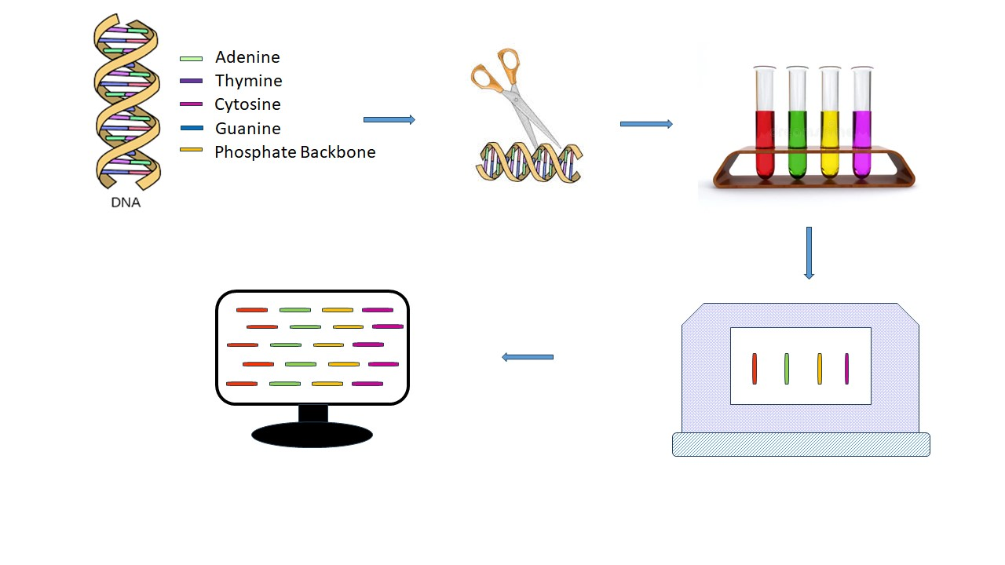
FIGURE 1. WHOLE GENOME SEQUENCING

APPLICATIONS OF GENOME SEQUENCING IN PRECISION MEDICINE :

Drug Development :

Genomics has been used as a tool for accelerating drug development. Various conceptual approaches and techniques assist target identification, target prioritization and tractability, as well as the prediction of outcomes from pharmacological changes. It provides depth understanding of disease and drug disruption at the tissue and single-cell level, and by the capacity to screen for loss of function or activation of genes, genome-wide, using CRISPR technologies.the information provided by genome sequencing on specific drug receptors and targets and specific biomarkers dicovery create more effective and targeted personalised treatments.

Disease Risk Assessment :

It can detect genetic variations linked to a elevated likelihood of developing specific illnesses .this data empowers health care professionals to evaluate an individuals susceptibility to disorders such as heart diseases , diabetes and particular typesof cancers. Individual with agreater risk can then be offered customised preventive approaches and screenings.

Targeted Therapeis :

Targeted therapy using genomics in precision medicine involves developing and applying treatments that are specifically tailored to an individual's genetic and molecular characteristics. This approach aims to address the underlying causes of diseases by targeting specific genetic mutations, altered pathways, or molecular abnormalities. Targeted therapy Using genomics works by performing genetic analysis, treatment design and personalised treatment .It is applied in different neurological , cardiovascular ,cancer and hereditary diseases.

CHALLENGES ASSOCIATED IMPLEMENTING GENOMICS IN PRECISION MEDICINE:

Data Interpretation And Security:

Genomic data is very complex and huge which requires advanced computational and bioinformatics tools to accurately interpret and analyse the information. Genetic variations translation into insights is challenging. It is highly sensitive and personal. Protecting data from unauthorised access is the main concern.

Ethical And Privacy Considerations:

The use of genetic information raises ethical concerns related to data ownership, consent , misuse of data for other purposes.

Cost And Accessibilty:

It is highly expensive process which cannot be affordable to all the population. High cost makes it inaccessible foe majority individuals.

Clinical Validation:

All genetic markers and genetic sequences may not have clear clinical significance. Validation of particular genetic sequence and its therapy (treatment options ) requires rigorous research and practice and evidence.

- PHARMACOGENOMICS BASED PRECISION MEDICINE:

PHARMACOGENOMICS:

Pharmacogenomics is the study that deals with the relationship between genomic variations and their effect on drugs.. When a gene variant is associated with a particular drug response in a patient, there is the potential for making clinical decisions based on genetics by adjusting the dosage or choosing a different drug, for example. Scientists assess gene variants affecting an individual's drug response the same way they asses gene variants associated with diseases. This field combines pharmacology (the science of drugs) and genomics (the study of genes and their functions) to develop effective, safe medications that can be prescribed based on a person’s genetic makeup.
Many drugs that are currently available are “one size fits all,” but they don't work the same way for everyone. It can be difficult to predict who will benefit from a medication, who will not respond at all, and who will experience negative side effects (called adverse drug reactions). Genetic differences will be used to predict whether a medication will be effective for a particular person and which dose will help prevent adverse drug reactions[8].
Pharmacogenomics plays a crucial role within the framework of precision medicine. Precision medicine seeks to deliver tailored healthcare solutions by considering an individual's genetic, environmental, and lifestyle elements[9]. Pharmacogenomics plays two major roles in precision medicine.
- It guides pharmaceutical companies in drug discovery and development.
- It guides physicians in selecting the right drug for patients based on their genetic make-up, in avoiding ADR, and in maximizing drug efficacy by prescribing the right dose
The components of pharmacogenomics are :

PHARMACOKINETICS AND PHARMACODYNAMICS :

Drug Transporters:

Drug transporters are proteins located in cell membranes that play a crucial role in the movement of drugs and other molecules into and out of cells. These transporters are integral to various physiological processes, including drug absorption, distribution, metabolism, and elimination. genetic variations in drug transporter genes can influence an individual's response to medications[10].
Transporters are membrane proteins that are ubiquitous throughout the body functioning to control the influx of essential nutrients and ions and the efflux of cellular waste, toxins, and drugs. Transporters located in the liver, intestine, kidney, and blood–brain barrier (BBB) are of particular interest in drug development and utilization. Multiple transporters work in a coordinated fashion to transport endogenous and exogenous substances into and out of cells. In certain organs, such as the liver and intestine, transporters and drug-metabolizing enzymes work together to affect the pharmacokinetics of drugs.Transporters play an important role in drug disposition, therapeutic efficacy, adverse drug reactions, and drug–drug interactions. Multiple environmental and genetic factors may affect the variability of transporter expression. Understanding the contribution of genetic variability to transporter expression and phenotype may allow clinicians to individualize drug therapy based on genetic factors. There are two major superfamilies of transporters important in drug disposition.
Solute carrier (SLC) transporters : a family of passive and active transporters that rely on chemical and/or electrical gradients for transport .The SLC transporters, also known as solute carrier transporters, are a large and diverse group of membrane proteins that facilitate the transport of various solutes across cell membranes. These transporters play a crucial role in the movement of essential nutrients, ions, metabolites, and drugs across cell membranes in various tissues and organs throughout the body.
- SLC22 (Organic Cation and Anion Transporter) Family:
- This family includes transporters that mediate the uptake and efflux of organic cations and anions. Examples include:
- OCT1 (SLC22A1): Mediates the uptake of various organic cations, including some drugs, in the liver.
- OCT2 (SLC22A2): Involved in the renal uptake of organic cations and plays a role in drug elimination.
- OAT1 (SLC22A6) and OAT3 (SLC22A8): Facilitate the renal secretion of organic anions and are involved in drug excretion.
- SLC47 (Multidrug and Toxin Extrusion) Family:
- This family includes transporters that mediate the efflux of cationic drugs and other compounds. Examples include:
- MATE1 (SLC47A1) and MATE2-K (SLC47A2): Found in the kidneys and contribute to the renal excretion of cationic drugs and toxins.
- SLC15 (Peptide Transporter) Family:
- Peptide transporters play a role in the uptake of peptides and peptide-like drugs. Examples include:
- PEPT1 (SLC15A1): Found in the intestines, mediates the uptake of di- and tripeptides, including some drugs.
- PEPT2 (SLC15A2): Found in the kidneys, plays a role in the reabsorption of peptides and peptide-like drugs.
- SLC16 (Monocarboxylate Transporter) Family:
- Monocarboxylate transporters facilitate the transport of monocarboxylates such as lactate, pyruvate, and certain drugs. Examples include:
- MCT1 (SLC16A1): Found in various tissues, including the intestines, plays a role in the absorption of monocarboxylates.
- MCT2 (SLC16A7): Found in the brain and other tissues, involved in lactate transport.
- SLC29 (Equilibrative Nucleoside Transporter) Family:
- Equilibrative nucleoside transporters are responsible for the transport of nucleosides and nucleoside analogs. Examples include:
- ENT1 (SLC29A1) and ENT2 (SLC29A2): Facilitate the cellular uptake of nucleosides and nucleoside-based drugs.
- SLC6 (Neurotransmitter Transporter) Family:
- This family includes neurotransmitter transporters that regulate the reuptake of neurotransmitters in the nervous system. Examples include:
- SERT (SLC6A4): Serotonin transporter, responsible for the reuptake of serotonin.
- NET (SLC6A2): Norepinephrine transporter, involved in the reuptake of norepinephrine.
- DAT (SLC6A3): Dopamine transporter, responsible for the reuptake of dopamine.
- ATP-binding cassette (ABC) transporters, a family of primary active transporters that are ATP dependent. These transporters utilize energy from ATP (adenosine triphosphate) hydrolysis to pump substrates against their concentration gradient, contributing to a wide range of physiological processes.

Types of ABC Transporters:

There are two main classes of ABC transporters based on their direction of transport:
- Uptake ABC Transporters: These transporters move substrates into cells. Examples include:
- ABCG2 (BCRP): Involved in xenobiotic and drug efflux, found in tissues like the intestines and blood-brain barrier.
- ABCB1 (MDR1, P-gp): Mediates drug efflux from cells, found in various tissues including the intestines and blood-brain barrier.
- ABCC1 (MRP1): Mediates cellular efflux of various substrates, including some drugs.
- Efflux ABC Transporters: These transporters pump substrates out of cells. Examples include:
- ABCA1: Involved in cholesterol efflux from cells and HDL biogenesis.
- ABCG1: Mediates cholesterol and phospholipid efflux, contributing to lipid metabolism.

Effect of polymorphisms in genes encoding drug transporters :

Drug transporters primarily control the movement of all drugs and their active or inactive metabolites into or out of cells. Therefore, polymorphisms of drug transporter genes can modify the absorption, distribution, and excretion rates, and ultimately safety and efficacy of the administered drugs.
In the ABC transporter superfamily of drug transporters, 49 genes have been identified, which are divided into seven subfamilies from ABCA to ABCG
The impact of some important polymorphisms on the drug transport activities of various ABC transporters is summarized in Figure 3. In addition, approximately 360 genes have been identified in the SLC superfamily and are classified into 46 subfamilies. Among them, members of the organic anion transporter (OAT), organic anion transporting polypeptides (OATP), and organic cation transporter (OCT) subfamilies are of particular significance in drug disposition. In addition, polymorphisms in genes encoding SLCO, SLC22, and SLC47 family members within the SLC superfamily have key roles in modulating drug transport activities of the corresponding transporters.
ABC transporter, ATP-binding cassette transporter; MDR1, multidrug resistance protein 1; BCRP, breast cancer resistance protein; MRP, multidrug resistance-associated protein.genetic polymorphisms on the transport activities of different allele variants of SLC transporters including SLCO and SLC47 (A) as well as SLC22 (B). SLC, solute carrier; SLCO, solute carrier organic anion; OCT, organic cation transporter; OCTN, organic cation transporter novel; OAT, organic anion transporter; MATE1, multidrug and toxin extrusion protein 1; URAT, urate transporter.

Pharmacogenomics in the absorption of drugs

Absorption is the movement of the drug from its site of administration into the bloodstream. It’s a complex process that involves several membrane-bound drug transporters, such as P-glycoprotein (P-gp, MDR1) and multidrug resistance (MDR) transporters, encoded by the ABC genes. The gene ABCB1, which codes for P-gp, has more than 50 SNPs, which vary in frequency based on ethnicity. These mechanisms have a bearing on the ultimate bioavailability of the drug. Bioavailability is the fraction of the drug that reaches the bloodstream or the site of action after it is administered.

Pharmacogenomics in the distribution of drugs

Following administration, the drug is distributed into all of the body compartments and tissues that it is able to enter based on its physical-chemical properties. The drug is distributed into an imaginary volume, called volume of distribution (Vd), which is primarily dependent on physiological parameters such as body mass index and fat deposits. Vd may be dependent on PGx for distribution to certain body compartments such as the brain across the blood-brain barrier and breast milk, which are dependent on transporter genes like ABC. Overexpression of these genes can result in drug resistance. Polymorphism in genes ABCB1 and SLCO1B1 have also been shown to affect drug distribution.

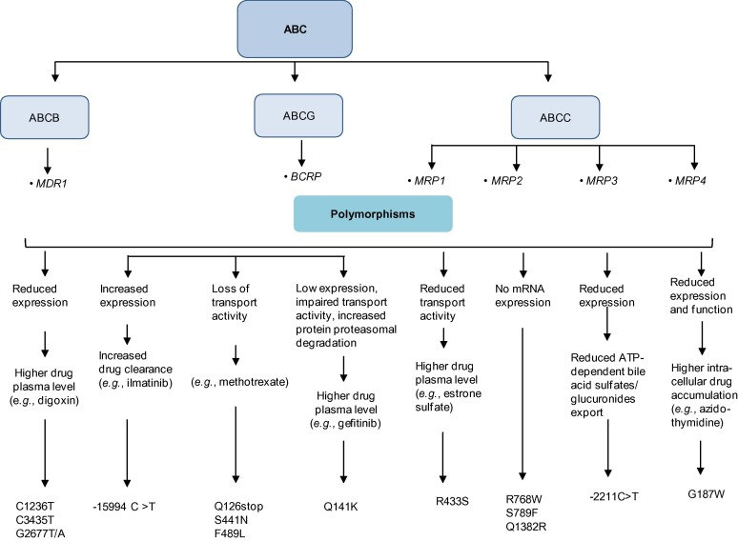
FIGURE 2. EFFECT OF POLYMORPHISMS IN GENES ENCODING DRUG TRANSPORTERS-ABC
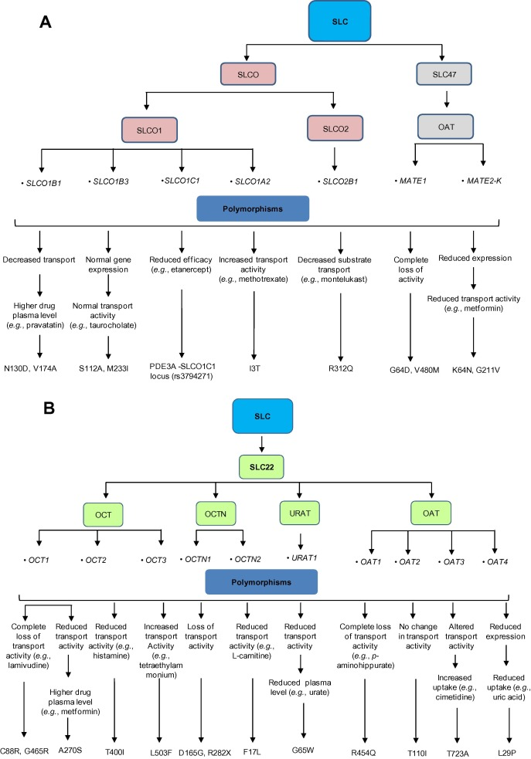
FIGURE 3. EFFECT OF POLYMORPHISMS IN GENES ENCODING DRUG TRANSPORTERS-A AND B SLC

Pharmacogenomics in metabolism of drugs:

Drug metabolism is the metabolic breakdown of drugs, usually through specialized enzymatic systems. Most drug metabolism occurs in the liver and intestine. Drug metabolism is divided into three phases

Phase I metabolism involves:

Oxidation (via cytochrome P450), reduction, and hydrolysis reactions. Conversion of a parent drug to more polar (water soluble) active metabolites by unmasking or inserting a polar functional group (-OH, -SH, -NH2).
Drugs metabolized via phase I reactions have longer half-lives.

Phase II metabolism involves:

Glucuronidation , acetylation, and sulfation reactions. “Conjugation reactions” that increase water solubility of a drug with a polar moiety glucuronate, acetate, and sulfate. Conversion of a parent drug to more polar (water soluble) inactive metabolites by conjugation of subgroups to -OH, -SH, -NH2 functional groups in the drug. Drugs metabolized via phase II reactions that are excreted via the kidney.Patients deficient in acetylation capacity (slow acetylators) may have prolonged or toxic responses to normal doses of certain drugs because of decreased rates of metabolism.

Phase III metabolism involves:

Further modification of the conjugated drug and excretion.
- A detoxification process and transportation of the conjugates against a concentration gradient out of the cell into the interstitial space between cells.
- The conjugated drug entering the capillary system and then the main bloodstream, and filtration by the kidneys.
- Excretion: excretion describes how drugs leave the body, whether by urine, bile, or, in some cases, exhalation.
- Hepatic Elimination: Transporters in the liver play a significant role in the elimination of drugs from the body. They actively transport drugs from the blood into the bile for excretion into the intestines or directly into the urine. Variations in hepatic drug transporters can affect the rate of drug elimination.
- Renal Elimination: Transporters in the kidneys are responsible for the excretion of drugs into the urine. Genetic variations in renal transporters can impact drug clearance and the risk of drug accumulation.

Pharmacodynamics :

Pharmacodynamics is a branch of pharmacology that focuses on how drugs interact with their target molecules and produce their effects within the body. It deals with understanding the relationship between drug concentration and its effects on the body's physiological processes. Pharmacodynamics encompasses various aspects, including drug-receptor interactions, cellular responses, and the overall impact on the body.
Disorders that affect pharmacodynamic responses include genetic mutations, thyrotoxicosis, malnutrition, myasthenia gravis, Parkinson disease, and some forms of insulin-resistant diabetes mellitus. These disorders can change receptor binding, alter the level of binding proteins, or decrease receptor sensitivity. Aging tends to affect pharmacodynamic responses through alterations in receptor binding or in postreceptor response sensitivity (see table Effect of Aging on Drug Response).Pharmacodynamic drug–drug interactions result in competition for receptor binding sites or alter postreceptor response.

GENETIC VARIATIONS :

The Human Genome Project (HGP), concluded in April 2003, revealed that humans have about 20,500 genes and that 99.5 percent of the genes are similar.6 The remaining 0.5 percent are variations that are responsible for the individual’s eye color, blood group, predisposition toward particular diseases, etc. The most common type of DNA sequence variation found in the human genome is the single nucleotide polymorphism (SNP, pronounced “snip”). Another type of variation, called structural variations (SV), are deletions, insertions, tandem repeats, inversions, and copy number variations (CNV). There are approximately 11 million SNPs in the human genome, with an average of one every 1,300 base pairs. SNPs act as biological markers and determine an individual’s response to certain drugs, susceptibility to environmental factors such as toxins, and risk of developing disease [11].

Genetic differences among individuals can affect virtually all aspects of a disease and its treatment. Genetic variations can affect disease management with regard to the following:
- The rate of disease occurrence
- The risk of disease progression or recurrence
- The drug or drug class most likely to provide benefit
- The therapeutic dose
- The nature and extent of beneficial responses to treatment
- The likelihood of drug toxicity.

Genetic variations relevant to drug development include:
- Genes relevant to the drug’s pharmacokinetics (absorption, distribution, metabolism [including formation of active metabolites], and excretion)
- Genes that code for intended or unintended drug targets and other pathways related to the drug’s pharmacologic effect
- Genes that can predispose to toxicities such as immune reactions
- Genes that influence disease susceptibility or progression.

All of these genetic factors can affect the benefit-risk drug profile

Genetic polymorphisms in drug transporters and phase-1 drug-metabolizing enzymes can alter the pharmacokinetic and pharmacokinetic properties of the administered drugs, their metabolites, or both at the target site, resulting in variability in drug responses. Theoretically, variations at even a single base (SNPs) or sets of closely-related SNPs (haplotypes) in genes involved in the pharmacokinetic and pharmacodynamic pathways at any stage could affect the overall drug response of an individual. Mutations in the gene coding regions could cause alterations in gene expression or protein structure, leading to variations in protein quantity and quality. In the case of enzymes, such mutations affect both the protein function and the rate and kinetic constants. Changes in drug-receptor or drug–enzyme interactions due to structural alterations of enzymes or receptors could also result in variations in drug responses. Polymorphisms in genes responsible for drug transport can affect the pharmacokinetic properties of an administered drug and ultimately its plasma concentration as well as concentrations in the target tissues.

Variations in drug response:

It is well known that individuals vary significantly in their clinical responses to administered drugs and the outcomes, which can be inherited or acquired, are always patient-specific. Such interindividual variation is often a challenge to optimizing a dosage regimen because most drugs are effective in only 25%–60% of patients. Many patients are unable to fully respond and benefit from the first recommended drug treatment. For example, an average of 38%, 40%, 43%, 50%, and 75% of patients who have depression, asthma, diabetes, arthritis, and cancer, respectively, show no response to initial treatments.

Contributing factors in interindividual drug responses:

Individual-specific response to medication can be attributed to many multifold and complex factors including the unique genetic makeup (mutations such as SNPs, gene deletions, and duplications). These genetic factors, as well as physiological conditions (age, gender, body size, and ethnicity); environmental influences (exposure to toxins, diet, and smoking); and pathological factors (liver and renal function, diabetes, and obesity) can work alone or in combination to influence drug responses

Cytochrome p450:
Cytochrome P450 (CYP), which represents a large and diverse group of heme-containing enzyme superfamily, is involved in the oxidative metabolism of structurally-diverse molecules like drugs, chemical, and fatty acids. The genetic polymorphism in the genes encoding CYP members was firstly reported for CYP2D6. The highly polymorphic CYP2D6 gene is located on the chromosome 22q13.1, consisting of nine exons and eight introns (GenBank accession No. NM 000106.5) . More than 100 CYP2D6 genetic variants has seen, resulting from point mutations, duplication, insertions or deletions of single or multiple nucleotides, and even whole-gene deletion. Individuals carrying different CYP2D6 allelic variants have been classified as poor metabolizers (PMs), intermediate metabolizers (IMs), extensive metabolizers (EMs), and ultrarapid metabolizers (UMs) according to the metabolic nature of the drugs and degree of involvement in drug metabolism of these variants . Although constituting only 2%–4% of the total amount of CYPs in the liver, CYP2D6 actively metabolizes approximately 20%–25% of all administered drugs The drugs metabolized by CYP2D6 include tricyclic antidepressants, serotonin reuptake inhibitors, antiarrhythmics, neuroleptics, and β-blockers
The highest levels of polymorphism are found in genes involved in drug metabolism, especially the cytochrome (CYP) 450 genes. These account for 80 percent of current pharmacogenomics drug labeling requirements by the FDA. There are approximately 50 CYP 450 genes: 49 genes and one pseudogene. There are numerous isoforms of CYP450. Isoforms are CYP enzyme variants that have derived from one particular gene. CYP isoforms are classified into families and subfamilies. CYP families are genes that have at least 40 percent sequence homology. Members of a subfamily must have at least 55 percent sequence homology. Only about a dozen enzymes belonging to the 1, 2, and 3 CYP-families are responsible for the metabolism of the majority of drugs and other xenobiotics.
Genetic polymorphisms in drug metabolism genes are expressed as differing phenotypes:
Ultra Rapid Metabolizer – Under Dosed : Lack Of Efficacy
Normal Extensive Metabolizer : Expected Response
Poor Metabolizer – Over Dosed : Adverse Drug Reaction

The major CYP 450 genes involved in drug metabolism and the proportions of drugs metabolized by them are: CYP3A4/5 : 36 % ;CYP2A6,CYP2B6 : 3 %;CYP2E1 : 4 %; CYP2C19 : 8% ;CYP1A2 : 11 %; CYP2C8/9 : 16 %; CYP2D6 : 19 %
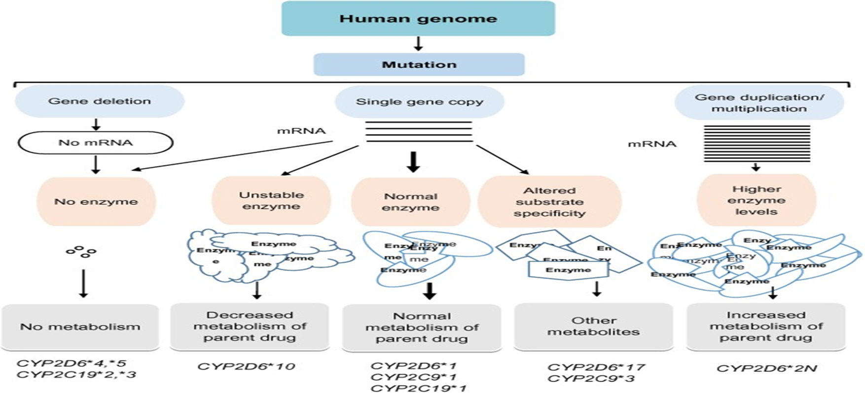
FIGURE 4. INFLUENCE OF GENETIC POLYMORPHISMS IN THE CYPS.

Influence of genetic polymorphisms of drug-metabolizing enzymes or transporters on drug–drug interactions :

Effects of one drug are modified by other concomitantly administered drugs due to drug–drug interactions, which may be attributed to the altered pharmacokinetic or pharmacodynamic properties of one drug-induced by the coadministered drug. The polymorphisms in drug-metabolizing and transporter genes are an important risk factor of drug–drug interactions and varied interindividual drug responses [12]. These polymorphisms can lead to decreased levels of a drug-metabolizing enzyme in an individual, which may cause severe adverse drug reactions following the coadministration of enzyme inhibitors [13]. Among the CYPs, CYP2C9, CYP2C19, and CYP2D6 are involved in the metabolism of approximately 40% of routinely administered drugs. Different CYP allelic variants significantly contribute to the variability of an individual’s susceptibility to drug–drug interactions and drug-metabolizing capacities. Different drugs interact with the CYP metabolic machinery differently[14].
The metabolism of some drugs by CYP enzymes is extremely specific, for example, metoprolol is primarily metabolized by CYP2D6, whereas other drugs such as warfarin may be simultaneously metabolized by several CYPs including CYP2D6, CYP3A4, and CYP1A2. Polymorphisms related to the altered expression of drug metabolizing and transporter genes will ultimately affect the therapeutic effects of administered drugs. When a drug is metabolized by more than one CYP metabolic pathway and the administered drug acts by inhibiting or inducing CYPs, genetic polymorphisms could redirect the metabolism of drugs via other CYP routes. This could lead to drug–drug interactions. For example, antifungal voriconazole is actively metabolized by CYP3A4 and CYP2C19, whereas ritonavir strongly inhibits CYP3A4 while inducing CYP2C19 metabolic activities[15].
When CYP2C19 PM patients are treated with voriconazole and ritonavir, up to 461% increased AUC of voriconazole was observed, since the patients were unable to metabolize voriconazole owing to reduced CYP2C19 and CYP3A4 activities . In another case, the antiplatelet activity of clopidogrel was reduced when it was administered with proton pump inhibitors such as esomeprazole and omeprazole owing to the inhibition of CYP2C19 , whereas an increased activity of clopidogrel was anticipated in the presence of rifampicin and aspirin . Clopidogrel is a prodrug that needs oxidative activation in vivo by CYP1A2, CYP2B6 and CYP2C19 for its anti-platelet activity . Genetic polymorphisms in CYP2C19, CYP1A2, 2B6*6, and CYP3A5*3 were found to be associated with the varied degree of drug–drug interactions for clopidogrel, due to its highly-complex pharmacokinetics and variable drug response as compare to other anti-platelet drugs.
Mutations in the drug transporter genes also contribute to drug–drug interactions and adverse drug reactions. HMGCR inhibitors such as atorvastatin, rosuvastatin, and pravastatin are actively transported by OATP1B1 and ABCG2 . The concomitant administration of cyclosporine (a potent inhibitor of OATP1B1 and ABCG2) with statins like rosuvastatin and pitavastatin will result in higher plasma levels of statins, leading to rhabdomyolysis . Digoxin is potently cleared by MDR1, therefore its coadministration with verapamil, clarithromycin, or talinolol that inhibits MDR1 transport activity leads to increased plasma levels due to decreased renal clearance of the drug

Drug Safety:

Within the United States, serious side effects from pharmaceutical drugs occur in 2 million people each year and may cause as many as 100,000 deaths, according to the Food and Drug Administration. Costs associated with adverse drug reactions (ADRs) are estimated at $136 billion annually. ADRs come in two forms. One form results from misuse, such as taking too much of a medication or taking the medication too often or for too long. The second form involves the mysterious, idiosyncratic effects of various drugs. The term "idiosyncratic" is used because these (often serious) side effects are not related to drug dose and are thought to be unpredictable. Scientists believe many idiosyncratic effects result from individual variation that is encoded in the genome. Thus, genetic variation in genes for drug-metabolizing enzymes, drug receptors, and drug transporters have been associated with individual variability in the efficacy and toxicity of drugs. Genetics also underlies hypersensitivity reactions in patients who are allergic to certain drugs, such as penicillin, wherein the body mounts a rapid, aggressive immune response that can cause not only a rash, but can also hinder breathing and cause edema to the point of cardiovascular collapse.
Predicting serious ADRs is a priority for pharmacogenomic research. For example, the enzyme CYP2D6, one of a class of drug-metabolizing enzymes found in the liver, breaks down and terminates the action of certain antidepressant, antiarrhythmic, and antipsychotic drugs. Molecular cloning and characterization studies of the gene that codes for this enzyme have described more than 70 variant alleles (Meyer, 2000). These alleles contain one or more point mutations, only some of which affect enzyme activity; however, some of these alleles involve gene deletions and duplications that can lead to increased enzyme activity. Individuals who are homozygous or heterozygous for the wild-type or normal activity enzymes (75%–85% of the population) are called extensive metabolizers; intermediate (10%–15%) or poor (5%–10%) metabolizers are carriers of two alleles that decrease enzyme activity (Ingelman-Sundberg, 1999); and ultrarapid metabolizers (1%–10%) are carriers of duplicated genes. The most common alleles can be detected by DNA chip microarrays, allowing most patients to be assigned to a particular phenotype group.

TABLE 1. EXAMPLES OF SOME DRUGS WITH GENETIC POLYMORPHISMS THAT IN?LUENCE DRUG EFFECTS IN HUMANS.
S.No. | Drug | Variable clinical effect | Genes with associated variants | Possible mechanism
1 | Azathioprine and mercaptopurine | Increased hematopoietic toxicity  reduced therapeutic effect at standard doses | TPMT | Hypofunctional alleles  Wild types alleles
2 | Irinotecan | Increased hematopoietic toxicity | UGT1A1 | decreased expression due to regulatory polymorphism
3 | Fluorouracil | Increased toxicity | DPD | abrogration of enzymatic activity due to exonic mutation
4 | Antidepressants  And beta blockers | increased toxicity  Decreased activity | CYP206 | hypofunctional alleles  Gene Duplication
5 | Codeine | decreased analgesia |  | hypofunctional alleles
6 | Omeprazole | peptic ulcer response | CYP2C19 | hypofunctional alleles
7 | Warfarin | increased anticoagulant effects  Reduced anticoagulant effects | CYP2C9  VKORC1 | coding region variants causing reduced S-warfarin clearance  variant haplotypes in regulatory regions to variable expression
8 | HIV protease inhibitors  Digoxin | decreased CD4 response in HIV infected Patients, decreased digoxin bioavailability | ABCB1 | altered P- glycoprotein function
9 | Abacavir | immunologic reactions | HLA variants | altered immunologic response
10 | Beta1 antagonists | decreased cardiovascular response | Beta1 adrenergic receptor | altered receptor function /number
11 | Beta2 antagonists | decreased bronchodilation | Beta2 adrenergic receptor | altered receptor function/ number
12 | Diuretics | blood pressure lowering | adducin | altered cytoskeletal function by adducin variants
13 | QT-prolonging drugs | drug inducing arrhythmia | ion channels  (HERG, KvLQT1, Mink, MiRP1) | exposure of subclinical reduction in repolarizing currents by drugs
14 | HMG-CoA reductase  Inhibitors | Low-density lipoprotein cholesterol lowering | HMGCR | altered HMG-CoA reductase activity

- MOLECULAR PROFILING BASED PRECISION MEDICINE:

MOLECULAR PROFILING:

It is a study involving the analysis of an organism molecules such as DNA, RNA, Proteins. It helps in understanding their individual structure, function and interactions. There are several advancements in the technology and this is one of it which has the ability to look into the tumour and identify the specific genes which leads to any changes or defects .It is used in various aspects like medicine, genetics variations and mutation in the cellular processes[16].
Molecular based precision medicine is an approach to medical treatment and health care which looks into individual molecular profile for prevention, diagnosis and treatment strategies. It involves in examining the individuals genetic, genomic- proteomic and other molecules information to make more targeted and personalized medical decisions. This type of medicine are used to increase the therapeutic outcomes, reduce adverse effects and improve overall patients quality of life. Specially in the cases like cancer treatment and rare genetic disorder[17].

TYPES OF MOLECULAR PROFILING:

- Genomic profiling:

It refers to the study of how all the persons genes interact with each other and the environment. It can analyze a broad panel of genes to detect the substitution , insertions and detectors. Genetics and genomics are two different terms, as the genetics refers to the study of single genes and how do they involving in passing down the specific traits from parents to off springs. Where as the genomics is individuals gene interaction among people and environment. Molecular profiling is a type of genomic test that checks the abnormal gene changes.

- Transcriptomic profiling:

This is the study of transcriptomic used to understand the complete set of all the ribonucleic acid (RNA) in a cell, which includes their transcription, expression, functions, location and degradation. It also reads the structures of transcripts and their parent genes in the5`-3` end sequences; splicing patterns and modifications. Transcriptomics cover all types of transcripts including messenger RNAs (mRNAs), micro RNAs (miRNAs) and different types of long non coding RNAs (Inc RNAs). Modern transcriptomics are used to analyze the expression of multiple transcripts in different physiological or pathological conditions.

- Proteomic profiling:

It is the study the accurate measurement of abundance of proteins and phosphoproteins from multi sample. This method is used to understand the protein expression; modifications, interactions and functions in various biological processes and disease mechanism. This proteonic profiling can be accomplished by various methods such as mass spectrometry, two dimensional, gel electrophoresis, liquid chromatography, protein microarrays, short gun proteomics, top-down and bottom up proteomics. It is applied in identification of bio makers to diagnose the type of disease and measure the disease status and to measure a response to a treatment.

- Metabolomic profiling:

It is the study of metabolomics is a term used to observe the measurement of multiple small molecule metabolites in biological samples in body fluids such as blood, saliva and urine. Metabolomics are the additions to the genomics, transcriptomics and proteomics. This study is done in various techniques to analyze the small molecules which can be intermediate or the end products of various cellular processes, which include:
  - Untargeted metabolomics: in which all the detachable metabolites are analyzed within a sample and allows a view of metabolite pathways and potential biomarkers. It usually involves comparison of the metabolite of control and test groups to identify the differences between their metabolite profiles. This is done in three steps: profiling, compound identification and interpretation.
  - Targeted metabolomics: it is study to takeout large number of targeted panels of selected groups of metabolites using mass spectroscopy. It mainly focuses on the qualification of specific set of metabolites which is suitable for studying specific pathways or compounds. These may include metabolites of lipids, COOH, organic acids and drug mertabolites.

- Lipidomics:

It is the study of total number of lipid content in a cell or an organ. Lipids play major role in energy storage, cell signaling and membrane structure. This are identified by the process of mass spectrometry, liquid chromatography and gas chromatography mass spectrometry which are used to analyze different classes of lipids such as fatty acids, phospholipids and sterols. They are classified as:
- Shortgun lipidomics:This is the untargeted metabolomics involves the direct analysis of lipid extracts using mass spectroscopy.
- Targeted lipidomics: This is the targeted which concentrates on the specific lipid classes or subclasses.
- Liquid chromatography- mass spectrometry lipidomics: This is done by utilizing liquid chromatography along with mass spectrometry to separate and analyze the lipid species based upon their mass to charge ratios.
- Gas-chromatography-mass spectrometry: This method is done by contains gas chromatography with mass spectrometry to analyze volatile and thermally stable lipid molecules such as fatty acids.
- High resolution mass spectroscopy:This method is done with enhanced mass accuracy and resolution, which improves the identification and quantification of lipid species.

- Epigenomic profiling:

It is the study involving the analysis of epigenetic marks, which consists of eukaryotic cell. It examines the modifications to DNA and associated proteins that affect gene expression without altering the DNA sequences. This process modifiers the local genome activity without changing the underlying DNA sequences by regulatory gene expression. This method is done in four major mechanism:
i. DNA methylation.
ii. Histone modifications.
iii. Chromatin compaction.
iv. Nuclear organization.
DNA methylation involves direct chemical addition of a methyl group to certain bases in DNA. Histones undergoes a variety of chemical modifications on their tail domains, detection of this method is done on antibody specifically designed to bind modified histone tails for immuno preceipitation with different levels of resolution.

- Glycomic profiling:
Glycomic profiling can identify an entire set of N and O- glycons present in different range of biological material. It analyzes the entire set of glycons which are complex sugars present in a sample including secretions, cell lines, tissues and organs. Profiling of glycomic changes in a cell or organism can be used to provide overview on glycome, total glycosylation pattern of glycoprotein, glycolipids. N-glycomic and O- glycomic profiling are two common types of analysis.
There a certain types which include:
- Mass spectrometry:This method involves analyzing the mass to charge ratios of glycon ions which allows the identification and quantification of different glycon structures
- Liquid chromatography: This method profiling separates based on their size, charge or hydrophobicity. This method can be used along with the mass, spectrometry for aquarate glycan characterization.
- Lection microassays: lectins are the proteins that bind to specific glycan structure. This is a new technology that utilizes a large panel of lectins immobilized on well defined substrate for analysis of glycans and glycoproteins. This method identifies the glycan profiles of samples based on lectin binding patterns .
- Matrix assisted laser desorption / ionization(MALDI) imaging mass spectroscopy: This method is used to analyze for spatial visualization of glycan distributions within tissue sections. This is done by mass spectrometry allows for the rapid profiling of different biomolecular species from biofluids and tissues. It also analyzes the lipidomic analysis, genotyping, micro organism identification and metabolomics.

- Phosphoproteomic profiling:

It is the study to identify the phosphorylation events in proteins. This method is used to analyze the phosphorylated proteins, which have proteins that have phosphate groups attached to specific aminoacid, such as tyrosine, serine. This identify the wide range of cellular processes, including signals transduction, cell cycle control and protein – protein interactions.
This takes place in many methods as:
- Sample preparation: cells and tissues are lysed to extract proteins. Phosphorylated proteins are identified by using immobilized metal affinity chromatography (IMAC).
- Protein digestion: The protein sample is digested into peptides using proteolyte enzyme like trypsin after that this produces a mixture of peptides, source of which contain phosphirylated residues.
- Phosphopeptide enrichment: This obtained phospho peptide are further enriched from the peptide mixtures by the method like titanium oxide chromatography.
- Mass spectrometry: Now, this enriched phospho peptides are analyzed using mass spectroscopy. Mass spectrometry data are processed and searched against protein databases to identify phosphorylated peptides. Analysis of the data involves identifying enriched phosphorylated peptides, pathway analysis and exploring biological functions.

- Methylomic profiling:

This is the study identifying DNA methylation patterns in a genome. This provides the understanding into gene expression regulation, biological, process and diseases. They are several types to study DNA methylation such as :
- Whole genome bisulphite sequencing ( WGBS): this method gives a complete view f DNA methylation by sequencing the entire genome after converting the unmethylated cytosines to uracils through bisulphite treatment.
- Targeted bisulphite sequencing: in this type, specific genomic regions of interest are amplified and sequence to analyze their methylation patterns.
- Methylation array: This is done by using micro array technology, which examines the methylation status of specific CPG sites across the genome, providing high through put. These arrays contain probes that hybridize with DNA region.
- Bisulphite sequencing: This is the gold standard method for DNA methylation. It treats DNA with bisulphite converts unmethylated cytosines to uracils, while methylated cytosines remain unchanged.
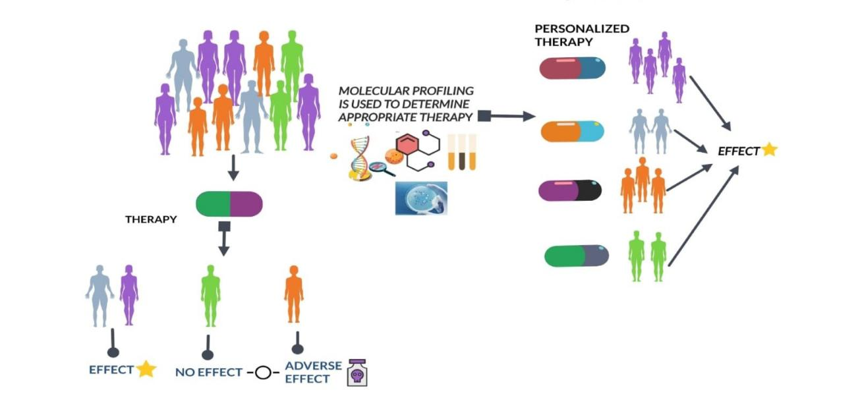
FIGURE 5. MOLECULAR PROFILING FOR APPROPRIATE THERAPY.

APPLICATIONS OF MOLECULAR PROFILING:

These have wide range of applications in research and medicine.
Cancer research and diagnosis: Molecular profiling can identify specific genetic mutations, gene expressions associated with different type of cancer. This information can aid in early diagnosis, prognosis prediction[18].
Drug discovery and development: Profiling molecular pathways and gene expression can identify potential dug targets and biomakers for drug response. This speeds up the discovery and development of new therapeutic agents.
Personalized medicine: Molecular profiling allows for medical treatment to individual patients based on their genetics which helps in improving the efficacy and safety of treatments.
Genomic research: Molecular profiling helps in researchers to study the structures, function and variation of genomes which leads to evolution and genetic diseases.
Neuroscience: profiling techniques can provide information regarding gene expression patterns in the brain which helps to understand the neurological disorders and brain development of every individual.
Infectious disease research: This profiling can identify pathogen specific genes, proteins and immune responses which helps in the development of diagnostic tests and vaccines.
Forensic science: This profiling techniques like DNA fingerprinting are used for identifying individuals in criminal investigation and paternity tests[17].

- IMAGING BASED PRECISION MEDICINE:

Imaging-based precision medicine is a term used to define a medical strategy that combines advanced imaging technology in order to customize a patient's diagnosis, treatment, and management regimens. To learn in-depth information about a patient's anatomy, physiology, and molecular characteristics, it involves the use of a wide range of imaging modalities, including magnetic resonance imaging (MRI), computed tomography (CT), positron emission tomography (PET), single-photon emission computed tomography (SPECT), and others[19].

Key components include:
- Personalised Treatment Selection: Clinicians can identify particular aspects of a disease that may respond better to particular drugs by analysing imaging data. Imaging, for instance, might direct the choice of targeted drugs in oncology based on the presence specific molecular markers.
- Diagnosis and classification: Precision imaging methods may give comprehensive knowledge into the kind and severity of diseases. For instance, depending on their metabolic activity, MRI and PET scans can assist physicians differentiate between various tumour types, allowing more precise diagnosis.
- Treatment monitoring : Apatient's response to treatment over time is possible through imaging. A treatment's efficiency or the need for modifications can be determined by changes in tumour size, metabolic activity, or other characteristics.
- Interventions with a Minimal Invasiveness: Imaging-guided techniques, such as image-guided biopsies or minimally invasive procedures, allow for precise targeting of diseased tissues having a Minimal Invasiveness while minimising harm to healthy surrounding tissue.
- Predicting Disease Progression: The risk of illness development can be predicted using longitudinal imaging data, which can also assist guide therapy choices. Brain imaging, for instance, helps monitor the development of amyloid plaques over time in conditions like Alzheimer's and other neurodegenerative disorders.
- Risk assessment and prevention: Imaging can assist in detecting early disease symptoms in people who are at risk, providing early intervention and preventative measures.
- Research and Drug Development: Imaging plays a crucial role in preclinical and clinical research, helping researchers develop new treatments, study disease mechanisms, and evaluate treatment efficacy.

TYPES OF IMAGING PRECISION MEDICINE

- Molecular Imaging: It is the monitoring and analysis of internal body molecular processes. Monitoring particular molecules or chemicals, such as glucose metabolism, oxygen consumption, or specific receptors related to diseases, is done using techniques like positron emission tomography (PET) and single-photon emission computed tomography (SPECT).
- Functional Imaging: Real-time physiological processes are captured using functional imaging techniques. Examples include dynamic contrast-enhanced MRI (DCE-MRI), which analyses blood flow patterns in tumours to track treatment response, and functional MRI (fMRI), which measures variations in blood flow to assess brain activity.
- Image-Guided interventions: Interventions that apply real-time imaging to guide them during medical operations are known as image-guided interventions. Examples include image-guided radiation therapy, which precisely targets tumours while minimising damage to adjacent tissue, and image-guided surgery, where preoperative images help doctors in navigating throughout procedures.
- Multi-Modal Imaging: This method integrates data from many imaging modalities (such as MRI, PET, and CT) to provide a more thorough and precise evaluation of a patient's condition. Combining several image types can help with treatment planning and diagnosis
- Pharmacokinetic imaging: uses imaging techniques to monitor how medicines are metabolised and distributed throughout the body. It can be used to predict drug reactions, assess therapy effectiveness, and optimise drug dose.
- Radiomics and Imaging Biomarkers: Radiomics is the process of defining tissue characteristics and disease traits by extracting quantitative data from medical pictures. These data can be utilized to create imaging biomarkers, which are quantifiable measurements that offer details on the presence, prognosis, and effectiveness of a disease. Radiomics and imaging biomarkers aid in the selection of a specific course of treatment.
- Theranostic Imaging: Theranostics combines focused therapy with diagnostic imaging. In this method, specific illness markers are identified using imaging techniques, and then specific medicines are administered right to those signs. For example, radioactive isotopes can be joined to molecules that bind to cancer cells, allowing the combination of therapy and diagnosis in a single step.
- Quantitative imaging: Measurement of physical characteristics from medical images, such as tumour size, density, blood flow, and more, is known as quantitative imaging. This information can be used to evaluate the course of a disease, how well a patient is responding to treatment, and their general health.
- Predictive imaging: Using imaging data, predictive imaging seeks to predict how diseases will develop and how treatments will work. Complex imaging information can be analyzed using machine learning and AI approaches to create predictive models, helping clinicians decide on the best course of action.
- Imaging in Personalized Drug Development: To determine the efficacy and safety of new drugs, medical imaging is also employed in drug development. Imaging may provide details about a drug's interactions with the body and its primary goal, enabling researchers to create more specialised treatment plans[19].

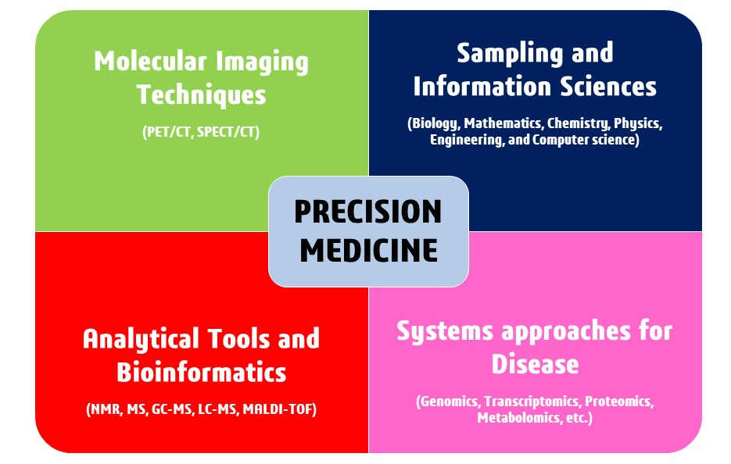
FIGURE 6. IMAGING BASED PRECISION MEDICINE

APPLICATIONS OF IMAGING BASED PRECISION MEDICINE:

Cancer diagnosis and treatment: The size, location, and features of tumors can be precisely determined by medical imaging techniques like MRI, CT scans, and PET scans. With the help of this data, oncologists can choose the most effective course of action, be it surgery, radiation therapy, chemotherapy, or targeted therapies.
Neurological disorders: imaging methods such as fMRI (functional magnetic resonance imaging) and diffusion tensor imaging may help in the diagnosis and understanding of disorders of the nervous system such as multiple sclerosis, Parkinson's disease, and Alzheimer's disease. These methods allow early diagnosis and specific treatment plans by monitoring alterations in brain structure and function over time.
Cardiovascular Medicine: Echocardiography, cardiac MRI, and coronary angiography are imaging modalities that are essential for diagnosing and managing heart diseases. They offer thorough insights on how the heart works, how blood flows, and how the blood vessels are doing, helping physicians make decisions about how to manage problems like heart failure, coronary artery disease, and arrhythmias.
Orthopaedics and musculoskeletal disorders: Imaging-based precision medicine helps in the diagnosis and treatment of soft tissue injuries, joint function, and bone density by orthopaedic specialists. For disorders including fractures, osteoarthritis, and sports-related injuries, methods like MRI and X-rays help with diagnosis and therapy planning
Personalized Radiation Therapy: In cancer treatment, precision medicine involves targeting radiation therapy based on the specific characteristics of a tumor. Advanced imaging techniques assist in accurately locating tumors and surrounding healthy tissues, enabling radiation oncologists to deliver higher doses to the tumor while minimizing damage to healthy tissue.
Minimally Invasive treatments: Real-time imaging is used to direct catheters, needles, or other tools to the precise site of a problem during image-guided treatments, including minimally invasive operations and interventional radiology. This improves the precision and safety of treatments, lowering patient risk and speeding up recovery.
Pharmacogenemics: Imaging can be useful in pharmacogenomic research, which examines how a person's genetic composition affects how well they respond to drugs. It is possible to create customised treatment programmes by combining genetic and imaging data to anticipate how patients will react to particular medications.
Trauma Care: Imaging technology like CT scans and X-rays are essential in both of these fields. They enable quick and precise injury evaluation, assisting healthcare professionals in making decisions about patient treatment more quickly.
Preventive healthcare:can result from early disease identification and risk assessment using imaging. As an illustration, coronary calcium scoring with CT scans can determine a person's risk of developing heart disease even before any symptoms show up.
Longitudinal Monitoring: Repeated imaging throughout time helps monitor the development of the disease and the success of treatment. This is helpful for diseases like cancer, where routine scans can track the effectiveness of treatment on the tumour.
Pediatric imaging: To reduce radiation exposure and ensure correct diagnosis, children frequently need specialized imaging procedures. Adapting imaging methods for pediatric patients while maintaining diagnostic accuracy is made possible by precision medicine methods[20].

- DIGITAL HEALTH AND WEARABLES IN PRECISION MEDICINE:

The field of precision medicine has seen significant advancements and adaptation of digital health and wearables playing a crucial role which aims to provide individualized treatment and care based on a patient's unique attributes, environment, lifestyle, and genetics, and through the data collected by these devices, they can help improve the quality of care for patients, medical treatments and interventions, early detection of the disease, which leads to more effective and efficient healthcare outcomes[21]. Here’s how they contribute in the precision field.

- Data collection and monitoring: by gathering and analysing large amounts of patient data, we can gain insights into individual characteristics and plan their treatment accordingly to approach an understanding why individuals and populations have different disease experiences. Furthermore aims to integrate various types of data including genetic information, health behaviours and environmental exposures to develop more effective and targeted strategies for improvements.
- Clinical data: plays a crucial role by providing valuable intuition into personal characteristics, including molecular biomarkers and behavioural patterns individuals. It has a wide range of information of patient’s health which consists of patient medical history , physical examination, diagnostics test , imaging studies, and treatment response. This data provides a clear picture of patient’s health status which helps us in making precised decisions for better patient outcome. It also aids in identifying disease pattern, symptoms and abnormalities along with genetic and molecular information which can differentiate the sub types of the disease. This also takes information from various laboratory tests such as blood tests, urine tests, or tumor markers about the organ function. It relies on clinical trial data which includes information on treatment effectiveness, side effects, and patient outcomes observed during controlled studies.
- Biomarkers data: are measurable indicators that helps to predict disease states, or response to treatments. They can be genetic, molecular, diagnostic, prognostic, predictive, monitoring.
- Genetic biomarkers: such as mutations, single nucleotide polymorphisms (SNPs) are used to identify specific genetic variations associated with disease risk.
- Molecular biomarkers: such as proteins, RNA are used to provide insights into the underlying molecular changes associated with diseases.
- Diagnostic biomarkers: diagnose disease by identifying specific molecular or genetic condition of the disease.
- Prognostic biomarkers: this guides about likely course of a disease, which includes its aggressiveness, likelihood of recurrence, or progression.
- Predictive biomarkers: it demonstrates the likelihood of response to a specific and effective therapies for individual patient.
- Monitoring biomarkers: enables us to monitor therapy response, disease progression and make necessary adjustments.
- Omics data: focuses on the molecular complexities of diseases and designs personalised treatment strategies. This includes biological components such as genes, proteins, metabolites, and more. It enhances treatment selection and minimizes adverse effects, ultimately leading to improved patient outcomes.
- Health monitoring devices: development of health monitoring devices can be used at the point of care or even in comfort of one’s own home which gains access to tools that seamlessly integrate into their daily lives, allowing for continuous health monitoring and earlier identification of potential health issues. It measures clinically relevant parameters such as heart rate variability, skin temperature, blood glucose levels, sleep quality, activity levels, environmental factors and electrodermal activities. Few examples of variable devices include continuous glucose monitoring sensors for diabetes, activity trackers for obesity, and smartwatches for cardiovascular health. This devices collects data that is essential to personalise treatment plans and monitor patients for potential complications. Overall, it offers new opportunities by enabling continuous, non-invasive monitoring of an individual’s health status.
- Electronic health record (EHRs): are digital versions of a patient’s clinical and demographic information like medical history, laboratory and diagnostic test results, medications, allergies and more.
EHRs enable healthcare providers to:
- Identify populations at risk: Identifies individuals with genetic predispositions, populations at risk of developing specific diseases and for managing targeted interventions.
- Monitor treatment response: Tracks a patient’s treatment progress over time, adjusts treatment plans to meet individual needs, and identifies any adverse effects that may require further assessment.
- Support medical research: provides vast amount of data to identify patterns and trends, test new therapies and develop new treatment strategies, ultimately leading to better out comes.
- Patient reported data: this data helps medical professionals accurately classify and diagnose diseases by correlating patient’s clinical phenotypes data. Moreover it also enables the delivery of targeted prevention and treatment measures that ensure patient’s receive the right interventions at right time. The integration of electronic patient reported outcomes into daily routine care showed several benefits by allowing the better understanding of patient’s experiences, concerns, treatment goals and accuracy of patient’s health information.

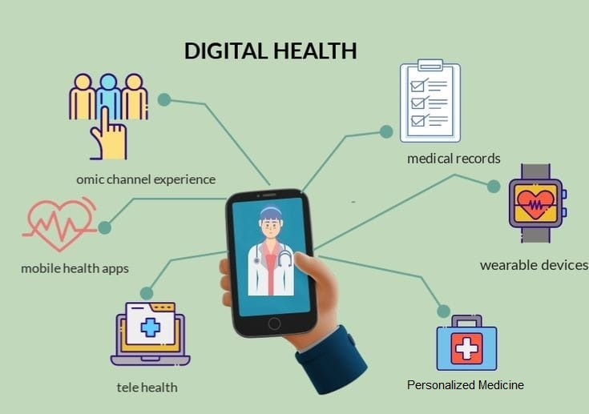
FIGURE 7. DIGITAL HEALTH

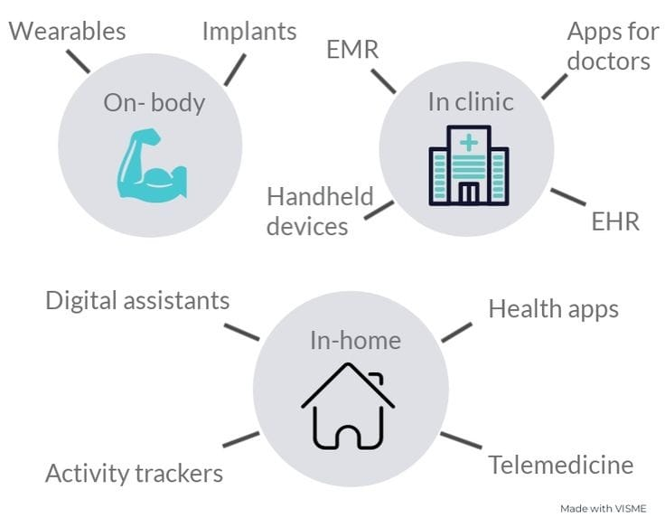
FIGURE 8. WEARABLES

APPLICATIONS OF DIGITAL HEALTHCARE AND WEARABLES

In digital healthcare the use of genomic sequencing combined with wearable sensors can be used for cancer treatments, by analyzing a patient’s genomic profile along with real-time physiological data from wearables, we can tailor treatments based on individual characteristics and monitor response rates more accurately and for early disease detection. Another application is remote monitoring using wearable devices for chronic disease management, better decision-making for dosing or adjustments in therapy in patient’s with other conditions such as diabetes, hypertension. Smartwatches now also offer additional features like electrocardiogram recording, blood pressure recording, blood glucose recording, and etc for more comprehensive, accurate health monitoring[22].

- DATA ANALYTICS & ARTIFICIAL INTELLIGENCE (DA & AI):

DA & AI in precision medicine aims to tailor treatments to individual patient based on their unique genetic, environmental and lifestyle factors.
The DA & AI contributions are :
  - Personalized Treatment: It includes tailoring medical care and the interventions to the specific characteristics of each individual patient. This approach takes into account factors such as :
- Genomic Information: Genetic data is a key component of personalized treatment .It identifies genetic mutations and variations that may affect drug responses . This helps in selective treatment that are having better efficacy and minimum adverse effect.
- Targeted therapies: with patient genetic information& molecular profile,with this the physician can choose the specially target the underlying mechanisms of a disease . This increases the likelihood of successful treatment with minimizing unnecessary side effects.
- Drug selection: It involves selections of medications based on patient’s genetic and metabolic traits . This helps to avoid the drugs that may be harmful / ineffective and helps to identifies those that are likely to work well for individual patient.
- Dosage Optimization: genetic information can influence how an individual metabolizes drugs. It determine the most appropriate dosage for each patient ,avoiding over/under dose .
- Early detection and prevention :personalized treatment allows for early detection of diseases and preventive measures and interventions to reduce the risk .
- Individualized care plans : the plan includes patient’s unique characteristics,medical historyand preferences.
- Monitorinig & adaptation:monitoring patients using sensors ,wearable devices,digital health tools. This data helps doctors to track treatment progress &adjustment needed.
- Patient engagement : patients are actively involved in treatment decisions. This leads to higher treatment adherence and better outcomes.
- Challenges: implementing personalized treatment collections,analysis privacy concers ,data security must also be addressed.

  - Genomic analysis: AI can analyze genomic data to identify genetic mutations &variationsthat may contribute to diseases.
- Sequencing Genomes:It starts with sequencing a persons entire genome or specific genes of interest.This involves determining the order of DNA bases (adenine,thymine,cytosine,and guanine) in their DNA.
- Genetic variations: It identifies genetic variations,such as single nucleotide polymorphisms(SNPS)or structural variations,that may be associated with disease risk,drug metabolism,and treatment responses.
- Disease Risk Assessment:By comparing an individuals genetic variants to known associations,genomic analysis .This help in early detection &preventive strategies.
- Targeted Therapies:genomic analysis can reveal specific genetic mutations driving diseases like cancer.
- Clinical decision support : provides clinlicals with eaddition information when making treatment decisions & informed care plans .
- Pharmacogenomics:predicts how a patient will respond to medications based on their genetic profile.
- Cancer genomics:genomic analysis of tumor tissue identifies genetic alterations that contribute to cancer development.
- Rare disease diagnosis:helps to diagnosis rare genetic disorders by identifying specific mutations responsible for condition.
- Data integration : genomic data is integrated with other health data such as medical history & environmental factors , to create a comprehensive picture .
- Research Advancenments:aggregating & analysis large scale genemoic data across populations help researches, novel disease associations potential therapeutic targets[23].

  - Predictive Diagnostics : It involves data sources, including genetic information, medical history and life style factors to predicts an individual’s risk of specific disease.
- Data collection: it includes genetic information,family medical history, environmental exposures, biomarker measurements, lifestyle habits.
- Risk assessment: advanced algorithms analyse the collected data to assess an individual’s risk of certain disease .
- Early detection : to identify the disease risk before symptoms manifest detecting diseases at early stages leads to better outcomes &effective treatment.
- Customized screening: based on individual risk ,health care providers can recommend targeted screening test or monitoring protocols to detect disease .
- Preventive strategies: Predictive diagnostics enable the health care professionals to plan preventive strategies it includes life style modifications medication , interventions to reduce risk factors.

  - Drug Discovery: Involves identifying &developing medications that are tailored to the specific genetic , molecular, biological characteristics of individual patient. Aim is to increase the effectiveness of treatments with reducing side effects. It includes:
- Genomic analysis: Genetic & molecular data obtained through techinques like genomics sequencing to identify specific targets .
- Target identification:researchers pinpoint genes,proteins,pathways that are implicated in the disease.
- Biomarker discovery:which are specific molecular indicators of disease progression are identified to guide drug development& slelection.
- Rational drug designs :based on the identified targets &biomarkers drugs are designed to interact with the specific molecular mechanism.
- High-throughput screening:compounds are tested against the disease targets to identify potential drug.
- Preclinical testing:drug candidates undergo rigours testing in cell culture ,animal models to assess safety,efficacy,potential side effects.
- Clinical trials :drug that pass preclinical testing move on to clinical trials,which are often designed to target patient with specific genetic characteristics.
- Patient stratification: considers patient diversity with treatment to different genetic/molecular subgroup for maximum effectiveness.
- Data integration:involves genetic,molecular ,clinical,other data to make informed decisions at every stage.
- Iterative process:it involves refining compounds based on trial results&improving disease mechanisms.
- Faster development: This approaches can lead to faster drug development,and approvalswith high response rates.
- Challenges: Includes reliable disease targets ,addressing drug resistance ,ensuring drugs are accesscible to patients.

  - Clinical Trials: It involves tailoring nediical treatment to the individual of each patient.These trials aim to determine the most effective treatments based on genetic ,molecular,other relevant information By identifying the right treatments for specific patients groups ,precision medicine can improve outcomes and reduce adverse effects.

  - Treatment monitoring: Involves closely tracking a patient’sresponse to personalized treatment plan.Includes regular assessment of biomarkers,genetic changes .Monitoring allows providers to adjust treatments as needed,ensuring to choose interventions remain effective and minimally harmful.

  - Population health insights: It involves the data from large groups of individuals to identify patterns , trends, genetic variations that can impact health outcomes.By studying diverse populations ,reserachers can uncover genetic factors that contribute to disease response to treatments ,overall health disparities.the helath insights help refine the precision medicine approaches making them more effective and different demographic groups.

  - Ethical considerations: It involves the isssues like privacy, data security,consents,equitable access to treatments, balancing personalized care with potential misuse of genetic information and ensuring diverse populations benefit are important aspects to address.
FIGURE 9. ARTIFICIAL INTELLIGENCE IN PRECISION MEDICINE

- PREVENTIVE PRECISION MEDICINE (PPM):

Preventive precision medicine (PPM) refers to advancement of technologies and personalized data to predict and prevent the disease before they occur
These include healthcare strategies according to an individual’s genetic and molecular attributes. This approach adapts interventions such as Genetic testing, environmental monitoring, health screening, immunization, early detection , lifestyle adjustment, Targeted therapies and Education

Genetic testing

Genetic testing measures are used in precision medicine to analyse an individual's genetic makeup and identify any genetic variations or mutations that may be associated with certain diseases or conditions. This information can help healthcare providers tailor treatment plans, intervention and susceptibility of disease the specific needs of each patient. Genetic testing measures can include various techniques such as DNA sequencing, gene expression profiling, and chromosomal analysis.

Environmental monitoring

Environmental monitoring in preventive precision medicine involves tracking an individual’s exposure to external factors that can influence health outcomes. These factors can include air and water quality, diet, exercise habits, occupation, and even social determinants of health. The goal is to understand how these environmental factors interact with an individual’s genetic and molecular makeup to impact their health and disease susceptibility.
Various sensors, wearable devices, and data collection methods are used to gather information about an individual’s environment. For example, air quality sensors can measure pollutants, while wearable fitness trackers can monitor physical activity and sleep patterns.

Health screening

Health screening in preventive precision medicine aims to shift healthcare from a reactive to a proactive model .It involves the systematic and personalized assessment of an individual's health to detect potential diseases or risk factors at an early stage.

Immunization

Based on genetic information, healthcare professionals can select vaccines that are likely to be most effective for the individual. Genetic markers can help determine the most appropriate timing for vaccinations to ensure the best immune response and also predict an individual's likelihood of responding well to specific vaccines, helping prioritize vaccinations for diseased person.
By integrating genetic information into immunization strategies, preventive precision medicine aims to enhance the individualized effectiveness of vaccines, reduce the risk of adverse reactions, and contribute to more informed decision-making for both individuals and public health initiatives.

Early detection

Early detection involves the identification of initial signs of diseases or health risks before symptoms manifest. This approach relies on an individual's genetic and molecular data to pinpoint potential disease predispositions and employs targeted screenings, biomarker assessments, and personalized risk stratification to catch conditions at their inception. By intervening promptly, tailored treatments can be implemented, leading to more effective disease management and improved overall outcomes. This proactive approach not only benefits individuals but also contributes to broader insights into disease patterns and informs public health strategies.

Lifestyle adjustment

This approach tailors recommendations for diet, physical activity, sleep, stress management, and other lifestyle factors based on an individual's genetic susceptibilities. By aligning lifestyle choices with genetic insights, the aim is to mitigate the risk of diseases associated with specific genetic markers and promote long-term well-being. This proactive strategy empowers individuals to make informed choices, enhances disease prevention, and contributes to a broader understanding of effective preventive measures.
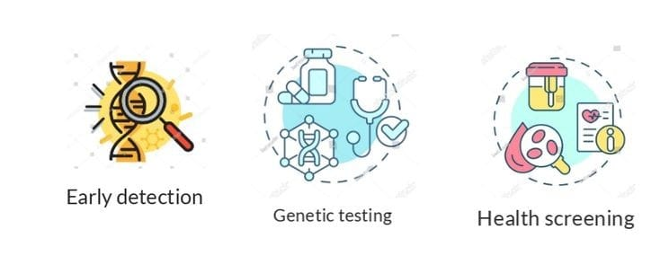
FIGURE 10. PRECISION PREVENTIVE MEDICINE
Targeted therapies

It involving the adaptation of medical treatments according to an individual’s genetic and molecular makeup. This process aims to mitigate disease risks and enhance overall health by:
- Genetic Analysis: Examining an individual's genetic and molecular data to identify specific variations or anomalies that might contribute to disease susceptibility
- Tailored Treatment: Selecting treatments, such as medications or interventions, based on the individual's genetic characteristics, targeting underlying factors that contribute to disease risk.
- Reduced Side Effects: By pinpointing the most appropriate treatments, the potential for adverse reactions and unnecessary side effects can be minimized.
- Early Action: Implementing these therapies at an early stage can prevent disease progression or lessen its impact.
- Continuous Monitoring: Regularly assessing the individual's response to treatment allows for adjustments if needed.
- Personalization: Treatment plans are uniquely tailored to the individual's genetic composition, maximizing their effectiveness.
- Informing Guidelines: Aggregating data on the success of targeted therapies can inform the development of broader medical guidelines and treatments
- Enhanced Outcomes: Targeted therapies contribute to improved disease management, ultimately reducing the burden of illness and promoting overall well-being[24].

Education

It is a process that involves individuals to make well-informed decisions concerning their health and disease prevention. Genetic Literacy, interpreting results, assessing risks, lifestyle changes, Personalized guidelines, ethical Awareness and professional understanding are the key components.
By providing education about genetic information, preventive precision medicine empowers individuals to actively engage in their health management, make informed choices, and collaborate effectively with healthcare providers in shaping personalized strategies for disease prevention. These approaches collectively aim to individualize healthcare strategies, leading to improved disease prevention and overall well-being management

REFERENCES

1. Akhoon N (2021) Precision Medicine: A New Paradigm in Therapeutics. Int J Prev Med 12:12. https://doi.org/10.4103/ijpvm.IJPVM_375_19
2. Naithani N, Sinha S, Misra P, et al (2021) Precision medicine: Concept and tools. Med J Armed Forces India 77:249–257. https://doi.org/10.1016/j.mjafi.2021.06.021
3. Lu CY, Terry V, Thomas DM (2023) Precision medicine: affording the successes of science. npj Precis Oncol 7:3. https://doi.org/10.1038/s41698-022-00343-y
4. Strianese O, Rizzo F, Ciccarelli M, et al (2020) Precision and Personalized Medicine: How Genomic Approach Improves the Management of Cardiovascular and Neurodegenerative Disease. Genes (Basel) 11:747. https://doi.org/10.3390/genes11070747
5. Burian AN, Zhao W, Lo T, Thurtle‐Schmidt DM (2021) Genome sequencing guide: An introductory toolbox to whole‐genome analysis methods. Biochem Mol Biol Educ 49:815–825. https://doi.org/10.1002/bmb.21561
6. Morash M, Mitchell H, Beltran H, et al (2018) The Role of Next-Generation Sequencing in Precision Medicine: A Review of Outcomes in Oncology. J Pers Med 8:30. https://doi.org/10.3390/jpm8030030
7. Ross JP, Dion PA, Rouleau GA (2020) Exome sequencing in genetic disease: recent advances and considerations. F1000Research 9:336. https://doi.org/10.12688/f1000research.19444.1
8. Lam YWF (2019) Principles of Pharmacogenomics :
9. Chandra R (2023) The role of pharmacogenomics in precision medicine. 1–13
10. Sakaeda T, Nakamura T, Okumura K (2004) Pharmacogenetics of Drug Transporters and Its Impact on the Pharmacotherapy. Curr Top Med Chem 4:1383–1396
11. Mini E, Nobili S (2009) Pharmacogenetics: implementing personalized medicine. Clin Cases Miner Bone Metab 6:17–24
12. Geick A, Eichelbaum M, Burk O (2001) Nuclear Receptor Response Elements Mediate Induction of Intestinal MDR1 by Rifampin. J Biol Chem 276:14581–14587. https://doi.org/10.1074/jbc.M010173200
13. Muller C, Bailly JD, Jaffrezou JP, et al (1994) [Pharmacological control of P-glycoprotein expression]. Bull Cancer 81:386–91
14. Sukhai M, Piquette-Miller M (2000) Regulation of the multidrug resistance genes by stress signals. J Pharm Pharm Sci 3:268–80
15. Ahmed S, Zhou Z, Zhou J, Chen S (2016) Pharmacogenomics of Drug Metabolizing Enzymes and Transporters : Relevance to Precision Medicine. Genomics Proteomics Bioinformatics 14:298–313. https://doi.org/10.1016/j.gpb.2016.03.008
16. Gambardella V, Lombardi P, Carbonell-Asins JA, et al (2021) Molecular profiling of advanced solid tumours. The impact of experimental molecular-matched therapies on cancer patient outcomes in early-phase trials: the MAST study. Br J Cancer 125:1261–1269. https://doi.org/10.1038/s41416-021-01502-x
17. Zhang Q, Fu Q, Bai X, Liang T (2020) Molecular Profiling–Based Precision Medicine in Cancer: A Review of Current Evidence and Challenges. Front Oncol 10:1–9. https://doi.org/10.3389/fonc.2020.532403
18. Malone ER, Oliva M, Sabatini PJB, et al (2020) Molecular profiling for precision cancer therapies. Genome Med 12:8. https://doi.org/10.1186/s13073-019-0703-1
19. Society E (2015) Medical imaging in personalised medicine: a white paper of the research committee of the European Society of Radiology (ESR). Insights Imaging 6:141–155. https://doi.org/10.1007/s13244-015-0394-0
20. Shaw A, Seban R, Besson FL, et al (2022) Editorial: Breakthrough in Imaging-Guided Precision Medicine in Oncology. Front Oncol 12:10–13. https://doi.org/10.3389/fonc.2022.908561
21. Giansanti D (2023) Precision Medicine 2.0: How Digital Health and AI Are Changing the Game. J Pers Med 13:1057. https://doi.org/10.3390/jpm13071057
22. Kasoju N, Remya NS, Sasi R, et al (2023) Digital health: trends, opportunities and challenges in medical devices, pharma and bio-technology. CSI Trans ICT 11:11–30. https://doi.org/10.1007/s40012-023-00380-3
23. Fröhlich H, Balling R, Beerenwinkel N, et al (2018) From hype to reality: data science enabling personalized medicine. BMC Med 16:150. https://doi.org/10.1186/s12916-018-1122-7
24. Golubnitschaja O, Kinkorova J, Costigliola V (2014) Predictive, Preventive and Personalised Medicine as the hardcore of ‘Horizon 2020’: EPMA position paper. EPMA J 5:6. https://doi.org/10.1186/1878-5085-5-6

