CONTRAST RADIOGRAPHY IN HEAD & NECK IMAGING

Dr.Fatima Khan & Dr.Ekta Sawariya

Contrast radiography is one of the most important adjunct procedures for imaging of the oral and maxillo-facial region. Despite the advent of newer investigation techniques, it remains one of the most useful diagnostic tools. 1Contrast radiography improves or allows the visualization of organs surrounded by tissues of the same radiographic opacity, thus providing information about the size, shape and position of these structures and neighboring areas. It shows the internal structure of an organ, including its mucosal pattern and may also occasionally help in assessing organ function.2

Contrast media (CM) enhance the quality of images, revolutionizing the radiologist’s ability to differentiate soft tissue densities. Ideally, CM should achieve very high concentration in the tissues without producing any adverse effects.3

Artificial contrast can be produced in a variety of ways. Material with high co-efficient of absorption can be placed in or around the structure of interest. The use of artificially induced contrast has been helpful in allowing the evaluation of structures that would otherwise be radio graphically invisible .Use of radiopaque agent is termed as positive contrast agent whereas use of gas (like air, oxygen, carbon dioxide ) is termed as negative contrast agent When both are used concomitantly, it is known as ‘double contrast’ The contrast media that permits detailed visualization of the internal structure or organ that would not otherwise be demonstrable4.

**Definition: -** It is defined as a radiopaque substance that has been developed to alter artificially, the density of different parts of the patients thus altering the subject’s contrast4.

**Classification:-**

Contrast agents are classified on the basis of their physical & chemical characteristics, including their chemical structure, osmolaltity, iodined contents &ionization in solution. In clinical practice, categorization based on osmolarality in widely used4,5.

**ACCORDING TO CHARR DH (1988)**

1. **Depending on their Nature of Material**

* Iodine Based
* Non-iodined based e.g barium sulphate

1. **Depending on the Solvent**

* Conventional ionic water soluble
* Oil soluble

1. **Depending on the Ionic Nature**

* Acidic monomer e.g diatrizoate, iothalamate
* Non-ionic monomer e.g iopamidol, iohexol, ioversol mono- acidic dimer
* Non-ionic dimer e.g iodixanol, iorrol4

**ACCORDING TO WHAIRESE (1996)**

1. **Iodine based aqueous solution**

* Ionic monomer e.g iothalamate (Conray), Metrizoate ( Isopaque), diatrizoate (Urografin)
* Ionicdimmers, e.g ioxaglate (Hexabrix)
* Non-ionic monomer e.g iopamidol ( Niopan) , ioxhexol (Omnipaque), iopromide(Ultravist)

1. **Iodine based oil solution:** For example ethidol, pantopaque& lipiodol4

**ACCORDING TO THEIR PROPERTIES**

The radio contrast medium currently in used are based upon fully situated benzoic acid molecules with their atoms of iodine replacing the hydrogen atom at position 2,3 & 6 rings of benzoic ring, the different agents can be classified according to their properties5:-

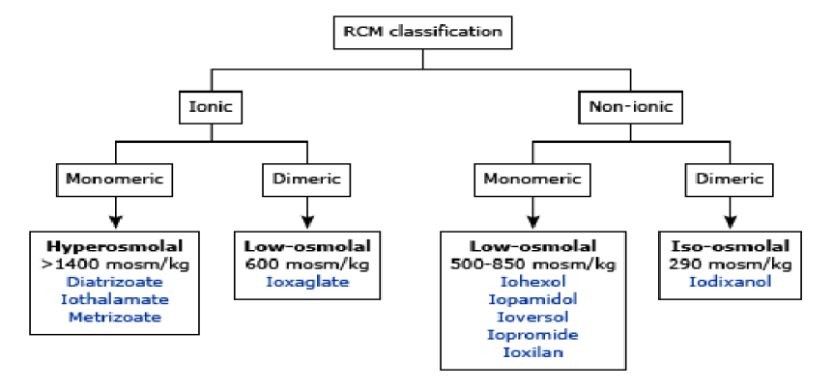

**General property of contrast media**

1. **Viscosity:-**

Viscosity of the fluid is assessed by measuring its rate of flow through a standard thin capillary tube under standard condition of pressure and temperature.

It helps to determine or refers to the thickness of a fluid. Radiologically, viscosity can be explained as the amount of force needed to inject the contrast agent through needle or catheter into a patient. More viscous the agent more will be the difficulty in injecting it.

1. **Osmolality:**

it refers to a process in which solution of higher concentration draws water from the solutions of lower concentratation.

The sensations of heat and discomfort or even pain experienced by the patient are directly related to the osmolality of the contrast medium.4, 6, 7

1. **Chemotoxicity:** It is defined as the mechanism responsible for causing the toxic effects of the contrast media. (e.g. osmolality, electrical charge).

There are a number of properties of contrast medium which are related to Chemotoxicity e.g8

|  |  |
| --- | --- |
| Hydrophilicity | Aqueous in nature |
| Lipophilicity | Fat like(lipid) organic in nature |
| Protein binding | It is a contrast medium which binds to plasma protein in the blood stream |
| Histamine release | It is a character of allergic reaction and the property of contrast medium to release histamine from mast cell may be responsible for the allergy like reaction with some contrast media. |

**IDEAL PROPERTIES OF CONTRAST AGENTS**

1. **Safe:** Contrast media should be safe to use and handle
2. **Non toxic:** It should be non-toxic and should have no adverse reactions.
3. **Should not cross the blood -brain barrier:** It should not cross the cell membrane or penetrate the cells or the blood-brain barrier. Their transfer is to the breast milk & placental passage should be limited.
4. **Similar physiologic properties when compaired to blood, saliva:** Their physiologic properties should be similar to the body fluids they come in contact with, e.g. saliva and blood etc. should be miscible with saliva(body fluid).
5. **Inertness:** It should have pharmacologic inertness (local and systemic).
6. **Opacification:** It should produce satisfactory opacification.
7. **Low surface tension:** It should have low surface tension and low viscosity to allow filling of fine components.
8. **Easy injectablility:** It should be easy to inject with excellent x-ray absorption characteristic at the x-ray energies used in diagnostic radiology.
9. It should have minimum toxicity, chemical stability, and acceptable by the patient with no carcinogenic effects.
10. **Elimination:** Elimination should be easy, but the elimination time should be such that it provides adequate time for satisfactory radiography.
11. **Residual contrast media:** The residual contrast media should beabsorbed by the body and detoxified by liver or kidney. They should not have any residual side effects.4,6

**APPLICATION OF CONTRAST AGENTS IN ORAL RADIOLOGY**

* Contrast media in Sialography
* Contrast media in Arthrography
* Contrast media in Lymphangiography
* Contrast media in Ultrasound Imaging
* Contrast media in Computed Tomography
* Contrast media in Magnetic Resonance Imaging
* Contrast media in Angiography

**SIALOGRAPHY:-** Sialography is a radiographic technique in which a radiopaque contrast agent in infused into the ductal system of a salivary gland prior to imaging with plain films,

Fluoroscopy, panoramic radiography, tomography, or computed tomography (CT).Sialography provides a straightforward demonstration of the ductal system.

It is useful diagnostic adjunct to reveal location and integrity of salivary gland, thus indicating the presence of disease that changes internal architecture.9, 10

**Technique for introducing the contrast media: -** The three main techniques available for introducing thecontrast medium into the ductal system, having cannulated the relevant duct orifice, can be summarized as follows:

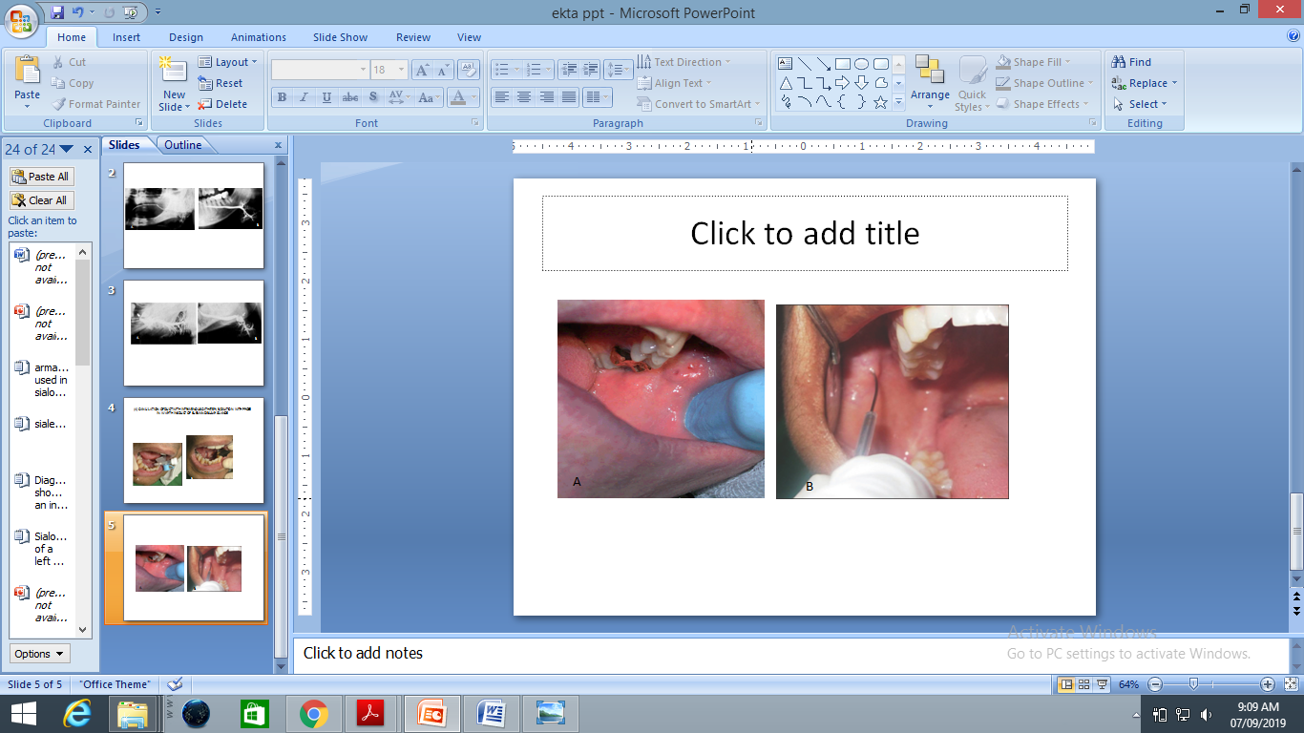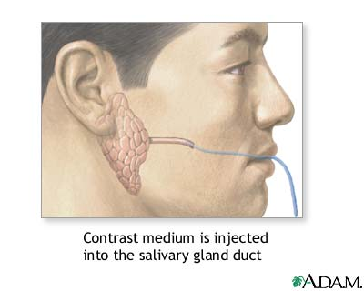

**Insersation of cannulated probe into the stensen’s duct showing contrast media is injected into the salivary gland.**

1. **Simple injection technique:-** Oil-based or aqueous contrast medium is introduced usinggentle hand pressure until the patient experiences tightness ordiscomfort in the gland,(about 0.7 ml for the parotid gland,0.5 ml for the submandibular gland).

**Advantages**

* Simple
* Inexpensive.

**Disadvantage**

* The arbitrary pressure which is applied may cause damage to the gland.
* Patient's responses may lead to under filling or overfilling of the gland.11,12,13

1. **Hydrostatic technique: -** Aqueous contrast media is allowed to flow freely into the gland under the force of gravity until the patient experiences discomfort.

**Advantages**

* The controlled introduction of contrast medium is less likely to cause damage or give an artefactual picture
* Simple
* Inexpensive.

**Disadvantages**

* Irritation of tissue
* Sometime it may be painful1112,13

1. **Continuous infusion pressure-monitored technique: -** Using aqueous contrast medium, a constant flow rate is adopted and the ductal pressure monitored throughout the procedure.

**Advantages**

* The controlled introduction of contrast media at known pressures is not likely to cause damage.
* Does not cause overfilling of the gland.
* Does not rely on the patient's responses.

**Disadvantages**

* Complex equipment is required
* Time consuming11,12,13

**Phases of sialography**

The procedure is divided into three phases:

* **Ductal phase:** - It begins with the injection of the contrast medium and terminates ones the parenchyma becomes hazy.
* **Acinar phase: -** It begins with the competition of the ductal opacification and ends when there is a generalized increase in density of the gland. The phase is of great importance in the pre CT ear, when sialography is indented to demonstrate the presence of intraglandular and extra glandular masses.
* **Evacuation phases: -** It provides an estimate of the secretory function of the salivary gland. After sialography view is taken the catheter should be removed from the duct orifice. Patient is instructed to chew gum or suck on lemon or other sialagogue like 1% solution of citric acid given, and then ask to rinse. This will stimulate any glandular function and cause execration of dye. Normal salivary gland execrates 100 % dye contrast with in 5 minutes after removal of catheter.11,12,13,14

**Normal sialography: - For Parotid gland:11,12,13**

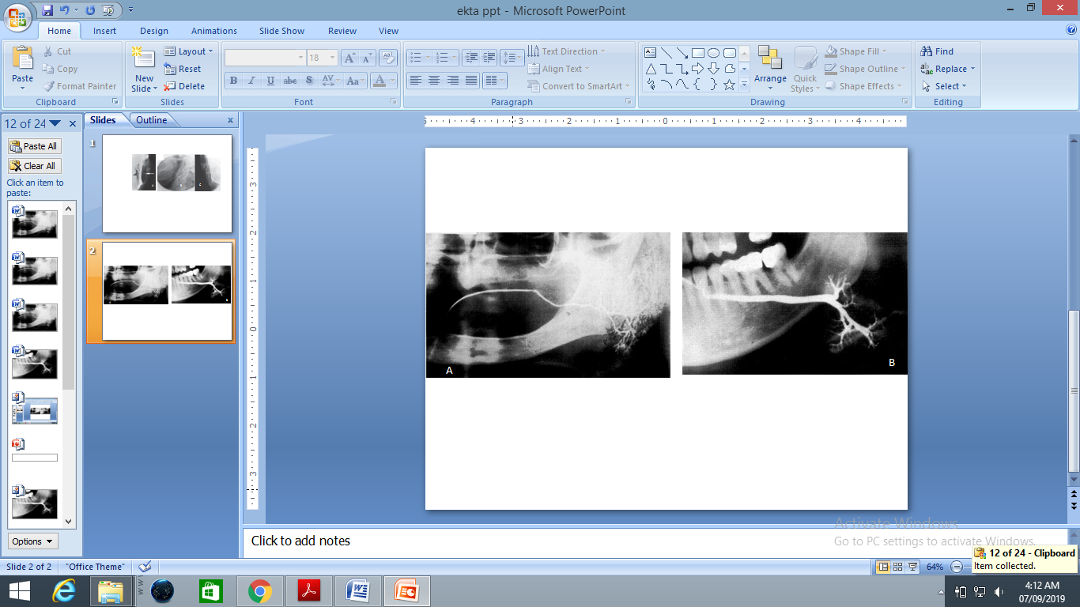

**Sialograph showing a normal left parotid gland, the tree in winter appearance**

**Pathological appearances:** -

There is also irregular salivary duct stricture (narrowing) of the duct, which creates an appearance known as **"sausage link"** pattern on a sialogram, Suggestions of abscesses and autoimmune diseases such as Sjögren syndrome can also be elicited.5, 10,11,12,13,14,15,16

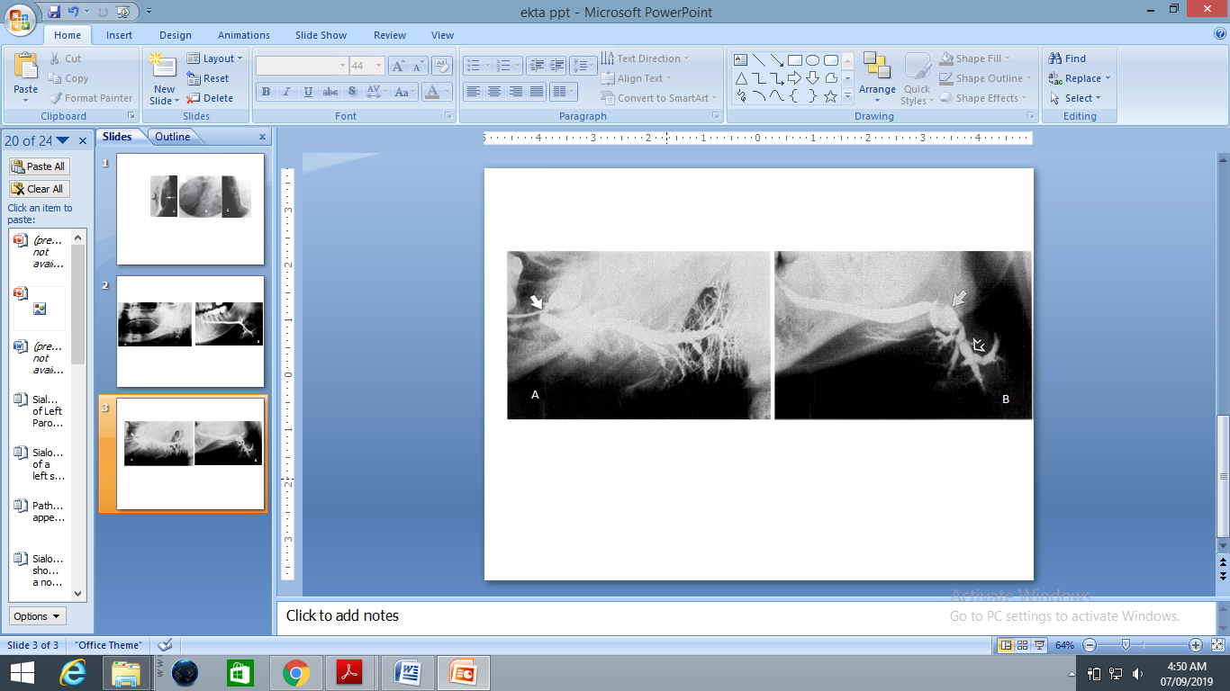

**Fig: - Sialograph of a left parotid showing gross dilatation of the main duct caused by Sialodochitis secondary to stenosis at the orifice (arrowed).**

Sialadenitis is inflammation of the salivary glands, which may cause acinar atrophy and create an appearance known as **"pruning of the tree"** on a sialogram, where there are less branches visible from the duct system. A space occupying lesion that occurs within or adjacent to a salivary gland can displace the normal anatomy of the gland. This may create an appearance known as **"ball in hand"** on an sialogram, where the ducts are curved around the mass of the lesion.10, 11, 12, 13,14,15,16

* **For submandibular gland: -**After the appropriate orifice has been identified, the duct can be explored with the lacrimal probe and the probe should pass through the length of the floor of the mouth to the level of the posterior border of the mylohyoid muscle, a penetration of about 5 cm.
* Because of the tortuous course of the parotid duct, the cheek has to be turned outward before the probe is inserted into the duct. The aversion of the cheek will help to reduce the possibility of penetrating the duct at one of the sharp angles in its course.
* The probe should slide easily back and forth and also rotate freely without dragging.

Appropriate volumes of dye required vary from 0.0 to 0.75 ml for submandibular glands11

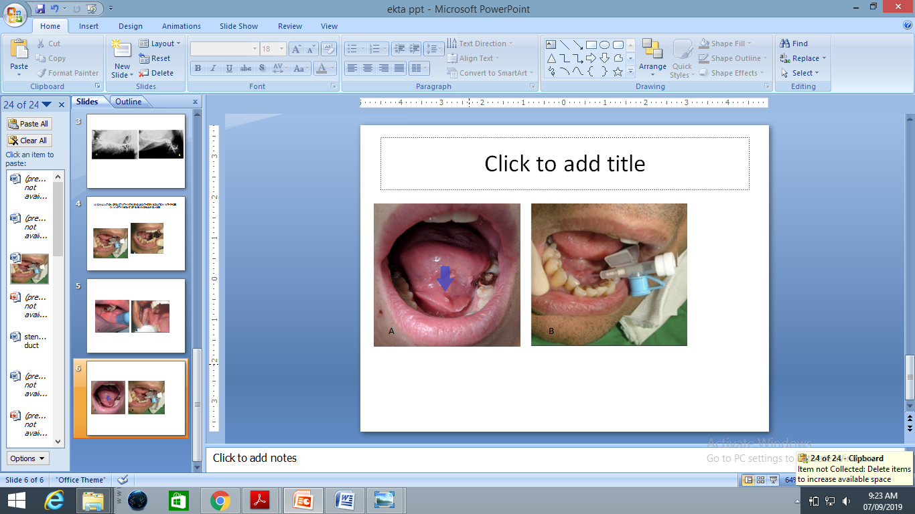

**Figure** :- (A) Blue arrow the clinical picture of submandibular duct orifice is situated on the summit of the small papilla at the side of the lingual frenum (B) Insersation of cannulated probe into the warthins duct

**Submandibular gland: -** The main duct of even diameter (3-4mm wide) and should be filled completely and uniformly. This gland is small than the parotid but overall appearance is similar with branching duct structure tapering gradually towards the periphery that so called as a **bush in winter appearance.** 11,12,13



**Figure :- Sialograph is showing a normal left submandibular gland, the bush in winter appearance*.***

**Advantage of sialography**

1. High resolution of ductal system
2. Controlled localized radiation dose
3. Much existing information on appearance of a specific dieses state (detection of radiolucent sialolith, duct strictures or derverticuls)11,12,13

**Disadvantage of sialography**

1. Painful on injection ,difficult to perform
2. Allergy to iodine
3. Difficult to interpret with precision
4. Extravasations into adjacent tissue causing irritation or necrosis
5. Single gland is examine at time
6. Difficult to obtain histological evidence to substantiate the sialographic interpretation.11,12,13

**ARTHROGRAPHY**

Arthrography involves injection of a radiopaque contrast material into the joint spaces. The space occupied by the disc can then be visualized lying between the layers of contrast material.17

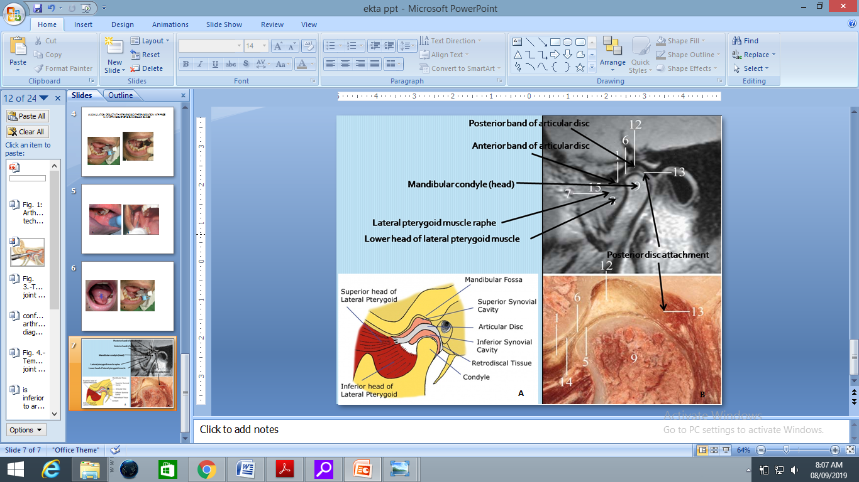

**Arthrography technique**

**TYPES OF ARTHROGRAPHY**

1. Single contrast arthrography- Injection of contrast agent into the lower TMJ space, is referred to as lower joint space or single contrast arthrography However, when we see the contrast material in the upper TMJ space without injecting in that space, then we can suspect, damage to the articular disc.11
2. Double contrast radiography - - When the contrast agent is injected into both the upper and lower TMJ space, it is called double contrast arthrography. This further

helps in getting a clear picture of the outline of the articular disc. Opacification of both the joint spaces following injection of only one denotes a pathological condition.11

**ADVANTAGES**

1. Arthrography provides information regarding the soft tissue components, specifically the shape and position of the articular disc.
2. Arthrography is indicated for an evaluation of the soft-tissue components of the TMJ.
3. More is accurate for anterior displacement of the disc, but relatively insensitive for medial and lateral displacements.
4. Arthrography assures a correct pre-operative diagnosis of loose bodies (joint mice).
5. An arthrogram can clearly distinguish the synovial changes of an inflammatory arthritis from an internal derangement resulting from meniscal dysfunction..
6. Shape and position of the disc is appreciable which can be enhanced with tomography.
7. An internal derangement and inflammation can be distinguished by an arthrogram.18,

**Limitations & Disadvantage**

1. Severely de-formed disc are excluded from this procedure.
2. Painful procedure.
3. Medial or Lateral articular disc displacements pose a challenge during interpretation.
4. Strict asepsis has to be maintained.
5. Capsule may rupture if too much contrast media is injected.
6. Contraindicated in acute joint infection.11

**Lymphangiography**

Lymphangiography (LG) is a valuable tool for the detection of radiographic examination of the lymphatic system following the injection of contrast medium. It has a cornerstone role in diagnosis and management of lymphatic circulatory disorder. Conventional lymphography has been considered the standard of reference for diagnosing pathologic conditions of the lymph nodes and lymphatics.19

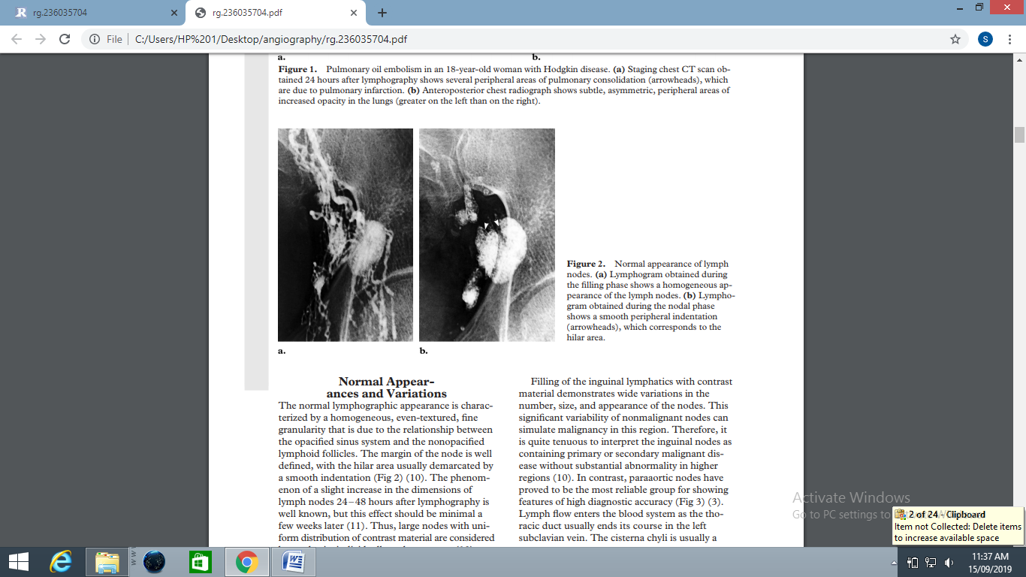

Normal appearance of lymph nodes. (a) Lymphogram obtained during the filling phase shows a homogeneous appearance of the lymph nodes. (b) Lymphogram obtained during the nodal phase shows a smooth peripheral indentation (arrowheads), which corresponds to the hilar area.

**Contrast medium used:-**

* Oil based contrast medium e.g. lipiodol ultra fluid is used.
* Water soluble contrast media is used to demonstrate the distal lymphatic vessels but, because it diffuses so rapidly into the circulation, it cannot demonstrate the lymphnode.20

**Ultrasonography (US)**

Contrast agents have their scope not only in radiology but also in ultrasonography. Ultrasonography contrast lacked substances to be administered to patients to improve or increase the diagnostic yield, which is very peculiar considering that contrast agents is long been used with all the other imaging techniques.21

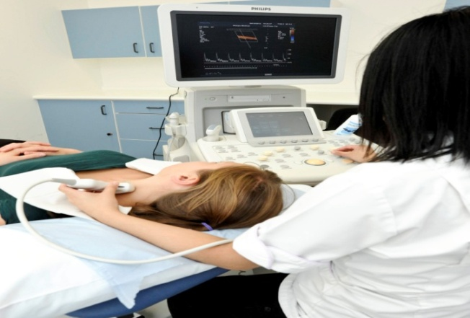

**USG machine an investigation in head and neck region**

# List of Ultrasound contrast agents

|  |  |  |  |
| --- | --- | --- | --- |
| Name | Shell composition | Gas | Manufacturer |
| AI-700 | Polymer | Perfluorocarbon | Acusphere |
| Biosphere | Gelatin/polymer | Air | Point Biomedica |
| BR14 | Phospholipid | Perfluorobutane | Bracco Diagnostics |
| BY 963 | Lipid | Air | Byk-Gulden |
| Levovist | Galactose/palmitic acid | Air | Schering |
| Definity | Lipid | Perfluoropropane | Bristol-Myers Squibb |
| Imagent | Surfactant | Perfluorocarbon | Imcor Pharmaceuticals |
| Optison | Albumin | Perfluoropropane | GE Healthcare |
| Sonazoid | Lipid | Perfluorobutane | GE Healthcare |

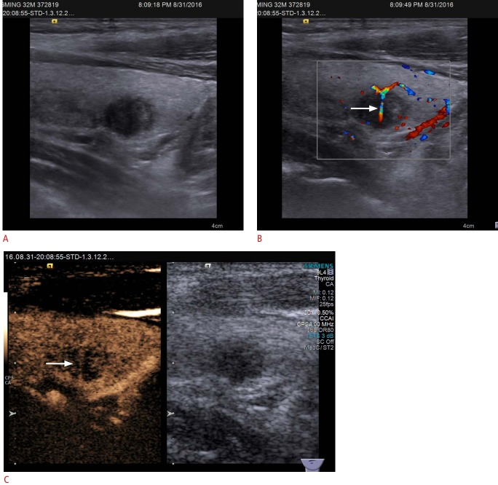

**Figure: -** Conventional ultrasonography (US) and contrast-enhanced ultrasound (CEUS) imaging of papillary thyroid carcinoma in a 32-year-old man. (A) Gray-scale US shows a hypo echoic solid nodule in the right thyroid lobe with a poorly defined margin, assessed as thyroid imaging .( B) Color Doppler US shows branching vessels (arrow) within the mass. C. CEUS shows hypo enhancement with penetrating vessels (arrow) in the mass

**Computed Tomography**

**Contrast agent used in CT: -** Iodine-based dye, barium solution CT allow organs and

structure to be seen easily. Most widely used material is 30mg of iodine fir an average-built

adult which can be scanned 5-15 min later**.**

Contrast can be administered through IV by injecting or taking orally. Patient usually

Instructed not to eat or drink for a few hour prior to injection the contrast the contrast media

because of dye may cause stomach upset patient are made to drink an oral contrast solution 1-2

hour before CT scan.4

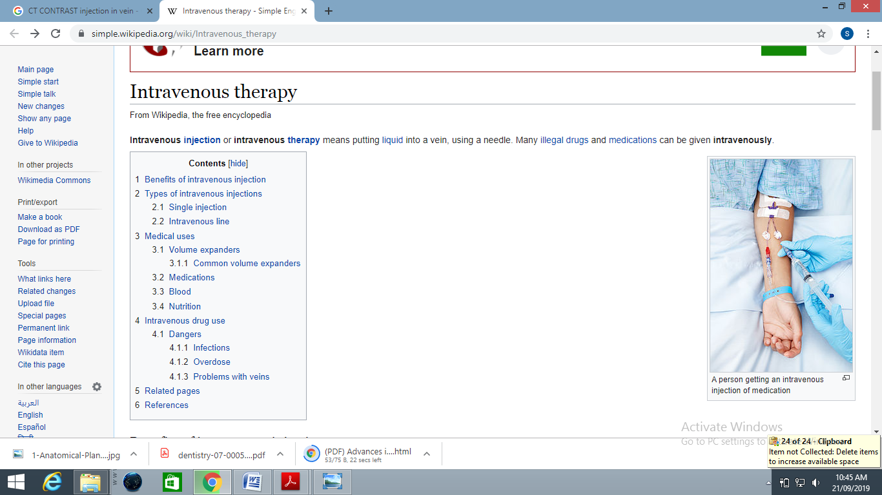

**Figure: - A person getting an intravenous injection of contrast media**

**Indications of contrast CT:-**

1. Investigations of intracranial diseases including tumors, hemorrhage, hyper vascular lesions and infarcts.
2. Investigations of suspected intracranial and spinal cord damage following trauma to the head and neck.
3. Investigation of the TMJ.
4. Preoperative assessment of maxillary alveolar bone height and thickness before inserting implants.
5. Assessment of fractures involving:
   * The orbits and nasoethmoidal complex.
   * The cranial base.
   * The odontoid peg.
   * The cervical spine.
6. Investigations of tumors and tumor like discrete swellings intrinsic and extrinsic to the salivary glands. 22,23

**Contraindication-**

* Pregnancy
* History of allergic contrast agent
* Hyperthyroidism
* Impaired renal function4

**Magnetic Resonance Imaging (MRI)**

It is a latest non –invasive imaging modalities that use electric signals generated from response

Of hydrogen nuclei to strong magnetic field and radio wave/RF pulse to produce an image to

allow specialists to explore inner working of human body, to detect and define the difference

between healing and diseased tissue without the use of x –ray.4

**Contrast- enhanced dental MRI: -**Contrast agents are pharmaceuticals that increase

the information content of diagnostic images. They serve to improve the sensitivity and

Specificity of diagnostic images by altering the intrinsic properties of tissues, which influence

the fundamental mechanisms of contrast. Strategic localization of the agent can regionally

change the tissue properties and result in preferential enhancement. Magnetic resonance

imaging (MRI) contrast agents are widely used to increase the contrast difference between

normal and abnormal tissues.24

**MRI contrast agent use:-**

* MRI contrast agents have been approved for clinical use in the United States as of 1994.
* Six more MRI contrast agents were approved by FDA for clinical use from 1995 through 2017: gadopentetate dimeglumine (gadolinium diethylene triamine pentaacetic acid (Gd-DTPA), gadodiamide (gadolinium diethylene triamine penta-acetic acid bis-methylamide (GD-DTPA-BMA), Gadoteridol (Gadolinium-1,4,7- tris (carboxymethyl)-10-(2' hydroxypropyl)-1,4,7 -10-tetraazacyclododecane (Gd-HPD03A]), gadoterate meglumine (gadolinium-tetraazacyclododecane tetra acetic acid (Gd-DOTA)25

**Indication:-**

* For the diagnosis and evaluation of benign and malignant tumors of jaws.
* Soft tissue tumors and carcinoma.
* In surgery of parotid gland MRI can detect the cause of facial nerve within the glandular tissue and help lessen the likelihood of post-operative facial nerve palsy.
* For the assessment of intracranial lesions involving particular posterior cranial fossa, the pituitary and the spinal cord.
* For non-invasive evaluation of the integrity and position of articular disk with in the TMJ.
* Investigation of the TMJ to show both the bony and soft tissue components of joint including disc position.4,26

**Contraindication of contrast MRI:-**

1. Patients with chronic, severe kidney disease (GFR < 30 mL/min/1.73m2 ) or acute kidney injury
2. Pregnant & Lactating women4,26

**ANGIOGRAPHY**

The word itself comes from the Greek words angeion, "vessel", and graphein, "to write" or "record". The film or image of the blood vessels is called an angiograph, or more commonly an angiogram. The word can describe both an arteriogram and a venogram.27

It is used to visualize the inside, or [lumen](https://en.wikipedia.org/wiki/Lumen_(anatomy)), of blood vessels and organs of the body, with particular interest in the [arteries](https://en.wikipedia.org/wiki/Artery), [veins](https://en.wikipedia.org/wiki/Vein), and the [heart chambers](https://en.wikipedia.org/wiki/Heart_chamber). This is traditionally done by injecting a radio-opaque [contrast agent](https://en.wikipedia.org/wiki/Radiocontrast) into the blood vessel and imaging using [X-ray](https://en.wikipedia.org/wiki/X-ray) based techniques such as [fluoroscopy](https://en.wikipedia.org/wiki/Fluoroscopy).28

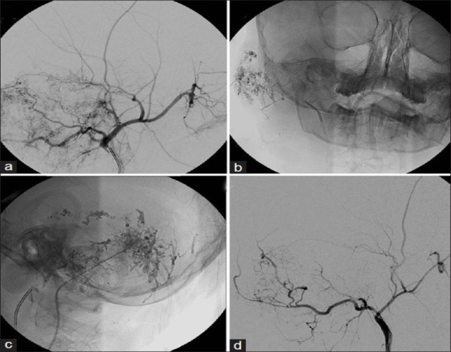

**Figure** (a) Pre-embolization right ECA angiogram showing intense vascularity in the temporal bone region suggestive of hemangioma, (b and c) Intra-operative frontal and lateral fluoroscopy images showing the embolization glue cast within the hemangioma.

(d) Post-embolization right ECA angiogram showing reduction in vascularity of the lesion.

**Side effect and management of contrast agent**

**MILD SIDE EFFECT:-** Altered taste, Cough, Headache, Nausea, Vomiting, Sweats, Anxiety, Dizziness, Itching, Pallor, Swelling of the eye & face, Chills, Flushing, Nasal stuffiness, Rash, Hives, Warmth.

**MODERATE SIDE EFFECT:-** Bronchospasm, Wheezing, Hypertension, Mild Hypotension, Dyspnea, Laryngeal edema, tachycardia, bradycardia, Generalized or diffuse erythema.

**SEVER SIDE EFFECT: -** Cardiopulmonary Arrest Convulsions, Profund hypotension, clinically manifest arrhythmias Laryngeal edema (severe or rapidly progressing)

Unresponsiveness.4, 29

**Management of adverse reaction:-4,29,30**

|  |  |  |
| --- | --- | --- |
| **Detailed management and treatment of adverse reactions to Contrast agents (table 6)** | | |
| Symptom | Notes | Treatment |
| Urticaria | * Monitor; most improve. If symptomatic consider treatment. | 1. Diphenhydramine: 1 mg/kg (max ¼ 50 mg) PO/IM/IV (if IV dose, administer slowly over 1-2 minutes) 2. Epinephrine: IM 0.3-0.5 mL of 1:1000   OR   1. EpiPen: IM 0.3 mL of 1:1000 Pediatric dosing of epinephrine: 0.01 mg/kg IM |
| Facial/laryngeal oedema | * In severe; call emergency medical team * If severely hypotensive, IV epinephrine preferred | 1. Oxygen by face mask 6-10 L/min 2. Epinephrine: IM 0.3-0.5 mL of 1:1000; can repeat every 5-10 minutes up to 1 mg total   OR   1. EpiPen: IM 0.3 mL of 1:1000; can repeat every 5-10 minutes up to 3, if required Pediatric dosing of epinephrine: 0.01 mg/kg IM   OR   1. (if severely hypotensive) Epinephrine: IV 1-3 mL of 1:10,000 given slowly over 2-3 min; repeat 1 mg dose as needed |
| Bronchospasm | * Continuously monitor. If progressively worse, consider adding additional treatment. * IV epinephrine preferential for severe reactions, * if severely hypotensive - Call emergency medical team | 1. Oxygen by face mask 6-10 L/min 2. Beta-agonist (Albuterol?) inhaler: 180 mcg 3. Epinephrine: IM 0.3-0.5 mL of 1:1000; can repeat every 5-10 minutes up to 1 mg total   OR   1. EpiPen: IM 0.3 mL of 1:1000; can repeat every 5-10 minutes up to 3, if required Pediatric dosing of epinephrine: 0.01 mg/kg IM   OR   1. (if severely hypotensive) Epinephrine: IV 1-3 mL of 1:10,000 given slowly over 2-3 min; repeat 1 mg dose as needed |
| Hypotension with Bradycardia | * Usually spontaneous recovery | 1. Oxygen by face mask: 6-10 L/min 2. Elevate legs 3. Saline 0.9%: 10-20 mL/kg 4. Atropine: IV 0.6e1.0 mg, saline flush; can repeat up to 3 mg |
| Hypotension with tachycardia | * If severely hypotensive, IV epinephrine preferred | 1. Oxygen by face mask: 6-10 L/min 2. Elevate legs 3. Saline 0.9%: 10-20 mL/kg 4. Epinephrine: IM 0.3-0.5 mL of 1:1000; can repeat every 5-10 minutes up to 3, if required   OR   1. EpiPen: IM 0.3 mL; can repeat every 5-10 minutes up to 3, if required Pediatric dosing of epinephrine: 0.01 mg/kg IM OR   (if severely hypotensive)   1. Epinephrine: IV 1-3 mL of 1:10,000 given slowly over 2-3 min; Repeat 1 mg dose as needed |
| Hypertension | * Hourly Monitor BP level | 1. Oxygen by face mask: 6-10 L/min 2. Labetalol: IV 20 mg over 2 min; can double every 10 min 3. Flurosemide: IV 20-40 mg over 2 min |
| Seizures | * If continuous, call emergency medical team | 1. Turn patient onto side to avoid aspiration 2. Suction airway if required 3. Oxygen by face mask: 6-10 L/min 4. Lorazepam: IV 2-4 mg |
| Pulmonary oedema | * Call emergency medical team | 1. Oxygen by face mask: 6-10 L/min 2. Elevate head of bed 3. Furosemide: IV 20-40 mg over 2 min 4. Morphine: IV 1-3 mg; repeat as needed |
| Cardiac arrhythmia; normotensive | * Generally no treatment required. * Perform 12-lead ECG? | 1. Oxygen by face mask: 6-10 L/min |
| Cardiac arrhythmia; hypotensive | * Call emergency medical team * If severely hypotensive, IV epinephrine preferred | 1. Oxygen by face mask: 6-10 L/min 2. Saline 0.9%: 10-20 mL/kg 3. Epinephrine: IM 0.3-0.5 mL of 1:1000; can repeat every 5-10 minutes up to 3, if required   OR   1. EpiPen: IM 0.3 mL of 1:1000; can repeat every 5-10 minutes up to 3, if required Pediatric dosing of epinephrine: 0.01 mg/kg IM   OR   1. (if severely hypotensive) Epinephrine: IV 1-3 mL of 1:10,000 given slowly over 2- 3 min; repeat 1 mg dose as needed |
| Nausea/vomiting | * Monitory; if unrelenting/severe administer recommended treatment | 1. Available antiemetic |
| Hypoglycemia | * If patient can swallow * -If patient cannot swallow, | 1. Oxygen by face mask: 6-10 L/min 2. Ounces fruit juice   OR   1. Dextrose 50%: IV D50 0.5 ampule over 2 min   OR   1. Glucagon: IM 1 mg |
| Unresponsiveness | * Call emergency medical team * Initiate life support | 1. Life supporting drugs are used |

**List of safety measures in the use of contrast agents for the patients injectable contrast agents**

|  |  |
| --- | --- |
| 1 | Biographies of patients before contrast agent injection |
| 2. | Check the history of disease & preparation of the patient prior to injection |
| 3. | Complete consent form & questionnaire to identify patients at high risk(PAR) |
| 4. | Preventive measures for patients at high risk |
| 5. | Educating patients about the possible side effects of administration of the contrast agent |
| 6. | Hygiene of contrast agent injection site |
| 7. | Control suction and oxygen therapy equipment function properly prior to contrast injection |
| 8. | Preparation and injection of contrast agents under the suitable temperatures |
| 9. | Observe speed the injection |
| 10. | Care of the needle stick & Use of sterile injection technique |
| 11. | Use of safe disposal box after injection |
| 12. | Monitor the patient for 60 minutes after injection |
| 13. | Encouraging patients to drink liquids after the test |
| 14. | Patient education about the intern to the usual diet |
| 15 | Skilled use of defibrillator |
| 16. | Control access to cardiopulmonary resuscitation Tralee before administration of contrast agent.31 |

**List of safety measures in the use of contrast agents for the patients Non-injectable contrast agent**

|  |  |
| --- | --- |
| 1. | Biographies of patients before contrast agent injection |
| 2. | Check the history of disease prior to prepare the patient |
| 3. | Check patient preparation prior to injection |
| 4. | Check pregnancy and lactation in women prior to prescribing contrast |
| 5. | Educating patients about the possible side effects of prescribing the contrast agent |
| 6. | Health measures about preparing and administering the contrast agent |
| 7. | Control access to resuscitation Tralee, before administration of contrast |
| 8. | Attention to sterile techniques during catheterization |
| 9. | Check the Suction equipment, oxygen therapy and proper functioning of the prescribing the contrast agent |
| 10. | Patient education about the Back to the usual diet |
| 11. | Contrast agents used immediately after opening and preparation |
| 12. | Use of separate contrast agent for each patient |
| 13. | Preparation and prescribing contrast agents in appropriate concentration, temperatures and volume |
| 14. | Keeping remaining oral contrast agents in good condition |
| 15. | Care for the prevention of infection when using reusable equipment |
| 16. | Catheterization done by physician |
| 17. | Access to the resuscitation team if necessary |
| 18. | Encouraging patients to drink liquids after the test.31 |

REFERANCES:-

1. Devaji Rao k Conventional dental radiography vs advanced dental imageology. Journal of Indian Academy of Oral Medicine and Radiology 2008;20(2) :77-80
2. Mamatha GP Contrast Radiography in Dentistry- Journal of Indian academy of Oral medicine and Radiology. Lambert Academic publishing 2014;15(3):89-92
3. C. Pomara, N. Pascale, F. Maglietta M. Neri, Riezzo E .Use of Contrast Media in Diagnostic Imaging: Journal of Radio Medicolegal Research Ethics and Forensic Radiology 2015; 120 (1):802–809
4. Anil Govindrao Ghom .Textbook of oral radiology; 3rd edition. Noida : Elsevier ;2008.Chapter38,Contrast agent;p402-411
5. Nasir H Siddiquie ,Contrast Medium Reaction, Recognition & Treatment International Journal of Basics and Clinical Pharmacology 2014;3(6)
6. Arshiya S, B.balajirao, GP Mamtha. General Properties of Contrast Media: A review. Journal of Indian Academy of Oral Medicine and Radiology 2018;15(3):89-92
7. Jessica B. Robbins, MD Myron, A Pozniak. Contrast Media Tutorial University of Wisconsin Journal of Radiology Madison 2010: 1-32.
8. Gerald’s FGC, Laurent S, Sons JW et al. Classification and Basic Properties of Contrast Agents for Magnetic Resonance Imaging :A review 2008;3(2)
9. [Sialogram on Medline Plus](https://www.nlm.nih.gov/medlineplus/ency/article/003812.htm) . Journal of Human Health Service 2019: 1-2
10. S. S. Rose. First Assistant, Department of Surgery, University of Manchzster Sialography in Diagnosis. British Medical Journal of India 2019;26(300):521-528
11. Freny karjodhkar, Text book of oral radiology 2nd edition chapter 16:324
12. [Reginald T, GralaB, Golebiowski M, Zuchowska A, Sawicka M](https://onlinelibrary.wiley.com/action/doSearch?ContribAuthorStored=Payne%2C+Reginald+T)  et al Sialography: Its Technique and Applications, [British Journal of Radiology](https://www.researchgate.net/journal/0007-1285_British_Journal_of_Radiology)*2010; 75(3):25–37.*
13. White and Pharaoh’sOral Radiology principles and interpretation 6th edition chapter 31:578.
14. Heun y & Eugene c. kaatte. Current Status of Sialography. Journal of Dentomaxillofacial Radiology1972; 115 (2): 1-9.
15. Hupp JR, Ellis E, Tucker Contemporary Oral and Maxillofacial Surgery 5th edition 2008 : 402–405.
16. Burket's Text book of oral medicine and radiology; Oral Medicine 12th Edition: 226-227.
17. Ravikaran Ongole & Parveen B.N et al. Text book of oral medicine & radiology1st edition: chapter 11 –salivary gland disorder: 292
18. Michael J. Pharaoh, Temporomandibular Joint Imaging 1993; 37(4):627-628.
19. [Wolfgang Lee](https://www.ncbi.nlm.nih.gov/pubmed/?term=Lee%20EW%5BAuthor%5D&cauthor=true&cauthor_uid=25469083) E,  [Hoon Shin](https://www.ncbi.nlm.nih.gov/pubmed/?term=Shin%20JH%5BAuthor%5D&cauthor=true&cauthor_uid=25469083) J ,Park J , Kim SH et al. Lymphangiography to Treat Postoperative Lymphatic Leakage: A Technical Review., Korean Journal of Radiology2014; 15(6): 724–732.
20. Guermazi A, Brice P, Hennequin C, Sarfati E "Lymphography: An Old Technique Retains Its Usefulness". 2003; 23 (6): 1541–1558
21. [Calliada F](https://www.ncbi.nlm.nih.gov/pubmed/?term=Calliada%20F%5BAuthor%5D&cauthor=true&cauthor_uid=9652516),  [Campani R](https://www.ncbi.nlm.nih.gov/pubmed/?term=Campani%20R%5BAuthor%5D&cauthor=true&cauthor_uid=9652516),  [Bottinelli O](https://www.ncbi.nlm.nih.gov/pubmed/?term=Bottinelli%20O%5BAuthor%5D&cauthor=true&cauthor_uid=9652516), [Bozzini A](https://www.ncbi.nlm.nih.gov/pubmed/?term=Bozzini%20A%5BAuthor%5D&cauthor=true&cauthor_uid=9652516), Sommaruga et al. Ultrasound Contrast Agents Basic Principles 1998; 27 (2):157-60.
22. Ashraf I, Najmuddin M, Shah A, et al. TMJ Imaging: A Review International Journal of Contemporary Medical Research 2016;3(8):2454-7379
23. Wier, Katzberg R, Temporomandibuolar Joint Imaging. American Journal Society of Anesthesiology 1990;34(1):121-126
24. Xiao YD, Paudel R, Liu J, Cong M, et al. MRI Contrast Agents: Classification and Application Review.International Journal of Molecular Medicine 2016;38(5):1319-1326
25. Michael A, Arthur B, Dublin et al. Magnetic Resonance Imaging (MRI) Gadolinium 2019;19(1):17-59
26. Katti G, Arshiya SA, Shireen A. Magnetic Resonance Imaging (MRI) – A Review, International Journal of Dental Clinics 2011;3(1):65-70
27. Johnson GT. ["Arteriogram, Venograms Are Angiogram Territory"](http://articles.chicagotribune.com/1986-01-23/features/8601060680_1_bleeding-arteries-angiography). 2018 ;79(4)
28. Wake R, Yoshiyama M. History of Angiography research. 2011 ;19(4)
29. MD Anderson. Management of Contrast Media Reactions – Adult Department of Clinical Effectiveness V3 Approved by The Executive Committee of the Medical Staff 2017:1-10
30. Wei YW, Leow KS , Zhu Y.Prevention and Management of Adverse Reactions Induced by Iodinated Contrast Media 2016; 45:(4)
31. Amiri F, Rasoul M. Contrast Agents and Observing Patient Safety Programs in Radiology Departments in Kermanshah Province Hospitals in West of Iran 2018; 26(1): 42–45.