**Title: Cost effective Stress monitoring system**

**Authors**

Dr. Vani B P, Associate Professor, Department of ECE, Saividya Institute of Technology

SR BHAVANA Department of ECE, Saividya Institute of Technology

S ALIYA ANJUM Department of ECE, Saividya Institute of Technology

SHIRIN RAJIV Department of ECE, Saividya Institute of Technology

INCHARA M Department of ECE, Saividya Institute of Technology

**ABSTRACT**

In reality, circumstances that cause anxiety or anger are more likely to cause stress. Fear, concern, or uneasiness are all examples of anxiety. The cost of healthcare is steadily decreasing as global population growth occurs. As soon as it is practical, new technology must be created to keep track of the mental and physical well-being of individuals throughout their daily lives. A device that notices physiological stress signs is called as a stress detector. These techniques mostly focus on the heart. Pulse is monitored using heart rate monitors. They provide analyses and act as watchdogs. The heart rate monitor and Galvanic Skin Response (GSR) sensor are promising medical technologies for stress detection, wellness monitoring, and healthcare.

Application includes healthcare, where it supports individualized treatment by monitoring patient stress levels throughout procedures. Individuals may quantify stress, identify causes, and create approaches by engaging in wellness monitoring.

On-the-go stress monitoring is made probable by enclosure of wearables or mobile apps, encouraging self-awareness and reasoned decision-making. This technology can improve stress reduction methods, wellness monitoring, and healthcare procedures.

INTRODUCTION

Stress can manifest in numerous ways, including physical, emotional, and behavioral symptoms. It is important to manage stress efficiently to maintain overall well-being and avoid its negative impact on mental and physical health.

Stress management

# Stress, when long-lasting and unmanaged, can disrupt the body's equilibrium and leads to a number of health concerns, such as heart difficulties, immune system deterioration, mental health conditions, and a lower quality of life. Real stress handling practices can provision restore balance, improve resilience, and recover overall well-being.

# Heartrate Monitoring

# Monitoring heart rate provides insights into your cardiovascular health, fitness level, and recovery status, allowing to make well-versed decisions about training, volume, and overall well-being. A subordinate heart rate is generally related with better appropriateness and overall cardiac health.

# Blood Pressure monitoring

# Accurate blood pressure readings are crucial for assessing and managing cardiovascular health effects. An erroneously lower reading can lead to underestimating the risk of heart disease and stroke, potentially delaying necessary interventions and treatments.

# The main objective here is to produce a strategy that utilizes BP, GSR, and heart rate sensors connected to an Arduino Uno, displaying the data on an LCD display with a graph, and incorporating a GSM unit to guide messages for real-time monitoring or alerts which is cost effective and accurate.

Currently a compact and cost-effective system for measuring physiological signals is required which has applicability in stress management systems developed. This scheme objects to afford an accessible solution for persons seeking to monitor and manage their stress levels efficiently. By incorporating various sensors and advanced data processing techniques, this method can monitor physiological signals including heart rate, skin conductance, and breathing rate with extreme precision. These signals are key indicators of stress and can help people gain considerations into their own physiological responses. The compact design of this system guarantees portability and ease of use, allowing users to monitor their stress levels in real-time and make well-versed decisions about their well-being. With this innovative approach, empowering individuals with the tools they need to manage their stress more efficiently and improve their overall quality of life can be developed.

**SYSTEM REQUIREMENTS**

**HARDWARE REQUIREMENTS**

The basic requirements of a project typically include:

**GSR SENSOR**

The Galvanic Skin Resonance (GSR) sensor measures the varying points of the skin conductivity of electric current. Higher levels of perspiration on the skin lead to a greater conductance of electrical currents. A greater level of conductivity can be taken as either positive/negative emotional arousal. GSR work by detecting variations in electrical activity resultant from changes in sweat gland activity.

**HEART RATE SENSOR**

The photoplethysmography serves as the groundwork for the heartbeat sensor. The timing of the pulses is crucial in circumstances where the heart rate is to be traced. The pace of heartbeats determines the volume of blood that flows to organs, and because blood absorbs light, signal pulses are analogous to heartbeat pulses.

**SPO2 SENSOR**

The Oxygen saturation (SPO2) of hemoglobin in blood is continually measured using pulse oximeters which are low-priced and non-invasive medical sensors. It demonstrations what amount of blood is oxygenated.

The difference in preoccupation of hemoglobin by oxygenated and deoxygenated blood is the foundation of the pulse oximetry theory. Much infrared light is absorbed by oxygenated hemoglobin while less red light is let through. In contrast, deoxygenated hemoglobin lets more infrared light and absorbs more red light while.

**BP Sensor**

The Blood Pressure Sensor is a non-invasive which measures systolic, diastolic, and mean arterial pressure utilizing the oscillometric method. Pulse rate is also reported from such sensors.

The idea behind oscillatory devices is that, as blood is flowing through an artery between the systolic and diastolic pressures, it creates vibrations in the arterial wall which may be observed and converted into electrical signals.

**Temperature Sensor**

A temperature sensor is a expedient which measure temperature. There are diverse types of temperature sensors accessible and they each use different technologies and ideologies to take the temperature measurement.

**Arduino Board**

The optimum board for coding is the Arduino UNO. The UNO is the most tough board which we can start to if it is first time experimenting with the platform. The Arduino family's UNO board is the prevalent model.

Arduino UNO is based on the ATmega328P. It has 16 MHz ceramic resonator, 6 analog inputs, 14 digital input/output, a USB port, a power connector, an ICSP header, and a reset button. Everything needed to support the microcontroller is included in the board to use it, just use a USB cable to connect to a computer, or an AC-to-DC converter or battery to power it.

**LCD Display**

Liquid crystal display (LCD) is a particular type of display module used in a wide collection of circuits and devices, together with mobile phones, calculators, computers, TVs, and other electronics. The prime advantages of accepting this unit widely are its small cost, comfort of programming, simulation capabilities, and lack of any limits on the display of customized characters, unique animations, etc.

**SOFTWARE REQUIREMENTS**

The Arduino board stated is used widely because of its distinguishing features it offer from basic 8-bit boards to items for IoT applications, wearables, embedded settings and 3D printing.

An open-source electronics platform called Arduino is built on simple hardware and software. We achieve this by using the Arduino software (IDE), which is based on Processing, and the Wiring-based Arduino Programming Language.

**SYSTEM DESIGN**

**BLOCK DIAGRAM**



Figure1.1 Block Diagram of Prototype

**WORKING**

In this development, various sensors are associated to an Arduino board, and a supply voltage is provided to power the system. The sensors used include a temperature sensor, a blood pressure (BP) sensor, a SPO2 sensor (which measures oxygen level in the blood), and a GSR sensor (which measures stress level).

The Arduino board runs a program code that interacts with each sensor, retrieves the necessary data, and performs required calculations or conversions. The temperature sensor provides readings of the body temperature, the BP sensor measures the blood pressure, the SPO2 sensor detects the oxygen level in the blood, and the GSR sensor determines the stress level.

**FLOWCHART**

The obtained sensor readings are displayed on an LCD screen, providing users with real-time information about the body temperature, BP, SPO2 levels, and stress level. Additionally, the stress level data is graphically denoted on the LCD, allowing users to observe and analyze their stress levels over time.

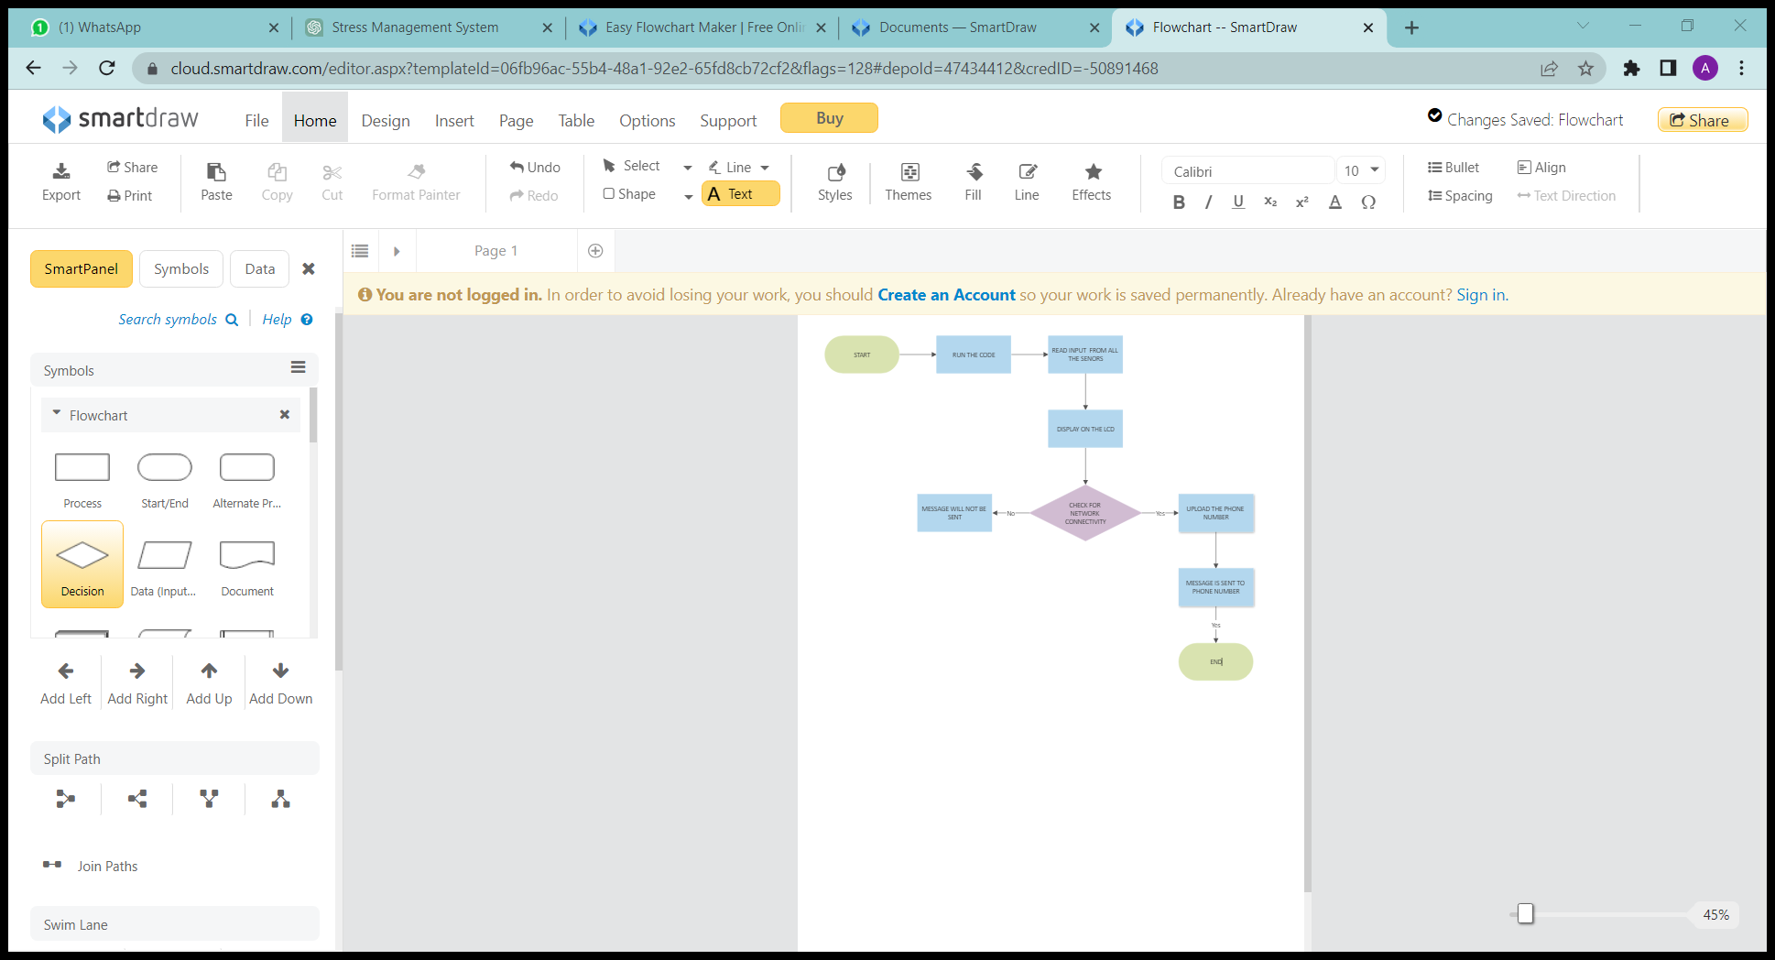

Figure 1.2 Flowchart of the Procedure

To enable remote monitoring or data transmission, the system incorporates a GSM module and a Wi-Fi module. These modules facilitate communication amid the Arduino board and a mobile phone. The sensor readings, including body temperature, BP, SPO2 levels, and stress level data, are sent to the mobile phone through the GSM module or Wi-Fi module. This allows users to remotely access and monitor their vital signs and stress levels using a mobile application or a web interface.

By combining sensor integration, data processing, LCD display, and wireless communication, this project creates a complete system that permits users to monitor their health parameters and stress levels in real-time, providing valuable insights and facilitating proactive healthcare management.

By combining sensor integration, data processing, LCD display, and GSM communication, this project showcases a practical application for monitoring and tracking vital signs and stress levels. It provides users with accessible and timely information in real time, empowering them to take proactive measures for their health and well-being.

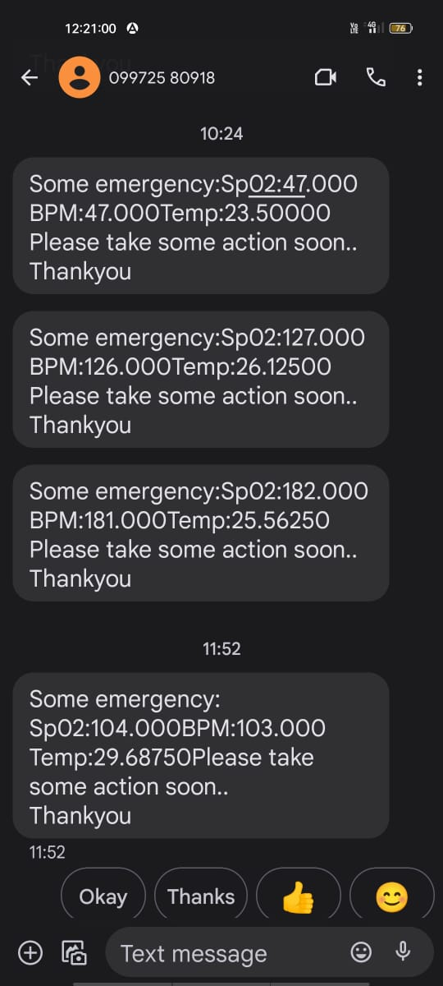

Figure 1.3 Message received on integrated mobile device through GSM

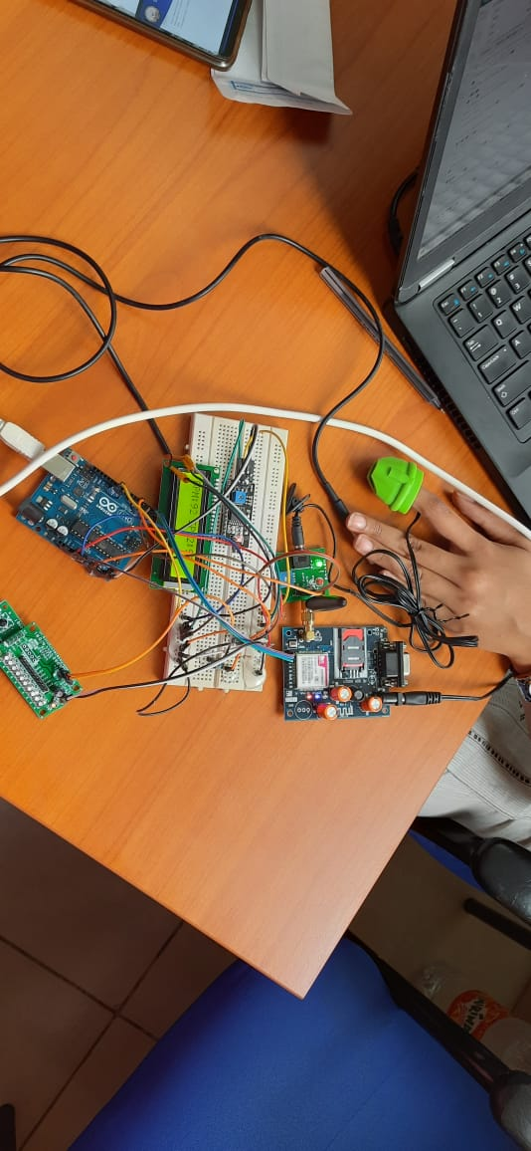

Figure 1.4 Working Model

CONCLUSION

In conclusion, this Prototype successfully demonstrates the functionality of multiple sensors by displaying their readings on an LCD display and transmitting them to a mobile phone using a GSM module. By integrating sensors such as the temperature sensor, BP sensor, SPO2 sensor, and GSR sensor, users can monitor the vital signals and stress levels in real-time. The LCD display provides immediate access to the sensor readings, while the graph representation of stress levels allows users to analyze patterns over time. The usage of GSM module enables remote monitoring, as the sensor readings are sent as messages to a mobile phone. This developed prototype can also act as IOT node in Healthcare applications and offers a practical solution for health monitoring and stress management, empowering individuals to make knowledgeable decisions about their well-being.

REFERENCES

1. Talaat, F.M., El-Balka, R.M. “Stress monitoring using wearable sensors: IoT techniques in medical field”. Neural Comput & Applic 35, 18571–18584 (2023). https://doi.org/10.1007/s00521-023-08681-z

2. R. Singh et al., “Cloud Server and Internet of Things Assisted System for Stress Monitoring,” Electronics, vol. 10, no. 24, p. 3133, Dec. 2021, doi: 10.3390/electronics10243133

3. Rajesh kumar.M et al., “IOT Based Physiological Stress Monitoring and Managing Device” International Journal of Innovative Research in Advanced Engineering (IJIRAE) ISSN: 2349-2163 Issue 03, Volume 6 (March 2019)

4. Pijush Sarkar, Abojit Boro ,Gunindra Pegu “Heartbeat Sensor Using Arduino” Department of Electronics and Communication Engineering, Central Institute of Technology Kokrajhar, India(2020)

5. Michal T. Tomczak et al.,“Stress Monitoring System for Individuals With Autism Spectrum Disorders” National Centre for Research and Development, Poland (NCBiR) (2020)

# 6. Minal Patil, Abhishek Madankar ,Dr. P. D. Khandait, “Heart Rate Monitoring System”, Dept. of E and TC Engineering Y. C. College of Engineering Nagpur, India (2020)