Voltage sag reduction using a UVTG-based dynamic voltage restorer
Vijay S. Karale¹  Dept. of Electrical Engineering  S.S.G.M. College of Engineering  Shegaon.  vijayskarale@gmail.com | Dr. Saurabh S.Jadhao²  Associate. Prof. Dept. Electrical Engineering S.S.G.M. College of Engineering Shegaon.  ssjadhao@gmail.com | Dr. Sudhir R. Paraskar³  Prof & Head Dept. Electrical Engineering S.S.G.M. College of Engineering Shegaon.  srparaskar@gmail.com

ABSTRACT
Unnecessary conflict is caused by voltage dips or sags on both the utility and consumer sides. In order to correct voltage sag, a dynamic voltage restorer device based on the voltage source converter (VSC) topology is used in this research. A modified power device called a dynamic voltage restorer (DVR) is used to reduce power quality issues in the electrical power system network and increase voltage stability. Typically, DVR is mounted between load feeders. and source in the delivery network. In this paper, a method of voltage sag compensation based on unit vector template generation (UVTG) and dynamic voltage restorer is discussed. Results are obtained after simulation with the MATLAB program.
Keywords: sensitive load, dynamic voltage restorer, and voltage sag

INTRODUCTION
The most crucial concept in today's power delivery systems is power quality. Poor power quality has a variety of effects on energy consumers, including production loss, appliance damage, an increase in power losses, interference with communication lines, etc. Electrical utility companies' primary goal is to provide its customers with constant-magnitude, sinusoidal voltage that is uninterrupted [1,2]. Custom power devices are employed to enhance power quality. Hingorani initially introduced the idea of tailored power in 1995 [16]. Custom power (CP) is a concept that refers to the use of electronic controllers in power system networks. The Distribution Statcom (D-STATCOM), Dynamic Voltage Restorer (DVR), and Unified Power Quality Conditioner (UPQC) are a few examples of specialized power units. Battery Systems (BESS), Distribution Series Capacitors (DSC), Surge Arresters (SA), Uninterruptible Power Supplies (UPS), Solid State Fault Current Limiter (SSFCL), Solid-State Transfer Switches (SSTS), and Static Electronic Tap Changers (SETC) are some examples of active power filters [2]. Either in series, shunt, or a combination of the two connections are used to connect the CPD devices. Power systems ensure high-quality electrical power supplies, which calls for balanced, sinusoidal voltage and current waveforms. Additionally, the system's voltage level torque should be within a safe range, often within 100+ -5% of its rated value. The performance of the equipment is compromised if the voltage is greater or lower than this predetermined value. There is a requirement for voltage adjustment because when the voltage is low, the television's picture begins to roll and the induction motor's speed is reduced to the square of the voltage. Today, the electric utility grid's focus on power quality is crucial. Voltage disturbances at the point of common coupling (PCC) cause sensitive industrial equipment to malfunction, which results in the failure of grid components like transformers and economic losses[5,6]. To reduce voltage sag and safeguard sensitive loads from it, dynamic voltage restorations are an effective solution. The voltage level torque on the system should also be within a safe range, often within 100+ -5% of their rated value if the voltage is more or less than this pre-specified value, performance of the voltage sag, which is the most significant voltage disturbance. The voltage source converter that injects a series voltage into the line is known as a dynamic voltage restorer. Dynamic voltage restorers have the ability to function as series active power filters. The unit vector template generation (UVTG) control approach, which is DVR-based, is used to compensate for voltage sag in this paper. They currently link to the low and medium voltage distribution system in series or shunt and are based on converter technology. Shunt passive filters must be used in conjunction with series active power filters in order to to correct the harmonics of the load current and voltage. DVR works as a source of electricity with regulated voltage. Both plans with voltage source inverters and a dc bus with a reactive element, like a battery, are preferable to implement. Voltage dips are one of the most prevalent issues with power quality today. Voltage sag is a brief (10 ms to 1 minute) event during which the voltage magnitude is defined in terms of r.m.s. It is frequently determined merely by two factors: amplitude and duration. The voltage sag magnitude ranges from 10% to 90% of nominal voltage, or 90% to 10% remaining voltage, and has duration of up to one minute. A voltage drop is a natural occurrence in a three-phase system. The voltage sag is a three-phase phenomenon that is caused by the sag and affects both phase-to-ground and phase-to-phase voltage.

CONFUGURATION OF DVR
The injection transformer, harmonic filter, voltage source converter, and energy storage control are the major components of a dynamic voltage restorer [9].
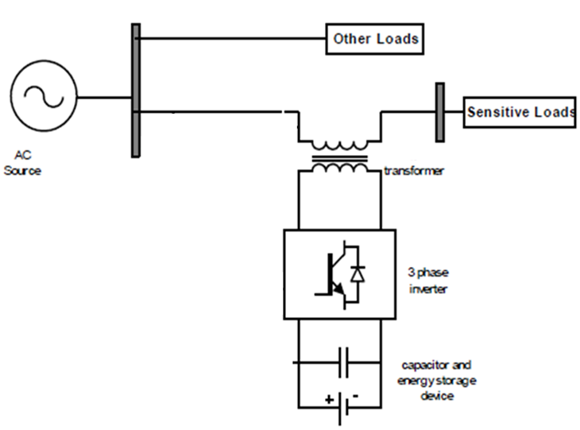
Fig.1 Basic block diagram of DVR
The dynamic voltage restorer (DVR) is a series-connected device that is used to reduce voltage sag. The dynamic voltage restorer compensates for the supply voltage problem by injecting a voltage series with the line to achieve distortion-free voltage at the load terminal. The series converter is represented by the equation below.
V_{inj}(ωt) = V_{L}(ωt) – V_{S}(ωt) (1)
Vi_{nj}(t), V_{L}(t), and V_{S}(t) are the series converter injected voltage , load voltage and real source voltage, respectively."Fig.1" is a schematic diagram of a DVR system. The DVR is divided into two sections: a) the power circuit and b) the control circuit and PI controllers. Voltage source converter (VSC), series connected injection transformer, passive filter, and energy storage device comprise the power circuit. The control circuit in DVR is used to calculate the parameters such as magnitude, frequency, and phase shift of the control signal that must be injected through DVR. The power circuit generates an injected voltage in response to this control signal. The DVR compensates for voltage sag in order to keep the load voltage to sensitive loads within acceptable limits. The DVR is intended to reduce voltage sag of a diverse magnitude for various durations. Because the transformer connection in the distribution network is of the delta-star type, zero sequence voltage will not propagate through the transformer; thus, only positive sequence voltage restoration and negative sequence voltage compensation are required. The VSC makes use of an insulated gate. IGBTs are bipolar transistors. It is powered by an energy source and produces adjusted alternating current voltage with the help of an inverter. A passive filter suppresses switching harmonics and corrects the voltage form to be injected. The DVR is connected to the distribution line via an injection transformer that is connected in series with the line. The three single phase injection transformer is used to inject the voltage that is absent at the PCC.
The primary goal of this study is to correct for both symmetrical and unsymmetrical voltage sags.
SELECTION OF DC CAPACITOR
The dc bus capacitance is chosen depending on the amount of transient energy required when the load changes. Given that the energy stored in the capacitor is used to meet the energy demand of the load for a fraction of the power cycle.[18]
(½){C_{DC}(V²_{DC} –V²_{DC1})}=3V_{f}I_{f} ∆t (4)
Where VDC is the rated voltage, VDC1 is the voltage drop allowed during the transient, t is the time required for support, and CDC is the DC bus capacitance.

CONTROL STRATEGY AND PRAPOSED METHDOLOGY
The proposed control strategy of the dynamic voltage restorer is discussed in this section. The UVTG technique is utilized to control the dynamic voltage restorer in the controlled block diagram DVR for generating reference voltage signal, as shown in fig.2.[2][3][4]
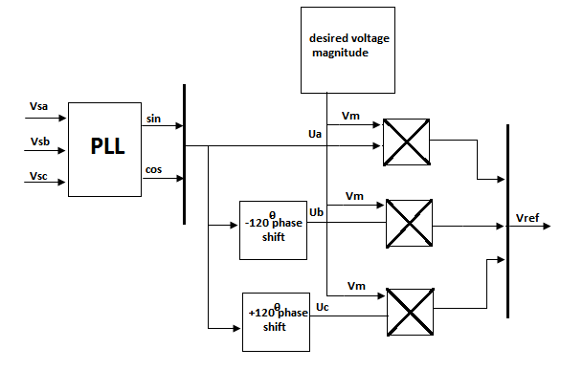
Fig.2 Control block diagram of series APF based on UVTG technique.
The series APF component (DVR) is adjusted to adjust the voltage between the point of common coupling and the load so that the voltage is balanced, distortion-free, and maintains the desired magnitude.[2] [3] The three-phase input voltage may be distorted, or there may be power quality issues at the point of common coupling (PCC). The input source voltage is measured and multiplied by gain equal to 1/Vm (Vm is the peak amplitude of the fundamental voltage)[3] to obtain the unit vector template signal. The phase lock loop (PLL) is used to establish supply voltage synchronization. The following equation describes how to extract a three-phase voltage reference signal for a series APF using unit vector template generation (UVTG) and a phase lock loop (PLL). Distorted three-phase power supply Voltages are sensed and fed into a PLL, which produces two quadrature unit vectors (sinwt and coswt). Using eqn.(2), the in-phase sine and cosine outputs of the PLL are utilized to compute the supply in phase, 120o displaced three unit vectors (Ua,Ub, Uc) as:

(2)
The computed three in-phase unit vectors are then multiplied by the required peak value of the PCC phase voltage (Vm), yielding the three-phase reference PCC voltages, which are as follows.
(3)
The desired peak value of the PCC voltage under Consideration is 338V (=415sqrt (2)/sqrt(3)).The Computed voltages from reference voltages from eqn.(2) are then given to the comparator along with the sensed three phase PCC voltages(V_{La}, V_{Lb} and V_{Lc}).[3]
This load voltage must be equal to the reference load voltage in order to obtain the distortion free load voltage.
This reference voltage is now compared to the load voltage, yielding the error signal shown in fig.(3).
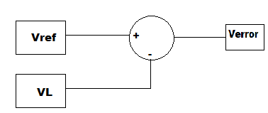
Fig.3 Generation of error signal.
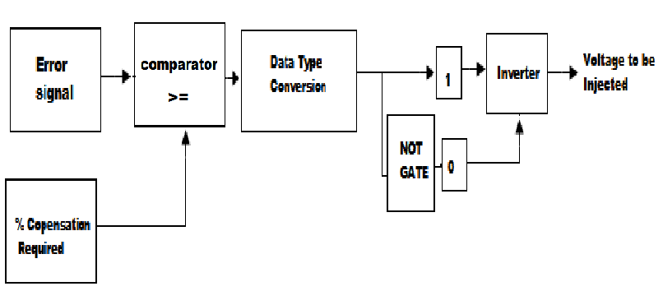
Fig.4 Generation of triggering pulses
Figure 4 depicts the creation of triggering pulses from an error signal and the percentage of correction required. The error signal and the needed% compensation are compared, and the output data type is converted to Boolean. The Boolean signal's logical operation generates the necessary triggering pulses to the inverter, which generates the voltage to be injected.
Simulation of control algorithm
The basic functions of a controller in a DVR are to detect voltage sag, distortion, and harmonic events in the system; compute the correcting voltage; generate trigger pulses to the sinusoidal PWM-based DC-AC inverter; correct any anomalies in the series voltage injection; and terminate the trigger pulses when the event has passed. In the absence of voltage sags, the controller can also be utilized to switch the DC-AC inverter into rectifier mode and charge the capacitors in the DC energy link. The suggested system's control approach is based on a comparison of a voltage reference and the measured terminal voltage (Va, Vb, Vc).When the supply falls below a certain threshold, voltage sags are recognized 20% of the voltage at the reference. The error signal is used as a modulation signal to generate a commutation pattern for the voltage source converter's power switches (IGBTs). The commutation pattern is formed using the sinusoidal pulse width modulation (SPWM) approach; voltages are controlled by the modulation. The PLL circuit is designed to generate a single sinusoidal wave that is in phase with the mains voltage.
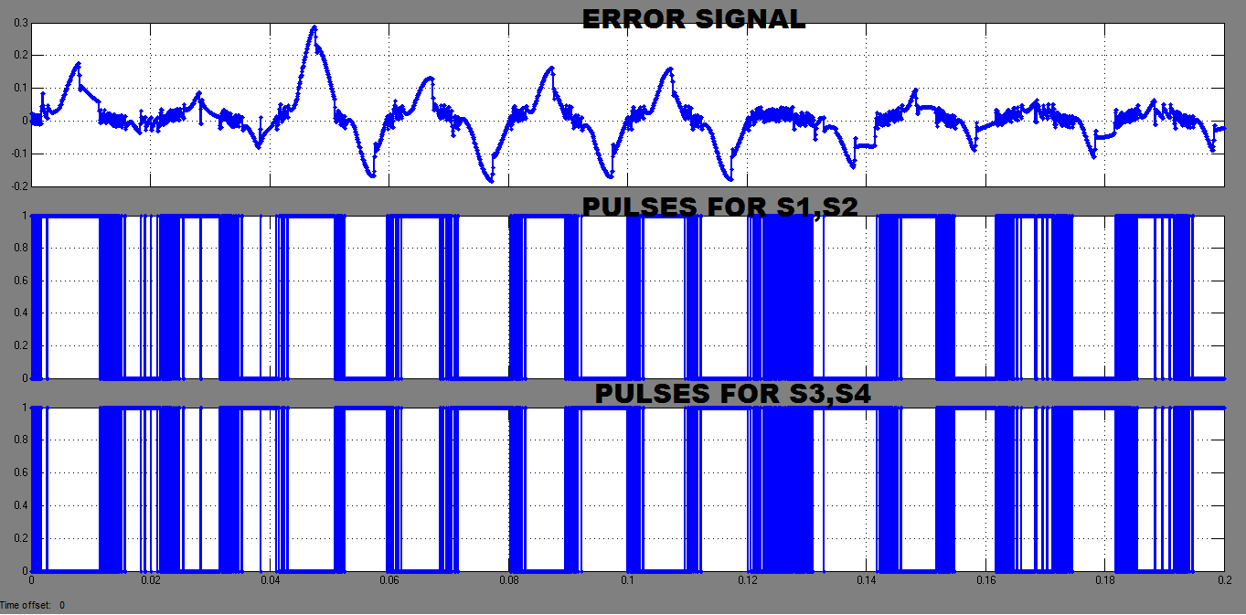
Fig.5 triggering pulses
The comparator outputs switching signals to the twelve switches of the VSI of Series APF. It will generate the switching signals necessary to convert the voltage at PCC to the appropriate sinusoidal reference voltage. As a result, the voltage injected across the series transformer via the ripple filter cancels out both balance and imbalance voltage sag in the supply voltage.
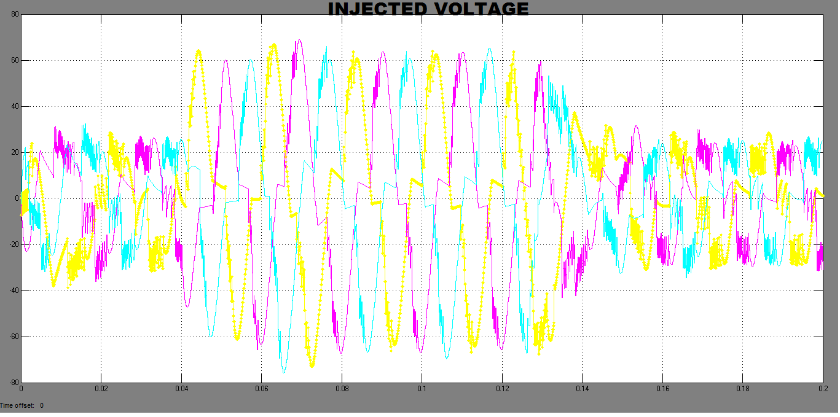
Fig.6 Injection transformer output
Figure 6 depicts the voltage to be injected in series with the load voltage. The injected voltage is the approximate sine wave voltage caused by transformer winding inductance.

IV. SIMULATION AND RESULTS
MATLAB simulation and results for dynamic voltage restorer (DVR) voltage sag mitigation based on unit vector template generation approach are reported in this section. There are two scenarios investigated for the DVR based on UVTG control technique, which is given below.
CASE I: Compensation for 20% sag in the balance voltage.
In the case of a power system, this sag is usually caused by faults or the start of a sudden significant load. The diagram below depicts a generalized power system.

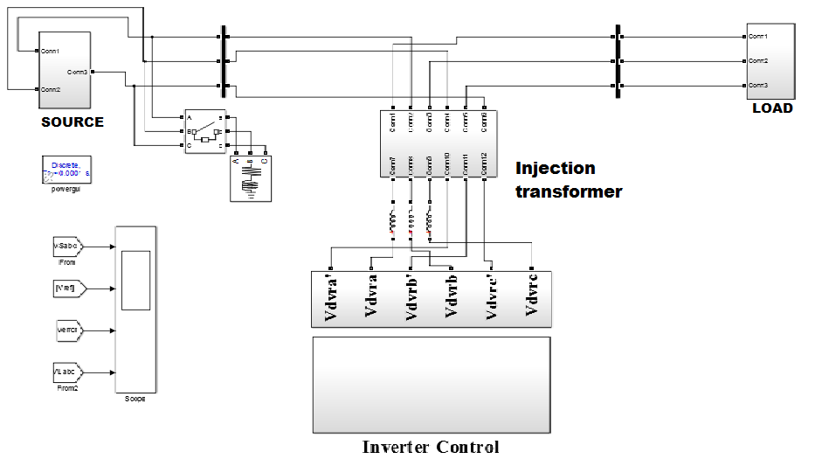

Fig.7 Shows Simulation of system when sudden load increase on source side

Figure shows the simulation result of 20% supply balance voltage sag created in all three phases due to a sudden increase in the large load at 0.04s and cleared at 0.12s. When the supply voltage sag is created at 0.04s, the dynamic voltage restorer kicks in and injects the missing voltage during the sag.
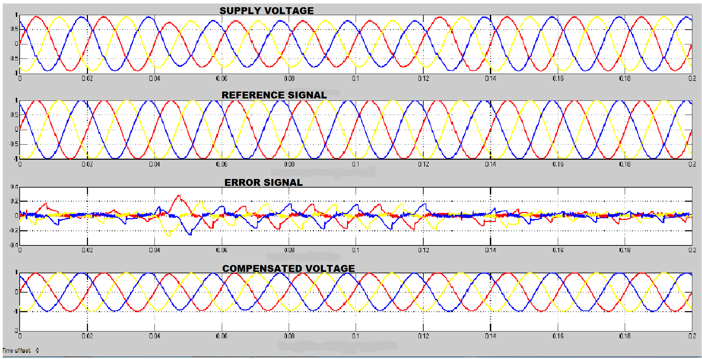

Fig.8 Simulation and results of Case I

System voltage | Voltage sag | Injected  voltage | Mitigated voltage
415V | 0.2pu | 0.10*2 | 1pu

Table 1. Observed Output of Case I
CASE II: 25% balance voltage sag compensation.
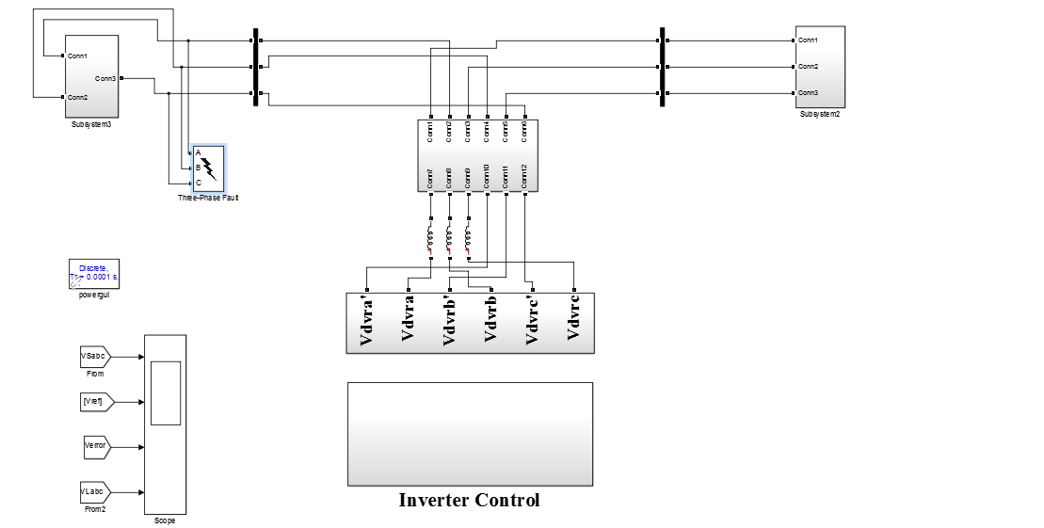

Fig.9 Shows Simulation of system with balanced voltage sag.
Figure shows the simulation result of a 25% supply balance voltage sag caused by a three phase to ground fault for 0.04s and cleared at 0.12s. When supply voltage sag occurs at 0.04s, the dynamic voltage restorer kicks in and injects the missing voltage during the sag.

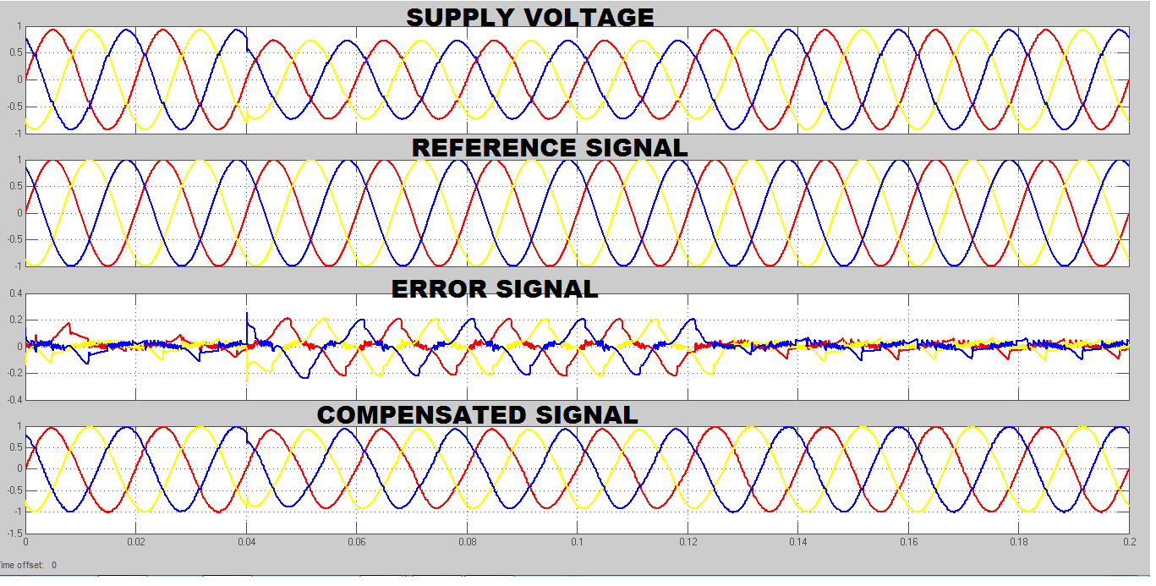

Fig.11 simulation and result for voltage in case II

System voltage | Voltage sag | Injected  voltage | Mitigated voltage
415V | 0.25pu | 0.125*2 | 1pu

Table 2. Observed Output of Case II

Case III: 25%unbalance sag compensation.
Figure shows the simulation result of a 25% supply unbalance voltage sag caused by a single phase to ground fault for 0.04s and cleared at 0.12s. When the supply voltage sag is created at 0.04s, the dynamic voltage restorer kicks in and injects the missing voltage during the sag.

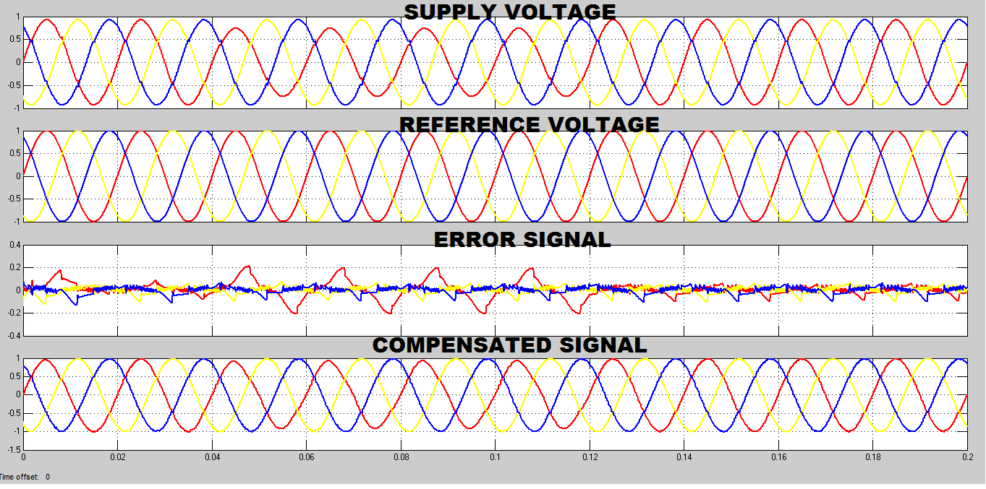
Fig.12 simulation and result for voltage in case III
System voltage | Voltage sag | Injected  voltage | Mitigated voltage
415V | 0.25pu | 0.125*2 | 1pu

Table 3. Observed Output of Case III
It is demonstrated in both cases that the voltage injected by the inverter equals 1-Sag Voltage (pu).

V.CONCLUSION
This paper describes the modeling and simulation of a DVR using MATLAB. For DVR, a proposed control system based on unit vector template generation (UVTG). The MATLAB simulink models were used to test the effectiveness of the proposed control strategy. The simulation results reveal that the DVR's performance in minimizing voltage sag is Satisfactory. The simulation findings further show that the DVR swiftly adapts for sags and has excellent voltage regulation. The DVR can easily manage both balanced and unbalanced circumstances and injects the necessary voltage component to quickly rectify any abnormality in the supply voltage in order to keep the load voltage balanced and constant at the nominal value.

REFERENCES

- Rosli Omar and Nasrudin Abd Rahim “Mitigation of voltage sag/swell by using DVR” ARPN Journal of Engineering and Applied Sciences, vol. no 4, June 2009.

- Bhim Singh and venkateswarlu.P “A simplified control algorithm for three-phase , four wire unified power quality conditioner” Presented at journal of power electronics ,vol no.1, January 2010

- S. N. Gohil, M.V.Makwana, K.T. Kadivar,G.J.Tetar “Three phase unified power quality conditioner(UPQC) for power quality improvement using UVTG Technique” 2013 International conference on renewable energy and sustainable energy [ICRESE’13].
- B.Singh, a chandra and k al haddad “review of active filters for power quality improvement” IEEE trans. Industrialelectronics,vol 46, No 5,pp.960-97, oct. 1999
- IEEE Std. 1159 – 1995, “Recommended Practice for Monitoring Electric Power Quality”.
- Vijay Karale and Saurabh jadhao “voltage sag mitigation using dynamic voltage restorer” proceeding of 2nd international conference on innovative in electrical & electronics engineering (ICIEE)., No.184, Aug 2015.
- P.Boonchiam and N. Mithulananthan, Thammasat “Understanding of Dynamic Voltage Restorers through MATLAB Simulation,” Int. J. Sc. Tech., Vol. 11, No. 3, July-Sept 2006.
- J. G. Nielsen, M. Newman, H. Nielsen,and F. Blaabjerg, “Control and testing of a dynamic voltage restorer (DVR) at medium voltage level,” IEEE Trans.Power Electron., vol. 19, no. 3,p.806, May 2004.
- Ghosh and G. Ledwich, “Power Quality Aamir Hanif, Mohommad Ahmed Choudhary,and Tahir Mehmood “Feed-Forward Control Strategy for the VSC of DVR for Smooth and Clean Power Flow to Load”.
- Hideaki Fujita and Hirofumi Akagi, “The Unified Power Quality Conditioner”, IEEE transaction on power electronics, VOL. 13, NO. 2, MARCH 1998
- H. Awad, J.Svensson, M. Bollen, “Mitigation of Unbalanced Voltage Dips Using Static Series Compensator”, IEEE Trans. On Power Elec., Vol. 19, No. 13, May 2004
- Hochgraf, R. Lasseter, “Statcom controls for Operation with Unbalanced Voltages”, IEEE Trans. On Power delivery, Vol. 13, No. 2, April 1998.
- Gunther, E.W., Mehta, H.: A survey of distribution system power quality. In: IEEE Trans. on PowerDelivery, vol.10 (1995), No.1, Jan.1995, pp.322-329.
- IEEE recommended Practices and Recommendations for harmonics Control in Electric Power Systems. In:IEEE std.519, 1992.
- Kotwal, C., Pillai, G. N., Gupta, H. O.: Modeling and Simulation of Different Topologies for VSI Based Static Synchronous Series Compensator. In: JEE, Vol.10(2010), Edition-4.
- H. Hingorani “Introducing custom power” IEEE spectrum, vol.32 no.6,June 1995 p 41- 48.
- Bhim Singh ,Amrish Chandra And Kamal AL-Haddad “Power quality problems and mitigation techniques” Published by 2015 John Wiley & Sons,Ltd

